Greater Nottingham

Aligned Core Strategy
Accessibility of Settlements Study January 2010

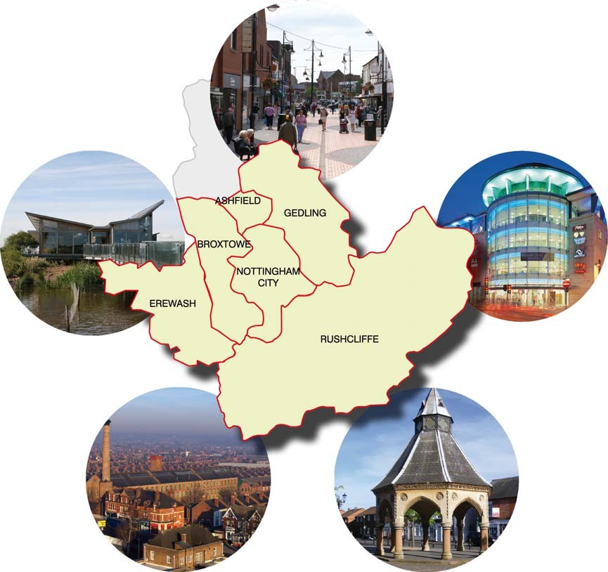

Greater Nottingham Accessibility of Settlements Study

- Introduction
- Overview – purpose and background
- Methodology
- Definition of settlements and origin points
- Identifying and classifying facilities
- Weightings for classifications of facilities
- Measuring access to facilities
- Accession model and scoring system
- Model results and conclusions
- Limitations to the study and potential further work APPENDICES
Appendix 1 - Results tables
Appendix 2 - Figures illustrating results

Appendix 3 - Facility classification & sub-categories with weightings
Appendix 4 – List of facilities with thresholds and sources of data Appendix 5 - Maps of settlements and areas, bus services,
facilities.

Appendix 6 – Evidence base for justification of weightings and travel time thresholds given to facilities

Appendix 7 - Discussion of factors influencing the results produced by the accessibility modelling process

Appendix 8 - Glossary

Introduction

  - Ashfield, Broxtowe, Erewash, Gedling, Nottingham City and Rushcliffe Councils are working jointly in order to prepare evidence to support the emerging aligned Core Strategies and Local Development Frameworks within their districts. Nottinghamshire County Council is assisting in this work. Part of the evidence base will be to inform the authorities about suitable settlements for the location of appropriate levels of development.

  - The aim of any spatial development strategy is to ensure that new development takes place at the appropriate scale in the most sustainable settlements. Most development should be concentrated within those settlements with the largest range of shops and services with more limited development within local service centres and villages. The overall aim of the plan is to create sustainable communities. The East Midlands Regional Plan (RSS, March 2009) already establishes a strategy of ‘concentration and regeneration which has established a hierarchy setting out the Principal Urban Area (PUA) (i.e. the Nottingham conurbation) and two Sub-Regional Centres (SRC) at Hucknall and Ilkeston. (see map 1).

  - PPS1 ‘Delivering Sustainable Development’ sets out the Government’s overarching planning policies and emphasises that sustainable development is the core principle underpinning planning. Paragraph 27 includes:

‘In preparing development plans, planning authorities should seek to: …Bring forward sufficient land … taking into account issues such as accessibility and sustainable transport needs, [and] …..Provide improved access for all to jobs, health, education, shops, leisure and community facilities, open space, sport and recreation, by ensuring that new development is located where everyone can access services or facilities on foot, bicycle or public transport rather than having to rely on access by car, while recognising that this may be more difficult in rural areas.’

  - PPS3 ‘Housing’ reiterates this principle and Annex B of PPS12 (Local Development Frameworks) states ‘Accessibility should be a key consideration when drawing up local development documents’ (para. B13).

  - According to the CfIT¹ report “Planning for Sustainable Travel” -

“Larger settlements provide an opportunity for greater self-containment and a mix of uses offering access to a range of shops, services and employment within the built-up area, thereby reducing the need for inter- urban travel. We should aim to maximise the proportion of new development which is allocated within or immediately adjacent to larger towns and cities. … There are many factors that are associated with sustainable travel and they tend to be inter-related, but data trends, using National Travel Survey analysis, show that metropolitan areas and large urban areas and (at a minimum) settlements with a population of 25,000 tend to have shorter annual travel distances and lower car mode shares than average.“ ²

¹ CfIT is an independent body advising the Government on integrated transport policy. http://www.cfit.gov.uk

² Planning for Sustainable Travel Summary Guide (October 2009) CfIT http://www.plan4sustainabletravel.org/summary_guide/

  - Research has been done on settlement size and energy efficiency of travel.

“A study in South Oxfordshire (cited by CfIT) paints a complex picture. The most energy efficient settlement included in the study was one of the largest towns (Henley), where there was a high trip generation rate (i.e. total number of trips) but low energy consumption rate per person and trip, reflecting a good provision of local facilities and services. The least energy efficient settlement was a small, remote settlement (Ewelme) with limited services and facilities. The settlement was too small to be self- sufficient and travel by car was essential to reach work and facilities. Towns in the intermediate settlement sizes produced a confused picture where population structure, distance from employment and other facilities, and levels of car ownership were all important factors in determining the energy efficiency of travel [strongly correlated with carbon emissions] (Banister, 1980; Banister, 1992). This research demonstrates the importance of settlement size and accessibility to other urban areas and other factors in determining travel patterns. ” ²

  - However, for smaller settlements (than those mentioned in 1.5 above), which may have a degree of development likely to be necessary it is important to understand which the most accessible settlements will be that could support more sustainable living.

  - The Regional Plan aims to concentrate development in and around the larger ‘Principal Urban Areas’ and Sub-Regional Centres”. However, Policy 3 Distribution of New Development states that outside of Principal urban areas and Sub-regional Centres “The development needs of other settlements and rural areas should also be provided for. New development in these areas should contribute to … shortening journeys and facilitating access to jobs and services…”

  - This report describes the work done to assess the accessibility of settlements to guide this plan-led development. The settlement appraisal described here will provide a consistent, transparent and rational basis for indicating suitable locations for development, locations for services, or a settlement hierarchy that can be set out in a Core Strategy.

Overview
  - The purpose of the work is to establish common means of measuring and assessing in general terms the level of accessibility of existing settlements, particularly in terms of their residents access to jobs, shopping, education and other services by walking, cycling and public transport. There are limits to the work, described in Section 10.³
  - The work evaluates on a consistent basis across the whole study area the ease of accessibility to a range of facilities and services. These are those which would contribute to a high quality of life for people and which, if more accessible in low-carbon means for a greater number of people, would contribute to sustainable development and the objectives of the Regional Plan and emerging LDF Core Strategies. This is one aspect of identifying more sustainable settlements.

³ The scope of the work does not extend to other aspects of sustainable development such as impact upon natural resources, infrastructure requirements and capacity, etc.; this is the concern of other evidence-base work. Also it does not concern where development may play a part in regenerating the area or future growth might support more services, for example smaller settlements in rural areas which generally have low levels of accessibility.

  - The work has several uses, it will -

    - Identify which settlements have higher levels of accessibility, assisting in the creation of a hierarchy of settlements if required,

    - contribute to setting out spatial policies to apply to different settlements including the suitability or unsuitability of growth,

    - identify where settlements fall short, for example, access to health facilities, which can assist service planning (although it should be noted that the usage and capacity of existing facilities has not been accounted for).

    - Identify if the level of accessibility to different types of facility varies widely for any particular location.

Methodology

  - The study establishes a consistent approach to accessibility measurement for all the settlements in the area.
  - All origin points in a range of locations within and beyond the built-up areas were assessed on their accessibility in terms of travelling time (by walking, cycling and public transport) to a range of facilities and services, and an overall average score for the settlement as a whole was calculated.

  - There are a series of steps that the methodology has taken:-
- Establish the boundaries of the settlements to be assessed, as defined by each authority.
- Within each settlement identify the geographic points to represent the origin of travel for residents.
- Draw up the selection of facilities and services that represent those that residents would require for a high and sustainable quality of life. A list is contained in Appendix 4.
- A form of weighting given to the facilities, for example essential facilities such as doctors’ surgeries, Post Offices to be given more weight than access to leisure facilities, and more frequent travelling more than occasional visits.
- Establish measures that represent a scale of accessibility for the facilities and services, and a travel time threshold that represents what people would consider to be a reasonable travel time by sustainable means. They consist of the accessibility (usually related to travelling time) to the nearest facility using walking, cycling or the public transport network (bus/heavy rail/light rail).
- Using the data obtained from steps 1-4, carry out accessibility analysis using Accession accessibility modelling software (developed for the Department for Transport).
- Once an assessment has been made of all the geographic points across the study area, derive a score for each settlement by

averaging all the scores from within that settlement to give a comparable and consistent rating.

  - The remaining sections describe this work in more detail

Definition of settlements and origin points

  - The study needed to establish a clear selection of towns and villages and define their boundaries. The task was ultimately to obtain an accurate source of home address locations within the settlements. Residential postcodes were selected as being most representative of the distribution of addresses. The total number, while large, was useful to generate average scores for the settlement, and could still be handled by the computer software.

  - The settlements are listed in Appendix 3. There was no lower limit of size, the decision being taken by each local authority. The size ranged from 1 postcode to 359 for Eastwood, representing over 8,000 delivery points. The Sub-Regional Centres were treated as a whole, although there is no reason that they could not be sub-divided. In the Principal Urban Area areas were sub-divided according to the authorities’ wishes; in general these areas were larger, over 5,000 origin points.

  - The settlements to be evaluated in the study were identified by the relevant District Planning Authority, and these settlement boundaries were defined in GIS using Ordnance Survey data of built-up areas. The whole settlement was included because in non-residential areas there would be no residential postcodes, thus automatically accounting for population distribution.

  - Rural locations outside settlements were not included, as the sustainability of settlements is the focus of this work. The methodology was applied to other areas including areas within the Principal Urban Area and Sub-regional centres. This gives a comparison to show relative levels of accessibility across different locations. For ease all the areas studied are referred to as ‘locations’, with those not within the PUA or SRCs being termed ‘settlements’.

Identifying and classifying facilities
  - Development of the Department for Transport’s Accessibility Planning Guidance has led to the production of 7 core accessibility indicators.
  - The Indicators provide a number of measures of accessibility by public transport, walking and (where appropriate) cycling to seven service types: primary schools, secondary schools, further education, GPs, hospitals, food and convenience stores and employment.

  - The core indicators have been calculated to help Local Authorities develop their evidence base for their accessibility strategies and in support of two of the new 198 National Indicators for Local Authorities (NI175 - Access to Services and NI 176 - Access to Employment). Using nationally consistent datasets gives Local Authorities a picture of journey-time barriers to accessibility, allows comparison with other authorities and gives those who decide that accessibility should be one of their 35 Local Area Agreement targets a baseline against which to set those targets.

  - Further information about the indicators can be found in a guidance note and the technical report, available from the DfT Transport Statistics website⁴.

  - In this study, recognition of the fact that people don’t necessarily take their ‘nearest’ job to their home has led to an additional measure of accessibility to employment has been included, namely access to 5 or more major employment sites within 20 minutes travel time by public transport, walking and cycling.

Weightings for classifications of facilities
  - The categories and sub-categories had weightings applied to them to reflect their ‘importance’ or how desirable it is for a population to be located within a certain distance / time of the destination. The weightings also reflect the frequency with which the service would be used. For example whist having access to a doctor may be considered very important, one would more rarely make this trip than destinations such as supermarkets and local convenience stores. These would be of lesser importance but the weightings reflect the high frequency of trips to these types of destinations.
  - These weightings have been derived from other similar accessibility studies and through consultation and testing within the Greater Nottingham Planning Officer group. The categories and weightings are also aligned to the priorities within the Local Transport Plan for Greater Nottingham 2006/7 to 2010/11 Accessibility Strategy. The methodology employed has resulted in access to GP’s being weighted as most important, followed by access to primary schools, secondary schools and employment opportunities.
  - In deciding these weightings, account was also taken of the English Indices of Deprivation (ID 2007, CLG). Certain facilities were included in the ID2007 to measure accessibility to key essential facilities in the Barriers to housing and essential services domain of the ID 2007. Access to a primary school, post office, GP surgery and local convenience store/food store were included on the basis that people consider these services to be essential and prefer these facilities to be within a short walking distance (10 mins) from their home. Weightings were also informed by the South Bucks District Council Accessibility & Infrastructure Study (Main Report Autumn 2006 with support from Halcrow Consulting), and agreed by the steering group.

  - It is recognised that there will be a close relationship between level of accessibility of an origin and the public transport network for certain origins irrespective of which destination facility is being measured to, therefore access to the public transport network is accounted only in terms of access to the long distance network (as a facility).

  - The full list of facilities and weightings is in Appendix 4, justification for weightings is also given in Appendix 6.

Measuring access to facilities

  - For each origin point in each settlement, typical travelling times by public transport, walking and cycling to its nearest facility were calculated and scored according to whether the time fell within a suitable defined travel time threshold. Suitable travel time thresholds for each sub-category were

⁴ Department for Transport (DfT) Core National Accessibility Indicators (2008), http://www.dft.gov.uk/pgr/statistics/datatablespublications/ltp/coreaccessindicators2008

derived from previous research and surveys⁵, relating to people’s aspirations, expectations and acceptance of the ‘maximum’ journey times generally perceived as ‘acceptable’. These travel time thresholds have been used in the calculations of the Department for Transport (DfT) core national accessibility indicators.
  - The parameters used for the accessibility modelling are in line with those proposed by the DfT (Department for Transport)⁶ and in the light of good practice; they are as follows:
- Maximum walk speed 4.8 km/h (unless measuring access to nursery and primary schools where walk speed is 3 km/h)
- Maximum cycle speed 16 km/h (unless measuring access to nursery and primary schools where cycle speed is 10 km/h)
- Maximum walk distance from origin points to joining points on the public transport network (bus stops, tram stops, rail stations) is 400 metres (5 mins walk)
- Maximum walk distance to be used when interchanging between different services of the same mode of public transport and between separate modes of public transport (bus/rail/light rail) is 400 metres.
- Maximum walk distance from alighting point of final public transport journey to final destination is 400 metres
- Calculations for public transport travel times to include all timetabled services (bus/heavy rail/light rail) scheduled to operate on a Monday between 07:00 and 09:00 hrs. Only journeys beginning and ending in this time frame are applicable
- The sampling interval for the assessments is 10 minutes. This is the frequency which Accession calculates the fastest total journey time between each origin/destination pair in the time period window above. The fastest total journey time out of the sampled times is then used in the accessibility calculations.
  - The travel time thresholds and parameters have also been agreed in consultation with the Greater Nottingham planning officer group.

  - Further details including supporting evidence relating to the derivation of suitable travel time thresholds can be found in Appendix 6.

Accession model and scoring system

  - Accessibility is calculated from origins to destinations using an accessibility modelling package called ‘Accession’. For each origin point, the typical travelling time by a selected mode of transport to a destination point can be calculated. There are various Accession modelling methodologies, and a weighted method has been used as this takes into account journey times, the full range of facilities in an area and allows different weightings to be applied to different types of facility. The choice of parameters used in the

⁵ See Appendix 7
⁶ Department for Transport (DfT) Core National Accessibility Indicators (2008), http://www.dft.gov.uk/pgr/statistics/datatablespublications/ltp/coreaccessindicators2008

accessibility modelling package and a discussion of the underlying assumptions is given in Appendix 7.

  - Some way of reflecting a choice of means of access is used, e.g. using a mix of bus and walking. Also the method accounts for people being generally prepared to travel some distance to work, and not necessarily take their 'nearest job' to their home. The parameters used in the accessibility modelling process for the strategic accessibility assessment as part of the Greater Nottingham Accessibility Strategy were the basis for this element.

  - Travel times by walking, cycling and public transport are calculated using a detailed digitised road network and the latest public transport timetable data for a Local Authority (bus, tram & heavy rail) with timings down to individual bus stop level to calculate the fastest travel times for travel for a specified mode of transport between any pair of origin/destination points for any given time period during a specified day of the week. For this work the time period of 07:00 hrs to 09:00 hrs on a weekday was used.
  - The process used to provide a score for each settlement is as follows:
    - for each destination facility dataset and mode of travel, calculate travel times from each origin point to each destination point in the set, and establish the shortest time from each origin point (in other words the nearest facility);
    - for each set of results for each mode score each origin point as to whether it falls within the specified travel time threshold to its nearest destination⁷;
    - repeat this for the three modes to be assessed (walk, cycle, public transport);
    - calculate the total score for every origin point using the three specified modes and multiply this by the total number of domestic delivery points attached to each origin point;
    - repeat the above process for all the destination facility datasets;
    - sum for each origin point the total scores;
    - calculate a total score for each settlement based on the sum of the total final score for every origin point within the settlement;
    - divide by the total number of domestic delivery points in the settlement to give an average score for that settlement.

Results and commentary

  - The results from the work are contained in Appendix 1 and in a spreadsheet available from the Study web pages. They give total scores plus those related to the each theme (e.g. employment) for accessibility in the locations and settlements of the study area. While it is not appropriate to analyse specific settlement results here, some general points may be made.

  - There is a very large range of average scores for the areas studied – 16 to 290 points, a factor of over 10. [A maximum score would be 300, achieving the threshold for all three of the means of access each having a total score of 100]. There is not a minimum score which in itself indicates an ‘accessible location’, the scores for locations show relative levels of accessibility.

⁷ In the case of access to employment opportunities travelling time was to a range of employment destinations (see para. 5.5).

Consequently valuable analysis can be obtained by relating scores to size of settlements and considering the reasons that certain locations may score well or less well.

  - Map 1 indicates that, unsurprisingly, better scores are achieved by larger settlements and areas within the larger urban areas. For those scoring better the location may benefit from being close to larger places, this is apparent looking at the better scores, for size of settlement, where these are clustered closer together in the eastern part of the HMA. However, some locations score less well than might be expected, for example, parts of West Bridgford score less well than Bingham. One reason for this may be because origin points in West Bridgford are beyond the 400 metre maximum walking distance to a bus stop and therefore score zero in that assessment.

  - Of those with low scores the majority are in Rushcliffe, these are small villages and only 1, Cropwell Bishop, has more than 20 postcode counts (appr. 500 delivery points).

  - While the significance of the differences is often small, the reasons for this could be investigated with further study of the scoring. Individual scores are contained in the associated data spreadsheets.

Map 1
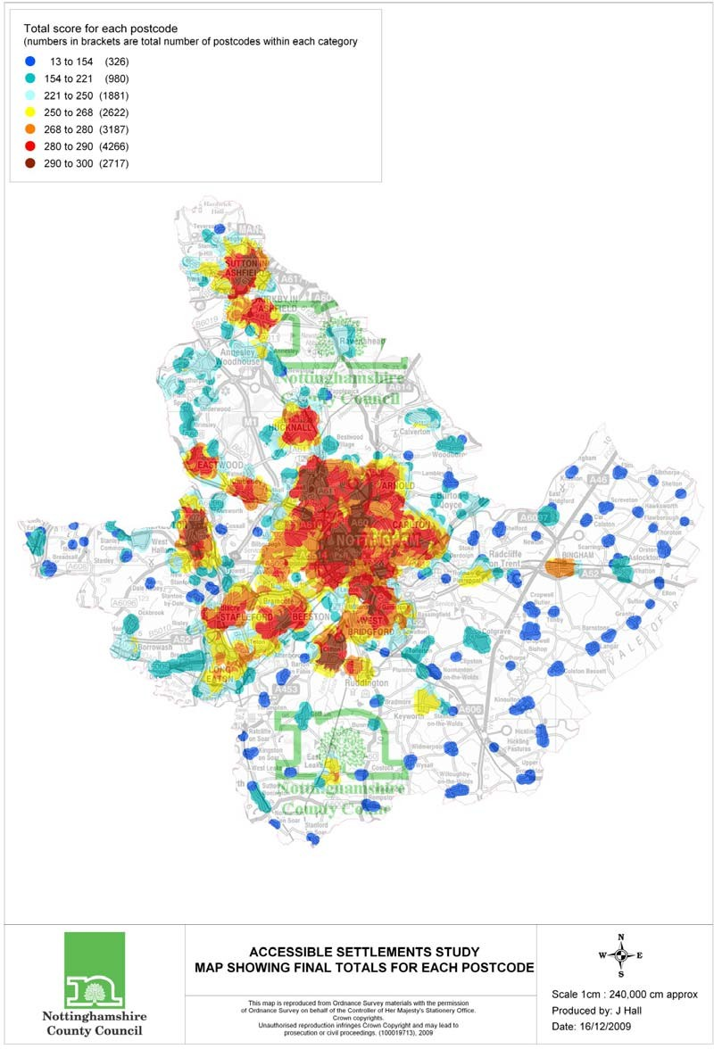

  - Figure 1 shows the relationship of scores with size for free standing settlements. Typically those scoring poorly are unsurprisingly smaller and more remote settlements. (N.B. size in this report refers to the number of residential delivery points, which is closely related to the number of households.)
  - There does not appear to be any relationship to size for smaller settlements; with a wide scatter of scores. The chart indicates where locations score better or less well than their size might indicate, with larger villages & towns scoring closer to the trend line. The scores appear to reach a plateau at around 500 delivery points⁸.

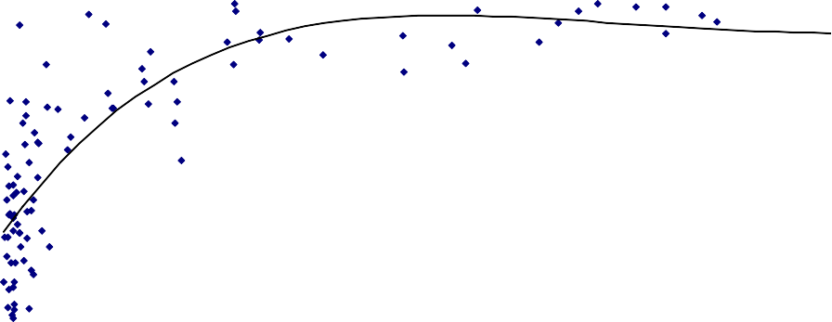
Figure 1
SIze of Location (Delivery Points)
3500
3000
2500
2000
1500
1000
500
0
100.0

50.0

0.0
Cropwell Bishop
150.0
Cotgrave
200.0
Annesley
250.0
Skegby
Ruddington
Bingham
350.0

300.0
Average Score against Size - Settlements

⁸ This can be compared to the findings of the Rural White Paper 2000, that settlements with over 1,000 population there is a 65% chance that the settlement will have the basic facilities provided eg primary school, post office, local food store.

  - A brief analysis of the relationship of the scores for all locations indicates weak relationships of score with size for each by theme. The strongest correlation is in employment, principally because of very poor results for smaller settlements. For other themes, especially for health, community and education provision accessibility is stronger in smaller settlements probably due in part to the provision of facilities in small villages to address the very issue of access to services.
  - It appears that the correlation of score with size builds up for all themes together, i.e. where settlements may be weak in one area, this is compensated for in another theme, rather than reinforced.

  - The way that a theme scores especially well or poorly against scores for other themes can be analysed. For example, in Little Eaton, community facilities can be highlighted as having relatively poor accessibility for that settlement. Conversely having a primary school gives Willoughby, Flawborough and Flintham better scores for education although they are smaller settlements that otherwise score poorly (see also Appendix 2). The settlements where one theme contributes most or least to the total score are shown below. Note that these settlements do not necessarily score highly in total, for example Colston Bassett only scores 16 (out of 300), but
6.3 (39%) is contributed from health accessibility.

Settlements with highest proportion of total score coming from each theme -
Health | Retail Services | Employment | Education | Community
Ratcliffe on Soar | Shelton | Langar | Willoughby- on-the-  Wolds | Upper Broughton
Kneeton | Shelford | Breadsall | Flawborough | Ratcliffe on Soar
Colston Bassett | Owthorpe | Draycott | Flintham | Colston Bassett
Stanford on Soar | Hickling Pastures | Widmerpool | Orston | Granby
Barton in Fabis | Stanton-on-the- Wolds | West Hallam | Morley | Hickling
Settlements scoring most below average for one theme -
Health | Retail Services | Employment | Education | Community
Flawborough | Willoughby-on- the-Wolds | Ratcliffe on Soar | Ratcliffe on Soar | Little Eaton
Shelton | Thrumpton | Clipston | Owthorpe | Smalley and  Stanley Common
Flintham | Upper Broughton | Stanton-on- the-Wolds | Shelton | Breaston
Sibthorpe | Breadsall | Owthorpe | Colston Bassett | West Hallam
Cropwell Bishop | Ratcliffe on Soar | Newton | Upper Broughton | Trowell
Full details in supporting spreadsheet ‘Relative scoring’

Limitations to the study

  - Outside the scope of the study are the quality of facilities, and the accessibility of individual sites, e.g. whether disabled access is provided, or the range of shops provided by a shopping centre. Neither is the cost (or nature) of the journey accounted for.

  - Another aspect not reflected is the element of choice exercised in people’s decisions on where to access the facilities. For example, people may wish to exercise choice of schools, and while a primary school may be reasonably accessible, this may not be the school of choice. Similar considerations enter into many decisions where free access by car opens up more choice.

  - The work rests on the currency of information about bus services, roads and paths, facility provision, etc. This has been obtained as up-to-date as possible, and details are in the data sources. In particular data on shops and shopping parades, was difficult to obtain, and in cases such as pharmacies, dentists and pre-school nurseries was only available for 2006. Also, the consistency of data on open space was difficult to ensure, although definitions were carefully established; a factor that is clear when comparing settlements in different districts.

  - The work has some other limitations which should be spelt out. The methodology takes fastest overall travelling time, so a train-linked village can score well, even though the train service may have a lower frequency than a (slower) bus service. It is recognised that the choice and value of parameters may influence the value of the final results, particularly walking distances to bus stops and time periods chosen. In addition the work measures accessibility by public transport for a short time period (7-9am) during the day. A further discussion of these matters is in Appendix 8.

  - One aspect where the study does not, as it stands, reflect accessibility as accurately as possible is in the area of secondary education. Rural secondary schools, and some primary schools are particularly subject to the provision of free home-to-school transport to transport pupils and students living more than 2 miles from their designated primary school and more than 3 miles from their designated secondary school. These services are not included in the analysis. Consequently for some villages which score poorly in terms of education this does not reflect poor accessibility in practical terms for students. Study of the sensitivity of results to this factor indicates that the ranking of total accessibility would not change if access to secondary schools were removed from the scoring.

  - A further limitation lies in the comparison of different locations because of their different sizes and contexts. Clearly, an area within the built-up area of the PUA draws on a range of facilities from adjoining areas. Indeed the value of being part of a conurbation is important to areas’ sustainability and accessibility. Consequently any conclusions relating to size for those locations in the PUA should recognise this. However, it is a valid conclusion to recognise how those locations may be weak in relation to other areas in the PUA, or the fact that locations near the PUA (or SRCs) score well for their good connectivity with those larger settlements. It is worthwhile referring to the Commission for Integrated Transport work mentioned in Section 1 for further information on the relevance of scale, size and accessibility of larger urban areas to sustainable living (the relationships between population size, provision of services, facilities, travel patterns and accessibility are considered in Appendix 6).

Potential further work

  - It is anticipated that this work as it stands will provide a wealth of information to inform the local authorities and other service providers in helping to identify settlements for provision of services (for example community transport, health facilities, etc.), and appropriate developments that would improve sustainability. The work may also be broadened across the whole of Nottinghamshire.

  - In addition, further enhancements of the work would draw out valuable information. By establishing tighter areas around the centres of settlements, by studying facilities within walking (cycling?) distance of these the capacity or scale of the centre as opposed to the 'sustainability' of the whole settlement can be ascertained.

  - In a similar way the work could yield an indication of the density of facilities (e.g. how many within walking distance of each other, or the area where all facilities have over, say 10 others within walking distance).

  - Both these applications can inform the role and development of existing town and village centres.
  - The study could assess only cycling and walking scores, thus indicating the settlements’ ability to support short distance access. The comparison here might reveal the advantages of areas within the PUA for short distance access to jobs, for example.

  - The study could be extended to consider access by public transport across the day, or in terms of how much of the day there is a service. While this information would be revealed by studying public transport links alone, application of this work emphasising certain facilities, for example, shops and supermarkets in relation to off-peak public transport availability would be informative.

APPENDICES

Appendix 1 - Results tables
Table A1.1: Locations and Settlements: Total Score by District Table A1.2: Settlements: Scores by Theme, Total Score order

Appendix 2 - Figures illustrating results
Figure A2.1: Average Score against Size – Settlements
Figure A2.2: Comparison of Employment Theme against all Themes by Location

Appendix 3 - Facility classification & sub-categories with weightings
Appendix 4 – List of facilities with thresholds and sources of data Appendix 5 - Maps of settlements and areas, bus services,
facilities.
Appendix 6 – Evidence base for justification of weightings and travel time thresholds given to facilities

Appendix 7 - Discussion of factors influencing the results produced by the accessibility modelling process

Appendix 8 - Glossary

Appendix 1 - Results tables

The Tables below give some summary results

Table A1.1: Locations and Settlements: Total Score by District

Settlement / Location  Ashfield | Total domestic delivery points | Total score
Annesley/Annesley Woodhouse | 3021 | 239.6
Hucknall | 13581 | 266.8
Huthwaite | 2437 | 248.0
Jacksdale | 1212 | 227.3
Kirkby | 8668 | 274.8
Selston | 2805 | 230.7
Skegby | 988 | 247.5
Stanton Hill | 984 | 253.1
Sutton | 15128 | 279.5
Teversal | 45 | 116.5
Teversal and Fackley | 185 | 207.5
Underwood | 952 | 224.8
Broxtowe
Awsworth | 1085 | 226.1
Beeston/Bramcote/Chilwell/Attenborough/Toton | 22684 | 268.7
Brinsley | 977 | 207.9
Cossall | 59 | 111.4
Eastwood/Giltbrook/Newthorpe | 8097 | 269.4
Kimberley/Nuthall/Watnall⁹ | 6584 | 268.1
Stapleford | 8076 | 271.6
Strelley | 32 | 180.2
Trowell | 435 | 238.4
Erewash
Borrowash | 2351 | 239.1
Breadsall | 289 | 153.2
Breaston | 1958 | 208.3
Dale Abbey | 47 | 91.4
Draycott | 1354 | 214.7
Ilkeston | 14511 | 273.5
Kirk Hallam | 2682 | 251.3
Little Eaton | 728 | 163.5
Long Eaton | 13920 | 258.0
Morley | 120 | 97.0
Ockbrook | 726 | 194.7
Risley | 366 | 245.6
Sandiacre | 3849 | 272.3
Sawley | 2960 | 244.9
Smalley and Stanley Common | 617 | 178.1
Stanley | 232 | 173.7
Stanton by Dale | 150 | 149.3
West Hallam | 1694 | 229.7

⁹ The score for Kimberley/Nuthall/Watnall includes an area of Nuthall ward that falls within the Nottingham built-up area (PUA). Removing that area (around Mornington Crescent) improves the settlement’s score to appr. 273.

Gedling  Bestwood Village | 591 | 204.7
Bonington | 3051 | 270.9
Burton Joyce | 1088 | 231.7
Calverton | 2269 | 224.3
Carlton Hill | 3195 | 276.9
Carlton Ward | 3286 | 280.4
Daybrook Ward | 2311 | 289.4
Gedling Ward | 2820 | 257.2
Killisick | 1071 | 274.3
Kingswell | 2248 | 286.9
Lambley | 276 | 143.0
Linby | 70 | 237.4
Mapperley | 3228 | 258.9
Netherfield | 3611 | 268.0
Newstead | 349 | 167.5
Papplewick | 98 | 168.9
Phoenix Ward | 2050 | 273.8
Porchester | 3190 | 283.6
Ravenshead | 1901 | 222.0
St. James | 1868 | 266.8
St. Mary's | 2829 | 280.7
Stoke Bardolph | 30 | 95.2
Valley Ward | 1970 | 277.1
Woodborough | 468 | 174.4
Woodthorpe | 2988 | 283.8
Nottingham  Area 1 | 13503 | 286.6
Area 2 | 14991 | 284.3
Area 3 | 18411 | 277.9
Area 4 | 21256 | 290.2
Area 5 | 14603 | 287.0
Area 6 | 15748 | 284.3
Area 7 | 8413 | 272.9
Area 8 | 11104 | 283.5
Area 9 | 11454 | 281.0

Table A1.1: Locations and Settlements: Total Score by District (cont.)

Rushcliffe
Aslockton | 447 | 186.2
Barnstone | 166 | 82.0
Barton in Fabis | 78 | 69.7
Bingham | 1896 | 269.6
Bradmore | 136 | 156.4
Bunny | 84 | 163.5
Car Colson | 46 | 108.9
Clipston | 11 | 77.3
Colston Bassett | 46 | 16.1
Costock | 114 | 133.7
Cotgrave | 1697 | 201.8
Cropwell Bishop | 755 | 135.5
Cropwell Butler | 155 | 147.7
East Bridgford | 738 | 179.6
East Leake | 2008 | 248.6
Elton | 28 | 116.1
Flawborough | 23 | 24.3
Flintham | 92 | 59.6
Gotham | 627 | 217.3
Granby | 121 | 52.1
Hawksworth | 50 | 26.5
Hickling | 130 | 48.9
Hickling Pastures | 37 | 57.9
Holme Pierrepont | 26 | 94.4
Keyworth | 2520 | 253.7
Kingston on Soar | 47 | 81.8
Kinoulton | 332 | 56.9
Kneeton | 25 | 38.1
Langar | 150 | 122.0
Newton | 18 | 105.4
Normanton on Soar | 65 | 123.1
Normanton-on-the-Wolds | 91 | 111.9
Orston | 132 | 105.4
Owthorpe | 17 | 62.8
Plumtree | 99 | 179.4
Radcliffe on Trent | 2807 | 250.9
Ratcliffe on Soar | 6 | 43.6
Rempstone | 105 | 76.1
Ruddington | 2475 | 268.5
Scarrington | 64 | 87.1
Screveton | 52 | 57.6
Shelford | 73 | 80.7
Shelton | 41 | 18.5
Sibthorpe | 45 | 39.3
St James Park | 93 | 147.3
Stanford on Soar | 22 | 130.2
Stanton-on-the-Wolds | 13 | 140.1

Sutton Bonington | 464 | 175.0
Thoroton | 48 | 43.1
Thrumpton | 51 | 22.2
Tithby | 22 | 77.4
Tollerton | 601 | 194.4
Upper Broughton | 114 | 23.3
West Bridgford Abbey | 1901 | 274.0
West Bridgford Compton Acres | 1893 | 273.1
West Bridgford Edwalton | 1748 | 251.9
West Bridgford Gamston | 1946 | 255.7
West Bridgford Lady Bay | 1987 | 273.4
West Bridgford Lutterall | 1793 | 272.1
West Bridgford Melton | 2074 | 281.9
West Bridgford Musters | 1580 | 277.4
West Bridgford Trent Bridge | 1904 | 288.3
West Leake | 49 | 94.1
Whatton | 188 | 175.2
Widmerpool | 71 | 80.3
Willoughby-on-the-Wolds | 200 | 69.8
Wysall | 102 | 96.9

Table A1.2: Settlements: Scores by Theme, Total Score order

Settlements Outside the PUA Education Empl. Health Retail

Comm. facilities Total

score score score score score score

Sutton | 69.4 | 44.2 | 70.2 | 69.7 | 26.1 | 279.5
Kirkby | 72.2 | 43.9 | 71.1 | 59.7 | 27.9 | 274.8
Ilkeston | 69.0 | 43.8 | 68.7 | 68.0 | 23.9 | 273.5
Bingham | 74.9 | 36.4 | 56.0 | 72.8 | 29.4 | 269.6
Eastwood/Giltbrook/Newthorpe | 63.0 | 43.7 | 65.7 | 70.6 | 26.5 | 269.4
Ruddington | 66.0 | 38.5 | 62.5 | 74.5 | 27.0 | 268.5
Kimberley/Nuthall/Watnall¹⁰ | 66.5 | 40.0 | 66.7 | 68.9 | 26.0 | 268.1
Hucknall | 67.6 | 42.6 | 62.1 | 67.0 | 27.5 | 266.8
Keyworth | 66.5 | 36.3 | 54.7 | 73.2 | 23.0 | 253.7
Stanton Hill | 65.8 | 30.0 | 65.8 | 65.0 | 26.4 | 253.1
Kirk Hallam | 70.5 | 36.9 | 53.5 | 68.8 | 21.6 | 251.3
Radcliffe on Trent | 67.3 | 34.9 | 52.1 | 72.1 | 24.6 | 250.9
East Leake | 61.7 | 28.7 | 58.5 | 71.9 | 27.6 | 248.6
Huthwaite | 55.7 | 39.1 | 63.1 | 68.1 | 22.0 | 248.0
Skegby | 58.7 | 35.3 | 63.6 | 64.2 | 25.6 | 247.5
Risley | 63.6 | 39.8 | 56.1 | 59.5 | 26.6 | 245.6
Sawley | 61.7 | 40.8 | 53.0 | 63.9 | 25.4 | 244.9
Annesley/Annesley Woodhouse | 60.3 | 38.1 | 61.5 | 53.8 | 25.9 | 239.6
Borrowash | 53.8 | 31.1 | 60.7 | 69.3 | 24.2 | 239.1
Trowell | 65.6 | 38.6 | 51.9 | 62.2 | 20.1 | 238.4
Linby | 68.8 | 31.7 | 53.7 | 59.9 | 23.2 | 237.4
Burton Joyce | 56.6 | 26.4 | 53.9 | 74.2 | 20.6 | 231.7
Selston | 65.4 | 27.5 | 58.6 | 53.2 | 26.0 | 230.7
West Hallam | 62.0 | 37.5 | 62.2 | 49.0 | 18.9 | 229.7
Jacksdale | 55.6 | 28.4 | 59.0 | 58.6 | 25.7 | 227.3
Awsworth | 63.3 | 33.6 | 43.8 | 62.4 | 23.1 | 226.1
Underwood | 61.6 | 29.1 | 58.6 | 52.3 | 23.1 | 224.8
Calverton | 60.9 | 21.3 | 53.9 | 60.3 | 28.0 | 224.3
Ravenshead | 54.9 | 25.0 | 59.2 | 59.2 | 23.8 | 222.0
Gotham | 61.4 | 30.0 | 50.1 | 48.8 | 27.0 | 217.3
Draycott | 63.3 | 37.5 | 28.8 | 65.0 | 20.1 | 214.7
Breaston | 63.2 | 33.8 | 30.5 | 63.8 | 17.1 | 208.3
Brinsley | 50.8 | 29.6 | 47.1 | 62.1 | 18.3 | 207.9
Teversal and Fackley | 45.1 | 22.5 | 58.5 | 58.9 | 22.5 | 207.5
Bestwood Village | 52.7 | 28.8 | 49.0 | 52.1 | 22.1 | 204.7
Cotgrave | 40.7 | 2.4 | 56.4 | 73.8 | 28.5 | 201.8
Ockbrook | 44.5 | 30.0 | 50.9 | 48.5 | 20.9 | 194.7
Tollerton | 57.8 | 29.7 | 31.9 | 57.0 | 18.0 | 194.4
Aslockton | 61.9 | 28.8 | 23.6 | 49.9 | 22.1 | 186.2
Strelley | 55.5 | 22.3 | 49.9 | 36.9 | 15.7 | 180.2
East Bridgford | 54.0 | 15.0 | 49.5 | 42.4 | 18.7 | 179.6
Plumtree | 53.4 | 12.7 | 37.2 | 52.0 | 23.9 | 179.4
Smalley and Stanley Common | 59.4 | 28.8 | 44.7 | 31.5 | 13.8 | 178.1
Whatton | 52.1 | 26.6 | 25.1 | 48.4 | 23.0 | 175.2
Sutton Bonington | 45.1 | 14.1 | 58.6 | 40.1 | 17.1 | 175.0

¹⁰ The score for Kimberley/Nuthall/Watnall includes an area of Nuthall ward that falls within the Nottingham built-up area (PUA). Removing that area (around Mornington Crescent) improves the settlement’s score to appr. 273.

Woodborough | 53.2 | 13.2 | 37.6 | 47.0 | 23.5 | 174.4
Stanley | 56.3 | 25.6 | 43.8 | 32.5 | 15.5 | 173.7
Papplewick | 53.8 | 4.0 | 44.1 | 44.0 | 23.1 | 168.9
Newstead | 58.2 | 0.0 | 42.6 | 44.0 | 22.6 | 167.5
Bunny | 45.9 | 23.1 | 37.6 | 42.5 | 14.3 | 163.5
Little Eaton | 51.7 | 23.5 | 31.3 | 44.6 | 12.4 | 163.5
Bradmore | 45.9 | 0.0 | 37.6 | 53.2 | 19.6 | 156.4
Breadsall | 51.6 | 27.2 | 34.8 | 20.7 | 19.0 | 153.2
Stanton By | 36.3 | 4.5 | 37.5 | 50.0 | 21.0 | 149.3
Cropwell Butler | 43.1 | 15.0 | 25.1 | 42.5 | 22.0 | 147.7
St James Park | 43.4 | 0.0 | 36.8 | 47.1 | 19.9 | 147.3
Lambley | 59.6 | 0.0 | 23.3 | 39.3 | 20.8 | 143.0
Stanton-On-The-Wolds | 35.0 | 0.0 | 37.6 | 55.0 | 12.5 | 140.1
Cropwell Bishop | 49.7 | 4.8 | 12.9 | 48.4 | 19.8 | 135.5
Costock | 52.5 | 0.0 | 31.4 | 31.0 | 18.8 | 133.7
Stanford On Soar | 35.1 | 0.0 | 50.0 | 31.8 | 13.3 | 130.2
Normanton On Soar | 41.3 | 0.0 | 43.8 | 27.5 | 10.5 | 123.1
Langar | 45.0 | 22.5 | 12.6 | 27.5 | 14.4 | 122.0
Teversal | 28.8 | 15.0 | 25.0 | 34.8 | 13.0 | 116.5
Elton | 32.5 | 0.0 | 37.6 | 32.5 | 13.5 | 116.1
Normanton-On-The-Wolds | 38.5 | 0.0 | 25.1 | 29.9 | 18.3 | 111.9
Cossall | 33.9 | 0.0 | 37.1 | 27.0 | 13.4 | 111.4
Car Colson | 36.3 | 0.0 | 25.1 | 30.0 | 17.5 | 108.9
Newton | 38.8 | 0.0 | 25.1 | 27.5 | 14.0 | 105.4
Orston | 48.8 | 0.0 | 12.2 | 28.1 | 16.4 | 105.4
Morley | 40.6 | 0.0 | 23.0 | 21.6 | 11.8 | 97.0
Wysall | 25.9 | 0.0 | 23.1 | 32.3 | 15.6 | 96.9
Stoke Bardolph | 18.0 | 0.0 | 27.2 | 30.0 | 20.0 | 95.2
Holme Pierrepont | 25.0 | 0.0 | 31.4 | 25.0 | 13.0 | 94.4
West Leake | 22.0 | 0.0 | 25.1 | 27.5 | 19.5 | 94.1
Dale Abbey | 33.8 | 0.0 | 26.6 | 20.6 | 10.5 | 91.4
Scarrington | 32.5 | 0.0 | 12.6 | 25.0 | 17.0 | 87.1
Barnstone | 31.2 | 7.3 | 12.6 | 14.9 | 15.9 | 82.0
Kingston on Soar | 15.7 | 0.0 | 27.3 | 19.5 | 19.3 | 81.8
Shelford | 14.7 | 0.0 | 12.6 | 35.7 | 17.7 | 80.7
Widmerpool | 13.3 | 13.3 | 18.8 | 26.0 | 9.0 | 80.3
Tithby | 21.6 | 0.0 | 18.8 | 24.0 | 13.0 | 77.4
Clipston | 21.3 | 0.0 | 20.5 | 25.0 | 10.5 | 77.3
Rempstone | 19.6 | 0.0 | 20.7 | 20.6 | 15.2 | 76.1
Willoughby-on-the-Wolds | 40.7 | 0.0 | 12.6 | 3.0 | 13.5 | 69.8
Barton in Fabis | 15.0 | 0.0 | 25.1 | 17.1 | 12.5 | 69.7
Owthorpe | 0.0 | 0.0 | 18.8 | 27.5 | 16.5 | 62.8
Flintham | 30.0 | 0.0 | 0.5 | 15.7 | 13.5 | 59.6
Hickling Pastures | 11.3 | 0.0 | 12.6 | 25.0 | 9.0 | 57.9
Screveton | 21.3 | 0.0 | 6.3 | 20.0 | 10.0 | 57.6
Kinoulton | 17.8 | 0.0 | 10.5 | 15.6 | 13.0 | 56.9
Granby | 15.0 | 0.0 | 12.6 | 10.0 | 14.5 | 52.1
Hickling | 11.3 | 0.0 | 6.6 | 17.5 | 13.5 | 48.9
Ratcliffe on Soar | 0.0 | 0.0 | 22.6 | 7.5 | 13.5 | 43.6
Thoroton | 7.5 | 0.0 | 12.6 | 15.0 | 8.0 | 43.1

Table A1.2: Settlements: Scores by Theme, Total Score order (cont.)

Sibthorpe | 13.8 | 0.0 | 0.5 | 15.0 | 10.0 | 39.3
Kneeton | 3.8 | 0.0 | 18.8 | 10.0 | 5.5 | 38.1
Hawksworth | 3.8 | 0.0 | 6.3 | 10.0 | 6.4 | 26.5
Flawborough | 13.8 | 0.0 | 0.0 | 5.0 | 5.5 | 24.3
Upper Broughton | 0.0 | 0.0 | 6.9 | 2.4 | 14.1 | 23.3
Thrumpton | 7.9 | 0.0 | 7.0 | 1.3 | 5.9 | 22.2
Shelton | 0.0 | 0.0 | 0.0 | 15.0 | 3.5 | 18.5
Colston Bassett | 0.0 | 0.0 | 6.3 | 5.3 | 4.5 | 16.1

The complete results tables are contained in an excel spreadsheet and an Adobe Acrobat file:
GNAS study results tables.xls and GNAS study results tables.pdf The spreadsheet includes the following sheets:
Name Contents
Scores score order All scores for settlements in descending order of Total (all themes) score
Scores district order All scores for settlements in alphabetical order by
district
Ranking by Theme Scores by theme in order of theme score Facilities Count Number of facilities by settlement by district Scores PUA / non-PUA As “scores score order” split by PUA / non-PUA Scores non-PUA by size Non-PUA settlements in size order
Relative scoring Theme scores relative to overall score by settlement Listing of Locations Alphabetical list of location names and districts
A second spreadsheet contains charts illustrating the results: GNAS study results charts.xls

Notes on Charts
Charts – score by size (6) Chart comparing score with size for each theme
(See Figure A2.1 below)
Charts – by theme (5) Chart comparing theme score with Total (all
themes) score for each theme (See Figure A2.2 below)

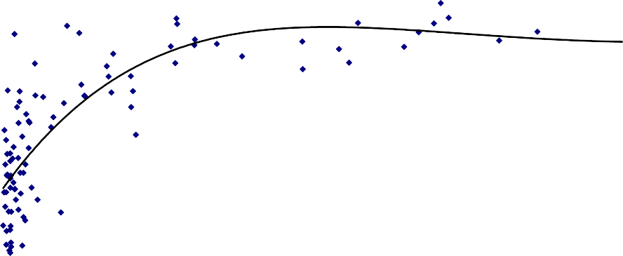
100.0
SIze of Location (Delivery Points)
50.0
0.0
0
500
1000
1500
2000
2500
3000
3500
Cropwell Bishop
150.0
Cotgrave
200.0
Annesle
250.0
Skegby
Ruddington
Bingham
300.0
350.0
Figure A2.1 Average Score against Size - Settlements

Figure A2.2: Comparison of Employment Theme against all Themes by Location
16000

14000

12000

10000

8000 Series1
Series2

6000

4000

2000

0
1 3 5 7 9 11 13 15 17 19 21 23 25 27 29 31 33 35 37 39 41 43 45 47 49 51 53 55 57 59 61 63 65 67 69 71 73 75 77 79 81 83 85 87

50.0
Draycott
Breadsall
Langar
Cotgrave
This chart compares how access to this theme scores against the settlement average. Above the diagonal line indicates better; below the line relatively less well.

45.0

40.0

35.0
Absolute score Employment

30.0

25.0

20.0

15.0

10.0

5.0

0.0
0.0 50.0 100.0 150.0 200.0 250.0 300.0 350.0
total overall average score for settlement

Appendix 3 - Facility classification & sub-categories with
weightings

Table A3.1 - Facility classification & sub-categories with weightings
Category & weighting | Sub-category | Weighting within category | Overall weighting
Education 25% | Nurseries (registered) | 15% | 3.75
 | Primary schools (public) | 40% | 10
 | Secondary schools (public) | 30% | 7.5
 | Further Education (up to 19years) | 15% | 3.75
Community Facilities 10% | Public libraries (static) | 25% | 2.5
 | Community centres / village halls | 30% | 3
 | Public indoor recreational | 20% | 2
 | Formal public outdoor recreational (inc open spaces & public realm) | 15% | 1.5
 | Long distance public transport interchange | 10% | 1
Health 25% | Hospitals | 25% | 6.25
 | Doctors surgeries & health centres | 50% | 12.5
 | Dentists | 15% | 3.75
 | Opticians | 10% | 2.5
Retail 25% | Primary & secondary retail centres | 20% | 5
 | Superstores (> 2,500 sq m.) | 20% | 5
 | Shopping parades/local convenience stores / Newsagent | 20% | 5
 | Pharmacies | 10% | 2.5
 | Post offices | 20% | 5
 | Banks / building societies / ATM | 10% | 2.5
Employment 15% | Local employment areas (output areas with over 300 employed) | 50% | 7.5
 | Access to employment (SOA's with over 500 employed) | 50% | 7.5

Table A4.1 – Facilities & Thresholds
Destination set |  |  | Travel threshold |  | time | Data sources
Nurseries |  |  | 15 | mins |  | Neighbourhood Statistics (data from 2006)
Primary Schools |  |  | 15 | mins |  | Nottinghamshire County Council & Nottingham City Council (Sustainability Appraisal Officer); Department for Transport (DfT) 2009 Core National Accessibility Indicators destination  dataset (for Derbyshire)
Secondary Schools |  |  | 20 | mins |  | Nottinghamshire County Council & Nottingham City Council (Sustainability Appraisal Officer); Department for Transport (DfT) 2009 Core National Accessibility Indicators destination  dataset (for Derbyshire)
Further Education 19 years) | (up | to | 30 | mins |  | Nottinghamshire County Council & Nottingham City Council (Sustainability Appraisal Officer); Department for Transport (DfT) 2009 Core National Accessibility Indicators destination  dataset (for Derbyshire)
Public Libraries |  |  | 15 | mins |  | Nottinghamshire County Council and Nottingham  City Council websites; Derbyshire County Council website
Community Centres/Village Halls |  |  | 15 | mins |  | 2008 Royal Mail Addresspoint file.  Notts & Derbyshire District Planning Officers
Public Indoor recreational |  |  | 20 | mins |  | District Council websites
Formal public outdoor recreational (inc open  spaces & public realm) |  |  | 20 | mins |  | Notts & Derbyshire District Planning Officers (to include destinations with unrestricted & restricted  access only)
Long Distance public transport interchange |  |  | 30 | mins |  | Nottinghamshire County Council
Hospitals |  |  | 30 | mins |  | Nottinghamshire County Council & Nottingham City Council (Sustainability Appraisal Officer); Department for Transport (DfT) 2009 Core National Accessibility Indicators destination  dataset (for Derbyshire)
Doctors surgeries & health centres |  |  | 15 | mins |  | Nottinghamshire County Council & Nottingham City Council (Sustainability Appraisal Officer); Department for Transport (DfT) 2009 Core National Accessibility Indicators destination  dataset (for Derbyshire)
Dentists |  |  | 30 | mins |  | Neighbourhood Statistics (data from 2006)
Opticians |  |  | 30 | mins |  | Neighbourhood Statistics (data from 2006)
Primary & secondary retail centres |  |  | 20 | mins |  | Notts & Derbyshire District Planning Officers
Superstores (above 2,500 sq m floorspace) |  |  | 15 | mins |  | Department for Transport (DfT) 2009 National Accessibility Indicators.  Notts & Derbyshire District Planning Officers | Core
Supermarkets (below 2,500 sq m floorspace); convenience stores; shopping parades |  |  | 15 | mins |  | Department for Transport (DfT) 2009 National Accessibility Indicators.  Notts & Derbyshire District Planning Officers 2008 Royal Mail Addresspoint file. | Core
Pharmacies |  |  | 15 | mins |  | Neighbourhood Statistics (data from 2006)
Post Offices |  |  | 15 | mins |  | Royal Mail website
Cashpoint/ATM |  |  | 15 | mins |  | Vocalink Ltd
Employment areas |  |  | 20 | mins |  | 2001 census

Table A4.2 - Sources of data
Data |  | Description
Origin data |  | 2009 Royal Mail Codepoint file, point locations of postcodes with domestic delivery points. The final dataset comprises  some individual 15,979 origin points across the whole study area
Destination data |  | See above
Public data | Transport | Bus & Tram ATCO-CIF file for Nottinghamshire County and Nottingham UA in July 2009. Public transport data for Derbyshire (Erewash District) dated October 2008 and downloaded from the National Public Transport Data Repository (nptdr) website. Heavy rail ATCO-CIF file obtained  January 2009.
Road network |  | The OS ITN digitised road Nottinghamshire County Council. | network | provided | by

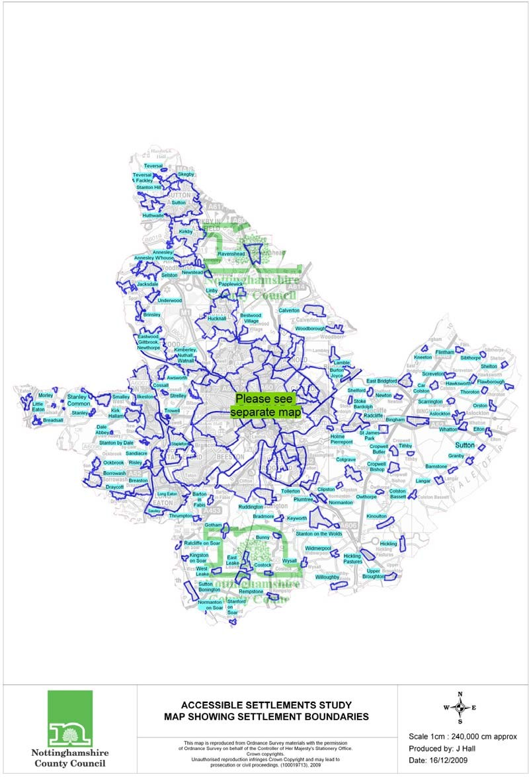

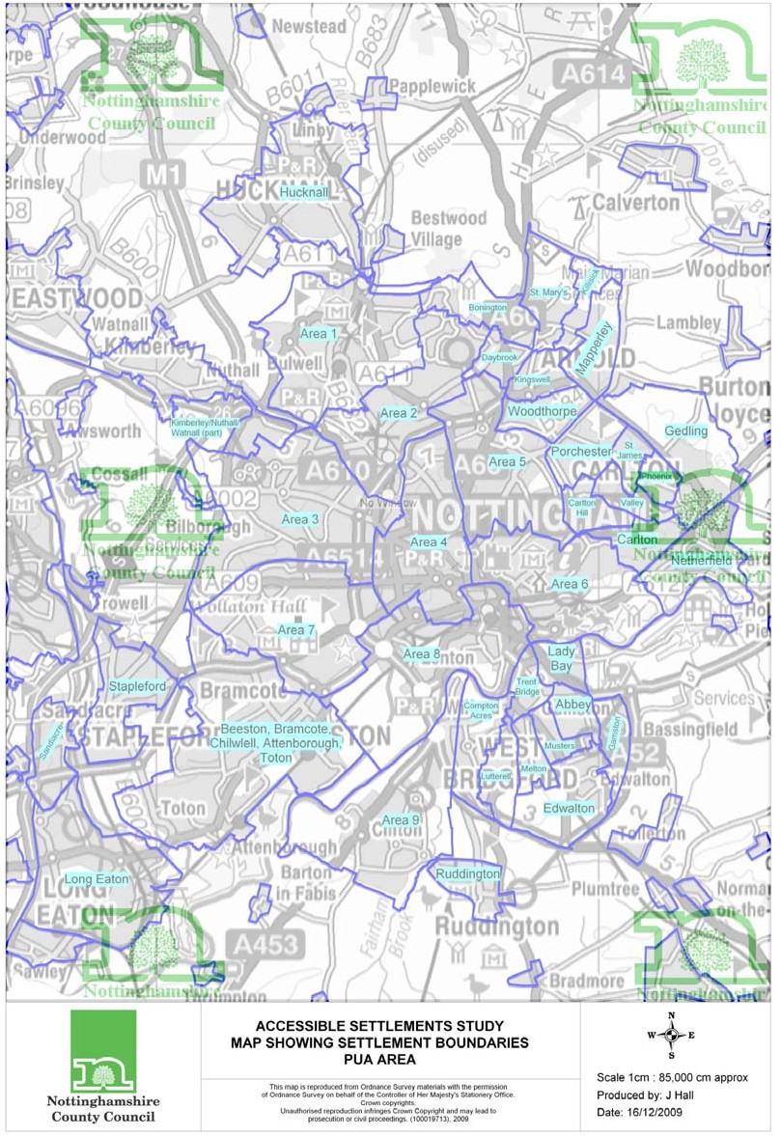

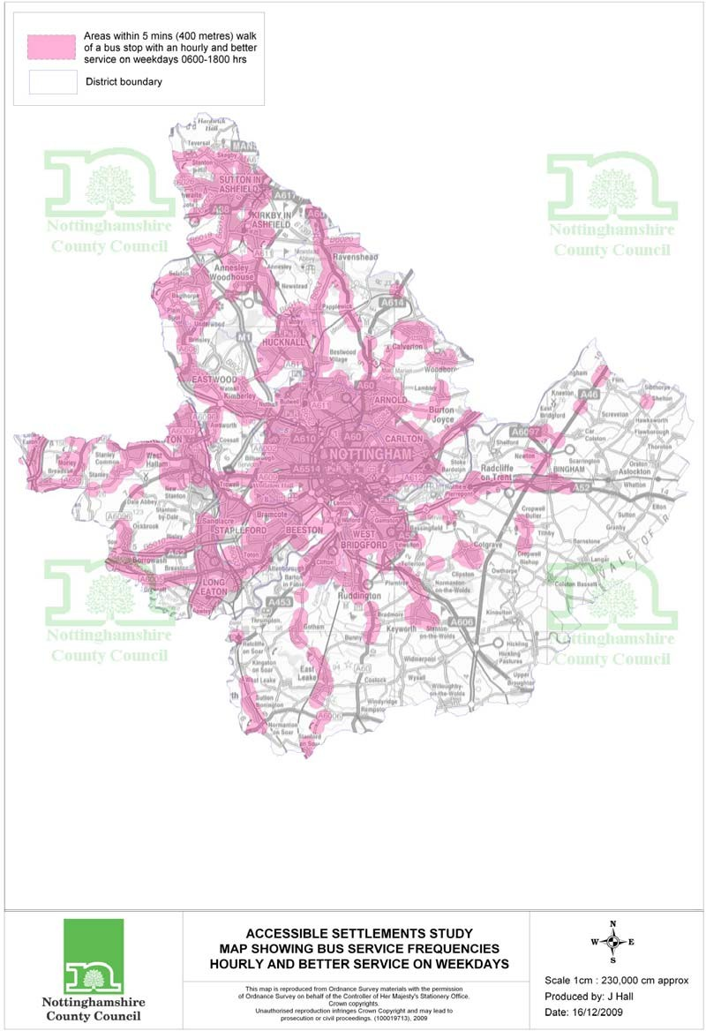

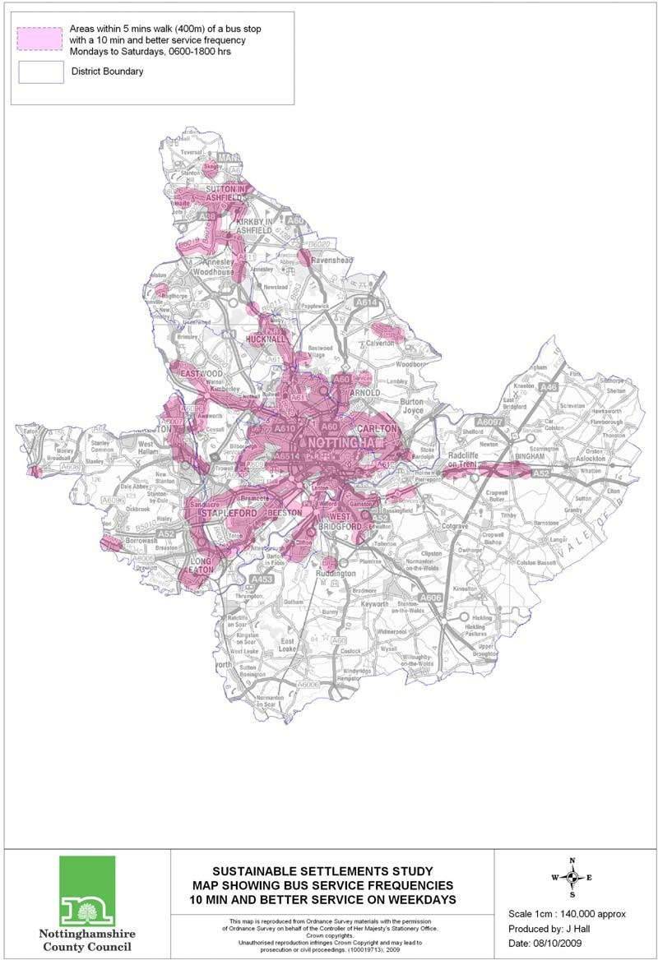

APPENDIX 6: Evidence base for justification of weightings and travel time thresholds given to facilities
This appendix is in two parts. The first part reviews evidence giving justification for the inclusion of certain service/facility types in the accessibility assessments and also justification for their relative importance and weighting in meeting the needs of the population. The second part reviews the evidence on typical travelling time thresholds to facilities.

Part 1: Background evidence on relationship between population size, provision of services, facilities, travel patterns and accessibility
Before discussing the findings of key sources of information which have been used to justify the weightings given to facilities, it is worthwhile considering the main relationships and linkages between population size, provision of services, facilities, travel patterns and accessibility.

Work carried out as part of the URBASSS project in the late-1990’s/ early 2000 (EPSRC Sustainable Cities Programme, Bartlett School of Planning at University College London and Gloucestershire County Council) aimed to investigate these interrelationships further. The results of the study would be used to inform future housing development strategies in Gloucestershire in terms of reducing the need to travel and increasing accessibility to services and facilities. The linkages and interrelationships involved are shown in figure A6.1 below, which appears on the URBASS page on the Bartlett Planning School website¹¹ and is noted in Banister and Williams (1998) ¹².

Figure A6.1
resident population size
density of development and settlement
provision of services and facilities
travel patterns, energy consumption and accessibility
Location of new housing development
To conclude this section, Banister and Williams note that ‘it is necessary to understand these linkages and the travel patterns which can be generated, so

¹¹ http://www.bartlett.ucl.ac.uk/URBASSS/URBASSSexecutivesum.htm
¹² Banister D and Williams J, ‘How big is sustainable? The interaction between settlement size and travel behaviour’. Paper presented at the ETC conference 1998. Available at: http://www.etcproceedings.org/paper/how-big-is-sustainable-the-interaction-between- settlement-size-and-travel-behav.pdf

that guidance can be provided on the scale and distribution of provision of services and facilities required for new and sustainable housing development. It is also necessary to assess the relative merits of different housing strategies in promoting the development of essential services and facilities in areas which are under supplied, or to allocate additional housing in areas which are under- supplied or to allocate additional housing in areas to support the existing supply of services and facilities’.

Table A6.1

 | Distance travelled | Modal split | Energy consumption | Accessibility
Location | Location of new housing development outside existing urban areas increases distances travelled  Location close to strategic transport networks increases travel  Free-standing development increases travel | Location close to transport networks influences modal split – rail or road | Location is an important determinant of energy consumption and car dependency | Development close to existing urban areas reduces self- containment and thus access to non- car households
Density of development | Total distance travelled varies with density – 20% variation in distance travelled results from changing densities | Car use in larger cities increases at a greater rate if densities are low  As densities increase modal split moves towards greater use of rail and bus  Relationship between density and car use is not linear but the relationship between density and public transport provision is linear | Increasing densities reduces energy consumption by transport  Density is the most important physical variable in  determining energy consumption
 |  | As density increases, average trip length, the use of the car and distance travelled reduces

Table A6.1 (cont.)

 |  | Distance travelled | Modal split | Energy consumption | Accessibility
Size | of | Total distance travelled increases | Use of non-car modes (public | The most energy- | Accessibility to
resident population |  | as settlement size decreases | transport, walk, cycle) increases with increase in settlement size | efficient settlement in terms of transport | services is generally better in large
 |  |  |  | is one which either has a resident | settlements
 |  |  |  | population size of
 |  |  |  | 25-100k or 250k
Provision of local services and facilities |  | Diversity of services and facilities in close proximity reduces distances travelled  People prepared to travel further for higher order services and facilities | Diversity of services and facilities in close proximity alters modal split  Local provision does not determine modal choice, personal and household characteristics are the  determinants | Energy consumption may reduce with local provision as trip length reduces and modal split may alter | Accessibility increases with local provision
 |  | Local provision reduces trip length and thus total distance travelled

Greater Nottingham Accessibility of Settlements Study January 2010 36

Provision and accessibility of services and facilities and thresholds
Williams and Banister (1997)¹³ note that the number of trips and distance travelled within a settlement can also be affected by the provision and accessibility of services and facilities. The basis argument here is that the settlement has to be of a sufficient size to offer the range of employment, service and leisure activities to residents. These must be in close proximity to each other to encourage the use of green modes and public transport, as car dependence increases with distance between services and facilities. In addition, diversity of services and facilities is essential to encourage self-sufficiency in a settlement and reduce travel between and within settlements.

As settlement size increases, a fuller range of services/facilities can be supported by the population and the level of settlement self-sufficiency rises. To achieve a ‘sustainable settlement’, the authors suggest that a hierarchy of functions is considered, based on two levels:

- Facilities provided locally which offer a sufficient diversity to meet daily needs in close proximity to where people live. This will reduce distances travelled and encourage a modal shift towards more sustainable modes of transport
- The next level occurs where the diversity of services/facilities increases and the distance people are prepared to travel to their destination also increases. It then becomes important that these higher order functions which are needed on a less frequent than daily basis are accessible by public transport.
The ideas discussed above are summarised in figure A6.2 below (from Williams and Banister (1997)

Figure A6.2
Thresholds
eg. walk < 2kms cycle <8 kms
bus 2-8 kms
Diversity increases = greater distances Less than daily use – frequency Higher order facilities – functions Public transport accessible - mode
Proximity increases = shorter distances
Daily activities = frequency Local facilities = functions
Settlement size

¹³ Williams J and Banister D (1997), ‘Land use options to reduce the need to travel’, EPSRC Sustainable Cities Programme Working Paper 3. Available at http://www.bartlett.ucl.ac.uk/URBASSS/WP3.pdf

In a consultancy study looking at Sustainable Neighbourhoods for the Manchester and Salford Housing Market Renewal Pathfinder¹⁴, the relationship between catchment area size and density of population was noted, with population density affecting the range of services that can be provided within walking distance. The study noted that the average density of population per hectare at a town or city level from the 2001 census is generally below what is required to support the provision of even basic services (primary school, post office) within acceptable walking distance. The main point to note here is that services can be provided at lower population density across a wider area if car travel or travel by public transport can be assumed. Therefore poorer communities which cannot afford significant transport costs will need to live in an urban environment with higher residential densities than more affluent groups.

Study ‘Defining fair access to rural service provision in the North West - a study of rural service standards’

The concepts put forward above about a hierarchy of accessibility needs are validated by the results of the consultancy study carried out by Rural Innovation and Community Futures consultancy for Lancashire County Council to define ‘fair access’ to services in the rural north west¹⁵. A survey was carried out amongst rural residents of Lancashire to ascertain where rural residents believe that services should be made available and thus determining their expectations and aspirations for accessibility. Table A6.3 below lists the results of the survey, the customer hierarchy of local service accessibility. The percentage figures show the percentage of respondents that placed the service in the category.

Table A6.3

‘Local – on demand’ Home/within 10 minutes  walk | ‘Service centre’  Within 30 minutes travel | ‘Distant’  Within 60 minutes travel
Primary School (86%) | Further Education (72%) | Higher Education (45%)
Nursery/Childcare (81%) | Hospital (71%)
Post Office (76%) | Employment Services (71%)
GP/Health Centre (74%) | Training (60%)
Food Shop (74%) | Secondary School (60%)
Cash (71%) | Library (53%)
Community Hall (67%) | Dentist (51%)
Pub (65%)
District Nurse (62%)
Pharmacy (60%)
Bank/Building Society (60%)

The study considered that access to a service can be said to be ‘fair’ when the service is provided either within 10 mins walking distance (for those services agreed with the community that should be available locally) or within 30 mins

¹⁴ ‘Sustainable Neighbourhoods – urban form analysis for Manchester and Salford Housing Market Renewal Pathfinder’ (2005), published by consultants ECOTEC, Llewellyn-Davies and Manchester Geomatics. Available at http://www.ManchesterSalfordhrm.co.uk
¹⁵ ‘Fair access to rural services in the North West – a study on rural service standards’ (2005), available at http://www.lancashire.gov.uk/environment/ruralpathfinder/documents

journey time by useable public transport (for those services agreed with the community should be available in larger service centres.

Rural White Paper 2000
The ‘Rural White Paper 2000’¹⁶ published by Defra, and Natural England’s study ‘Rural services 2000’ suggest that settlements with a resident population of over 1,000 have, or potentially have, greater capacity (than smaller settlements) to accommodate further growth.

The White Paper assessed trends of services and facilities provision in rural areas of the UK. The data indicates that the majority of rural settlements contain a number of ‘core’ local services such as a shop, public transport or a school, with larger settlements being more likely to have these ‘core’ set of local services than the smaller ones. While settlements with around 400 residents have only a 15 per cent likelihood of having this core set of services, those with around 1,000 residents have a 65 per cent likelihood.
The White Paper specifically highlights the essential services that are vital to a rural community. These include: a convenience facility; an education facility; a health facility; a community facility; and a public transport facility.

South Bucks District Council – Accessibility & Infrastructure Study (2006)
This study was carried out by Halcrow Consultants to inform the preparation of the South Bucks Core Strategy¹⁷. The aims of the study were to:

- Examine the level of existing infrastructure services and facilities (including social infrastructure such as schools, doctors, shops and leisure facilities, public transport);
- And to identify areas where a range of infrastructure services and facilities are easily accessible, and areas that are poorly served by such facilities and services.
Data was collected on a wide range of existing community infrastructure facilities and services within South Bucks District. This included education, libraries, public transport, health, community facilities (including open space and village halls), basic shops and local employment areas. In addition, weightings were given to facilities and main categories of facilities. Additional ‘weight’ was given to those facilities and services considered by Officers of the Council and the Consultants to be the most important. For example, primary schools and GP surgeries were considered to be more important than recycling facilities and opticians. In deciding these weightings, account was taken of the indicators included in the English Indices of Deprivation 2004 (geographical barriers sub-domain, ODPM). The indicators measured by the ID 2004 and ID 2007 were weighted road distances to primary schools, GP surgeries, post offices and local food stores. Table A6.4 below shows the infrastructure types and weightings used in the study.
Table A6.4

¹⁶ Available at: http://www.defra.gov.uk/rural/documents/policy/ruralwp/rural.pdf
¹⁷ Available at http://www.Southbucks.gov.uk/environment_planning/planning/local_development_framework
/background studies

Main categories & weightings | Sub-categories to include | Weighting  within each category
Education  25% | - Nurseries  - Primary Schools  - Secondary Schools  - FE Colleges | 15%  40%  30%  15%
Community Facilities 10% | - Libraries  - Community Centres/Village Halls  - Indoor recreational facilities  - Outdoor recreational facilities  - Recycling facilities | 25%  30%  20%  15%  10%
Health  25% | - Hospitals (with A&E)  - GP Surgeries/Health Centres  - Dentists  - Opticians | 25%  50%  15%  10%
Shops 25% | - Supermarkets  - Local Convenience stores/Newsagent  - Pharmacies  - Post Offices  - Banks/Building Societies/ATMs | 30%  20%  10%  30%  10%

Part 2: Background evidence on typical travelling times to key facilities, difficulties in accessing key services, modes of travel used, and recommended and acceptable travel time thresholds

Department for Transport (DfT) National Travel Survey: shortest journey time to local facilities on foot or by public transport in 2007

Table A6.5 below gives results from the National Travel Survey in 2007 on percentages of households within defined travel time thresholds of key facilities.

Table A6.5

Percentage of households | Shortest journey time on foot or by public transport (2007)*
Facility | 15 mins  or less (%) | 15-30  mins (%) | greater than  30 mins (%) | Total
Shop selling groceries | 93 | 5 | 2 | 100
Shopping centre | 54 | 34 | 12 | 100
Post Office (2006 only)* | 87 | 11 | 2 | 100
GP Surgery | 79 | 16 | 5 | 100
Hospital | 22 | 37 | 41 | 100
Chemist (2006 only)* | 83 | 13 | 4 | 100
Primary School | 90 | 9 | 1 | 100
Secondary School | 61 | 32 | 7 | 100
College | 49 | 36 | 15 | 100
*Note: 2006 data only.

Department for Transport (DfT) Personal travel factsheets¹⁸

These factsheets summarises findings from the National Travel Survey (NTS) relating to personal travel for travel to school, travel to work, and shopping. The results cover trips within Great Britain by household residents and are based on data for 2006. Details related to each journey purpose are given below.

Travel to school

- For primary pupils, the average time taken to travel to school in 2006 was
12.6 mins. The equivalent figure for Secondary school pupils was 24.4 minutes.
- The average primary school pupil travelled 1.5 miles to get to school in 2006, and for secondary pupils the average journey time to school was 3.4 miles.
- For trips of less than one mile, 81% of primary pupils walked to school. Travel by car was the most commonly used mode of transport to school for children aged 5 to 10 years for all trips over 1 mile.
- Secondary pupils travelled to school on foot for 92% of trips of less than one mile and 61% of trips between 1 and 2 miles. For longer journeys, car and bus were the most popular modes.
Travel to work
- The average length of a commuting trip in 2005 was 8.7 miles. Travel to/from work accounted for 15% of all trips.

¹⁸ http://www.dft.gov.uk/pgr/statistics/datatablespublications/personal/factsheets

- The average journey to work takes 27 minutes. Commuting trips by car take 24 minutes, by bus 40 minutes, by rail 66 minutes and on foot 17 minutes.
- Usual method of travel to work is 71% by car, 11% walk, 8% go by bus/coach, 6% by rail, and 3% by bicycle.
- People from households in the highest income quintile travel more than twice as far to work on average (12.3 miles) as those in the lowest income quintile (5.8 miles).
Shopping trips
- Shopping trips accounted for a fifth (20%) of all trips by household residents in Great Britain in 2005. The average length of a shopping trip was 4.3 miles.
- Approximately half of all shopping trips were for food shopping (105 trips per person per year), and the remainder are for non-food shopping.
- Food shopping trips tend to be shorter than non-food shopping with an average trip length of 3.1 miles compared with 5.4 miles respectively.
- The car is the main mode of travel for nearly two thirds (63%) of all shopping trips, with 42% made as a car driver and 21% as a car passenger. A quarter are made on foot and most of the remainder (8%) are made by bus.
East Midlands Personal Travel Survey 2005: Nottinghamshire and Nottinghamshire Joint LTP area¹⁹

This survey was undertaken with a stratified sample of households based on car ownership levels. The primary objective of the work was to provide a snapshot of personal travel to assist in the implementation of the second Local Transport Plan in 2005/06. 1205 personal interviews were conducted in Nottingham City UA and 810 were conducted in the county areas of Gedling, Broxtowe, Ashfield (Hucknall) and Rushcliffe (West Bridgford). The main points of the survey relating to each trip purpose are given below.
Education trips

- For education trips, 40 % of respondents walked, 11% travelled by bus, and 41% travelled by car.
- The mean trip time duration by mode in minutes was: walk (14.6 mins), cycle (12.9 mins), bus (23.8 mins), car driver (20.9 mins).
- For mean trip distance by mode in kilometres (for all journey purposes), journeys on foot were 0.8kms, journeys by cycle 2.1 kms, journeys by bus
5.3 kms, and journeys by car as a car driver 8.8 km.

Work trips

- Trips to/from work account for 24% of all trips made by respondents. The main mode of travel to/from work was car driver (63% of respondents), followed by walking (13.2% of respondents), and bus (13.1% of respondents).
- The average journey distance in miles for trips to and from work was 9.4 miles. Similarly, the average journey time duration for trips to and from work was 25.3 minutes.

¹⁹ East Midlands Personal Travel Survey 2005: Nottinghamshire and Nottinghamshire Joint LTP area’. A study by TTR Consultants for Nottinghamshire, Derbyshire and Leicestershire County Councils, Nottingham UA, Derby UA and Leicester UA.

Shopping trips

- 27.4% of all trips made by respondents were for shopping purposes. The main mode of travel to/from shopping was car driver (39.2% of respondents).
AUNT-SUE consortium – postal consultation survey on peoples’ attitudes towards accessibility and travelling to key facilities²⁰

As part of a wider research project to derive suitable travel time thresholds to facilities to input into accessibility planning and modelling processes, the AUNT- SUE consortium (Accessibility and User Needs in Transport for Sustainable Urban Environments) conducted a postal questionnaire amongst residents in Hertfordshire. The survey sought to establish the current journey times travelled by respondents to the following destinations: work, regular food shopping (either at a small shop or at a supermarket), and a GP surgery/health centres. A supplementary question then asked as to what respondents thought was a reasonable amount of time to access these facilities. 1355 questionnaires were returned, giving a response rate of 58%. The main results are given in the table below.

Table A6.6

Average time (mins) | Actual time | What respondents thought was a  ‘reasonable time’
Work | 30 | 29
Food Shops | 12 | 12
GP Surgery | 9 | 10
Paper produced by D. Ruston ‘Difficulty in accessing key services’ ²¹

This paper reports on the results of surveys undertaken in January and March 2001 and 2001 as part of the overall National Statistics Omnibus Survey to examine the difficulty experienced by adults when accessing a range of services. The analysis of the results looked at actual difficulty (as measured by journey time) and mode of transport used in accessing services. The services examined were access to a Hospital, GP surgery, Chemist, Post Office and main food shop. Table A6.7 below shows the usual time taken to travel to services, and table A6.8 breaks the above results down by settlement size, whereby smaller settlements (called ‘rural’ in the paper) are defined as having fewer than 3,000 residents.
Table A6.7

Household Percentages (%) | Less than 10 mins | 11-20  mins | Greater than 20 mins | Totals
GP surgery | 74 | 20 | 6 | 100
Post Office | 87 | 11 | 2 | 100
Main food shopping | 56 | 32 | 12 | 100
Local Hospital | 24 | 33 | 43 | 100
Chemist | 82 | 15 | 4 | 100

²⁰ Mackett R, Titheridge H, Solomon J, ‘Benchmarking accessibility’, presentation given to the AUNT-SUE symposium November 2006. Available at http://www.Aunt- Sue.info/references.html
²¹ http://www.statistics.gov.uk/accesstoservices

Table A6.8

Household  Percentages (%) |  | 10 minutes or less | 11 minutes or more | Totals
Smaller | GP surgery | 67 | 33 | 100
 | Post Office | 86 | 14 | 100
 | Main food shopping | 45 | 55 | 100
 | Local Hospital | 18 | 82 | 100
 | Chemist | 71 | 29 | 100
Larger | GP surgery | 76 | 24 | 100
 | Post Office | 87 | 13 | 100
 | Main food shopping | 59 | 41 | 100
 | Local Hospital | 26 | 74 | 100
 | Chemist | 85 | 15 | 100

Table A6.9 shows the usual mode of transport to services, by settlement size. Table A6.9
Household  Percentages (%) |  | Foot | Car | Public transport | Other | Totals
Smaller | GP surgery | 17 | 77 | 4 | 3 | 100
 | Post Office | 43 | 53 | 1 | 3 | 100
 | Main food shopping | 4 | 91 | 4 | 1 | 100
 | Local Hospital | 1 | 91 | 6 | 2 | 100
 | Chemist | 21 | 72 | 4 | 3 | 100
Larger | GP surgery | 38 | 51 | 9 | 3 | 100
 | Post Office | 62 | 33 | 3 | 2 | 100
 | Main food shopping | 15 | 74 | 9 | 2 | 100
 | Local Hospital | 7 | 72 | 17 | 4 | 100
 | Chemist | 52 | 40 | 4 | 4 | 100

Department for Transport (DfT) Core National Accessibility Indicators²²

The report ‘Making the connections’ published by the Government’s Social Exclusion Unit in February 2003 recommended that accessibility planning be built into the Local Transport Plan process undertaken by Local Transport Authorities in England. In order to monitor progress on accessibility planning in England and to provide Local Authorities with a dataset which they can use to undertake strategic accessibility assessments within their area, the Department for Transport (DfT) identified a set of indicators to characterise the transport geography of England, paying particular attention to social groups at risk of exclusion. The specification of the core national accessibility indicators is set out in the guidance on accessibility planning in Local Transport Plans (DfT, 2004). The indicators are:

- % of a) pupils of compulsory school age; b) pupils of compulsory school age in receipt of free school meals within 15 and 30 minutes travel time of a primary school by public transport/walking;
- % of a)pupils of compulsory school age; b) pupils of compulsory school age in receipt of free school meals within 20 and 40 minutes travel time of a secondary school by public transport/walking and cycling;

²² http://www.dft.gov.uk/pgr/statistics/datatablespublications/ltp/coreaccessindicators2008

- % of 16-19 year olds within 30 and 60 minutes of a further education establishment by public transport/walking and cycling;
- % of a) people of working age (16-74); b) people in receipt of Jobseekers’ Allowance within 20 and 40 minutes travel time of a major work destination by public transport/walking and cycling.
- % of a) all households; b) all households with no car within 15 and 30 minutes travel time of a Supermarket/convenience store by public transport/walking and cycling;
- % of a) all households; b) all households with no car within 15 and 30 minutes travel time of a GP Surgery/Health Centre by public transport/walking;
- % of a) all households; b) all households with no car within 30 and 60 minutes travel time of a Hospital by public transport/walking;
Study ‘Developing a physical accessibility standard for healthy food in the West Midlands²³

This study was commissioned by the Government Office for the West Midlands (GO-WM) and undertaken by JMP Consultants Ltd. The results were disseminated to interested parties at a seminar in September 2009.
The Government Office for the West Midlands commissioned the development of a physical accessibility standard for healthy food for the West Midlands region. Primarily the standard was developed for use within the next phase of local transport plans to firmly anchor principles of healthy lifestyles within accessibility planning. However the final report notes that ‘this research has policy implications for spatial planning, transport and public health to promote a shift in thinking about the future of ‘healthy’ transport and food’.
The standard was developed based on a review of existing policy and research (including a review of tools and methods for measuring accessibility), market research with the general public, targeted focus groups with people from key access-impaired groups, stakeholder interviews and a review of available data sources. Accessibility mapping was undertaken to create example baseline measurements. Whilst developing the standard, one of the conclusions drawn about how it should be developed included the consideration of access by walking, cycling or public transport in the accessibility modelling process, with the recognition that this would link to wider physical activity and sustainable travel agendas.

The standard agreed for the region is ‘percentage of households within 20 minutes, by walking, cycling or using public transport, of a place where fruit and vegetables are sold’.

²³ http://wwww.foodwm.org.uk/panlist.aspx?id=food_health_wm_food_access

Appendix 7: Discussion of factors which may influence the results produced by the accessibility modelling process

Introduction
- Accession (the accessibility modelling software used in this study) principally calculates the journey times by selected mode between a set of origins using a public transport network or a digitised road network.
- The total travel time by public transport includes the time taken to walk from the initial origin point to a bus stop or train station, the time in waiting to connect to a service, the time spent on the actual journey, any time spent interchanging between services or between different modes of transport, and the time taken to walk from the final alighting point (bus/rail station) to the destination point.
- The standard Accession calculation calculates for each origin/destination pair the fastest travel time that can be achieved, sampled at a specified time interval in the time period specified. The fastest travel time that can be achieved between each origin/destination pair from all these samples over the total time period is output and then used in the accessibility assessments.
- If the fastest travel time between origins and destinations is that which can be achieved entirely by walking given the stated walking speeds and not by public transport, then this walking time is output and included in the assessments.
Parameters input into the model which can affect final results
- Connection distances from origin points to joining points on the public transport network

  - The choice of maximum connection distance/maximum walking distance from origin points to joining points (bus stops/tram stops/rail stations) on the public transport network and for alighting points for access to the final destination is important. If a connection distance to public transport is outside of the parameters set (400 metres for this study), a ‘not accessible’ value is returned, and is given a zero public transport score. (NB If the origin and destination points are within the threshold by walking, even if not by public transport, that connection will still be given an appropriate walking time score.)
  - The choice of maximum connection distance/walking distance has a bearing on the availability and choice of public transport services from an origin point. For instance, a person may be prepared to walk further than the maximum connecting distance specified to another bus stop in order to access a faster bus service, or to a nearby railway station with a faster service but at a lower service frequency. Using this faster service may result in a reduced total travel time and this may bring the total travel time within the specified threshold. If this is so, the origin point would be scored appropriately and could therefore, lead to an increase in accessibility.
- Choice of time period to assess accessibility and service frequency
  - If a journey cannot be made completely within the specified time period (for this study assumed to be 0700-0900 hrs on Mondays), again a ‘not accessible’ value is returned. A journey will be scored accessible providing it begins and ends within that period.

  - The calculation of fastest overall journey time itself does not take into account service frequency. A route served by 4 services an hour is effectively treated the same as a route served by one service an hour as long as the service allows the opportunity for the journey to be completed entirely within the defined time period. This is demonstrated in the two examples given below.
  - In order to meet a 09:00 am arrival at a destination, a person using an infrequent bus service with one departure between 0700-0900 am at 07:30am and a total travelling time of 20 minutes would mean the person arriving at their final destination with 1 hr 10 minutes waiting time.
  - For a journey with the same travel time using a bus service every 10 minutes, the latest time the person could leave in order to guarantee a 09:00am arrival would be 08:40am.
  - Assuming the total journey time is sampled every 10 minutes during the specified time period, Accession would in both cases assign a value of 20 minutes to be the fastest journey time that can be achieved. Given that the calculated journey times for each option are equal, the question of whether the journey times for the first option could be achieved throughout the day on a regular basis would need to be asked to establish which option offers the greater levels of accessibility.

- ‘Whole day’ accessibility and service frequency
  - The public transport network used in this study to assess accessibility is based on a snapshot of the whole public transport network for the area, and contains all scheduled local bus, tram and heavy rail services operating between 0700-0900 hrs on a Monday. Only the travel times of journeys from origin points to destination points are calculated. It is realised that these assumptions used in the model may not provide a complete picture of accessibility available from each origin point throughout the day. However the enclosed map (Appendix 5) shows that the majority of origin points within the settlements are within 400 metres of a bus stop which offers an hourly and better service frequency for services operating Mondays to Saturdays between 0600-1800 hrs.
  - Given this relatively good frequency of bus services in the area throughout the day contributing to a good overall public transport network, it can be postulated that the total travel time between each origin/destination pair using this public transport network would not vary significantly throughout the day. Exceptions might in the case of deep rural areas where service frequency may be poor or where there may not be a service that exists later in the day to enable a return journey to be made.

Appendix 8 - Glossary

NB If a term cannot be found in this glossary, a helpful resource on-line is the Royal Town planning Institute’s Planning ‘Jargon Buster’: http://www.rtpi.org.uk/download/7371/TownPlanningBooklet-Glossary.pdf
Accessibility – A term to indicate the ease of getting between two places, usually in terms of time; for example a home and workplace. In this study accessibility by sustainable means (walking, cycling and public transport) is being assessed. For a more detailed explanation see Appendix 6.

Accessibility Planning, Accessibility Strategy, Accessibility Standard -
Accession accessibility software – Software produced by DfT to assist the measurement of accessibility

Core Strategy - The key Development Plan Document, setting out the long term spatial vision for the area, the spatial objectives and strategic policies to deliver that vision. As such, it implements the spatial aspects of the Sustainable Community Strategy.
Department for Communities and Local Government (CLG) - The Government Department responsible for planning and local government.

Department for Transport (DfT) - The Government Department responsible for transport, highways and public transport and addressing public attitudes to travel.
Development Plan - An authority’s development plan consists of the relevant Regional Spatial Strategy and the Development Plan Documents contained within its Local Development Framework.

East Midlands Regional Plan - See Regional Spatial Strategy.

Greater Nottingham - Area covered by the aligned Core Strategies. Includes the whole council areas of Broxtowe, Erewash, Gedling, Nottingham City and Rushcliffe, together with the Hucknall part of Ashfield. The partnership also includes both Derbyshire and Nottinghamshire County Councils.

Hierarchy, Settlement hierarchy – A classification, in this case of settlements, to establish their importance against each other when applying planning policies.

Infrastructure – this is a term used for all those facilities that support the population and its activities, including the ecology of an area. It may include education, health, leisure and open space provision, emergency services, social services, community, transport and power facilities, telecommunication and water utilities. The distribution networks for these facilities and services are included. In addition Green infrastructure (see above) is included – such as accounting for flood risk, environmental quality and access to recreational open space.

Indices of Deprivation (ID 2007, CLG) - The Index of Multiple Deprivation combines a number of indicators, chosen to cover a range of economic, social and housing issues, into a single deprivation score for each small area in England. The Indices are used widely to analyse patterns of deprivation.

Local Area Agreements (LAA) - Agreement setting out the priorities for a local area agreed between central government and a local area (the local authority and Local Strategic Partnership) and other key partners at the local level.

Local Development Document (LDD) - A Document that forms part of the Local Development Framework and can be either a Development Plan Document or a Supplementary Planning Document. LDDs collectively deliver the spatial planning strategy for the local planning authority's area.

Local Development Scheme - Sets out the programme for preparing Development Plan Documents.

Local Development Framework (LDF) - A portfolio of Local Development Documents which set out the spatial strategy for the development of the local authority area.

Local Transport Plan -

Location – See Settlement
National Indicators for Local Authorities – Indicators used to show the means of delivering towards the Local Area Agreement.
Open Space - Any unbuilt land within the boundary of a village, town or city which provides, or has the potential to provide, environmental, social and/or economic benefits to communities, whether direct or indirect.

Principal Urban Area (PUA) - The contiguous built up area of Nottingham. It includes West Bridgford, Clifton, Beeston, Stapleford, Long Eaton, Bulwell, Arnold and Carlton.
PPS / Planning Policy Statement - Published by the Department for Communities and Local Government to provide concise and practical guidance. These are produced for a variety of specific topics and can be found at www.communities.gov.uk.

Regional Plan, Regional Spatial Strategy (RSS) - Strategic planning guidance for the Region that Development Plan Documents have to be in general conformity with. The East Midlands Regional Plan (RSS) was issued in March 2009, and is undergoing a Partial Review.
Rural Area - The use of this term can vary depending on the context. When used generally it refers to areas including smaller settlements which are beyond the towns and cities (as in para. 1.3). Elsewhere it can mean more specifically the areas of Greater Nottingham that are not built up (as in para. 4.4), usually identified as Green Belt and/or Countryside. No definition of rural or rural area is used here.

Settlement – In this study areas defined for analysis are called locations. Within the PUA these have been broken down into areas smaller than Nottingham as a whole. Outside the built-up areas the term settlement has been used, this corresponds to a town or village. Ilkeston and Hucknall are included as settlements as well as being called Sub-regional Centres. (See para. 4.2)

Spatial Planning / Spatial development strategy - Spatial planning goes beyond traditional land use planning to bring together and integrate policies for the development and use of land with other policies and programmes which

influence the nature of places and how they function. This will include policies which can impact on land use by influencing the demands on, or needs for, development, but which are not capable of being delivered solely or mainly through the granting or refusal of planning permission and which may be implemented by other means.

Sub-Regional Centres - Towns which are large enough to contain a critical mass of services and employment, which for Greater Nottingham the Regional Spatial Strategy defines as Hucknall and Ilkeston.

Sustainable Communities, Sustainable settlement – Communities and settlements laid out and planned according to sustainable development principles.
Sustainable Development - A guiding principle for all activities in their relationship with the environment. One of the most popular definitions is that “sustainable development meets the needs of the present without compromising the ability of future generations to meet their own needs”. (Source: DCLG)

Travel time threshold -

Weighting – A means of reflecting in a scoring system the relative importance of different factors – see main report Section 6.

