Analysis of Constraints

for the District of Ashfield

August 2023

THIS PAGE IS INTENTIONALLY BLANK
Contents
Section |  | Page
1 | Object and Aims of the Analysis | 1
2 | Green Belt and Countryside | 3
3 | Nature Conservation | 6
4 | Heritage Assets | 11
5 | Flood Risk | 14
6 | Landscape Character | 16
7 | Agricultural Land | 17
8 | Conclusion | 20
ALPR | Ashfield Local Plan Review 2002.
JUS-T | Jacksdale, Underwood and Selston - Tomorrow
LNR | Local Nature Reserve
LWS | Local Wildlife Site
NPPF | National Planning Policy Framework.
PPG | Planning Practice Guidance
ppSPA | Possible Potential Special Protection Area
SSSI | Site of Special Scientific Interest
TSSNP | Teversal, Stanton Hill & Skegby Neighbourhood Plan

- Object and Aims of the Analysis

- The Analysis has been undertaken to form part of the evidence base for the emerging Local Plan to determine the level of development that can be sustainably accommodated within the District.

- The National Planning Policy Framework, 2021 (NPPF) sets out that the purpose of the planning system is to contribute towards the achievement of sustainable development. Achieving sustainable development means that the planning system has there overarching objectives, which are independent and need to be pursed in mutually supporting ways. These objectives are

- an economic objective – to help build a strong, responsive and competitive economy, by ensuring that sufficient land of the right types is available in the right places and at the right time to support growth, innovation and improved productivity; and by identifying and coordinating the provision of infrastructure.

- a social objective – to support strong, vibrant and healthy communities, by ensuring that a sufficient number and range of homes can be provided to meet the needs of present and future generations; and by fostering well-designed beautiful and safe places, with accessible services and open spaces that reflect current and future needs and support communities’ health, social and cultural well-being; and

- an environmental objective – to protect and enhance our natural, built and historic environment; including making effective use of land, improving biodiversity, using natural resources prudently, minimising waste and pollution, and mitigating and adapting to climate change, including moving to a low carbon economy.

- In bringing forward the Local Plan one of the key aspects for the Council and its residential and business communities is how much growth and development can be delivered within the District whilst, balancing the economic; social; and environmental objectives.

- The NPPF in paragraph 11 identifies that Plans and decisions should apply a presumption in favour of sustainable development. For plan-making this means that:

- all plans should promote a sustainable pattern of development that seeks to: meet the development needs of their area; align growth and infrastructure; improve the environment; mitigate climate change (including by making effective use of land in urban areas) and adapt to its effects;

- strategic policies should, as a minimum, provide for objectively assessed needs for housing and other uses, as well as any needs that cannot be met within neighbouring areas, unless:

- the application of policies in this Framework that protect areas or assets of particular importance provides a strong reason for restricting the overall scale, type or distribution of development in the plan area; or

- any adverse impacts of doing so would significantly and demonstrably outweigh the benefits, when assessed against the policies in this Framework taken as a whole.

- In this context, the Analysis considers whether there are constraints that restrict the overall scale type or distribution with the development plan. It aims to provide an assessment of the constraints in the District of Ashfield, necessary to understand the capacity of the District to accommodate development. It considers strategic level constraints that could impact on the ability for the Council to meet future development requirement as set out in the National Planning Policy Framework, 2021 and Planning Practice Guidance.

- The Analysis addresses several different themes within Ashfield providing an analysis of the national and local constraints. These are set out in the sections on:

- Green Belt and Countryside
- Nature Conservation
- Designated Heritage Assets
- Flooding
- Landscape Character
- Agricultural Land Quality
- It is anticipated that using the information gathered through this study that it will be possible to identify land that has no potential for development and those that may have potential subject to further assessment and consideration of other evidence documents. At this stage, this assessment focuses on constraints relating to land designations. Matters relating to infrastructure delivery and economic viability that could constrain the delivery of new development are not considered within the focus of this analysis.

- Green Belt and Countryside

Green Belt

  - A substantial part of the District is designated as part of the Nottingham and Derby Green Belt (Figure 1) and equates to approximately 41% of Ashfield. This includes land around Hucknall, land to the south and east of Kirkby-in-Ashfield and land surrounding the rural villages of Selston, Jacksdale, Underwood and part of Brinsley. The village of Bagthorpe is ‘washed over’ by the Green Belt.

  - The Green Belt is a policy rather than an environmental designation introduced as a tool to restrict urban growth and the designation is given to some areas of land within the district with the primary aim of preventing urban sprawl and to maintain gaps between built up areas.

  - Government policy attaches great importance to the Green Belt. Paragraph 137 of the NPPF states that the ‘fundamental aim of Green Belt policy is to prevent urban sprawl by keeping land permanently open; the essential characteristics of Green Belts are their openness and their permanence’. As part of the aim of Green Belt is preventing the coalesce of urban land there are five specific purposes as to what Green Belt is for as set out in paragraph 138 of the NPPF:

(a)to check the unrestricted sprawl of large built-up areas;
(b)to prevent neighbouring towns merging into one another;
(c)to assist in safeguarding the countryside from encroachment;
(d)to preserve the setting and special character of historic towns; and
(e)to assist in urban regeneration, by encouraging the recycling of derelict and other urban land.

  - Green Belt boundaries should only be altered where exceptional circumstances can be fully evidenced and justified through preparation or updating of a Local Plan. Therefore, it falls to Ashfield District Council to demonstrate that all other reasonable options have been explored before seeking to justify a change in Green Belt boundaries.

  - An analysis of areas within the District that continue to serve Green Belt purposes identified in national policy is set out within the Ashfield Strategic Green Belt Review (2016). This was further updated within the Green Belt Boundary Review Technical Paper (2021), which identifies anomalies within Green Belt boundaries and to assess whether there has been any change that constitutes exceptional circumstances. The evidence base also includes the Green Belt Harm Assessment (2020) which provides a detailed study of harm arising to the Green Belt purposes from through the release of designated land. The overall approach to how ADC has sought to meet future development needs whilst minimising the loss of Green Belt land is set out in the Spatial Strategy Background Paper.

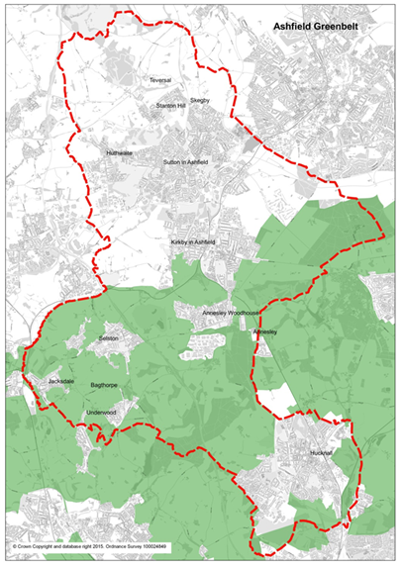
Figure 1: Extent of Green Belt within Ashfield & surrounding districts
Source: Ashfield District Council

Countryside

  - Countryside not designated as Green Belt is predominantly located in the north and is located within a rural context characterised by open landscapes lying outside of the urban areas and smaller settlements, as set out in policy EV2 of the emerging Local Plan.

  - There is little scope to focus any development in the countryside areas north of Stanton Hill, which includes areas surrounding the smaller settlements of Fackley and Teversal, including a number of isolated dwellings north towards Stanley and to the west on Wild Hill towards Tibshelf, which is located in the neighbouring county of Derbyshire. These areas have no access to local shops, schooling or health facilities within walking distance and as such are dependent on visits to areas to the south of the district or further afield for everyday services. The transport network is similarly constrained with most roads being rural lanes unsuitable for heavy or frequent vehicle usage. Public transport is similarly constrained with no railway stations and a limited bus service which does not reach further north than Fackley.

  - A high proportion of these countryside areas are also affected by other constraints outlined elsewhere within this analysis. This includes substantial areas of nature conservation value located across the district and heritage value, which includes areas of Stanley affected by the setting of Grade I Hardwick Hall to the north.

  - Where countryside has been allocated for future development within the emerging Local Plan the strategy has been to concentrate this close to urban areas which have good access to existing services and infrastructure. This would create the most sustainable developments whilst preserving the intrinsic beauty and character of the countryside and its wider benefits in accordance with paragraph of 174b of the NPPF.

- Nature Conservation

SSSI’s, Irreplaceable Habitats and European Sites

  - This section provides an analysis of land within the District designated for its nature conservation importance which acts as a strategic constraint on development. This includes relevant constraints identified in both national policy (figure 2) and locally designated sites (figure 3).

  - Ashfield is recognised as one of the most biodiverse areas in Nottinghamshire, due largely to its varied geological context of magnesian limestone, triassic sandstone (to the east) and coal measures (to the west). The District supports a broad range of habitats, including heathland, ancient woodland dumbles, calcareous grasslands (often on post-industrial sites) and fields rich in wild flowers. The east is characterised by small fields and streams, while the west and south contains large blocks of tree planting. The rivers and streams within the District provide habitat for significant populations of water vole and native crayfish.

  - Ashfield has nine Sites of Special Scientific Interest (SSSI), representing some of the County’s richest habitats, which are individually identified in table 1 below. Paragraph 11 of the NPPF specifically identifies SSSIs as one of the specific designations which indicate that development should be restricted.

Ashfield - SSSI | Area (ha) | Interest
Annesley Woodhouse Quarries | 34.60 | Biological
Bagthorpe Meadows | 6.31 | Biological
Bogs Farm Quarry | 4.90 | Biological
Bulwell Wood, Hucknall | 16.87 | Biological
Dovedale Wood | 13.43 | Biological
Friezeland Grassland | 3.68 | Biological
Kirkby Grives | 22.02 | Biological
Teversal Pastures | 17.92 | Biological
Teversal – Pleasley Railway | 5.012 | Biological
Total | 124.73

Table 1: Sites of Special Scientific Interest in Ashfield District Council
Source: Natural England

  - Irreplaceable habitats are also identified within NPPF paragraph 11 as a factor which provides a strong reason for restricting the overall scale, type or distribution within the plan area. Ancient woodlands are classified as irreplaceable habitats in paragraph 180 of the NPPF and are applicable to Ashfield. Ancient woodlands as identified by Natural England that are located within the area of Ashfield District Council are set out in table 2 below. High Park Wood crosses the boundaries of Ashfield and Broxtowe District Councils and covers a total area of approximately 156ha.There are also 3 ancient woodlands; Starth Wood, Elhole Wood and Watnall Coppice that are just outside the district, on the western boundary close to the urban edge of Hucknall.

Ashfield – Ancient Woodland | Area ha
Annesley Park Oak Plantation, Annesley | 1.42
Bloomer Wood, Kirkby-in-Ashfield | 1.09
Bulwell Wood, Hucknall | 15.35
Dawgates Wood 1, Skegby | 3.06
Dovedale Wood, Stanley | 12.14
Healds Wood, Stanton Hill/Skegby | 1.81
High Park Wood, Underwood | 64
Kennel Wood, Annesley | 1.05
Kirkby Cliff Farm, Pinxton | 0.22
Little Oak Plantation, Annesley | 8.64
Maghole Brook, Pinxton | 0.34
Millington Springs, Underwood | 20.34
Norwood, Teversal | 29.64
Normanshill/Thieves Wood, Sutton in Ashfield | 13.34
Park Springs, Annesley | 1.9
The Dumbles, Annesley | 27.67
Total | 202.01

Table 2: Ancient Woodlands in Ashfield District Council
Source: Natural England

  - The Sherwood Forest area is considered as a possible potential Special Protection Area (ppSPA), which is a site of European importance. Natural England has confirmed that Sherwood Forest satisfies Stage 1 of the RSPA Selection Guidelines for breeding nightjar and woodlark. Natural England therefore advocates that further consideration of Sherwood Forest against Stage 2 of the SPA Selection Guidelines at the appropriate stage during the UK SPA Review process. Accordingly, Natural England advocates that a risk-based approach or similar be adopted until such a time that the full SPA Review process has been completed. Paragraph 181 of the NPPF notes that a ppSPA should be afforded the same level of protection as other habitat sites identified in the framework.
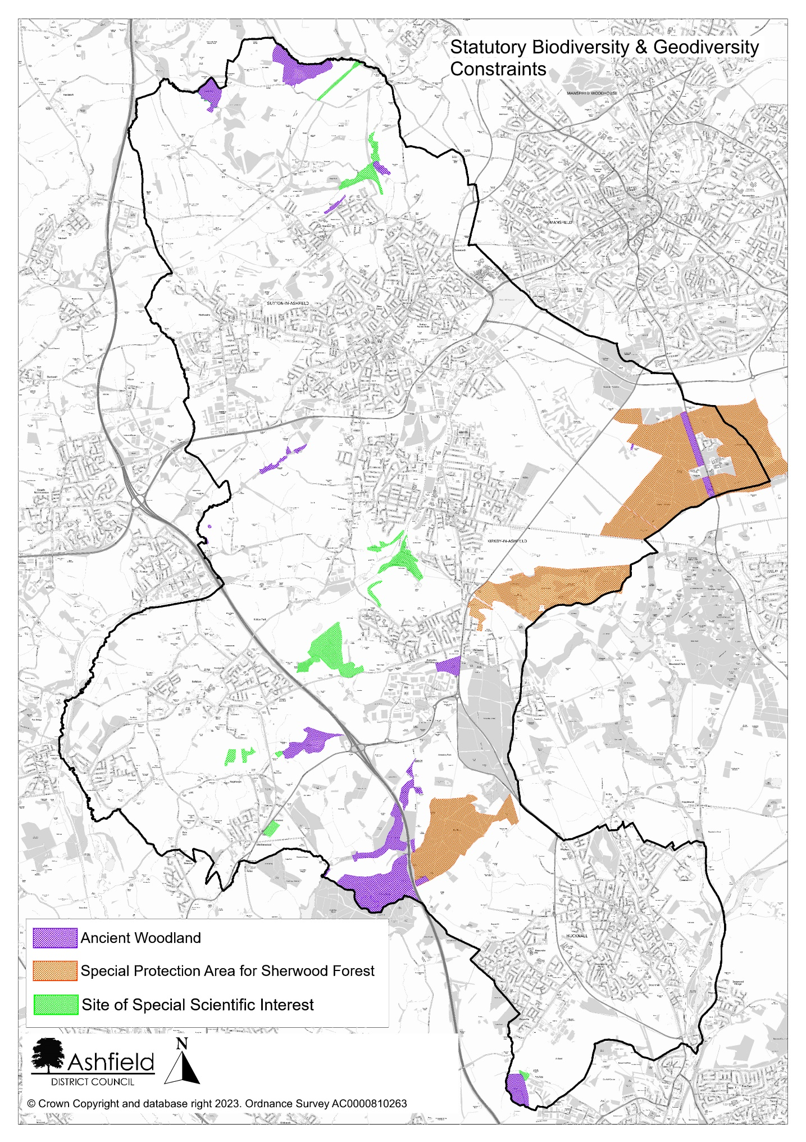
Figure 2: Designated Natural Assets in Ashfield (including the ppSPA for Sherwood Forest).
Locally Designated Sites

  - The framework recognises that LPAs should “take a strategic approach to maintaining and enhancing networks of habitats and green infrastructure; and plan for the enhancement of natural capital at a catchment or landscape scale across local authority boundaries” (NPPF para 175). These networks include Local Wildlife Sites, Local Geological Sites and Local Nature Reserves, which are designated at a local level. Although LWS and LGS sites are not statutorily protected, they may restrict the level of development as the conservation and enhancement of these areas will need to be considered as part of any future development.

  - Local Wildlife Sites (formerly ‘Sites of Importance for Nature Conservation’) are locally designated sites incorporated into the planning system for protection. They represent sites that are of at least County-wide importance, and form a crucial framework of ‘stepping stones’ for the migration and dispersal of species. In 2021, Ashfield was recorded as having 217 LWS although the number varies as new sites meeting the agreed criteria are identified while others are known to have deteriorated and may be removed. These sites are on both public and private land and are identified and surveyed by the local Biological and Geological Records Centre, based on criteria set by the Nottinghamshire LWS panel, and are subject to regular review.

  - Local Geological Sites (formerly Regionally Important Geological Sites) represent important examples of local geology and assist in the understanding of natural processes. Ashfield has 4 of the 133 recognised LGS in Nottinghamshire, 3 of which are also currently designated as LWS.

  - Local Nature Reserves are identified by Natural England a statutory designation made under Section 21 of the National Parks and Access to the Countryside Act 1949 by principal local authorities. LNRs are designated in consultation with Natural England to encourage public access and enjoyment of the natural environment. Ashfield currently has four LNR as identified in the table below. The district boundary between Ashfield and Mansfield crosses over part of Kingsmill Reservoir. In addition, the Bulwell Hall Meadows Local Nature Reserve falls partially within the southern part of our District but is predominantly located within Nottingham City authority’s boundary.

Ashfield – Local Nature Reserves | Area ha | LNR Type
Brierley Forest Park, Sutton in Ashfield | 80.6 | Urban
Kingsmill Reservoir, Sutton in Ashfield | 27.53 | Urban
Portland Park, Kirkby | 9.43 | Urban
Teversal to Pleasley Railway | 21.49 | Urban
Total | 139.05
Table 3: Local Nature Reserves in Ashfield
Source: Ashfield District Council

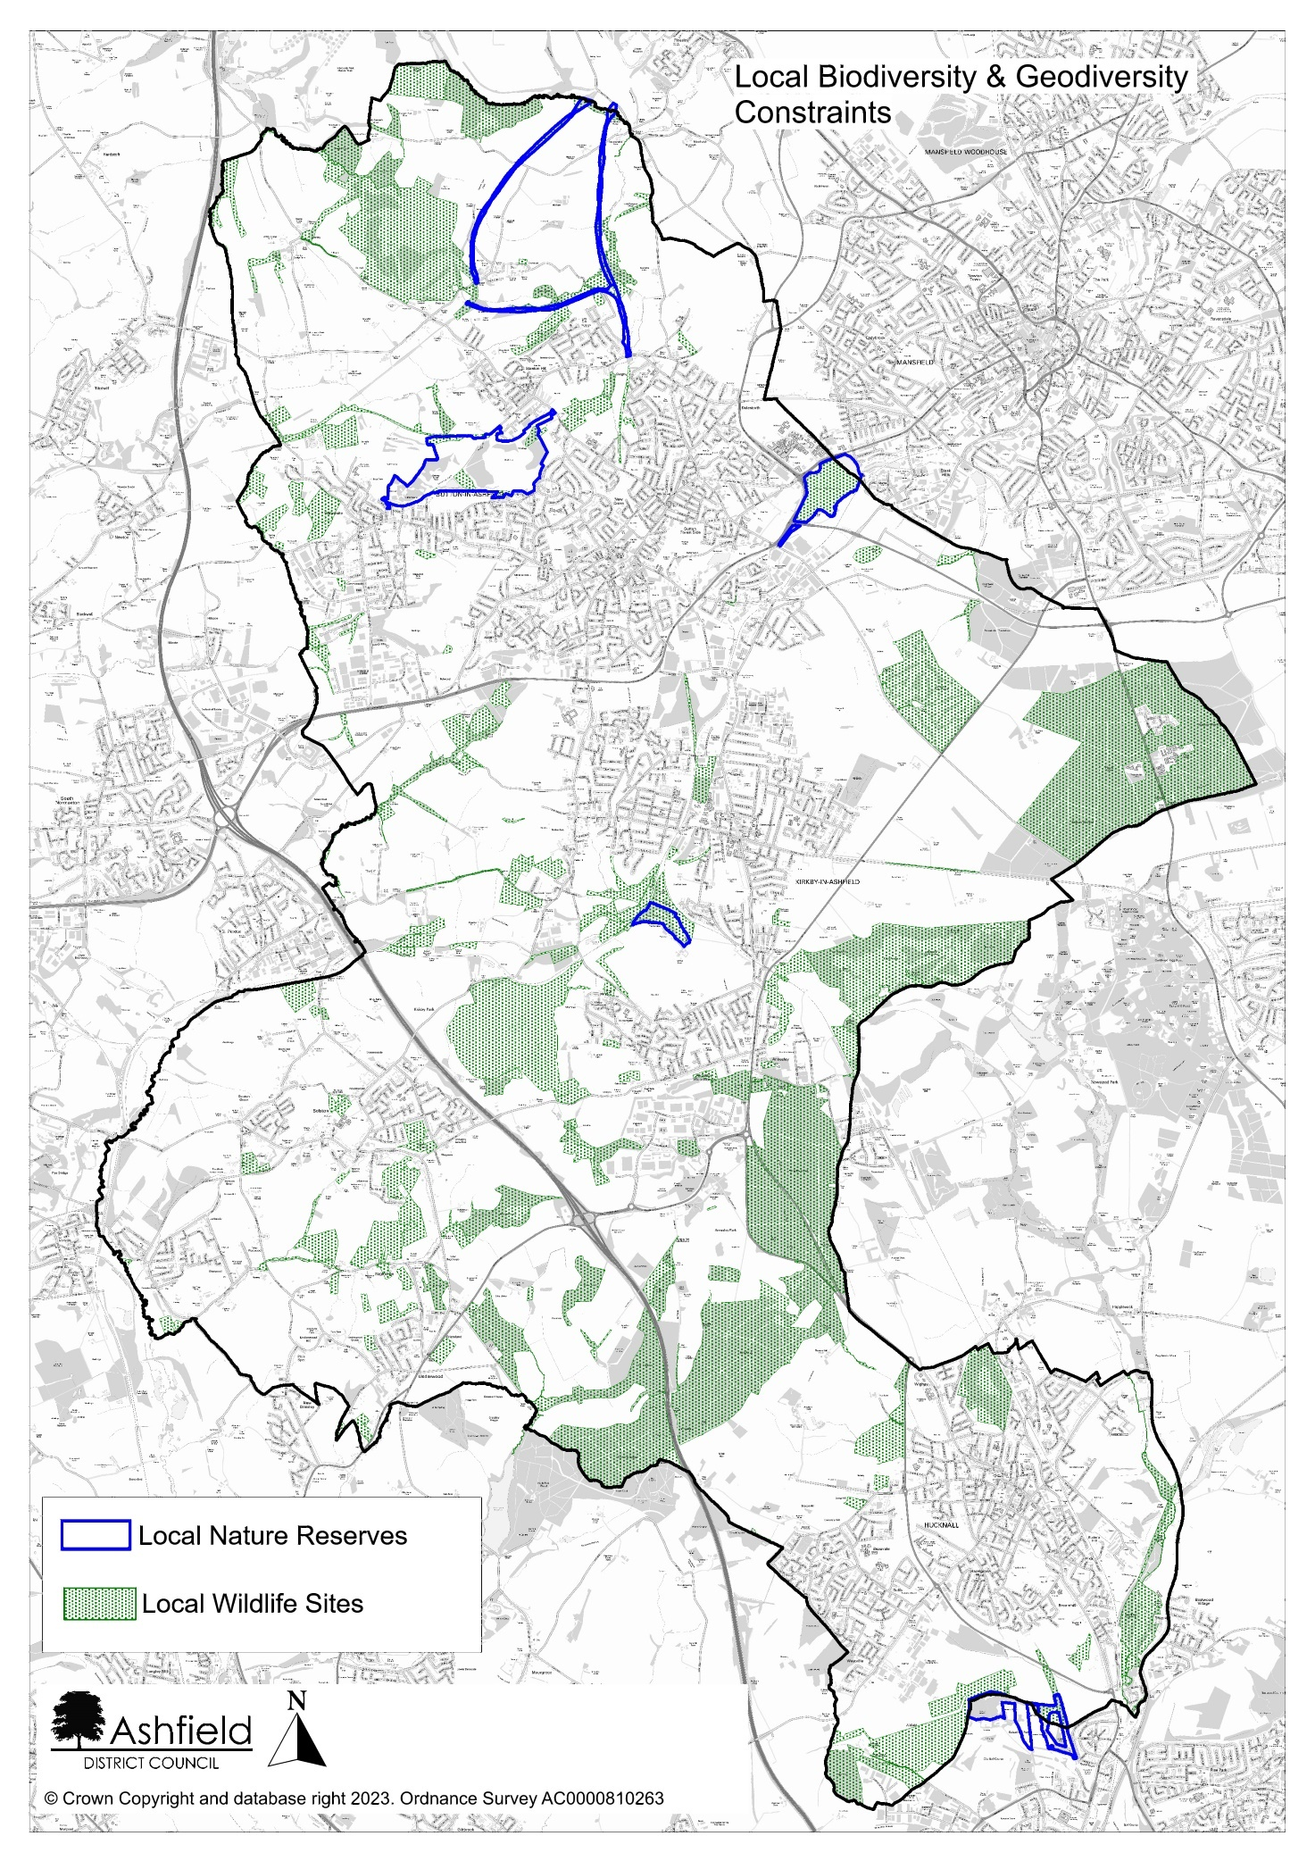
Figure 3: Locally Designated Biodiversity Sites in Ashfield

- Heritage Assets

  - Paragraphs 189-190 of the NPPF recognises heritage assets as an irreplaceable resource and should be conserved in a matter appropriate to their significance. It also requires an LPA to set out a positive strategy for the conservation and enjoyment of the historic environment, including heritage assets most at risk through neglect, decay or other threats. This strategy should take into account

- the desirability of sustaining and enhancing the significance of heritage assets and putting them to viable uses consistent with their conservation;
- the wider social, cultural, economic and environmental benefits that conservation of the historic environment can bring;
- the desirability of new development making a positive contribution to local character and distinctiveness; and
- opportunities to draw on the contribution made by the historic environment to the character of a place.

  - Following these requirements means heritage assets pose a constraint to development, proportionate to their scale and significance, whilst meeting the need to plan positively to conserve and enhance the historic environment. Other practical constraints occur such as the scale and cost of development that can be delivered within or near to heritage assets. However, a blanket approach to restricting development is not always appropriate, as NPPF paragraph 202 outlines that where development would lead to less than substantial harm, this should be weighed against the public benefits this may generate.

  - This analysis focuses on those heritage assets which have the greatest influence on shaping strategic options – either because of their influence on the character of an area, their intrinsic significance or of the large extent of the designated land and/or its setting.

  - Ashfield benefits from a number of heritage assets including 6 designated Conservation Areas, 80 Listed Buildings, 9 Scheduled Ancient Monuments and 2 Registered Parks and Gardens. These assets are indicated on Figure 4.

  - Hardwick Hall, a Grade 1 listed building and Old Hall, a Grade1 listed building and Scheduled Monument, is located just over the district boundary with Bolsover District Council to the north of the District. The two halls are located on the edge of an elevated scarp and are prominent in the landscape. The National Trust has commissioned a Hardwick Setting Study, which sets out detailed information on the setting of these buildings. It sets out a characterisation of the Landscape around Hardwick into 14 areas. The areas surrounding the small hamlet of Stanley to the north are particularly sensitive in regard to development due to the association with the landscape character and setting of Hardwick Hall.

  - Registered Historic Parks and Gardens are important in historical and landscape terms and may also be of wildlife and recreational value. Ashfield has two designed landscapes on the Historic England Heritage Register of Parks and Gardens of Special Historic Interest. This includes Hardwick Hall Grounds in the north end of the district, which is Grade I of international importance and covers approximately 300 hectares, 50 of which are within Ashfield. The Registered Park and Gardens of Annesley Hall is also located between the built-up areas of Hucknall and Annesley Woodhouse, which is Grade II* of exceptional interest and covers an area of 289 hectares. The District also has a locally designated Historic Park and Garden at Skegby Hall, Sutton in Ashfield which is protected in the emerging Local Plan (under policy EV9).

  - Ashfield’s six designated Conservation Areas are Kirkby Cross, Lower Bagthorpe, Teversal, New Annesley, Sutton in Ashfield Church and Market Place and Hucknall Town Centre. Combined, these areas cover a total area of 128ha. As noted, the presence of a heritage asset does not necessarily preclude development, however the need to preserve their setting is a key consideration and may limit development at the edge of the Conservation Areas. Many of the District’s Conservation Areas also contain a number of designated and non-designated heritage assets.

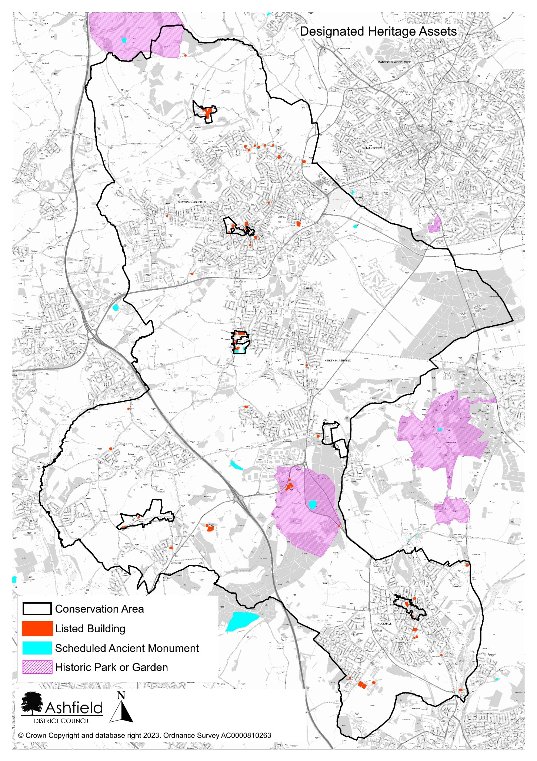

Figure 4: Designated Heritage Assets in Ashfield

- Flood Risk

  - Paragraph 151 of the NPPF sets out the approach for how the risk of flooding should be handled in respect of new development:

‘Inappropriate development in areas at risk of flooding should be avoided by directing development away from areas at highest risk (whether existing or future). Where development is necessary in such areas, the development should be made safe for its lifetime without increasing flood risk elsewhere.’

  - Housing is defined as a ‘More Vulnerable’ use in the Planning Practice Guidance and this is stated to be an ‘appropriate use’ in Flood Zones 1 and 2. It is not regarded as an appropriate use in Flood Zone 3, unless it passes an ‘Exception Test’ (only in the case of Flood Zone 3a – High Probability – and not 3b – the Functional Floodplain). Flood Zone 3 should therefore be regarded as a significant constraint, with Flood Zone 2 requiring consideration of the vulnerability of the land uses.

  - Ashfield Council have produced a Strategic Flood Risk Assessment (SFRA) to assess the risk of flooding within areas of the District. The SFRA identifies that while the risk of flooding from watercourses is relatively low compared with some neighbouring authorities, properties at Hucknall and Jacksdale are particularly at risk from watercourses. Additional water into the River Leen raises potentially significant flood issues in Nottingham. The impact of climate change and the topography is anticipated to result in an increasing risk from surface water flooding in the District.

  - Figure 5 identifies areas within the District that lie within Flood Zones 2 and 3. Flood Zone 3 covers approximately 151ha (1.38% of the District). Flood Zone 2 covers approximately 224ha (2.04% of the district). A sequential test formed part of the process of selecting proposed sites in the draft Local Plan, avoiding development in Flood Zones 2 and 3 as far as possible.

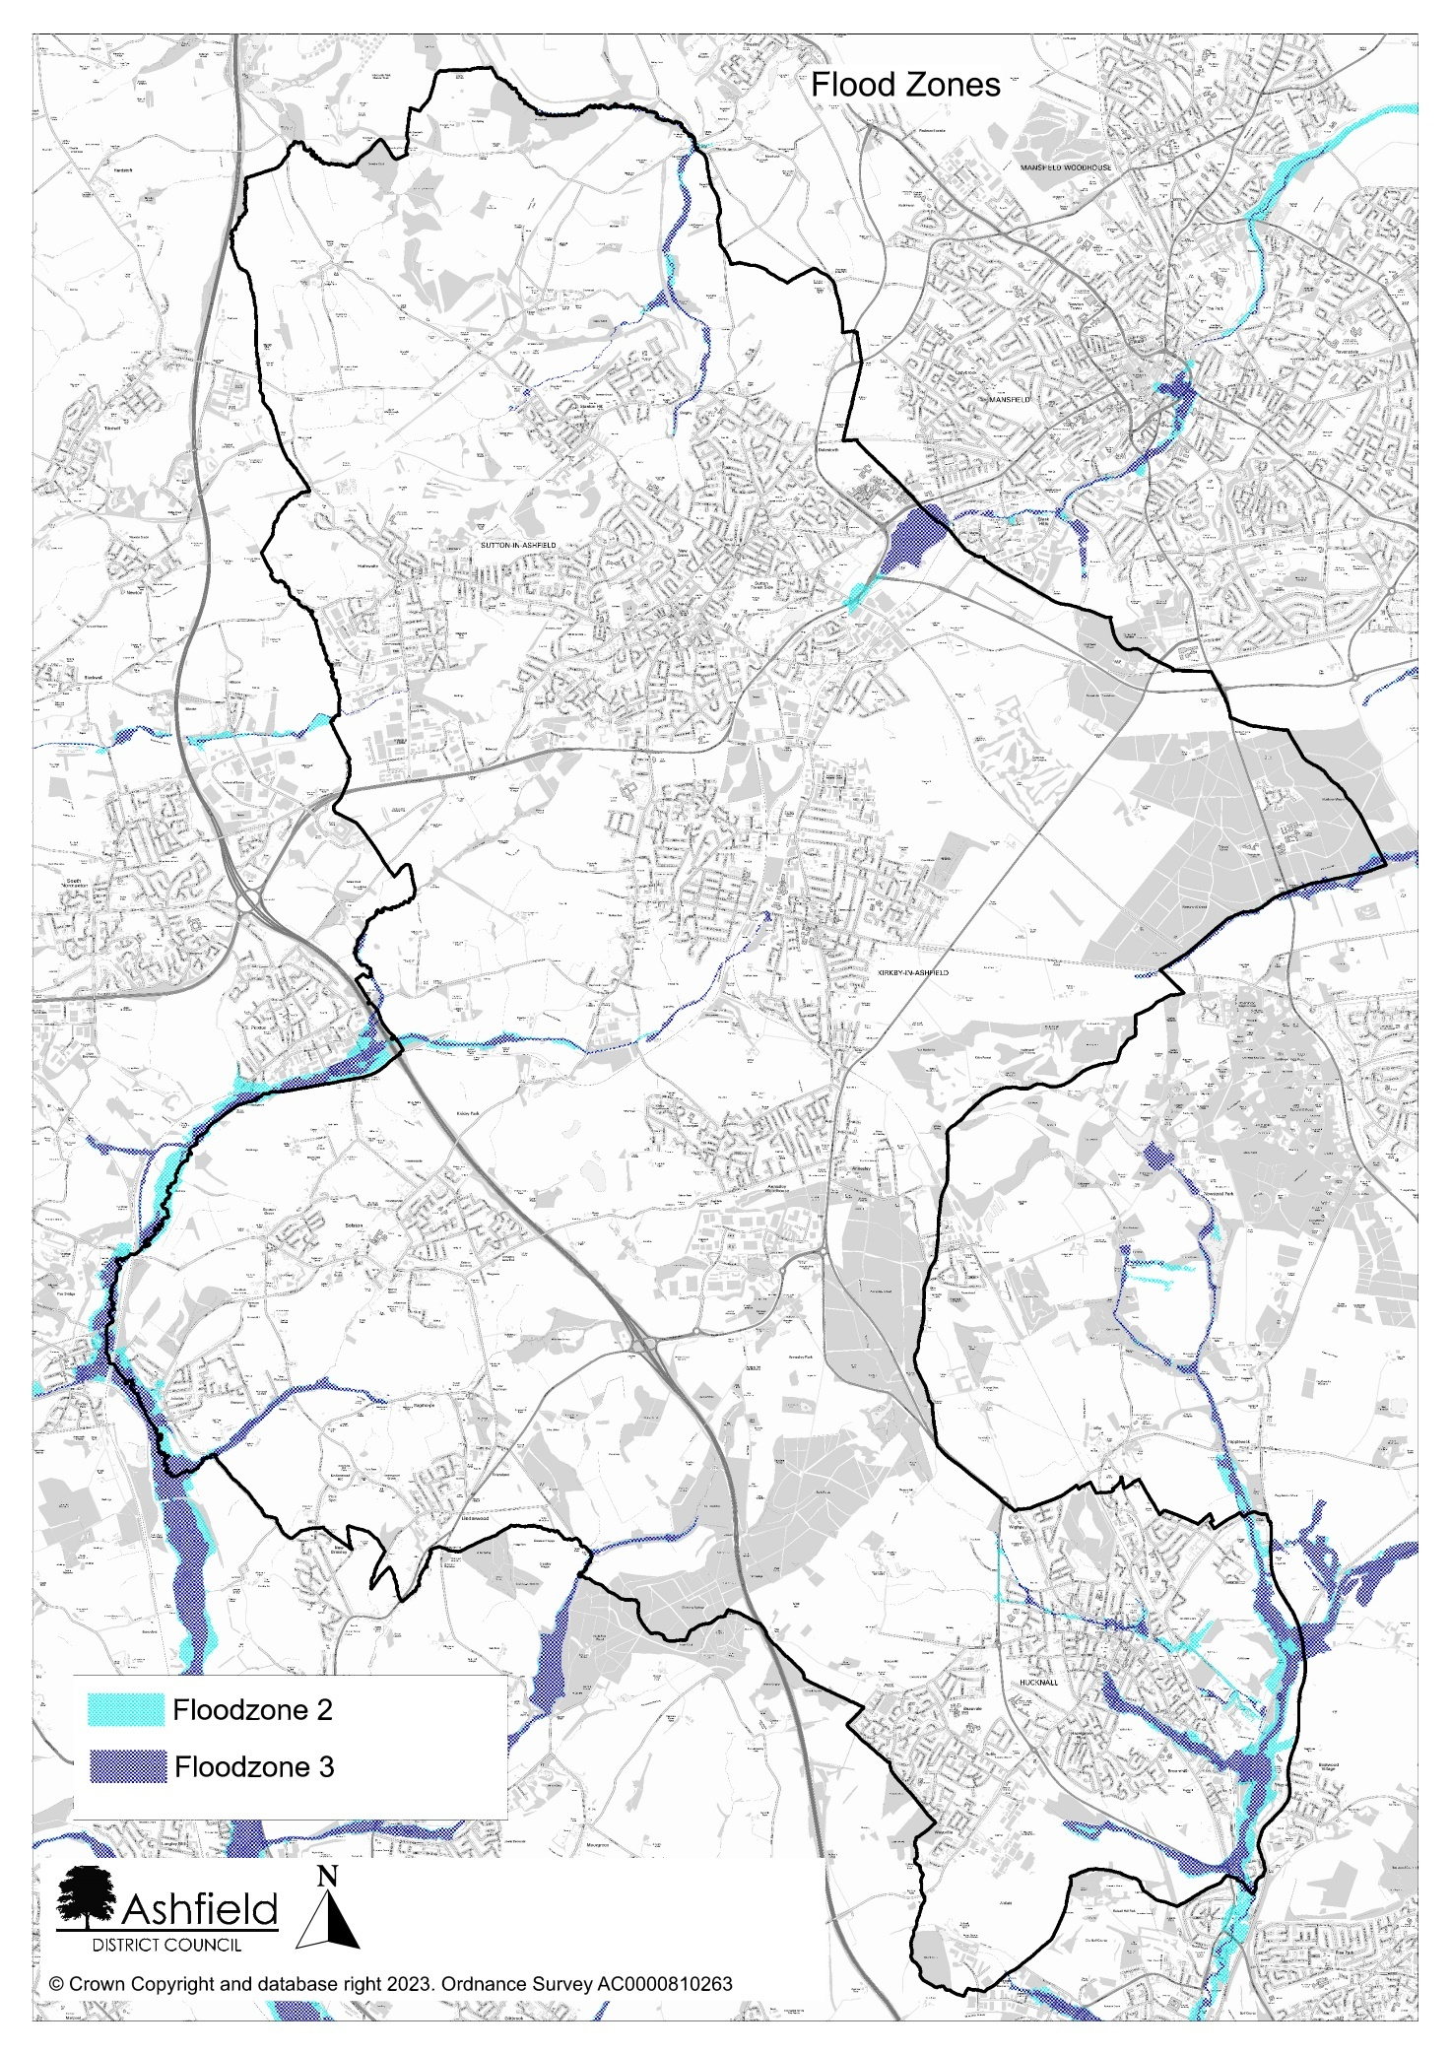
Figure 5: Ashfield Flood Zones 2 and 3
- Landscape Character

  - The Landscape Character Assessment for Ashfield (2009) sets out three landscape character areas which broadly influence the scale and form of development across the District. These are:

- Magnesium Limestone Ridge
- Nottinghamshire Coalfields
- Sherwood.
Each of these areas has been further sub-divided into component landscape character areas know as Draft Policy Zones (DPZ). Each DPZ identifies and lists the key features which make it special and provides a judgement on the condition of the landscape and its strength of character.

  - There are no nationally designated landscape areas in Ashfield, however planning policies and decisions should ensure that development is sympathetic to landscape setting, amongst other factors (NPPF para 130). At the local level, Ashfield has two areas covered by Neighbourhood Plans; the Teversal, Stanton Hill and Skegby Neighbourhood Plan (TSSNP) 2016-2032 and the Jacksdale, Underwood and Selston Neighbourhood Plan 2017-2023 (known as the JUS-T Plan). Both identify important landscapes within their respective areas and include policies that aim to protect their distinctive character.

  - The TSSNP encompasses the built up areas of Skegby and Stanton Hill, as well as Teversal village, Fackley and the hamlets of Stanley and Norwood. Policy NP4 sets out that the green corridors between Stanton Hill and Skegby, and between Teversal and Stanton Hill are particularly sensitive. Development is required to maintain the sense of openness between these areas. In addition, the TSSNP identifies that publicly accessible views relating to landscapes around Hardwick Hall, Teversal Village and Silverhill Country Park are highly regarded by residents and may limit what form of development in these areas can be achieved.

  - The JUS-T Plan covers the south-west part of the district, including the named settlements of Jacksdale, Underwood and Selston, alongside Bagthorpe village and part of Brinsley. It characterises the settled areas as being strongly defined by views of the surrounding rural landscape contributing to a sense of openness. Policy NP3 requires that new development does not visually detract from established view corridors within the neighbourhood plan area.

  - Given the above, while this does not prevent any development from taking place, it should be acknowledged that maintaining the quality of landscape areas within the district is a factor that could affect the spatial distribution of development.

- Agricultural Land

  - The NPPF recognises the importance of agricultural land. Footnote 58 of the NPPF states that ‘Where significant development of agricultural land is demonstrated to be necessary, areas of poorer quality land should be preferred to those of a higher quality.’ The best and most versatile agricultural land is identified as land in grades 1, 2, and 3a of the Agricultural Land Classification.

  - The Regional classification maps do not currently distinguish between grade 3a and 3b in Ashfield. As such, for the purposes of the constraints study, only land identified as Grades 1 and 2 are considered. Using the provisional 1980’s Agricultural Land Classification Map, it has been possible to identify varying qualities of agricultural land within the district. There is no Grade 1 land in Ashfield. Areas designated as Grade 2 is shown on figure 6.

  - The maps indicate a large concentration of highest quality agricultural land north of the urban edge of Hucknall, in farmland to the west of Kirkby in Ashfield and in sections of open countryside north of Skegby, with smaller pockets of higher quality land located elsewhere in the district.

  - The use of agricultural land to meet identified development needs will need to be balanced against agricultural issues, as well as impacts upon landscapes and the established character of an area. Given the relatively limited quantity of best and most versatile land, there is likely to be a greater importance of limiting development of these areas, in accordance with the Framework.

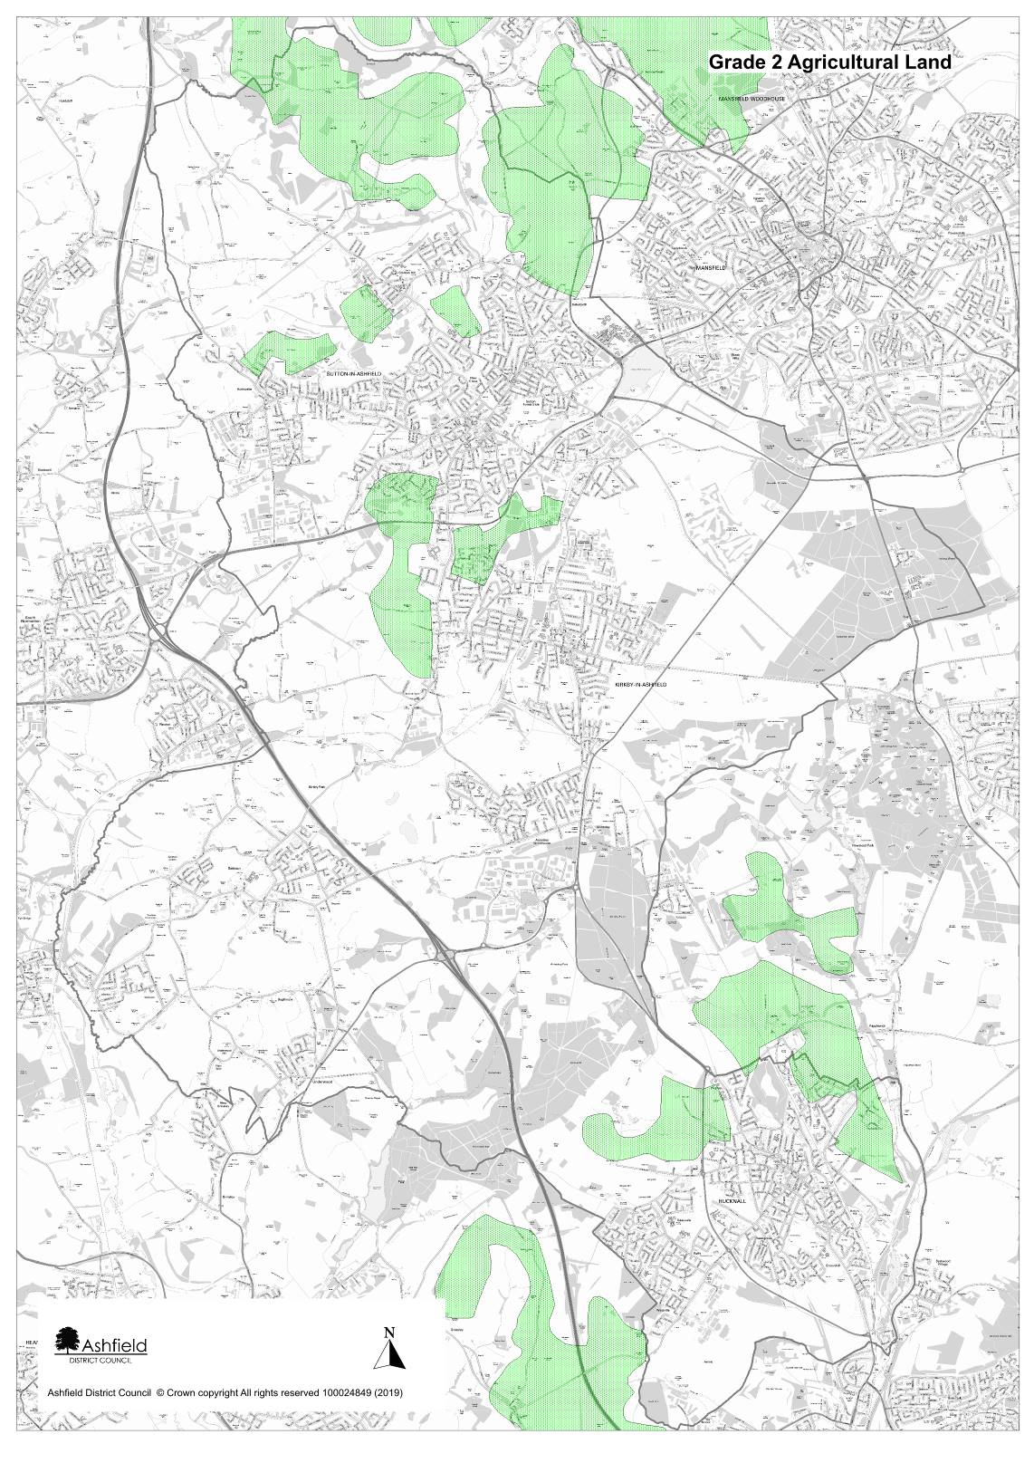
Figure 6: Agricultural Land Grade Two Approximate Location
Source: Natural England – Agricultural Land Classifications Provisional (England)
N.B. The map does not subdivide Grade 3 land into sub classifications. It is stressed by Natural England that these maps are not sufficiently accurate for use in assessment of individual fields or sites.

- Conclusion
  - This study has identified that Ashfield District possesses several key constraints which limit the quantum of development that can be reasonably achieved across the District. Many of these constraints are located on the edge of, or outside of the Main Urban Areas and Named Settlements of Ashfield and are comprised of large areas of designated Green Belt, as well as undesignated countryside.

  - As previously noted, approximately 41% of the total District area is designated as Green Belt, which due to national policy requirements, should only be altered in exceptional circumstances. The circumstances justifying the release of Green Belt land are discussed in Background Paper 1: Spatial Approach and Site Selection. Areas of countryside not designated as Green Belt and situated outside of the main urban areas and named settlements account for approximately 26% of the total District area, however not all of this area is likely to be suitable for development, due to the constraints discussed elsewhere in this study.

  - Separate from Green Belt (due to its nature as a policy-based constraint), there are other land-based designations which have a significant impact on the spatial distribution of new development. This includes constraints which heavily restrict the possible use of the land in question and therefore can be argued to rule out larger strategic-scale development as a matter of principle. This includes the following designations relevant to Ashfield:

- Land designated as a SSSI
- Land containing Ancient Woodlands
- Land designated as a possible potential Special Protection Area
- Land designated as a Local Nature Reserve
- Land that is within the Functional Flood Plain (Flood Zone 3b)
- Land designated as a Registered Park and Garden

  - In addition to the above, this study has shown that a significant portion of the District area is subject to other key constraints, including the need to safeguard the best quality agricultural land which is very limited in Ashfield. Any development of these areas is likely to require further assessment and mitigation and may restrict the quantity that can be delivered. In other cases, it may be necessary to redirect development to other areas with fewer constraints. With the exception of landscape areas discussed in section 6, all constraints discussed within this study are illustrated on figure 7, alongside the site allocations in the draft Local Plan.
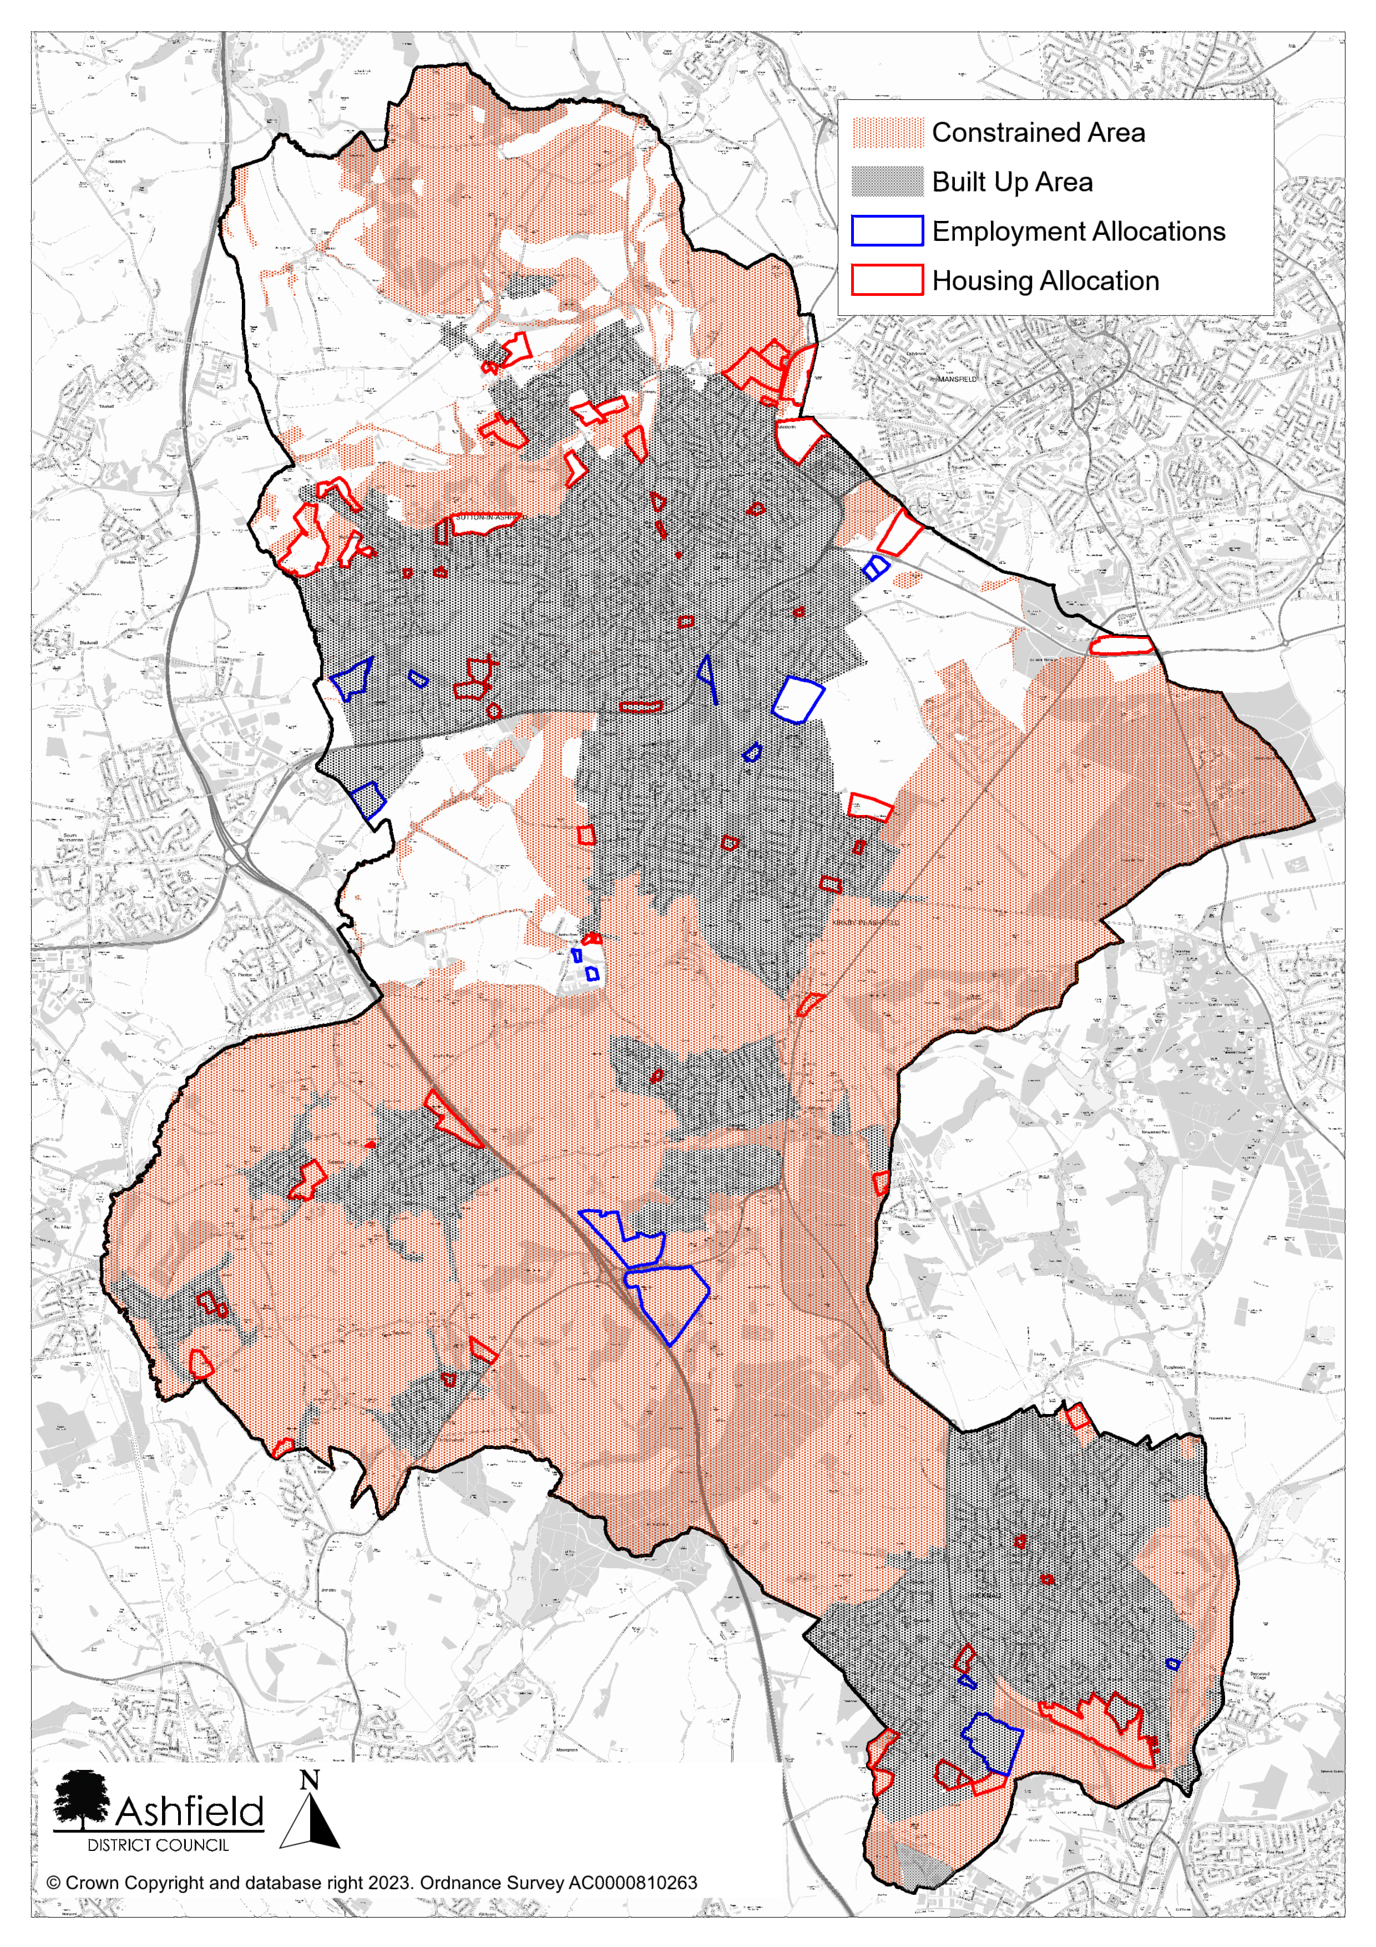
Figure 7: Combined constraints, site allocations and built up areas

Advice Note to Local Planning Authorities regarding the consideration of the likely effects on the breeding population of nightjar and woodlark in the Sherwood Forest Region, Natural England, March 2014.
Hardwick Setting Study 2016, Atkins for National Trust.
National Planning Policy Framework, Annex 2: Glossary, page 65

