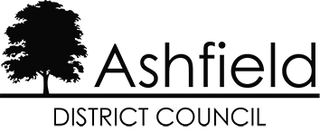

Sheltered Scheme – Darlison Court, Hucknall

Period Covered: April 2022 to March 2023
Running Costs (eligible for Housing Benefit and Universal Credit) | Weekly Charge Per Unit
1. Communal Cleaning | £1.69
2. Communal Window Cleaning | £0.02
3. Fire Safety/Alarms | £0.35
4. Communal Electric Supply | £0.55
5. Administrative Charge @15% | £0.39
**Total Weekly Service Charge | £3.00

Breakdown of costs
1. Communal Cleaning
For the cost of cleaning communal areas at the scheme including communal room, kitchen, toilets, hallways, stairways, and corridors. A specification can be provided upon request.
2. Communal Window Cleaning
For the cost of cleaning windows to communal areas on a routine basis in line with the agreed contract specification. This does not include individual residents’ property windows. A specification can be provided upon request.
3. Fire Safety/Alarms
For the statutory servicing and inspection of communal fire alarm systems, emergency lighting, smoke detectors, firefighting equipment and suppression system undertaken by our contractors.
4. Communal Electric Supply
For the cost of providing lighting within the communal areas of the scheme.
5. Administrative Charge
The Administrative charge is for administration costs incurred when organising and managing the services above.
** Please note that the total charge above is not the full costs incurred in delivering the services to you. The service charge you pay is only a contribution towards the full costs.

