Green & Blue Infrastructure and Biodiversity Strategy
2022 -2032

Connecting People, Places and Nature

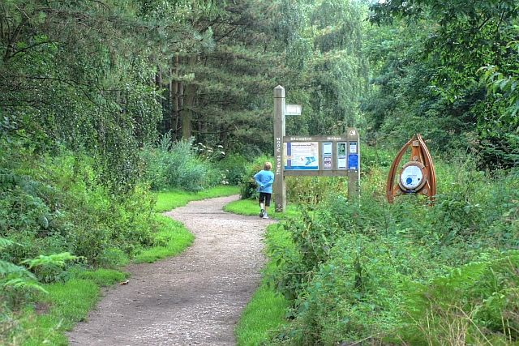

September 2022

Disclaimer

This document or some parts of it may not be accessible when using adaptive technology.

If you require assistance with accessing the content of the document, please contact the Planning team and quote the document name and the web page you found it on:
- email: localplan@ashfield.gov.uk
- telephone: 01623 457381 or 01623 457382 or 01623 457383.

Contents

Summary 1

1. | Introduction | 3
2. | Policy context overview | 7
2.1 | National Policy | 7
2.2 | Local Policy | 9
3. | Green & Blue Infrastructure Functions and Themes | 12
3.1  3.2  3.3  3.4  3.5  3.6  3.7  3.8 | Biodiversity  Accessibility and sustainable transport  Recreation  Climate Change and environmental quality  Health and well-being  Growth and Investment  Social  Landscape and Culture | 12  13  13  14  16  17  17  18
4. | Methodology | 21
4.1 | Audit of existing Green Infrastructure | 21
4.2  4.3 | Developing a Green Infrastructure Framework  The Green Infrastructure Framework | 21  22
5. | Ashfield Green & Blue Infrastructure in Context | 25
5.1  5.2  5.3  5.4  5.5  5.6  5.7  5.8 | Biodiversity  Accessibility and sustainable transport  Recreation  Climate Change and environmental quality  Health and well-being  Growth and Investment  Social  Landscape and Culture | 25  36  40  43  44  48  50  51
6. | A Green & Blue Infrastructure Framework for Ashfield | 57
6.1 | Strategic Corridors | 57
6.2 | Local Corridors | 68
6.3 | Delivery | 78
7. | Appendices | 79
 | Appendix 1 - Policy context | 79
 | Appendix 2 - Local Landscape Character Areas | 80
 | Appendix 3 - Designated sites | 83
8. | List of Figures
8.1  8.2 | Key habitat linkages  Ecological value | 34  35
8.3 | Accessibility | 39
8.4 | Accessible green space | 42
8.5  8.6 | Deprivation in Ashfield  Community facilities | 46  47
8.7 | Growth and Investment | 49
8.8 | Cultural Assets | 55
8.9 | Water courses and green space | 56
8.10 | Green Infrastructure Network for Ashfield | 58
8.11 | Green Infrastructure Network: Hucknall | 79
8.12 | Green Infrastructure Network: Rural area | 72
8.13 | Green Infrastructure Network: Kirkby and Sutton | 77
9. | References | 85

Summary

Green and Blue Infrastructure (GI) is the network of multi-functional green and blue spaces and other natural features, urban and rural, which is capable of delivering a wide range of environmental, economic, health and wellbeing benefits for nature, climate, local and wider communities, and prosperity.
In the same way that transport infrastructure is made up of a network of roads, railways, and other elements, green infrastructure has its own set of components, including parks, rivers, street trees and gardens. Green infrastructure needs developing and expanding to serve communities in the same way that grey infrastructure (such as roads, sewers, and energy networks) is planned.
The Council has an important role to play in GI development and delivery with its broad environmental, health /social, economic, and planning responsibilities. The Council will aim to secure GI opportunities through the planning and development process and work towards implementing different management regimes on Council owned land where appropriate.

A Green and Blue Infrastructure network for Ashfield has been developed which links into the wider GI network across Nottinghamshire, Derbyshire, and other areas of the East Midlands (Figure 8.10). The network identifies strategically planned links between existing and proposed green spaces with the communities around them. Through the management, enhancement and extension of these networks, multi-functional benefits can be realised for local communities, businesses, visitors, and the environment.
“Multifunctionality can apply to individual sites and routes, but it is when the sites and links are taken together that we achieve a fully multifunctional green infrastructure network.” Green Infrastructure Guide, Natural England 2009.

Green & Blue Infrastructure and the Local Plan
The population of Ashfield was 119,497 in 2011, the mid 2020 estimate gives the population as 128,337 and therefore a significant number of new houses will be required to accommodate the expected growth. Green Infrastructure will need to be an integral part of planned development to help to achieve sustainable growth.
This Strategy will inform Ashfield’s emerging Local Plan and provide a framework to support the delivery of a well-used, well managed, high quality, multifunctional network of green / blue corridors and assets across Ashfield and beyond into neighbouring areas.

This Strategy complements the District’s Public Open Space Strategy 2016 - 2026 Public Open Space Strategy 2016-2026which was adopted in 2020 and The Nottinghamshire Biodiversity Opportunity Mapping Project Ashfield District 2016 Nottinghamshire Biodiversity Opportunity Mapping Project Ashfield District 2016 . The Council’s Green Infrastructure and Biodiversity Technical Paper (2013) has been used as the source document for this strategy. The original methodology has not been altered. Supporting strategy references have been updated and checked to ensure consistency of findings in the preparation of this document.
1.INTRODUCTION

Green Infrastructure is a network of multi-functional green and blue spaces and other natural features, urban and rural, which is capable of delivering a wide range of environmental, economic, health and wellbeing benefits for nature, climate, local and wider communities, and prosperity. (National Planning Policy Framework, 2021) National Planning Policy Framework July 2021. “It contributes to reducing C0₂ and adapting to climate change. It forms an essential element in the development of successful and sustainable communities.” Green Infrastructure Guidance, Natural England.

“Green Infrastructure functions at a range of levels, from large rural landscapes and strategic corridors to local-scale green space in urban and rural settlements. Good quality Green Infrastructure (GI) has an important role to play in our urban and rural environments for improving health and wellbeing, air quality, nature recovery and resilience to and mitigation of climate change, along with addressing issues of social inequality and environmental decline”. Introduction to the Green Infrastructure Framework - Principles and Standards for England. Natural England 2022
Green Infrastructure includes parks, open spaces, playing fields, woodlands, allotments, cemeteries, private gardens, and river corridors, as well as agricultural land, country parks, private estates, and wasteland. They can be in public or private ownership. By linking these areas together, many benefits can be realised for both people (through the creation of accessible, attractive, and functional routes and spaces) and wildlife (through the provision of better, bigger, and interconnected habitats).

Biodiversity is an all-encompassing term to describe the variety of all life and natural processes on Earth. The International Union for Conservation of Nature IUCN –The International Union for Conservation and Nature IUCN
Department for the Environment, Fisheries and Agriculture ( Defra) research shows that biodiversity is reducing at an increasing rate due to human activity, in particular development, agriculture, and forestry. The State of Nature 2019 report states that 41% of all UK species have declined in abundance. Habitats which have been particularly affected include hedgerows, meadows, and wetlands. In Nottinghamshire, grassland habitats are particularly at risk. “The biodiversity resource of the county is highly impoverished. For example;
- Just 1.5% of the area of Nottinghamshire is designated as nationally important wildlife sites, comparing poorly with a regional average of around 4.5% and a national (England) average of just over 8%.
- 97% of the county’s flower-rich meadows have been lost since the 1930s.
- 90% of heathland has been lost since 1922.
- Species such as grass of Parnassus, pearl-bordered fritillary and Nottingham catchfly have become extinct in the county.” Nottinghamshire Minerals Local Plan Background Paper Biodiversity January 2016
It is predicted that continued loss of biodiversity will result in rapid decline of the Earth’s natural resources. Agricultural production could be adversely affected if bacteria and fungi, critical for soil fertility and breakdown of wastes disappear. Another example is healthcare where 15,000 species of medicinal plants are globally threatened. The International Union for Conservation of Nature IUCN –The International Union for Conservation and Nature IUCN
In recent years, awareness has grown of the need to safeguard and increase biodiversity, demonstrated through the county level Local Biodiversity Action Plans and the introduction of the duties on local authorities regarding biodiversity through the Natural Environment and Rural Communities Act of 2006.
Under the Act, the Council has a duty to have regard for the conservation of biodiversity in exercising its functions. The duty aims to raise the profile of biodiversity, to clarify existing commitments and to make biodiversity an integral part of policy and decision-making. In 2016, Ashfield District Council worked with the Nottinghamshire Biodiversity Action Group to produce a Biodiversity Opportunity Map (BOM) for Ashfield District, to link to neighbouring authorities BOMs with the aim of producing a county wide map Nottinghamshire Biodiversity Opportunity Mapping Project Ashfield District 2016. The BOM maps indicate that Ashfield is a particularly important area for its biodiversity and supports a diverse range of habitat types. The broad habitats of woodland, heathland and acid grassland, other grassland and wetland are well represented within the District and concentrations of opportunities for each of these have been identified as part of the BOM process.
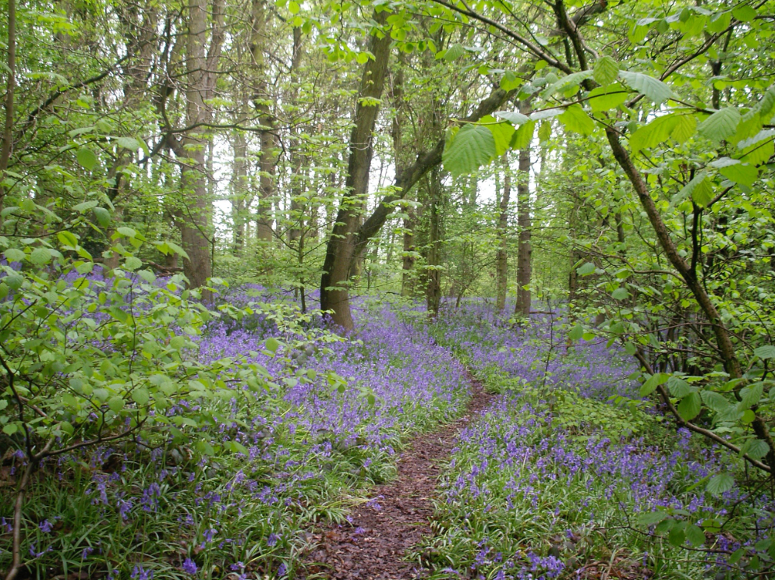
Bluebells at Portland Park
The Council will aim to secure biodiversity opportunities through the planning and development process and work towards implementing different management regimes on Council owned land where appropriate.
The Environment Act 2021 introduces a new system of spatial plans - Local Nature Recovery Strategies (LNRSs) aiming to boost biodiversity and protect valuable habitats. Local Nature Recovery Strategies can also be used to identify how habitat for nature can deliver wider environmental benefits and, improve people’s access to green space particularly in urban areas. All new developments will be required to deliver a ten per cent increase in biodiversity ( Biodiversity Net Gain or BNG) after development, compared to the level before. The Environment Act 2021 identifies 10% as a minimum requirement which is anticipated to come into force in the winter of 2023.This can provide an investment mechanism for both on-site and off-site GI, which can be achieved by either enhancing existing habitats or creating new ones. BNG can therefore be used to both raise the quality of existing greenspace and provide new GI.
Ashfield’s Public Open Space Strategy 2016 - 2026 (adopted 2020) Ashfield Public Open Space Strategy 2016- - 2026 evaluates green space provisions mainly in terms of the recreational opportunities it offers. It considers the distribution and quality of publicly accessible space and is used to assess whether communities have sufficient access to good quality recreational or amenity green space. The vision of the Public Open Space Strategy is “ a network of high quality green and open spaces, to improve health and wellbeing and provide focal points for vibrant communities. Bringing people together and providing opportunities for sport, exercise, and events.”
It provides a focus for the sustainable long-term management of public open spaces, the continued improvement of public spaces and the provision of new public open space and associated facilities through the development management process. It replaces the previous Ashfield Green Space Strategy, (2008) which was used to prepare the Green Infrastructure and Biodiversity Technical Paper (2013). The Public Open Space Strategy 2016 – 2026 has been checked against the Green Infrastructure and Biodiversity Technical Paper (2013) to ensure consistency of findings in the preparation of this document.
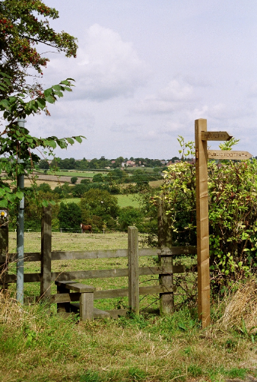
Hidden Valleys Footpath
In contrast, Green Infrastructure considers the wider multiple benefits that green and blue space, and their linkages offer. As well as considering the findings of the Public Open Space Strategy, the Green Infrastructure and Biodiversity Strategy also considers a range of other benefits that green and blue space can provide. These are explored in more detail in Section 4. When considering these broader functions, it is sometimes appropriate to include private green space as well as the public space identified in the Public Open Space Strategy. Green Infrastructure also goes beyond the site-specific and considers the ‘bigger picture’, particularly in terms of how green and blue spaces work together and form strategic networks.
The Public Open Space Strategy 2016 – 2026 is an important informing document and the spaces it considers are a key component of Ashfield’s overall Green Infrastructure. It is intended that the two documents complement and support each other to provide a comprehensive strategic approach.
The approach to developing the Green Infrastructure and Biodiversity Technical Paper (2013) was based on guidance and best practice demonstrated by completed Green Infrastructure (GI) Studies current as of 2013. The key stages were:
- Mapping and analysis of existing GI, within Ashfield and into neighbouring districts
- Identification of deficiencies and opportunities for GI creation and enhancement
- Review of relevant policy and other assessments, for example, Greater Nottingham Landscape Character Assessment (2009)
- Review of the district’s previous Nature Conservation Strategy (2003)
The Green Infrastructure and Biodiversity Technical Paper (2013) has been used as the source document for this strategy. The original methodology as set out in Section 4 Methodology of this document has not been altered. Supporting strategy references have been updated and checked to ensure consistency of findings in the preparation of this document

- Policy context overview

2.1 NATIONAL POLICY
The concept of Green and Blue Infrastructure is supported through several national strategies and policy documents. Many key documents stress the importance of protecting green spaces for their contribution to quality of life such as “A Green Future: Our 25 Year Plan to Improve the Environment”, A Green Future: Our 25 Year Plan to Improve the Environment which sets out government action to help the natural world regain and retain good health. It aims to deliver cleaner air and water in our cities and rural landscapes, protect threatened species and provide richer wildlife habitats. It calls for an approach to agriculture, forestry, land use and fishing that puts the environment first.
The Environment Bill 2021 The Environment Bill 2021 embodies this approach, setting environmental targets for resource use and biodiversity.
Natural England’s Green Infrastructure Framework is a commitment in the Government’s 25 Year Environment Plan. It supports the greening of towns and cities and connections with the surrounding landscape. Networks of green and blue spaces and other natural features can bring big benefits for nature and climate, health, and prosperity. At present access to green and blue spaces varies considerably across the country, and there are opportunities for these important assets to be better managed for the environment and to deliver a wider range of multifunctional benefits.

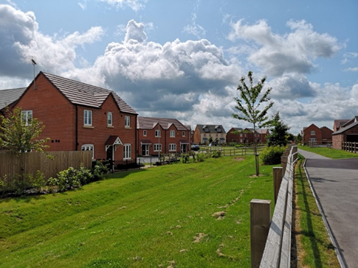
Larwood Housing development. With kind permission of W Westerman Ltd
The National Planning Policy Framework (NPPF) July 2021 supports and promotes biodiversity protection and the principles of Green Infrastructure. Part 15 of the NPPF specifically recognises the importance of the planning system and states that it “should contribute to and enhance the natural and local environment” and that local planning authorities should “take a strategic approach to maintaining and enhancing networks of habitats and green infrastructure; and plan for the enhancement of natural capital at a catchment or landscape scale across local authority boundaries.” Local Planning authorities should also minimise” impacts on and provide net gains for biodiversity, including by establishing coherent ecological networks that are more resilient to current and future pressures”.
The National Planning Policy Framework (NPPF) July 2021 paragraph 179 also states that plans should
“a) Identify, map and safeguard components of local wildlife-rich habitats and wider ecological networks, including the hierarchy of international, national, and locally designated sites of importance for biodiversity; wildlife corridors and stepping stones that connect them; and areas identified by national and local partnerships for habitat management, enhancement, restoration, or creation; and
b) promote the conservation, restoration and enhancement of priority habitats, ecological networks and the protection and recovery of priority species; and identify and pursue opportunities for securing measurable net gains for biodiversity.”
In order to achieve nature rich and beautiful places, “at a strategic level GI should
- Aim to strengthen ecological networks and reduce fragmentation of habitats
- Help deliver Biodiversity Net Gain requirements
- Contribute to cross species objectives such as pollinator strategies
- Integrate with the Nature Recovery Network and Local Nature Recovery Strategies
- Help achieve targeted individual species recovery
- Maintain and enhance geodiversity assets
- Reduce soil degradation and loss
- Be designed to deliver multiple benefits including landscapes that have a distinct sense of place”. Natural England GI principles 2022
The National Planning Policy Framework (NPPF) makes clear that all local planning authorities should prepare design guides or codes consistent with the principles set out in the National Design Guide 2021 The National Design Guide and the National Model Design Code July 2021 The National Model Design Code July 2021which reflect local character and design preferences. Design codes and guides should provide a framework for creating high-quality places. Green infrastructure forms part of the National Model Design Code (MHCLG 2021) , whereby Part 1 – The Coding Process states : “New development should contribute towards the creation of a network of green spaces and facilitate access to natural green space where possible”
National Planning Practice Guidance Natural Environment 2019 defines green infrastructure as “a natural capital asset that provides multiple benefits, at a range of scales. Paragraph: 005 Reference ID: 8-005-20190721.
It sets out the benefits such as food, water, flood and disease control and recreation ( ecosystem services) for communities. It identifies that GI can help in:
- Building a strong, competitive economy
Achieving well-designed places
- Promoting healthy and safe communities
- Mitigating climate change, flooding, and coastal change
- Conserving and enhancing the natural environment. Paragraph: 006 Reference ID: 8-006-20190721
It notes that GI strategies or frameworks prepared at a district scale can support and inform other strategic policies and delivery plans. Paragraph: 007 Reference ID: 8-007-20190721.
The Biodiversity UK Action Plan (1994) lists habitats and species considered to be threatened nationally, with the Local Biodiversity Action Plan (LBAP) for Nottinghamshire (1998) Local Biodiversity Action Plan providing information at a more local level. The LBAP, adopted by Ashfield District Council provides a framework for partnership working with the Nottinghamshire Biodiversity Action Group to meet the Action Plan’s targets for priority habitats and species.

2.2 LOCAL POLICY
This Strategy is part of the evidence base for informing future growth and infrastructure requirements in the emerging Local Plan. It has been informed by the Public Open Space Strategy and is a position statement of the Council’s Green Infrastructure and Biodiversity priorities in support of the Local Plan. This Strategy is to be read in conjunction with the Biodiversity Opportunity Map (BOM) for Ashfield District 2016, which is based on Sir John Lawton’s principles of bigger, better, and more connected as a landscape scale approach to conservation. The Lawton Review “Making Space for Nature” 24 September 2010.
The Ashfield Local Plan Review (Adopted 2002) aims to protect the Green Belt and open countryside with particular priority for Mature Landscape Areas and Nature Conservation Sites, including protected sites such as Sites of Special Scientific Interest, Local Nature Reserves and Sites of Interest for Nature Conservation (Policies EV1 to EV6). The Local Plan also identifies the need to protect Open Areas and Formal Open Spaces (Policies RC2 to RC4), Allotments (Policy RC5) and Recreational Routes (Policy RC8).
Ashfield’s new Local Plan is being developed and once formally adopted, will replace the Local Plan (2002). In respect of Green Infrastructure protection and enhancement policies, it will contain the policies relating to Green Infrastructure identified in this document and will utilise Ashfield’s Public Open Space Strategy recommendations for open space provision and associated standards. The Local Plan will also identify the key aspects of Green Infrastructure on a policies map.

Ashfield District Strategies
Due to the broad range of benefits Green Infrastructure and Biodiversity can deliver, this Strategy will contribute to several other council and partnership strategies and policies, including the Corporate Plan 2019 - 2023, Ashfield District Council Corporate Plan 2019 - 2023 , the Ashfield Health and Wellbeing Partnership Strategy Be Healthy, Be Happy 2021 - 2025 Ashfield Health and Wellbeing Partnership Strategy Be Healthy Be Happy 2021 - 2025 , Playing Pitch Strategy 2017 - 2020 (in the process of being updated) , and the Local Development Framework Infrastructure Delivery Plan 2016. Local Development Framework Infrastructure Delivery Plan 2016
As stated in Natural England’s GI Principles 2022, “ health inequalities are also often compounded by poor housing, higher rates of crime, a lack of places for play and higher risks due to traffic. Due to population density, people on lower incomes can also have to share greenspaces with high numbers of people, making restorative or contemplative experiences more difficult. People on lower incomes may also not have the resources to visit greenspaces that are not close to home. Therefore, to be effective in addressing health needs, green and blue spaces need to be close to where people live and work, be good quality, safe, welcoming, provide the necessary facilities and be well-maintained.
In order to achieve active and healthy places, at a strategic level GI should:
- Reflect public health authority, health leads, health and wellbeing boards, or clinical commissioning group strategic priorities
- Help achieve area wide specific health targeting for particular illnesses and goals such an increase in social prescribing.
- Align with health funding and support which can also deliver GI.
- Align with active travel plans”.
- The table in Appendix 1 provides an overview of the policy context at national, regional, county, and local level.

Greater Nottingham Blue-Green Infrastructure (BGI) Strategy July 2021
The Greater Nottingham authorities have determined that a Blue-Green Infrastructure (BGI) Strategy July 2021 is required to inform both the Greater Nottingham Strategic Plan (Local Plan Part 1) and the development of policies and allocations within it. This strategic plan is being prepared by Broxtowe Borough Council, Gedling Borough Council, Nottingham City Council and Rushcliffe Borough Council. Ashfield District Council borders a number of these authorities and therefore has important GI connections. Blue Green Infrastructure Strategy July 2021

Greenwood Community Forest

Ashfield is within the Greenwood Community Forest, which covers 161 square miles of Nottinghamshire, from Mansfield in the north to Nottingham in the south.
Greenwood is a partnership of local organisations working together to enable Nottinghamshire’s communities to create, improve and enjoy woodlands and other high quality accessible green spaces in a sustainable way that benefits the environment, landscape, and the local economy. Ashfield District Council is a member of the Greenwood Community Forest Partnership.

Annesley Art Features
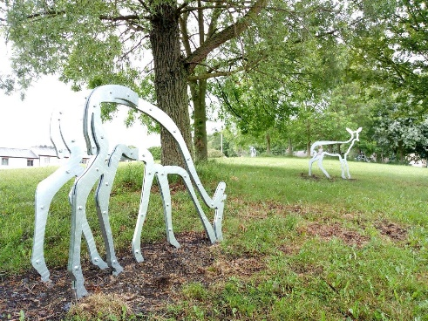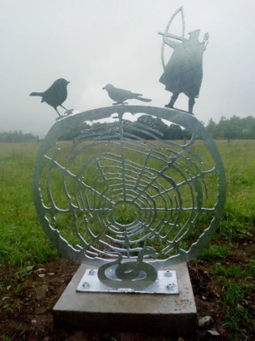
3.0 GREEN & BLUE INFRASTRUCTURE FUNCTIONS AND THEMES
The concept of ‘Multifunctionality’ is central to the Green Infrastructure (GI) approach, referring to the potential for GI to have a range of functions and to deliver multiple benefits. The following 8 main themes have been identified as being of relevance and importance to GI development in Ashfield.

3.1 BIODIVERSITY
Green Infrastructure provides habitat to support a wide variety of species and can play a key role in reversing the decline in biodiversity. Investing in GI can protect and enhance existing habitats, reverse habitat fragmentation through the creation of new green space (or the enhancement of existing green space) and increase biodiversity to support healthy ecosystems.
Species losses can have severe repercussions for the complex and often fragile ecosystems which connect all living things. Key threats have been the intensification of agriculture and the pressure for built development.
The importance of biodiversity is not an issue confined to rural areas. Nationwide wildlife surveys by the RSPB and others confirm that urban Green “Infrastructure is now critical for biodiversity, with species such as hedgehogs, frogs, songbirds, and butterflies thriving in the leafier parts of towns and cities.” Grey to Green, CABE Space (2009)
Furthermore, by supporting urban ecosystems, a wider range of species will inhabit areas close to communities, providing greater access to nature. This access can promote a greater awareness and understanding of the importance of biodiversity. The value of green infrastructure for biodiversity is worthy of consideration and it is also important for the health and wellbeing of the human inhabitants. State of Nature (2019)

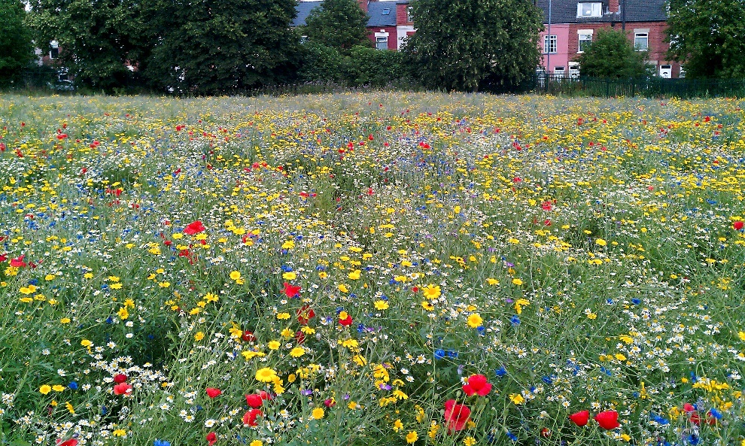
Wildflower meadows at Titchfield Park, Hucknall

3.2 ACCESSIBILITY AND SUSTAINABLE TRANSPORT
Green spaces have long been thought of as the “green lungs” of towns and cities, providing a network of restorative green space. To function in this way, it is vital that green spaces are well connected and easily accessible to as many people as possible.
Although green space is often thought of in terms of parks and open spaces, there are a range of linear green features, which provide important functions encouraging sustainable transport within and between communities. Footpaths, cycle trails, river / canal corridors and tree-lined streets, provide pleasant environments which can encourage people to walk or cycle as a realistic alternative to using vehicular transport. These green and blue routes can connect larger areas of green and blue space and can also provide everyday routes between homes, places of work, schools, shops, and other local services.

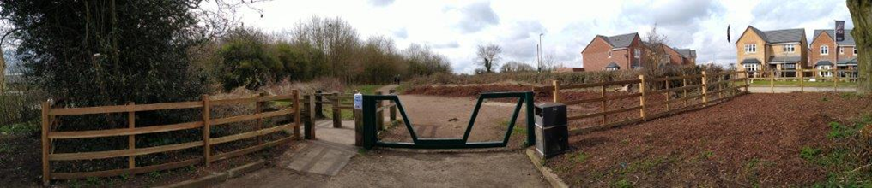
Brierley Forest Park access improvements

At the larger scale, recreational trail networks can provide popular tourist attractions, bringing people into an area and encouraging communities to explore their surroundings and develop a closer relationship with the natural environment.

3.3 RECREATION
“Recreation and amenity is one of the more widely recognised functions of green space. “East Midlands Regional Assembly, Green Infrastructure Scoping Study. Parks and green spaces provide areas and facilities for physical recreation, such as children’s play and formal and informal sports. They also provide a setting for more passive forms of recreation, such as walking, socialising, and appreciating nature. Linear green infrastructure offers recreational opportunities such as walking, running, cycling and horse-riding as outlined in 3.2.
Recreational opportunities that are easily accessible and freely available can have a positive effect on both the physical and mental health of local communities (see 3.5). Without good quality green spaces, the opportunity for these activities can be severely limited.

3.4 CLIMATE CHANGE AND ENVIRONMENTAL QUALITY
As a result of climate change, it is predicted that there will be an increase in both frequency and strength of storms, floods, heat waves and droughts in the future which will incur significant economic, social, and environmental costs. Green Infrastructure (GI) is an important tool for reducing the effects of climate change and can assist in adaptation, including flood attenuation, water management, the migration of species, and drought tolerant landscapes.
The floods of 2007 caused £10 billion worth of property damage in the UK. “Subsequent flooding in 2016 caused £1.6 billion worth of property damage “.Estimating the economic costs of the 2015-2016 winter floods (Jan 2018) Environment Agency. As climate change leads to more torrential rainstorms, GI can help to protect against flash flooding. Trees intercept rainfall and slow the rate of run-off, while green space can be used as a temporary storage area for flood water.
Green Infrastructure can contribute to the reduction of water pollution, through the natural processes of sedimentation, filtration, and biodegradation to remove pollutants. This can have a positive effect on the biodiversity of rivers and streams.
Tree canopies can contribute to reducing the ‘heat island effect’ (higher temperatures in urban areas caused by the amount of hard surfaces) thereby reducing the need for the use of cooling systems as well as water supply treatment. Carbon savings associated with this have been calculated to be considerably greater than the amount absorbed directly by urban trees through photosynthesis. The UK's new record-high temperature of 40.3°C at Coningsby, Lincolnshire in July 2022, has been confirmed by the Met Office. Average UK temperatures are predicted to rise by up to 4°C this century, but research by the University of Manchester shows that a 10% increase in the urban tree canopy cover would cancel out this increase. CABE website: Grey to Green campaign
Species choice in public planting can reduce the need for watering during dry periods, cutting down water usage.
When positive water management is planned and delivered correctly, GI can greatly reduce the speed and volume of water reaching drains, sewers, and water courses, helping to conserve water and reduce the severity of flooding events.
Careful choice of aquatic and marginal planting can help trap, filter out or reduce contaminants released to the environment, thus helping to improve water quality. Blue infrastructure is important for recreational activities such as walking alongside rivers and streams, and active sports such as sailing. Biodiversity, GI, and blue infrastructure combine to create habitats for migratory species and aquatic life.
Sustainable Drainage Systems or SuDS often form part of new developments and are designed to slow the water flow after rain events, creating new habitats, reducing water pollution, and enhancing and creating recreational opportunities. They can take the form of green roofs and walls, rain gardens, soakaways and permeable pavements .
In order to achieve positive water management, at a strategic level correct water management within GI should:
- Work as part of drainage and wastewater management plans
- Aim to reduce flooding at catchment and local scales, working with natural processes
- Protect groundwater from over exploitation, improve water supply and quality
- Provide water to create new or enhance existing wetland habitats and water courses
- Minimise water pollution and improve water quality
- Improve Climate Change Resilience of freshwater habitats and species
At a local level GI should:
- Help connect recreational, natural green and blue spaces
- Prioritise native species and ensure biosecurity principles are adhered to avoid spreading non -native invasive species and diseases
- Use water to enhance public open space for a variety of appropriate recreational uses, ensuring potential conflicts are managed
- Provide positive water management through Sustainable Drainage Systems (SuDS), ensuring responsibility for long term maintenance of SuDS is clearly identified. Natural England GI principles 2022
Rising energy costs mean that travel and food will continue to increase in cost. Attractive GI routes can encourage people to walk and cycle more, thereby reducing the use of cars and consequent CO2 emissions. Allotment sites provide the opportunity for local food production, also contributing to reduced emissions.
In 2017, urban green and blue space in Great Britain removed 27,900 tonnes of 5 key air pollutants. The avoided health costs were estimated at £162.6 million, with 70% of the avoided costs due to the positive effects of urban woodland Greenspace can also control the flow and distribution of air pollution. People’s exposure can be substantially reduced through carefully positioned green infrastructure that incorporates the right type of vegetation, separates people from pollution by introducing barriers and extends the distance between the pollution source and individuals . Redesigning road and pavement layouts, delivering well-designed urban greening schemes, and providing active travel routes through greenspace all help reduce exposure to air pollution and improve health. Improving access to greenspace 2020 review

3.5 HEALTH AND WELL- BEING
There is a wealth of research which demonstrates the positive contribution that green surroundings can make towards improved physical and mental health.

Green space provides the opportunity for a range of physical activities (see 3.3), all of which can help to promote more active lifestyles and improve physical health. High quality green routes can encourage people to walk or cycle, rather than using the car, which can help combat the risks associated with a sedentary lifestyle. It has been shown that people who are physically active reduce their risk of developing major chronic diseases by up to 50% and the risk of premature death by up to 30%. NHS, 2018
Public Health England’s Improving access to greenspace:2020 diagram below Improving access to greenspace 2020 shows the ways in which greenspace and GI may be linked to positive health outcomes.
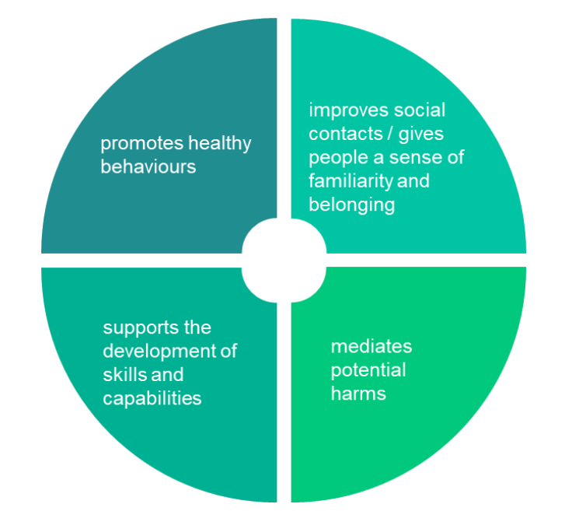
The review states “improving access to quality greenspace has the potential to improve health outcomes for the whole population. However, this is particularly true for disadvantaged communities, who appear to accrue an even greater health benefit from living in a greener environment. This means that greenspace also can be an important tool in the ambition to increase healthy life expectancy and narrow the gap between the life chances of the richest and poorest in society.”
Green infrastructure also offers other health benefits such as reduced incidences of respiratory illness, improved mental health and reduced stress. Natural spaces improve social cohesion and can help bring communities together. Research in the Netherlands found that city dwellers living near parks are healthier and suffer less depression than those not living near green space. The positive effect of green surroundings was greatest for people with low levels of education and income. Grey to Green campaign, CABE website.

A further health benefit can be achieved where Green Infrastructure resources are used to grow vegetables and other crops (whether in private gardens, allotments, or community gardens/orchards) providing both exercise and a source of fresh food.

3.6 GROWTH AND INVESTMENT
Investment in Green Infrastructure can help to attract external investment and improve the performance of the local economy. Improvements to public spaces in town centres have been shown to boost commercial trading by up to 40%, while high-quality green spaces can increase resident property values by 5–7%. Grey to Green campaign, CABE website
“For residents, workers and businesses high quality environments can be a catalyst for regeneration and community ownership, a focus for education, training and volunteering and stimulate job opportunities by attracting investment and tourism. There is evidence that spending time in green space can also benefit employees and students as it is associated with improved motor skills, better academic performance, and increased concentration.” Natural England GI principles 2022.
As well as affecting existing land values and businesses, the physical environment has a strong impact on external perceptions of an area and high-quality GI can encourage inward investment and help to create employment areas that are attractive to both businesses and potential employees. This impact on public perception can also be used to increase tourism (see 3.8).

3.7 SOCIAL
Green Infrastructure can provide a wide range of social benefits to local communities, through for example meeting friends and neighbours when out walking, sports provision, volunteering opportunities on green spaces and the use of allotments.
By providing space that is freely accessible to communities, social interaction is encouraged which can promote social networks and relationships, combating social exclusion and increasing the capacity of communities to support themselves and others.
Green spaces play an important role in hosting social events such as fairs, festivals, and fun days, which can bring communities together and provide positive celebratory occasions that can have a significant impact on perceived quality of life.
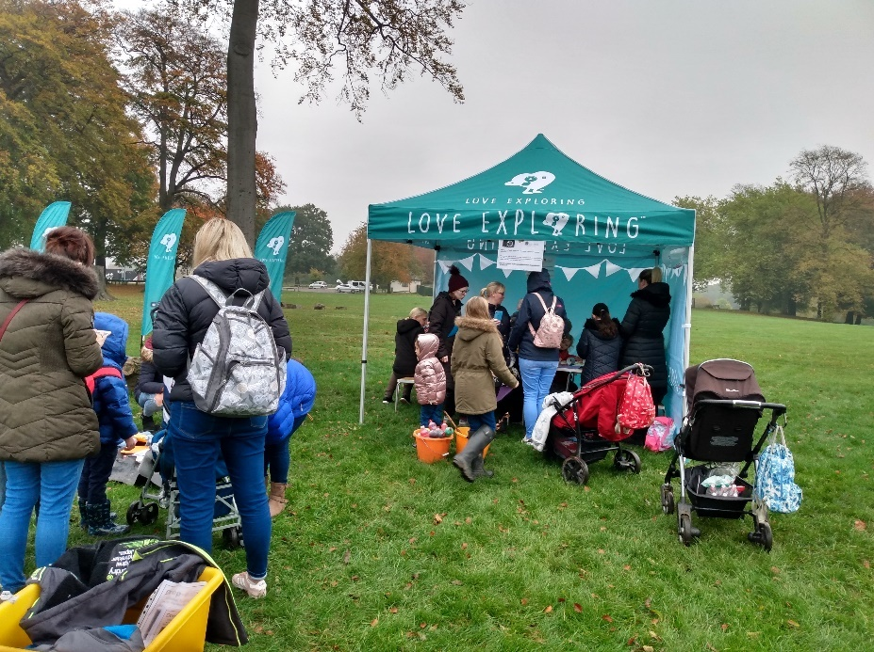
Mill Waters Harvest Festival Love Exploring Launch event
The relationship between residents and their local green spaces can often foster strong feelings of attachment, and improvements to Green Infrastructure can improve feelings of local pride and satisfaction. Conversely, the loss or neglect of open space can have severe negative effects on residents’ perceptions of their neighbourhood.
Green Infrastructure can provide an important educational resource for children and adults to learn about biodiversity, understand their local environment and develop new practical skills. School grounds can offer a range of curriculum related activities, while public space can also act as an ‘outdoor classroom’ and a way for schools to engage with their wider community.
Spaces for play have an important educational role and activities can support the development of children’s physical and social skills. Informal play opportunities provide a context for imaginary and creative play as well as developing an awareness of the natural environment. Play has a vital role in developing an understanding of personal risk, through activities that are challenging and social interaction.

3.8 LANDSCAPE AND CULTURE
The visual elements of Green Infrastructure are a fundamental element in defining the rich and varied character of landscape, as experienced by people. The effective use of Green Infrastructure can deliver landscape character enhancement, restoration, and re-creation. It is important to accommodate and managing change to retain the landscape characteristics and benefits that society and local communities value. This can contribute to creating a clear and distinctive sense of place which reinforces local identity and can help to foster belonging and attachment among communities. This can be of particular importance in areas such as Ashfield which have undergone significant economic change, resulting from the decline of coal mining, and quarrying followed by subsequent restoration work.
Green Infrastructure resources can also form important elements of local cultural and historical heritage. Revealing and exploring these cultural values within spaces can further support the development of a strong sense of place, local identity and feelings of pride and respect.
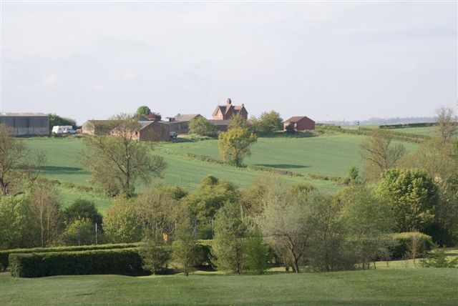
Rural view in Selston
The cultural and landscape benefits of Green Infrastructure can be vital to the development of successful tourism investment, either directly through the promotion of high-quality green space destinations, or indirectly through their contribution to strong local identities which can be used to promote the area. This also has an incidental effect for other forms of investment as outlined in section 3.6.
Natural England’s Green Infrastructure Principles 2022 state that “Comprehensive design for good GI should consider the following:
- Biodiversity/ nature recovery
- Health
- Carbon storage / sequestration
- Water - flood regulation, supply, and quality
- Soil protection and enhancement
- Air quality, noise, and temperature regulation
- Pollination
- Food production - community orchards, allotments, urban food
- Aesthetic value / sense of place
- Education
- Interaction with wildlife / access to nature
- Recreation / active travel
Understanding the landscape setting and character of a place is a key part of good design, and essential to ensure that new GI responds appropriately to place. Good quality GI needs strong governance and a long-term strategic approach to management, funding, monitoring, and evaluation. This means considering stewardship of GI from the outset and designing GI for long-term sustainability on site ”.

4.0 METHODOLOGY

4.1 AUDIT OF EXISTING GREEN INFRASTRUCTURE
To develop a spatial Green Infrastructure framework for the District, data and information was gathered from a variety of sources in 2013 to provide an accurate picture of the current state of Ashfield’s Green Infrastructure. This comprised a mixture of written documents, mapped data, and consultation/stakeholder feedback.
Sources in 2013 included the following:
- Ashfield Green Space Strategy, (2008), Ashfield Play Strategy (2007) and Ashfield Playing Pitch Strategy (2008)
- Ashfield Nature Conservation Strategy, 2003
- 6C’s GI Strategy, 2010
- Local Biodiversity Action Plan for Nottinghamshire, 1998.
- List of Local Sites, Nottinghamshire Biological and Geological records Centre, updated 2009.
- Greater Nottingham Landscape Character Assessment, TEP Consultants, 2009.
- Population & socio-economic data, ONS & IMD.
- Nottinghamshire Rights of Way Improvement Plan
- Mapping of existing GI assets across the district
- Information from neighbouring authorities

This information was mapped electronically and collated using Geographical Information System (GIS) existing Green Infrastructure resources on a range of themes, which could be contrasted and compared with each other by overlaying the mapped data. (See Figures 8.1 to 8.9)
As part of the preparation of this Strategy, the Public Open Space Strategy 2016 – 2026 (which replaced the Ashfield Green Space Strategy 2008) has been checked against the Green Infrastructure and Biodiversity Technical Paper (2013) to ensure consistency with the existing methodology and subsequent findings.

4.2 DEVELOPING A GREEN INFRASTRUCTURE FRAMEWORK

Vision

To provide a multi-functional network of green spaces for communities and wildlife ,which will deliver economic, social, environmental and health benefits, helping to create a sustainable future for Ashfield.
Analysis of Green Infrastructure provision in Ashfield was undertaken based on the eight themes identified in Section 3.
Many Green Infrastructure strategies at a larger scale use a methodology of scoring land, based on a quantitative assessment of its multifunctionality. At a district level, it was felt that such an approach was inappropriate and that a more reflective approach was required. Many of the datasets available become less reliable at a smaller scale and overlook local detail and complexity which makes a purely quantitative analysis of the information impractical. Scoring methods also risk overlooking sites which are particularly valuable for specific themes (for example geographically remote SSSIs) and can underplay the local conflict between functions which can sometimes make increasing multifunctionality at a local level unfeasible.
Therefore, instead of using a scoring method, the information was analysed visually, in combination with site visits and local knowledge and experience.
The key aims of the spatial analysis were:
- To identify existing networks and connections between Green Infrastructure resources, which contribute to a cohesive Green Infrastructure framework
- To identify key areas of opportunity to enhance or strengthen this framework
The themes of biodiversity and access were used in the first instance to establish an outline framework, which was modified and refined as the remaining themes were considered against it.
The framework identifies specific areas where existing resources have the potential to enhance the network by widening the range of functions they offer. Most commonly this could be through increasing access to a natural green space, or by enhancing the ecological value of currently low-value spaces. These opportunities are often achievable by existing landowners, managers and stakeholders through physical improvements, changes in management practice and the engagement of existing and potential user groups.
The framework identifies areas with potential for new Green Infrastructure to complement or complete the existing network. These opportunities will be predominantly delivered through the development process and opportunities arising out of it (although may also be made possible through grant funding opportunities).
Alongside the spatial mapping analysis, working practices, policies and initiatives were also considered. This qualitative analysis was particularly valuable in identifying opportunities for enhancing the value of Green Infrastructure on a wider basis.
  - THE GREEN INFRASTRUCTURE FRAMEWORK
The Green Infrastructure Framework comprises a hierarchy of Green Infrastructure corridors which link GI resources together as well as connecting to people and neighbourhoods. The corridors may either represent linear Green Infrastructure resources, such as rivers or cycle paths, or they may indicate a series of green accessible spaces which although not connected, form an identifiable ‘chain’ of green space along which passage is possible for either people or wildlife (or both).

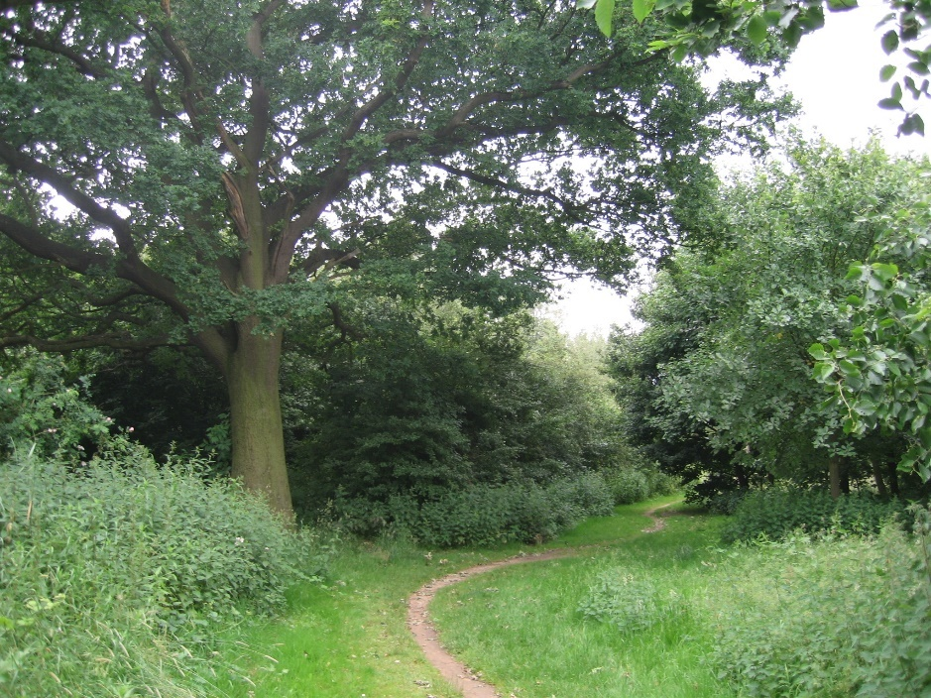
Green path
Although not all GI functions are appropriate for consideration in terms of a network of corridors, the development of this framework is an important part of the Green Infrastructure Strategy, particularly in terms of biodiversity and public access.
As connections and networks were identified, it became clear that a hierarchy was appropriate to distinguish between the main strategic corridors that cross the district (connecting settlements or major GI resources and extending into neighbouring authorities) and the more local corridors in the urban areas, which link neighbourhoods with green spaces and connect them to the broader strategic network.
A fundamental consideration when developing the framework was ensuring that strategic resources and corridors were well connected with local communities via local links, to create a comprehensive network which directly benefits local communities as well as providing the wider scale benefits of GI.
Although corridors are ideal for connecting areas of green space for walkers and cyclists as well as allowing more mobile wildlife to migrate to new sites, they are of little value to less mobile species. For this reason, green spaces need to be as large as possible, with interesting or rare habitats and species identified, protected, and monitored. Specific areas within green spaces also need to be set aside to encourage greater diversity, allowing the build up of species and populations which will then allow them to migrate through connecting features such as hedgerows, rivers, and other green corridors.

Natural England GI Principles 2022 states that “at a local level GI should:
- Thread different types and sizes of spaces through local GI networks
- Create a variety of habitats and facilities to supplement larger initiatives
- Aim for variation in the density and layout of GI
Aiming for variety also has the added benefit of creating the right conditions for the wider involvement of interest groups and individuals in the planning and delivery of GI”.
5.0 Ashfield GREEN & BLUE INFRASTRUCTURE in Context
This overview has been developed through a review of relevant plans and documents and an audit of Ashfield’s Green Infrastructure.
Each of the 8 themes identified in Section 3 are discussed within the context of the District, beginning with a description of the current position.

5.1 BIODIVERSITY
Ashfield is recognised as one of the most bio-diverse areas in Nottinghamshire, due largely to its varied geological context of Magnesian limestone, Triassic sandstone (to the east) and coal measures (to the west). It is an area heavily scarred by the industrial development of recent centuries, which has both damaged and fragmented habitats, while also creating new opportunities for wildlife in the form of disturbed and restored sites.
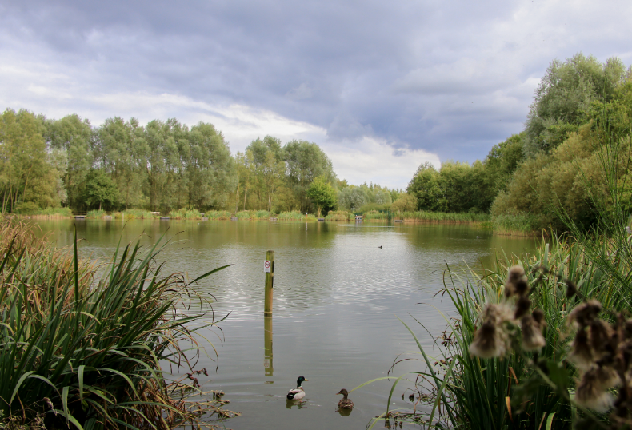
Brierley Forest Park: Brierley Waters
The District supports a broad range of habitats, including heathland, ancient woodland dumbles, calcareous grasslands (often on post-industrial sites) and fields rich in wildflowers. The west is characterised by small fields and streams, while the east and south contains large blocks of tree planting. The rivers and streams within the district provide habitat for significant populations of watervole and native crayfish.

5.1.1 Local Designations
The District contains several habitats and species types that are considered to be important, very important and unique in a County context.
Ashfield has nine Sites of Special Scientific Interest (SSSI), representing some of the County’s richest habitats and covering 125 hectares. These are spread across the area, and are based on varied geology of limestone, coal measures and sandstone. SSSIs are protected by specific legislation which includes a requirement for positive management.
Local Wildlife Sites (LWS) formerly known as Sites of Importance for Nature Conservation (SINC) are locally designated wildlife sites incorporated into the planning system for protection. They represent sites that are of at least County-wide importance and form a crucial framework of ‘stepping stones’ for the migration and dispersal of species. Sites are identified and surveyed by the local Biological and Geological Records Centre, based on criteria set by the Nottingham Local Sites Panel. Nottinghamshire Biological and Geological Record Centre

Local Nature Reserves (LNR) are sites under the control of the local authority, designated in consultation with Natural England to encourage public access and enjoyment of the natural environment. Ashfield currently contains four LNRs: Portland Park, the Teversal to Pleasley Railway, Brierley Forest Park and Kings Mill Reservoir as well as one on the boundary with Nottingham City (Bulwell Hall Park Meadows).
Local Geological Sites ( LGS) are part of a national system to raise the profile and offer some protection to sites that contain important examples of the local geology and geomorphology. Ashfield has 12 of the 133 recognised LGS in the county which are currently protected as LWS. Nottinghamshire LGS Criteria Nottinghamshire Biological and Geological Sites Panel Feb 2018 Nottinghamshire Biological and Geological Sites Panel LGS criteria .These sites are identified for future protection as part of the Ashfield Local Plan.

5.1.2 The Nottinghamshire Biodiversity Action Plan
Nottinghamshire Biodiversity Action Group is a partnership of voluntary, statutory and community groups working together to conserve and enhance the wildlife of Nottinghamshire.
The Local Biodiversity Action Plan (LBAP) for Nottinghamshire identifies the key priorities for species and habitat conservation in the County, focusing on habitats considered to be of conservation concern and priorities for protection, restoration, and re-creation. The priority habitats identified for Nottinghamshire are listed below.

Woodlands
Wet broadleaved woodland
Oak-birch woodland
Mixed ash dominated woodland
Planted coniferous woodland
Parkland and wood pasture

Waterways and wetlands
Reedbed
Fen, marshes, and swamps
Eutrophic standing waters
Mesotrophic standing water
Rivers and streams
Canals
Ditches

Grassland
Improved grassland
Lowland wet grassland
Lowland neutral grassland
Lowland dry acid grassland
Lowland calcareous grassland

Other
Ancient and/or species rich hedgerows
Farmland
Lowland heathland
Urban and Post-industrial habitats

All priority habitats have their own action plans to maximise the impact on the plants and animals that rely on them for food and shelter. Most of the species of conservation concern will benefit from these Habitat Action Plans. However, a small number of species have their own action plans, chosen because of their specific needs, which may not be picked up under habitat work, or because of their popularity. The latter act as flagship species to help promote biodiversity and include otter, water vole and barn owl.
A list of species of conservation concern for Nottinghamshire can be found at: Notts BAG website.
In 2008, the Nottinghamshire Biodiversity Action Group resolved to produce a Biodiversity Opportunity Map for the County. As of 2022, the map is nearing completion and will identify opportunities for improving habitat condition and connectivity across Nottinghamshire. The outcomes of the project will help to underpin the wider work of Nottinghamshire Biodiversity Action Group, which is the Local Biodiversity Action Plan partnership for Nottinghamshire. The mapping project is being undertaken in sub-areas of the county where funding has been made available. A biodiversity opportunity map has been created for Ashfield Nottinghamshire Biodiversity Opportunity Mapping Project Ashfield District 2016 along with Broxtowe, Gedling, Rushcliffe, Sherwood, and the Trent Valley.

5.1.3 Local habitat characteristics
Ashfield contains a broad range of habitat types, including ancient woodlands, limestone grasslands, and the wetlands of the Erewash and Leen rivers.
- Grasslands
The District has the greatest concentration of remaining permanent grasslands in the County. However much of the grassland in Ashfield, as throughout Nottinghamshire, has been either converted to arable land or agriculturally improved through re-seeding or sprayed with herbicide. Within the county, unimproved lowland grassland is estimated to have suffered a loss of between 97% and 99% since 1930 (Nottinghamshire BAG, 1998).
Acidic grasslands in Ashfield represent a significant area of the total remaining of this type of habitat in Nottinghamshire. Sites such as Holly Hill, Selston are characterised by fine leaved grasses such as wavy hairgrass and sheep’s fescue along with herbs such as heath bedstraw and sheep’s sorrel. The continued presence of acid grassland is often threatened by a reduction in grazing (a traditional management technique), encroachment of scrub and bracken and nutrient enrichment caused by, among other things, dog fouling.
Ashfield is also an important area for Calcareous Grasslands / Magnesian Limestone, which is a nationally uncommon habitat type. This special type of limestone grassland is characterised by flowering herbs and grasses, such as Frog Orchid and Rockrose. The finest remaining grasslands are associated with scarps, former quarries, and embankments and many have been designated as sites of regional and county importance, such as Kirkby Grives and Annesley Woodhouse Quarry.
Several grasslands around Annesley, Bagthorpe, Stanley and Huthwaite retain plant communities characteristic of old unimproved neutral hay meadows and grazed pastures in concentrations of small fields and along streamsides. These support a characteristic rich flora and species of a high conservation value such as Yellow Rattle and Saw-wort.
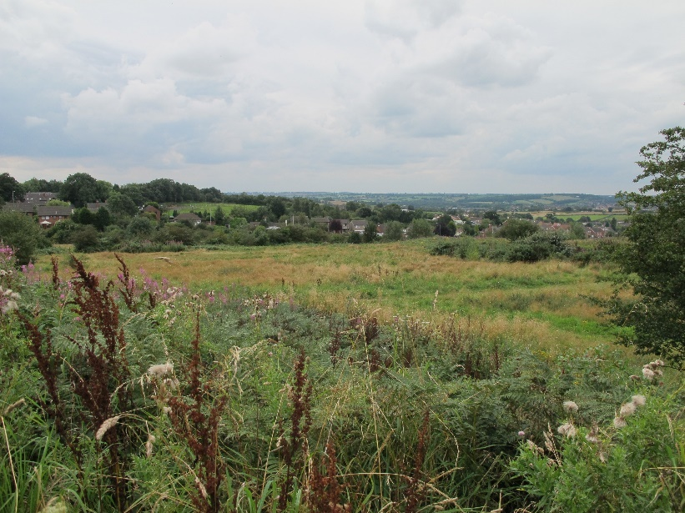
Holly Hill Grassland

- Woodland and hedgerows
Ashfield has a broad diversity of woodland types from ancient woodlands to coniferous plantations, many supporting flora and fauna of high conservation interest.
Ancient Woodlands are defined as woods known to have been in existence since the year 1600. Ashfield has over 12% of the ancient woodland recognised within the county and some of the finest examples in Nottinghamshire are found in the district. These are centred on the northern ancient county boundary, the eastern Thieves Wood, the western Valley Woods and in the central and southern woods of Millington and Morning Springs.
Damp and wet woodlands are also important and support their own special communities of flora and fauna. They are found where the water table is close to the surface or next to streams and rivers. Relic areas of once typical Oak and Birch woodlands on sandstone also survive, and this reflects what were the western-most parts of the old Sherwood Forest.
Several large forestry plantations are found within the district, including Thieves Wood and Annesley Woods. The latter is promoted as a public site, offering an important opportunity for people to visit and experience local woodland habitats. At Thieves and Harlow Woods coniferous plantations support county important moth species such as Map-winged, Gold Swift, Cream Wave and Scorched Wing.
Thieves Wood
Hedgerows provide an important refuge for wildlife and act as corridors for animals and plants to move and live along. Some of the oldest hedgerows mark parish or estate boundaries, or the line of old highways. In Ashfield, they are an important feature of the landscape, especially in the west where there are several ancient examples. Hedgerows in parts of the District are steeply banked along narrow lanes which make them special within Nottinghamshire.

- Water Habitats ( Blue infrastructure)
“Four major river systems begin in Ashfield, (The Erewash, Leen, Maun and Meden), and these form an essential ecological network of important wildlife sites across much of the County, and into Derbyshire.
Although Ashfield does not contain significant lengths of water courses, the River Erewash, and the River Leen are identified as sub-regional Green Infrastructure corridors”. Green Infrastructure Scoping Study, East Midlands Regional Assembly.
Tributaries for both rivers extend into the district forming a network of habitat corridors which often pass through urban areas and their communities (although often culverted). This offers a significant opportunity to connect people with these rich habitats and increase their potential where restricted by past development. The Leen and its tributaries are, for example, a habitat for native crayfish (a national priority species).

Naturally occurring bodies of water are otherwise uncommon in Ashfield. Where they occur, they support notable populations of amphibians and aquatic flora and fauna. Field flushes and drains support unusual plant communities such as Ragged Robin and Marsh Marigold and many rare species including sedges and fern, which have a restricted distribution in Nottinghamshire, and rare and protected species such as the Great Crested Newt.
Open water features such as King’s Mill Reservoir, Brierley Waters and the lake at Sutton Lawn are important for wintering wildfowl. King’s Mill Reservoir also supports a significant reed bed. Such habitats are uncommon in Nottinghamshire and are of notable conservation value, particularly for the survival of threatened species such as Water Vole.
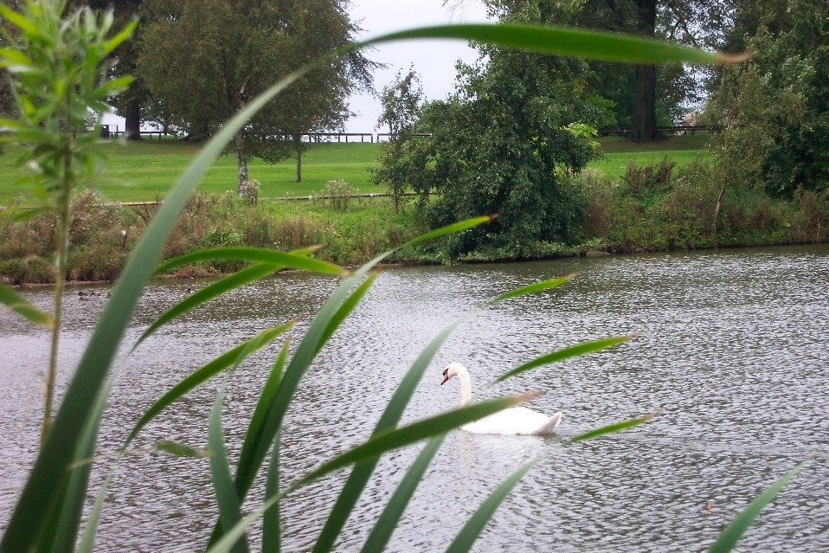
Lake at Sutton Lawn
- Disturbed sites
Coal heaps, former quarries, railway land, post-industrial sites, and related open areas, provide some of the most valuable habitat for flora and fauna in the District. Often such sites are characterised by a rich diversity of native and introduced species. Large numbers of plant species have exploited these sites and formed communities ranging from short ephemeral grassland to scrub, which in turn supports a wide range of invertebrates, mammals, and birds. Some of the sites in Ashfield support unusual communities and rare plants. Coal heaps may display Bee Orchid and Autumn Gentian, whilst providing a habitat for Grass snakes, Sky Larks, and Little Ringed Plover.
- Lowland Heathland
Lowland heathland is a nationally rare habitat, and a European priority habitat. In Nottinghamshire, over 90% has been lost since the 1920’s. In Ashfield there are good examples of heathland in the east of the district where it forms a habitat mosaic with acidic grassland. Such habitats support rare species, particularly exceptional invertebrate fauna, and provide important and diverse breeding habitats for birds, including national BAP species such as Nightjar.

5.1.4 Other habitat areas
As well as the priority habitats within the Local Biodiversity Action Plan, there are other elements of Green Infrastructure which contribute to the network of habitats and natural spaces. In terms of achieving a cohesive GI network for wildlife these spaces can be particularly valuable, providing stepping stones or connections within densely populated urban areas and in many cases, providing the most accessible way of experiencing nature for communities.
- Golf Courses
Golf courses in Ashfield, such as Coxmoor and Hollinwell have often been designed around existing landscape features prior to significant agricultural improvement, and hence preserve semi-natural habitats. They therefore retain many original habitat features, and some are designated as LWS.
New courses that have been developed have provided additional areas of planting which, as they develop, will add to biodiversity. In many cases these plantations form important links between large blocks of established woodland.
Golf courses are usually privately owned, and do not always provide access to the public.
- Churchyards and Cemeteries
These sites may have relatively diverse grassland communities and bats may inhabit the church buildings.
- School Grounds
Most schools have some green space and although traditionally this has tended to be relatively sterile in terms of wildlife value, many are increasingly incorporating opportunities for habitat creation and enhancement. This is often linked to the curriculum, along with areas for food production.
- Private Gardens and Allotments
These areas are particularly important within urban settings and have been shown to provide considerable wildlife interest. There has been a trend towards encouraging wildlife into gardens in recent years, typified by the popularity of media campaigns. In view of the limited amount of standing water within Ashfield, garden ponds can be vital for some populations of breeding amphibians.
Allotments have enjoyed a revival in recent years, with increasing demand. Allotment societies tend to encourage environmentally friendly or organic cultivation methods and allotments provide a rich food source and breeding opportunities for many bird species (particularly where hedge boundaries between plots have been retained).
Cumulatively gardens and allotments can provide significant areas of connected Green Infrastructure and form the most significant framework of green space in many of the urban areas of the district.
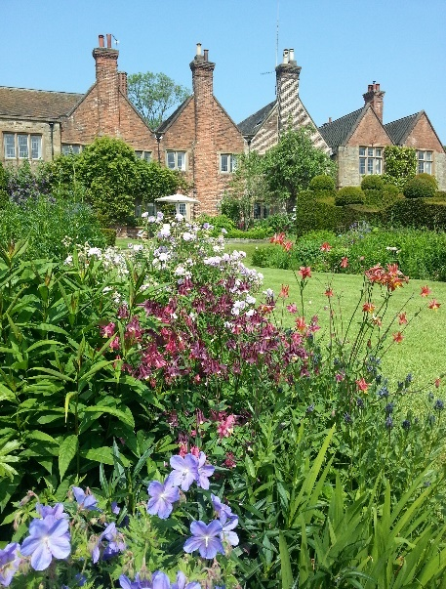 Felley Priory Gardens
In a few areas of the district, parts of gardens in suburban areas have been sold for house building. The issue of ‘Garden-grabbing’ can damage the character of an area, reduce the amount of green space, and potentially interrupt wildlife corridors. NPPF paragraph 71 advises that local policies should be in place to prevent this practice, where it is deemed to be a problem.
- Parks and green spaces
All parks and green spaces can help support and improve biodiversity. Examples of areas rich in biodiversity are the country parks; Brierley Forest Park and Portland Park, as well as areas within urban parks, for example the lake area and woodland within Sutton Lawn and the meadow areas at Titchfield Park, Hucknall.
Alternative management methods are increasingly being explored and trialled to increase the biodiversity value of these spaces which have been traditionally maintained for recreation and public amenity, often to the detriment of biodiversity.
- Wildlife Corridors
These are particularly important in relation to connecting areas of wildlife interest as well as being habitats in their own right. Areas such as roadside verges, railway lines and footpaths form a network of wildlife habitat across much of the District. Verges, gardens, and street trees provide wildlife habitats which can provide important links through urban areas.
- Railway Lines
Railway lines have the potential to support species rich wildlife communities. Disused railway lines support some of the most diverse assemblages of native plant species in the District and can provide important wildlife corridors. Some of these now provide recreational routes, for example the Teversal Trails. The scale of operational and disused railway lines in the district which are remnants of the area’s industrial past provide a considerable existing and potential source of biodiversity.
- Buildings and Structures
Many buildings and structures can provide opportunities for wildlife, such as bats, swifts, barn owls and kestrels. New buildings may offer opportunities for habitat creation through for example green roofs, or the provision of nesting areas or insect habitat.
- Agricultural Landscapes
Due to modern farming methods, such as the use of chemicals and removal of hedgerows to create larger fields, agricultural land tends to have low biodiversity. However, Countryside Stewardship grants have encouraged landowners to manage areas for nature which has resulted in greater biodiversity in some areas.

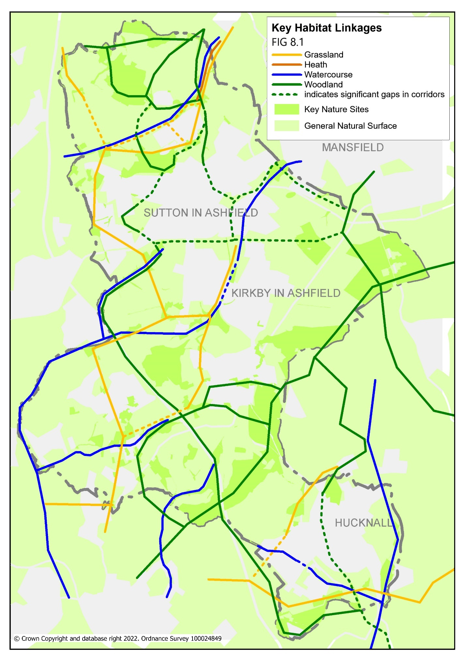
Figure 8.1 Key habitat linkages

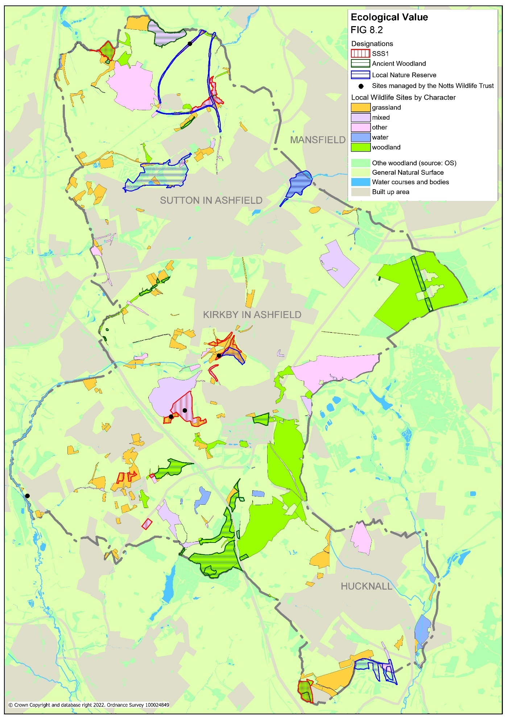

Figure 8.2 Ecological value

5.2 ACCESSIBILITY AND SUSTAINABLE TRANSPORT
There are relatively low levels of car ownership within the district in comparison to other areas in North Nottinghamshire, which means that good access to green space for pedestrians/cyclists (and via public transport) is of particular importance. North Nottinghamshire Accessibility Strategy (2006-2011).
There are several existing strategic and local off-road recreational routes which provide good cycling and walking opportunities and connect to green space and other route networks. Ashfield District Council and Nottinghamshire County Council have upgraded and created a significant number of routes around the District and worked with other partners to improve links into neighbouring areas. Examples include: the Brierley Branch route which links from the northern end of Brierley Forest Park into Derbyshire, the Teversal and Silverhill Trails and the Leen Valley.
These routes often follow former railway lines, a network of which cross the District and provide an excellent opportunity for developing linear green spaces, as well as contributing to a distinctive local character reflecting the areas industrial past. These are supported by a network of formal Rights of Way (see link below), some of which pass through or adjacent to green spaces.
The distribution of recreational routes is uneven across the District, with most formal recreational routes located in and around Sutton-in-Ashfield and Kirkby-in-Ashfield. These routes connect green spaces such as Silverhill, Kingsway Park and Portland Park and are also well connected to trail networks in neighbouring authorities, such as the Five Pits Trail into Derbyshire and the Lower Linear Route into Mansfield - see link below
Ashfield and Mansfield Trails West
In Hucknall, both strategic recreational routes and Rights of Way are less common, with the main exception of the National Cycle route which passes though the east of the town, although considerable stretches of this follow the highway rather than a green corridor. There are several large natural green spaces on the outskirts of Hucknall, but these are not well connected at present. There are several promoted routes in the countryside around Hucknall (the Robin Hood Way and the Hidden Valleys Trails), but again these are poorly connected to the existing green spaces of the town. Works to develop the Leen Corridor as a strategic recreational route were undertaken in 2011/12 to create stronger links to the rest of Hucknall, helping to address this deficiency.
Outside the main urban areas, there is a similar disparity in the distribution of Rights of Way. The rural areas around the villages of Selston, Underwood and Jacksdale are well served by a network of Rights of Way, but there is a notable lack of routes in the area to the east of Kirkby and Sutton (leaving Thieves Wood poorly connected to the residential areas of the District).
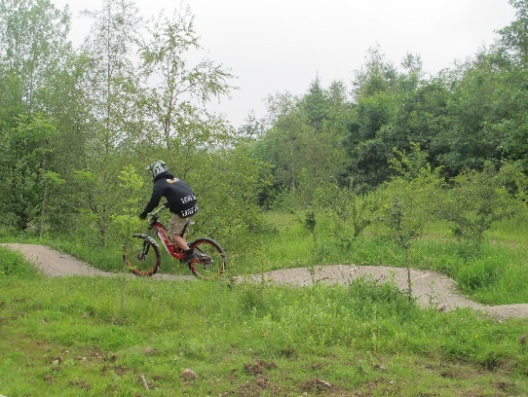
Mountain biking in Brierley Forest Park

The provision of a comprehensive network is limited by gaps and barriers, such as major roads, river corridors and railway lines. Overcoming these barriers and gaps is a priority in improving access across the district. Several important green infrastructure resources just outside the District also have the potential to be much better connected to the communities of Ashfield, including Hardwick Hall, Newstead Abbey, and the Erewash and Cromford Canals.

5.2.1 Nottinghamshire Rights of Way Improvement Plan
The Rights of Way Improvement Plan 2007-2012 (ROWIP) for the County, produced by Nottinghamshire County Council provided an assessment of how local Rights of Way meet the present and likely future needs of the public.
The aims of the ROWIP included protecting, maintaining, and enhancing the network; improving access, including for those with visual impairment and mobility problems; improving the safety and connectivity of the metalled road network with the Rights of Way network; increasing awareness of accessing the countryside and enhancing and increasing community involvement in managing and improving the network.
During consultation for the 2007-2012 ROWIP, several issues arose which are of particular relevance to the development of Green Infrastructure.

- There is a particular demand for circular walks and rides close to where people live.
- Walkers, riders, and cyclists primary requirement is a safe, traffic-free environment. Safe crossing where routes crossroads is a particular concern.
- Users face a range of problems that include poor signage, obstructions to the route (including stiles and gates), gaps in the network (or long stretches of road walking), poor off-road provision for cyclists and equestrians, and a lack of respect for the countryside (including littering and dog fouling).
- There is a need to promote the network (including permissive routes and open spaces) as people are often unaware of the access and recreation opportunities available.

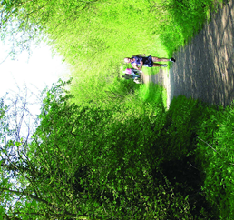 Brierley Forest Park

As a result of a subsequent consultation with stakeholders towards the end of the 2007-2012 ROWIP plan period, the County Council decided to publish a revised and updated plan in order to provide a long term strategy for how Nottinghamshire’s public rights of way network would be managed for the following eight years.
As a result of feedback from stakeholders and users of the ROWIP, the document was changed from Rights of Way Improvement Plan to Rights of Way Management Plan and is referred to as the Rights of Way Management Plan 2018-2026 or ROWMP2. Nottinghamshire County Council Rights of Way Management Plan 2018 - 2026

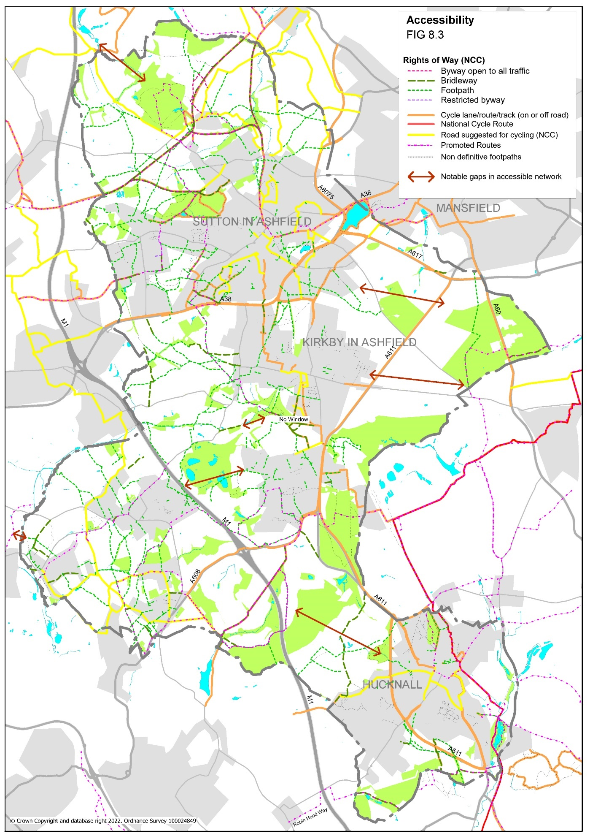

Figure 8.3 Accessibility

5.3 RECREATION
Recreation provision is one of the main areas of focus for Ashfield’s Public Open Space Strategy 2016-2026. In 2013, Ashfield’s Green Space Strategy 2008 analysed the provision of recreational green space across the district and provided guidance on areas of deficiency and oversupply, as well as an assessment of the quality of provision, based on the standards in place at that time. This strategy was supported by the Playing Pitch Strategy (2013) which considered the demand for formal sports pitches and opportunities for provision through the development planning process. The Green Space Strategy was replaced by the Public Open Space Strategy 2016 - 2026 which was adopted in 2020. The Playing Pitch Strategy (2013) was replaced by the Ashfield Playing Pitch Strategy 2017-20

Ashfield Standards for access to green space (Catchment areas).
Public Open Space Strategy 2016 - 2026
No person should live more than
- 480 metres (6-minute walk) from their nearest neighbourhood park / green space
- 1000m (12–13-minute walk) from their nearest destination park / green space
- 480m from their nearest area of natural green space
There is relatively good provision across the District, although there are opportunities to improve provision within Sutton, Hucknall and the Rurals. This issue is being addressed through the provision of several large areas of green space within new housing developments and should continue to be addressed through the Local Plan process.
The District has a good distribution of recreation grounds, large areas of open space usually with football pitches laid out, often including a play area and space for informal recreation. These provide a framework of recreational space, which is supported by more specific provision on main town parks (including cricket pitches, bowling greens and tennis courts) and private sports clubs.
The recreational value of many local green spaces has been greatly enhanced in recent years through the addition of new facilities, such as ball courts (also known as ‘multi-use games areas’ or MUGAs, suitable for five-a-side and basketball), kick walls, skate parks, outdoor gym facilities, trim trails, and BMX trails. The distribution of these facilities continues to be informed by Public Open Space Strategy 2016 - 2026 (which also considers recreational provision for teenagers).
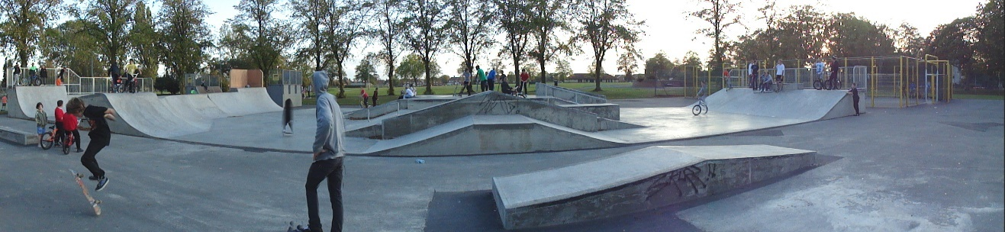
Titchfield Park Skatepark
Facilities for specific sports are more difficult to locate, requiring larger areas of land, and often attracting larger numbers of users by car from a wider area. In terms of District Council owned facilities, there is recognition that combining multiple facilities on single sites is a more efficient means of provision, reducing the number of changing rooms required, which have considerable maintenance implications. At present many of the District’s formal pitches are single pitches each with their own changing facilities. The provision and management of these facilities is guided by the Ashfield Playing Pitch Strategy 2017-20. Where opportunities arise, larger sites capable of co-locating several pitches are being developed.
While the provision for site-based recreation has already been considered by the Public Open Space Strategy 2016 - 2026, the Green Infrastructure and Biodiversity Strategy provides an opportunity for the consideration of more linear forms of recreation (such as walking, cycling and horse-riding).
Many spaces which have recreation as their primary function offer limited value in terms of other green space benefits. The mapping and analysis of Green Infrastructure has revealed a considerable opportunity to increase the multifunctionality of these spaces through changes to their design or management. Most of these spaces are within local authority ownership providing opportunities for flood mitigation and improvements to visual appearance and accessibility.

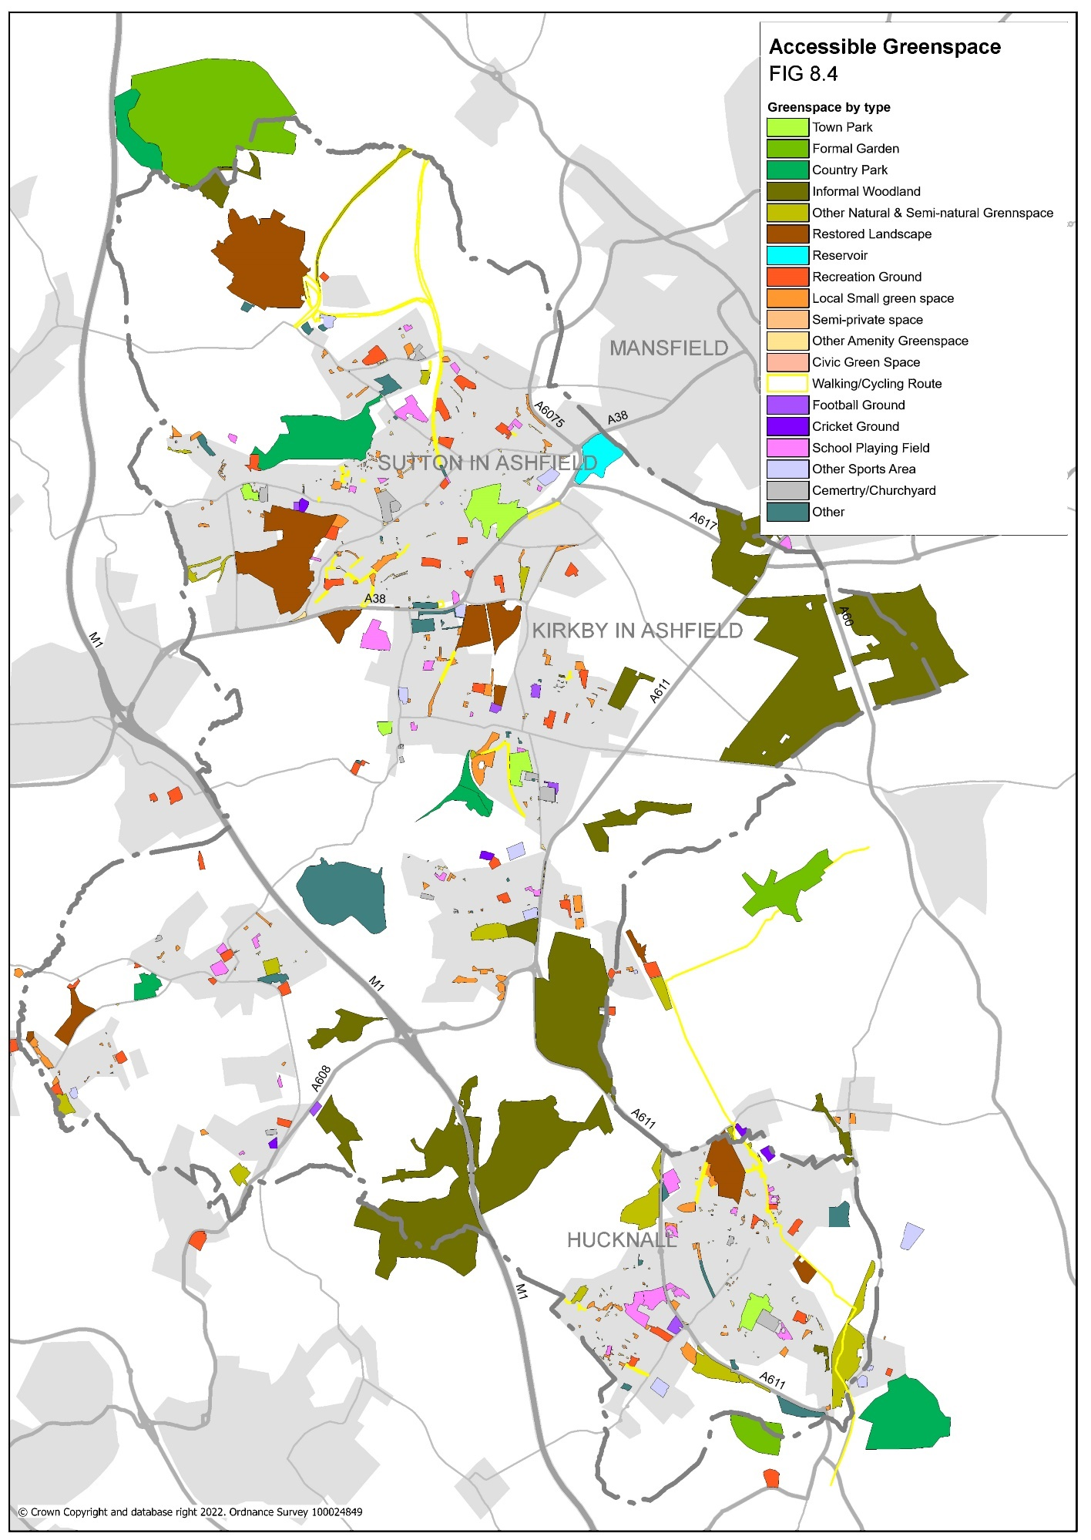
Figure 8.4 Accessible Green Space

5.4 CLIMATE CHANGE AND ENVIRONMENTAL QUALITY
The greatest risks to the District temperature increase, severe weather, and flooding. These remain constant climate change risks.

- Temperature increases and reduced rainfall in summer
Agricultural fields, parks, green spaces, and private gardens are likely to suffer during drier summers, with increased pressure on water supply. The Council will need to adapt the choice of plant species, using drought tolerant plants and reducing the amount of bedding plants which require frequent watering.

Homes, offices, and schools are likely to become uncomfortable in high temperatures, but this can be addressed, where practical, through the use of tree planting to provide shade and reduce internal temperatures.

- Severe weather and high winds
Extreme weather may damage buildings and facilities. Tree planting can help to alleviate some of these problems by creating wind breaks.

- Flooding
Flood damage in Ashfield was significant in June 2007 with serious flooding to some roads and homes. A number of houses and gardens throughout the District were flooded and major routes, including sections of the MARR (Mansfield and Ashfield Regeneration Route) were also hit by severe flooding. A study commissioned to assess the capacity of the current water infrastructure to accommodate growth without adversely affecting the environment, as part of preparation for the Local Plan (Outline Watercycle Study for Greater Nottingham & Ashfield), identified minor parts of Sutton in Ashfield, Annesley Woodhouse and Hucknall with medium to high probability of flooding. However, this principally reflects flooding from watercourses. The anticipated impact of climate change is an increase in the severity of storms. This increases the risk of flooding from surface water flowing off impermeable surfaces within urban areas. (Of the 55,000 properties damaged in the floods of the summer of 2007, two-thirds were flooded by surface run-off overloading drainage systems). There were also flooding events in 2020.

There are many ways in which pressure on drainage infrastructure can be alleviated through the design of green space and the modification of water courses. Projects such as the naturalisation of a formerly culverted section of the River Maun in 2004 and 2013, along with Titchfield Park Brook in Hucknall increase the capacity of the landscape to deal with flooding conditions, as well as creating bio-diverse environments for the public to enjoy.
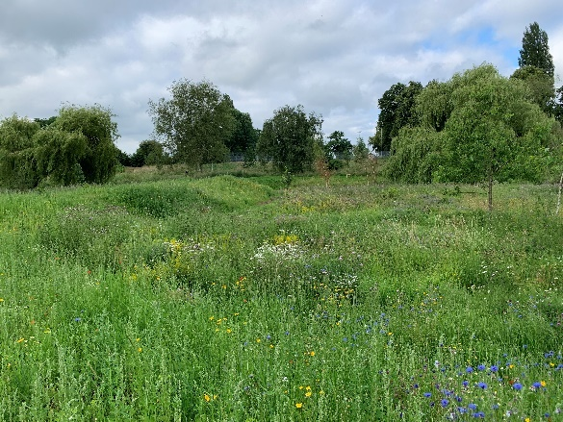
Tichfield Park. Stream culvert opened up and rewilded.
There are a significant number of culverted water courses within the District, some of which run through existing green space, providing the potential for a similar approach. Other forms of Sustainable Urban Drainage Systems (SuDS) also have the potential to help address drainage issues, such as the system of overflow storage areas on residential estates in northwest Hucknall. These offer areas of green space which can store large amounts of water in storm conditions, but which also perform other green-space functions when not in use, for example for recreation and wildlife.

National planning policy and guidance requires that development incorporates SuDS, unless there is clear evidence that it would be inappropriate. SuDS aim is to mimic the natural environment’s response to rainfall, usually by incorporating natural elements at the ground surface which reduce the flow of water offsite. It provides opportunities for creating and connect valuable areas of blue-green infrastructure. The Environment Act 2021 has introduced a requirement for new development to deliver at least a 10% increase in biodiversity net gain (BNG). This reflects an approach to development, and/or land management, which enhances the biodiversity value and SuDS can contribute considerably to BNG through a water enriched habitat.

5.5 HEALTH AND WELL-BEING
Poor health is an important issue within Ashfield, with average life expectancy lower than the regional and national averages and infant mortality significantly higher. Teenage conception rates are also higher than national averages.
The District falls below the national average for both higher education and income levels and has higher rates of ill health.
The District’s Ashfield Health and Wellbeing Partnership Strategy Be Healthy, Be Happy, 2021 – 2025 is being implemented through a partnership approach to address health inequalities and encourage residents to lead more active lifestyles.

The Council is improving sports facilities on parks and open spaces, through refurbishing existing courts and pitches and encouraging more informal use, through the provision of multi use ball courts, skate parks, outdoor gym areas and play areas for younger children.

Free provision on parks and green spaces is a particularly important element of increasing activity in Ashfield due to the high levels of deprivation, poor health, levels of obesity and the below average salaries of working residents.

“Greener environments are also associated with better mental health and wellbeing outcomes including reduced levels of depression, anxiety, and fatigue, and enhanced quality of life for both children and adults. Evidence indicates that people who report feeling more ‘connected to nature’ tend to have a more positive outlook on life (positive affect), increased vitality, life satisfaction, feelings that life is worthwhile and of personal growth compared to those who feel less connected.” Improving access to greenspace - new review for 2020 Public Health England

Allotments can be a good way for people to enjoy the outdoors, increase exercise and eat more healthily. There are substantial waiting lists for allotment sites within Ashfield and additional sites need to be provided through new housing developments.

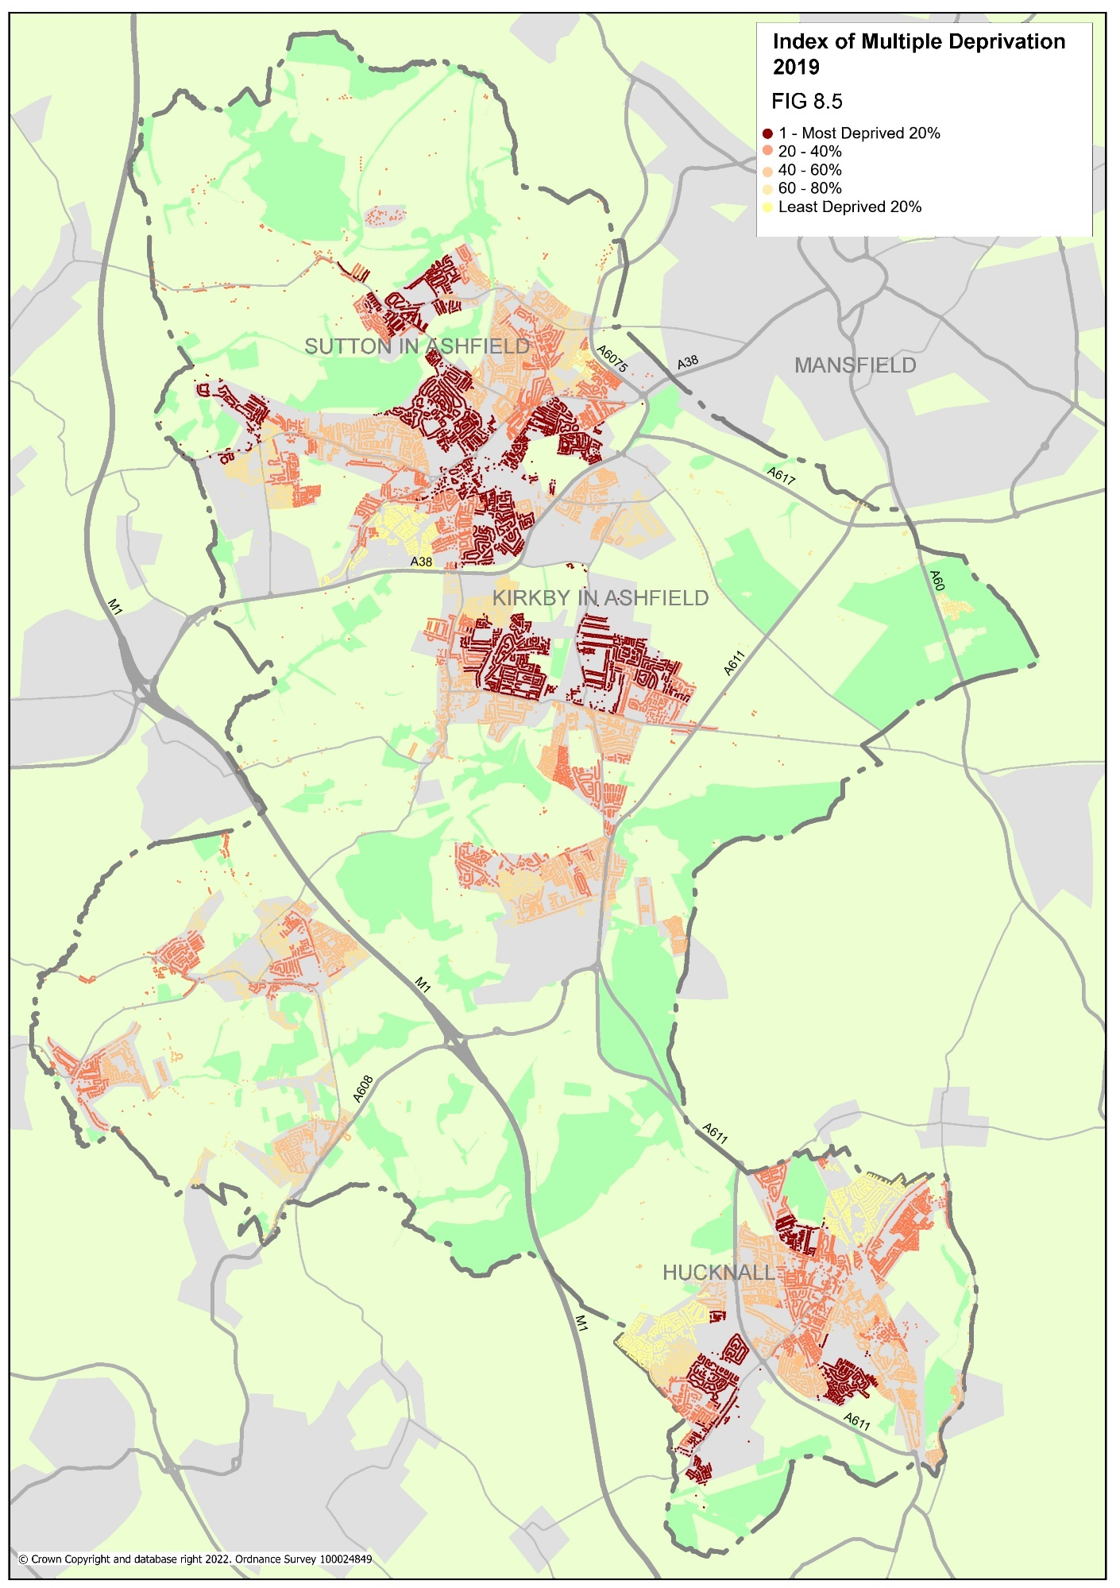
Figure 8.5 Deprivation in Ashfield

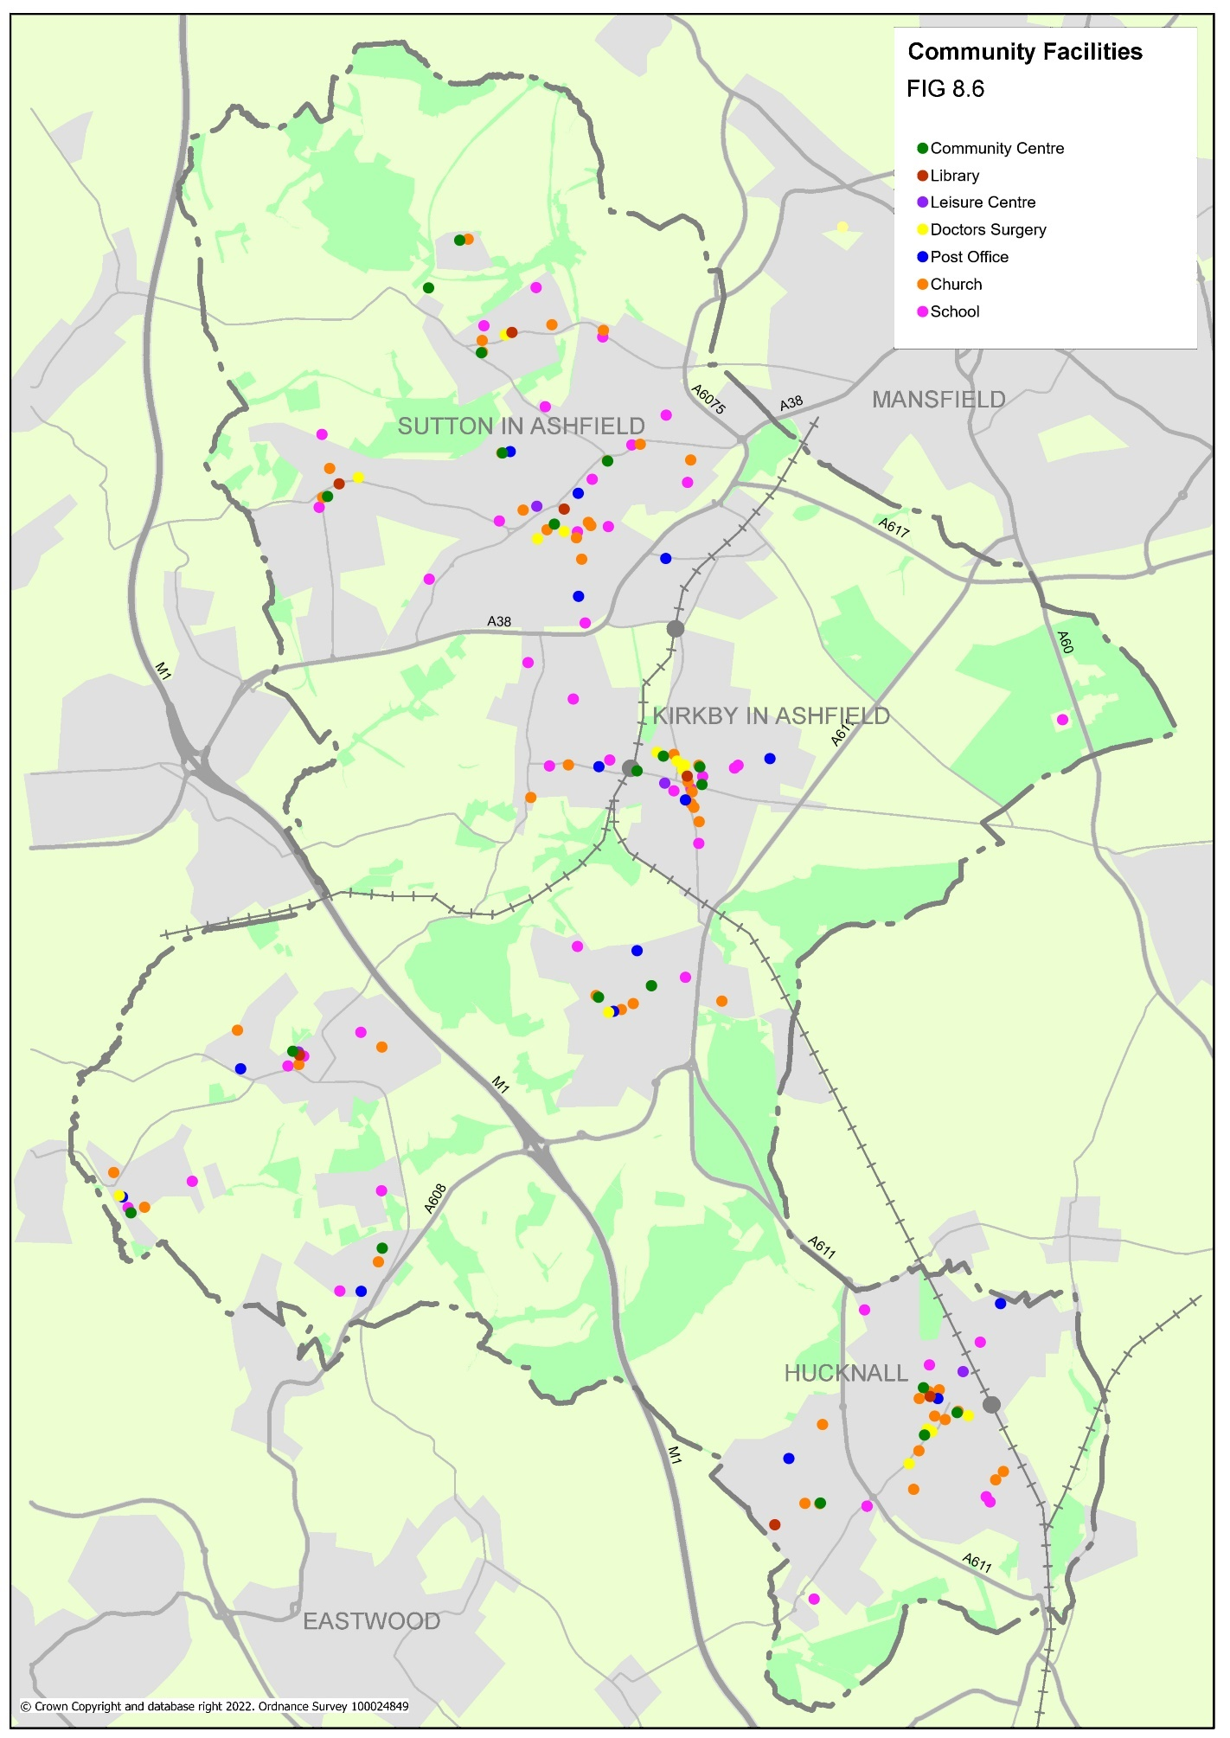
Figure 8.6 Community facilities
5.6 GROWTH AND INVESTMENT
Ashfield has a history of industrialised wealth from coal mining and textiles, but both industries declined in the 1980’s creating high unemployment and widespread deprivation. Although new employment opportunities have grown, unemployment rates are higher, and earnings are significantly lower than regional averages.
The Local Plan makes provision new homes. Using GI as a planning tool will help to ensure that this planned level of growth can be delivered in a sustainable manner.

Green Infrastructure can play an important role in helping to improve perceptions of the district and to attract investment. For example, Sherwood Business Park, developed in the late 1990’s adjacent to Junction 27 of the M1 has been designed around a Green Infrastructure, comprising lakes, wooded areas, and footpaths with good public transport links around the park. The business park also provides an important gateway into the District. These type of gateway sites provide opportunities to improve the overall appearance of the district, creating a positive image and helping to attract further investment.
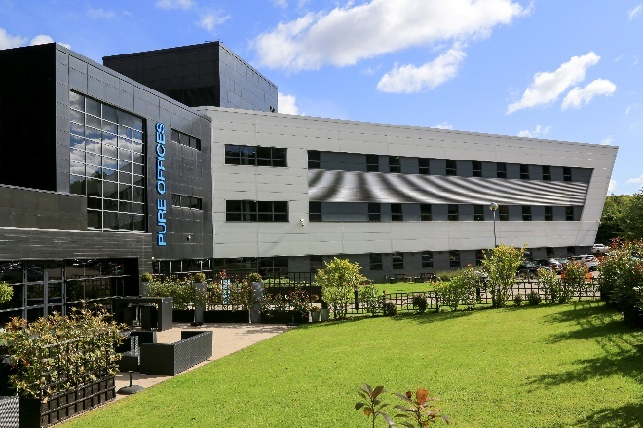
Sherwood Business Park
The ‘Ashfields’ residential estate in Sutton is designed around green routes and open spaces with ponds and other habitat, creating an attractive environment for people to live and encouraging walking and cycling.
Strategic development of Green Infrastructure can contribute towards the District’s tourism offer, enhancing the area's overall image as an attractive destination. Specific benefits include the potential development of nature-based and activity-based tourism utilising an enhanced network of high-quality green routes. An example is the trails network which has been developed linking Brierley Forest Park with trails into Derbyshire. This link into an established tourist destination has helped to attract visitors to the park from outside the District.

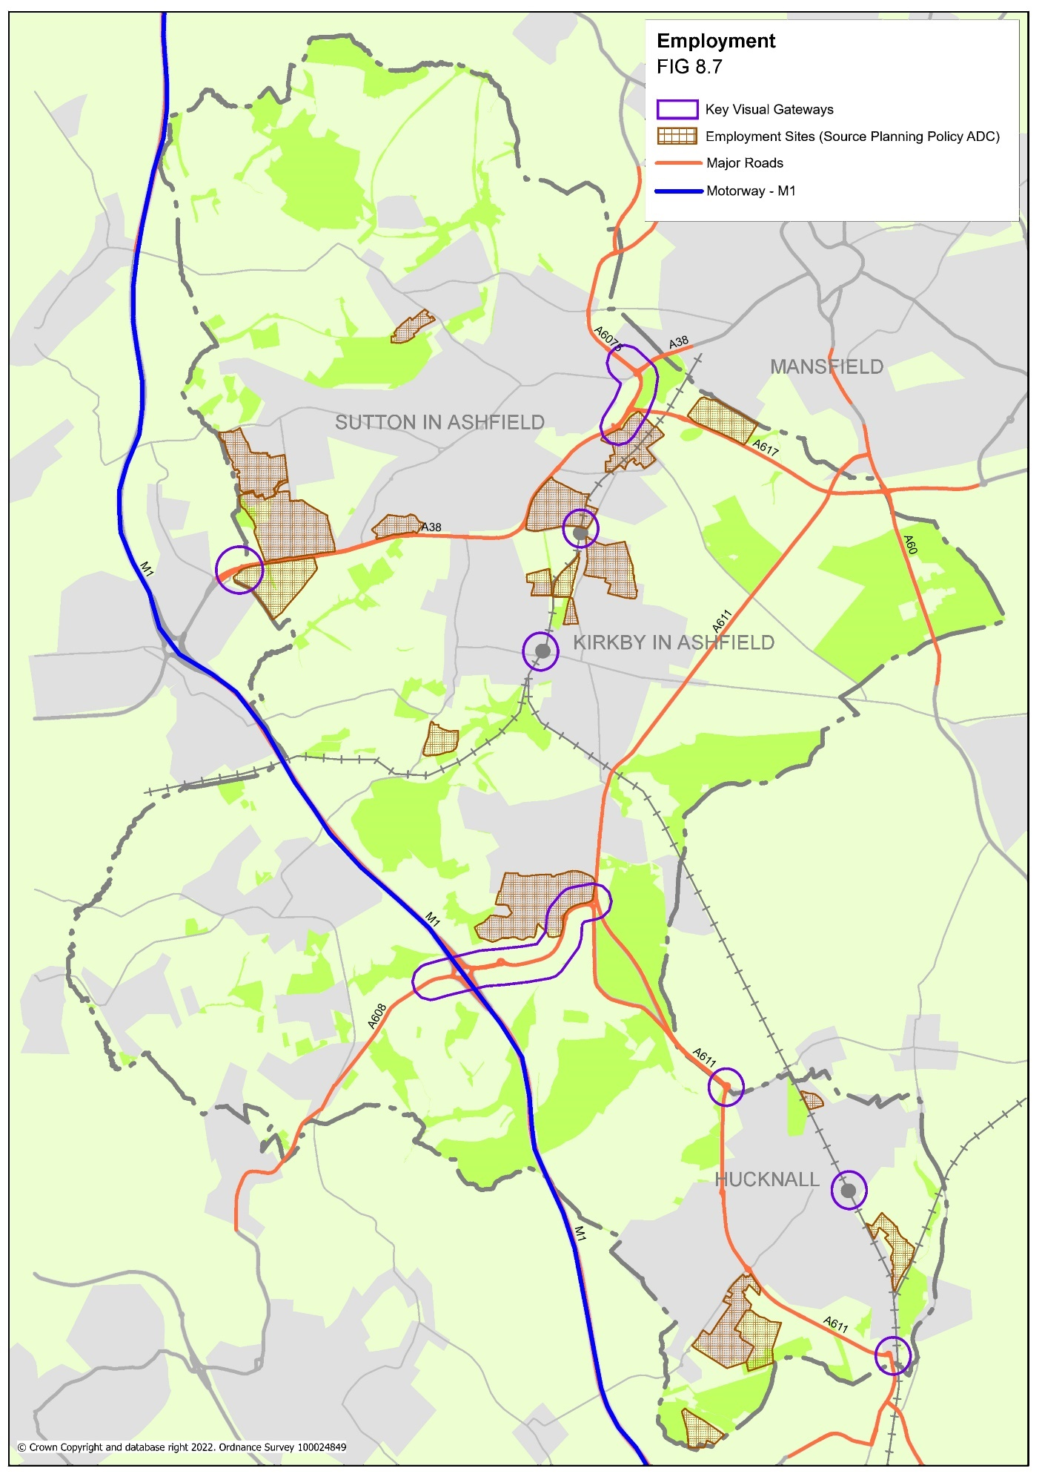

Figure 8.7 Growth and Investment

5.7 SOCIAL
Ashfield is an area with considerable inequalities among its residents. Within the District there are pockets of considerable deprivation, largely attributed to the decline of the mining industry. Deprivation is accompanied by typical societal characteristics, such as low education attainment, low car ownership and poor health. Green Infrastructure offers a unique, free opportunity to help address many of these issues through the range of benefits it can provide.
Ashfield is also an area which has experienced considerable change in recent decades as inward migration to new housing developments in the main settlements has expanded the population considerably. Green Infrastructure offers a means to help encourage social cohesion between existing and new communities, providing public realm space for events, celebrations, activities, and socialising.

5.7.1 Community groups and events
Ashfield District Council has undertaken an extensive community mapping exercise to identify the extent of community activity in the District. Many of the groups identified are associated with Green Infrastructure in some form and can be broadly grouped as; friends groups, residents groups, volunteer groups, interest/campaign groups, activity groups, support groups, asset management groups and educational organisations.
In addition to relationships between formal community groups and Green Infrastructure, there are also a number of more informal ways that the community benefits socially from GI in Ashfield.
Parks and green spaces provide a key venue for events, on land owned by the authority, including festivals, fairs, concerts, and fun-days.

5.7.2 Play
Spaces for play offer an important social function for child development. Ashfield District Council manages 49 play areas across the District’s open spaces and maintains a further 13 in the rural areas owned by parish councils. The Public Open Space Strategy 2016 – 2026 aims to improve the quality of play areas and to promote their organised use and promotion.

5.7.3 Local Pride
Green Infrastructure plays a vital part in the way people view their neighbourhood. Along with street cleaning, it is one of the main ways that the public judge the quality of their local environment. Ashfield holds 6 Green Flag Awards (the national standard for green space management) for the main parks and open spaces in the District. The Council has committed to further improvements to secure the seventh park to meets the Green Flag standard and the hope is, 2023 will bring seven awards for the District.
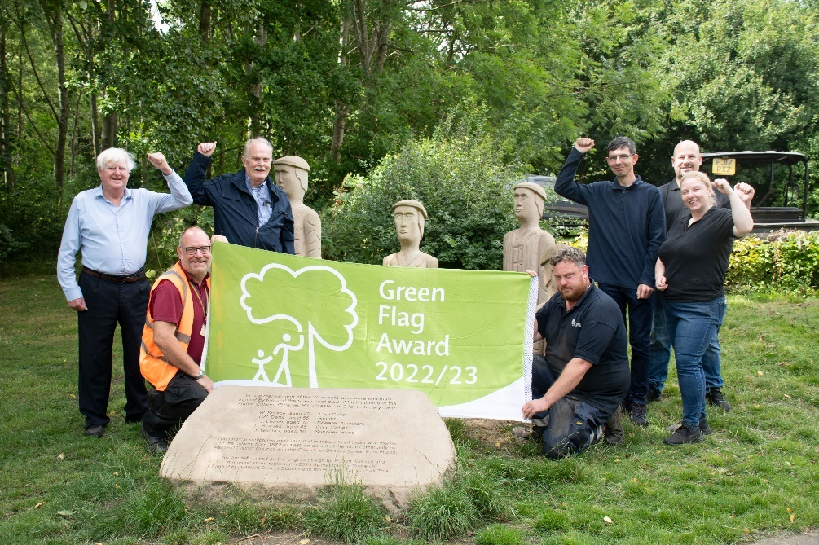
Green Flag Award : Brierley Forest Park

    - Education
GI sites form an important educational resource, providing opportunities for learning about the natural environment and there are a range of opportunities which could be provided at other sites across the District, particularly within the country parks and main town parks.

5.8 LANDSCAPE AND CULTURE

5.8.1 Landscape
The District has been shaped by a combination of underlying geology, its industrial past and management of the land over centuries. A Landscape Character Assessment for Greater Nottingham was undertaken in 2009 and identified 3 main distinctive landscape types within Ashfield (Appendix 2):
- Nottinghamshire Coalfields
An area heavily influenced by industrial activity with landscape features such as former spoil tips. A complex mix of built-up areas, industrial land, dereliction and farmed open countryside, with substantial areas of intact agricultural land, many areas of woodland and semi-natural vegetation. A generally low landscape, with variable hills, escarpments, and broad valleys.
Exceptionally important Coal Measures grasslands occur at Huthwaite, Bagthorpe and Selston. The wet areas support locally important populations of Water Vole, Grass Snake and Great Crested Newt.

- Magnesian Limestone Ridge
Sandy Limestones and marls form a ridge that ascends the country from near Nottingham through Ashfield District, where it is very obvious and outcrops to the east of the M1. This is of major geological importance in its own right and in regard to the impact that it has on habitats. Ancient woodland on the Magnesian Limestone is rich in woody species with Bird Cherry, Whitebeam, Wild Service-tree, and Yew. There is a diverse ground-flora in these woods including BAP species such as Bluebell, Herb Paris, Toothwort, and the only site in the county for Mountain St John's Wort. Many of the older hedgerows are rich in shrubs with Buckthorn, Spindle, and wild Berberis. Magnesian Limestone supports a rare type of grassland classed together with those of the Cotswold and Northamptonshire/Lincolnshire Oolitic Limestones. In Ashfield, it occurs where steep natural banks make it difficult to plough and on post-industrial land especially disused railway embankments and cuttings. Both the limestone and the Coal Measures are well-watered with numerous small streams.

- Sherwood Region
Located to the east of the Magnesian Limestone Ridge, this area comprises Permo-Triassic sandstones which rise as low hills along the eastern edge of the ridge. This sandstone formation is visible throughout the Sherwood Region at points where it is exposed in cuttings, sites of mineral extraction and natural breaks in the landform such as rivers. Here the soils are dry, poor, light, and pebbly and susceptible to windblow.

As part of the Landscape Character Assessment, recommendations for actions were provided for each local character area, which provide guidelines for protecting or enhancing the distinctive landscapes of the district. The landscape character of the district is also divided into more local character areas (Appendix 2).
The majority of the Landscape Character Assessments identified the Landscape Strength as moderate to good (with some poor). Almost all recommendations were to ‘enhance’ the existing. The Ashfield Local Plan Review (Adopted 2002) policy related to landscape is mature landscape areas Policy EV4 ALPR 2002.

5.8.2 Culture
Ashfield has a rich industrial and cultural heritage which contributes greatly to its overall character and local values. Notable themes and people include textiles, mining and engineering, D. H. Lawrence, Lord Byron, Ada Lovelace, the composer Eric Coates, the bare-knuckle fighter Ben Caunt and England cricketer Harold Larwood.

Ada Lovelace: Mathematician and writer

A number of landscapes in Ashfield have recognised historical significance, with nine scheduled ancient monuments and two Registered Historic Parks and Gardens, together with six conservation areas and a significant number of listed buildings and local heritage assets.

With the exception of the listed buildings and local heritage assets, the majority of these features are publicly accessible, providing opportunities to link to the Green Infrastructure network and providing informal recreation and enjoyment of open space. Although not always GI resources themselves, Ashfield’s cultural assets were included in the mapping, to ensure that connections and access to them are improved as part of the GI network.
Examples of cultural assets that form an integral part of the GI network include:
- Restored pit sites – Ashfield’s mining history has left a distinctive landscape of spoil heaps throughout the District. Many have been restored to accessible natural green space over the past thirty or so years and form an important and distinctive element of the overall local Green Infrastructure. Features such as reclaimed pit-wheels and commissioned art works evoke a sense of their past role in the local community, for example at Brierley Forest Park.
- Skegby Hall Gardens - an important example of Georgian 18th century Picturesque style garden design largely developed from 1797 onwards. Many of the original features of the garden have been lost such as the water garden, boathouse, and Temple of Peace, but the ponds and a significant proportion of the original tree planting survive.
- The River Leen – this river corridor connecting Hucknall to the City of Nottingham has a strong association with the cotton industry in the late eighteenth and early nineteenth centuries, with remnants of cotton mills to be found along the eastern edge of Hucknall, including the restored Papplewick Dam at Moor Pond Wood, just outside the district.

Other cultural assets within the district include Annesley Old Church (Grade I Listed Building) and Annesley Hall (Grade II Listed Building), both of which are set in Annesley Hall Park and Garden (Grade II* Listed), St. Mary Magdalene Church, Hucknall (Grade II* Listed Building) - where Lord Byron is buried, Church of St. Katherine, Teversal (Grade I Listed Building) and the wharf area on the Erewash corridor in Jacksdale where coal from the local collieries was loaded from the railways onto barges for shipment on the Cromford Canal.

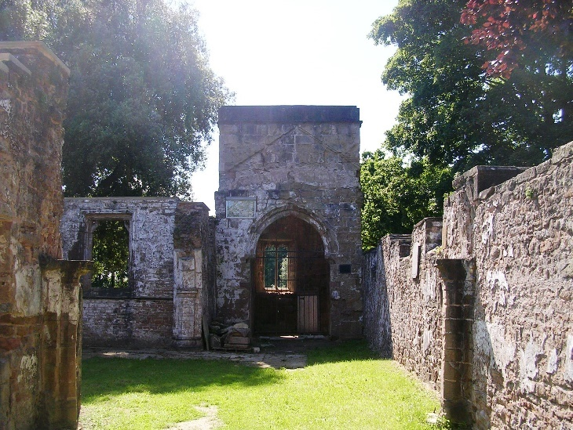
Annesley Old Church
As well as protecting and enhancing, there are also a number of important cultural sites just outside the boundary of the District, including two Grade I Historic Parks and Gardens: Hardwick Hall to the north and Newstead Abbey to the east, as well as Codnor Castle to the west. Opportunities exist for improving both physical and visual connections with these sites, to connect them more strongly to Ashfield’s communities and GI network.
As well as protecting specific landscapes of historical value, the wider Green Infrastructure also offers potential for reinforcing, celebrating, and exploring local cultural themes among communities. Recent GI projects in the District have emphasised this rich cultural heritage through, for example interpretation panels, artworks, and guided walks.
The ‘Hidden Valleys’ is a good example of promoting GI as a tourism opportunity and developing a sense of place. Miles of rural walks, cycle paths and bridleways north of Hucknall, encompass the villages of Jacksdale, Underwood, Bagthorpe, Selston, Annesley, Ravenshead, Newstead, Linby and Papplewick (and crossing district boundaries). The routes and their promotion have helped to create a distinctive and cohesive identity for this area, with sites of natural, industrial, and cultural heritage along the routes including Newstead Abbey, Papplewick Pumping Station, Annesley Hall, and Felley Priory.

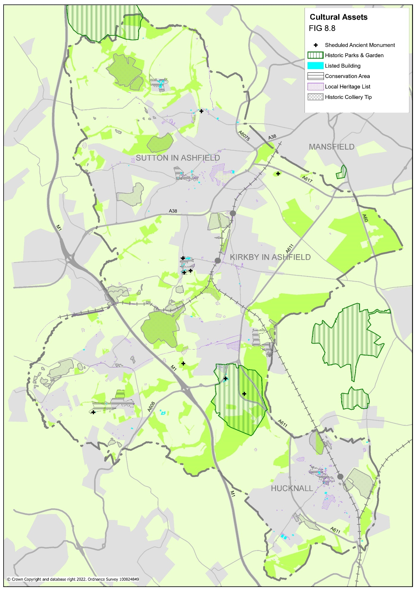

Figure 8.8 Cultural Assets

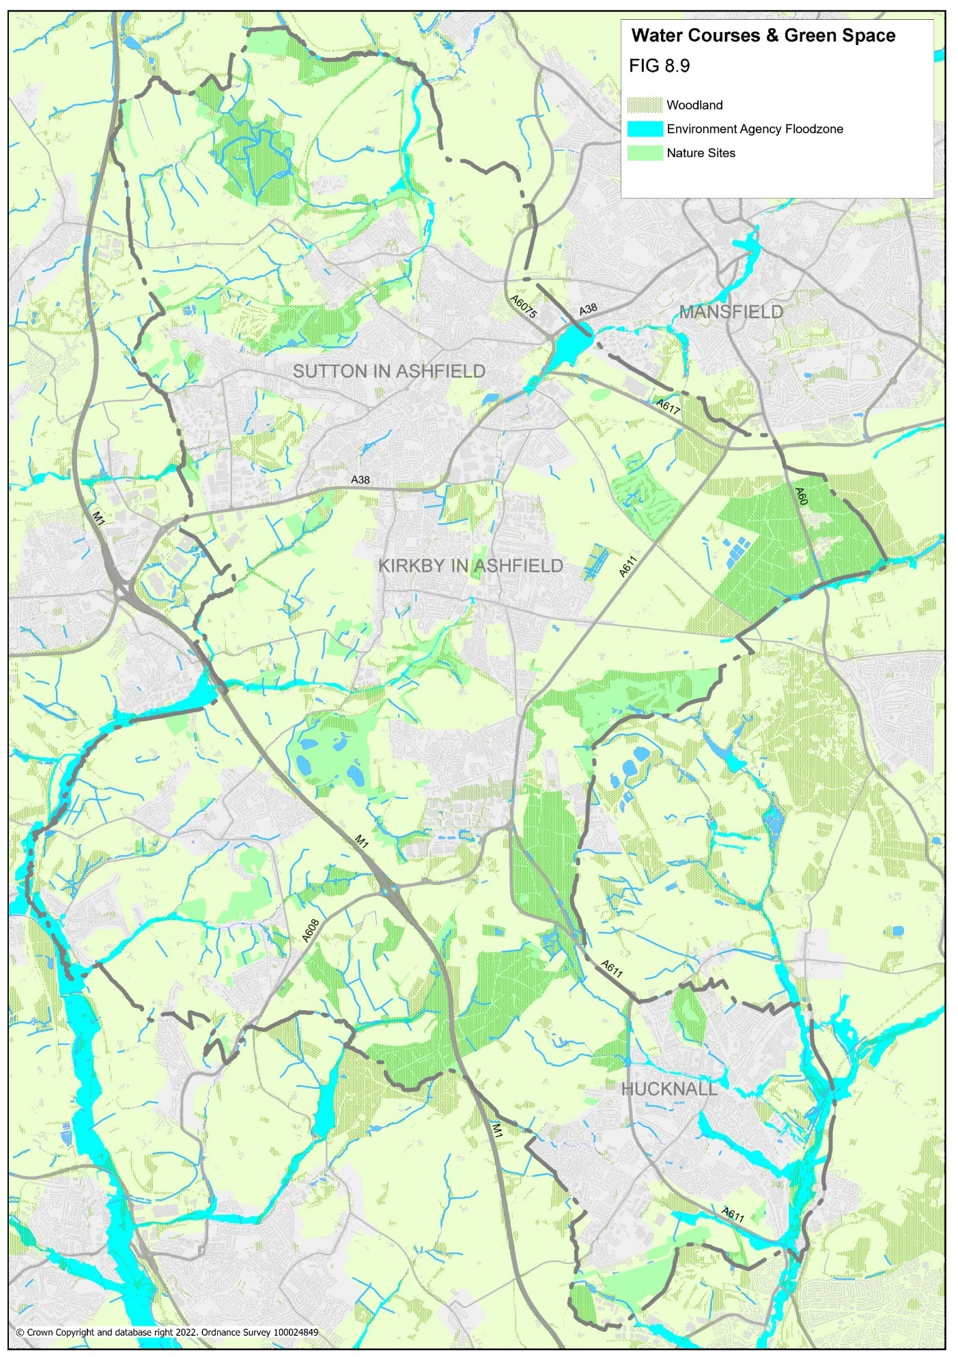
Figure 8.9 Water courses and green space
6. A GREEN & BLUE iNFRASTRUCTURE FRAMEWORK for Ashfield

6.1 STRATEGIC CORRIDORS

A Green Infrastructure Framework has been developed which identifies key corridors and networks of green spaces.

The framework has been split into strategic corridors and local corridors. Strategic corridors connect key Green Infrastructure resources and/or run between settlements and across district boundaries. Local corridors connect smaller green spaces and/or link neighbourhoods to the strategic network.

The strategic framework is presented at a District level, with a description of each corridor including:

- the key GI resources of the corridor,
- any key physical barriers to access which may limit development or require addressing (for example major road and railway lines),
- any significant ‘Green Gaps’ (stretches of the corridor with limited green character, or which may significantly limit the movement of wildlife)
- a description of any notable opportunities.

Local corridors are detailed for each of the four main areas of the district with a short description for each (Sutton, Kirkby, Hucknall and the Rural area), again highlighting key opportunities.

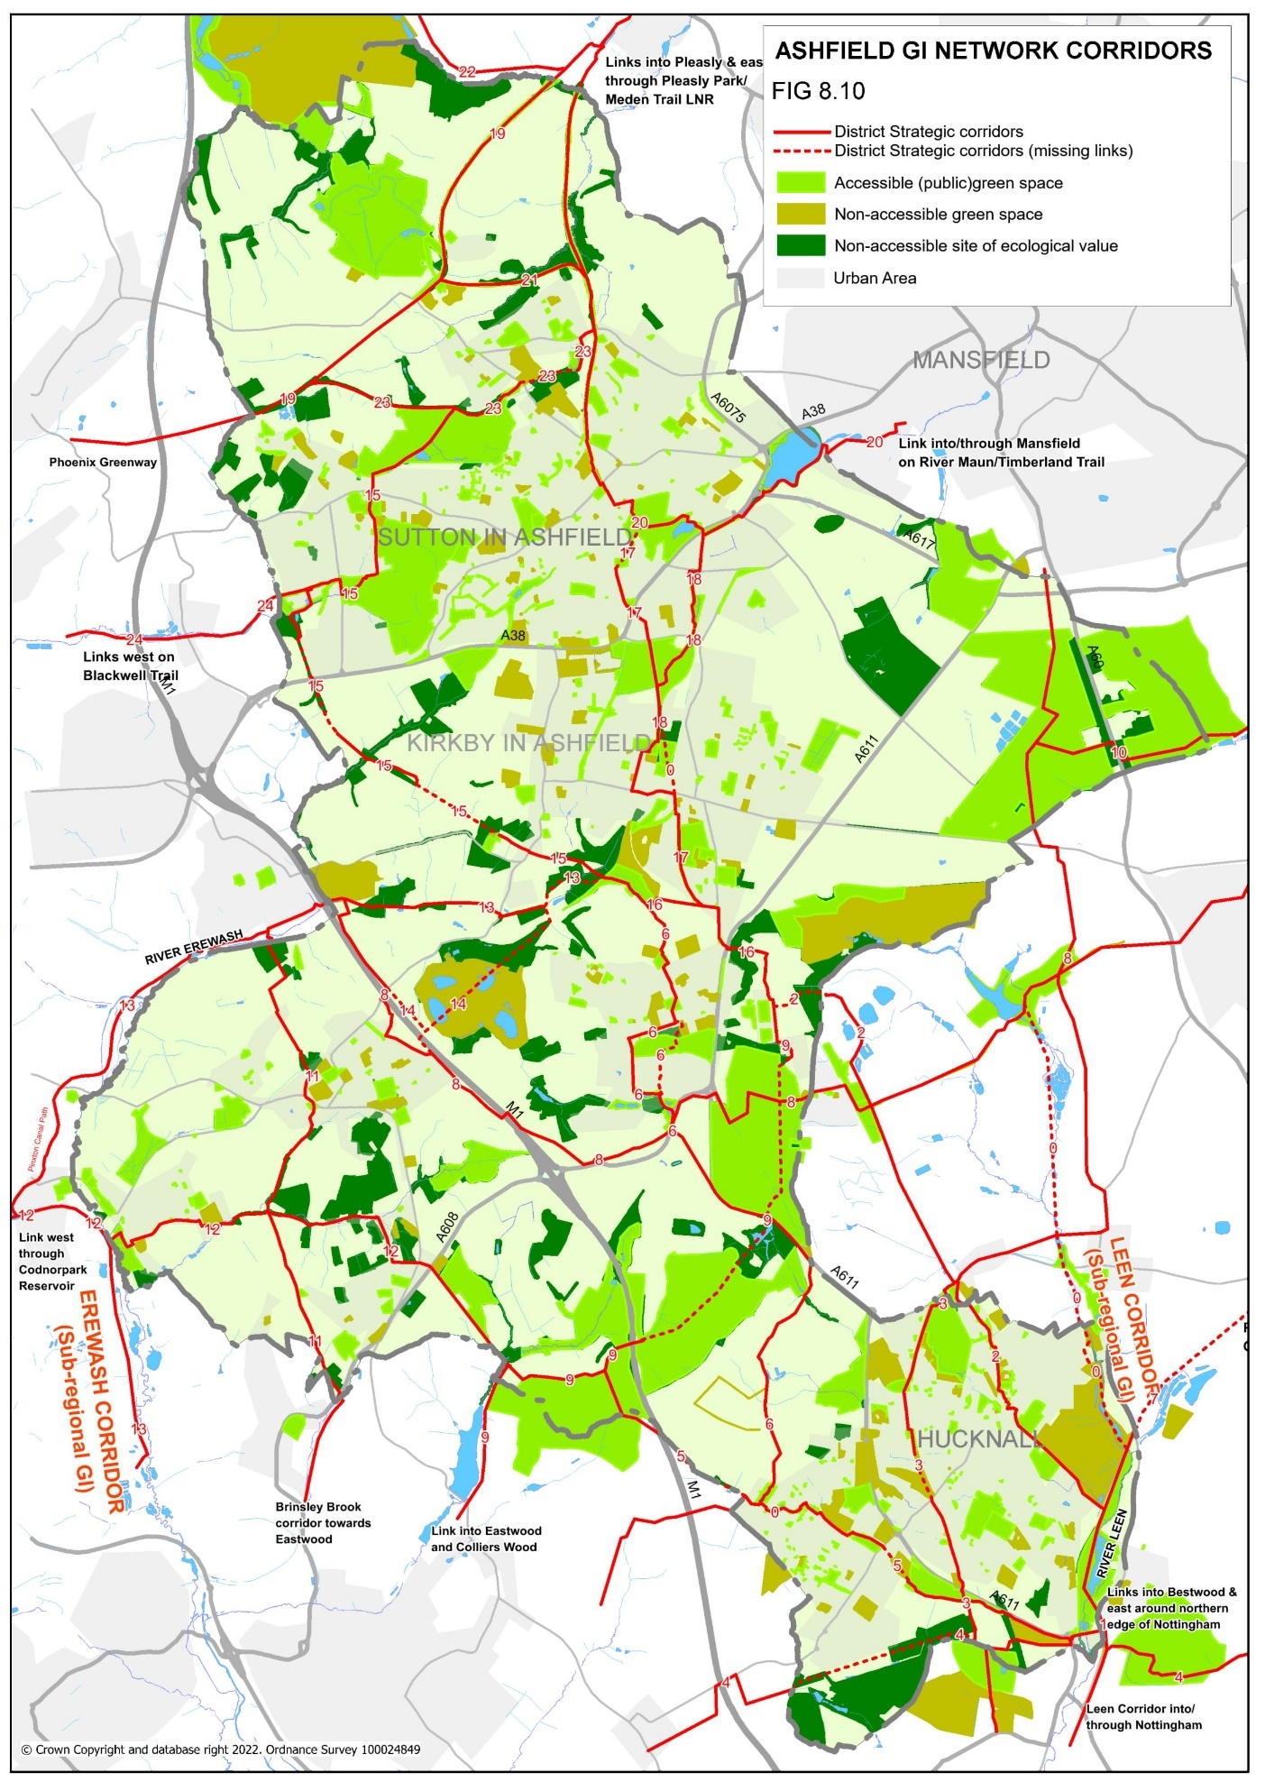
Figure 8.10 Green Infrastructure Network for Ashfield

GI-1: LEEN CORRIDOR
Identified as a sub-regional corridor in the 6Cs GI Strategy, this corridor is part of the larger Leen Valley which extends south through Nottingham City and connects to the River Trent. The corridor follows the river course north from Bulwell, between Hucknall and Bestwood Village, past the major new housing development on Papplewick Lane and towards Newstead Abbey. The National Cycle Route then continues east through Ravenshead.

Key GI resources: Long stretches of the River Leen are classified as LWS sites - Moorbridge Pond Nature Reserve, Mill Lakes, Moor Pond Wood, and the grounds of Newstead Abbey (Grade II Listed). The route also links to Bestwood Country Park in Gedling, one of Nottinghamshire County Council’s main country parks. The corridor incorporates part of National Cycle Route 6, out of Nottingham City and into Mill Lakes, as well as stretches of the Robin Hood Way and Hidden Valleys trail.
Key physical barriers: The corridor only runs as far as the north of Mill Lakes at present, pending the adoption of the open space associated with the Papplewick Lane housing development. There is increasingly limited accessibility from Moor Pond Woods north, in terms of narrower footpaths and restrictions to access of the Newstead Estate.
Green gaps: There are limited areas of lesser green value until the Leen enters Bulwell and passes through a series of industrial estates.

Key opportunities: A crossing of the River Leen and Calverton Rail Line has recently been achieved, opening the way to continue access north through the Papplewick housing estate, and along the Calverton Rail Line (see GI-7). Major potential as a sustainable route to work between east Hucknall and Nottingham.

GI-2 ANNESLEY-HUCKNALL-BESTWOOD
This corridor leaves the Leen corridor at Hucknall and runs northwest through north Hucknall, past Linby Village and Newstead Village (both in Gedling District) and enters Annesley at Annesley Rows.

Key GI resources: Mill Lakes LWS, Hucknall Leen Valley Golf Course, Leen Mills Recreation Ground, Linby-Newstead disused railway LWS and Newstead Country Park LWS. The corridor incorporates part of National Cycle Route 6, between Mill Lakes and Newstead Country Park, and connects to the main tram and train station in Hucknall. It also includes parts of the Hidden Valleys Trail. Identified as a City-Scale Green Infrastructure Corridor in the 6Cs GI Strategy.
Key physical barriers: Connections into Annesley from Newstead Country Park (across the railway line) are unclear at present.
Green gaps: Areas of lesser green value include Bestwood Village and Wigwam Industrial Estate.

Key opportunities: The Country Park at Newstead provides a valuable new resource and connecting this to neighbouring communities is a major opportunity to increase access to natural green space, as well as increasing access to the National Cycle Route from Annesley and the north of the District.

GI-3: HUCKNALL NORTH- BULWELL
Connects Bulwell (in the north of Nottingham City) to the centre of Hucknall and north through Papplewick Village to the Leen Corridor.

Key GI resources: Bulwell Hall Park LWS Farleys Lane Green Space, parts of the former railway line through Hucknall, Washdyke Recreation Ground, The Ranges (a restored colliery spoil heap and LWS) and the Mill Pond Plantation LWS. The corridor incorporates stretches of the Hidden Valleys trail and connects with proposed cycle links in Nottingham. It also runs close to Hucknall Town Centre. Identified as a City-Scale Green Infrastructure Corridor in the 6Cs GI Strategy.
Key physical barriers: The A611 bypass (passable) and an inaccessible stretch of the former railway between Watnall Road and Garden Road.
Green gaps: Areas of lesser green value include the residential stretch of Farleys Lane, and the stretch between Wood Lane and Washdyke Recreation Ground, although both are to a degree connected by private gardens (for wildlife benefit).
Key opportunities: The former railway between Garden Road and Watnall Road is a key opportunity to increase green space in an area of low provision and connect the GI networks of north and south Hucknall.

GI-4: SOUTH HUCKNALL
Connects the north of Bestwood (Nottingham City) with the south of Hucknall and west towards Eastwood.

Key GI resources: Bestwood Country Park LWS, Bulwell Hall Park (LWS including a tributary of the Leen), areas of the Rolls Royce estate (LWS) and Bulwell Hall Wood (a SSSI). The corridor incorporates stretches of the Robin Hood Way. Identified as a City-Scale Green Infrastructure Corridor in the 6Cs GI Strategy.
Key physical barriers: The railway crossing into Hucknall (Mill Lane) is restricted to pedestrians. Capacity of the route is limited to the west as it passes to the south of Rolls Royce.
Green gaps: Areas of lesser green value are limited.
Key opportunities: Major improvements to the route and biodiversity enhancement were carried out in 2011/12, including a new direct link from Bestwood Country Park to Mill Lane. An improved link east has been provided through Merlin Park ( part of planned development of the Rolls Royce site).

GI-5: HUCKNALL EAST to MORNING SPRINGS
Connects the south and west of Hucknall to the countryside between Hucknall and Underwood, where it connects with several other corridors.

Key GI resources: A green corridor through Hucknall following Farleys Brook (a tributary of the River Leen) which connects Farleys Lane Open Space, Nabbs Lane Recreation Ground, Holgate School Grounds, the flood prevention system around Polperro Lagoon and Common Farm; Misk Hills and Morning Springs Woodland (LWS and Ancient Woodland).The corridor incorporates stretches of the Hidden Valleys trails. It also passes close to Felley Priory (Grade II listed) with public gardens (limited opening) and the grounds of Hucknall Town Football Club.
Key physical barriers: There is no direct route between Nabbs Lane Recreation Ground and Farleys Lane green space. The accessible route deviates significantly from the main ecological corridor for a section as it leaves Hucknall to the west (Watnall Coppice East).
Green gaps: Areas of lesser green value include culverted sections of Farleys Brook and low value amenity green space (such as Nabbs Lane Recreation Ground). The corridor passes through an industrial area south of Nabbs Lane, which lacks a direct, accessible route (currently via stiles).

Key opportunities: Creation of better link between Farleys Lane Green Space and Nabbs Lane as part of any future development. Biodiversity improvements along Farleys Brook through west Hucknall, and on Nabbs Lane.

GI-6: HUCKNALL EAST- PORTLAND PARK
Connects Eastwood to the western edge of Hucknall and north through Sherwood Business Park, Annesley to Portland Park in Kirkby-in-Ashfield.

Key GI resources: Watnall Brickyard (in Broxtowe, LWS), Common Farm, Wighay Wood (LWS), Annesley Park ponds (inaccessible LWS), Annesley Hall (Grade II listed), Sherwood Business Park grounds, Forest Road Nature Area, Acacia Avenue and Nuncargate Recreation Grounds and Portland Park (SSSI). The southern part of the corridor is identified as a City-Scale Green Infrastructure Corridor in the 6Cs GI Strategy.
Key physical barriers: Annesley Estate (which forces the route onto the busy A611 along narrow paths). Access into/through the Forest Road Nature Area (from north and south - existing accessible routes takes a less direct route to the east).
Green gaps: Areas of lesser green value include Annesley (comprising low-value recreational space and small gardens). Arable areas between woodland are currently reasonably well connected by hedgerows.
Key opportunities: Improving access through Forest Road Nature Area. Improving biodiversity value of recreation grounds. Improving the overall quality of the link between Annesley and Hucknall. Upgrades planned as part of the Towns Fund programme of works.

GI-7: HUCKNALL CALVERTON RAILWAY
A potential future link that would connect the east of Hucknall to Calverton along a disused railway line.

Key GI resources: Mill Lakes (LWS) and Bestwood Duckponds, as well as the line itself. The corridor incorporates a stretch of the Robin Hood Way, and would also connect to the Leen corridor, continuing into Nottingham. Identified as a City-Scale Green Infrastructure Corridor in the 6Cs GI Strategy
Key physical barriers: The line is not currently open to the public. Only a small part of this corridor would fall within the district boundaries.
Green gaps: Limited green gaps due to the linear nature of the line

Key opportunities: The line has been purchased by Nottinghamshire County Council and an access ramp constructed from Mill Lakes, providing the ideal starting point for continuing the ‘rail trail’ to Calverton when funds allow.

GI-8: PINXTON - THIEVES WOOD
A corridor running east-west across the district from Pinxton, past Selston across to Newstead Park in Gedling, and back into the district at Thieves Wood, linking further north into Mansfield.

Key GI resources: The planted embankments of the M1, Icehouse Wood (Annesley), and the LWS sites of Annesley Forest, Annesley Pit, Newstead Park, and Thieves Wood. Much of the eastern stretch of the corridor follows stretches of the Robin Hood Way and Hidden Valleys trails. There are limited public green spaces along the western stretch between Pinxton and Annesley, where the corridor follows the line of the M1.
Key physical barriers: The M1 motorway limits access to the corridor from Selston to key points.
Green gaps: Areas of lesser green value include the land to the south of Sherwood business park (arable farmland) and Newstead Village (including low value recreational land).

Key opportunities: Limited immediate opportunities.

GI-9: ANNESLEY – EASTWOOD
A linear collection of woodland areas running from Eastwood north across the district (continues north along corridor GI-8)

Key GI resources: a number of Forestry Commission sites (such as Morning Springs, Park Forest, and Annesley Forest), the grounds of All Saints Church, Annesley Recreation Ground and Robin Hood Hills (LWS).
Key physical barriers: Although many of the resources along the corridor are accessible, formal access between them is poor and/or unclear, therefore the corridor is primarily an ecological asset at present.
Green gaps: Well-connected corridor.

Key opportunities: Establishing and formalising accessible routes through the woodland.

GI- 10: THIEVES WOOD TO BLIDWORTH
The route follows the Robin Hood Way through Thieves Wood and the adjoining Harlow Wood before crossing the district boundary into Mansfield District and continuing along the trail.

Key GI resources: The woodland and established trails.

Key physical barriers: Need to cross the A60, but otherwise established trails through the woodland and beyond.

Green gaps: No major gaps within the district.

Key opportunities: The majority of the route is outside the district.

GI-11: PINXTON- EASTWOOD
Connects Selston to Pinxton to the north (and the Erewash Corridor) towards Eastwood to the south.

Key GI resources: New Selston and Greenwell Recreation Grounds, the green break between Selston and Selston Green (including LWS site, Rosemary Hill pastures), grounds of Selston Parish Council and Selston Arts and Community College, the valley of the Bagthorpe Brook to the south of Selston and Bagthorpe Conservation Area. The corridor leads into the Brinsley Brook to the south. The corridor incorporates sections of the Hidden Valleys Trail. Although most of the route can be followed, footpaths and rights of ways deviate from the green corridor at several points through Selston and New Selston, particularly where the corridor passes through institutional grounds in Selston.
Key physical barriers: Limited capacity, relying on standard rural footpaths for much of the corridor.
Green gaps: Areas of lesser green value include the large fields to the north of Selston and the amenity grassland of recreation and school land.

Key opportunities: Improving accessibility of rural paths.

GI-12: MORNING SPRINGS - CODNOR PARK RESERVOIR
Continues from Corridor GI-5, running north west through Underwood and Jacksdale and out of the District into Codnor Park reservoir and further west towards Ripley, Derbyshire.

Key GI resources: Morning Springs (LWS and Ancient Woodland), Underwood Plantation (LWS), Bagthorpe Plantation (LWS), Bagthorpe Grasslands (LWS), Bagthorpe Brook, Jacksdale Nature Reserve and Wharf area, the Cromford Canal and Codnor Park Reservoir.
Key physical barriers: much of the green areas in Bagthorpe are inaccessible (necessitating routes along roads). The only access across the canal towards the reservoir is via stepping stones.
Green gaps: Areas of lesser green value include much of the route through Jacksdale (although some hedgerow follows the corridor).

Key opportunities: Improving links across the district boundary towards the reservoir and the green spaces to the west. A bridge at Wharf Green is required to cross the canal. Improving accessibility of rural paths.

GI-13: EREWASH CORRIDOR
Follows the course of the River Erewash and connects the south of Kirkby to the outlying rural areas in the west of the district, Pinxton, Jacksdale, and south towards Heanor (Derbyshire).

Key GI resources: the Erewash river corridor, Portland Park (Part of Kirkby Grives SSSI/LWS/ LNR), Kirkby Grives Grassland (LWS), Bentinck Colliery (LWS), Langton Marshy Grassland, Hall Green Meadow (LWS), Pye Hill Marshy Grassland (LWS), Wharf Green, Jacksdale Nature Reserve, and Jacksdale/Erewash Meadows (LWS and Nottinghamshire Wildlife Trust Site).The corridor links to, and incorporates a stretch of, the Pinxton Canal Path. The southern part of the corridor is identified as a sub-regional corridor in the 6Cs GI Strategy
Key physical barriers: Although rights of way follow the corridor for the majority of its length, most of these are some distance from the river itself. At times, significant deviations from the corridor are required (for example at Pye Bridge). There is also a significant gap in accessibility between Portland Park and Mill Lane to the south west, which prevents the Erewash corridor from reaching this key Ashfield site.
Green gaps: Areas of lesser green value include the industrial areas as the corridor passes through Pinxton.

Key opportunities: Creating a link along the Erewash corridor between Mill Lane and Portland Park. Increasing access to the river along the corridor.

GI-14: BENTINCK LINK
Connects Selston to Somercotes, Derbyshire.

Key GI resources: Bentinck Void and Bentinck Colliery (both LWS)
Key physical barriers: no direct public link across Bentinck site at present
Green gaps: The soil heap of Bentinck Void forms a ‘green gap’ in its unrestored form but does hold valuable conservation value as a site supporting a butterfly species of high conservation value (hence LWS status in its current form). Corridor bisected by M1, but links to embankment planting belt of the motorway.

Key opportunities: To secure a good quality public link through any proposed development, linking to Selston, Kirkby Woodhouse and GI Corridor 13 (to Portland Park).

GI-15: BRIERLEY FOREST PARK TO PORTLAND PARK
Connects Portland Park to the southwest of Kirkby and onward to the eastern edge of Sutton-in-Ashfield, following a former railway line.

Key GI resources: Portland Park, Kirkby Grives SSSI and LWS, Springfield Cottage Grassland (LWS), long stretches of disused railway (containing several LWSs), Nunn Brook, Rookery Park, Huthwaite Welfare Park and Cemetery, and Brierley Forest Park. The corridor passes through Kirkby Cross Conservation Area . It also links into the Blackwell Trail at Huthwaite (see GI-24).
Key physical barriers: Inaccessible stretches of the former railway line to the west of Kirkby-in-Ashfield. Slight detour along roads and through an industrial estate between Rookery Park and Nunn Brook, including crossing Common Road – route not clear on the ground. The footpath system of Rookery Park has yet to be fully completed to the east, limiting direct links from Sutton-in-Ashfield.
Green gaps: Areas of lesser green value include stretches of the railway converted to agriculture.
Key opportunities: Major project opportunity to secure access to the disused railway line between Kirkby and Nunn Brook, Huthwaite. Smaller scale opportunity to improve visibility of trail links from Common Road and improve connections at this point. Works potentially to be included in Towns Fund programme.

GI-16: PORTLAND PARK- ANNESLEY ROWS
Connects Portland Park to Annesley Rows and the GI Corridors to the east of the district.
Key GI resources: Portland Park (SSSI/LWS), Robin Hood Hills (LWS)
Key physical barriers: Good access. Some informal footpaths east of Derby Road, however.
Green gaps: Largely an access link at the moment with limited biodiversity value between Portland Park and Robin Hood Hills.

Key opportunities: Creation of woodland blocks to better connect the habitats of the two woodland and increase the green character of the route.

GI-17: KIRKBY SOUTH – SUTTON LAWN
Connects the south-east of Kirkby (and Annesley) with the east of the town and onwards north into Sutton-in-Ashfield.
Key GI resources: Kingsway Park (and the adjacent footpath on the disused railway line), West Park (and neighbouring plantation), Kirkby Wasteland (LWS), Kirkby Summit and Kirkby Hardwick Summit (restored spoil heaps). Taylor Crescent and Hardwick Lane Recreation Grounds and Sutton Lawn.
Key physical barriers: Kirkby town centre causes a significant detour from the corridor due to buildings and the railway which bisects the town. There is no current link between Hardwick Lane and Sutton Lawn.
Green gaps: Areas of lesser green value include the centre of Kirkby-in-Ashfield, Penny Emma Way industrial estate, the recreation grounds of Sutton, and Hardwick Lane (although private gardens provide some habitat linkage).
Key opportunities: Increasing the biodiversity value of recreation ground land; upgrading the bridleway between the two summit sites; securing a more direct green link through Kirkby town centre. Works potentially to be included in the Towns Fund programme.

GI-18: KIRKBY HARDWICK SUMMIT – SUTTON LAWN
Offers an alternative green route between these two points, following the River Maun.

Key GI resources: Kirkby Hardwick Summit, the River Maun Valley, Orchid Drive open space and Sutton Lawn. The corridor passes Sutton Parkway railway station, and the historic estate of Kirkby Hardwick (private).
Key physical barriers: The route across the spoil heap is informal and access into and out of the Maun Valley is indirect.
Green gaps: The link between Maun Valley and Sutton Lawn (limited to patches of private gardens).
Key opportunities: Creation of a direct route into Maun Valley site from both Sutton Parkway station (south) and Station Road (north). Formalisation of routes over Kirkby Hardwick summit (a Nottinghamshire County Council site). Works potentially to be included in the Towns Fund programme.

GI-19: PLEASLEY- TIBSHELF
Connects Pleasley to Teversal, Fackley, the north west tip of Huthwaite and out into Derbyshire towards Tibshelf.

Key GI resources: the Teversal Trails network (a restored disused railway and SINC including areas designated as SSSI), the restored Silverhill colliery, other sections of the disused railway network including Whiteborough Railway (LWS), and Tibshelf Ponds. The corridor incorporates sections of the Teversal Trails, Five Pits Trail and Phoenix Greenway and leads into the Meden Trail to the north.
Key physical barriers: Established as a major green recreational route – no major barriers.
Green gaps: As a former railway provides good linear habitat without major breaks. Less value along southern stretch between Teversal and Huthwaite. Works potentially to be included in the Towns Fund programme.

GI-20: PLEASLEY- KINGSMILL RESERVOIR
Connects Pleasley with Skegby via the popular Teversal Trails and into the centre of Sutton-in-Ashfield, then onwards east into the south of Mansfield.

Key GI resources: the Teversal Trails (LWS), Teversal Pastures (SSSI), the Stoneyford Trail, Quarrydale Recreation Ground (including a disused quarry designated a LWS), Stoneyford Road Recreation Ground, Priestsic Road Recreation Ground, Sutton Lawn, the Maun Way (a section of disused railway adjacent to the A38), Kings Mill Reservoir, and the River Maun leading into Mansfield. The corridor incorporates sections of the Teversal Trails (leading to the Meden Trail) and the ‘Lower Linear Route’ through Sutton-in-Ashfield.
Key physical barriers: Although accessible, the route between Priestsic Road and Sutton lawn through the centre of Sutton is not clear on the ground. Some busy roads bisect the strong linear trail between Sutton and Pleasley.
Green gaps: Areas of lesser green value include the centre of Sutton, from the end of the Stoneyford Trail to Sutton Lawn, with limited private gardens space to help bridge the gap.
Key opportunities: A stronger link between the southern tip of the trail at Northern View/Priestsic Road and Sutton Lawn, potentially secured through development. Works potentially to be included in the Towns Fund programme.

GI-21: TEVERSAL-SKEGBY
Connects Teversal to Skegby along a stretch of the Teversal Trails.

Key GI resources: Teversal Grange Sports Ground, Coppy Wood (LWS), the Trail itself and Teversal Pastures (SSSI).
Key physical barriers: Part of an established trail network- no major barriers.
Green gaps: Well-connected linear corridor.
Key opportunities: Key opportunities already realised as part of successful Teversal Trail network.

GI-22: ROWTHORNE TRAIL
Leads north out of the district from the tip of the Teversal Trails into Bolsover (Derbyshire).

Key GI resources: Rowthorne Trail LN.
Key physical barriers: Part of an established trail network-no major barriers
Green gaps: Well-connected linear corridor.
Key opportunities: Outside Ashfield district.

GI-23: SKEGBY-HUTHWAITE
Links Skegby and Healdswood with the green space network to the west, and recreational trails into Derbyshire.

Key GI resources: Skegby Hall Gardens (LWS and notable historic landscape), Stanton Hill Grasslands (LWS), Skegby Brook, Brierley Forest Park (LNR and 4 LWS’s) and Stubbinghill Farm Meadow (LWS). The corridor leads into the Five Pits Trail and Phoenix Greenway (into Derbyshire).
Key physical barriers: Lack of formal links between Skegby Hall Gardens and Brierley Forest Park.
Green gaps: There are limited areas of lesser green value.
Key opportunities: Securing an accessible green link through Skegby quarry/Stanton Hill Grasslands potentially through development.

GI-24: BLACKWELL TRAIL
Leads west from Huthwaite into South Normanton, Derbyshire, along a former railway line.

Key GI resources: The Nunn Brook and former railway sidings around it (LWS sites), and the Normanton Brook on the Derbyshire side.
Key physical barriers: Established trail – no major barriers. Awareness may be limited due to location of trail entrance within industrial estate.
Green gaps: Former rail line – good continuous green corridor.

Key opportunities: Increasing visibility of trail entrance from Common Road.

6.2 LOCAL CORRIDORS

HUCKNALL

H1 Blenheim Lane

Important link from Watnall Road into Bulwell in Nottingham City and part of Robin Hood Way. Opportunities to link into potential development on Rolls Royce site.

H2 Blenheim Lane – Bulwell Hall Park

Gateway into Bulwell Hall Park from the west and part of Robin Hood Way. Opportunities to improve gateway into the park and to upgrade path as part of potential Rolls Royce development.

H3 Rolls Royce site south

Potential link as part of new development to better connect west Hucknall to Nottingham city and the Blenheim Lane business park

H4 Rolls Royce site north

Another link through potential development to provide local circular routes and link proposed housing to the eastern Bulwell Hall Park entrance. Links into west Hucknall via existing bridleway onto Daniels Way.

H5 Hazelgrove link

Connects Hazelgrove neighbourhood with the potential Rolls Royce development site and south towards Bulwell Hall Park. Opportunities to improve the quality of narrow existing Right of Way.

H6 Titchfield Park – Bestwood Village link

Follows a tributary of the River Leen from Watnall Road, through the main town park and east towards Bestwood Village and the River Leen Valley.

Opportunities for improved signage but limited opportunity to create a continuous green route due to existing built areas.

H7 Farleys Lane former colliery lines

An alternative route south following former colliery rail lines, providing well used circular routes, and providing access to natural green space for Broomhill neighbourhood. Recently upgraded.

H8 Potential future link into development site on Nottingham Road

H9 Rolls Royce – Bolingey Way

Provides a connection from western end of Rolls Royce potential development site north to the western Hucknall neighbourhood. Opportunity to link into the Rolls Royce site through development plans. (outside district).

H10 Eelhole Wood

Potential link west through Eelhole Wood if access can be secured (outside district).

H11 Link to Dob Park

Footpath connecting neighbourhoods of north Hucknall to Dob Park. Opportunities to enhance gateways into Dob Park and formalise routes through fields south of Arrow Centre.

H12 North Hucknall – Watnall Coppice

East-west route connecting the National Cycle route in the east of Hucknall to north Hucknall neighbourhoods and east past Washdyke Recreation Ground into Dob Park and beyond towards the countryside footpaths east of Hucknall. Opportunities to enhance the environment through George Street neighbourhood and to improve legibility of links to Hucknall Leisure Centre in particular. Potential to link to National Cycle route limited by rail crossings.

H13 The Ranges

Links residential estates off Linby Road with the Ranges open space and to the central Hucknall GI route (GI-3). Also links to National Cycle Route. Potential to link to cycle route limited by rail crossing.

H14 Leen corridor link through Papplewick estate

Link secured as part of Papplewick Lane housing development, linking central Hucknall and the train/tram station with the River Leen Valley.

H15 North Hucknall – Annesley Woods

Footpath connecting north Hucknall communities with the footpath network around Annesley Woods and beyond.

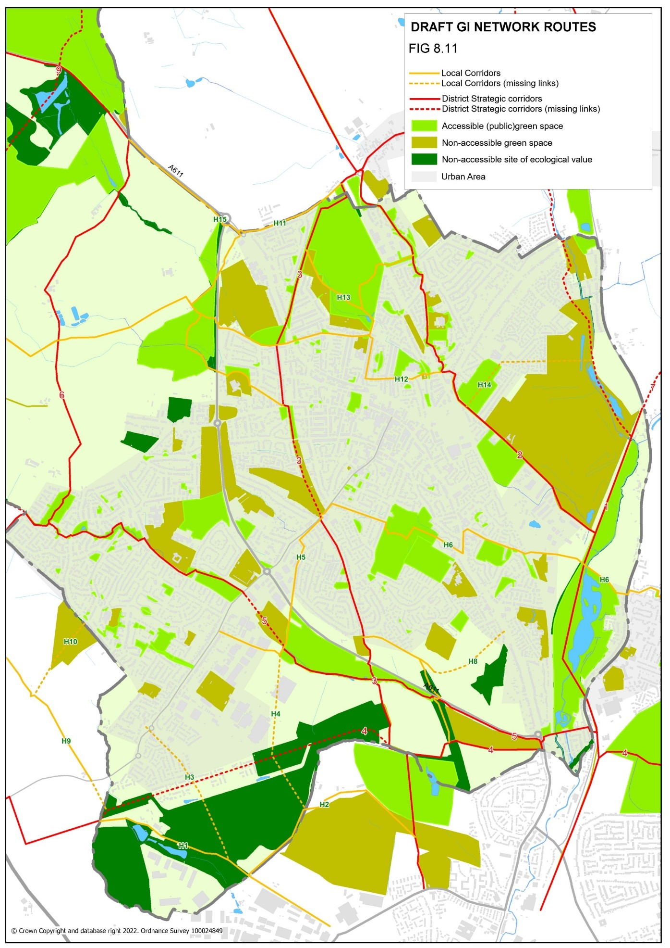

Figure 8.11 Green Infrastructure Network for Ashfield - Hucknall

SELSTON, JACKSDALE AND UNDERWOOD

R1 Jacksdale Wharf - Jubilee
Follows a line of green spaces along the course of the River Erewash and north into the village of Jubilee.

R2 Underwood - Jacksdale
Route linking the west of Underwood village with Jacksdale and further west to the River Erewash and Pinxton Canal. Poor links west out of the district which could be improved.

R3 Underwood links
Path connecting neighbourhoods in Underwood with GI-11 and GI-12.

R4 Underwood-Bagthorpe
Provides a circular route for walkers between Underwood and Bagthorpe.

R5 Bagthorpe-Selston (east)
Provides an off-road link from Underwood to Wood Nook and links east to GI-6.

R6 Bagthorpe-Selston (central)
Connects Bagthorpe with the community centre of Selston.

R7 New Selston links
Connects New Selston with the Erewash Valley (G-13) and south to Bagthorpe Brook (GI-11). Also links to Selston Golf Course.

R8 Mansfield Road – Selston Leisure Centre
Short link connecting Selston communities to the Leisure Centre, School, and Library, and to the main GI corridor north and south from the village (GI-11).

R9 Bentinck West
Existing rights of way connecting the east of Selston with the Erewash Valley (GI-12). Potential to enhance as part of any restoration of the Bentinck Void site.

R10 Felley Mill – Annesley Hall
A bridleway forming a link between these two historic estates. Also links south to Morning Springs and GI-9.

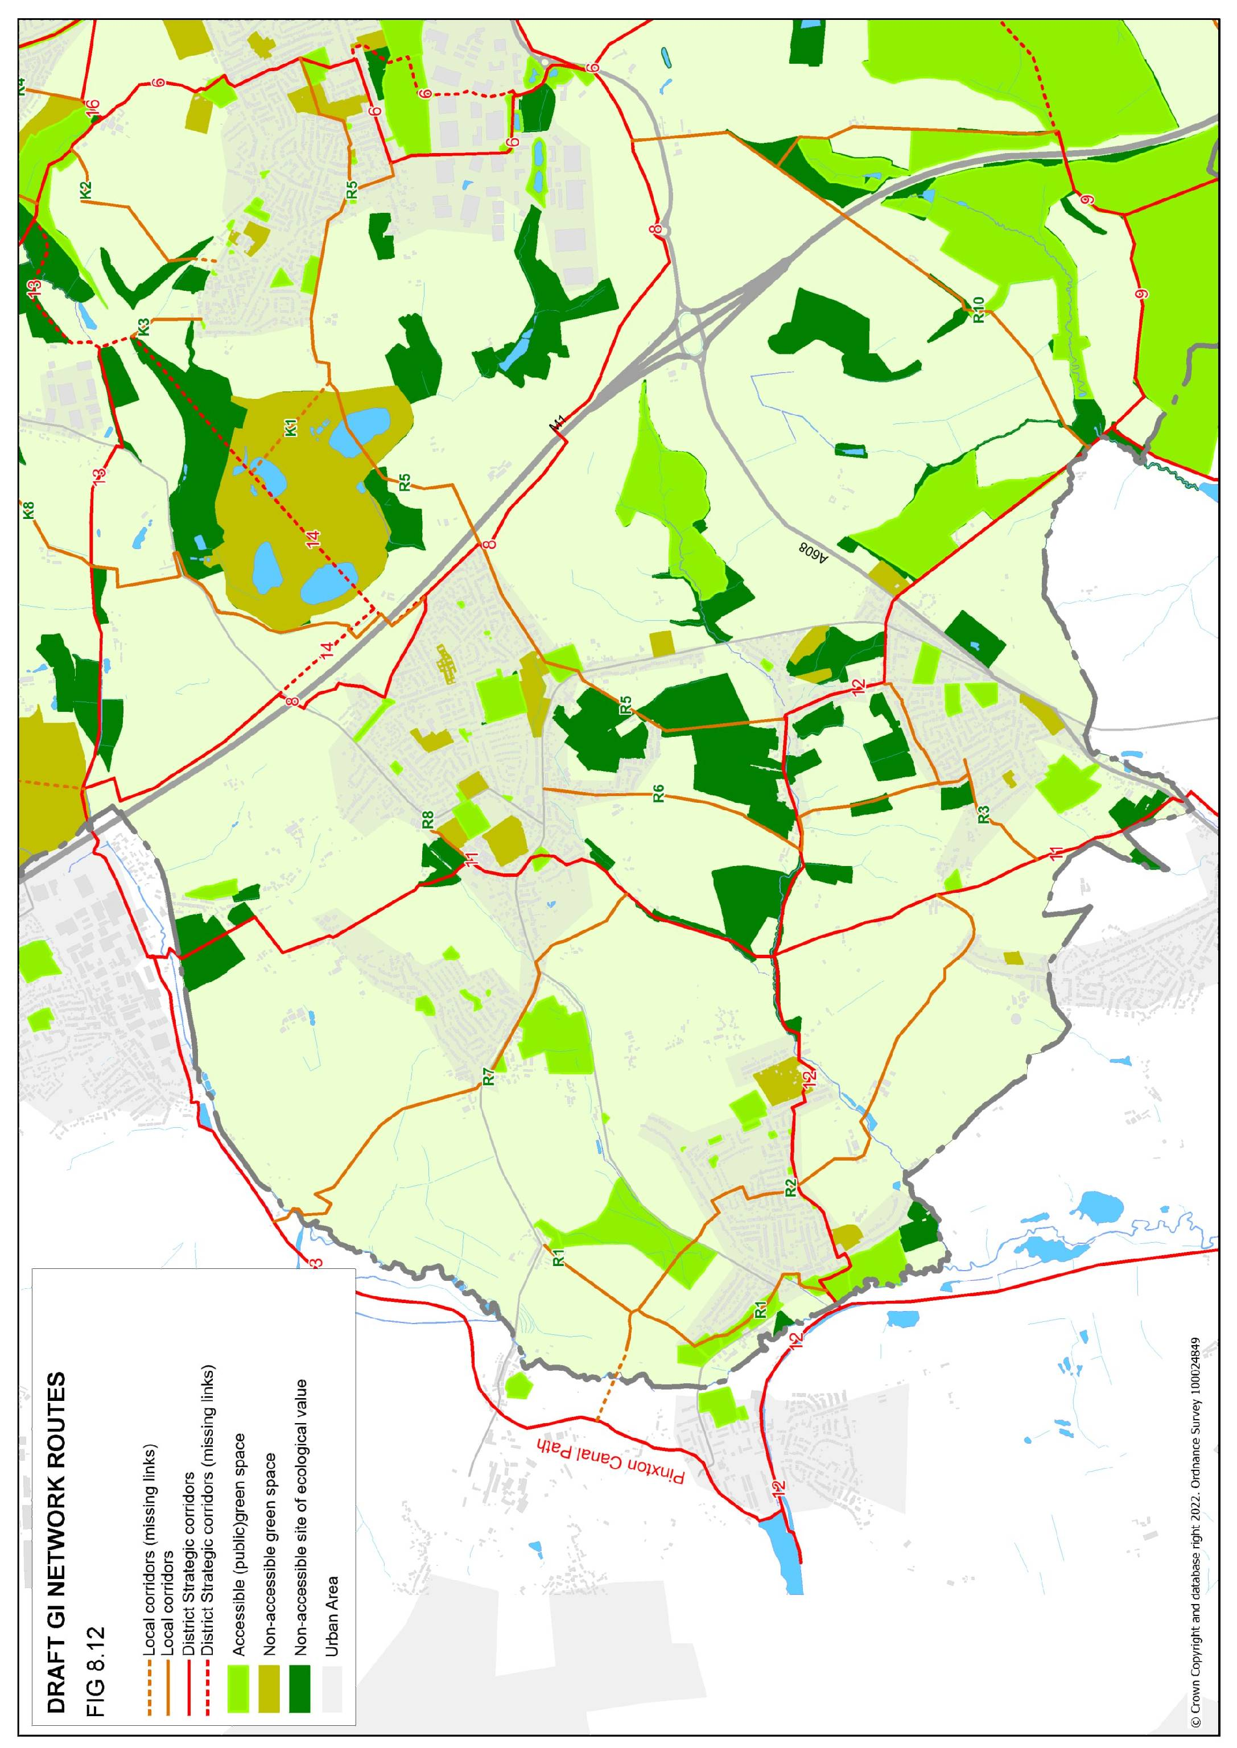

Figure 8.12 Green Infrastructure Network: Rural Area
KIRKBY IN ASHFIELD

K1 Bentinck Void – Annesley
A potential future link to connect residents of Annesley to any future green space resource on the Bentinck Void site. Connects to the centre of Annesley and Acacia Avenue Recreation Ground via various footpaths and cut-throughs. Potential to enhance green character of the corridor through Annesley to better connect individual sites.

K2 Main Road – Portland Park
Footpath connecting the west of Annesley with this key GI resource. Lacking a direct link to Main Road, which may be a future opportunity to create a clearer gateway to the countryside.

K3 Annesley – Mill Lane
A short link which would become more important if access along GI-14 was secured, as it would provide a direct link between this and residents in the west of Annesley.

K4 Lindleys Lane
Provides an important direct link between Kirkby residents and Portland Park, passing through a major new housing development. Some green value retained in the form of boundary hedges.

K5 Lane End links
A green route into Portland (although less direct than K4), following a former rail line, and requiring the crossing of a stepped bridge. Lane End recently enhanced as an open space for people and wildlife. Potential to enhance routes into Portland Park through the planned future extension of the park.

K6 Kirkby West - Kingsway Park
A greener route to Kingsway Park than following Victoria Road/Urban Road but involves steps to cross the railway. Potential to formalise footpath through Studfold Farm as part of green space provision of neighbouring development.

K7 Laburnum Avenue – A38
Mainly rural footpaths which offer a link from the Conservation Area of Kirkby Cross, north towards Sutton-in-Ashfield.

K8 Titchfield Park – Kirkby Summit
A long corridor which provides access to key GI resources for residents in the west of Kirkby. The corridor includes a green link all the way from Kirkby Summit down to Chapel Street. The link from this point to Titchfield Park is via roads and has little green value. Opportunities to address this may be limited but would have a positive effect on this streetscape. The gateway to Titchfield Park also has scope for enhancement.

K9 Northeast Kirkby
A series of small neighbourhood spaces along the northern edge of this neighbourhood, which is otherwise lacking in green space, including David Street (‘The Landing’) and Beacon Drive (‘Holiday Hill’). There are no rights of way into the countryside in this area, and there may be potential to continue the corridor into the countryside via Coxmoor plantation and link north to Cauldwell Wood.

K10 Kirkby – Thieves Wood
Although little more than a verge, this corridor is the main link between Kirkby-in-Ashfield and the major GI resource of Thieves Wood. Access is currently very poor, with no roadside pavement for much of the route and enhancements could help to address poor access to natural green space from this area of Kirkby.

KIRKBY-SUTTON LINKS

KS1 Central Kirkby-Sutton link
This route provides a key link between Kirkby west and Sutton, along an established bridleway. There is potential to enhance the route along Sutton Middle Lane as part of any development of this site, and Clare Road has potential as a more inviting gateway site. Much of the route north into Sutton is on roads, which limits potential, but any opportunity to ‘green’ this corridor would be beneficial. The route also continues south towards West Park, again on roads and cut-throughs.

KS2 Western Kirkby-Sutton link
A potential further link between the two towns, making use of the A38 bridge, which crosses to the industrial sites north of the A38 and also continuing as a green corridor north into the Calladine estate (secured through development). The bridge has poor connections to the south at present and any opportunity to link into the residents of west Kirkby would greatly increase its value.

SUTTON IN ASHFIELD

S1 Rookery Park – Sutton Lawn
This provides a corridor through the heart of Sutton-in-Ashfield, and links communities to the natural green spaces of Rookery Park and Calladine Pond. Completion of Rookery Park should provide links to GI-15. The Calladine estate offers substantial green corridors, but links further east to Sutton Lawn are less attractive, following High Pavement for a section. Connecting to Sutton Lawn would rely on securing the necessary connection described in GI-17 (at the back of Hardwick Recreation Ground). Any scope to enhance High pavement to provide greater GI benefit would be positive and create a much stronger green link across the town.

S2 Rookery Park path
A footpath link between residents in the north of Huthwaite and the employment opportunities of the industrial areas to the south and southwest. Upgraded in 2012.

S3 Huthwaite Welfare – Peveril Drive
A green route of rural character on the very edge of Huthwaite and linking into Sutton close to the Lammas Leisure Centre. Connects the key GI resources of Huthwaite Welfare Park and Rookery Park.

S4 Sutton Meadows – Brierley Forest Park
A north-south corridor linking Brierley Forest Park to Rookery Park, via green housing estate links, and continuing south (mainly via roads) to Sutton Meadows. Limited green value around Alfreton Road.

S5 Brierley Forest Park- Stoneyford Road trail
Connects GI-15 through Brierley Forest Park with the residential area of the Oval. Has the potential to link to the Stoneyford Trail, which would provide access to the wider Trails network and Sutton Lawn, if access through Stoneyford Road allotments could be achieved. Enhancing green ‘islands’ along the route would benefit wildlife links in the absence of a public link.

S6 North Huthwaite Links
A series of footpaths which provide access to the major Trails network to the north, and Brierley Forest Park to the east.

S7 Meden Bank footpath
A Right of Way west out of Meden Bank which provides a link to the major trails network (GI-19).

S8 Healdswood – Silverhill
Of limited green value but provides an important link between Healdswood communities and the Silverhill colliery site – a major local GI resource. Also continues west into Derbyshire along rural footpaths. Unavoidably follows Fackley Road for much of its length save for a footpath linking through to Healdswood Recreation Ground. Ecological links continue south towards Skegby Quarries, but public access is not possible at this time. This could be explored as part of any future development in this area.

S9 Silverhill - Hardwick
A strong ecological link north out of the district, but currently without public access. Such a link would connect Hardwick Park with the Trails networks of Ashfield and Derbyshire.

S10 Skegby north
A series of footpaths that connect residents of this part of Skegby to the neighbouring Teversal Trails and also to St Andrews churchyard. Green space provision in the area could be enhanced by improving access to the Skegby Quarries site next to the churchyard.

S11 Skegby - Mansfield
A rural footpath which links Skegby, and the Teversal Trail route, with Mansfield in the east. Also provides direct access to the Teversal Trail (GI-20) for residents in this area of Skegby.

S12 Maun Valley – Coxmoor Golf Course
A link east for residents around Kirkby Folly Road, and also the business parks of Penny Emma Way. Links to GI-18 and Sutton Parkway train station.

S13 Kirkby Folly Road – Cauldwell Wood
The creation of the MARR route rendered this road a dead end and provides potential for development as a green corridor connecting the east of Sutton with Cauldwell Wood and the Cauldwell Brook (and the south of Mansfield). Linear green space around Kirkby Folly Road provides a green finger into the built up area.

S14 Kingsmill – Cauldwell Wood
An existing link along the new MARR road connecting Kingsmill reservoir (and GI-20) to the east towards Cauldwell and Thieves Wood. Potential to enhance the ecological connections along this stretch and also enhance the green character for those travelling along it.

S15 Bleak Hills Lane
A green route leading from Kingsmill reservoir into Mansfield, through a large business park (outside the district).

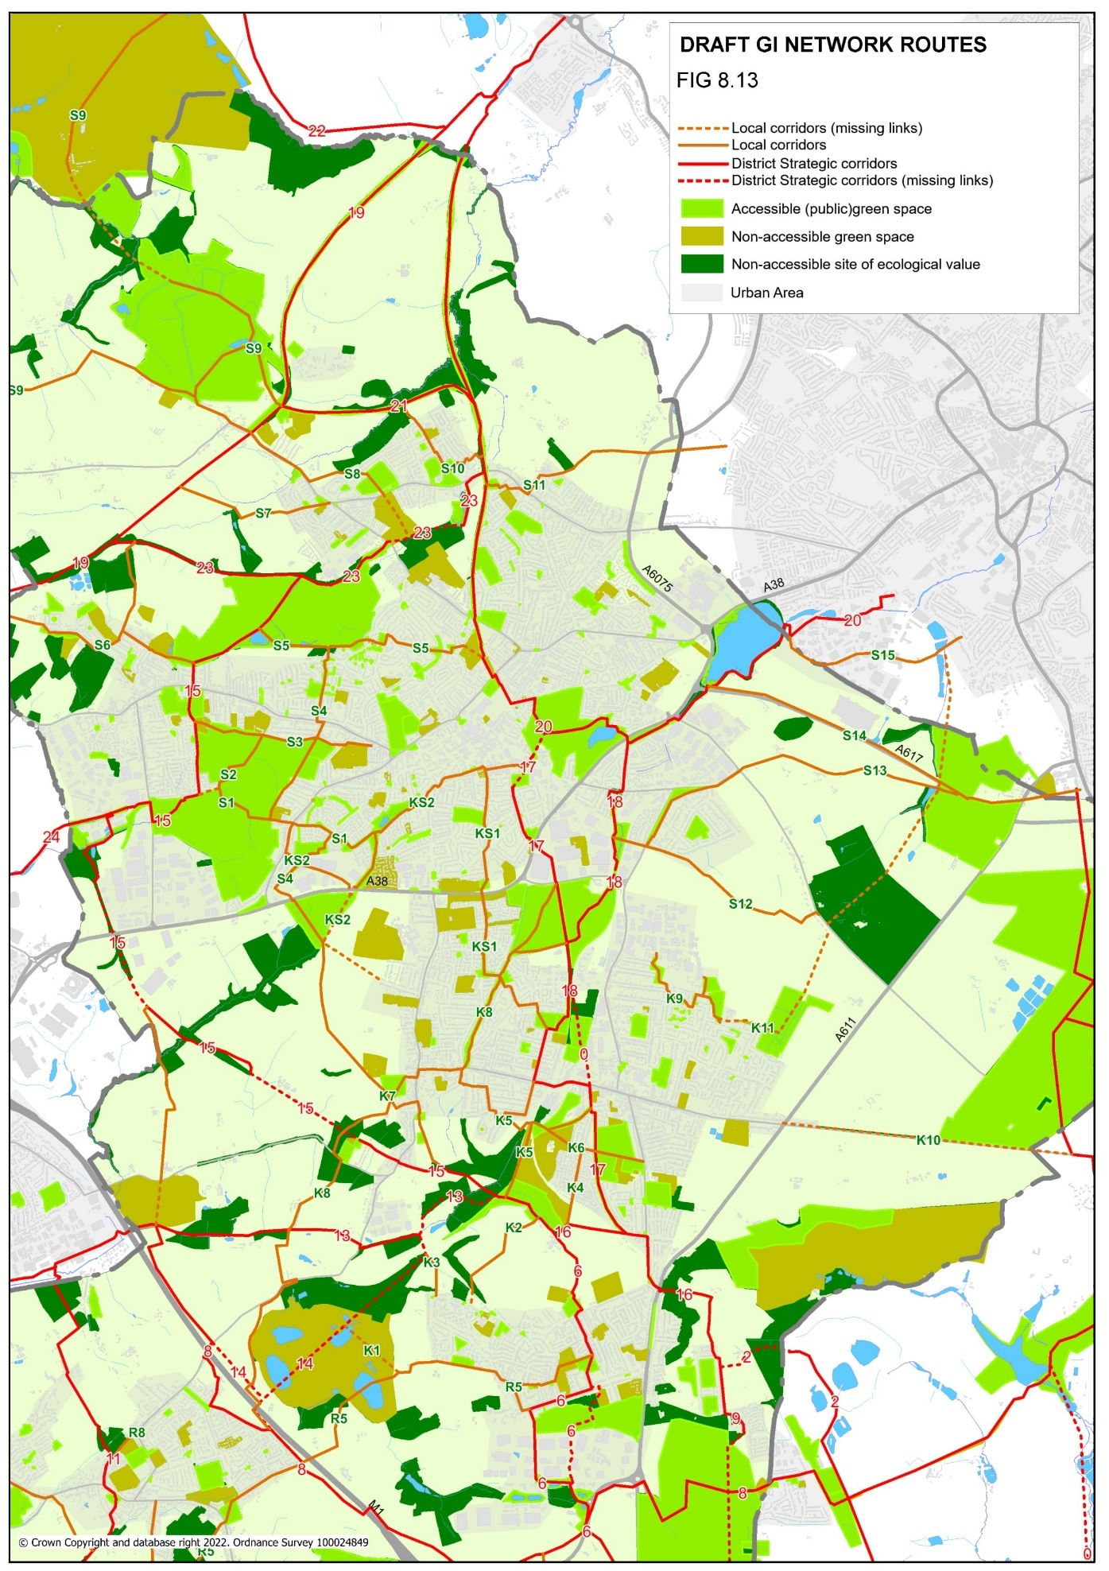

Figure 8.13 Green Infrastructure Network: Kirkby and Sutton

6.3 DELIVERY
An Infrastructure Delivery Plan (IDP) is being developed as part of the Local Plan process and will assist the Council to identify infrastructure and service requirements (including GI) which will be required to ensure that growth is sustainable. The IDP will also support funding bids and engagement with infrastructure providers. Creation of some GI corridors will be much longer term, as they rely on larger housing development sites being designated and brought forward through the Local Plan process. Other funding sources which can support the delivery of GI are likely to be the Local Transport Plan (via the County Council), Levelling Up Fund and other grant sources for example health programmes.

Masterplanning of future development sites provides an opportunity to deliver GI. Development briefs can be used to ensure that GI is delivered by the developer which is currently achieved through Section 106 agreements.
Masterplanning can also be used to maximise the environmental opportunities and address the constraints of the site and its surroundings, with protection and enhancement of existing environmental assets and the creation of new ones a priority for Ashfield.
The planning process provides considerable potential to promote and deliver GI through:
- “The protection, restoration, and enhancement of existing green infrastructure, increasing functionality
- The creation of new Green Infrastructure
- The linking of Green Infrastructure assets where developments coincide with or adjoin existing green space”. Green Infrastructure Guidance, Natural England.
Design and access statements are used to verify that applicants have considered the surrounding area and how a proposed development has been informed by what already exists. A key part of the statement is an explanation of how local context, including landscape character, biodiversity, and heritage, has influenced the design. Statements can provide an opportunity to ensure key Green Infrastructure assets on and adjoining a site, are protected, and enhanced through the development management process.

8.0 APPENDICES

Appendix 1: Policy context
Policy Documents

National Level
  - National Planning Policy Framework, 2021
  - Planning Practice Guidance Natural Environment, 2019
  - A Green Future: Our 25 Year Environment Plan to improve the Environment, 2018
  - Natural Environment & Rural Communities Act ,2016
  - UK 30 x 30 target, 2019
  - Introduction to the Green Infrastructure Framework - Principles and Standards for England. Natural England ,2022
  - National Design Guide, 2021
  - National Model Design Code, 2021
  - The Biodiversity UK Action Plan, 1994
  - Grey to Green, CABE Space 2009
  - State of Nature, 2019
  - Improving access to greenspace: A new review for 2020 (Public Health England), 2020
County / Greater Nottingham Level
  - 6Cs Green Infrastructure Strategy, 2010
  - Greater Nottingham Landscape Character Assessment, 2009
  - Nottinghamshire County Council Rights of Way Management Plan, 2018
  - The Nottinghamshire Biodiversity Opportunity Mapping Project Ashfield District, 2016
  - Greater Nottingham Blue-Green Infrastructure (BGI) Strategy, 2021
  - Local Biodiversity Action Plan in Nottinghamshire,1998
Ashfield District Council Level
  - Ashfield Climate Change Strategy 2021 - 2026
  - Strategic Flood Risk Assessment (ADC), 2009
  - Ashfield Playing Pitch Strategy 2017 -2020 (ADC)
  - Active Lifestyles Strategy for Ashfield 2017 - 2021(ADC)
  - Ashfield Health and Wellbeing Partnership Strategy Be Healthy, Be Happy, 2021 – 2025
  - Ashfield Public Open Space Strategy 2016 – 2026 (ADC)
  - Ashfield Corporate Plan 2019 - 2023
  - Ashfield Local Development Framework Infrastructure Delivery Plan 2016
  - Ashfield Local Plan Review,2002

Appendix 2- Local Landscape Character Areas

Character Area (DPZ): NC03 – Selston and Eastwood Urban Fringe Farmland
Description: Strong undulating landform, the coal measures underlying the area have had a significant impact on the land use in the past, which is still visible in restored landscapes and coal mining relics. Many smaller settlements in the area giving it an urban fringe character, land use is agricultural with field sizes being medium to large and geometrically shaped. Partially woodland appearance with new woodland planting on restored mineral workings.
Accessibility: A network of roads and public rights of way bisect the area.
Landscape Strength: Moderate (enhance).

Character Area (DPZ): NC04 – Moorgreen Rolling Woodland
Description: Rolling landform which includes enclosed valleys, steep slopes, and wooded plateaus. Rural character, agricultural with arable farming on the valley slopes and plateaus. Pockets of farmland are nestled between large woodland blocks. Fields sizes are larger on the slopes and plateaus and smaller and narrower along the valleys. Well wooded area with coniferous and mixed woodland blocks.
Accessibility: Limited access is provided by roads and rights of way.
Landscape Strength: Moderate-Good (conserve and enhance).

Character Area (DPZ): NC05 – Kirkby Coalfield Farmlands/ Kirkby Vales
Description: Strong undulating landform, semi-rural in character, agricultural land use. Field sizes are medium to large and geometrically shaped, with the boundaries mostly hedgerows. Woodland is typically linear and follows the base of slopes, watercourses, and a dismantled railway. Built form is typically restricted to scattered farms although the area extends to the urban fringes of Kirkby-in-Ashfield. Overhead lines and major road are prominent.
Accessibility: Little of the character area is accessible with the exception of the few public rights of way.
Landscape Strength: Moderate (enhance).

Character Area (DPZ): NC06 – Fulwood Restored Works
Accessibility: Small, enclosed area of undulating land, deeply sloping in places. Largely comprises an area of former industry and landfill site. Urban fringe character influenced by adjoining development. Mixture of rough grassland, farmland, and vacant and derelict land. Field boundaries are predominantly mature hedgerows. Woodland is typically young plantations on restored land.
Accessibility: Majority of area is publicly accessible by many rights of way.
Landscape Strength: Poor (restore/ create).

Character Area (DPZ): NC07- Stanley and Silverhill
Description: Strong undulating ground with prominent hills and ridges, distinctive woodland covered domed hill on spoil heap at Silverhill. Field pattern of mostly modern origin, field boundaries are mostly hedgerows. Agricultural landscape of rural character where urban areas and villages are infrequent.
Accessibility: Little of the character area is accessible with the exception of Silverhill.
Landscape Strength: Moderate – Good (conserve and enhance).

Character Area (DPZ): NC08 – River Meden Valley
Description: Gently sloping narrow valley landform, predominantly rural character in the north, extending to urban fringes in the south of the area. Land use is a mixture of arable and pasture with some pockets of woodland. Built form is sparse and typically restricted to scattered farmstead and the urban fringes of Stanton Hill and Skegby.
Accessibility: Limited access with few public rights of way.
Landscape Strength: Good (conserve).

Character Area (DPZ): ML16 – Nuthall Lowland, Wooded Farmland
Description: Low lying undulating landform, small ponds scattered throughout. Urban fringe character, however, pockets of land with uninterrupted rural character also exists. Land use is predominantly arable farming with field sizes generally large and irregular. Medium sized blocks of woodland are common through the area.
Accessibility: Limited access with few public rights of way.
Landscape Strength: Moderate (enhance).

Character Area (DPZ): ML17 – Linby Wooded Farmland
Description: Flat to gently undulating natural land, although restored mineral working sites create artificial elevations in the landform. Urban fringe farmland character but urban fringe of Hucknall does not have a strong influence in the area despite its close proximity. Large woodland block, field sizes are medium to large with fragmented hedgerows.
Accessibility: Limited access with few public rights of way.
Landscape Strength: Moderate (enhance).

Character Area (DPZ): ML18 – River Leen Corridor
Description: Low lying land with gently undulating landform, area located between the urban fringes of Hucknall and north Nottingham, but woodland hedges filter the views to the urban edges. Land use is predominantly mixed farming, areas of recreation land are also common. Historic field pattern has been lost.
Accessibility: Little of the character area is accessible with the exception of the few public rights of way.
Landscape Strength: Moderate (enhance).

Character Area (DPZ): ML19 - Kirkby Quarry, Portland Park, and Rise Hill
Description: The area is strongly associated with limestone quarrying; landform is disturbed in part by past quarry activity. Landform is typically strong undulating with steep slopes, landscape influenced by urban elements and has urban fringe character. Field boundaries are mostly hedges.
Accessibility: Area is publicly accessible by many rights of way.
Landscape Strength: Poor (restore/ create.

Character Area (DPZ): ML20 – Kirkby Plateau
Description: Flat broad plateau adjacent to the urban fringes of Kirkby and Sutton. Land falls sharply at the edge of the plateau to south and west, predominantly arable farming, eroded field patterns which are irregular. No significant woodland.
Accessibility: Area is mainly publicly accessible by rights of ways.
Landscape Strength: Poor – Moderate (enhance and restore).

Character Area (DPZ): ML21 – Brierley Forest Park
Description: Prominent man-made landform of restored former colliery with ‘engineered’ slopes. Primarily recreation and large areas of immature woodland plantation and grassland. Absent field pattern. Enclosed by urban areas of Sutton, Stanton Hill and Huthwaite.
Accessibility: Publicly accessible.
Landscape Strength: Moderate (enhance).

Character Area (DPZ): ML22 – Sutton and Teversal Plateau
Description: Gently rolling landform rising to a broad plateau with an open character. Agricultural landscape with infrequent urban elements. Past mining features are notable, field boundaries comprise hawthorn hedges. Woodland blocks are prominent.
Accessibility: Little of the character area is accessible with the exception of the few public rights of way.
Landscape Strength: Good (conserve).

Character Area (DPZ): ML23 – Skegby Plateau
Description: Area of farmland , predominantly rural character but influenced by urban elements, field pattern varies throughout the area and are medium to large in size, bounded by hawthorn hedges. Built development is limited in the area.
Accessibility: Little of the character area is accessible with the exception of the few public rights of way.
Landscape Strength: Good (conserve).

Appendix 3: Designated sites

Sites of Special Scientific Interest (Policy EV5 – Ashfield Local plan Review 2002)
Ra Bulwell Wood, Hucknall
Rb Friezeland grassland, Underwood
Rc Bagthorpe meadows
Rd Annesley Woodhouse quarry
Re Bogs Farm Quarry, Annesley Woodhouse
Rf Kirkby Grives, Kirkby
Rg Teversal pastures, Teversal
Rh Teversal to Pleasley Railway
Ri Dovedale Wood, Hardwick

Mature Landscape Areas (Policy EV4 – Ashfield Local Plan Review 2002)
Ra South of Hucknall
Rb Misk Hills
Rc Underwood
Rd Bagthorpe
Re Jacksdale
Rg Annesley
Rh Kirkby Park
Ri Hollinwell
Rj Dumbles
Rl Coxmoor/Kings Mill
Rm Huthwaite/Springwood
Rn Skegby Bottoms
Ro Teversal
Rp Dovedale/Hardwick Park
Rq Papplewick

Ancient Woodland Sites (Policy EV8 – Ashfield Local Plan Review 2002)
EV8/1 Bulwell Wood
EV8/2 Morning Springs
EV8/3 Park Springs
EV8/4 Millington Springs
EV8/5 The Dumbles
EV8/6 Healds Wood
EV8/7 Dawgates Wood
EV8/8 Dovedale Wood
EV8/9 Norwood

9.0 REFERENCES

- Grey To Green, Commission for Architecture, and the Built Environment, 2009
- The International Union for Conservation of Nature (IUCN)
- Green Infrastructure – Phase One Scoping Study, East Midlands Regional Assembly, 2006
- Nottinghamshire Local Biodiversity Action Plan, Nottinghamshire BAG, 1998
- Introduction to the Green Infrastructure Framework - Principles and Standards for England. Natural England 2022
- Ashfield’s Public Open Space Strategy 2016 – 2026
- The Nottinghamshire Biodiversity Opportunity Mapping Project Ashfield District 2016
- National Planning Policy Framework, July 2021
- A Green Future: Our 25 Year Plan to Improve the Environment”, (Ministry of Housing, Communities and Local Government 2020)
- The Environment Bill 2021
- National Design Guide (Ministry of Housing, Communities and Local Government 2021)
- National Model Design Code (Ministry of Housing, Communities and Local Government 2021)
- National Planning Practice Guidance 2019 (Ministry of Housing, Communities and Local Government)
- The Biodiversity UK Action Plan (1994)
- The Lawton Review “Making Space for Nature” 24 September 2010
- Ashfield Local Plan Review (Adopted 2002)
- Ashfield District Council Corporate Plan 2019 – 2023
- Ashfield Health and Wellbeing Partnership Strategy Be Healthy, Be Happy 2021 – 2025
- Ashfield District Council Playing Pitch Strategy 2017 – 2020
- Ashfield District Council Local Development Framework Infrastructure Delivery Plan 2016
- Ashfield District Council Local Development Framework Infrastructure Delivery Plan 2016
- Greater Nottingham Blue-Green Infrastructure (BGI) Strategy July 2021
- State of Nature (2019) State of Nature Partnership
- Estimating the economic costs of the 2015-2016 winter floods (Jan 2018) Environment Agency
- Improving access to greenspace A new review for 2020. Public Health England
- North Nottinghamshire Accessibility Strategy (2006-2011). Nottinghamshire County Council
- Rights of Way Management Plan 2018-2026. Nottinghamshire County Council

