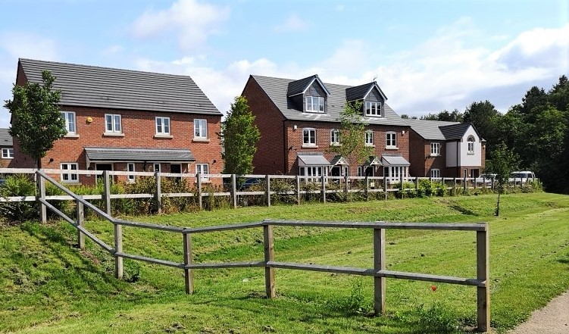

ASHFIELD DISTRICT HOUSING DELIVERY ACTION PLAN

July 2021

THIS PAGE IS INTENTIONALLY BLANK

CONTENTS

Section |  | Page
1 | Introduction | 1
2 | The Purpose and Aims of the Document | 3
3 | Geographical Context | 4
4 | Planning Policy Context | 5
5 | Housing Delivery Analysis | 8
6 | Engaging with Stakeholders | 19
7 | Actions and Initiatives | 21
8 | Monitoring and Review | 27
Appendix 1 | Local Housing Need based on the NPPF/PPG Standard Methodology – April 2021 | 28
Appendix 2 | Stakeholder Questionnaire | 29
Appendix 3 | Summary of Stakeholder Questionnaire Responses | 32

THIS PAGE IS INTENTIONALLY BLANK

Introduction
  - The 2018 National Planning Policy Framework (NPPF)1 and National Planning Practice Guidance (NPPG)2 introduced the Housing Delivery Test (HDT). The test measures the number of homes required over a three year period against the number of homes delivered and calculates the result as a percentage.

  - The latest HDT covers the monitoring years 2017/18, 2018/19 and 2019/20 and the results were published on the 19th January 2021. Ashfield scored a 65% result against the test as follows:

Year | Number of homes required | Number of homes delivered
2017-18 | 471 | 401
2018-19 | 502 | 344
2019-20 | 435 | 173
Total | 1407 | 918

Housing Delivery Test 2020 measurement – 65%
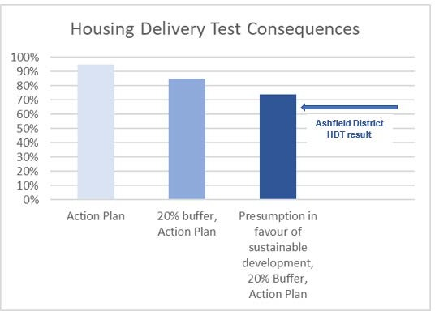

1https://assets.publishing.service.gov.uk/government/uploads/system/uploads/attachment_data/file/810197/N
PPF_Feb_2019_revised.pdf

2 https://www.gov.uk/guidance/housing-supply-and-delivery#housing-delivery-test

  - This requires the Council to:
    - Produce a Housing Delivery Action Plan (HDAP). The Plan should identify reasons for under-delivery, explore ways to reduce the risk of further under- delivery and set out measures the authority intends to take to improve levels of delivery, and
    - Apply a 20% buffer to 5 year housing land supply; and,
    - Apply the presumption in favour of sustainable development in decision-taking (in accordance with NPPF paragraph 11, footnote 7).

  - This document is the first Housing Delivery Action Plan produced by Ashfield District Council. Previous HDT results, under transitional arrangements, were as follows and did not necessitate direct action from the Council:-
    - 2018 – 116% No consequences
    - 2019 – 95% No consequences

The Purpose and Aims of the Document

  - The main aims of the Housing Action Plan are as follows:

- To provide a short summary of the Council’s HDT results and its implications;
- To provide an analysis of the key reasons for the historic under-delivery of new homes in the district against its housing requirement;
- To identify the measures the Council has already undertaken and intends to take to increase and accelerate the delivery of new housing in the district; and
- To identify the monitoring arrangements for the Housing Action Plan.

  - The Council recognises that delivering growth within the district is complex. Whilst it is noted that a number of the actions identified in the Housing Action Plan are principally within the remit of the Council to resolve (such as the production of planning documents and the timely determination of planning applications for housing schemes), the Council will also need support and the co-operation of those involved in delivering new homes, including landowners, developers, land promoters, government bodies/funding sources such as Homes England, infrastructure providers (such as utility providers) and upper tier authorities (i.e. Nottinghamshire County Council).

Geographical Context

  - Ashfield District covers an area of 10,956 hectares and is located on the western side of Nottinghamshire in the East Midlands Region. It adjoins five districts within the Nottinghamshire County including Nottingham City to the south and Mansfield to the north and east (plus Gedling, Newark & Sherwood, Broxtowe), and three Derbyshire districts (Amber Valley, Bolsover and Erewash). There are three Main Urban Areas in the District where housing, jobs and services are generally concentrated. The southernmost is Hucknall which lies immediately north of Nottingham. Kirkby in Ashfield and Sutton in Ashfield are to the north of the District and include the adjoining settlements of Annesley Woodhouse/Annesley, Huthwaite, Stanton Hill and Skegby.

  - The three large villages of Selston, Jacksdale and Underwood, located to the west of the M1 motorway, contain significant residential areas, but lack the concentration of employment opportunities and services found in the main centres. The remainder of the District is primarily countryside or Green Belt but contains a number of smaller settlements including New Annesley, Bagthorpe, Harlow Wood, Teversal and Fackley.

  - The District has excellent road links to much of the country due to its location beside the M1 motorway. Junction 26 of the M1, which is outside the District, provides a good link to Hucknall. Junction 27 of the M1 lies within the District and provides a major link to Ashfield’s three towns and Junction 28 can be easily accessed via the A38 and other major routes including the A611 and the A617 Mansfield-Ashfield Regeneration Route (MARR)3. Transport connectivity is further enhanced by the NET tram service in Hucknall connecting with Nottingham and associated train services, and also the Robin Hood Railway line with stations at Sutton Junction, Kirkby, and Hucknall

  - Map 1 illustrates the geographical context of the Ashfield District area.

3 Ashfield District Council Annual Monitoring Report 2017-2018 p.8

Map 1: Ashfield District Geographical Context
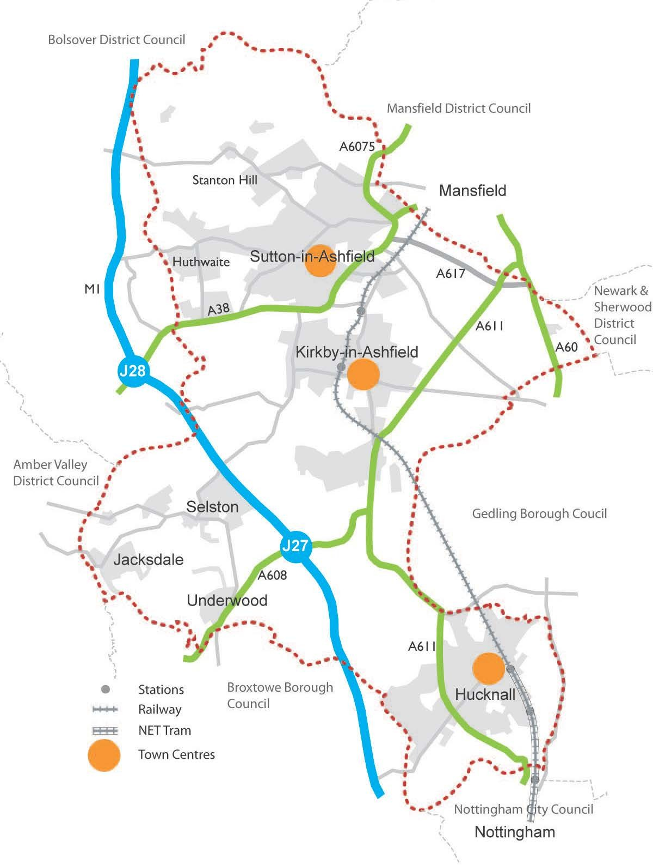

Planning Policy Context
The Local Plan

  - The current Local Plan for Ashfield comprises the ‘saved’ policies contained within the Ashfield Local Plan Review 2002 (ALPR). This identified housing land requirements and supply for the period 1991 to 2011. The ALPR Policy ST2, ST3 and ST4 aimed to concentrate development within the urban areas and the named settlements. The ALPR set out allocations of a number of housing and employment sites in what was formally the open countryside to meet anticipated future need. As part of the Plan, the urban and settlement boundaries were amended to include these allocations which were typically adjacent to the former main urban areas or named settlements. This reflects a sustainable approach as set out in the NPPF which does not prohibit the uses of settlement boundaries within development plan policies. However, the settlement boundaries within the ALPR were defined to allow for sufficient growth to meet future land use needs for the Plan period to 2011. Many of the housing allocations under Policy HG1 have been developed, which substantially limits the opportunity for the existing ALPR to meet future housing needs.

  - The Council are currently working towards producing a new Local Plan for the District which will identify sufficient land to meet housing requirements for the period 2020 to 2038.

The Green Belt

  - Ashfield District Council is a Green Belt authority with approximately half of the land outside of the urban areas forming part of the Nottingham-Derby Green Belt. Essentially this is the area in the southern half of the District, surrounding the town of Hucknall and the larger villages of Selston, Jacksdale and Underwood, alongside smaller settlements of New Annesley, Brinsley and Bestwood (see Map 2). The presumption against inappropriate development in the Green Belt and the need to demonstrate very special circumstances for larger scale residential development means that there is limited scope to permit development to address under delivery in Ashfield, unlike in non-Green Belt authorities. Any significant increase in housing land supply in these areas is dependent on a review of the Local Plan.

  - The NPPF states that altering Green Belt boundaries through a local plan can only be justified by exceptional circumstances. Such exceptional circumstances may include any unmet quantitative need for housing (as derived from using the standard method for assessing housing need) that cannot be accommodated within the built-up area.

Map 2: Extent of Green Belt in Ashfield District
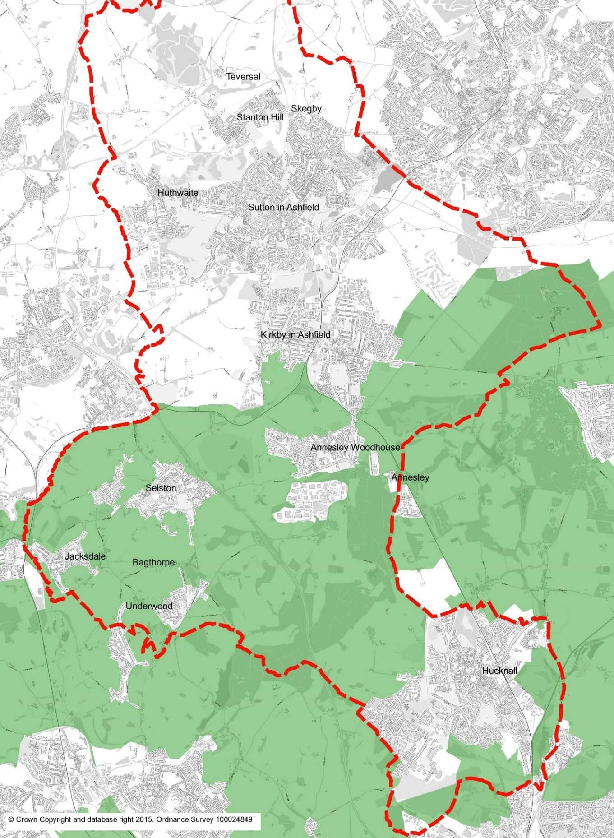

Neighbourhood Plans

  - Ashfield has 2 neighbourhood planning areas:
    - Jacksdale, Underwood and Selston (JUS-t Neighbourhood Plan Area)4

    - Teversal, Stanton Hill and Skegby5

  - The Teversal, Stanton Hill and Skegby Neighbourhood Plan 2016-2031 has been adopted as part of the development plan and is a consideration in determining planning applications. The plan does not allocate land for housing but does set out a community vision, design principles for residential development, and a requirement for a housing mix which incorporates smaller market dwellings to meet the needs of the elderly and first-time buyers. It also identifies green corridors between Stanton Hill and Skegby and between Teversal and Stanton Hill which are sensitive as they prevent coalescence between the settlements and provide opportunities for biodiversity. Development should avoid these green corridors to maintain this sense of openness.

  - The (JUSt) Neighbourhood Plan 2017 - 2032 for Selston has been adopted as part of the development plan and is a consideration in determining planning applications. Areas outside the settlement boundaries of Selston, Jacksdale, Underwood and Brinsley are within the Green Belt. The plan does not allocate land for housing but does set out a vision, design principles for development, a requirement for a housing mix which incorporates smaller market dwellings to meet the needs of the elderly and first time buyers, and supports assisted living accommodation. Development proposals are also required to demonstrate that identified view corridors, which are an important part of the landscape character, are protected.

Strategic Housing and Economic Land Availability Assessment (SHELAA)

  - The SHELAA involves a technical, high-level assessment of sites which could contribute towards the future supply of housing and employment land within Ashfield District. It provides background evidence on the potential availability of sites. The last SHLAA documents (Strategic Housing Land Availability Assessments - predecessors to the SHELAA) were published in January 2016. A new ‘Call for Sites’ exercise has since taken place in support of the new Local Plan and work is underway to publish an updated SHELAA report in Summer/Autumn 2021, prior to the consultation of the Draft Local Plan.

4 https://www.ashfield.gov.uk/planning-building-control/neighbourhood-plans/jacksdale-underwood-selston- neighbourhood-plan/

5 https://www.ashfield.gov.uk/planning-building-control/neighbourhood-plans/teversal-stanton-hill-skegby- neighbourhood-plan/

Self-build and Custom Build Register

  - This is completed and managed by the Council’s Forward Planning Team and is a register of individuals or groups who have expressed an interest in self-build and custom build projects. Ashfield District Council shares a joint register with Mansfield and Newark & Sherwood District Councils, as they fall within the same housing market area. As of 30th October 2020, a total of 17 individuals have been accepted on to the register, with 1 groups/associations registering interest. As this is a joint register, 12 individuals expressed an interest in self-build anywhere within the 3 Districts, 1 group expressed an interest in building in the Ashfield or Mansfield Districts, 2 individuals expressed an interest in building in the Ashfield or Newark & Sherwood Districts, with the remaining 3 individuals interested in self-build solely within Ashfield District.

Brownfield Register
  - The Council maintains and publishes a register of previously developed land which may be appropriate for residential development6. This includes sites with extant full planning permission, outline planning permission and permission in principle as well as sites without planning permission and comprises Part 1 of a Brownfield Register as set out in Planning Practice Guidance7. However, the Council has seen significant delivery of housing on former colliery and traditional textile factory sites. Other colliery sites have been developed for employment purposes or transformed into country parks. Consequently, there are limited brownfield sites that are deliverable within the District.

  - Part 2 of a brownfield land register enables the local planning authority to list sites from Part 1 where land would be suitable for a grant of permission in principle for residential development. As of July 2021, Ashfield does not have any sites listed in Part 2.

Affordable Housing Delivery Strategy 2019-20218
  - This document has been prepared by Ashfield District Council and aims to:
    - identify the scale of demand and supply of affordable housing in Ashfield district
    - maximise delivery of affordable homes by us on our land
    - maximise the delivery of affordable homes by housing associations and private developers in the district.

6 https://www.ashfield.gov.uk/planning-building-control/land-environment/brownfield-land-register
7 https://www.gov.uk/guidance/brownfield-land-registers
8 https://www.ashfield.gov.uk/your-council/strategies-plans-policies/housing-strategy-research/

Housing Delivery Analysis

  - The Council monitors housebuilding through the collection of data on planning applications and the completion/commencement of individual dwellings. These two elements provide the basis for measuring performance against the Council’s housing requirement. The data collected on housing approvals and completions feeds into the Council’s Housing Land Monitoring Report9, which is published on an annual basis.

Housing Requirement and Rate of Delivery
  - As set out in paragraph 3.1, the ‘saved’ policies of the Adopted Ashfield Local Plan Review 2002 (ALPR) identified housing land requirements and housing land allocations for the period 1991-2011. As such, the housing land requirement set out in local planning policy is acknowledged as being insufficient to meet future anticipated needs.

  - In July 2018 the Government published a revised National Planning Policy Framework which introduced the requirement for strategic policies to be informed by local housing need assessments, conducted using the standard method set out in National Planning Practice Guidance (PPG). The Local Housing Need (LHN) for Ashfield District, based on this standard methodology, is currently calculated at 45710 dwellings per annum (dpa), and represents a marginal decrease of 25 dpa below the annual figure used in the 2020 Housing Monitoring Report.

  - The chart below illustrates how historic delivery compares against housing requirements for the period 2002 to 2021. The period used is taken from the adoption date of the ‘saved’ Ashfield Local Plan Review (2002) up to present. The annual requirement is taken to be the adopted requirement at the point of housing delivery, or assessed Local Housing Need (LHN) where the adopted requirement is out of date.

  - Delivery has fluctuated throughout this period, with overall cumulative completions falling below the cumulative requirement as the 2002 Local Plan allocations are built out, and settlements become constrained by policy. The District has a legacy of redundant coal mining areas and textile industries which have provided numerous brownfield sites in the past. However, these have now been successfully

9 https://www.ashfield.gov.uk/planning-building-control/local-plan/monitoring/

10 The Local Housing Need is assessed using a standard approach based on published data. These include household projections and affordability ratios which vary on an annual basis. See Appendix 5 for more information.

redeveloped, leaving little scope for future development on brownfield/previously developed sites.
Dwellings

  - Cumulative completions are currently approximately 9% (800 dwellings) below the cumulative `requirement over the past 19 year period.
Comparison of Delivery against Requirement 2002 - 2021
10000
9000
8000
7000
6000
5000
4000
3000
2000
1000
0
cumulative completions
cumulative requirement
Year

Future Housing Supply/Trajectory
  - For the purposes of this report, the take up of housing land is monitored alongside the current LHN of 457 dwellings per annum to assess the rate of development against requirements and current land availability. An end date of 2038 is used to reflect the emerging Local Plan period and the NPPF requirement for strategic policies to look ahead over a minimum of 15 years from adoption. It is currently anticipated that the new Local Plan will be adopted in 2023, hence the monitoring period is taken to be 18 years from 2020 to 2038.

  - Table1 illustrates Ashfield’s housing land supply at 31st March 2021 set against the need for housing in the District for the period 2020-2038. The table refers to sites which can be delivered under current policy (as set out in the Ashfield Local Plan Review 2002) and includes sites with planning permission, housing land allocations and several sites put forward in the Strategic Housing and Economic Land Availability Assessment (SHELAA). The figures take account of deliverability with regard to availability, lead-in time and development rates.

  - The anticipated supply applies a discount rate to planning permissions to account for potential non-delivery (Appendix 4), alongside a windfall allowance to reflect small sites which may come forward beyond the first 5 years. These calculations are based on historic performance over a period of 10 years in order to take account of peaks and troughs in the housing market11 .

  - The table shows a significant under supply of housing land available to meet future need to 2038. This is due to the outdated status of the current Local Plan and the fact that the majority of SHELAA sites would be contrary to ‘saved’ policies within that Plan. For instance, most submitted sites fall outside what is currently identified as Main Urban Areas or Named Settlements, or are situated within the Green Belt and so cannot be identified as developable without a change in policy.

  - The trajectory chart below illustrates how and when housing is anticipated to be delivered over the 18 year period from 2020 to 2038, and how this compares with the assessed need. It is evident that additional sites will need to be identified and allocated for housing through a new Local Plan as soon as practically possible in order to prevent a supressed housing market in Ashfield.

11 See Housing land Supply: Explanatory Paper, January 2017 (ADC) www.ashfield.gov.uk

Table 1: Dwelling Requirement and Provision 2020-2038

Number | Requirement | Dwellings
1 | Annual Local Housing Need based on Standard Methodology at April 2021** | 457
2 | Houses needed to meet requirement, 1/4/2020 to 31/4/2038 (18 years) | 8,226
3 | Net Houses delivered*** 1/4/2020 to 31/3/2021 | 265
3a | Homes delivered through C2 residential institution development (dwelling equivalent - see para 3.6) 1/4/2020 to 31/3/2021 | 48
4 | Net requirement 2021 - 2038 | 7,913
Number | Supply | Dwellings
5 | Houses deliverable on small sites, 1/4/2021 to 31/3/2038
5a | With planning permission (including new build, net conversions and  change of use) at 1st April 2021 | 375
5b | Known permitted development/prior notification schemes not yet  implemented at 1st April 2021 | 5
5c | Demolitions and other losses with planning permission at 1/4/21 | -4
5d | Deduction to account for potential lapsed permissions | -101
5e | Windfall allowance beyond 5 years - 1/4/2026 to 1/4/2038 | 720
6 | Houses deliverable on large sites 1/4/2021 to 31/3/2038
6a | With planning permission at 1st April 2021 | 1770
6b | Demolitions and other losses with planning permission at 1/4/21 | 0
6c | Deduction to account for potential lapsed permissions | -58
6d | Potential delivery from sites without planning permission* | 360
7 | Provision from C2 residential institutions (dwelling equivalent) | 6
8 | Total housing supply 1/4/2020 to 31/3/2038  (5a+5b+5c+5d+5e+6a+6b-6c+6d+7) | 3,073
Number | Net Provision | Dwellings
9 | Under provision 2020 to 2038 | -4,840

* Large sites assessed as developable in the SHELAA, and deliverable under current policy (ALPR 2002 saved policies).
** Set out in Appendix 1
*** Including losses and dwellings delivered under permitted development

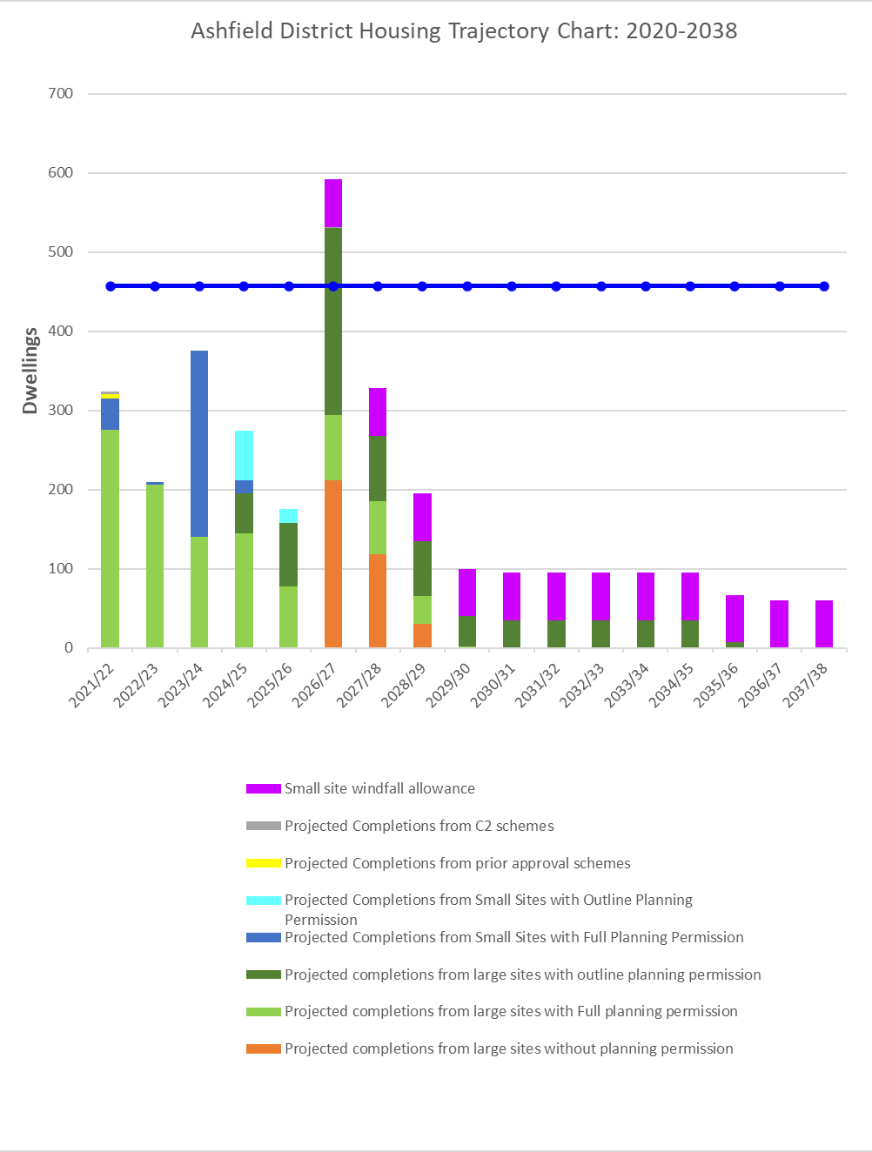

Five Year Housing Land Supply
  - The National Planning Policy Framework (NPPF) places a duty on Local Planning Authorities to demonstrate a supply of specific deliverable sites sufficient to provide five years’ worth of housing against their requirements.

  - Table 2 illustrates Ashfield’s 5 year housing land supply under current policy (ALPR 2002) as at 1st April 2021, and is summarised below. This takes account of:

    - The Council’s Local Housing Need (LHN) based on the standard method for calculation as set out in national planning guidance.
    - A 20% buffer applied to the 5 year supply calculations to help address recent under delivery, consistent with the requirements of NPPF paragraph 7312
    - Dwellings on sites with planning permission deliverable in 5 years.
    - Any large SHELAA sites deemed deliverable in the first 5 years (under ‘saved’ Ashfield Local Plan Review 2002 policy)13.
    - A discount rate applied to the planning permissions (where they are not already under construction) to account for potential non-delivery (see para 3.3).
    - No windfall allowance included in the 5 year supply.

Source | Supply
Supply of housing land under current policy in the Ashfield Local Plan Review 2002 (saved policies) | 2.25 years

  - As of 1 April 2021, the Council could only demonstrate a 2.25 years supply of housing land over the projected five year period. The NPPF’s presumption in favour of sustainable development (paragraph 11) therefore applies.

12 The Housing Delivery Test published in March 2021 has now fallen below 75%. A buffer of 20% (moved forward from later in the Plan period) has therefore been applied.
13 These include land allocated for housing in the current Local Plan, or on the Brownfield Register where there is a realistic prospect that housing completions will begin within 5 years.

TABLE 2: Five Year Land Supply - April 2021

Five Year Housing Requirement | Dwellings
Local Housing Need* @ 457 dpa x 5 years | 2285
Add 20% buffer | 457
Total 5 year requirement including buffer | 2742
Annual requirement including buffer | 548
Current Supply | Dwellings
Existing planning permissions deliverable within 5 years | 1344
Discount applied to permissions based on historic lapse rate | -121
Permitted Development deliverable within 5 years | 5
Residential Institutions (C2) deliverable within 5 years# | 4
Total amount of housing available and deliverable for the next 5 year period | 1232
5 Year Housing Land Supply Calculation | Dwellings
Deliverable sites for the 5 year period | 1232
Divided by annual requirement of | 548
Equates in years to | 2.25
Oversupply (+) or undersupply (-) of dwellings | -1510

* based on standard methodology
# dwelling equivalent, based on planning practice guidance ratio of 1.8

Section 106 Agreements
  - Section106 contribution requests need to be carefully considered as part of the planning application process to ensure that scheme viability and therefore delivery is not compromised. The Council produces an Annual Infrastructure Funding Statement14 which is a summary of financial contributions the council has secured through Section 106 agreements from new developments for off-site infrastructure works, affordable housing, and highway works completed as part of new developments.

14 https://www.ashfield.gov.uk/media/8d8a597125a4e4d/adc-ifs-19_20-final.pdf

Appeal Decisions
Over the past 2 years the Council have given 50 decisions on Major applications. Over the same period, there have been 2 planning appeals lost on Major developments, which accounts for 4% of decisions. It is estimated that if the Council loses 5 appeals on Major developments over the current 2 year rolling time period, central government could consider putting the council into special measures based on these results.

Implications of COVID-19 pandemic
  - The COVID-19 pandemic and social distancing measures are expected to have a significant impact on future housing delivery, although it is too early to assess how it will impact on house building or how quickly the industry might recover. It should also be noted that the housing delivery test (HDT) is backward looking over a three-year period, meaning that the impact of COVID-19 pandemic will not be evident in the HDT results for some time. The next HDT will cover the three-year period 1 April 2018 to 31 March 2021, which includes the nationwide lockdown period, and is likely to be substantially impacted unless the Government’s method of assessment is modified to take account of the pandemic.

  - Planning consultants Lichfields15 identifies the significant risks in the short to medium term as follows: -
    - Challenges to the capacity of the construction industry including the supply chain and labour supply;
    - Restructuring following business closures and redundancies;
    - Reduced consumer confidence;
    - The viability of housing sites may be affected leading to applications to renew permissions, review S106 agreements and/or to vary conditions; and
    - Delays to local plan preparation.

  - Work was suspended at the end of March 2020 on a number of large housing sites in Ashfield such as the Rolls Royce site, but has largely been recommenced since lockdown restrictions have been lifted. There were also delays with planning applications due to a requirement to complete survey work – for example Transport Assessments that held up a number of applications in the system.

  - The Business and Planning Act 2020 came into force on 22 July 2020 to make provision relating to the promotion of economic growth recovery and growth. The Act temporarily modifies the Town and Country Planning Act 1990 and the Planning (Listed Buildings and Conservation Areas) Act 1990 to enable certain planning

15 https://lichfields.uk/blog/2020/april/15/covid-19-testing-times-for-housing-delivery-hawks-vs- doves/

permissions and listed building consents in England which have lapsed or are due to lapse during 2020 to be extended. Those that have lapsed since 23 March 2020 and due to lapse until 31 December 2020 are to be extended to 1 May 2021. It also provides for the modification of conditions on working hours attached to planning permissions to be varied to allow longer working or working on days or part of days which would otherwise have not been permitted. A number of developers active on sites in Ashfield are currently taking advantage of extended working hours to aid completion.

Engaging with Stakeholders

  - In preparing this Action Plan the Council has sought to consult developers, housebuilders, agents, and architects to gain views on the main issues that may be slowing down housing delivery in the Ashfield District. A questionnaire was circulated to the stakeholders to gain a better understanding of current housing delivery and to identify any barriers and constraints. The questionnaire provided the opportunity for stakeholders to present their views and also consider the significance of a range of specific factors (e.g. Lack of sites, affordable housing requirements, S106 negotiation etc.) in slowing down housing delivery. The questionnaire can be found in Appendix 2.

  - Approximately 100 stakeholders were contacted on 2 occasions over a period of 4 weeks throughout June 2021. However, only a limited response was received from 7 stakeholders with involvement in current and planned housing developments within the District. As such, any extrapolation of data cannot be conclusive, but does give an indication of local stakeholder opinion. Appendix 3 sets out the summary of responses.

  - The key barriers experienced which have affected timely delivery were considered to be: -

    - Planning committee decisions based on poor reasons for refusal, leading to delays and costs associated with the appeal process;
    - Planning committee making decisions contrary to officer recommendations;
    - Delayed responses from statutory consultees;
    - Difficulty contacting case officers;
    - Pre-commencement conditions can delay start on site, e.g. s38 agreements;
    - Duplication of conditions on Outline and Reserved Matters permissions;
    - Significant policy constraints, such as Green Belt;
    - The absence of an up to date Local Plan

  - When asked to rate specific areas of potential concern, it can be seen in the graph below that the main barriers are considered to be: -

    - The lack of an up to date Local Plan, application timescales, and issues with pre-commencement/discharge of conditions.

The least problematic areas are considered to be: -

    - the requirement for affordable housing, infrastructure/utilities provision, and the housing market uncertainty.

Barriers to housing delivery in Ashfield - Stakeholder Responses

Issues of viability Economic/Housing market uncertainty
Lack of an up to date plan Dishcarging Conditions Application Timescales
Pre-commencement Conditions Infrastructure/ Utilities provision
S106 Negotiations Affordable Housing Requirements
Lack of Sites

0% 10% 20% 30% 40%

50%

60% 70% 80%

Very Significant Quite significant Not Significant

  - When asked what actions the Council could consider to help speed up the planning process/housing delivery, key responses were as follows: -

    - Use delegated powers to make more decisions via professional officers, rather than Committee;
    - Significant investment into officer/committee/member training;
    - Greater resourcing to county highways who have struggled to keep to reasonable response times with their consultations;
    - Additional professional Planning Officers;
    - Simplified planning permissions;
    - More timely discharge of planning conditions;
    - Issue amendment requests as soon as the consultation period is over to give time for discussion with the applicant and preparation of a considered response.
    - Speeding up the adoption of the Local Plan.

Actions and Initiatives
NPPF Suggested initiatives

  - The following actions have been suggested in the NPPG to address issues that affect the delivery of housing and have been considered as part of Ashfield District Council’s HDAP.
    - Review Housing and Economic Land Availability Assessment (HELAA) to identify sites potentially suitable and available for housing development;
    - Work with developers on the phasing of sites, including whether sites can be subdivided;
    - Offer more pre-application discussions to ensure issues are addressed early;
    - Consider the use of Planning Performance Agreements;
    - Carry out a new Call for Sites, as part of plan revision, to help identify deliverable sites;
    - Revise site allocation policies in the development plan, where they may act as a barrier to delivery;
    - Review the impact of any existing Article 4 directions for change of use from non-residential uses to residential use;
    - Engage regularly with key stakeholders to obtain up-to-date information on build out of current sites, identify any barriers, and discuss how these can be addressed;
    - Establish whether certain applications can be prioritised, conditions simplified, or their discharge phased on approved sites;
    - Ensure evidence on particular sites is informed by an understanding of viability;
    - Consider compulsory purchase powers to unlock suitable housing sites;
    - Use Brownfield Registers to grant permission in principle to previously developed land; and,
    - Encouraging the development of small and medium-sized sites.

Initiatives: Local Plan

Action | Purpose | Timeframe | Priority | Implementation | Outcome
Publish updates on Housing Economic Land Availability Assessment | Inform stakeholders of the sites the Council consider available, suitable, and deliverable for consideration within the Local Plan. | Short term | High | Forward Planning Team | Enable developers to identify sites submitted to the Council  For consideration for allocation in the emerging Local Plan.
Regulation 18 draft Local Plan consultation | Inform stakeholders and site promoters of the Council preferred sites for allocation  within the Local Plan. | Short term | High | Forward Planning Team | Provide a level of certainty to developers on sites the Council consider potentially suitable for allocation in the Local Plan.
Further targeted call for sites | To help identify additional sites that would be beneficial for consideration within the Local Plan. | Short term | Medium | Forward Planning Team | Provide an update of additional suitable sites for allocation within the Local Plan.
Regulation 19 Local Plan pre- submission consultation | Present to stakeholders the development sites the Council consider suitable, available and deliverable as part of the Local  Plan. | Medium term | High | Forward Planning Team | Provide a high level of certainty to developers on sites the Council consider potentially suitable for allocation in the Local Plan.
Submit Local Plan for adoption | Allow the Local Plan and development sites to be tested through examination on their deliverability. | Medium term | High | Forward Planning Team | Allow the Council strategy and allocated sites be tested through external examination.
Adopt Local Plan | Give certainty to developers on the Councils intention towards developing sites within the  District. | Long term | High | Forward Planning Team | Council will permit allocated development sites that have planning applications that meet policy criteria.

Initiatives: Development Management

Action | Purpose | Timeframe | Priority | Implementation | Outcome
Pre-application service | To enable parties to obtain advice on a potential application prior to  submission. | Ongoing | In place | Development Management/Forward Planning Team | Removes uncertainty and enables applications to progress more rapidly.
Major Projects Group | To enable infrastructure providers to review major applications with DM officers | Ongoing | In Place | Development Management Team | Enable issues with an application to be identified at an early stage and solutions sought in a round table setting.
Review response timescales from statutory and other key  consultees | Identify where slow responses from consultees frequently result in a delay in the decision making  process. | Short term | High | Development Management Team/ Planning Information Team | Enable feedback to statutory/key consultees to encourage improved resourcing where required and enable more acceptable response  timeframes.
Councillor training in respect of decision making  and reasons for refusal | To minimise schemes entering the appeals process, and any associated award for costs. | Short term | In place but reinforce | PAS, PINs, or similar external enablers | Enables faster delivery of suitable development and may resist incurring costs from appeals process.
Encourage pre- applications advice for residential  development | To resolve potential, issues before the application is submitted | Short term | In place but reinforce | Development Management | Removes uncertainty and enables applications to progress more rapidly.
Continued on next page.

Initiatives: Development Management cont…

Action | Purpose | Timeframe | Priority | Implementation | Outcome
Legal Agreements (S106) | To draft legal agreements simultaneously with the application to avoid  lengthy delays following a committee resolution | Short term | encouraged | Development Management/Legal Section | Enables planning permissions to be granted at an earlier date.
Encourage at pre- application stage the submission of draft heads of  terms | To reduce the timescale taken for legal agreements to be completed. | Short term | In place but reinforce | Development Management/Legal Section | Enables planning permissions to be granted at an earlier date.
Discharge of conditions tracker | To better understand the discharge of condition process and identify where there maybe blockages. | Medium term | Medium | Development Management Team/Information Support Team | Identify where there are delays in the processing of conditions discharges. This will inform if there's a need to formulate remediation actions.
Major Sites/Applications Tracker | To better understand the range of sites and their progress from informal enquiry/pre-app engagement through to permission/condition discharge and build-out. | Long term | Medium | Major Projects Focus group | Evaluate: Scope/range of major development opportunities; resources required to support relevant projects; progress on major pre-apps/applications; and when contact with developers is required to progress delays post  event stage and/or permission.

Initiatives: Delivery of Sites

Action | Purpose | Timeframe | Priority | Implementation | Outcome
District Council to act as a housing developer for new affordable housing schemes on its own  land. | To enable affordable housing schemes to be brought forward to contribute towards affordable housing need. | ongoing | In place | Housing Strategy Team/ Development Management Team | More affordable housing dwellings brought forward.
Review of unimplemented detailed planning  permissions | Encourage developers to bring sites forward | Short term | High | Forward Planning Team | Prioritise sites and contact landowners to enable site to be brought forward at an earlier date.
Engaging with promoters of SHELAA sites, outline planning permissions and existing allocations | Identify constraints to delivery of sites within the Local Plan and those being considered | Short term | High | Forward Planning Team | Inform site promoters on the Local Plan progress and sites suitable for potential allocation, agree phasing and delivery assumptions and requirements for demonstrating  deliverability of sites
Corporate prioritisation of housing delivery as a key cross-cutting theme to drive behaviour and decision making  within various parts of the Council | To encourage sustainable growth to meet the future needs of the District | Medium term | High | Corporate | Ensure sufficient residential development is forthcoming in a timely manner.
Continued on next page

Initiatives: Delivery of Sites cont...

Action | Purpose | Timeframe | Priority | Implementation | Outcome
Explore scope for new Local Plan monitoring indicators | More detailed analysis of housing delivery performance | Medium term | Medium | Forward Planning Team | Identification of housing deliverability performance and emerging trends that may require  further actions to increase deliverability.
Use of Brownfield  register & Permission in Principle | Promotion of smaller  sites to facilitate development by SMEs | Medium term | Medium | Forward Planning Team | Bring forward smaller sites to deliver housing.

Monitoring and Review

  - The Housing Delivery Action Plan will be reviewed on at least an annual basis where Ashfield District Council falls short of 95% of its HDT measurement during the reported year. The Council will monitor the effectiveness of actions themselves, as well as the outcomes (e.g. housing delivery rates and supply, the Council’s five year housing land supply position etc.). The actions will be updated where necessary and new ones may be added in response to external changes, such as new funding streams, Government initiatives and changes to legislation and/or policy.

  - In addition, the Council welcomes suggestions on any future actions the Council may take to help support house building in Ashfield District. These can be made by contacting us through the following methods: -

 Email: localplan@ashfield.gov.uk
 Telephone: 01623 457381/ 457382 / 457383
 Write to:

Ashfield District Council, Forward Planning, Council Offices,
Urban road, Kirkby in Ashfield, Nottinghamshire, NG17 8DA.

APPENDIX 1

Local Housing Need based on the NPPF/PPG Standard Methodology – April 2021

Planning practice guidance sets out the standard methodology for assessing the minimum number of homes expected to be planned for in a local planning authority area16.
Essentially the process is as follows: -

- Calculate the average annual household growth over a 10 year period, based on 2014 HH growth data.
Ashfield household growth 2021 to 2031 = 4224 (422 dpa)

- Adjust the annual figure used on the affordability of the area. This uses a ‘median workplace based affordability ratio’ as published by the ONS (Table 5c). The ratio for Ashfield is 5.30 (2020 ratio published March 2021).

Adjustment factor = (5.30-4) x 0.25
4

= 1.30 x 0.25
4

= 0.325 x 0.25

= 0.08125

- Total minimum annual need at March 2021 is calculated as follows: 1 + adjustment factor x projected household growth = 1.08125 x 422.4 = 456.72
457 dwellings per annum (dpa)

16 https://www.gov.uk/government/publications/housing-delivery-test-measurement-rule-book

APPENDIX 2
Stakeholder Questionnaire
The questionnaire below was circulated to approximately 100 developers/housebuilders, agents and architects who are currently, or have been recently active in Ashfield District, alongside the Home Builders Federation (HBF). The consultees were contacted on 2 separate occasions over the period of 4 weeks (June 2021) in order to provide the opportunity to raise concerns and share views which may assist in increasing housing delivery within the District. The summary of responses received is set out in Section 6 of this document.

Housing Delivery in the Ashfield District
Ashfield District Council is preparing a Housing Delivery Action Plan (HDAP) to provide a better understanding of current housing delivery in the district, to identify barriers and constraints to delivery, and to consider potential actions to increase delivery in the future.
As developers, housebuilders, agents and architects you perform an important role in the local housing market and we would welcome your feedback to help inform the Action Plan document. The aim of this questionnaire is to gain views from a range of stakeholders on the main issues that may be slowing down housing delivery in the Ashfield district.

UK General Data Protection Regulation (“UK GDPR”) and Data Protection Act 2018 (“DPA”) – Privacy Notice
Under the UK GDPR and DPA, Ashfield District Council is a Data Controller for the information is holds about you. The Council will hold information provided by you in relation to the answers provided to this questionnaire. The lawful basis under which the Council uses personal data for this purpose is Public Task. Please see the Council’s main Privacy Notice for details.
Data held in relation to the above purpose will be held by the Council for as long as necessary to fulfil the above purpose in accordance with data protection legislation, the Council’s main Privacy Notice and Retention Schedule. Subject to some legal exceptions, you have the right to request a copy of the personal data that the Council holds about you; to have any inaccuracies corrected; to have your personal data erased; to place a restriction on our processing of your data; to object to processing; and to request your data be ported. The information provided by you may also be used for other functions carried out by the Council in accordance with the UK GDPR and/or DPA as well as the Council’s main Privacy Notice.
For more information about how the Council may use your data and to learn more about your rights please see the Council’s main Privacy Notice which can be found here: https://www.ashfield.gov.uk/your-council/legal-information-public-data/privacy-notice/ or request a copy by writing to the Data Protection Officer, Ashfield District Council, Urban Road, Kirkby In Ashfield, Nottinghamshire NG17 8DA or by email to dpo@ashfield.gov.uk.

Organisation:
Date:

Questions:
What is your current involvement with promoting housing development in Ashfield?
Please provide details of any delays or issues holding up the delivery of housing in Ashfield (e.g. S106, viability, affordable housing etc).
To what extent do you consider the following to be significant barriers slowing down housing development in the District (tick as appropriate):
 |  | Very Significant | Quite significant | Not Significant
 | Lack of sites
 | Affordable housing requirements
 | S106 negotiations
 | Infrastructure/ utilities provision
 | Pre-commencement conditions
 | Application timescales
 | Discharging conditions
 | Lack of an up to date development plan
 | Economic/Housing market uncertainty
 | Issues of viability
Are there any actions that the Council could consider to help speed up the planning process/housing delivery? Please provide details
Please provide any other comments relating to housing delivery issues.

APPENDIX 3
Summary of Stakeholder Questionnaire Responses

Details of any delays or issues holding up the delivery of housing in Ashfield. | Poor planning committee decisions refusing or postponing decisions with no proper planning reason for refusal, leading to delays to ultimately deliverable and viable proposals - Profit margins are not substantial enough in this geographic area to cope with lengthy  planning delays.
Planning committee determining applications contrary to officer recommendations. Rebuilding the trust between the planning department and committee should be a priority. Additional planning training is required to better enable committee member to differentiate
between material outline planning matters and reserved matters.
The discretionary powers of officer to weigh the merits of applications
appears diminished.
Too much leeway is afforded to statutory consultees delaying key
matters like highways and drainage.
 | Lack of quality officer engagement which leads to ad-hoc decisions.
Case Officers are often hard to get in contact with, and do not place
enough pressure on consultees to give comments within the statutory timeframe.
Pre-commencement conditions required from statutory consultees can make it hard to get on site quickly following a detailed approval, e.g. the condition imposed by Highways to have a S38 in place prior to commencing on site which is unrealistic. Receipt of a planning permission often triggers the developer's obligation to purchase the site and for cash flow reasons it is often necessary to start as soon as possible after the site is purchased. It can often take many months to get a S38 Agreement in place which will delay developers' ability to
lawfully start on site.
Planning conditions imposed on Reserved Matters approvals that are conditions on the Outline Permission - this duplication often means
there are more conditions to discharge which delays a start on site.
Discussions around double counting of highway improvements
required by NCC that were in both a planning condition and a S106.
 | Significant policy constraints (e.g. greenbelt).
Developing sites is made difficult by the lack of an up to date Local Plan. The Forward Planning team do not appear to have a full
programme for putting the local plan together.
The absence of a plan led system due to no local plan instantly puts applicants at the mercy of the committee who appear anti-development which in turn results in a high % of appeal proceedings with the
inherent delays and cost.

To what extent do you consider the following to be significant barriers slowing down housing development in the district | As set out in the graph below, it can be seen that the key barriers (within the limitations of the specific questions) are considered to be the lack of an up to date Local Plan, application timescales, and issues with pre-commencement/discharge of conditions.  The least problematic areas are considered to be the requirement for affordable housing, infrastructure/utilities provision, and the housing market uncertainty.  Barriers to housing delivery in Ashfield - Stakeholder Responses  Issues of viability Economic/Housing market uncertainty  Lack of an up to date plan Dishcarging Conditions Application Timescales  Pre-commencement Conditions Infrastructure/ Utilities provision  S106 Negotiations Affordable Housing Requirements  Lack of Sites  0% 10% 20% 30% 40% 50% 60% 70% 80%  Very Significant Quite significant Not Significant
Are there any actions that the Council could consider to help speed up the planning process/housing delivery? | More delegated decisions by expert planning officers to avoid needless  committee delays.
 | Get the planning committee in check.
 | Significant investment into officer/committee/member training.
Greater resourcing to county highways who have struggled to keep to
reasonable response times with their consultations.
Knowledgeable, pragmatic and accessible Case Officers (and more of
them)
 | Simplified planning permissions.
 | More timely discharge of planning conditions.
Issue amendment requests as soon as the consultation period is over, rather than a few days before the committee meeting. This will give time for discussion with the applicant and preparation of a considered
rather than a rushed response.
 | Speeding up the adoption of the Local Plan.

