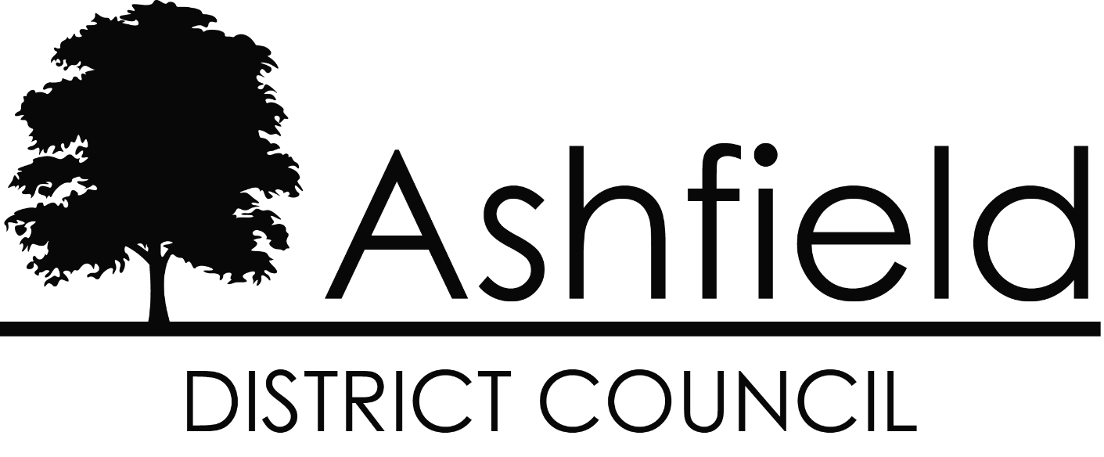

Hedgerow Policy

1

January 2014

Contents
- Background
- Hedgerows in Ashfield district
- Privately owned hedges
- Relevant Legislation
- Maintenance
- Use of Contractors
- New Developments

Background
  - The Council is committed to making the environment clean, safe and accessible, Hedgerows play an important role in the environment by helping prevent soil erosion, providing shelter for livestock and crops, assisting in boundary control, providing an essential habitat and food source for birds and wildlife, support biodiversity, as well as providing a key aesthetic feature of the English countryside.

  - Ashfield District Council’s (ADC’s) responsibility is to ensure that hedges within ADC owned or managed land are maintained to the required specification to ensure that they do not pose a physical or visual obstruction to road users and the public. The Council are also responsible for ensuring the integrity and health of the hedge it maintains which is an asset to birds and wildlife and that it remains a viable boundary.

Hedgerows in Ashfield District

  - Most of the hedgerows within Ashfield are mixed and deciduous, the most common species being:

    - Crataegus monogyna - Hawthorn
    - Ligustrum ovalifolium - Privet
    - Ilex aquifolium - Holly
    - Fagus sylvatica; - Beech

  - The Council maintains 3,846 linear metres of hedgerows which predominantly borders council owned land. We also maintain 28,809 square metres of shrub beds which are within the public domain.

Privately owned hedges
  - The vast majority of hedges bordering the public highway are privately owned, typically by farmers, who maintain them themselves. Their activity is regulated by Nottinghamshire County Council’s Highways Services Section, to ensure compliance with the relevant legislation.

Relevant Legislation
  - The Council will maintain hedgerows in accordance the following legislation

  - Hedgerows Regulations 1997
It is against the law to remove or destroy certain hedgerows without securing permission from the local planning authority. Permission is required before removing hedges that are at least 20 metres in length, over 30 years old and contain certain species of plant. Hedges contained within private residential properties do not require planning permission for removal.

  - Wildlife and Countryside Act 1981
Birds will often nest in hedges, shrubs and trees. The main nesting season has been determined by Natural England as 1st March to 31st July, although no dates are legally stated; however, nesting may occur outside this period. Nesting birds are protected under this legislation, which makes it an offence to:
    - Intentionally kill, injure or take any wild bird
    - Intentionally take, damage or destroy its nest whilst in use or being built
    - Intentionally destroy or take any egg or any wild bird
    - Intentionally or recklessly disturb wild birds or their dependant young while they are nesting (including disturbance of nesting young)

A person is not guilty on an offence if the act was the incidental result of a lawful operation and could not reasonably have been avoided.

  - Section 154 of the Highways Act 1980
The council has no responsibility for ensuring the maintenance of hedgerows adjacent to the public highway, unless on ADC land. Land owners, occupiers or tenants who are responsible for a hedge which borders the public highway are obliged to ensure that it is not overgrowing the pavement, obstructing a driver’s vision, or obstructing the light from a street lamp. If a privately owned hedge causes this problem, the council will inform the relevant authority (Nottinghamshire County Council) of any known cases to ask them to serve a notice on the land owner requiring it to be pruned.

Maintenance
With due regard to the legislation above, the Council will:

  - Maintain all ADC owned or managed hedgerows within the area based Environmental Services Teams. Lead Environment Officers will determine the maintenance requirements for hedgerows in their area and will endeavour to carry out maintenance outside of the period 1st March to 31st August to remain cautious in accordance with the information given to determine the nesting season from the Wildlife and Countryside act 1981.

In certain circumstances hedge maintenance may be required during these restricted periods, any work undertaken during these periods must be approved by a Lead Environment Officer following an inspection of the hedge and confirmation that either no birds are nesting or there are safety reasons for carrying out the work.

In the event of a nest being present in a hedge that needs to be pruned for safety reasons, hand tools will be used for maintenance, and where possible the nesting area will be left untouched.

  - Typically for Council maintained hedges, a tractor with mounted side-arm flail cutters will be utilised to undertake the maintenance. Clippings will not routinely be removed as they usually fall beneath the hedge and provide refuge for small animals and suppress weed growth. If however, clippings from a thorny hedge fall on a foot or cycle path, the council will sweep these away. For smaller hedges, handheld mechanical equipment will be used and clippings collected and disposed of.

  - For hedges maintained by the land owner, occupier or tenant, it is their responsibility to maintain the hedges and remove hazardous clippings from footpaths and cycle paths.

  - Where an ADC owned or managed hedgerow presents an immediate risk to public safety (e.g. overhangs a public highway, public footpath, or by obstructing a driver’s vision), it may be necessary to undertake emergency maintenance within the nesting season to comply with the Council’s obligations under section 154 of the Highways Act.

  - If nesting birds are discovered while hedge cutting, all operations will cease and the Lead Environment Officer or Service Lead must be contacted to determine the next course of action.

  - This maintenance policy will apply irrespective of whether the Council is undertaking work on public or private hedges and shrubs.

  - The Council will not routinely spray hedges with fertilizer or pesticides. This will only be done in exceptional circumstances, where a hedge is afflicted with a pest and requires treatment to maintain public safety.

  - The Council will not remove protected hedgerows unless approved to do so by the Planning department in accordance with Hedgerows Regulations 1997

  - Protected hedgerows within ADC ownership or management will be maintained individually or as part of a management plan. Lead Environment Officers will determine maintenance requirements on an individual basis.

Use of Contractors
  - Where the Council engages a contractor to undertake work on hedges, the contractor will be issued with this policy prior to commencing any work. They will be bound by the stipulations in this policy and will be required to sign that they have received and understood its contents.

New Developments
  - The council is committed to reducing maintenance liabilities on the service, this will include requesting that wherever possible hedgerow boundaries will be contained within property boundaries and not adopted by the council as part of any section 106 agreement for public open space.

