**Employment Land Forecasting Study**

Nottingham Core HMA and Nottingham Outer HMA

Final Report August 2015



###### Nottingham Core HMA and Nottingham Outer HMA

###### Employment Land Forecasting Study

Final Report

14 August 2015 50406/02/MW/CRo

Nathaniel Lichfield & Partners 3rd Floor

One St James's Square Manchester M2 6DN

###### nlpplanning.com

This document is formatted for double sided printing.

© Nathaniel Lichfield & Partners Ltd 2015. Trading as Nathaniel Lichfield & Partners. All Rights Reserved.

Registered Office:

14 Regent's Wharf All Saints Street London N1 9RL

All plans within this document produced by NLP are based upon Ordnance Survey mapping with the permission of Her Majesty’s Stationery Office. © Crown Copyright reserved. Licence number AL50684A

**Contents**

1.0 Introduction 1

Scope of Study 1

Structure of Report 2

2.0 Economic Context 4

Spatial Overview 4

Core HMA 7

Outer HMA 17

Functional Economic Market Areas 27

Conclusions 34

3.0 Overview of Employment Space 36

Core HMA 36

Outer HMA 46

Provision in Adjoining Areas 61

Conclusions 67

4.0 Commercial Property Market 68

Overview 68

Market Segments 69

Future Growth Potential 76

Conclusions 80

5.0 Future B Class Employment Space Requirements 82

Methodology 82

Forecasts of Job Growth 83

Labour Supply 99

Estimating the Land Requirement 102

Converting Net to Gross Requirements 103

Past Rates of Delivery 109

Safety Margin / Flexibility Factor 112

Summary 113

Sensitivity Testing 119

Conclusions 123

6.0 Implications and Conclusions 125

Economic Characteristics 125

Property Market Characteristics 126

Future Employment Land Needs 127

1.0 **Introduction**

* 1. Nathaniel Lichfield & Partners (NLP) was commissioned to prepare up to date evidence on economic prospects and employment land forecasts for the Nottingham Core Housing Market Area (HMA) and the Nottingham Outer HMA.
  2. The commissioning authorities are set out in Table 1.1.

Table 1.1 Commissioning Local Authorities by HMA

|  |  |
| --- | --- |
| **Nottingham Core HMA** | **Nottingham Outer HMA** |
| Broxtowe Borough Council Erewash Borough Council Gedling Borough Council Nottingham City Council  Rushcliffe Borough Council | Ashfield District Council Mansfield District Council  Newark and Sherwood District Council |

* 1. The study will form part of the evidence base for the emerging development plan documents of the eight commissioning authorities, helping to identify future employment land needs and guiding economic development over the period to 2033. On this basis, the study considers future quantitative land and floorspace requirements and any related qualitative factors for individual sectors or employment uses.
  2. Specific requirements of the brief include:
     1. Provision of forecasts of quantitative and qualitative needs by economic sector, estimating the scale of future floorspace needs for each HMA and local authority;
     2. Identification of Functional Economic Market Areas (FEMA), including advice on whether the Hucknall area in Ashfield District forms part of the Core or Outer FEMA;
     3. Make recommendations on qualitative needs by sector or employment use taking into account the proposed location of a HS2 hub station to serve the East Midlands at Toton; and
     4. Undertake an assessment of the balance between proposed housing provision and job forecasts for each HMA and local authority.

## Scope of Study

* 1. The focus of this report is on the employment space needs of the group of ‘B- class’ sectors outlined below:
* **B1a/b Business** (offices, research and development);
* **B1c/B2 Industrial** (light/general industrial); and
* **B8 Storage or Distribution** (warehouses, distribution centres).
  1. Demand for B-class employment land and floorspace represents the particular focus of this study, and references to ‘employment space’ are intended to mean all three of these elements (B1/B2/B8).
  2. The study also considers forecasts for growth in non B-class sectors to provide an indication of how the overall economy of the study area could change in the future. However, it does not specifically assess the space implications of these sectors because they are often planned for using different methodologies and are considered by other forms of technical evidence (e.g. retail assessment).
  3. It should be noted that there are a variety of factors and drivers to consider when objectively assessing business needs for a local area. This study utilises a combination of both quantitative and qualitative analysis to explore these issues within the context of the Nottingham Core and Outer HMAs and synthesises these to draw overall conclusions for each HMA.
  4. An important consideration for any work of this type is that it is inevitably a point-in-time assessment. This study has incorporated the latest data and other evidence available at the point of preparation where available on a consistent basis across the individual local authorities. The accuracy and sources of data derived from third party sources have not been checked or verified by NLP.
  5. As part of the study, consultation was undertaken with a range of stakeholders including commercial property agents and a representative from the D2N2 LEP. Whilst a Business Survey was undertaken as part of this study, a poor response rate meant that the findings were not robust enough to be used in isolation but were instead used to provide further contextual analysis. A stakeholder workshop was held in Mansfield in January 2015 with officers from all of the commissioning authorities and other stakeholders and comprised a presentation of interim findings and structured group discussion. The findings of this workshop, as well as the outcomes of separate stakeholder discussions, have been referenced throughout this report.

## Structure of Report

* 1. The report is structured as follows:
* **Economic Context** (Section 2.0) – a review of current economic conditions and trends within the two HMAs, identifying the strengths and weaknesses that may affect future needs for employment space;
* **Overview of Employment Space** (Section 3.0) – analysis of the current stock and trends of employment space within the two HMAs in terms of mix of uses, development rates, gains and losses and provision in adjoining areas;
* **Commercial Property Market** (Section 4.0) – a review of the sub- regional commercial property market, including the supply and demand for different types of employment space and the needs of different market segments;
  + **Future Requirements for B Class Employment Space** (Section 5.0) – estimates future employment space requirements for B-class sectors in quantitative terms, drawing on employment forecasts and other factors;
  + **Implications and Conclusions** (Section 6.0) – outlines the key implications in relation to planning for employment land needs across the Core and Outer HMAs
  1. Supporting data and assumptions, including a policy context review, are set out in the appendices.

# 2.0 Economic Context

* 1. This section establishes the economic context for the study by summarising recent economic conditions and trends within the Nottingham Core and Outer HMAs relative to the East Midlands region and the national economy. This is important for identifying the existing strengths and weaknesses of the local economy and the factors likely to influence the future demand for employment space.

## Spatial Overview

* 1. A spatial overview of the study area is provided in Figure 2.1.

Figure 2.1 Nottingham Core and Outer HMA Sub-Regional Context

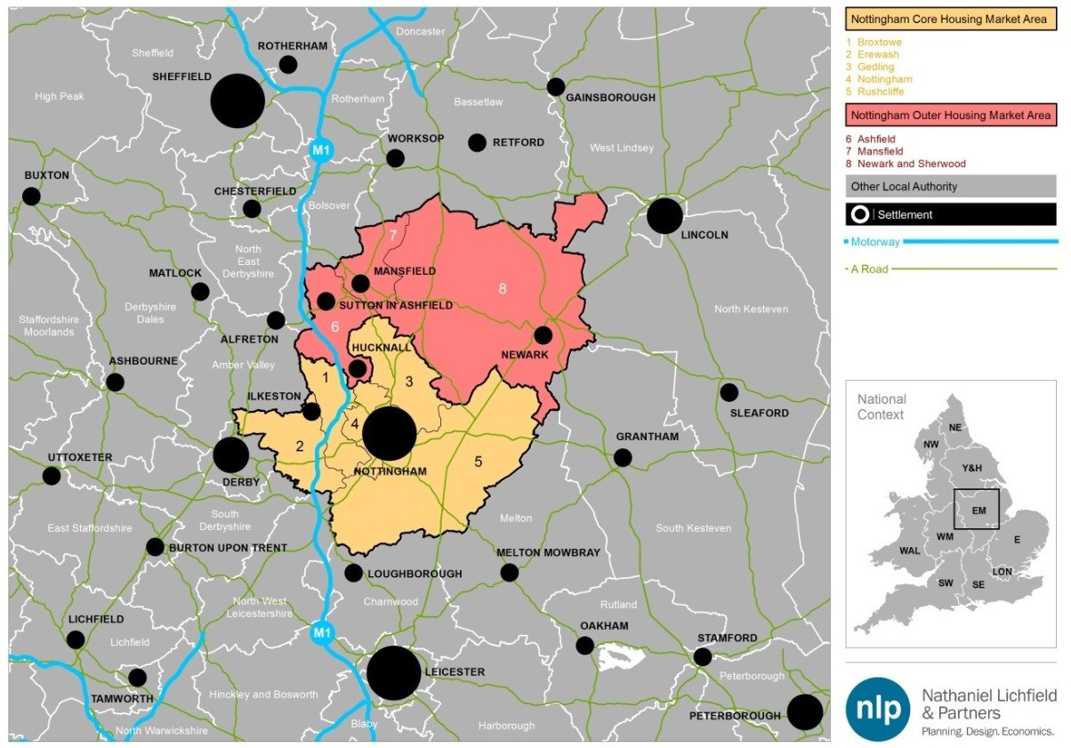

Source: NLP analysis

#### Nottingham Core HMA

* 1. The Nottingham Core HMA consists of the City of Nottingham (with a population of 306,000 residents) along with the boroughs of Gedling (114,000 residents), Erewash (112,000), Rushcliffe (111,000) and Broxtowe (109,000).1 Nottingham City is a designated Core City2 that is recognised as being of national importance and which is a key driver of the wider economy. Often perceived as the ‘capital’ of the East Midlands, it has very close links with the surrounding boroughs within the Core HMA. The main built up areas of the

1 2011 Census

2 A group of large regional cities which seek to counter the dominance of London

other Nottingham Core HMA authorities include Arnold/Carlton (Gedling), Beeston (Broxtowe) and West Bridgford (Rushcliffe) which form part of the ‘residential hinterland’ of Nottingham and are largely suburban in nature. As such, their office and industrial offers are less prominent than in Nottingham. This is also partly due to the restrictive nature of the Nottingham-Derby Green Belt which covers large parts of Broxtowe, Erewash, Gedling and Rushcliffe (and also parts of Nottingham City itself).

* 1. Gedling Borough’s main built up area consists of the suburbs of Arnold and Carlton as well as the two smaller areas of Netherfield and Colwick, in which 80% of the population live (with the remaining 20% in rural villages of varying size). Arnold is the largest suburb and includes the only major district retail centre in the Borough.
  2. Rushcliffe Borough’s main centre of population is West Bridgford. The remainder of the Borough is largely rural, with the population divided between six large settlements (Bingham, Radcliffe on Trent, Cotgrave, Keyworth, Ruddington and East Leake) and smaller rural villages.
  3. Around three-quarters of Erewash Borough’s population reside in the two principal towns of Ilkeston and Long Eaton. The remainder of the Borough is predominantly rural in character.
  4. Broxtowe is one of the most densely populated Boroughs in the East Midlands. It is characterised by a largely urban south with the settlements of Beeston, Chilwell, Bramcote, Stapleford, Attenborough, Toton and part of Trowell. The north of the Borough is more rural, with the largest settlements comprising the towns of Eastwood and Kimberley. The Borough has a relatively large student population (particularly in the Beeston wards) due to its accessibility to the University of Nottingham.

#### Nottingham Outer HMA

* 1. The Nottingham Outer HMA consists of the three districts of Ashfield (population 119,000), Mansfield (104,000) and Newark & Sherwood (115,000)3. Ashfield District contains three main urban areas: Sutton-in- Ashfield (the larger town centre identified as a ‘centre of sub-regional importance’ in the District’s 2011 Retail Study), Kirkby-in-Ashfield (the smaller town centre, defined as a ‘district centre’ in the Ashfield Retail Study4) and Hucknall. These centres also accommodate much of the industrial and distribution employment sites. Office premises are predominantly located at Sherwood Business Park, off Junction 27 of the M1 (a former designated Enterprise Zone). A significant part of the District is located in the Green Belt.
  2. The settlement of Hucknall lies at the southernmost point of Ashfield District, immediately to the north of Nottingham City. Whilst the town is within the administrative boundaries of Ashfield (and hence within the Outer HMA), it has a strong functional relationship to the Core HMA.

3 2011 Census

4 Ashfield District Council (2011) Ashfield Retail Study Update

* 1. Mansfield is dominated by the Mansfield urban area which includes Mansfield Woodhouse. The District’s other main urban area is Market Warsop, which lies in the north of the District and acts as a local service and retail centre for surrounding rural settlements. Employment sites are generally concentrated in the Mansfield urban area, such as at Millenium and Oakham Business Parks to the west, and the Old Mill Lane, Crown Farm, and Bellamy Road Industrial Estates to the east. Offices are primarily located in Mansfield’s central area and on the south-eastern edge of the town, at Ransomwood Business Park.
  2. Newark and Sherwood is the largest District in Nottinghamshire, covering over 65,000 hectares. The District contains much of the central and eastern parts of rural Nottinghamshire, bordering the authorities of Mansfield, Ashfield and Gedling to the west, Rushcliffe to the south, and North Kesteven and West Lindsey to the east. Main settlements include the former mining communities of Ollerton & Boughton, Edwinstowe, Rainworth and Clipstone, whilst other settlements include the more prosperous Newark and Southwell. Large areas of Sherwood Forest lie to the north-west of the District, which is a popular visitor attraction, whilst a proportion of the District is also located in the Green Belt.

#### Transport Links

* 1. Both HMAs are well served by strategic transport links. Regarding the strategic motorway network, both HMAs are connected to the M1 and the national motorway network via the A453 to junction 24 (technically outside the study area but of key importance due to its proximity to East Midlands Airport); the A52 to junction 25 (in Erewash); the A610 to junction 26 (in Broxtowe); and junction 27 (in Ashfield) as well as junctions 28 and 29 which, despite being outside of the study area (in Bolsover), link the M1 to the A38 and the A617 respectively towards Ashfield and Mansfield. Similarly, towards the east of the study area the A1 runs adjacent to Newark-on-Trent. The recent dualling of the A46 provides another high-speed link to the M1. This looks set to further increase the area’s connectivity, as will Mansfield’s £9 million public transport interchange.
  2. In terms of rail connectivity, Newark Northgate is a stop on the East Coast Mainline. With journey times to London Kings Cross taking less than an hour and a half, the area is popular with long distance commuters. Whilst there are direct rail connections from Nottingham City to London, Manchester, Birmingham, Sheffield, Leeds and Liverpool, journey times for some services are relatively long (particularly from Mansfield and Ashfield due to the need to travel to Nottingham via connecting services on the Robin Hood Line).
  3. The High Speed 2 (HS2) rail line will pass through the area via a hub station to serve the wider East Midlands region.5 The exact location of the station has not yet been confirmed, but one option under consideration is at Toton Sidings within the Borough of Broxtowe.

5 Broxtowe Borough, Gedling Borough and Nottingham City Aligned Core Strategy (2012) pg. 16

#### Deprivation

* 1. Analysing deprivation patterns across the two HMAs demonstrates a high level of divergence, with pockets of extreme deprivation in the inner urban areas of Nottingham City, Ashfield and Mansfield, whilst the surrounding rural areas and the sub-urban Nottingham hinterland tend to be considerably more affluent. The 2010 Indices of Multiple Deprivation (IMD), as illustrated in Figure 2.2, suggest that Nottingham City is one of the most deprived local authorities in England, ranked 17th out of 326 (based on ‘rank of average rank’). It is followed by Mansfield (36th), Ashfield (54th), Newark and Sherwood (147th), Erewash (150th), Gedling (196th), Broxtowe (219th) and finally Rushcliffe, which, ranked at 318th, is the third most affluent district across the whole of the Midlands/Northern England behind only South Northamptonshire and Harborough.

Figure 2.2 IMD 2010 Core and Outer HMA

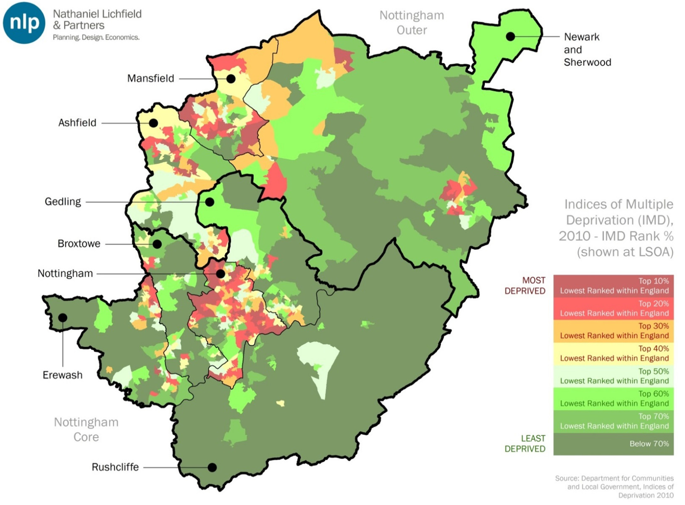

Source: IMD 2010 / NLP analysis

## Core HMA

#### Economic Sectors

* 1. The two HMAs are very large and diverse in terms of their economic strengths and weaknesses. For instance, the Core has a very strong business base, being home to many of the UK’s leading companies such as Alliance Boots, Capital One and Experian. Nottingham City also benefits from two

internationally renowned universities and, in ‘BioCity’, the largest bio-science enterprise incubation centre in the country.

* 1. In terms of key sectors within the HMA, a location quotient analysis (Figure 2.3) indicates those sectors within the Core HMA which are ‘over-represented’ in terms of employment, relative to regional and national averages. ‘Professional Services’ and ‘Administrative and Support Services’ are two major employers within the HMA and are sectors which demonstrate competitive advantage relative to the rest of the East Midlands6. Other ‘knowledge-based’ sectors which employ a large percentage of the local workforce include ‘Finance and Insurance’. ‘Health, Residential Care and Social Work’ is a non-B-class sector which has demonstrated strong employment growth across the entire Core HMA, with employment looking set to increase further in the future given the ageing population and their increased healthcare needs.
  2. In Figure 2.3, circles represent individual sectors within the Core HMA, with the size of each circle proportionate to the size of employment in each sector. Green circles comprise sectors which have demonstrated higher than average regional growth between 1997 and 2011, whereas red circles represent sectors which have grown at a lower rate than the regional average.

Figure 2.3 Location Quotient Analysis (Core HMA)

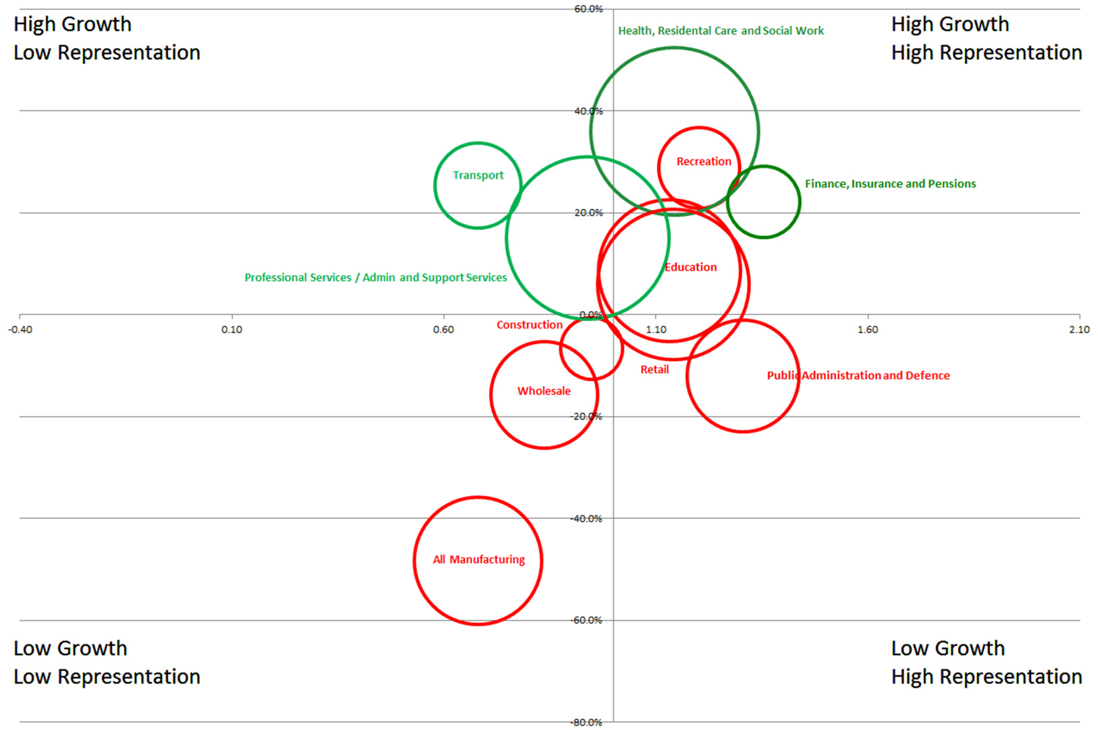

Source: Experian / NLP analysis

* 1. Given the area’s strategic spatial position within the UK alongside its key transport infrastructure, it is unsurprising that the transport sector has performed well, growing by over 25% between 1997 and 2011. The

6 This is the case even once the effects of two substantial recruitment agencies which skew the BRES data relating to ‘Administrative and Support Services’ have been excluded – see below.

Professional Services/Administration and Support Sectors are also a key area of growth, having increased by 15% in recent years and employing almost 50,000 people across the Core HMA.

* 1. With the presence of two universities and several Further Education (FE) colleges (in a number of districts across the HMA), Education remains a key (non-B-class) sector in terms of employment, as is Health and Retail.
  2. At a district level, recent analysis of BRES data by Nottingham Business School7, alongside analysis of Experian data, highlights those sectors where local authorities perform particularly well in terms of employment across the Core HMA. Each district in the Core HMA has been examined to identify those sectors which have demonstrated strong employment growth or are well represented in terms of employment relative to regional averages.
     + **Broxtowe** is well represented in manufacturing (comprising 16.3% of the Borough’s total employment versus 4.5% across Great Britain). This representation is prevalent across all the Nottinghamshire districts (other than Nottingham City and Rushcliffe), a legacy of its industrial heritage. Whilst employment in manufacturing has declined, the economy has diversified away from the previous dominance of low-value manufacturing towards hi-tech manufacturing, with large employers in the HMA including Alliance Boots (involved in the research and manufacture of pharmaceuticals). Other sectors which are well represented within the Borough include Wholesale and Retail (21% of employment versus 16% in the UK), bridging both B-class and Non-B- class uses, as well as Construction (which employs 6.6% of the local workforce, relative to the UK average of 4.5%).
     + **Erewash** has seen particularly strong growth in non-B-class sectors in recent years. Employment in Real Estate, for instance, rose 32% between 1997 and 2011, reflecting the strong residential and suburban nature of the Borough. Other Non-B Class employment sectors displaying strong employment growth include Education, where employment rose by 41% over the same period, alongside employment growth within Residential and Social Care (+85%).
     + **Gedling’s** workforce, as with Broxtowe’s, has a strong representation in the Construction sector, which comprises nearly 7% of its entire workforce (compared to 4.5% nationally). Furthermore, Wholesale and Retail employs 20.6% of the total workforce, compared to a national average of 16%.
     + **Nottingham City** is well represented across sectors such as Health and Social Work Activities (15.5% versus a UK average of 13.4%); Education (10.1% versus a UK average of 9.5%) as well as ‘Wholesale and Retail’.

7 Nottingham Business School on behalf of Newark and Sherwood District Council (2014): “*A Profile of Local Business Sector Concentrations for the Nottingham and Nottinghamshire Economic Prosperity Committee: Technical Note and Guidance*”, pg.6

* **Rushcliffe** is strongly represented within Public Administration and Defence (employing 7.4% of residents versus the national average of 5.2%). It also has strong employment representation within Non-B- Class sectors such as Education, which employs 10.7% of the resident workforce, and Accommodation and Food Services which employs 6.9% of workers.

#### Productivity

* 1. Figure 2.4 presents GVA output per head (a measure of productivity) for the Core HMA authorities8. Gedling and Rushcliffe have witnessed higher levels of productivity growth relative to the UK average up until the recession, when productivity in those two authorities decreased at a steeper rate than was experienced nationally. Nottingham City and Erewash, despite starting from a much lower base, have shown strong growth, increasing by 25% and 38% respectively over the 1997–2014 period. Compared with the 6% and 8% decrease over the same period in Gedling and Rushcliffe’s productivity respectively, there is now a much smaller (yet still sizeable) gap in the levels of productivity between the Core HMA authorities than there was 15 years ago.

Figure 2.4 GVA per head 1997-2011 (Core HMA)

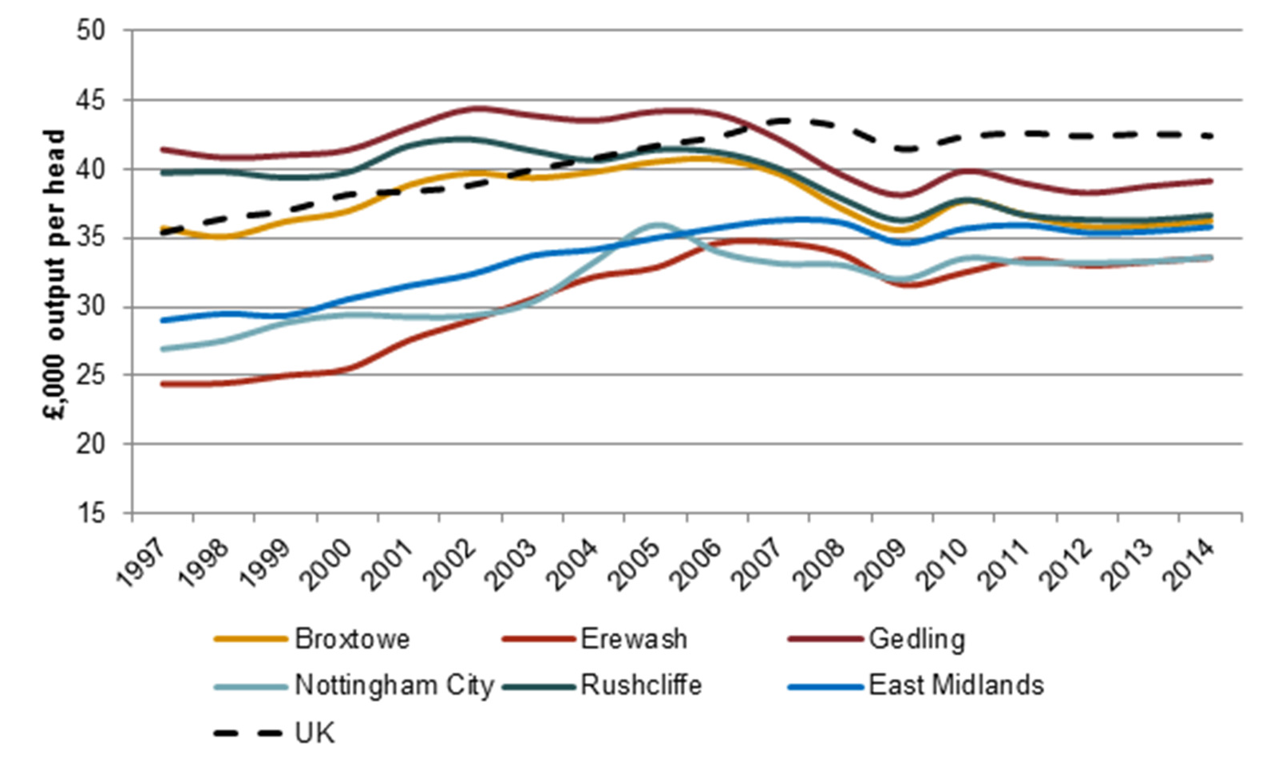

Source: Experian / NLP analysis

#### Distribution of Economic Activity

* 1. As part of this study, data from the Inter-Departmental Business Register (IDBR) has been obtained. This provides a comprehensive list of UK businesses and has been analysed to identify any inconsistencies or

8 NLP understands that neither the historic or forecast GVA figures from Experian are adjusted for inflation. The GVA figures are provided in real terms with all figures in the time series adjusted to be consistent with the buying power of money in a given reference year (i.e. 2011 for GVA).

anomalies which may affect forecasting of future requirements and also to identify any particular business or sector clusters.

* 1. Whilst many of the districts in the Core HMA are constrained (to an extent) by the Nottingham-Derby Green Belt (which can dampen the ability of business clusters to develop beyond the urban boundaries), significant clusters in these districts still exist within settlements that are inset from the Green Belt (such as Ruddington) or outside of the Green Belt altogether (such as Bingham).
  2. More detailed IDBR maps for individual local authority areas are included at Appendix 2.

Figure 2.5 Core HMA IDBR Data

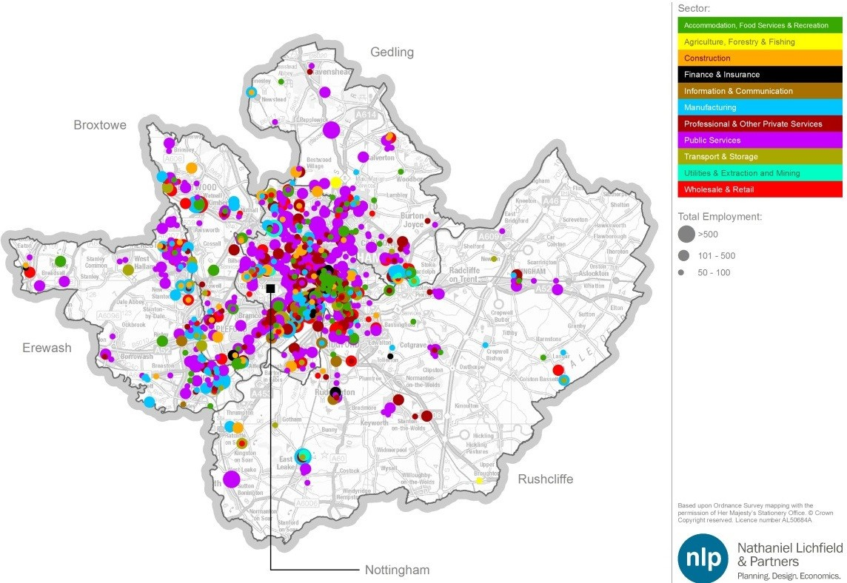

Source: IDBR / NLP analysis

###### Broxtowe

* 1. Business activity in Broxtowe is centred in the areas close to the A610, which runs through the northern half of the Borough. This includes the settlements of Eastwood and Kimberley. Similarly, there are notable clusters of businesses in the settlements of Stapleford and Beeston, which are located close to the A52, which runs through the southern half of the Borough. A large part of the Borough falls within the Nottingham-Derby Green Belt.

###### Erewash

* 1. The M1 passes through the Borough with particularly good access to Junction 25 (A52) and Junction 26 (A610). Most businesses in the Borough are located in and around Erewash’s main settlements of Long Eaton to the South East of the District (housing large employers such as the Transport and Logistics firm

DHL and Long Eaton Town Hall – Erewash Borough Council), or Ilkeston to the North East (which has two notable industrial estates at Quarry Hill and Manners and is also home to Ilkeston Town Hall – Erewash Borough Council). Outside of these main settlements, the Borough is predominantly rural in character, with much of it falling within the Nottingham-Derby Green Belt – although there is also a smaller cluster of firms within Borrowash to the South West of the Borough, which benefits from its close proximity to the A52 and Little Eaton to the North West which benefits from its close proximity to the A38.

###### Gedling

* 1. Business activity in Gedling is clustered around the south west side of the Borough which borders Nottingham City. There is a heavy concentration of businesses due north of the A60, to the south west of the Borough, as well as further south (with a particular clustering of manufacturing firms in Colwick Industrial Estate beside the A612).
  2. The Borough benefits from a substantial retail presence, particularly in Arnold to the south west, where four retail foodstores employ nearly 1,200 people between them.
  3. Other than the small, localised clusters of businesses in Ravenshead to the north and Calverton to the east, the remainder of the Borough is predominantly rural in nature. Much of the area falls within the Nottingham-Derby Green Belt, where the major employers comprise large public sector providers including Nottinghamshire Police, the NHS along the A60 (Mansfield Road), as well as a number of smaller retail outlets.

###### Nottingham City

* 1. Within Nottingham City Centre, as might be expected, there is a large clustering of ‘Accommodation, Food Services and Recreation’ firms (mainly comprising hotels and restaurants); a large retail offering within the City Centre; and many small Professional & Other Private Services firms. There are several clusters of Finance and Insurance firms throughout the City, notably Ng2 Business Park south west of the City Centre. The City is also a base for a considerable number of public sector employers.
  2. Ng2 Business Park also houses several Professional Services firms. One of these is the headquarters of a national recruitment agency, with all staff allocated to this location when in reality they are distributed across the UK. The implications of this with regard to BRES data and Experian modelling is significant, and is discussed later in this report.

###### Rushcliffe

* 1. Much like Gedling, the majority of businesses in Rushcliffe are clustered around the north west side of the Borough bordering Nottingham City, in and around West Bridgford. This area has a strong Wholesale and Retail

presence, alongside industrial sectors including ‘Professional and other Private Services’.

* 1. Much of the remainder of the Borough is rural in nature. As some of the Borough falls within the Nottingham-Derby Green Belt that encircles Nottingham and its suburbs, there are inevitably fewer large business clusters in these areas. However, smaller clusters of firms do exist in the Borough at locations such as Radcliffe-on-Trent and Bingham (which both benefit from being located near to the A52), along with Ruddington Fields (the home to a large Finance and Insurance employer) and East Leake (home to British Gypsum).

#### Stock of Businesses

* 1. Local economic growth in the Core HMA is facilitated by a number of factors, including the wider regional, national and international business environment; the skills of the local workforce; connectivity; and infrastructure.
  2. The main source of data on business activity for the Core HMA relates to business births. Indicators of business start-ups are important in informing economic development policy, as new starts can enhance the business stock and act as a spur to competition, with new entrants displacing less innovative incumbents and generating higher-quality employment.9 The level of entrepreneurial activity in the sub-region appears low – both in terms of the number of businesses per head of population as well as rates of self- employment (8.4% across Nottinghamshire, compared with 12% nationally10).
  3. Figure 2.6 presents the makeup of businesses within the Core HMA relative to regional and national averages. The HMA predominantly comprises of small businesses (which for the purposes of this study, and in accordance with the 2006 Companies Act, have been classified as those with fewer than 50 employees). Nottingham acts as a hub for large businesses looking for a presence in the region. As result, this authority has a larger proportion of medium (firms with 50-250 employees) and large businesses (with over 250 employees) contained within it.

9 Nottingham Trent Business School / Newark and Sherwood District Council (2013) ‘A Profile of the Economy, Labour Market and Business Structure of Newark and Sherwood’ pg 18

10 Nottinghamshire County Council (2012) Nottinghamshire Growth Plan, pg. 7

Figure 2.6 Businesses by Employment Size (Core HMA)

100.0%

99.0%

98.0%

97.0%

% Companies

96.0%

95.0%

94.0%

93.0%

Broxtowe Erewash Gedling Nottingham

City

Rushcliffe

East UK

Midlands

Small (<50) Medium (50-249) Large (250+)

Source: ONS (2013) UK Business: Activity, Size, Location / NLP analysis

#### Earning Levels

* 1. Earnings are often used as a proxy measure for the quality of local employment on the basis that highly skilled, productive individuals can expect higher rates of pay, and that employers who demand higher skill levels are prepared to pay above the market rate in order to attract such workers.
  2. Figure 2.7 compares residence and workplace-based earnings in the Core HMA boroughs alongside the East Midlands and national averages. Median residential earnings in Broxtowe, Erewash and Rushcliffe are higher than workplace-based earnings for these boroughs. This suggests a disparity between the relatively high skills levels of the resident workforce in boroughs such as Rushcliffe and the relatively low skills levels of employees working in the Borough. It also suggests that higher paid professionals are commuting out from these predominantly suburban areas to better paid jobs elsewhere (particularly in Nottingham City).

Figure 2.7 Gross Weekly Pay (£ median, full-time workers), 2014

700.0

600.0

500.0

400.0

**Weekly Pay, £**

300.0

200.0

100.0

0.0

Broxtowe Erewash Gedling Nottingham Rushcliffe Outer HMA

Average

East UK

Midlands

Workplace-based Residence-based

Source: ONS: Annual Survey of Hours and Earnings, 2014 / NLP analysis

#### Skill Levels

* 1. Workforce skills are vital in enabling businesses to develop innovative products, services and processes and/or successfully implement and take advantage of new technologies and ways of working. Skills are important for individuals, enabling them to access job opportunities and to progress within the labour market.11
  2. The level of skills among the residents of the Nottingham Core HMA varies considerably and addressing this ‘skills gap’ has been raised by D2N2 as a key area of improvement in order to grow the economy. Commercial property agents, for instance, have cited firms who have a difficulty in recruiting suitable staff because of the lack of certain skills in the area. This acts as a barrier to businesses relocating their operations to the area. Figure 2.8 demonstrates this inequality in skills levels12. Some boroughs (such as Rushcliffe) have a high percentage of residents educated to NVQ4+ (equivalent to a university degree and above) and a low percentage of those with no qualifications at all, whereas the boroughs with relatively low rates of residents with NVQ4+ (such as Nottingham City) tend to be those with a higher percentage of residents with no qualifications at all.

11 Nottingham Trent Business School / Newark and Sherwood District Council (2013) ‘A Profile of the Economy, Labour Market and Business Structure of Newark and Sherwood’ pg 18

12 It is not the case that there are no residents without any qualifications in Erewash, but instead ONS’s estimate is not given because the sample size is too small for a robust figure to be produced.

Figure 2.8 Skills Levels (Core HMA)

60

50

% of working-age population with qualification

40

30

20

10

0

Broxtowe Erewash Gedling Nottingham Rushcliffe Core HMA

Average

NVQ4+ No Qualifications

Source: ONS (2013) Annual Population Survey / NLP analysis

Note: Data on Erewash’s working age population with no qualification is non-disclosive due to sample size.

#### SWOT Analysis

* 1. This SWOT analysis of the Strengths, Weaknesses, Opportunities and Threats facing the Nottingham Core HMA is based upon: analysis of Experian employment forecasts for the area; consultation with commercial property agents and economic development officers; and a review of relevant background documents.

Table 2.1 SWOT Analysis

|  |  |
| --- | --- |
| **Strengths** | **Weaknesses** |
| * Excellent connectivity (air, road and rail links) which are all undergoing improvement * Strong public transport offer * Nottingham City seen as a business ‘hub’, a very attractive city for businesses to locate in * Two internationally renowned universities within the City, stimulating business spillover effects (through entrepreneurial incubation organisations such as The Hive) * Labour market viewed as flexible by businesses coming to the area * Increase in educational performance (GCSE performance, successful efforts to decrease NEETS and increase apprenticeships) | * Large inequalities exist between Boroughs within the Core HMA with regard to qualifications/skills levels * Rail links to some cities are not as strong as they could be (resulting in excessive journey times) * Non-academic, ‘workplace’ skills are often lacking in school leavers * Number of businesses per head of population remains low – self-employment rates average 7.6% across the study area versus 10.3% for England as a whole * Car Parking Levy is an additional cost which can be difficult for some small businesses to pay * Lack of large, modern, flexible office floorspace for firms to locate in restricts the level of inward investment the HMA can accommodate * City’s stock of offices continues to decline as more is lost to residential (particularly student accommodation) * Poor retention of graduates |
| **Opportunities** | **Threats** |
| * Extensive direct development likely to result in the area surrounding the HS2 Hub Station * City’s high office-to-residential conversions may have the effect of ‘clearing out bad stock’ which wouldn’t otherwise have been occupied, creating the opportunity to replace it with better quality stock * Opportunity for businesses in key knowledge-based industries (Law, Finance etc) looking to locate in the region in order to harness the large pool of graduates * Proximity to East Midlands Airport (a large air freight hub) provides an opportunity for further exports * Firms which export tend to be on average more productive and innovative – opportunity to sustain and enhance the region’s traditional strength in exporting goods and services | * Job growth outstripping working age population (shrinking workforce)– putting pressure on transport infrastructure * Continued decline of City Centre Office floorspace through conversion to Student Accommodation / Private Rental Residential Uses if additional new office space is not brought forward |

Source: NLP analysis

## Outer HMA

#### Economic Sectors

* 1. Ashfield and Mansfield District Councils produced ‘*Ambition: A Plan for Growth’*

in 201113. The document notes that the comparison between historic and

13 Ashfield Borough Council, Mansfield District Council and Nottinghamshire County Council (2011): “ambition: a plan for growth. Ashfield and Mansfield Joint Economic Masterplan 2011-2021”

future trends suggests a gradual but clear move away from traditional sectors towards the following:

* + - Business Services
    - Health
    - Wholesale
    - Manufacture of Transport Equipment
    - Transport and Logistics
  1. The potential for growth in these sectors is supported by NLP’s assessment of the local economy, based on the analysis of location quotients (Figure 2.9). Figure 2.9 identifies the performance of various sectors within the HMA, with the size of each circle proportionate to the size of employment in the sector (across the entire HMA). The sectors in green have demonstrated higher than average regional growth (between 1997 and 2011), whereas sectors in red have shown growth lower than the regional average.
  2. For example, the Wholesale sector identified by the ‘*Ambition’* report as a future growth sector, has demonstrated stronger employment growth relative to the regional average over the period 1997 – 2011. The Health sector has also shown higher than average growth in the region over the same period; it is not only a large employer in absolute terms but also in relative terms compared with the region as a whole. There are also signs that the HMA is rebalancing its economy away from its previous dominance in traditional manufacturing industry, towards stronger growth in areas such as Business Services.
  3. Within this analysis, the various manufacturing sub-sectors have been grouped together, with an overall decline in employment exhibited across the HMA. However, separating out the important sub-sector of transport equipment manufacture is important, given that both Mansfield and Ashfield have a strong representation in the sector, providing supply chain services for large employers such as Toyota and Bombardier based in nearby Derbyshire. Likewise, the strategic transport links from the M1 running through Ashfield and the A1 adjacent to Newark-on-Trent, is reflected in the strong employment growth in Wholesale sector (up 33% between 1997 and 2011).
  4. In terms of other sectors not highlighted by the ‘*Ambition’* report, recreation is strongly represented across the HMA as a whole, and with the Visitor Economy being one of the D2N2 LEP’s ‘priority sectors’ looks set to continue to grow. Newark and Sherwood contains both Sherwood Forest (which the County Council has committed to ensuring hosts a “modern and exciting visitor centre and attraction” in the Plan for Growth) and the new National Civil War Centre, which are both major draws to the area. Whilst the employment growth in Telecommunications appears low in absolute terms, relative to regional growth (where employment within this sector actually fell) there appears to be a strong comparative advantage. The locational quotient of this sector is 2.21 (and as such is off the scale on Figure 2.9).

Figure 2.9 Location Quotient Analysis (Outer HMA)



120.0%

High Growth

Low Representation

High Growth

High Representation

**Public Administration and Defence**

100.0%

80.0%

**Professional Services / Admin and Support Services**

**Education**

**Health, Residental Care and Social Work**

60.0%

40.0%

**Wholesale**

20.0%

**Construction**

**Retail**

0.0%

-0.40

0.10

0.60

1.10

1.60

2.10

-20.0%

**Finance, Insurance and Pensions**

**Manufacturing**

-40.0%

Low Growth

Low Representation

-60.0%

Low Growth

High Representation

-80.0%

Source: Experian / NLP analysis

* 1. Recent analysis of BRES data by Nottingham Business School demonstrates which sectors each local authority is over-represented in in terms of employment.14 In summary:
     + **Ashfield** is well represented in ‘Manufacturing’ sectors, which account for 20% of workforce employment relative to a national average of just 9%. As with the Core HMA, manufacturing employment has begun to shift away from the previous dominance of low-value manufacturing towards hi-tech manufacturing, with large employers within Ashfield including Rolls Royce (involved in the manufacture of transport equipment, one of D2N2’s ‘priority sectors’);
     + **Mansfield** has a strong representation of employment within Construction, with the sector employing 7% in the District compared to a national average of 4.5%. The retail element of ‘Wholesale and Retail’ (which accounts for 20.7% of employment in Mansfield District, versus 16% in the UK as a whole) is Non-B-Class use, whereas the Wholesale element will be predominantly classified as a B8 land use;

14 Nottingham Business School on behalf of Newark and Sherwood District Council (2014) “A Profile of Local Business Sector Concentrations for the Nottingham and Nottinghamshire Economic Prosperity Committee: Technical note and Guidance”, pg.6-7

* Around 13% of **Newark and Sherwood’s** workforce is employed within Manufacturing, compared to a national rate of around 9%. The District has a particular strength within the Food and Drink Manufacturing sub- sector, containing a significant proportion of the nearly 17,000 people employed in this sector within the entire Nottinghamshire region. This sector thrives in rural areas due to its relationship with agriculture; the agri-food sector continued to grow even during the recession. Large blue chip food manufacturers present in the District include British Sugar (based in Newark). As noted earlier, employment in the telecoms industry, which is strong across the entire Outer HMA, is particularly strong in Newark and Sherwood, where employment increased by 760, despite decreasing across the East Midlands region as a whole.

#### Productivity

* 1. Figure 2.10 presents output per head for each of the authorities within the Outer HMA, set against the regional and national averages. Whilst Mansfield, Ashfield and Newark & Sherwood all have similar levels of GVA, and have all risen at roughly equivalent levels throughout the period examined (1997 – 2014), there remains a gap between the levels achieved by these authorities and that of the UK in general.

Figure 2.10 GVA per head 1997-2011 (Outer HMA)

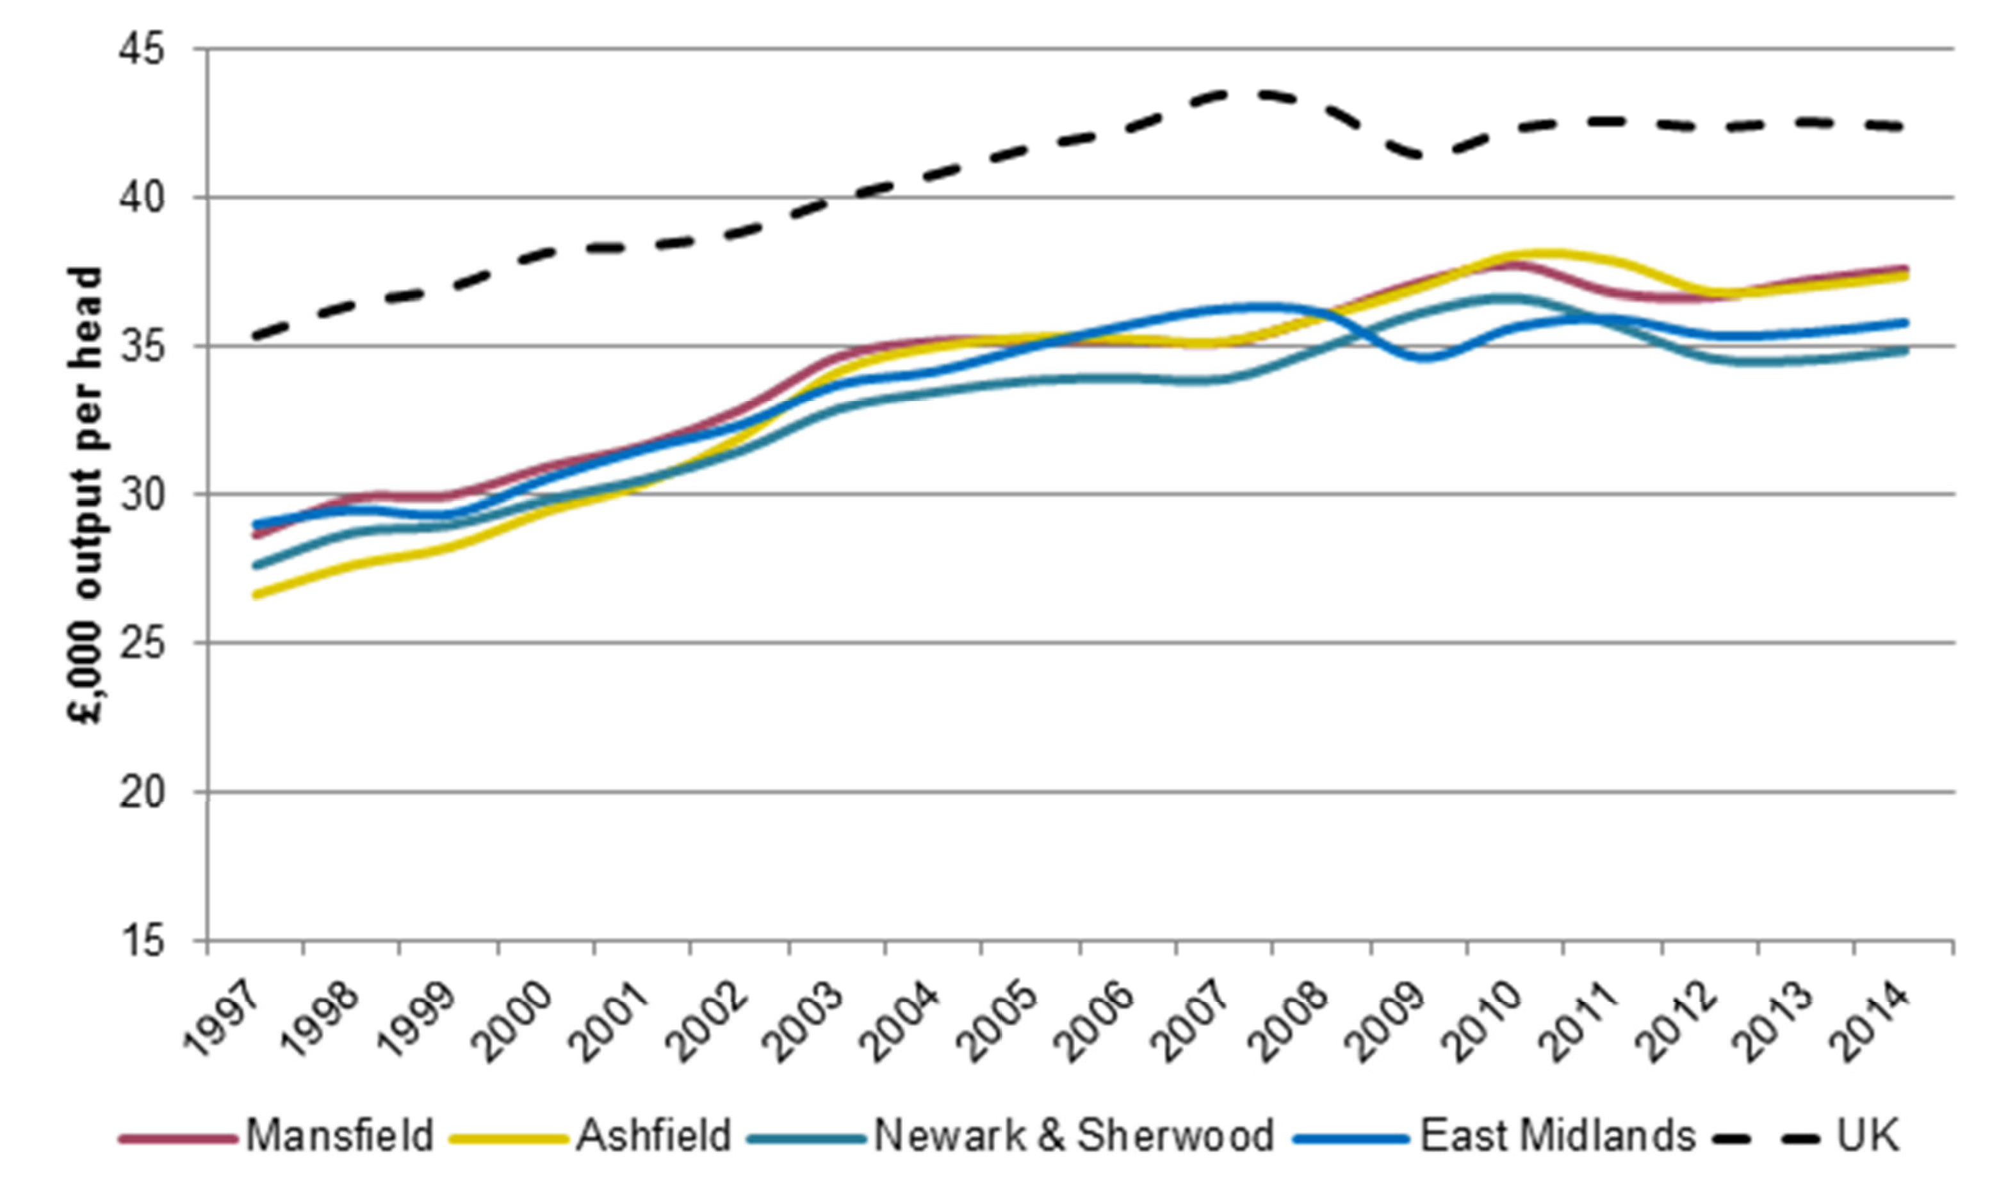

Source: Experian / NLP analysis

#### Distribution of Economic Activity

* 1. As with the Core HMA districts, as part of this study data has been gathered and analysed from the IDBR relating to Ashfield, Mansfield and Newark and Sherwood districts. A summary of the industrial sectors present in the HMA is illustrated in Figure 2.11, with individual District-level IDBR maps in Appendix 2.

Figure 2.11 IDBR Data (Outer HMA)

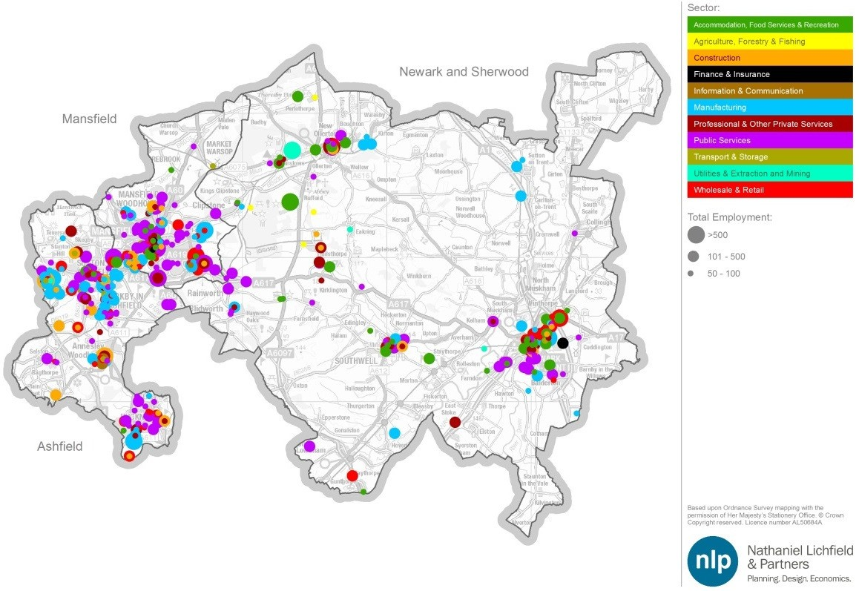

Source: IDBR / NLP Analysis

* 1. As with the Core HMA, data has been analysed to identify any inconsistencies or anomalies which may affect forecasting of future requirements and also to identify any particular business or sector clusters. The results are summarised by individual district below.

###### Ashfield

* 1. Kirkby-in-Ashfield and Sutton-in-Ashfield are the two main settlements in the northern part of the District, both of which accommodate substantial industrial and distribution employment sites. Towards the northwest of the District there are large clusters of manufacturing firms, notably beside J28 of the M1 and alongside the A38 leading towards Sutton-in-Ashfield (such as Castlewood Business Park and Fulwood Industrial Estate). Kirkby-in-Ashfield also houses large clusters of manufacturing businesses particularly off Lowmoor Road. Sherwood Park is located to the south of Kirkby-in-Ashfield (off J27 of the M1 motorway). A former Enterprise Zone, Sherwood Park has substantial concentrations of both office and distribution space, accommodating internationally recognised multi-national companies such as Eon, Dell Computers, Rolls-Royce and Prolog, alongside Wholesale and Retail traders such as Pendragon Plc (a seller of luxury cars) and Dixons.
  2. There exists a clear geographical gap between clusters of firms in Kirkby-in- Ashfield (which contains Sherwood Park at J27) and Sutton-in-Ashfield within the northern half of the District, and Hucknall towards the southern edge of the District.
  3. Although there are actually around 25% fewer people employed in the public sector than might be expected across the region as a whole (based on the Location Quotient analysis) there are a number of large public sector employers based in Ashfield. Of particular note, Kings Mill Hospital, in Sutton- in-Ashfield, is the largest employer in the District.
  4. There are a considerable number of people employed within the Construction industry in the District, with firms in Huthwaite and Sherwood Park employing around 1,400 employees between them.
  5. Hucknall, to the south of the District, has a number of important manufacturing firms. Prominent amongst these is the large Rolls Royce factory at the southernmost point of the District, alongside a number of public sector employers such as schools and Nottinghamshire Fire & Rescue Service.

###### Mansfield

* 1. Industrial employment sites in Mansfield District are mainly concentrated in the Mansfield urban area, including Old Mill Lane Industrial Estate towards the north east and Crown Farm Business Park to the east, whereas commercial offices are predominantly located in the central area of Mansfield Town or out- of-centre business parks such as at Ransomwood (located along the south eastern edge of the Mansfield urban area). As might be expected, Mansfield Town Centre features a concentration of firms providing Accommodation, Food Services and Recreational services.
  2. Several large manufacturing firms are located within Crown Farm Industrial Estate towards the east of the District, Oakham Business Park towards the south west of the District, alongside Millennium Business Park further west beside the A6191. There are large concentrations of firms around the A617 and A6191 which lead off from J29 of the M1 (which lies outside of the District); throughout Mansfield Town Centre; and to the south of the Town Centre. There is also a small cluster of businesses to the north of Mansfield, in Market Warsop.
  3. The Mansfield and Ashfield Regeneration Route (MARR) has been credited with encouraging enterprise in its immediate vicinity through increasing accessibility within both Districts between the M1 and A1.

###### Newark and Sherwood

* 1. There are particular business concentrations towards the south east of Newark-on-Trent, as well as along the A6075 (Blidworth, Ollerton & Boughton, and Edwinstowe) to the north of the District, with a particular cluster of manufacturing firms on the Boughton Industrial Estate. In addition, smaller clusters of businesses exist within the settlements of Southwell and Bilsthorpe.
  2. There was until recently one large mining employer in the District locatedin Edwinstowe, towards the north west of Newark & Sherwood. However, Thoresby Colliery, which employed over 600 people, closed on 10th July 2015.
  3. The rural nature of the District has contributed to the development of a considerable number of agricultural businesses, although due to the nature of these companies they tend to be scattered across the District rather than being clustered around a few particular areas. Partly as a result of this, food and drink manufacturing has become a key sector that the District performs well in (such as British Sugar based in Newark), with a high percentage of the 17,000 Nottinghamshire jobs within this sector based within this District itself. Telecoms is another sector which has fared very well in the District, continuing to grow (as with food and drink manufacturing) even through the recent recessionary period.

#### Stock of Businesses

* 1. Figure 2.12 presents the size of businesses within the Outer HMA. The area is predominantly represented by small businesses. However, a considerable proportion of medium sized businesses are also present in Ashfield and Mansfield, with Ashfield containing a similar proportion of large businesses (those with over 250 employees), as Nottingham City. Large firms present in Ashfield include Rolls Royce (with over 850 employees), E.On (over 900) and Dixons (over 400). It is likely that these firms have been attracted by the dual attraction of the area’s proximity to strategic transport links (with the M1 running through the District), combined with a competitive labour market.

Figure 2.12 Businesses by Employment Size (Outer HMA)

100.0%

99.0%

98.0%

97.0%

% Companies

96.0%

95.0%

94.0%

93.0%

Ashfield Mansfield Newark and Sherwood

East Midlands UK

Small (<50) Medium (50-249) Large (250+)

Source: ONS (2013) UK Business: Activity, Size, Location / NLP analysis

#### Earning Levels

* 1. Earnings are often used as a proxy measure for the quality of local employment, based on the presumption that employers who demand higher levels of skill are prepared to pay above the market rate in order to attract such workers. Figure 2.13 compares residence- and workplace-based earnings in

the Outer HMA Authorities compared to the East Midlands and national average rates.

* 1. There is a clear disparity between the Core and Outer HMA, with all three authorities that make up the Outer HMA having lower resident-based wages than the Core HMA Authorities, as well as the regional and national average.

Figure 2.13 Gross Weekly Pay (£ median, full-time workers), 2014 (Outer HMA)

600.0

500.0

400.0

**Weekly Pay, £**

300.0

200.0

100.0

0.0

Ashfield Mansfield Newark and

Sherwood

Core HMA Average

East UK

Midlands

Workplace-based Residence-based

Source: ONS (2015) Annual Survey of Hours and Earnings, 2014 / NLP analysis

###### Skills Levels

* 1. The level of skills among the residents of the Nottingham Core and Outer HMA varies considerably and addressing this ‘skills gap’ has been raised by D2N2 as a key area of improvement in order to grow the economy. Commercial property agents, for instance, have pointed to difficulties in recruitment because of the lack of certain skills in an area acting as a barrier that certain businesses face when looking to relocate their operations. Figure 2.14 demonstrates this inequality. All three authorities within the Outer HMA have a higher percentage of residents with no formal qualifications (relative to the Core HMA average), as well as having a lower percentage of residents educated to NVQ4+ (equivalent to a university degree and above) relative to the Core HMA average.

Figure 2.14 Skills Level (Outer HMA)

35

% of working-age population with

qualification

30

25

20

15

10

5

0

Ashfield Mansfield Newark and

Sherwood

Outer HMA Average

NVQ4+ No Qualifications

Source: ONS Annual Population Survey (2013) / NLP analysis

* 1. Despite the lower than average educational performance, both HMAs have seen significant improvements over time, with almost 88% of students across Nottinghamshire achieving five or more A*-C grades in GCSEs or equivalent in 2012.15 Efforts to reduce the number of NEETS (not in education, employment or training) have proven successful and the area boasts a high level of apprenticeships.
  2. Qualifications are an imperfect measure of skill. Individuals with a given level of skill may not have a formal qualification, and qualifications at a given level may not confer skills that are relevant to an individual’s job.16 Whilst academic performance in the study area may be increasing, businesses often comment on the need for young people to become more ‘work ready’, in the sense of possessing qualities such as punctuality, customer care and team working alongside academic knowledge.17
  3. It is also widely acknowledged that the growth of the knowledge economy is strongly linked to the availability of higher level skills. The D2N2 LEP has therefore set addressing this skills gap as one of its priorities. The LEP’s Skills and Employment Programme will involve “*integrating Further Education provision and employment opportunities… that will meet the demands of business*”. In addition, the Nottingham ‘Skills Hub’ will “*respond directly to the needs of local employers; supplying the skills required for Nottingham’s key employment and growth sectors*”. These facilities are forecast to train approximately 1,200 people per year.18

15 Nottinghamshire County Council (2012) Nottinghamshire Growth Plan, pg. 8

16 Nottingham Trent Business School / Newark and Sherwood District Council (2013) ‘A Profile of the Economy, Labour Market and Business Structure of Newark and Sherwood’ pg 18

17 Nottinghamshire County Council (2012) Nottinghamshire Growth Plan, pg. 19

18 D2N2 LEP (2013), SEP Executive Summary, pg. 6

#### SWOT Analysis

* 1. This SWOT analysis of the Strengths, Weaknesses, Opportunities and Threats facing the Nottingham Outer HMA is based upon: analysis of Experian employment forecasts for the area; conversations with commercial property agents and economic development officers; and a review of relevant background documents.

Table 2.2 SWOT Analysis for the Outer HMA

|  |  |
| --- | --- |
| **Strengths** | **Weaknesses** |
| * Central location provides excellent road links (proximity to M1, A1, north/south and east/west via the A38 which connects the area to the West Midlands) and rail links * Wages are lower than regional averages (strength from a business perspective) * High levels of economic activity * Employment land tends to be cheaper than in the Core HMA * Strong demand for industrial property, demonstrated by lower than average vacancy rates * Competitively-priced premises for new and existing businesses * Newark has a particular strength in agriculture and telecoms, sectors which continued to grow even during the recession * Fifth largest urban area in the East Midlands * Ashfield/Mansfield area has a vibrant office market for serviced accommodation and ‘grow on’ space * High quality natural and built environment which is attractive to investors | * Lower than average qualifications hampers the ability to attract high value-added sectors * Lower than average wages * Pockets of deprivation * Negative perceptions of Mansfield and Ashfield leading to difficulties in attracting knowledge-based workers * Low car ownership in Ashfield and Mansfield raises issues over employment accessibility * Nottingham City overshadows inward investment away from the Outer HMA * Office market weak (the demand that does exist tends to be from local companies catering for indigenous demand) * High levels of net out-commuting * Newark Town Centre suffers from congestion at times |
| **Opportunities** | **Threats** |
| * Lower wages present opportunities to capture growth which ‘spills over’ from Nottingham City (given much development in the Core HMA is constrained by the Nottingham-Derby Green Belt) * Continue to specialise and develop a competitive advantage in distinct sectors (such as logistics and telecoms) * Strengthening links between Ashfield and Mansfield and the surrounding areas has the potential to lead to greater economic growth, increasing individual prosperity, reducing deprivation and providing benefit to the region as a whole * Availability of high quality, serviced, employment land * High level of accessibility to the strategic road and rail network means that much of the western part of the HMA appeals to Inward Investment in manufacturing and logistics projects * Investment in a more integrated public transport system will be vital for ensuring that Ashfield and Mansfield residents are able to access employment opportunities * Opportunities to strengthen the areas’ traditional industrial sectors in order to move them up the value chain * Investment in digital connectivity creates opportunity for businesses to be created where they otherwise may not have (especially given Newark and Sherwood’s highly rural nature) * The dualling of the A46 has provided another high | * Essential elements of the visitor experience coming under threat from funding cuts including heritage and cultural venues, festivals and events and visitor information services * Poor quality office stock has seen more people work from home, a trend which may continue * An ageing population and a declining workforce |

speed link to the M1 and opens up further opportunities for investment

Source: NLP analysis

## Functional Economic Market Areas

* 1. Examining commuting flows can help define the functional economic market area (FEMA) of a particular local economy.19 These commuting flows can be assessed using the latest travel-to-work patterns data from the 2011 Census.
  2. Previous analysis of Travel to Work Areas (TTWAs) across the country was carried out by ONS in 2008, based on 2001 commuting patterns (Figure 2.15). From the modelling work undertaken, ONS considered that the majority of the Nottingham Core and Outer HMA districts were contained within four TTWAs – Mansfield (which contained Mansfield, most of Ashfield, some of Newark & Sherwood and parts of Bolsover, North East Derbyshire and Amber Valley further west); Nottingham (which included Nottingham City, Hucknall, Gedling, Broxtowe, Rushcliffe, and parts of Newark & Sherwood, Erewash and Amber Valley); Derby (which includes part of Erewash); and Lincoln (which includes part of Newark & Sherwood).

Figure 2.15 ONS Travel-to-work-area analysis based on 2001 Census commuting data

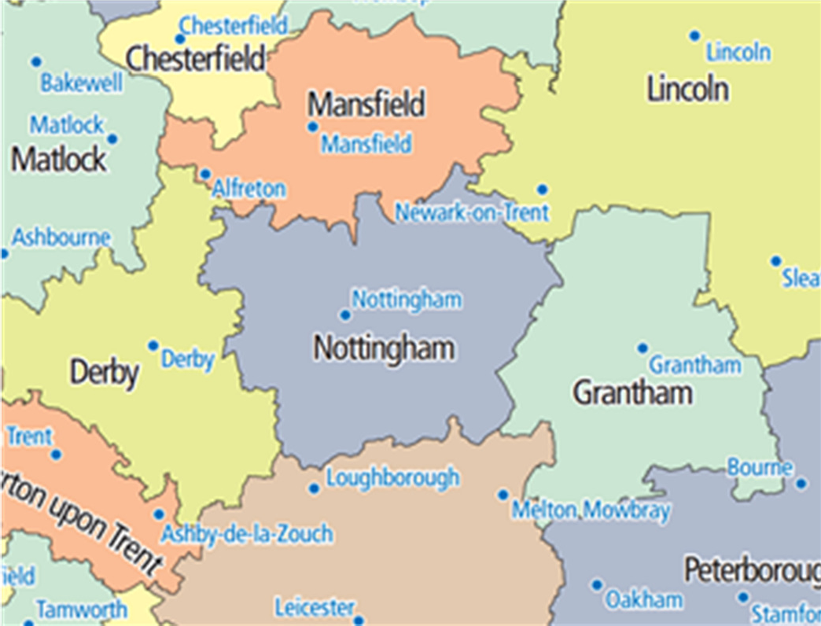

Source: ONS (2008)

* 1. Carrying out a new analysis of commuting patterns (with data gathered from the 2011 Census) suggests a slightly different picture. The Core HMA (Figure 2.16) has strong linkages with the three Outer HMA districts, with 7,769 Core HMA residents commuting into Ashfield on a daily basis for work, 2,910 commuting into Mansfield and 4,080 into Newark & Sherwood. A significant number of Core HMA residents also commute into Derby, with 10,901 travelling across daily (6,348 from Erewash alone).
  2. Overall, some 275,554 residents live and work in the Core HMA, with Nottingham City by far the biggest draw attracting 20,015 commuters living in Gedling, 15,394 from Broxtowe and 15,002 from Rushcliffe. The Core HMA

19 CLG (2010) Functional Economic Market Areas: An Economic Note

experiences a net out-commute of 3,245 residents – the only local authority within the HMA to experience a level of net in-commuting is Nottingham City (a very substantial +51,193).

Figure 2.16 Commuting Flows (Core HMA)

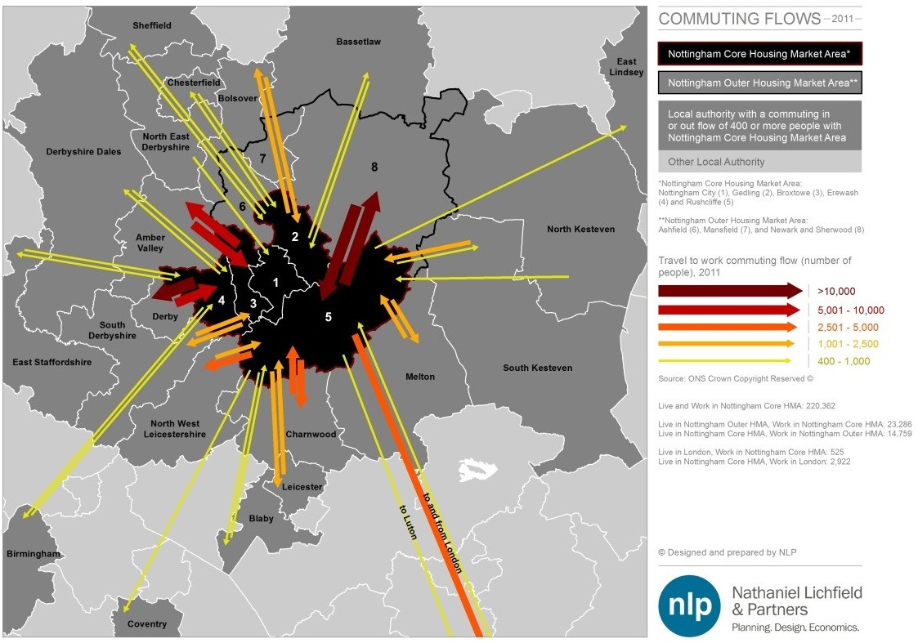

Source: 2011 Census / NLP analysis

* 1. Commuting data from the three local authorities within the Outer HMA was collated and analysed in a similar manner (Figure 2.17). Overall, 107,107 local residents also work within Ashfield, Mansfield and Newark & Sherwood. There are very strong linkages between the Core and Outer HMAs, with 14,759 Core HMA residents travelling into the three Outer districts on a daily basis for work. Linkages are particularly strong with Gedling, which contributes 4,494 of the Outer HMA’s workforce. Outer HMA districts also have relatively strong linkages with the neighbouring districts of Bassetlaw, Bolsover and Amber Valley.
  2. Overall, the Outer HMA experiences a net out-commuting rate of 13,214, predominantly to the Core HMA (primarily to Nottingham City). Ashfield has a net out-commuting rate of 2,221; Mansfield a net out-commuting rate of 7,371, and Newark & Sherwood a net out commuting rate of 3,622.

Figure 2.17 Commuting Flows (Outer HMA)

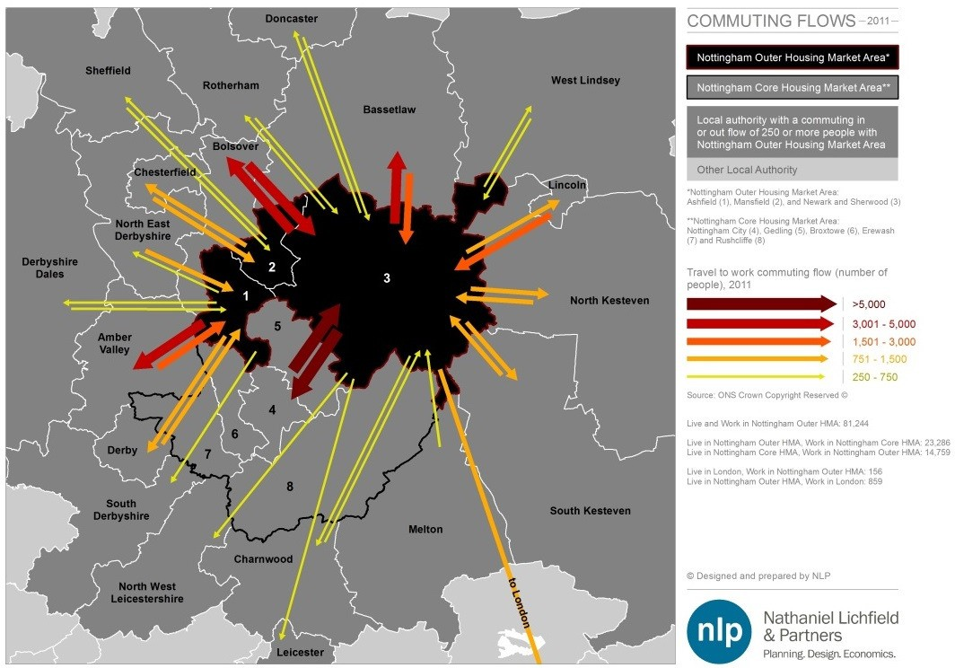

Source: 2011 Census / NLP analysis

* 1. A commonly accepted approach to defining a TTWA (and by extension, a FEMA) is where at least 75% of an area’s resident workforce is also employed in the area, and of all those working in the area at least 75% also live there.
  2. Both the Core and Outer HMAs have been tested to see whether they would comprise a TTWA on the basis of these two tests, using the 2011 Census commuting data. The results are presented in Table 2.3.
  3. This analysis indicates that none of the districts in isolation could be said to be a TTWA in themselves; however, including the three districts of Ashfield, Mansfield and Newark & Sherwood together would suggest that around 68% of local employed residents also work in the area, whilst for the alternative test (based on the number of employed residents as a percentage of all jobs in the area) the rate is higher, at 74%. The latter figure is only slightly below the indicative 75% threshold, suggesting that it forms a reasonable TTWA.
  4. The figures are even higher when one considers the five Core HMA districts as a TTWA. Table 2.3 indicates that the FEMA test ranges from 80.1% to 80.9% depending upon which indicator is tested. As such, a strong argument can be made that the Core HMA forms a distinct TTWA, and hence FEMA, in its own right due to the considerable economic draw of Nottingham City.

Table 2.3 2011 Commuting Data 20

|  |  |  |  |  |  |  |
| --- | --- | --- | --- | --- | --- | --- |
|  | **Live and work in LA\*** | **Resident workforce population** | **Workplace population** | **Net flow** | **FEMA Test (live and work in same area: % resident workforce)** | **FEMA Test (live and work in same area: % workplace population)** |
| Ashfield | 27,478 | 55,484 | 53,263 | -2,221 | 49.5% | 51.6% |
| *of which Hucknall*  *comprises* | *5,250* | *15,527* | *9,858* | *-5,669* | *33.8%* | *53.3%* |
| Mansfield | 25,270 | 48,561 | 41,190 | -7,371 | 52.0% | 61.3% |
| Newark & Sherwood | 33,937 | 54,899 | 51,277 | -3,622 | 61.8% | 66.2% |
| **OUTER HMA** | **107,707** | **158,944** | **145,730** | **-13,214** | **67.8%** | **73.9%** |
| **OUTER HMA**  **Excluding Hucknall** | **96,525** | **143,396** | **135,872** | **-7,524** | **67.3%** | **71.0%** |
| Broxtowe | 20,004 | 53,367 | 39,012 | -14,355 | 37.5% | 51.3% |
| Erewash | 26,576 | 55,112 | 43,203 | -11,909 | 48.2% | 61.5% |
| Gedling | 21,725 | 55,929 | 37,164 | -18,765 | 38.8% | 58.5% |
| Nottingham City | 85,202 | 123,743 | 174,936 | 51,193 | 68.9% | 48.7% |
| Rushcliffe | 25,324 | 55,665 | 46,256 | -9,409 | 45.5% | 54.7% |
| **CORE HMA** | **275,554** | **343,816** | **340,571** | **-3,245** | **80.1%** | **80.9%** |
| **CORE HMA**  **Including Hucknall** | **290,311** | **359,364** | **350,429** | **-8,935** | **80.8%** | **82.8%** |

Source: 2011 Census / NLP analysis

*Includes residents who live and work in the same LA; plus homeworkers, plus those who state they have no fixed workplace.

#### Hucknall

* 1. One issue to be analysed is the role of Hucknall in defining the FEMA. Although the town of Hucknall (defined as Ashfield MSOA 013-16) is located within the District of Ashfield (in the Outer HMA), for many practical reasons it is often considered to be part of the Greater Nottingham conurbation as it is located on the northern boundary of Nottingham and has very strong linkages with the City.
  2. In this context, it is instructive to examine commuting patterns of employed residents in Hucknall. Figure 2.18 presents the 2011 Census commuting data for Hucknall and surrounding areas, illustrating where Hucknall residents commute to work on a daily basis.
  3. There are a total of 15,548 Hucknall residents who are in employment.
  4. Of these:
     + 5,250 live and work in the four MSOAs that broadly correlate to the town’s boundaries;
     + 4,647 commute into Nottingham City for work;

20 NLP has included ‘Home-Workers’ and ‘No Fixed Place’ as per the ONS methodology regarding commuting calculations

* + - * 1,234 commute elsewhere in Ashfield District;
      * 6,763 commute to the 5 Core HMA authorities (including Nottingham City);
      * Just 1,888 commute elsewhere in the Outer HMA (1,234 elsewhere in Ashfield; 422 to Mansfield and just 232 to Newark & Sherwood).
  1. These flows are demonstrated in Figure 2.18, which shows particularly significant commuter flows into Nottingham, Gedling and Broxtowe from Hucknall.

Figure 2.18 Commuting patterns in Hucknall

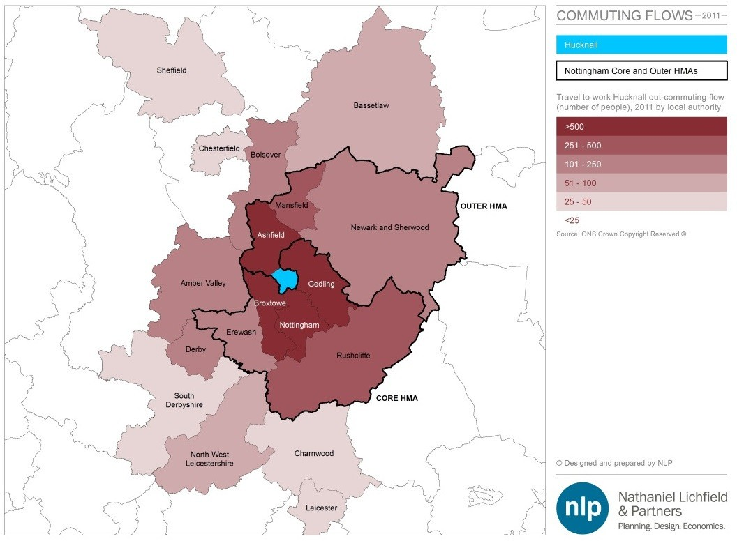

Source: MSOA commuting data from the Census, 2011 / NLP analysis

* 1. Referring back to Table 2.3, an analysis has been undertaken of the implications on the FEMA retention tests of including the four MSOAs comprising Hucknall in the Core HMA, and excluding it from the Outer HMA. Perhaps unsurprisingly, the TTWA retention rates for the Core HMA increase from 80.1% to 80.8% using the first FEMA indicator and from 80.9% to 82.9% using the second, when it is included alongside the five districts.
  2. However, it is also worth noting that the overall FEMA tests decline slightly for the Outer HMA if Hucknall is excluded, which may reflect the relationship with the rest of Ashfield District and the high number of jobs in Hucknall that are taken up by its own residents.
  3. In summary, it is considered that Hucknall has stronger linkages with the Core HMA districts, and particularly Nottingham City, than it does with the rest of Ashfield and particularly the other two Outer HMA districts of Mansfield and

Newark and Sherwood. As such, it is considered that it would be more appropriate to consider it as being located within the Nottingham Core FEMA (although paradoxically, due to the number of jobs based in Hucknall, the actual level of self-containment of commuting across the Outer HMA districts would actually reduce slightly if Hucknall were to be excluded from the calculations).

#### Working Age Population

* 1. Figure 2.19 illustrates the relationship between the change in working age population and employment growth. Between 1997 and 2011, increases in employment outstripped growth in the working age population in all Authorities within both HMAs bar Erewash, Nottingham City and Gedling (although it should be noted that a significant amount of the growth in Nottingham City’s population over this period can be attributed to the expansion of its two universities).

Figure 2.19 Historic Growth Trends of Working Age Population and Workforce Job Growth

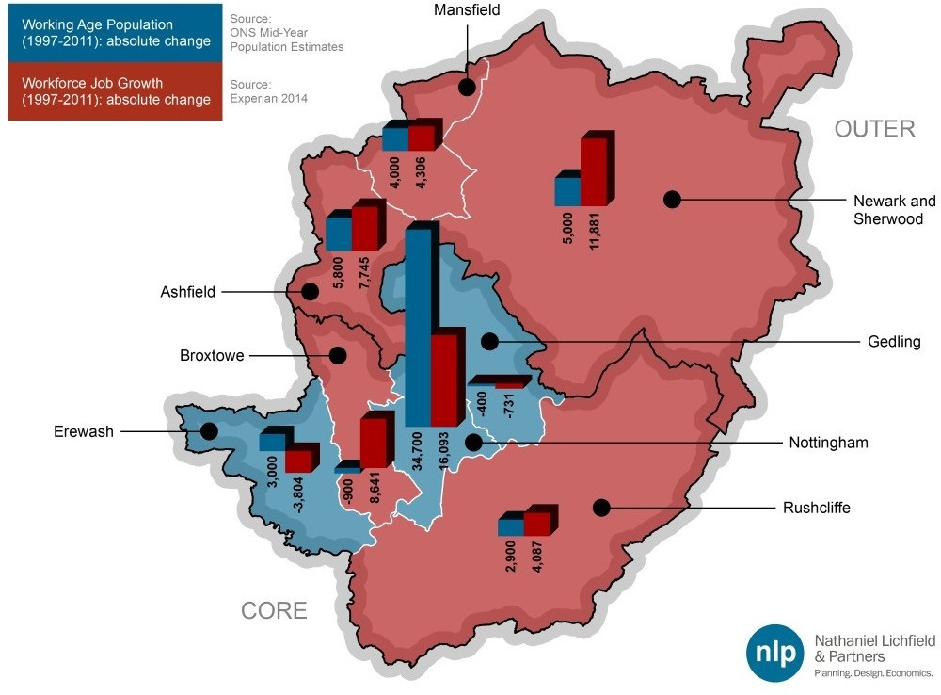

Source: ONS 2012-based SNPP / Experian / NLP analysis

* 1. Table 2.4 compares the future projections for job growth (set out in detail in Section 5.0) with the likely labour supply growth and the FTE job growth projections set out in the ACS (where appropriate), alongside other relevant economic indicators. It indicates that the job growth projected by the latest Experian projections is below the level that could be supported by the ACS dwelling requirements and also the FTE targets set out in the Employment Background Paper to the ACS. The Policy On projections are, however, higher than the other three projections.
  2. Commuting from surrounding local authorities is likely to increase, as people travel to fill the newly created jobs. This will in turn increase pressure on the travel infrastructure, whether that is the rail or road network. Whilst building connectivity (such as investment in travel infrastructure) between local labour markets will assist employment growth, it is necessary to provide sufficient family homes and starter homes to encourage a younger workforce to move into these areas.

Table 2.4 Job Forecasts relative to Labour Supply

|  |  |  |  |  |  |  |  |
| --- | --- | --- | --- | --- | --- | --- | --- |
| **Local Authority** | **Experian Increase in Employment (2011-2033)**  **[1]** | **NLP Policy On Adjusted 2011-2033**  **[2]** | **ACS Workplace labour supply figures 2011-2033**  **[3]** | **Employment Background Paper ACS FTE jobs [4]** | **Unemploym ent [5]** | **Net Commuting Level (2011)**  **[6]** | **Job Density Figure (2013)**  **[7]** |
| Broxtowe | 7,174 | 9,429 | 1,804 | 5,306 | 5.7 | -14,355 | 0.57 |
| Gedling | 1,307 | 1,318 | 3,945 | 4,788 | 5.4 | -18,765 | 0.47 |
| Nottingham City | 19,914 | 29,438 | 28,059 | 26,012 | 9.9 | +51,193 | 1.04 |
| **ACS Plan Area** | **28,395** | **40,185** | **33,808** | **36,106** | **8.0** | **+18,073** | **0.83** |
| Erewash | 3,009 | 3,020 | 5,422 | 5,306 | 5.2 | -11,909 | 0.61 |
| Rushcliffe | 9,834 | 10,754 | 8,390 | 5,694 | 3.8 | -9,409 | 0.64 |
| **CORE HMA** | **41,238** | **53,959** | **47,620** | **47,106** | **7.0** | **-3,245** | **0.77** |
| Ashfield | 9,713 | 10,724 | 12,338 | n/a | 5.5 | -2,221 | 0.69 |
| Mansfield | 4,816 | 5,282 | 5,929 | n/a | 5.9 | -7,371 | 0.56 |
| Newark & Sherwood | 7,362 | 8,465 | 10,015 | n/a | 5.5 | -3,622 | 0.72 |
| **OUTER HMA** | **21,891** | **24,471** | **28,282** | **n/a** | **5.7** | **-13,214** | **0.66** |

Source: [1] Experian / NLP analysis, Nottingham City figure adjusted; [2] NLP Policy On projection [3] based on dwelling targets in the ACS / jobs targets in joint Outer Nottingham HMA SHMA; [4] FTE jobs in the Employment Background Paper informing the Aligned Core Strategy; [5] ONS Annual Population Survey Model Based Unemployment April 2014- March 2015 [6] 2011 Census; [7] ONS Job Density data 2013

Note The Experian job growth and the NLP Policy On increases relate to total workforce job growth and not FTE job growth, so direct comparisons with the Employment Background Paper ACS figures are not possible.

* 1. Currently every authority within both the Core and Outer HMAs (with the notable exception of Nottingham City) experiences net out-commuting. The Experian projections show employment growth outstripping increases in the working age population for Broxtowe and Rushcliffe over the plan period 2011- 2033.
  2. This presents the Local Authorities with an opportunity to address the high rates of unemployment in some areas (with more jobs being available per head of population, which would increase the job density). It would also simultaneously help to create sustainable levels of employment within each district by ‘clawing back’ many of those who are currently commuting out of each area for employment. This would clearly be a policy choice for each local authority to make. The reverse is true for the remaining authorities, and particularly Nottingham City, Ashfield and Newark & Sherwood, although for Nottingham this will bring the City closer into balance as it is already a net importer of labour.
  3. A final point relates to a shift in where the jobs are likely to be located in future. Figure 2.20 compares the past jobs growth the 8 districts experienced between 1997 and 2011, with the future job growth projections provided by Experian (adjusted for Nottingham City – see discussion below) for 2011-2033. This indicates that over the previous 14 years job growth was distributed almost equally between the five Core HMA authorities and the three Outer HMA districts, at around 24,000 jobs in each HMA.
  4. However, Experian project that in future (even allowing for an adjusted Nottingham City figure), the five Core HMA authorities will accommodate the bulk of future job growth, with annual growth up to 1,875, almost double the Outer HMA’s growth (995 jobs annually).

Figure 2.20 Past versus Future Job Growth Projections for the Core and Outer HMAs

2000

CORE HMA Nottingham Broxtowe Erewash

City

Gedling

Rushcliffe

OUTER HMA Newark Ashfield Mansfield

1500

1000

500

0

-500

Average Annual Employment Growth 1997-2011 Average Annual Employment Growth 2011-2033

Source: Experian / NLP analysis

## Conclusions

* 1. The study area is well connected, particularly with regard to the motorway network, with the M1 running through districts within both the Core and Outer HMAs districts and the A1 alongside Newark. These connections have a significant impact regarding employment land requirements, as many firms see connectivity as a critical factor when considering where to locate their operations. Having access to key motorway networks and supply routes makes an area more attractive to a company and increases demand for employment land around these areas.
  2. The Core HMA is generally characterised by a resident population with a relatively high level of skills and higher wages (compared to both the Outer HMA and regional averages). There are disparities within this, most notably within Nottingham City. A considerable gap exists between the resident population’s skills (which tend to be lower than the rest of the HMA) and the employment on offer (which tends to be higher-value in sectors such as

Finance and Professional Services). The City is viewed as the business ‘hub’ of the East Midlands region, with national and international companies looking to have a presence in the region locating here.

* 1. As such, the majority of large businesses in the HMA are clustered in the City, which is partly due to the Nottingham-Derby Green Belt which constrains many of the surrounding Core HMA authorities, alongside areas around junctions 25, 26 and 27 of the M1. Other authorities within the Core HMA have business groupings, but these tend to be more dispersed and localised in nature. Business activity outside of these smaller centres tends to be focused in large business parks based around the motorway junctions that run through these districts. Several of these districts are effectively suburban hinterlands which are popular residential locations for those who are looking to commute to work in the City. This is reflected in the higher average resident-based wages (relative to the workplace-wages) of these suburban areas.
  2. The Outer HMA is characterised by more distinct economic markets. Whilst both HMAs have an above average percentage of their workforce employed within manufacturing, this is especially the case within the Outer HMA, although even here manufacturing employment is shifting towards higher-tech manufacturing in order to move up the value chain in terms of the products they produce.
  3. The lower skills levels that residents in the Outer HMA tend to have in turn affect the type of work available for residents (often of a lower value) which can dampen average wage levels. Lower skill levels in these locations are a potential barrier to investment by businesses, and it is widely acknowledged that the growth of the knowledge economy is strongly linked to the availability of higher level skills. As such, improving both academic and workplace skills has been made a priority by the D2N2 LEP.
  4. Following the FEMA analysis, it is considered that the Core HMA forms a distinct self-contained FEMA, although applying the FEMA tests for the three Outer HMA districts is slightly less clear cut, although on the basis of the assessment an argument can be made that the Outer HMA is self-contained. For Hucknall the analysis identifies that of the residents in employment, 6,484 work in Hucknall or the rest of Ashfield while 6,763 commute to the five Core HMA authorities. Whilst Hucknall is within the administrative boundaries of Ashfield/Outer HMA, it is highly connected to the Core HMA and could be viewed as being located within that FEMA.

# 3.0 Overview of Employment Space

* 1. This section provides an overview of the current stock of employment space in the Nottingham Core and Outer HMAs, and recent trends and changes to the supply of this employment space. Both the amount of employment land and the quantity of built employment space has been considered across the main types of employment uses (i.e. office (B1 a/b), manufacturing industry (B1c/B2) and warehousing/distribution (B8)). This analysis draws upon data from the following sources:
     + commercial floorspace data from the ONS and various datasets from the Valuation Office Agency (VOA);
     + monitoring data on employment space from each local authority; and
     + commercial property market databases and information supplied by local commercial agents.

## Core HMA

#### Current Stock of Employment Space

* 1. In 2012, the local authorities within the Nottingham Core HMA contained over 5,495,000 sqm of office/industrial floorspace. Of this, 79% was made up of industrial and warehousing floorspace21 with the remaining 21% comprising office floorspace (Figure 3.1). However, whilst floorspace within the Core HMA is still dominated by industrial space, over the past 12 years its dominance has lessened, with a 14% decline in industrial floorspace compared with a 20% increase in office floorspace.

Figure 3.1 Composition of Existing Stock Office and Industrial Floorspace within Core HMA (2012)

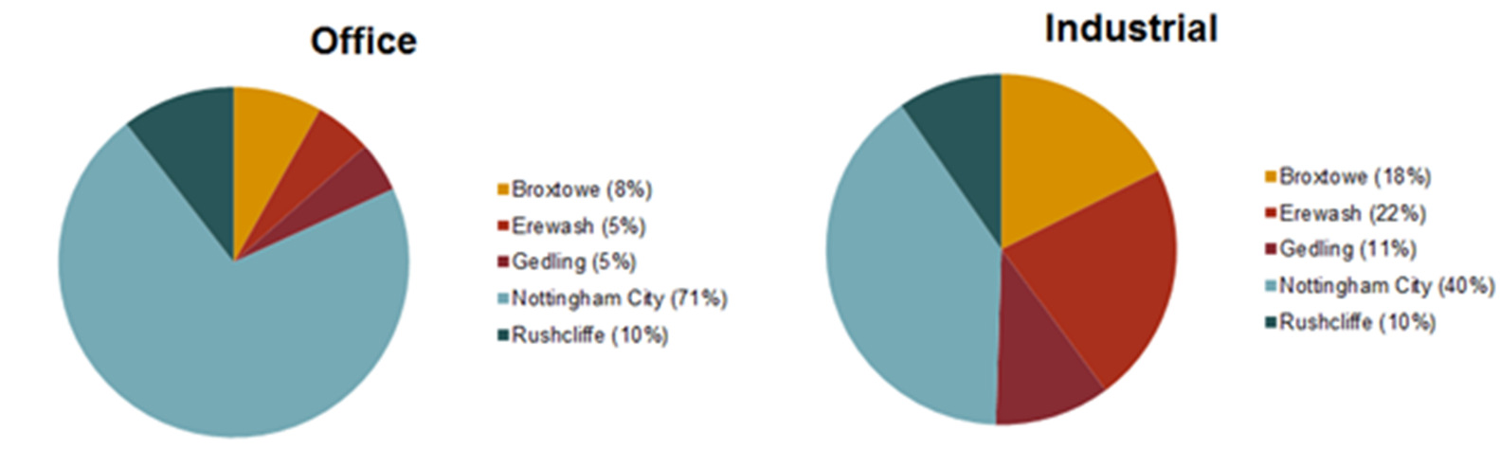

Source: VOA Business Floorspace (Experimental Statistics) (2012) / NLP analysis

* 1. The vast majority of office floorspace is located within Nottingham City, which accommodates 71% of the 1,162,000 sqm total office floorspace across the Core HMA (Figure 3.1). Nottingham City is widely viewed as the ‘capital of the East Midlands’ and hence is often the first port of call for businesses looking for a presence in the region, which helps to explain its dominance of the office

21 Note: the VOA includes a wide variety of uses in the ‘industrial’ floorspace categorisation. Whilst predominantly related to B2 (industrial) and B8 (warehousing), other categories are also included, such as scrap metal/breakers yards, waste transfer and recycling sites and vehicle testing centres, many of which would be classified as Sui Generis uses.

market within the Core HMA. The City has seen a modest growth in office floorspace over the period 2000 to 2012, at 14% compared to 25% across the East Midlands as a whole (Figure 3.2). As this is a net figure, this low growth rate may at least partly be due to the significant losses of office floorspace resulting from the changes to the permitted development rights facilitating office to residential conversions, which have been very high for Nottingham City over the past few years (see discussion below).

Figure 3.2 Changes in Office Floorspace in Nottingham City, 2000–2012

6,000

5,000

Floorspace in Thousands m2

4,000

3,000

2,000

1,000

0

2000 2001 2002 2003 2004 2005 2006 2007 2008 2009 2010 2011 2012

EAST MIDLANDS Nottingham UA

Source: VOA Business Floorspace (Experimental Statistics) (2012)

* 1. Whilst in absolute terms Nottingham City still dominates the local office market, the other four boroughs in the Core HMA have experienced a strong growth in office floorspace over the past 12 years albeit from a lower base. In particular, Broxtowe has seen growth of 76%, to 95,000 sqm, which is significantly above the Core HMA’s average growth rate of just 20%. Rushcliffe has the largest stock of employment floorspace outside of Nottingham City, with 122,000 sqm, although growth has flatlined since the 2007/08 recession.

Figure 3.3 Office Floorspace in the Core HMA (excluding Nottingham City), 2000–2012

140



120

Floorspace in Thousands m2

100

80

60

40

20

0

2000 2001 2002 2003 2004 2005 2006 2007 2008 2009 2010 2011 2012

Erewash Broxtowe Gedling Rushcliffe

Source: VOA Business Floorspace (Experimental Statistics) (2012)

* 1. Nottingham City also has the largest share of industrial floorspace in the Core HMA, containing 40% of the HMA’s total 4,333,000 sqm stock in 2012. However, this figure has been declining steadily, down 29% from 2000 levels to a figure of 1,725,000 sqm in 2012. This is in contrast to the growth in industrial floorspace across the East Midlands as a whole (up 4.5% from 2000).

Figure 3.4 Change in Industrial Floorspace in Nottingham City, 2000-2012

3,000

2,500

Floorspace in Thousands m2

2,000

1,500

1,000

500

0

2000 2001 2002 2003 2004 2005 2006 2007 2008 2009 2010 2011 2012

Nottingham UA

Source: VOA Business Floorspace (Experimental Statistics) (2012)

* 1. As can be seen from Figure 3.5, this downward trend is also mirrored by Erewash and Broxtowe, the two boroughs with the largest stock of industrial space outside Nottingham in the Core HMA.
  2. Erewash’s stock has decreased by 7.5% over the 12 year period, whilst Broxtowe’s decline has been even more severe, at 12.5%. In contrast, the two boroughs with the smallest amount of industrial stock, Rushcliffe and Gedling, have seen increases in the overall amount of industrial land since 2000 (by 32% and 21% respectively), although in recent years this growth has levelled off.

Figure 3.5 Change in Industrial Floorspace in Core HMA (excluding Nottingham City) 2000-2012

1,200

1,000

Floorspace in Thousands m2

800

600

400

200

0

2000 2001 2002 2003 2004 2005 2006 2007 2008 2009 2010 2011 2012

Erewash Broxtowe Gedling Rushcliffe

Source: VOA Business Floorspace (Experimental Statistics) (2012)

#### Vacancy

* 1. Based on a review of commercial property being actively marketed within the Core HMA area via national commercial property websites22 (as of January 2015), there was around 182,000 sqm of office floorspace being marketed in the Core HMA, equivalent to around 17% of the total B1a/b stock across the five boroughs. Similarly, an analysis of marketed industrial and warehousing (B1c/B2/B8) properties in the Core HMA indicated that there was 178,000 sqm of floorspace available, around 4.5% of the total 3,900,000 sqm industrial stock across the five boroughs.23
  2. Based on this analysis, Table 3.1 summarises the implied office and industrial vacancy rates for each of the five Core HMA boroughs based on marketed floorspace compared to the total stock of floorspace on the VOA database. Office vacancy rates ranged from a low of 3.5% in Erewash, to a high of 19.6%

22 Using RightMove and PropertyLink, which collate listings of major commercial property agents

23 Disclaimer: For some listings the exact floorspace level available (i.e. if not fully rented) was not known, therefore the only available figure was used (often the total floorspace of the development). This figure may therefore represent an overestimation.

in Nottingham City. Vacancy rates of industrial/warehousing floorspace were also highly variable across the five boroughs, from a low of 1.9% (again in Erewash) to a high of 17.3% in Gedling.

Table 3.1 Core HMA Vacancy Rates (floorspace)

|  |  |  |
| --- | --- | --- |
| **Local Authority** | **Office Vacancy Rate** | **Industrial Vacancy Rate** |
| Broxtowe | 16.5% | 10.2% |
| Erewash | 3.5% | 1.9% |
| Gedling | 12.5% | 17.3% |
| Nottingham City | 19.6% | 2.7% |
| Rushcliffe | 8.8% | 2.0% |
| **CORE HMA** | **17.0%** | **4.5%** |

Source: VOA and review of commercial property websites

* 1. A typical commercial property market could expect a vacancy rate of around 8- 10% to allow for occupier churn and choice24. This compares with a figure of 17.0% for the Core HMA overall, suggesting that there is a degree of over- supply of office space at present. This is primarily attributable to Nottingham City’s high vacancy rate (19.6%), which is the location for most of the office space in the HMA. This figure, however, is to an extent ‘skewed’ by the quantity of poor quality offices in the area. Many of these offices (which often do not meet the standards required of modern businesses), are being lost to residential use as a result of the changes to the Permitted Development Rights system; commercial property agents suggested that many poor quality premises still remain. This boosts the vacancy figure for the area as a whole and masks the fact that the availability of good quality, Grade A office space is much lower. For instance, in 2010 it was reported that the vacancy rate for high quality Grade A office space was 12%25.
  2. Regarding industrial premises, there is a clear lack of supply alongside strong demand, which results in low vacancy rates (4.5%). This figure is below the level that could be considered the ‘normal’ level of vacancy necessary to enable a properly functioning property market. It suggests that the variety and supply of premises in the HMA may be limited and therefore available properties are occupied quickly. Agents confirmed this position and commented that the industrial vacancy rates may have even been artificially increased by a few large buildings that are not suitable for occupation, but which are still on the market. The amount of available, good quality, stock in the smaller size categories is generally considered very low across the HMA.
  3. The exception is Gedling. This is partly due to Gedling’s location further away from the M1 and other key transportation links than the other authorities in the HMA. This may help create a perception that it is a slightly less desirable location to invest/locate in, contributing towards the higher vacancy rates. In addition, Gedling’s high industrial vacancy rate is inflated by the high numbers of vacant units at Colwick Industrial Estate and Pintail Close; once these listings are removed the overall vacancy rate drops significantly, to just 1.1% .

24 A typical industry standard used in a number of ELRs across the country and supported by discussions with local commercial agents during the production of this study.

25 Nottingham Office Review 2010

* 1. To help address this, Gedling Borough Council is promoting a new Trent Crossing in the vicinity of Colwick which would greatly increase accessibility to the eastern side of the Borough.
  2. Agents also noted that, with respect to Erewash’s very low vacancy rates, this can be partially attributable to the fact that despite the borough’s excellent strategic location and proximity to junctions on the M1, the amount of developable employment land, particularly in the Green Belt-constrained west, is very limited. Nevertheless demand remains strong for sites that are able to come forward, with office floorspace increasing by around 48% to 62,000 sqm between the years 2000-2012 versus a rate of 20% across the Core HMA as a whole.26

#### Development Rates (gross and net completions)

###### Office Floorspace Completions

* 1. Data on past completions by B-class sector was provided by each of the Core HMA boroughs. It should be noted that the data provided is highly variable in quality, with base dates ranging from 2001/02 to 2009/10. Furthermore, records of losses generally do not go back as far as the completions data does, making ‘net’ calculations problematic. NLP also has concerns regarding the robustness of some of the data concerning losses of office space in Nottingham City, as the data seems likely to be an under-estimate given that Nottingham reportedly has one of the highest rates of office-to-residential permitted development conversions in England.27
  2. Conversely, NCC Officers commented that whilst the Council has granted a significant amount of permitted development rights for office conversion to residential use, a comparatively limited amount has actually been implemented so far. Whether this is due to a significant time lag between approvals and implementation, or whether they will not come forward at all, the point is that forecasting future losses from this source based on past data is likely to be inaccurate. As such, the completions data discussed below should be treated with a high degree of caution. Bearing these points in mind, Figure 3.6 compares the amount of (gross) office floorspace that has been delivered in the Core HMA since 2007/08 (where available).
  3. Completions over the period 2004/05-2013/14 have been analysed, since this is a reasonably long period that reflects a full business cycle with periods of both economic growth and (severe) recession. Table 3.2 demonstrates that the vast majority of gross completions were located in Nottingham City, particularly in the years 2005/06 and 2007/08 before the recession and subsequent economic downturn suppressed completions dramatically. In the City, completions peaked at 14,692 sqm in 2007/08, before falling to virtually nothing in 2008/09. Rushcliffe had the next highest level of office floorspace completions, at 1,569 sqm annually, much of which actually took place in the

26 VOA Business Floorspace (Experimental Statistics) (2012)

27 ‘Charge of the conversions’, Planning magazine special report, 27 November 2014

years most affected by the economic downturn. In contrast, Gedling has had very limited office floorspace development in recent years, with virtually no completions recorded since 2005/06.

Figure 3.6 Gross Office Floorspace Completions 2007/08-2013/14 in the Core HMA

16,000

14,000

12,000

Office Floorspace Gross Completions(sqm)

10,000

8,000

6,000

4,000

2,000

0

2007/08 2008/9 2009/10 2010/11 2011/12 2012/13 2013/14

Broxtowe Erewash Gedling Nottingham Rushcliffe

Source: Five Core HMA Councils / NLP analysis

Table 3.2 Gross Annual B1a/b Office Floorspace Completion Rates in Core HMA, 2004/05-2013/14 (sqm)28

|  |  |  |  |  |  |  |  |  |  |  |
| --- | --- | --- | --- | --- | --- | --- | --- | --- | --- | --- |
|  | **2004**  **/05** | **2005**  **/06** | **2006**  **/07** | **2007**  **/08** | **2008**  **/09** | **2009**  **/10** | **2010**  **/11** | **2011**  **/12** | **2012**  **/13** | **2013**  **/14** |
| Broxtowe | n/a | n/a | n/a | n/a | 1,401 | 762 | 2,284 | 225 | 1,974 | 272 |
| Erewash | n/a | n/a | n/a | n/a | n/a | 0 | 354 | 0 | 220 | 0 |
| Gedling | 0 | 0 | 0 | 0 | 0 | 0 | 0 | 0 | 0 | 0 |
| Nottingham | n/a | 14,672 | 8,440 | 14,692 | 0 | 9,232 | 0 | 333 | 8,871 | 0 |
| Rushcliffe | n/a | 317 | 0 | 2,258 | 5,447 | 4,005 | 0 | 421 | 0 | 1,675 |
| **Total Core HMA** | **n/a** | **n/a** | **n/a** | **n/a** | **n/a** | **13,999** | **2,638** | **979** | **11,065** | **1,947** |

Source: Source: Core HMA Councils / NLP analysis

Note: It was not possible for Broxtowe Borough Council to distinguish between B1a, B1b or B1c, hence it is possible that the figures recorded in the Table over-estimate the amount of office floorspace that has actually been delivered in the Borough between 2008/09-2013/14.

* 1. The average gross completions rate is in stark contrast to the losses illustrated in Figure 3.7 and the net figures presented in Table 3.3. For example, although Nottingham has been averaging around 6,250 sqm of B1a/b office development in the years 2005/06 to 2013/14, over the same time period the

28 A plot ratio of 40% has been used to convert hectares to square metres where necessary

City has also lost almost 10,150 sqm, resulting in net loss of 3,900 sqm annually.

* 1. This has been skewed by losses over the past two years since the Government’s introduction of office-to-residential permitted development rights, which has significantly accelerated the amount of office floorspace lost/converted to residential uses (much of which has been redeveloped for student accommodation in the City Centre) – 23,184 sqm has been lost in the past two years alone. Net completion rates are also negative for Erewash and Gedling. The net figure for the latter borough is likely to have been skewed by the loss of the 11,601 sqm / 4.9ha B1a EMEB Headquarters at Arnold in 2004/05, which comprises 95% of office losses in the borough.

Figure 3.7 Gross Office Losses 2001/02-2013/14 in the Core HMA

16,000

14,000

12,000

Office Florospace Gross Losses (sqm)

10,000

8,000

6,000

4,000

2,000

0

2004/5 2005/6 2006/7 2007/08 2008/9 2009/10 2010/11 2011/12 2012/13 2013/14

Broxtowe Erewash Gedling Nottingham Rushcliffe

Source: Core HMA Councils / NLP analysis

Note: data on losses unavailable before 2009/10 for Broxtowe and Erewash, and before 2005/06 for Nottingham and Rushcliffe

* 1. On the basis of the data presented in Table 3.3, the total net annual delivery of office floorspace (albeit over a range of time periods) is -769 sqm, primarily driven by Nottingham and Rushcliffe.

Table 3.3 Gross/Net Annual Net B1a/b Office Completion Rates

|  |  |  |  |
| --- | --- | --- | --- |
|  | **Average Annual Gross Completions of B1a/b Office** | **Average Annual Losses of B1a/b Office**  **(time periods vary)** | **Average Annual Net Completions of B1a/b Office**  **(time periods vary)** |
| Broxtowe | 1,103 sqm 2009/10 to  2013/14 | 663 sqm  (2009/10 to 2013/14) | 441 sqm  (2009/10 to 2013/14) |
| Erewash | 115 sqm 2009/10 to 2013/14 | 575 sqm  (2009/10 to 2013/14) | -460 sqm  (2009/10 to 2013/14) |
| Gedling | 0 sqm 2004/05 to 2013/14 | 1,217 sqm  (2004/05 to 2013/14) | -1,217 sqm  (2004/05 to 2013/14) |
| Nottingham | 6,249 sqm 2005/06 to  2013/14 | 10,149 sqm  (2005/06 to 2013/14) | -3,900 sqm  (2005/06 to 2013/14) |
| Rushcliffe | 1,569 sqm 2005/06-  2013/14) | 275 sqm  (2005/06 to 2013/14) | 1,294 sqm  (2005/06 to 2013/14) |

Source: HMA Councils / NLP analysis

###### Industrial Land Completions in the Core HMA

* 1. As regards industrial and warehousing land, the Tables in Appendix 5 and Figure 3.8 present the gross annual completion rates of B2/B8 employment land in the Core HMA. They indicate that Nottingham has had the highest amount of industrial development in recent years, delivering 7.2 ha since 2005/06 at an average of 0.8ha per annum. Whilst Broxtowe Borough has only delivered 1.1ha of industrial/warehousing land since 2009/10, it should be noted that pre-recession it was delivering significantly higher levels of employment land. Whilst the Council was unable to provide a detailed split of take up by Use Class before 2009/10 (hence the data range presented in Figure 3.8), significant industrial developments before this time included 3.2ha at Chetwynd Barracks, Chilwell (2003/04); 3.0 ha at South Street Eastwood (2006/07) and 2.2 ha on land off the A610 at Eastwood (2007/08).

Figure 3.8 Gross Annual Completion Rates in Core HMA for B2/B8 industrial land, 2004/05-2013/14 (ha)

3.00

2.50

2.00

Completions of Industrial Land (ha)

1.50

1.00

0.50

0.00

2004/5 2005/6 2006/7 2007/08 2008/9 2009/10 2010/11 2011/12 2012/13 2013/14

Broxtowe Erewash Gedling Nottingham Rushcliffe

Source: Core HMA Councils / NLP analysis Note: data on completions unavailable before 2009/10 for Erewash; before 2004/05 for Gedling; and before 2005/06 for both Nottingham and Rushcliffe

* 1. In terms of losses of industrial land, Figure 3.9 demonstrates that this has been particularly significant in Nottingham, with an average of 6.5 ha lost annually since 2005/06 to non-B class uses, whilst Erewash has lost just 3.1 ha in total. As regards Nottingham City, this very high rate of loses is reasonably consistent over time, albeit the City experienced particularly high rates of loss in 2006/07 and 2009/10, with the former including the loss of the Thomas Forman site and Basford Gas Works (c.11ha in total), whilst the latter included the loss of the 7ha former B2 industrial land at Jubilee Campus.

Figure 3.9 B2/B8/Mixed Losses 2005/06-2013/14 in the Core HMA (ha)

18.00

16.00

14.00

12.00

Losses of Industrial Land (ha)

10.00

8.00

6.00

4.00

2.00

0.00

2004/5 2005/6 2006/7 2007/08 2008/9 2009/10 2010/11 2011/12 2012/13 2013/14

Broxtowe Erewash Gedling Nottingham Rushcliffe

Source: Five Core HMA Councils / NLP analysis

Note: data unavailable before 2009/10 for Erewash, and before 2005/06 for Nottingham and Rushcliffe

* 1. Table 3.4 demonstrates that overall, Rushcliffe has been delivering 0.6ha net of industrial land annually, whilst Nottingham City has been losing 5.7 ha (net) annually.

Table 3.4 Gross/Net Annual Net B2/B8 Completion Rates

|  |  |  |  |
| --- | --- | --- | --- |
|  | **Gross** | **Average Annual Gross Losses of B1c/B2/B8 Industrial land** | **Net** |
| **Average Annual Gross Completions of B1c/B2/B8 Industrial land** | **Average Annual Net Completions of B1c/B2 Industrial** |
| Broxtowe | 0.22 ha  (2009/10-2013/14) | 0.36 ha  (2009/10-2013/14) | -0.14 ha  (2009/10-2013/14) |
| Erewash | 0.78 ha  (2009/10-2013/14) | 0.615 ha  (2009/10-2013/14) | 0.168 ha  (2009/10-2013/14) |
| Gedling | 0.58 ha  (2004/05-2013/14) | 0.28 ha  (2004/05-2013/14) | 0.30 ha  (2004/05-2013/14) |
| Nottingham | 0.80 ha  (2005/06-2013/14) | 6.48 ha  (2005/06-2013/14) | -5.68 ha  (2005/06-2013/14) |
| Rushcliffe | 0.72 ha  (2005/06-2013/14) | 0.15 ha  (2005/06-2013/14) | 0.57 ha  (2005/06-2013/14) |

Source: HMA Councils / NLP analysis

## Outer HMA

#### Current stock of employment space

* 1. In 2012, the local authorities within the Nottingham Outer HMA contained around 2,897,000 sqm of office/industrial floorspace. The split between office and industrial is even starker than within the Core HMA, with 90% of all floorspace in the HMA being occupied by industrial use. Despite starting from a much lower base since 2000, office floorspace has increased by 70% across the Outer HMA. Moreover, and in contrast to the Core HMA, the stock of industrial floorspace has also increased by 22% over the same time period (Figure 3.10).

Figure 3.10 Office and Industrial Floorspace in the Outer HMA, 2000 – 2012

3000

2500

2000

Floorspace in thousands m2

1500

1000

500

0

2000 2001 2002 2003 2004 2005 2006 2007 2008 2009 2010 2011 2012

Office Industrial

Source: VOA Business Floorspace (Experimental Statistics) (2012)

* 1. Within the Outer HMA there are substantial variations in the overall delivery performance of the three districts (see Figure 3.11). For instance, prior to 2006 Ashfield had significantly lower levels of office floorspace than either Mansfield or Newark & Sherwood. However, due in large part to the development of Sherwood Business Park, during 2005 and 2006 Ashfield saw the level of office space increase over two-and-a-half times, bringing it up to the level of office floorspace of the other two authorities within the Outer HMA (at around 100,000 sqm).
  2. One potential reason underpinning the substantial increase in Ashfield District’s office floorspace figures in 2005 (and also the rise in industrial buildings in 2005) is that the fiscal benefits from the Sherwood Park EZ expired in 2005. Therefore, the buildings on the EZ that would previously have been exempt from business rates came onto the VOA valuation list together when the designation expired.
  3. Overall, between 2000 and 2012 Ashfield saw its total office floorspace stock increase by 191%; Mansfield, by 29%, and Newark and Sherwood by 53%.

Figure 3.11 Changes in Office Floorspace in the Outer HMA 2000-2012

120

100

Office Floorspace in Thousands m2

80

60

40

20

0

2000 2001 2002 2003 2004 2005 2006 2007 2008 2009 2010 2011 2012

Ashfield Mansfield Newark and Sherwood

Source: VOA Business Floorspace (Experimental Statistics) (2012)

* 1. In terms of industrial floorspace, Ashfield has the largest amount of floorspace, at 1,195,000 sqm in 2012 (Figure 3.12), having increased by 25% over the 12- year period despite a re-adjustment to the total stock in the immediate aftermath of the recession. Newark & Sherwood’s total industrial stock is lower, at 844,000, although the District’s overall growth has been even greater than Ashfield’s (at 30% over the 12-year assessment period). Mansfield’s industrial stock is much lower, at 560,000 sqm, and has also seen a lower rate of growth, at 9%, since 2000.

Figure 3.12 Industrial Floorspace in the Outer HMA districts

1400

1200

Industrial Floorspace in Thousands m2

1000

800

600

400

200

0

2000 2001 2002 2003 2004 2005 2006 2007 2008 2009 2010 2011 2012

Ashfield Mansfield Newark and Sherwood

Source: VOA Business Floorspace (Experimental Statistics) (2012)

#### Vacancy Rates

* 1. Based on a review of commercial property being actively marketed in the Outer HMA area via national commercial property websites29 (as of January 2015), there was c.43,000 sqm of office floorspace available in the Outer HMA, equivalent to around 14.7% of the total B1a/b stock (Table 3.5).
  2. An analysis of marketed industrial properties in the Outer HMA indicated that there was around 61,500 sqm of industrial floorspace available, or 2.5% of the total 2.5 million sqm of industrial stock across the Outer HMA. Ashfield’s proximity to the M1 and Newark’s proximity to the A1 were cited by commercial property agents as to why these areas have particularly low industrial vacancy rates (relative to the typical market average rate of 8-10% to allow for flexibility and choice).

Table 3.5 Outer HMA Vacancy Rates

|  |  |  |
| --- | --- | --- |
| **Local Authority** | **Office Vacancy Rate** | **Industrial Vacancy Rate** |
| Ashfield | 20.8% | 1.0% |
| Mansfield | 9.1% | 3.4% |
| Newark and Sherwood | 12.4% | 4.3% |
| **OUTER HMA** | **14.7%** | **2.5%** |

Source: VOA and review of commercial property websites

* 1. Commercial agents suggested that there was very limited demand for office space across the Outer HMA, hence the reported office vacancy figures may be an under-estimate. Other stakeholders pointed out that this figure masks the fact that many existing office premises are of a very poor quality and do not meet occupier requirements in terms of size, specification and location, and may not be actively marketed (and hence reported on the Commercial Property Websites as a result, thus pushing down the overall vacancy rate).
  2. In particular, Ashfield’s high office vacancy rate is partly a result of the high levels of vacant space at Sherwood Business Park, which has the result of skewing the figures upwards. If the vacancies at Sherwood Business Park were removed, this would have the effect of reducing the overall level of office floorspace vacancy rates down from 20.8% to just 2.6%.
  3. The majority of office demand appears to arise primarily from local firms catering for an indigenous market, as opposed to large, inward investment deals that may be seen in locations such as Nottingham, Derby or Leicester.
  4. In contrast, the Outer HMA’s industrial market was frequently described by agents as being ‘buoyant’, which may explain why the vacancy rate of 2.5% overall is well below the typical normal market level of 8-10%. However, even this low vacancy rate may be over-stating the level of available, good quality industrial space, with several agents suggesting that the availability of modern, small to medium size (5,000-50,000 sq ft) units in sought after locations in the three districts is virtually non-existent and gets snapped up as soon as any suitable units become available.

29 Using RightMove and PropertyLink, which collate listings of major commercial property agents

#### Development Rates (gross and net completions)

###### Office Floorspace Completions

* 1. Data on past completions by B class sector was provided by Officers representing the Outer HMA districts. As noted above, the data provided is highly variable in quality, with base dates ranging from 2001/02 to 2006/07. Again, records of losses generally do not go back as far as the completions data does, making ‘net’ calculations problematic.
  2. As such, the completions data discussed below should be treated with a degree of caution. Bearing these points in mind, Figure 3.13 compares the amount of (gross) office floorspace that has been delivered in the Outer HMA since 2005/06 for Ashfield District (including Hucknall), and 2006/07 to 2013/14 for Mansfield and Newark & Sherwood Districts.30

Figure 3.13 Gross Office Floorspace Completions 2005/06-2013/14 in the Outer HMA

16,000

14,000

Office Floorspace Gross Completions (sqm)

12,000

10,000

8,000

6,000

4,000

2,000

0

2005/6 2006/7 2007/08 2008/9 2009/10 2010/11 2011/12 2012/13 2013/14

Ashfield Hucknall Mansfield Newark and Sherwood

Source: Outer HMA Councils / NLP analysis

Note: Completions data unavailable for Mansfield or Newark & Sherwood before 2006/07.

* 1. The figures show a pronounced spike in 2006/07 for Mansfield, which is primarily related to the delivery of 12,082 sqm across four sites:

1. Ratcher Hill Quarry (2,750 sqm), which was an extension of the very successful Ransom Wood Business Park with a new office building for the NHS;
2. Oakham Business Park Phase 2 (known as the I-Centre) which is now fully developed and comprised 6,233 sqm office space delivered in that year alone;

30 When necessary land was converted to floorspace using a 40% plot ratio. Both completions and losses data used the same base for consistency purposes.

1. An office development at Millenium Business Park in north west Mansfield for 2,787 sqm; and,
2. A small incubation centre at Park Road in Mansfield Woodhouse (312 sqm).
   1. Newark and Sherwood’s office delivery peaked the subsequent year (2007/08), due to the completion of B1 office units at Sherwood Energy Village, Newark Industrial Estate and the Trentside Business Village.
   2. The delivery of office space unsurprisingly fell significantly across all the authorities during the recession and the immediate aftermath, and over the past four years or so the amount coming forward across the Outer HMA has totalled just 10,161 sqm. The 2005/06 figure for Ashfield is distorted by the large development at Sherwood Business Park that year.
   3. In this regard, it is important to note that Sherwood Park was located within a designated Enterprise Zone, which came into force on 21st November 1995 for a period of 10 years (The East Midlands Enterprise Zone (Ashfield) (Designation) Order 1995). Within the EZ, areas were identified specifically for B1 plots which were constructed, but never occupied as the EZ fiscal benefits subsided and expired over time. There is no evidence that a similar site designated as an EZ will come forward in Ashfield for the foreseeable future, and hence it is open to question whether office development on the scale seen at Sherwood Park will occur over the Plan period.

Table 3.6 Gross Annual B1a/b Office Floorspace Completion Rates in Outer HMA, 2005/06-2013/14 (sqm)

|  |  |  |  |  |  |  |  |  |  |
| --- | --- | --- | --- | --- | --- | --- | --- | --- | --- |
|  | **2005**  **/06** | **2006**  **/07** | **2007**  **/08** | **2008**  **/09** | **2009**  **/10** | **2010**  **/11** | **2011**  **/12** | **2012**  **/13** | **2013**  **/14** |
| Ashfield | 5,079 | 0 | 272 | 8,036 | 858 | 184 | 544 | 0 | 731 |
| *(of which located in Hucknall)* | *0* | *0* | *0* | *541* | *858* | *0* | *0* | *0* | *318* |
| Mansfield | - | 12,082 | 1,157 | 4,075 | 697 | 0 | 84 | 476 | 0 |
| Newark & Sherwood | - | 7,615 | 15,185 | 0 | 6,738 | 342 | 4,436 | 1,870 | 1,494 |
| **Total Outer HMA** | **-** | **19,697** | **16,614** | **12,111** | **8,293** | **526** | **5,064** | **2,346** | **2,225** |

Source: Source: Outer HMA Councils / NLP analysis

* 1. The rate of average gross completions is in stark contrast to the losses illustrated in Figure 3.14 and the net figures presented in Table 3.7. For example, net completion rates are positive for Newark & Sherwood due to total losses of 15,146 sqm, compared to gross development of 37,680 sqm over the same time period.

Figure 3.14 Gross Office Losses 2001/02-2013/14 in the Outer HMA

8,000

7,000

6,000

Office Floorspace Losses(sqm)

5,000

4,000

3,000

2,000

1,000

0

2005/6 2006/7 2007/08 2008/9 2009/10 2010/11 2011/12 2012/13 2013/14

Ashfield Hucknall Mansfield Newark and Sherwood

Source: Outer HMA Councils / NLP analysis

* 1. On the basis of the data presented in Table 3.7, the total net annual delivery of office floorspace (admittedly over slightly different time periods) is 4,765 sqm, primarily driven by completions in Newark and Sherwood.

Table 3.7 Gross/Net Annual Net B1a/b Office Completion Rates in the Outer HMA?

|  |  |  |  |
| --- | --- | --- | --- |
|  | **Average Annual Gross Completions of B1a/b Office** | **Average Annual Losses of B1a/b Office**  **(time periods vary)** | **Average Annual Net Completions of B1a/b Office**  **(time periods vary)** |
| Ashfield | 1,745 sqm (2005/06-  2013/14) | 1,396 sqm (2005/06 to 2013/14) | 349 sqm (2005/06 to 2013/14) |
| *(of which located in Hucknall)* | *191 sqm* | *58 sqm* | *133 sqm* |
| Mansfield | 2,321 sqm (2006/07 to  2013/14) | 855.5 sqm (2006/07 to 2013/14) | 1,465.5 sqm (2006/07 to 2013/14) |
| Newark & Sherwood | 4,710 sqm (2006/07 to  2013/14) | 1,893 sqm (2006/07 to 2013/14) | 2,817 sqm (2006/07 to 2013/14) |

Source: Outer HMA Councils / NLP analysis

###### Industrial Land Completions

* 1. As regards industrial and warehousing land, the Tables in Appendix 5 and Figure 3.15 present the gross annual completion rates of B2/B8 employment land in the Outer HMA. Ashfield has had the highest amount of industrial development in recent years, delivering 71.6 ha since 2001/02 at an average of

5.51 ha per annum (of which around 1.15 ha per annum has been located in Hucknall). In the years prior to the recession however, Ashfield was delivering an impressive 9.9 ha of industrial land annually due in no small part to the mixed B-Use development at Sherwood Business Park.

Figure 3.15 Gross Annual Completion Rates in Outer HMA for B1c/B2/B8 industrial land, 2002/03-2013/14 (ha)

25

20

Completions of Industrial Land (ha)

15

10

5

0

Ashfield Hucknall Mansfield Newark & Sherwood

Source: Outer HMA Councils / NLP analysis

Note: data on completions unavailable before 2006/07 for Mansfield and before 2005/06 for Newark & Sherwood

* 1. Sherwood Business Park comprises a mixed use development of around 25ha which accommodates offices amongst logistics firms, a hotel and other leisure businesses. Agents commented that it was initially very successful, with firms locating on this site, just a mile away from J27 of the M1, partly due to the lack of business rates through its former Enterprise Zone status.
  2. In contrast, since 2006/07, Mansfield has delivered just under 17ha at a rate of 2.11ha annually, whilst Newark & Sherwood has delivered 41.5 ha at an annual rate of 9.2ha since 2005/06. However, of the 41.5 ha completions figure in Newark & Sherwood, almost half relates to the development of just one site – the Dixons Mastercare National Distribution Warehouse and its later extension in 2003/04 and 2006/07. Excluding this from the figures would result in annual completions of industrial land in the District of 2.61 ha, rather than

4.61 ha including the Mastercare development.

* 1. In terms of losses of industrial land, Figure 3.9 illustrates that losses of industrial land have been consistently high in Ashfield District, which includes the loss of:

1. 3.13ha of manufacturing land to residential at Stag Site, Park Drive in Hucknall in 2003/04;
2. the mixed use development at Annesley Colliery (2010/11), which resulted in the loss of 5.71 ha of former industrial land for housing and open space; and
3. 2.55ha of industrial land at Kirkby Folly Road that was redeveloped for residential uses by Miller Homes in 2007/08.
   1. Losses reflect the decline of the coal and textile industries within the District. Therefore, the level of vacant sites experienced in the past may not necessarily continue at these rates into the future.
   2. Losses have been significantly lower in both Mansfield and Newark & Sherwood, at around 1.35 ha annually for the former district, and 1.32ha for the latter. Losses were particularly high across all of the Outer HMA authorities during the economic downturn, but have since reduced.

Figure 3.16 B1c/B2/B8/Mixed Losses 2001/02-2013/14 in the Outer HMA (ha)

7

6

5

Losses of Industrial Land (ha)

4

3

2

1

0

Ashfield Hucknall Mansfield Newark & Sherwood

Source: Outer HMA Councils / NLP analysis

Note: Hucknall losses are also included within the overall Ashfield District figures; data on losses unavailable before 2006/07 for Mansfield and Newark & Sherwood

* 1. Table 3.8 summarises gross completions against losses to derive a figure for net B2/B8 completion rates. It indicates that across the Outer HMA, both Ashfield (+3.33 ha) and Newark & Sherwood (+3.67 ha) have been delivering consistently high levels of B2/B8 industrial land despite the recession and subsequent economic downturn. In contrast, Mansfield has delivered just 0.75 ha net over the past nine years or so. It is likely, however, that Newark & Sherwood’s figure has been boosted as a direct result of the Dixons Mastercare development which, at 19.05 ha, comprises 46% of the District’s entire B2/B8 industrial land completions over the 9-year assessment period. If this development were to be excluded from the figures, the net annual completion rate would fall from 3.67 ha to just 1.29 ha.

Table 3.8 Gross/Net Annual Net B1c/B2/B8 Completion Rates

|  |  |  |  |
| --- | --- | --- | --- |
|  | **Gross** | **Average Annual Gross Losses of B1c/B2/B8 Industrial land** | **Net** |
| **Average Annual Gross Completions of B1c/B2/B8 Industrial land** | **Average Annual Net Completions of B1c/B2/B8 Industrial** |
| **Outer HMA Districts** | | | |
| Ashfield | 5.51 ha (2001/02-2013/14) | 2.18 ha (2001/02-2013/14) | 3.33 ha (2001/02-2013/14) |
| *(of which located in Hucknall)* | *1.15 ha (2001/02-2013/14)* | *0.51 ha (2001/02-2013/14)* | *0.64 ha (2001/02-2013/14)* |
| Mansfield | 2.106 ha (2006/07-2013/14) | 1.354 ha (2006/07-2013/14) | 0.753 ha (2006/07-2013/14) |
| Newark & Sherwood | 4.99 ha (2005/06-2013/14) | 1.32 ha (2005/06-2013/14) | 3.67 ha (2005/06-2013/14) |
| Source: HMA Councils / NLP analysis | |  |  |

#### Permitted Development Rights

* 1. In May 2013, the Government introduced Permitted Development (PD) Rights to allow for change of use from B1 (a) offices to residential, whereby premises can undergo change of use without the need to obtain planning permission. The effect of the new permitted development rights could be to increase the rate of losses of office space potentially above past trends.
  2. In conversations with commercial property agents, many cited the recent introduction of Permitted Development Rights as the main cause of high office losses, particularly within Nottingham City. Some poor-quality office stock within the City Centre has been converted to student and, increasingly, private residential accommodation because of the higher capital returns these uses attract.
  3. Commercial property agents stated that there still remains a large amount of poor quality office units in the City Centre which will continue to be lost to residential uses, although it is unknown exactly how much more will be lost and at what point the rate of such losses will begin to stabilise. Agents highlighted that similar conversions may start to occur elsewhere in the study area as a way of ‘clearing out’ unsuitable office stock. The high number of university students Broxtowe houses may increase the pressure on owners of poor quality office stock within the Borough to facilitate similar conversions to residential.
  4. As noted above, whilst the Council has approved a significant amount of permitted development rights for office conversion to residential use, a comparatively limited amount has actually been implemented so far, which means that future losses may be higher than has been seen in the past few years from this source.

#### Emerging Supply of Employment Space

###### Core HMA Broxtowe

* 1. The Broxtowe Borough Aligned Core Strategy (adopted September 2014) provides for a minimum of 15 ha of B1/B2/B8 land and 34,000 sqm of B1a office floorspace (assumed to occupy 8.5 ha of employment land based on a plot ratio of 40%). This equates to a total of 23.5 ha of allocated employment land. Policy 4 of the ACS also promotes significant new economic development as part of Sustainable Urban Extensions on land in the vicinity of the proposed HS2 station at Toton (a minimum of 18,000 square metres B- class employment space) and at the Boots Site (c.200,000 sqm of business and commercial space with a high tech, high quality focus) as part of the c.98ha Enterprise Zone31 split between Broxtowe and Nottingham City. As well as Boots' office headquarters, the zone includes a distribution centre, production facility, along with the MediCity centre and a Reckitt Benckiser facility.
  2. Broxtowe Borough Council monitoring data records the amount of significant employment planning applications for employment use. The level of employment land available, taken from the latest Annual Monitoring Report, is summarised in Table 3.9. This indicates there is approximately 17.87 ha of employment land with extant planning permission, with the majority of this being mixed-use.

Table 3.9 Summary of Employment Land Available in Broxtowe, 2012-13

|  |  |  |  |  |  |
| --- | --- | --- | --- | --- | --- |
|  | **B1 (ha)** | **B2 (ha)** | **B8 (ha)** | **Mixed**  **(Unrestrict ed) (ha)** | **Total** |
| Allocated, no planning permission | 1.2 | - | - | 20.2 | 21.4 |
| Allocated with outline permission | 1 | - | - | 17.3 | 18.3 |
| Allocated with detailed permission | - | - | - | - | 0 |
| Not allocated detailed permission (potential gains) | 0.04 |  | 0.03 |  | 0.048 |
| Not allocated detailed permission (potential losses) | -0.144 | -0.26 | -0.07 | - | -0.474 |
| **Total Net Supply Currently Available** | **2.096** | **-0.26** | **-0.04** | **37.5** | **39.274** |

Source: Broxtowe Annual Monitoring Report 2012/13

###### Erewash

* 1. The Erewash Core Strategy was adopted in March 2014. It places a particular emphasis on offices and research and development as part of providing for a science and knowledge-based economy. Policy 4 states that a minimum of

31 <http://enterprisezones.communities.gov.uk/enterprise-zone-finder/nottingham-enterprise-zone/>

42,900 sqm of new offices and research development will be provided in Erewash and will be delivered by:

1. promoting complementary office development (use class B1(a)) in and adjoining the town centres of Ilkeston and Long Eaton in accordance with the strategy set out at Policy 6;
2. promoting significant new economic development as part of the sustainable new neighbourhood at the Stanton Regeneration Site. This will provide about **10 ha for a business park** (use class B1); and
3. identifying and maintaining a supply of good quality land to provide for new and relocating industrial and warehousing uses (in use classes B1(c), B2 and B8). At least **10 ha of employment land for industrial and warehousing** (use classes B1(c), B2 and B8) will be provided, predominantly at the Stanton Regeneration Site.
   1. Alongside these allocations, data provided by Erewash Borough Council suggests that as of February 2015, there was some 376 sqm of B1a/b office development with extant planning permission in the pipeline in and around the Borough, plus 447 sqm B1c floorspace, 444 sqm B2 floorspace and 795 sqm of B8 floorspace (excluding change of use within the B Use classes, resulting in no net gain overall).

###### Gedling

* 1. The Gedling Borough Aligned Core Strategy (adopted September 2014) provides for a minimum of 10 ha of B1/B2/B8 land and 23,000 sqm of B1a office floorspace (assumed to occupy 5.75 ha of employment land based on a plot ratio of 40%). Policy 4 of the ACS also promotes significant new economic development as part of Sustainable Urban Extensions at Top Wighay Farm (8.5 ha B1/B8), Teal Close (7 ha) and Gedling Colliery/Chase Farm (5 ha).

Table 3.10 Allocations/Planning Permissions in Gedling Borough

|  |  |  |  |
| --- | --- | --- | --- |
| **Site** | **Status** | | **Remaining Site Area** |
| **Gedling Borough** | | | |
| Teal Close | Aligned Core Strategy Strategic Allocation  Permission for B1/B2/B8 employment uses (up to 18,000 square metres) occupying approximately 7 ha granted June 2014 (outside the monitoring period). | | 18,000 sqm  / 7ha |
| Top Wighay Farm | Aligned Core Strategy Strategic Allocation  8.5 ha - no planning permission. | | 8.5 ha |
| Gedling Colliery / Chase Farm | Aligned Core Strategy Strategic Allocation  1 ha developed for coal mine methane exploratory borehole and site is currently operational. No planning permission for the remainder of the site (5 ha). | | 5 ha |
| Hillcrest Park | Replacement Local Plan allocation  1.90 ha completed (light industrial and warehouse units).  1.1 ha remaining. | | 1.1 ha |
| **TOTAL** | | **21.6 ha** | |

Source: Gedling Borough AMRs / ACS / NLP analysis

* 1. Gedling Borough Council monitoring data records the amount of significant employment planning applications for employment use. Table 3.11 summarises the extant planning permissions for employment development, which includes the aforementioned 7 ha at Teal Close.

Table 3.11 Extant Planning Permission for Significant Employment Land Development in Gedling Borough

|  |  |  |
| --- | --- | --- |
| **Site** | **Status** | **Site Area** |
| Teal Close | Planning consent granted June 2014 | 7 ha |
| 19 Newstead Industrial Park  - Bunches Florapost Ltd | Approved 19th December 2013 for B1/B8 warehouse extension, first floor mezzanine | 470 sqm |
| Richard C Tuxford Exports Ltd | Full planning permission for B1c - 5 No. new starter units and ancillary yard area | 0.23 ha (526 sqm) |

Source: Gedling Borough AMRs / ACS / NLP analysis

###### Nottingham City

* 1. The Nottingham City Aligned Core Strategy (adopted September 2014) provides for a minimum of 12 ha of B1/B2/B8 land and 253,000 sqm of B1a office floorspace.
  2. According to the latest (Interim) AMR for Nottingham City,32 as of December 2014 there was some 227,900 sqm of B1a/b office development with extant planning permission in the pipeline in and around the City.

###### Rushcliffe

* 1. The Rushcliffe Local Plan Part 1: Core Strategy was adopted in December 2014. It places a particular emphasis on office development (Use Classes B1 (a & b)) as part of providing for a science and knowledge-based economy, identifying 67,900 sqm of new office floorspace to 2028 for these purposes. The Core Strategy also identifies a minimum of 20 ha of good quality land to provide for new, and relocating industrial and warehouse uses (in Use Classes B1(c), B2 and B8) across Rushcliffe.
  2. Policy 5 promotes significant new economic development at the following strategic allocations:

1. The SUE to the South of Clifton through the provision of around 20 ha of B1, B2 and B8 employment land;
2. The provision of around 15.5 ha of employment land providing for a mix of B1, B2 and B8 through the development on land to the North of Bingham;
3. The provision of around 4.5 ha of employment land providing for a mix of B1, B2 and B8 through the redevelopment and regeneration of the Former Cotgrave Colliery;
4. The retention of the existing hangars for employment purposes and the provision of around 6.5 ha of additional land for B1, B2 and B8 purposes through the redevelopment and regeneration of the Former RAF Newton.

32 Nottingham City Council (December 2014) Annual Monitoring Report

1. The SUE to the East of Gamston/North of Tollerton through the provision of around 20 hectares of B1, B2 and B8 employment land.
   1. This forward supply of allocated sites, plus significant sites with extant planning permission for employment uses as of December 2014, is summarised in Table 3.12. It suggests that Rushcliffe Borough has a forward land supply (including extant planning permissions) of 77.2 ha of B1/B2/B8 land.

Table 3.12 Allocations / Sites with Extant Planning Permission for Significant Employment Land Development in Rushcliffe Borough

|  |  |  |  |
| --- | --- | --- | --- |
| **Site** | **Allocation Status** | **Planning Status** | **Site Area Remaining** |
| Hollygate Lane, Cotgrave | Policy E1 1996 Local Plan Allocation | No planning application. | 1.00 ha |
| Hathern Station, Sutton Bonington | Policy E1 1996 Local Plan Allocation | No planning application. | 1.00 ha |
| Brickworks, Bunny | Policy E1 1996 Local Plan Allocation | Full planning permission until August 15 for 5,400 sqm B1a and 14,000 sqm B8. | 6.70 ha |
| British Gypsum, Gotham | Policy E1 1996 Local Plan Allocation | General policy allowing for redevelopment for employment uses. | N/A |
| Melton Road SUE, West Bridgford | 2014 Core Strategy Allocation. | 4 ha in total. 2 ha now has planning permission for retail development. | 2.00 ha |
| North of Bingham | 2014 Core Strategy Allocation. Proposed adoption shortly, subject to Full Council | Outline planning permission granted for mixed use scheme including 3,146 sqm B1(a) and 52,000 sqm B8. | 15.50 ha |
| Former RAF Newton, Shelford & Newton | 2014 Core Strategy Allocation. Proposed adoption shortly, subject to Full Council | Outline planning permission granted for mixed use scheme including 6.5 ha of B1/B2/B8.- | 6.50 ha |
| Former Cotgrave Colliery | 2014 Core Strategy Allocation. Proposed adoption shortly, subject to Full Council | Outline planning permission granted for the employment element of a mixed use scheme. | 4.50 ha |
| South of Clifton SUE, Barton in Fabis | 2014 Core Strategy Allocation. Proposed adoption shortly, subject to Full Council | Assumed 3ha B1(a) and 17 ha of B2 and B8 | 20.00 ha |
| East of Gamston/North of Tollerton SUE | 2014 Core Strategy Allocation. Proposed adoption shortly, subject to Full Council | - | 20.00 ha |
| **TOTAL** | | | **77.2 ha** |

Source: Rushcliffe Borough Council December 2014

###### Outer HMA Ashfield

* 1. According to the latest employment land monitoring data provided by Ashfield District Council, as at April 2014 there was a total of 26.5 ha of undeveloped employment land allocated in Hucknall in the 2002 Ashfield Local Plan Review. The sites are summarised in Table 3.13. For the remaining part of Ashfield

District (not including Hucknall), there remains a total of 82.5 ha of B-class employment land that remains undeveloped from the original Local Plan site allocations in 2002 (Table 3.14).

Table 3.13 Allocations / Sites with Extant Planning Permission for Significant Employment Land Development in Hucknall, Ashfield District (as of April 2014)

|  |  |  |  |  |
| --- | --- | --- | --- | --- |
| **Site** | **Allocation Status** | **Allocated Land Available** | **Land with extant planning permission** | **Total Site Area Remaining** |
| A611/ Annesley Road | EM1Hj | - | 1.4 | 1.4 |
| Wigwam Lane North and Central | EM1Hg | 1.0 | - | 1.0 |
| Former Hucknall No.1 Colliery | EM1Hc | 1.5 | 0.4 | 1.9 |
| Watnall Road Sports Ground | EM1Hd | 0.6 | - | 0.6 |
| Watnall Road/Adj. To Nabbs Lane | EM1Hb | 0.8 | - | 0.8 |
| Land at Bestwood Road | EM1Na | 0.5 | - | 0.5 |
| Former Dowty site Watnall Road | EM1Hk | 1.1 | - | 1.1 |
| Blenheim Lane Industrial Estate | EM1Ra | - | 7.8 | 7.8 |
| Rolls Royce, Watnall Road | EM1Ha | 8.2 | - | 8.2 |
| Butlers Hill | EM1He | - | 3.2 | 3.2 |
| **HUCKNALL TOTAL** | | **26.5 ha** | | |

Source: Ashfield District Council April 2014

Table 3.14 Allocations / Sites with Extant Planning Permission for Significant Employment Land Development in Ashfield District, excluding Hucknall (as of April 2014)

|  |  |  |  |  |
| --- | --- | --- | --- | --- |
| **Site** | **Allocation Status** | **Allocated Land Available** | **Land with extant planning permission** | **Total Site Area Remaining** |
| Fulwood Industrial Estate | EM1Sc EM1Sd EM1Se EM1Sf | 3.3 | - | 3.3 |
| Hamilton Road/ Coxmoor Road | EM1Sm | 1.2 | - | 1.2 |
| Brierley Industrial Park | EM1Sn | 1.1 | - | 1.1 |
| West of Fulwood | EM1Sb | 5.5 | 8.1 | 13.6 |
| Land off Coxmoor Road/A38 | EM11Sk | 2.01 | 0.59 | 2.60 |
| Midland Road/ Station Road | EM1Sj | - | 0.6 | 0.6 |
| Pinxton Lane | EM1Sa | 8.6 | 15.26 | 23.86 |
| South west Oakham Business Park | EM1Re | - | 23.5 | 23.5 |
| Portland Industrial Estate | EM1Kc | 4.1 | 0.2 | 4.3 |
| Kings Mill Road East/Oddicroft Ln | EM1Ke | - | 1.7 | 1.7 |
| Annesley Colliery | EM1Rc | - | 3.1 | 3.1 |
| Bentinck Colliery | EM1 Rd | - | 3.6 | 3.6 |
| **ASHFIELD DISTRICT TOTAL (EXCLUDING HUCKNALL)** | | **82.46 ha** | | |

Source: Ashfield District Council April 2014

* 1. In terms of significant sites with extant planning permission for employment uses, planning permission (2013/0123) has been granted for the mixed use site at Rolls Royce comprising approximately 27 ha of employment land. Part

of the site was existing employment land and the ‘new’ employment land extends to approximately 20 ha of employment land.

###### Mansfield

* 1. According to the latest 2014 Employment Monitoring Report produced by Mansfield District Council, the District had a forward supply of 51.77 ha of employment land (as at 31st March 2014) (Table 3.15). This includes undeveloped allocated sites in the 1998 Local Plan with land remaining to be developed, plus sites with the benefit of extant planning permission for employment uses. The sites are summarised in Table 3.15.

Table 3.15 Allocations / Sites with Extant Planning Permission for Significant Employment Land Development in Mansfield District

|  |  |  |  |
| --- | --- | --- | --- |
| **Site** | **Allocation Status** | **Comments** | **Site Area Remaining** |
| Plot 17 Long Stoop Way, Forest Town | Full Planning Permission | Detailed planning permission for land to be used for open storage | 0.25 |
| Netherfield Lane, Off Netherfield Lane, Meden Vale | LP Allocation | Serviced site. Some starter / workshop units exist | 3.30 |
| Abbott Road (Penniment Farm), Off Abbott Road (A6075), Mansfield | Outline Planning Permission | Hallam Land Management. Greenfield site with excellent access to junctions 28 and 29 of the M1 | 12.00 |
| Commercial Gate, Off Commercial Gate, Mansfield | LP Allocation | Office use only. Adjacent to the Acorn Business Park next to the inner ring road. Close to Mansfield Railway Station. | 0.20 |
| Sherwood Oaks Business Park, Off Southwell Road West (A617), Mansfield | LCP  Full Planning Permission | Sandora.  Attractive greenfield site. Prominent position off the main A617 Mansfield  / Ashfield RR. There is currently one plot with detailed planning permission for offices | 5.82  0.13 |
| Ransomwood Business Park, Off Southwell Road West (A617), Mansfield | LP Allocation | Ransomwood Estates Business Park B1 uses only. Some offices exist within an attractive woodland setting. | 1.95 |
| Ratcher Hill Quarry, Off Southwell Road West (A617), Mansfield | LP Allocation | Mansfield Sand Ltd.  Access off the main A617Mansfield – Newark road. | 2.91 |
| Lindhurst Land adjacent A617 MARR Between Nottingham Road and Southwell Road West | Full Planning Permission | Outline planning permission for an urban extension involving a mixture of B uses | 23.2 |
| Oxclose Lane Off Oxclose Lane, Mansfield Woodhouse | Full Planning Permission | Located next to Mansfield Woodhouse railway station. Planning permission implemented in part. | 0.10 |
| Old Mill Lane Industrial Park, Off Hallam Way, Mansfield Woodhouse | Full Planning Permission LPC  LP Allocation | Serviced site. Developing industrial estate with good accessibility off the northern section of the Outer ring road | 0.38  0.36  1.10 |
| 11 Millway, Old Mill Lane Industrial Estate | Outline Planning Permission | Serviced site. Developing industrial estate with good accessibility off the northern section of the outer ring road | 0.07 |
| **TOTAL** | | | **51.77 ha** |

Source: Mansfield District Council 2014 Employment Monitoring Report

###### Newark & Sherwood

* 1. According to the latest 2014 Employment Land Availability Study produced by Newark & Sherwood District Council, the District has a forward supply of

179.36 ha of employment land (as at 31st March 2014). This includes undeveloped allocated sites in the Core Strategy and Allocations & Development Management DPD (73.45 ha), plus sites with the benefit of extant planning permission for employment uses (64.69 ha) and available land in a designated employment area (41.22 ha). The sites are summarised in Table 3.16.

Table 3.16 Allocations / Sites with Extant Planning Permission for Significant Employment Land Development in Newark & Sherwood District (hectares)

|  |  |  |  |  |  |  |  |  |
| --- | --- | --- | --- | --- | --- | --- | --- | --- |
|  | **Newark & Rural South** | **Collingham** | **Rural North** | **Sherwood** | **Southwell** | **Mansfield Fringe** | **Nottingham Fringe** | **District Total** |
| Land with extant outline planning permission for employment use | 50.00 | 0.00 | 0.00 | 0.00 | 0.50 | 0.00 | 0.00 | **50.50** |
| Land with extant full planning permission for employment use | 7.65 | 0.00 | 0.24 | 4.57 | 1.43 | 0.30 | 0.00 | **14.19** |
| **Total Commitments as at 31st March 2014** | **57.65** | **0.00** | **0.24** | **4.57** | **1.93** | **0.30** | **0.00** | **64.69** |
| Available employment land in a designated employment area | 31.48 | 0.00 | 0.00 | 9.74 | 0.00 | 0.00 | 0.00 | **41.22** |
| Core Strategy Allocation – Land around Fernwood | 15.00 | 0.00 | 0.00 | 0.00 | 0.00 | 0.00 | 0.00 | **15.00** |
| Sites in the adopted Allocations & Development Management DPD (without an extant planning permission) | 28.14 | 0.75 | 0.00 | 6.17 | 4.89 | 18.50 | 0.00 | **58.45** |
| **TOTAL** | **179.36** | | | | | | | |

Source: Newark & Sherwood District Council 2014 Employment Land Availability Study, Figure 3

## Provision in Adjoining Areas

* 1. In accordance with the Duty to Co-operate, consultation has taken place with adjoining local authorities to identify cross boundary work being undertaken and understand the extent of available employment land in adjoining authorities and any major new economic developments which might compete with the local authorities within the Nottingham Core and Outer HMA for future demand. A brief review has therefore been undertaken of the current position in each area.

#### Bassetlaw District

* 1. The East Midlands Northern Sub-Regions ELR (2008) recommended that between 79.5 – 92.5ha of employment land should be made available in Bassetlaw for the period 2006-2026. Following Bassetlaw’s Employment Land Capacity Study (2010) the Council extended their employment land target to 107 hectares until 2028, as set out in the adopted Core Strategy DPD (2011).
  2. Work has ceased on the Site Allocations DPD; however, through discussions, the Council stated that it had been their intention to over-provide in terms of employment land due to a strategic 80ha employment site coming forward. This document is no longer being progressed and as such, there remains a shortfall in land allocated for employment uses. Despite this, the Council anticipate that they will still be able to meet their employment land target within their authority area, with no land from any of the Nottingham Core or Outer HMA authorities being required to assist them in meeting their requirements.
  3. With the exception of modest commuting interactions, the Council does not consider that current and future proposals for employment development in Bassetlaw will have a significant impact upon the Nottingham Core and Outer HMA Local Authority areas. There are currently no cross boundary sites or on- going work between Bassetlaw Council and the 8 Core and Outer HMA districts in relation to delivering employment land or inward investment initiatives. Bassetlaw is part of the Sheffield LEP and, given this, the Council consider that it has stronger connections with the Sheffield area rather than Nottingham.

#### South Kesteven District

* 1. The South Kesteven Employment Land Capacity Study (2010) identified a need for between 99 - 195ha of employment land in the District for the period 2006 – 2026. SKDC does not consider that it has a shortfall of employment land; Policy E1 of South Kesteven’s Core Strategy (adopted 2010) allocates c.205ha of employment land in several locations across the District. Given this, the Council expect that employment land requirements will be meet within this authority area, with no land from surrounding Local Authorities needed to assist in meeting these targets.
  2. B1 and B2 sectors uses are key to the economic growth of the area. In particular, there is a significant amount of demand for modern office space (B1) in Grantham; however there is a limited amount of this type of development coming forward in the town.
  3. There are no cross boundary sites or ongoing work between the SKDC and any of the Nottingham Core or Outer HMA districts in terms of delivering employment land or inward investment initiatives. The prime relationship between the Council and the Nottingham Core and Outer HMA Local Authorities is commuting.
  4. There is a major development coming forward in the District’s South Quadrant, which will take the form of a major urban extension at Grantham. This will comprise a relief road, mixed use employment, housing and a new junction onto the A1. Again, it is considered by SKDC that the only significance that this development would have upon the Nottingham Core and Outer HMA areas would be in terms of commuting.

#### Bolsover District

* 1. The East Midlands Northern Sub-Regions ELR (2008) identified a need for 165

- 220ha of employment land in Bolsover District for the period 2006 - 2026. The Council’s AMR (2012-2013) identified that there is currently 47.95ha of allocated employment land, and 60.79ha of land with planning permission for employment uses, giving a total portfolio of 108.74ha.

* 1. The Council anticipates that if current development levels remain the same, its employment land requirement should be met. However, the Council are currently in the process of commissioning a new ELR and are uncertain as to whether or not any of the Nottingham Core or Outer HMA Local Authorities’ land will be required to meet their own needs.
  2. Bolsover District Council currently has one cross boundary employment site with Ashfield, Castlewood Grange, located close to J28 of the M1. This is a site of approximately 100ha, 30ha of which is located within Ashfield District. Within the 70ha of land located in Bolsover District, 10.6ha of land remains (according to the latest 2014 monitoring statistics). The Council has advised that outline planning permission has been granted on the site for employment uses. The authority also has strong relationships with Mansfield and Newark with regards to commuting patterns.

#### Amber Valley Borough

* 1. Derby HMA’s ELR (2008, updated 2013) recommended that a minimum of 75 hectares of employment land should be provided in Amber Valley for the period 2008 - 2028. At the current time, largely due to loss of allocated land, the Council believe that it is fully meeting the recommended target.
  2. The Council identified that the general manufacturing sector in the Borough is crucial to economic growth and a key sector in the area. Amber Valley has the highest percentage of manufacturing dependence in Derbyshire, thus it is imperative that employment rates in this sector remain strong. As a general trend, there is less demand for large employment sites in the area. A prime issue in terms of employment sites is that firms looking to expand are unable to find the land (serviced plots) that they desire. This is a particularly problematic issue for the advanced engineering sector.
  3. The main relationships that Amber Valley Borough has with the Nottingham Core and Outer HMA districts are commuting and trading between businesses. There are currently no major employment developments coming forward in the Borough that would have an impact on the Nottingham Core and Outer HMA

districts, so it is unlikely that any of the Nottingham Core or Outer HMA Local Authorities’ land will be required to meet Amber Valley’s employment land needs (which will be assessed later in 2015 as part of the preparation for its Local Plan Part 2).

#### Melton Borough

* 1. The Leicester and Leicestershire HMA Employment Land Study [ELS] was undertaken in 2013. For Melton, the study forecast a need for 4,000 sqm of offices; 7.3ha of industrial land; and no requirement for strategic warehousing land for the period 2010-2031. The Supply/Demand balance shows a surplus of 3,700sqm of office space and 7.8ha of industrial land. Work to produce a new ELS for the Borough is currently underway.
  2. The Council anticipates that it will be able to meet the demand for employment land within its own area and will not require land from any of the Nottingham Core or Outer HMA Local Authorities in order to assist it in meeting its targets. There is currently 12.5ha of employment land with planning permission and the completion figure for 2013 - 2014 for all Class B uses was 23,161.9sqm.
  3. There are currently no cross boundary sites or on-going work between Melton and any of the eight districts involved in this study. The main connections between Melton Borough Council and the Nottingham Core and Outer HMA districts are commuting patterns and the inward and outward pull of people for services.

#### City of Lincoln

* 1. The Central Lincolnshire HMA ELR was undertaken in 2010. This study identified that 55.04ha of employment land was required within the City of Lincoln area between 2010 and 2026. The study identified a shortfall of 10.49ha within the City of Lincoln area. A new ELR covering the City of Lincoln Council, North Kesteven District Council and West Lindsey District Council is currently being prepared.
  2. The City Council anticipates that some of its shortfall may be met within the North Kesteven District or West Lindsey District Council areas. This is not expected to impact on any of the Nottingham Core or Outer district areas. The employment land targets across Central Lincolnshire as a whole are expected to be met in full.
  3. The City Council noted that Teal Park is a major employment development that is coming forward. Although this development is located within North Kesteven District, due to the tight boundaries that the authorities have, the development would primarily serve the City of Lincoln area. This site will deliver 17.5ha of commercial/industrial land. The Council considers this will have little impact on the Nottingham Core and Outer Local Authority areas, with the main impact being commuting.
  4. The City Council is currently in the early stages of working alongside Newark and Sherwood District Council, West Lindsey District Council, North Kesteven District Council and South Kesteven District Council in developing an inward investment strategy for the area. There are currently no cross boundary sites or on-going work between the City of Lincoln Council and any of the Nottingham Core or Outer Local Authority areas in relation to the delivery of employment land.

#### North Kesteven District

* 1. The Central Lincolnshire HMA ELR was completed in 2010 and recommended that 84.15ha of employment land should be provided within North Kesteven District Council for the period 2010 to 2026. This meant that the Council had an oversupply of 45.4ha of employment land. A new ELR covering North Kesteven District Council, City of Lincoln and West Lindsey District Council is currently being prepared. The Council anticipate that the targets for employment land can be met within its local authority area.
  2. As described above, Teal Park is a major employment development that is coming forward, which will provide 17.5ha of commercial/ industrial development within North Kesteven District Council. The development is anticipated to have little impact on any of the Nottingham Core or Outer HMA Local Authority Areas, with the only impact being in terms of commuting. A second major employment development that is coming forward within the local authority area is Network 46. This is a 17.5ha site with outline planning permission for B1, B2 and B8 uses. Due to the distance that this site is from the Nottingham Core and Outer HMA authority areas, it is considered that this will have little impact on these areas, other than on commuting patterns.
  3. The Council is not working on any cross boundary sites with any of the Nottingham Core or Outer HMA Local authority areas; however as noted above, the Council is currently in the early stages of working alongside Newark and Sherwood District Council, West Lindsey District Council, City of Lincoln and South Kesteven District Council in developing an inward investment strategy for the wider area.

#### West Lindsey District

* 1. The Central Lincolnshire HMA ELR was undertaken in 2010. This study identified that 52.28ha of employment land would be required between 2010 and 2026. The study identified that West Lindsey had an oversupply of 7.25ha of employment land. A new ELR covering West Lindsey District Council, North Kesteven District Council and City of Lincoln is currently being prepared.
  2. The Council is not working on any cross boundary sites with any of the Nottingham Core or Outer HMA districts. However, it is currently in the early stages of working alongside Newark and Sherwood District Council, North Kesteven District Council, City of Lincoln and South Kesteven District Council in developing an inward investment strategy for the area.
  3. There are no major employment developments coming forward in West Lindsey District Council at this time.

#### North West Leicestershire District

* 1. The Leicester and Leicestershire HMA ELS was undertaken in 2013. The study identified a demand for 31,900sqm of offices, 35.5ha of industrial land and 51.9ha of strategic warehousing land over the period 2010 to 2031. The Supply/Demand balance calculated a deficit of offices (24,400sqm) and industrial land (11.04ha), and a surplus of 101.59ha of strategic warehousing land. The authority believes that it will be able to meet these targets for employment land within its area.
  2. There are currently no cross boundary sites or on-going work between North West Leicestershire District Council and any of the Nottingham Core or Outer HMA authorities.
  3. The East Midlands Gateway has been identified by the Council as a major economic development that is coming forward. The development would comprise a Strategic Rail Freight Interchange and it is anticipated that this could create around 7,000 new jobs. This application is currently progressing through the NSIP major projects approval process, and is due to be determined later in 2015. A major application has also recently been received by the Council for a B8 Distribution Centre (38.9ha). It is thought that these developments could impact upon the Nottingham HMA authorities in terms of commuting.
  4. Due to the distribution centres and business parks in the district, the Council considers that there is a strong commuting relationship between the area and the Nottingham Core and Outer HMA authorities in terms of commuting, that will only get stronger if the East Midlands Gateway development progresses.

#### Charnwood Borough

* 1. Charnwood Borough Council’s ELR was undertaken in 2014. It identifies employment land requirements of between 24.27 – 41.37ha to 2028. However, the study also recommends that three further sources of employment need to be accounted for. These comprise a further 3ha to replace active employment land lost to non B-class employment uses; up to 25.68ha to support the industrial and strategic warehousing land deficits of Leicester City (assuming that up to half of this will be accommodated in Charnwood); and that further land would be required to meet the needs of constrained businesses in Charnwood (no figure provided for this). The study concludes that 53-70ha of land is likely to be required over the Plan period to 2028.
  2. The figures of 24.27 – 41.37ha have been taken forward to examination and the Council considers that it will be able to meet these targets for employment land in their authority area.
  3. The Council views knowledge-based industries as being critical in driving future economic growth within the Borough and are making land available in order to support the growth of this industry. There are several major developments coming forward in the area, all of which are rooted in the knowledge-based sector. Loughborough University’s Science and Enterprise Park has the aim of encouraging a range of industries in the knowledge-based sector; the Charnwood Biomedical site was formerly AstraZeneca’s Research and Development base and the site comprises laboratories and offices, being attractive to businesses that are active in Biomedical Sciences. The Council believes that this development could compete with Bio City in Nottingham in terms of attracting businesses. Interchange Leicester is another key employment site, located in Birstall on the north edge of Leicester. The site is approximately 8ha in size, half of which is already developed for Class B1, B2 and B8 uses.
  4. There are currently no cross boundary sites or on-going work between this authority and any of the Nottingham Core or Outer HMA Local Authorities. The Council believes the commuting relationship between this authority and the Nottingham Core and Outer HMA Authorities is weak.

## Conclusions

* 1. The following conclusions can be drawn based on the preceding analysis:

1. The Nottingham Core HMA has 1,162,000sqm of office floorspace and 4,333,000sqm of industrial floorspace. The majority of office floorspace is located in Nottingham City (71%), and whilst the City also contains the largest amount of industrial floorspace (40%) it is more evenly distributed amongst the other local authorities in the HMA.
2. The employment floorspace across the Nottingham Outer HMA is strongly dominated by industrial uses, taking up 90% of the total 2,897,000sqm floorspace located in the HMA.
3. Since 2000 within the Core HMA there has been a significant reduction (- 14%) in industrial floorspace alongside an increase in office floorspace (+20%). In contrast the Outer HMA has witnessed increases in both office and industrial floorspace (70% and 22% respectively), driven by growth in Ashfield and Newark & Sherwood.
4. None of the Local Authorities in the immediate vicinity of either the Nottingham Core or the Outer HMA have identified that land will be required in the study area to meet their own employment land needs.
5. However, it is noted that a significant site straddles the border of Erewash and Rushcliffe – the East Midlands Gateway. Planned for North West Leicestershire District, this could potentially become a significant employment draw for Nottingham Core HMA residents increasing levels of net out-commuting.

# 4.0 Commercial Property Market

* 1. This section provides an overview of the commercial property market within the Nottingham Core and Outer HMAs, including recent trends in demand and supply. The findings are underpinned by discussions with a number of commercial property agents currently active in the sub-region, and where appropriate this has been supplemented within information derived from a number of sources including commercial property availability databases, published reports, data from Invest In Nottingham and discussions with economic development officers. A list of consultees is included at Appendix 3.

## Overview

* 1. The UK economic recovery, which began in 2013, has now become firmly entrenched, and sentiment in commercial property appears to be the most positive it has been for some years. Improvements in market conditions have been supported by the greater availability of real estate debt and equity finance, occupier demand is steadily increasing, and generally rents and capital values are broadly stable.
  2. While central London offices are still the out-performing market segment, some investors and developers are also looking further afield in an attempt to access stock and achieve good returns. However, much of this activity is focusing on the best performing locations in the South East or major provincial cities. In more economically marginal locations, and those without a significant existing commercial property market, there is still uncertainty and lenders and developers are likely to remain cautious.
  3. Falls in the capital value and rental levels of office and industrial premises of up to 40%, combined with stricter lending criteria from banks and the abolition of tax relief on empty property, means that property development is less profitable, finance is harder to obtain and the risks of developing space without an end-user identified are high.
  4. As a result of this ‘value gap’, speculative development has become very rare across virtually all of the UK outside of prime London markets. According to local agents the majority of new developments in both the Nottingham Core and Outer HMAs comprise owner-occupier sites, where businesses are willing to make an initial loss because they will be able to recoup this over time whilst occupying the premises.
  5. All commercial agents noted that whilst seven years have now passed since the recession there is still notably no speculative investment within either the Core or Outer HMA, a trend can also be witnessed across the rest of the UK. The market is, however, slowly recovering, with agents describing more confidence and activity within the commercial property market of late. This is particularly in terms of businesses wishing to improve their premises by moving

to bigger, higher quality, energy efficient premises to achieve a better profile for their business.

* 1. Reduced supply of sites and high rents has meant that the East Midlands ‘Golden Triangle’ around the M1, M6 and M42 has expanded further north to include the motorway network in and around the two Nottingham HMAs. Furthermore, the EU Working Time Directive has placed restrictions on the duration that drivers are legally allowed to drive without a break, with J28 of the M1 seen as the ‘cut-off’ point north of the M25. Therefore Nottingham’s central location (and in particular the western side of the study area) combined with its competitive rents (relative to smaller cities such as Leicester) makes it a desirable location for industrial and distribution development because of its strategic position for transport in all directions within the UK.
  2. The Outer HMA is also well connected to strategic transport links, with the M1 running through Ashfield. The A1 runs adjacent to Newark and whilst not as centrally located as the M1 corridor, the recent dualling of the A46 provides better transport links to the West Midlands and the south and complements the existing north south links of the A1. The availability of greenfield employment land alongside major transport routes offers a reasonable opportunity for future development.
  3. With regard to rental levels, commercial property agents provided this information, comparing Nottingham with rival business locations nearby:

Table 4.1 Rental values for locations across the East Midlands

|  |  |  |
| --- | --- | --- |
| **Location** | **Office Rent (£ per sq ft)** | **Industrial Rent (£ per sq ft)** |
| Nottingham | £19.50 (Grade A) / £11.00 (Secondary) | £5.50 (Grade A) / £4.25 (Secondary) |
| Derby | £16.50 / £8.00 | £5.00 / £2.75 |

Source: East Midlands Market Insite, InnesEngland (2014)

## Market Segments

#### Industrial

* 1. Figure 4.1 and Figure 4.2 shows the number of enquiries received by Invest in Nottingham (Nottinghamshire’s Inward Investment Agency) for industrial and warehousing space in the Nottinghamshire region (which includes all of the Authorities in the Core and Outer HMA in addition to Bassetlaw and with the exception of Erewash). This suggests there is strong demand for very small industrial units of under 5,000 sq ft for small industrial firms. The majority of firms are looking for industrial units of between 5,000 -50,000 sq ft units to base or expand their business into. There are also a few outliers for companies that are looking for extremely large industrial spaces of over 200,000 sq ft.
  2. Equivalent data for business enquiries was obtained from Derbyshire’s equivalent (the Derbyshire Economic Partnership)33. Between 1st April 2013 and 1st April 2015 a total of 115 enquiries were received by the organisation. Out of these 115, 37 (32%) related to the Erewash area. Of these 37 enquiries, 18 (49%) were from overseas companies, many of which are attracted to the area in order to create an operational base along the M1 corridor, or to take advantage of the authority’s strategic location between both Nottingham and Derby.

Figure 4.1 Size of Industrial Enquiries (sq ft)

12

10

8

Number of Enquiries

6

4

2

0

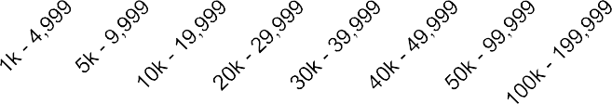

Source: Invest in Nottingham, Enquiries Data (2011-2015) Figure 4.2 Size of Warehouse Enquiries (sq ft)

8

7

6

Number of Enquiries

5

4

3

2

1

0

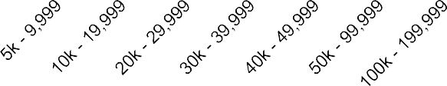

Source: Invest in Nottingham, Enquiries Data (2011-2015)

33 Statistics were not available showing the size Erewash’s commercial enquiries, so a like-for-like comparison between Erewash and the other authorities in the study area was not possible, but other statistics were obtained for comparison purposes.

###### Core HMA

* 1. Despite the recent shift towards the service sector, industry remains an important economic driver within the Core HMA. As such there remains strong demand for industrial premises within the HMA, although agents highlighted the ‘cascade effect’ in terms of demand for industrial premises that exists with increasing distance from the M1. Indeed, at the time of Nottingham City Region’s previous Employment Land Review (2007) the two boroughs furthest away from the M1 motorway (Rushcliffe and Gedling) had the lowest concentration of industrial space out of all the Authorities examined34.
  2. Particular favoured locations include the business parks along the M1, such as Pegasus Business Park and Phoenix Office Park.
  3. Away from the M1 motorway junctions the market is more subdued (especially so for distribution space), although some industrial estates do thrive. South west Gedling in particular has a strong cluster of businesses, including Colwick Industrial Estate/Victoria Park. This amounts to around 125 ha of B1, B2, B8 and non B class uses and includes good quality office accommodation at Colwick Quays. The Colwick area is close to Nottingham City with a reasonable and similar level of access to the A52 along Colwick Loop Road/Daleside Road and via the Lady Bay Bridge. Gedling has an important role in providing for sites and premises needs arising from the Nottingham area especially for relocating industrial/warehousing occupiers and specifically those looking for small freehold units.
  4. A number of storage and distribution occupiers are also present in Gedling Borough, including Parcel Force (at Victoria Business Park), Keuhne and Nagel, Park Logistics and RADS storage (on the Colwick Industrial Estate). The John Lewis Distribution Centre operates out of Arnold, as does the Royal Mail Delivery Sorting Office. In this context, it is noted that Gedling’s fairly modest industrial/warehousing needs are driven by B8 distribution uses.
  5. The Core HMA also includes an Enterprise Zone, located partly in Nottingham City (Medipark, Nottingham Science Park and part of the Alliance Boots site) and partly in Broxtowe Borough (Beeston Business Park and part of the Alliance Boots site), a map of which is presented in Figure 4.3. The Enterprise Zone looks set to bring forward significant industrial premises within the Core HMA, and has the target of creating around 10,000 jobs35 (within both office- based and industrial-based employment) within the LEP identified target sectors. Beeston Business Park, for instance, is providing a range of industrial units (as well as office spaces) from 100 to 900,000 sq ft focused around ICT and technology led-businesses, with businesses already located here including Siemens, SMS Technologies and ATOS.36

34 Roger Tym & Partners and Lambert Smith Hampton (2007) Nottingham City Region Employment Land Review, pg. 36

35 Broxtowe, Erewash, Gedling, Nottingham City & Rushcliffe Councils (2012) Employment Background Paper, pg. 9

36 Invest in Nottingham

Figure 4.3 Nottingham Enterprise Zone Map

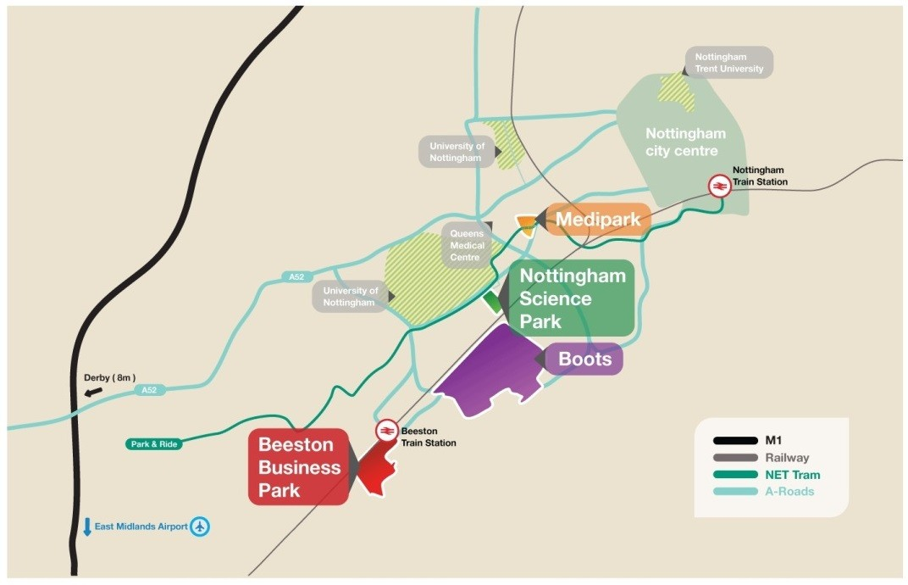

Source: Invest In Nottingham, 2014

###### Outer HMA

* 1. Industrial demand within the Outer HMA remains strong, particularly for units of 15,000 sq ft and under. However as with the Core HMA there exists weaker interest for industrial premises the further the site is away from strategic transport locations such as the M1 (Ashfield and Mansfield) or the A1 (Newark and Sherwood).
  2. Ashfield District has also successfully delivered Business Parks with Castlewood Business Park (beside the M1/A38 interchange), which now accommodates several high profile names such as Co-Operative Food (featuring a large logistics hub), UDG, Meridian, Bombardier and Midland Aerospace. At Junction 27 of the M1, Sherwood Business Park is also an important location for logistics including L’Oreal, who recently let a 159,000 sq ft distribution facility at the Park.
  3. Mansfield is not directly served by either the M1 or the A1, hence its industrial sector tends to be more indigenous, catering for the needs of local markets.
  4. Newark’s proximity to the A1 was cited as a key reason for the area’s strong demand for industrial premises, centred around the Newark Industrial Estate towards the north east of the town centre. The lack of speculative investment combined with strong demand means that there is a very low level of ‘churn’ in the market, with agents commenting that the low vacancy rate recorded for the District (4.3%) may in fact be an overestimate.
  5. Away from the main urban areas and transport corridors, demand for industrial and warehousing premises continues to be indigenous, and speculative development is often unviable without public funding assistance. As with the

Core HMA agents referred to the ‘cascade effect’ in terms of desirability for business premises. Whilst the A1 is a key transport location which runs adjacent to Newark, their clients do not see it as desirable as locations in close proximity to the M1.

#### Offices

* 1. Figure 4.4 shows the number of enquiries received by Invest in Nottingham (Nottinghamshire’s Inward Investment agency) for office space in the Nottinghamshire region (which includes all of the authorities in the Core and Outer HMA in addition to Bassetlaw and with the exception of Erewash). It provides quantitative evidence to support the commercial agent discussions. The majority of demand in both the Core and Outer HMA is for relatively small offices of 2,000 sq ft catering to SMEs, although there is also a substantial amount of demand for office space that is considerably larger than this, catering for inward investment by larger companies.

Figure 4.4 Size of Office Enquiries (sq ft)

35

30

25

Number of Enquiries

20

15

10

5

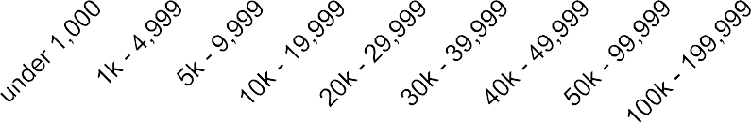0

Source: Invest in Nottingham, Enquiries Data (2011-2015)

###### Core HMA

* 1. Demand for office premises in the Core HMA is strong, although it faces the challenge of having very high office-to-residential conversions (especially within Nottingham City which in late 2014 was reported to have the second highest rate out of all the authorities in England, mostly being converted into student accommodation). Agents took the view that many of these offices were unlikely to have been let in any case as they did not meet modern business needs.
  2. The Core HMA is very large and diverse. As noted above, Nottingham City is often viewed as the capital of the East Midlands, accommodating the majority

of office floorspace in the HMA. It is also often where international firms locate when they are seeking a presence in the region.

* 1. There is a clear relationship between the quality of the office stock and its likely occupancy – grade A office space tends to be occupied very quickly whilst secondary office space is more likely to remain vacant. Moreover, the availability of high quality office space is limited. For instance, for both the city centre and out-of-town markets, only 133,000 sq ft of almost 2 million sqft of total office stock (as of 2014) is grade A office space, representing less than 7% of total stock.37
  2. Much of the substandard secondary office stock of previous years was either refurbished speculatively or has been lost to residential accommodation (a particular issue in Nottingham City). Whilst within Nottingham City there may be sufficient demand to make the refurbishment of poor quality office blocks profitable, the same cannot be said for all of the other boroughs in the Core HMA. This continued lack of suitable office accommodation (the development of which is often dampened by viability concerns) has led some agents to observe more small businesses working from home as opposed to occupying more formal, serviced office space.
  3. There exists a sizeable office market outside of the City Centre and Nottingham City more generally. Ng2 is around half a mile outside of the city centre and is occupied by a wide range of professional services firms such as Innes England, HSBC and Experian38. There are also a number of key business parks around strategic transport locations within the Core HMA boroughs that the M1 passes through. Interchange 25 beside Junction 25 (within Erewash), and Phoenix Office Park beside Junction 26 (within Broxtowe) are all business parks outside of Nottingham City which house significant office premises. Whilst agents also pointed to other concentrations of office spaces in centres such as Long Eaton (in Erewash), Beeston and Eastwood (both in Broxtowe), they noted that the premises in these areas tend to be of lower quality and occupied by smaller companies, many of whom are owner-occupiers.
  4. Agents stated that occupiers seeking offices in authorities which are further away from the strategic transport links, such as Rushcliffe or Gedling, tend to look for smaller, more competitively priced units, where the cachet of location is of less significance. These premises tend to be of lower quality and available on a freehold basis, although agents did not rule out an increase in demand that may result from a refurbishment of this stock.
  5. Whilst there is steady supply of ‘oven-ready’ employment sites (which are often strategically positioned, with the necessary infrastructure available to them), occupiers are still needed to ensure developers are willing to come forward and build out allocated sites.

37 Office Market Pulse East Midlands Q4 2014, Lambert Smith Hampton <http://www.lsh.co.uk/office-pulses/q4-2014/office-> market-pulse-east-midlands-q4-2014#sec3

38 <http://www.ng2.co.uk/occupiers.php?id=208>

* 1. It was noted by some agents that another factor which is restraining speculative development was the liability such developers will face if their development remains unoccupied for long periods once completed, with the continued existence of punitive empty property rates.
  2. Since April 2012, every workplace in Nottingham City with 11 or more car parking spaces has had to pay the Workplace Parking Levy. This charge, which also applies beyond the City Centre itself, will rise to £375 per parking place per year from April 2015. The levy, introduced to pay for public transport initiatives, such as the second line of the Nottingham Express Transit tram line to Chilwell via the City Centre and Beeston, has been cited by some agents as a potential barrier to business expansion, especially by small businesses (as opposed to larger businesses that have a greater ability to absorb the additional cost).

###### Outer HMA

* 1. In contrast to the Core HMA, demand for office premises in the Outer HMA remains weak, and highly localised in nature. Agents commented that micro- businesses are increasingly working from home rather than occupying more formal office space which often leans towards the poorer-quality end of the spectrum. Agents did, however, point to the success of flexible managed work spaces which cater for small businesses in the Outer HMA.
  2. Speculative development is held back by the low rents of around £5-10/sqft that offices in these districts can command. Agents predicted demand to remain low for the foreseeable future, other than for new, high quality office premises within the urban areas of Ashfield, Mansfield and Newark or with ready access to key transport links, such as to the M1 / A1 corridors. A barrier that prevents businesses from moving or expanding into Newark is the congestion that the town can experience.
  3. Agents cited anecdotal evidence that as many existing sites require some form of renovation, the general absence of suitable premises (when combined with barriers such as congestion and the increased flexibility that the internet has enabled), is resulting in an increasing number of small businesses in the HMA working from home instead of from an office.
  4. Whilst within Nottingham City there may be sufficient demand to make the refurbishment of poorer quality office blocks profitable, the same cannot be said for some of the other districts, particularly within the Outer HMA, where agents specifically commented on the low level of demand for office spaces. Low rental values are making refurbishment unprofitable, and offices are often lost for residential uses.
  5. Office schemes that been successful in the Outer HMA tend to feature managed work spaces which cater for small businesses. Other managed office schemes have formed part of mixed-use developments which aim to avoid an over-supply of employment accommodation by providing a mix of

retail, warehousing, office and residential uses.39 For instance, Sherwood Business Park in Ashfield was a mixed-use development housing offices amongst logistics firms, a hotel and other leisure businesses across 25ha of land. Formed in 1988, it was one of the areas granted Enterprise Zone status, and initially was very successful, with a number of large firms locating there (on a site just a mile away from J27 of the M1) to take advantage of the lower business rates.

* 1. However, once Enterprise Zone status ended it became harder to retain office occupiers due to accessibility issues (there was little public transport to and from the site) and a difficulty in recruitment (agents cited a mismatch between the skills employers needed and the skills of the local labour force in Mansfield and Ashfield). Instead, agents stated that industrial firms have performed better in this Business Park, which accommodates a workforce of around 6,000 people within firms such as E.ON, Pendragon, Boots, Tsubakimoto, Eddie Stobart, L’Oreal, Prolog and Rolls Royce40.
  2. Other office locations within edge-of-town locations, such as Ransomwood Business Park located to the south east of Mansfield, tend to be occupied by firms which cater to indigenous demand.

## Future Growth Potential

* 1. Figure 4.5 shows the proportion of enquiries received by Invest in Nottingham (Nottinghamshire’s Inward Investment agency) by use class in the Nottinghamshire region. This demonstrates that demand for office and industrial space dominates, with a much lower level of demand for warehousing space across the sub-region.

Figure 4.5 Proportion of Enquiries by Use-Class

Office (B1a): 44%

Industrial (B1c/B2): 37%

Warehouse (B8): 19%

Source: Invest in Nottingham, Enquiries Data (2011-2015)

* 1. Both HMA’s have large SME markets, and serviced office centres have been demonstrated to be very attractive to small and emerging companies (agents highlighting this as one area of particularly strong growth, relative to the

39 Roger Tym & Partners and Lambert Smith Hampton (2007) Nottingham City Region Employment Land Review, pg. 36

40 <http://www.ashfield-dc.gov.uk/about-ashfield/the-district-in-context.aspx>

general unsuitability/high vacancy of much of the office stock in the study area). These non-traditional/flexible work spaces are a relatively new provision within the market, starting to appear following the recession. They often offer a ‘fixed budget price’ (‘per month’ all-in-one price as opposed to a price per sqm) for some units, which appeals to small businesses due to the lower liability of having a rolling contract (as opposed to having to sign a standard 10-or-15- year lease). This type of accommodation has proven very successful, with agents pointing to higher occupancy rates (relative to traditional office accommodation) among these serviced office centres.

* 1. Whilst large-scale speculative investment has yet to return to the market, serviced offices have become increasingly popular, especially with SMEs (which comprise the majority of businesses within both HMAs). When these types of office provisions are combined with suitable ‘follow on spaces’ the right environment is provided for service and knowledge-based industries to grow. The flexibility that these types of offices offer becomes less important when a company employs more than around 20 employees; however as the study area has a very high concentration of SME businesses the development of these offices looks to be conducive to growth.
  2. Growth of SMEs could be complemented by D2N2’s ‘Growth Hub’, which will act a single point of contact for new and existing businesses (providing assistance with regard to business services, funding options etc) in a similar vein to the former East Midlands Regional Development Agency’s ‘Business Link’.
  3. Because of the lack of suitable supply of medium-sized industrial units (between 5,000 – 50,000 sq ft) within both HMAs many SMEs (alongside enterprises originated through the university) wishing to expand premises are being ‘lost’ to nearby locations such as Leicester and Derby.
  4. In terms of distribution sites, agents were optimistic with regards to future demand for sites in strategic locations. As distribution sites are highly dependent on close access to strategic transport networks, it would appear logical to concentrate future supply in areas where demand has been highest – beside or near to junctions on the M1, although agents did cite the A50 and the A38 as providing possible sites once locations beside the M1 become scarcer.
  5. Agents considered that Rushcliffe in particular had strong prospects for growth, on the grounds that the area has a large population base / future growth prospects and had enhanced its transport links (notably the A46, which connects to the area to the A1 through Newark and onwards to Lincoln). Agents were therefore of the view that there could be a steady increase in demand in this area over time (a point supported by the Experian econometric projections, which forecast a 22% increase in employment over the period to 2033 in the Borough).
  6. In terms of particular sectors driving growth, agents and economic development officers broadly agreed that the D2N2 priority sectors are those which will dominate future growth within both HMAs, although which sectors

within this category will obviously be unique to each Authority as each has its own specialisms. For instance, Newark’s rural nature makes it particularly appropriate for agriculture and hence food and drink manufacturing, a sector which will is likely to grow into the future.

* 1. Nottinghamshire County Council has invested £17m to ensure that by the end of 2015, at least 90% of Nottinghamshire’s premises can access superfast broadband services.41 Research has demonstrated a clear economic case for investment in superfast broadband, as a way to improve digital connectivity and hence promote economic growth.42 This is of particular relevance to areas where the private sector would consider the roll-out of such a service to be financially unviable (particularly remote, rural areas). This has been complemented by the County Council delivering a ‘demand stimulation programme’ consisting of free training and awareness raising sessions designed to improve business readiness to increase their use of online technologies and encourage innovation in using higher broadband speeds.43

###### High Speed 2

* 1. High Speed 2 (HS2) is a new high-speed railway which is planned to be built in two phases – the first from London to Birmingham and the second from Birmingham to Manchester and Leeds. The Leeds line extension is envisaged to stop at a hub station within the East Midlands to serve the cities of Nottingham, Derby and Leicester. The exact location of the East Midlands hub station has not yet been determined, although research has been undertaken to estimate the benefits of the station being located in several different potential locations.
  2. A ‘Station Location Analysis’ prepared by Volterra considers Toton in Broxtowe, Breaston in Erewash and East Midlands Parkway in Rushcliffe. The stated purpose of the hub station is to:

*“create an economic focal point, attracting and developing investment and job creation, as well as supporting further investment in the cities it serves”44*

* 1. In terms of the impact of direct investment (i.e. in the immediate area surrounding the station), the Volterra report concludes:

*“Toton currently offers the greatest certainty in being able to deliver direct development, both jobs and homes within the vicinity of the station”45*

* 1. This conclusion reflects the comparative lack of constraints to development at Toton, but also that plans have already been progressed for direct development if the station becomes a reality. Provision is also made in the Aligned Core Strategy to support development in this location if the HS2 hub is developed.

41 Nottinghamshire County Council (2012) Nottinghamshire Growth Plan, pg. 9

42 Costs and Benefits of Superfast Broadband in the UK (2012) Paolo Dini, Claire Milne and Robert Milne, pg. 18

43 Nottinghamshire County Council (2012) Nottinghamshire Growth Plan, pg. 15

44 Volterra Partners (2015) Options for the East Midlands on HS2: Toton, Breaston & East Midlands Parkway, paragraph 7.4

45 Ibid.

* 1. Whilst Toton is not currently a strong location for employment land, the potential HS2 station in the area could facilitate a step-change in the market, opening up the area to businesses seeking to benefit from the improved accessibility and reduced journey times. Volterra analysis estimates potential for between 680 and 875 new homes, and between 2,800 and 19,800 sq.m of commercial office floorspace. This could support up to 1,500 new jobs once operational.46 However, drawing on empirical evidence from elsewhere in the UK and internationally, Volterra concludes:

*“Commercial development is unlikely in the near term within the vicinity of the HS2 station at Toton. The absence of a market in the area, combined with the uncertainty surrounding a HS2 station in 20 years, means that there will be huge doubts over the viability of office type developments around the station in the near or medium terms.”*

* 1. An outline planning application on land at Toton which includes 3,000 sqm B1(a) office space is currently pending consideration by Broxtowe Borough Council.47 Application supporting information refers to potential phasing of the office space delivery mainly in 2019/2020 after residential and other commercial phases, but anticipates:

*“It is envisaged that demand for offices in this location will be low in the early phases. In reality they are likely to be in demand as work on the HS2 line and hub accelerates.”*

* 1. This is not to understate the future potential for employment development to be attracted to a future hub at Toton, but reflects that it takes time for commercial markets to become established and delivery might expect to be phased after the residential components have commenced. This is consistent with the experience at other high speed rail stations including Stratford and Ebbsfleet (both on High Speed 1 route between London and continental Europe) where commercial elements have been delayed or their phasing has been put back.
  2. There is very limited empirical evidence available to demonstrate the particular benefits to specific sectors of access to high speed rail services. However, it is likely to be the higher-value sectors (such as financial and professional services, company HQs etc) that will place greater weight on this type of service for rapid access to other geographical markets when compared to existing rail services. The increased connectivity and journey time savings may also open up the possibility of firms relocating to Toton, particularly if there is a cost advantage over other locations. For most businesses, general proximity to the HS2 hub may be sufficient rather than necessarily requiring a site immediately adjacent to the station. However, a high profile new development associated with the HS2 hub may serve to create a new urban district with a critical mass and mix of uses and facilities that could be attractive for some types of firms moving into the area.

46 Volterra Partners (2013) Maximising the Economic Benefits of the East Midlands HS2 Station at Toton, pg. 45. Volterra job estimates based on applying standard employment densities to range of proposed office floorspace on two sites adjacent to Toton.

47 Reference 12/00585/OUT

###### Funding Schemes

* 1. Demand for new development is being supressed due in part to a lack of willingness of banks to lend, and the general unavailability of credit for businesses. Nottinghamshire County Council is attempting to rectify this by using various funding schemes open to businesses within the D2N2 LEP’s ‘priority sectors’:
  2. For example, the Nottingham Technology Grant Fund (NTech) offers grants of between £25k and £1m to health and life sciences, digital content and cleantech businesses across the County.
  3. Likewise, the Nottinghamshire Investment Fund will provide investments of between £100k and £1m and in exceptional circumstances up to £5m, to fund early stage ‘Investment-ready’ growth enterprises within the County. The County Growth Plan also details a ‘peer-to-peer fund’ from Nottinghamshire County Council that aims to provide “increased opportunities for businesses to get the backing they need to fund growth”48
  4. The D2N2 LEP has established sector working groups to develop sector skills plans for each of their priority sectors. These will drive future investment in skills and employment through European Social Funds to be allocated to the LEP. Meanwhile Nottinghamshire County Council proposes to work closely with D2N2’s sector working groups on investment priorities by giving companies in their priority sectors preferences through:
     + The Nottinghamshire Economic Development Capital Fund;
     + Start-up activities delivered by Nottinghamshire Business Venture;
     + The apprenticeship programme delivered on behalf of Nottinghamshire Business Investment Zone project.49
  5. The ‘Think BIG’ fund is a £2 million funding scheme created by Newark & Sherwood District Council to encourage business growth within the district and create new jobs. The loan fund ranges from £25,000 to £150,000 for businesses with a turnover of less than £150,000 or with fewer than 5 employees. It is part of a wider plan to stimulate economic growth in all business sectors but particularly those where there are existing strengths and future potential, including engineering, information & communications technologies, logistics, food processing and low carbon technologies.

## Conclusions

* 1. There is a gap between the strong demand for high quality Grade A office premises in Nottingham City Centre and the lack of supply for these spaces. A continued lack of speculative investment means that much of the available office stock (some of which does not meet modern business requirements) is

48 Nottinghamshire County Council (2012) Nottinghamshire Growth Plan, pg. 13

49 Nottinghamshire County Council (2014) Report to Economic Development Committee ‘Sector Working - Outlining our Approach’

unlikely to be renovated or redeveloped, leading to large amounts of vacant stock which is being lost to residential uses.

* 1. A comparable office market has not developed to the same extent in the Outer HMA as it has within the Core HMA. The market tends to be more indigenous in nature, serving the needs of local residents and businesses.
  2. A strong industrial market is present within the Core HMA, benefiting from substantial industrial estates and business parks located alongside the strategic transport network which passes through the HMA. The desirability of a business location generally decreases with increasing distance from strategic transport links, particularly for distribution units. The area lacks a strong supply of units for industrial SMEs to expand into, which has contributed to a number moving to nearby cities such as Derby or Leicester which can better meet their needs. However, the Enterprise Zone within Nottingham and Broxtowe looks set to unlock a significant amount of industrial space going forward.
  3. The industrial market in the Outer HMA also remains strong, benefiting from strategic transport links with the M1 passing through Ashfield and the A1 passing through Newark-on-Trent. Ongoing constraints amongst the major banks to provide sufficient finance, along with viability concerns restraining speculative investment, ensures that supply remains supressed and is unable to meet latent demand, particularly from SMEs seeking sites of between 5-50k sq ft to expand.
  4. As regards future growth, agents remain optimistic regarding future demand for industrial units, given the relatively strong demand for such units. With regard to attitudes towards the office market, this is highly variable and locationally- specific. Agents remained optimistic regarding the future demand for Grade A office units in Nottingham City Centre and areas close to strategic transport locations, and are more pessimistic with regard to demand for offices in the Outer HMA and peripheral locations away from strategic transport locations. The proposed HS2 hub at Toton provides longer-term potential to establish a new office market in this location, but it is recognised that it will take time to establish and probably only when HS2 becomes operational. The implication is that the scale of any potential uplift in demand for employment space could be limited in the planning period to 2033 (on the basis that Phase 2 is currently expected to begin operating trains around 2033).
  5. Regarding locations for industrial sites, it would appear logical to concentrate future supply in and around key transport corridors where the strongest levels of demand exist, benefiting from their strategic locations near to the key M1/A1 transport corridor whilst minimising any potential congestion for businesses for which transportation or logistics would be an issue. It should of course be noted that the M1 Corridor is also in the Green Belt around Nottingham City, with the western side between Nottingham and Derby comprising a particularly sensitive area.

# 5.0 Future B Class Employment Space Requirements

* 1. This section considers future employment space requirements in the Nottingham Core and Outer HMAs for the period 2011-2033 by drawing on several methodologies that are guided by the national Planning Practice Guidance (PPG). These scenarios are used to inform the assessment of future employment space needs for office and industrial (i.e. manufacturing and distribution) uses. As requested by the client team, the final requirements are specified in floorspace (sq.m) for B1a/b office, and land (in hectares) for B1c/B2/B8 uses in order to align with the local authorities’ employment land policies in their respective adopted/emerging Local Plans.
  2. Where information has been available, data relating to ‘B1c/B2 industrial’ and ‘B8 warehousing’ is provided separately. However, where distinguishable information was not available, the term ‘industrial’ is used to encompass both B1c/B2 and B8 use-classes.

## Methodology

* 1. The National Planning Policy Framework (the Framework) requires local authorities to: “*set out a clear economic vision and strategy for their area which positively and proactively encourages sustainable economic growth*” [§21]. Considering this in evidence base terms, this should be underpinned by a “*clear understanding of business needs within the economic markets operating in and across their area*” [§160].
  2. Within this context a number of future scenarios have been developed in this study to provide a framework for considering future economic growth needs and B class employment space requirements within the two HMAs between 2011 and 2033.
  3. In line with the Practice Guidance, these future scenarios draw upon:
     1. Projections of employment growth in the main B class sectors (**labour demand**) derived from the latest available economic forecasts prepared by Experian;
     2. Estimating future growth of **local labour supply** based on the housing requirement contained in each of the Core HMA authorities’ adopted Local Plans and each of the Outer HMA authorities’ emerging SHMA, and the amount of jobs and employment space that this could support, based on NLP PopGroup demographic model runs; and,
     3. Consideration of **past trends in completions of employment space** based on monitoring data supplied by the eight Councils, and how these might change in future. Due to concerns regarding the accuracy/consistency of much of the past take up data provided by the Councils (as noted in section 3.0), past trends in completions have been

used as a sensitivity test to the detailed labour demand/supply forecasting work.

* 1. Accordingly, this has framed the consideration of three scenarios and a sensitivity test to help understand the implications of different assumptions on future demand outlined in Figure 5.1.

Figure 5.1 Range of Growth Scenarios/Approaches

**Job growth (Experian baseline)**



**1**

**2 Job growth (LEP Policy On)**



**Forecasts of job demand by sector**

**Labour Supply Housing Requirements**



**3**



**4**

**Growth of workplace population, assuming current commuting rates continue**



**Past completions continue**

**(Sensitivity Test)**

**Net annual completions of industrial**

**& office space**

* 1. All of these approaches have some limitations and careful thought needs to be given as to how appropriate each is to circumstances within individual local authorities and HMAs (notwithstanding that these are defined in terms of housing market factors as opposed to functional economic and business factors). It should be noted that the assessment is not purely quantitative, and there will also be qualitative factors to consider when identifying future employment space needs.
  2. For each scenario, outputs are presented for each local authority with totals for each HMA as well as the study area overall.

## Forecasts of Job Growth

* 1. Forecasts of job growth for the five Core and three Outer HMA districts for the period up to 2031 were obtained from Experian’s December 2014 quarterly release. The total job growth figures were taken forward on a pro-rata basis from 2031 to 2033 to align with the requirements of the brief. Unless otherwise stated, the term ‘jobs’ refers to total ‘workforce jobs’ and includes part time and full time employment.
  2. It is important to acknowledge that there will be an element of landless growth here, whereby job growth/decline will not automatically give rise to an immediate increase/decrease in floorspace, or land, requirements. This is due in part to the current spare capacity across many firms in this part of the East Midlands, whereby companies that have laid off staff in the immediate aftermath of the recession, have been operating out of the same building and hence can accommodate a return to past staffing levels without having to physically expand their operations. Such latent capacity will have a bearing on the extent to which the Local Authorities may wish to tailor their B1/B2/B8 allocations going forward, and should be monitored over time.

#### Scenario 1) Experian Baseline

* 1. The forecasts of job growth by sector used here reflect recent trends at a regional level. Growth in the 38 industrial sectors reflects how each district has performed relative to the East Midlands region’s growth in the past. These forecasts also reflect the current post-recession economic climate, and the uncertainty surrounding future macro-economic prospects generally. It should be noted that policy interventions have been on-going for a number of years in both HMAs, and therefore the Experian base forecast does not entirely represent a ‘policy-off’ situation. Experian’s Data Guide to its UK Regional Planning Service Model, setting out how the forecasts have been prepared, is included in Appendix 7.
  2. The overall Experian baseline employment change across the Core HMA resulting from these forecasts amounts to 69,285 jobs between 2011 and 2033, the vast majority of which relate to Nottingham City. A further 21,891 net jobs are forecast for the Outer HMA. The split of job growth relating to each of the 38 Experian SIC sectors over the period 2011-2033 is shown in Table 5.1.

Table 5.1 Total Workforce Job Growth, 2011-2033

|  |  |  |  |  |  |  |  |  |
| --- | --- | --- | --- | --- | --- | --- | --- | --- |
| **Experian Sector** | **Broxtowe** | **Erewash** | **Gedling** | **Nottingham** | **Rushcliffe** | **Ashfield** | **Mansfield** | **Newark & Sherwood** |
| Agriculture, Forestry & Fishing | 273 | -167 | 969 | -54 | 133 | -191 | 213 | -355 |
| Extraction & Mining | -10 | -2 | -34 | 1 | 32 | 7 | -4 | -155 |
| Food, Drink & Tobacco | 271 | -6 | 36 | -1,274 | 114 | -67 | -7 | 922 |
| Textiles & Clothing  Wood & Paper | -54 | -418 | -202 | -439 | -37 | -471 | -103 | -14 |
| 141 | -15 | -23 | -314 | 6 | -110 | 3 | 103 |
| Printing and Recorded Media | -14 | -122 | -69 | -766 | 3 | -485 | -117 | 2 |
| Fuel Refining | 0 | 0 | 1 | -31 | 1 | 0 | -9 | -6 |
| Chemicals | 140 | -68 | 4 | -81 | 6 | -116 | 2 | -6 |
| Pharmaceuticals | 872 | 80 | 0 | -14 | 2 | 45 | 1 | 1 |
| Non-Metallic Products | 58 | -106 | 44 | -250 | 374 | -517 | 84 | 116 |
| Metal Products | 285 | 197 | 240 | -553 | 141 | -603 | 133 | 634 |
| Computer & Electronic Products | -117 | -59 | -184 | -781 | -85 | -42 | 116 | 6 |
| Machinery & Equipment  Transport Equipment | -201 | -294 | -95 | -296 | -63 | -62 | -26 | -212 |
| -151 | -605 | -95 | -103 | -31 | -551 | 30 | -25 |
| Other Manufacturing | -22 | -118 | 86 | -884 | 100 | -333 | 34 | 91 |
| Utilities | 172 | 355 | 101 | -1,239 | -374 | 317 | -227 | 32 |
| Construction of Buildings | 794 | 25 | 397 | 1,566 | 342 | 679 | 1,170 | 293 |
| Civil Engineering | 231 | 37 | 55 | 1,243 | 54 | 1,635 | 180 | 127 |
| Specialised Construction | 758 | -37 | 360 | 2,050 | 403 | 1,267 | 1,573 | 386 |
| Activities |
| Wholesale | 836 | 588 | 794 | 316 | 671 | 2,044 | 611 | -301 |
| Retail | -496 | 304 | -613 | 1,062 | 432 | 220 | -953 | -818 |
| Land Transport, Storage & Post | -563 | -1,117 | 360 | -1,148 | 760 | -633 | -521 | 341 |
| Air & Water Transport | 1 | -8 | 0 | -4 | 18 | 0 | 0 | 0 |
| Accommodation & Food Services | 361 | 702 | 370 | 2,767 | 1,278 | 197 | 706 | 980 |
| Recreation | -193 | -96 | -156 | -86 | 76 | -88 | 7 | -311 |
| Media Activities | 18 | 33 | -81 | -56 | 99 | 28 | 106 | 32 |

|  |  |  |  |  |  |  |  |  |
| --- | --- | --- | --- | --- | --- | --- | --- | --- |
| **Experian Sector** | **Broxtowe** | **Erewash** | **Gedling** | **Nottingham** | **Rushcliffe** | **Ashfield** | **Mansfield** | **Newark & Sherwood** |
| Telecoms | -98 | 1 | -56 | -659 | 11 | 37 | -41 | 246 |
| Computing & Information Services | -246 | 21 | -227 | -1,392 | 822 | 834 | -53 | 161 |
| Finance  Insurance & Pensions | 229 | 172 | -70 | 701 | 1,052 | -296 | -190 | -109 |
| 13 | -7 | 0 | 160 | 3 | -2 | -8 | -1 |
| Real Estate | 131 | -84 | 185 | 1,240 | 216 | 122 | 36 | 144 |
| Professional Services | 2182 | 576 | 1,010 | 11,594 | 4,681 | 1,612 | 922 | 2,658 |
| Administrative & Supportive Services | 1783 | -751 | -719 | 24,197 | -459 | 354 | -862 | -502 |
| Other Private Services | -350 | -334 | -424 | 3,143 | 39 | 459 | -108 | 818 |
| Public Administration & Defence | -292 | -278 | -1,794 | -4,760 | -2,015 | 439 | -402 | 384 |
| Education | 99 | 1,725 | 276 | 3,523 | 550 | 377 | 1,439 | 268 |
| Health | 136 | 953 | 428 | 6,877 | 336 | 2,358 | 644 | 480 |
| Residential Care & Social Work | 197 | 1,931 | 433 | 2,706 | 145 | 1,250 | 437 | 955 |
| **TOTAL** | **7,174** | **3,008** | **1,307** | **47,961** | **9,834** | **9,713** | **4,816** | **7,362** |

Source: Experian

* 1. It should be noted, however, that the Experian data series for Nottingham City identifies a methodological anomaly within the ‘dispensing chemists’ and ‘labour recruitment’ sectors that significantly impact the number of jobs recorded in these sectors of the City’s economy and the variability of their size and growth rates over time (Figure 5.2). This reflects the presence of some large employers within these industries within which jobs are allocated to only one primary industrial sector, or jobs are allocated to head offices located within the City but in reality a large proportion of these employees are actually based elsewhere. For this reason, the time series data for these two sectors has been modified by NLP to re-allocate some of these jobs to other sectors and/or to only include those jobs which are actually based within the City based on cross-referencing to other datasets including IDBR.

Figure 5.2 Trends in Selected Industrial Sectors in Nottingham City, 1998-2013

40,000

35,000

30,000

25,000

20,000

Workforce Jobs

15,000

10,000

5,000

0

1998 1999 2000 2001 2002 2003 2004 2005 2006 2007 2008 2009 2010 2011 2012 2013

5231 : Dispensing chemists 7450 : Labour recruitment and provision of personnel

Source: ABI/BRES/NLP analysis

* 1. The Nottingham City baseline figures have subsequently been adjusted downwards to exclude various anomalies and errors in the underlying BRES data. This reduces the Core HMA net job growth down from 69,285, to 41,238 (with Nottingham City’s job growth declining from +47,961 to 19,914). For the Outer HMA, the equivalent job growth is 21,891 but is not subject to any adjustments.
  2. The adjusted forecasts are broken down as follows across the eight districts (Table 5.2).

Table 5.2 Total Workforce Jobs, 2011-2033

|  |  |  |  |  |  |  |  |  |
| --- | --- | --- | --- | --- | --- | --- | --- | --- |
|  | **2011** | **2016** | **2021** | **2026** | **2028** | **2031** | **2033** | **Change 2011-33** |
| Broxtowe | 43,000 | 44,918 | 46,531 | 48,071 | 48,647 | 49,522 | 50,174 | **+7,174** |
| Erewash | 42,116 | 42,964 | 43,309 | 44,029 | 44,328 | 44,851 | 45,125 | **+3,008** |
| Gedling | 35,775 | 35,451 | 35,746 | 36,286 | 36,571 | 36,963 | 37,082 | **+1,307** |
| **Nottingham** | 219,706 | 227,580 | 238,452 | 250,864 | 255,701 | 263,307 | 267,667 | **+47,961** |
| **Nottingham (Adjusted)** | 196,200 | 196,751 | 201,185 | 207,774 | 210,286 | 214,304 | 216,114 | **+19,914** |
| Rushcliffe | 45,202 | 46,645 | 48,974 | 51,564 | 52,571 | 54,142 | 55,036 | **+9,834** |
| **CORE HMA TOTAL** | **362,293** | **366,729** | **375,745** | **387,724** | **392,403** | **399,782** | **403,531** | **+41,238** |
| Ashfield | 53,727 | 56,768 | 58,326 | 60,425 | 61,182 | 62,557 | 63,440 | **+9,713** |
| Mansfield | 43,547 | 43,734 | 44,930 | 46,412 | 46,986 | 47,925 | 48,363 | **+4,816** |
| Newark & Sherwood | 51,464 | 53,657 | 55,211 | 56,905 | 57,347 | 58,157 | 58,826 | **+7,362** |
| **OUTER HMA TOTAL** | **148,738** | **154,159** | **158,467** | **163,742** | **165,515** | **168,639** | **170,629** | **+21,891** |

Source: Experian

* 1. Table 5.3 summarises the job growth over the study period 2011-2033 for each of the eight districts, with the job growth separated out by use classes. This includes an allowance for jobs in other non B class sectors that typically utilise industrial or office space, such as some construction uses, vehicle repair, courier services, road transport and cargo handling and some public administration activities (see Appendix 6 for a definition of which B-Class sector each SIC industry used in the Experian forecasts is classed within).

Table 5.3 Forecast Employment Change in the Nottingham Core/Outer HMA districts 2011-2033 – Experian Baseline Total Workforce Jobs

|  |  |  |  |  |  |  |
| --- | --- | --- | --- | --- | --- | --- |
|  | **Offices**  **(B1a/b)\*** | **Manufacturing**  **(B1c/B2)\*\*** | **Distribution**  **(B8)\*\*\*** | **Total B-class**  **Jobs** | **Other Non B-**  **Class Jobs** | **Jobs in All**  **Sectors** |
| Broxtowe | 2,669 | 1,818 | 120 | **4,607** | 2,567 | **7,174** |
| Erewash | 458 | -1,175 | -526 | **-1,243** | 4,252 | **3,009** |
| Gedling | 536 | 152 | 791 | **1,479** | -172 | **1,307** |
| Nottingham | 10,668 | -5,187 | -374 | **5,107** | 14,806 | **19,914** |

|  |  |  |  |  |  |  |
| --- | --- | --- | --- | --- | --- | --- |
|  | **Offices**  **(B1a/b)\*** | **Manufacturing**  **(B1c/B2)\*\*** | **Distribution**  **(B8)\*\*\*** | **Total B-class**  **Jobs** | **Other Non B-**  **Class Jobs** | **Jobs in All**  **Sectors** |
| Rushcliffe | 6,586 | 685 | 1,174 | **8,445** | 1,388 | **9,834** |
| **CORE HMA** | **20,917** | **-3,707** | **1,185** | **18,397** | **22,841** | **41,238** |
| Ashfield | 2,475 | -2,179 | 795 | **1,091** | 8,623 | **9,714** |
| *…of which located in*  *Hucknall* | *405* | *-356* | *130* | ***178*** | *1,410* | ***1,589*** |
| Mansfield | 674 | 1,042 | 25 | **1,741** | 3,075 | **4,816** |
| Newark & Sherwood | 3,054 | 1,744 | 135 | **4,933** | 2,430 | **7,363** |
| **OUTER HMA** | **6,203** | **607** | **955** | **7,765** | **14,128** | **21,893** |
| Source: Experian 2014/NLP analysis  * includes a proportion of public sector employment and administration & support  **includes vehicle repair and some construction activities  *** includes elements of transport & communications sectors  ±Adjusted for sector and employee location coding anomalies | | | | | services |  |

Note: Hucknall figure has been derived on a proportionate basis as c.16% of total BRES 2013 employment in Ashfield is based in the four wards of Hucknall.

* 1. Using Experian’s baseline forecasts (which are based to an extent on past trends and current representation across the industrial classifications relative to the national and regional averages), Table 5.3 indicates significant gains in B- class jobs for the Core HMA as a whole, equal to 18,397 between 2011 and 2033, although this level of growth is outstripped by growth in the Non-B-uses (Health, Education and Other Private Services in Nottingham). There is very strong growth in office-based activities and minor gains in distribution jobs offset by a moderate decline in manufacturing employment.
  2. Even with the overall level of jobs adjusted downwards to take into account significant coding errors, Nottingham City is still driving job growth in the Core HMA, with almost 10,670 jobs in office-based sectors alone; however this is countered by significant job losses in industrial (B1c/B2) sectors equal to 5,187 job losses over the 22-year plan period. B-class job growth is particularly strong in Rushcliffe (+8,446 B-class jobs) and to a lesser extent Broxtowe (+4,607). Erewash is the only borough in the Core HMA to have a negative job growth in the B-class uses, although this is counter-acted by strong growth in Non-B class use jobs.
  3. The overall level of job growth forecast in the Outer HMA is around two thirds that of the Core HMA, at 21,893, with Ashfield having the largest share (at 9,714). This is almost entirely driven by non-B class job growth however, with Ashfield projected to lose around 2,180 manufacturing jobs and having just 1,090 B-class job growth over the 22-year plan period. In contrast, Newark & Sherwood, which is forecast to have a lower level of overall growth than Ashfield, is paradoxically expected to see more than four-times the level of growth in B-class jobs, particularly office and even manufacturing. Mansfield is also expected to see strong growth in manufacturing, and largely neutral growth in office and warehousing space to 2033.
  4. In terms of what this might mean for the town of Hucknall in Ashfield, the Experian data does not provide growth projections below District level. NLP has therefore analysed the relative split between jobs in the four 2011 wards that broadly delimit Hucknall (namely Hucknall Central, Hucknall East, Hucknall North and Hucknall West) and the total workforce jobs across the District as a whole. According to the latest BRES data (2013), out of 49,601 jobs based in Ashfield District as a whole, employment totals 8,112 in Hucknall (i.e. 16.4% of the Ashfield total). This proportion has been applied to the overall job growth for Ashfield to derive an indicative growth figure for Hucknall.

###### Translate to Floorspace Requirements

* 1. In order to translate the resulting figures into employment land projections, employment densities and plot ratios by use class were then applied to the workforce job change figures to translate these into employment land projections.
  2. These job forecasts can then be converted to future employment space requirements assuming typical ratios of jobs to floorspace for the different B uses50. To estimate floorspace needs, the following average ratios have been applied:

1. One B1a/b general office workforce job requires 12.5 sq. m. of employment floorspace [Gross External Area, or GEA];51
2. One B1c light industrial job requires 47 sq. m. of employment floorspace [GEA];
3. One B2 industrial workforce job requires 36 sq. m. of employment floorspace [GEA];
4. A combined B1c/B2 factor of one job per 42 sq. m. was obtained by taking an average of the aforementioned B1c/B2 GEA equivalents;
5. Warehousing: 1 job per 65 sqm is assumed for general, smaller scale warehousing52 and 1 job per 74 sqm for large scale, lower density units. A 50:50 split has been assumed.
   1. These assumptions are based on the latest HCA/Offpat guidance on employment densities published in 2010, adjusted to translate FTEs into workforce jobs.53 This guidance takes account of recent trends in terms of the changing use of employment space, the main change being the more efficient utilisation of office space due to increased flexible working and hot desking. This has resulted in a decrease in the amount of floorspace per office worker that is assumed compared to earlier guidance.

50 These job density factors are based on the 2010 Employment Densities Guide proposed by the HCA and Offpat (2010). However, that guide only provided employment densities in terms of FTE jobs and for a range of different measures of floorspace. To convert FTE jobs to total jobs, the ratios of Full time and Part time jobs for the relevant sector nationally in the 2009 BRES were used, with 1 Part time job taken as equivalent to 0.5 of a Full time job.

51 The HCA Guidance provides job-to-floorspace ratios in NIA; this has been translated into GEA by NLP (as GEA provides a better fit for planning purposes) with an uplift of 15% for offices and 5% for industrial and warehouse premises to translate NIA to Gross Internal Area [GIA]. GIA was then converted to GEA by adding a further 2.5% to reflect the area of external walls etc. 52 Given that the majority of B8 warehousing has been low bay warehousing in recent years, the ‘small’ warehousing jobs ratio of 1 FTE job per 70 sqm has been used from the HCA guidance

53 Based on HCA/Offpat Employment Densities Guide, 2010

* 1. An adjustment has been made to reflect the fact that vacancy rates in Nottingham are currently around 20% for commercial floorspace and around 3% for industrial/warehousing floorspace.54 Equivalent figures for the other districts are as follows:
* Broxtowe: 17% B1a/b / 10% B1c/B2/B8;
* Erewash: 4% B1a/b / 2% B1c/B2/B8;
* Gedling: 13% B1a/b / 17% B1c/B2/B8;
* Rushcliffe: 9% B1a/b / 2% B1c/B2/B8;
* Ashfield: 21%55 B1a/b / 1% B1c/B2/B8;
* Mansfield: 9% B1a/b / 3% B1c/B2/B8; and,
* Newark & Sherwood: 12% B1a/b / 4% B1c/B2/B8.
  1. On the basis that a figure of 10% better reflects ‘normal’ market conditions, the model has assumed that where current rates are higher (or lower), the future supply should be adjusted so that the stock is brought back into balance and to achieve a vacancy rate of 10% overall. So in areas with a relatively low vacancy rate for both office and industrial units (i.e. Rushcliffe and Mansfield), the model ensures that slightly more land is provided to ‘boost’ vacancy rates to the required level, whilst for areas with high vacancy rates (such as Nottingham City’s office sector) the opposite process occurs.
  2. Where a reduction in jobs is forecast, the associated negative floorspace was halved (in line with common methodological practice amongst ELRs undertaken elsewhere across the country), to reflect the fact that job decline at a particular company does not automatically translate into a comparable loss of floorspace, at least not in the short-medium term, due in part to companies being locked into leasing agreements etc. No further adjustment was made for vacancy in such instances.
  3. The resultant floorspace estimates are provided in Table 5.4. They indicate a net floorspace requirement for B1a/b, B1c/B2 and B8 uses in the Core HMA of just under 340,000 sqm. This is primarily driven by growth in Rushcliffe and Broxtowe over the 22-year assessment period. A worked example of how the net employment floorspace figures are derived is presented in Appendix 8.
  4. It should be noted that these figures are justified on the basis of Experian’s assumptions concerning which industrial sectors are likely to see the most pronounced growth/decline over the plan period. Experian has not made a judgement as to whether this level of growth is sustainable in the sense that office space might be more suitably located in town and city centres; rather its forecasts have been based primarily on how each local economy has performed in recent years; how well various sectors are doing and how they

54 On the basis of an assessment of commercial property websites in January 2015, set against the Business Floorspace (Experimental Statistics) published in 2012 by the VOA. The realism of these figures has been tested with local agents, who broadly agreed with the figures for office and industrial uses.

55Although it should be noted that the figure for B1a/b office vacancies is skewed by the high level of vacancies at Sherwood Business Park. Were these to be excluded, then the B1a/b vacancy rate would fall to around 3%.

might be expected to perform in future relative to national and regional sectoral trends.

* 1. Whilst the need for office floorspace totals almost 80,000 sqm in Nottingham, this is counter-acted by a decline in B1c/B2 floorspace. Erewash also has a negative requirement overall (primarily due to on-going declines in the manufacturing and distribution sectors); Broxtowe has a significant requirement for B1c/B2 floorspace and Rushcliffe has the greatest need for B8 floorspace (driven by job growth in the ‘wholesale’ and ‘land transport, storage & post’ industrial sectors). Rushcliffe also has a very strong level of growth in office space requirements, driven primarily by strong growth in the Professional Services sector. Gedling’s requirements are minimal overall, with growth driven by B8 warehousing requirements.
  2. As for the Outer HMA, Table 5.4 indicates a net floorspace requirement for B1a/b, B1c/B2 and B8 uses of a very similar magnitude of almost 340,000 sqm. This is primarily driven by growth in Newark & Sherwood over the 22- year assessment period. Newark & Sherwood has the highest net gain in manufacturing floorspace requirements of anywhere in the Core or Outer HMA districts, with a need for over 100,000 sqm to 2033 (specifically driven by job growth in the manufacture of food and drink products).
  3. The District also has the highest need for B1a/b office floorspace, at over 40,100 sq.m. In contrast, Ashfield’s requirements are driven by growth in B8 warehousing floorspace, with a net decline in B2 manufacturing requirements. As with the job growth split, Hucknall’s proportion of future floorspace requirements has been split on the basis of the total employment based in the town (16.35% of Ashfield’s total workforce). Mansfield’s requirements are driven by B2 industrial needs (notably specialised construction activities, a proportion of which tend to be based on B2 industrial land).

Table 5.4 Forecast Net Floorspace Change (sqm) in the Core and Outer HMAs 2011-2033

|  |  |  |  |  |
| --- | --- | --- | --- | --- |
| **2011-2033** | **Offices (B1a/b)** | **Manufacturin g (B1c/B2)** | **Distribution (B8)** | **Total B- class** |
| Broxtowe | 29,833 | 84,017 | 8,544 | **122,394** |
| Erewash | 10,036 | -24,683 | -18,284 | **-32,931** |
| Gedling | 6,427 | -8,631 | 43,022 | **40,818** |
| Nottingham | 79,111 | -108,917 | -12,982 | **-42,788** |
| Rushcliffe | 93,199 | 46,283 | 111,780 | **251,262** |
| **CORE HMA** | **218,606** | **-11,931** | **132,080** | **338,755** |
| Ashfield | 25,522 | -45,766 | 97,062 | **76,818** |
| *…of which located in*  *Hucknall* | *4,174* | *-7,485* | *15,874* | ***12,563*** |
| Mansfield | 9,911 | 69,805 | 12,751 | **92,467** |
| Newark & Sherwood | 40,121 | 103,731 | 25,342 | **169,193** |
| **OUTER HMA** | **75,554** | **127,770** | **135,155** | **338,478** |
| Source: Experian/NLP analysis  **Scenario 2) Job Growth: D2N2 LEP, Policy On** | | | |  |

* 1. An alternative job-based estimate of future needs has been compiled which was termed the D2N2 Local Enterprise Partnership [LEP], or ‘Policy-On’, scenario. As noted above, the D2N2’s Strategic Economic Plan [SEP] sets out one single Growth Strategy target – to support the creation of an additional 55,000 private sector employee jobs in D2N2 by 2023.
  2. The LEP identified several core growth sectors that should be promoted and supported in the years ahead across D2N2:

1. Transport Equipment Manufacturing;
2. Life Sciences;
3. Food and Drink Manufacturing;
4. Construction;
5. Visitor Economy;
6. Low Carbon Goods + Services;
7. Transport + Logistics; and
8. Creative Industries.
   1. The SEP sets out a number of priority actions, with job outputs aligned to various projects. This suggests that over 32,000 of the 55,000 private sector jobs target could be based in the Nottingham Core and Outer HMA districts.
   2. Based on a detailed review of the SEP, this job target has been mapped across to ‘best fit’ with the standard industrial sectors which form the basis of

the Experian forecasts. In addition, an allowance has been made for the likely job growth associated with the proposed HS2 station at Toton.

* 1. Table 5.5 sets out the 10 LEP/HS2 key projects and the associated job growth, separated out between the 8 districts that comprise the study area on the basis of where the (direct) jobs are most likely to be created.
  2. This indicates that almost 21,000 of the direct private sector net additional jobs relating to the specific projects set out in the D2N2 SEP could be located within Nottingham City. A further 5,000 could be located in Broxtowe; over 2,200 in Ashfield (related to the Rolls Royce plant in Hucknall); 2,400 in Newark & Sherwood; 2,000 in Rushcliffe; 1,000 in Mansfield and very few jobs in either Erewash or Gedling.

Table 5.5 D2N2 Priority Projects / HS2 Station and their Likely Direct Impact by Local Authority

|  |  |  |  |  |  |  |  |  |  |  |
| --- | --- | --- | --- | --- | --- | --- | --- | --- | --- | --- |
| **Project Name** | **Nottingham Creative Quarter** | **Nottingham Enterprise Zone** | **D2N2**  **Business Growth Fund** | **Broadmarsh and Southern Gateway** | **Rolls Royce site Hucknall** | **A46 Corridor projects, Rushcliffe** | **Sherwood Growth Corridor** | **Newark Southern Link Road** | **Single Further Education Hub for Nottingham** | **Toton HS2 Station \*** |
| **Estimated Direct Jobs** | **7,103** | **6,871** | **200** | **9,900** | **2,200** | **2,000** | **1,000** | **2,400** | **490** | **1,500** |
| **Estimated Split of total jobs, by district:** | | | | | | | | | | |
| Broxtowe | 0% | **50%** | **12.5%** | 0% | 0% | 0% | 0% | 0% | 0% | **100%** |
| Erewash | 0% | 0% | **12.5%** | 0% | 0% | 0% | 0% | 0% | 0% | 0% |
| Gedling | 0% | 0% | **12.5%** | 0% | 0% | 0% | 0% | 0% | 0% | 0% |
| Nottingham | **100%** | **50%** | **12.5%** | **100%** | 0% | 0% | 0% | 0% | **100%** | 0% |
| Rushcliffe | 0% | 0% | **12.5%** | 0% | 0% | **100%** | 0% | 0% | 0% | 0% |
| Ashfield | 0% | 0% | **12.5%** | 0% | **100%** | 0% | 0% | 0% | 0% | 0% |
| Mansfield | 0% | 0% | **12.5%** | 0% | 0% | 0% | **100%** | 0% | 0% | 0% |
| Newark & Sherwood | 0% | 0% | **12.5%** | 0% | 0% | 0% | 0% | **100%** | 0% | 0% |

Source: D2N2 LEP SEP / NLP analysis

* Note: Job estimate based on Volterra Partners (2013, p. 45). These jobs have been assigned to Broxtowe because they are based on the potential delivery of office floorspace adjacent to the HS2 hub.

* 1. It is likely that not all of these jobs will genuinely comprise ‘net additional jobs’ to the study area compared to the Experian baseline forecast. The SEP document states that:

“*Our target is to increase the potential growth in the number of private sector employee jobs from 30,000 (if current trends were to continue) to 55,000 in the ten year period to 2023*” [page 69].

* 1. On this basis, it has been assumed that around 25,000 of the 55,000 jobs identified in the SEP will be ‘net additional’ to the underlying baseline rate of growth. As such, NLP has applied a c.55% discount to the 32,164 jobs identified in Table 5.5 (relating to the SEP projects) to identify the number likely to be genuinely ‘additional’ to the Experian baseline projections. For

consistency purposes, a similar approach has been taken towards the 1,500 HS2-related jobs at Toton56.

* 1. The resultant 15,302 jobs relating to the LEP’s aspirations have been incorporated within the Experian baseline forecasts to derive a ‘policy on’ scenario.
  2. The next task involved translating the job growth into industrial sector classifications. Appendix 4 summarises NLP’s assumptions regarding the split of jobs for each SEP project by industrial sector and Use Class.
  3. Table 5.6 summarises the resultant job growth for each district resulting from the net additional 15,302 LEP SEP/HS2 jobs.
  4. This indicates that 9,524 of the direct private sector net additional jobs relating to the specific projects set out in the D2N2 SEP could be located within Nottingham. A further 2,255 could be located in Broxtowe; over 1,011 in Ashfield (related to the Rolls Royce plant in Hucknall); 1,102 in Newark & Sherwood; 920 in Rushcliffe; 466 in Mansfield and very limited jobs in Erewash or Gedling.
  5. Of the 12,722 additional jobs in the Core HMA likely to arise from this scenario, some 10,201 are likely to be based on office, industrial or warehousing land, with the difference from the Experian baseline most pronounced in Nottingham City. For the Outer HMA, of the 2,580 net additional jobs anticipated to arise from the D2N2 projects, 1,843 are expected to be located on office, industrial or warehousing land.

Table 5.6 D2N2 Policy On – Net Additional Jobs from Experian Baseline

|  |  |  |  |  |  |  |
| --- | --- | --- | --- | --- | --- | --- |
|  | **Offices**  **(B1a/b)** | **Manufacturing**  **(B1c/B2)** | **Distribution**  **(B8)** | **Total B-class**  **Jobs** | **Other Non B-**  **Class Jobs** | **Jobs in All**  **Sectors** |
| Broxtowe | 955 | 798 | 128 | **1,882** | 373 | **2,255** |
| Erewash | 4 | 3 | 2 | **9** | 2 | **11** |
| Gedling | 4 | 3 | 2 | **9** | 2 | **11** |
| Nottingham | 6,983 | 784 | 2 | **7,768** | 1,756 | **9,524** |
| Rushcliffe | 186 | 196 | 151 | **533** | 388 | **920** |
| **CORE HMA** | **8,132** | **1,784** | **285** | **10,201** | **2,521** | **12,722** |
| Ashfield | 4 | 1,003 | 2 | **1,008** | 3 | **1,011** |
| *…of which located in Hucknall* | *0* | *1,000* | *0* | ***1,000*** | *0* | ***1,000*** |
| Mansfield | 155 | 154 | 2 | **311** | 155 | **466** |
| Newark & Sherwood | 186 | 210 | 128 | **524** | 579 | **1,103** |
| **OUTER HMA** | **345** | **1,367** | **132** | **1,843** | **737** | **2,580** |

Source: Experian 2014 / D2N2 SEP / NLP analysis

56Job figures taken from the draft report: “*Options for the East Midlands on HS2: Toton, Breaston & East Midlands Parkway - Station Location Analysis*”, prepared by Volterra Partners in January 2015

* 1. Table 5.7 summarises the total jobs anticipated to arise under the Policy On Scenario by applying the 15,302 LEP net additional jobs to the underlying Experian baseline projections. It indicates that over the Plan period 2011- 2033, there would be a total of 53,960 net additional jobs in the Core HMA, of which 28,597 are likely to be based on B-class land. All of the 15,302 job growth relating to the LEP projects would take place in years 2013-2023 as set out in the LEP’s SEP.
  2. There are forecast to be a further 24,471 net additional jobs in the Outer HMA, of which 9,607 are likely to be based on B-class land. These figures are some 12,722 and 2,580 jobs higher than the Experian baseline scenario for the Core and Outer HMAs respectively.

Table 5.7 Forecast Employment Change in the Nottingham Core/Outer HMA districts 2011-2033 – D2N2 Policy On – Total Jobs

|  |  |  |  |  |  |  |  |
| --- | --- | --- | --- | --- | --- | --- | --- |
|  | **Offices**  **(B1a/b)** | **Manufacturing**  **(B1c/B2)** | **Distribution**  **(B8)** | **Total B-**  **class Jobs** | **Other Non B-**  **Class Jobs** | **Jobs in All**  **Sectors** | **Diff from**  **Baseline** |
| Broxtowe | 3,625 | 2,616 | 248 | **6,489** | 2,940 | **9,429** | 2,255 |
| Erewash | 462 | -1,173 | -524 | **-1,235** | 4,255 | **3,020** | 11 |
| Gedling | 540 | 155 | 792 | **1,487** | -169 | **1,318** | 11 |
| Nottingham | 17,652 | -4,403 | -372 | **12,877** | 16,562 | **29,439** | 9,524 |
| Rushcliffe | 6,772 | 881 | 1,326 | **8,979** | 1,776 | **10,754** | 920 |
| **CORE HMA** | **29,051** | **-1,924** | **1470** | **28,597** | **25,364** | **53,960** | **12,721** |
| Ashfield | 2,478 | -1,177 | 797 | **2,099** | 8,626 | **10,724** | 1,011 |
| *…of which based in Hucknall* | *405* | *644* | *130* | ***1,178*** | *1,411* | ***2,589*** | *1,000* |
| Mansfield | 830 | 1196 | 27 | **2,052** | 3,229 | **5,282** | 466 |
| Newark & Sherwood | 3,239 | 1,954 | 263 | **5,456** | 3,009 | **8,465** | 1,102 |
| **OUTER HMA** | **6,547** | **1,973** | **1,087** | **9,607** | **14,864** | **24,471** | **2,580** |
| Source: Experian 2014 / NLP analysis  Note: columns/rows may not sum due to rounding  Note: Hucknall figure has been derived on a proportionate basis in Ashfield is based in the 4 wards of Hucknall. The 1,000 pote been added onto the Hucknall figure in totality. | | | | | as c.16% of total BRES 2013 employment ntial manufacturing jobs at Rolls Royce have | | |

###### Translate to Floorspace Requirements

* 1. These employment forecasts were then converted to floorspace requirements in a similar manner to the Experian baseline forecasts. The resulting forecasts are significantly more optimistic in terms of office job growth and less pessimistic regarding industrial decline. These are set out in Table 5.8.

Table 5.8 Forecast Net Floorspace Change (sqm) in the Core/Outer HMAs 2011-2033 - D2N2 Policy On

|  |  |  |  |  |
| --- | --- | --- | --- | --- |
| **2011-2033** | **Offices (B1a/b)** | **Manufacturing (B1c/B2)** | **Distribution (B8)** | **Total B-class** |
| Broxtowe | 43,097 | 121,268 | 18,465 | **182,830** |
| Erewash | 10,088 | -24,624 | -18,216 | **-32,751** |
| Gedling | 6,479 | -8,567 | 43,153 | **41,065** |
| Nottingham | 176,100 | -92,463 | -12,926 | **70,711** |
| Rushcliffe | 95,777 | 55,430 | 123,453 | **274,660** |
| **CORE HMA** | **331,541** | **51,044** | **153,929** | **536,515** |
| Ashfield | 25,574 | -24,709 | 97,205 | **98,071** |
| *…of which based in Hucknall* | *4,183* | *38,233* | *15,897* | ***58,313*** |
| Mansfield | 12,068 | 77,008 | 12,869 | **101,944** |
| Newark & Sherwood | 42,699 | 113,524 | 35,233 | **191,455** |
| **OUTER HMA** | **80,341** | **165,823** | **145,307** | **391,470** |

Source: Experian / NLP analysis

*Note: this has been calculated on the basis of adding the 2,200 new jobs likely to arise from the Rolls Royce plant to the negative growth forecast for B2 jobs (-356), multiplied by the 42 sqm employment density.

* 1. Overall, this scenario implies an increase in floorspace equal to around 536,500 sqm across the Core HMA (almost 60% higher than the Experian baseline projection), the vast majority of which would be located in Broxtowe and Rushcliffe. The projected (net) office growth in Nottingham City is expected to exceed the B1a/b increase for the other four boroughs combined. B1c/B2 manufacturing land is projected to increase particularly steeply in Broxtowe (+120,205 sqm), whilst Rushcliffe is anticipated to experience the highest growth in B8 warehousing land.
  2. Across the three Outer HMA authorities, this scenario forecasts an increase in floorspace equal to over 390,000 sqm (over 15% higher than the Experian baseline projection), almost 50% of which would be located in Newark and Sherwood. This District is projected to see the greatest increase in office and industrial floorspace requirements, with warehousing requirements highest in Ashfield District.

###### Estimating the Office Floorspace / Industrial Land Requirement from Experian Baseline and D2N2 LEP Policy On Scenarios

* 1. The next step involves translating floorspace into land requirements for industrial and warehousing uses. This has been calculated by applying appropriate plot ratio assumptions to the floorspace estimates. It has been assumed that a gross area of 1 ha is required to develop 4,000 sqm of industrial or warehousing / distribution space (equal to a plot ratio of 40%).

This plot ratio is taken from the former ODPM Guidance on ELRs57 and reflects typical development densities for these uses.

* 1. The resulting net floorspace requirements for the two job forecast-based scenarios are set out in Table 5.9 and Table 5.10.

57 ODPM (December 2004): Employment Land Reviews: Guidance Note

Table 5.9 Core HMA Net Floorspace / Land Requirements by Demand-Led Scenarios (sqm for B1a/b, ha for B2/B8)

|  |  |  |  |  |  |  |  |  |  |  |
| --- | --- | --- | --- | --- | --- | --- | --- | --- | --- | --- |
| **Scenario**  **Use** | **Core HMA Labour Demand** | | | | | | | | | |
| **1. Experian Baseline Job Growth** | | | | | **2. ‘Policy-On’ Job Growth** | | | | |
| **Broxtowe** | **Erewash** | **Gedling** | **Nottingham** | **Rushcliffe** | **Broxtowe** | **Erewash** | **Gedling** | **Nottingham** | **Rushcliffe** |
| Offices (B1a/b) (sqm) | 29,833 | 10,036 | 6,427 | 79,111 | 93,199 | 43,097 | 10,088 | 6,479 | 176,100 | 95,777 |
| Industrial (B1c/B2) ha | 21.00 | -6.17 | -2.16 | -27.23 | 11.57 | 30.32 | -6.16 | -2.14 | -23.12 | 13.86 |
| Warehousing (B8) ha | 2.14 | -4.57 | 10.76 | -3.25 | 27.95 | 4.62 | -4.55 | 10.79 | -3.23 | 30.86 |

Source: NLP analysis

Table 5.10 Outer HMA Net Floorspace / Land Requirements by Demand-Led Scenarios (sqm for B1a/b, ha for B2/B8)

|  |  |  |  |  |  |  |  |  |
| --- | --- | --- | --- | --- | --- | --- | --- | --- |
| **Scenario**  **Use** | **Outer HMA Labour Demand** | | | | | | | |
| **1. Experian Baseline Job Growth** | | | | **2. ‘Policy-On’ Job Growth** | | | |
| **Ashfield** | **(of which in Hucknall)** | **Mansfield** | **Newark & Sherwoo** | **Ashfield** | **(of which in Hucknall)** | **Mansfield** | **Newark & Sherwoo** |
| Offices (B1a/b) (sqm) | 25,522 | 4,174 | 9,911 | 40,121 | 25,574 | 4,183 | 12,068 | 42,699 |
| Industrial (B1c/B2) ha | -11.44 | -1.87 | 17.45 | 25.93 | -6.18 | 9.56 | 19.25 | 28.38 |
| Warehousing (B8) ha | 24.27 | 3.97 | 3.19 | 6.34 | 24.30 | 3.97 | 3.22 | 8.81 |
| Source: NLP analysis | | | |  | |  |  | |

## Labour Supply

#### Scenario 3: Labour Supply

###### Core HMA

* 1. It is also important to consider how many jobs and hence how much employment space, would be needed to broadly match forecast growth of the five Core HMA boroughs’ resident workforce. In contrast to the preceding approaches, this forecasts the supply of labour rather than labour demand. It then indicates the amount of new jobs needed to take-up this future supply of workers and minimise local unemployment, and how much employment space would be needed to accommodate these jobs.
  2. To ensure alignment with other elements of the districts’ evidence base, the following housing targets (as set out in their respective adopted Local Plans) were modelled in PopGroup:
* Broxtowe Borough Council: **362 dpa** (Aligned Core Strategies [ACS] Part 1 Local Plan 2014);
* Erewash Borough Council: **368 dpa** (Erewash Core Strategy 2014);
* Gedling Borough Council: **426 dpa** (ACS 2014);
* Nottingham City Council: **1,009 dpa** (ACS 2014);
* Rushcliffe Borough Council: **774 dpa** (Rushcliffe Local Plan Part 1: Core Strategy 2014).
  1. It has been assumed that the dwelling targets outlined above apply from 2011 to 2028 in line with the respective adopted Local Plan policies58. Based on the target net growth in housing over the Plan period, PopGroup enables an estimation to be made of the number of people likely to be resident in those homes. From there, it is possible to work out how many net additional jobs are likely to be required to service that population, based on robust estimations of economic activity rates, unemployment and commuting patterns.
  2. The most up-to-date information available for the PopGroup model at the time of writing (February 2015) comprised the ONS 2012-based SNPP and the 2011-based (interim) CLG household projections.
  3. The labour supply implications of this scenario have been modelled by NLP to take account of economic activity rates and future pension age changes outlined in current national policy. A 2011 Census workplace ratio was applied to these projections to convert the resident labour supply to a workplace-based equivalent. This provides an approximation of the number of people likely to be seeking work within the five boroughs comprising the Nottingham Core

58For the purposes of this study, it should be noted that this rate has been extended to 2033 on a pro-rata basis and may well not be borne out in reality. In particular, Rushcliffe has enhanced growth to 2028 to accommodate Nottingham City’s housing needs. This situation may not carry on after 2028.

HMA as it allows for a proportion of the resident population commuting to jobs elsewhere and for some in-commuting.

* 1. Appendix 10 provides a more detailed breakdown of the methodology and data sources used in the PopGroup model.
  2. The end result of the modelling process is presented in Table 5.11. The workplace labour supply forecasts indicate an increase of 47,620 workers in the Core HMA by 2033, of which over 19,750 would be based on B-class employment land (based on the forecast proportion of B Class jobs within total jobs in the Core HMA in 2011 and 2033.59

Table 5.11 Forecast Labour Supply/Job Requirement in Core HMA to 2033

|  |  |  |  |  |  |  |  |  |
| --- | --- | --- | --- | --- | --- | --- | --- | --- |
|  | **Average per year (2011-2033)** | | | | **Change 2011-2033** | | | |
| **Dwellings** | **Resident Labour Supply** | **Workplace labour supply (Total Jobs)** | **B-Class Jobs** | **Dwellings** | **Resident Labour Supply** | **Workplace labour supply (Total Jobs)** | **B-Class Jobs** |
| Broxtowe | 362 | 84 | 82 | **87** | 7,960 | 1,854 | 1,804 | **1,917** |
| Erewash | 368 | 138 | 246 | **-9** | 8,090 | 3,026 | 5,422 | **-191** |
| Gedling | 426 | 266 | 179 | **105** | 9,380 | 5,862 | 3,945 | **2,309** |
| Nottingham | 1,009 | 661 | 1,275 | **361** | 22,195 | 14,547 | 28,059 | **7,951** |
| Rushcliffe | 774 | 522 | 381 | **353** | 17,028 | 11,493 | 8,390 | **7,770** |
| **CORE HMA TOTAL** | **2,939** | **1,671** | **2,163** | **897** | **64,653** | **36,782** | **47,620** | **19,756** |

Source: NLP analysis

Note: The B-Class job figures in this table relate to workforce jobs and not FTE jobs

* 1. The resulting job numbers were then translated into estimated requirements for B-class employment floorspace by applying the same standard employment densities used in the job growth based approach and adding a similar allowance for vacancy.
  2. Overall, future employment space requirements based on meeting the job needs of local residents would mean over 405,000 sqm B-class employment space being required by 2033, more than half of which is located in Rushcliffe (Table 5.12). The equivalent B1c/B2 and B8 land requirement would be in the order of 43.19 ha across the Core HMA.

59 Source: Experian employment forecasts, December 2014

Table 5.12 Core HMA B Class Net Floorspace Required from Labour Supply Growth 2011-2033

|  |  |  |  |  |  |  |
| --- | --- | --- | --- | --- | --- | --- |
| **Use** | **Broxtowe** | **Erewash** | **Gedling** | **Nottingham** | **Rushcliffe** | **Total Core HMA** |
| Offices (B1a/b) | 14,254 | 12,821 | 9,184 | 105,775 | 87,087 | 229,121 |
| Industrial (B1c/B2) | 32,379 | -12,125 | 4,658 | -92,729 | 40,799 | -27,018 |
| Warehousing (B8) | -9,155 | -10,178 | 59,685 | 61,061 | 102,369 | 203,782 |
| **Total** | **37,479** | **-9,482** | **73,527** | **74,107** | **230,256** | **405,887** |
| Source: NLP analy Table 5.13 Core HMA | | sis  B Class Net Land | Required from Labour Supply Growt | | h 2011-2033 |  |
| **Use** | **Broxtowe** | **Erewash** | **Gedling** | **Nottingham** | **Rushcliffe** | **Total Core HMA** |
| Industrial (B1c/B2) | 8.10 | -3.03 | 1.16 | -23.18 | 10.20 | -6.75 |
| Warehousing (B8) | -2.29 | -2.55 | 14.92 | 15.27 | 25.59 | 50.94 |
| **Total** | **5.81** | **-5.58** | **16.09** | **-7.92** | **35.79** | **44.19** |
| Source: NLP analysis  5.61 This labour supply based estimate provides a useful benchmark for | | | | | |  |

comparison with labour demand approaches. Based on 2,939 net additional dpa across the Core HMA, this projection produces a floorspace requirement that sits midway between the Experian Baseline and the ‘policy on’ job growth scenarios.

###### Outer HMA

* 1. At the time of writing, a joint Strategic Housing Market Assessment (SHMA) is being undertaken on behalf of the three Outer HMA authorities. The SHMA has identified demographic scenarios, the resultant projections of which are set out in Table 5.14.

Table 5.14 Projected Labour Supply Job Projections 2013-2033

|  |  |  |  |  |
| --- | --- | --- | --- | --- |
|  | **Ashfield** | **Mansfield** | **Newark and Sherwood** | **Total Outer HMA** |
| Employed Population 2013-33 | 11,465 | 8,233 | 9,854 | **29,553** |
| Net Job Growth 2013-33 | 11,360 | 7,218 | 9,610 | **28,188** |
| **Net Job Growth 2011-33\*** | **12.338** | **5,929** | **10,015** | **28,282** |

Source: JG Consulting 2015

*Note: As the SHMA modelling has a base date of 2013, for the purposes of this ELR the recorded job growth as set out in the Experian projections between 2011 and 2013 has been incorporated within the figures.

* 1. The net job growth for Mansfield actually decreases by around 1,300 jobs once the base date is extended to 2011 from 2013, as the Experian data indicate a substantial loss in jobs over these two years.

###### Translate to Floorspace Requirements

* 1. The resulting job numbers were then translated into estimated requirements for B-class employment floorspace by applying the same standard employment densities used in the job growth based approach (using the same proportionate breakdown of B-class jobs as in the Experian baseline scenario for each district) and adding a similar allowance for vacancy. As the SHMA job projections are not provided for Hucknall, an assumption has been made that approximately 16.4% of Ashfield District’s total jobs will come forward in the town (based on the current spit of jobs in Hucknall, based on the 2013 BRES employment data).
  2. Overall, future employment space requirements based on meeting the job needs of local residents would mean over 420,000 sqm B-class employment space being required by 2033, more than half of would be located in Newark and Sherwood (Table 5.15).

Table 5.15 Outer HMA B-Class Floorspace Required from Labour Supply Growth 2011-2033

|  |  |  |  |  |  |
| --- | --- | --- | --- | --- | --- |
| **Use** | **Ashfield** | ***Hucknall*** | **Mansfield** | **Newark & Sherwood** | **Total Outer HMA** |
| Offices (B1a/b) | 29,629 | *4,846* | 11,392 | 45,806 | **86,827** |
| Industrial (B1c/B2) | -37,391 | *-6,115* | 78,059 | 124,318 | **164,986** |
| Warehousing (B8) | 115,840 | *18,945* | 16,435 | 37,127 | **169,402** |
| **Total** | **108,079** | ***17,676*** | **105,887** | **207,250** | **421,216** |
| Source: NLP analysis  Table 5.16 Outer HMA B-Class Net Land Required from Labour Supply Growth | | | | 2011-2033 |  |
| **Use** | **Ashfield** | ***Hucknall*** | **Mansfield** | **Newark & Sherwood** | **Total Outer HMA** |
| Industrial (B1c/B2) | -9.35 | *-1.53* | 19.52 | 31.08 | **39.72** |
| Warehousing (B8) | 28.96 | *4.74* | 4.11 | 9.29 | **47.10** |
| **Total** | **19.61** | ***3.21*** | **23.62** | **40.36** | **86.80** |
| Source: NLP analysis  This labour supply based estimate provides a | | | useful benchmark for | |  |

* 1. 5.66

comparison with labour demand approaches.

This projection produces a

floorspace requirement that sits above both the Experian Baseline and the Policy On job growth scenarios.

## Estimating the Land Requirement

* 1. The next step involves translating floorspace into land requirements for industrial and warehousing uses. Office floorspace requirements have not been translated into land requirements at the request of the client team.
  2. This has been calculated by applying appropriate plot ratio assumptions to the floorspace estimates. It has been assumed that a gross area of 1 ha is required to develop 4,000 sqm of industrial or warehousing / distribution space (equal to a plot ratio of 40%). This plot ratio is taken from the former ODPM Guidance on ELRs60 and reflects typical development densities for these uses.
  3. The resulting net industrial land requirements for the various scenarios are set out in Table 5.17.61

Table 5.17 Nottingham Core/Outer HMAs Net Industrial/Warehousing Land Requirements by Scenario (ha)

|  |  |  |  |  |  |  |
| --- | --- | --- | --- | --- | --- | --- |
| **Scenario**  **Use** | **1) Experian** | | **2) Policy On** | | **3) Labour Supply** | |
| **B1c/B2** | **B8** | **B1c/B2** | **B8** | **B1c/B2** | **B8** |
| Broxtowe | 21.00 | 2.14 | 30.32 | 4.62 | 8.10 | -2.29 |
| Erewash | -6.17 | -4.57 | -6.16 | -4.55 | -3.03 | -2.55 |
| Gedling | -2.16 | 10.76 | -2.14 | 10.79 | 1.16 | 14.92 |
| Nottingham | -27.23 | -3.25 | -23.12 | -3.23 | -23.18 | 15.27 |
| Rushcliffe | 11.57 | 27.95 | 13.86 | 30.86 | 10.20 | 25.59 |
| **All Core HMA** | **-2.99** | **33.03** | **12.76** | **38.49** | **-6.75** | **50.94** |
| Ashfield | -11.44 | 24.27 | -6.18 | 24.30 | -9.35 | 28.96 |
| *(of which located in Hucknall)* | -1.87 | 3.97 | 9.56 | 3.97 | *-1.53* | *4.74* |
| Mansfield | 17.45 | 3.19 | 19.25 | 3.22 | 19.52 | 4.11 |
| Newark & Sherwood | 25.93 | 6.34 | 28.38 | 8.81 | 31.08 | 9.28 |
| **OUTER HMA TOTAL** | **31.94** | **33.8** | **41.45** | **36.33** | **41.25** | **42.35** |

Source: NLP analysis

## Converting Net to Gross Requirements

* 1. To convert the net requirement for employment space into a gross requirement (the amount of employment space or land to be allocated/planned for), an allowance is also typically made for some replacement of losses of existing employment space that may be developed for other, non B-Class, uses in future.
  2. Judgements were therefore made on the suitability and degree of the allowance for future losses which it would be appropriate to apply here based on the consultants’ understanding of supply-side deliverability factors in the Core and Outer HMAs and current trends in the market. Not all losses need necessarily be replaced as some will reflect restructuring in the local economy as less space may be needed in some sectors (particularly traditional

60 ODPM (December 2004): Employment Land Reviews: Guidance Note

61 To take an example, the 119,941 sqm B8 net requirement for Rushcliffe identified under the Policy On job growth projection was increased to reflect the 40% plot ratio, and divided by 10,000 to translate square metres (floorspace) into 29.985 ha (land).

manufacturing) in future. However, even in declining industrial sectors some replacement will inevitably be needed to refresh the quality of the stock and to avoid the employment land supply continually declining.

* 1. On balance, the only non-B class development on employment land that appeared to represent a real diversion from the ‘norm’ in either the Core or Outer HMA related to the redevelopment of the East Midlands Electricity Board offices HQ at Arnold in Gedling. This took place in 2004/05 and resulted in the loss of 4.9ha/11,601 sqm of B1a offices. This loss alone comprised 64% of the total losses of employment land recorded between 2004/05 and 2013/14. The average rate of loss for the subsequent nine years in Gedling was around 0.3 ha. On the assumption that this is an anomaly to the data, it appears reasonable to exclude this rate of loss from the net office projections going forward.
  2. The adjustments to Gedling’s office floorspace completion rate excluding the loss of 11,601 sqm in 2004/05 results in the net annual completion rate reducing from -1,217 sqm to -57 sqm per annum.

#### Analysis of Potential Future Losses Identified in the SHLAAs

* 1. Not all such losses of employment land should necessarily be replaced or reflected in an increased gross land requirement. This presumption assumes that the stock of employment land in the Nottingham Core/Outer HMAs features a number of older sites that are less well equipped to meet future needs and are of a scale that reflect past industrial requirements, rather than the amounts of land needed in future.
  2. However, it is likely that some other sites may also be lost by 2033 and these will represent losses to the overall land portfolio reducing choice within the market. An analysis was undertaken of the most recent Strategic Housing Land Availability Assessments [SHLAA] data for each of the districts in the Core/Outer HMAs.
  3. This exercise indicates that:

###### Core HMA Boroughs:

* + - **Broxtowe:** 11 SHLAA sites were identified by Council Officers62 with permission for alternative uses and/or which may be suitable (in whole or part) for residential or other purposes. This totals **48.8 ha** (of which 19.6ha relates to Beeston Business Park, which is part of the EZ and could come forward in the near future for mixed use);

62 Note: there are more SHLAA sites than the 11 referenced for Broxtowe; however the additional sites are generally smaller and/or with lower degrees of confidence about future uses.

* + - * **Erewash:** 73 SHLAA sites currently in/allocated for employment uses were identified by Council Officers as having the potential to be suitable for residential development. This totals **193.27 ha**. A considerable number also have extant planning permission for alternative uses (11 sites, equal to 8.77 ha), thus increasing the likelihood of each being lost from Erewash’s stock of employment land.

However, this figure includes 133.73 ha relating to the Stanton Regeneration Site, which is a strategic allocation within the Erewash Local Plan (2014) (and a currently undetermined application) that will provide housing (c. 2,000 dwellings), employment and associated infrastructure as set out in Policy 20 of the Plan. The employment element will include a c.10ha Business Park, 10ha of land for general industry and additional replacement employment land for job losses. It is questionable as to whether this 133.73 ha could be described as being a potential ‘loss’ going forward, with the overall figure reducing to **59.54 ha** if it is excluded;

* + - * **Gedling:** five sites were identified by Officers as being previously in employment use but which may be suitable for residential or other purposes. These totalled **20.54 ha** and included ‘Tank Farm’ on Colwick Industrial Estate, Carlton, an 8.71 ha site previously in employment use and now with extant planning permissions for retail use. Of the 20.54 ha, some 15.04 ha either has extant planning permission for alternative uses or is subject to a resolution to grant, thus increasing the likelihood of being lost from Gedling’s stock of employment land;
      * **Nottingham:** 36 SHLAA sites were identified by Council Officers with permission for alternative uses and/or which may be suitable (in whole or part) for residential or other purposes. This totals **78.52 ha** (of which 13.8 ha relating to Nottingham District Land Registry);
      * **Rushcliffe:** three SHLAA sites were identified by Council Officers that could potentially be released for housing or other purposes. These include Artex Blue Hawk, a 3.7ha site that has good potential for coming forward in the medium term through a formal allocation; Brookside Road, Ruddington, a 1.3ha site; and Ludlow Hill Industrial Estate, a 1.8 ha site. These three potential losses total **6.8 ha**.

###### Outer HMA Districts:

* + - * **Ashfield:** three employment sites were submitted to the SHLAA process which are considered to have a reasonable prospect of coming forward for residential use over the plan period, totalling just under 3 hectares. To this should be added five existing employment sites which currently have extant planning permission for residential use, totalling 8.59 ha. This includes the 3.13 ha Annesley Colliery site and the 2.5 ha former Courtaulds Factory in Sutton-in-Ashfield, both of which have full extant planning permission for residential uses. Finally, two employment allocations are anticipated to be lost to residential use, totalling 2.2 ha, one of which (the 1.6ha Coxmoor Road Employment Allocation) has full planning permission for residential development granted on appeal.

Counting just the existing employment sites likely to be lost would suggest a loss of around **11.6 ha** of land over the plan period.

* + - **Mansfield:** three sites were identified as being previously/currently in employment use but which may be suitable for residential or other purposes. These totalled 5.28 ha, plus a further 1.38 ha at Sheepbridge Lane/Gibbons Road which is currently partly in use for employment purposes, and which has recently had its planning permission for residential development (48 units) lapse (in May 2014). To this should be added three existing employment sites which currently have extant planning permission/resolution to grant for residential use, totalling 7.17 ha. This includes the 3.5 ha former Mansfield Standard Sand Company, which has outline planning permission for 107 units. In total, this would suggest that there is a strong likelihood that at least 13.8 ha of existing employment land could be lost over the plan period.
    - **Newark & Sherwood:** officers considered that there were no employment sites identified in the SHLAA for residential use (other than a couple that are already allocated for alternative uses within the Adopted Allocations DPD). Regarding planning permission for alternative non-B class uses on existing employment sites, as of April 2014 15 employment sites, covering

3.70 hectares, are likely to be lost, plus a further 5 sites (20.56 ha) have also been identified for redevelopment. So far in 2014/15, the 0.13 ha Ampertronic Site has extant planning permission for a change of use from B1c light industrial and offices to retailing motor homes and offices. In total then, it appears likely that around 24.4 ha of employment land could be lost to alternative uses over the coming years.

* 1. Whilst it is probable that not all of these identified developed and previously developed sites will be lost to residential/other non B-use purposes, it is worth considering given the introduction of Permitted Development Rights permitting streamlined ‘office-to-residential’ conversion, especially given that recent losses in Nottingham City have been driven by the conversion of older office City Centre stock to student accommodation through the recent changes to the Permitted Development Order. Whilst this is likely to continue for the foreseeable future, it has been suggested by a number of local commercial agents that many of the most suitable office sites for conversion to residential use have already been lost.
  2. Furthermore, the loss of employment space across much of the Core/Outer HMAs has been driven by losses of industrial (particularly B2) uses, which is forecast to continue going forward (see Table 5.18).

Table 5.18 Potential Employment Land Losses

|  |  |  |  |  |
| --- | --- | --- | --- | --- |
|  | **Past Losses** | | **SHLAA/Commitments (ha)** | |
| **Office annual (sqm)** | **Industrial annual (ha)** | **B-Class Total (15-years)** | **B-Class Annual** |
| **Core HMA** | | | | |
| Broxtowe | 663 | 0.356 | 48.80 | 3.25 |
| Erewash | 575 | 0.615 | 59.54** | 3.97 |
| Gedling | **57\*** | 0.28 | 20.54 | 1.37 |
| Nottingham | 10,149 | 6.48 | 78.52 | 5.23 |
| Rushcliffe | 275 | 0.15 | 6.8 | 0.45 |
| **Outer HMA** | | | | |
| Ashfield | 1,396 | 2.18 | 11.6 | 0.77 |
| Mansfield | 855 | 1.354 | 13.8 | 0.92 |
| Newark & Sherwood | 1,893 | 1.32 | 24.4 | 1.63 |
| Source: NLP analysis |  |  |  |  |

*Note: excludes 11,601 sqm lost to East Midlands Electricity Board offices HQ at Arnold in Gedling, which was judged to be atypical.

**Note: excludes Stanton Regeneration Site.

###### Core HMA Conclusions on Future Losses

* 1. Based on the data presented above, it is considered that the past rate of losses experienced across the four Core HMA boroughs excluding Nottingham (and adjusted for Gedling as discussed above) represent a reasonable basis for going forward. If anything, it represents an under-estimate of the amount that could be lost given the amount of employment land that currently has extant planning permission for non-B class uses.
  2. For Nottingham City however, the amount of land lost in recent years has been extremely high and, if trended forward over a 22-year period, would be significantly in excess of the amount of land identified for (potential) release in the SHLAA. Given that agents considered that the very high rate of loss of office space is unlikely to continue into the future as many of the most appropriate sites have involved loss of older, redundant office space for residential/student accommodation, it appears reasonable to reduce both the past losses of office floorspace and industrial land by a half. This is broadly equal to the difference between past losses and SHLAA employment sites, once an allowance has been made to translate office floorspace to land.
  3. The resultant replacement allowances are summarised in Table 5.19.

Table 5.19 Suggested annual replacement of losses going forward

|  |  |  |
| --- | --- | --- |
| **Core HMA** | **Future Losses Replacement** | |
| **Office annual (sqm)** | **Industrial annual (ha)** |
| Broxtowe | 663 | 0.36 |
| Erewash | 575 | 0.61 |
| Gedling | 57 | 0.28 |
| Nottingham | 5,074 | 3.24 |
| Rushcliffe | 275 | 0.15 |
| **CORE HMA** | **6,644** | **4.639** |

Source: NLP analysis

* 1. Balancing these considerations, it has been assumed that a replacement factor of around 6,644 sqm per annum of office floorspace and 4.64 ha per annum of B2/B8 land across the Core HMA, provides a reasonable basis for future planning. However, this should be monitored by the authorities over the next few years and adjusted as necessary to ensure that it is approximate to future losses.

###### Outer HMA Conclusions on Future Losses

* 1. For the three Outer HMA districts, based on the discussion above, it is considered that the past rate of losses experienced across Newark & Sherwood represents a reasonable basis for going forward.
  2. For Ashfield there appears to be a mismatch between the high levels of losses experienced since 2001/02 (of 2.18 ha industrial land and 1,396 sqm office floorspace annually) and future commitments/potential SHLAA sites, at 0.77ha. On this basis, it appears reasonable to reduce both the past losses of office floorspace and industrial land in Ashfield by a half.
  3. Similarly, for Mansfield there appears to be a mismatch between the high levels of past losses (855 sqm office floorspace & 1.35 ha industrial land annually) and future commitments/potential SHLAA sites, at 0.92 ha. The SHLAA/commitments represent the estimate of land which is anticipated to be lost over the plan period up to 2033. Therefore as with Ashfield it is considered reasonable to reduce the level of losses for both office and industrial land by a half in Mansfield going forward.
  4. The resultant replacement allowances are presented in Table 5.20.

Table 5.20 Suggested annual replacement of losses going forward

|  |  |  |
| --- | --- | --- |
| **Outer HMA** | **Future Losses Replacement** | |
| **Office annual (sqm)** | **Industrial annual (ha)** |
| Ashfield | 698 | 1.09 |
| Mansfield | 428 | 0.68 |
| Newark & Sherwood | 1,893 | 1.32 |
| **OUTER HMA** | **3,019** | **3.08** |

Source: NLP analysis

* 1. Balancing these considerations, a replacement factor of around 3,020 sqm per annum of office floorspace and 3.1 ha per annum of B2/B8 land, has been assumed to provide a reasonable basis to go forward in the Outer HMA. This should be monitored by the authorities over the next few years and adjusted as necessary to ensure that it is approximate to future losses.

## Past Rates of Delivery

* 1. Because they reflect market demand and actual development patterns on the ground, in many situations long term completion rates of employment floorspace can provide a reasonable basis for informing future land needs, particularly where land supply or demand has not been unduly constrained historically. However, the future demand picture may not reflect past trends and some adjustments may be needed.
  2. For example, this approach assumes that past trends of office and industrial development in both a relatively buoyant as well as recessionary economic period would continue unchanged, but may not fully reflect the impacts of future challenges and uncertainties or longer term workplace trends that could reduce future demand for space. Conversely, it may under-estimate future demand if the supply was constrained in the past, for example because of the unavailability of good quality sites or infrastructure/viability factors.
  3. Data on past completions by B class sector was provided by each local authority. The data provided is highly variable in quality, with base dates ranging from 2001/02 to 2009/10 which may not reflect longer term trends. Furthermore, records of losses generally do not go back as far as the completions data does, making ‘net’ calculations problematic. NLP also has concerns regarding the robustness of some of the data concerning losses of office space in Nottingham City, as the data seems likely to be an under- estimate given that Nottingham apparently has the second highest rate of office-to-residential permitted development right conversions in the country.
  4. As such, the completions data should be treated with a degree of caution, which is why NLP has employed this as a sensitivity test to the previous scenarios, rather than as a standalone scenario in its own right.

###### Adjustments to Net Completions

* 1. Section 3.0 of this report provided details of the net completion rates of office and industrial floorspace/land for each of the 8 districts in the Core/Outer HMAs. Simply projecting these trends forward assumes that past trends of development would continue unchanged in the Core and Outer HMAs, which may not fully reflect changes in the economy as it continues to grow. It may also underestimate future demand if the supply was constrained in the past. Similarly, it may also underestimate future demand given the designation of the Nottingham Enterprise Zone and the D2N2 LEP’s aspirations for growth. This could result in some of the key sites in these areas becoming more attractive for relocations / expansions from local firms.
  2. On the other hand, future development rates for industrial space may be less than has been achieved historically as the sector rationalises and/or makes more efficient use of space. Whist Nottingham is understood to have had the second highest level of office-to-residential conversions in the past couple of years following the Government’s changes to Permitted Development rights, agents considered that this was unlikely to continue at this pace as many of the best sites (predominantly secondary office space in central locations) had already come forward.
  3. Clearly the recession and prolonged economic downturn has had a significant effect on the viability of development schemes and in this regard the Nottingham Core/Outer HMAs are no different from the majority of other areas outside London and the Greater South East. Nevertheless, it is understood from speaking with the Economic Development Officers representing the authorities and local commercial agents that the districts may have experienced relatively low levels of industrial development relative to underlying demand. This is considered to be due, in part, to a lack of suitable, available and deliverable land, particularly to accommodate small industrial units.
  4. Whilst the Experian projections suggest a strong growth in office jobs across all of the districts (particularly Nottingham), conversely the same projections indicate an overall decline in B1c/B2 industrial floorspace requirements across the Core HMA (again, primarily in Nottingham City), whilst growth in these sectors is expected to be more positive in the Outer HMA districts. Whilst this may conflict with the key priority growth sectors identified by the LEP (which includes B2-related sectors include transport equipment and advanced manufacturing and life sciences), it suggests that the process of structural change (whereby older industrial estates make way for more modern facilities such as Alliance Boots’ Beeston campus) may mean that a step change in B2 net employment land delivery is unlikely for the foreseeable future.
  5. In addition, all of the following suggest that the completions rates may not significantly increase in the future:

1 The move towards a more service sector economy with significantly higher employment densities;

1. The future supply of land in the authorities which are particularly constrained by the Nottingham and Derby Green Belt;
2. The restructuring of the traditional manufacturing economy with the potential for ‘recycling’ of older sites;
3. The Government’s measures to facilitate the change of use from B1a office to residential without the need for planning permission, which has already had a profound effect on net office completions in Nottingham City;
4. The long term impacts of the economic downturn;
5. The significant reduction in public sector spending available to deliver difficult brownfield sites; and,
6. The need to consider alternative uses for existing B-class sites (i.e. for waste and recycling).
   1. Finally, the analysis in Section 3.0 of this report assessed the underlying reasons behind the completions and losses across the eight districts in recent years to test whether any ‘abnormal’ developments could have skewed the figures:
7. On balance, the only development that appeared to represent a real diversion from the ‘norm’ in the Core HMA related to the redevelopment of the East Midlands Electricity Board offices HQ at Arnold in **Gedling**. This took place in 2004/05 and resulted in the loss of 4.9ha/11,601 sqm of B1a offices. As noted above, this rate of loss was excluded from the net office projections going forward for Gedling;
8. For **Nottingham City** both the past losses of office floorspace and industrial land were reduced by a half. This is broadly equal to the difference between past losses and SHLAA employment sites, once an allowance has been made to translate office floorspace to land;
9. In general, the only development that appeared to represent a real diversion from the ‘norm’ in the Outer HMA related to **Newark & Sherwood**. This comprises the development of the Dixons Mastercare warehousing and ancillary offices at South Airfield Farm in 2006/07. This 19.05ha development comprises almost half of the Council’s total delivery of industrial land over the period 2005/06 and 2013/14. It appears unlikely that this level of inward investment will occur in the foreseeable future, and represents a clear spike in the completions data.
10. On the assumption that this is an anomaly to the data, it appears reasonable to exclude this gain from the net office projections going forward. The adjustments to Newark & Sherwood’s industrial land requirements, excluding the 19.05ha Mastercare development in 2006/07, would bring the overall net completion rate down to 1.29 ha, or

28.44 ha net over the 22-year plan period;

5 For both **Ashfield and Mansfield Districts,** due to apparent discrepancies between past rates of loss and likely future losses based

on the SHLAA data, it was considered appropriate to reduce both the past losses of office floorspace and industrial land by a half.

* 1. Making these adjustments to the potential future completion rates for the five Core and three Outer HMA districts results in the following land requirements (Table 5.21).

Table 5.21 Employment Space Requirement based on Adjusted Past Trends Continuing, 2011-2033

|  |  |  |  |  |  |  |  |  |
| --- | --- | --- | --- | --- | --- | --- | --- | --- |
| **Sector (Use Class)** | **Assumed annual completion rate** | | | | **Floorspace / Land Required** | | | |
| **Office floorspace (B1a/b) (sqm)** | | **Industrial land (B1c/B2/B8) (ha)** | | **Office floorspace (B1a/b) (sqm)** | | **Industrial land (B1c/B2/B8)**  **(ha)** | |
| **Net** | **Gross** | **Net** | **Gross** | **Net** | **Gross** | **Net** | **Gross** |
| Broxtowe | 441 | 1,103 | -0.14 | 0.22 | 9,693 | 24,275 | -2.99 | 4.84 |
| Erewash | -460 | 115 | 0.168 | 0.78 | -10,116 | 2,526 | 3.69 | 17.21 |
| Gedling | -57 | 0 | 0.301 | 0.58 | -1,261 | 0 | 6.62 | 12.73 |
| Nottingham | 1,175 | 6,249 | -2.44 | 0.80 | 25,839 | 137,476 | -53.68 | 17.56 |
| Rushcliffe | 1,294 | 1,569 | 0.57 | 0.72 | 28,466 | 34,523 | 12.54 | 15.89 |
| **CORE HMA TOTAL** | **2,393** | **9,036** | **-1.541** | **3.10** | **52,621** | **198,800** | **-33.82** | **68.23** |
| Ashfield | 1,047 | 1,745 | 4.41 | 5.505 | 23,036 | 38,388 | 97.14 | 121.12 |
| *(of which located in Hucknall)* | *162* | *191* | *0.90* | *1.15* | *3,562* | *4,197* | *19.76* | *25.39* |
| Mansfield | 1,894 | 2,321 | 1.43 | 2.106 | 41,661 | 51,070 | 31.45 | 46.34 |
| Newark & Sherwood | 2,817 | 4,710 | 1.29 | 2.61 | 61,969 | 103,620 | 28.44 | 57.39 |
| **OUTER HMA TOTAL** | **5,758** | **8,776** | **7.13** | **10.22** | **126,666** | **193,078** | **157.03** | **224.85** |

Source: NLP analysis

Note: It was not possible for Broxtowe Borough Council to distinguish between B1a, B1b or B1c, hence it is possible that the figures recorded over-estimate the amount of office floorspace that has actually been delivered in the Borough between 2008/09-2013/14

## Safety Margin / Flexibility Factor

* 1. To estimate the overall requirement of employment space that should be planned for in allocating sites, and to allow some flexibility of provision, it is normal to add an allowance as a safety margin for factors such as delays in some sites coming forward for development.
  2. This margin is a contingency factor, providing a modest additional land buffer so that supply is not too tightly matched to estimated demand, and so that shortages of land do not arise if future demand turns out to be greater than the

forecasts. Such flexibility is sensible given the uncertainties in the forecasting process and the scope for delays in developing employment space.63

* 1. The South East England Planning Partnership Board (SEEPB)64 Guidance on employment land assessments recommends an allowance that is equivalent to the average time for a site to gain planning permission and be developed, typically about two years.
  2. For the eight Core/Outer HMA districts, on the basis of the gross completions65 analysis set out in the Past Completions sensitivity test (above), the following safety margins were added for B Class uses:

Table 5.22 Nottingham Core/Outer HMA Safety Margin Allowances (all B-Class Uses)

|  |  |  |  |  |
| --- | --- | --- | --- | --- |
|  | **Gross Average Annual Completions** | | **2-year Safety Margin Added 2011-2033** | |
| **B1a/b Office (sqm)** | **B1c/B2/B8 (ha)** | **B1a/b Office (sqm)** | **B1c/B2/B8 (ha)** |
| Broxtowe | 1,103 | 0.22 | 2,207 | 0.44 |
| Erewash | 115 | 0.782 | 230 | 1.564 |
| Gedling | 0 | 0.579 | 0 | 1.158 |
| Nottingham | 6,249 | 0.798 | 12,498 | 1.60 |
| Rushcliffe | 1,569 | 0.72 | 3,138 | 1.44 |
| **Core HMA Total** | **9,036** | **3.10** | **18,073** | **6.202** |
| Ashfield | 1,745 | 5.505 | 3,490 | 11.01 |
| *(of which located in Hucknall)* | *191* | *1.15* | *382* | *2.31* |
| Mansfield | 2,321 | 2.106 | 4,643 | 4.21 |
| Newark & Sherwood | 4,710 | 2.61 | 9,420 | 5.22 |
| **Outer HMA Total** | **8,776** | **10.22** | **17,553** | **20.44** |

Source: NLP analysis

## Summary

* 1. The steps taken to derive a net to gross requirement, plus an allowance for a margin of choice, are summarised in Table 5.23 to Table 5.31.

63 This safety margin is separate from the consideration of vacancy rate which is dealt with in §7.20.

64 SEEPB Economic and Employment Land Assessments Supplementary Guidance Consultation Document, 2009. Although the SEEPB no longer exists and the formal status of this guidance is not established, it is considered to be a source of good practice.

65 The standard approach is to use gross take-up figures for this purpose.

###### Core HMA

Table 5.23 Broxtowe Gross Employment Land Comparisons 2011-2033

|  |  |  |  |  |  |  |
| --- | --- | --- | --- | --- | --- | --- |
| **BROXTOWE** | | **Floorspace (sqm)** | **Hectares** | | | |
| **B1a/b** | **B1c/B2** |  | | **B8** |
| **1) Experian** | 2011-2033 (net) | 29,833 | 21.00 |  | | 2.14 |
| 2011-2033 (gross) | 44,414 |  | 30.97 | |  |
| **Baseline** |
| **+ Flexibility factor** | **46,621** |  | **31.41** | |  |
| **2) Policy On** | 2011-2033 (net) | 43,097 | 30.32 |  | | 4.62 |
| 2011-2033 (gross) | 57,679 |  | 42.77 | |  |
| **+ Flexibility factor** | **59,886** |  | **43.21** | |  |
| **3) Labour Supply** | 2011-2033 (net) | 14,254 | 8.10 |  | -2.29 | |
| 2011-2033 (gross) | 28,836 |  | 13.64 | |  |
| **+ Flexibility factor** | **31,043** |  | **14.08** | |  |
| **Past** | 2011-2033 (net) | 9,693 |  | -2.99 | |  |
| 2011-2033 (gross) | 24,275 |  | 4.84 | |  |
| **Completions** |
| **+ Flexibility factor** | **26,482** |  | **5.28** | |  |

Source: NLP analysis

Table 5.24 Erewash Gross Employment Land Comparisons 2011-2033

|  |  |  |  |  |  |  |
| --- | --- | --- | --- | --- | --- | --- |
| **EREWASH** | | **Floorspace (sqm)** | **Hectares** | | | |
| **B1a/b** | **B1c/B2** |  | | **B8** |
| **1) Experian** | 2011-2033 (net) | 10,036 | -6.17 |  | | -4.57 |
| 2011-2033 (gross) | 22,677 |  | 2.78 | |  |
| **Baseline** |
| **+ Flexibility factor** | **22,907** |  | **4.35** | |  |
| **2) Policy On** | 2011-2033 (net) | 10,088 | -6.16 |  | | -4.55 |
| 2011-2033 (gross) | 22,730 |  | 2.82 | |  |
| **+ Flexibility factor** | **22,959** |  | **4.38** | |  |
| **3) Labour Supply** | 2011-2033 (net) | 12,821 | -3.03 |  | -2.55 | |
| 2011-2033 (gross) | 25,462 |  | 7.95 | |  |
| **+ Flexibility factor** | **25,692** |  | **9.51** | |  |
| **Past** | 2011-2033 (net) | -10,116 |  | 3.69 | |  |
| 2011-2033 (gross) | 2,526 |  | 17.21 | |  |
| **Completions** |
| **+ Flexibility factor** | **2,755** |  | **18.78** | |  |

Source: NLP analysis

Table 5.25 Gedling Gross Employment Land Comparisons 2011-2033

|  |  |  |  |  |  |
| --- | --- | --- | --- | --- | --- |
| **GEDLING** | | **Floorspace (sqm)** | **Hectares** | | |
| **B1a/b** | **B1c/B2** |  | **B8** |
| **1) Experian** | 2011-2033 (net) | 6,427 | -2.16 |  | 10.76 |
| 2011-2033 (gross) | 7,687 |  | 14.71 |  |
| **Baseline** |
| **+ Flexibility factor** | **7,687** |  | **15.87** |  |
| **2) Policy On** | 2011-2033 (net) | 6,479 | -2.14 |  | 10.79 |
| 2011-2033 (gross) | 7,740 |  | 14.76 |  |
| **+ Flexibility factor** | **7,740** |  | **15.92** |  |
| **3) Labour Supply** | 2011-2033 (net) | 9,184 | 1.16 |  | 14.92 |
| 2011-2033 (gross) | 10,445 |  | 22.20 |  |
| **+ Flexibility factor** | **10,445** |  | **23.36** |  |
| **Past** | 2011-2033 (net) | -1,261 |  | 6.62 |  |
| 2011-2033 (gross) | 0 |  | 12.73 |  |
| **Completions** |
| **+ Flexibility factor** | **0** |  | **13.89** |  |

Source: NLP analysis

Table 5.26 Nottingham Gross Employment Land Comparisons 2011-2033

|  |  |  |  |  |  |
| --- | --- | --- | --- | --- | --- |
| **NOTTINGHAM** | | **Floorspace (sqm)** | **Hectares** | | |
| **B1a/b** | **B1c/B2** |  | **B8** |
| **1) Experian** | 2011-2033 (net) | 79,111 | -27.23 |  | -3.25 |
| 2011-2033 (gross) | 190,748 |  | 40.77 |  |
| **Baseline** |
| **+ Flexibility factor** | **203,246** |  | **42.37** |  |
| **2) Policy On** | 2011-2033 (net) | 176,101 | -23.12 |  | -3.23 |
| 2011-2033 (gross) | 287,737 |  | 44.90 |  |
| **+ Flexibility factor** | **300,235** |  | **46.49** |  |
| **3) Labour Supply** | 2011-2033 (net) | 105,775 | -23.18 |  | 15.27 |
| 2011-2033 (gross) | 217,412 |  | 63.33 |  |
| **+ Flexibility factor** | **299,909** |  | **64.92** |  |
| **Past** | 2011-2033 (net) | 25,839 |  | -53.68 |  |
| 2011-2033 (gross) | 137,476 |  | 17.56 |  |
| **Completions** |
| **+ Flexibility factor** | **149,973** |  | **19.16** |  |

Source: NLP analysis

Table 5.27 Rushcliffe Gross Employment Land Comparisons 2011-2033

|  |  |  |  |  |  |  |
| --- | --- | --- | --- | --- | --- | --- |
| **RUSHCLIFFE** | | **Floorspace (sqm)** | **Hectares** | | | |
| **B1a/b** | **B1c/B2** |  | | **B8** |
| **1) Experian** | 2011-2033 (net) | 93,199 | 11.57 |  | | 27.95 |
| 2011-2033 (gross) | 99,257 |  | 42.86 | |  |
| **Baseline** |
| **+ Flexibility factor** | **102,395** |  | **44.31** | |  |
| **2) Policy On** | 2011-2033 (net) | 95,777 | 13.86 |  | | 30.86 |
| 2011-2033 (gross) | 101,835 |  | 48.06 | |  |
| **+ Flexibility factor** | **104,973** |  | **49.51** | |  |
| **3) Labour Supply** | 2011-2033 (net) | 87,087 | 10.20 |  | 25.59 | |
| 2011-2033 (gross) | 93,145 |  | 39.14 | |  |
| **+ Flexibility factor** | **96,283** |  | **40.58** | |  |
| **Past** | 2011-2033 (net) | 28,466 |  | 12.54 | |  |
| 2011-2033 (gross) | 34,525 |  | 15.88 | |  |
| **Completions** |
| **+ Flexibility factor** | **37,661** |  | **17.33** | |  |

Source: NLP analysis

* 1. In summary, the demand-led range of indicative total gross land requirements over the plan period 2011 to 2033, factoring in a two-year margin of choice, results in the following range of demand projections for the five Core HMA boroughs:
     + Broxtowe: **26,482 – 59,886 sqm** office floorspace; **5.28 – 43.21**

ha industrial land;

* + - Erewash: **2,755 – 25,692 sqm** office floorspace; **4.35-18.78** ha

industrial land;

* + - Gedling: **0 - 10,445 sqm** office floorspace; **13.89 – 23.36** ha

industrial land;

* + - Nottingham: **149,973 – 300,235 sqm** office floorspace; **19.16 –**

**64.92** ha industrial land;

* + - Rushcliffe: **37,661 – 104,973 sqm** office floorspace; **17.33 – 49.51**

ha industrial land.

* 1. Taking the Core HMA overall, the office floorspace requirements range from 216,870 sq.m – 501,952 sq.m, with industrial land requirements ranging from 59.76 – 199.78 ha.

###### Outer HMA

Table 5.28 Ashfield Gross Employment Land Comparisons 2011-2033

|  |  |  |  |  |  |
| --- | --- | --- | --- | --- | --- |
| **ASHFIELD** | | **Floorspace (sqm)** | **Hectares** | | |
| **B1a/b** | **B1c/B2** | | **B8** |
| **1) Experian** | 2011-2033 (net) | 25,522 | -11.44 |  | 24.27 |
| 2011-2033 (gross) | 40,873 |  | 36.80 |  |
| **Baseline** |
| **+ Flexibility factor** | **44,363** |  | **47.81** |  |
| **2) Policy On** | 2011-2033 (net) | 25,574 | -6.18 |  | 24.30 |
| 2011-2033 (gross) | 40,926 |  | 42.10 |  |
| **+ Flexibility factor** | **44,415** |  | **53.11** |  |
| **3) Labour Supply** | 2011-2033 (net) | 29,629 | -9.35 |  | 28.96 |
| 2011-2033 (gross) | 44,981 |  | 43.59 |  |
| **+ Flexibility factor** | **48,470** |  | **54.60** |  |
| **Past** | 2011-2033 (net) | 23,036 |  | 97.14 |  |
| 2011-2033 (gross) | 38,388 |  | 121.12 |  |
| **Completions** |
| **+ Flexibility factor** | **41,877** |  | **132.13** |  |

Source: NLP analysis

Table 5.29 Hucknall Gross Employment Land Comparisons 2011-2033

|  |  |  |  |  |  |
| --- | --- | --- | --- | --- | --- |
| **HUCKNALL** | | **Floorspace (sqm)** | **Hectares** | | |
| **B1a/b** | **B1c/B2** |  | **B8** |
| **1) Experian** | 2011-2033 (net) | 4,174 | -1.87 |  | 3.97 |
| 2011-2033 (gross) | 4,810 |  | 7.72 |  |
| **Baseline** |
| **+ Flexibility factor** | **5,191** |  | **10.03** |  |
| **2) Policy On** | 2011-2033 (net) | 4,183 | 9.56 |  | 3.97 |
| 2011-2033 (gross) | 4,818 |  | 19.16 |  |
| **+ Flexibility factor** | **5,200** |  | **21.47** |  |
| **3) Labour Supply** | 2011-2033 (net) | 4,846 | -1.53 |  | 4.74 |
| 2011-2033 (gross) | 5,481 |  | 8.84 |  |
| **+ Flexibility factor** | **5,863** |  | **11.14** |  |
| **Past** | 2011-2033 (net) | 3,562 |  | 19.76 |  |
| 2011-2033 (gross) | 4,197 |  | 25.39 |  |
| **Completions** |
| **+ Flexibility factor** | **4,579** |  | **27.69** |  |

Source: NLP analysis

Table 5.30 Mansfield Gross Employment Land Comparisons 2011-2033

|  |  |  |  |  |  |  |
| --- | --- | --- | --- | --- | --- | --- |
| **MANSFIELD** | | **Floorspace (sqm)** | **Hectares** | | | |
| **B1a/b** | **B1c/B2** |  | | **B8** |
| **1) Experian** | 2011-2033 (net) | 9,911 | 17.45 |  | | 3.19 |
| 2011-2033 (gross) | 19,320 |  | 35.53 | |  |
| **Baseline** |
| **+ Flexibility factor** | **23,963** |  | **39.74** | |  |
| **2) Policy On** | 2011-2033 (net) | 12,068 | 19.25 |  | | 3.22 |
| 2011-2033 (gross) | 21,477 |  | 37.36 | |  |
| **+ Flexibility factor** | **26,120** |  | **41.57** | |  |
| **3) Labour Supply** | 2011-2033 (net) | 11,392 | 19.52 |  | 4.11 | |
| 2011-2033 (gross) | 20,801 |  | 38.51 | |  |
| **+ Flexibility factor** | **25,444** |  | **42.73** | |  |
| **Past** | 2011-2033 (net) | 41,661 |  | 31.45 | |  |
| 2011-2033 (gross) | 51,070 |  | 46.34 | |  |
| **Completions** |
| **+ Flexibility factor** | **55,713** |  | **50.55** | |  |

Source: NLP analysis

Table 5.31 Newark & Sherwood Gross Employment Land Comparisons 2011-2033

|  |  |  |  |  |  |  |
| --- | --- | --- | --- | --- | --- | --- |
| **NEWARK & SHERWOOD** | | **Floorspace (sqm)** | **Hectares** | | | |
| **B1a/b** | **B1c/B2** |  | | **B8** |
| **1) Experian** | 2011-2033 (net) | 40,121 | 25.93 |  | | 6.34 |
| 2011-2033 (gross) | 81,772 |  | 61.22 | |  |
| **Baseline** |
| **+ Flexibility factor** | **91,192** |  | **66.44** | |  |
| **2) Policy On** | 2011-2033 (net) | 42,699 | 28.38 |  | | 8.81 |
| 2011-2033 (gross) | 84,350 |  | 66.14 | |  |
| **+ Flexibility factor** | **93,770** |  | **71.36** | |  |
| **3) Labour Supply** | 2011-2033 (net) | 45,806 | 31.08 |  | 9.28 | |
| 2011-2033 (gross) | 87,457 |  | 69.31 | |  |
| **+ Flexibility factor** | **96,877** |  | **74.53** | |  |
| **Past** | 2011-2033 (net) | 61,969 |  | 28.44 | |  |
| 2011-2033 (gross) | 103,620 |  | 57.39 | |  |
| **Completions** |
| **+ Flexibility factor** | **113,040** |  | **62.60** | |  |

Source: NLP analysis

* 1. In summary, the demand-led range of indicative total gross land requirements over the plan period 2011 to 2033, factoring in a 2-year margin of choice, results in the following range of demand projections for the three Outer HMA districts:
     + Ashfield: **41,877 – 48,470 sqm** office floorspace; **47.81 –**

**132.13 ha** industrial land;

* + - * Hucknall: **4,579 – 5,863 sqm** office floorspace; **10.03 –**

**27.69 ha** industrial land

* + - * Mansfield: **23,963 - 55,713 sqm** office floorspace; **39.74 -**

**50.55 ha** industrial land;

* + - * Newark & Sherwood: **91,192 - 113,040 sqm** office floorspace; **62.60 –**

**74.53 ha** industrial land.

* 1. Taking the Outer HMA overall, the office floorspace requirements range from 161,611 sq.m – 223,086 sq.m, with industrial land requirements ranging from 160.18 – 284.9 ha.

## Sensitivity Testing

* 1. Clearly the levels of future demand for B-use class land projected by the various employment-based projections differ. The projections are largely trend-based; in particular, the rate of past completions has been (at least partly) recorded during an unprecedented recession in the commercial market

nationally. It is likely that the actual performance of the Nottingham Core/Outer HMA’s economy and commercial property market will lie somewhere between the econometric and past trends projections.

* 1. In order to provide a clearer steer as to what level of growth the eight districts should be planning for, it is important to apply a series of reality checks.

###### Adjustments to Plot Ratios

* 1. The estimates of land requirements are clearly highly sensitive to the various assumptions used. The job / floorspace ratios and plot ratios adopted here reflected those in the former ODPM guidance66. At present, it is assumed that the plot ratio67 of 40% is generally applied to industrial space and warehousing.
  2. If a lower level were applied to all types of employment land of, say, 30%, this would make a fairly significant difference to the overall gross requirement, resulting in a 30% increase in the gross requirements, from 11% in Ashfield and 18% in Mansfield, right up to 29% in Broxtowe and 30% in Rushcliffe.
  3. However, given that the D2N2 LEP is seeking to broaden the area’s employment base and become less reliant on older manufacturing industries, and to encourage more service-based development such as the creative industries (which tend to have higher plot densities), and with the Framework’s requirement for office space to be located in town centres rather than out of centre, this could point to plot densities increasing, rather than decreasing in future. On this basis, it is considered reasonable to assume that the majority of future development in the authority areas will be at plot ratios closer to 40% than 30%.

66 Employment Land Reviews Guidance Note, ODPM (2004)

67 A plot ratio is the total building square meterage (building area) divided by the site size square meterage (area of the plot). Therefore, a plot ratio of 150% would indicate that the total floor area of a building is 1.5 times the gross area of the plot on which it is constructed. For practical purposes, this would equate to a 3 storey building with fifty percent plot coverage, the remaining plot area being occupied, for example, by access roads, parking and landscaping.

###### Adjustments to the Margin of Choice

* 1. Another significant assumption in terms of sensitivity testing is the 2-year safety margin added. A two-year margin of choice may ordinarily be seen as being reasonable, particularly in the light of the on-going economic uncertainties and the need to provide market ready sites to prevent occupiers from moving beyond the authority areas when searching for appropriate sites. Hence an increased margin of choice would help to provide a balanced portfolio. A number of agents have commented that an overall lack of supply, combined with the lack of appropriately sized units and poor infrastructure/access serve as a deterrent to companies wishing to locate in the local authority areas.
  2. It should also be noted that the UK as a whole is likely to experience a period of economic recovery in the coming years which may result in increased demand for employment land beyond that projected by the various scenarios.
  3. In summary, it is suggested that the approach taken in defining a two-year margin of choice remains valid.

###### Allowance for Vacancy

* 1. As noted above, an assumption was made that where the current vacancy rate of office/industrial floorspace was above/below the indicative 10% rate reflecting ‘normal’ market conditions, an adjustment was made to either reduce or increase the overall supply to bring levels of demand back into line.
  2. Whilst in most instances this has had very little impact on the amount of land required, in others, where the vacancy rate is currently either very low or very high, it may have a more important impact on defining the land requirement in the econometric/labour supply modelling work.
  3. To test the likely extent of this impact, NLP ran a sensitivity test that excluded any uplift/reduction to address the vacancy rate. The resultant comparison with the earlier scenarios is set out in Table 5.32.
  4. This indicates that whilst for the majority of authorities the vacancy adjustment had a relatively minor impact (particularly when the net floorspace requirements were negative and hence an adjustment for vacancy was not incorporated into the calculations), certain districts saw a more pronounced change. In particular, given the very low level of industrial vacancies in Rushcliffe, excluding any uplift to address this reduces the overall B1c/B2/B8 gross land requirement by over a quarter, or up to 12ha.
  5. Whilst it will be important to monitor vacancy levels over time, the stakeholder consultant indicated that the lack of suitable, available units across many parts of the Core and Outer HMA demands a policy response; hence it is considered that ‘over-providing’ employment land is a suitable approach to addressing the issue.
  6. However, it is important to note that in Nottingham City, whilst the headline office vacancy rate appears high at 20%, commercial agents were of the view that much of this floorspace did not meet the commercial needs of modern occupiers, and there was still a shortage of good quality Grade A space. On this basis it will be important to apply a qualitative judgement to the figures identified in the quantitative modelling, with an uplift potentially necessary to address the issue in Nottingham City.

Table 5.32 Sensitivity Test – Difference Excluding any Allowance for Vacancy

|  |  |  |  |  |  |  |  |  |  |
| --- | --- | --- | --- | --- | --- | --- | --- | --- | --- |
|  | **Current Vacancy Rate** | | | **Gross B1a Office Floorspace (sqm)** | | | **Gross B2/B8 Industrial Land (ha)** | | |
| **B1a/b** | **B1c/B2/B8** | | **1) Experian** | **2) Policy On** | **3) Lab Sup** | **1) Experian** | **2) Policy On** | **3) Lab Sup** |
| **Core HMA** | | | | | | | | | |
| Broxtowe | 17% | | 10% | +3,536  (+7.6%) | +2,209  (+3.7%) | +4,134  (13.3%) | -1.97  (-6.3%) | -3.15  (-7.3%) | -0.65  (-4.6%) |
| Erewash | 4% | | 2% | -4,309  (-18.0%) | -4,314  (-17.9%) | -4,326  (-16.2%) | n/a | n/a | n/a |
| Gedling | 13% | | 17% | +279  (+3.6%) | +273  (+3.5%) | -58  (-0.6%) | +5.94  (+37.4) | +5.93  (+37.2%) | +7.3 /  (31.3% |
| Nottingham | 20% | | 3% | +54,243  (+26.7%) | +44,545  (14.8%) | -22,090  (-7.4%) | n/a | n/a | -14.02  (-21.6%) |
| Rushcliffe | 9% | | 2% | -10,871  (-10.6%) | -11,126  (-10.6%) | -60,252  (-62.6%) | -11.91  (-26.9%) | -12.43  (-25.1%) | -11.49  (-28.3%) |
| **Outer HMA** | | | | | | | | | |
| Ashfield | 21% | | 1% | +5,411  (+12.2%) | +5,406  (+12.2%) | +5,001  (+10.3%) | -10.41  (-21.8%) | -10.46  (-19.7%) | -10.92  (-20.0%) |
| Mansfield | 9% | | 3% | +885  (+17.0%) | +884  (+17.0%) | +818  (+14.0%) | -1.71  (-17.0%) | -4.51  (-21.0%) | -1.78  (-16.0%) |
| Newark & Sherwood | 12% | | 4% | -1,482  (-6.2%) | -1,698  (-6.5%) | -1,629  (-6.4%) | -9.26  (-23.3%) | -9.44  (-22.7%) | -9.56  (-22.4%) |
| Source: NLP analysis | | | | | | | |  | |

Note: where ‘n/a’ is registered, this indicates that the net requirement for land was negative, and hence no further adjustment was made for vacancy rates.

###### Future Split of B1/B2/B8

* 1. The Labour Supply Scenario 3 was derived from the total jobs associated with the growth in labour force likely to arise from a set housing target in the Core HMA districts’ Local Plans and the Outer HMA districts’ draft SHMA. In order to derive employment land projections, it was necessary to apply a series of assumptions to the headline job growth figure, including estimating the proportion of job growth that was likely to be associated with B1, B2 and B8 industries.
  2. A robust approach is to apply the split derived from the Experian projections for B-class/non B-class employment land. Such an approach necessarily assumes that the balance of each district’s economy shifts over time in line with Experian’s forecasts, with the requirement for B1a/b office floorspace, and B1c/B2 and B8 land changing accordingly. This sensitivity test analysed the

implications of maintaining a constant split of employment across the B-class sectors over time.

* 1. To take Broxtowe as an example, the Experian projections suggested that in 2011, 44% of all employment is likely to use B-class space, increasing to 47% by 2033. Within this split, the Experian data indicated that in 2011 B1a/b office jobs comprised 36% of all B-class employment, compared to 42% for B1c/B2 industrial and 22% for B8 warehousing jobs. By 2033, the Experian projections suggested that this split would change to 40% for B1a/b, 42% for B1c/B2, and 18% for B8.
  2. This sensitivity test modelled the implications to the labour supply scenario of keeping the 2011 Experian split constant over the Plan period for the B-use classes, i.e. 36% B1a/b, 42% for B1c/B2 industrial and 22% for B8 warehousing jobs in both 2011 and 2033.
  3. As demonstrated in Table 5.33, keeping the split constant between 2011 and 2033 generated some quite significant differences to the requirements, most notably for Nottingham City. The City’s office requirement more than halved whilst the industrial/warehousing land requirement increased from 65 ha to 155 ha. This is perhaps unsurprising given that the original Experian projections indicated a substantial shift in employment patterns over the coming years, with the proportion of B-class employment likely to be based in offices increasing from 61% to 72%, whilst manufacturing jobs (as a proportion of all

B-class jobs) were forecast to decrease from 24% in 2011 to 15% in 2033.

* 1. However, it does demonstrate the importance of the local authorities monitoring the shift in employment across key industrial sectors over time and responding accordingly. It also suggests that less weight could be attached to the labour supply scenario for Nottingham City, given the sensitivity of the modelling data for the City under this scenario.

Table 5.33 Sensitivity Test – Constant B-Class split for Labour Supply Scenario 3

|  |  |  |  |  |
| --- | --- | --- | --- | --- |
|  | **Gross B1a/b Floorspace (sqm)** | | **Gross B1c/B2/B8 Land (ha)** | |
| **Experian Split 2033** | ***Constant Split 2011-2033*** | **Experian Split 2033** | ***Constant Split 2011-2033*** |
| **Core HMA** | | | | |
| Broxtowe | 31,043 | 15,651 | 14.08 | 15.19 |
| Erewash | 25,692 | 23,273 | 9.51 | 53.43 |
| Gedling | 10,445 | 4,254 | 23.36 | 10.61 |
| Nottingham | 299,909 | 141,864 | 64.92 | 154.64 |
| Rushcliffe | 96,283 | 35,224 | 40.58 | 33.71 |
| **Outer HMA** | | | | |
| Ashfield | 48,470 | 24,893 | 54.60 | 110.62 |
| Mansfield | 25,444 | 22,089 | 42.73 | 43.04 |
| Newark & Sherwood | 96,877 | 65,061 | 74.53 | 73.96 |

Source: NLP analysis

## Conclusions

* 1. In interpreting the outputs of this section, regard should be had to the Planning Practice Guidance which states that local authorities should develop an idea of future economic needs based on a range of data and forecasts of quantitative and qualitative need. In this respect, planning for employment growth should avoid relying on single sources of data or projections which tend to rely upon a number of different variables which are inevitably subject to change.
  2. It is also important to recognise that there are inevitable uncertainties and limitations associated with modelling assumptions under any of the future growth scenarios considered. In particular, there are some inherent limitations to the use of local level employment forecasts generally and also where there are significant data anomalies as is particularly the case for Nottingham City. In addition, it should be noted that economic forecasts are regularly updated and the resulting employment outputs will change over the respective plan periods of the different local authorities.
  3. Three different scenarios of future employment space requirements have been considered, based on a number of approaches which reflect economic growth (both baseline and ‘policy on’) and potential labour supply factors, plus a sensitivity test analysing past development trends:

1. The baseline scenario reflects a forecast view of the ‘ambient’ level of future growth in the economy based on the sector mix within the local economy and the area’s relationship to broader macroeconomic assumptions. As noted earlier, the forecast data has some limitations particularly for Nottingham City and therefore adjustments have been made for the purposes of addressing anomalies where these are known. Within these limitations, the baseline scenario effectively represents the starting point for assessing future business needs.
2. The ‘policy on’ scenario reflects an assumption of higher future economic growth in line with LEP objectives and linked to delivery of a range of interventions, and also the delivery of a HS2 hub at Toton. This results in a significant uplift over and above the baseline position (mainly within the Core HMA). This scenario provides a theoretical assessment of potential future economic growth and does not take account of potential market demand, delivery or planning policy factors. It is also possible that a share of this growth potential is already captured within the baseline forecast. Therefore, this scenario should be regarded as a yardstick of future economic potential in line with the LEP’s policy aspirations (and the investments and interventions that flow from these) rather than a prescriptive requirement for planning purposes.
3. The labour supply based estimate provides a useful benchmark for comparison with the labour demand approaches, and produces a floorspace requirement that sits between the past completions and ‘policy on’ job growth scenario. The outputs for Nottingham City under this scenario should be treated with a degree of caution given the potential

for wide variations in the gross requirement generated by a minor adjustment to the B-class split by 2033;

1. As noted above, significant limitations exist within the available data on past development trends across both HMAs to the extent that this scenario is not considered, in isolation, to provide a robust basis for future planning. The data is highly sensitive to in the inclusion of ‘one off’ completions and losses in some cases. There is also a lack of consistency across the local authorities in terms of the type and timescales of data collected. In practical terms, this indicates a requirement for the local authorities to establish a clearer monitoring framework for employment land taking account of the requirements of the PPG.

# 6.0 Implications and Conclusions

* 1. This section draws together the key findings from the preceding sections and outlines the key implications in relation to planning for employment land needs across the Core and Outer HMAs.

## Economic Characteristics

* 1. As noted in Section 2.0, the two HMAs represent a sizeable economic sub- region but with diverse business sectors and comparative growth rate trends. Overall the area benefits from good strategic accessibility by road and rail, and this could be further enhanced in the future through the development of a High Speed 2 hub for which a number of locations are currently under consideration.
  2. Nottingham City is the largest economy across the two HMAs, has a broad base of service and knowledge-based sectors, and accommodates the highest proportion of major employers (including headquarter functions for a number of firms). However, some traditional sectors such as manufacturing remain important, and parts of the Core HMA (such as Broxtowe) have diversified into higher-value manufacturing activities. The Outer HMA generally has lower representation in advanced service sectors, for example with a greater share of manufacturing and wholesaling activities, and also non B-class sectors and some other specialist sectors such as food processing.
  3. The Core HMA is generally characterised by a resident population with relatively high skills levels and higher wages; however, there are some significant disparities, notably in Nottingham City. Earnings levels across the Outer HMA authorities are lower than within the Core HMA, and this partly reflects the skills base which is somewhat lower. As has been noted in earlier assessments, productivity levels (i.e. GVA output per worker) across all parts of the Core and Outer HMAs remain below national levels, albeit similar to the East Midlands average.
  4. In spatial terms, a key characteristic of the Core HMA is the Nottingham-Derby Green Belt which means that the majority of employment sites tend to be clustered on larger sites around the edges of Nottingham or focused around key transport routes, as well as within central areas of the City. In the Outer HMA, there are particular concentrations of employment space at Hucknall and Sherwood Park (both within Ashfield), several industrial estates around Mansfield and at Newark-on-Trent, generally close to main road connections, such as Newark Industrial Estate.

#### Functional Economic Relationships

* 1. An understanding of functional economic market areas (FEMA) is an important consideration for a large sub-regional assessment of this type. Examining the latest 2011 Census commuting data reveals that all authorities within the Core

and Outer HMAs are net exporters of labour, apart from Nottingham City which is a significant net importer of workers.

* 1. The Core HMA is a small net exporter of labour, but can be characterised as a distinct self-contained FEMA with about 80% of residents working in the same area. The Outer HMA is a more significant exporter of labour, primarily to Nottingham City, and consequently is a less self-contained sub-region with just under 70% of residents working in the same area.
  2. The strong inter-connections between districts mean that the distinction between the Core and Outer HMAs can be less clear, as illustrated by the town of Hucknall. Located in Ashfield District within the Outer HMA, over 40% of Hucknall’s residents commute into the Core HMA (mainly to Nottingham) for work compared to just 12% commuting to other parts of the Outer HMA. On this basis, Hucknall might be regarded as being more closely aligned to the Core rather than Outer HMA.

## Property Market Characteristics

* 1. Latest VOA data indicates the total stock of commercial office and industrial space within the Core HMA stands at 5,495,000 sq.m, of which 70% comprises industrial and warehousing space. Nottingham City dominates the supply, accounting for 70% of office space and 40% of industrial space within the Core HMA. Since 2000, the Core HMA has been losing industrial space in overall terms (-14%), and gaining office floorspace (+20%) most notably in Broxtowe and Rushcliffe. However, industrial vacancy rates are now generally low (aside from on some specific large sites) and office vacancy levels are higher. Office space in Nottingham City Centre has been particularly impacted following the introduction of office-to-residential Permitted Development Rights targeted at older outdated space.
  2. The Outer HMA contains a total stock of 2,897,000 sq.m of commercial office and industrial space, about half the quantum in the Core HMA; some 90% is comprised of industrial and warehousing space. In contrast to the Core HMA, the Outer HMA has recorded increases in both office (+70%) and industrial (+22%) floorspace, largely driven by development in Ashfield (notably Sherwood Enterprise Park) and Newark & Sherwood. Vacancy rates for offices and industrial space are generally lower in the Outer HMA, with the exception of Sherwood Enterprise Park where vacancy rates of office space are currently high.
  3. This assessment has been informed by consultation with a range of commercial property agents to understand the key trends and patterns in demand for office and industrial floorspace. In terms of the office market, this indicated that there is a gap between the strong demand for high quality ‘Grade A’ office premises within Nottingham City Centre and the lack of available supply. A lack of speculative office development is limiting supply, while there is an oversupply of older outdated space which is less likely to be reoccupied (some of which is now being converted to residential). The office market in the

Outer HMA is considerably less well developed, centred on smaller-scale localised requirements.

* 1. The industrial market within the Core HMA is generally buoyant and reflects the good strategic road access in most locations, which is particularly sought after by distribution users. However the area lacks a good supply of smaller industrial units which has contributed to some occupiers relocating to nearby centres such as Derby and Leicester. The Enterprise Zone within Nottingham and Broxtowe may alleviate this issue in the future by unlocking land for new industrial development. The industrial market within the Outer HMA is also strong, particularly in close proximity to the M1 and A1. Lack of speculative development and lack of access to finance has also constrained supply of new space coming forward.
  2. In terms of future prospects, there were generally positive views regarding the strength of the industrial market provided new supply can be secured and focused in close proximity to key transport routes. The position for offices is more mixed, with a general view that locations within and around Nottingham would continue to see the strongest levels of demand but that greater availability of Grade A premises was the key priority, particularly for larger firms. The proposed HS2 hub at Toton could create a new market for office space in that location, but any potential uplift in demand is only likely once services are operational (currently estimated to be in 2033).

## Future Employment Land Needs

* 1. A number of scenarios have been analysed in Section 5.0 to indicate the broad scale and type of employment growth arising from different approaches to modelling employment land needs for the Core and Outer HMAs. The scenarios reflect both indigenous needs arising within individual authorities; additional economic potential associated with planned infrastructure and other investment; and the growth of future labour supply. Whilst growth needs have been identified on an HMA and individual local authority basis, there will be some degree of footloose needs that potentially operate and can be accommodated across individual local authority boundaries.
  2. The range of requirement figures discussed below draw on Table 5.23 to Table

5.31 in the previous section and are not repeated here. As noted earlier, there are some important caveats which apply to the accuracy of take-up data that is available and used to inform this study. Therefore it is recommended that greater weight should be placed on the econometric (baseline and policy on) and labour-supply scenarios for planning purposes, but the past completions scenario is referred to below as a yardstick for comparison.

* 1. To ensure a flexible and responsive policy framework, it will be necessary not just to focus on meeting forecast quantitative requirements (which will fluctuate over time), but to consider the opportunities and risks that flow from particular policies or types of land allocations. This might concern how delivery can be prioritised in some locations or for some types of employment uses, or how

scope can be created for meeting as yet undefined inward investment opportunities.

#### Core HMA

* 1. Taking the Core HMA overall, the office floorspace requirements range from 216,870 sqm – 501,952 sqm, with industrial land requirements ranging from 59.76 – 199.78 ha.
  2. The need for office and industrial/warehousing space should be considered on a Core HMA-wide basis and the distribution between the constituent authorities should have regard to the strategy of urban regeneration and the strategic priorities and locations set out in the 2014 Aligned Core Strategy (ACS).
  3. In distributing the floorspace and land requirements, the Councils should also consider the following principles:
     + good accessibility to the transport network and labour market;
     + sites that are attractive to the market;
     + the availability of sites for employment use; and
     + Green Belt designations, in particular those to maintain openness and prevent coalescence between Nottingham, Derby and other surrounding settlements.
  4. There is reasonable alignment between the Experian baseline and policy on scenarios for all of the Core HMA authorities; the main deviation being for Broxtowe where the policy on scenario indicates a higher office space requirement (arising from the HS2 hub at Toton). The labour supply scenario implies higher requirements in all authorities apart from Broxtowe and Rushcliffe.
  5. For Broxtowe, Gedling and Nottingham City, the levels of future needs can be compared with the planning requirements set out in the 2014 ACS extrapolated to 2033 for comparison purposes.68 (Table 6.1).

Table 6.1 Comparison of Aligned Core Strategy Requirements and Scenarios

|  |  |  |  |  |
| --- | --- | --- | --- | --- |
| **District** | **Offices (B1a/b) (sq.m)** | | **Industrial (B1c/B2/B8) (ha)** | |
| Aligned Core Strategy * | Scenario Range | Aligned Core Strategy * | Scenario Range |
| Broxtowe | 44,000 | 26,482 – 59,886 | 19.5 | 5.3 – 43.2 |
| Gedling | 29,765 | 0 – 10,445 | 13.0 | 13.9 – 23.4 |
| Nottingham City | 327,412 | 149,973 – 300,235 | 15.5 | 19.2 – 64.9 |
| **Total** | **401,180** | **176,455 – 370,566** | **48.0** | **38.4 – 131.5** |

Source: NLP analysis * Note: extrapolated to 2033 for comparison purposes; totals rounded

* 1. This comparison indicates that the maximum total office space requirements for Broxtowe, Gedling and Nottingham City arising from the scenarios (370,566 sq.m) is only slightly lower than if the ACS planning requirement was extended

68 Requirements for individual local authorities up to 2028 are set out in Appendix 11

to 2033 (401,180 sq.m). There is, however, some slight variation in the spatial distribution, namely some reduction in office requirements in Nottingham City, a greater proportionate reduction in Gedling, and a potential 36% increase in Broxtowe compared to the ACS.

* 1. For Nottingham, the labour-supply and policy on scenarios coalesce around a requirement of 300,000 sq.m – which although above the baseline position – does reflect the City’s role as a focus for growth within the LEP Strategic Economic Plan, and is broadly in line with the ACS requirement. All of the scenarios point to a significantly lower office requirement for Gedling to 2033 compared to the ACS. However this is not inconsistent with market feedback and the trend that, according to monitoring data, very limited new office space has been developed in the Borough during the past decade.
  2. As noted above, the upper end of the office requirements range for Broxtowe is sensitive to the assumption of an uplift in office space requirements associated with the HS2 hub at Toton and there is uncertainty about to what extent this additional demand would necessarily materialise in the period to 2033 given that operational services are currently estimated to commence only at the end of the planning period (i.e. from 2033 onwards). Evidence from other high speed rail routes suggest it is unlikely that there would be a significant level of speculative development or market demand arising significantly in advance of the commencement of services, particularly in what is effectively a new market location. Therefore, the extent to which Broxtowe seeks to plan for office provision over and above the level implied by the ACS would need to reflect this sensitivity and the future confirmation of timing and delivery of a potential HS2 hub at Toton.
  3. The position is less clear cut for industrial69 uses; the ACS planning requirement (extended to 2033) results in an industrial land requirement of 48 ha across the Core HMA, compared to between 38 – 131 ha from the scenarios. The scenarios imply an underlying need and potential for additional industrial land in the Core HMA that sits above past trend completions (which define the lower end of the range but may be less reliable due to data limitations). If the past trends scenario is excluded, the other scenarios generally point to higher industrial requirements compared to the ACS. Given the general constraints on land supply within Nottingham City, it seems probable that the additional requirements identified would be need to be accommodated in Broxtowe and Gedling in locations with good access to strategic routes and according with the other principles noted in para 6.19 above.
  4. Erewash and Rushcliffe are not included within the ACS. In terms of Erewash, three scenarios indicate an office floorspace requirement of around 25,000 sqm, which is significantly higher than past completions. Industrial land requirements are within the range of 4-9 ha, although these are lower than implied by past completions (19 ha). It should be noted however that the past completions data for Erewash only relates to a five year period and therefore

69 Industrial here refers to both B1c/B2 Industrial uses as well as B8 warehouse uses

may be less reliable as a comparison. Therefore, for both office and industrial uses, the other scenarios are considered a more robust basis for future planning.

* 1. For Rushcliffe, the office floorspace requirements range between about 96,000

– 105,000 sq.m, but are higher than implied by past completions (37,600 sq.m). Industrial land requirements are generally within the range of 40-50 ha, also higher than past completions (17 ha). This reflects that future growth in Rushcliffe is projected to be higher than past trends both in terms of job and labour supply growth.

#### Outer HMA

* 1. Taking the Outer HMA overall, the office floorspace requirements range from 161,611 sq.m – 223,086 sq.m, with industrial land requirements ranging from

160.18 – 284.9 ha. As with the Core HMA, there is reasonable consistency between the Experian baseline and policy on scenarios.

* 1. For Ashfield and Newark & Sherwood, the range of office space requirements implied by the scenarios are generally fairly narrow in the context of a planning horizon to 2033. The scenario range for Mansfield is wider, but with the past completions scenario appearing to be an outlier at some 30,000 sq.m higher than the next highest scenario (policy on). If this is excluded, the office requirements range for the Outer HMA overall reduces to 161,611 sq.m – 193,493 sq.m, and the requirement for Mansfield averages circa 25,000 sq.m across the other three scenarios.
  2. The range of industrial land requirements is particularly skewed by the past completions scenario for Ashfield which in itself equates to an additional 77.5 ha of requirement, without which the range of industrial requirements would narrow to 160.18 – 207.4 ha across the Outer HMA. As noted above, there are some general caveats which apply to the accuracy of take-up data that is available. However, apart from Ashfield, rolling forward the level of past industrial completions in Mansfield and Newark & Sherwood generates requirements that are generally close to the Experian baseline and policy on scenarios.
  3. Given the earlier commentary about Hucknall and the town’s greater relationship with the Core HMA implied by commuting flows, employment land requirements have been set out separately from the figures for Ashfield District. It should be emphasised that data and requirements at a more local scale (i.e. based on groupings of output areas) need to be treated with caution. The figures presented for Hucknall assume that the town’s current share of the total jobs in Ashfield District (16.4%) remains the same over the period to 2033, but this could be subject to change.
  4. In this context, a modest office floorspace requirement for Hucknall of about 5,000 sq.m is indicated across all scenarios and an industrial land requirement of between 10 – 27 ha. The upper end of the range reflects policy on factors (i.e. the Rolls Royce site) and past completions. By comparison, the Experian

baseline and labour supply scenarios indicate a lower industrial requirement of 10-11 ha. However, it is to be expected that these policy factors will increase the land requirement over and above baseline needs.

Glossary

|  |  |
| --- | --- |
| B-Class employment | All office, industrial and warehousing/storage employment (in use classes B1a, B1b, B1c, B2 and B8). |
| Base Year | Starting year for assessment. |
| BRES | The Business Register and Employment Survey (BRES) is the official source of employee and employment estimates by detailed geography and industry. |
| Economic Activity Rate | The % of population (both employed and unemployed) that constitutes the manpower supply of the labour market. |
| Employed Population | Total number of employed population resident within a particular area. |
| Employee Jobs | Excludes self-employed jobs, HM Forces and Government Supported Trainees. The estimates also exclude employee jobs in farm agriculture. |
| Employment Densities | Employment density refers to the average floorspace per person in an occupied building, and is therefore a measure of how much space each person occupies within the workplace. |
| Full Time Equivalents [FTEs] | A unit of measurement whereby an FTE of 1.0 means that the person employed is equivalent to a full-time worker, while an FTE of 0.5 signals that the worker is employed on a part-time basis. |
| Gross External Area | Broadly speaking the whole area of a building taking each floor into account and including the perimeter wall thickness and external projections. |
| Gross Internal Area | In general terms the whole enclosed area of a building within the external walls, taking each floor into account but excluding the thickness of the external walls. |
| GVA | Gross value added (GVA) is a measure in economics of the value of goods and services produced in an area, industry or sector of an economy. |
| IMD 2010 | The English Indices of Deprivation 2010, focussing on the national and sub- national patterns of multiple deprivation. |
| Job Density | Jobs density is defined as the number of jobs in an area divided by the resident population aged 16-64 in that area. |
| Knowledge-based industries | Those industries which are relatively intensive in their inputs of technology and/or human capital. |
| Location Quotients | Location Quotients measure the proportion of employment in an industry at the local authority level relative to the regional average. |
| National Planning Policy Framework [The Framework] | Published in March 2012, The National Planning Policy Framework sets out the Government’s planning policies for England and how these are expected to be applied. |
| Net Internal Area | The usable area within a building measured to the face of the internal finish of perimeter or party walls ignoring skirting boards and taking each floor into account. This excludes toilets, lobbies, cleaners’ cupboards, lifts, stairwells, corridors, circulation areas and internal structures such as walls and pillars. |

|  |  |
| --- | --- |
| Resident Labour Supply | The supply of working age population resident within a particular area. |
| Resident Workforce Population | All usual residents aged 16 and over in employment |
| Plot Ratios | Plot ratios measure the total area of each floor (gross) of the building(s) (including plant), and relate this to the area of the site, excluding roads, pavements, access roads to backland sites and any land included in the site. For example, a two storey building covering half the site would have a plot ratio of 1:1, as would a 5-storey building covering one fifth of the site. |
| PopGroup | Forecasting model to project future population levels, based upon assumptions regarding fertility, mortality and migration. |
| Total Workforce Jobs | Total number of people in employment, regardless of whether it is a full/part time split (versus full time equivalent FTE jobs). |
| Working Age Population | The population of a particular area aged 15 to 64. |
| Workplace Labour Supply | The supply of working age population working within a particular area (i.e. workplace-based jobs). |
| Workplace Population | The population whose usual place of work is in that local authority, including both individuals who live and work in the local authority and individuals who work in the local authority but commute from a home elsewhere within England or Wales. |

Appendix 1 Policy Context

#### Introduction

National planning policy places a particular emphasis on sustainable development through a process of:

1. Reviewing employment and housing land allocations to ensure the supply meets identified needs;
2. Proactively supporting sustainable economic development to deliver the homes, business and industrial units, infrastructure and thriving local places that the country needs; and
3. Encouraging the effective use of land by reusing land that has been previously developed (brownfield land), with a view to promoting regeneration.

This Appendix provides a summary of the relevant policy documents relating to employment land and economic development within the Nottingham Core and Outer HMAs.

#### National Planning Policy Framework (March 2012)

The Framework sets out the Government’s economic, environmental and social planning policies for England. The Framework [§14] states that the purpose of the planning system is to contribute to the achievement of sustainable development, which should be seen as a ‘golden thread’ running through both plan-making and decision taking.

The document states that there are three dimensions to sustainable development: economic, social and environmental. The economic role that the planning system must perform involves contributing to building a strong, responsive and competitive economy, by ensuring that sufficient land of the right type is available in the right places and at the right time to support growth and innovation; and by identifying and co-ordinating development requirements, including the provision of infrastructure [§7].

The Framework states that ‘significant weight’ should be placed on the need to support economic growth through the planning system [§19]. To help achieve economic growth, Local Plans should [§21]:

* + - Set out a clear economic vision and strategy for their area which positively and proactively encourages sustainable economic growth;
    - Set criteria, or identify strategic sites, for local and inward investment to match the strategy and to meet anticipated needs over the plan period;
    - Support existing business sectors, taking account of whether they are expanding or contracting and, where possible, identify and plan for new or emerging sectors likely to locate in their area. Policies should be flexible enough to accommodate needs not anticipated in the plan and to allow a rapid response to changes in economic circumstances;
    - Plan positively for the location, promotion and expansion of clusters or networks of knowledge driven, creative or high technology industries;
      * Identify priority areas for economic regeneration, infrastructure provision and environmental enhancement; and
      * Facilitate flexible working practices such as the integration of residential and commercial uses within the same unit.

The Framework [§22] also highlights that allocated employment sites for which there is no reasonable prospect of development should not be protected in the long term. Proposals for alternative uses on such sites should be treated on their merits having regard to market signals and the relative need for different land uses to support sustainable local communities.

The Framework [§23] confirms that offices are a ‘main town centre use’, and as such, LPAs should apply a sequential test to planning applications for main town centre uses that are not in an existing centre and are not in accordance within an up-to-date Local Plan:

*“They should require applications for main town centre uses to be located in town centres, then in edge of centre locations and only if suitable sites are not available should out of centre sites be considered. When considering edge of centre and out of centre proposals, preference should be given to accessible sites that are well connected to the town centre. Applicants and LPAs should demonstrate flexibility on issues such as format and scale.”* [§24]

Planning policies to support economic growth in rural areas in order to create jobs and prosperity are required [§28].

LPAs are required to ensure that the Local Plan is based on adequate, up-to- date and relevant evidence about the economic, social and environmental characteristics and prospects of the area. LPAs should ensure that their assessment of strategies for housing, employment and other uses are integrated, and that they take full account of relevant market and economic signals. [§158]

The Framework [§160] advises that LPAs should have a clear understanding of business needs within the economic markets operating in and across their area.

To achieve this, they should:

* 1. Work together with county and neighbouring authorities and with Local Enterprise Partnerships [LEPs] to prepare and maintain a robust evidence base to understand both existing business needs and likely changes in the market; and
  2. Work closely with the business community to understand their changing needs and identify and address barriers to investment, including a lack of housing, infrastructure or viability.

The Framework [§161] states that LPAs should use this evidence base to assess (*inter alia*):

1. The needs for land or floorspace for economic development, including both the quantitative and qualitative needs for all foreseeable types of economic activity over the plan period;
2. The existing and future supply of land available for economic development and its sufficiency and suitability to meet the identified needs. Reviews of land available for economic development should be undertaken at the same time as, or combined with, Strategic Housing Land Availability Assessments and should include a reappraisal of the suitability of previously allocated land; and,
3. Deprived locations may benefit from planned remedial action.

Public bodies have a duty to cooperate on planning issues that cross administrative boundaries [§178]. The Framework requires local authorities to demonstrate evidence of having effectively cooperated to plan for issues with cross-boundary impacts when their local plans are submitted for examination [§181]. It set out where co-operation might be appropriate and what form it might assume. It concludes that “*cooperation should be a continuous process of engagement from initial thinking through to implementation*”.

#### Practice Guidance

###### CLG Planning Practice Guidance (2014)

CLG has produced on-line Planning Practice Guidance [the Practice Guidance] which includes guidance on the assessment of housing and economic development. This replaces the previous ODPM Employment Land Reviews: Guidance Note from 2004.

The Practice Guidance provides a methodology for assessing economic development needs. It states70 that plan makers should liaise closely with the business community to understand their current and potential future requirements.

Plan makers should also consider:

* + - The recent pattern of employment land supply and loss to other uses;
    - Market intelligence (from local data and discussions with developers and property agents, recent surveys of business needs or engagement with business and economic forums);
    - Market signals such as levels and changes in rental values, and differentials between land values in different uses;
    - Public information on employment land and premises required;
    - Information held by other public sector bodies and utilities in relation to infrastructure constraints;
      * The existing stock of employment land. This will indicate the demand for and supply of employment land and determine the likely business needs and future market requirements (though it is important to recognise that existing stock may not reflect the future needs of business);
      * The locational and premises requirements of particular types of business; and,
      * Identification of oversupply and evidence of market failure.

When examining the recent completions of employment land, the Practice Guidance71 advises that it is important to consider projections (based on past trends) and forecasts (based on future scenarios) and identify occurrences where sites have been developed for specialist economic uses.

In terms of forecasting future trends the Practice Guidance72 advises that:

* + - * Plan makers should consider forecasts of quantitative and qualitative need (i.e. the number of units and amount of floorspace for other uses needed) but also its particular characteristics (e.g. footprint of economic uses and proximity to infrastructure);
      * Local authorities should develop an idea of future needs based on a range of data which is current and robust;
      * Emerging sectors that are well suited to the area being covered by the analysis should be encouraged where possible; and,
      * The available stock of land should be compared with the particular requirements of the area so that ‘gaps’ in local employment land provision can be identified.

The Practice Guidance73 advises that plan makers should consider:

* + - * Sectoral and employment forecasts and projections (labour demand);
      * Demographically derived assessments of future employment needs (labour supply techniques);
      * Analyses based on past completions of employment land and property and/or future property market requirements;
      * Consultation with relevant organisations, studies of business trends, and monitoring of business, economic and employment statistics.

In identifying the type of employment land needed the Practice Guidance74 advises that:

* + - * The need for rural employment should not be overlooked;
      * Underlying population projections can be purely demographic or tied to future housing stock which needs to be assessed separately; and,

71 2a-031-20140306

72 2a-032-20140306

73

ibid

74 2a-033-20140306

* + - Plan makers should be careful to consider that national economic trends may not automatically translate to particular areas with a distinct employment base.

In order to derive employment land requirements, the Practice Guidance75 states that when translating employment and output forecasts into land requirements there are four key relationships which need to be quantified:

1. Standard Industrial Classification sectors to use classes;
2. Standard Industrial Classification sectors to type of property;
3. Employment to floorspace (employment density); and
4. Floorspace to site area (plot ratio based on industry proxies).

#### Local Planning Policy

###### Nottingham Core HMA Local Authorities

###### Broxtowe Borough Council, Gedling Borough Council and Nottingham City Councils’ Aligned Core Strategy – Local Plan Part 1 (2014)

Broxtowe Borough Council, Gedling Borough Council and Nottingham City Councils’ Aligned Core Strategy [ACS] was adopted in September 2014 and sets out the strategic planning policies for the area to guide development until 2028.

Policy 4 of this document sets out the strategy for these areas in terms of employment provision and economic development. Policy 4 places an emphasis on the provision of suitable sites for office development (Use Classes B1 a and b) as part of the strategy for supporting the growth of a science and knowledge-based economy.

This policy states that a minimum of 310,000 square metres of new office and research development between 2011 and 2028 will be provided as follows:

* + - Broxtowe Borough: 34,000 sqm
    - Gedling Borough: 23,000 sqm
    - Nottingham City: 253,000 sqm

Policy 4 of the ACS promotes Nottingham City Centre as the primary location for new offices, as well as the Southside and Eastside Regeneration Zones and the Eastcroft area of the Waterside Regeneration Zone. In addition to this, the policy promotes office development of a lesser scale in the town centres of Arnold, Beeston and Bulwell.

In order to provide a range and choice of sites up to 2028 for new and relocating industrial and warehouse uses (Use Classes B1(c), B2 and B8), as a minimum 37 hectares (2011-2028) will be identified as follows:

* + - Broxtowe Borough: 15 hectares
      * Gedling Borough: 10 hectares
      * Nottingham City: 12 hectares

Policy 4 promotes significant new economic development as part of Sustainable Urban Extensions:

* + - * Top Wighay Farm (Gedling)
      * Teal Close (Gedling)
      * Gedling Colliery/Chase Farm (Gedling)
      * Land in the vicinity of the proposed HS2 station at Toton (Broxtowe)
      * At the Boots site (Broxtowe and Nottingham City) – part of a designated Enterprise Zone.

The policy states that development of a lesser scale will be promoted within major development schemes to achieve a sustainable mix of uses.

###### Erewash Borough Council’s Core Strategy (adopted 2014)

Erewash Borough Council’s Core Strategy was formally adopted in March 2014. Policy 4 relates to Employment Provision and Economic Development. This policy is summarised below.

Policy 4 sets out that the Borough’s economy will be strengthened and diversified with the provision of new floorspace to meet restructuring, modernisation and inward investment needs. This will be achieved as follows:

* + - * Ensuring the availability of a range of suitable sites for new employment and where feasible rail accessibility for storage and distribution uses should be utilised;
      * Placing emphasis on offices and research and development (use classes B1 (a and b) to support a science and knowledge-based economy. A minimum of 42, 900 sqm of new offices and research and development will be provided in the Borough and delivered in the following ways:
        + Promoting office development (B1(a)) in and adjoining the town centres of Ilkeston and Long Eaton in accordance with the strategy set out at Policy 6 (Town Centres)
        + Promoting significant new economic development as part of the sustainable new neighbourhood at the Stanton Regeneration Site as set out in Policy 20, in order to provide around 10 hectares for a business park (use class B1);
      * Identifying and maintaining a supply of good quality land to provide for new and relocating industrial and warehousing uses (in use classes B1 (c), B2 and B8). A minimum of 10 hectares of employment land for industrial and warehousing (use classes B1 (c), B2 and B8) will be provided, predominantly at the Stanton Regeneration Site as set out in Policy 20.

###### Rushcliffe Borough Council’s Local Plan Part 1: Core Strategy (adopted 2014)

Rushcliffe Borough Council’s Local Plan Part 1: Core Strategy was adopted in December 2014. This document sets out the strategic approach to development until 2028. The Council is currently producing the Local Plan Part 2, which will contain land allocation policies.

Policy 5 of the Core Strategy relates to employment provision and economic development. The policy states that the economy will be strengthened and diversified with new floorspace being provided (across all employment sectors) to meet restructuring, modernisation and inward investment needs.

This will be achieved as follows:

1. Providing a range of suitable sites for new employment that are attractive to the market. Where possible, rail accessibility for storage and distribution uses should be utilised;
2. Placing emphasis on office development (use classes B1 (a and b)) to support the growth of a science and knowledge based economy. Sites will be identified within Rushcliffe to provide a minimum of 67,900 sqm of new floorspace.
3. A supply of good quality land will be identified and maintained to provide for new and relocating industrial and warehouse uses (use classes B1 (c), B2 and B8) across Rushcliffe. A minimum of 20 hectares of employment land will be identified for these uses. The Borough Council will work together with other Greater Nottingham authorities to ensure that a sufficient supply of industrial and warehousing land is maintained across the wider economic area.
4. Significant new economic development will be promoted at the following strategic allocations:
   * The Sustainable Urban Extension to the South of Clifton through the provision of around 20 hectares of B1, B2 and B8 employment land;
   * Around 15.5 hectares of employment land providing for a mix of B1, B2 and B8 through the development on land to the north of Bingham;
   * Around 4.5 hectares of employment land providing for a mix of B1, B2 and B8 through the redevelopment and regeneration of the Former Cotgrave Colliery;
   * Retention of existing hangars for employment purposes, together with the provision of around 6.5 hectares of additional land for B1, B2 and B8 purposes on the Former RAF Newton site;
   * The Sustainable Urban Extension to the east of Gamston/north of Tollerton through the provision of around 20 hectares of B1, B2 and B8 employment land.
5. Encouraging economic development associated with the University of Nottingham, Sutton Bonington campus and other Centres of Excellence in Rushcliffe.
6. Encouraging economic development of an appropriate scale to diversify and support the rural economy.
7. Working with partners and using planning obligations to provide appropriate training opportunities to support residents in accessing new jobs.
8. Appropriately managing existing employment sites.

#### Nottingham Outer HMA Local Authorities

###### Ashfield District Council’s Local Plan (adopted 2002)

The Ashfield Local Plan was submitted for examination in December 2013. It was the Inspector’s conclusion that the plan should be withdrawn. Given this, the saved policies of Ashfield’s Local Plan (adopted in 2002), remains the principal local planning framework for the District. The saved policies relating to employment land are set out below.

Policy EM1 allocates a total of 194.3 hectares (gross) for employment development across 35 sites in the District.

Policy EM2 relates to the Open Air Testing Zone at Rolls Royce, Hucknall and states that only testing facilities that specifically require an open air location will be permitted where they cannot be development in the main urban area for technical or environmental reasons.

Policy EM4 states that proposals for alternative uses of allocated employment sites will not be permitted.

Policy EM5 relates to the protection of existing employment sites and buildings, stating that proposals which would cause the loss of existing employment sites or buildings will only be permitted where specified criteria can be met.

###### Mansfield District Council’s Local Plan (1998)

Work is underway by Mansfield District Council to produce a new Local Plan, which is currently at the Issues and Options stage. As such, the District’s Local Plan (adopted 1998) remain the primary Development Plan for the District.

However, Policy E1, which stated that provision will be made for approximately 190 hectares of employment land for the period 1996-2006, has not been saved by the Secretary of State. The relevant saved employment policies are set out below.

Policy E2 states that planning permission will be granted for the development of employment uses outside the urban boundary, as defined on the Proposals Map, provided that they meet one or more of a set criteria.

Policy E3 asserts that planning permission will be granted for the developed of employment uses within the urban boundary, provided that specified criteria are met.

Policy E4 relates to the protection of employment land, stating that planning permission will not be granted for developments which would lead to the loss of employment land and/or premises, unless they would meet specified criteria.

The reminder of saved employment policies refers to site specific development allocations.

###### Newark and Sherwood District Council’s Core Strategy (2011) & Allocations and Development Management DPD (2013)

The Newark and Sherwood Core Strategy was adopted in March 2011 and, together with the Council’s Allocations and Development Management DPD (adopted in 2013), the documents form the Development Plan for the local authority area.

Spatial Policy 2 of the Core Strategy sets out employment land requirement for Newark and Sherwood District as in the range of 210 - 220ha for the period 2006 - 2026. The policy states that between 97 - 106ha of new allocations will be required in order to meet this target.

Paragraph 1.33 of the Council’s Allocations and Development Management DPD (2013) states that the Employment Land Availability Study (April 2012) identified that the district had a provision of 225.44ha of employment land for the period up to 2026. This figure takes into account completions, losses, extant planning permissions, available employment land in designated employment areas, allocations in the Core Strategy and allocations in the Publication Allocations and Development Management DPD.

#### Background Employment Land and Economic Studies

###### The Nottingham City Region Employment Land Study (2007)

The Nottingham City Region Employment Land Study [NCRELS] is a key local evidence base document supporting the economic development policies relating to the Core Strategies covering the Greater Nottingham area. This document was originally published in 2007 and later updated in 2009; the update was conducted in order to reflect the latest housing provision figures in the East Midlands Regional Strategy [EMRS] (see below).

The 2007 study focused on assessing whether employment land identified in the study is able to meet current and future employment requirements. The study suggested that there would be a shift towards a service-based local economy across the City Region. Office-based employment was expected to grow by approximately 13,300 jobs (21%) of which 10,000 were forecast to be in Nottingham City. Employment in industrial/warehousing sectors was projected to fall by 13,400 jobs (15%). Overall, the total B-space employment

was expected to remain virtually unchanged, as that estimated growth in the service sectors was forecast to broadly offset losses in traditional employment sectors.

These employment figures equated to completions of 240,000sqm of office space for the period 2003 - 2016, which is equal to 18,000sqm per year. The study forecast a net reduction in industrial and warehousing space of 416,00sqm between 2003 and 2016 or 32,000sqm per year. The study projected a net reduction in B-class floorspace of 13,000sqm per year, which equates to 176,000sqm between 2003 and 2016.

###### The Nottingham City Region Employment Land Study (2009)

In 2009 the Nottingham City Region Employment Land Study (NCRELS) was updated in order to reflect the higher housing requirement that was set out in the EMRS. On the basis of the uplifted housing requirement and associated changes to the local labour supply, the NCRELS update increased the original 13,310 office jobs by a further 5,325 jobs, giving an overall figure of 18,635 office jobs for the period 2003 - 2016. This figure equated to 1,433 jobs per year. In translating the office jobs into floorspace, the update report concluded that an additional 95,800sqm would be required.

The report concluded that the increased housing requirements would not affect the findings of the 2007 study in terms of industrial and warehousing.

###### Greater Nottingham Employment Background Paper (2012)

This study updated and rolled forward elements of the work completed for the NCRELS (both the 2007 and 2009 update) as described above. The paper projects a net gain of 37,400 jobs between 2011 - 2028. This growth figure is based on a decline of 11,300 jobs in manufacturing/warehousing together with an increase of 24,400 jobs in the office sector and 24,400 jobs in non B-class sectors.

###### Ambition, a Plan for Growth: Ashfield and Mansfield Joint Economic Masterplan (2011-2021)

This strategic document, produced by the two district authorities and Nottinghamshire County Council, sets out the vision for the economy of Ashfield and Mansfield, functioning as one economic area.

The Economic Masterplan states that low skill levels and worklessness restrict the capacity of the area to increase its productivity. In terms of employment, the document states its aim to utilise the existing labour market in order to meet demand, as opposed to importing higher skilled workers to fill higher skilled job roles. Given this, a key aim of the document is to connect residents with employment opportunities. There is also an emphasis on encouraging the non-economically active to return to work. Attracting, retaining and increasing the number of highly skilled individuals within the local economy remains an aspiration.

The report acknowledges that, although growth sectors and attracting investment are important, the creation of new businesses is also fundamental. Thus the document places an emphasis on assisting businesses starting up.

The Economic Masterplan sets out the following Key Performance Indicators, as follows:

Core HMA Vacancy Rates

|  |  |
| --- | --- |
| **Measure** | **Target** |
| Businesses assisted to improve performance | 540 |
| Jobs created | 136 |
| Businesses improving performance | 6 |
| Businesses created/attracted | 145 |
| People assisted to start a business | 45 |
| Spin-out businesses started | 14 |
| Grants distributed | £424,000 |
| Increased availability of serviced employment land | 10 hectares |
| Reuse/reallocation of brownfield land | 4 hectares |
| Increased private sector investment | £6,000,000 |
| New available commercial floor space | 6,000 sq m |

Source: Ashfield and Mansfield Joint Economic Masterplan

###### D2N2 Local Enterprise Partnership’s Strategic Economic Plan

D2N2 Local Enterprise Partnership’s [LEP’s] Strategic Economic Plan [SEP] was submitted to the Government in March 2014. The plan aims to raise growth rates in the area, create increased prosperity and increase levels of employment. The document sets out a vision that the area will ‘*become a more prosperous, better connected, and increasingly competitive and resilient economy’* (p.8). The vision suggests that the D2N2 will make a leading contribution to the UK’s advanced manufacturing and life sciences sectors.

The Growth Strategy set out a single target: to support the creation of an additional 55,000 private sector employee jobs in D2N2 to 2023. The proposed actions in the SEP feed into meeting this target. In order to achieve the ambitions set out in the SEP, the following will need to be put into place:

* + - A business support system that responds to the specific needs of businesses in the D2N2 area and promotes business start-ups and growth;
    - A range of tools to ensure that businesses can access the financial support they need;
    - An innovation ecosystem that commercialises cutting edge R&D and supports product and process innovation within businesses, including developing the skills needs to develop more innovative businesses and driving innovation through supply chains;
    - A skills and training system which ensures young people are properly prepared for work, enables employers to access the skilled workers they need and supports people to develop their skills and employability;
      * Economic infrastructure that meets the needs of the 21st Century, including a world-class transport system, that allows D2N2 to capitalise on their position at the heart of the UK’s road and rail network, alongside excellent local connectivity, a range of employment locations to suit our diverse business base, digital infrastructure that reaches all parts of the area and a housing offer that reinforces the vibrancy of the cities, towns and villages and attracts and retains the high quality workforce that the businesses need.

As stated above, the Strategic Economic Plan will contribute to the creation of 55,000 additional private sector employee jobs in the D2N2 area between 2013 and 2023. The document makes clear that the aim is not just to grow the economy, but to re-balance it. Between the period 1998 – 2008, just over 30,000 jobs were created in the area. Despite this, the number of private sector jobs fell by around 2,200. Between the period 2013 – 2023, the Plan aims to ensure that approximately 93% of employment growth results in a thriving private sector business base.

The following targets are set out in the plan to assist in achieving this aim:

* + - * The provision of a range of business support services, available to all businesses, that respond to businesses needs and encourage business growth;
      * Providing access to the finance that businesses need to grow;
      * A programme of innovation investment that supports companies to develop new products and processes and gives them the skills to invest in innovation;
      * Ensuring the workforce and young people have the skills businesses need to grow and prosper in the 21st century economy;
      * Creating the sites and premises that will allow indigenous businesses to grow as well as attracting inward investors from across the world;
      * Ensuring transport and broadband infrastructure enable growth rather than constraining it; and
      * Ensuring the appropriate mix of housing for economic growth.

The Strategic Economic Plan identifies eight priority sectors in which D2N2 is already strong or has the capacity to grow. These are:

* + - * Transport Equipment Manufacturing (Employment 2012: 20,200)
      * Life Sciences (Employment 2012: 7,200)
      * Food and Drink Manufacturing (Employment 2012: 17,000)
      * Construction (Employment 2012: 40,000)
      * Visitor Economy (Employment 2012: 65,300)
      * The Low Carbon Economy (Employment 2012: 28,700)
      * Transport and Logistics (Employment 2012: 28,600)
      * Creative Industries (Employment 2012: 26,500)

Of the 55,000 private sector jobs targeted for the D2N2 area between 2013 and 2023, approximately 30,500 appear to be located in the Core / Outer Nottingham HMA:

* + - 7,103 in Nottingham Creative Quarter (creative industries/life sciences);
    - 6,871 in Nottingham EZ (supporting technology intensive companies);
    - 200 D2N2 Business Growth Fund (supports SMEs/inward investors in priority sectors);
    - 9,900 Broadmarsh and Southern Gateway, Nottingham (visitor economy

/ retail);

* + - 2,200 at the Rolls Royce site, Hucknall (business park & residential);
    - 2,000 for the A46 Corridor projects, Rushcliffe (facilitating 3 urban extensions);
    - 1,000 Sherwood Growth Corridor (employment land and Mansfield urban extension);
    - 800 for the Newark Southern Link Road (unlocking major strategic site);
    - 490 as part of a Single Further Education Hub for Nottingham.

A key aim is to ensure that supply meets demand, that businesses in the D2N2 area have the skills they need available to them locally and that residents are equipped to access the opportunities that are created. Strategies to reduce unemployment and increase skills levels are already being delivered at a local level.

The Plan also sets out an ambition of accelerating the delivery of 77,000 new homes that are needed in order to support growth in the D2N2 area.

###### The Nottingham Growth Plan

The Nottingham Growth Plan identifies barriers hindering the growth of the city and sets out a series of measures for driving the economy forward. The Growth Plan identifies Nottingham’s strengths and challenges and sets out a strategy for growth that both exploits and addresses these factors. The Plan identifies that Nottingham already has strength in three important growth sectors: digital content, lifesciences and clean technology and states that these industries have the potential for rapid growth in the future. It is considered that these industries will create a more vibrant economy and will represent a significant boost for Nottingham’s service sector in general, as well as providing prosperity and sustainable employment.

The document sets out three key actions for the delivery of the Growth Plan. These are focused around three key areas:

* + - Fostering enterprise – this includes making investment capital, technology grants and business rate support available and assisting businesses with the appropriate training and mentoring;
      * Developing a skilled workforce – this includes ensuring that the workforce has appropriate skills that meet the demands of the emerging industries;
      * Building a 21st century infrastructure - this includes developing ultraband and wireless connectivity in the city; instigating land development, creating hubs for the growth of emerging industries and expanding green energy supply.

###### The Nottinghamshire Growth Plan

The Nottinghamshire Growth Plan aims to deliver sustainable improvements to the economy of Nottinghamshire and instil confidence amongst businesses and partnerships. The Plan identifies key drivers of the County’s economic growth and sets out an objective for each, as set out below.

* + - * Competitive business growth – create an environment that allows businesses to flourish and where innovation is valued;
      * Infrastructure and connectivity – enable Nottinghamshire to become one of the best connected counties, driving investment and creating new jobs;
      * Talent and aspiration – increase competitiveness by creating the conditions to growth an increasing skilled and productive workforce.

The Plan identifies a series of actions that can be taken forward to support each of these drivers which, the document states, will lead to the creation of a stronger economy in Nottinghamshire.

###### East Midlands Northern Sub-Region Employment Land Review

The Northern Sub Region Employment Land Review was commissioned by the seven districts and the county authorities that form the East Midlands Northern Sub Region. The study examines employment growth across this sub-region up to 2026 and provides a recommendation for the amount of employment land that each district will need. The net figures for each district are set out below:

* + - * Ashfield District – 9.9 – 34.5 ha
      * Bassetlaw District – 79.5 – 92.5 ha
      * Bolsover District – 64.3 – 84.5 ha
      * Chesterfield Borough – 29.1 – 44.4 ha
      * Mansfield District – 23.7 – 35.2 ha
      * Newark and Sherwood District – 31.0 – 52.6 ha
      * North East Derbyshire District – 36.9 – 68.2 ha

The above figures indicate that the Sub-Region as a whole could require between 274 – 412ha of employment land (net). The report indicates that Bassetlaw District has the highest net projection and net demand is projected to be lowest for Ashfield and Mansfield Districts.

The report sets out various trends in the Sub-Region: moderate growth in demand for B1 land, a general decline in demand for B2 land and strong growth in demand for B8 land.

###### Ashfield and Mansfield: Economic Analysis Final Report (June 2009)

The purpose of this study was to identify which sectors are best placed to see the fastest growth in the future and will benefit from integrated growth policy. The report also informs the Ashfield and Mansfield’s Joint Property Strategy (see below), which was produced in tandem with this report.

The report identifies the district’s strengths and weaknesses and concludes by considering target markets for the region, given the assets it has, and priority areas for investment. The report considers the role of the public sector in four main areas:

* + - Place shaping – ensuring that the area has a desirable quality of place to attract businesses to the region, such as a good physical infrastructure, strong skill base and an attractive environment for workers;
    - Positioning the key sectors – highlighting assets that should be attractive to specific sectors/sub sectors. Priority sectors are identified as follows:
* Business services;
* Wholesale;
* Transport;
* Transport Equipment; and
* Health.
  + - Place branding – dispelling misconceptions and creating a positive brand and perception of the region as a location to do business;
    - Supporting businesses – assisting businesses directly in located to the region and supporting businesses moving in.

###### The Gedling Growth Strategy

This study, carried out by Rose Regeneration on behalf of Gedling Borough Council, aims to address the mismatch between the workforce in the Borough. (highly skilled, commanding high wages at their place of work) and the employment base in the Borough (which has a high proportion of part time jobs, offers lower wages and has a high proportion of small businesses). It recognises the strong economic links with the Core City of Nottingham and the opportunities which exist to develop a distinctive Gedling Brand and for greater economic potential.

Sites which provide the potential for Gedling to strengthen its employment base include Bestwood, Gedling Colliery/Chase Farm site (adjacent Gedling Country Park), North of Papplewick Lane, Top Wighay Farm and Ravenshead. Where possible, high quality employment should be encouraged as a means of retaining the high skilled workforce in the Borough Calverton is a key

settlement for growth and is considered to provide an opportunity for rural living and working, given it has a significant employment base.

###### Mansfield and Ashfield Districts Joint Property Strategy 2009

Ashfield and Mansfield District Councils commissioned a Joint Property Strategy with the aim of establishing a balanced property portfolio in order to meet the current and future demand for commercial and industrial property. The report set out anticipated land demands and analysed current allocations and potential losses from both allocated and existing employment land. The total current commercial floorspace was analysed to identify areas of over and undersupply.

Net employment land projection figures for the period 2009 – 2026 are set out as follows:

* + - * Ashfield District (excluding Hucknall) – 16.04 ha
      * Ashfield District (Hucknall) – 4.37 ha
      * Mansfield District – 13.88 ha

The report identified a need for mid-size move on space in the North Notts market for office and industrial premises, with the relevant size bands in the industrial market being 5 – 20,000 sqft and in the office market being 2,500 – 10,000 sqft.

Undersupply was identified in Ashfield District (Hucknall), however due to the high vacancy rates in stock levels, no further action is recommended by the report.

The Property Strategy suggests that the B8 sector will generate the largest amount of land requirements across the study period. As such, it recommends that land supply should be targeted toward provision that is appropriate for this sector.

The study states that, as long as existing and committed employment sites identified for potential release/mixed use are released, projections indicate that land provision across the study area as a whole can be brought into balance.

###### Newark and Sherwood Council Employment Land 2010 Arup Update

The purpose of this study is to provide an update to the previous Employment Land Review for the Northern Sub Region of the East Midlands, in light of significant changes in Newark and Sherwood that have since occurred. The previous study was carried out from 2006-2008 and provided a suggested range of demand for Newark and Sherwood as 31 – 52.6ha (net). This study indicates the need for an increased employment land requirement in the future.

This updated report for Newark and Sherwood sets the new range of projected demand between 127.28ha and 165.82ha of additional land being required up to 2026. It is acknowledged that this falls short of the 200 – 210ha identified in the Newark and Sherwood Publication Core Strategy, but provides a

justification for an increase of employment land up to 210ha of land concluding that this a ‘reasonable and credible’ figure.

Appendix 2 IDBR Maps

Figure A2.1 Ashfield IDBR Data

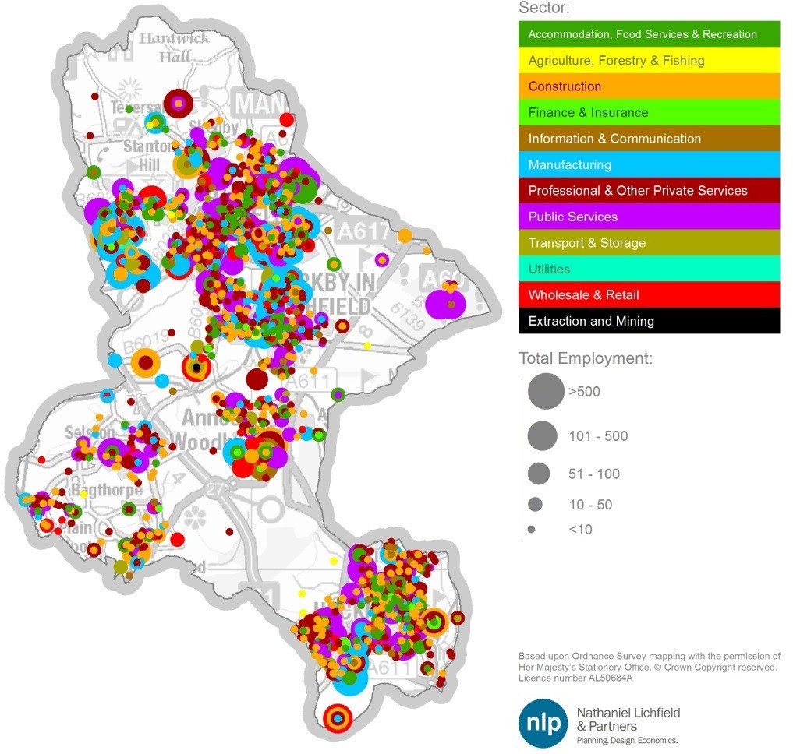

Source: IDBR / NLP analysis

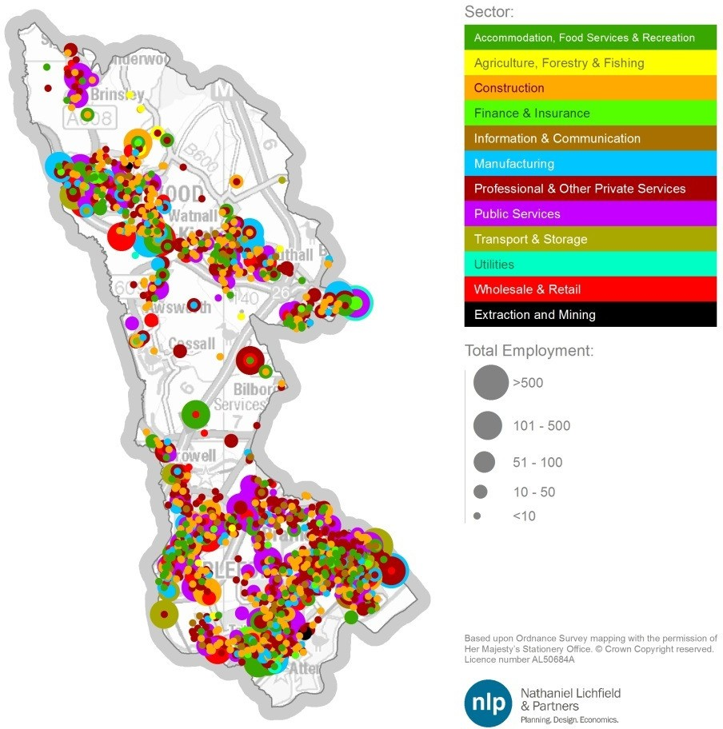

Source: IDBR / NLP analysis Figure A2.3 Erewash IDBR

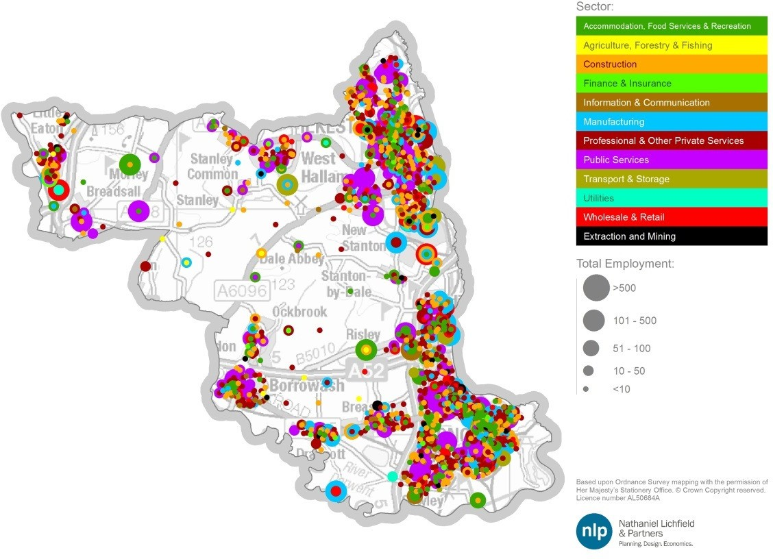

Source: IDBR / NLP analysis

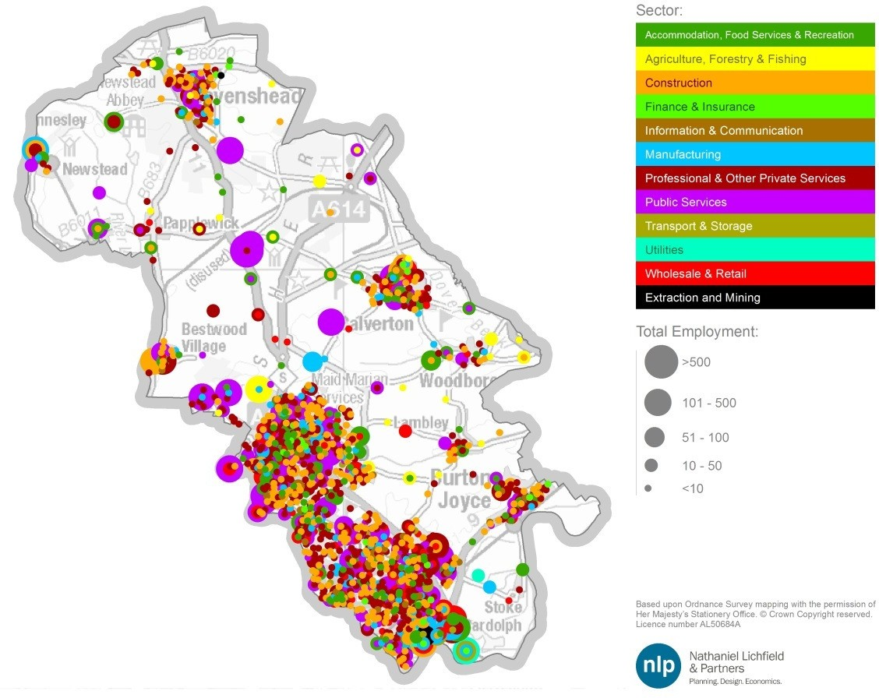

Source: IDBR / NLP analysis Figure A2.5 Mansfield IDBR

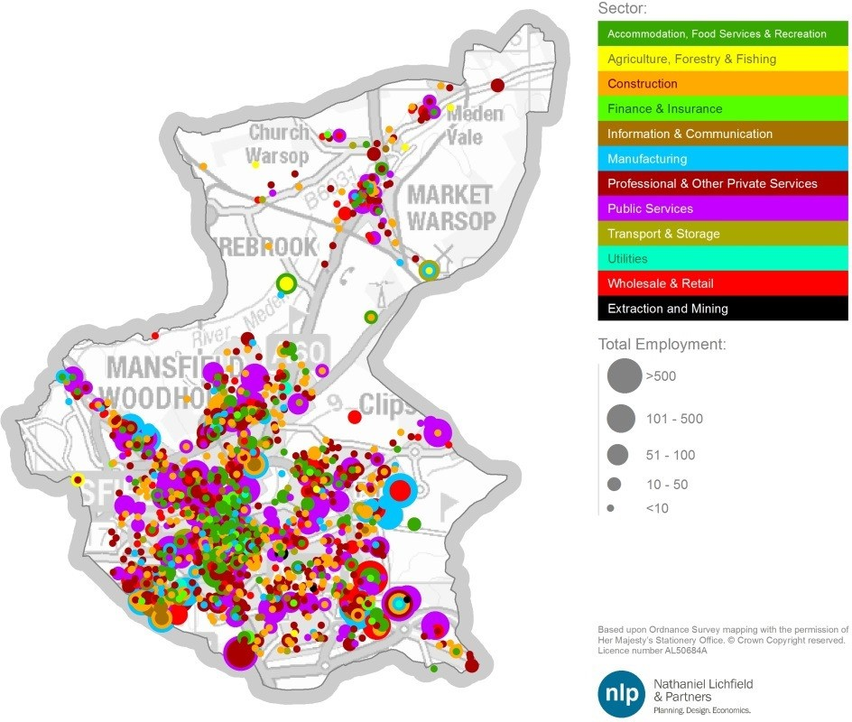

Source: IDBR / NLP analysis

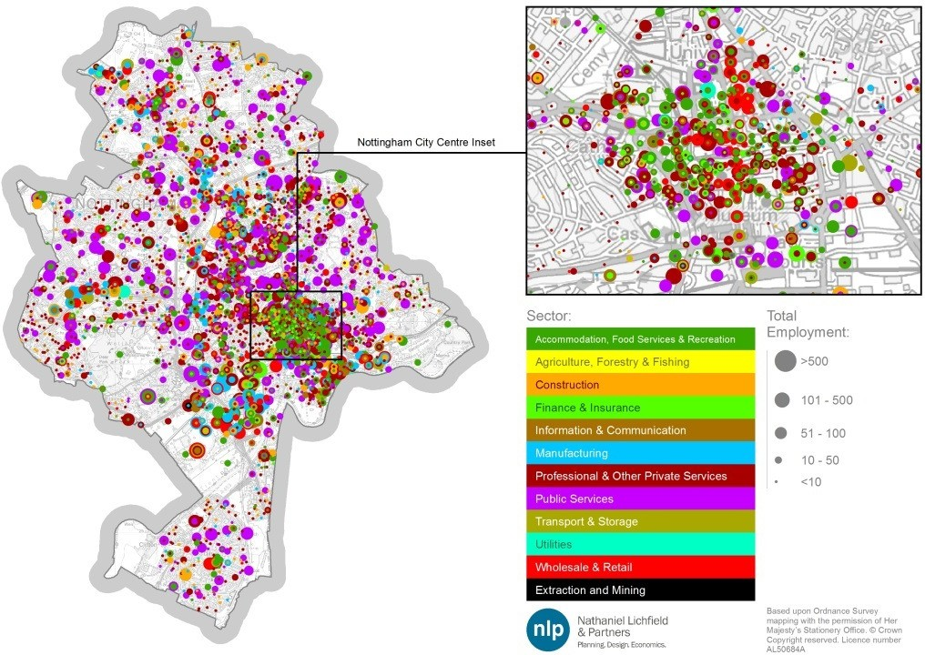

Source: IDBR / NLP analysis Figure A2.7 Newark & Sherwood IDBR

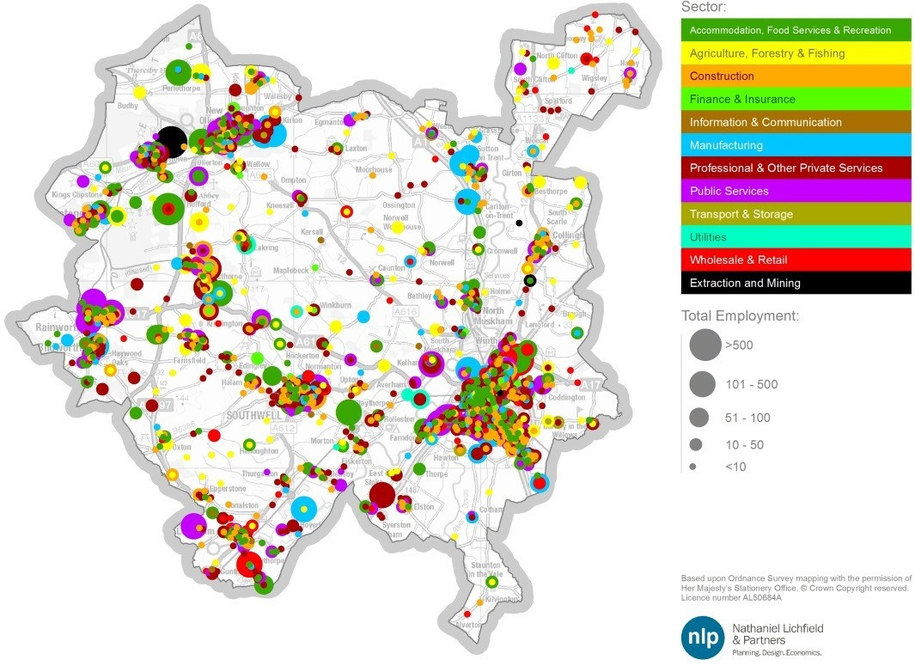

Source: IDBR / NLP analysis

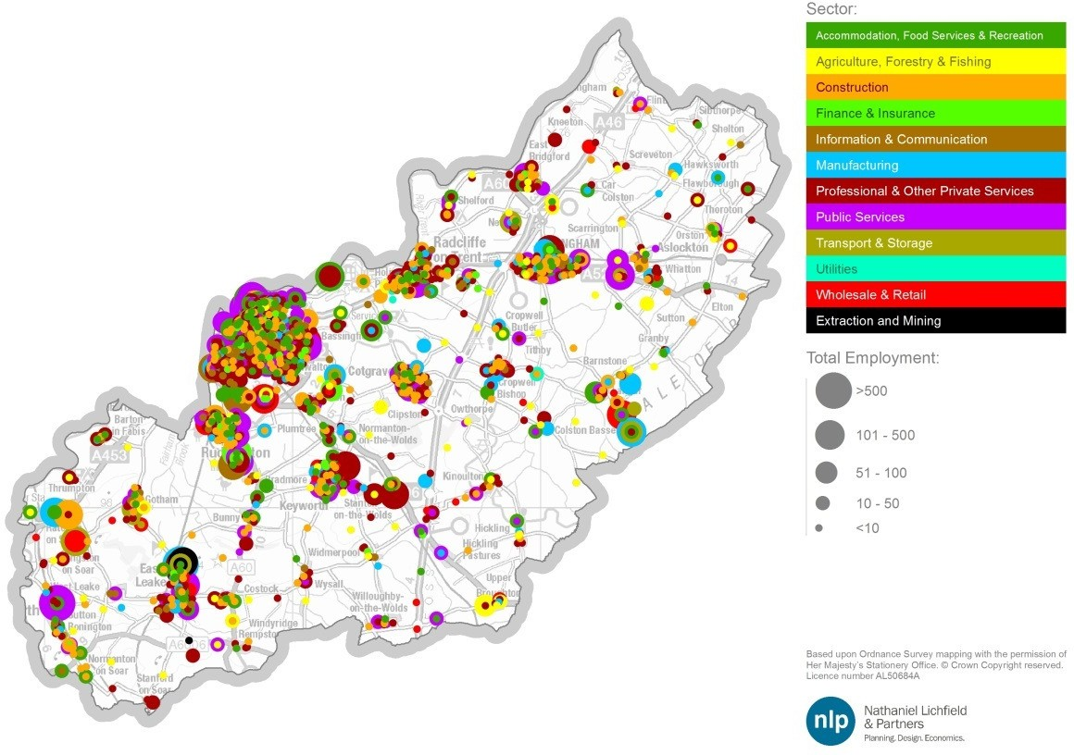

Source: IDBR / NLP analysis

|  |  |  |
| --- | --- | --- |
| **Name** | **Position** | **Organisation** |
| Sean Bremner | Commercial Property Agent | Lambert Smith Hampton |
| Chris Sinclair | Commercial Property Agent | Innes England |
| Gary Wood | Commercial Property Agent | Wood and Co. |
| Nigel Carnell | Commercial Property Agent | WA Barnes |
| Geoff George | Economic Development Officer | Nottinghamshire County Council |
| Louise Ashby | Economic Development Officer | Gedling Council |
| Ken Nettleship | Trade and Investment Account Manager | Invest In Nottingham |
| Baback Yazdani | Dean | Nottingham Business School |
| Johnathon Hendy | Assistant Planner | Bolsover District Council |
| Samantha Brooman | Planning Policy Officer | Melton Borough Council |
| Jenny Stephenson | Regeneration Officer | City of Lincoln, North Kesteven District Council and West Lindsey  District Council |
| Tom Bannister | Principal Planning Policy Officer | Bassetlaw District Council |
| Stephen Jackson | Regeneration and Growth Manager | Amber Valley Borough Council |
| Karen Sinclair | Planning Policy and Partnerships Service Manager | South Kesteven District Council |
| Suzanne Feneley | Principal Economic Development Officer | North Kesteven District Council |
| Katie Mills | Planning Policy Team Leader | North West Leicestershire District  Council |
| Richard Cooper | Principal Planning Officer | North East Derbyshire District Council |
| David Hankin | Team Leader for Economic Development and Regeneration | Charnwood Borough Council |

Table A4.1 Comparison between SEP Priority Aspirations and SIC2 sectors

|  |  |  |  |  |  |  |
| --- | --- | --- | --- | --- | --- | --- |
| **Priority Actions** | **Total Jobs** | **Net Additional Jobs** | **District(s)** | **Target Sector** | **Approximate Comparable Standard Industrial Classifications** | |
|  | |  |  | | **Sector** | **Approx. Use Class**  **/ Split of total** |
| **Nottingham Creative Quarter** | 7,103 | 3,229 | Nottingham | Creative industries  Life sciences | Media Activities Telecoms  Professional Services | B1a 25%  B1a 25%  B1a 25% |
|  |  |  | Computing & Information Services | B1a 25% |
|  |  |  | Nottingham / Supporting Broxtowe technology  (50:50 split) intensive  companies | | Manufacturing of | B2 25% |
|  |  |  | Pharmaceuticals | B1a 25% |
| **Nottingham** |  |  | Professional Services | B1a 25% |
| **Enterprise**  **Zone** | 6,871 | 3,123 | Computing & Information Services | B2 25% |
|  |  |  | Computer & Electronic |  |
|  |  |  | Products Manufacturing |  |
|  |  |  | Distributed evenly across the 8 districts | Incentives to support SMEs and inward investors in the 8 priority sectors | Transport Equipment | B2 11.1%  B1a 11.1%  B2 11.1%  Non B-use 11.1%  Non B-use 11.1%  B1a 11.1%  Some B8 11.1% Some B2/ B8 11.1% B1a 11.1% |
|  |  |  | Manufacturing |
|  |  |  | Professional Services |
|  |  |  | Food and Drink |
|  |  |  | Manufacturing |
| **D2N2** |  |  | Construction |
| **Business** | 200 | 91 | Recreation |
| **Growth Fund\*** |  |  | Computing and Information |
|  |  |  | Services |
|  |  |  | Land Transport, Storage |
|  |  |  | and Post |
|  |  |  | Wholesaling; and |
|  |  |  | Media Activities |
|  |  |  | Nottingham | Visitor Economy Retail  Business Services | Recreation | Non B-use 17% |
|  |  |  | Retail | Non B-use 17% |
| **Broadmarsh** |  |  | Media Activities | B1a 16.5% |
| **and Southern** | 9,900 | 4,500 | Computing & Information | B1a 16.5% |
| **Gateway** |  |  | Services | B1a 16.5% |
|  |  |  | Finance | B1a 16.5% |
|  |  |  | Professional Services |  |
| **Rolls Royce site, Hucknall** | 2,200 | 1,000 | Ashfield | Transport Equipment Manufacturing | Transport Equipment Manufacturing | B2 100% |
| **A46 Corridor** |  |  | Rushcliffe | Construction Warehousing Manufacturing Life Sciences |  | Non B-Use 20%  Non B-Use 20%  Some B2/B8 10%  Some B8 10%  B2 20%  B1a 20% |
| **projects,** |  |  |  |
| **Rushcliffe** |  |  |  |
| (Local |  |  | Civil Engineering |
| infrastructure  projects to |  |  | Construction of Buildings |
| unlock |  |  | Wholesaling |
| employment | 2,000 | 909 | Land Transport, Storage & |
| and residential |  |  | Post |
| development  sites along the |  |  | Manufacturing |
| A46 at RAF |  |  | Professional Services |
| Newton, |  |  |  |
| Cotgrave and |  |  |  |
| Bingham) |  |  |  |
| **Sherwood** |  |  | Mansfield | Construction Manufacturing Life Sciences | Civil Engineering | Non B-Use 16.67% |
| **Growth**  **Corridor**  (transport | 1,000 | 455 | Construction of Buildings Manufacturing | Non B-Use 16.67%  B2 33.3% |

|  |  |  |  |  |  |  |
| --- | --- | --- | --- | --- | --- | --- |
| **Priority Actions** | **Total Jobs** | **Net Additional Jobs** | **District(s)** | **Target Sector** | **Approximate Comparable Standard Industrial Classifications** | |
| infrastructure and measures to unlock 5.8ha of employment land and Lindhurst SUE on south side of Mansfield) |  |  |  |  | Professional Services | B1a 33.3% |
| **Newark Southern Link Road** (Unlocking a major strategic mixed use site to the south of Newark to facilitate an SUE) | 2,400 | 1,091 | Newark & Sherwood | Construction Warehousing Manufacturing Life Sciences Visitor Economy | Civil Engineering Construction of Buildings  Land Transport, Storage & Post  Wholesaling Manufacturing Professional Services  Retail | Non B-Use 16.7%  Non B-Use 16.7%  Some B8 8.3%  Some B2/B8 8.3%  B2 16.7%  B1a 16.7%  Non B-Use 16.7% |
| **Single Further Education Hub for Nottingham** | 490 | 223 | Nottingham | Education | Education | Non B-Use 100% |
| **TOTAL** | **32,164** | **14,620** |  |  |  |  |
| **Potential East Midlands HS2 Station at Toton** | 1,500 | 682 | Broxtowe | Construction  Business Services  Transport & Logistics | Civil Engineering Construction of Buildings  Land Transport, Storage & Post  Warehousing Professional Services | Non B-Use 25%  Non B-Use 25%  Some B8 12.5%  Some B2/B8 12.5%  B1a 25% |

Source: NLP analysis / D2N2 SEP, pages 16-21; Volterra Options for East Midlands on HS2 (2015)

*400 jobs across the D2N2; 200 jobs identified for the 8 districts across the Core and Outer HMAs as these areas contain around half of the total population and workplace jobs across Derbyshire and Nottinghamshire.

Appendix 5 Gross Completions Rates – Raw Data

Table A5.1 Gross Annual Completion Rates in Core HMA for B1a/b Office Floorspace, 2001/02-2013/14 (ha)



**Use**

**2001 2002 2003 2004 2005 2006 2007 2008 2009 2010 2011 2012 2013**

**/02 /3 /4 /5 /6 /7 /08 /9 /10 /11 /12 /13 /14**

Broxtowe

B1a/b

-

-

-

-

-

-

-

1,401 762 2,284 225 1,974 272

Erewash

B1a/b

-

-

-

-

-

-

-

-

0

354

0

220

0

Gedling

B1a/b

-

-

-

0

0

0

0

0

0

0

0

0

0

Nottingham B1a/b

-

-

-

-

14,672 8,440 14,692

0

9,232

0

333 8,871

0

Rushcliffe

B1a/b

-

-

-

-

317

0

2,258 5,447 4,005

0

421

0

1,675

Source: Source: Core HMA Councils / NLP Analysis

Table A5.2 Gross Annual Completion Rates in Core HMA for B2/B8 industrial land, 2001/02-2013/14 (ha)



**Use**

**2001 2002 2003 2004 2005 2006 2007 2008 2009 2010 2011 2012 2013**

**/02 /3 /4 /5 /6 /7 /08 /9 /10 /11 /12 /13 /14**

B1c/B2

-

-

-

-

-

-

-

-

0

0

0

0

0.03

B8

-

-

-

-

-

-

-

-

0.9

0.16

0

0

0

Broxtowe

Mixed

-

-

-

-

-

-

-

-

0

0.01

0

0

0

ALL

-

1.12

3.91

0.82

1.12

4.57

3.97

0.67

0.90

0.17

0.00

0.00

0.03

B1c/B2

-

-

-

-

-

-

-

-

0

0.32

0.56

0.50

0.20

B8

-

-

-

-

-

-

-

-

0

1.10

0

0.87

0.36

Erewash

Mixed

-

-

-

-

-

-

-

-

0

0

0

0

0

ALL

-

-

-

-

-

-

-

-

0

1.42

0.56

1.37

0.56

B1c/B2

-

-

-

1.82

0.06

0

0

1.13

0.29

0

0

0

0

B8

-

-

-

0.80

0

0

0

0

0.45

0

0

0

0

Gedling

Mixed

-

-

-

0

0

0

0

1.24

0

0

0

0

0

ALL

-

-

-

2.62

0.06

0

0

2.36

0.74

0

0

0

0

B1c/B2

-

-

-

-

0.63

0

0

0

0

0

0.41

0

0.13

B8

-

-

-

-

0

0

0

0

0

0

0.18

0

1.59

Nottingham

Mixed

-

-

-

-

0

0

0

1.47

2.37

0

0.40

0

0

ALL

-

-

-

-

0.63

0.00

0.00

1.47

2.37

0.00

0.99

0.00

1.73

B1c/B2

-

-

-

-

0

0

0

0.10

0

0

2.50

0

0

B8

-

-

-

-

0.10

0

0

1.24

0.15

0

0

0.01

0

Rushcliffe

Mixed

-

-

-

-

0

0

0

0

2.40

0

0

0

0

ALL

-

-

-

-

0.10

0.00

0.00

1.34

2.55

0.00

2.50

0.01

0.00

Source: Source: Core HMA Councils / NLP analysis

Note: ‘Mixed’ does not separate out the proportion of land that was subsequently developed for B1a/b office use, hence it is possible that the overall figure in this Table slightly over-estimates the amount of industrial land coming forward, whilst the amount of office completions discussed in the two previous tables may be under-represented.

Table A5.3 Gross Annual Completion Rates in Outer HMA for B1a/b Office Floorspace, 2001/02-2013/14 (ha)

|  |  |  |  |  |  |  |  |  |  |  |  |  |  |  |
| --- | --- | --- | --- | --- | --- | --- | --- | --- | --- | --- | --- | --- | --- | --- |
|  | **Use** | **2001**  **/02** | **2002**  **/3** | **2003**  **/4** | **2004**  **/5** | **2005**  **/6** | **2006**  **/7** | **2007**  **/08** | **2008**  **/9** | **2009**  **/10** | **2010**  **/11** | **2011**  **/12** | **2012**  **/13** | **2013**  **/14** |
| Ashfield | B1a/b | - | - | - | - | 5,079 | 0 | 272 | 8,036 | 858 | 184 | 544 | 0 | 731 |
| (of which located in Hucknall) | B1a/b | - | - | - | - | 0 | 0 | 0 | 541 | 858 | 0 | 0 | 0 | 318 |
| Mansfield | B1a/b | - | - | - | - | - | 12,082 | 1,157 | 4,075 | 697 | 0 | 84 | 476 | 0 |
| Newark & Sherwood | B1a/b | - | - | - | - | - | 7,615 | 15,185 | 0 | 6,738 | 342 | 4,436 | 1,870 | 1,494 |

Source: Source: Core HMA Councils / NLP Analysis

Table A5.4 Gross Annual Completion Rates in Outer HMA for B2/B8 industrial land, 2001/02-2013/14 (ha)

**Use**

**2001 2002 2003 2004 2005 2006 2007 2008 2009 2010 2011 2012 2013**

**/02 /3 /4 /5 /6 /7 /08 /9 /10 /11 /12 /13 /14**

B1c/B2 5.40

7.00

6.67

7.47 15.30 1.70

5.69

0.00

0.00

0.20

0.26

1.64

0.00

B8

2.29

3.00

0.65

0.76

5.72

3.80

1.41

0.00

0.00

0.00

0.00

0.00

0.00

Ashfield*

Other

1.10

0.00

0.31

0.37

0.82

0.00

0.00

0.00

0.00

0.00

0.00

0.00

0.00

ALL

8.79 10.00 7.64

8.60 21.84 5.50

7.10

0.00

0.00

0.20

0.26

1.64

0.00

B1c/B2

2.40

0.80

0.30

0.50

7.00

0.00

0.00

0.00

0.00

0.20

0.00

0.00

0.00

(of which

located in Hucknall)

B8

0.00

0.00

0.00

0.00

0.00

3.80

0.00

0.00

0.00

0.00

0.00

0.00

0.00

Mixed

0.00

0.00

0.00

0.00

0.00

0.00

0.00

0.00

0.00

0.00

0.00

0.00

0.00

ALL

2.40

0.80

0.30

0.50

7.00

3.80

0.00

0.00

0.00

0.20

0.00

0.00

0.00

B1c/B2

-

-

-

-

-

1.00

1.45

0.93

1.05

0.04

0.00

0.00

0.00

B8

-

-

-

-

-

1.48

1.81

0.00

1.41

0.10

0.02

0.58

0.27

Mansfield

Mixed

-

-

-

-

-

2.30

0.30

0.00

3.42

0.00

0.69

0.00

0.00

ALL

-

-

-

-

-

4.78

3.56

0.93

5.88

0.14

0.71

0.58

0.27

B1c/B2

-

-

-

-

1.34

1.66

2.16

0.30

0.53

0.34

1.27

0.00

5.25

B8

Newark &

Sherwood

-

-

-

-

0.00 19.05 0.00

0.12

0.25

0.00

3.49

0.46

0.40

Mixed

-

-

-

-

0.26

0.00

0.00

1.56

0.80

0.00

2.25

0.03

0.00

ALL

-

-

-

-

1.60 20.71 2.16

1.98

1.58

0.34

7.01

0.49

5.65

Source: Outer HMA Councils / NLP analysis

Note: ‘Mixed’ does not separate out the proportion of land that was subsequently developed for B1a/b office use, hence it is possible that the overall figure in this Table slightly over-estimates the amount of industrial land coming forward, whilst the amount of office completions discussed in the previous tables may be under-represented.

*The 19.9ha delivered between 2001/02 and 2005/06 on Sherwood Business Park has been split 14%/86% B1 office/B8 warehousing on the basis of the recorded floorspace split between those two uses at the site by ADC in 2005/06 – no earlier detailed records were provided by the Council.

Appendix 6 Definition of B Class Sectors

The method used for re-categorising the employment forecasts by sector into B-Class uses is summarised below. This is based on the latest BRES 2013 SIC4 level data.

Apportionment of B Class Sectors to Land Uses – Broxtowe Borough

|  |  |  |  |
| --- | --- | --- | --- |
| **Experian Sector** | **Proportion of Jobs by Use Class** | | |
| **B1a/b office** | **B1c/B2 industrial** | **B8 warehousing** |
| Agriculture, Forestry & Fishing | Non B-Class | | |
| Extraction & Mining | Non B-Class | | |
| Food, Drink & Tobacco  Textiles & Clothing | 0%  0% | 100%  100% | 0%  0% |
| Wood & Paper | 0% | 100% | 0% |
| Printing and Recorded Media | 0% | 100% | 0% |
| Fuel Refining | 0% | 100% | 0% |
| Chemicals | 0% | 100% | 0% |
| Pharmaceuticals | 0% | 100% | 0% |
| Non-Metallic Products  Metal Products | 0%  0% | 100%  100% | 0%  0% |
| Computer & Electronic Products | 0% | 100% | 0% |
| Machinery & Equipment | 0% | 100% | 0% |
| Transport Equipment | 0% | 100% | 0% |
| Other Manufacturing  Utilities | 0% | 100%  52% | 0% |
| Construction of Buildings | Non B-Class | | |
| Civil Engineering | Non B-Class | | |
| Specialised Construction Activities | 0% | 50% | 0% |
| Wholesale | 0% | 17% | 68% |
| Retail | Non B-Class | | |
| Land Transport, Storage & Post  Air & Water Transport | 0% | 0% | 80% |
| Non B-Class | | |
| Accommodation & Food Services | Non B-Class | | |
| Recreation | Non B-Class | | |
| Media Activities | 100% | 0% | 0% |
| Telecoms  Computing & Information Services | 100%  100% | 0%  0% | 0%  0% |
| Finance | 100% | 0% | 0% |
| Insurance & Pensions | 100% | 0% | 0% |
| Real Estate | 100% | 0% | 0% |
| Professional Services | 100% | 0% | 0% |
| Administrative & Supportive Services | 26% | 0% | 0% |
| Other Private Services  Public Administration & Defence | Non B-Class | | |
| 10% | 0% | 0% |
| Education | Non B-Class | | |
| Health | Non B-Class | | |
| Residential Care & Social Work | Non B-Class | | |

Source: Experian / NLP analysis

|  |  |  |  |
| --- | --- | --- | --- |
| **Experian Sector** | **Proportion of Jobs by Use Class** | | |
| **B1a/b office** | **B1c/B2 industrial** | **B8 warehousing** |
| Agriculture, Forestry & Fishing | Non B-Class | | |
| Extraction & Mining | Non B-Class | | |
| Food, Drink & Tobacco | 0% | 100% | 0% |
| Textiles & Clothing | 0% | 100% | 0% |
| Wood & Paper | 0% | 100% | 0% |
| Printing and Recorded Media  Fuel Refining | 0%  0% | 100%  100% | 0%  0% |
| Chemicals | 0% | 100% | 0% |
| Pharmaceuticals | 0% | 100% | 0% |
| Non-Metallic Products | 0% | 100% | 0% |
| Metal Products  Computer & Electronic Products | 0%  0% | 100%  100% | 0%  0% |
| Machinery & Equipment | 0% | 100% | 0% |
| Transport Equipment | 0% | 100% | 0% |
| Other Manufacturing | 0% | 100% | 0% |
| Utilities |  | 68% |  |
| Construction of Buildings | Non B-Class | | |
| Civil Engineering | Non B-Class | | |
| Specialised Construction Activities | 0% | 53% | 0% |
| Wholesale | 0% | 23% | 71% |
| Retail | Non B-Class | | |
| Land Transport, Storage & Post | 0% | 0% | 85% |
| Air & Water Transport  Accommodation & Food Services | Non B-Class  Non B-Class | | |
| Recreation | Non B-Class | | |
| Media Activities | 100% | 0% | 0% |
| Telecoms | 100% | 0% | 0% |
| Computing & Information Services | 100% | 0% | 0% |
| Finance | 100% | 0% | 0% |
| Insurance & Pensions  Real Estate | 100%  100% | 0%  0% | 0%  0% |
| Professional Services | 100% | 0% | 0% |
| Administrative & Supportive Services | 30% | 0% | 0% |
| Other Private Services | Non B-Class | | |
| Public Administration & Defence  Education | 10% | 0% | 0% |
| Non B-Class | | |
| Health |  | Non B-Class |  |
| Residential Care & Social Work |  | Non B-Class |  |

Source: Experian / NLP analysis

|  |  |  |  |
| --- | --- | --- | --- |
| **Experian Sector** | **Proportion of Jobs by Use Class** | | |
| **B1a/b office** | **B1c/B2 industrial** | **B8 warehousing** |
| Agriculture, Forestry & Fishing | Non B-Class | | |
| Extraction & Mining | Non B-Class | | |
| Food, Drink & Tobacco | 0% | 100% | 0% |
| Textiles & Clothing | 0% | 100% | 0% |
| Wood & Paper | 0% | 100% | 0% |
| Printing and Recorded Media  Fuel Refining | 0%  0% | 100%  100% | 0%  0% |
| Chemicals | 0% | 100% | 0% |
| Pharmaceuticals | 0% | 100% | 0% |
| Non-Metallic Products | 0% | 100% | 0% |
| Metal Products  Computer & Electronic Products | 0%  0% | 100%  100% | 0%  0% |
| Machinery & Equipment | 0% | 100% | 0% |
| Transport Equipment | 0% | 100% | 0% |
| Other Manufacturing | 0% | 100% | 0% |
| Utilities |  | 92% |  |
| Construction of Buildings | Non B-Class | | |
| Civil Engineering  Specialised Construction Activities | Non B-Class | | |
| 0% | 50% | 0% |
| Wholesale | 0% | 17% | 71% |
| Retail | Non B-Class | | |
| Land Transport, Storage & Post | 0% | 0% | 63% |
| Air & Water Transport  Accommodation & Food Services | Non B-Class  Non B-Class | | |
| Recreation | Non B-Class | | |
| Media Activities | 100% | 0% | 0% |
| Telecoms | 100% | 0% | 0% |
| Computing & Information Services | 100% | 0% | 0% |
| Finance | 100% | 0% | 0% |
| Insurance & Pensions  Real Estate | 100%  100% | 0%  0% | 0%  0% |
| Professional Services | 100% | 0% | 0% |
| Administrative & Supportive Services | 6% | 0% | 0% |
| Other Private Services | Non B-Class | | |
| Public Administration & Defence  Education | 10% | 0% | 0% |
| Non B-Class | | |
| Health | Non B-Class | | |
| Residential Care & Social Work | Non B-Class | | |

Source: Experian / NLP analysis

|  |  |  |  |
| --- | --- | --- | --- |
| **Experian Sector** | **Proportion of Jobs by Use Class** | | |
| **B1a/b office** | **B1c/B2 industrial** | **B8 warehousing** |
| Agriculture, Forestry & Fishing | Non B-Class | | |
| Extraction & Mining | Non B-Class | | |
| Food, Drink & Tobacco | 0% | 100% | 0% |
| Textiles & Clothing | 0% | 100% | 0% |
| Wood & Paper | 0% | 100% | 0% |
| Printing and Recorded Media  Fuel Refining | 0%  0% | 100%  100% | 0%  0% |
| Chemicals | 0% | 100% | 0% |
| Pharmaceuticals | 0% | 100% | 0% |
| Non-Metallic Products | 0% | 100% | 0% |
| Metal Products  Computer & Electronic Products | 0%  0% | 100%  100% | 0%  0% |
| Machinery & Equipment | 0% | 100% | 0% |
| Transport Equipment | 0% | 100% | 0% |
| Other Manufacturing | 0% | 100% | 0% |
| Utilities |  | 49% |  |
| Construction of Buildings | Non B-Class | | |
| Civil Engineering | Non B-Class | | |
| Specialised Construction Activities | 0% | 56% | 0% |
| Wholesale | 0% | 18% | 74% |
| Retail | Non B-Class | | |
| Land Transport, Storage & Post | 0% | 0% | 53% |
| Air & Water Transport  Accommodation & Food Services | Non B-Class  Non B-Class | | |
| Recreation | Non B-Class | | |
| Media Activities | 100% | 0% | 0% |
| Telecoms | 100% | 0% | 0% |
| Computing & Information Services | 100% | 0% | 0% |
| Finance | 100% | 0% | 0% |
| Insurance & Pensions  Real Estate | 100%  100% | 0%  0% | 0%  0% |
| Professional Services | 100% | 0% | 0% |
| Administrative & Supportive Services | 12% | 0% | 0% |
| Other Private Services | Non B-Class | | |
| Public Administration & Defence  Education | 10% | 0% | 0% |
| Non B-Class | | |
| Health |  | Non B-Class |  |
| Residential Care & Social Work |  | Non B-Class |  |

Source: Experian / NLP analysis

|  |  |  |  |
| --- | --- | --- | --- |
| **Experian Sector** | **Proportion of Jobs by Use Class** | | |
| **B1a/b office** | **B1c/B2 industrial** | **B8 warehousing** |
| Agriculture, Forestry & Fishing | Non B-Class | | |
| Extraction & Mining | Non B-Class | | |
| Food, Drink & Tobacco | 0% | 100% | 0% |
| Textiles & Clothing | 0% | 100% | 0% |
| Wood & Paper | 0% | 100% | 0% |
| Printing and Recorded Media  Fuel Refining | 0%  0% | 100%  100% | 0%  0% |
| Chemicals | 0% | 100% | 0% |
| Pharmaceuticals | 0% | 100% | 0% |
| Non-Metallic Products | 0% | 100% | 0% |
| Metal Products  Computer & Electronic Products | 0%  0% | 100%  100% | 0%  0% |
| Machinery & Equipment | 0% | 100% | 0% |
| Transport Equipment | 0% | 100% | 0% |
| Other Manufacturing | 0% | 100% | 0% |
| Utilities |  | 38% |  |
| Construction of Buildings | Non B-Class | | |
| Civil Engineering  Specialised Construction Activities | Non B-Class | | |
| 0% | 52% | 0% |
| Wholesale | 0% | 13% | 81% |
| Retail | Non B-Class | | |
| Land Transport, Storage & Post | 0% | 0% | 83% |
| Air & Water Transport  Accommodation & Food Services | Non B-Class  Non B-Class | | |
| Recreation | Non B-Class | | |
| Media Activities | 100% | 0% | 0% |
| Telecoms | 100% | 0% | 0% |
| Computing & Information Services | 100% | 0% | 0% |
| Finance | 100% | 0% | 0% |
| Insurance & Pensions  Real Estate | 100%  100% | 0%  0% | 0%  0% |
| Professional Services | 100% | 0% | 0% |
| Administrative & Supportive Services | 21% | 0% | 0% |
| Other Private Services | Non B-Class | | |
| Public Administration & Defence  Education | 10% | 0% | 0% |
| Non B-Class | | |
| Health | Non B-Class | | |
| Residential Care & Social Work | Non B-Class | | |

Source: Experian / NLP analysis

|  |  |  |  |
| --- | --- | --- | --- |
| **Experian Sector** | **Proportion of Jobs by Use Class** | | |
| **B1a/b office** | **B1c/B2 industrial** | **B8 warehousing** |
| Agriculture, Forestry & Fishing | Non B-Class | | |
| Extraction & Mining | Non B-Class | | |
| Food, Drink & Tobacco | 0% | 100% | 0% |
| Textiles & Clothing | 0% | 100% | 0% |
| Wood & Paper | 0% | 100% | 0% |
| Printing and Recorded Media  Fuel Refining | 0%  0% | 100%  100% | 0%  0% |
| Chemicals | 0% | 100% | 0% |
| Pharmaceuticals | 0% | 100% | 0% |
| Non-Metallic Products | 0% | 100% | 0% |
| Metal Products  Computer & Electronic Products | 0%  0% | 100%  100% | 0%  0% |
| Machinery & Equipment | 0% | 100% | 0% |
| Transport Equipment | 0% | 100% | 0% |
| Other Manufacturing | 0% | 100% | 0% |
| Utilities |  | 15% |  |
| Construction of Buildings | Non B-Class | | |
| Civil Engineering | Non B-Class | | |
| Specialised Construction Activities | 0% | 58% | 0% |
| Wholesale | 0% | 17% | 64% |
| Retail | Non B-Class | | |
| Land Transport, Storage & Post | 0% | 0% | 82% |
| Air & Water Transport  Accommodation & Food Services | Non B-Class  Non B-Class | | |
| Recreation | Non B-Class | | |
| Media Activities | 100% | 0% | 0% |
| Telecoms | 100% | 0% | 0% |
| Computing & Information Services | 100% | 0% | 0% |
| Finance | 100% | 0% | 0% |
| Insurance & Pensions  Real Estate | 100%  100% | 0%  0% | 0%  0% |
| Professional Services | 100% | 0% | 0% |
| Administrative & Supportive Services | 27% | 0% | 0% |
| Other Private Services | Non B-Class | | |
| Public Administration & Defence  Education | 10% | 0% | 0% |
| Non B-Class | | |
| Health |  | Non B-Class |  |
| Residential Care & Social Work |  | Non B-Class |  |

Source: Experian / NLP analysis

|  |  |  |  |
| --- | --- | --- | --- |
| **Experian Sector** | **Proportion of Jobs by Use Class** | | |
| **B1a/b office** | **B1c/B2 industrial** | **B8 warehousing** |
| Agriculture, Forestry & Fishing | Non B-Class | | |
| Extraction & Mining | Non B-Class | | |
| Food, Drink & Tobacco | 0% | 100% | 0% |
| Textiles & Clothing | 0% | 100% | 0% |
| Wood & Paper | 0% | 100% | 0% |
| Printing and Recorded Media  Fuel Refining | 0%  0% | 100%  100% | 0%  0% |
| Chemicals | 0% | 100% | 0% |
| Pharmaceuticals | 0% | 100% | 0% |
| Non-Metallic Products | 0% | 100% | 0% |
| Metal Products  Computer & Electronic Products | 0%  0% | 100%  100% | 0%  0% |
| Machinery & Equipment | 0% | 100% | 0% |
| Transport Equipment | 0% | 100% | 0% |
| Other Manufacturing | 0% | 100% | 0% |
| Utilities |  | 77% |  |
| Construction of Buildings | Non B-Class | | |
| Civil Engineering  Specialised Construction Activities | Non B-Class | | |
| 0% | 59% | 0% |
| Wholesale | 0% | 24% | 58% |
| Retail | Non B-Class | | |
| Land Transport, Storage & Post | 0% | 0% | 63% |
| Air & Water Transport  Accommodation & Food Services | Non B-Class  Non B-Class | | |
| Recreation | Non B-Class | | |
| Media Activities | 100% | 0% | 0% |
| Telecoms | 100% | 0% | 0% |
| Computing & Information Services | 100% | 0% | 0% |
| Finance | 100% | 0% | 0% |
| Insurance & Pensions  Real Estate | 100%  100% | 0%  0% | 0%  0% |
| Professional Services | 100% | 0% | 0% |
| Administrative & Supportive Services | 7% | 0% | 0% |
| Other Private Services | Non B-Class | | |
| Public Administration & Defence  Education | 10% | 0% | 0% |
| Non B-Class | | |
| Health | Non B-Class | | |
| Residential Care & Social Work | Non B-Class | | |

Source: Experian / NLP analysis

|  |  |  |  |
| --- | --- | --- | --- |
| **Experian Sector** | **Proportion of Jobs by Use Class** | | |
| **B1a/b office** | **B1c/B2 industrial** | **B8 warehousing** |
| Agriculture, Forestry & Fishing | Non B-Class | | |
| Extraction & Mining | Non B-Class | | |
| Food, Drink & Tobacco | 0% | 100% | 0% |
| Textiles & Clothing | 0% | 100% | 0% |
| Wood & Paper | 0% | 100% | 0% |
| Printing and Recorded Media  Fuel Refining | 0%  0% | 100%  100% | 0%  0% |
| Chemicals | 0% | 100% | 0% |
| Pharmaceuticals | 0% | 100% | 0% |
| Non-Metallic Products | 0% | 100% | 0% |
| Metal Products  Computer & Electronic Products | 0%  0% | 100%  100% | 0%  0% |
| Machinery & Equipment | 0% | 100% | 0% |
| Transport Equipment | 0% | 100% | 0% |
| Other Manufacturing | 0% | 100% | 0% |
| Utilities |  | 59% |  |
| Construction of Buildings | Non B-Class | | |
| Civil Engineering | Non B-Class | | |
| Specialised Construction Activities | 0% | 51% | 0% |
| Wholesale | 0% | 28% | 53% |
| Retail | Non B-Class | | |
| Land Transport, Storage & Post | 0% | 0% | 86% |
| Air & Water Transport  Accommodation & Food Services | Non B-Class  Non B-Class | | |
| Recreation | Non B-Class | | |
| Media Activities | 100% | 0% | 0% |
| Telecoms | 100% | 0% | 0% |
| Computing & Information Services | 100% | 0% | 0% |
| Finance | 100% | 0% | 0% |
| Insurance & Pensions  Real Estate | 100%  100% | 0%  0% | 0%  0% |
| Professional Services | 100% | 0% | 0% |
| Administrative & Supportive Services | 23% | 0% | 0% |
| Other Private Services | Non B-Class | | |
| Public Administration & Defence  Education | 10% | 0% | 0% |
| Non B-Class | | |
| Health |  | Non B-Class |  |
| Residential Care & Social Work |  | Non B-Class |  |

Source: Experian / NLP analysis

Appendix 7 Experian Data Guide: UK

Regional Planning Service

Appendix 8 Demand-Led Scenario Worked

Example

In order to explain the methodology used in translating Experian’s econometric job projections into an employment floorspace/land requirement, a worked example is set out below setting out the steps and assumptions used. The example taken is the calculation of office floorspace for Rushcliffe Borough for the Experian baseline scenario.

**Step 1:** Identify total number of workforce employees in the relevant B1a/b Industrial Sectors for Rushcliffe in 2011.

This includes:

* **Media Activities** (100% of all jobs likely to be based in B1a/b office floorspace): 220 jobs;
* **Telecoms** (100% of all jobs likely to be based in B1a/b office floorspace): 53 jobs;
* **Computing and Information Services** (100% of all jobs likely to be based in B1a/b office floorspace): 1,655 jobs;
* **Finance** (100% of all jobs likely to be based in B1a/b office floorspace): 1,459 jobs;
* **Insurance & Pensions** (100% of all jobs likely to be based in B1a/b office floorspace): 8 jobs;
* **Real Estate** (100% of all jobs likely to be based in B1a/b office floorspace): 659 jobs;
* **Professional Services** (100% of all jobs likely to be based in B1a/b office floorspace): 4,579 jobs;
* **Administrative and Support Services** (Specifically the sub-sector ‘Office administrative, office support and other business support activities’, which comprises 20.7% of the total number of jobs in the overall Administrative & Support Services category in the 2013 BRES data): 1865 jobs in total, 20.7% of which = 386 jobs;
* **Public Administration and Defence** (Generally taken as comprising 10% of all jobs likely to be based in B1a/b office floorspace): 4,125 jobs, 10% of which = 413 jobs.
* **TOTAL B1A/B-RELATED JOBS IN 2011: 9,431 Step 2:** Translate 2011 jobs into floorspace.

The total B1a/b office jobs estimated by Experian/NLP in 2011 is multiplied by a suitable employment density figure of 1 job per 12.5 sqm of office floorspace, based on the HCA and Offpat 2010 Employment Densities Guidance, adjusted to provide Gross External Areas.

* 9,431 jobs x 12.5 sqm = **117,893 sqm** occupied floorspace.

An allowance is subsequently made to translate this ‘occupied’ floorspace into ‘total’ floorspace by making an allowance for vacancies. In Rushcliffe Borough’s case, the vacancy rate (based on an analysis of commercial agency websites and databases of marketed floorspace) for office floorspace is 8.8%.

* 117,893 sqm /0.912% = **129,268 sqm** total floorspace.

**Step 3:** Translate 2033 jobs into floorspace. Steps 1 and 2 are repeated, but using the 2033 Experian sectoral workforce projections for that year. As the Experian projections are not broken down below SIC2 level, It has been necessarily assumed that the proportion of jobs in the ‘Administration and Support Services’ sub-sector ‘Office administrative, office support and other business support activities’ remains constant over time.

###### TOTAL B1A/B-RELATED JOBS IN 2033: 16,018

* 16,018 jobs x 12.5 sqm = **200,221 sqm** occupied floorspace.

As before, an allowance is subsequently made to translate this ‘occupied’ floorspace into ‘total’ floorspace by making an allowance for vacancies.

However, in an effort to re-balance the market, the model seeks to reduce the overall floorspace requirement where there is an over/under-supply of floorspace at present, using the market signal of vacancy rates. It is assumed that 10% represents a reasonable level of fluidity in the market necessary for it to function effectively.

* 200,221 sqm /0.9% = **222,468 sqm** total floorspace.

In Rushcliffe Borough’s case, as the office vacancy rate is slightly below what many agents consider to be the ‘ideal’ level of vacancy in a healthy commercial market, this results in the level of floorspace required in future increasing slightly than would otherwise be the case.

The 2033 figure is simply subtracted from the 2011 figure to derive the net office floorspace requirement:

* 222**,**468 sqm – 129,268 sqm = **93,200 sqm**.

For the industrial and warehousing calculations, the floorspace figure was simply translated into land by applying a plot ratio of 40%. This was not applied to the office floorspace figure as the client team specified their requirement for a B1a/b floorspace, rather than land, figure.

Appendix 9 Experian Data

|  |  |  |  |  |  |  |  |
| --- | --- | --- | --- | --- | --- | --- | --- |
| **Experian Sector** | **2011** | **2016** | **2021** | **2026** | **2031** | **2033** | **Difference 2011-2033** |
| Agriculture, Forestry & Fishing | 296 | 349 | 419 | 483 | 544 | 569 | **273** |
| Extraction & Mining | 28 | 25 | 23 | 21 | 19 | 18 | **-10** |
| Food, Drink & Tobacco | 1,023 | 1,117 | 1,181 | 1,227 | 1,269 | 1,294 | **271** |
| Textiles & Clothing | 194 | 199 | 186 | 167 | 145 | 140 | **-54** |
| Wood & Paper  Printing and Recorded Media | 607 | 784 | 779 | 762 | 735 | 748 | **141** |
| 207 | 239 | 227 | 211 | 194 | 193 | **-14** |
| Fuel Refining | 0 | 0 | 0 | 0 | 0 | 0 | **0** |
| Chemicals | 1,341 | 1,412 | 1,459 | 1,472 | 1,468 | 1,481 | **140** |
| Pharmaceuticals | 453 | 948 | 1,114 | 1,189 | 1,246 | 1,325 | **872** |
| Non-Metallic Products  Metal Products | 311 | 367 | 376 | 371 | 364 | 369 | **58** |
| 728 | 899 | 909 | 946 | 987 | 1,013 | **285** |
| Computer & Electronic Products | 294 | 290 | 254 | 221 | 188 | 177 | **-117** |
| Machinery & Equipment | 305 | 250 | 203 | 159 | 122 | 104 | **-201** |
| Transport Equipment | 264 | 263 | 211 | 165 | 127 | 113 | **-151** |
| Other Manufacturing | 267 | 229 | 238 | 243 | 247 | 245 | **-22** |
| Utilities | 186 | 200 | 245 | 292 | 342 | 358 | **172** |
| Construction of Buildings  Civil Engineering | 1,103 | 1,335 | 1,514 | 1,666 | 1,825 | 1,897 | **794** |
| 358 | 420 | 468 | 517 | 568 | 589 | **231** |
| Specialised Construction Activities | 2,720 | 2,627 | 2,893 | 3,140 | 3,409 | 3,478 | **758** |
| Wholesale | 3,061 | 3,220 | 3,447 | 3,643 | 3,821 | 3,897 | **836** |
| Retail | 5,003 | 4,649 | 4,600 | 4,573 | 4,552 | 4,507 | **-496** |
| Land Transport, Storage & Post | 2,544 | 2,260 | 2,136 | 2,080 | 2,032 | 1,981 | **-563** |
| Air & Water Transport  Accommodation & Food Services | 2 | 3 | 3 | 3 | 3 | 3 | **1** |
| 2,218 | 2,232 | 2,345 | 2,450 | 2,546 | 2,579 | **361** |
| Recreation | 1,054 | 863 | 876 | 881 | 879 | 862 | **-193** |
| Media Activities | 154 | 155 | 162 | 167 | 170 | 172 | **18** |
| Telecoms | 159 | 78 | 77 | 74 | 70 | 61 | **-98** |
| Computing & Information Services | 1,467 | 1,280 | 1,292 | 1,277 | 1,243 | 1,221 | **-246** |
| Finance | 531 | 522 | 600 | 672 | 739 | 760 | **229** |
| Insurance & Pensions | 30 | 34 | 37 | 40 | 42 | 43 | **13** |
| Real Estate  Professional Services | 600 | 608 | 647 | 684 | 719 | 731 | **131** |
| 2,431 | 3,683 | 3,953 | 4,187 | 4,415 | 4,613 | **2,182** |
| Administrative & Supportive Services | 4,507 | 4,854 | 5,330 | 5,728 | 6,128 | 6,290 | **1,783** |
| Other Private Services | 724 | 733 | 613 | 500 | 406 | 374 | **-350** |
| Public Administration & Defence | 1,397 | 1,135 | 1,091 | 1,114 | 1,132 | 1,106 | **-292** |
| Education | 3,086 | 3,143 | 3,106 | 3,149 | 3,176 | 3,185 | **99** |
| Health  Residential Care & Social Work | 1,188 | 1,204 | 1,215 | 1,265 | 1,312 | 1,324 | **136** |
| 2,159 | 2,309 | 2,302 | 2,332 | 2,338 | 2,356 | **197** |
| **TOTAL** | **43,000** | **44,918** | **46,531** | **48,071** | **49,522** | **50,174** | **7,174** |

Source: Experian / NLP analysis

Note: 2033 represents an NLP extrapolation on a pro-rata basis

|  |  |  |  |  |  |  |  |
| --- | --- | --- | --- | --- | --- | --- | --- |
| **Experian Sector** | **2011** | **2016** | **2021** | **2026** | **2031** | **2033** | **Difference 2011-2033** |
| Agriculture, Forestry & Fishing | 164 | 69 | 39 | 21 | 12 | -3 | **-167** |
| Extraction & Mining | 3 | 2 | 1 | 1 | 1 | 1 | **-2** |
| Food, Drink & Tobacco | 129 | 134 | 132 | 128 | 124 | 124 | **-6** |
| Textiles & Clothing | 888 | 848 | 742 | 625 | 508 | 470 | **-418** |
| Wood & Paper | 236 | 288 | 268 | 245 | 222 | 221 | **-15** |
| Printing and Recorded Media | 456 | 516 | 460 | 401 | 345 | 334 | **-122** |
| Fuel Refining | 0 | 0 | 0 | 0 | 0 | 0 | **0** |
| Chemicals | 254 | 224 | 217 | 205 | 192 | 186 | **-68** |
| Pharmaceuticals | 94 | 146 | 164 | 167 | 167 | 174 | **80** |
| Non-Metallic Products | 898 | 987 | 945 | 873 | 802 | 792 | **-106** |
| Metal Products | 1,562 | 1,936 | 1,832 | 1,781 | 1,741 | 1,759 | **197** |
| Computer & Electronic Products | 65 | 33 | 24 | 17 | 11 | 6 | **-59** |
| Machinery & Equipment | 325 | 225 | 147 | 93 | 58 | 31 | **-294** |
| Transport Equipment | 663 | 448 | 289 | 182 | 113 | 58 | **-605** |
| Other Manufacturing | 1,947 | 2,058 | 2,004 | 1,922 | 1,840 | 1,829 | **-118** |
| Utilities | 536 | 611 | 695 | 775 | 859 | 891 | **355** |
| Construction of Buildings | 952 | 901 | 943 | 960 | 975 | 977 | **25** |
| Civil Engineering | 203 | 212 | 222 | 230 | 237 | 240 | **37** |
| Specialised Construction Activities | 2,223 | 2,109 | 2,150 | 2,167 | 2,189 | 2,186 | **-37** |
| Wholesale | 3,031 | 3,193 | 3,353 | 3,472 | 3,566 | 3,620 | **589** |
| Retail | 5,113 | 4,856 | 5,011 | 5,193 | 5,389 | 5,417 | **304** |
| Land Transport, Storage & Post | 1,925 | 1,503 | 1,243 | 1,061 | 910 | 809 | **-1,117** |
| Air & Water Transport | 15 | 12 | 11 | 9 | 8 | 7 | **-8** |
| Accommodation & Food Services | 2,184 | 2,209 | 2,408 | 2,614 | 2,822 | 2,886 | **702** |
| Recreation | 1,009 | 815 | 855 | 891 | 922 | 913 | **-96** |
| Media Activities | 153 | 145 | 159 | 171 | 183 | 186 | **33** |
| Telecoms | 37 | 34 | 36 | 37 | 38 | 38 | **1** |
| Computing & Information Services | 575 | 508 | 545 | 574 | 594 | 596 | **21** |
| Finance | 519 | 501 | 567 | 623 | 675 | 691 | **172** |
| Insurance & Pensions | 11 | 4 | 5 | 5 | 5 | 4 | **-7** |
| Real Estate | 484 | 422 | 420 | 415 | 408 | 400 | **-84** |
| Professional Services | 1,571 | 2,121 | 2,137 | 2,122 | 2,095 | 2,147 | **576** |
| Administrative & Supportive Services | 1,567 | 1,326 | 1,179 | 1,024 | 884 | 816 | **-751** |
| Other Private Services | 1,349 | 1,465 | 1,336 | 1,187 | 1,045 | 1,015 | **-334** |
| Public Administration & Defence | 1,023 | 809 | 766 | 770 | 770 | 745 | **-278** |
| Education | 5,075 | 5,675 | 5,885 | 6,265 | 6,643 | 6,800 | **1,725** |
| Health | 1,639 | 1,786 | 1,962 | 2,222 | 2,505 | 2,592 | **953** |
| Residential Care & Social Work | 3,238 | 3,833 | 4,157 | 4,581 | 4,993 | 5,169 | **1,931** |
| **TOTAL** | **42,116** | **42,964** | **43,309** | **44,029** | **44,851** | **45,125** | **3,009** |

Source: Experian / NLP analysis

Note: 2033 represents an NLP extrapolation on a pro-rata basis

|  |  |  |  |  |  |  |  |
| --- | --- | --- | --- | --- | --- | --- | --- |
| **Experian Sector** | **2011** | **2016** | **2021** | **2026** | **2031** | **2033** | **Difference 2011-2033** |
| Agriculture, Forestry & Fishing | 1,081 | 1,361 | 1,590 | 1,788 | 1,962 | 2,050 | **969** |
| Extraction & Mining | 116 | 115 | 104 | 94 | 85 | 82 | **-34** |
| Food, Drink & Tobacco | 172 | 187 | 192 | 194 | 205 | 208 | **36** |
| Textiles & Clothing | 797 | 876 | 794 | 695 | 613 | 595 | **-202** |
| Wood & Paper  Printing and Recorded Media | 133 | 124 | 119 | 114 | 112 | 110 | **-23** |
| 378 | 405 | 374 | 338 | 315 | 309 | **-69** |
| Fuel Refining | 0 | 1 | 1 | 1 | 1 | 1 | **1** |
| Chemicals | 42 | 46 | 46 | 45 | 46 | 46 | **4** |
| Pharmaceuticals | 1 | 1 | 1 | 1 | 1 | 1 | **0** |
| Non-Metallic Products  Metal Products | 423 | 484 | 481 | 463 | 463 | 467 | **44** |
| 771 | 934 | 919 | 929 | 989 | 1,011 | **240** |
| Computer & Electronic Products | 391 | 388 | 327 | 274 | 224 | 207 | **-184** |
| Machinery & Equipment | 129 | 99 | 78 | 58 | 43 | 34 | **-95** |
| Transport Equipment | 120 | 79 | 61 | 46 | 34 | 25 | **-95** |
| Other Manufacturing | 386 | 452 | 456 | 452 | 464 | 472 | **86** |
| Utilities | 454 | 492 | 523 | 540 | 546 | 555 | **101** |
| Construction of Buildings  Civil Engineering | 853 | 976 | 1,073 | 1,144 | 1,214 | 1,250 | **397** |
| 353 | 329 | 355 | 379 | 403 | 408 | **55** |
| Specialised Construction Activities | 2,708 | 2,575 | 2,747 | 2,887 | 3,035 | 3,068 | **360** |
| Wholesale | 2,356 | 2,540 | 2,742 | 2,917 | 3,078 | 3,150 | **794** |
| Retail | 4,329 | 3,898 | 3,839 | 3,802 | 3,772 | 3,716 | **-613** |
| Land Transport, Storage & Post | 1,539 | 1,491 | 1,573 | 1,710 | 1,866 | 1,899 | **360** |
| Air & Water Transport  Accommodation & Food Services | 0 | 0 | 0 | 0 | 0 | 0 | **0** |
| 2,066 | 2,090 | 2,202 | 2,307 | 2,402 | 2,436 | **370** |
| Recreation | 913 | 751 | 765 | 772 | 771 | 757 | **-156** |
| Media Activities | 96 | 47 | 36 | 28 | 22 | 15 | **-81** |
| Telecoms | 70 | 40 | 32 | 25 | 19 | 14 | **-56** |
| Computing & Information Services | 330 | 243 | 197 | 157 | 124 | 103 | **-227** |
| Finance | 369 | 320 | 323 | 316 | 305 | 299 | **-70** |
| Insurance & Pensions | 4 | 4 | 4 | 4 | 4 | 4 | **0** |
| Real Estate  Professional Services | 406 | 445 | 488 | 531 | 574 | 591 | **185** |
| 940 | 1,421 | 1,570 | 1,711 | 1,858 | 1,950 | **1,010** |
| Administrative & Supportive Services | 2,149 | 1,818 | 1,733 | 1,615 | 1,495 | 1,430 | **-719** |
| Other Private Services | 783 | 765 | 621 | 497 | 398 | 360 | **-424** |
| Public Administration & Defence | 2,324 | 1,416 | 1,074 | 864 | 693 | 530 | **-1,794** |
| Education | 3,172 | 3,303 | 3,289 | 3,362 | 3,423 | 3,448 | **276** |
| Health  Residential Care & Social Work | 2,296 | 2,362 | 2,417 | 2,552 | 2,685 | 2,724 | **428** |
| 2,325 | 2,573 | 2,600 | 2,674 | 2,719 | 2,758 | **433** |
| **TOTAL** | **35,775** | **35,451** | **35,746** | **36,286** | **36,963** | **37,082** | **1,307** |

Source: Experian / NLP analysis

Note: 2033 represents an NLP extrapolation on a pro-rata basis

|  |  |  |  |  |  |
| --- | --- | --- | --- | --- | --- |
| **Experian Sector 2011** | **2016** | **2021** | **2026** | **2031 2033** | **Difference 2011-2033** |
| Agriculture, Forestry & Fishing 51 | 2 | 2 | 2 | 2 -3 | **-54** |
| Extraction & Mining 0 | 1 | 1 | 1 | 1 1 | **1** |
| Food, Drink & Tobacco 2,367 | 1,948 | 1,690 | 1,440 | 1,209 1,093 | **-1,274** |
| Textiles & Clothing 573 | 433 | 332 | 246 | 174 134 | **-439** |
| Wood & Paper 607  Printing and Recorded Media 1,152 | 623 | 509 | 409 | 322 294 | **-314** |
| 1,015 | 795 | 609 | 456 386 | **-766** |
| Fuel Refining 28 | 0 | 0 | 0 | 0 -3 | **-31** |
| Chemicals 87 | 22 | 19 | 15 | 13 6 | **-81** |
| Pharmaceuticals 82 | 86 | 86 | 78 | 69 68 | **-14** |
| Non-Metallic Products 449  Metal Products 1,386 | 409 | 344 | 279 | 222 199 | **-250** |
| 1,468 | 1,220 | 1,042 | 883 833 | **-553** |
| Computer & Electronic Products 928 | 713 | 485 | 329 | 218 147 | **-781** |
| Machinery & Equipment 311 | 183 | 116 | 70 | 42 15 | **-296** |
| Transport Equipment 94 | 0 | 0 | 0 | 0 -9 | **-103** |
| Other Manufacturing 1,906 | 1,826 | 1,565 | 1,321 | 1,102 1,022 | **-884** |
| Utilities 1,211 | 514 | 286 | 156 | 85 -28 | **-1,239** |
| Construction of Buildings 3,182  Civil Engineering 1,809 | 3,396 | 3,840 | 4,214 | 4,606 4,748 | **1,566** |
| 2,180 | 2,429 | 2,678 | 2,939 3,052 | **1,243** |
| Specialised Construction 6,622  Activities | 6,584 | 7,231 | 7,831 | 8,486 8,672 | **2,050** |
| Wholesale 9,398 | 8,926 | 9,285 | 9,523 | 9,685 9,714 | **316** |
| Retail 23,431 | 23,177 | 23,498 | 23,928 | 24,396 24,493 | **1,062** |
| Land Transport, Storage & Post 6,054 | 5,456 | 5,194 | 5,092 | 5,010 4,906 | **-1,148** |
| Air & Water Transport 17  Accommodation & Food Services 9,999 | 14 | 14 | 14 | 13 13 | **-4** |
| 10,148 | 10,949 | 11,744 | 12,514 12,766 | **2,767** |
| Recreation 6,250 | 5,271 | 5,624 | 5,923 | 6,172 6,164 | **-86** |
| Media Activities 1,865 | 1,687 | 1,749 | 1,786 | 1,814 1,809 | **-56** |
| Telecoms 1,243 | 806 | 767 | 710 | 644 584 | **-659** |
| Computing & Information 5,846  Services | 5,225 | 5,098 | 4,870 | 4,581 4,455 | **-1,392** |
| Finance 5,490 | 5,104 | 5,565 | 5,892 | 6,127 6,191 | **701** |
| Insurance & Pensions 1,018 | 1,094 | 1,138 | 1,155 | 1,163 1,178 | **160** |
| Real Estate 3,359  Professional Services 11,277 | 3,483 | 3,808 | 4,142 | 4,486 4,599 | **1,240** |
| 16,431 | 18,256 | 20,014 | 21,817 22,871 | **11,594** |
| Administrative & Supportive 38,410  Services | 44,858 | 50,421 | 55,369 | 60,407 62,607 | **24,197** |
| Other Private Services 4,431 | 5,845 | 6,411 | 6,862 | 7,288 7,574 | **3,143** |
| Public Administration & Defence 14,016 | 10,688 | 9,957 | 9,846 | 9,689 9,256 | **-4,760** |
| Education 20,909 | 21,839 | 22,209 | 23,189 | 24,112 24,432 | **3,523** |
| Health 22,814  Residential Care & Social Work 11,034 | 24,085 | 25,149 | 27,080 | 29,066 29,691 | **6,877** |
| 12,040 | 12,410 | 13,005 | 13,494 13,740 | **2,706** |
| **TOTAL 219,70**  **6** | **227,58**  **0** | **238,45**  **2** | **250,86**  **4** | **263,30 267,66**  **7 7** | **47,961** |

Source: Experian / NLP analysis

Note: 2033 represents an NLP extrapolation on a pro-rata basis

|  |  |  |  |  |  |  |  |
| --- | --- | --- | --- | --- | --- | --- | --- |
| **Experian Sector** | **2011** | **2016** | **2021** | **2026** | **2031** | **2033** | **Difference 2011-2033** |
| Agriculture, Forestry & Fishing | 1,232 | 1,288 | 1,357 | 1,372 | 1,353 | 1,365 | **133** |
| Extraction & Mining | 189 | 261 | 247 | 232 | 218 | 221 | **32** |
| Food, Drink & Tobacco | 264 | 301 | 326 | 346 | 368 | 378 | **114** |
| Textiles & Clothing | 111 | 97 | 93 | 86 | 77 | 74 | **-37** |
| Wood & Paper  Printing and Recorded Media | 63 | 67 | 68 | 68 | 68 | 69 | **6** |
| 188 | 216 | 211 | 202 | 191 | 191 | **3** |
| Fuel Refining | 0 | 1 | 1 | 1 | 1 | 1 | **1** |
| Chemicals | 52 | 50 | 53 | 55 | 57 | 58 | **6** |
| Pharmaceuticals | 1 | 2 | 3 | 3 | 3 | 3 | **2** |
| Non-Metallic Products  Metal Products | 838 | 1,101 | 1,155 | 1,168 | 1,178 | 1,212 | **374** |
| 229 | 302 | 313 | 333 | 357 | 370 | **141** |
| Computer & Electronic Products | 116 | 85 | 66 | 51 | 39 | 31 | **-85** |
| Machinery & Equipment | 76 | 55 | 40 | 28 | 19 | 13 | **-63** |
| Transport Equipment | 40 | 37 | 26 | 18 | 12 | 9 | **-31** |
| Other Manufacturing | 285 | 320 | 341 | 358 | 376 | 385 | **100** |
| Utilities | 354 | 158 | 71 | 32 | 14 | -20 | **-374** |
| Construction of Buildings  Civil Engineering | 852 | 901 | 1,004 | 1,083 | 1,163 | 1,194 | **342** |
| 175 | 179 | 194 | 209 | 224 | 229 | **54** |
| Specialised Construction Activities | 1,909 | 1,868 | 2,016 | 2,142 | 2,275 | 2,312 | **403** |
| Wholesale | 2,799 | 2,944 | 3,130 | 3,280 | 3,409 | 3,470 | **671** |
| Retail | 3,505 | 3,381 | 3,536 | 3,713 | 3,898 | 3,937 | **432** |
| Land Transport, Storage & Post | 1,301 | 1,344 | 1,500 | 1,726 | 1,992 | 2,061 | **760** |
| Air & Water Transport  Accommodation & Food Services | 23 | 24 | 29 | 34 | 39 | 41 | **18** |
| 2,800 | 2,972 | 3,292 | 3,625 | 3,962 | 4,078 | **1,278** |
| Recreation | 2,675 | 2,327 | 2,488 | 2,626 | 2,744 | 2,751 | **76** |
| Media Activities | 220 | 206 | 238 | 273 | 310 | 319 | **99** |
| Telecoms | 53 | 45 | 51 | 57 | 63 | 64 | **11** |
| Computing & Information Services | 1,655 | 1,615 | 1,877 | 2,139 | 2,402 | 2,477 | **822** |
| Finance | 1,459 | 1,440 | 1,756 | 2,078 | 2,415 | 2,511 | **1,052** |
| Insurance & Pensions | 8 | 7 | 9 | 10 | 11 | 11 | **3** |
| Real Estate  Professional Services | 659 | 667 | 729 | 792 | 855 | 875 | **216** |
| 4,579 | 6,801 | 7,496 | 8,155 | 8,834 | 9,260 | **4,681** |
| Administrative & Supportive Services | 1,865 | 1,790 | 1,697 | 1,573 | 1,448 | 1,406 | **-459** |
| Other Private Services | 1,440 | 1,708 | 1,657 | 1,570 | 1,475 | 1,479 | **39** |
| Public Administration & Defence | 4,125 | 2,889 | 2,576 | 2,436 | 2,293 | 2,110 | **-2,015** |
| Education | 4,413 | 4,379 | 4,481 | 4,705 | 4,913 | 4,963 | **550** |
| Health  Residential Care & Social Work | 1,716 | 1,830 | 1,856 | 1,941 | 2,021 | 2,052 | **336** |
| 2,933 | 2,987 | 2,991 | 3,044 | 3,065 | 3,078 | **145** |
| **TOTAL** | **45,202** | **46,645** | **48,974** | **51,564** | **54,142** | **55,036** | **9,834** |

Source: Experian / NLP analysis

Note: 2033 represents an NLP extrapolation on a pro-rata basis

|  |  |  |  |  |  |  |  |
| --- | --- | --- | --- | --- | --- | --- | --- |
| **Experian Sector** | **2011** | **2016** | **2021** | **2026** | **2031** | **2033** | **Difference 2011-2033** |
| Agriculture, Forestry & Fishing | 183 | 63 | 34 | 17 | 9 | -8 | **-191** |
| Extraction & Mining | 19 | 35 | 31 | 28 | 25 | 26 | **7** |
| Food, Drink & Tobacco | 236 | 247 | 226 | 202 | 175 | 169 | **-67** |
| Textiles & Clothing | 596 | 371 | 299 | 232 | 168 | 125 | **-471** |
| Wood & Paper | 273 | 296 | 254 | 214 | 173 | 163 | **-110** |
| Printing and Recorded Media | 885 | 882 | 723 | 580 | 444 | 400 | **-485** |
| Fuel Refining | 0 | 0 | 0 | 0 | 0 | 0 | **0** |
| Chemicals | 235 | 200 | 179 | 156 | 130 | 120 | **-116** |
| Pharmaceuticals | 149 | 248 | 245 | 220 | 190 | 194 | **45** |
| Non-Metallic Products | 1,467 | 1,609 | 1,420 | 1,213 | 997 | 950 | **-517** |
| Metal Products | 2,506 | 2,857 | 2,495 | 2,243 | 1,958 | 1,903 | **-603** |
| Computer & Electronic Products | 163 | 150 | 143 | 135 | 125 | 121 | **-42** |
| Machinery & Equipment | 124 | 108 | 95 | 81 | 68 | 62 | **-62** |
| Transport Equipment | 1,463 | 1,555 | 1,355 | 1,149 | 962 | 912 | **-551** |
| Other Manufacturing | 825 | 786 | 701 | 616 | 522 | 492 | **-333** |
| Utilities | 1,182 | 1,240 | 1,348 | 1,423 | 1,470 | 1,499 | **317** |
| Construction of Buildings | 1,175 | 1,249 | 1,442 | 1,612 | 1,792 | 1,854 | **679** |
| Civil Engineering | 2,177 | 2,737 | 3,046 | 3,351 | 3,663 | 3,812 | **1,635** |
| Specialised Construction Activities | 3,324 | 3,335 | 3,721 | 4,083 | 4,476 | 4,591 | **1,267** |
| Wholesale | 4,611 | 5,187 | 5,652 | 6,072 | 6,469 | 6,655 | **2,044** |
| Retail | 4,388 | 4,157 | 4,277 | 4,426 | 4,588 | 4,608 | **220** |
| Land Transport, Storage & Post | 2,559 | 2,314 | 2,153 | 2,063 | 1,984 | 1,927 | **-633** |
| Air & Water Transport | 0 | 0 | 0 | 0 | 0 | 0 | **0** |
| Accommodation & Food Services | 1,904 | 1,899 | 1,970 | 2,032 | 2,083 | 2,101 | **197** |
| Recreation | 773 | 665 | 684 | 693 | 693 | 685 | **-88** |
| Media Activities | 46 | 36 | 45 | 57 | 71 | 74 | **28** |
| Telecoms | 42 | 40 | 51 | 63 | 76 | 79 | **37** |
| Computing & Information Services | 777 | 771 | 988 | 1,240 | 1,535 | 1,611 | **834** |
| Finance | 405 | 281 | 226 | 177 | 136 | 109 | **-296** |
| Insurance & Pensions | 5 | 6 | 5 | 3 | 3 | 3 | **-2** |
| Real Estate | 470 | 482 | 516 | 548 | 581 | 592 | **122** |
| Professional Services | 2,027 | 2,866 | 3,090 | 3,290 | 3,492 | 3,639 | **1,612** |
| Administrative & Supportive Services | 2,603 | 2,586 | 2,739 | 2,837 | 2,925 | 2,957 | **354** |
| Other Private Services | 1,272 | 1,742 | 1,757 | 1,729 | 1,689 | 1,731 | **459** |
| Public Administration & Defence | 1,903 | 1,696 | 1,800 | 2,039 | 2,302 | 2,342 | **439** |
| Education | 3,338 | 3,583 | 3,547 | 3,614 | 3,681 | 3,715 | **377** |
| Health | 6,835 | 7,134 | 7,559 | 8,256 | 8,979 | 9,193 | **2,358** |
| Residential Care & Social Work | 2,787 | 3,355 | 3,510 | 3,731 | 3,923 | 4,037 | **1,250** |
| **TOTAL** | **53,727** | **56,768** | **58,326** | **60,425** | **62,557** | **63,440** | **9,713** |

Source: Experian / NLP analysis

Note: 2033 represents an NLP extrapolation on a pro-rata basis

|  |  |  |  |  |  |  |  |
| --- | --- | --- | --- | --- | --- | --- | --- |
| **Experian Sector** | **2011** | **2016** | **2021** | **2026** | **2031** | **2033** | **Difference 2011-2033** |
| Agriculture, Forestry & Fishing | 87 | 115 | 157 | 210 | 281 | 300 | **213** |
| Extraction & Mining | 29 | 29 | 28 | 27 | 25 | 25 | **-4** |
| Food, Drink & Tobacco | 121 | 110 | 113 | 114 | 115 | 114 | **-7** |
| Textiles & Clothing | 165 | 106 | 96 | 84 | 71 | 62 | **-103** |
| Wood & Paper  Printing and Recorded Media | 293 | 344 | 331 | 314 | 296 | 296 | **3** |
| 623 | 698 | 643 | 579 | 517 | 506 | **-117** |
| Fuel Refining | 8 | 0 | 0 | 0 | 0 | -1 | **-9** |
| Chemicals | 93 | 99 | 100 | 97 | 95 | 95 | **2** |
| Pharmaceuticals | 0 | 1 | 1 | 1 | 1 | 1 | **1** |
| Non-Metallic Products  Metal Products | 779 | 937 | 930 | 892 | 855 | 863 | **84** |
| 557 | 672 | 659 | 666 | 678 | 690 | **133** |
| Computer & Electronic Products | 439 | 476 | 503 | 530 | 544 | 555 | **116** |
| Machinery & Equipment | 205 | 208 | 204 | 193 | 181 | 179 | **-26** |
| Transport Equipment | 394 | 487 | 474 | 449 | 421 | 424 | **30** |
| Other Manufacturing | 463 | 506 | 508 | 501 | 494 | 497 | **34** |
| Utilities | 220 | 106 | 54 | 28 | 14 | -7 | **-227** |
| Construction of Buildings  Civil Engineering | 1,659 | 1,764 | 2,087 | 2,391 | 2,723 | 2,829 | **1,170** |
| 378 | 385 | 436 | 488 | 542 | 558 | **180** |
| Specialised Construction Activities | 3,039 | 3,112 | 3,552 | 3,986 | 4,469 | 4,612 | **1,573** |
| Wholesale | 2,279 | 2,340 | 2,524 | 2,686 | 2,834 | 2,890 | **611** |
| Retail | 5,982 | 5,403 | 5,293 | 5,204 | 5,116 | 5,029 | **-953** |
| Land Transport, Storage & Post | 1,162 | 903 | 807 | 744 | 688 | 641 | **-521** |
| Air & Water Transport  Accommodation & Food Services | 0 | 0 | 0 | 0 | 0 | 0 | **0** |
| 2,254 | 2,254 | 2,465 | 2,681 | 2,896 | 2,960 | **706** |
| Recreation | 1,236 | 1,052 | 1,127 | 1,190 | 1,242 | 1,243 | **7** |
| Media Activities | 281 | 277 | 309 | 341 | 377 | 387 | **106** |
| Telecoms | 84 | 54 | 53 | 50 | 47 | 43 | **-41** |
| Computing & Information Services | 300 | 260 | 262 | 259 | 252 | 247 | **-53** |
| Finance | 759 | 631 | 631 | 614 | 586 | 569 | **-190** |
| Insurance & Pensions | 48 | 51 | 49 | 45 | 41 | 40 | **-8** |
| Real Estate  Professional Services | 364 | 369 | 380 | 389 | 397 | 400 | **36** |
| 1,592 | 2,246 | 2,321 | 2,376 | 2,430 | 2,514 | **922** |
| Administrative & Supportive Services | 3,484 | 3,067 | 2,989 | 2,848 | 2,700 | 2,622 | **-862** |
| Other Private Services | 1,293 | 1,489 | 1,413 | 1,305 | 1,195 | 1,185 | **-108** |
| Public Administration & Defence | 3,011 | 2,448 | 2,414 | 2,533 | 2,646 | 2,610 | **-402** |
| Education | 4,282 | 4,679 | 4,873 | 5,222 | 5,590 | 5,721 | **1,439** |
| Health  Residential Care & Social Work | 2,392 | 2,635 | 2,693 | 2,837 | 2,977 | 3,036 | **644** |
| 3,192 | 3,421 | 3,451 | 3,538 | 3,589 | 3,629 | **437** |
| **TOTAL** | **43,547** | **43,734** | **44,930** | **46,412** | **47,925** | **48,363** | **4,816** |

Source: Experian / NLP analysis

Note: 2033 represents an NLP extrapolation on a pro-rata basis

|  |  |  |  |  |  |  |  |
| --- | --- | --- | --- | --- | --- | --- | --- |
| **Experian Sector** | **2011** | **2016** | **2021** | **2026** | **2031** | **2033** | **Difference 2011-2033** |
| Agriculture, Forestry & Fishing | 676 | 572 | 504 | 427 | 353 | 321 | **-355** |
| Extraction & Mining | 674 | 741 | 667 | 596 | 533 | 519 | **-155** |
| Food, Drink & Tobacco | 2,237 | 2,522 | 2,776 | 3,002 | 3,075 | 3,159 | **922** |
| Textiles & Clothing | 70 | 74 | 72 | 67 | 57 | 56 | **-14** |
| Wood & Paper | 326 | 422 | 434 | 440 | 420 | 429 | **103** |
| Printing and Recorded Media | 180 | 214 | 209 | 201 | 182 | 182 | **2** |
| Fuel Refining | 5 | 0 | 0 | 0 | 0 | -1 | **-6** |
| Chemicals | 36 | 28 | 30 | 32 | 31 | 31 | **-6** |
| Pharmaceuticals | 0 | 1 | 1 | 1 | 1 | 1 | **1** |
| Non-Metallic Products | 456 | 528 | 559 | 576 | 561 | 572 | **116** |
| Metal Products | 1,178 | 1,491 | 1,566 | 1,696 | 1,754 | 1,812 | **634** |
| Computer & Electronic Products | 152 | 165 | 164 | 163 | 157 | 158 | **6** |
| Machinery & Equipment | 647 | 631 | 582 | 518 | 454 | 435 | **-212** |
| Transport Equipment | 150 | 179 | 163 | 145 | 127 | 125 | **-25** |
| Other Manufacturing | 269 | 317 | 338 | 354 | 352 | 360 | **91** |
| Utilities | 684 | 685 | 703 | 710 | 713 | 716 | **32** |
| Construction of Buildings | 1,220 | 1,243 | 1,348 | 1,418 | 1,486 | 1,513 | **293** |
| Civil Engineering | 406 | 439 | 469 | 495 | 521 | 533 | **127** |
| Specialised Construction Activities | 2,607 | 2,605 | 2,744 | 2,848 | 2,958 | 2,993 | **386** |
| Wholesale | 2,164 | 2,070 | 2,032 | 1,967 | 1,890 | 1,863 | **-301** |
| Retail | 5,762 | 5,279 | 5,171 | 5,090 | 5,018 | 4,944 | **-818** |
| Land Transport, Storage & Post | 2,446 | 2,430 | 2,479 | 2,608 | 2,756 | 2,787 | **341** |
| Air & Water Transport | 7 | 6 | 6 | 7 | 7 | 7 | **0** |
| Accommodation & Food Services | 5,496 | 5,690 | 5,949 | 6,184 | 6,387 | 6,476 | **980** |
| Recreation | 1,979 | 1,636 | 1,678 | 1,697 | 1,696 | 1,668 | **-311** |
| Media Activities | 222 | 198 | 213 | 230 | 251 | 254 | **32** |
| Telecoms | 1,032 | 929 | 1,053 | 1,161 | 1,256 | 1,278 | **246** |
| Computing & Information Services | 411 | 395 | 449 | 503 | 557 | 572 | **161** |
| Finance | 347 | 297 | 286 | 269 | 248 | 238 | **-109** |
| Insurance & Pensions | 3 | 3 | 3 | 3 | 2 | 2 | **-1** |
| Real Estate | 581 | 578 | 624 | 669 | 712 | 725 | **144** |
| Professional Services | 2,527 | 3,916 | 4,284 | 4,617 | 4,943 | 5,185 | **2,658** |
| Administrative & Supportive Services | 2,871 | 2,728 | 2,665 | 2,545 | 2,415 | 2,369 | **-502** |
| Other Private Services | 2,068 | 2,730 | 2,815 | 2,827 | 2,812 | 2,886 | **818** |
| Public Administration & Defence | 2,416 | 2,123 | 2,223 | 2,483 | 2,765 | 2,800 | **384** |
| Education | 3,117 | 3,274 | 3,245 | 3,307 | 3,361 | 3,385 | **268** |
| Health | 2,127 | 2,166 | 2,248 | 2,405 | 2,563 | 2,607 | **480** |
| Residential Care & Social Work | 3,915 | 4,352 | 4,459 | 4,644 | 4,783 | 4,870 | **955** |
| **TOTAL** | **51,464** | **53,657** | **55,211** | **56,905** | **58,157** | **58,826** | **7,362** |

Source: Experian / NLP analysis

Note: 2033 represents an NLP extrapolation on a pro-rata basis

Appendix 10 PopGroup Modelling Methodology

### Scenarios – Assumptions and Approach for the Core HMA Labour Supply Modelling

There are a number of underlying assumptions which NLP has adopted that form the basis for the labour supply scenario in PopGroup. These include:

1. Future change assumed in the Total **Fertility** Rates (TFR) and Standardised **Mortality** Rates (SMR) are based on the birth and death projections derived from the ONS 2012-based SNPP. This in turn is used to derive projected TFRs and SMRs in PopGroup;
2. Projected **migration** under the 2012-SNPP based scenario is taken from the age-specific numbers of in and out internal and international migrants as projected. For the labour supply scenario, migration is flexed (i.e. inflated or constrained) in order to produce a population and labour force that the housing target is capable of supporting.
3. Inputs on **headship rates** are based on the 2011-based SNHP which provide data by 5 year age group and sex for the five Nottingham Core HMA districts. These cover the period to 2021; after this time, an Indexed approach has been taken to household formation rates, aligning with the long term 2008-based SNHP.
4. In the Core HMA (as in any area), housing **vacancies and second homes** will result in the number of dwellings needed exceeding the total number of households under any given scenario. In establishing future projections, it is likewise expected that the dwelling need will exceed household projections. Hence a vacant and second home rate of 96.1% is applied in all scenarios from 2012 onwards (this is the average rate for 2012, 2013 and 2014) for Nottingham City, 96.4% for Gedling, 96.3% for Broxtowe, 96.7% for Rushcliffe, 96.2% for Erewash etc.
5. In order to calculate **unemployment rates**, the figures for 2012 (13.7% for Nottingham City) and 2013 (12.2%) (as taken from the Annual Population Survey) were used. This figure gradually declined on a linear basis to the longer term (pre-recession) average of 9.1% by 2020. In Gedling, these rates were 6.8% in 2012 and 7.2% in 2013, declining to

5.15%. In Broxtowe, unemployment was 5.2% in 2012 and 8.2% in

2013, declining to 4.7%. In Rushcliffe, unemployment was 4.9% in 2012

and 3.4% in 2013, stabilising at 3.7% by 2020. In Erewash, this was

2.1% in 2012 and 8.1% in 2013, declining to 5.0%. Post 2020, this figure was then held constant to the end of the forecasting period on the grounds that it better reflects the long term trend that the current unemployment rate.

1. Age and gender-specific **Economic Activity Rates** are used. The basis for this is the ONS 2006-based Labour Force Projections. The annual growth rates for these projections are re-based to the 2011 Census, and also take into account the 2012 Annual Population Survey. These are

assumed to remain constant beyond the end year of the 2006-based labour force projections; however, they have been adjusted to take account of changing pension ages (beyond that already taken into account in the projections, i.e. to account for pension age increases for both men and women above age 65).

1. It has been assumed that the **commuting rate (or labour force ratio)** remains static with no inferred increase or decrease in the ratio between in- and out- commuting. The 2011 Census identified the commuting rate in Nottingham City of 0.67 (i.e. Nottingham is an area of net in- commuting). The equivalent commuting rates for the other Core HMA authorities are as follows: Gedling 1.67, Broxtowe 1.46, Rushcliffe 1.26, Erewash 1.34.

Appendix 11 Employment Land Needs to 2028

##### Core HMA

Table 6.2 Broxtowe Gross Employment Land Comparisons 2011-2028

|  |  |  |  |  |  |  |
| --- | --- | --- | --- | --- | --- | --- |
| **BROXTOWE** | | **Floorspace (sqm)** | **Hectares** | | | |
| **B1a/b** | **B1c/B2** |  | | **B8** |
| **1) Experian** | 2011-2028 (net) | 23,071 | 18.11 |  | | 0.97 |
| 2011-2028 (gross) | 34,339 |  | 25.13 | |  |
| **Baseline** |
| **+ Flexibility factor** | **36,545** |  | **25.57** | |  |
| **2) Policy On** | 2011-2028 (net) | 36,335 | 27.42 |  | | 3.45 |
| 2011-2028 (gross) | 47,603 |  | 36.92 | |  |
| **+ Flexibility factor** | **49,810** |  | **37.36** | |  |
| **3) Labour Supply** | 2011-2028 (net) | 11,081 | 7.69 |  | -2.10 | |
| 2011-2028 (gross) | 22,348 |  | 11.64 | |  |
| **+ Flexibility factor** | **24,555** |  | **12.08** | |  |
| **Past** | 2011-2028 (net) | 7,490 |  | -2.31 | |  |
| 2011-2028 (gross) | 18,758 |  | 3.74 | |  |
| **Completions** |
| **+ Flexibility factor** | **20,965** |  | **4.18** | |  |

Source: NLP analysis

Table 6.3 Erewash Gross Employment Land Comparisons 2011-2028

|  |  |  |  |  |  |  |
| --- | --- | --- | --- | --- | --- | --- |
| **EREWASH** | | **Floorspace (sqm)** | **Hectares** | | | |
| **B1a/b** | **B1c/B2** |  | | **B8** |
| **1) Experian** | 2011-2028 (net) | 9,414 | -4.32 |  | | -3.86 |
| 2011-2028 (gross) | 19,182 |  | 2.28 | |  |
| **Baseline** |
| **+ Flexibility factor** | **19,411** |  | **3.84** | |  |
| **2) Policy On** | 2011-2028 (net) | 9,466 | -4.30 |  | | -3.84 |
| 2011-2028 (gross) | 19,234 |  | 2.31 | |  |
| **+ Flexibility factor** | **19,464** |  | **3.87** | |  |
| **3) Labour Supply** | 2011-2028 (net) | 13,122 | -0.51 |  | -1.40 | |
| 2011-2028 (gross) | 22,891 |  | 8.54 | |  |
| **+ Flexibility factor** | **23,120** |  | **10.11** | |  |
| **Past** | 2011-2028 (net) | -7,817 |  | 2.85 | |  |
| 2011-2028 (gross) | 1,952 |  | 13.30 | |  |
| **Completions** |
| **+ Flexibility factor** | **2,181** |  | **14.86** | |  |

Source: NLP analysis

Table 6.4 Gedling Gross Employment Land Comparisons 2011-2028

|  |  |  |  |  |  |
| --- | --- | --- | --- | --- | --- |
| **GEDLING** | | **Floorspace (sqm)** | **Hectares** | | |
| **B1a/b** | **B1c/B2** |  | **B8** |
| **1) Experian** | 2011-2028 (net) | 4,807 | -2.09 |  | 6.89 |
| 2011-2028 (gross) | 5,781 |  | 9.52 |  |
| **Baseline** |
| **+ Flexibility factor** | **5,781** |  | **10.68** |  |
| **2) Policy On** | 2011-2028 (net) | 4,860 | -2.08 |  | 6.92 |
| 2011-2028 (gross) | 5,834 |  | 9.57 |  |
| **+ Flexibility factor** | **5,834** |  | **10.73** |  |
| **3) Labour Supply** | 2011-2028 (net) | 7,563 | 1.31 |  | 11.04 |
| 2011-2028 (gross) | 8,537 |  | 17.08 |  |
| **+ Flexibility factor** | **8,537** |  | **18.24** |  |
| **Past** | 2011-2028 (net) | -974 |  | 5.11 |  |
| 2011-2028 (gross) | 0 |  | 9.84 |  |
| **Completions** |
| **+ Flexibility factor** | **0** |  | **11.00** |  |

Source: NLP analysis

Table 6.5 Nottingham Gross Employment Land Comparisons 2011-2028

|  |  |  |  |  |  |
| --- | --- | --- | --- | --- | --- |
| **NOTTINGHAM** | | **Floorspace (sqm)** | **Hectares** | | |
| **B1a/b** | **B1c/B2** |  | **B8** |
| **1) Experian** | 2011-2028 (net) | 49,321 | -22.59 |  | -3.34 |
| 2011-2028 (gross) | 86,265 |  | 29.12 |  |
| **Baseline** |
| **+ Flexibility factor** | **148,083** |  | **30.71** |  |
| **2) Policy On** | 2011-2028 (net) | 146,310 | -18.48 |  | -3.33 |
| 2011-2028 (gross) | 232,574 |  | 33.25 |  |
| **+ Flexibility factor** | **245,072** |  | **34.84** |  |
| **3) Labour Supply** | 2011-2028 (net) | 86,416 | -17.75 |  | 17.76 |
| 2011-2028 (gross) | 172,681 |  | 55.07 |  |
| **+ Flexibility factor** | **185,178** |  | **56.66** |  |
| **Past** | 2011-2028 (net) | 19,967 |  | -41.48 |  |
| 2011-2028 (gross) | 106,231 |  | 13.57 |  |
| **Completions** |
| **+ Flexibility factor** | **118,729** |  | **15.17** |  |

Source: NLP analysis

Table 6.6 Rushcliffe Gross Employment Land Comparisons 2011-2028

|  |  |  |  |  |  |  |
| --- | --- | --- | --- | --- | --- | --- |
| **RUSHCLIFFE** | | **Floorspace (sqm)** | **Hectares** | | | |
| **B1a/b** | **B1c/B2** |  | | **B8** |
| **1) Experian** | 2011-2028 (net) | 73,492 | 10.10 |  | | 22.03 |
| 2011-2028 (gross) | 78,173 |  | 34.72 | |  |
| **Baseline** |
| **+ Flexibility factor** | **81,311** |  | **36.16** | |  |
| **2) Policy On** | 2011-2028 (net) | 76,070 | 12.39 |  | | 24.95 |
| 2011-2028 (gross) | 80,750 |  | 39.92 | |  |
| **+ Flexibility factor** | **83,889** |  | **41.37** | |  |
| **3) Labour Supply** | 2011-2028 (net) | 67,554 | 8.67 |  | 19.69 | |
| 2011-2028 (gross) | 72,234 |  | 30.94 | |  |
| **+ Flexibility factor** | **75,373** |  | **32.39** | |  |
| **Past** | 2011-2028 (net) | 21,996 |  | 9.69 | |  |
| 2011-2028 (gross) | 26,677 |  | 12.28 | |  |
| **Completions** |
| **+ Flexibility factor** | **29,815** |  | **13.72** | |  |

Source: NLP analysis





Nathaniel Lichfield & Partners 3rd Floor

One St James’s Square Manchester

M2 6DN

**nlpplanning.com**