TECHNICAL PAPER

GREEN BELT BOUNDARY REVIEW

2021

Green Belt Boundary Review 2021

Introduction

This report is an update of the previous Green Belt Boundary Review undertaken in 2016.

An extensive part of the District of Ashfield is within the Nottingham and Derby Green Belt including land around Hucknall, land to the south, and east of Kirkby-Ashfield, and the rural areas to the west of the M1 motorway. The Green Belt boundaries in Ashfield have been established over a substantial period of time in the following plans:

The Green Belt Local Plan prepared by Nottinghamshire County Council and adopted in 1989.
The Ashfield Local Plan, 1995.
The Ashfield Local Plan Review, 2002.

The review of the 2002 Ashfield Local Plan commenced following Government changes to the plan making system and the adoption of the East Midlands Regional Plan. Since this time there have been significant modifications to the way the Council plans for the future of the District, most significantly the Governments shift from Regional Strategies and Planning Policy Guidance Notes and Statements to the Localism agenda and the National Planning Policy Framework document.

During this transitional period the Council has agreed to take a new approach and produce a new form of Local Plan which will capture the shift to Localism.

A consideration of the Green Belt boundaries set out in the 2002 Local Plan, identified that there were some anomalies in the existing Green Belt and urban/settlement area boundaries. This has led the Council to carry out a review of the Green Belt boundaries within the District.

The review of the Green Belt was undertaken in relation to boundaries around:

Hucknall and the south and east of Kirkby in Ashfield;
The villages inset in the Green Belt comprising Jacksdale, Selston, Underwood, Bestwood, Brinsley and New Annesley; and
Sherwood Business Park.

The aims of the review were:

- To identify the locations of any existing anomalies to the Green Belt boundaries; and
- To assess whether there has been any change which constitutes exceptional circumstances and should result in an amendment to the Green Belt boundary.

The survey was not intended to review or identify locations adjacent to the Main Urban Areas or villages where development may be appropriate. Consequently, the review does not consider circumstances where the Green Belt may need to be adjusted to accommodate development. This has been undertaken as a separate exercise when considering the development allocations and forms part of the Local Plan consultation.

Green Belt Boundary Review Methodology

The Planning Policy Context

National Planning Policy Framework (NPPF)

The NPPF states that the Government attaches great importance to Green Belts and stresses that the fundamental aim of Green Belt policy is to prevent urban sprawl by keeping land permanently open; the essential characteristics of Green Belt are their openness and their permanence.

The five purposes of including land in Green Belts are:

to check the unrestricted sprawl of large built-up areas;
to prevent neighbouring towns from merging into one another
to assist in safeguarding the countryside from encroachment;
to preserve the setting and special character of historic towns; and
to assist in urban regeneration, by encouraging the recycling of derelict and other urban land.

The NPPF identifies that once established, Green Belt boundaries should only be altered where exceptional circumstances are fully evidenced and justified, through the preparation or updating of plans. Strategic policies should establish the need for any changes to Green Belt boundaries, having regard to their intended permanence in the long term, so they can endure beyond the plan period.

Paragraph 142 of the NPPF states that when drawing up or reviewing Green Belt boundaries, the need to promote sustainable patterns of development should be taken into account. Strategic policy-making authorities should consider the consequences for sustainable development of channelling development towards urban areas inside the Green Belt boundary, towards towns and villages inset within the Green Belt or towards locations beyond the outer Green Belt boundary.

The NPPF in paragraph 143 provides that when defining boundaries, plans should:

ensure consistency with the development plan’s strategy for meeting identified requirements for sustainable development;
not include land which it is unnecessary to keep permanently open;

where necessary, identify areas of ‘safeguarded land’ between the urban area and the Green Belt, in order to meet longer-term development needs stretching well beyond the plan period;
make clear that the safeguarded land is not allocated for development at the present time. Planning permission for the permanent development of safeguarded land should only be granted following a local plan review which proposes the development;
be able to demonstrate that Green Belt boundaries will not need to be altered at the end of the plan period; and;
define boundaries clearly, using physical features that are readily recognisable and likely to be permanent.

Assessment of Boundaries

The provisions of the Planning and Compensation Act 1991 specify that any future reviews of Green Belt boundaries should be undertaken by district councils as part of the Local Plan. This is reinforced by NPPF, Paragraph 140, which sets out that the appropriateness of existing Green Belt boundaries should only be considered when a Local Plan is being prepared or updated. Detailed Green Belt boundaries are identified by the Ashfield Local Plan Review 2002. As part of the review off the Local Plan the Council has consider whether there are an anomalies in relation to the Green Belt boundaries.

The NPPF identifies that boundaries should use physical features that are readily recognisable and likely to be permanent (NPPF paragraph 143). In Ashfield, a number of settlements have been inset in the Green Belt (excluded from the Green Belt) and the physical features around the settlements have been utilised to ensure that the Green Belt boundary is consistent, permanent and easily recognisable on the ground.

The methodology used for reviews the Green Belt boundary follows three key principles:

Principle One: The Green Belt boundary should not be amended unless there are exceptional circumstances which necessitate a revision. (NPPF paragraph 140).
Simply removing any hedge or fence which form part of the existing Green Belt boundary is not in itself considered to be an exceptional circumstance where the existing Green Belt boundary should be revised.

Principle Two: Where there is green space at the edge of the built-up area and it meets any of the purposes of included land in the Green Belt set out in NPPF paragraph 138, the green space should be included within the Green Belt. In Ashfield it is anticipated that the following purposes will apply in relation to the Green Belt:

- Restricting sprawl: preventing the extension of the built-up area, for example ribbon development along roads.

- Assisting in safeguarding the countryside: This can be seen as reflecting the agricultural use, the nature conservation value, landscape character and the visual impression formed by elements such as trees, hedgerows, field patterns and the settlement pattern.

- To assist in urban regeneration: The designation of Green Belt will in itself help to fulfil this purpose.

- Prevent neighbouring towns merging: Essentially this is the role the Green Belt has in separating settlements. It is not anticipated to be a substantive issue in relation to the purpose of the review.

Principle Three: Where any amendments to the Green Belt boundary are recommended they should follow a physical feature on the ground that creates a strong and logical boundary. They should also use physical features that are readily recognisable and likely to be permanent. (NPPF paragraph 143). Any boundary change should be of a permanent nature which will not need to be altered at the end of the development plan period.

Examples of appropriate boundaries include:

Railway lines and motorways using the edge of operational land;
A road using the edge of the carriageway. The road will generally be included within the settlement unless a more logical line would include the road in the Green Belt;
A pathway, stream/ditch (the boundary follows the top of the bank on the non Green Belt side) or belts of trees or other physical feature;
Property boundaries where they adjoin the open countryside and would normally be marked by a physical feature such as a hedgerow or a fence- line;
The building line represented by the edge of buildings which provides a straight logical boundary and represents the edge of the urban/village area. Typically this may the found in farms where the farmhouse may form the logical Green Belt boundary rather than the extensive farm buildings;
In the absence of any physical feature to follow on the ground, to provide a straight line between two physical features.

Farmyards create difficult issues in determining Green Belt boundaries. Farm buildings may change over time and under NPPF the construction of new farm buildings is appropriate development within the Green Belt. Under these circumstances, the building line of the farmhouse may be the most appropriate determinate of the Green Belt boundary.

Methodology

Stage 1: Desk top study to:
  - Identify the planning policy context;
  - Set out Green Belt assessment criteria; and
  - Verify areas for assessment based largely on field boundaries.

Stage 2: Field surveys, undertaken against the Green Belt Assessment Criteria for each of the identified areas for assessment around the relevant main urban areas and villages.
The survey consisted of the completion of a detailed assessment sheet for each area, a supporting plan, an aerial photograph and photographs undertaken on the site visit.

Stage 3: Analysing results of the field survey in relation to the identified criteria and set out initial recommendations for any amendments to the Green Belt boundaries.

Stage 4: Initial recommendations reviewed by other officers. If any proposals were not universally agreed a further site visit was undertaken before final conclusions were reached.

Green Belt Boundary Amendments

The following description, supporting explanation and plans identify the changes to the Green Belt boundaries.

HUCKNALL

HK08 – South of A611, east of Hucknall Industrial Park

The Green Belt boundary line departs from the hedgerow that demarcates the Green Belt and cuts through a field to the north east of the site. The Green Belt boundary is to be amended so that it continues along the hedgerow to the footpath to the north of the site. It should then continue along the footpath to meet the existing Green Belt boundary to the north. The hedgerow and footpath provide a far more robust, defensible boundary in the long term.
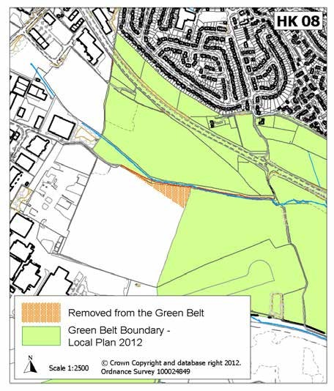

HK11 – Farleys Lane

The Green Belt boundary is to be amended so that it follows the Hucknall Bypass (A611). See H05/3 – Broomhill below. This is to accommodate a residential allocation to meet the long term housing needs of Hucknall.

This small parcel of land does not form part of the housing allocation, but it would be illogical to retain this area as Green Belt, as it no longer serves Green Belt purposes (as set out in the NPPF – shown on page 4 of this document). The A611 will provide a far more robust, defensible boundary in the long term.
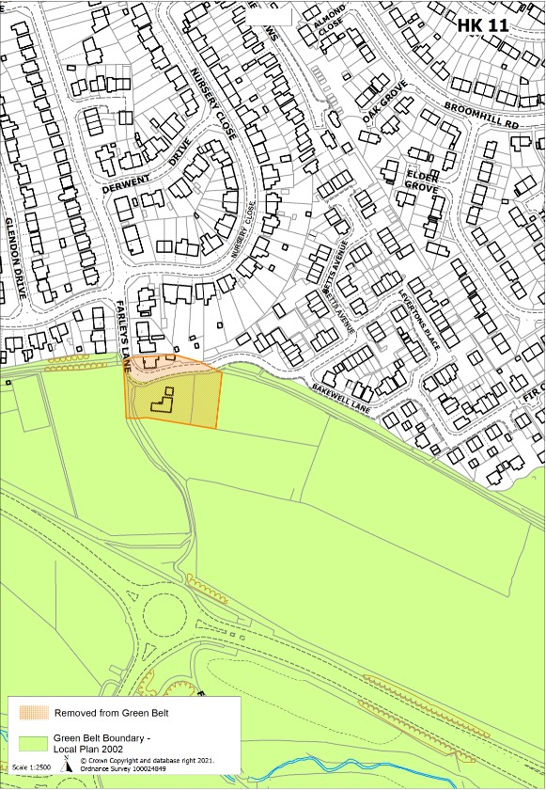

H05/1 – Rear of Shortwood Avenue

The Green Belt boundary is to be amended so that it follows the Hucknall Bypass (A611). This is to accommodate a residential allocation to meet the long term housing needs of Hucknall. The A611 will provide a far more robust, defensible boundary in the long term.

The area will be protected under policy EV5: Protection of Green Spaces and Recreational Facilities. The area is important for several reasons including its effectiveness as a buffer between the existing development and the Hucknall Bypass (A611), and for its visual amenity within the built-up area.
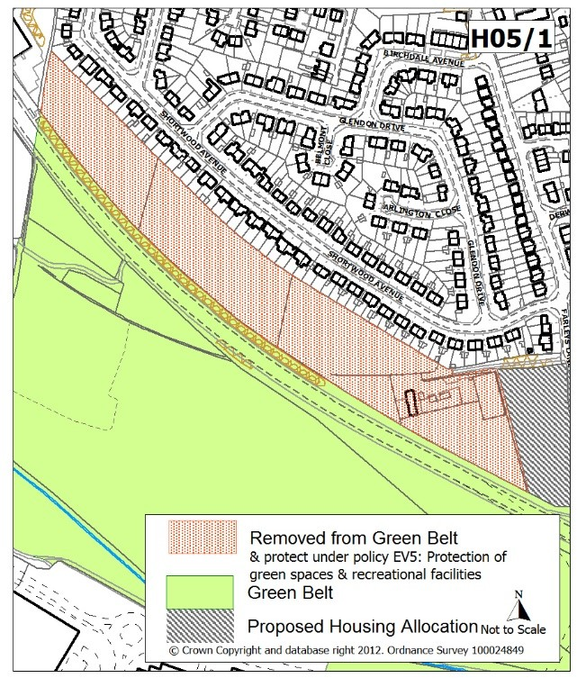

H05/3 – Broomhill

The Green Belt boundary is to be amended so that it follows the Hucknall Bypass (A611). This is to accommodate a residential allocation to meet the housing needs of
Hucknall.

This small parcel of land does not form part of the housing allocation, but it would be illogical to retain this area as Green Belt, as it no longer serves Green Belt purposes (as set out in the NPPF – shown on page 4 of this document). The A611 will provide a far more robust, defensible boundary in the long term.
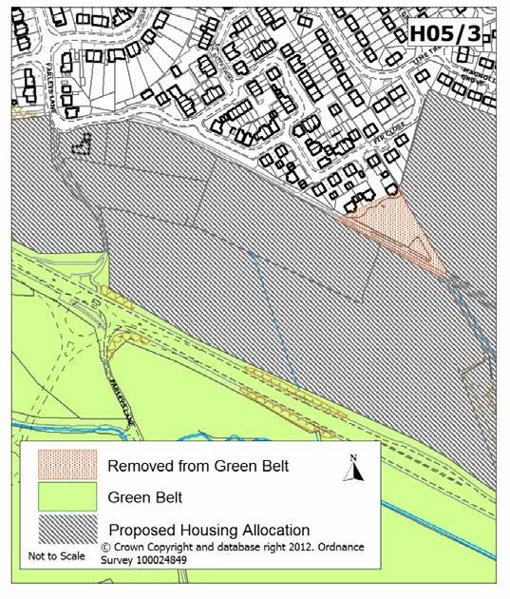

H05/5 – Rear of Nottingham Road

The Green Belt boundary is to be amended so that it follows the Hucknall Bypass (A611). This is to accommodate a residential allocation to meet the long term housing needs of Hucknall.

This small parcel of land does not form part of the housing allocation, but it would be illogical to retain this area as Green Belt, as it no longer serves Green Belt purposes (as set out in the NPPF – shown on page 4 of this document). The A611 will provide a far more robust, defensible boundary in the long term.
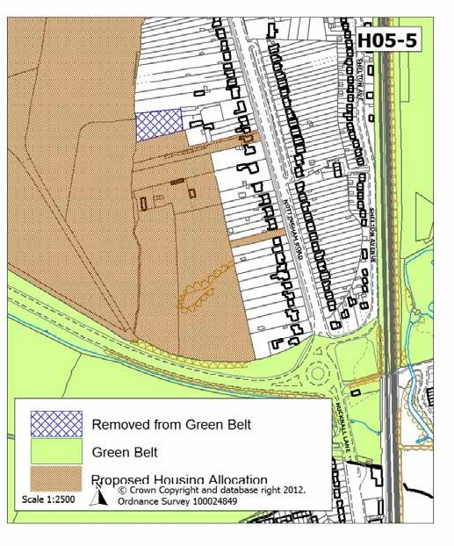

KIRKBY WOODHOUSE

AN19 - Main Road, Kirkby Woodhouse

Planning permission was granted for an extension to the car sales forecourt on Main Road in 2002 (planning application reference V/2002/0386). Consequently, the car sales forecourt is currently partially in the Green Belt. This area is not open in character due to the nature of the business. Therefore, the boundary will be amended so that the car sales forecourt is removed from the Green Belt as it is not serving the function of keeping the area open in character. It is proposed that the Green Belt boundary should follow the wall which surrounds the car sales forecourt as this would provide a physical structure to demarcate the Green Belt boundary.

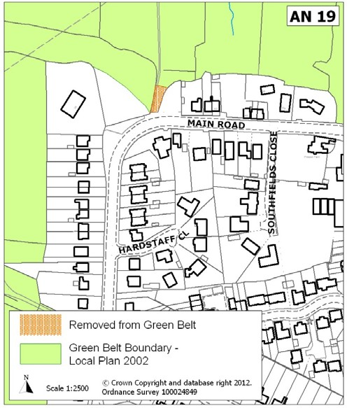

AN21 – Rise Hill

The Green Belt boundary will be amended at 7 Rise Hill. An extension has been built since the last Green Belt Review was undertaken in 1999 (planning application V/1997/0466 - the property received full planning permission in August 1997 for the extension). This has now resulted in the Green Belt boundary cutting through the centre of the dwelling which has impacted on the open character of the Green Belt. It is therefore considered that there are exceptional circumstances to amend the Green Belt boundary at this location. As such, the Green Belt boundary will be moved so that it aligns with the gable end of the extension to the north.

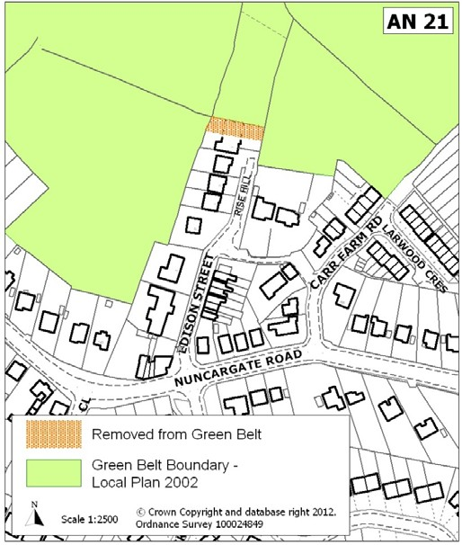

AN10 - Forest Road, Annesley Woodhouse

The site lies to the south of Annesley and encompasses three small fields and privately owned redundant allotments. For the purposes of consistency, it was thought more appropriate to follow the Green Belt boundary along the rear boundaries of the existing properties and as the area is regarded as being open in character it therefore serves a Green Belt function. The Green Belt boundary will be amended to closely follow the boundaries of the rear gardens of properties 33 to 67 Forest Road, and the redundant allotments to include the site in the Green Belt.
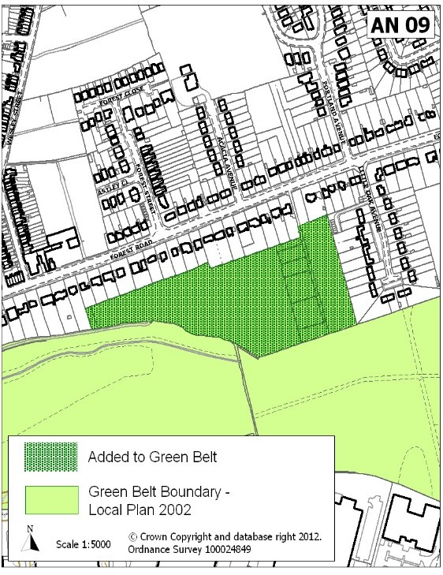

SHERWOOD BUSINESS PARK

SB04 – Land East of Willow Drive

The Green Belt boundary will be amended so that it follows the public highway/driveways of industrial buildings at Sherwood Business Park. The Green Belt boundary is currently based on the original planning application for Sherwood Business Park (Ref.
V/1995/0012). Now that the business park has been fully developed it is apparent that the Green Belt boundary does not follow a physical feature on the ground. Therefore, in order to address this the Green Belt boundary will be aligned with the public highway/driveways. It is considered that the special circumstances for this change relate to the fact that an accurate Green Belt boundary could not be defined until Sherwood Business Park was fully developed
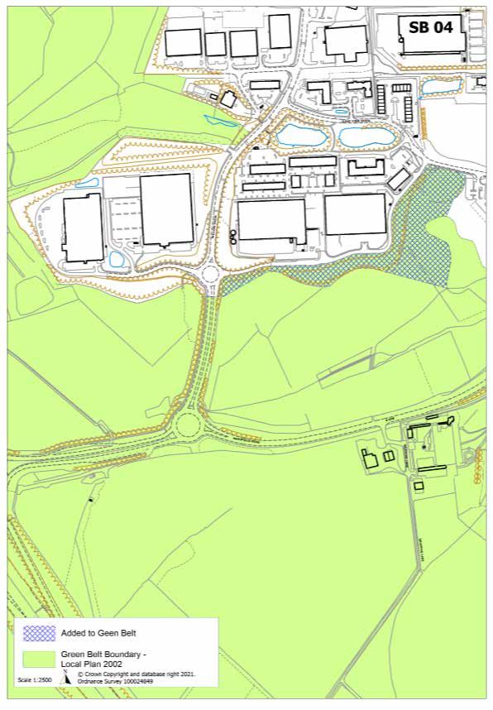

UNDERWOOD

UW08 - Hill Farm

The Green Belt boundary is largely defensible in this area and tightly follows the buildings in the north as no suitable alternative exists which would maintain the openness satisfactorily (the next defensible boundary would be to retract the Green Belt to include a substantial garden into the settlement envelope). However, it is noted that 153 Main Road was extended in 1991, prior to the Green Belt boundary being re-drafted in 1999. The extension does not appear on the map bases, resulting in an error on the 2002 Ashfield Local Plan Proposals Map. Part of the dwelling is therefore currently located within Green Belt and a minor amendment will be made to address this issue.
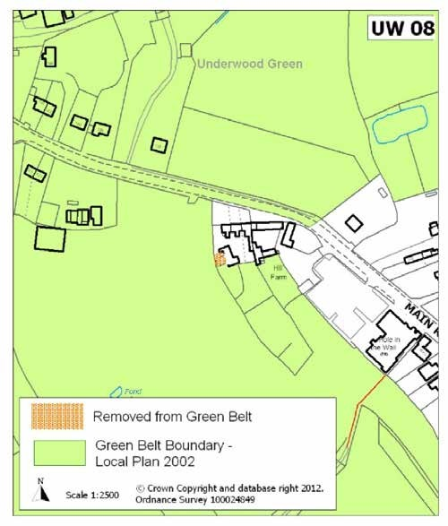

SELSTON

SG11 – Green Farm, Church Lane

The character of Selston Green to the north of Church Lane reflects, in terms of the plan form, a roadside village development. There has been residential infilling in this area but a line of dwellings to the north of Church Lane remains the dominant character of the area. New dwellings have been constructed to the rear of 5 Church Lane and no.s 17 & 19 Church Lane, these change the character of the immediate area. The Green Belt boundary will be amended to reflect the physical boundaries of the new dwellings.
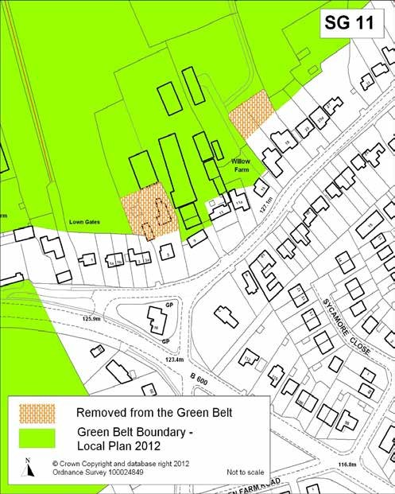

ST14 - Land forming part of the grounds of Wren Hall, Nottingham Road

The character of Wren Hall has changed over time and taken with the completion of the two storey extension to Wren Hall (2010/0273) it is considered that this constitutes an exceptional circumstance which justifies a change to the Green Belt boundary. Given the character of this part of Selston, with its ribbon type development along Nottingham Road and with a tight Green Belt boundary reflecting the edge of the settlement the boundary will be amended to include the formal gardens of Wren Hall in the urban area.
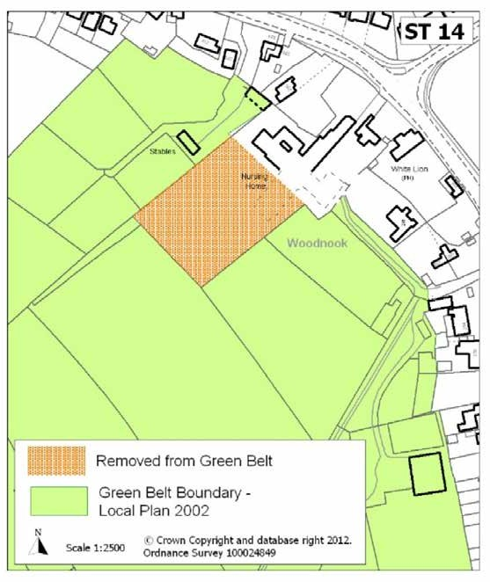

ST24- South of Lilley Close

The Green Belt boundary was amended to “Nottingham Road West” (See Technical Paper 1999) under the Ashfield Local Plan Review 2002. There appears to have been a drafting error in relation to land adjacent to the property at 10 Lilley Close, which was taken out of Green Belt but for which there are no physical boundaries to the amendment. Therefore, the Green Belt will be amended to follow the side and rear boundary to the garden of 10 Lilley Close and the hedge to the boundary of the land to the rear of 68 Nottingham Road and as such a small area of land will be returned to Green Belt.
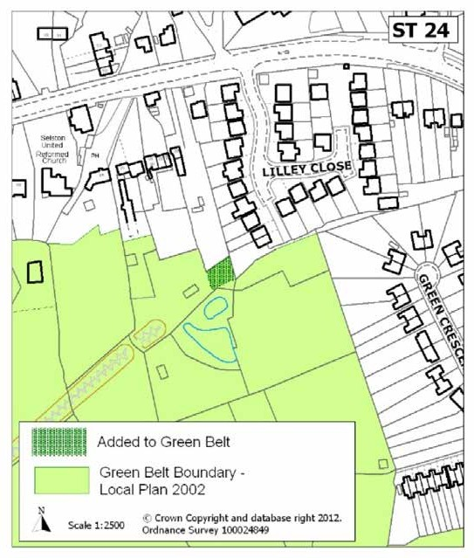

SG15 - Broom Close Farm, Church Lane

The existing Green Belt boundary follows a stepped course between agricultural buildings that may have been erected since the Green Belt boundary was initially established. The Green Belt boundary will be amended so that it follows a line from the existing Green Belt boundary to the rear of 139 & 141 Church Lane across the Farm. The boundary will follow the brick wall of the stable block & the gable end of the adjacent stable block before taking a straight line across the yard to intersect with the current Green Belt boundary, which runs to the north-eastern side of the access drive to the Farm. This results in a small additional area of land being included in the Green Belt.
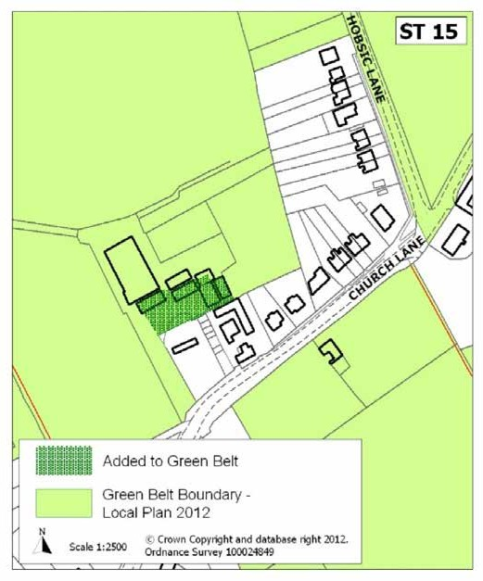

S03/7 – Land off Meadow View

The existing Green Belt boundary is demarcated by a brook/drain in the majority of this area. However, the brook/drain has been re-directed and therefore there is no physical boundary on the ground. Furthermore, the land to the rear of the properties on Meadow View has been allocated for residential purposes to meet the long term housing needs of the rural area.

This small parcel of land does not form part of the housing allocation, but it would be illogical to retain this area as Green Belt, as it no longer serves Green Belt purposes (as set out in the NPPF).
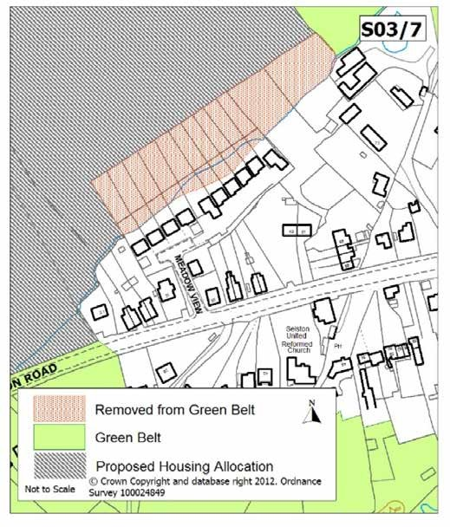

S03/9 – Land off Stoney Lane, Selston

The Green Belt boundary is to be amended so that it follows a belt of mature trees and a stream to the northwest. This is to accommodate a residential allocation to help meet the long term housing needs of the rural area.

This small parcel of land does not form part of the housing allocation, but it would be illogical to retain this area as Green Belt, as it no longer serves Green Belt purposes (as set out in the NPPF).
