Annual Monitoring Report

2022 to 2023

CONTENTS Page
District Background 1
Figure 1 – Map of the District 1
Census 2021 2
Table 1 – Population Change 3
The Index of Multiple Deprivation 4
Figure 2 - Ashfield Map of deprivation 4
Health and Happiness 6
Table 2 – Health 6
HOMES AND HOUSING 7
Table 3 – Housing 7
Affordable Home Acquisitions and Losses 7
Table 4 – Affordable Housing 7

ECONOMIC GROWTH AND PLACE 8

Flood Risk 8

Planning Application 8

Table 5 – Planning Application 8

Table 6 – Major Application 9

Table 7 -Minor Applications 9

Planning Appeals 9

Table 8 – Planning Appeals 9

Regeneration 11
Table 9 – External funding for regeneration 11
Developer Contributions 12
Table 10 – Developer Contributions 12
Table 11 – The Economy 12

Employment 13

NEIGHBOURHOOD 14
Table 12-Recorded Crime 14
Ashfield’s Local Plan 15
Ashfield Local Plan Review 2002 15
Planning Contributions 14

Statement of Community Involvement (SCI) 15

The Emerging Local Plan 16

Ashfield Social Value Policy 18

District Background
Ashfield is ideally situated in the heart of the country, situated on the M1 directly between the cities of Nottingham, Derby and Sheffield. Nestled on the edge of beautiful countryside, with three towns and a number of rural villages it is renowned for its welcoming, supportive and passionate communities. The area is complemented by a wide variety of award-winning parks and outdoor spaces, a range of sporting facilities, educational activities, cafes and natural environments to relax and enjoy.
The three town centres in Ashfield; Hucknall, Kirkby and Sutton provide a great variety of shops and services. With low cost, easy to access parking and well served by public transport links. Hucknall is on the NET Nottingham tram network and is the most northerly stop on the green line. There are three railway stations in the district, along the Robin Hood line, connecting with Worksop (to the North) and Nottingham (to the South).
Rich in natural, cultural and industrial heritage, Ashfield is the home of a number of historical and cultural/ literary figures, most notably Lord Byron and his daughter Ada Lovelace, regarded as being the first ever computer programmer. The area has miles of way-marked rural walks, cycle paths and bridleways nestled amongst wooded areas and open countryside. Areas of countryside within the district are much of what D. H. Lawrence referred to as “The country of my heart” and based many of his novels around the places and families of the area. The villages of Jacksdale, Underwood, Bagthorpe, Lower Bagthorpe, Selston, Annesley, Ravenshead, Newstead, Linby and Papplewick are set within the Hidden Valleys landscape.
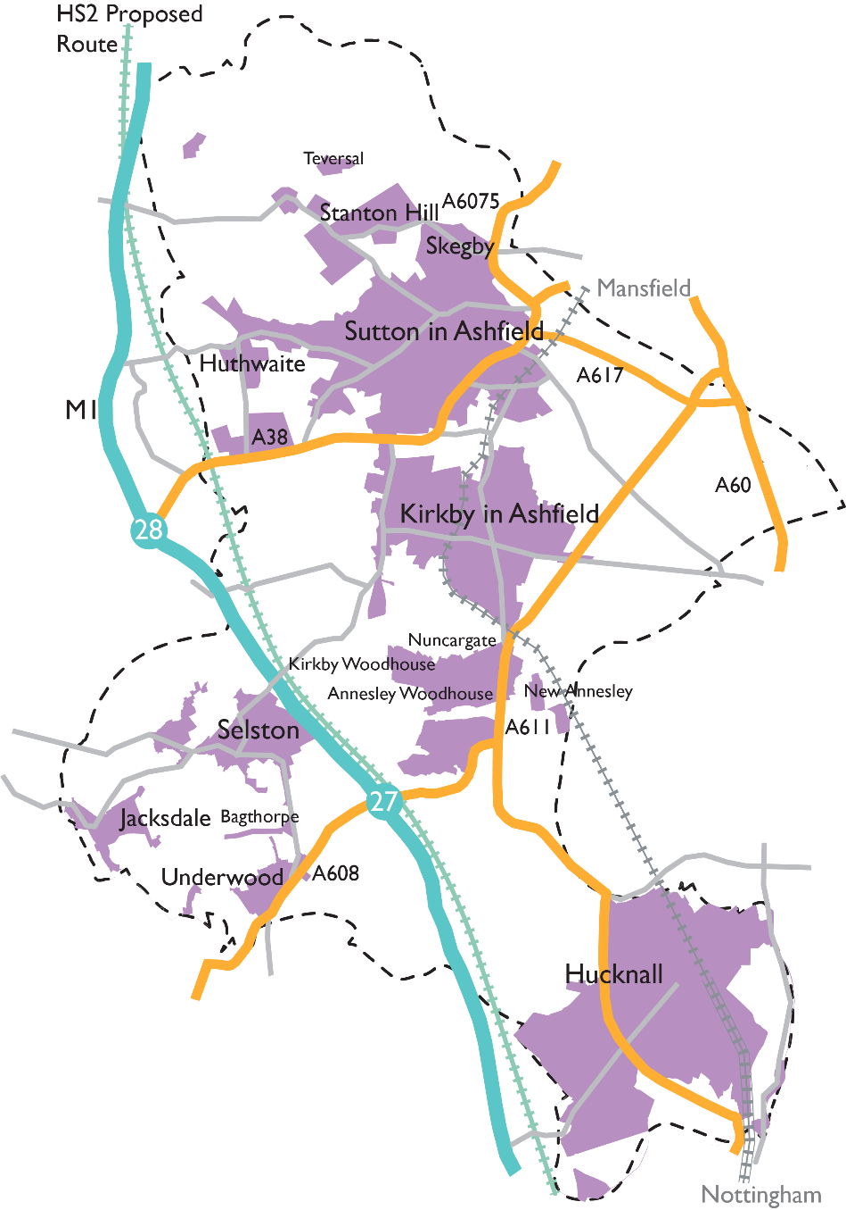

Figure 1 Map of the district

CENSUS 2021
In Ashfield, the population size has increased by 5.7%, from 119,497 in 2011 to 126,305 in 2021. This is lower than the overall increase for England with a 6.6% increase. The increase for the East Midlands is 7.7%.
There were 54,500 households with at least one resident, an increase of 3,600 since 2011.
There are 1,153 people per square kilometre, 1,091 in 2011

Age
The median age on Census day was 42 years, 41 in 2011
61.7% of the population are aged 16-65, an increase of 1.8% from 2011
19.7% of the population are over 65 an increase of 22.5% from 2011
18.6% are 15 years or younger, an increase of 4% from 2011
The United Kingdom was the place of birth of 94.3% of the resident population.

Households
66.3% are single family households
29.4% are one person households
4.3% are other household types
43.6% of people aged over 16 are living as a couple (47.9% in 2011)
17.6% are co-habiting (14.5% in 2011)
23.1% not living as a couple: single (21.3% in 2011)

Ethnicity
95.1% of the population identified as White (97.7% in 2011)
1.6% identified as Asian or Asian British (0.9% in 2011)
1.2% identified as Black, Black British, Caribbean, or African (0.4% in 2011
1.6% identified as Mixed or Multiple ethnic groups (0.9% in 2011)
0.4% identified as other ethnic group (0.1% in 2011)

Religion
50.3% have no religion (33.8% in 2011)
42% identified as Christian (58.2% in 2011)

Language
96.4% of households had English as their main language
1.9% of households had had no people who have English as a main language

Table 1 The Population of Ashfield Census 2011 and Census 2021

Population 2022

 | All People | Aged 0-17 | Aged 18-64 | Aged 65+
Ashfield | 127,200 | 20.8% | 59.3% | 20%
East Midlands | 4,934,900 | 20.3% | 60% | 19.7%

The Index of Multiple Deprivation
A revised Index of Deprivation was released in 2019.
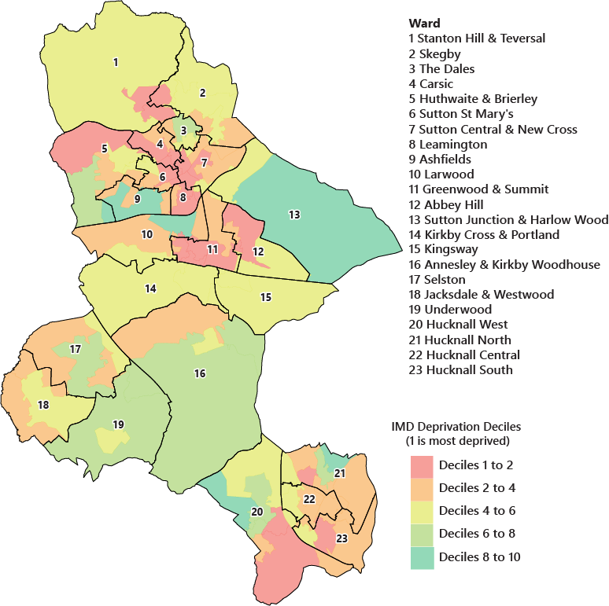
The index measures the overall prevalence of deprivation in Local Authorities and small areas (Lower Super Output Area’s) based on 7 domains.
Figure 2 Map showing the Index of Multiple Deprivation 2019
- Health
- Income
- Employment
- Education
- Crime
- Living environment
- Barriers to housing and Services
There are also two sub-groups concerning older people and children.
Based on the domain scores each area is given an overall score. These scores are then ranked nationally. 1 is the most deprived. The district of Ashfield is ranked 63rd out of 317 local authorities. As a comparison, Rushcliffe Borough Council in the south of Nottinghamshire is ranked 314.
The most deprived area in the district is the Leamington Estate in Sutton in Ashfield and the least deprived the Ashfields Estate also in Sutton in Ashfield. However, this description does not apply to every person living in these areas. Many non-deprived people live in deprived areas, and many deprived people live in non-deprived areas. It is important to note that the IoD2019 is designed to identify and measure specific aspects of deprivation, rather than measures of affluence.
To explore the Index of Multiple Deprivation further, click this link here.

Health and Happiness
The picture of the health of Ashfield is not overall positive, but trends of life expectancy, adult obesity, children in poverty, and, in particular, smoking prevalence have improved over recent years.
Health Data | Period | Ashfield |  | East Midlands
Obesity Aged 10-11** | 2022-2023 | 24.5% | é | 22.6% | é
Overweight or obese adults | 2021-2022 | 70.8% | é | 67% | é
Children in low-income families* | 2021-2022 | 23.9% | é | 21% | é
Life expectancy at birth – male *** | 2020-21 | 78.2 | ê | 79.2 | ê
Life expectancy at birth – female*** | 2020-21 | 81.5 | ê | 82.7 | ê
Life expectancy at age 65 – male *** | 2018-20 | 17.6 | ê | 18.5 | ê
Life expectancy at age 65 – female *** | 2018-20 | 19.9 | ê | 20.8 | ê
Percentage adults who are active**** | 2021-2022 | 61.4% | ê | 66.3% | ê
Percentage adults who are inactive**** | 2021-2022 | 23.8% | ê | 22.9% | ê
Fast food outlets per 1000 population** | 2021 | 0.958 | ê | 0.926 | é
Smoking prevalence in adults (18+) (2020 definition)** | 2022 | 11.3% | é | 14% | é
Winter mortality index** | 2020-2021 | 44.5 |  | 34.5
Table 2 - Health

* Relative poverty, below 60% of the average income *** Office for National Statistics
** Public Health England **** Sport England

The District and our communities are changing, and we recognise the need to build stronger, more resilient communities that can come together to provide help and support to each other. It also means focusing on some of our most deprived neighbourhoods to make sure that everyone has the same opportunities to achieve their goals and lead happy and healthy lives.

HOMES AND HOUSING
Many homes in the district are owner occupied and in good condition. The Council is proactive in supporting owners to return empty properties back to occupation and fixing signs of disrepair.
- Ashfield has 57,662 homes (from Council Tax). 7% of these properties are in Band D and 54% in Band A. Across the East Midlands band D contains 10.8% of properties and Band A 37%

Housing Data | Period | Ashfield |  | East Midlands
Average house price | 2023 Q1 | £203,229 | é | £271,319 | é
Mean monthly private rent | 2022-2023 | £620 | é | £698 | é
Affordability ratio* | 2022 | 1:5.85 | ê | 1:7.5 | ê
Table 3 - Housing

*Median house price to median earnings

Affordable Home Acquisitions and Losses
2022-23 | Loss | Gain
Right to Buy scheme | 21 ê | -
New build owned & built by Ashfield District Council | - | 62 é
New build from developer contributions transferred to Ashfield District Council | - | 0 é
Acquisitions from the private sector | - | 15 é

- In the private sector there were 351 net housing completions in 2022-2023, a decrease in 61 homes from 2021-22
- 46 affordable homes were delivered by developer contributions, up from 124 in 2021-22
- Further information on housing development in the district can be found in the Annual Housing Monitoring Report 2022

Table 4 – Affordable Housing

ECONOMIC GROWTH AND PLACE

Planning and Development Management
Ashfield handles planning applications for home improvements and large-scale commercial projects in the Ashfield area.
There are many types of application ranging from householder questionnaires to find if permission is required and permission for work to trees, to large commercial applications such as the recent Amazon warehouse development in Sutton in Ashfield. Each one must be considered on its economic, environmental, community and legal merit. In 2022-23 Ashfield received 1,095
valid applications.

Planning Applications 2022-23

Application Type | Applications Received | Applications Decided
Full Planning Application | 490 | 519
Householder Questionnaire | 72 | 73
Pre-Application Enquiry | 139 | 137
Approval of details | 128 | 107
Trees | 52 | 55
Prior Approval | 47 | 48
Telecoms | 40 | 37
Advertisements | 13 | 16
Other Applications | 114 | 193
TOTAL | 1095 | 1085

88
Table 5 – Planning Applications

Flood Risk
Planning applications are referred to the Environment Agency if they are in Flood Zones. In 2022-2023 Planning received objections from the Environment Agency regarding flood risks in 4 applications:
V/2022/0393 – Environment Agency advice followed; permission granted.

V/2022/0841– Environment Agency advice followed; permission granted.

V/2021/0777 – Decision Pending.

V/2022/0066 – Decision Pending.

Application Type | Decision | Granted
Major Dwelling* | 12 | 7
Major Office or Light Industry | 1 | 0
Major General Industry | 4 | 4
Major Retail or Services | 0 | 0  Table 6 – Major Applications
*10 or more dwellings
Application Type | Decision | Granted
Minor Dwelling* | 111 | 68
Minor Office or Light Industry | 6 | 6
Minor General Industry | 18 | 11
Minor Retail or Services | 22 | 14
Table 7 – Minor Applications

Planning Appeals
In 2022-23 there were 14 appeals against planning decisions, of which 5 were allowed.
Application Reference | Proposal | Decision
V/2020/0346 | Extension and Alterations to Existing Livestock Building | DISMISSED
V/2020/0346 | Extension and Alterations to Existing Livestock Building | DISMISSED
V/2021/0090 | Erection of a B8 Unit with Ancillary Trade Counter | DISMISSED
V/2021/0400 | Application to Vary Conditons 6 - External Seating and 7- Patio Door Access of Planning Permission V/2018/0110 | DISMISSED
V/2021/0454 | Agricultural Storage Barn | ALLOWED
V/2021/0567 | Install Replacement Windows and Doors | DISMISSED
V/2021/0639 | Change of Use From 2 x C3 Dwellings into 1 x Sui-Generis 10 Bedroom HMO Including Erection of Single Storey Extension to Rear | ALLOWED
V/2021/0681 | Proposed Re-Use and Conversion of Stone Built Stable Building to a Dwelling (2 Bedroom) | ALLOWED

Table 8 – Planning Appeals
Table 8 – Planning Appeals continued
Application Reference | Proposal | Decision
V/2021/0756 | Application to Vary Condition 2 of Planning Permission V/2021/0066 - Seeking to Change the Facing Materials For This New Building | ALLOWED
V/2021/0770 | 4 x Skylight Windows to Roof | ALLOWED
V/2021/0902 | Outline Application with Some Matters Reserved for a Maximum of 9 Dwellings and Associated Access | DISMISSED
V/2022/0203 | Removal of Integral Garages to Plots 1 & 3 to Create Habitable Room and Two Detached Garages. | DISMISSED
V/2022/0598 | Two Storey Side Extension | DISMISSED
V/2022/0630 | Two Storey Side & Single Storey Rear Extension and Loft Conversion and Rendering to Dwelling | DISMISSED

Regeneration
The Council with its partners has developed a business case for the reopening of the freight-only line between the Robin Hood Line in Nottinghamshire and the Erewash Valley Line in Derbyshire (between Kirkby Lane End and Ironville Junctions) and convert it to carry passenger train.
The business case is supported by Ashfield and Mansfield Station Masterplans which identify development and place making improvement opportunities arising from locations near Kirkby-in-Ashfield and Sutton Parkway Stations.
Additional work is being undertaken to investigate the economic, social, and environmental benefits of providing additional station platforms at both Kingsmill and Selston (Jubilee), building on recent Maid Marian Line studies by AECOM and Systra on behalf of Nottinghamshire Councils.
An Ashfield Economic Recovery Plan was commissioned by the Council to inform how town centres and employment are supported post pandemic.

Ashfield District Council Towns Fund
Kirkby in Ashfield and Sutton in Ashfield were chosen by the government in Autumn 2019, as two of the towns in the UK to receive the governments Towns Fund. The Government set out the three areas of regeneration the Towns Fund will focus on:
- urban regeneration, planning and land use,
- skills and enterprise infrastructure, and
- digital and transport connectivity.
Since then, the Council, together with the Discover Ashfield Board have been working closely with stakeholders including business, education, health, transport, and local elected Members to develop the Kirkby and Sutton Town Investment Plan.
For further information on the Towns Fund click this link

On 8 June 2021 the government announced that it was awarding the Kirkby and Sutton Town Deal £62.6 million. Together with funding secured from the Towns Fund Accelerator Fund (£1.5m) and the Future High Streets Fund, over £70 million has now been secured for Ashfield.

Developer Contributions
Developer contributions, also known as Section 106 payments, are made by a developer to the council to mitigate against additional pressures from development, for example, for education, health care, or transport.
Infrastructure Type | Contributions Received 2022-23
Public Open Space | £736,064.89
Education | $1,762,967.39
Transport | £347,110.59
Health | £557,398.15
Libraries | £2,247.31
Public Realm | £241,702.44
Waste Management | £12,429.77
Tree Planting | £6,000.00
Interest | £44,827.50
TOTAL | £3,710748.04

The Ashfield Economy
The table below shows how the economy of Ashfield compares with that of the wider East Midlands

*1 would mean 1 job for every person of working age
**Jan 2023 – Dec 2023

The table below shows the money received by the council in 2021-22 and what it is ringfenced for. In 2021-22 £4,000,000 more was received than in 2020-21. See page 11 for more information on planning contributions.

Table 10 – Developer Contributions

Economic Data | Ashfield | East Midlands
Median Gross Weekly Pay 2023 | £606 é | £640 é
Job Density 2022* | 0.79 é | 0.81 é
NVQ Level 3 or above 2023 | 53.5% é | 61.9% é
Economic Activity Rate 2021-23 | 68.7% ê | 78.4% é
Unemployment Rate ** | 4.9% é | 3.7% é

Table 11 – The Economy

EMPLOYMENT
Ashfield District Council and its partners are committed to increasing the number of higher skilled/higher paid jobs in Ashfield. Doing this will benefit the local economy, as people spend their greater disposable income in shops and with other local services. This will also assist the reputation of Ashfield as a location of choice for investors, where all of their employment and supply chain needs can be met.

For an in depth understanding of Ashfield’s economy in the East Midlands context follow this link.

Ashfield Local Plan Review 2002
The Council’s Employment Land Monitoring Report details change in the business space landscape over time. Land is available in Ashfield through sites allocated for employment purposes in the Ashfield Local Plan Review 2002 or through planning permissions for new development sites. The employment land position is set out in the Employment Land Monitoring Report 2023 which can be viewed here.

Land is available in Ashfield through sites allocated for employment purposes in the ALPR 2002 or through planning permissions for new development sites.
The following land has been developed on employment allocations during the year:
- Castlewood Grange Business Park, Plot 1, for a B8 use, comprising an area of 5.0 ha
- Castlewood Grange Business Park, Plot 8, for a B2/B8 use, comprising an area of 2.94 ha
- Butlers Hill, Hucknall (0.72 ha) has implemented planning permission for open storage.
- In relation to other significantly sized units on allocated sites:
- Castlewood Grange Business Park, Plot 10 consent granted for E (g) (iii), B2 and B8 comprising 7,124 sq m on a plot of 2.375 ha. (V/2021/0621). The unit is under construction.
- West of Fulwood has permission on Plot 4, Export Drive, Huthwaite has planning consent for the construction of a warehouse including ancillary offices, totalling 17,706.5 sq m.
- The employment land allocation of Midland Road/ Station Road (Maun Valley) Sutton in Ashfield (ALPR Policy EM1Sj) has been developed for residential purposes.

Further information on the local economy is set out in the following:

- Nottingham Core HMA And Nottingham Outer HMA Employment Land Needs Study 2021.
- Strategic distribution and logistics background paper 2023.
- The Nottinghamshire Core & Outer HMA Logistics Study Final Report 2022.

These studies are available on the Council’s website under ‘emerging local plan’ under the Draft Local Plan Consultation or the evidence base.

NEIGHBOURHOOD
Ashfield is pro-active in encouraging more recycling, tackling environmental crime and finding innovative ways of delivering services that are responsive to the needs of our residents, visitors and businesses.
By working with our communities and businesses the Council is better able to understand what matters and to shape services to help people enjoy living, visiting and working in Ashfield. We will work with our partners to ensure people feel safe and are safe by reducing levels of crime and disorder and anti-social behaviour.

Recorded Crime 2020 to 2023
Category | 2020-2021 | 2021-2022 | 2022-2023
Anti-social behaviour | 5339 | 3378 | 2018
Violent crime | 3864 | 4469 | 4604
Criminal damage arson | 1254 | 1354 | 1348
Shoplifting | 811 | 1105 | 1361
Public order | 773 | 958 | 945
Burglary | 574 | 565 | 490
Other theft | 612 | 650 | 738
Vehicle crime | 448 | 525 | 565
Drugs | 418 | 318 | 282
Other crime | 293 | 292 | 336
Possession of weapons | 113 | 101 | 133
Robbery | 90 | 79 | 90
Bicycle theft | 62 | 94 | 108
Theft from the person | 54 | 51 | 67
The Ashfield recycling rate at 37% in 2021-22 (36.4% in 2020-21) is lower than that for the East Midlands with 42.2 (41.4% in 2020-21).
Ashfield also has 6.4 reported fly tipping incidents per 1000 population, down slightly from last year. This is compared to 16.3 reported per 1000 population in the East midlands.
Overall crime has declined in 2021-2022, though some categories; shoplifting, vehicle crime, possession of weapons, bicycle theft and theft from the person have increased. The table opposite shows the change from 2020-2021.
In 2022-32 there were 90 reported crimes per 1000 population in Ashfield and 92 per 1000 across Nottinghamshire. Both are an increase on the previous year.
The district boasts 5 Green Flag parks, a number maintained for several years, and Neighbourhood Services maintain over 3 km² of land, much of which is grass.
Table 12 – Recorded Crime

Ashfield’s Local Plan

Development Plan
The Development Plan for Ashfield comprises the Ashfield Local Plan Review (November 2002) saved policies, together with the Teversal, Stanton Hill and Skegby Neighbourhood Plan and the Jacksdale, Selston, Underwood, tomorrow (JUSt) Neighbourhood Plan. Therefore, the starting point for decision making on planning applications are the development plan policies set out in the following:
- Ashfield Local Plan Review 2002

- Teversal, Stanton Hill and Skegby Neighbourhood Plan where applicable

- Jacksdale, Selston, Underwood tomorrow (JUSt) Neighbourhood Plan where applicable.

The neighbourhood plan policies will only apply to applications within the relevant neighbourhood plan areas.

The National Planning Policy Framework (NPPF) is a material consideration and may provide reasons why an application for planning permission should be granted notwithstanding the Development Plan. When considering the weight to be given to development plan policies, it is necessary to consider the degree of consistency of policies with the NPPF.

The Waste Local Plan and the Minerals Local Plan are brought forward by Nottinghamshire County Council.

Planning Contributions
The Ashfield Local Plan Review 2002 Policies HG4 Affordable Housing, HG6 Public open space, and TR6 Developer Contribution to Transport Improvements together with policies in the Neighbourhood Plans are the Council’s key policies on planning obligations in the context of negotiations on planning applications. However, they must be seen alongside the NPPF priorities, including changes to the affordable housing requirements and requirements for education, health, and community facilities.
The policies are supplemented by a number of adopted strategies which are available on the Council website under the emerging local plan evidence base.

Further information on planning contributions and the Infrastructure Funding Statement is available on the Council website under Section 106.

Statement of Community Involvement (SCI)
The SCI sets out how the local community can help to shaping the Local Plan, to taking forward a Neighbourhood Plan or be involvement in planning applications and permission in principle. It is available at Statement of Community Involvement.

The Statement of Community Involvement (SCI) was adopted in 2020. At this time, it is not anticipated that any amendments will be required to the SCI.

The Emerging Local Plan -
The Local Plan 2020 to 2038
(Information on the emerging Local Plan is up to 15th December 2022)

Emerging Local Plan
A Draft Local Plan was consulted on under Regulation 18 of the Town and Country Planning (Local Planning)(England) Regulations, as amended, from 4th October to 16th November 2021. All available and deliverable brownfield sites were included within the Draft Local Plan.

During the Regulation 18 Consultation, the Prime Minister at the Conservative Party Conference stated:

‘….you can also see how much room there is to build the homes that young families need in this country not on green fields not just jammed in the south east but beautiful homes on brownfield sites in places where homes make sense.’

The Plan was paused by the Council to clarify the implications of meeting the housing need for Ashfield purely on brownfield sites. This reflected that the Council could not meet the identified

housing need derived from the Government’s standard method formula set out in national planning practice guidance on brownfield sites. The Council has sought clarification from the Department for Levelling up Housing & Communities (DLUHC) regarding the issues around brownfield land, greenfield sites and Green Belt release, in relation to the implications for the emerging plan in Ashfield District. In addition, questions over infrastructure provision were raised together with the continuing ambiguity over the possible potential Special Protection Areas for Sherwood Forest in relation to the conservation of wild birds.

The responses from the DLUHC reflected the position set out in the current NPPF and national planning practice guidance. They identified that local circumstances and constraints, such as Green Belt, can be taken into account. However, it was also identified that each Local Plan is subject to a rigorous independent examination by a Planning Inspector on behalf of the Secretary of State to ensure the Plan is sound and accords with national planning policy.

During the Conservative Party Leadership campaign in the summer, statements made by both candidates supporting that there will be future changes to the planning system particularly in relation to ‘housing targets’ and the protection of the Green Belt.

In relation to housing targets, the then Prime Minister, The Rt Hon Elizabeth Truss, in press reports, set out that her intension is to “put power back in local councillors’ hands who know far better than Whitehall what their communities want.” She has also stated that "I want to abolish the top-down, Whitehall inspired Stalinist housing targets," which "I think that's the wrong way to generate economic growth." The Prime Minister also highlighted the importance of the Green Belt. Reflecting the statements by The Rt Hon Elizabeth Truss, the Council has determined to take forward a revised Local Plan reflecting the national pronouncements by the then Prime Minister, on the Green Belt and housing numbers whilst continuing to emphasis the location advantages of Ashfield for employment and the skills growth associated with the Plan.

The implication of this decision for the Ashfield Local Plan is that the impact on the Green Belt from proposed housing allocations should be reduced and a lower number of houses should be taken forward as part of the emerging Local Plan. After considering the responses from the Draft Local Plan Consultation, the Council has determined in principle to take forward a Local Plan to a Regulation 19 Consultation but it does not include the proposed new settlements allocations at Whyburn Farm, Hucknall and Cauldwell Road/Derby Road, Sutton in Ashfield. It is emphasised that this decision in principle is subject to the consideration of the Sustainability Appraisal of the proposed changes to the draft Local Plan.

Further information on the approach adopted by the Council to the emerging Local Plan is available on the Council’s website in relation to:

- The Local Plan Development Panel 23rd September 2022.
- The Cabinet Meeting of 27th September 2022.
- The Cabinet Meeting of 13th December 2022.

Browse Meetings.

In relation to the evidence base the following studies/assessments have been completed:
- Ashfield Town Centre / Local Centre Study 2023
- Brownfield Land Capacity Assessment reviews the supply of brownfield land within the district that could potentially be brought forward for development.
- Infrastructure delivery plan sets out the infrastructure required to support the growth proposed in the emerging Ashfield Local Plan 2023 - 2040.
Additional studies have been commission including a Whole Plan Viability Assessment, Heritage Impact Asset and Habitat Regulations Assessment

The Council continues to work proactively with infrastructure and service providers.

Further information on the draft Local Plan, its supporting background papers and evidence base is available on the Council’s website at Emerging Local Plan.

Ashfield Social Value Policy
The Council’s Corporate Social Value Policy sets out the Council’s commitment to social value and the added benefits that can be gained from projects and public procurement, specifically for the social, economic and environmental benefit of local people living in the local area.

The Policy identifies that it is important for Ashfield District Council to know and understand what is being delivered so that we can understand where we need to concentrate improvement on. The draft Local Plan consultation document included a social value policy and the Council has been involved with the Social Value Task Force in the development of the policy approach.

Queries
If you have any queries regarding the emerging Local Plan officers in Forward Planning Team can be contacted by:
- email: localplan@ashfield.gov.uk
- Telephone: 01623 457381 or 457382 or 457383

