2020 Air Quality Annual Status Report (ASR)

For Ashfield District Council
In fulfillment of Part IV of the Environment Act 1995
Local Air Quality Management
29th October 2020

For Ashfield District Council

Local Authority  Officer | Steve Fell  Senior Environmental Protection Technician
Department | Place and Community
Address | Ashfield District Council Urban Road  Kirkby-in-Ashfield  Nottinghamshire NG17 8DA
Telephone | 01623 457416
e-mail | s.fell@ashfield.gov.uk
Report Reference Number | ADC/ASR (1) 2020
Date | 29th October 2020

Ashfield District Council

Executive Summary - Air Quality in Our Area

Air Quality in Ashfield

Air pollution is associated with a number of adverse health impacts. It is recognised as a contributing factor in the onset of heart disease and cancer. Additionally, air pollution particularly affects the most vulnerable in society: children and older people, and those with heart and lung conditions. There is also often a strong correlation with equalities issues, because areas with poor air quality are also often the less affluent areas1,2.
The annual health cost to society of the impacts of particulate matter alone in the UK is estimated to be around £16 billion3.

Since 2003 Ashfield District Council has undertaken monitoring of the air quality within the district under the Local Air Quality Management regime and reports back to DEFRA. Fortunately, Ashfield District Council has been able to consistently meet the Air Quality Objectives set by National Government in relation to Local Air Quality Management.

In 2018 the Authority had to undertake a feasibility study for DEFRA following a Ministerial direction due to an exceedance of an Air Quality Objective along a stretch of the A38. The exceedance was based on the roadside Nitrogen Dioxide concentration and was identified by the governments Climate Pollution Mapping Model. Defra accepted the conclusions highlighted within the feasibility study, however despite this the Authority has continued to monitor the air quality along the A38 and the trend is down at Fullwood Cutting the location originally identified by the Ministerial direction.

1 Environmental equity, air quality, socioeconomic status and respiratory health, 2010
2 Air quality and social deprivation in the UK: an environmental inequalities analysis, 2006
3 Defra. Abatement cost guidance for valuing changes in air quality, May 2013

The District of Ashfield is a Smoke Control Area and the Environmental Protection Team at Ashfield District Council use the Clean Air Act Legislation to control the levels of air pollution from domestic, commercial and industrial combustion activities. In addition, air pollution within the district from key industrial processes is regulated by the Environmental Permitting (England and Wales) Regulations 2016.

The Trans-boundary nature of air pollution sources and episodes make it a prerequisite that Ashfield District Council works with partner organisations to control air pollution problems and develop strategies for reducing levels of detrimental air pollution. These partner organisations include the Environment Agency, Pubic Health England and the neighbouring Nottinghamshire Authorities through the work of the Nottinghamshire Environmental Protection Working Group and at the regional level through the work of the East Midlands Air Quality Network. In 2018 we worked jointly with Bolsover District Council after the Government issued a Ministerial direction in February 2018, both Authorities had an exceedance of an Air Quality Objective based on the Climate Pollution Mapping Model along a stretch of the A38

This report focuses on monitoring data collected during 2019 and again the District of Ashfield continues to meet the air quality objectives set by National Government in relation to Local Air Quality Management. However, this is not the case nationally and now local authorities are also being asked to report on actions and initiatives they are undertaking to improve local and regional air quality.

Actions to Improve Air Quality

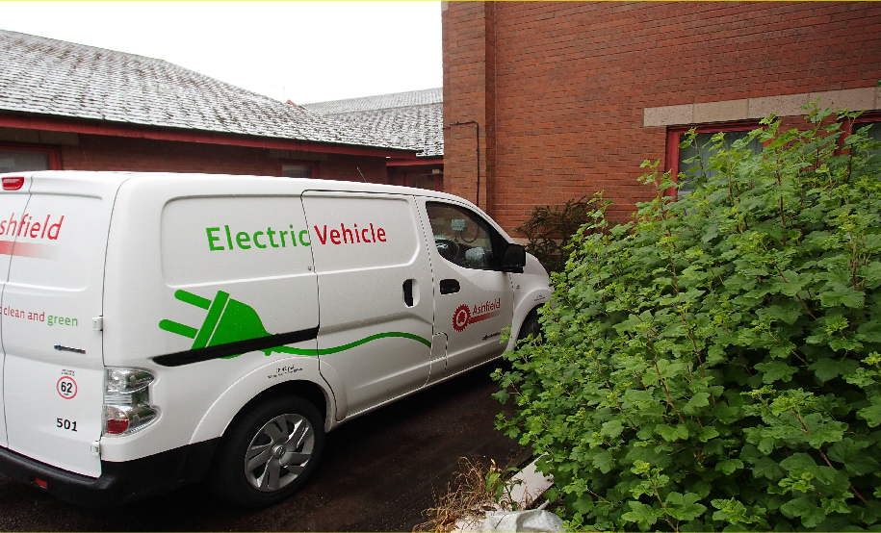

Ashfield District Council has not had to declare an AQMA but it is still important for the Council to take steps to address air quality within the District.

- Over the last year the new draft Nottinghamshire Air Quality Strategy has now been reviewed and amended by the public health teams at Nottinghamshire County Council and Nottingham City Council in addition to the Environmental Health Chief Officers group. It is currently awaiting an official launch.

- As an Authority Ashfield District Council has promoted the use of more sustainable forms of transport within in its operational fleet, as a means of reducing the effects of detrimental Air Quality. The Council started to use electric bin lifts, fitted to its refuse collection vehicles in 2011 and now operates 14 vehicles, 70% of its refuse collection vehicles. The Council obtained its first full electric van in 2015 and continues to evaluate the opportunity to convert further vehicles to hybrid or full electric as they become widely available from the vehicle manufactures. There have been no changes to the transport fleet during 2019 whilst the service has been undergoing a comprehensive review. Transport fleet renewals are now being looked at providing an opportunity to increase the Electric or Hybrid Fleet. All new van renewals are to the Euro 6 Standard for engines.

- The Council supports the bikes to work scheme for all employees and provide facilities to encourage employees to cycle to work.

- As already stated the Council will continue to enforce all legislation aimed at reducing air pollution and it will continue to make assessments of all new commercial, industrial and large domestic housing projects that apply for planning approval.

Conclusions and Priorities

During 2019 the District of Ashfield continued to meet the air quality objectives set by National Government based on monitoring data, however this is not the case nationally and now local authorities are also being asked to report on actions and initiatives they are undertaking to improve local and regional air quality

Despite Ashfield District Council not having any AQMA’s our priority is to continue working with partners such as Public Health England to develop public engagement in light of the health issues associated with detrimental air quality and with neighbouring Nottinghamshire Authorities and Nottinghamshire County Council to implement the updated Nottinghamshire Air Quality Strategy.

Promoting public awareness of air pollution and the actions that individuals can take to reduce air pollution should help to ensure that the levels of Air Pollution within the District of Ashfield continue to the meet National Air Quality Objectives. It is important that the health effects of detrimental air quality are conveyed to the public and highlight to the public that even lower levels of air pollutants can affect public health

In Hucknall the District borders the Nottingham Clean Air Zone and our engagement with Public Health England and the work with the Nottinghamshire Environmental Protection Working Group will help to address this issue. People commuting from neighbouring District Authority areas into Nottingham City can have an impact on their air pollution problems and it again highlights the importance of engaging with the public to promote sustainable transport options.

Local Engagement and How to Get Involved

Residents living or working in Ashfield and Business’s based in Ashfield can take steps to improve local air quality by electing to adjust their life style choices. These changes centre on the increased use of sustainable transport and a reduction in personal car use.

Ashfield has good links to all forms of public transport. The Robin Hood railway line (which runs from Nottingham to Worksop) has stations at Kirkby-in-Ashfield, Sutton Parkway and Hucknall. Hucknall is also a terminus for the Nottingham Express Transit (NET) tram route to Nottingham.

Walking and cycling are both good for an individual’s general health but it also makes a positive contribution to resolving the problems associated with detrimental air quality in congested areas. Contact your local school and enquire whether they operate any group cycling or walking schemes.

When the time comes to replacing your existing vehicle consider purchasing an electric or low emission vehicle. The Government via OLEV (the Office of Low Emission Vehicles) are providing a number of different grant schemes and tax incentives to encourage the general public and business to switch to using electric and low emission vehicles. There are grants available that promote the use of plug in electric cars and vans. Coupled with ‘feed in tariffs’ that enable consumers to get money for generating their own electricity these incentives could help the domestic consumer to reduce the cost of running a car whilst also making a contribution to reducing the levels of anthropogenic air pollution.

There are also incentives through grants and tax incentives to encourage business to switch to electric or low emission vehicles. There is specific grant money available for public transport providers to purchase cleaner, greener buses. In addition to electric and hybrid vehicles the government are also encouraging business to develop the electric charging network.

The whole of the district of Ashfield has been designated a Smoke Control Area under the Clean Air Act 1993 and whilst this places restrictions on the burning of waste by business it does not completely prohibit the burning of waste by householders who can still burn garden waste provided they do not cause nuisance to other residents. All forms of combustion including bonfires can give rise to increases in the levels of particulate both PM10 and PM 2.5 which leads to increases in cardiovascular and respiratory diseases especially within vulnerable groups such as the elderly, children and asthma sufferers. Local residents can contribute to reducing particulates by recycling waste rather than burning it. Ashfield District Council currently offers a garden waste collection scheme using the fortnightly collection of brown/black lidded bins and large quantities of waste can be taken to the household waste recycling centres. They are located at Wigwam lane Hucknall, Sidings Road Kirkby in Ashfield and at Hermitage Lane Mansfield. It is important that Nottinghamshire residents register with Nottinghamshire County Council before using the household waste recycling centres.

Table of Contents

Executive Summary - Air Quality in Our Area 1
Air Quality in Ashfield 1
Actions to Improve Air Quality 3
Conclusions and Priorities 5
Local Engagement and How to Get Involved 6
- Local Air Quality Management 11
- Actions to Improve Air Quality 112
  - Air Quality Management Areas 112
  - Progress and Impact of Measures to address in Air Quality in Ashfield 112
  - PM2.5 Local Authority Approach to Reducing Emissions and or Concentrations 17
- Air Quality Monitoring Data and Comparison with Air Quality Objectives and National Compliance119
  - Summary of Monitoring Undertaken 119
  - Individual Pollutants 119
Appendix A: Monitoring Results 21
Appendix B: Full Monthly Diffusion Tube Results for 2017 27
Appendix C: Supporting Technical Information / Air Quality Monitoring Data QA/QC 28
Appendix D: Maps of Monitoring Locations 44
Appendix E: Diffusion Tube Results Trend Analysis 67
Appendix F: Summary of Air Quality Objectives in England 84
Glossary of Terms 85
References 86

List of Tables

Table 2.1 – Progress on Measures to Improve Air Quality Table A.1– Details of Non - Automatic Monitoring Sites Table A.2– Annual Mean NO2 Monitoring Results
Table B.1 – NO2 Monthly Diffusion Tube Results 2015 - 2019 Table C.1 – Diffusion Tube Bias Adjustment Factor
Table F.1 – Summery of Air Quality Objectives for England

List of Figures

Figure E.1 – Trend Analysis for Nitrogen Dioxide tubes located at Outram Street, Sutton Figure E.2 – Trend Analysis for Nitrogen Dioxide tubes located at Dalestorth Street, Sutton

Figure E.3 – Trend Analysis for Nitrogen Dioxide tubes located at Field Place A38, Sutton Figure E.4 – Trend Analysis for Nitrogen Dioxide tubes located at Church Hill, Kirkby Figure E.5 – Trend Analysis for Nitrogen Dioxide tubes located at M1 Pinxton
Figure E.6 – Trend Analysis for Nitrogen Dioxide tubes located at Station Road, Sutton Figure E.7 – Trend Analysis for Nitrogen Dioxide tubes located at Common Road, Huthwaite Figure E.8 – Trend Analysis for Nitrogen Dioxide tubes located at Badger Box, Annesley Figure E.9 – Trend Analysis for Nitrogen Dioxide tubes located at Croft Primary, Sutton Figure E.10 Trend Analysis for Nitrogen Dioxide tubes located at Stoneyford Court, Sutton Figure E.11 Trend Analysis for Nitrogen Dioxide tubes located at Kirkby Cross
Figure E.12 Trend Analysis for Nitrogen Dioxide tubes located at Mansfield Road, Selston Figure E.13 – Trend Analysis for Nitrogen Dioxide tubes located at Ashgate Road, Hucknall Figure E.14 – Trend Analysis for Nitrogen Dioxide tubes located at Mansfield Road, Sutton Figure E.15 Trend Analysis for Nitrogen Dioxide tubes located at Fullwood Cutting, A38 Sutton Figure E.16 Trend Analysis for Nitrogen Dioxide tubes located at Snipe, A38 Sutton
Figure E.17– Trend Analysis for Nitrogen Dioxide tubes located at Kingsway, Kirkby

Local Air Quality Management

This report provides an overview of air quality in Ashfield during 2019. It fulfils the requirements of Local Air Quality Management (LAQM) as set out in Part IV of the Environment Act (1995) and the relevant Policy and Technical Guidance documents.

The LAQM process places an obligation on all local authorities to regularly review and assess air quality in their areas, and to determine whether or not the air quality objectives are likely to be achieved. Where an exceedance is considered likely the local authority must declare an Air Quality Management Area (AQMA) and prepare an Air Quality Action Plan (AQAP) setting out the measures it intends to put in place in pursuit of the objectives. This Annual Status Report (ASR) is an annual requirement showing the strategies employed by District of Ashfield to improve air quality and any progress that has been made.
The statutory air quality objectives applicable to LAQM in England can be found in Table F.1 in Appendix F.

Actions to Improve Air Quality

Air Quality Management Areas

Air Quality Management Areas (AQMAs) are declared when there is an exceedance or likely exceedance of an air quality objective. After declaration, the authority must prepare an Air Quality Action Plan (AQAP) within 12-18 months setting out measures it intends to put in place in pursuit of the objectives.

Ashfield District Council currently does not have any Air Quality Management Areas. For reference, a map of Ashfield District Council’s monitoring locations is available in Appendix D

Progress and Impact of Measures to address in Air Quality in Ashfield

Defra’s appraisal of last year’s ASR concluded Ashfield District Council have not declared any AQMAs nor do they undertake any automatic monitoring.

Non-automatic (passive) monitoring of NO2 was conducted at 19 sites during 2018. One exceedance of the annual mean objective was measured, however following distance correction to the nearest relevant exposure this was reduced to zero exceedances. Data capture was below 75% at four sites, with data capture good at all other monitoring locations.

QA/QC procedures have been applied with a national bias adjustment factor used. Distance corrections were conducted for sites not representative of relevant exposure. Annualisation was carried out for the sites with data capture <75%. The report provides maps of each monitoring site and a breakdown of historical trend data.

There is detailed discussion of the measures taken during 2018 to tackle air quality. Priorities for the next reporting year are outlined.

On the basis of the evidence provided by the local authority the conclusions reached are acceptable for all sources and pollutants. Following the completion of this report, Ashfield District Council should submit an Annual Status Report in 2020.

Ashfield District Council has taken forward a number of measures during the current reporting Year of 2019 in pursuit of improving air quality. Details of the measures completed, in progress or planned are set out in Table 2.1.

Progress on measure one which was the development of an Air Quality Planning Guidance Document has still not been moved forwards over the last year. The Development of an Air Quality Planning Guidance Document remains an option and Table 2.1 has again been updated with a more realistic timescale. The adoption of the Local Plan is currently a priority for the forward planning team.

Ashfield District Council can confirm that Measure Two which was the development of an updated Nottinghamshire Air Quality Strategy is now achieved. The Strategy document as now been approved by the Public Health Team at Nottinghamshire County Council, the Public Health Team at Nottingham City Council and the Chief Environmental Health Officers group. It is now awaiting a formal launch.

Measure Three is ongoing and through the work of the Nottinghamshire Environmental Protection Working Group the Environmental Protection Team at Ashfield have developed closer working links with the Public Health Team at Nottinghamshire County Council.

Measure four which is a promotional event around National Clean Air Day and which encourages public participation is an ongoing measure. Ashfield District Council undertook a limited event for Clean Air Day in 2019 that focussed on the Clean Air Act legislation. Ashfield is smoke control area and the council were receiving an increasing number of complaints from residents reporting problems with domestic wood burning on exempt appliances and so the Council promoted guidance for burning wood on exempt appliances.

Measures Five and Six were to work with the licencing team on the development of a Taxi Licencing Policy which encompassed incorporation of more stringent emission limits on new taxi licences was not achieved. These measures have been left on the table to progress the measures at a later date.

During 2019 Ashfield District Council used grant money to install electric charging points at four locations within the district.

- At Kings Mill Reservoir in Sutton in Ashfield there are now three charging points available including rapid charging.
- At Yorke Street car park in Hucknall there are now three charging points available including rapid charging.
- At the Council Offices in Kirkby in Ashfield two standard charging point are available.
- At New Street car park in Sutton in Ashfield two standard charging point are available.

In addition the development control team are now both accepting conditions in relation to the installation of infrastructure for charging points and for the installation of charging points. There is an expectation for larger commercial developments to install either the infrastructure for charging points or the charging points as part of planning conditions. An example would be the

expansion of the East Midlands Designer Outlet which as a condition of their planning application installed two standard charging points.
Table 2.1 – Progress on Measures to Improve Air Quality

Mea sure No. | Measure | EU Category | EU Classification | Lead Authority | Planning Phase | Implementation Phase | Key  Perform ance Indicato r | Target Pollution Reduction in the AQMA | Progres s to Date | Estimated Completion Date | Comments
1 | Work with development control to produce an Air Quality Planning Guidance Document | Air Quality Planning and Policy Guidance | Policy Guidance And Development | ADC | 2018 - 2019 | 2019-2021 | N/A | Not Known | None | 2022
2 | Development of a Nottinghamshire Air Quality Strategy |  | Control | Nottingham City | Started | Started September | N/A | Not Known | Approved. | 2020 | Waiting an Official Launch
 |  | Working with |  |  |  | 2016 following a  Second
 |  | Regional Groups to develop Area  Wide |  |  |  | Workshop with Development Control and Lead  Councillors from
 |  | Strategies |  |  |  | Each  Nottinghamshire
 |  |  |  |  |  | Authority
3 |  | Working with | Control |  | Started | Ongoing | N/A | Not Known | Started | Ongoing
 | Working with Public  Health England to promote public | Regional  Groups to develop Area |  | Nottinghamshire  County Council Transport and
 | involvement. | Wide Strategies |  | Public Health  England
4 | Undertake a promotional event around Clean Air Day 2019 | Public Information | Control & Promoting Low Emission Transport | ADC | Sept - Dec 2018 | Spring 2019 | N/A | Not Known | None | Ongoing | Limited event which did not involve the other Nottinghamshire Authorities
5 | New Taxi Licencing Policy to include low emission vehicles | Taxi Licencing Conditions | Promoting Low Emission Transport | ADC | Started | 2017-2018 | N/A | Not Known | None | Not Known | Euro 5 for Petrol Euro 6 for Diesel

Mea sure No. | Measure | EU Category | EU Classification | Lead Authority | Planning Phase | Implementation Phase | Key  Perform ance Indicato r | Target Pollution Reduction in the AQMA | Progres s to Date | Estimated Completion Date | Comments
6 | New Taxi Licencing Policy to include low emission vehicles | Taxi Licencing Conditions | Promoting Low Emission Transport | Newark and Sherwood | Started | 2018-2019? | N/A | Yes in Some Nottinghamshire Authorities | None | Not Known | Electric Vehicles
7 | Developing the EV Charging infra structure within Ashfield | Promoting Low Emission Transport | EV Recharging | ADC | Discussions Started | 2018 onwards | N/A | Not Known | Started | Ongoing

PM2.5 Local Authority Approach to Reducing Emissions and or Concentrations

As detailed in Policy Guidance LAQM.PG16 (Chapter 7), local authorities are expected to work towards reducing emissions and/or concentrations of PM2.5 (particulate matter with an aerodynamic diameter of 2.5µm or less). There is clear evidence that PM2.5 has a significant impact on human health, including premature mortality, allergic reactions, and cardiovascular diseases.

Ashfield District Council has not undertaken any continuous monitoring of PM2.5 particulate matter during 2019 and does not have the continuous monitoring equipement available to monitor PM2.5 particulate matter. Having reviewed the monitoring data from published background maps it does not identify any ‘hot spot area’s’ located within Ashfield for PM2.5 particulate matter.

Ashfield District Council is taking the following measures to address PM2.5 particulates:

    - It is important that we continue to enforce the Clean Air Act 1993 and the Environmental Permitting (England and Wales) Regulations 2016 to control particulate emissions from industrial processes including combustion processes and to ensure that domestic combustion is controlled.

    - Where planning applications are received for new industrial and commercial processes that require an air quality assessment then the modelling of PM2.5 particulate emissions will need to be assessed. Measure one of table 2.1 highlights the development of an air quality planning and guidance policy document and this needs to address the problem of PM2.5 particulate emissions.

    - Measure two of table 2.1 highlights the importance of working with partners to update the Nottinghamshire Air Quality Strategy. PM2.5 particulate matter was considered when developing the new strategy. Working with Public Healh England through the East Midland Air Quality Network provided the opportunity to ensure that any guidance, measures and targets are based on up to date knowledge and provided the opportunity to link the Nottinghamshire Air Quality Strategy with the latest public health outcomes.

Air Quality Monitoring Data and Comparison with Air Quality Objectives and National Compliance

Summary of Monitoring Undertaken

During 2019, the District of Ashfield continued to meet the air quality objectives set by National Government based on monitoring data.

There have been a number of changes to the monitoring strategy during 2019 which resulted in monitoring being extended to four new locations. Two of these locations were temporary and were as a result of receiving complaints from the public. The site at Hucknall Leisure Centre was monitored by a single diffusion tube for 4 months and the bias adjusted and annualised result was 18.2 µg/m3. and the site at Oakfield Avenue was monitored by a single diffusion tube for 4 months and the bias adjusted and annualised result was 27.6 µg/m3. .
The locations at Stonyford Road, Stanton Hill, Sutton in Ashfield and the location at Wagnall Road Hucknall were both selected to monitor roadside concentrations of Nitrogen Dioxide as a result of planning approval being granted to a number of residential developments and which could have a cumulative impact on local air quality at these locations.
The Council has also continued monitoring roadside nitrogen dioxide using triplicate diffusion tubes at two locations on the A38 again as a consequence of the Ministerial direction in 2018.. These locations were selected to monitor roadside emissions and were not strictly part of the Councils LAQM monitoring regime but the results have been recorded in the report.

    - Automatic Monitoring Sites

Ashfield District Council undertook no automatic (continuous) monitoring during 2019.

    - Non-Automatic Monitoring Sites

Ashfield District Council undertook non- automatic (passive) monitoring of NO2 at 23 sites during 2019. Table A1 in Appendix A shows the details of the sites.

Maps showing the location of the monitoring sites are provided in Appendix D. Further details on Quality Assurance/Quality Control (QA/QC) and bias adjustment for the diffusion tubes are included in Appendix C.

Individual Pollutants
The air quality monitoring results presented in this section are, where relevant, adjusted for “annualisation” and bias. Further details on adjustments are provided in Appendix C.

    - Nitrogen Dioxide (NO2)

Table A2 in Appendix A compares the ratified and adjusted monitored NO2 annual mean concentrations for the past 5 years with the air quality objective of 40µg/m³. For diffusion tubes, the full 2019 dataset of monthly mean values is provided in Appendix B.

During 2019 there were no exceedances of the air quality objective of 40µg/m3 and Ashfield District Council has not had to undertake a detailed assessment or declare an Air Quality Management Area.

    - Particulate Matter (PM10)

No monitoring of Particulate Matter (PM10) was carried out within the district during 2019.

    - Particulate Matter (PM2.5)

No monitoring of Particulate Matter (PM2.5) was carried out within the district during 2019*.

    - Sulphur Dioxide (SO2)

No monitoring of Sulphur Dioxide was carried out within the district during 2019.

Appendix A: Monitoring Results
Table A1 – Details of Non - Automatic Monitoring Sites

Site ID | Site Name | Site Type | X OS  Grid Ref | Y OS  Grid Ref | Pollutants Monitored | In AQMA  ? | Distance to Relevant Exposure  (m) (1) | Distance to kerb of nearest road (m) (2) | Tube collocated with a Continuous Analyser? | Height (m)
Tube 4 | Outram Street Sutton | Urban Centre | 449628 | 358967 | NO2 | No | 3 | 1.5 | No | 2
Tube 5 | Dalestorth Street  Sutton | Roadside | 450062 | 359653 | NO2 | No | 1.7 | 1 | No | 2
Tubs 7 | A38  Sutton | Other | 448987 | 357610 | NO2 | No | 10 | 2.5 | No | 2
Tube 10/11/12 | Church  Hill Kirkby | Kerbside | 448968 | 355816 | NO2 | No | 1.5 | 0.5 | No | 2
Tube 14 | M1  Pinxton | Other | 446492 | 355266 | NO2 | No | 28 | 22 | No | 2
Tube 22 | Station  Road Sutton | Other | 450259 | 358512 | NO2 | No | 12.7 | 2.4 | No | 2
Tube 23 | Common Road  Huthwaite | Roadside | 446827 | 358508 | NO2 | No | 2.4 | 2.4 | No | 2
Tube 27/28/  29 | Badger Box  Annessly | Roadside | 450844 | 353799 | NO2 | No | 9 | 2 | No | 2
Tube 31 | Sutton  Croft Primary | Kerbside | 449850 | 358779 | NO2 | No | 4.5 | 2.5 | No | 2
Tube 35 | Sutton  Stoneyford | Roadside | 449812 | 359577 | NO2 | No | 6 | 3.5 | No | 2

Site ID | Site Name | Site Type | X OS  Grid Ref | Y OS  Grid Ref | Pollutants Monitored | In AQMA  ? | Distance to Relevant Exposure  (m) (1) | Distance to kerb of nearest road (m) (2) | Tube collocated with a Continuous Analyser? | Height (m)
 | Court
Tube 37/38/  39 | Kirkby Cross | Roadside | 449017 | 356204 | NO2 | No | 0.5 | 0.5 | No | 2
Tube 40 | Mansfield Road  Selston | Roadside | 447037 | 353573 | NO2 | No | 2.8 | 1.5 | No | 2
Tube 41, | Ashgate Road | Roadside | 454057 | 348989 | NO2 | No | 2.8 | 3.5 | NO | 2
Tube 44 | Mansfield Road Sutton in  Ashfield | Roadside | 449923 | 359563 | NO2 | No | 1.6 | 0.5 | No | 2
Tubes 45/46/47 | Fullwood  Cutting A38 | Roadside | 446696 | 357325 | NO2 | No | 4.8 | 12.0 | No | 2
Tube 48 | Alfreton Road Sutton In  Ashfield | Roadside | 447831 | 357752 | NO2 | No | 2.6 | 1.5 | No | 2
Tube 52 | Kingsway  Kirkby In Ashfield | Kerbside | 450698 | 355953 | NO2 | No | 2 | 1 | No | 2
Tubes  53/54/55 | A38  Snipe | Roadside | 447862 | 357543 | NO2 | No | 12 | 2 | No | 2
Tube 56 | Stanton  Hill | Roadside | 448594 | 360555 | NO2 | No | 1..6 | 3 | No | 2
Tube 57 | Hucknall  Leisure | Other | 453664 | 349532 | NO2 | No | - | - | No | 2

Site ID | Site Name | Site Type | X OS  Grid Ref | Y OS  Grid Ref | Pollutants Monitored | In AQMA  ? | Distance to Relevant Exposure  (m) (1) | Distance to kerb of nearest road (m) (2) | Tube collocated with a Continuous Analyser? | Height (m)
 | Centre
Tube 58 | Rookery  Lane | Other | 447447 | 357447 | NO2 | No | 12 | 17.5 | No | 2
 | Sutton
Tube 59 | Oakfield  Avenue | Other | 449081 | 357653 | NO2 | No | 21 | 30 | No | 2
 | Sutton
Tube 60 | Watnall | Roadside | 452432 | 347873 | NO2 | No | 3 | 24 | NO | 2
 | Road
 | Hucknall

Table A.2 – Annual Mean NO2 Monitoring Results

Site ID | Site Type | Monitoring Type | Valid Data Capture for Monitoring Period (%) (1) | Valid Data Capture 2019  (%) (2) | NO2 Annual Mean Concentration (µg/m³) ⁽³⁾
 |  |  |  |  | 2015 | 2016 | 2017 | 2018 | 2019
Tube 4 Outram Street Sutton | Urban Centre | Diffusion Tube |  | 100 % | 27.8 | 31.2 | 29.6 | 29.0 | 28.6
Tube 5 Dalestorth Street Sutton | Roadside | Diffusion Tube |  | 100 % | 31.9 | 33.8 | 30.4 | 31.5 | 32.1
Tube 7 A38  Sutton | Other | Diffusion Tube |  | 100 % | 25.7 | 28.3 | 24.0 | 25.2 | 24.2
Tube 10/11/12  Church Hill Kirkby | Kerbside | Diffusion Tube |  | 100 % | 37.1 | 40.6 | 35.3 | 35.2 | 36.7
Tube 14 M1  Pinxton | Other | Diffusion Tube |  | !00% | 27.6 | 28.0 | 29.3 | 28.9 | 25.5
Tube 22 Station Road Sutton | Other | Diffusion Tube |  | 100% | 32.9 | 32.3 | 33.4 | 31.8 | 32.5
Tube 23 Common Road Huthwaite | Roadside | Diffusion Tube |  | 100% | 33.2 | 34.1 | 33.5 | 32.7 | 32.6
Tube 27/28/29  Badger Box Annesley | Roadside | Diffusion Tube |  | 100% | 32.9 | 34.9 | 34.7 | 33.0 | 32.1
Tube 31 Croft Primary Sutton | Kerbside | Diffusion Tube |  | 100% | 27.8 | 28.8 | 27.0 | 27.4 | 26.8
Tube 35 Stoneyford Court Sutton | Roadside | Diffusion Tube |  | 100% | 28.8 | 30.9 | 28.6 | 30.9 | 28.8
Tube 37/38/39 | Roadside | Diffusion Tube |  | 100% | 31.6 | 34.6 | 33.1 | 33.2 | 29.7

Kirkby Cross
Tube 40 Mansfield Road Selston | Roadside | Diffusion Tube |  | 100% |  | 29.0 | 24.7 | 27.0 | 24.8
Tube 41, Ashgate Road Hucknall | Roadside | Diffusion Tube |  | 100% | 24.3 | 24.5 | 26.3 | 23.7 | 23.2
Tube 44 Mansfield Road Sutton In Ashfield | Roadside | Diffusion Tube |  | !00% | _ | _ | 31.1 | 31.6 | 31.9
Tubes 45/46/47  Fullwood Cutting A38 | Roadside | Diffusion Tube |  | 100% | - | - | - | 39.1 | 37.7
Tube 48 Alfreton Road | Roadside | Diffusion Tube | 100% | 34.4% | - | - | - | 26.6 | 33.0
Tube 52 Kingsway Kirkby In Ashfield | Roadside | Diffusion Tube |  | !00% | - | - | - | 33.9 | 33.4
Tubes 53/54/55  Snipe Loc2 | Roadside | Diffusion Tubes |  | 100% | - | - | - | 36.7 | 47.9
Tube 56 Stanton Hill | Roadside | Diffusion Tubes |  | 83% | - | - | - | - | 23.7
Tube 57 Hucknall Leisure Centre | Other | Diffusion Tubes | 100% | 34.4% | - | - | - | - | 18.2
Tube 58 Rookery Lane | Other | Diffusion Tubes | 100% | 66.7% | - | - | - | - | 33.1
Tube 59 Oakfield Avenue | Other | Diffusion Tubes | 100% | 41.7% | - | - | - | - | 27.6
Tube 60 Watnall Road | Roadside | Diffusion Tubes | 100% | 17% | - | - | - | - | 25.0

☑ Diffusion tube data has been bias corrected
☑ Annualisation has been conducted where data capture is <75%

Appendix B: Full Monthly Diffusion Tube Results for 2019
Table B.1 – NO2 Monthly Diffusion Tube Results – 2019

Site ID | NO2 Mean Concentrations (µg/m³)
 | Jan | Feb | Mar | Apr | May | Jun | Jul | Aug | Sep | Oct | Nov | Dec | Annual Mean
 |  |  |  |  |  |  |  |  |  |  |  |  | Raw Data | Bias Adjusted (0.93) and Annualised  (1) | Distance Corrected to Nearest Exposure (²)
Tube 4 | 43.4 | 39.6 | 38.1 | 25.7 | 26.7 | 25.8 | 26.6 | 20.5 | 29.7 | 29.3 | 33.5 | 30.8 | 30.8 | 28.6 | 26.5
Tube 5 | 40.8 | 48.8 | 34.4 | 31.5 | 27.5 | 25.3 | 27.6 | 30.3 | 32.4 | 34.3 | 41.2 | 40.2 | 34.5 | 32.1 | 30.2
Tube 7 | 33.8 | 29.6 | 25.8 | 26.9 | 24.0 | 22.5 | 21.0 | 15.9 | 25.4 | 26.1 | 33.7 | 27.6 | 26.0 | 24.2 | 21.0
Tubes 10/11/12 | 44.7 | 52.2 | 37.1 | 34.1 | 36.6 | 36.4 | 35.8 | 32.3 | 40.0 | 38.8 | 46.7 | 39.8 | 39.5 | 36.7 | 31.9
Tube 14 | 42.1 | 38.0 | 30.5 | 18.6 | 21.5 | 23.1 | 23.7 | 24.6 | 27.4 | 25.1 | 34.2 | 20.4 | 27.4 | 25.5 | 22.5
Tube 22 | 44.3 | 51.6 | 37.4 | 30.1 | 28.3 | 27.5 | 27.0 | 29.6 | 32.2 | 34.7 | 38.3 | 38.3 | 34.9 | 32.5 | 26.3
Tube 23 | 43.1 | 48.6 | 37.2 | 30.5 | 29.3 | 27.6 | 29.1 | 32.2 | 31.4 | 34.5 | 40.5 | 37.7 | 35.1 | 32.6 | n/a
Tubes 27/28/29 | 49.9 | 48.8 | 41.0 | 20.2 | 27.9 | 26.3 | 28.2 | 32.4 | 34.4 | 30.1 | 36.9 | 37.4 | 34.5 | 32.1 | 26.6
Tube 31 | 39.9 | 40.5 | 31.7 | 22.3 | 23.9 | 24.0 | 24.6 | 19.2 | 27.9 | 24.6 | 38.0 | 28.8 | 28.8 | 26.8 | 25.1
Tube 35 | 40.8 | 48.6 | 29.9 | 26.9 | 18.4 | 23.6 | 26.1 | 25.3 | 29.9 | 34.5 | 30.5 | 37.1 | 31.0 | 28.8 | 26.7
Tubes 37/38/39 | 38.5 | 42.5 | 27.4 | 35.9 | 27.2 | 27.5 | 23.9 | 20.1 | 30.1 | 33.2 | 44.5 | 31.4 | 31.9 | 29.7 | n/a
Tube 40 | 36.4 | 34.6 | 25.1 | 27.6 | 21.0 | 21.0 | 20.2 | 18.0 | 23.7 | 27.2 | 39.9 | 25.8 | 26.7 | 24.8 | 24.0
Tube 41 | 37.5 | 39.3 | 26.3 | 16.6 | 17.3 | 16.7 | 19.0 | 21.0 | 23.7 | 27.2 | 28.0 | 26.6 | 24.9 | 23.2 | 22.8
Tube 44 | 49.0 | 40.7 | 40.1 | 29.1 | 31.2 | 26.7 | 30.1 | 22.5 | 34.7 | 29.6 | 44.6 | 33.7 | 34.3 | 31.9 | 28.3
Tubes 45/46/47 | 43.1 | 53.7 | 43.0 | 38.0 | 32.7 | 32.5 | 35.2 | 40.7 | 40.6 | 37.7 | 42.9 | 46.2 | 40.5 | 37.7 | 31.7
Tube 48 | 32.4 | 43.6 | 28.9 | 23.2 | - | - | - | - | - | - | - | - | 31.9 | 33.0 | 30.8
Tube 52 | 51.0 | 36.6 | 43.7 | 31.1 | 34.2 | 30.8 | 32.0 | 29.5 | 35.1 | 32.3 | 42.1 | 32.3 | 35.9 | 33.4 | 31.0
Tubes 53/54/55 | 57.4 | 62.9 | 54.9 | 41.5 | 46.8 | 45.6 | 51.9 | 51.5 | 57.8 | 46.7 | 49.1 | 51.7 | 51.5 | 47.9 | 22.7
Tube 56 | - | 38.2 | 28.4 | 26.3 | 26.0 | 24.8 | 24.0 | 21.7 | 28.3 | 30.7 | - | 32.5 | 25.5 | 23.7 | 22.1
Tube 57 | - | 32.0 | 19.2 | 15.1 | 12.8 | - | - | - | - | - | - | - | 19.8 | 18.2 | n/a
Tube 58 | - | - | - | - | 26.0 | 28.4 | 30.5 | 35.9 | 34.4 | 31.9 | 34.8 | 39.6 | 32.7 | 33.1 | 30.3
Tube 59 | - | - | - | - | - | 22.1 | 22.0 | 24.0 | 25.7 | 24.1 | - | - | 23.6 | 27.6 | 25.3
Tube 60 | - | - | - | - | - | - | - | - | - | - | 41.0 | 30.0 | 35.5 | 25.0 | 19.9

- National bias adjustment factor used
- Annualisation has been conducted where data capture is <75%

Appendix C: Supporting Technical Information / Air Quality Monitoring Data QA/QC
Laboratory Used

Nottinghamshire Authorities agreed to employ a single laboratory to undertake the supply and analysis of diffusion tubes. All authorities have agreed to use Gradko Laboratories, utilising the 20% TEA in Water. This is to enable the authorities to effectively compare results over the whole of the county.

Consequently, Ashfield District Council started utilising Gradko Laboratories from April, 2008 and continues to do so.

Laboratory Performance

There can be considerable differences in diffusion tube performance due to a number of factors. One of the issues affecting diffusion tubes is the exposure procedures employed.

Such factors have been reduced as much as possible by Ashfield District Council implementing the Quality Assurance procedures, in the deployment, exposure and collection of the tubes. However, another factor in diffusion tube performance is related to the way in which the diffusion tubes are prepared and analysed. Accordingly, it is important the Council utilise the services of a Laboratory that operates its own QA/QC systems to ensure reliability and consistency of analysis results.

Ashfield District Council utilise the services of Gradko Laboratories for the supply and analysis of Nitrogen Dioxide diffusion tubes. Gradko is UKAS accredited for Nitrogen Dioxide diffusion tube analysis. Additionally, they participate in a centralised QA/QC scheme, namely the Workplace Analysis Scheme for Proficiency (WASP). WASP is an independent analytical performance testing scheme, operated by the Health and Safety Laboratory (HSL). It is recommended that diffusion tubes used for Local Air Quality Management should be obtained from laboratories that have demonstrated satisfactory performance in the WASP scheme. From the report ‘Annual Performance Criteria for NO2 Diffusion Tubes used in Local Air Quality Management (LAQM), 2008 onwards, and Summary of Laboratory Performance in Rounds 98-102’ (February 2009), it is shown that Grodno’s performance has been rated as Good.

Gradko Laboratories NO2 diffusion tube procedures have been amended to follow the guidelines of the DEFRA document related to the preparation, extraction, analysis and calculation procedures for NO2 passive diffusion tubes. These amendments are minimal

because they already carried out most of the procedures before the introduction of the Guidelines. Their internal analysis procedures are assessed by U.K.A.S. on an annual basis for compliance to ISO17025.

Bias Adjustment Factors

Diffusion tubes generally under or over-read when compared to a reference automatic analyser. This is referred to as bias. This bias can be corrected by applying a correction factor that is derived either from a local study or from a nationally derived database. Local Authorities are advised to report on both local and national adjustment factors and thereafter decide which to utilise, depending on a number of factors.

Ashfield District Council did not have suitable data to undertake a co-location study to calculate a local bias factor. Therefore, the bias adjustment factor derived from the national database has been utilised for the purpose of this report.

This report as used a Bias Adjustment Factor of 0.93

Table C.1 Diffusion Tube Bias Adjustment Factor
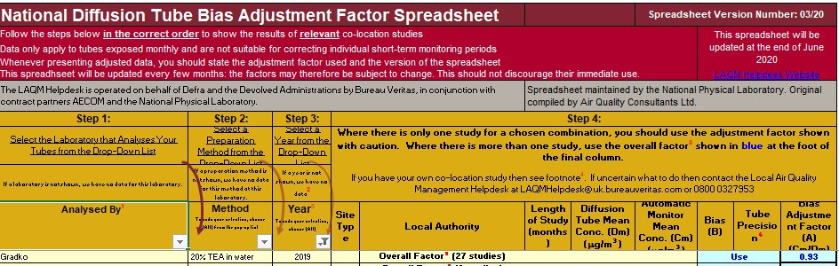

Nitrogen Dioxide – Distance Fall-Off Calculations
Sutton Outram Street (Tube 4)

Step 1 |  | How far from the KERB was your measurement  made (in metres)? | (Note  1) |  | 1.5 | metres
Step 2 |  | How far from the KERB is your receptor (in metres)? | (Note 1) |  | 3 | metres
Step 3 |  | What is the local annual mean background NO2 concentration (in μg/m3)? | (Note 2) |  | 15.1 | μg/m3
Step 4 |  | What is your measured annual mean NO2 concentration (in μg/m3)? | (Note 2) |  | 28.6 | μg/m3
Result |  | The predicted annual mean NO2 concentration (in  μg/m3) at your receptor | (Note 3) |  | 26.5 | μg/m3

Sutton Dalestorth Street (Tube 5)

Step 1 |  | How far from the KERB was your measurement  made (in metres)? | (Note  1) |  | 1 | metres
Step 2 |  | How far from the KERB is your receptor (in metres)? | (Note 1) |  | 1.7 | metres
Step 3 |  | What is the local annual mean background NO2 concentration (in μg/m3)? | (Note 2) |  | 14.8 | μg/m3
Step 4 |  | What is your measured annual mean NO2 concentration (in μg/m3)? | (Note 2) |  | 32.1 | μg/m3
Result |  | The predicted annual mean NO2 concentration (in  μg/m3) at your receptor | (Note 3) |  | 30.2 | μg/m3

Sutton A38 Fire Station (Tube 7)

Step 1 |  | How far from the KERB was your measurement  made (in metres)? | (Note  1) |  | 2.5 | metres
Step 2 |  | How far from the KERB is your receptor (in  metres)? | (Note  1) |  | 10 | metres
Step 3 |  | What is the local annual mean background NO2 concentration (in μg/m3)? | (Note 2) |  | 14.9 | μg/m3
Step 4 |  | What is your measured annual mean NO2 concentration (in μg/m3)? | (Note 2) |  | 24.2 | μg/m3
Result |  | The predicted annual mean NO2 concentration (in  μg/m3) at your receptor | (Note 3) |  | 21.0 | μg/m3

Kirkby Church Hill (10,11and 12)

Step 1 |  | How far from the KERB was your measurement  made (in metres)? | (Note  1) |  | 0.5 | metres
Step 2 |  | How far from the KERB is your receptor (in  metres)? | (Note  1) |  | 1.5 | metres
Step 3 |  | What is the local annual mean background NO2 concentration (in μg/m3)? | (Note 2) |  | 12.1 | μg/m3
Step 4 |  | What is your measured annual mean NO2 concentration (in μg/m3)? | (Note 2) |  | 36.7 | μg/m3
Result |  | The predicted annual mean NO2 concentration (in  μg/m3) at your receptor | (Note 3) |  | 31.9 | μg/m3

M1 Pinxton (Tube14)

Step 1 |  | How far from the KERB was your measurement  made (in metres)? | (Note  1) |  | 22 | metres
Step 2 |  | How far from the KERB is your receptor (in  metres)? | (Note  1) |  | 28 | metres
Step 3 |  | What is the local annual mean background NO2 concentration (in μg/m3)? | (Note 2) |  | 18.1 | μg/m3
Step 4 |  | What is your measured annual mean NO2 concentration (in μg/m3)? | (Note 2) |  | 25.5 | μg/m3
Result |  | The predicted annual mean NO2 concentration (in  μg/m3) at your receptor | (Note 3) |  | 22.5 | μg/m3

Hucknall Ashgate Road (Tube 41)

Step 1 |  | How far from the KERB was your measurement  made (in metres)? | (Note  1) |  | 3.5 | metres
Step 2 |  | How far from the KERB is your receptor (in  metres)? | (Note  1) |  | 2.8 | metres
Step 3 |  | What is the local annual mean background NO2 concentration (in μg/m3)? | (Note 2) |  | 13.4 | μg/m3
Step 4 |  | What is your measured annual mean NO2 concentration (in μg/m3)? | (Note 2) |  | 23.2 | μg/m3
Result |  | The predicted annual mean NO2 concentration (in  μg/m3) at your receptor | (Note 3) |  | 22.8 | μg/m3

Sutton Station Road (Tube 22)

Step 1 |  | How far from the KERB was your measurement  made (in metres)? | (Note  1) |  | 2.4 | metres
Step 2 |  | How far from the KERB is your receptor (in  metres)? | (Note  1) |  | 12.7 | metres
Step 3 |  | What is the local annual mean background NO2 concentration (in μg/m3)? | (Note 2) |  | 17.2 | μg/m3
Step 4 |  | What is your measured annual mean NO2 concentration (in μg/m3)? | (Note 2) |  | 32.5 | μg/m3
Result |  | The predicted annual mean NO2 concentration (in  μg/m3) at your receptor | (Note 3) |  | 26.3 | μg/m3

Common Road Huthwaite (Tube 23)
No Distance fall off

Annesley Badger Box (Tubes 27, 28 and 29)

Step 1 |  | How far from the KERB was your measurement  made (in metres)? | (Note  1) |  | 2 | metres
Step 2 |  | How far from the KERB is your receptor (in  metres)? | (Note  1) |  | 9 | metres
Step 3 |  | What is the local annual mean background NO2 concentration (in μg/m3)? | (Note 2) |  | 16.5 | μg/m3
Step 4 |  | What is your measured annual mean NO2 concentration (in μg/m3)? | (Note 2) |  | 32.1 | μg/m3
Result |  | The predicted annual mean NO2 concentration (in  μg/m3) at your receptor | (Note 3) |  | 26.6 | μg/m3

Sutton Croft Primary Station Road (Tube 31)

Step 1 |  | How far from the KERB was your measurement  made (in metres)? | (Note  1) |  | 2.5 | metres
Step 2 |  | How far from the KERB is your receptor (in  metres)? | (Note  1) |  | 4.5 | metres
Step 3 |  | What is the local annual mean background NO2 concentration (in μg/m3)? | (Note 2) |  | 15.1 | μg/m3
Step 4 |  | What is your measured annual mean NO2 concentration (in μg/m3)? | (Note 2) |  | 26.8 | μg/m3
Result |  | The predicted annual mean NO2 concentration (in  μg/m3) at your receptor | (Note 3) |  | 25.1 | μg/m3

Stoneyford Court Sutton (Tube 35)

Step 1 |  | How far from the KERB was your measurement  made (in metres)? | (Note  1) |  | 3.5 | metres
Step 2 |  | How far from the KERB is your receptor (in  metres)? | (Note  1) |  | 6 | metres
Step 3 |  | What is the local annual mean background NO2 concentration (in μg/m3)? | (Note 2) |  | 14.4 | μg/m3
Step 4 |  | What is your measured annual mean NO2 concentration (in μg/m3)? | (Note 2) |  | 28.8 | μg/m3
Result |  | The predicted annual mean NO2 concentration (in  μg/m3) at your receptor | (Note 3) |  | 26.7 | μg/m3

Kirkby Cross (Tubes 37, 38 and 39)
No Distance fall off

Mansfield Road Selston (Tube 40)

Step 1 |  | How far from the KERB was your measurement  made (in metres)? | (Note  1) |  | 1.5 | metres
Step 2 |  | How far from the KERB is your receptor (in  metres)? | (Note  1) |  | 2.8 | metres
Step 3 |  | What is the local annual mean background NO2 concentration (in μg/m3)? | (Note 2) |  | 19.0 | μg/m3
Step 4 |  | What is your measured annual mean NO2 concentration (in μg/m3)? | (Note 2) |  | 24.8 | μg/m3
Result |  | The predicted annual mean NO2 concentration (in  μg/m3) at your receptor | (Note 3) |  | 24.0 | μg/m3

Mansfield Road Sutton in Ashfield (Tube 44)

Step 1 |  | How far from the KERB was your measurement  made (in metres)? | (Note  1) |  | 0.5 | metres
Step 2 |  | How far from the KERB is your receptor (in  metres)? | (Note  1) |  | 1.6 | metres
Step 3 |  | What is the local annual mean background NO2 concentration (in μg/m3)? | (Note 2) |  | 14.4 | μg/m3
Step 4 |  | What is your measured annual mean NO2 concentration (in μg/m3)? | (Note 2) |  | 31.9 | μg/m3
Result |  | The predicted annual mean NO2 concentration (in  μg/m3) at your receptor | (Note 3) |  | 28.3 | μg/m3

Fullwood Cutting A38 (Tube 45/46/47)

Step 1 |  | How far from the KERB was your measurement  made (in metres)? | (Note  1) |  | 4.8 | metres
Step 2 |  | How far from the KERB is your receptor (in  metres)? | (Note  1) |  | 12.0 | metres
Step 3 |  | What is the local annual mean background NO2 concentration (in μg/m3)? | (Note 2) |  | 15.4 | μg/m3
Step 4 |  | What is your measured annual mean NO2 concentration (in μg/m3)? | (Note 2) |  | 37.7 | μg/m3
Result |  | The predicted annual mean NO2 concentration (in  μg/m3) at your receptor | (Note 3) |  | 31.7 | μg/m3

Alfreton Road Sutton in Ashfield (Tube 48)

Step 1 |  | How far from the KERB was your measurement  made (in metres)? | (Note  1) |  | 1.5 | metres
Step 2 |  | How far from the KERB is your receptor (in  metres)? | (Note  1) |  | 2.6 | metres
Step 3 |  | What is the local annual mean background NO2 concentration (in μg/m3)? | (Note 2) |  | 14.5 | μg/m3
Step 4 |  | What is your measured annual mean NO2 concentration (in μg/m3)? | (Note 2) |  | 33.0 | μg/m3
Result |  | The predicted annual mean NO2 concentration (in  μg/m3) at your receptor | (Note 3) |  | 30.8 | μg/m3

Kingsway Kirkby in Ashfield (Tube 52)

Step 1 |  | How far from the KERB was your measurement  made (in metres)? | (Note  1) |  | 1 | metres
Step 2 |  | How far from the KERB is your receptor (in  metres)? | (Note  1) |  | 2 | metres
Step 3 |  | What is the local annual mean background NO2 concentration (in μg/m3)? | (Note 2) |  | 16.5 | μg/m3
Step 4 |  | What is your measured annual mean NO2 concentration (in μg/m3)? | (Note 2) |  | 33.4 | μg/m3
Result |  | The predicted annual mean NO2 concentration (in  μg/m3) at your receptor | (Note 3) |  | 31.0 | μg/m3

Snipe Location 1(Tube 53/54/55)

Step 1 |  | How far from the KERB was your measurement  made (in metres)? | (Note  1) |  | 1.7 | metres
Step 2 |  | How far from the KERB is your receptor (in  metres)? | (Note  1) |  | 50 | metres
Step 3 |  | What is the local annual mean background NO2 concentration (in μg/m3)? | (Note 2) |  | 14.9 | μg/m3
Step 4 |  | What is your measured annual mean NO2 concentration (in μg/m3)? | (Note 2) |  | 47.9 | μg/m3
Result |  | The predicted annual mean NO2 concentration (in  μg/m3) at your receptor | (Note 3) |  | 22.7 | μg/m3

Stanton Hill (Tube 56)

Step 1 |  | How far from the KERB was your measurement  made (in metres)? | (Note  1) |  | 1.6 | metres
Step 2 |  | How far from the KERB is your receptor (in  metres)? | (Note  1) |  | 3 | metres
Step 3 |  | What is the local annual mean background NO2 concentration (in μg/m3)? | (Note 2) |  | 12.1 | μg/m3
Step 4 |  | What is your measured annual mean NO2 concentration (in μg/m3)? | (Note 2) |  | 23.7 | μg/m3
Result |  | The predicted annual mean NO2 concentration (in  μg/m3) at your receptor | (Note 3) |  | 22.1 | μg/m3

Rookery Lane (Tube 58)

Step 1 |  | How far from the KERB was your measurement  made (in metres)? | (Note  1) |  | 12 | metres
Step 2 |  | How far from the KERB is your receptor (in metres)? | (Note 1) |  | 17.5 | metres
Step 3 |  | What is the local annual mean background NO2 concentration (in μg/m3)? | (Note 2) |  | 14.9 | μg/m3
Step 4 |  | What is your measured annual mean NO2 concentration (in μg/m3)? | (Note 2) |  | 33.1 | μg/m3
Result |  | The predicted annual mean NO2 concentration (in  μg/m3) at your receptor | (Note 3) |  | 30.3 | μg/m3

Oakfield Avenue (Tube 59)

Step 1 |  | How far from the KERB was your measurement  made (in metres)? | (Note  1) |  | 21 | metres
Step 2 |  | How far from the KERB is your receptor (in  metres)? | (Note  1) |  | 30 | metres
Step 3 |  | What is the local annual mean background NO2 concentration (in μg/m3)? | (Note 2) |  | 15.0 | μg/m3
Step 4 |  | What is your measured annual mean NO2 concentration (in μg/m3)? | (Note 2) |  | 27.6 | μg/m3
Result |  | The predicted annual mean NO2 concentration (in  μg/m3) at your receptor | (Note 3) |  | 25.3 | μg/m3

Watnall Road (Tube 60)

Step 1 |  | How far from the KERB was your measurement  made (in metres)? | (Note  1) |  | 3 | metres
Step 2 |  | How far from the KERB is your receptor (in  metres)? | (Note  1) |  | 24 | metres
Step 3 |  | What is the local annual mean background NO2 concentration (in μg/m3)? | (Note 2) |  | 15.6 | μg/m3
Step 4 |  | What is your measured annual mean NO2 concentration (in μg/m3)? | (Note 2) |  | 25.0 | μg/m3
Result |  | The predicted annual mean NO2 concentration (in  μg/m3) at your receptor | (Note 3) |  | 19.9 | μg/m3

Short-term to Long-term Data Adjustment
The diffusion tube results for High Street Hucknall and Mansfield Road Sutton in Ashfield were annualised as Box 7.8 of TG 2016.

Alfreton Road Sutton in Ashfield

Long term site | Annual mean | Period mean | Ratio (Am/Pm)
Chesterfield Road Side | 17.5 | 20.0 | 0.875
Nottingham Centre | 27.9 | 32.9 | 1.375
Average (Ra) |  |  | 1.125

Hucknall Leisure Centre

Long term site | Annual mean | Period mean | Ratio (Am/Pm)
Chesterfield Road Side | 17.5 | 17.9 | 0.978
Nottingham Centre | 27.9 | 27.9 | 1.000
Average (Ra) |  |  | 0.989

Rookery Lane Sutton in Ashfield

Long term site | Annual mean | Period mean | Ratio (Am/Pm)
Chesterfield Road side | 17.5 | 16.3 | 1.073
Nottingham Centre | 27.9 | 25.3 | 1.102
Average (Ra) |  |  | 1.088

Oakfield Avenue Sutton in Ashfield

Long term site | Annual mean | Period mean | Ratio (Am/Pm)
Chesterfield Road side | 17.5 | 13.7 | 1.277
Nottingham Centre | 27.9 | 22.4 | 1.246
Average (Ra) |  |  | 1.262

Watnall Road Hucknall

Long term site | Annual mean | Period mean | Ratio (Am/Pm)
Chesterfield Road side | 17.5 | 24.7 | 0.709
Nottingham Centre | 27.9 | 34.6 | 0.806
Average (Ra) |  |  | 0.758

Appendix D: Maps of Monitoring Locations
Location of Nitrogen Dioxide Diffusion Tube at Outram Street, Sutton

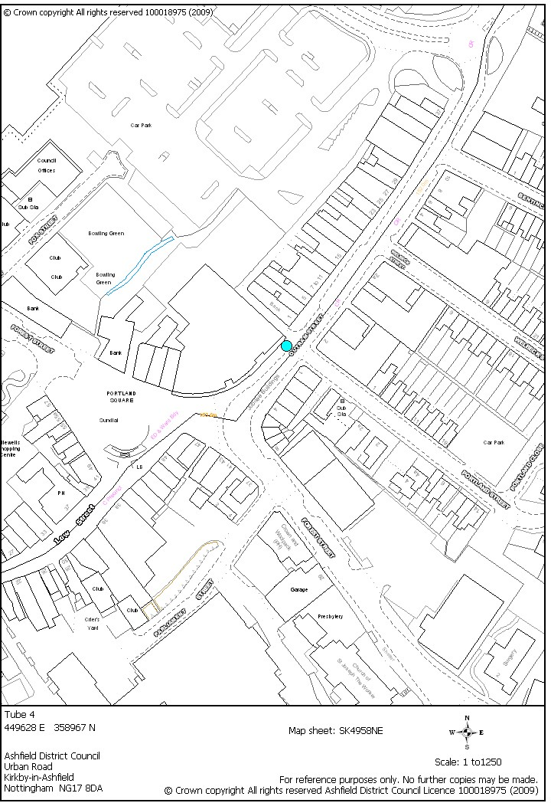

Location of Diffusion Tube at Dalestorth Street, Sutton

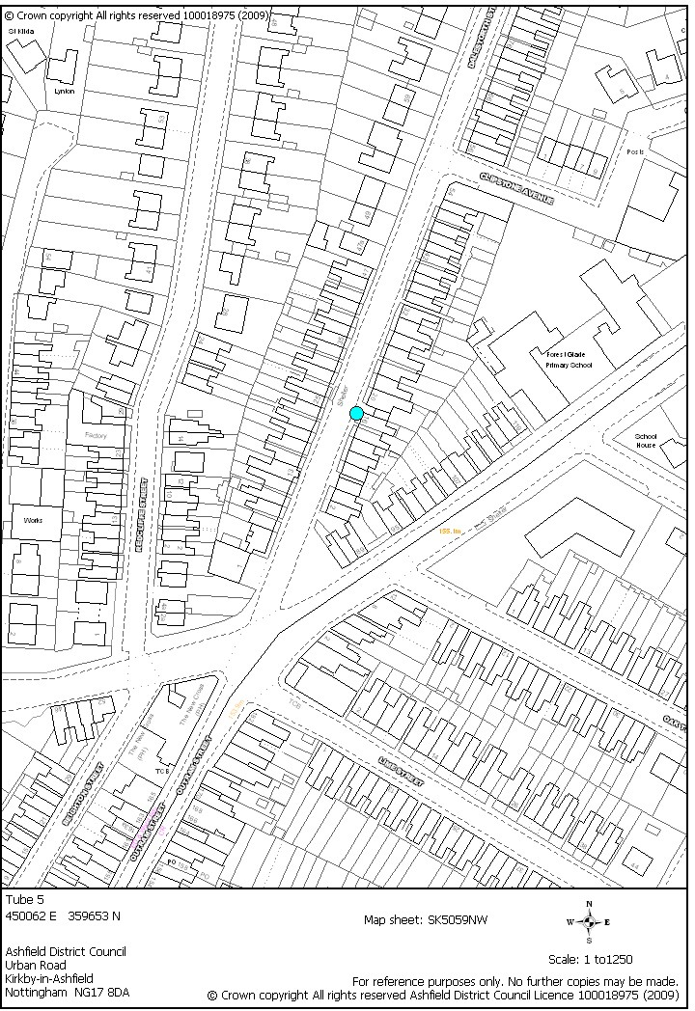

Location of Nitrogen Dioxide Diffusion Tubes at A38 Fire Station, Sutton

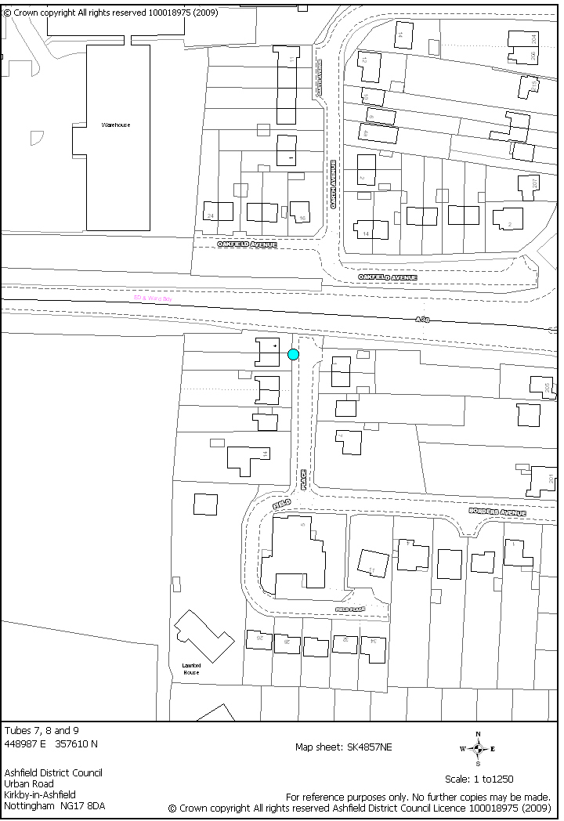

Location of Nitrogen Dioxide Diffusion Tubes at Church Hill, Kirkby

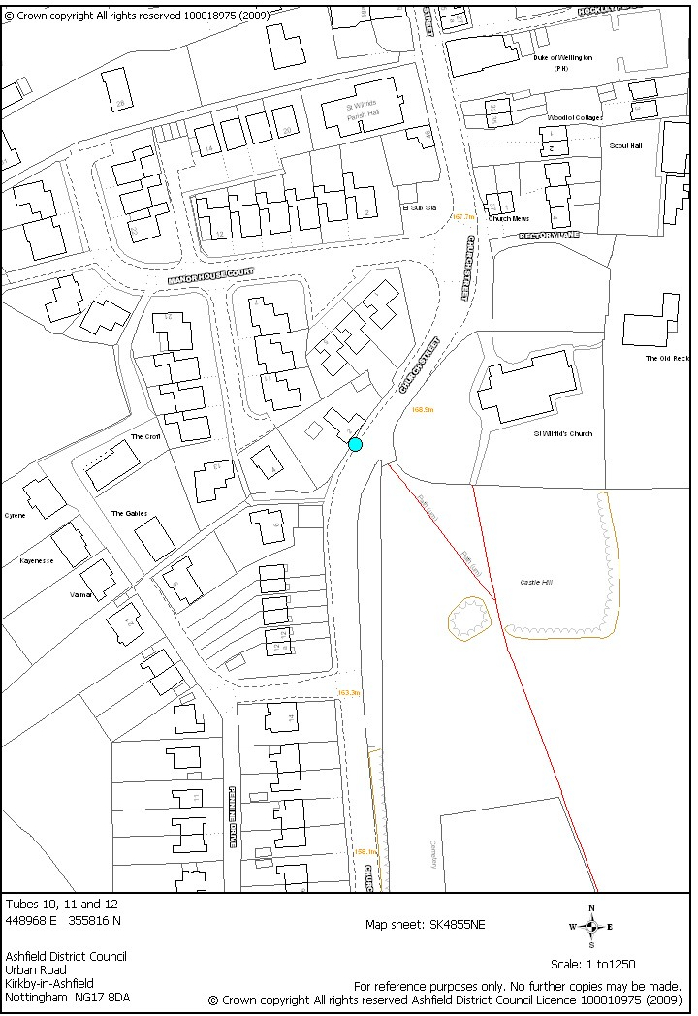

Location of Nitrogen Dioxide Diffusion Tube at M1 Pinxton

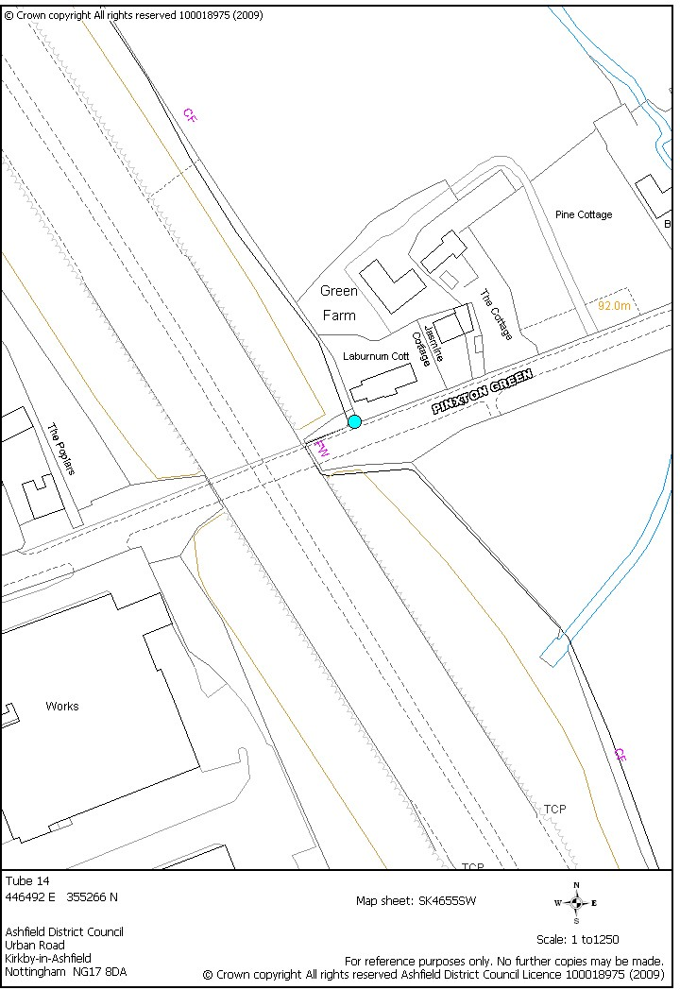

Location of Nitrogen Dioxide Diffusion Tube at Station Road, Sutton

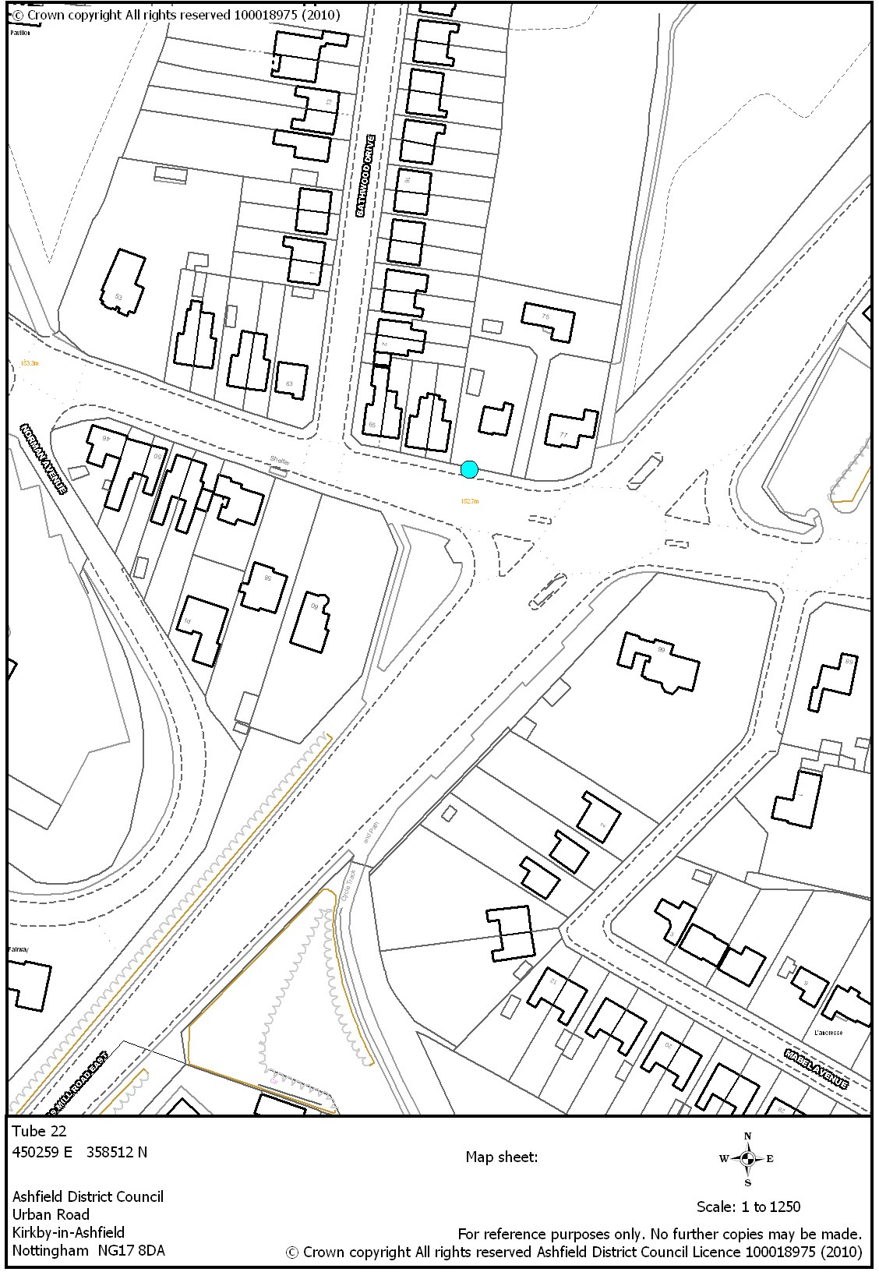

Location of Nitrogen Dioxide Diffusion Tube at Common Road, Huthwaite

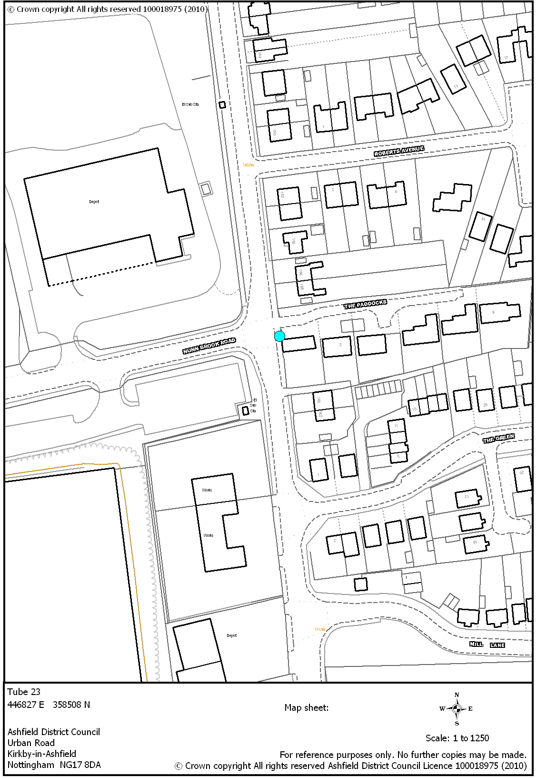

Location of Nitrogen Dioxide Diffusion Tube at the Badger Box, Annesley

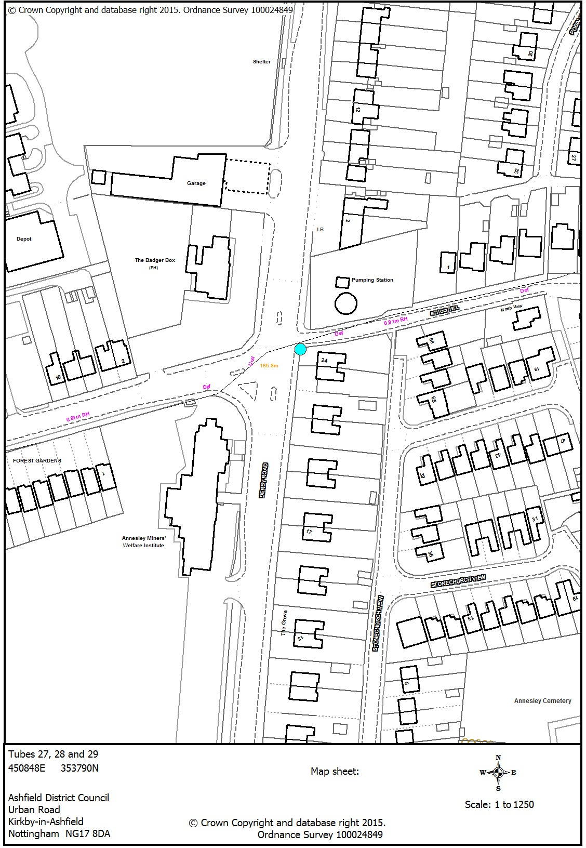

Location of Nitrogen Dioxide Diffusion Tube at Croft Primary School Sutton

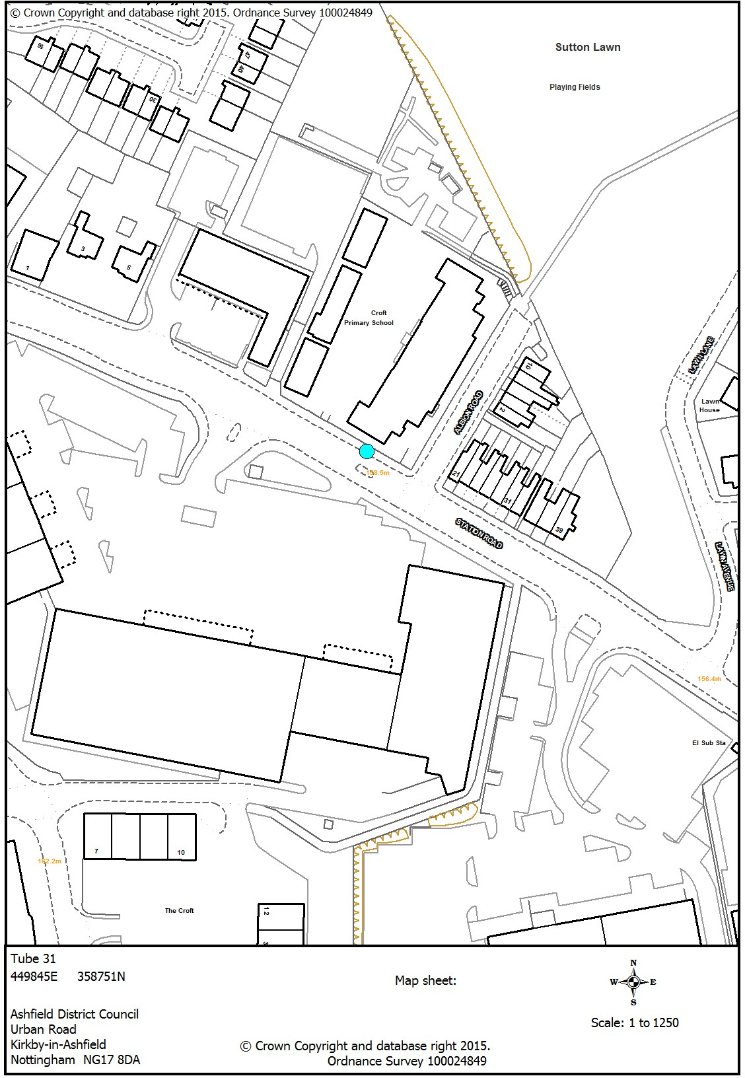

Location of Nitrogen Dioxide Diffusion Tube at Stoneyford Court Sutton

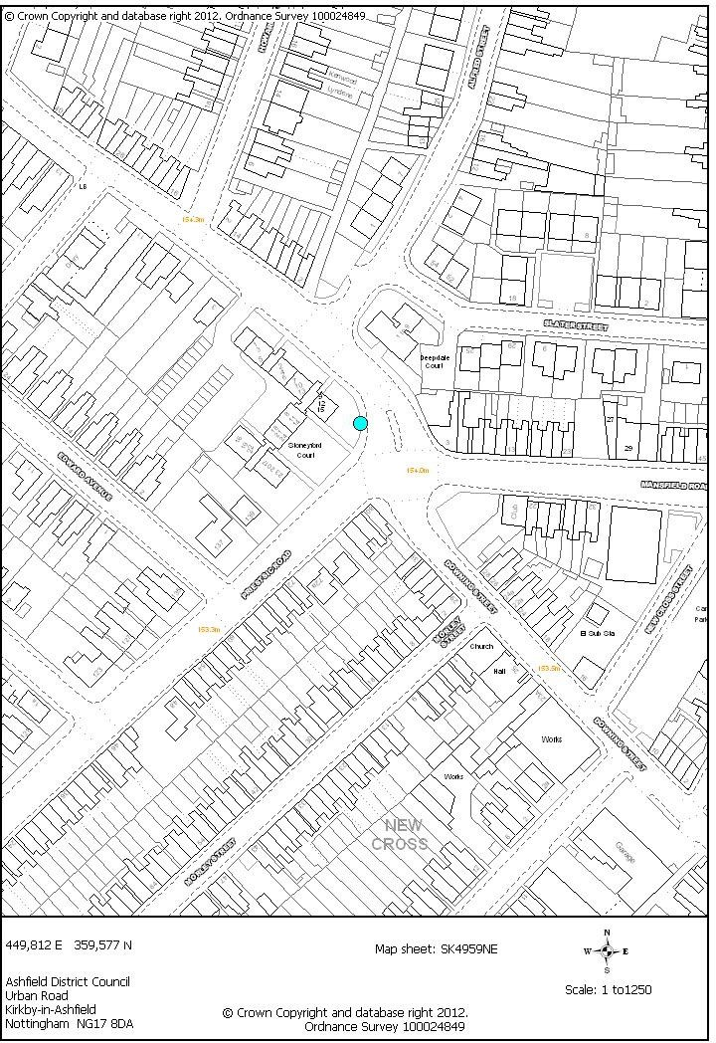

Location of Nitrogen Dioxide Diffusion Tube at Kirkby Cross

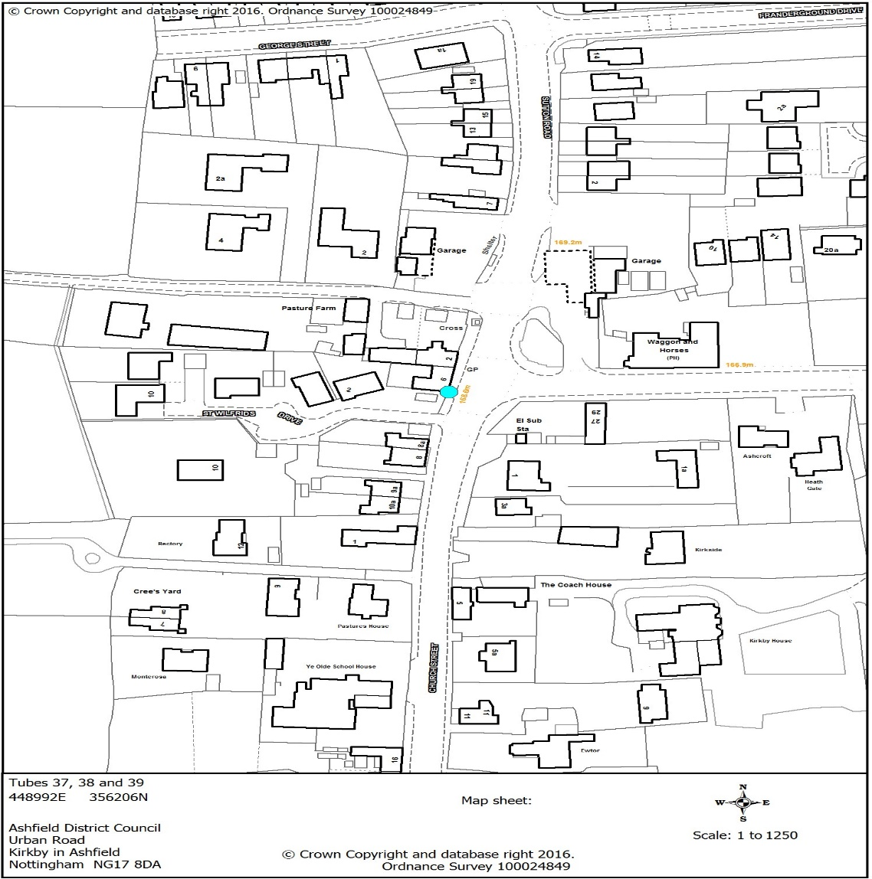

Location of Nitrogen Dioxide Diffusion Tube at Mansfield Road Selston

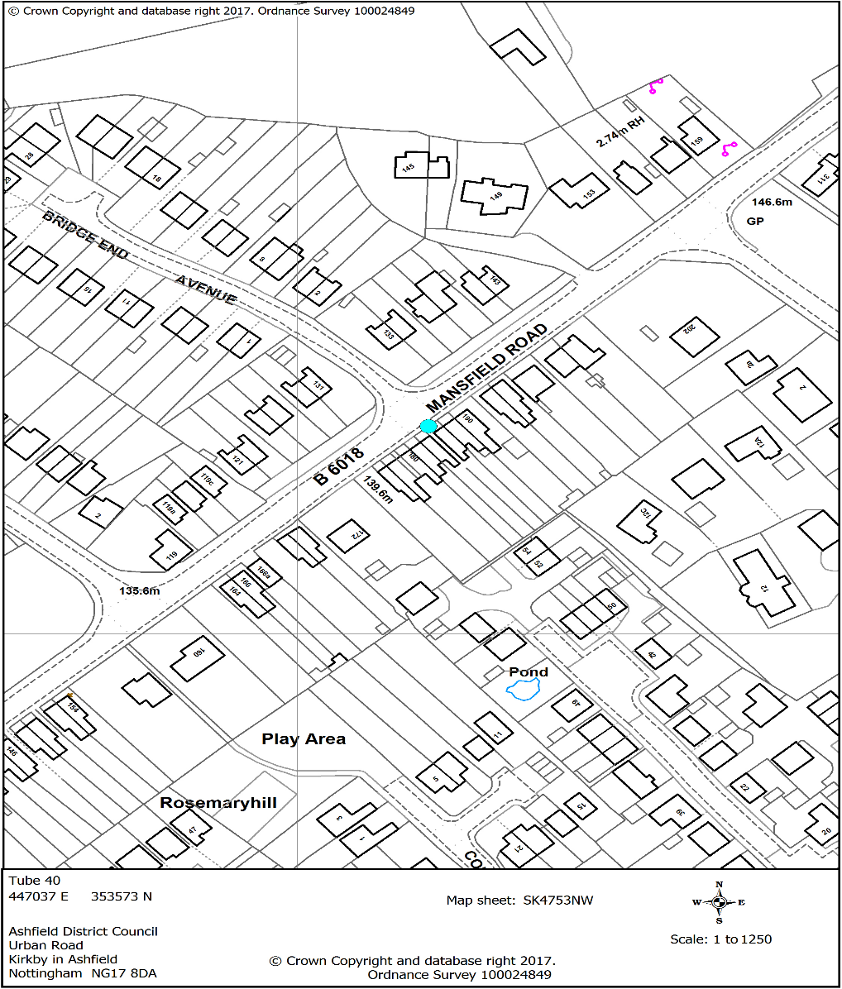

Location of Nitrogen Dioxide Diffusion Tube at Hucknall Ashgate Road

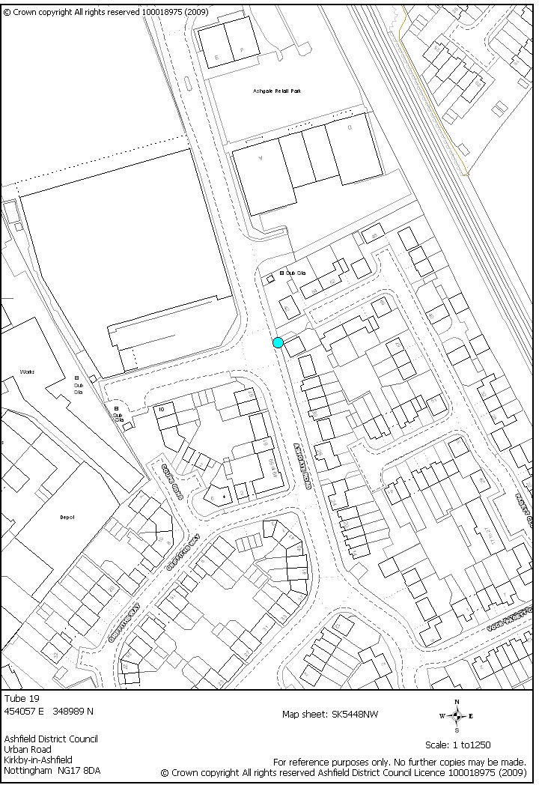

Location of Nitrogen Dioxide Diffusion Tube at Mansfield Road Sutton in Ashfield

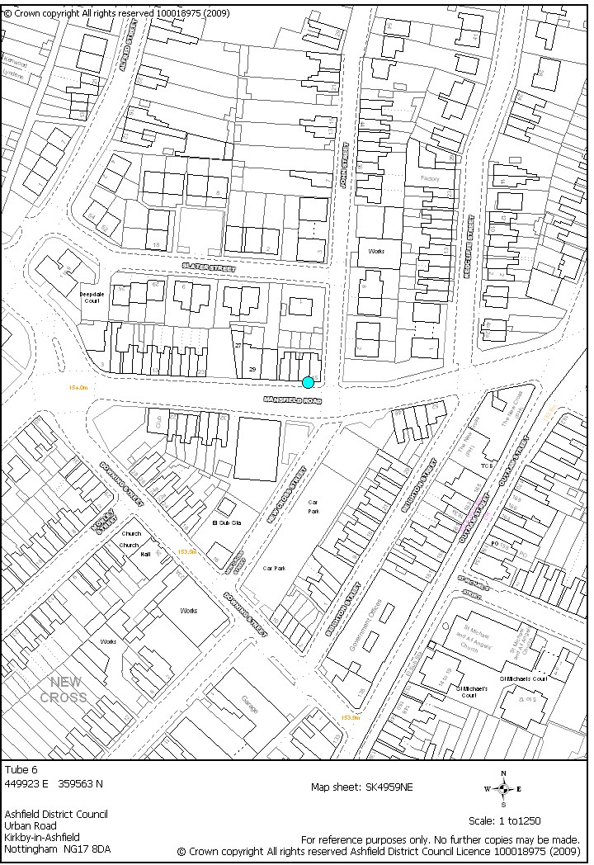

Location of Nitrogen Dioxide Diffusion Tube at Fullwood Cutting, A38 Sutton

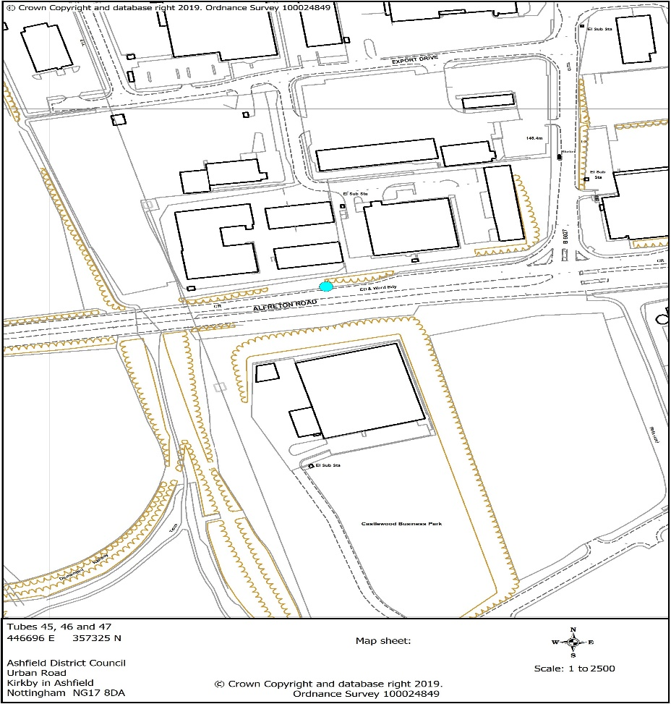

Location of Nitrogen Dioxide Diffusion Tube at Alfreton Road Sutton in Ashfield

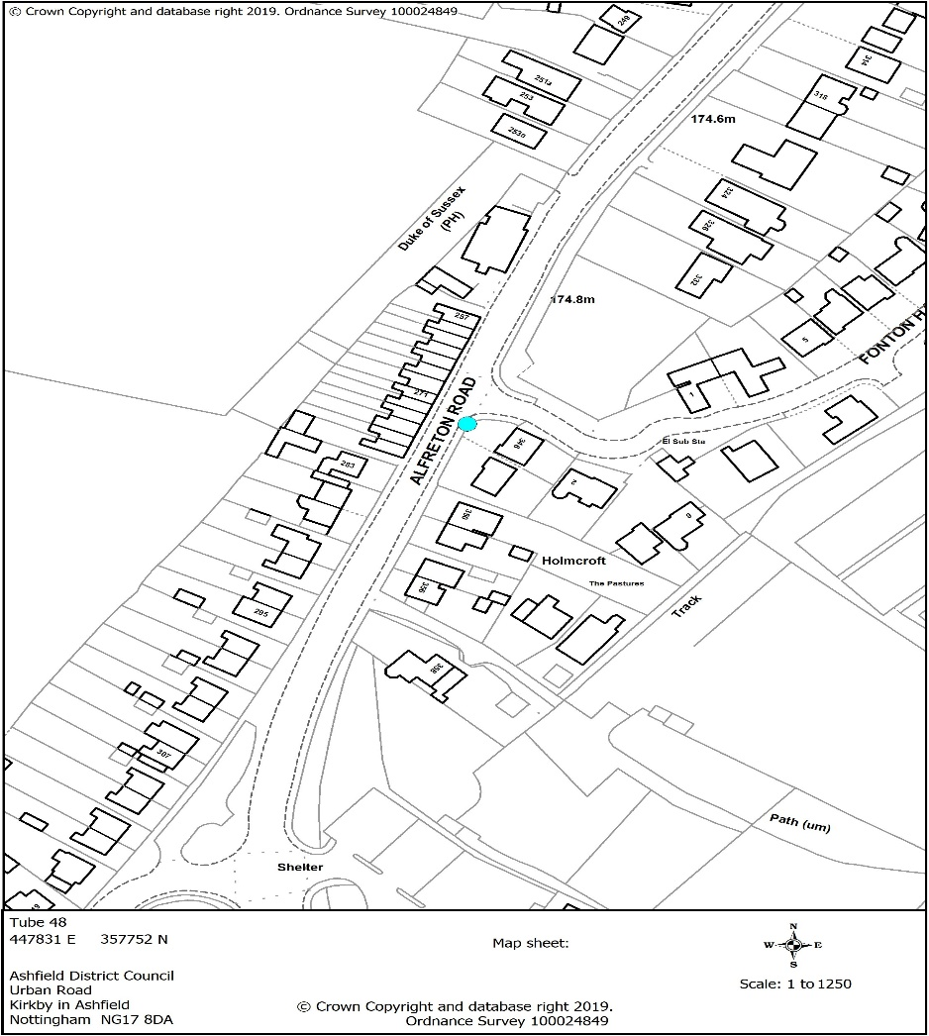

Location of Nitrogen Dioxide Diffusion Tube at Kingsway Kirkby in Ashfield

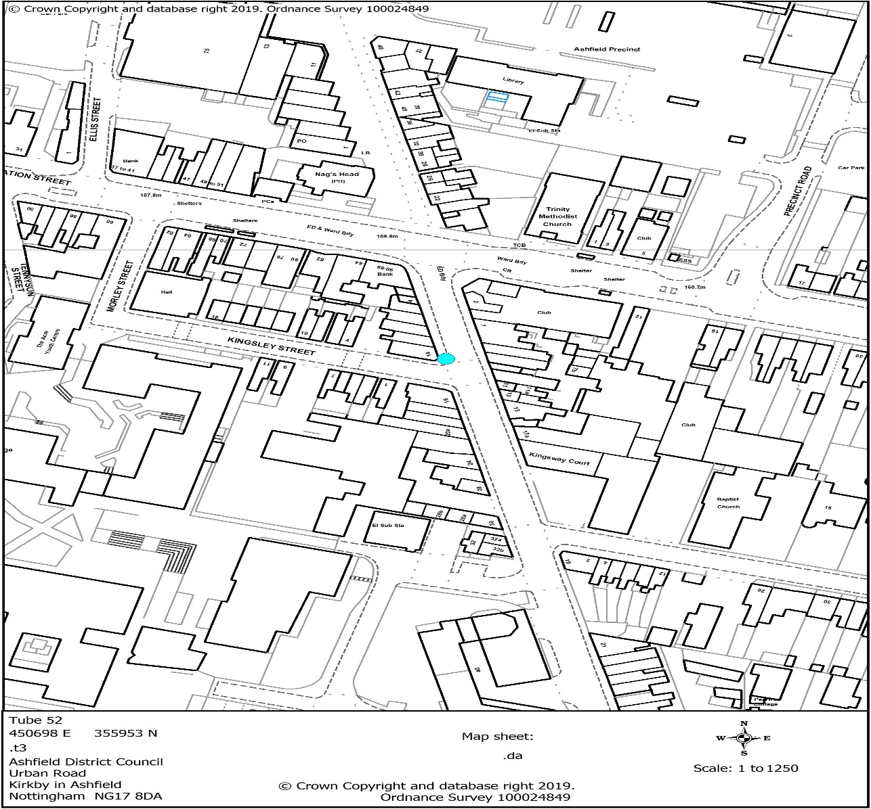

Location of Nitrogen Dioxide Diffusion Tube at Snipe Location 2

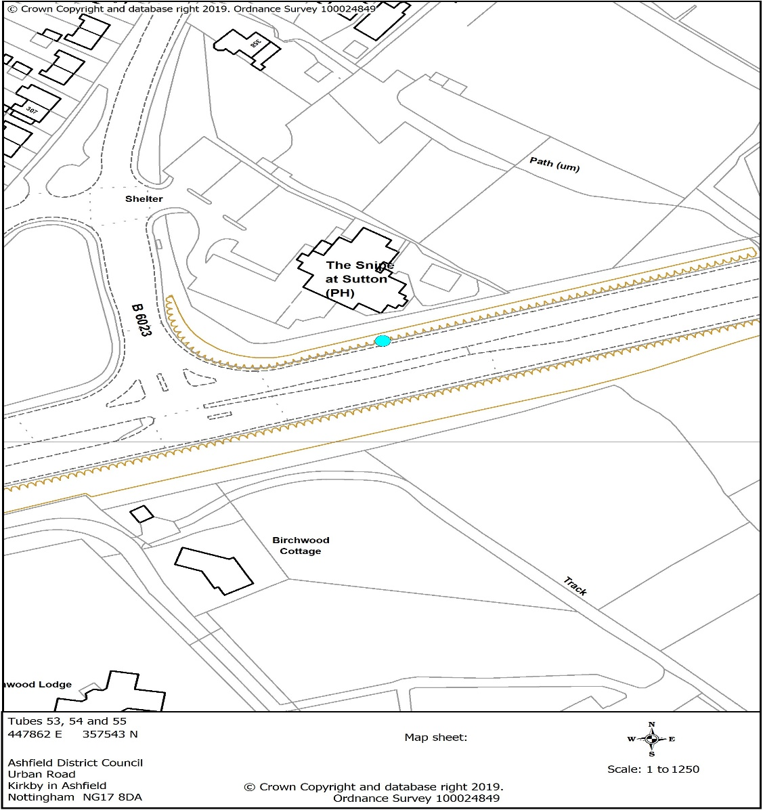

Location of Nitrogen Dioxide Diffusion Tube at Stanton Hill, Sutton in Ashfield

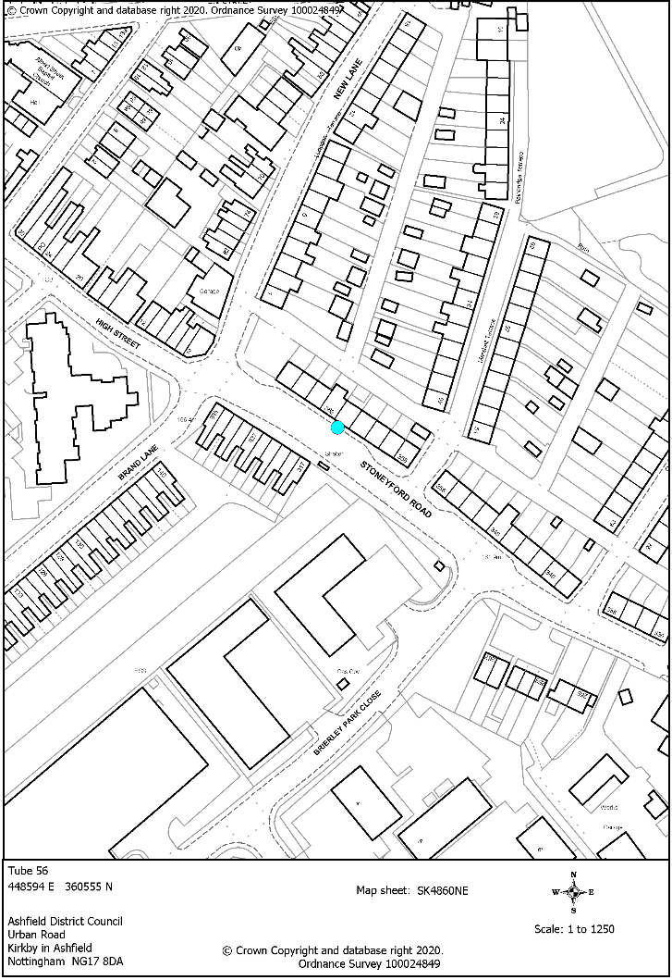

Location of Nitrogen Dioxide Diffusion Tube at Huchnall Leisure Centre

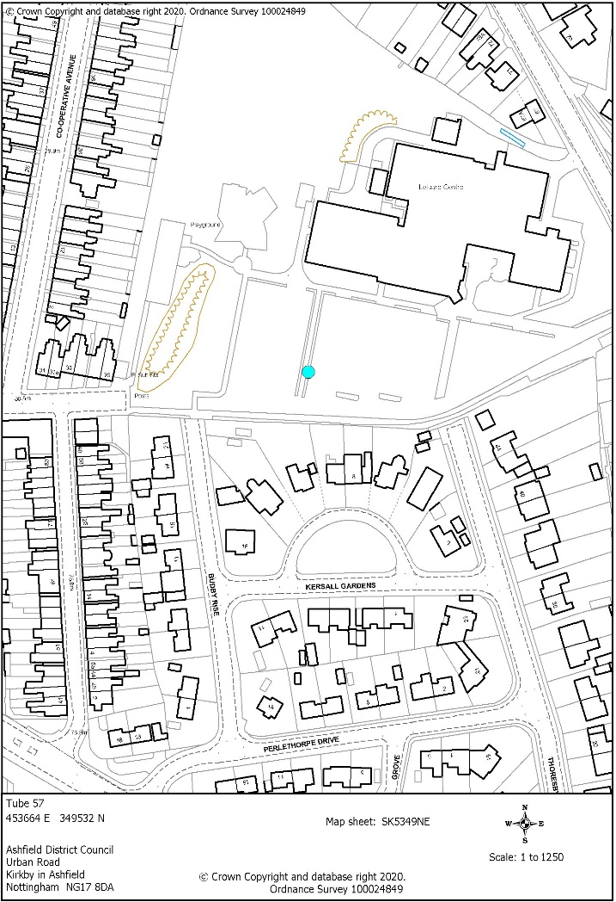

Location of Nitrogen Dioxide Diffusion Tube at Rookery Lane Sutton in Ashfield

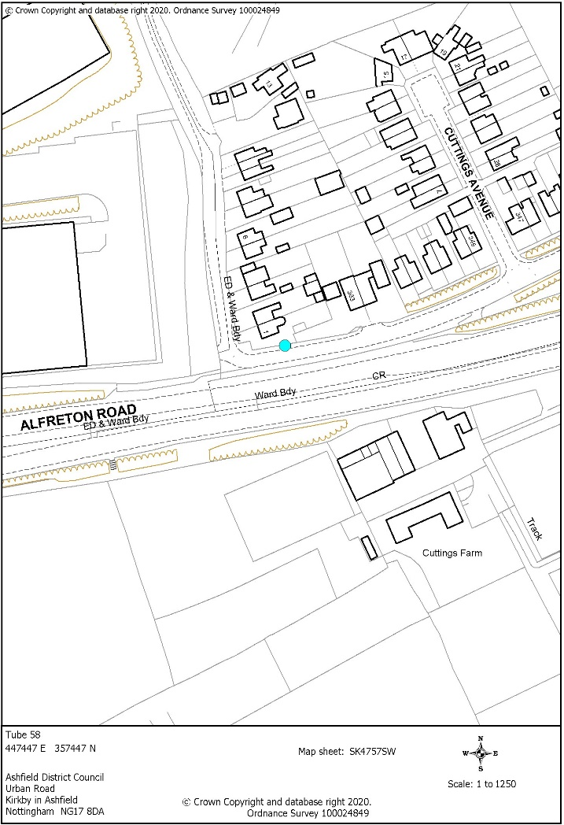

Location of Nitrogen Dioxide Diffusion Tube at Oakfield Avenue Sutton in Ashfield

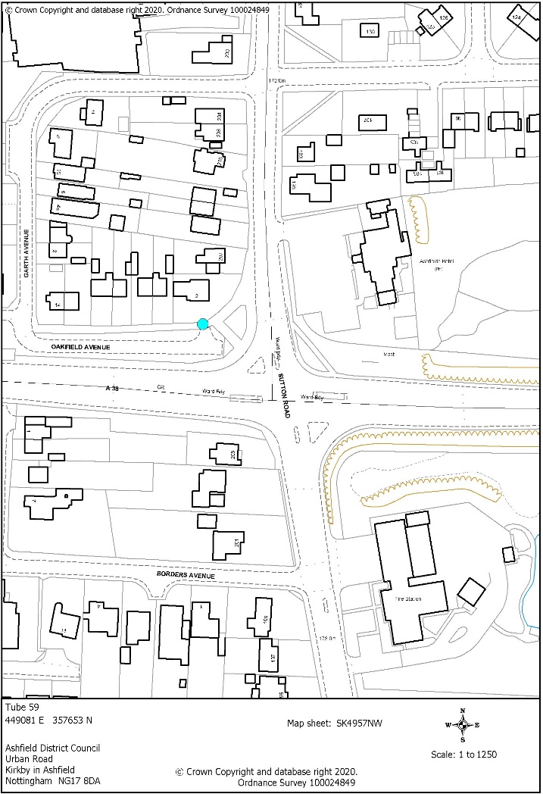

Location of Nitrogen Dioxide Diffusion Tube at Watnall Road Hucknall

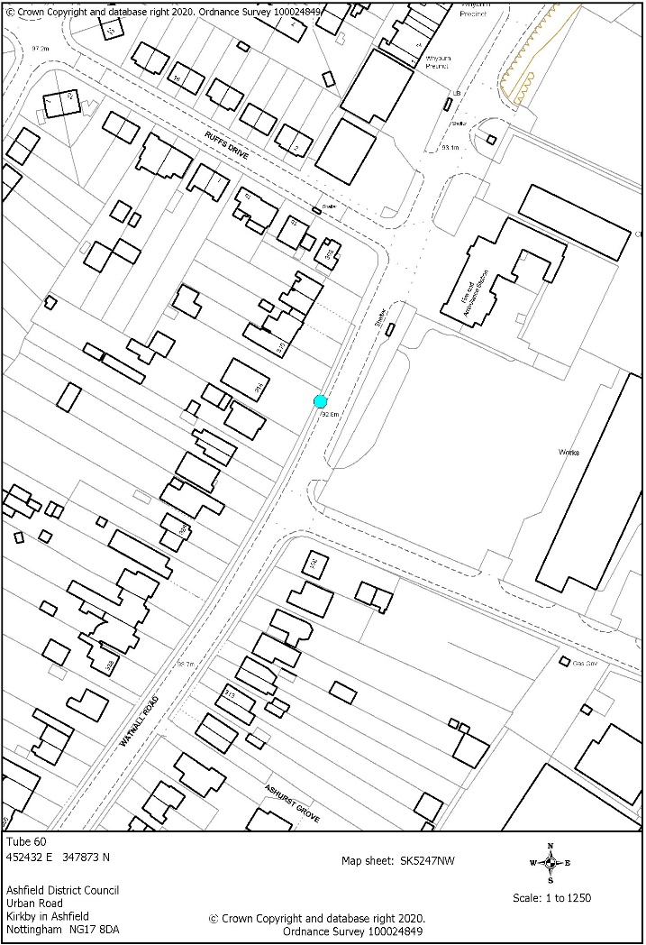

Appendix E: Diffusion Tube Results Trend Analysis
Figure E.1 Trend Analysis for Nitrogen Dioxide Diffusion Tubes at Outram Street, Sutton in Ashfield

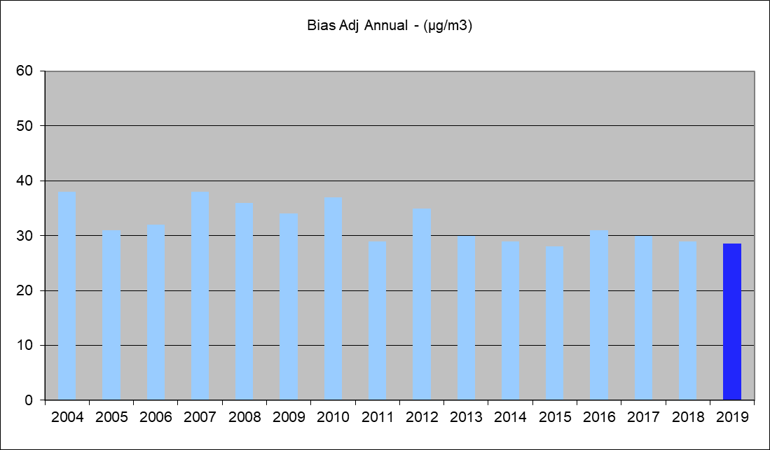

Figure E.2 Trend Analysis for Nitrogen Dioxide Diffusion Tube at Dalestorth Street, Sutton in Ashfield

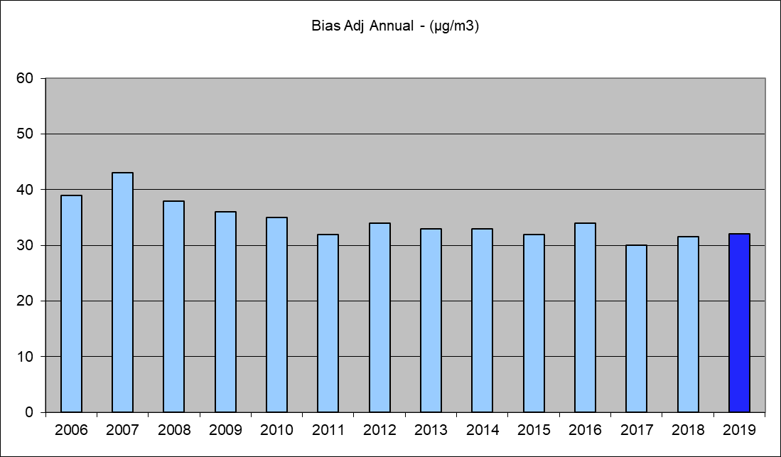

Figure E.3 Trend Analysis for Nitrogen Dioxide Diffusion Tubes at Field Place, A38, Sutton in Ashfield

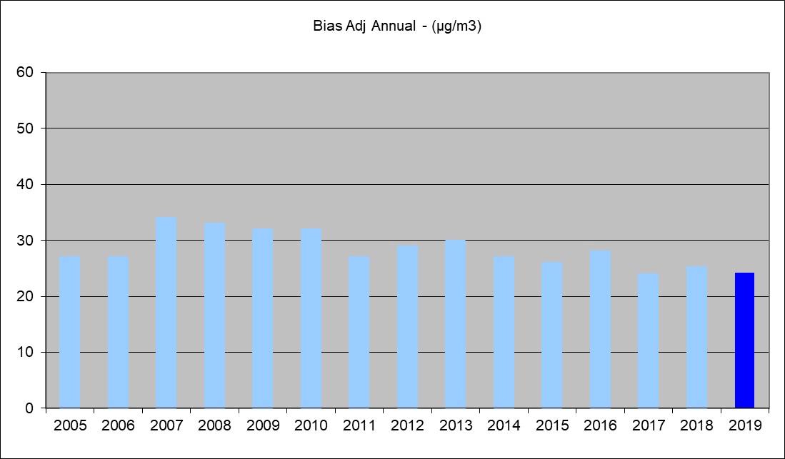

Figure E.4 Trend Analysis for Nitrogen Dioxide Diffusion Tubes at Church Hill, Kirkby

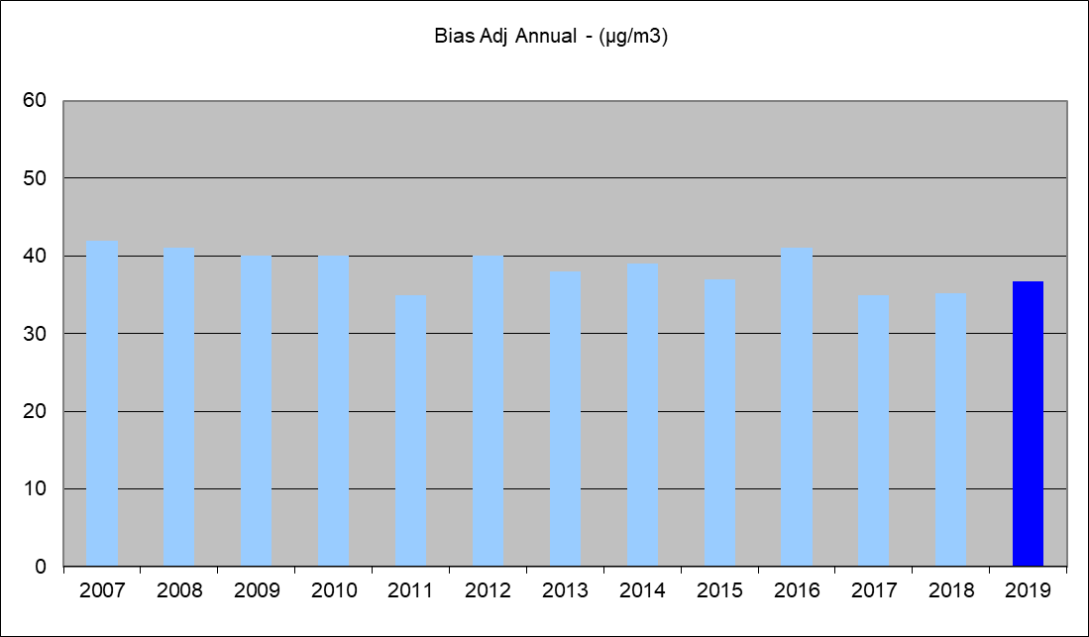

Figure E.5 Trend Analysis for Nitrogen Dioxide Diffusion Tubes at Pinxton

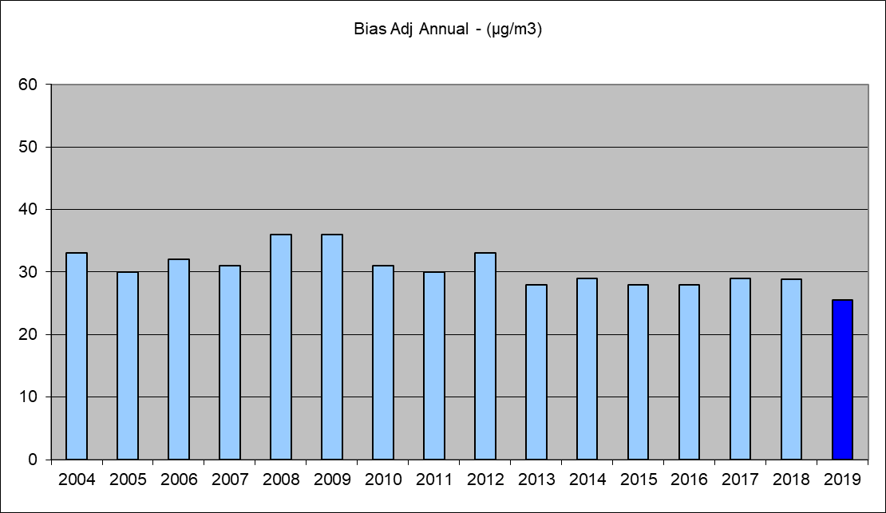

Figure E.6 Trend Analysis for Nitrogen Dioxide Diffusion Tubes at Station Road, Sutton in Ashfield

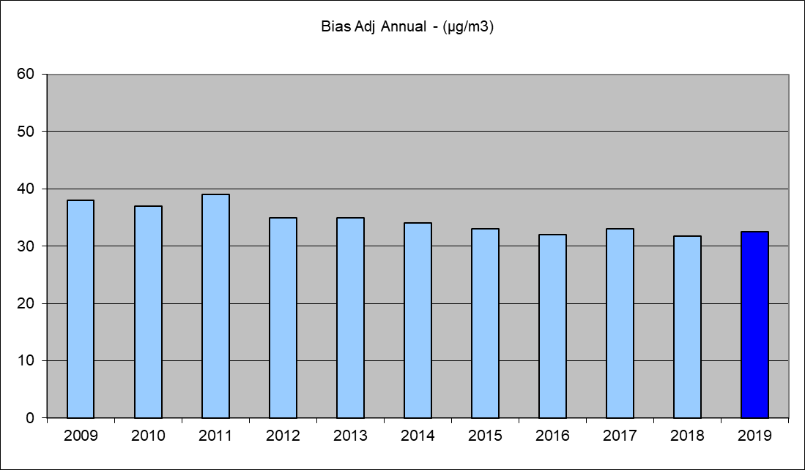

Figure E.7 Trend Analysis for Nitrogen Dioxide Diffusion Tubes at Common Road, Huthwaite

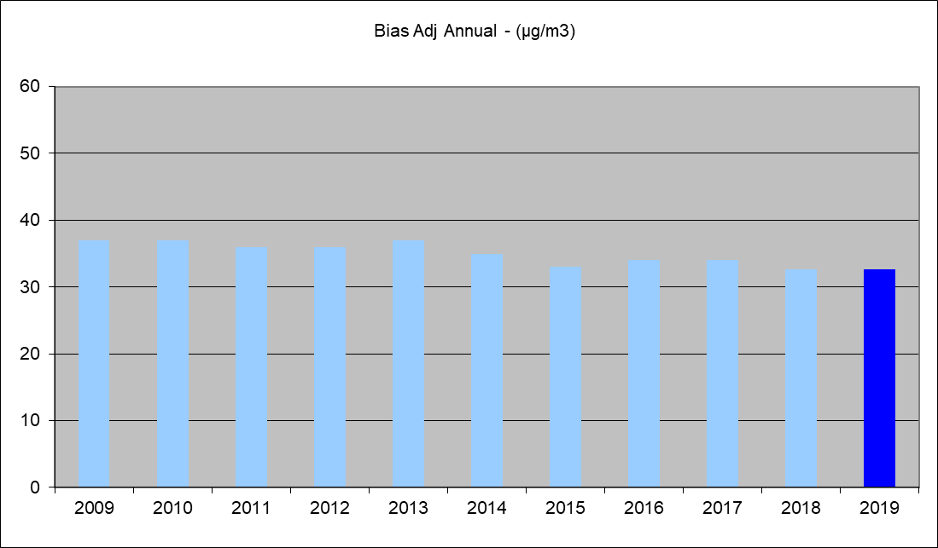

Figure E.8 Trend Analysis for Nitrogen Dioxide Diffusion Tubes at Badger Box, Annesley

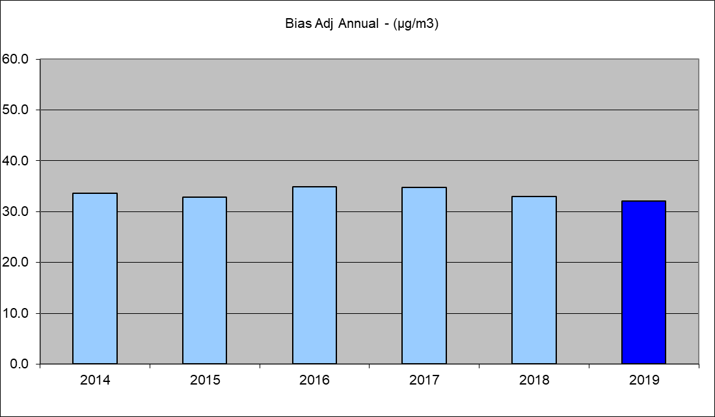

Figure E.9 Trend Analysis for Nitrogen Dioxide Diffusion Tubes at Croft Primary, Sutton in Ashfield

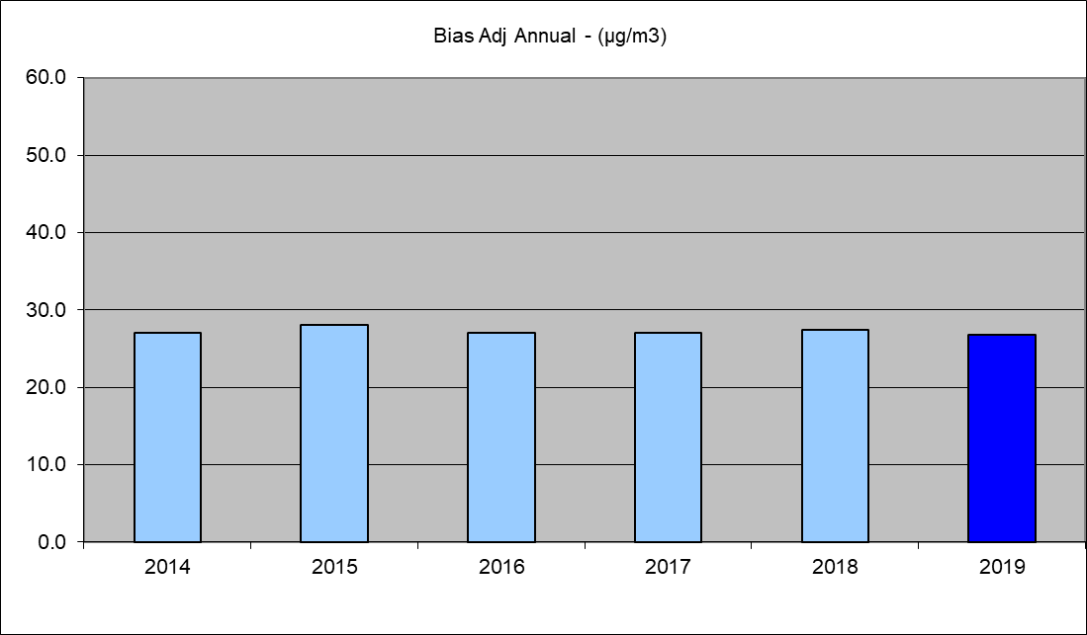

Figure E.10 Trend Analysis for Nitrogen Dioxide Diffusion Tubes at Stoneyford Court, Sutton in Ashfield

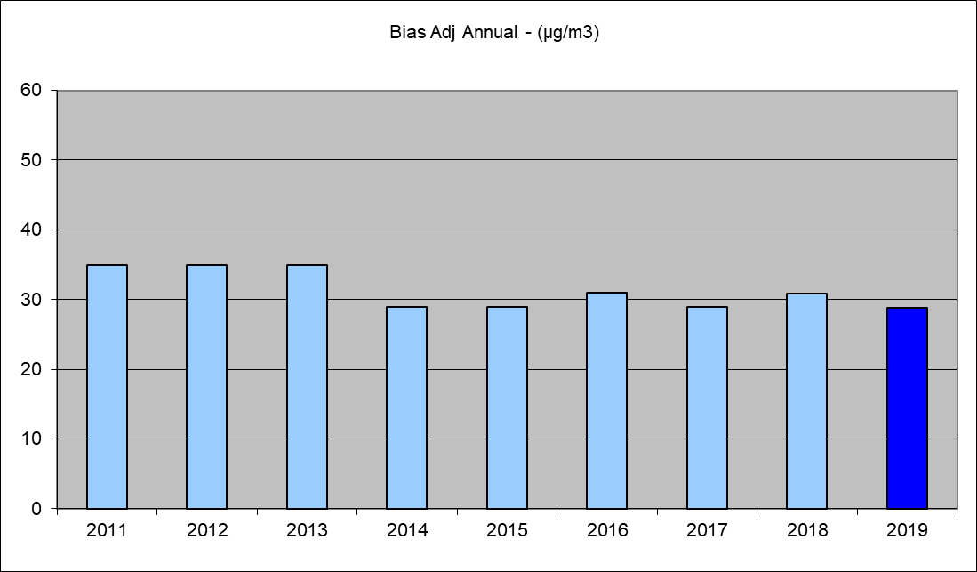

Figure E.11 Trend Analysis for Nitrogen Dioxide Diffusion Tubes at Kirkby Cross Kirkby

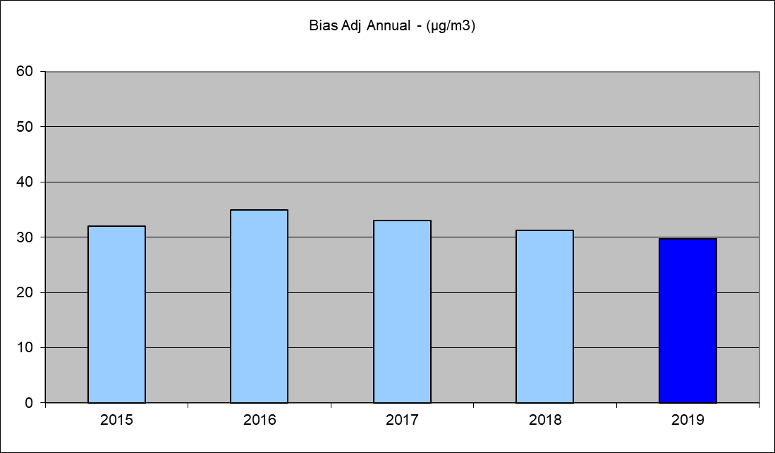

Figure E.12 Trend Analysis for Nitrogen Dioxide Diffusion Tubes at Mansfield Road Selston

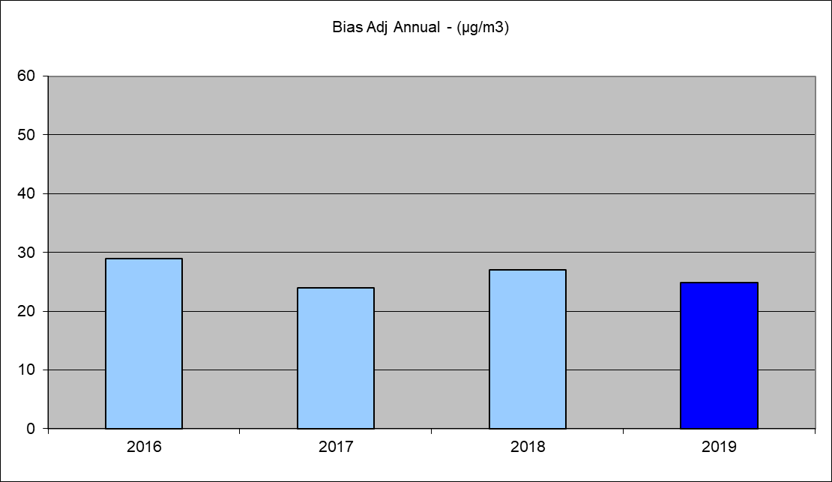

Figure E.13 Trend Analysis for Nitrogen Dioxide Diffusion Tubes at Ashgate, Hucknall

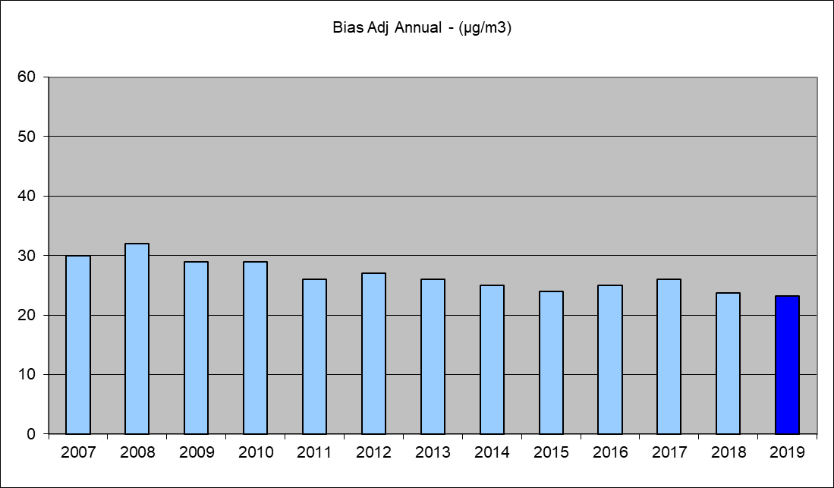

Figure E.14 Trend Analysis for Nitrogen Dioxide Diffusion Tubes at Mansfield Road Sutton

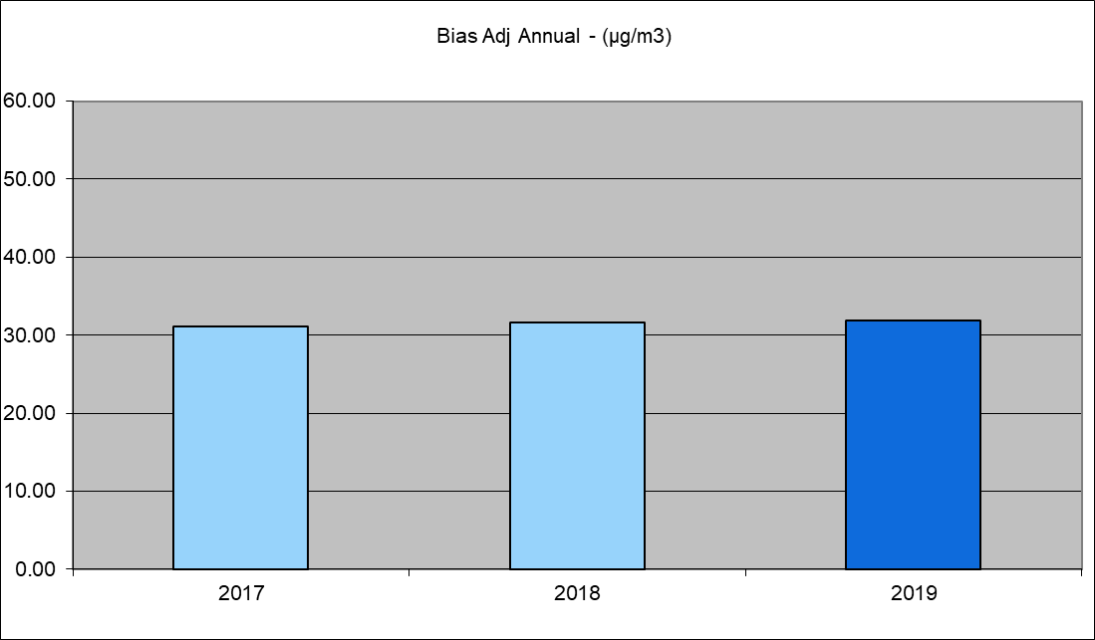

Figure E.15 Trend Analysis for Nitrogen Dioxide Diffusion Tubes at Fullwood Cutting Sutton

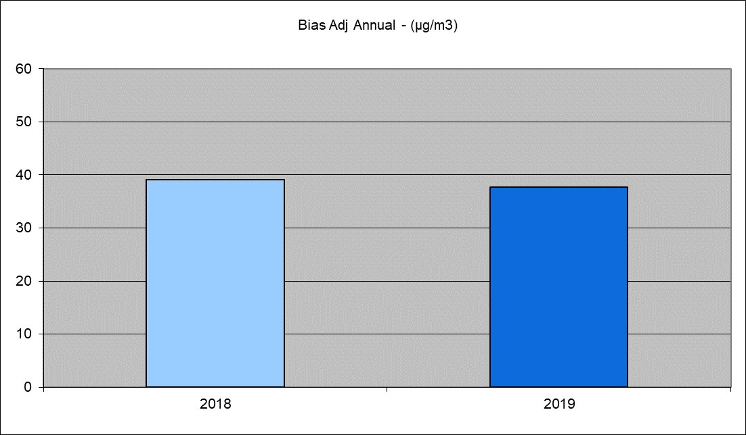

Figure E.16 Trend Analysis for Nitrogen Dioxide Diffusion Tubes at Snipe A38 Sutton

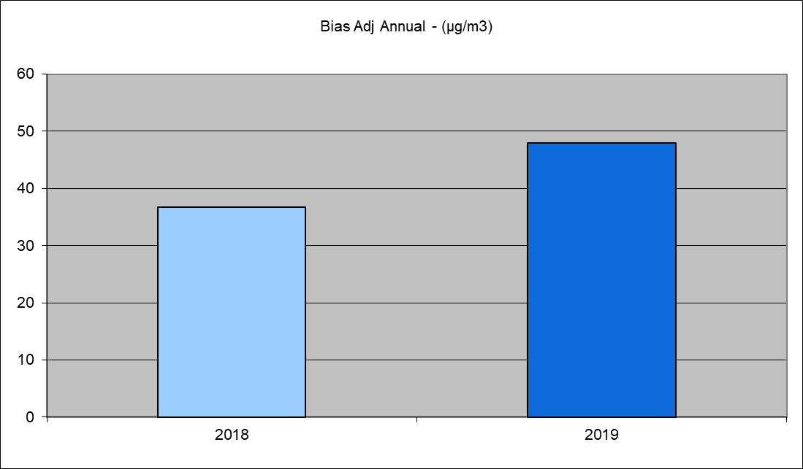

Figure E.17 Trend Analysis for Nitrogen Dioxide Diffusion Tubes at Kingsway Kirkby in Ashfield

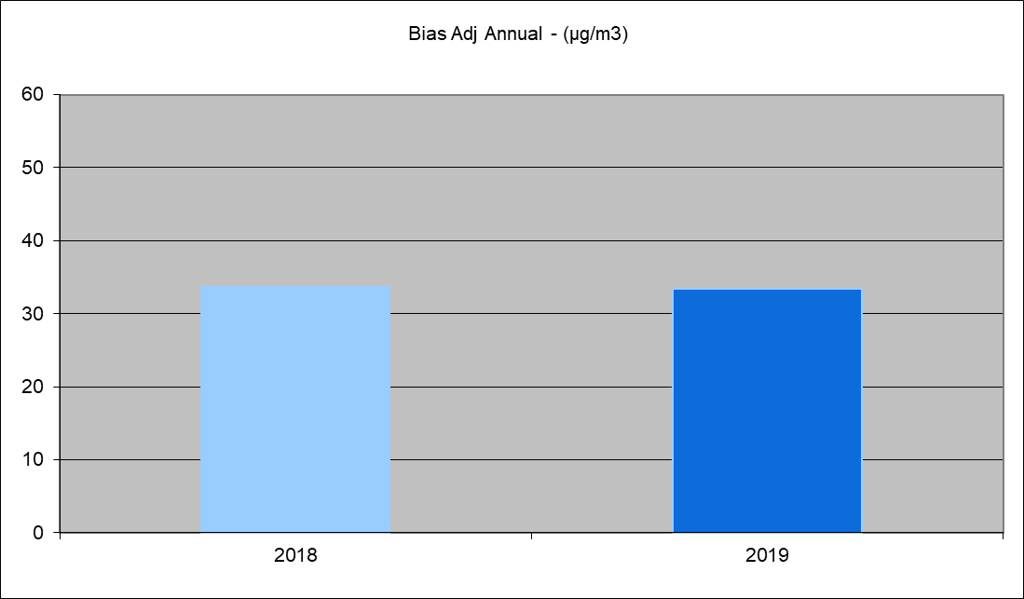

Appendix F: Summary of Air Quality Objectives in England
Table F.1 – Air Quality Objectives in England

Pollutant | Air Quality Objective4
 | Concentration | Measured as
Nitrogen Dioxide (NO2) | 200 µg/m3 not to be exceeded more than 18 times a year | 1-hour mean
 | 40 µg/m3 | Annual mean
Particulate Matter (PM10) | 50 µg/m3, not to be exceeded more than 35 times a year | 24-hour mean
 | 40 µg/m3 | Annual mean
Sulphur Dioxide (SO2) | 350 µg/m3, not to be exceeded more than 24 times a year | 1-hour mean
 | 125 µg/m3, not to be exceeded more than 3 times a year | 24-hour mean
 | 266 µg/m3, not to be exceeded more than 35 times a year | 15-minute mean

4 The units are in microgrammes of pollutant per cubic metre of air (µg/m3).

Glossary of Terms

.Abbreviation | Description
AQAP | Air Quality Action Plan - A detailed description of measures, outcomes, achievement dates and implementation methods, showing how the local authority intends to achieve air quality limit values’
AQMA | Air Quality Management Area – An area where air pollutant concentrations exceed / are likely to exceed the relevant air quality objectives. AQMAs are declared for specific pollutants and objectives
ASR | Air quality Annual Status Report
Defra | Department for Environment, Food and Rural Affairs
DMRB | Design Manual for Roads and Bridges – Air quality screening tool produced by Highways England
EU | European Union
FDMS | Filter Dynamics Measurement System
LAQM | Local Air Quality Management
NO2 | Nitrogen Dioxide
NOx | Nitrogen Oxides
PM10 | Airborne particulate matter with an aerodynamic diameter of 10µm (micrometres or microns) or less
PM2.5 | Airborne particulate matter with an aerodynamic diameter of 2.5µm or less
QA/QC | Quality Assurance and Quality Control
SO2 | Sulphur Dioxide

Ashfield District Council

References
None

LAQM Annual Status Report 2020

