ANTI-SOCIAL BEHAVIOUR, CRIME AND POLICING ACT 2014 (the “Act”)

The Public Spaces Protection Order

– Ashfield District Council 2024 (the “2024 Order”)

Ashfield District Council (“the Authority”), being satisfied that:

- activities as described in articles 1-12 below which are carried on in a public place within the Authority’s area have had a detrimental effect on the quality of life of those in the locality; or

- it is likely that activities will be carried on in a public place within that area and that they will have such an effect.

And that the effect, or likely effect, of the activities:

- is, or is likely to be, of a persistent or continuing nature,

- is, or is likely to be, such as to make the activities unreasonable, and

- justifies the restrictions imposed by this Order.

And that the prohibitions described in articles 1-12 below are reasonable to impose in order—
- to prevent the detrimental effect from continuing, occurring or recurring, or

(b) to reduce that detrimental effect or to reduce the risk of its continuance, occurrence or recurrence.

And being satisfied on reasonable grounds that extending the period for which The Public Spaces Protection Order – Ashfield District Council 2021 (the “2021 Order”) has effect is necessary to prevent—

- occurrence or recurrence after that time of the activities identified in the 2021 Order, or

(b) an increase in the frequency or seriousness of those activities after that time

And pursuant to section 72 of the Act the Authority:

- having had particular regard to the rights of freedom of expression and freedom of assembly set out in articles 10 and 11 of the European Convention on Human Rights and

- having carried out the necessary consultation, notification and publicity

HAS DECIDED TO EXTEND AND VARY the 2021 Order under section 60 and 61 of the Act as follows:

- The land described in the Schedules to this order (“the Restricted Areas”) being land in the area of the Authority to which the Act applies is land protected by this Order.

- This Order may be cited as The Public Spaces Protection Order – Ashfield District Council 2024 (the “2024 Order”) and shall come into force on 1st October 2024 and remain in place for a period of 3 years.

Definitions

In this Order:

“Alcohol” has the meaning given by section 191 of the Licensing Act 2003

“Authorised Officer” means an employee of the Authority who is authorised in writing by the Authority for the purpose of this Order

“Authorised Person” includes an Authorised Officer and a Police Community Support Officer (PCSO)

“Prescribed Charity” means:
i. Dogs for the Disabled (registered charity number 700454)
ii. Support Dogs Ltd (registered charity number 1088281)
iii. Canine Partners (registered charity number 803680)
iv. Dog Assistance in Disability (Registered Charity Number 1098619)
v. Medical Detection Dogs (Registered Charity Number 1124533)

‘Public Place’ means any place to which the public or any section of the public has access, on payment or otherwise, as of right or by virtue of express or implied permission

Offences

- Prohibition of Alcohol Consumption
1.1 This article applies to land specified in Schedule 1 of this Order.
1.2 No person shall consume alcohol or have an open container of alcohol in their possession on any land to which this article applies subject to the exemptions referred to at Appendix A below.
1.3 Where a constable or an Authorised Person reasonably believes that a person is or has been consuming alcohol in breach of the prohibition in 1.2 above, or intends to consume alcohol in circumstances in which doing so would be a breach of that prohibition, under section 63(2) of the Act the constable or Authorised Person may require the person:
(a) not to consume, in breach of the Order, alcohol or anything which the constable or Authorised Person reasonably believes to be alcohol;
(b) to surrender anything in the person’s possession which is, or which the constable or Authorised Person reasonably believes to be, alcohol or a container for alcohol.
1.4 A constable or an Authorised Person who imposes a requirement under section 63(2) of the Act must tell the person that failing without reasonable excuse to comply with the requirement is an offence.
1.5 A requirement imposed by an Authorised Person under section 63(2) of the Act is not valid if the Authorised Person is asked by the person to show evidence of his or her authorisation and fails to do so.
1.6 A constable or an Authorised Person may dispose of anything surrendered under section 63(2)(b) of the Act in whatever way he or she thinks appropriate.
1.7 A person who fails without reasonable excuse to comply with a requirement imposed on him or her under section 63(2) of the Act commits an offence and is liable on summary conviction to a fine not exceeding level 2 on the standard scale.
2. Urinating
2.1 This article applies to land specified in Schedule 1 of this Order.
2.2 A person commits an offence if they urinate or defecate on any land to which this article applies unless:
(a) he has a reasonable excuse for doing so; or
(b) the owner, occupier or other person or authority having control of the land has expressly consented to his doing so.
2.3 In accordance with section 67 of the Act a person who is guilty of an offence under article 2 shall be liable on summary conviction to a fine not exceeding level 3 on the standard scale.
3. Direction to Move On
3.1 This article applies to land specified in Schedule 1 of this Order.
3.2 A person commits an offence if they fail to comply immediately with a direction by a constable or an Authorised Person to move on from any location on any land to which this article applies to such distance from that location and for such a time period as specified by the constable or Authorised Person unless:
(a) he has a reasonable excuse for failing to do so; or
(b) the owner, occupier or other person or authority having control of the land has expressly consented to his failing to do so.
3.3 A constable or an Authorised Person may only give a direction under this article if such direction is reasonably necessary to prevent nuisance or behaviour by a person that is likely to cause annoyance or disturbance to any other person.
3.4 In accordance with section 67 of the Act a person who is guilty of an offence under article 3 shall be liable on summary conviction to a fine not exceeding level 3 on the standard scale.
4. Dog Fouling
4.1 This article applies to land specified in Schedule 2 of this Order
4.2 If a dog defecates at any time on any land to which this article applies and a person who is in charge of the dog at that time fails to remove the faeces from the land forthwith, that person shall be guilty of an offence unless—
(a) he has a reasonable excuse for failing to do so; or
(b) the owner, occupier or other person or authority having control of the land has expressly consented to his failing to do so.
  - For the purposes of this article:

- A person who habitually has a dog in his possession shall be taken to be in charge of the dog at any time unless at that time some other person is in charge of the dog;

- placing the faeces in a receptacle on the land which is provided for the purpose, or for the disposal of waste, shall be a sufficient removal from the land;

- being unaware of the defecation (whether by reason of not being in the vicinity or otherwise) or not having a device for or other suitable means of removing the faeces shall not be a reasonable excuse for failing to remove the faeces.

  - In accordance with section 67 of the Act a person who is guilty of an offence under article 4 shall be liable on summary conviction to a fine not exceeding level 3 on the standard scale.
5. Failure to produce a device for or other suitable means of removing dog faeces on demand
5.1 This article applies to land specified in Schedule 2 of this Order.
5.2 If at any time on any land to which this article applies a person who is in charge of a dog at any time fails to produce forthwith a device for or other suitable means of removing dog faeces (whether or not the dog has defecated) when asked to do so by a constable or an Authorised Person, that person shall be guilty of an offence unless:
(a) he has a reasonable excuse for failing to do so; or
(b) the owner, occupier or other person or authority having control of the land has expressly consented to his failing to do so.
5.3 For the purposes of this article, a person who habitually has a dog in his possession shall be taken to be in charge of the dog at any time unless at that time some other person is in charge of the dog.

5.4 In accordance with section 67 of the Act a person who is guilty of an offence under article 5 shall be liable on summary conviction to a fine not exceeding level 3 on the standard scale.

6. Dog Exclusion

  - This article applies to land specified in Schedule 3 of this Order

  - A person who is in charge of a dog shall be guilty of an offence if, at any time, he takes the dog onto, or permits the dog to enter or to remain on, any land to which this article applies unless—
- he has a reasonable excuse for doing so; or
- the owner, occupier or other person or authority having control of the land has expressly consented to his doing so.
6.3 For the purposes of this article, a person who habitually has a dog in his possession shall be taken to be in charge of the dog at any time unless at that time some other person is in charge of the dog.
6.4 In accordance with section 67 of the Act a person who is guilty of an offence under article 6 shall be liable on summary conviction to a fine not exceeding level 3 on the standard scale.
- Dogs on Leads

  - This article applies to land specified in Schedule 4 of this order
7.2 A person who is in charge of a dog shall be guilty of an offence if, at any time, on any land to which this article applies he does not keep the dog on a lead of not more than five (5) metres in length, unless—
(a) he has a reasonable excuse for failing to do so; or
(b) the owner, occupier or other person or authority having control of the land has expressly consented to his failing to do so.
7.3 For the purposes of this article, a person who habitually has a dog in his possession shall be taken to be in charge of the dog at any time unless at that time some other person is in charge of the dog.
7.4 In accordance with section 67 of the Act a person who is guilty of an offence under article 7 shall be liable on summary conviction to a fine not exceeding level 3 on the standard scale.
- Dogs on Lead by direction

8.1 This article applies to land specified in Schedule 2 of this Order.
8.2 A person who is in charge of a dog shall be guilty of an offence if, at any time, on any land to which this article applies, he does not comply with a direction given to him by a constable or an Authorised Person to put and keep the dog on a lead of not more than five (5) metres in length, unless—
(a) he has a reasonable excuse for failing to do so; or
(b) the owner, occupier or other person or authority having control of the land has expressly consented to his failing to do so.
8.3 For the purposes of this article:
(a) a person who habitually has a dog in his possession shall be taken to be in charge of the dog at any time unless at that time some other person is in charge of the dog
(b) a constable or an Authorised Person may only give a direction under this article to put and keep a dog on a lead if such restraint is reasonably necessary to prevent a nuisance or behaviour by the dog likely to cause annoyance or disturbance to any other person on any land to which this article applies or the worrying or disturbance of any animal or bird.
8.4 In accordance with section 67 of the Act a person who is guilty of an offence under article 8 shall be liable on summary conviction to a fine not exceeding level 3 on the standard scale.
- Dogs Specified Maximum Amount

  - This article applies to land specified in the Schedule 2 of this Order.

9.2 A person who is in charge of more than one dog shall be guilty of an offence if, at any time, he takes onto any land to which this article applies more than six (6) dogs, unless—
(a) he has a reasonable excuse for doing so; or
(b) the owner, occupier or other person or authority having control of the land has expressly consented to his doing so.
9.3 For the purposes of this article, a person who habitually has a dog in his possession shall be taken to be in charge of the dog at any time unless at that time some other person is in charge of the dog.
9.4 In accordance with section 67 of the Act a person who is guilty of an offence under article 9 shall be liable on summary conviction to a fine not exceeding level 3 on the standard scale.
10 Restricting Access
10.1 This Article applies to land specified in Schedule 5 of this Order (“the Restricted Access Highway”).
10.2 A person commits an offence if at any time he uses the public right of way on land to which this article applies unless he has a reasonable excuse for doing so.
10.3 A barrier or barriers may be installed, operated and maintained at each of the respective ends of the Restricted Access Highway. Ashfield District Council is responsible for maintaining and operating the barrier or barriers.
10.4 In accordance with section 67 of the Act a person who is guilty of an offence under article 10 shall be liable on summary conviction to a fine not exceeding level 3 on the standard scale.
11 Vehicle Nuisance
11.1 This Article applies to land specified in Schedule 2 of this Order.
11.2 A person commits an offence if at any time without reasonable excuse he:
(a) participates in Car Cruising;
(b) promotes, organises or publicises Car Cruising (including but not limited to via email, the internet, Facebook, Twitter or similar social media, or any publication or broadcast);
(c) attends any meeting either as a vehicle owner, driver, passenger or spectator where a reasonable person would consider that Car Cruising is taking place.
11.3 “Car Cruising” is defined as two or more motor vehicles (including motor bikes) being on a highway or a public place where any such vehicle or occupant of such vehicle performs any of the Prohibited Activities.
11.4 The “Prohibited Activities” are:
(a) causing danger or risk of injury to road users (including pedestrians) by speeding or racing;
(b) causing damage or risk of damage to property;
(c) speeding or racing;
(d) performing stunts (including but not limited to performing a doughnuts manoeuvre drifting, skidding, handbrake turns, wheel spinning);
(e) sounding horns or playing loud music so as to cause a nuisance;
(f) revving of engines so as to cause a nuisance;
(g) using foul or abusive language;
(h) using threatening, intimidating or anti-social behaviour; or
(i) causing obstruction on a public highway or publicly accessible place (whether moving or stationary)
11.5 In accordance with section 67 of the Act a person who is guilty of an offence under article 11 shall be liable on summary conviction to a fine not exceeding level 3 on the standard scale.
12. Street Harassment

12.1 This article applies to land specified in Schedule 2 of this Order.

12.2 A person commits an offence if at any time without reasonable excuse he is verbally abusive to another person or behaves in a way that causes or is likely to cause harassment alarm or distress to another person. This will include but not be limited to making sexually inappropriate comments or displaying inappropriate behaviours towards women and girls.

12.3 In accordance with section 67 of the Act a person who is guilty of an offence under article 12 shall be liable on summary conviction to a fine not exceeding level 3 on the standard scale.

Exemptions

Nothing in articles 4, 5 and 6 shall apply to a person who has a disability which affects his sight, hearing, mobility, manual dexterity, physical coordination or ability to lift, carry or otherwise move everyday objects, in respect of a dog trained by a prescribed charity and upon which he relies for assistance.

Fixed Penalties

A constable or an Authorised Person may issue a fixed penalty notice to anyone he or she has reason to believe has committed an offence under section 63 or 67 in relation to a public spaces protection order.

EXECUTED AS A DEED by affixing )
THE COMMON SEAL of )
ASHFIELD DISTRICT COUNCIL )
This day of 2024 )
In the presence of :- )

Chairman:

Authorised Officer:

Appendix A

Section 62 of the Act - Premises etc. to which alcohol prohibition does not apply

(1) A prohibition in a public spaces protection order on consuming alcohol does not apply to—

(a) premises (other than council-operated licensed premises) Authorised by a premises licence to be used for the supply of alcohol;

(b) premises Authorised by a club premises certificate to be used by the club for the supply of alcohol;

(c) a place within the curtilage of premises within paragraph (a) or (b);

(d) premises which by virtue of Part 5 of the Licensing Act 2003 may at the relevant time be used for the supply of alcohol or which, by virtue of that Part, could have been so used within the 30 minutes before that time;

(e) a place where facilities or activities relating to the sale or consumption of alcohol are at the relevant time permitted by virtue of a permission granted under section 115E of the Highways Act 1980 (highway-related uses).

(2) A prohibition in a public spaces protection order on consuming alcohol does not apply to council-operated licensed premises—

(a) when the premises are being used for the supply of alcohol, or

(b) within 30 minutes after the end of a period during which the premises have been used for the supply of alcohol.

(3) In this section—

“club premises certificate” has the meaning given by section 60 of the Licensing Act 2003;

“premises licence” has the meaning given by section 11 of that Act;

“supply of alcohol” has the meaning given by section 14 of that Act.

(4) For the purposes of this section, premises are “council-operated licensed premises” if they are Authorised by a premises licence to be used for the supply of alcohol and—

(a) the licence is held by a local authority in whose area the premises (or part of the premises) are situated, or

(b) the licence is held by another person but the premises are occupied by a local authority or are managed by or on behalf of a local authority.

The Public Spaces Protection Order

– Ashfield District Council 2024

Schedule 1 – Alcohol Consumption, Urinating, Direction to move on (Prohibitions 1, 2 & 3)

Public spaces within Areas 1-8 (shown edged in red and shaded in red on the plans attached), being Public Places in the Authority's area to which the Act applies.

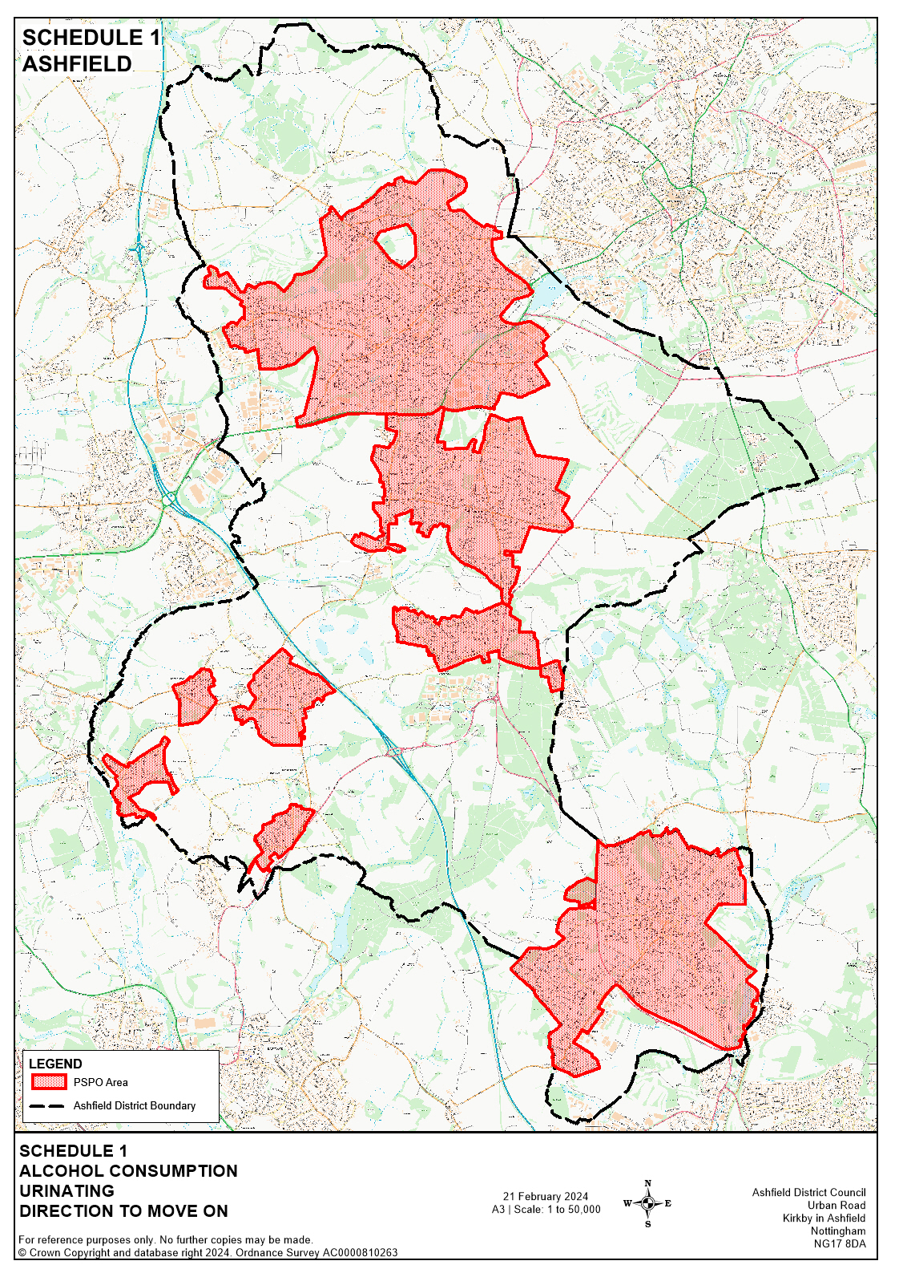
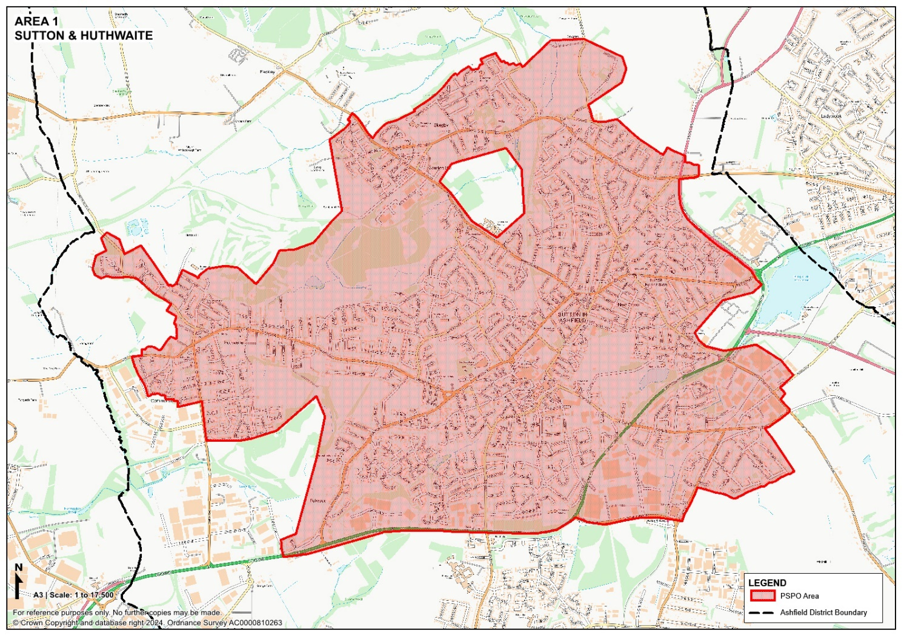

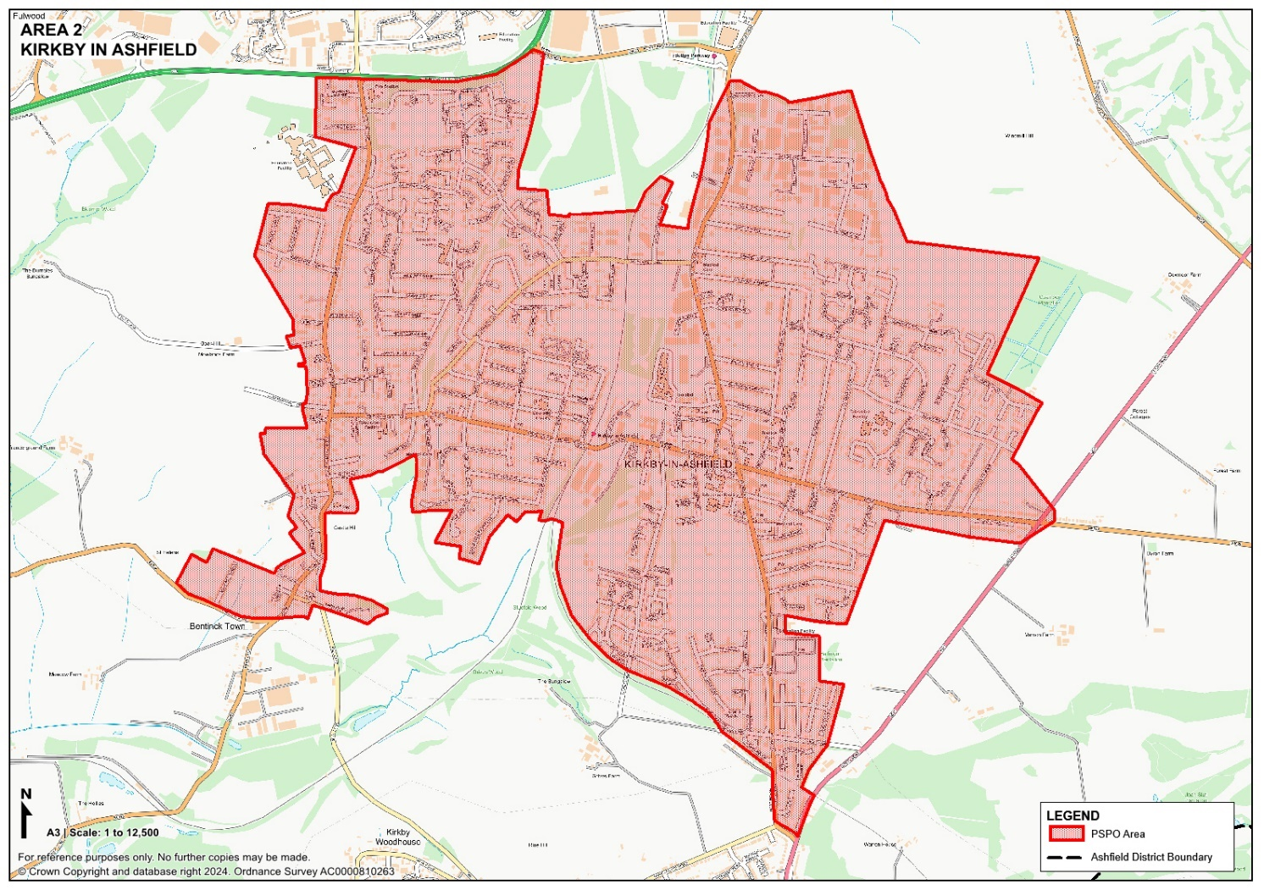

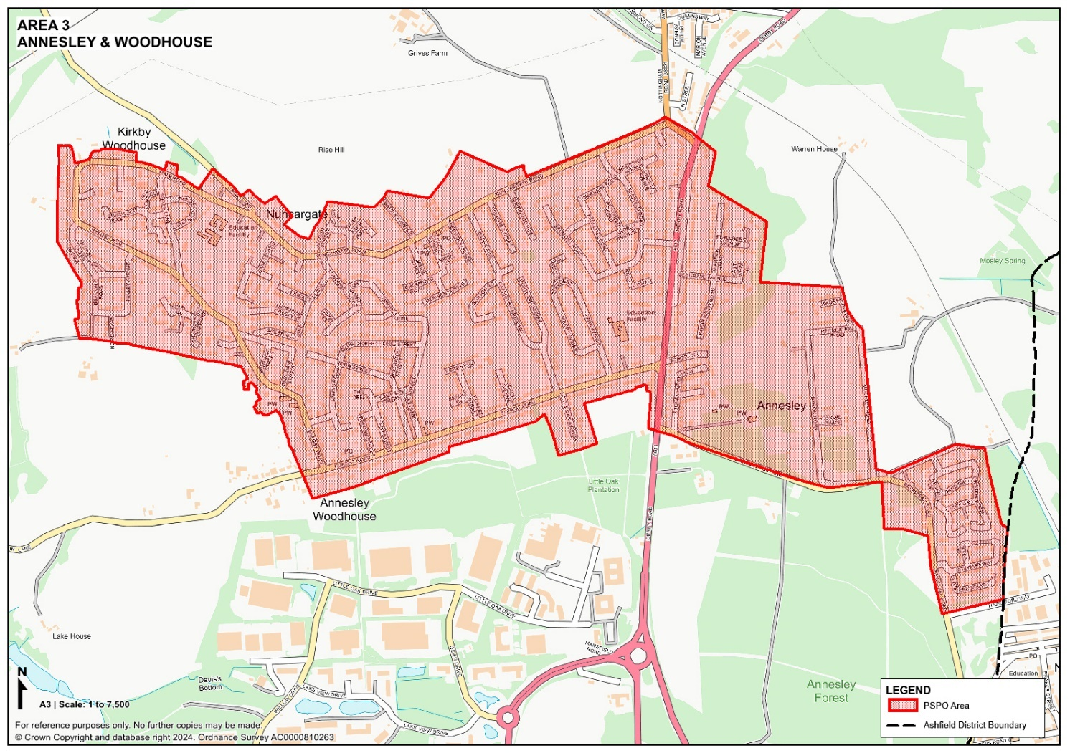

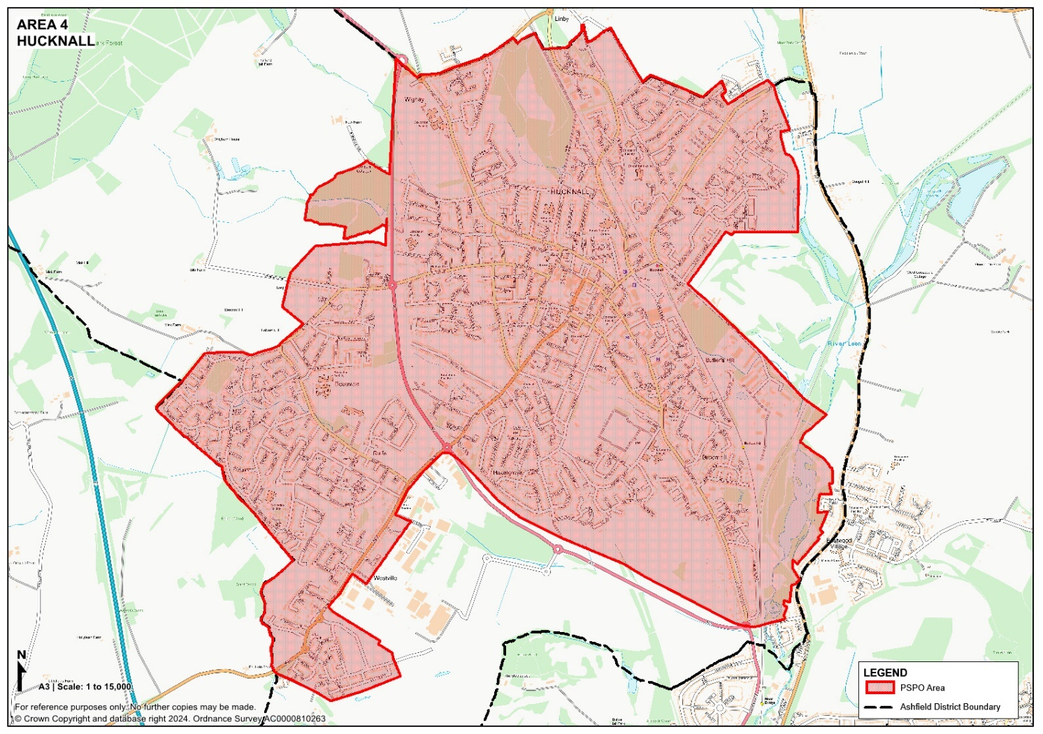

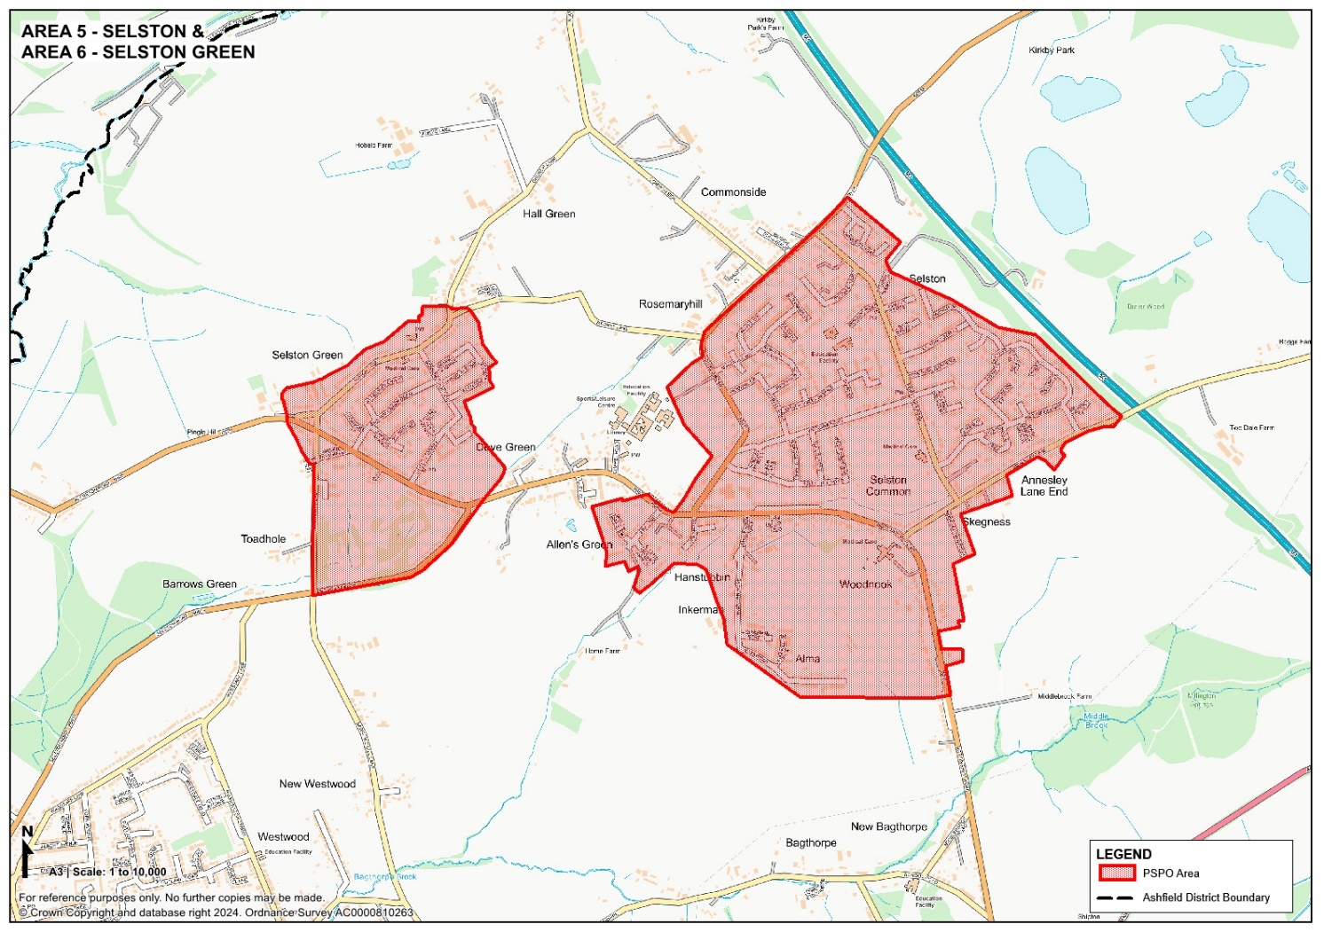

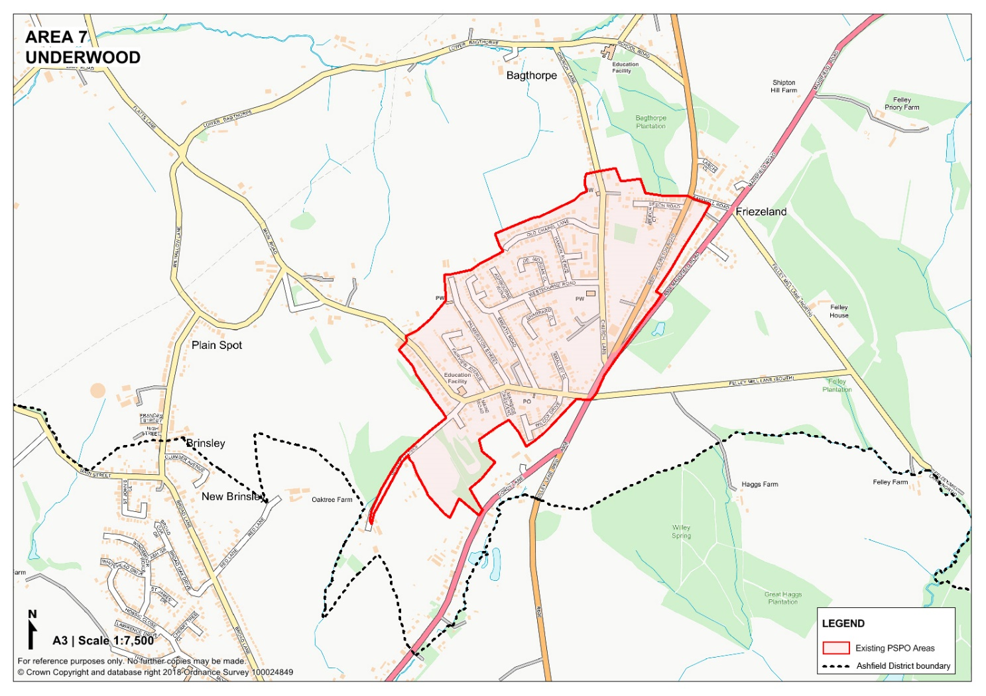

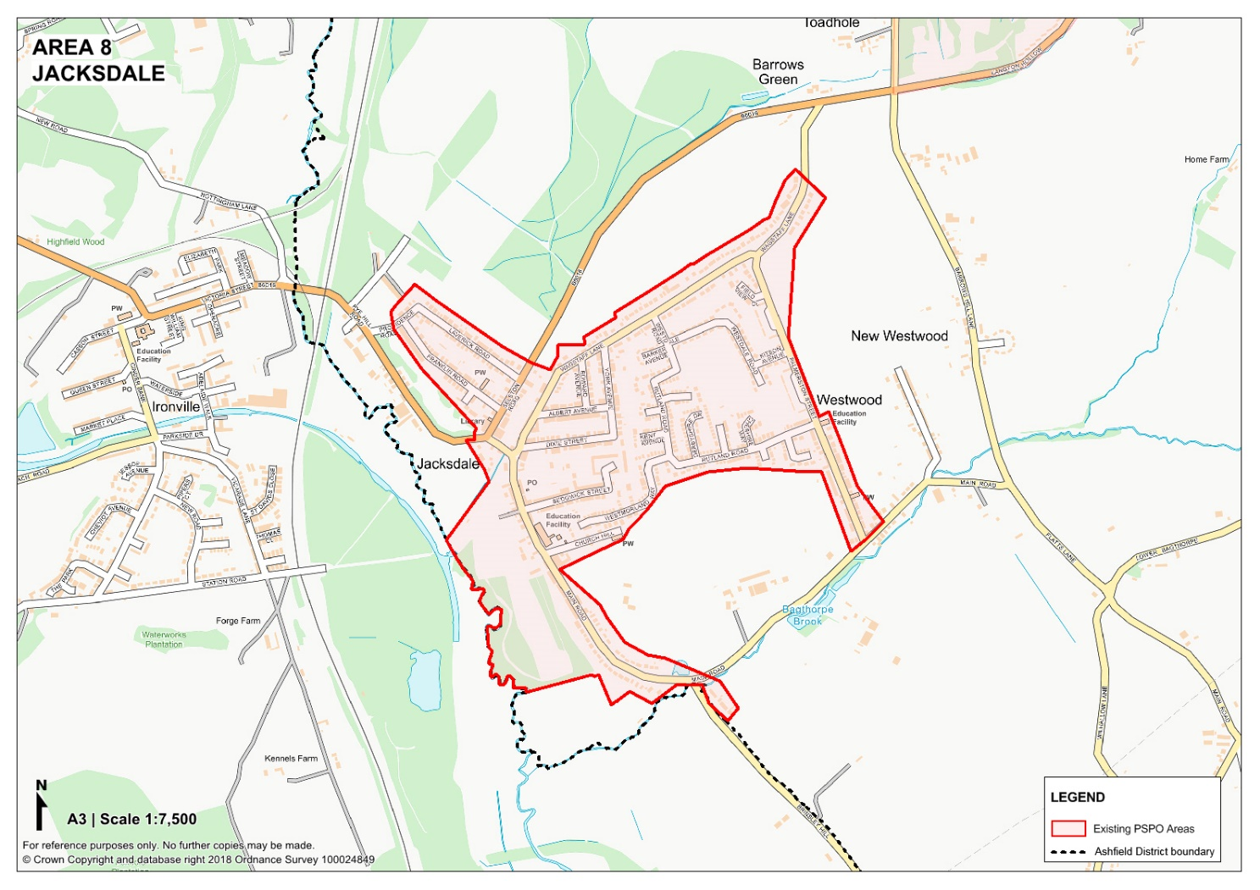
The Public Spaces Protection Order
– Ashfield District Council 2024
Schedule 2 – Dog Fouling, Failing to produce a suitable means of removing dog faeces, Dogs on lead by direction, Dogs specified maximum amount, Vehicle Nuisance, Street Harassment (Prohibitions 4, 5, 8, 9, 11 and 12)
1. Subject to the exception in paragraph 2 below, public spaces within the area shown edged in red on the plan attached, being Public Places in the Authority's area to which the Act applies.
2. Excepted from the description in paragraph 1 above is land that is placed at the disposal of the Forestry Commissioners under section 39(1) of the Forestry Act 1967.

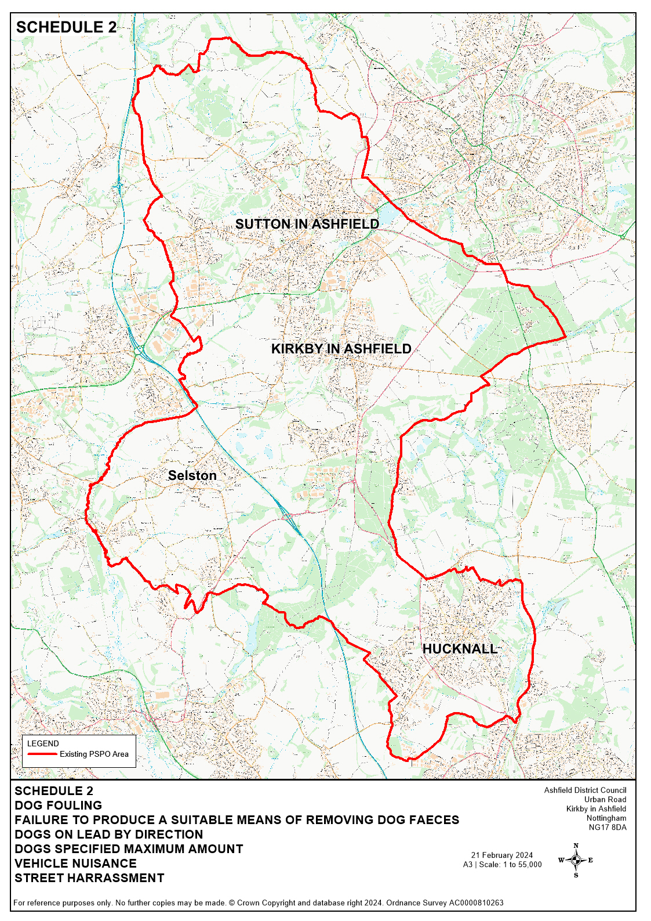

The Public Spaces Protection Order
– Ashfield District Council 2024
Schedule 3 – Dog Exclusion areas (prohibition 6)
Public spaces described in the following Schedule and shown within the areas coloured in red on the plans attached, being Public Places in the Authority's area to which the Act applies, and which is signed at its entrance(s) as a “Dog Exclusion Area” (whether the sign uses those particular words or words and/or symbols having like effect)

Land Designated Specifically:
- Sutton-in-Ashfield
1.1 The children’s play area at Stoneyford Road Recreation Ground
  - The children’s play area and multi-use games area at The Oval Recreation Ground
  - The children’s play area at Brierley Country Park, Huthwaite
  - The children’s play area, the tennis courts, the bowling green, the all weather football pitch and the multi-use games area at Sutton Lawn Pleasure Ground
  - The children’s play area and multi-use games area at Cowpasture Lane Recreation Ground
  - The children’s play area at the John Whetton Recreation Ground (Roundhills),
  - The children’s play area at Stamper Crescent Recreation Ground
  - The children’s play area, the multi-use games area, and the fitness area at Healdswood Recreation Ground
  - The children’s play area at Hill Crescent Recreation Ground
  - The children’s play area at Bluebell Wood Way Recreation Ground
  - The children’s play area at Sudbury Drive Recreation Drive
  - The children’s play area at Springwood View Close Recreation Ground (locally known as “the Riley Recreation Ground”)
  - The children’s play area, multi-use games area, tennis court, and the bowling green at the Welfare Grounds, Huthwaite, Sutton in Ashfield.
  - The children’s play area at Meden Bank

- Kirkby-in-Ashfield
  - The children’s play area at Mayfield Street Recreation Ground
  - The children’s play area, the all-weather football pitch, the youth area/skate park, and the tennis courts at Kingsway Park
  - The children’s play area, tennis courts, bowling green and additional enclosed area at Titchfield Park
  - The children’s play area at Morvern Park, Welbeck Street
  - The children’s play area, at Beacon Drive Recreation Ground
  - The children’s play area and multi-use games area at Forster Street Recreation Ground (locally known as “West Park”)
  - The children’s play area at David Street
  - The children’s play area at Larwood Park
  - The children’s play area and park at Hornbeam Park
  - The public open space at Portland Park

- Annesley / Annesley Woodhouse
3.1 The children’s play area at The Steeples Recreation Ground, Annesley Woodhouse
3.2 The children’s play area and multi-use games area at Cavendish Crescent Recreation Ground, Annesley Woodhouse (known locally as “Acacia Recreation Ground”)
3.3 The children’s play area at Byron Road Recreation Ground, Annesley
3.4 The children’s play area at Nuncargate Road Recreation Ground, Annesley Woodhouse

- Hucknall
  - The children’s play equipment areas, the bowling green, skate park, synthetic pitch area, tennis court, and basketball court at Titchfield Park
  - The children’s play area and basketball ground at Bestwood Road Recreation Ground
  - The children’s play area at the Leisure Centre Recreation Ground, Linby Road
  - The children’s play areas, BMX pump track and multi-use games area at Nabbs Lane Recreation Ground
  - The children’s play area at Milton Rise Recreation Ground
  - The children’s play area at Snowdrop Close
  - The children’s play areas at Washdyke Lane
  - The children’s play area at Rolls Royce
  - The children’s play area at Lime Tree Road

- Selston
5.1 The children’s play area and skate park at Nottingham Road Recreation Ground
5.2 The children’s play area at Valentine Avenue Recreation Ground
  - The children’s play area at Green Well Park
  - The children’s play area at Green Farm Road Recreation Ground
  - The children’s play area at Jubilee Recreation Ground
  - The children’s play area at New Selston Recreation Ground
  - The children’s play area and green space areas at Selston Country Park

- Jacksdale
  - The children’s play area at Palmerston Street Recreation Ground, Westwood.
  - The children’s play area and skate park at Main Road Recreation Ground

- Underwood
  - The children’s play area at Underwood Hill Recreation Ground
  - The children’s play area at Middlebrook Road Recreation Ground
  - The children’s play area at Church Lane (Friezeland) Recreation Ground
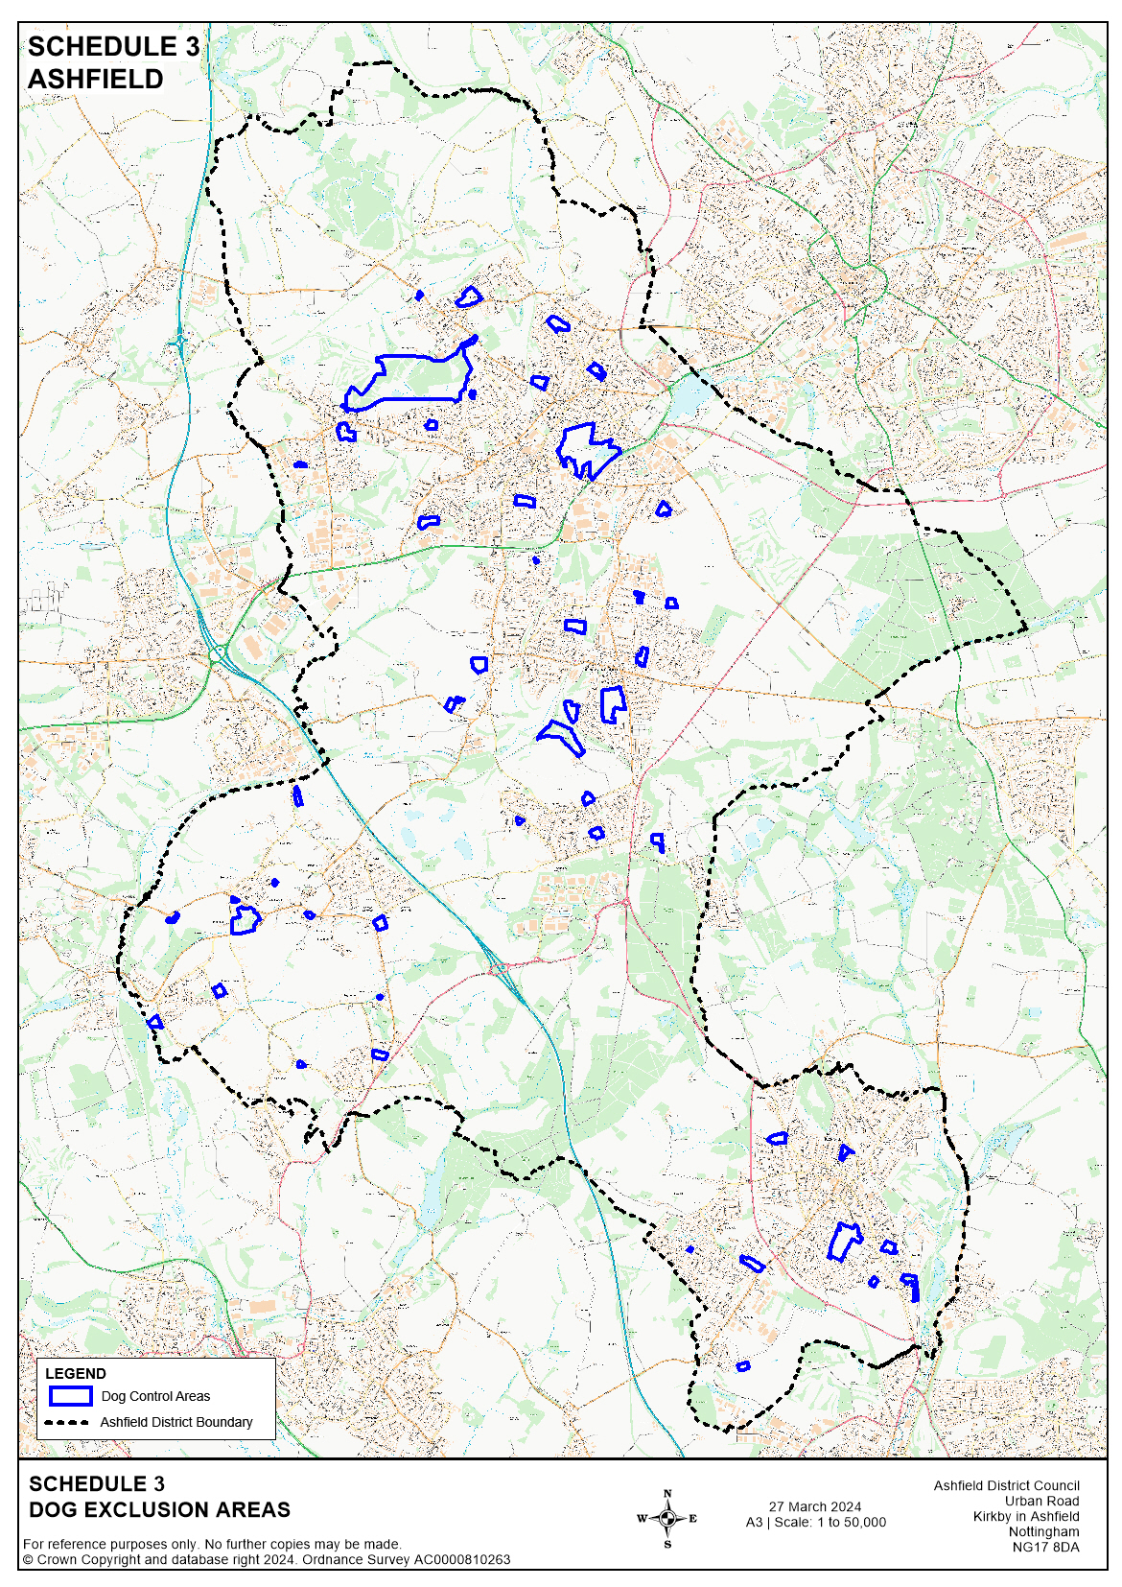

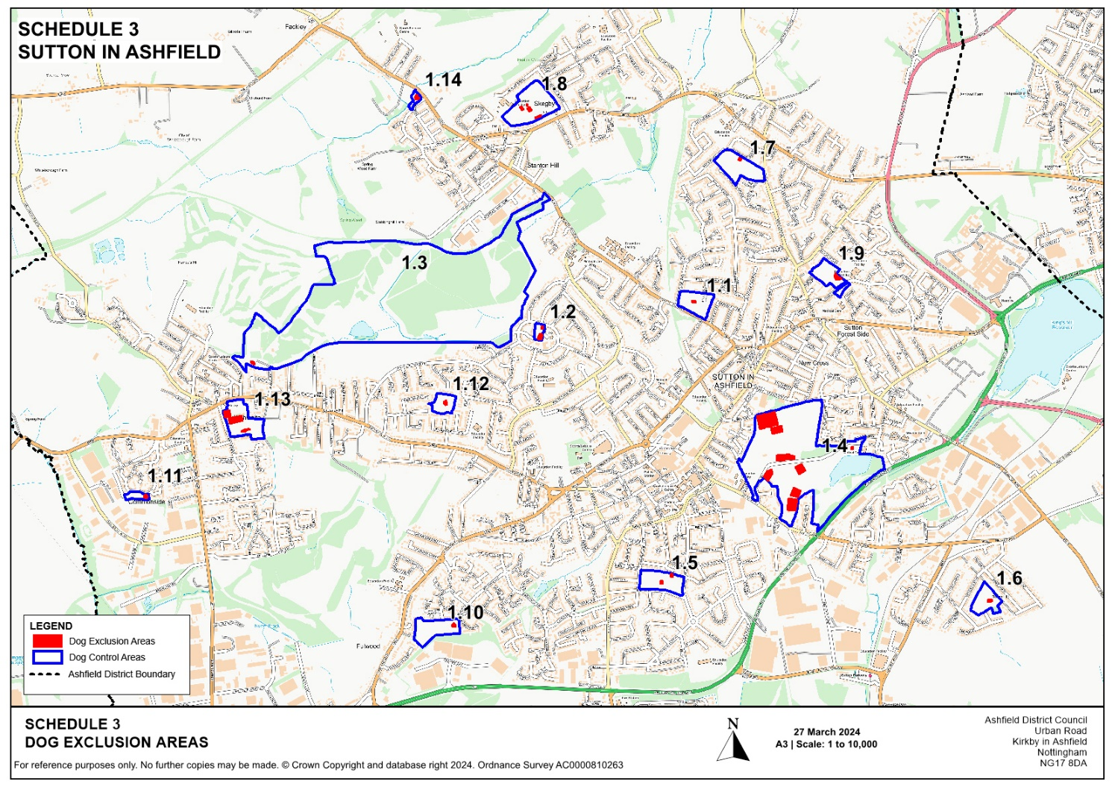

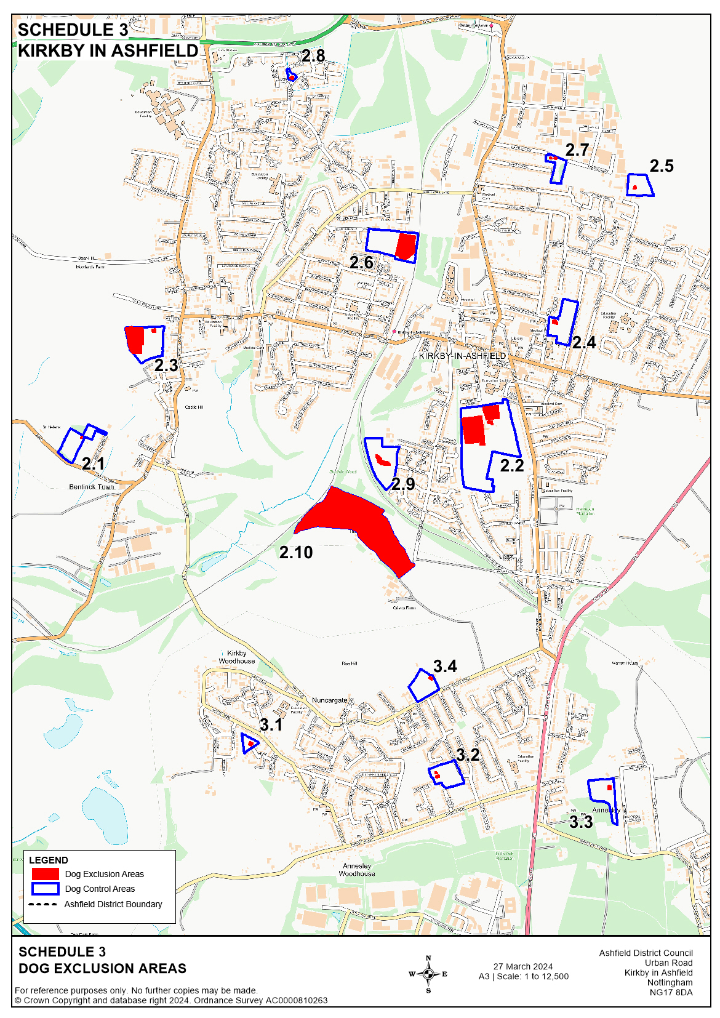
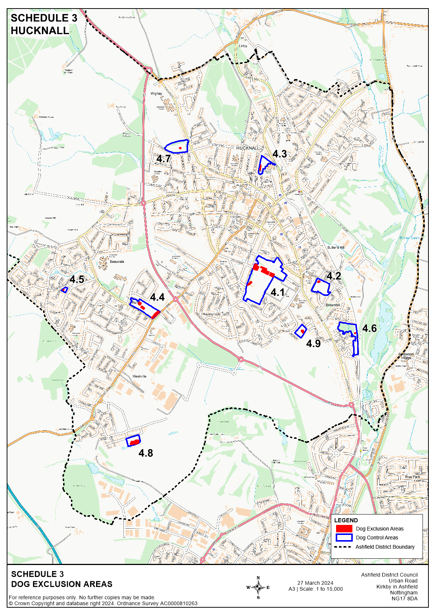
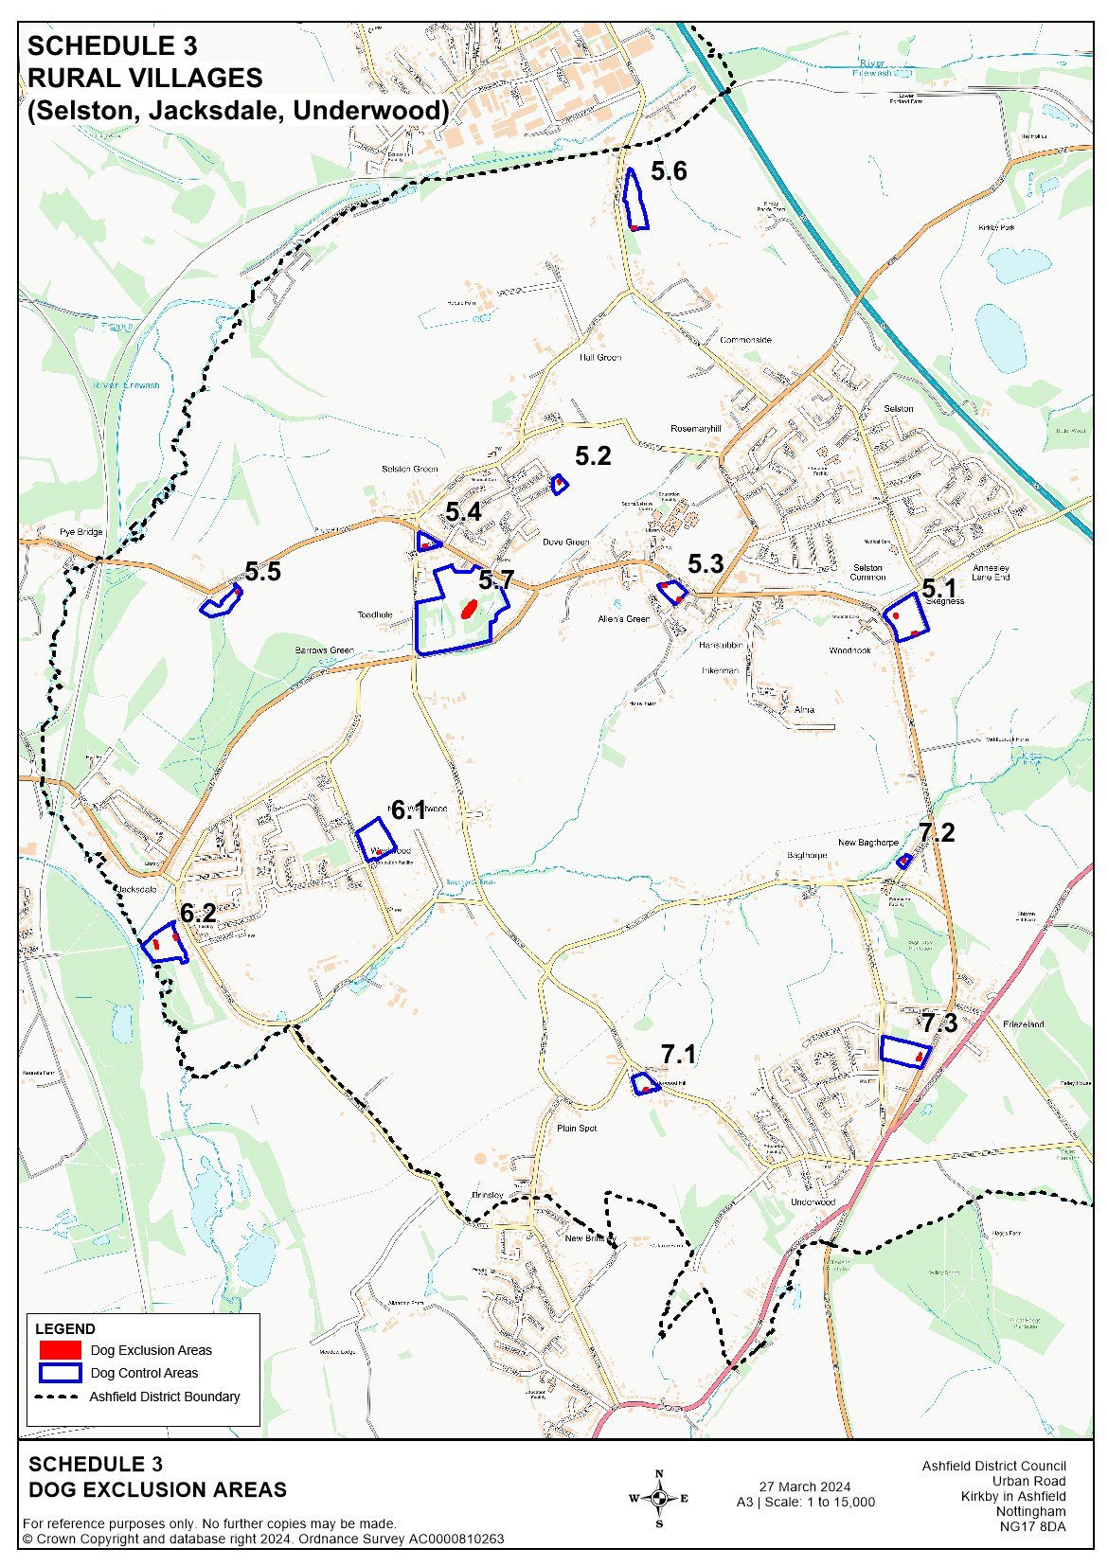
The Public Spaces Protection Order
– Ashfield District Council 2024
Schedule 4 – Dogs lead only areas (Prohibition 7)
Public spaces described in the following Schedule, being Public Places in the Authority's area to which the Act applies, and which is signed as “Dogs on leads area” (whether the sign uses those particular words or words and/or symbols having like effect)

Land Designated Specifically:

- Each and every length of road (which term includes adjoining pavements, footways and verges) except public footpaths and bridleways
The following areas which are shown edged in red and shaded in red on the plans attached hereto:
- The following pedestrianised areas: (a) Hucknall Market Place, Hucknall (b) Kirkby Precinct, Kirkby-in-Ashfield (c) Portland Square, Low Street and Sutton Market Place, Sutton-in-Ashfield
3. Cemeteries and churchyards:
- Hucknall: St Mary Magdalene Church, Hucknall Cemetery
- Kirkby-in-Ashfield: St Wilfrids Church, Kingsway Old Cemetery, Kingsway New Cemetery, Annesley Woodhouse Cemetery
- Sutton-in-Ashfield: St Andrews Church, St Mary Magdalenes Church, Sutton Cemetery, Huthwaite Cemetery
- Rural Villages (Selston, Jacksdale and Underwood): St Helens Church, St Marys Church, St Michaels and All Angels Church

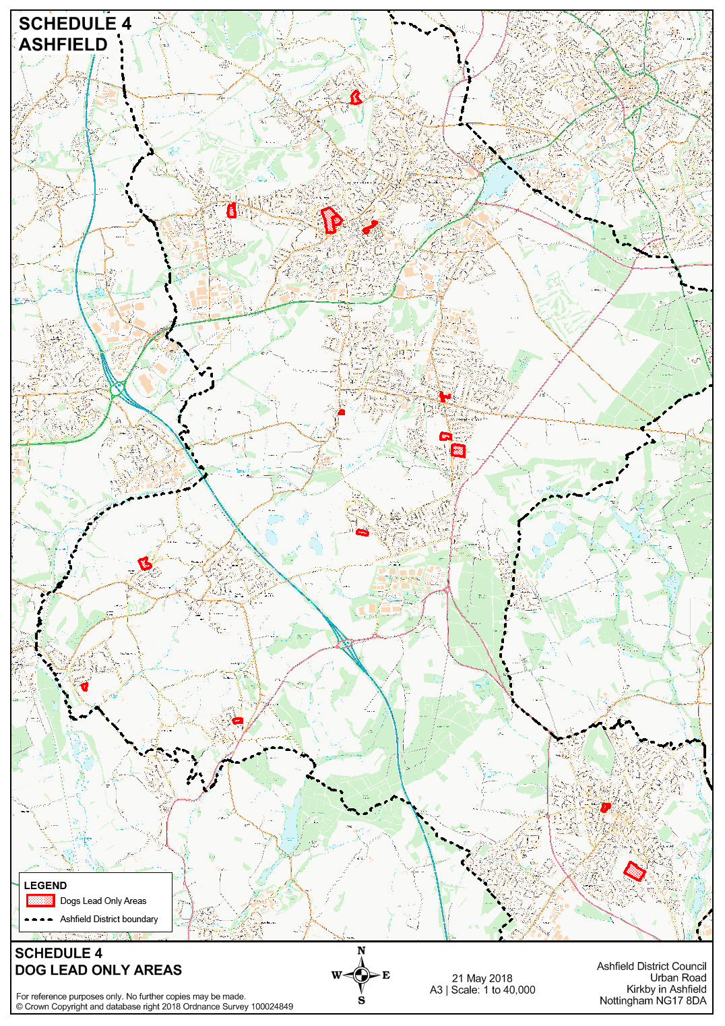
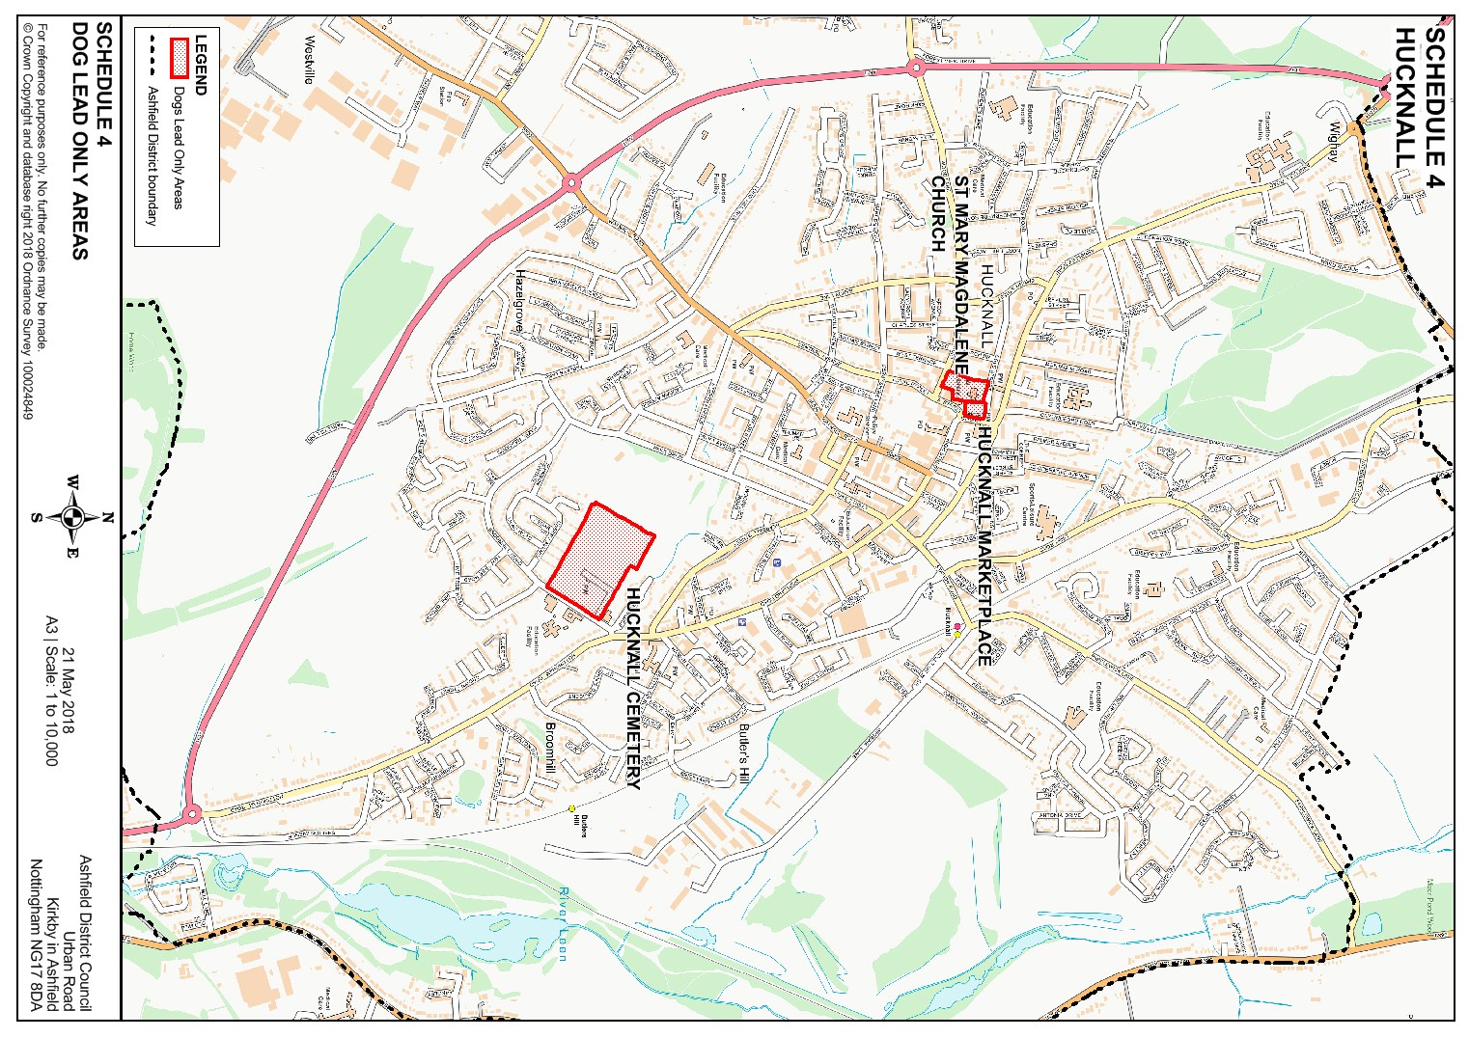

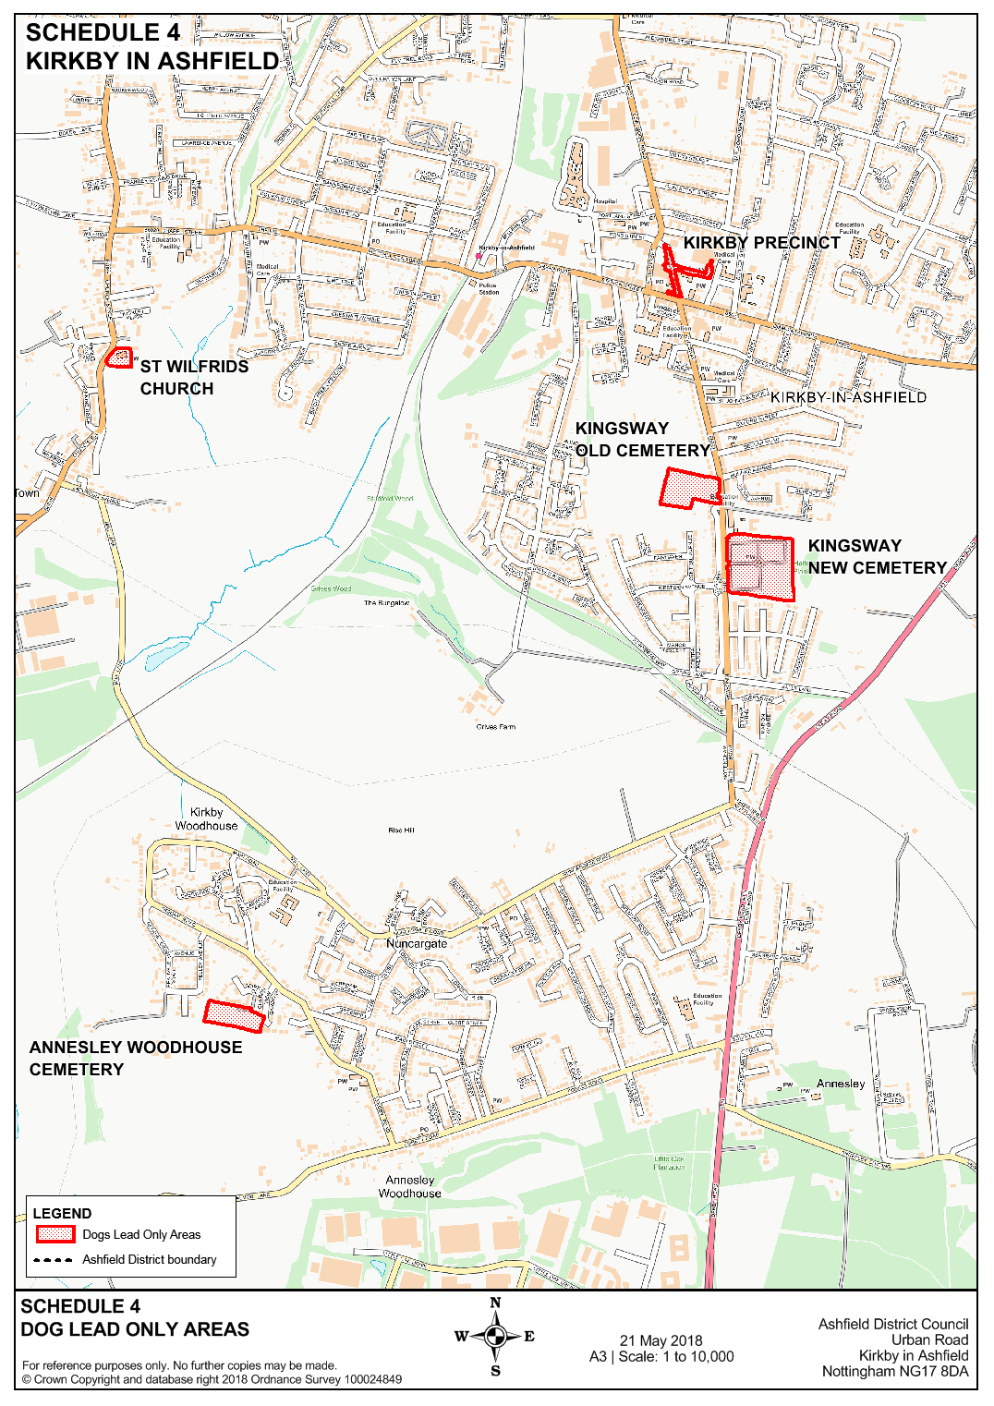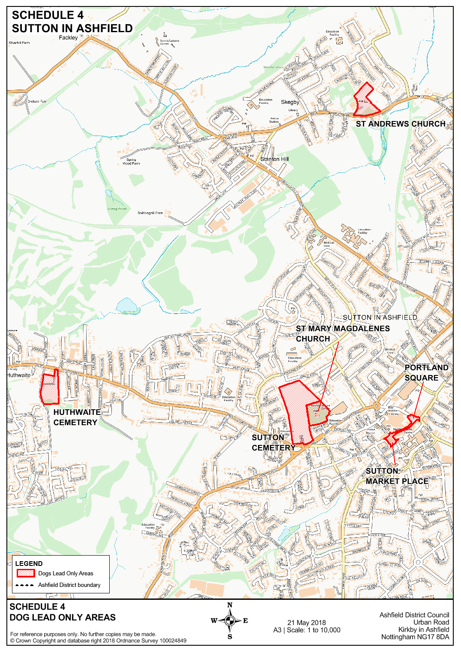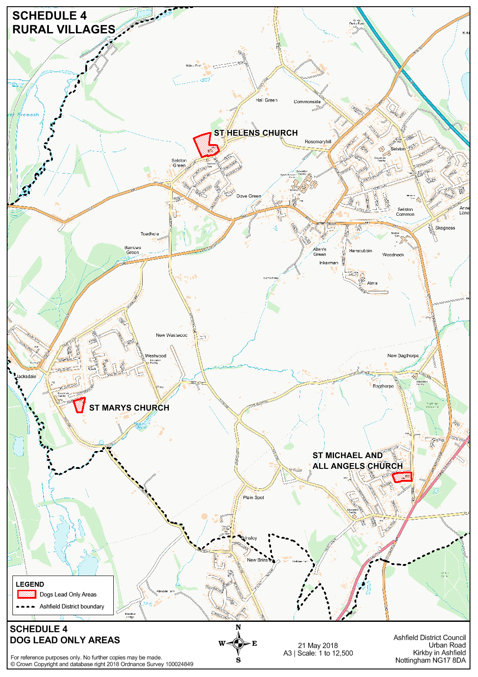
The Public Spaces Protection Order
– Ashfield District Council 2024
Schedule 5 (Restricting Access – Prohibition 10)
The highway described in the following Schedule and shown edged by bold red lines on the plan attached, being a Public Place in the Authority's area to which the Act applies

Land Designated Specifically (“the Restricted Access Highway”):
The strip of land between Bentinck Street and Welbeck Street, Sutton-in-Ashfield, Nottinghamshire.

