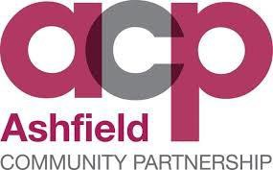

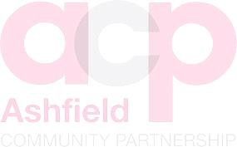Community Safety Partnership Public Consultation 2019

**DEAN DAKIN – COMMUNITY SAFETY AND STRATEGIC PARTNERSHIP OFFICER**

This page is deliberately left blank.

**Introduction**

The Community Safety Partnership (CSP) carries out an annual Strategic Assessment. This makes use of a range of partnership data including police crime figures, anti-social behaviour data, demographic information, environmental services data and information from an annual public consultation. Based on the Strategic Assessment, a Community Safety Partnership Plan is either written every three years or refreshed annually. Data from this consultation has been included in the 2019 Strategic Assessment and will be used to inform the Community Safety Plan for 2019-2022.

Public consultations form an important part of the Partnership’s evaluation process, gathering data around the community’s perception of crime and disorder and awareness of emerging issues in both their local area and the District as whole.

The consultation was designed specifically to:

* Understand public perception of progress in terms of tackling crime and ASB.
* Understand what contributes to making people feel safe and unsafe.
* Gain an understanding of people’s concerns about some of the underlying issues that impact on Crime and ASB.
* Gain an understanding of people’s awareness of new and emerging issues within the district.
* Understand those issues that cause the greatest level of public concern.

It is appreciated that the data collected may have a wider use than informing the CSP’s annual Strategic Assessment and is therefore shared with a number of partnerships, networks and organisations across the district to help set priorities, develop plans and support funding bids. This will remain compliant with DPA/GDPR.

**Method**

The consultation took place over the period from 29.08.2019 to 01.12.2019.

Whilst the co-ordination of the consultation took place within the District’s Community Safety Team, the delivery of the survey took place over a number of partnership communication channels and public events.

An online version of the survey was made available via the District’s website and promoted through social media channels. Key partners provided similar opportunities, through the face-to-face completion and social media accounts.

The Consultation was delivered at a number of locations and public events over the period. The times and places of these events were coordinated to encourage engagement will all sections of the community. All Ward Councillors were made aware of the consultation.

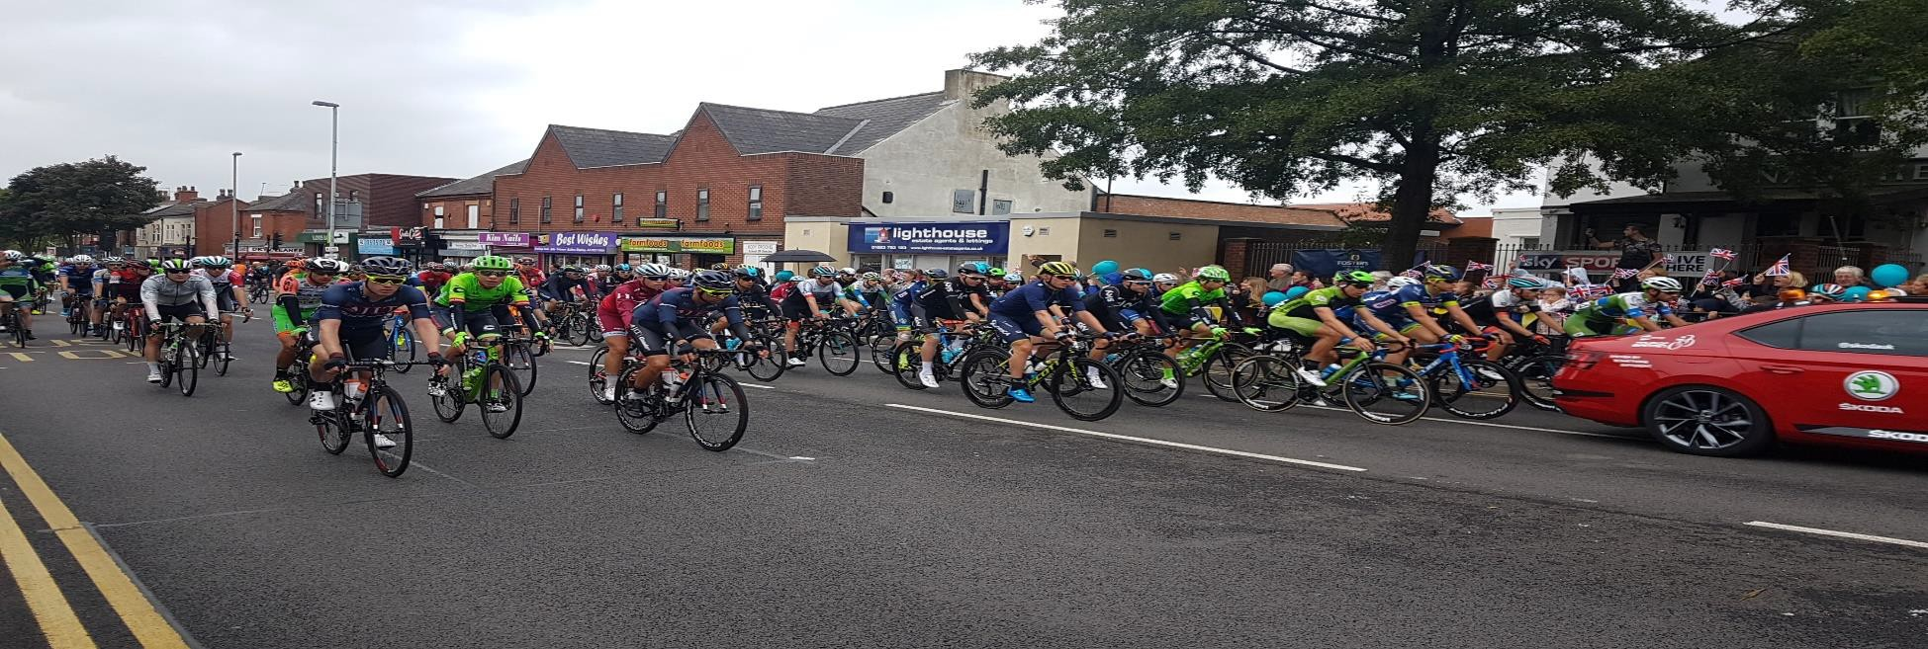

**Results and geographical distribution of respondents.**

|  |  |
| --- | --- |
| **Area** | **% Total of Surveys** |
| Sutton-in-Ashfield/Huthwaite/Skegby/Stanton Hill | 48.11% |
| Kirkby-in-Ashfield/Annesley | 25.10% |
| Hucknall | 17.15% |
| Rural Villages – Selston/Jacksdale/Underwood | 9.62% |

**Evaluation**

## Question 2 - “Thinking about your local area, 15-20 minutes’ walk from where you live, how have levels of crime and anti-social behaviour changed over the past year?”

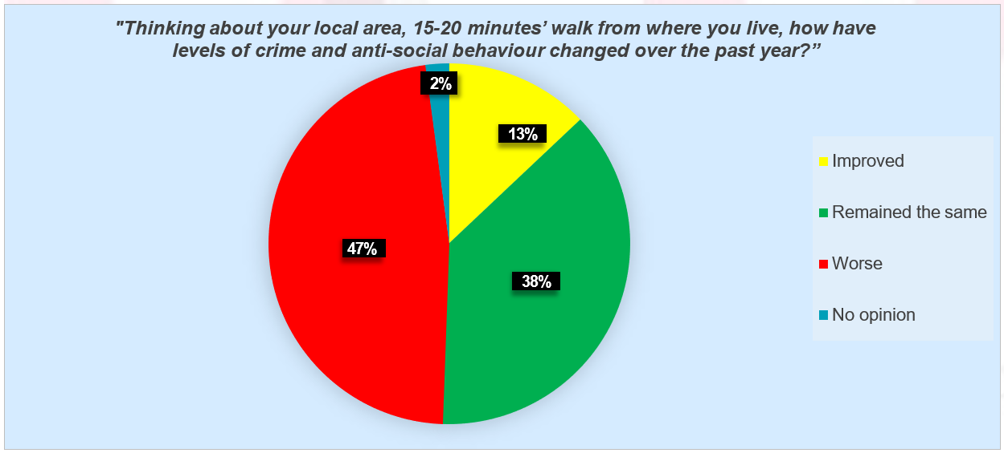

When compared to the 2018 survey those residents who feel that crime and anti-social behaviour has become worse has fallen from 73% to 47%, but those who feel there has been no change has risen from 19% to 38%.

The proportion of those who feel the area has improved rose from 6% to 13%. Whilst this is a positive it is still of concern that the majority of respondents have expressed the opinion that crime and anti-social behaviour has become worse or shown no change.

* *“The only reason I feel safe where I live at the moment is because I have been here all my life and my face fits the area! I also don’t go out in the local areas and frankly I avoid it as much as I possibly can”*
* *“If we have regular police patrols like we used to have before all the cuts.”*
* *“Lack of Police presence.”*
* *“I wouldn't say it's particularly safe.”*
* *“The lack of parental control in some areas. Housing problem families near old people. Drug abuse.”*

**Question 3 - What makes your area a safe place?**

The content of the open question has been broken down into 14 themes. Each answer has been reviewed manually and scored against all 14 themes.

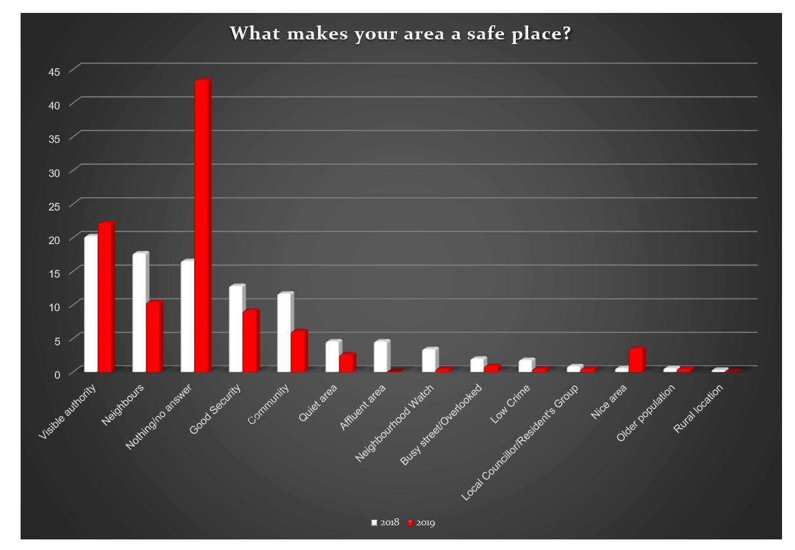

Of those who answered there is a consistent message within this information that indicates that the people within the local community are what make other people feel safe, their immediate neighbours, those that live in the local area and the presence of those organisations who have a role addressing community safety issues. This is similar to the 2018 survey.

The greatest proportion of respondents (**43.4%**) failed to answer or indicated that nothing made them feel safe.

The 14 themes can be grouped under broader headings that help us to understand the key components of community safety:

|  |  |  |
| --- | --- | --- |
| **GROUP** | **%Total 2018** | **% Total 2019** |
| Community | 39.18% | 30.76% |
| Agencies | 25.00% | 40.00% |
| Additional measures | 18.91% | 16.15% |
| Environment | 14.18% | 12.30% |
| Low levels of crime / ASB | 2.02% | 0.79% |

It is encouraging to see that the greatest proportion of respondents indicated that confidence in local agencies is important, with 40.0% giving examples in this category (25% in 2018). The greatest proportion recognise a police presence as important. Other local organisations are also recorded, with the district council and Neighbourhood Watch being referenced and support of local Councillors, and residents groups.

* *“Visible policing.”*
* *“Police presence.”*

There continues to be a strong message that people themselves make each other feel safe; they are part of a well- established community, with good relationships between neighbours (25%). They feel less likely to experience crime and disorder issues in the first place, but should something bad happen, someone would help or support them.

* *“People in the village working together for a better environment. Would be better with more police.”*
* *“People trying to look out for each other!”*
* *“Local residents taking responsibility.”*

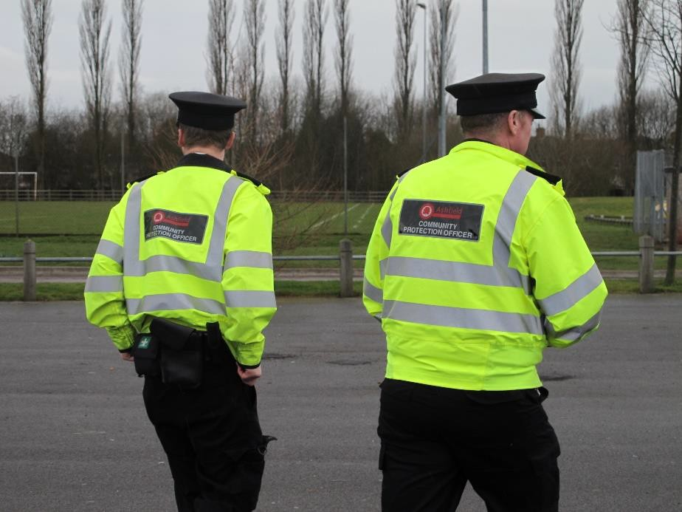

Additional measures in an area can have a positive impact on people’s perception of safety; these include good street lighting, good home security, the presence of CCTV in the area and high levels of street cleansing; 16.15% list these as significant to their local area.

* *“Good street lighting, plenty of CCTV cameras.”*
* *“My dogs.”*
* *“The doors of my house.”*

The location and design of where people live clearly has a positive effect with 12.3% of respondents identifying this as making them feel safe.

* *“Live on a senior citizens street and very good.”*
* *“A busy area so lots of residents for support.”*
* *“No pubs on the estate.”*

Only small proportion (0.79%) mention the low levels of crime and disorder in their answer. This is a decline from 2018 where 2.02% of respondents selected this option. This clearly should be a concern for the partnership going forward.

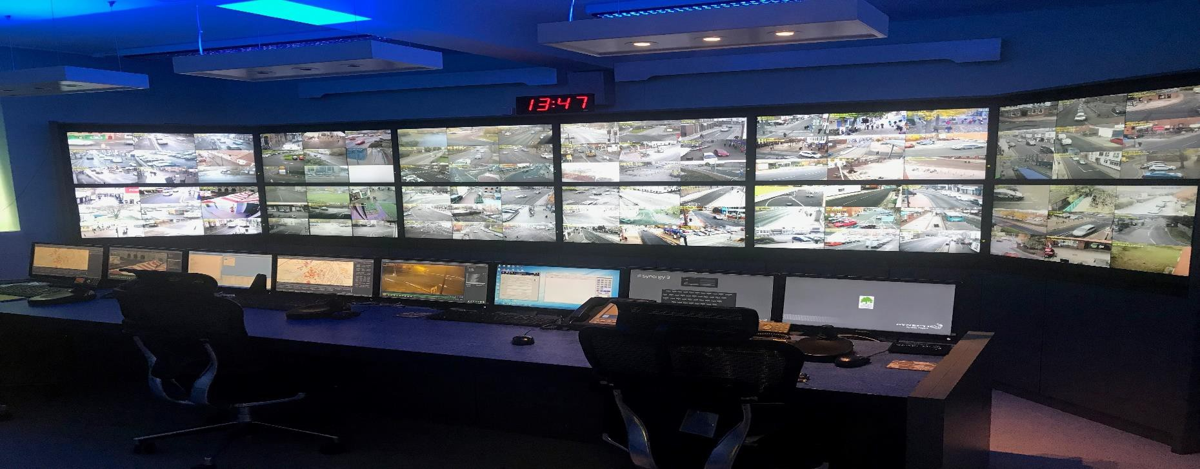

## Question 4 - What makes your area an unsafe place?

The content of this open question have been broken down into 18 themes.

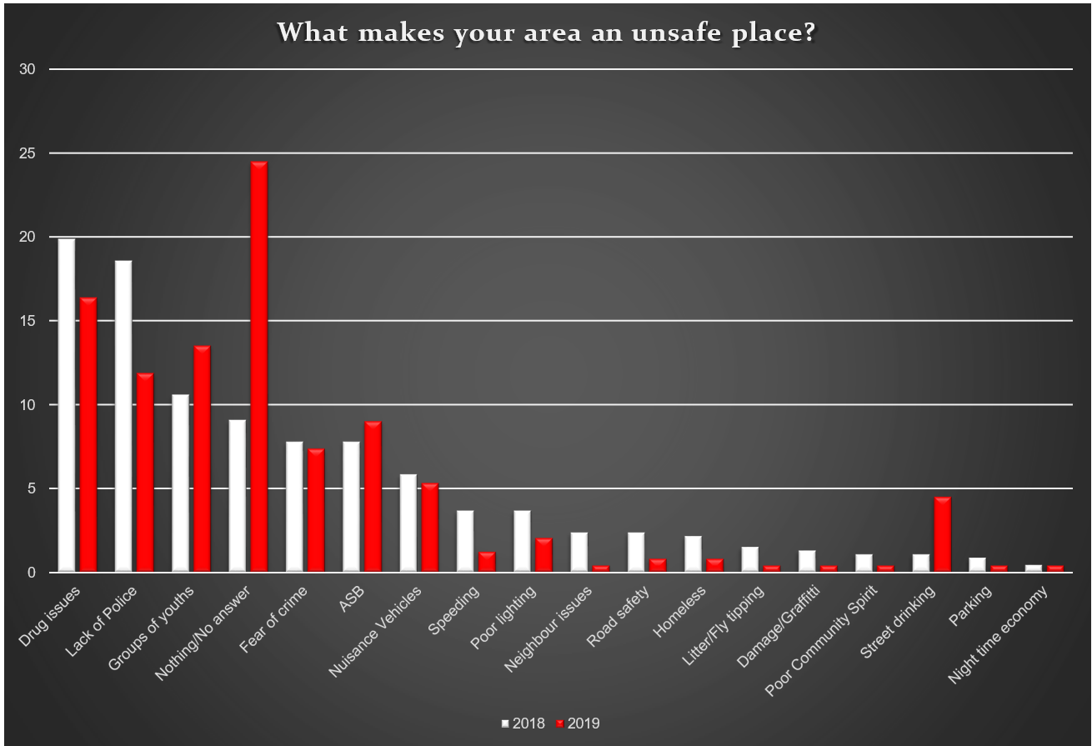

The top three issues remain the same. Drug issues are once again the top issue followed by groups of youths and a lack of Police.

The top ten issues are:

|  |  |  |
| --- | --- | --- |
|  | TOP TEN ISSUES 2018 | TOP TEN ISSUES 2019 |
| 1 | Drug issues | Drug issues |
| 2 | Lack of Police | Groups of youths |
| 3 | Groups of youths | Lack of Police |
| 4 | Fear of Crime | Anti-social behavior |
| 5 | Anti-social behavior | Fear of Crime |
| 6 | Nuisance vehicles | Nuisance vehicles |
| 7 | Speeding | Street drinking |
| 8 | Poor lighting | Poor lighting |
| 9 | Road safety | Speeding |
| 10 = | Homeless. | Homeless |
| 10 = | n/a | Road safety |

It is clear that behaviour continues to have a strong impact on how safe a person feels; they are more affected by **drug issues** (16.39%) and visible **groups of youths** (13.52%) than the **fear of crime** (7.37%). That may be due to the visibility of such issues. This is supported by the fact that a **lack of Police** is now the third highest area for concern (11.88%).

## Question 5 - In your local area do you feel that levels of crime and anti-social behaviour are linked to any of the following? (Please tick all that apply)

This question is intended to develop an understanding of some of the underlying issues within a community.

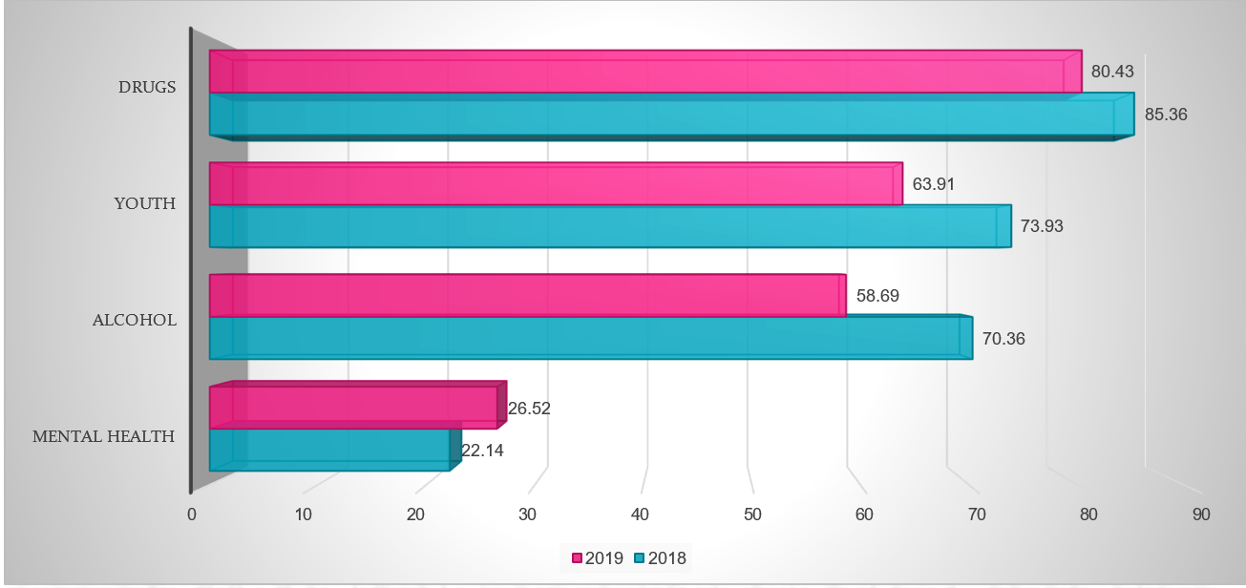

This once again mirrors the results of the 2018 survey. Substance misuse and youth issues are of high concern within the community with 80.43% suggesting that drugs are significant, 58.69% that alcohol is a factor and 63.91% that youth

issues are important in their community. These concerns are consistent with the comments recorded in question 2 and are further supported by responses to Questions 6 and 8.

## Question 6 - Which of the following issues do you understand? (Please tick all that apply)

This is designed to provide an understanding around the awareness of emerging issues within the Ashfield District.

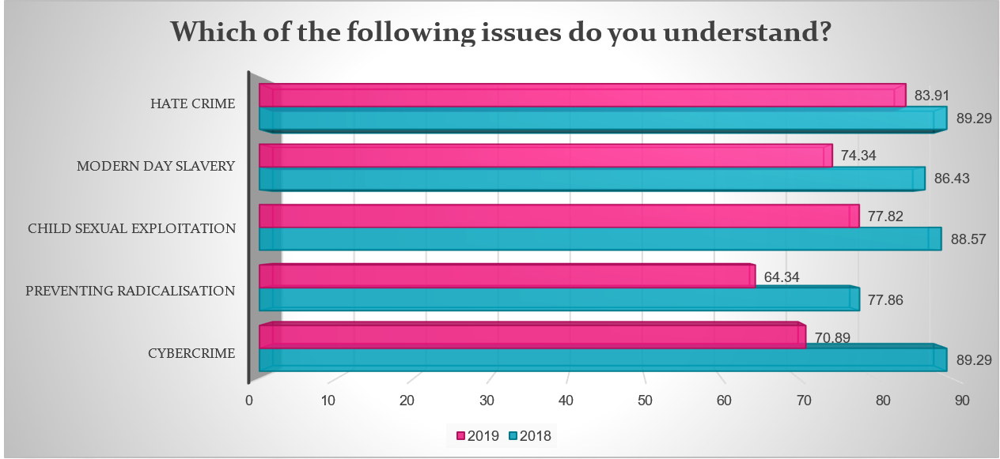

Once again an initial evaluation of the results is positive with high proportions of the community suggesting that their levels of understanding of the issues listed are high.

Awareness levels were highest around the issues of Hate Crime (83.91%), Child Sexual Exploitation (77.82%) and Modern Day Slavery (74.34%).

Lower levels of awareness exist for Cybercrime (70.89%) and Preventing Radicalisation (64.34%). Once again feedback from partners that delivered the face-to-face surveys suggests that those completing the survey were aware of the general terms, but did not necessarily understand the issues within a local context. This feedback means that the partnership should continue to treat these results with some caution.

## Question 7 - Now using your knowledge of the whole of the Ashfield District, please tell us the top 10 issues that concern you the most from the list below? (Please tick up to 10 boxes)

The aim of this question was to understand the communities concerns around a wide range of community safety issues. Respondents were invited to select up to 10 from a list of 26 options. The list of concerns is based upon those that were most frequently selected, with the top ten issues highlighted in red

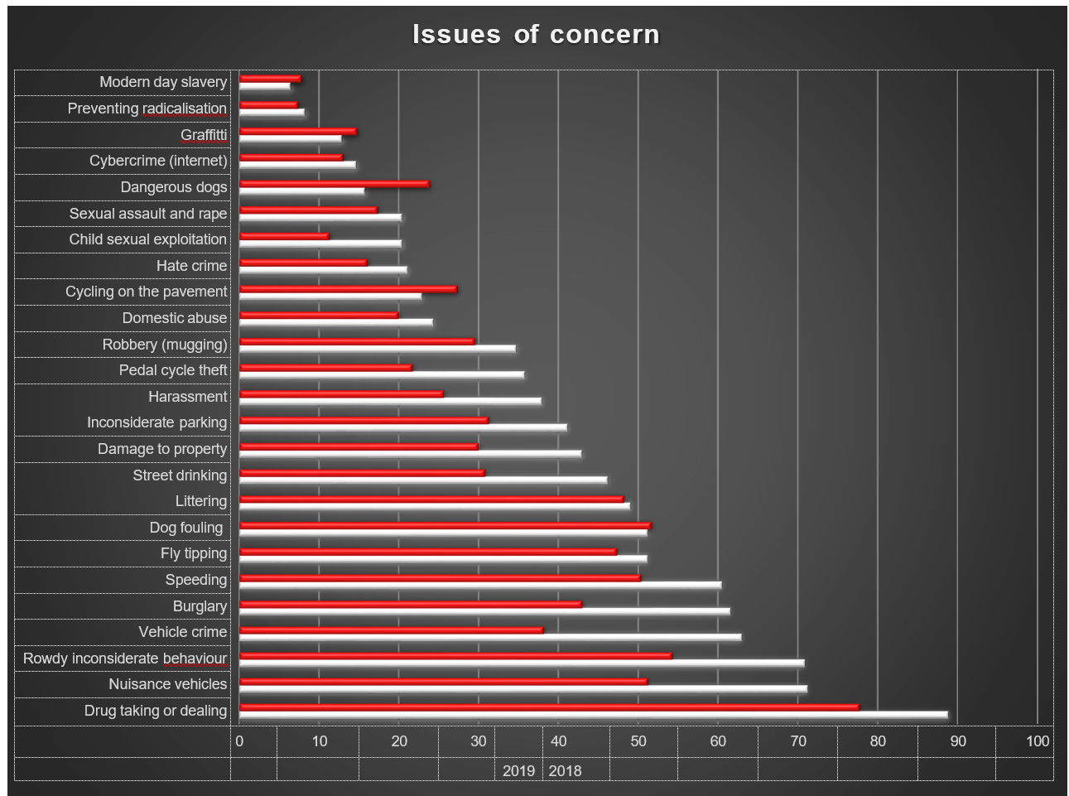

It is important to recognise that these responses are around levels of concern and therefore offer different information to the issues raised in questions 4 and 8. It should not be assumed that a person has a concern about an issue because it currently affects them.

However, it should be noted that ‘drug taking or dealing’ remains predominant concern for the second consecutive year and this remains a consistent theme between all of the questions.

|  |  |  |  |  |
| --- | --- | --- | --- | --- |
|  | TOP TEN ISSUES OF CONCERN 2018 |  | TOP TEN ISSUES OF CONCERN 2018 |  |
| 1 | Drug taking or dealing | 88.93% | Drug taking or dealing | 77.82% |
| 2 | Nuisance vehicles | 71.07% | Rowdy/inconsiderate behaviour | 54.34% |
| 3 | Rowdy/inconsiderate behaviour | 70.71% | Dog fouling | 51.73% |
| 4 | Vehicle crime | 62.86% | Nuisance vehicles | 51.3% |
| 5 | Burglary | 61.43% | Speeding | 50.4% |
| 6 | Speeding | 60.36% | Littering | 48.26% |
| 7/8 | Fly tipping | 51.07% | Fly tipping | 47.39% |
| 7/8 | Dog fouling | 51.07% | Burglary | 43.04% |
| 9 | Littering | 48.93% | Vehicle crime | 38.2% |
| 10 | Street drinking | 46.07% | Inconsiderate parking | 31.3% |

## Question 8 - If there anything else you would like to tell us about crime and anti-social behaviour in the district of Ashfield?

The responses to this open question has been broken down into 20 themes with 53% of respondents providing a response.

The top five themes from those responses are as follows with the 2018 results in brackets:

1. **Greater levels of enforcement required – 30.63% (7.17%)**
2. **Lack of Police/other authority – 27.02% (28.25%)**
3. **Fear of crime/levels of crime – 22.52% (18.38%)**
4. **Drug taking or dealing – 12.61% (11.21%)**
5. **Street cleansing/litter/fly tipping – 7.27% (4.93%)**

The significant change was that respondents clearly feel that there is a lack of enforcement activity from agencies; 30.63% compared to 7.17% in 2018. Comments in this category centred around drugs, anti-social behaviour and vehicles.

There continues to be a clear message from the community that a lack of Police and other authorities is a significant concern as is the fear of crime/levels of crime.

Respondent’s comments:

* + *“In the last two years I’ve had my number plates pinched twice, both our cars vandalised, my neighbours car has been vandalised …thieves and crooks riding about dangerously on bikes constantly. The area is unpoliced.”*
  + *“I'm a single mum with a 7 year old son and I don’t feel safe where I live, a lot of what happens is a few doors away from me. The speeding is a joke.”*
  + *“No point. All you do is have a meeting about it and do nothing*.”
  + *“Just that I think the Police do a great job with the resources that they have. Well done.”*
  + *“It’s got worse, there’s a lot of movement in and out of the area with low property prices we seem to be attracting a lot of problems new to the area such has drug gangs and there’s a lack of responsibility among these people.”*
  + *“Things are getting a lot worse you don't feel safe anymore.”*
  + *“More police need to be on the streets, not just when crime is at its highest, but constantly, as a prevention to people who think they rule the streets and can do as they please. People are now feral.”*
  + *“Would be nice to see some visible patrols and interactions with people, being part of the community rather than just reacting. And don't tell me you regularly patrol because I live, shop, work and spend most of my spare time in Ashfield and only ever see police in their cars reacting and never see the so-called community protection officers. In my personal opinion, if the community protection officers aren't going to be visible then they might as well not be there, save the money or better still put it towards some real policemen.”*
  + *“Take a walk around the town centres and housing areas at different times, you can see clearly the issues, always surprising we have to fill these type of survey to inform you of this, I get the feeling the man running don’t live in the area.”*
  + *“Lack of police presence I have personally seen an increase in crime since Sutton police station was closed. All police officers are sent to Mansfield on a Friday and Saturday night leaving Sutton and estates such as Carsic unpoliced and this is well-known, criminal damage, violence, illegal vehicles, weapons are rife on Carsic estate. The police aren’t giving a presence on here and aren’t proactive in checking people’s residences while patrolling the estate they usually drive past my house at 30mph without slowing for the speed bumps while there could be something happening on my front garden, what I mean is they drive around with their heads in the clouds. I wish there could be a permanent police presence on Carsic estate and they could actually pay attention to their surroundings when driving through the estate. Especially the old people of the estate they live alone and are preyed on”*
  + *“We have moved in the last 2 years from the Broomhill area due to the increase in drugs and anti-social behaviour.”*
  + *“It's in pockets of areas; in the poorer areas it is more prevalent. Cheap alcohol and nothing to do...”*
  + *“Why don’t CPOs do bins on street under sec 46 environmental act 1990?”*
  + *“Let’s see more Police patrols.”*
  + *“The area had improved over the past 6 to 8 months but is slowly returning to how it was before. Especially Outram Street.”*
  + *“If something I reported need to see something happening. A response to the problem needs to be seen.”*

**Conclusion**

The consultation has gathered a significant amount of information about the communities’ opinions, awareness and concerns of community safety issues.

Headlines;

* + Levels of crime and anti-social behaviour are perceived as becoming **worse** or **remaining the same** over the past year. Positively, those who indicated that levels have **improved** rose from 6 % to 13%.
  + Respondents identified that a **well-established community, good neighbours** and **visible authority** in the community are the key factors in making their area safe. This is the same as in 2018.
  + Respondents stated that **drug issues, groups of youths** and a **lack of Police** are the key factors in making their area an unsafe place.This is the same as 20218.
  + Respondents’ perception is that **substance misuse** and **youth issues** are the main contributors to levels of crime and anti-social behaviour. This is the same as 2018.
  + Respondents claim to have a good understanding of **modern day slavery, hate crime** and **child sexual exploitation,** but less so about **cybercrime** and **preventing radicalisation**. Claimed levels of understanding are all relatively high, but each shows a reduction on the figures from 2018.
  + Respondents are most concerned about **drug taking or dealing**, **rowdy/inconsiderate behaviour**, **dog fouling** and **nuisance vehicles**. This reflects the results in 2018.

**Did the consultation achieve its aims?**

1. Understand public perception of progress in terms of tackling crime and ASB

Findings from the consultation clearly show that the largest proportion of respondents (47%) believe that levels of crime and anti-social behavior have increased or remained the same (38%) over the past twelve months.

13% of respondents felt that there had been improvement.

This reflects a minor improvement, but the Community Safety Partnership must recognise that an overwhelming majority of residents have concerns over the levels of crime and anti-social behaviour.

1. Understand what contributes to making people feel safe and unsafe

There was a consistent message that positive relationships with neighbours and being part of an established community has the greatest impact on people’s feeling of safety. The physical environment is also important, as is a visible presence of authority.

Whilst a wide range of issues contribute to people feeling unsafe they are dominated by two themes; a lack of Police/visible authority and drug issues. These themes repeat the results of 2018 are consistent throughout the survey and are a clear indication of the concerns of the respondents.

1. Gain an understanding of people’s concerns about some of the underlying issues that influence Crime and ASB

It is clear that communities continue to recognise **Alcohol**, **Drugs** and **Youth issues** as significant contributors to the problems in their local communities. Levels of concerns around mental health were also recorded, but at a much lower level. Whilst the levels of crime and ASB associated with mental health may be lower, the complex needs of individuals often mean that the partnership resources required are greater. It should also be considered that issues around mental health might be less visible to the community and therefore harder to identify.

1. Gain an understanding of people’s awareness of new and emerging issues in the district.

Respondents claim to have a high level of awareness of these issues in 2019; particularly for child sexual exploitation and hate crime. This varied from 2018 and is clearly dependent upon the knowledge of those surveyed.

1. Understand those issues that cause the greatest level of public concern

As in 2018, it is clear that there is a correlation between those issues that affect people’s feeling of safety and those that cause them the greatest concern. Overall, there are consistent issues raised around drugs and a lack of visible authority in the district. These repeated issues present the challenge going forward for the Community Safety Partnership.

**How will the data be used?**

The information gathered within the consultation will be shared with local partners to be used to inform both strategic and local level work.

Where information relates to areas outside of the CSP, they will be passed on to the appropriate organisation. For example, road safety concerns will be shared with the casualty reduction partnership.

The results of this consultation may also identify the need to go back to the community and ask more focused questions around an issue as part of future engagement work. This will be delivered through the action plans developed to support the new CSP Plan.

Questionnaire:

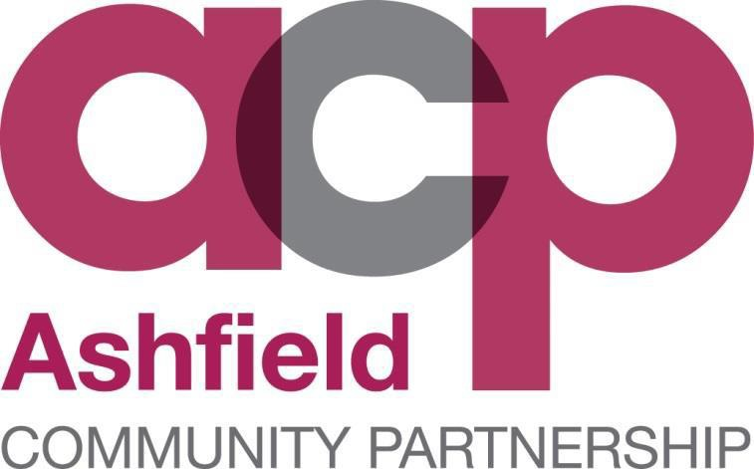

**COMMUNITY SAFETY PARTNERSHIP CONSULTATION 2019**

**Question 1. – To help us locate the area where you live, please provide your postcode**

**Question 2. - Within your local area, a 15-20 minute walk from where you live, how do you consider levels of crime and anti-social behaviour changed over the past year?**

**Question 3. - What makes your area a safe place?**

**Question 4. - What makes your area an unsafe place?**

**Question 5. - In your local area do you feel that levels of crime and anti-social behaviour are linked to any of the following? (Please tick all that apply)**

* Alcohol
* Mental Health
* Youth
* Drugs

**Question 6. - Which of the following issues do you understand? (Please tick all that apply)**

* Hate Crime
* Modern Day Slavery
* Child Sexual exploitation
* Preventing Radicalisation
* Cybercrime

**Question 7. - Using your knowledge of the Ashfield District, please tell us the top 10 issues that concern you the most from the list below? (Please tick up to 10 boxes)**

* Drug taking or dealing
* Modern day slavery
* Graffiti
* Pedal cycle theft
* Dangerous dogs
* Harassment
* Preventing radicalisation
* Cybercrime (internet)
* Nuisance vehicles
* Child sexual exploitation
* Hate crime
* Cycling on the pavement
* Domestic abuse
* Sexual assault and rape
* Dog fouling
* Vehicle crime
* Fly tipping
* Inconsiderate parking
* Damage to property
* Street drinking
* Robbery (mugging)
* Littering
* Speeding
* Rowdy/Inconsiderate behaviour
* Burglary

**Question 8. - Is there anything else you would like to tell us about crime and anti-social behaviour in the Ashfield District.?**