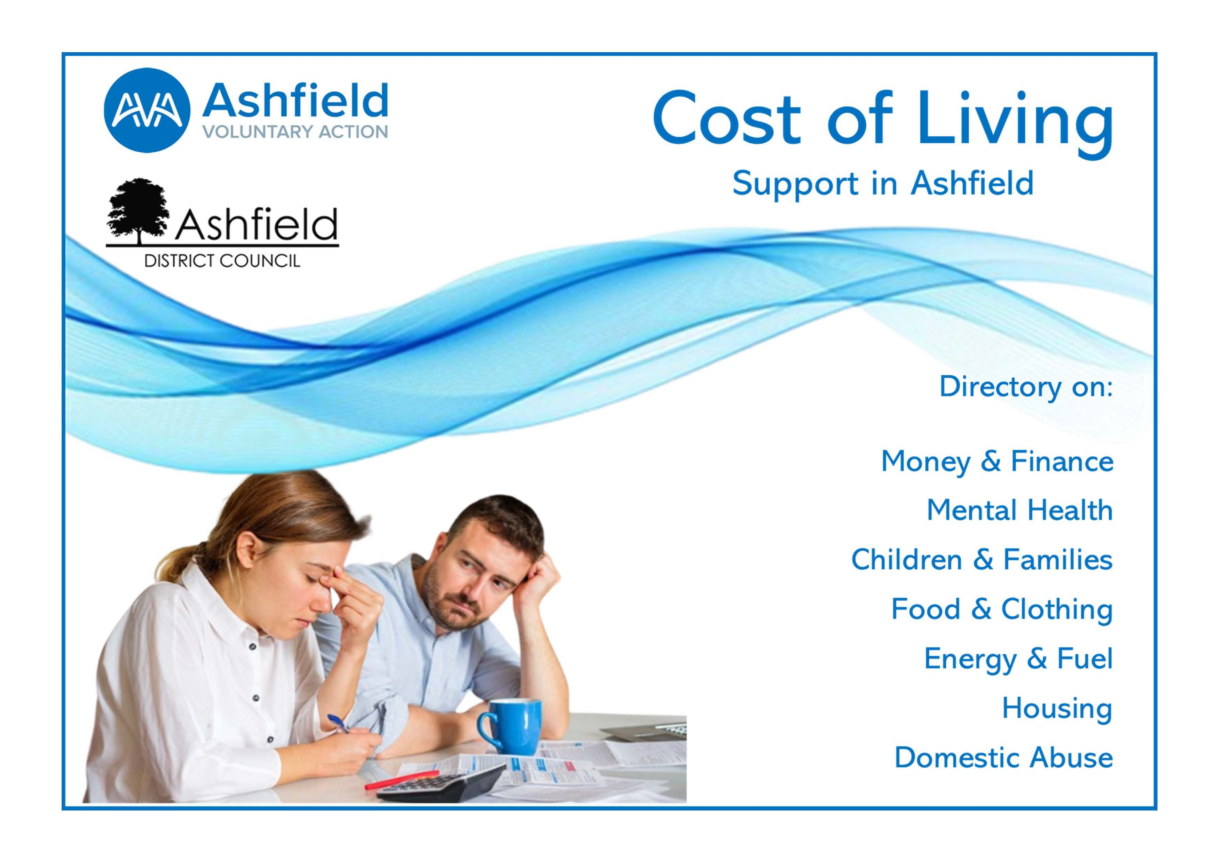
Contents
FOOD BANKS, FOOD CLUBS & OTHER FOOD RELATED SUPPORT IN ASHFIELD 3
FOOD BANKS, FOOD CLUBS & OTHER FOOD RELATED SUPPORT IN ASHFIELD 5
MONEY, DEBIT ADVICE, BENEFITS CHECKS AND SUPPORT 6
MENTAL HEALTH 8
CHILDREN AND FAMILIES 10
ENERGY & FUEL 12
HOUSING 13
DOMESTIC ABUSE 14
USEFUL CONTACTS 15
USEFUL LINKS 16

FOOD BANKS, FOOD CLUBS & OTHER FOOD RELATED SUPPORT IN ASHFIELD
AREA | TYPE | ORGANISATION | DAY | TIME | CONTACT DETAILS | INFORMATION
Sutton-in-Ashfield | Food Club | Leamington Summer House Children’s Centre | Wednesday | 10 am -12  noon | Leamington Summer House Children's Centre  Clare Road  Sutton-in-Ashfield | Only for families with children under five years of age.
Sutton-in-Ashfield | Food Club | St John’s Church | Monday | 1 - 3 pm | St John’s Church  Titchfield Street  Sutton-in-Ashfield
Kirkby-in-Ashfield | Food Club | Summit Centre Children’s Centre | Wednesday | 1.30 – 3.30  pm | Summit Centre Children's Centre Pavilion Road  Kirkby-in-Ashfield | Only for families with children under five  years of age
Kirkby-in-Ashfield | Food Bank | Ashwood Centre | Tuesday | 2 - 3 pm | Ashwood Centre Kirkby Storehouse Foodbank Portland Street  Kirkby-in-Ashfield  NG17 7AB | Referral needed Referrals or first-time walk-in with questions asked.   07803 552 381
Kirkby Woodhouse / Annesley | Food Bank | Community Foodbank | Thursday | 1.30 - 3 pm | Community Foodbank  St John's Hall  Skegby Road  Kirkby Woodhouse | Referrals or first-time walk in with questions asked.
Sutton-in-Ashfield | Food Bank | St Mary's Food Bank Sutton | Monday & Friday | 10 - 12.30  pm | Portland Pathways  Outram Street  Sutton-in-Ashfield | Lee Fletcher   07376 309 289 BY APPOINTMENT ONLY
Hucknall | Food Bank | Under One Roof | Monday &  Tuesday | 9.30 am -  2.30 pm |  | Upon referral, call   0115 9521 236
Selston | Food Bank | Selston Food Bank at the Tin Hat Centre | Every weekday | 10 am – 12  noon | Tin Hat Centre  Matthew Holland Complex  Chapel Rd  Selston, NG16 6BW | Referrals required
Stanton Hill | Food Share | Stanton Hill Food Share | Wednesday  & Saturday | 9 am –  11.45 pm | Skegby & Stanton Hill Library  Mansfield Road,  NG17 3EE
Mansfield & Ashfield | Food Bank | Mansfield and Ashfield Emergency Foodbank | Monday to Friday | 10 am – 4 pm | Telephone service  parcel pick-up in Kirkby-in-Ashfield & Mansfield | PROFESSIONAL REFERRALS ONLY
Sutton-in-Ashfield | Homeless support | Sutton Christian Fellowship | Monday, Wednesday  & Saturday | Morning | Sutton Christian Fellowship  High Pavement  Sutton-in-Ashfield | Walk-in
Ashfield | Website | Feeding Ashfield Website – providing an interactive map of all food clubs, food banks and allotments across the District, along with healthy option takeaways. https://www.ashfield.gov.uk/environment-health/health-wellbeing/feeding-ashfield/ |  |  | Ashfield District Council website
Mansfield | Website | https://www.mansfield.gov.uk/health-wellbeing/food-support/3 |  |  | Mansfield District Council website

FOOD BANKS, FOOD CLUBS & OTHER FOOD RELATED SUPPORT IN ASHFIELD

How Food Banks and Food Share projects work
Food banks give you enough food to last you for a few days. Some will let you go every week for several weeks; others you can only use once every three months; they are all different. Most open for a set time one day a week and you must go at this time. They are free to use and get their food through donations. Some have things like fresh bread, but others just have dried and tinned goods like pasta, tins of soup and cereals.

Each food bank has its own way of working, but most will ask you to bring along a special referral form or letter. Referral letters need to be obtained by someone you have contact with from a public, private or voluntary sector organisation. Letters should be on letter headed paper. Once you have your referral form or letter you can take it along to the food bank in your area.

Some community groups also run food share projects. This is where local shops donate food, which is near its use-by date but still good to eat, so that it can be shared in the local community. Food share projects usually have things like fresh vegetables and bakery products which can be eaten that day or the next or can be frozen. Foodbanks tend to have dried and tinned which means it will keep for a long time. Some foodbanks have things like fresh bread, but others just have dried and tinned goods like pasta, tins of soup and cereals. A lot of foodbanks also have toiletries, and some carry baby food and products.

Food clubs help to reduce food waste by offering residents good quality food at a low cost. You do not need to be referred to a food club as many food clubs are open to all, however it is a good idea to check the joining criteria of your nearest food club as some are only available to families with young children.
You can find out more about the locations of food clubs in Ashfield on our interactive map: https://www.ashfield.gov.uk/environment-health/health-wellbeing/feeding-ashfield/

MONEY, DEBIT ADVICE, BENEFITS CHECKS AND SUPPORT
SUPPORT | LINK | CONTACT DETAILS | INFORMATION
Government Support | https://helpforhouseholds.campaign.gov.uk |  | Government website with information on childcare costs, help with energy bills, household costs, transport costs, income support and help finding work.
Household Support Fund | https://www.nottinghamshire.gov.uk/business- community/financial-support-for-residents-and- community-groups/nottinghamshire-household- support-fund-phase-2 |  0300 500 80 80  Customer service lines very busy, application to be completed online wherever possible. | Providing vouchers for food and energy bills for those on pension credits and holiday food vouchers for those on free school meals. Open to Nottinghamshire County Council residents who are most in need.  Application to be completed online.
Universal Credit Advice | https://www.understandinguniversalcredit.gov.uk |  0800 328 5644 | DWP information on Universal Credit and information on the cost-of-living support package.
Entitled to Independent  Benefits Calculator | https://www.entitledto.co.uk/ |  0800 325 5644 | Includes a free online benefits calculator.
Ashfield District Council Benefits page | https://www.ashfield.gov.uk/  https://www.ashfield.gov.uk/environment-health/cost- of-living-support/money-bills-and-debt-support/  info@ashfield.gov.uk |  01623 450 000 | Links and information on Universal Credit, Housing Benefits, Council Tax discounts and exemptions. Site also offers a portal to manage your benefits online.
Ashfield Citizens Advice | https://www.ashfieldca.org.uk/ | General Advice:   01623 203 080  National Adviceline:   0800 144 88 48 | Give advice on all areas of social welfare law, with the main enquiry areas being benefits, debt, employment and housing.
Step Change Debt Charity | https://www.stepchange.org |  0800 138 1111 | Free and impartial debt advice
National Debt Line | https://nationaldebtline.org |  0808 808 4000 | National Debt line is a charity that gives out free and independent debt advice over the phone and online.
Turn 2 Us | https://www.turn2us.org.uk |  | Turn 2 Us helps people in financial need gain access to welfare benefits, charitable grants, and other financial help.
Access to Work Scheme | https://www.gov.uk/access-to-work |  | Help to get or stay in work if you have a physical, or mental health condition, or disability.
Money Helper | https://www.moneyhelper.org.uk/en |  | Money advice site covering benefits, budget planning, savings and more.
Christian’s Against  Poverty (CAP) | https://capuk.org/ |  0800 328 0006 | Free debt and budgeting advice available to anyone that needs it.
St John’s Community Foodbank – support with PIP and universal credit |  | stjohnsfoodb@gmail.com | Appointment only – sessions are from 1.30 – 3.00 pm on a Thursday afternoon at St John’s Church Hall Outreach Project in Kirkby  Woodhouse. Email for availability.

MENTAL HEALTH
ORGANISATION | SERVICE DESCRIPTION | OPENING HOURS | CONTACT DETAILS / LINK | INFORMATION
Harmless | Support for adults focusing on mental health and self-harm. | 9 am – 5 pm | 0115 880 0280  https://harmless.org.uk/
The Samaritans | Samaritans respond to a call for help, listen and support communities. | 24 hours a day | 0116 123 Child line: 0800 11 11 https://www.samaritans.org/
Insight IAPT | Provides NHS therapies for adults to help with counselling issues like low mood, stress, and anxiety in Ashfield. |  | 0300 555 5582  https://www.insightiapt.org/#
Kooth | Free, anonymous adult online counselling for young people ages 11-25. | Monday - Friday 12 pm - 10 pm | https://www.kooth.com/
Qwell | Free, anonymous adult online counselling and emotional wellbeing service. | Monday - Friday 12 pm - 10 pm Weekends:  6 pm - 10 pm | https://www.qwell.io
Nott Alone (Nottingham Mind) | Local mental health advice and help for young people in Nottingham & Nottinghamshire. | Monday - Sunday  7 am - 7 pm | https://www.nottalone.org.uk
LGBT+ Service Nottinghamshire | Provides one-to-one and group services for children and young people ages 11-25 who identify as LGBT+. |  | 01909 479 191  https://www.lgbtplusnotts.org.uk | A young person over 13 years of age can call themselves, but those under 13 must have someone over 18 to call on their behalf.
Young Minds | Mental health support for young people. | Monday-Friday  9 am - 5 pm | https://www.youngminds.org.uk   0800 11 11
Papyrus | Prevention of young suicide. |  | https://www.papyrus-uk.org   0800 068 4141
The Mix | A free confidential helpline providing support with mental health, money, homelessness, finding a job, break-ups, and drugs. |  | https://www.themix.org.uk   0808 808 4994

CHILDREN AND FAMILIES
AREA | ORGANISATION | CONTACT DETAILS / LINK | INFORMATION
 | Childcare Choices | https://www.childcarechoices.gov.uk | The Childcare Choices website explains all the different subsidized childcare available.
Ashfield | Play Areas | https://www.ashfield.gov.uk/community-leisure/parks-green-spaces-visitor-centres/ | A list of Community areas / play areas in the Ashfield area.
Ashfield Area | National Childbirth Trust | https://www.nct.org.uk/ | Your local parent support network.
Ashfield Area | HAF | https://https://www.gov.uk/government/publications/holiday-activities-and-food-programme | The HAF programme supports children to eat more healthily and be more active over school holidays.
Sutton-in- Ashfield | Sutton Library | https://www.inspireculture.org.uk/reading-information/find-a-library/sutton-ashfield-library/   01623 677 200 | The three main libraries in Ashfield are in Kirkby-in-Ashfield, Sutton-in-Ashfield and Hucknall. Libraries provide a space to read, chat, join groups and meet new people in a safe place.
Hucknall | Hucknall Library | https://www.inspireculture.org.uk/reading-information/find-a-library/hucknall-library/   01623 677 200
Kirkby in Ashfield | Kirkby-in-Ashfield  Library | https://www.inspireculture.org.uk/reading-information/find-a-library/kirkby-ashfield-library/
Ashfield | Feel Good Families | https://www.ashfield.gov.uk/environment-health/health-wellbeing/feel-good- families/ | Offering free activities for children across Ashfield and providing support services for families, again with an interactive map of the District.
Ashfield & Mansfield | Tuvida | https://www.tuvida.org/nottsyoungcarers | Support for young carers.
Ashfield | ATTFE unit in Idlewells |  | ATTFE offers free activities for children, young people and families, as well as education courses and drop-in sessions.
Ashfield & Mansfield | Charity | In Ashfield there are many charity shops including: The British Heart Foundation, Headway, PDSA, the Samaritans, the Salvation Army and YMCA.  Search on Yell to find charity shops near you. | Charity Shops are a great way to save money on clothing and household items and help you to do your bit for the environment.
Ashfield | Car Boot Sales | Skegby: https://www.facebook.com/SkegbyCarBoot  Botany Avenue indoor: https://www.ttfairs.co.uk/  Hucknall car boot: https://www.facebook.com/Hucknall-Car-Boot-Sale-  188624344506251/ | Car Boots are a great way to save money, as well as making extra money for things you no longer need.
Ashfield | School Uniform Banks and uniform exchanges | Voluntary and community sector organisations and other places providing free and low-cost second-hand school uniforms include:  Ashfield Voluntary Action  Idlewell Centre  Ashfield School | Whilst there is not a formal school uniform bank in Ashfield. There are organisations providing pre-loved school uniforms and no and low cost. These projects tend to operate at the start of the new school year.
Ashfield | Facebook groups and marketplace | www.facebook.com | A great way to buy and sell items such as clothing and household goods locally. Searches can be filtered by area.

ENERGY & FUEL
AREA | TYPE / ORGANISATION | CONTACT DETAILS / LINK | INFORMATION
Ashfield | Petrol and Fuel | www.petrolprices.com | All the latest Petrol and diesel prices in Ashfield.
Ashfield | Ashfield Citizen Advice | https://www.ashfieldca.org.uk/  Tel: 01623 203080 | Out in the community providing advice at several locations.
Ashfield | Energy Saving Trust | https://energysavingtrust.org.uk/ | An independent organisation working to address the climate emergency. They empower millions of householders every year to make better energy choices.
Ashfield | Simple Energy Advice | https://www.simpleenergyadvice.org.uk/   0800 444 202 | Home energy efficiency advice, information available online supported by an information helpline.
Ashfield | Warm Spaces | https://www.ashfield.gov.uk/benefits-council- tax/winter-warmth-help/winter-warmth-wellness/ | Ashfield District Council have a website that explains and gives out helpful tips including advice on keeping warm and places to go this winter.
Ashfield | Ashfield Voluntary Action | https://www.ashfieldvoluntaryaction.org.uk/ | Outlet for Winter Warmer packs.

HOUSING
AREA | ORGANISATION | CONTACT DETAILS / LINK | INFORMATION
Ashfield | Council Housing | https://www.gov.uk/council-housing | Information and advice about all aspects of council housing.
Ashfield | Facing Eviction | https://www.ashfield.gov.uk/housing/at-risk-of-  being-homeless/ | Advice and support services and help with housing issues and homelessness.
Ashfield | New Roots | https://www.nrce.co.uk/ | Offering support to both single young people aged 16-25, and to young parents aged 16-19 in Ashfield
Ashfield | Jigsaw Support Scheme | https://jigsawsupportscheme.org.uk/ | Hoarding support services, available to Ashfield residents.
Ashfield | Fresco Environmental Waste and Recycling | https://frescoenvironmental.com/freequote | Information about extra bins that you may be entitled to if you have a large family, and how register for recycling services.
Ashfield & Mansfield | Framework | https://www.frameworkha.org/service/brighter- futures | Housing support – Framework’s Brighter Futures service supports people with learning disabilities, Asperger’s or brain injuries to maintain and thrive in their own homes.

DOMESTIC ABUSE
AREA | ORGANISATION | CONTACT DETAILS / LINK | INFORMATION
Ashfield | Victim Support | https://www.victimsupport.org.uk/   0808 168 9111 | Victim Support is an independent charity dedicated to supporting victims of crime and traumatic incidences in England and Wales.
Ashfield | Women’s Aid Nottingham (JUNO) | https://junowomensaid.org.uk/   0808 800 0340 | 24hr free helpline  The commissioned specialist domestic abuse support provider for women, children and teenagers who live in Ashfield.
Ashfield | Equation | https://equation.org.uk/ | Domestic abuse in Nottingham city and county. They provide a local stalking advocacy support service for men experiencing stalking in a non-  domestic abuse context.
Ashfield | Refuge | https://refuge.org.uk/ | The free phone 24-hour National Domestic Abuse Helpline for women and children.
Ashfield | Ashfield District Council | https://www.ashfield.gov.uk/community-leisure/anti-social- behaviour-community-safety/abuse- safeguarding/domestic-abuse/ | Domestic abuse support from ADC.
Nottinghamshire | Nottinghamshire County Council | https://www.nottinghamshire.gov.uk/care/health-and- wellbeing/domestic-abuse-and-sexual-violence-support | Domestic abuse support from NCC.
Ashfield & Mansfield | Nidas | https://www.nidas.org.uk/get-help-for-men/ | Domestic abuse support from Nidas.

USEFUL CONTACTS
AREA | ORGANISATION | CONTACT DETAILS / LINK | INFORMATION
Ashfield | Ashfield District Council | https://www.ashfield.gov.uk/ | Help with Jobs, empty homes, bin collection, paying your council tax, planning applications and finding / renting homes.
Nottingham | Nottingham County Council | https://www.nottinghamshire.gov.uk   0300 500 8080
Ashfield | Citizen Advice | https://www.ashfieldca.org.uk/ | Give advice on all areas of social welfare law, with the main enquiry areas being benefits, debt, employment and housing.
England | Household Money Saving | https://www.householdmoneysaving.com/ | Reviewing various ways to make extra money and providing tips  on how to save on your everyday bills.
Ashfield | Our Centre | http://ourcentre.org.uk/ | Providing community transport in Ashfield.
Ashfield | Age UK | https://www.ageuk.org.uk/ | For information, support, and advice.
Ashfield | Ashfield Day Service |  01623 550 376  Sheepwash Lane  Sutton-in-Ashfield  Nottinghamshire NG17 5GG | Day services, also known as day centres, provide people with the opportunity to get out and do something during the day, to help them to stay independent. This includes social activities, education, employment and training, and local facilities and housing.

USEFUL LINKS
WHAT | ORGANISATION | CONTACT DETAILS / LINK | INFORMATION
Cost of Living Support, Help for Households and other local support | Ashfield District Council | https://https://www.ashfield.gov.uk/environment-health/cost-of-living-support/ | Ashfield District Council has pulled together a wide range of information, support, and services to help people through the cost-of-living crisis. The website provides links to a wide range of financial and other support.
Cost of Living Support Factsheet 26th May 2022 | UK Gov | https://www.gov.uk/government/publications/cost- of-living-support/cost-of-living-support-factsheet- 26-may-2022 | Information from the UK government on the range of financial and other support available to UK residents.
Help for Households | UK Gov | https://helpforhouseholds.campaign.gov.uk/ | Government website with information on the range of support available, including energy support, transport, household, childcare and income support.
Information on local services | Ashfield Voluntary Action | https://www.ashfieldvoluntaryaction.org.uk/ | For local information on projects and schemes providing support to Ashfield residents.

Please contact Sarah Taylor from Ashfield Voluntary Action if any amendments or additions are needed. s.taylor@ashfieldvoluntaryaction.org.uk  01623 555 551

Thank you to Bassetlaw CVS who provided a template from which this directory has been developed.

