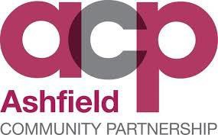

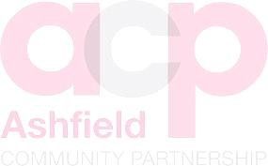Community Safety Partnership Public Consultation 2018

**DEAN DAKIN – COMMUNITY SAFETY AND STRATEGIC PARTNERSHIP OFFICER**

This page is deliberately left blank.

**Introduction**

The Community Safety Partnership (CSP) carries out an annual Strategic Assessment. This makes use of a range of partnership data including police crime figures, anti-social behaviour data, demographic information, environmental services data and information from an annual public consultation. Based on the Strategic Assessment, a Community Safety Partnership Plan is either written every three years or refreshed annually. Data from this consultation has been included in the 2018 Strategic Assessment and will be used to develop a new Community Safety Plan for 2019-2022.

Public consultations form an important part of the Partnership’s evaluation process, gathering data around the community’s perception of crime and disorder and awareness of emerging issues in both their local area and the District as whole.

The 2018 consultation was designed specifically to:

* Understand public perception of progress in terms of tackling crime and ASB.
* Understand what contributes to making people feel safe and unsafe.
* Gain an understanding of people’s concerns about some of the underlying issues that impact on Crime and ASB.
* Gain an understanding of people’s awareness of new and emerging issues within the district.
* Understand those issues that cause the greatest level of public concern.

It is appreciated that the data collected may have a wider use than informing the CSP’s annual Strategic Assessment and is therefore shared with a number of partnerships, networks and organisations across the district to help set priorities, develop plans and support funding bids. This will remain compliant with DPA/GDPR.

**Method**

The consultation took place over the period from 20.07.2018 to 30.09.2018.

Whilst the co-ordination of the consultation took place within the District’s Community Safety Team, the delivery of the survey took place over a number of partnership communication channels and public events.

An online version of the survey was made available via the District’s website and promoted through social media channels. Key partners provided similar opportunities, through the face to face completion and social media accounts.

The Consultation was delivered at a number of locations and public events over the period. The times and places of these events were coordinated to encourage engagement will all sections of the community. All Ward Councillors were made aware of the consultation and details of the survey were promoted through a number of political party sites.

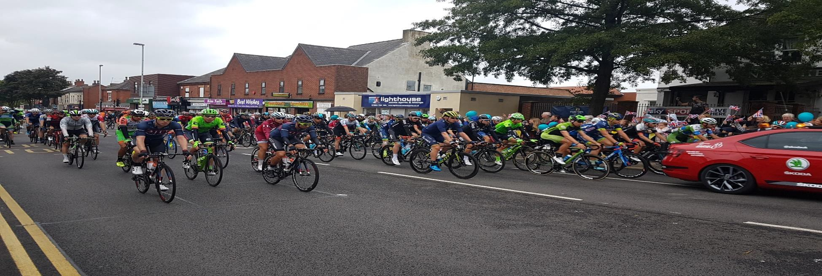

**Results and geographical distribution of respondents.**

The total number of surveys was **756**.

|  |  |
| --- | --- |
| **Area** | **% Total of Surveys** |
| Sutton-in-Ashfield/Huthwaite/Skegby/Stanton Hill | 43.13% |
| Kirkby-in-Ashfield/Annesley | 27.68% |
| Hucknall | 23.39% |
| Rural Villages – Selston/Jacksdale/Underwood | 5.79% |

**Evaluation**

## Question 2 - “Thinking about your local area, 15-20 minutes’ walk from where you live, how have levels of crime and anti-social behaviour changed over the past year?”

95% of respondents answered this question.

"Thinking about your local area, 15-20 minutes’ walk from where you live, how have levels of crime and anti-social behaviour changed over the past year?”

Improved - 6%, Remained the same - 19%, Worse - 73%, No opinion - 2%

Clearly, the data shows that the perception is that crime and anti-social behavior have become worse over the past year. The very fact that the next largest proportion of people believe that there has been no change indicates that there is a concern in respect of the public perception of the area.

* *“More youths riding mopeds no helmets two on each really noisy. Young people hanging around in groups making you feel intimidated.”*
* *“Gone up at an incredible rate. We suffer ASB every single day and witness it wherever we go within Sutton, especially the centre and surrounding streets.”*
* *“Gone up massively. Most of my neighbours have had their garages or sheds broken into. Always seeing reports of theft and violence around Kirkby.*
* *“Crime has got bad around this area never see police or community support offices which we pay council tax for.”*
* *“It's very rural where we are and we don't have a problem with either.”*

**Question 3 - What makes your area a safe place?**

90.7% of respondents answered this question.

The content of the open question has been broken down into 14 themes. Each answer has been reviewed manually and scored against all 14 themes.

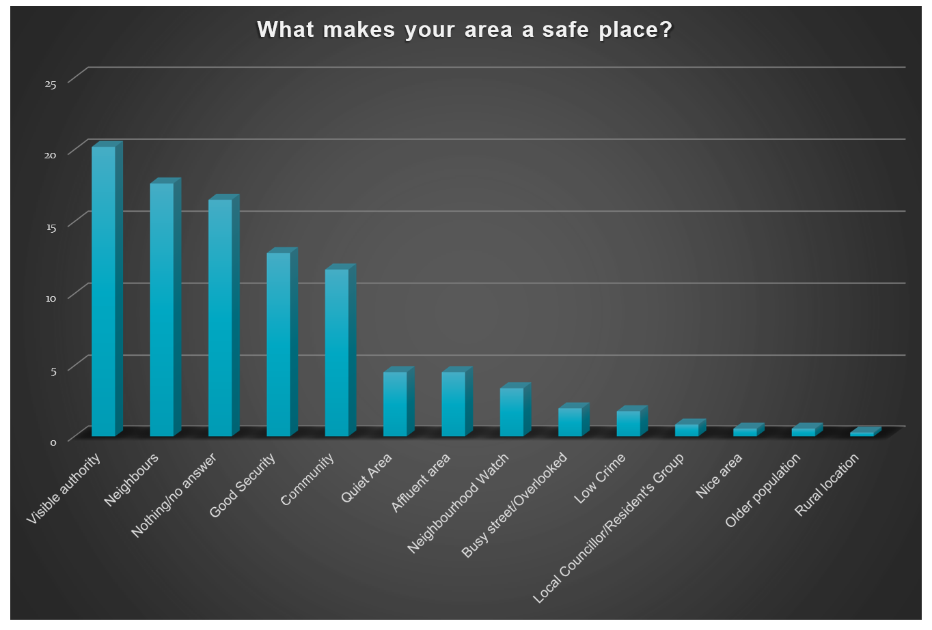

There is a consistent message within this information that indicates that the people within the local community are what make other people feel safe, their immediate neighbours, those that live in the local area and the presence of those organisations who have a role addressing community safety issues.

These 14 themes can be grouped under broader headings that help us to understand the key components of community safety:

|  |  |
| --- | --- |
| **GROUP** | **%Total** |
| Community | 39.18% |
| Agencies | 25.00% |
| Additional measures | 18.91% |
| Environment | 14.18% |
| Low levels of crime / ASB | 2.02% |

There is a strong message that people themselves make each other feel safe; they are part of a well-established community, with good relationships between neighbours. The greatest proportion of responses falls into this category (39.18%). They feel less likely to experience crime and disorder issues in the first place, but should something bad happen, someone would help or support them.

* *“Good friendly and caring community.”*
* *“Good neighbours, nice area, nice local school.”*
* *“Neighbours watching out for each other. Prevention - eg home lighting, cctv, alarm.”*

Confidence in local agencies is important, with over 25.0% giving examples in this category. The greatest proportion recognise a police presence as important. Other local organisations are also recorded, with the district council and Neighbourhood Watch being referenced and support of local Councillors, and residents groups.

* *“The sight of police officers on the street. Also to see these people being issued with a fine acts as a deterrent to future misdemeanors.”*
* *“Police officers, PCSOs and CPOs visible in the local area.”*
* *“The police and the council.”*

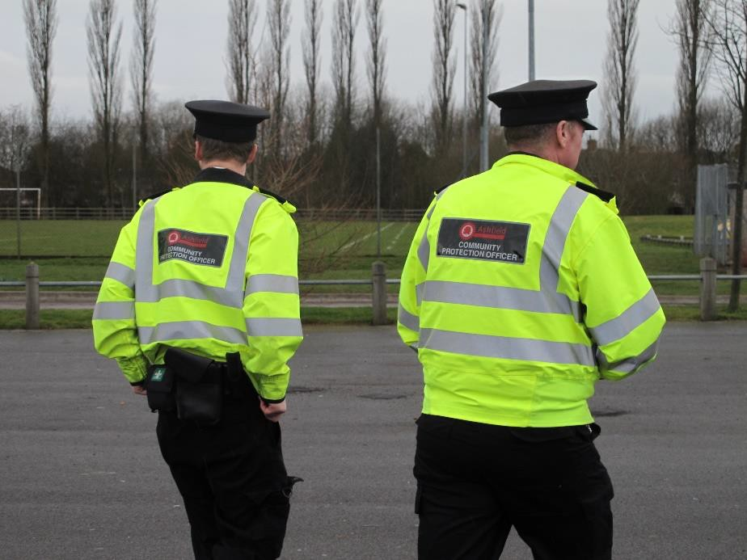

Additional measures in an area can have a positive impact on people’s perception of safety; these include good street lighting, good home security, the presence of CCTV in the area and high levels of street cleansing. 18.91% list these as significant to their local area.

* *“Being secure in our own house. We have installed an alarm, security lights and extra locks.”*
* *“The CCTV must seem to have a positive effect.”*
* *“The security measures we have installed.”*

The location and design of where people live clearly has a positive effect with 14.18% of respondents identifying this as making them feel safe.

* *“Luckily I live on a close so know most of my neighbours and we look out for each other.”*
* *“I live in a private cul-de-sac and as such have no real issues as anyone visiting has nowhere to go if not on genuine visits.”*
* *“I live on a terrace street to many eyes for people to commit crimes.”*

Only small proportion (2.02%) mention the low levels of crime and disorder in their answer. This clearly presents a challenge for partner agencies to alter this perception.

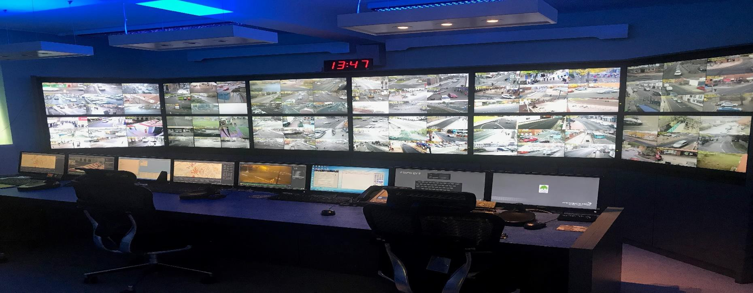

## Question 4 - What makes your area an unsafe place?

92.86% of respondents answered this question.

The content of this open question have been broken down into 18 themes.

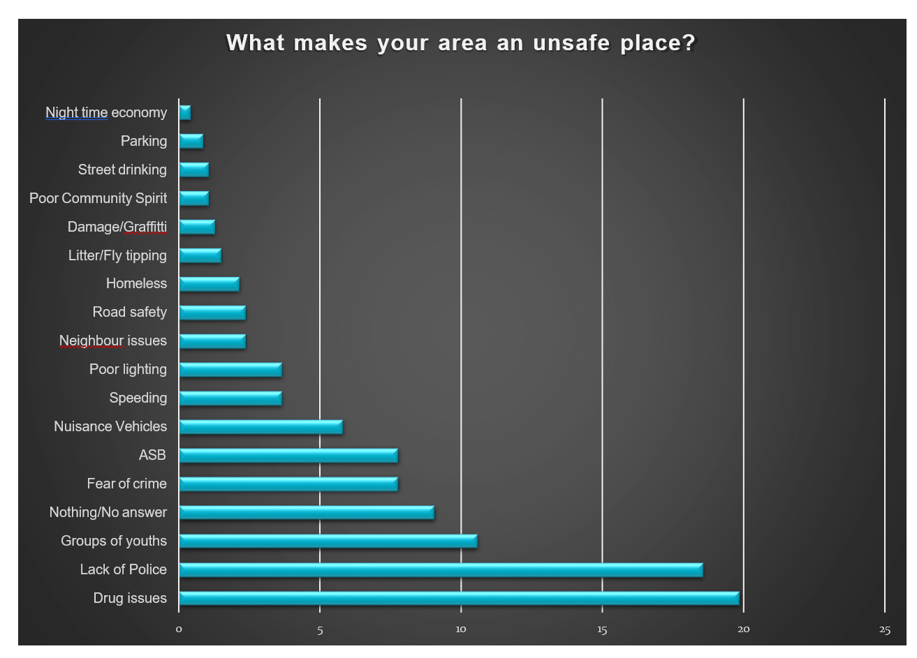

It is clear that drug issues and a lack of Police are the two predominant issues. There is also a concern over groups of youths gathering across the district.

The top ten issues are:

|  |  |
| --- | --- |
|  | TOP TEN ISSUES 2018 |
| 1 | Drug issues |
| 2 | Lack of Police |
| 3 | Groups of youths |
| 4 | Fear of Crime |
| 5 | Anti-social behavior |
| 6 | Nuisance vehicles |
| 7 | Speeding |
| 8 | Poor lighting |
| 9 | Road safety |
| 10 | Homeless. |

It is clear that behaviour has a strong impact on how safe a person feels; they are more affected by **drug issues** (19.87%) and visible **groups of youths** (10.58%) than the **fear of crime** (7.7%). That may be due to the visibility of such issues. This is supported by the fact that a **lack of Police** is the second highest area for concern (18.57%). There are concerns around traffic related issues, with concerns about **nuisance vehicles** (5.83%), **speeding** (3.67%) and **road safety** (2.37%).

## Question 5 - In your local area do you feel that levels of crime and anti-social behaviour are linked to any of the following? (Please tick all that apply)

This question is intended to develop an understanding of some of the underlying issues within a community.

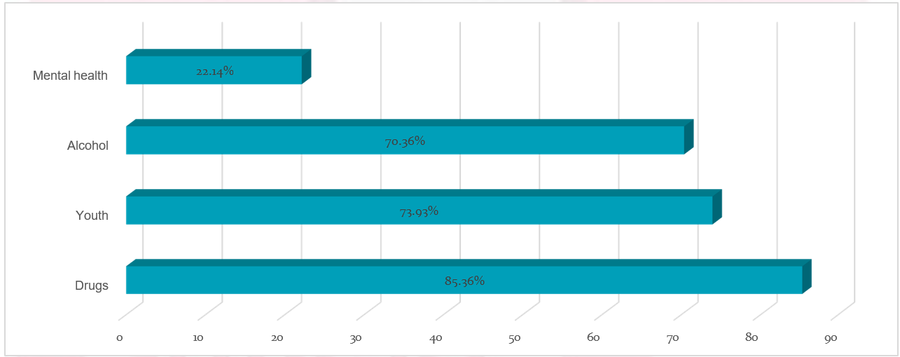

Substance misuse and youth issues are of high concern within the community with 85.36% suggesting that drugs are significant, 70.36% that alcohol is a factor and 73.9% that youth issues are important in their community. These concerns are consistent with the comments recorded in question 2 and are further supported by responses to Questions 6 and 8.

## Question 6 - Which of the following issues do you understand? (Please tick all that apply)

This is designed to provide an understanding around the awareness of emerging issues within the Ashfield District.

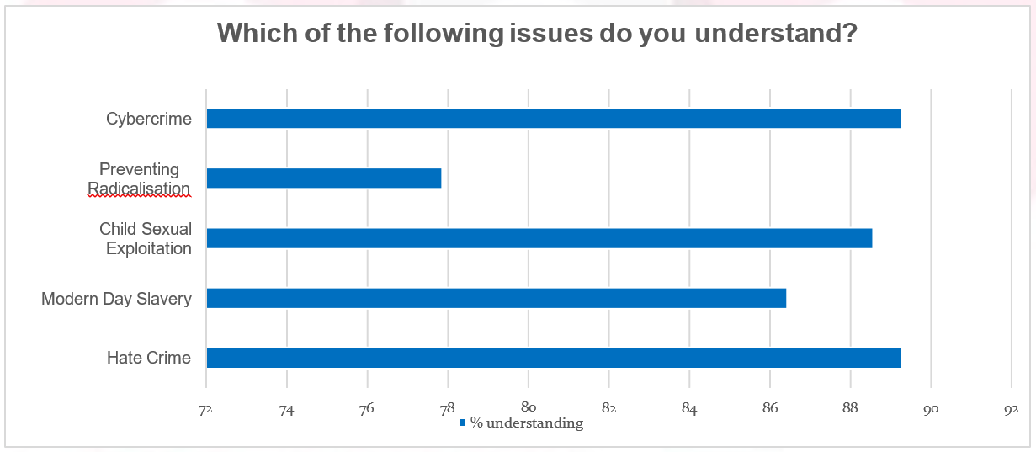

An initial evaluation of the results is positive with high proportions of the community suggesting that their levels of understanding of the issues listed are high.

Awareness levels were highest around the issues of Hate Crime (89.29%), Child Sexual Exploitation (88.57%) and Cybercrime (89.29%).

Lower levels of awareness exist for Modern Day Slavery (86.43%) and Preventing Radicalisation (77.86%); these areas should be taken forward into the new Community Safety Partnership plan. Feedback from partners that delivered the face-to-face surveys suggests that those completing the survey were aware of the general terms, but did not necessarily understand the issues within a local context. This feedback means that the partnership should treat these results with some caution.

## Question 7 - Now using your knowledge of the whole of the Ashfield District, please tell us the top 10 issues that concern you the most from the list below? (Please tick up to 10 boxes)

The aim of this question was to understand the communities concerns around a wide range of community safety issues. Respondents were invited to select up to 10 from a list of 26 options. The list of concerns is based upon those that were most frequently selected, with the top ten issues highlighted in red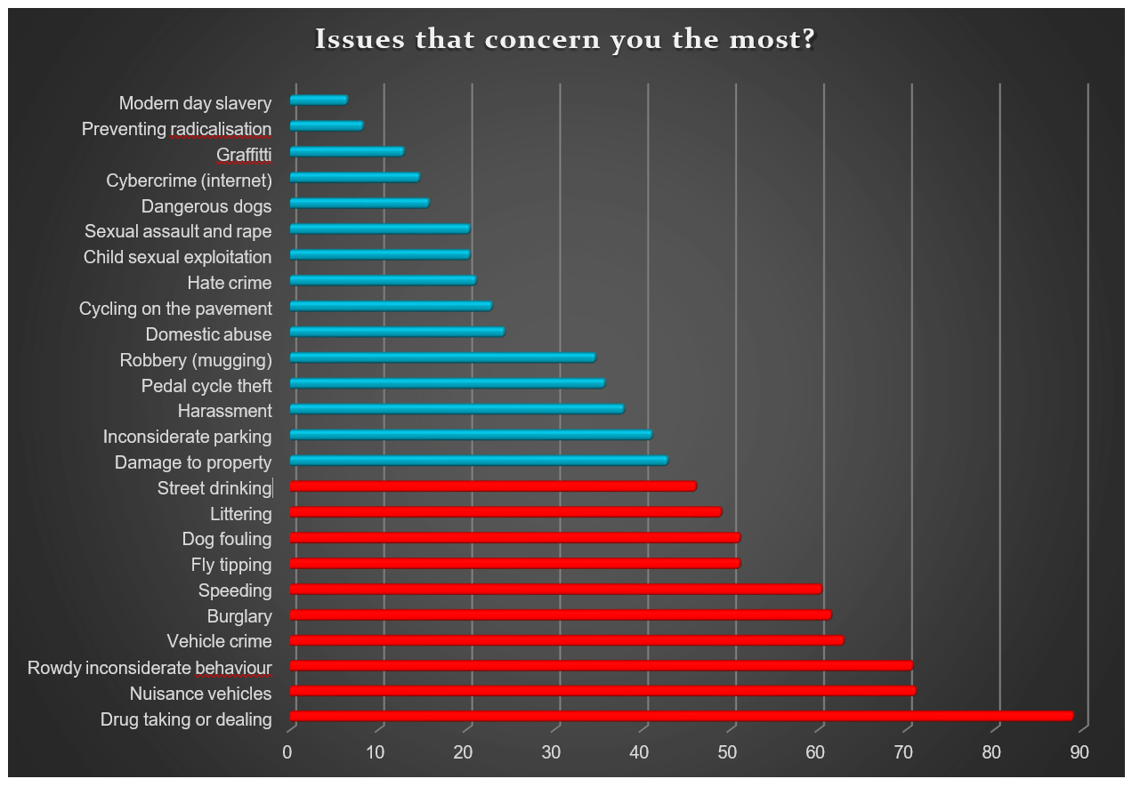

It is important to recognise that these responses are around levels of concern and therefore offer different information to the issues raised in questions 4 and 8. It should not be assumed that a person has a concern about an issue because it currently affects them.

However, it should be noted that ‘drug taking or dealing’ is clearly the predominant concern and this is a consistent theme between all of the previous questions.

|  |  |  |
| --- | --- | --- |
|  | TOP TEN ISSUES OF CONCERN 2018 |  |
| 1 | Drug taking or dealing | 88.93% |
| 2 | Nuisance vehicles | 71.07% |
| 3 | Rowdy/inconsiderate behaviour | 70.71% |
| 4 | Vehicle crime | 62.86% |
| 5 | Burglary | 61.43% |
| 6 | Speeding | 60.36% |
| 7/8 | Fly tipping | 51.07% |
| 7/8 | Dog fouling | 51.07% |
| 9 | Littering | 48.93% |
| 10 | Street drinking | 46.07% |

## Question 8 - If there anything else you would like to tell us about crime and anti-social behaviour in the district of Ashfield?

The responses to this open question has been broken down into 20 themes with 64.63% of respondents providing a response.

The top five themes from those responses are as follows:

1. **Lack of Police/other authority – 28.25%**
2. **Fear of crime/levels of crime – 18.38%**
3. **Drug taking or dealing – 11.21%**
4. **Greater levels of enforcement required – 7.17%**
5. **Street cleansing/litter/fly tipping – 4.93%**

There is a clear message in respect of a perceived lack of authority and the fear/levels of crime being a substantially higher percentage than other themes. Yet again drugs feature in the top 3 responses.

Respondent’s comments:

* + *“There should be tougher penalties; nothing came from us reporting our neighbour’s behaviour so we've had to learn to live with it. The police had no power whatsoever, although they tried their best.”*
  + *“I have not seen a police officer, police support officer and community support officer walking these streets in over 1 year. I have tried to report what I believe is drug dealing but nothing was acted upon.”*
  + *“Just that I think the Police do a great job with the resources that they have. Well done.”*
  + *“We need more police officers, bring back local beat officers. Encourage and support new housing developments to set up neighbourhood watch. Police drop in sessions?”*
  + *“I can only speak for a small part of Ashfield and there are worse areas I do know, but as I'm an older person in Hucknall I don't go out after dark and my door is locked up as I'm afraid. I here motor bikes or cars speeding down the road. Youths shouting even late at night or early morning. I don't leave anything on the front garden because they take them and smash up or leave on someone's garden elsewhere. I could go on but it won't get me anywhere. All the cuts of funding are just getting worse and with that all the things the funding is for are getting worse, whether it's looking after the drug abusers or mental health etc. I worry now how I will pay all my bills and they keep going up, the council tax the worst, the government cuts funds then it's passed to us but we can't say we are not paying we have to find it, so go without food, heating etc.*
  + *“It doesn’t appear to be being addressed appropriately. Crime is getting worse and it is usually drug related.”*
  + *“I feel that the local drug users who hang around our schools, shopping centres and streets are a danger to members of the public & our children. This shouldn’t be allowed as it is intimidating to everyone.”*
  + *“Crime and antisocial behaviour as reported on social media has increased. I do not go into Sutton in Ashfield at night .”*

**Conclusion**

The consultation has gathered a significant amount of information about the communities’ opinions, awareness and concerns of community safety issues.

Headlines;

* + Levels of crime and anti-social behaviour are perceived as becoming **worse** over the past year.
  + Respondents identified that a **well-established community, good neighbours** and **visible authority** in the community are the key factors in making their area safe.
  + Respondents stated that **drug issues** and a **lack of Police** are the key factors in making their area an unsafe place.
  + Respondents perception is that **substance misuse** and **youth issues** are the main contributors to levels of crime and anti-social behaviour.
  + Respondents claim to have a good understanding of **cybercrime, hate crime** and **child sexual exploitation,**

but less so about **modern day slavery** and **preventing radicalisation**.

* + Respondents are most concerned about **drug taking and dealing**, **nuisance vehicles** and

**rowdy/inconsiderate behaviour**.

**Did the consultation achieve its aims?**

1. Understand public perception of progress in terms of tackling crime and ASB

Findings from the consultation clearly show that an overwhelming proportion of respondents (73%) believe that levels of crime and anti-social behavior have increased or remained the same (19%) over the past twelve months.

Only 6% of respondents felt that there had been improvement.

Clearly, these results present a significant challenge for the Community Safety Partnership to address public perception.

1. Understand what contributes to making people feel safe and unsafe

There was a consistent message that positive relationships with neighbours and being part of an established community has the greatest impact on people’s feeling of safety. The physical environment is also important, as is a visible presence of authority.

Note: A local level evaluation of these categories may give examples of good practice that can be developed in areas with higher levels of community safety concerns.

Whilst a wide range of issues contribute to people feeling unsafe they are dominated by two themes; a lack of Police/visible authority and drug issues. These themes are consistent throughout the survey and are a clear indication of the concerns of the respondents.

1. Gain an understanding of people’s concerns about some of the underlying issues that impact on Crime and ASB

It is clear that communities recognise Alcohol, Drugs and Youth issues as significant contributors to the problems in their local communities. Levels of concerns around mental health were also recorded, but at a much lower level. Whilst the levels of crime and ASB associated with mental health may be lower, the complex needs of individuals often mean that the partnership resources required are greater. It should also be considered that issues around mental health might be less visible to the community and therefore harder to identify.

1. Gain an understanding of people’s awareness of new and emerging issues in the district.

Respondents claim to have a high level of awareness of these issues; particularly for cybercrime and hate crime. Where levels of awareness were lower, for modern day slavery and preventing radicalisation, more work to raise awareness and educate the community on how to access appropriate services may need to be done.

1. Understand those issues that cause the greatest level of public concern

It is clear that there is a correlation between those issues that affect people’s feeling of safety and those that cause them the greatest concern. Overall there are consistent issues raised around drugs and a lack of visible authority in the district. This evidence of community concern will be a valuable addition to the development of the new 2019 - 2022 CSP plan.

**How will the data be used?**

The information gathered within the consultation will be shared with local partners to be used to inform both strategic and local level work.

Where information relates to areas outside of the CSP, they will be passed on to the appropriate organisation. For example, road safety concerns will be shared with the casualty reduction partnership.

The results of this consultation may also identify the need to go back to the community and ask more focused questions around an issue as part of future engagement work. This will be delivered through the action plans developed to support the new CSP Plan.

Questionnaire:

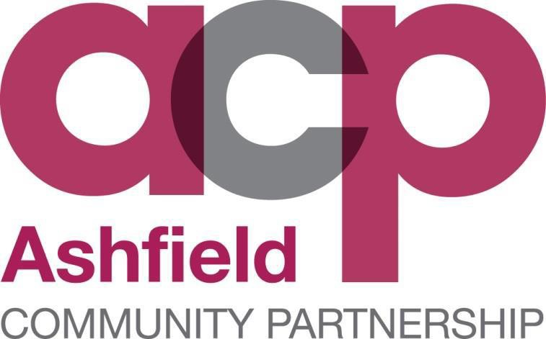

**COMMUNITY SAFETY PARTNERSHIP CONSULTATION 2018**

**Question 1. – To help us locate the area where you live, please provide your postcode**

**Question 2. - Within your local area, a 15-20 minute walk from where you live, how do you consider levels of crime and anti-social behaviour changed over the past year?**

**Question 3. - What makes your area a safe place?**

**Question 4. - What makes your area an unsafe place?**

**Question 5. - In your local area do you feel that levels of crime and anti-social behaviour are linked to any of the following? (Please tick all that apply)**

* Alcohol
* Mental Health
* Youth
* Drugs

**Question 6. - Which of the following issues do you understand? (Please tick all that apply)**

* Hate Crime
* Modern Day Slavery
* Child Sexual exploitation
* Preventing Radicalisation
* Cybercrime

**Question 7. - Using your knowledge of the Ashfield District, please tell us the top 10 issues that concern you the most from the list below? (Please tick up to 10 boxes)**

* Drug taking or dealing
* Modern day slavery
* Graffiti
* Pedal cycle theft
* Dangerous dogs
* Harassment
* Preventing radicalisation
* Cybercrime (internet)
* Nuisance vehicles
* Child sexual exploitation
* Hate crime
* Cycling on the pavement
* Domestic abuse
* Sexual assault and rape
* Dog fouling
* Vehicle crime
* Fly tipping
* Inconsiderate parking
* Damage to property
* Street drinking
* Robbery (mugging)
* Littering
* Speeding
* Rowdy/Inconsiderate behaviour
* Burglary

**Question 8. - Is there anything else you would like to tell us about crime and anti-social behaviour in the Ashfield District.?**