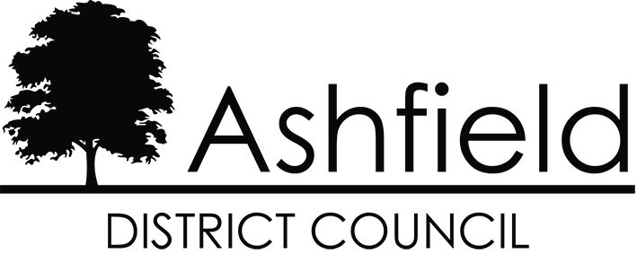

# Ashfield District Local Plan Examination

# Matters, Issues and Questions identified by the Inspectors

# Matter 6:

**Climate Change**

**December 2024**

**Ashfield District Council’s response to Inspectors’ Document INS03**

This document is Ashfield District Council’s response to the Matter, Issues and Questions (MIQs) identified for examination by Inspectors Mr. Philip Mileham and Mr Graham Wyatt, of the Planning Inspectorate, as published on the 30th September 2024. This is one of twelve separate papers produced to address the specific matters and issues identified on the front page.

Each response paper includes a number of references to specific evidence which has been relied upon in answering the MIQs. These reference numbers (shown as **[XXXX]**) relate directly to the Examination Library website, where all evidence is published: <https://www.ashfield.gov.uk/local-plan-examination/examination-library/>

The Inspectors’ questions are shown below in ***bold italics***.

The Council’s responses are shown in normal typeface below the Inspector’s questions.

|  |
| --- |
| Proposed Modifications arising from the Inspectors’ MIQs are set out in grey tint boxes. |

## Issue: Whether the Local Plan has been positively prepared and whether it is justified, effective and consistent with national policy in relation to climate change

### Relevant Policies:

**CC1 - Zero/Low Carbon Developments and Decentralised, Renewable, Low Carbon Energy Generation**

**CC2 - Water Resource Management**

**CC3 - Flood Risk and SuDS**

**S3 - Meeting the Challenge of Climate Change**

***6.1 Are the requirements of the Meeting The Challenge of Climate Change And Adapting To Its Effects policies CC1 – CC3 justified by appropriate available evidence, having regard to national guidance, and local context?***

Council’s response

* + 1. Policy CC1 supports zero and low carbon developments and renewable and low carbon energy generation. The policy sets out a range of criteria which development proposals will be considered against. The policy provides flexibility in considering the inclusion of climate change mitigation and adaptation measures in paragraph 1 of the policy, which recognises that such measures will be expected ‘unless it can be demonstrated that compliance with the policy is not viable or feasible or there are significant adverse effects in relation to other policy requirements’.

6.1.2 Footnote 1 of Policy CC1 reflected the former footnotes to paragraph 158 of the September 2023 version of the NPPF. These footnotes in the NPPF were cancelled by the Government on 08 July 2024 and we therefore suggest that footnote 1 to Policy CC1 be deleted.

6.1.3 Paragraph 8 c) of the NPPF recognises mitigation and adaptation to climate change as one of the overarching objectives of the planning system. Paragraph 11 a) of the NPPF identifies mitigation and adaptation to climate change as being within the scope of plan-making. Chapter 14 of the NPPF focuses in more detail on climate change. It recognises that:

‘The planning system should support the transition to a low carbon future in a changing climate, taking full account of flood risk and coastal change’ (paragraph 152).

and

‘Plans should take a proactive approach to mitigating and adapting to climate change’ (paragraph 153).

Paragraphs 154 – 155 of the NPPF provide further guidance on the role of local plans in addressing climate change.

6.1.4 Policy CC2 supports water quality and water efficiency. Paragraph 4.17 of the accompanying text highlights the objective of the Water Framework Directive in achieving good ecological status in water bodies. Paragraphs 4.19 – 4.20 highlight the Humber River Basin Management Plan and the sensitivity of the Ashfield area to groundwater pollution. Paragraph 4.26 highlights the Environment Agency’s identification of the Severn Trent Water area as seriously water stressed for metering purposes. Paragraph 153 of the NPPF highlights water supply as a matter that local plan policies should take into account.

6.1.5 Policy CC3 addresses flood risk management and sets out the requirements for the Sequential Test and, where appropriate, the Exceptions Test. Paragraph 4.32 of the accompanying text sets out the flood risk characteristics of Ashfield. Chapter 14 of the NPPF provides guidance on planning and flood risk. Paragraph 161 of the NPPF states that:

‘All plans should apply a sequential, risk-based approach to then location of development – taking into account all sources of flood risk and the current and future impacts of climate change – so as to avoid, where possible, flood risk to people and property.’

It is considered that the requirements set out in Policies CC1 – CC3 are justified.

***6.2 Has Policy CC1 been shaped by engagement with all stakeholders, including infrastructure providers and statutory consultees?***

Council’s response

6.2.1 Yes. This is evidenced by the Duty to Cooperate and Statements of Common Ground with Environment Agency and with Nottinghamshire County Council as lead flood authority.  The Council is part of the Nottinghamshire Lead Officers Energy meetings which include the Environmental Strategy Working Group, Local Authority Energy Partnership (LAEP) and Nottinghamshire Carbon Neutral Officers Group.  Meetings were held with The Coal Authority (now Mining Remediation Authority) to explore opportunities for Mine water heating projects in Ashfield. Engagement has been undertaken with Severn Trent and the National Grid.  The Council also produced a Planning guidance document on Climate Change 2022, which was subject to stakeholder consultation.

***6.3 Has Policy CC3 and S3 been shaped by engagement with all stakeholders, including infrastructure providers and statutory consultees?***

Council’s response

6.3.1 Yes. This is evidenced by the Duty to Cooperate and Statements of Common Ground with Environment Agency and with Nottinghamshire County Council as lead flood authority. Engagement has been undertaken with Severn Trent and the Environment Agency as part of CC3 and S3 policy development.  The Council also produced a Planning guidance document on Climate Change 2022, which was subject to stakeholder consultation.

***6.4 Do Policies CC1 -CC3 serve a clear purpose, avoiding unnecessary duplication of national policy? Is the wording consistent with national policy?***

Council’s response

6.4.1 Yes, the policies serve a clear purpose and avoid unnecessary repetition of national policy, as set out in NPPF para 16 f) which states that plans should ‘serve a clear purpose, avoiding unnecessary duplication of policies that apply to a particular area (including policies in this Framework, where relevant)’.

6.4.2 The supporting text to these policies provides further detail and refers to the evidence base.

***6.5 Do Policies CC1 – CC3 provide clear direction as to how a decision maker should react to a development proposal?***

Council’s response

6.5.1 Yes, the policies provide clear direction as set out in NPPF para 16 d) which states that plans should ‘contain policies that are clearly written and unambiguous, so it is evident how a decision maker should react to development proposals’.

6.5.2 The supporting text to these policies provides further detail and refers to the evidence base.