September 2023

Strategic Distribution and Logistics Background Paper

Contents
Introduction 3
The Logistics Study 3
Local Plan Progress 4
Wider Market Area 5
Logistics Study methodology 7
Relationship between the outcomes and recommendations of the Logistics Study and those arising from the Employment Land Study of employment land need 8
Approach - strategic distribution site search methodology 11
Step 1: Establishing a “pool” of sites 11
Step 2: Selection of ‘Reasonable Alternatives’ 15
Step 3: Assessment of ‘Reasonable Alternatives’ and Identification of Preferred Sites 15
Conclusions 32
Appendix 1: List of sites assumed to meet strategic distribution need within the Logistics Study Area 34
Appendix 2: Step 2 – Assessment of ‘Pool Sites’ and Identification of Reasonable Alternatives 36
Ashfield 36
Broxtowe 44
Erewash 56
Gedling 60
Nottingham 63
Rushcliffe 64
Appendix 3: Steps 3 – Identification of Suitable and Preferred Sites. 75
Ashfield 75
Broxtowe 97
Erewash 140
Rushcliffe 154
Appendix 4: Existing / potential supply of strategic B8 sites in the Logistics Study Area and preferred sites 170

Introduction

- This Strategic Distribution and Logistics Sites Background Paper has been prepared by Ashfield, Broxtowe, Erewash, Gedling, Nottingham and Rushcliffe Councils which make up the Greater Nottingham Planning Partnership area. It considers whether there are any suitable potential sites to meet needs for strategic distribution and logistics facilities; and the suitability for these to be considered for allocation through the preparation of the emerging Greater Nottingham Strategic Plan and the emerging Draft Ashfield Local Plan and the Erewash Core Strategy Review.

- By way of background, Councils across the Nottingham Core and Nottingham Outer Housing Market Area jointly commissioned consultants to carry out an employment land study - called the Nottingham Core and Outer HMA Employment Land Study 2021 (Lichfields, May 2021). This study forms part of a joint evidence base for the relevant Councils to support local plan preparation and decision making.

- The study included a specific recommendation to give further consideration to assess whether to make provision for major logistics facilities within the Nottingham Core and Outer Housing Market and wider area. The recommendation at paragraph 10.25 of the Employment Land Study states:

‘Given the scale and urgency of this issue, the District Councils (potentially working with adjoining districts along the M1 Corridor) may wish to consider commissioning a further strategic study to quantify the scale of strategic B8 logistics need across the Core/Outer HMA and beyond that builds on the indicative suggestions set out above. This future study should seek to quantify the scale of strategic B8 requirements and potentially identify sites where this need should be allocated. Our view would be that the main focus of this future study should be along the M1 Corridor and A-roads near to the Motorway junctions’.
The Logistics Study

- On behalf of Ashfield, Broxtowe, Erewash, Gedling, Mansfield, Newark & Sherwood, Nottingham City and Rushcliffe Councils, Nottingham County Council commissioned consultants Iceni to undertake a logistics study – Nottinghamshire Core and Outer HMA Logistics Study – to assess the specific needs for strategic distribution or logistics facilities across the Nottingham Core and Outer HMA.
- The Logistics Study is available here:

nottinghamshire-logistics-study-august-2022.pdf (gnplan.org.uk)

- The Logistics Study was published in August 2022 and the purposes and objectives of the study are set out in paragraph 1.2 of the report. As acknowledged by Iceni (paragraph 1.4) the study has been undertaken from a “policy off” perspective meaning that constraints such as the Green Belt or issues determining sustainability (historic and natural environment constraints and socio-economic factors) have not been considered in the ability of the area to accommodate future logistic requirements. These policy considerations are for the relevant Councils to consider through a separate site selection exercise. It is also the case that the study has not involved modelling capacity of the road network or individual junctions and there may be capacity constraints to be considered in terms of any potential sites identified (paragraph 1.5). This would be addressed through future transport modelling work.

- The study has been prepared within the context of the National Planning Policy Framework (NPPF) 2021, Planning Practice Guidance and other relevant literature and studies, some of which are summarised below. The context provided by national planning policy and guidance and the literature reviewed is set out in the Logistics Study in chapter 2 (pages 4 - 13). In accordance with national planning policy the study assesses the quantitative need for additional strategic distribution floorspace and also sets out more specific locational criteria for locating strategic distribution and logistics. The quantum of space estimated is therefore not viewed as a target but as guidance to the extent of which need may be met once account is taken of policy and environmental constraints.

Local Plan Progress
- Broxtowe Borough, Gedling Borough, Nottingham City and Rushcliffe Councils are preparing the Greater Nottingham Strategic Plan with the next stage of plan preparation being a regulation 18 consultation on preferred strategic logistics sites later in 2023 followed by a regulation 19 consultation during 2024. Ashfield District is preparing a draft Local Plan with a Regulation 19 consultation likely to take place later this year. Erewash Borough has, at the time of writing, submitted a Core Strategy Review for examination. Newark & Sherwood District Council has adopted its Amended Core Strategy in 2019 and is preparing an Allocations and Development Management Development Plan Document. Mansfield District Council adopted its local plan in October 2020. However, all of these Councils are working in partnership to a common evidence base wherever possible and towards applying a consistent approach in taking forward the findings of the Logistics Study.

- The Logistics Study identifies Areas of Opportunity which the consultants consider meet the locational criteria set out in the Study for strategic warehousing and logistics in full. These Areas of Opportunity, with the exception of one, relate primarily to the M1 and A453 Corridors covering parts of Nottinghamshire, Derbyshire and North West Leicestershire. Except the area around Newark-on-Trent, the Areas of Opportunity along the M1 corridor are partly located within the Nottingham Core HMA and the more western part of the Nottingham Outer HMA corresponds to the area of the Greater Nottingham Planning Partnership with the remainder of these areas being in Derbyshire and Leicestershire. Consequently, the extent of the Areas of Opportunity located within the Greater Nottingham Planning Partnership area and consideration of potential sites raise significant cross boundary strategic planning issues for the relevant authorities. The Area of Opportunity surrounding Newark-on-Trent (along the A1 and A46) relates more to the A1 corridor although it is acknowledged that this is part of the study area adopted by the Logistics Report in assessing supply and demand. Parts of these Areas of Opportunity also relate to parts of Derbyshire, Derby and North West Leicestershire which the study acknowledges have identified significant levels of supply (Logistics Study paragraph 5.8).

- Greater Nottinghamshire Planning Partnership have jointly prepared this Background Paper as the basis for identifying preferred sites within their administrative areas. Newark & Sherwood Council and Mansfield District Council (the other authorities included in the Logistics Study) will be consulted on the content of this Background Paper, the preferred sites identified within the Greater Nottingham Strategic Plan Area and their contribution to meeting the needs identified within the Iceni Logistics Study and this background paper.

Wider Market Area

- The Logistics Study sets out views of stakeholders (paragraph 3.43) whose opinions vary on the extent of the market with some indicating occupiers are footloose and look at M1 junctions 20 - 36 being the whole East Midlands and beyond. Junctions north of junction 24 to junction 28 are regarded as prime locations within the East Midlands in terms of location, accessibility and access to labour markets. Junction 29 is regarded to be the top end of the East Midlands area. The study notes a difference between sites on the M1 and the wider Nottinghamshire area, with the M1 being the prime territory for larger units.

- The study identifies significant levels of supply outside the study area of 1,675 hectares including the M1 to the north, Leicestershire to the south, Derby to the west and Bassetlaw (Logistics Study paragraph 5.8 and Table 5.2). The Councils consider that the Logistics Study area is therefore a sub market of a

wider market area.

- The modelling undertaken within the Study is a “policy off” or an unconstrained approach which at the upper end of the estimates would, in the Study’s view, capture a greater share of the regional market if accommodated within the study area (Logistics Study paragraph 8.31) where historic delivery has been suppressed due to Green Belt and other constraints (Logistics Study paragraph 8.30).

Logistics Study and relationship to other studies

- The Logistics Study has taken into account other relevant studies which cover part of the Nottingham Core and Outer HMA including Warehousing and Logistics in Leicester and Leicestershire: Managing Growth and Change 2021. This study looks at the 2020-41 need for large scale logistics across Leicester and Leicestershire. Paragraph 2.8 of the Logistics Study states:

“The principal modelling techniques in the 2021 report used to forecast space for large scale logistics to 2041 are past completions trends (2011-2020) and a traffic growth with replacement demand model, alongside a margin of 5yrs completions. North West Leicestershire notably drives the completions trend reflecting units at East Midlands Gateway and Distribution Centre. These models demonstrate a good level of alignment in terms of providing recommendations for long term needs which amount to 2.6m sq. m, derived of
  - m sq. m of rail served sites and 1.5m sq. m of road served sites”.
- An interesting point is that the Leicester and Leicestershire Study suggests that a significant amount of jobs are a result of a replacement for aged existing units rather than in newly created units (Logistics Study, paragraph 11.32).

- The Logistics Study also refers to the A1 Corridor Logistics Assessment: Bassetlaw (August 2021) - which provides a high level assessment of the large scale logistics market on the A1 corridor in Bassetlaw and the wider property market area otherwise referred to as the A1 Study. The A1 Study Area is defined as running from the M18 at Thorne in Doncaster down to Junction 25 of the M1 at Erewash as well as taking in Chesterfield to the west and Newark-on-Trent in the east. The A1 Study is principally used to support the emerging Bassetlaw Local Plan. However, the A1 Study indicated the property market area included the whole of Nottinghamshire, as well as south Doncaster and parts of Derbyshire and Sheffield. Whilst the Logistics Study acknowledges that the A1 Study is not directly comparable with their study, it is clear that the proposed 410,000 square metre strategic distribution centre at Apleyhead Junction in Bassetlaw District would make a significant contribution to sub regional needs (Logistics Study paragraph 8.33).

Logistics Study methodology

- In terms of methodology, the Logistics Study uses a range of models to forecast demand for strategic distribution and logistics floorspace (as set out in chapters 6 - 8 and summarised in chapter 9 and in chapter 14 Summary and Conclusions paragraph 14.17). In summary the scenarios / models used and assessed range of floorspace requirements in square metres are set out in brief below:

- Labour demand - minus 51,000 to 135,000 sq. m
- Completions trend - 707,000 to 893,000 sq. m
- 2012 - 21 net absorption - 554,500 to 731,400 sq. m
- 2017 - 21 net absorption - 927,300 to 1,113,00 sq. m
- Traffic Growth with Replacement Demand (TGRD) Low - 574,000 to 760,000 sq. m
- TGRD Central - 744,000 to 760,000 sq. m
- TGRD High - 1,084,000 to 1,270,000 sq. m
- Share of M1 Junction 24 - 28 - 1,600,000 to 1,786,000 sq. m
- Increased delivery relative to Nottinghamshire / Leicester and Leicestershire 1,300,000 to 1,486,000 sq. m

- The labour demand, completions trends and net absorption with compensation methods are not considered by the Logistics Study to be suitable for assessing logistics needs as they consider they have been affected by historic supply constraints influencing the forecasts. The Logistics Study recommends at paragraph 9.4 that: “the higher range estimates are appropriate for seeking to determine the unconstrained logistics market requirements being 1,270,000 to 1,786,000 sq. m” (i.e. the last three bullets above). Paragraph 9.5 refines the recommendation for the higher range estimates further in stating: “Given that some of the modelling techniques are more exploratory, and that Bassetlaw plays a role in absorbing some sub regional needs, on balance it is recommended that the most appropriate range is 1,270,000 to 1,486,000 sq. m. Taking into account the current strength of market indicators the recommendation is with the upper figure to be used for planning policy purposes”.

- In summary the Logistics Study concluded:

- The requirement for planning policy purposes should be 1,486,000 sq. m or 425 hectares of logistics space (applying the Logistics Study’s recommended land required figure which is the gross area of land required to accommodate the new build forecast assuming 35% floorspace to plot footprint ratio I.e. one hectare of land would accommodate 3,500 square metres of distribution floorspace).

- There is 315,000 sq. m of committed supply (units over 9,000 sq. m with planning permission or allocations in adopted local plans).
- Potential “pipeline” sites (allocations in draft plans such as the draft allocations at Junction 27 and planning applications pending) would reduce the need to 601,000 sq. m or 172 hectares subject to the allocations being confirmed (Logistics Study paragraph 9.9).
- Some of the need is expected to be met through the redevelopment of existing logistics or other large manufacturing sites. It is assumed that this would meet 10 to 20% of the identified need reducing this need to 137 - 155 ha. (Paragraph 10.16).
- Residual need would fall to the order of two to three large strategic logistics parks.

- The Logistics Study recommends that the following Areas of Opportunity be considered:

- Area adjacent to M1 Junction 28 and 27 (Sutton in Ashfield, Alfreton, Kirkby-in-Ashfield and towards Hucknall);
- Area adjacent to M1 Junction 26 (Langley Mill, Eastwood and Kimberley);
- Area adjacent to M1 Junction 25;
- Area adjacent to A453; and
- Area surrounding Newark (along A1 and A46).
- The Logistics Study estimates the residual need to be in the region of 601,000 square metres and indicates that this would fall in the order of 2-3 large strategic logistics parks (Logistics Study paragraph 14.21). The Logistics Study indicates that sites should be sufficiently large and flexible in configuration with a minimum size of 25 hectares being recommended although sites of 50 hectares or more are preferred (paragraph 10.11). The estimate of 601,000 square metres equates to approximately 172 hectares at a 35% plot ratio. This estimate falls to a range of around 480,000 - 540,900 square metres or 137 - 155 hectares (at a 35% plot ratio) as the Logistics Study considers 10 to 20% of need could come forward on redevelopment of existing sites. Taking into account that sites of 25 hectares and above are most appropriate, the Logistics Study considers that need across the area may be met through the allocation of a number of sites.

Relationship between the outcomes and recommendations of the Logistics Study and those arising from the Employment Land Study of employment land need

- The Logistics Study at paragraph 5.6 notes that some of the supply identified is already captured in the general supply of employment land as set out in the

2021 Nottingham Core HMA and Nottingham Outer HMA Employment Land Needs Study. It states:

“Authorities would need to consider the relationship between the recommendations and outcomes in that study and those arising from the Iceni study when considering Local Plan development”.

- The Nottingham Core and Outer Employment Land Study prepared by Lichfields estimates the amount of general employment land likely to be required up to 2038 including for offices, industrial and general warehousing purposes. The Employment Land Study identified that the strategic logistics needs of national and regional distribution centres are generally not reflected in either the past take-up or econometric modelling data (with the partial exception of Ashfield District’s past take up data). (Para 9.4). The study recognised that Ashfield had seen significant logistics development which was reflected at least in part by the past take up rates. (Para. 9.21, 10.21 and 10.56). In relation to the potential “pipeline” of sites for strategic distribution, proposed allocations in Ashfield and Erewash make the greatest contribution alongside Rushcliffe at the Ratcliffe on Soar Power Station.

- In Ashfield the sites in the vicinity of junction 27 are draft allocations and were not part of the land supply identified in the Employment Land Study. Land allocated at Harrier Park in Ashfield was identified as an allocation in the Employment Land Study and is for general employment uses which may include warehousing. In this context, the Logistics Study has assumed 50% of the remaining land at this site would be likely be strategic warehousing and given its location and demand for large scale warehousing units in the District this would seem a reasonable assumption.

- The Employment Land Study assessed the market attractiveness of part of the Stanton site in Erewash being a 10 ha site allocated in the adopted Erewash Core Strategy (March 2014). However, as noted in the study, additional land has been promoted at Stanton which the study states was circa 85 hectares although at that time the intentions of the owners were not clear. The scale of the site was such that the study considered that the size of the revised Stanton site could play a key role in meeting wider employment needs over and above Erewash’s own requirements. Subsequently the submission draft Erewash Core Strategy (November 2022) includes Stanton North as a draft strategic employment allocation for 80 hectares within the Erewash Core Strategy Review and has planning permission for over 260,000 sq. m of employment space. The exact quantity of B8 is to be determined but it is anticipated to be very significant and it is therefore considered that the assumption used by the Logistics Study is reasonable. It is also the case that this strategic employment allocation is more than sufficient to meet Erewash Borough’s employment needs.

- Ratcliffe on Soar power station was reviewed within the Employment Land Study which recommended it should be allocated and it was not part of the employment land supply. A Local Development Order (adopted in July 2023) has granted planning permission in principle for up to 810,000 square metres of employment uses with logistics being seen as an appropriate use (up to 180,000 square metres of strategic distribution floorspace). This site is also considered to be of a wider than Borough wide significance and the amount of warehousing space assumed by the Logistics Study is considered reasonable.

- Other sites in the potential supply largely reflect planning applications or planning permissions for strategic warehouse units. In line with the recommendation in the Logistics Study (paragraph 5.6 as quoted above) the assumed supply of strategic B8 employment land has been disaggregated from the general employment land supply as set out in the Employment Background Paper. The assumed supply of strategic scale (planning permissions / allocations and potential pipeline supply in the Logistics Study Area with units capable of accommodating strategic warehousing units above 9,000 sq. m) has been updated to take into account changes since the publication of the Logistics Study and is set out in Appendix 1.

Revised Residual Need

- In summary, having disaggregated general employment land within committed and pipeline sites and included planning permissions granted since publication of the Logistics Study (for example Land off the A17 near Newark), 914,641 sq. m of floorspace (on 245.94 ha of land) is now identified within the study area. This will make a substantial contribution to meeting distribution and logistics need, reducing the need from 1,486,000 sp. m to 571,359 sq. m of floorspace.

- As indicated in the Logistics Study, if 10 to 20% of this remaining need is met through the redevelopment of existing sites this need is reduced further to between 514,223 sq., m and 457,087 sq. m.

- Applying the floorspace to plot footprint ratio of 35% equates to between 131 ha and 147 ha of land required across the study area.

Approach - strategic distribution site search methodology

- The approach taken to identifying sites which may be suitable for allocation involves the following steps:
- Step 1: establish an initial “pool” of potential sites;
- Step 2: identify “reasonable alternatives” from the “pool” of sites in step 1; and
- Step 3: undertake detailed assessment of the “reasonable alternatives” to determine which may be suitable and those that are preferred.

Step 1: Establishing a “pool” of sites

- The first step of the approach is to establish a “pool” of sites for consideration. The Councils’ view is that the assessment of suitable sites should include sites that are in the region of 25 hectares and above and are within or close to Areas of Opportunity (as identified in the Logistics Study).

- The Logistics Study identifies draft allocations at Junction 27 of the M1, Whyburn Farm, New Stanton and Ratcliffe on Soar Power Station as potential “pipeline” sites. Since the Logistics Study was published, Ashfield District Council has resolved to not take forward the Whyburn Farm draft allocation (Ashfield District Council, Cabinet decision 13th December 2022).

- A “call” for potential major distribution sites was undertaken during the autumn of 2022 and a number of sites were promoted by developers / landowners as part of this exercise. Other potential sites were identified by the Councils including draft allocations in emerging Local Plans or sites promoted for employment uses through the Greater Nottingham Strategic Plan Growth Options Consultation July 2021 and February 2022, and the Preferred Approach Consultation in January 2023. Overall, thirty sites have been identified as the “pool” of sites for the initial sieving exercise.

Table 1: “pool” of sites

Authority | Reference | Site name and address | Source
Ashfield | ADC-L01 | Land East of Pinxton Lane, South of A38, Sutton in  Ashfield, Notts. | Call for sites for strategic  distribution
Ashfield | ADC-L02 | Land to the North East of Junction 27 M1 Motorway off A608 Mansfield Road, Annesley, Nottinghamshire. | Submitted to the SHELAA and included as a Draft allocation in  the emerging

Authority | Reference | Site name and address | Source
Ashfield Local Plan
Call for sites for strategic distribution
Ashfield | ADC-L03 | Land to the South East of Junction 27 M1 Motorway off A608 Mansfield Road, Annesley, Nottinghamshire. | Submitted to the SHELAA and included as a Draft allocation in the emerging Ashfield Local Plan  Call for sites for  strategic distribution
Ashfield | ADC-L04 | Land to the South of Sherwood Business Park, off A608 Mansfield Road, Annesley, Nottinghamshire. | Call for sites for strategic distribution
Ashfield | ADC-L05 | Land to the East of Sherwood Business Park, off A611 Derby Road,  Annesley, Nottinghamshire. | Call for sites for strategic distribution
Broxtowe | BBC-L01 | Former Bennerley Coal Disposal Point | Call for sites for strategic  distribution
Broxtowe | BBC-L02a | Gilt Hill (smaller site) | Call for sites for strategic distribution
Broxtowe | BBC-L02b | Gilt Hill (larger site) | Call for sites for  strategic distribution
Broxtowe | BBC-L03 | Gin Close Way | Call for sites for strategic distribution
Broxtowe | BBC-L04 | Land at Kimberley Eastwood Bye Pass | Call for sites for  strategic distribution
Broxtowe | BBC-L05 | Land at Low Wood Road, Nuthall | Call for sites for strategic  distribution
Broxtowe | BBC-L06 | Land at New Farm Nuthall | Call for sites for strategic  distribution

Authority | Reference | Site name and address | Source
Broxtowe | BBC-L07 | Land at Shilo Way | Call for sites for strategic  distribution
Broxtowe | BBC-L08 | Land to the south-east of M1 junction 26, Nuthall | Call for sites for strategic distribution
Broxtowe | BBC-L09 | Land at Waterloo Lane, Trowell | Call for sites for  strategic distribution
Erewash | EBC-L01 | Stanton North employment allocation, Low’s Lane, Ilkeston, Derbyshire | Allocation in the Erewash Core Strategy Review Submission  Version.
Erewash | EBC-L02 | Land South-West of Junction 25 of the M1, Long  Eaton, Derbyshire | Call for sites for strategic  distribution
Gedling | GBC-L01 | West of Kighill Farm, Ravenshead, Nottinghamshire | Call for sites for strategic distribution
Gedling | GBC-L02 | Land at Stockings Farm, Redhill, Arnold, Nottinghamshire | Promoted through the Growth Options Consultation for mixed use development  Call for sites for strategic distribution.
Nottingham City Council | NCC-L01 | Stanton Tip / Stanton Park | Allocation within Local Plan Part 1 and Part 2.
Rushcliffe | RBC-L01 | Ratcliffe-on-Soar Power Station | LDO (adopted July 2023)  Promoted through the Growth Options Consultation  Call for sites for strategic distribution.

Authority | Reference | Site name and address | Source
Rushcliffe | RBC-L02 | Nottingham ‘Gateway’ | Promoted through the Growth Options Consultation for mixed use development  Call for sites for strategic  distribution
Rushcliffe | RBC-L03 | South of Owthorpe Lane, Cotgrave | Promoted through the Growth Options Consultation  Call for sites for strategic  distribution
Rushcliffe | RBC-L04 | Land North of Owthorpe Lane, Cotgrave | Promoted through the Growth Options Consultation  Call for sites for strategic distribution
Rushcliffe | RBC-L05 | Stragglethorpe Junction, | Promoted through the Growth  Options Consultation
Rushcliffe | RBC-L06 | Margidunum | Promoted through the Growth Options  Consultation
Rushcliffe | RBC-L07 | Jerico Farm | Promoted through the Growth Options Consultation for mixed use development  Call for sites for strategic  distribution
Rushcliffe | RBC-L08 | Butt Lane (Fosse Way) East Bridgford | Call for sites for strategic  distribution

Authority | Reference | Site name and address | Source
Rushcliffe | RBC-L09 | Land South of A52, Whatton | Call for sites for strategic  distribution
Rushcliffe | RBC-L10 | Melton Road, Edwalton | Call for sites for strategic distribution

Step 2: Selection of ‘Reasonable Alternatives’

- This step provides the basis for shortlisting sites called Reasonable Alternatives through a sieving assessment which was relatively broad brush in nature and gave consideration to site size, proximity to Areas of Opportunity and whether the site has good connections to the highway network. In terms of site size, a certain amount of flexibility was applied in the context that sites should be in the region of 25 ha or more (this minimum site size is suggested in the Logistics Study). The relevant pro-formas are attached as Appendix 2. The conclusions consider whether a site is or is not being treated as a “reasonable alternative” and therefore assessed under step 3. This is explained and justified within these conclusions.

- Fourteen sites were shortlisted for further consideration. In some cases, the sieving assessment identified potential impacts which will need further consideration but did not rule the site out from being considered a “reasonable alternative”. The Logistics Study also acknowledged that sites below 25 hectares would contribute towards meeting needs for warehousing and logistics space.

- In general, most of the sites were rejected on the basis of being too small, remote from Areas of Opportunity, or having poor access to the motorway or dualled highway network.

Step 3: Assessment of ‘Reasonable Alternatives’ and Identification of Preferred Sites

- As stated above, the following fourteen sites were shortlisted for further consideration:

Authority | Reference | Site name and address
Ashfield | ADC-L01 | Land East of Pinxton Lane, South of A38, Sutton in Ashfield
Ashfield | ADC-L02 | Land to the North East of Junction 27 M1 Motorway off A608 Mansfield Road, Annesley,  Nottinghamshire.

Authority | Reference | Site name and address
Ashfield | ADC-L03 | Land to the South East of Junction 27 M1 Motorway off A608 Mansfield Road, Annesley,  Nottinghamshire.
Broxtowe | BBC-L01 | Bennerley Coal Disposal Point
Broxtowe | BBC-L02a | Gilt Hill (smaller site)
Broxtowe | BBC-L02b | Gilt Hill (larger site)
Broxtowe | BBC-L04 | Land at Kimberley Eastwood Bye Pass
Broxtowe | BBC-L05 | Land at Low Wood Road, Nuthall
Broxtowe | BBC-L06 | Land at New Farm Nuthall
Broxtowe | BBC-L08 | Land to the south-east of M1 junction 26, Nuthall
Erewash | EBC-L01 | Stanton North employment allocation, Low’s Lane, Ilkeston, Derbyshire
Erewash | EBC-L02 | Land South-West of Junction 25 of the M1, Long Eaton, Derbyshire
Rushcliffe | RBC-L01 | Ratcliffe-on-Soar Power Station
Rushcliffe | RBC-L02 | Nottingham ‘Gateway’

- These sites have been subject to a more detailed assessment. In particular, more detailed advice has been sought from the two County Highways Authorities which cover the Greater Nottingham Planning Partnership Area and National Highways. Critically, Step 3 and the assessment of reasonable alternatives has informed the appraisal of reasonable alternatives in the Sustainability Appraisal. The Step 3 assessments of each site can be found in Appendix 3.

- In addition to identifying Areas of Opportunity, the Logistics Study contains recommendations on relevant criteria for site selection largely relating to operational requirements including:
- Good connections with the strategic highway network – close to a junction with the motorway network or long-distance dual carriageway. Motorway/dual carriageway junctions and the approach routes should have sufficient network capacity;
- Sufficiently large and flexible in its configuration so that it can accommodate the range of sizes of distribution centre warehouse units now required by the market, with a minimum size of 25 ha being recommended but ideally seeking sites of 50 ha and above which is more representative of delivering a comprehensive logistics park including infrastructure, screening and biodiversity net gain;
- Served from an electricity supply grid with sufficient capacity to permit the charging of large fleets of battery-electric freight vehicles simultaneously, or part of the electricity supply grid which can be upgraded (network reinforcement) relatively easily and at a reasonable cost, or include proposals such as solar panels, solar farm, wind farm or other sustainable energy that reduce reliance on the grid;

- Accessible to labour, including the ability to be served by sustainable transport, and located close to areas of employment need; and
- Located away from incompatible land-uses

- In relation to the criterion on electricity grid connections, the Councils have relied on information provided by promoters or general assumptions about grid connectivity. Further assessment of the electrical grid connection would be required including seeking views from the relevant utilities providers before the final decision to allocate a site is made.

- The criterion above emphasises the importance of good connections with the strategic highway network and the Logistics Study explains that it has not considered the development of rail served sites for the reasons set out in paragraph 10.3 of the Logistics Study. Whilst the Councils accept this and have not made the absence of rail connectivity or potential rail connectivity a “showstopper”, the ability to connect to the rail network or potential for this would be a significant advantage when determining which sites are preferred at Step 4 – selecting preferred sites. This is consistent with the Government’s commitment as set out in the Department for Transport’s plan to reduce emissions from transport called Decarbonising Transport - A Better Greener Britain which commits to support and encourage modal shift of freight from road to more sustainable alternatives, such as rail, cargo bike and inland waterways. This document can be accessed below:

https://www.gov.uk/government/publications/transport-decarbonisation-plan

- The above criteria recommended within the Logistics Study relate largely to operational requirements and do not address either site specific planning policy or environmental constraints. In addition to operational requirements, site specific constraints criteria have been included within the Step 3 assessment. Together these will determine which sites may be suitable for allocation.

- The Councils note that, with the exception of one site in Ashfield, the sites are located within the Nottingham and Derby Green Belt and include some of the most sensitive parts of the Green Belt where the objective of preventing urban sprawl and the merging of neighbouring towns are fundamental aims of Green Belt policy. Alongside the recommendations within this background paper, it was necessary for the authorities to consider national and local planning policy requirements and constraints (including addressing climate change and the transformation to a low carbon economy, protection of the environment and the protection of the Green Belt). This will identify which of the reasonable alternative sites are considered suitable locations for strategic distribution, where exceptional circumstances exist to remove land from the Green Belt,

and consequently which should be the preferred strategic distribution allocations within the Greater Nottingham Strategic Plan.

- Information was collected on the following criteria (set out in Table 2) as recommended by the Logistics Study and planning policy, flood risk, environmental, heritage, landscape and other potential constraints identified by the Councils as follows:

Table 2: Step 3 Assessment Criteria

Criteria | Reason | Source
Site name and reference | Unique and consistent name and reference number for  clarity.
Site size by area (hectares) floorspace (square metres)  - Approximately 25 hectares  and above. | As recommended in the Logistics Study. | Evidence Base (gnplan.org.uk)
Within or close to an | As | In house assessment
Area of Opportunity | recommended in
as identified in the | the Logistics
Logistics Study: | Study.
- Area adjacent to
M1 Junction 28
and 27 (Sutton in
Ashfield, Alfreton,
Kirkby in Ashfield
and towards
Hucknall);
- Area adjacent to
M1 Junction 26
(Langley Mill,
Eastwood and
Kimberley);
- Area adjacent to
M1 Junction 25;
- Area adjacent to
A453; and
- Area surrounding
Newark (along A1
and A46).

Criteria | Reason | Source
Existing use | The current use of the site is  recorded | SHLAA Review 2022 / SHELAA  (ADC) or promoter
Extension to an existing site or a new site | As recommended in the Logistics Study. | In house assessment
Known land contamination | Whether there is known or likely ground contamination resulting as  a consequence of previous use for e.g. former industrial land. | SHLAA Review 2022 / SHELAA  (ADC) or promoter
PDL or greenfield | As recommended in the Logistics Study.  The NPPF  requires that the reuse of previously developed land is encouraged. In making decisions preference will be given to sites which are previously developed or contain a proportion of  previously developed land. | SHLAA Review 2022 / SHELAA  (ADC) or promoter
SHLAA / SHELAA  conclusions (if available) |  | SHLAA Review 2022 / SHELAA (ADC)
Growth Options  Study Conclusions (if relevant) |  | The Growth Options Study (AECOM July 2020)
Viability (if known) | If the site were selected as a strategic  allocation, its | Information submitted by promoter.  Plan Wide Viability

Criteria | Reason | Source
 | viability will be considered through the preparation of the Plan Wide Viability Assessment as part of local plan  preparation. | Assessment to be commissioned.
Utilities (if known) | As recommended in the Logistics Study.  Responses from infrastructure providers will  also be required. | Information submitted by promoter.
Blue and green infrastructure | Compliance with NPPF which promotes the conservation and enhancement of BGI. Impact on BGI  infrastructure is an important part of making decisions. | Greater Nottingham Blue and Green Infrastructure Strategy July 2021  https://www.gnplan.org.uk/eviden ce-base/  Green & Blue Infrastructure and Biodiversity Strategy 2022 – 2032 (ADC).  Green Infrastructure Strategy 2015 – 2030 (BBC)
Whether the site is in Green Belt | The protection of the Green Belt is an important factor and changes to Green Belt boundaries require ‘exceptional circumstances’. | Greater Nottingham Planning Partnership Green Belt Review (2023) and Background Paper, (2023).  2016 Strategic Green Belt Review Methodology and Addendum Updated 2021 (ADC).  Strategic Growth Area Assessments (EBC)
Agricultural land classification | Compliance with NPPF which prioritises the development of  poorer quality land. | SHLAA Review 2022 / SHELAA (ADC)  The 1:250 000 Series Agricultural Land Classification, Natural England.

Criteria | Reason | Source
Impact on air quality | Whether the site is within or near an Air Quality Management Area, where poor air quality is identified and pollution exceeds air quality  objectives. | SHLAA Review 2022 / SHELAA (ADC)
Transport and accessibility  - Good connections with the strategic highway network  - Close to a junction with the motorway network or long-distance dual carriageway.  - The approach routes should have sufficient network capacity.  - Good access to labour markets  - Good access to public transport | As recommended in the Logistics Study.  Compliance with the NPPF which requires impacts from development on transport network are addressed. | Transport - in house assessment with input from National Highways and County Highways.  Transport Assessment to be commissioned for Greater Nottingham.  The ADC Strategic Transport Study  Accessibility to labour market - in house assessment.
Flood risk | The NPPF seeks to steer development away from areas at high risk of flooding.  Although employment uses are regarded as one of the less vulnerable uses to flood risk it is important that strategic distribution facilities as  important to the flow of goods | SHLAA 2022 Review / SHELAA (ADC)

Criteria | Reason | Source
 | are not impeded by flood water.
Natural environment | The NPPF  requires that designated sites of nature conservation interest should be protected in line with their importance. The presence of sites of designated nature conservation interest within or in the vicinity of the site is considered  important. | SHLAA 2022 Review / SHELAA (ADC)
Historic environment | The protection and enhancement of designated and non-designated heritage assets such as Listed Buildings and Conservation Areas is a  requirement of the law. | SHLAA 2022 Review / SHELAA (ADC)  In house Heritage Impact Assessments  Heritage Impact Assessment (ADC)
Landscape and topography | Compliance with the NPPF. The impact of development sites in terms of the potential impact on the landscape and visual amenity is a key issue for  large scale distribution sites. | Greater Nottingham Landscape Character Assessment June 2009
Compatibility of surrounding uses | Compliance with the NPPF which requires developments  create places | In house assessment

Criteria | Reason | Source
with a high standard of amenity.
Is also recommended in the Logistics
Study.

- When determining which site(s) are preferred, the Councils have first considered which are potentially suitable. This focuses on constraints that are likely to be “showstoppers”, for example significant biodiversity or heritage interests, or inadequate and unresolvable highways access.

- From these the preferred sites are identified taking into account whether the site is sustainably located and can utilise low carbon transport infrastructure, and whether there are environmental or other constraints which limit the extent to which the scale of need in the Logistics Study should be met within the study area.

- In particular consideration will be given to:

- whether the site could enable the transfer of freight onto the rail network, or, if direct access to the rail network is not available, is it in close proximity to an existing rail freight interchange;
- whether the site is located close to centres of population and employees and is accessible by public transport and active travel infrastructure;
- whether, within these centres of population, there are areas of high unemployment and deprivation;
- whether there are good connections with the strategic highway network – close to a junction with the motorway network or long-distance dual carriageway. Motorway/dual carriageway junctions and the approach routes should have sufficient network capacity;
- if the site is within the Green Belt, whether this would undermine a key purpose of Green Belt policy;
- whether the site is being promoted for development;
- whether there are other policy designations (such as open space or employment) and evidence suggesting the designation should continue;
- whether a significant portion of the site is at risk of flooding; and
- whether development of the site would cause significant harm to a number of the factors identified (such as heritage, landscape).

Summary of Step 3 Site Assessments

- The assessment of reasonable alternatives (Appendix 3) has identified eight sites that are potentially suitable and three that are preferred.

- Former Bennerley Coal Disposal Point (BBC-L01) – Preferred Site
- Gilt Hill (smaller site) (BBC-L02a)
- Gilt Hill (larger site) (BBC-L02b)
- Low Wood Road (BBC-L05)
- New Farm (BBC-L06)
- South east of Junction 26 (BBC-L08)
- Stanton North (EBC-L01) – Preferred Site
- Ratcliffe on Soar Power Station (RBC-L01) – Preferred Site
- Nottingham Gateway (RBC-L02)

- Within Ashfield, two of the three reasonable alternative sites are identified as proposed employment allocations (in effect preferred sites) in the draft Local Plan. Both of these sites are located east of Junction 27 of the M1, adjacent to the Sherwood Business Park. The unallocated site is located off the A38, at Pinxton Lane and is not preferred.

- Within Erewash, the site at Stanton North benefits from outline permission including as-yet unspecified scale of B8 logistics floorspace. It is also a strategic employment site in the Erewash Core Strategy Review. As such it is a Preferred Site.

- Where constraints have been flagged by the assessment, in most instances these have either been overcome to the satisfaction of the local planning authority through the granting of outline planning permission – or will be addressed in a future reserved matters application.

- The site is identified as a preferred location for strategic logistics.

- These assessment and conclusions concerning suitability and preference of each site are summarised below.

Site Ref | Site Name | Summary Step 3 Site Assessments
ADC-L01 | Land East of Pinxton Lane | The site is well located adjacent to the A38 and in close proximity to the junction 28 of the M1. Site is located close to populations in Sutton in Ashfield, Kirkby in Ashfield, South Normanton and Alfreton. It is also unconstrained by Green Belt policy.  However, the site is below the optimal size for strategic distribution and logistics. Nor is the site accessible by rail or in close proximity to existing rail freight interchange.  Critically the site contains a Local Wildlife Site and ancient woodland. Adverse effects on biodiversity are substantial environmental issues. The emerging Local Plan identifies distribution and logistics allocations at Junction 27 and this site is not  a preferred site.
ADC-L02 | Land to the North East of Junction 27 | The site is well located adjacent to existing employment development at the Sherwood Business Park and has good connections to junction 27 of the M1 (via the A608). It is identified as a proposed allocation within the Draft Local Plan.  Whilst the site is in the Green Belt and below the optimal size for strategic distribution, given the sites proximity to the M1 and Sherwood Park, the site has been taken forward as a proposed allocation in the Local Plan for logistics.
ADC-L03 | Land to the South East of Junction 27 | The site is well located adjacent to existing employment development at the Sherwood Business Park and has good connections to junction 27 of the M1 (via the A608). It is identified as a proposed allocation within the Draft Local Plan.  Whilst the site is in the Green Belt and below the optimal size for strategic distribution, given the sites proximity to the M1 and Sherwood Park, the site has been taken forward as a proposed allocation in the Local Plan for logistics.
BBC-L01 | Former Bennerley Coal Disposal Point | The site covers approximately 68 ha, however due to its shape it is unlikely to achieve the standard ratio of 3.5 footprint. The landowner indicates approximately 74,000 sqm.  Highways access to the M1 is achievable via the A610 at junction 26. Access onto the A610 is likely to be acceptable, subject to transport assessment and consideration of cumulative impacts.  It is located adjacent to a railway line with access potentially achievable via a disused spur and railway bridge that crosses the River Erewash. The potential to deliver a rail access is a substantial benefit as it will enable low carbon transportation of rail freight. It would also provide rail access for distribution and logistics within the wider area, including existing strategic distribution sites to the north at junctions 27 and 28.  The site is located close to centres of populations at Eastwood, Awsworth and Ilkeston/Cotmanhay. It is also near to Kimberley/Nuthall and Nottingham.  The site contains areas of brownfield land, unlike the other reasonable alternative sites (with the exception of Ratcliffe on Soar Power Station).

Site Ref | Site Name | Summary Step 3 Site Assessments
The site is close to areas of high deprivation within Eastwood, Ilkeston/Cotmanhay and also near to areas of deprivation in Nottingham. The development of this site for distribution and logistics would bring economic benefits to these areas.

However, the site is located within the Green Belt between Awsworth/Eastwood and Cotmanhay/Ilkeston, where merging would be significant. It is also located adjacent to Bennerley viaduct, which is Grade II* listed, and the development of the site for strategic distribution and logistics will affect its setting. This is reflected in the landscape character assessment.

The site also crosses the Erewash Valley, which is identified as a primary and secondary green infrastructure corridor. There 3 Local Wildlife Sites within the site and 1 Local Wildlife Site within 250m. The potential adverse effects on heritage, ecological and recreational are substantial constraints.

Notwithstanding the identified constraints, the benefits of this location adjacent to the railway line and the opportunities to deliver a lower carbon (possibly carbon neutral) distribution and logistics development, alongside the presence of areas of brownfield land, absence of substantial highways access constraints and proximity to existing populations (including deprived communities) could, if these effects are avoided and/or mitigated and sufficiently reduced, outweigh them. Exceptional circumstances required to remove this site from the Green Belt may therefore exist and the site is identified as a potentially
suitable and a preferred location for strategic distribution and logistics development.
BBC-L02a | Gilt Hill (smaller site) | The site is well located adjacent to the A610 and in close proximity to the junction 28 of the M1. The site is located close to populations in Kimberley/Nuthall, Awsworth, Eastwood and Nottingham. There is also potential for a tram extension, however given the distance from the Phoenix Park tram stop (the current terminus), this is far less certain. As there is no rail access, the site would only distribute freight by road.  Highways access to the M1 is achievable via the A610 at junction 26. Access onto the A610 is likely to be acceptable, subject to transport assessment and consideration of cumulative impacts. Measures may be required to prevent HGV’s routing along the A608.  The site is close to areas of high deprivation within Nottingham and Eastwood and the development of this site for distribution and logistics would bring economic benefits to these areas.  The removal of this land for development would have major impact on the Green Belt, merging Eastwood and Kimberley. Critically the site is only 25 ha, significantly below the optimal size (50 ha) for strategic distribution and logistics sites.  Although potentially suitable, when compared against other sites it is not preferred.
BBC-L02b | Gilt Hill (larger site) | The site is well located adjacent to the A610 and in close proximity to the junction 28 of the M1. The site is located close to populations in Kimberley/Nuthall, Awsworth, Eastwood and Nottingham. There is also potential for a tram extension, however

Site Ref | Site Name | Summary Step 3 Site Assessments
given the distance from the Phoenix Park tram stop (the current terminus), this is far less certain. As there is no rail access, the site would only distribute freight by road.

Highways access to the M1 is achievable via the A610 at junction 26. Access onto the A610 is likely to be acceptable, subject to transport assessment and consideration of cumulative impacts. Measures may be required to prevent HGV’s routing along the A608.

The site is close to areas of high deprivation within Nottingham and Eastwood and the development of this site for distribution and logistics would bring economic benefits to these areas.

The removal of this land for development would have major impact on the Green Belt, merging Eastwood and Kimberley. The site covers 42ha, only 8ha less than the optimal site size for strategic distribution and logistics.
Although potentially suitable and of a sufficient size, when compared against other sites it is not preferred.
BBC-L04 | Land at Kimberley Eastwood Bypass | Although the site is located at Junction 26 of the M1 and close to populations in Nuthall, Kimberley and Eastwood, there would be a significant impact on congestion at Junction 26. There is also a significant difference of land levels between the site and the A610 that could make it difficult to form an access. Any new junction is likely to be a left in/left out which will direct traffic towards Giltbrook Interchange which is not an optimal HGV route onto the M1. The close proximity of the site access and J26 may increase the likelihood of collisions / compromise performance.  There are also concerns regarding the absence of any footway leading directly to the site, and would not encourage cycling along the A610. It is not clear how the development will prioritise the needs of pedestrians/cyclists and is therefore considered contrary to the NPPF.  In addition, the site is only 21ha (less than the optimal sites size of 50ha) and compared to other sites, there is no potential for rail access and the transferal of freight from road to rail.  The site is however close to areas of high deprivation within Nottingham and Eastwood and the development of this site for distribution and logistics would bring economic benefits to these areas.  Given the concerns regarding the accessibility of the site and absence of potential rail access this site is not considered suitable and compared to other sites, which are larger, it is not a preferred site for distribution and logistics.
BBC-L05 | Low Wood Road | The site covers 57ha and is of a sufficient scale to deliver optimal strategic distribution and logistics development.  The site is well located close to the A610, Junction 26 of the M1, and adjacent to the main built up area of Nottingham, Nuthall,  Kimberley and Eastwood. There is also potential for a tram extension as the site is adjacent to an indicative route. The site is closer to the existing terminus at Phoenix Park than other sites which are west of the M1 and could be accessed by a tram

Site Ref | Site Name | Summary Step 3 Site Assessments
route extension, however any extension of the tram remains an ambition and is not confirmed. As there is no rail access, the site would only distribute freight by road. Alternative methods to achieve carbon zero development or to offset the carbon impact have not been demonstrated.

Due to the scale of development and distance from Junction 26 of the M1 there will be a significant (cumulative) impact and off- site highways mitigation at M1 J26 may be required. Furthermore, the preferred access point is Low Wood Road and development of this site should seek to minimise the impact of development traffic on the amenity of residents along Nottingham Road. In addition, it would be necessary to ensure that appropriate public transport infrastructure is provided to serve the site with suitable footway connections and crossings where necessary.

The site is close to areas of high deprivation within Nottingham and Eastwood and the development of this site for distribution and logistics would bring economic benefits to these areas.

Development of parts of the site would have a major impact on the Green Belt gap between the main built-up area of Nottingham and the built-up area of Kimberley/Watnall/Nuthall. Development of any of the site would have a substantial impact on this gap. There are also two wildlife sites within the site and a conservation area within 100m.

Given the sites size, location and potential tram extension, the site is potentially suitable. However, when compared against other sites, the absence of rail access, its greenfield status and potential impacts on nature conservation mean the site is less preferable than BBC-L01 (Former Bennerley Coal Disposal Site). If alternative methods to achieve carbon zero development or to offset the carbon impact could be demonstrated, including consideration of the feasibility of a tram extension, its suitability
and preference may be increased.
BBC-L06 | Land at New Farm | The site covers 40.9ha and whilst this is less than the minimum site size, it is large enough to accommodate strategic scale distribution and logistics. It is not however in such close proximity to Junction 26 and would be accessed by the existing Blenheim Industrial Park, connecting to Low Wood Road. As there is no rail access, the site would only distribute freight by road.  It is adjacent to Nottingham, also close to Hucknall and Nuthall/Kimberley, within which there are areas of higher deprivation. These areas would benefit from the increased employment opportunities and there is reasonable ability to be served by public transport and active travel.  Due to the scale of development and distance from M1 Junction 26 there will be a significant (cumulative) impact and off-site highways mitigation at M1 J26 may be required. National Highways’ preferred approach to highways mitigation is via a Section 278 whereby highways infrastructure improvements are designed, delivered, and funded by the applicant.  There are two Sites of Special Scientific Interest (Seller’s Wood and Bulwell Wood) adjacent to the site and one Local Wildlife Site within the site and four within 250m of the site.

Site Ref | Site Name | Summary Step 3 Site Assessments
 |  | Whilst the site is potentially suitable, there are specific concerns regarding the proximity of two SSSIs, the absence of rail access and distance from Junction 26. Consequently, it is not preferred when compared against other sites, notably those on brownfield land and with access to the rail network.
BBC-L08 | Land to south- east of junction 26 of M1 | The site is half the minimum size, measuring 25ha.  It is however located adjacent to Junction 26 of the M1 and would most likely access this junction via the A6002 at Mornington Crescent then the A610. The scale of development and distance from M1 J26 suggest that there will be a significant (cumulative) impact and off-site highways mitigation at M1 J26 may be required. As there is no rail access, the site would only distribute freight by road.  The land is adjacent to Nuthall, very close to Nottingham and Kimberley and also close to Eastwood. These areas include neighbourhoods of high deprivation. Access from these communities can be achieved by good public transport and active travel infrastructure.  Whilst the site may be potentially suitable, due to its smaller size it is not preferred.
EBC-L01 | Stanton North | This site has been identified as a site which should be considered further by Stage 2, largely as a consequence of its planning status which sees the site benefit from outline permission for a strategic scale of new employment land and premises. Given the site’s current planning status, there is an acceptance by the local planning authority of the site’s suitability to deliver an as- yet unspecified scale of B8 logistics floorspace. This has been further strengthened by the site’s inclusion as a strategic employment site in the Erewash Core Strategy Review.  Where constraints have been flagged by the assessment, in most instances these have either been overcome to the satisfaction of the local planning authority through the granting of outline planning permission – or will be addressed in a future reserved matters application.  The site is identified as a preferred location for strategic logistics.
RBC-L01 | Ratcliffe-on- Soar Power Station | The site covers 265 ha (gross), however only 36.4 ha of this is proposed for logistics. In accordance with the adopted LDO, this will be located north of the A543 on the brownfield site of power station.  Access can be achieved onto the A453 (and M1) via existing junctions on the A453. Given the scale of employment development Improvements are likely to be required to junctions on the strategic and non-strategic road network. The Transport Assessment identified a 'severe' impact on the strategic road network at several junctions including M1 Junction 24. Mitigation required at several strategic road junctions. The adopted LDO establishes that mitigation can be agreed and delivered as the site is redeveloped. Rail access can be achieved using the existing rail spur that serves the existing power station.

Site Ref | Site Name | Summary Step 3 Site Assessments
Alongside the strategic road network there is potential for increased traffic on county roads if there is not sufficient capacity on the A453 (the primary route of access), noting that mitigating impacts on Junction 24 may not be delivered until the final phase of the site’s development.

Although the site is not located near to centres of population or areas of higher deprivation, like the other reasonable alternatives, the northern part of the site is adjacent to East Midlands Parkway Railway Station which provides direct rail services to Nottingham, London via Leicester and Sheffield via Derby and Chesterfield. The station also has a bus/coach stop with national and local services.

Whilst the allocation of land south of the A453 is likely to have significant effects on the openness of the Green Belt in this area, redevelopment of the power station offers an opportunity to positively enhance the Green Belt and contribute to Green Belt purposes.

Archaeological remains may extend under the site and the Redhill Railway Tunnel Portals are listed.

Given the site’s extensive areas of brownfield land (north of the A453), its location close to the M1, existing junctions onto the A453, proximity to the East Midlands Parkway railway station and access to the railway network, the power station is potentially suitable as a location for strategic distribution and logistics and a preferred site. This is confirmed through the LDO and the
proposed allocation of the site through the Greater Nottingham Strategic Plan. This will require the establishment of exceptional circumstances in order to remove the site from the Green Belt.
RBC-L02 | Nottingham ‘Gateway’ | The site is significant in size, covering 168h. Alternatively a smaller site of 115ha is also being promoted. Both sites provide an opportunity to deliver a distribution and logistics site that far exceeds the minimum size requirements. The site is within a reasonable distance of major labour pool at Clifton, within which there are areas of high deprivation.  Access directly onto the A453 is not considered acceptable as it does not provide any wider strategic benefits. Consequently, the landowner has proposed a road bridge over the A453 which connects the site to Green Street from which the A453 can be accessed at the Mill Hill Roundabout. This island may need significant alterations.  Indicative masterplan proposes a tram extension to the site and a bus / tram stop. Whilst a tram extension is identified through the site, the present terminus is some distance away in Clifton, and there is only a protected route secured through the Strategic Allocation South of Clifton. As with the sites around Junction 26 of the M1 there are no proposals or funding secured to extend the tram route.  The site is not located adjacent to or near existing rail infrastructure. It is however only 6 miles from the nearest operational rail freight interchange at the East Midlands Logistics Park (further if access to the A453 can only be achieved via the Mill Hill roundabout).

Site Ref | Site Name | Summary Step 3 Site Assessments
Whilst the site would, on its own, provide a significant contribution to meeting distribution and logistics needs and there are no significant environmental constraints, there are concerns that the site cannot access the strategic road network without significant highways improvements, including a road bridge (over the A453), widening of Green Street and alterations to the Mill Hill roundabout. Consequently, the site, although potentially suitable (subject to ensuring highways access), is not preferred when compared against those that have railway access.

The site is located within an area of Green Belt that performs well against Green Belt purposes. Exceptional circumstances would need to be established to allocate this site.

Potential supply of strategic warehousing and logistics space
- Table 5.1 of the Logistics Study estimates that 315,000 sq. m of floorspace is committed for potential strategic warehousing (planning permissions and allocations in adopted local plans) and a further 569,634 sq. m is potentially in the future “pipeline” (in draft local plans and planning applications pending). The supply position has therefore been updated to take account of changes since the publication of the Logistics Study and the results of the site assessment exercise set out in this Background Paper. The updated supply position including commitments (planning permissions and allocations in adopted local plans) and potential pipeline supply (draft local plan allocations) are set out at Appendix 1.

- In summary, there is 461,041 sq. m of distribution and logistics permitted (committed) on approximately 138 ha of land and 453,600 square metres on about 108.3 ha potentially in the “pipeline” which would mean need would fall to around 571,359 sq. metres on around 163 ha. The Logistics Study considered that redevelopment of existing employment sites could meet 10 – 20% of this remaining need further reducing demand to between 131 and 147 hectares. The preferred sites identified in the Preferred Approach Consultation would make provision for about 74,000 sq. metres on 68 ha. The exact quantum of floorspace is at present unknown to be determined at the planning application stage.

Appendix 4 outlines the potential supply and compares this against residual need concluding that a very high proportion of the need identified by the Logistics Study would be met leaving a residual amount of between 63 – 79 ha.

Conclusions
- The Logistics Study recommends providing for approximately 425 ha of strategic warehousing and logistics facilities within the Study Area. The Logistics Study estimates of need are considered to be guidance and not a target as the Councils must balance meeting demand for strategic warehousing and logistics against planning policy and environmental constraints. There is a considerable amount of “committed” and potential “pipeline” supply already identified by the Councils across the Nottingham Core and Outer HMAs and two the three preferred sites (at Stanton and Ratcliffe) already have some form of planning permission for B8 development.

- The Greater Nottingham Councils have taken into account the various operational criteria and planning policy constraints and consider on balance that the preferred sites which could be allocated in the Partnership’s emerging

Local Plans including the Greater Nottingham Strategic Plan, broadly meet the relevant criteria. These preferred sites are:

- Former Bennerley Coal Disposal Point (BBC-L01)
- Stanton North (EBC-L01)
- Ratcliffe on Soar Power Station (RBC-L01)

- In combination with the identified “commitments” and potential “pipeline” (including Stanton North and Ratcliffe on Soar Power Station) supply across the entire study area, the preferred sites set out in paragraph 49 above the Greater Nottingham area would provide for a significant growth in the delivery of strategic warehousing facilities in the Logistics Study Area and an increased market share of the wider strategic distribution market.

- Although not considered within this paper, additional distribution and logistics may come forward within the Greater Nottingham area and those other authorities within the Logistic Study area. This could include identifying additional smaller sites that can accommodate units of 9,000 sqm and above that could also have an important role to play in meeting wider B8 logistics needs and to provide necessary flexibility to address any shortfall in supply, subject to wider planning considerations.

Appendix 1: List of sites assumed to meet strategic distribution need within the Logistics Study Area
Table A: Allocations and planning permissions

Authority | Site Address | Status | Reference | Floorspace sq. m | Site area hectares
Ashfield | Castlewood Business Park | Planning permission | V/2018/0652 | 19,235 | 5
Ashfield | Castlewood  Business Park | Planning  Permission | V/2021/0362 | 12,467 | 2.94
Ashfield | West of Fullwood | Allocation | EM1Sb | 17,707 | 4.54
Ashfield | Harrier Park | Allocation | EM1Ha and planning permission  V/2015/0776 | 31,000 | 7.75
Mansfield | Penniment Farm, Unit 1 | Reserved natters | 2017/0572/RES | 13,299 | 3.64
Newark & Sherwood | Land off Brunel Drive | Application permitted to vary conditions in order to erect building for storage and  distribution | 22/02164/S73M  Section 73 application to vary conditions approved under 21/02/408/FULM | 63,834 | 15.61
Newark & Sherwood | Land South of Newark | Outline Planning Permission | 10/01586/OUT  Allocation NAP2A | 110,000 | 31.3
Newark & Sherwood | Land at  Stephenson Way, Newark | Allocation | Allocation NUA/E/2 | 21,000 | 5.88
Newark & Sherwood | Land off the A17  Coddington | Planning Permission and reserved matters  approval | 20/01452/OUTM  and 22/02427/RMAM | 37,000 | 16.6
Nottingham City | Former Horizon  Factory | Outline planning  permission | 18/01455/POU | 39,619 | 20
Nottingham City | Blenheim Lane | Reserved matters approval | 21/02346/REM | 17,000 | 3.5
Rushcliffe | South of Clifton | Outline  planning permission | 14/01417/OUT | 24,443 | 6.98

Authority | Site Address | Status | Reference | Floorspace sq. m | Site area hectares
Rushcliffe | South of Clifton | Reserved  matters approval | 21/02346/REM | 9,437 | 2.7
Rushcliffe | RAF Newton | Reserved matters approval | 22/01468/REM | 14,000 | 4.1
Rushcliffe | 50% North of Bingham | Allocation | Strategic allocation Policy  22. | 31,000 | 7.1
Total |  |  |  | 461,041 | 137.64

Table B Potential “pipeline”

Authority | Site Address | Status | Reference | Floorspace sq. m | Site area hectares
Ashfield | Junction 27  M1 North East | Draft allocation | Ashfield Draft Local Plan | 73,600 | 18.4
Ashfield | Junction 27 South East | Draft allocation | Ashfield Draft Local Plan | 90,000 | 22.5
Erewash | Stanton North | Planning  permission | 1221/0002 | 110,000 | 31
 |  | Draft allocation | Core Strategy
Indicative
masterplan
Rushcliffe | Ratcliffe on | Adopted | Ratcliffe on | 180,000 | 36.4
 | Soar Power | Local | Soar Local
 | Station | Development | Development
 |  | Order | Order July
 |  |  | 2023
Total |  |  |  | 453,600 | 108.3

Table C Total Commitments and “Pipeline”

Total commitments  and “pipeline” |  |  |  | 914,641 | 245.94

Appendix 2: Step 2 – Assessment of ‘Pool Sites’ and Identification of Reasonable Alternatives

29 sites within Ashfield, Broxtowe, Erewash, Gedling, Nottingham City and Rushcliffe were assessed at Stage 1 in order to identify those that are reasonable alternative sites and further assessment within Stage 2.

Ashfield
ADC-L01: Land East of Pinxton Lane, South of A38, Sutton in Ashfield

Map
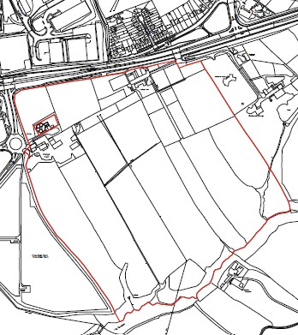

Stage 1 Criteria | Details
Strategic Scale – Is the site greater than 25Ha? | 38 ha of which the applicant considers that approximately 25 ha is the net developable area predominantly for Use Classes B2 and B8.  Yes
Strategic Location – Is the site within an Area of Opportunity? | Yes – Area adjacent to M1 Junction 28 and 27 (Sutton in Ashfield, Alfreton, Kirkby in Ashfield and towards Hucknall albeit not all roads dualled notably A611 and A608).  Nottinghamshire Core & Outer HMA Logistics Study Final Report 2022. Iceni. Paragraph 10.8.

Stage 1 Criteria | Details
Strategic Highway Connections – Does the site have good connections to the highway network close to a junction with the M1 or long distance dual carriageway? | The site is located off the A38 to the east of Junction 28 of the M1 Motorway. The submission identifies that the site is proposed to be accessed off the roundabout on Pinxton Lane. Significant highway improvements were undertaken as part of the development of Castlewood Business Park. This included the roundabout on Pinxton Lane and substantial junction improvement to the A38 and Pinxton Lane intersection.
Conclusion – Is the site a reasonable alternative that is carried forward to a Stage 2 Assessment? | The site is identified as a reasonable alternative for further consideration. This reflects the site’s size, its location within an area of opportunity as identified in the Logistics Study and its location off the A38 and close to Junction 28 of the M1 Motorway. The site will need to be considered against any environmental infrastructure and policy constraints within the  Stage 2 assessment.

ADC-L02: Land to the North East of Junction 27 M1 Motorway off A608 Mansfield Road, Annesley

Map – Illustrative Plan
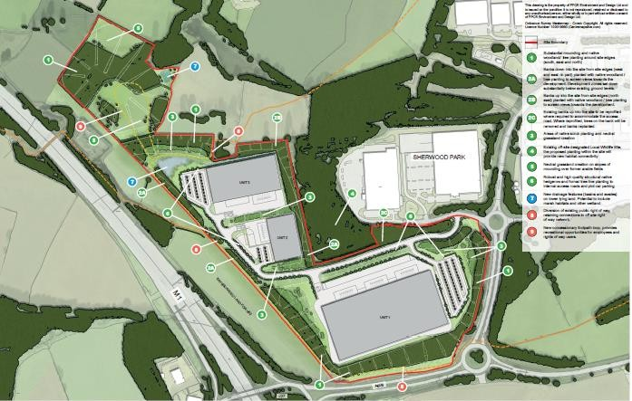

Stage 1 Criteria | Details
Strategic Scale – Is the site greater than 25Ha? | The site form part of a proposed employment land allocation in the Draft Local Plan Consultation Oct/Nov 2021. It is also subject to an outline planning application V/2022/0360 which identifies the site area as 26.32 ha. The application proposes a maximum of 65,000 sq m the majority of which would be logistics but with some potential element of B2 uses.  Yes
Strategic Location – Is the site within an Area of Opportunity? | Yes – Area adjacent to M1 Junction 28 and 27 (Sutton in Ashfield, Alfreton, Kirkby in Ashfield and towards Hucknall albeit not all roads dualled notably A611 and A608).  Nottinghamshire Core & Outer HMA Logistics Study Final Report 2022. Iceni. Paragraph 10.8.
Strategic Highway Connections – Does the site have good connections to the highway network close to a junction with the M1 or long distance dual carriageway? | The site is located off the A608 Mansfield Road, Annesley linking into Sherwood Business Park. It has good connections to the M1 Motorway being located to the north east of Junction 27.
Conclusion – Is the site a reasonable alternative that is carried forward to a  Stage 2 Assessment? | The site is identified as a reasonable alternative for further consideration. This reflects the site’s size, its location within an area of opportunity as identified in the Logistics Study and  its location off the A608 close to Junction 27 of the M1

Stage 1 Criteria | Details
Motorway. The site will need to be considered against any
environmental, historic, infrastructure and policy constraints within the Stage 2 assessment.

ADC-L03: Land to the South East of Junction 27 M1 Motorway off A608 Mansfield Road, Annesley
dk
Map
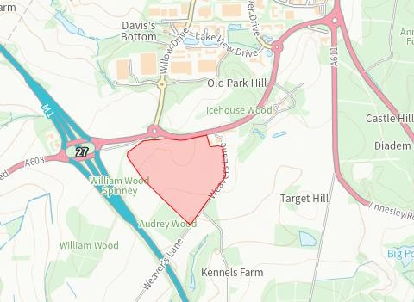

Stage 1 Criteria | Details
Strategic Scale – Is the site greater than 25Ha? | The completed Greater Nottingham Councils’ Call for potential Strategic Distribution Sites form identifies the site area as 23.75 ha. This is a smaller site that was submitted to Ashfield District Council SHELAA in 2019.  However, a planning application has been submitted on the site, V/2022/0246, which identifies the site area as 26.75 ha. It proposes development with a gross internal area of up to 91,716 sq. m. The use is identified as B2/B8.  Yes
Strategic Location – Is the site within an Area of Opportunity? | Yes – Area adjacent to M1 Junction 28 and 27 (Sutton in Ashfield, Alfreton, Kirkby in Ashfield and towards Hucknall albeit not all roads dualled notably A611 and A608).  Nottinghamshire Core & Outer HMA Logistics Study Final Report 2022. Iceni. Paragraph 10.8.
Strategic Highway Connections – Does the site have good connections to the highway network close to a junction with the M1 or long distance dual carriageway? | The Highway Authority in response to Ashfield’s SHELAA identified that the site is located off the A608 Mansfield Road, Annesley to the south east of Junction 27 of the M1 Motorway identified that the site has access constraints which could be overcome - accessed off a 4th arm off the existing Sherwood Business Park island on the A608. This will require the existing island being increased substantially in size with appropriate re-alignment of the dual carriageway/ provision of deceleration lanes etc. on the A608.

Stage 1 Criteria | Details
 | It is understood that additional work is being undertaken in relation to highways and the potential impact in relation to Junction 27 of the M1 Motorway as part of the current planning application.
Conclusion – Is the site a reasonable alternative that is carried forward to a Stage 2 Assessment? | The site is identified as a reasonable alternative for further consideration. This reflects the site’s size, its location within an area of opportunity as identified in the Logistics Study and its location off the A608 close to Junction 27 of the M1 Motorway. The site will need to be considered against any environmental, historic, infrastructure and policy constraints  within the Stage 2 assessment.

ADC-L04: Land to the South of Sherwood Business Park, off A608 Mansfield Road, Annesley

Map
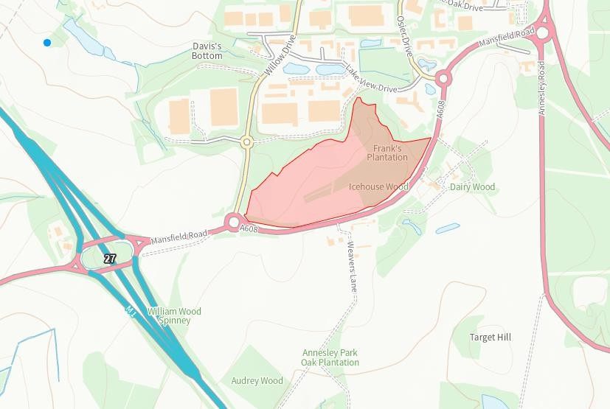

Stage 1 Criteria | Details
Strategic Scale – Is the site greater than 25Ha? | The site area is identified as 17.6 ha with a proposed development of up to 27,870 sq. m.  No
Strategic Location – Is the site within an Area of Opportunity? | Yes – Area adjacent to M1 Junction 28 and 27 (Sutton in Ashfield, Alfreton, Kirkby in Ashfield and towards Hucknall albeit not all roads dualled notably A611 and A608).  Nottinghamshire Core & Outer HMA Logistics Study Final  Report 2022. Iceni. Paragraph 10.8.
Strategic Highway Connections – Does the site have good connections to the highway network close to a junction with the M1 or long distance dual carriageway? | The site is located off the A608 Mansfield Road, Annesley to the north east of Junction 27 of the M1 Motorway and links to Sherwood Business Park.
Conclusion – Is the site a reasonable alternative that is carried forward to a  Stage 2 Assessment? | The site does not meet the criteria of being more than 25 ha and consequently is not carried forward to a  Stage 2 Assessment.

ADC-L05: Land to the East of Sherwood Business Park, off A611 Derby Road, Annesley

Map
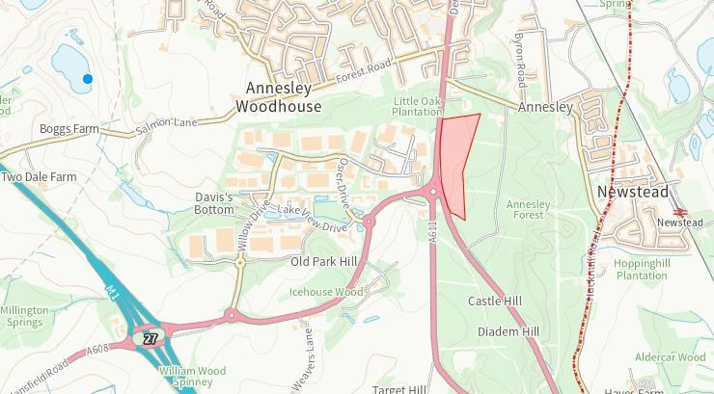

Stage 1 Criteria | Details
Strategic Scale – Is the site greater than 25Ha? | The site area is identified as 9.0 ha with the proposed development of up to 18,580 sq. m.  No
Strategic Location – Is the site within an Area of Opportunity? | Yes – Area adjacent to M1 Junction 28 and 27 (Sutton in Ashfield, Alfreton, Kirkby in Ashfield and towards Hucknall albeit not all roads dualled notably A611 and A608).  Nottinghamshire Core & Outer HMA Logistics Study Final Report 2022. Iceni. Paragraph 10.8.
Strategic Highway Connections – Does the site have good connections to the highway network close to a junction with the M1 or long distance dual carriageway? | The site is located off the A611, Derby Road, Annesley. The site is approximately 2.4 kilometres from Junction 27 of the M1 Motorway. Consequently it has good connections to the highway network and M1.
Conclusion – Is the site a reasonable alternative that is carried forward to a  Stage 2 Assessment? | The site does not meet the criteria of being more than 25 ha and consequently is not carried forward to a  Stage 2 Assessment.

Broxtowe

BBC-L01: Former Bennerley Coal Disposal Point

Map
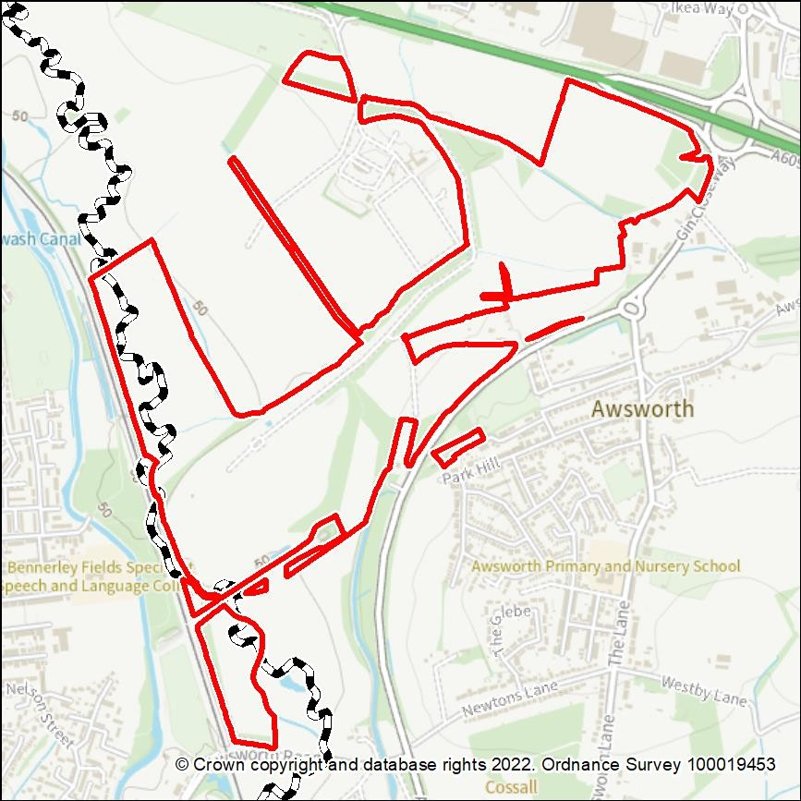

Stage 1 Criteria | Details
Strategic Scale – Is the site greater than 25Ha? | Yes.  The site covers 68 ha.
Strategic Location – Is it within an Area of Opportunity | Yes, the site is located within an Area of Opportunity at Junction 26 of the M1.
Strategic Highway Connections – Does the site have good connections to the highway network close to a junction with the M1 or long distance dual carriageway? | The owners/promoters advise:  “Existing access onto the A610, secondary access could also be provided onto an existing junction on the A6096. Directly connected to the rail network. The site is central to the strategic highway network which linking [sic] to Junction 26 of M1 for connections to the south and north, near the A50 to the west and A610 to the east. This would provide suitable road access to the site for HGV’s.”
Stage 1 Conclusion | The site is being identified as a reasonable alternative for further consideration because of its capacity, its proximity to  the A610/M1 and the possibility of rail access.

Stage 1 Criteria | Details

BBC-L02a: Gilt Hill (smaller site)

Map
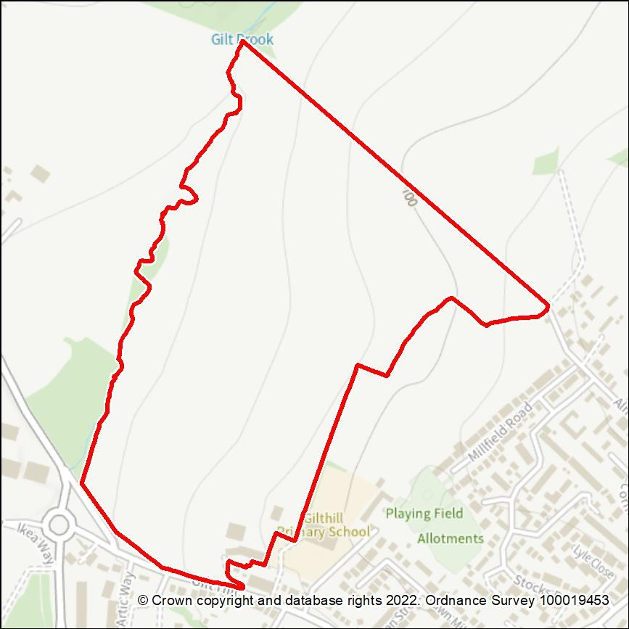

Stage 1 Criteria | Details
Strategic Scale – Is the site greater than 25Ha? | Yes.  The site covers 25.17 ha.
Strategic Location – Is it within an Area of Opportunity | Yes, the site is located within an Area of Opportunity at junction 26 of the M1.
Strategic Highway Connections – Does the site have good connections to the highway network close to a junction with the M1 or long distance dual carriageway? | The owners/promoters advise:  “The site has good access to the strategic highway network with access on to the A610 dual carriageway, which is 2 miles to Junction 26 of the M1 Motorway.”
Stage 1 Conclusion | The site is identified as a reasonable alternative for further consideration because of its capacity, location within an Area of Opportunity and its proximity to the A610/M1.

BBC-L02b: Gilt Hill (larger site)

Map
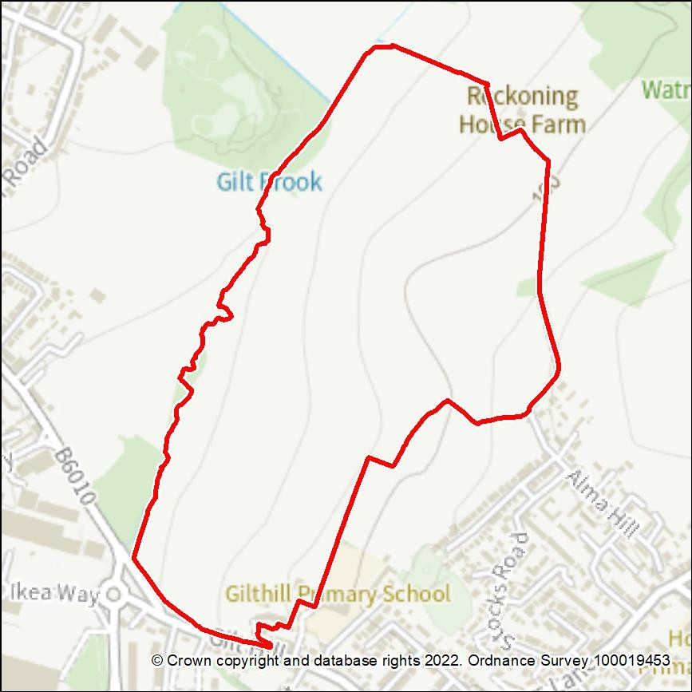

Stage 1 Criteria | Details
Strategic Scale – Is the site greater than 25Ha? | Yes.  The site is approximately 50 ha.
Strategic Location – Is it within an Area of Opportunity | Yes, the site is located within an Area of Opportunity at junction 26 of the M1.
Strategic Highway Connections – Does the site have good connections to the highway network close to a junction with the M1 or long distance dual carriageway? | The owners/promoters advise:  “The site has good access to the strategic highway network with access on to the A610 dual carriageway, which is 2 miles to Junction 26 of the M1 Motorway.”
Stage 1 Conclusion | The site is identified as a reasonable alternative for further consideration because of its capacity, location within an Area of Opportunity and its proximity to the A610/M1.

BBC-L03: ‘Gin Close Way’

Map
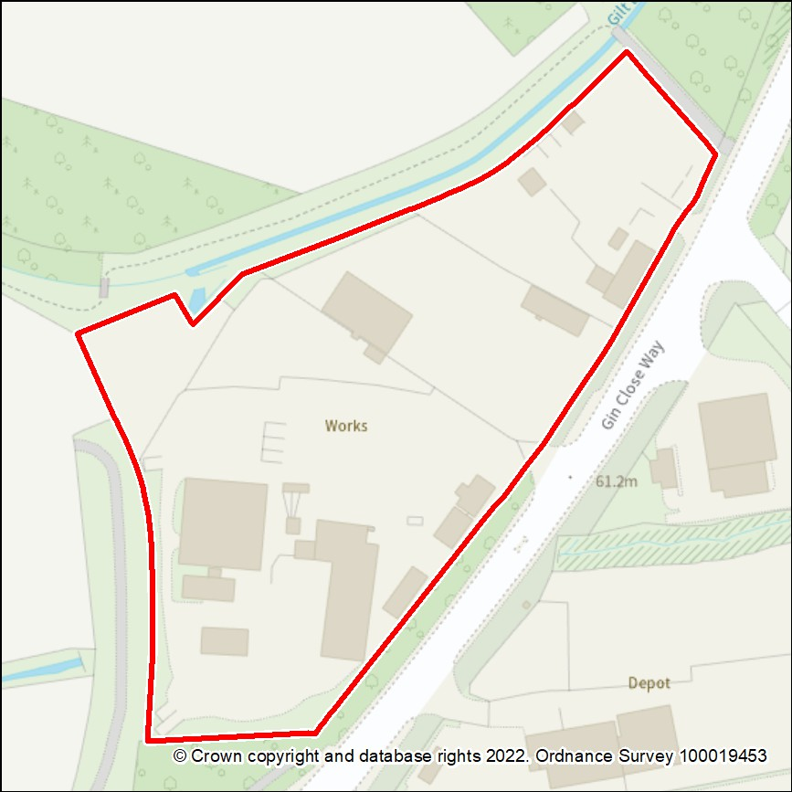

Stage 1 Criteria | Details
Strategic Scale – Is the site greater than 25Ha? | No.  The site is only 1.97ha  (However, it could be considered in conjunction with adjacent site BBC-L01.)
Strategic Location – Is it within an Area of Opportunity | Yes, the site is located within an Area of Opportunity at junction 26 of the M1.
Strategic Highway Connections – Does the site have good connections to the highway network close to a junction with the M1 or  long distance dual carriageway? | Yes, site is adjacent to A6096 and its junction with the A610. Junction 26 of the M1 is approximately 2 miles via the A610.
Stage 1 Conclusion | The site is not being identified as a reasonable alternative for further consideration in itself, because of its size. However, it could be considered in conjunction with the adjacent site BBC-L01, given its proximity to the A610/M1.

BBC-L04: Land at Kimberley Eastwood Bypass

Map
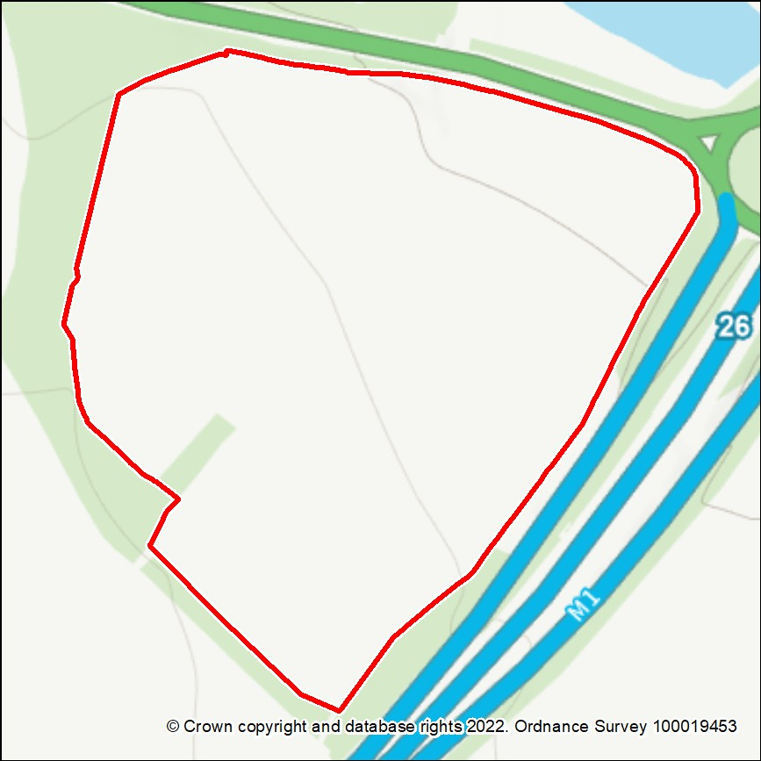

Stage 1 Criteria | Details
Strategic Scale – Is the site greater than 25Ha? | No.  The site is 21.64 ha.
Strategic Location – Is it within an Area of Opportunity | Yes, the site is within the Area of Opportunity around junction 26 of the M1.
Strategic Highway Connections – Does the site have good connections to the highway network close to a junction with the M1 or long distance dual carriageway? | The owners/promoters advise that “the site benefits from exceptional connections with the strategic highway network. It sits immediately adjacent to J26 of the  M1 and the A610.”
Stage 1 Conclusion | The site is being identified as a reasonable alternative for further consideration because of its size, location within an Area of Opportunity and connectivity to the A610 and M1.

BBC-L05: Land at Low Wood Road, Nuthall

Map
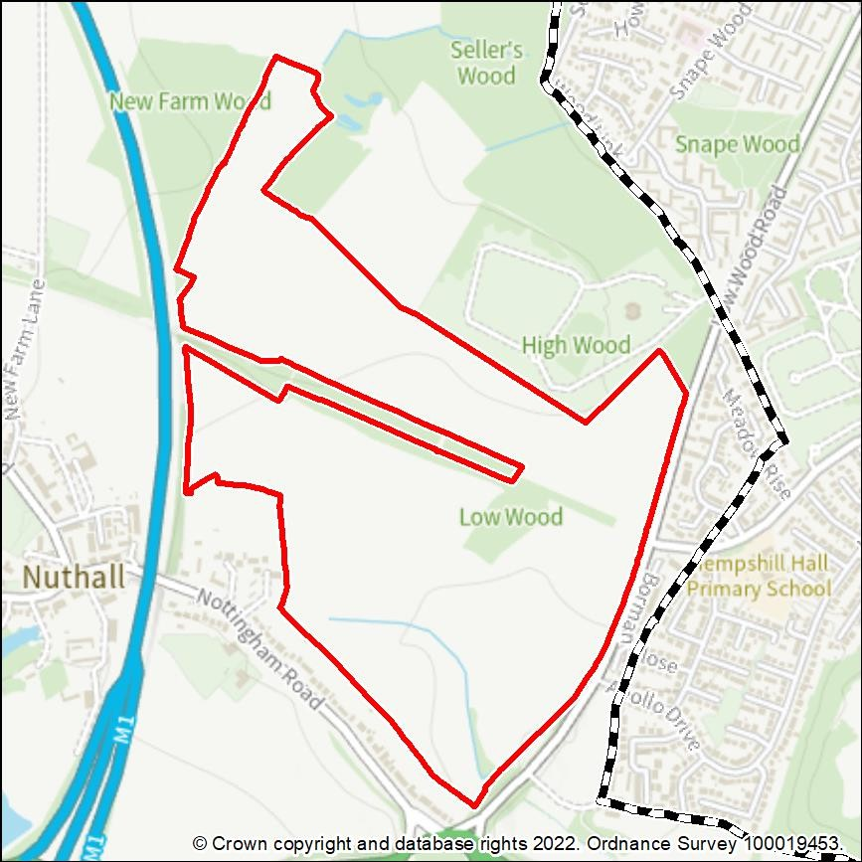

Stage 1 Criteria | Details
Strategic Scale – Is the site greater than 25Ha? | Yes.  The site covers 57.22 ha.
Strategic Location – Is it within an Area of Opportunity | Yes, the site is located close to Junction 26 which is an Area of Opportunity.
Strategic Highway Connections – Does the site have good connections to the highway network close to a junction with the M1 or long distance dual carriageway? | The owners/promoters advise:  “The site immediately adjoins the A610 off the two proposed access roads which connects the site to the M1 at Junction  26. Junction modelling undertaken by our Transport Consultant indicates that there is sufficient capacity within the existing junctions within the vicinity of the site.”
Stage 1 Conclusion | The site is being identified as a reasonable alternative for further consideration because of its capacity, location within an Area of Opportunity and its connectivity to the  A610 and M1.

BBC-L06: Land at New Farm, Nuthall

Map
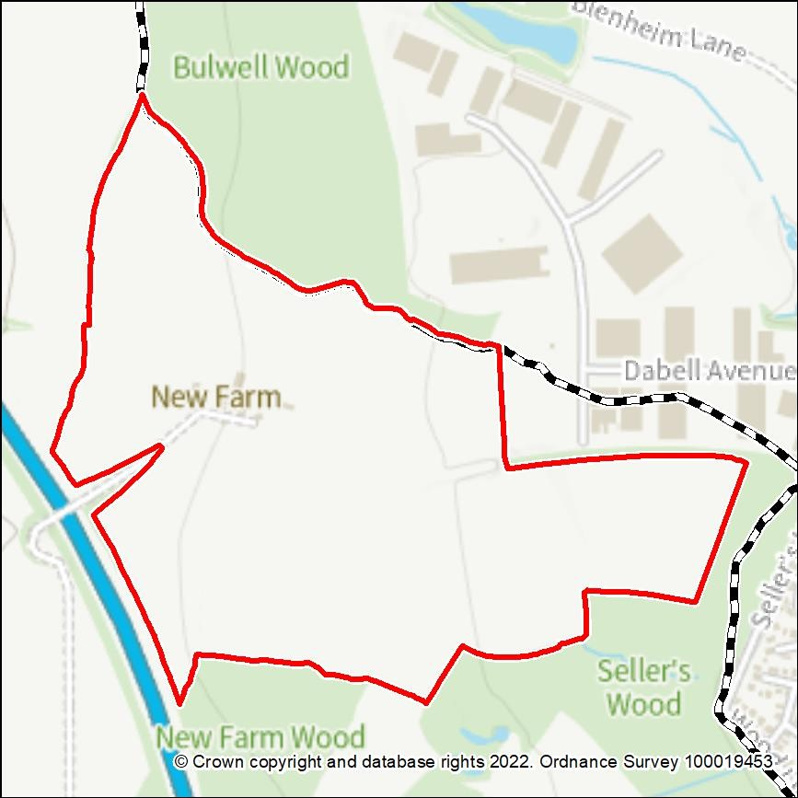

Stage 1 Assessment | Details
Strategic Scale – Is the site greater than 25Ha? | Yes.  The site is 40.90 ha.
Strategic Location – Is it within an Area of Opportunity | Yes, the site is located within an Area of Opportunity around Junction 26 of the M1.
Strategic Highway Connections – Does the site have good connections to the highway network close to a junction with the M1 or long distance dual carriageway? | The owners/promoters advise:  “Access to Blenheim Industrial Park, connecting to Low Wood Road (A6002) which connects to the A610 and M1 motorway. Approximately 3.7km (6 minute drive) from the M1 J26 via good quality roads.”
Stage 1 Conclusion | The site is identified as a reasonable alternative for further consideration because of its capacity, its location within an Area of Opportunity and its proximity to the M1 and A610.

BBC-L07: Land at Shilo Way

Map
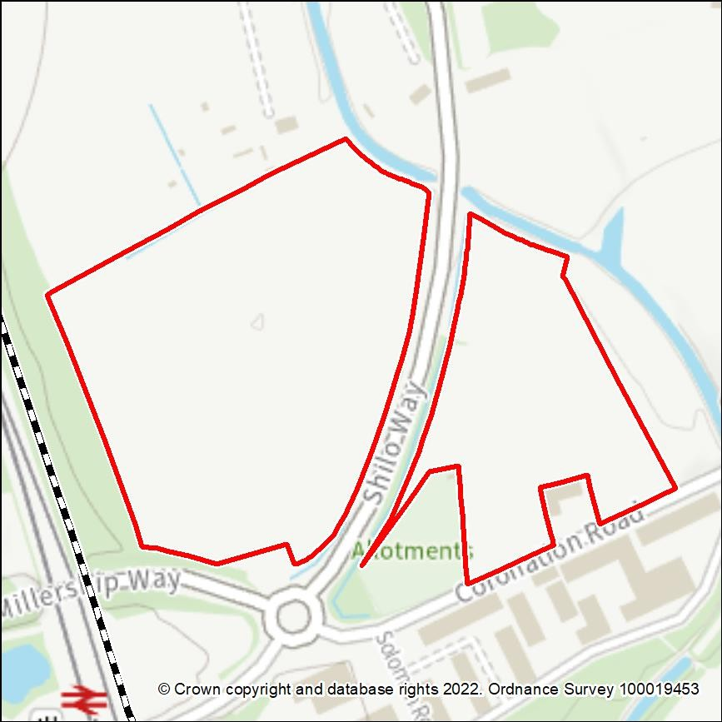

Stage 1 Criteria | Details
Strategic Scale – Is the site greater than 25Ha? | 10.07ha  (The owners/promoters' figure is 11 ha.) The site is divided by a road.  No.
Strategic Location – Is it within an Area of Opportunity | Yes, the siite is within an Area of Opportunity around junction 26 of the M1.
Strategic Highway Connections – Does the site have good connections to the highway network close to a junction with the M1 or long distance dual carriageway? | Yes, site is adjacent to A6096. Junction 26 of the M1 is approximately 3.5 miles via the A6096 and A610.
Stage 1 Conclusion | The site is not being identified as a reasonable alternative for further consideration because its limited size appears to make it unsuitable for large-scale  logistics development.

BBC-L08: Land to south-east of junction 26 of M1, Nuthall

Map
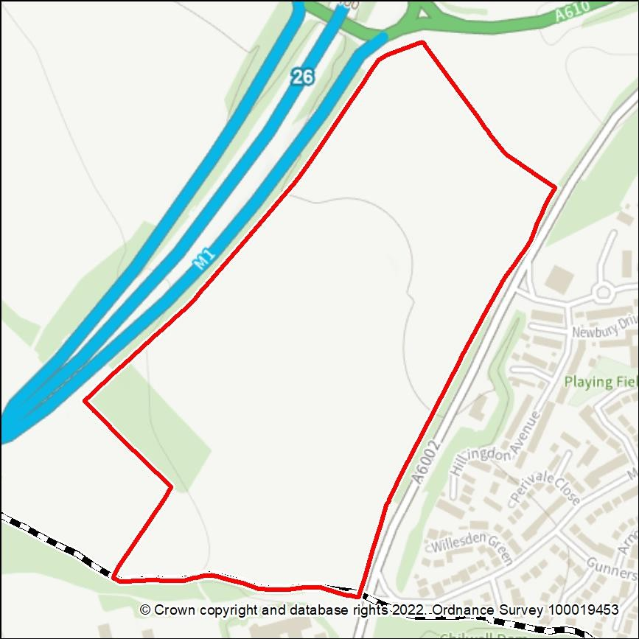

Stage 1 Criteria | Details
Strategic Scale – Is the site greater than 25Ha? | Yes.  The site is 25.01 ha.
Strategic Location – Is it within an Area of Opportunity | Yes, the site is within an Area of Opportunity around junction 26 of the M1.
Strategic Highway Connections – Does the site have good connections to the highway network close to a junction with the M1 or long distance dual  carriageway? | The owners/promoters advise that: “Access would be via the A6002, which connects to junction 26 of the M1”.
Stage 1 Conclusion | The site is identified as a reasonable alternative for further consideration because of its capacity, its location within an Area of Opportunity and its proximity to the M1 and A610.

BBC-L09: Land at Waterloo Lane, Trowell

Map
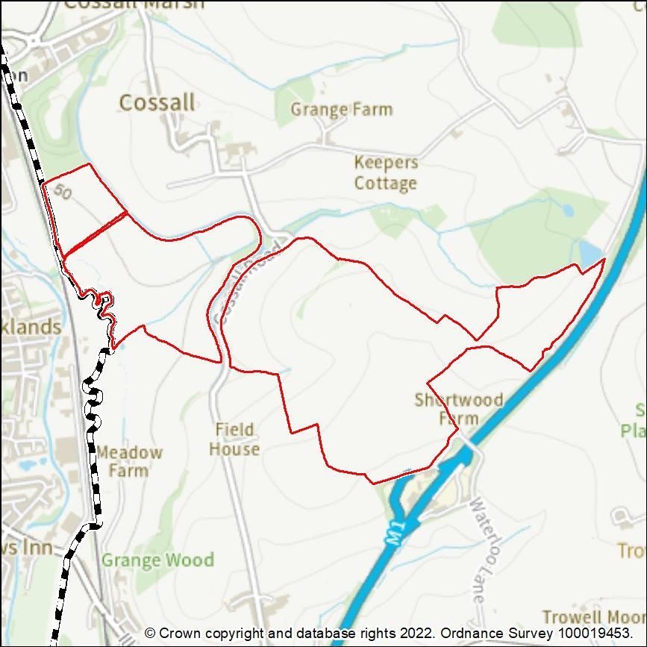

Stage 1 Criteria | Details
Strategic Scale – Is the site greater than 25Ha? | Yes.  The site is 118.06 ha. (The owners/promoters’ figure is 120 ha.)
Strategic Location – Is it within an Area of Opportunity | Partially, although adjacent to the M1, it is not located close to either Junction 25 or 26.
Strategic Highway Connections – Does the site have good connections to the highway network close to a junction with the M1 or long distance dual carriageway? | The owners/promoters advise that connectivity to the M1 would be achieved “via Trowell service junction of M1 and A609/A610 to J26 M1”.  Access directly onto the M1 via Trowell Services is likley to raise complicated negotiations with Highways England, detailed modelling of impacts upon the M1 (congestion and safety), and likely motorway access improvements.  Alternative access via Junction 26 would appear to involve use of the A6002 (east of the M1), between the A609 and A610.
Stage 1 Conclusion | The site is not being identified as a reasonable alternative for further consideration because it is peripheral to, and partly

Stage 1 Criteria | Details
 | outside, the ‘Area of Opportunity’, and because it appears to have no appropriate means of access.

Erewash

EBC-L01: Stanton North

Map
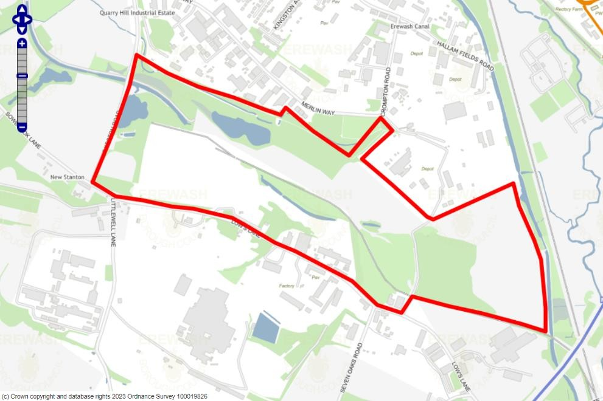

Stage 1 Criteria | Details
Strategic Scale – Is the site greater than 25Ha? | Yes, the site is a strategic employment allocation in the draft Erewash Core Strategy Review. It is approximately 80 hectares in size.  An outline planning permission for a maximum of 261,241sqm of mixed employment floorspace was granted in 2022 as part of ERE/1221/0002. The logistics/B8 component will be determined through a reserved matters application.
Strategic Location – Is the site within an Area of Opportunity? | No – the site is located north of Area of Opportunity 3 (Para 10.8 of the Report) identified around J25 of the M1 which also stretches east and west along the A52 corridor.
Strategic Highway Connections – Does the site have good connections to the highway network close to a junction with the M1 or long distance dual carriageway? | Whilst the site is in very close proximity to the M1 motorway, vehicular access is more indirect, with road connections to the strategic highway network needing to be taken through Sandiacre to access J25.

Stage 1 Criteria | Details
Conclusion – Is the site a reasonable alternative that is carried forward to a Stage 2 Assessment? | The site is identified as a reasonable alternative for further consideration because of its size, its location on the edge of an area of opportunity (as identified in the Logistics Study), its location adjacent to the M1 and the planning status of the site now it benefits from an outline consent for mixed employment uses.

EBC-L02: Land to the Southwest of Junction 25 M1 Motorway & A52 Brian Clough Way, Breaston

Map
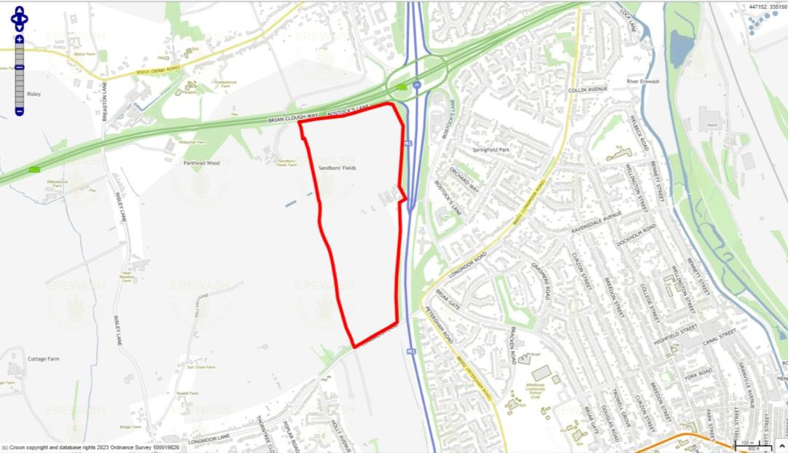

Stage 1 Criteria | Details
Strategic Scale – Is the site greater than 25Ha? | Yes – the site measures 31ha in size and therefore is considered to be strategic. The site was subject of a representation promoting it to the Borough Council as part of the Erewash Core Strategy Review.
Strategic Location – Is the site within an Area of Opportunity? | Yes – the site is located within Area of Opportunity 3 (Para 10.8 of the Report) identified around J25 of the M1, an area which also stretches east and west along the A52 corridor.
Strategic Highway Connections – Does the site have good connections to the highway network close to a junction with the M1 or long distance dual carriageway? | The site adjoins the M1/A52 intersection at Junction 25. Roughly half of the site’s boundary is shared with the M1 and the A52, both highways which form part of the strategic road network. Possibility of forming access from the site directly off the raised level intersection, although long-term congestion issues at this junction.
Conclusion – Is the site a reasonable alternative that is carried forward to a Stage 2 Assessment? | The site is identified as a potential reasonable alternative for further consideration. This reflects the site’s size, its location within an area of opportunity as identified in the Iceni Study and its location adjacent to J25 of the M1 Motorway. The site will need to be considered against any environmental,

Stage 1 Criteria | Details
 | historic, infrastructure and policy constraints within the Stage 2 assessment.

Gedling

GBC-L01: West of Kighill Farm

Map
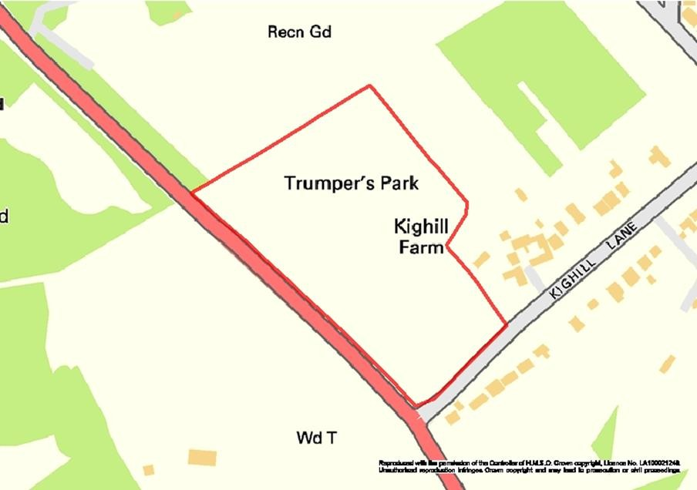

Stage 1 Criteria | Details
Strategic Scale – Is the site greater than 25Ha? | 5.45 ha  No
Strategic Location – Is the site within an Area of  Opportunity? | No
Strategic Highway Connections – Does the site have good connections to the highway network close to a junction with the M1 or long distance dual carriageway? | The Highway Authority will seek to resist any new access points off the A60 Mansfield Road in this vicinity which forms part of the core road network, as it could have an effect on traffic flows to the detriment of highway safety. The rural location of the site will likely encourage heavy car use and is not sustainable.  Approximately 9 miles to M1 junction 27. Does not have direct access to A60 which is not dualled. The site does not meet the criteria for road access.
Conclusion – Is the site a reasonable alternative that is carried forward to a  Stage 2 Assessment? | The site is not identified as a reasonable alternative for further consideration because it is too small and does not meet the criteria for road access.

GBC-L02: Land at Stockings Farm, Redhill

Map
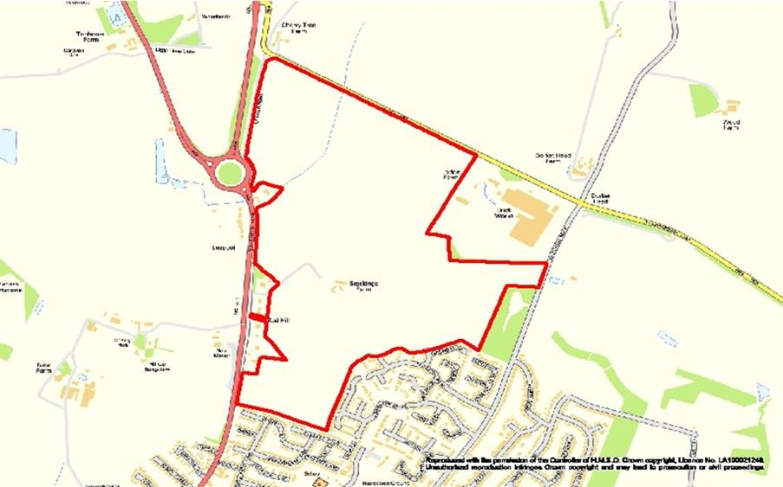

Stage 1 Criteria | Details
Strategic Scale –  Is the site greater than 25Ha? | 10 ha promoted for employment uses by landowner as part of a mixed use site (SHLAA site G462). Site G462 net developable area is approximately 20 ha.  No
Strategic Location – Is the site within an Area of Opportunity? | Not located within an Area of Opportunity for strategic distribution sites.
Strategic Highway Connections – Does the site have good connections to the highway network close to a junction with the M1 or long distance dual carriageway? | The development traffic would rely on using a very congested section of the A60 Mansfield Road between Leapool Island and Oxclose Lane. Due to land constraints, it is difficult to see where appropriate traffic mitigation can be introduced. Whilst it would be possible to heavily promote public transport services to encourage more sustainable travel, these services would ultimately be reliant on the same congested highway network unless adequately catered for by the introduction of bus priority measures. How this would be achieved is very unclear.  Access onto Leapool Island A60 and A614. The A60 and A614 are not dualled. The A60 towards Nottingham is heavily congested. The site is remote from M1 junctions. Junction 26 is approximately 10km.  The site is within 30 minutes travel time by public transport, walking and cycling to Arnold shopping centre and therefore accessible to the labour market.

Stage 1 Criteria | Details
Conclusion – Is the site a reasonable alternative that is carried forward to a Stage 2 Assessment? | The land is not considered a reasonable alternative for strategic distribution on the basis that the site is insufficiently large enough and not within an Area of Opportunity for distribution uses. The location does not meet the criteria for having good road access with congestion on the A60 and its  associated AQMA being a particular issue.

Nottingham

NCC-L01: Stanton Tip / Stanton Park

Map
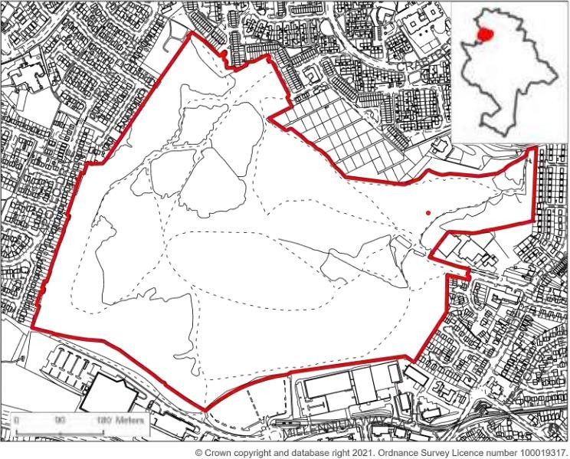

Stage 1 Criteria | Details
Strategic Scale – Is the site greater than 25Ha? | No, 42.65 hectares, but only 25 ha net developable area. As the existing Local Plan allocation is for mixed use, the full 25 ha is not available for logistics use.
Strategic Location – Is  the site within an Area of Opportunity? | Yes – the site is on the edge of 1 of 5 ‘Areas of Opportunity’- area adjacent to M1 Junction 26 (Langley Mill, Eastwood and Kimberley)’ identified by Logistics Study.
Strategic Highway Connections – Does the site have good connections to the highway network close to a junction with the M1 or long distance dual carriageway? | Close to the A610 and junction 26 of the M1
Conclusion – Is the site a reasonable alternative that is carried forward to a Stage 2 Assessment? | The site is not a reasonable alternative for further consideration within Stage 2 because of the land available for strategic logistics is less than 25ha.  Although an element of logistics use may be appropriate as part of a mix of uses, the site is not considered suitable for a  strategic scale logistics development.

Rushcliffe
RBC-L01: Ratcliffe-On-Soar Power Station

Map
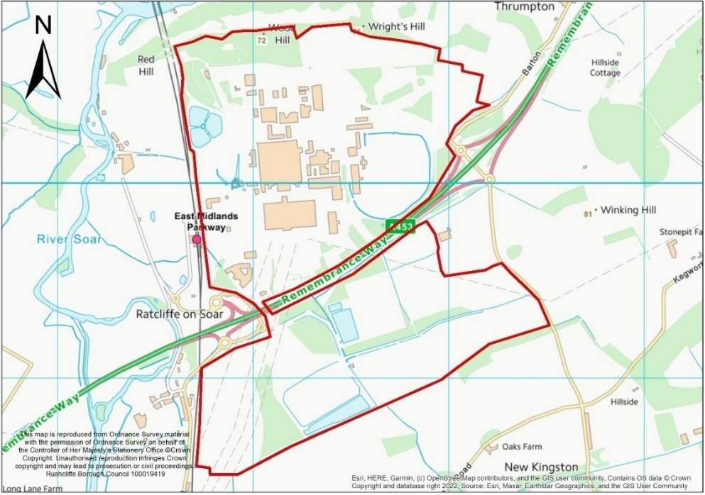

Stage 1 Criteria | Details
Strategic Scale – Is the site greater than 25Ha? | 265 ha (gross), of which approximately 36.4 Ha of the site is proposed for logistics  Yes
Strategic Location – Is the  site within an Area of Opportunity? | Yes, the site is within an Area of Opportunity adjacent to A453.
Strategic Highway Connections – Does the site have good connections to the highway network close to a junction with the M1 or long distance dual carriageway? | Access can be achieved onto the A453 (and M1) via existing junctions on the A453. Given the scale of employment development improvements are likely to be required to junctions on the strategic and non-strategic road network.
Conclusion – Is the site a reasonable alternative that is carried forward to a Stage 2 Assessment? | The site is identified as a reasonable alternative for further consideration because of the site’s location adjacent to the strategic network (A453 (M1)) and access to it. The A453 is an Area of Opportunity for strategic distribution. It also has existing utilities infrastructure. Part of the site is promoted by the landowner as a location for strategic distribution and up to 180,000 sqm of logistics development is identified within the draft LDO. Redevelopment offers opportunities  to improve the local environment and wider area.

RBC-L02: Nottingham ‘Gateway’

Map
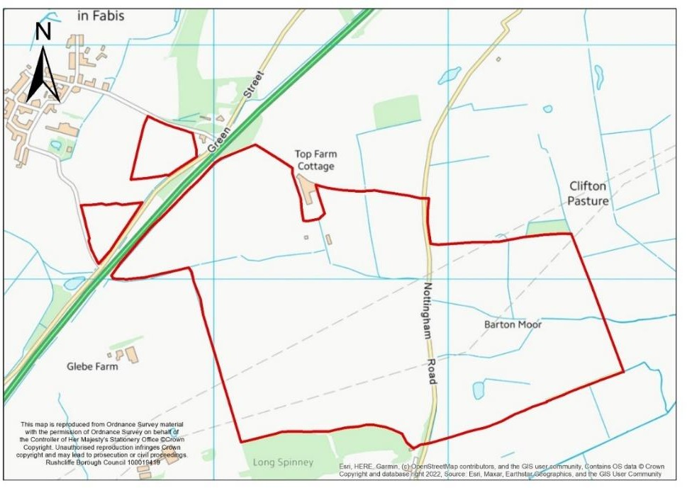

Stage 1 Criteria | Details
Strategic Scale – Is the site greater than 25Ha? | 168 ha. An alternative smaller area of approximately 115Ha is also being promoted which excludes the land to the east of Nottingham Road in its entirety  Yes
Strategic Location – Is the site within an Area of  Opportunity? | Yes – within the A453 Area of Opportunity.
Strategic Highway Connections – Does the site have good connections to the highway network close to a junction with the M1 or long distance dual carriageway? | Adjacent to the A453 and the northern edge of the site is around 4.5 miles away from Junction 24 of the M1 if direct access could be achieved onto the A453. Access would require a new junction or access to an existing junction. The landowner has proposed a junction arrangement which is considered further in the part 2 assessment, together with National Highways view on whether direct connection to the A453 would be acceptable in principle
Conclusion – Is the site a reasonable alternative that is carried forward to a Stage 2 Assessment? | The site is identified as a reasonable alternative for further consideration because of the site’s size, its location within an area of opportunity (as identified in the Logistics Study) and location adjacent to the A453. Alongside environmental and policy constraints, consideration within the Stage 2 assessment must determine whether access onto the A453  is viable and deliverable.

RBC-L03: South of Owthorpe Lane

Map
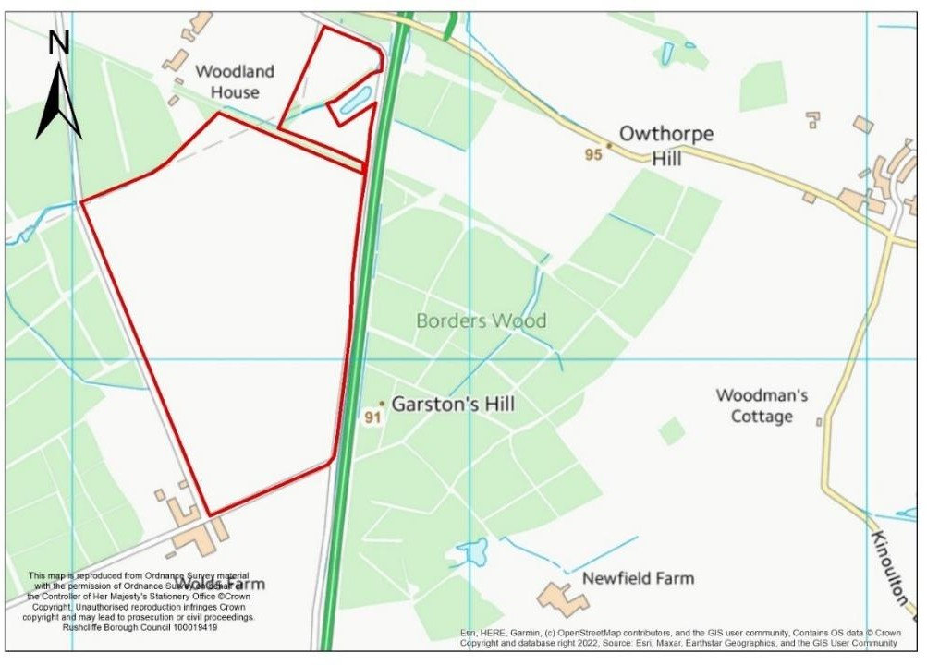

Stage 1 Criteria | Details
Strategic Scale – Is the site greater than 25Ha? | 50 ha  Yes
Strategic Location – Is the site within an Area of  Opportunity? | No – Although on the A46, it is beyond the Area of Opportunity identified along the A46 at Newark.
Strategic Highway Connections – Does the site have good connections to the highway network close to a junction with the M1 or long distance dual carriageway? | Site is adjacent to A46 and access to this strategic highway may be achieved via the Owthorpe Road Junction, subject to advice from Highways England.  The site’s location is not considered optimal for strategic distribution. As identified in the Logistics Study, access to the M1 and A1 is a priority. However, the M1 is 22 miles south on the A46 at Leicester, less if lorries travel through Cotgrave and use the A606, A52 and A453 (joining at Kegworth).  The A1 can be joined 20 miles north at Newark, directly along the A46, or 20 miles east at Grantham via the A52.  These alternative routes east and west require the use by lorries of single carriageway roads to access the A1 and M1.
Conclusion – Is the site a reasonable alternative that is carried forward to a  Stage 2 Assessment? | Although located adjacent to the A46, the site is beyond the Areas of Opportunity identified in the Nottinghamshire Core & Outer HMA Logistics Study. It is also around 22 miles from  the M1 and around 20 miles from the A1.

Stage 1 Criteria | Details
 | Therefore, the site is not identified as a reasonable alternative for further consideration.

RBC-L04: Land north of Owthorpe Lane

Map
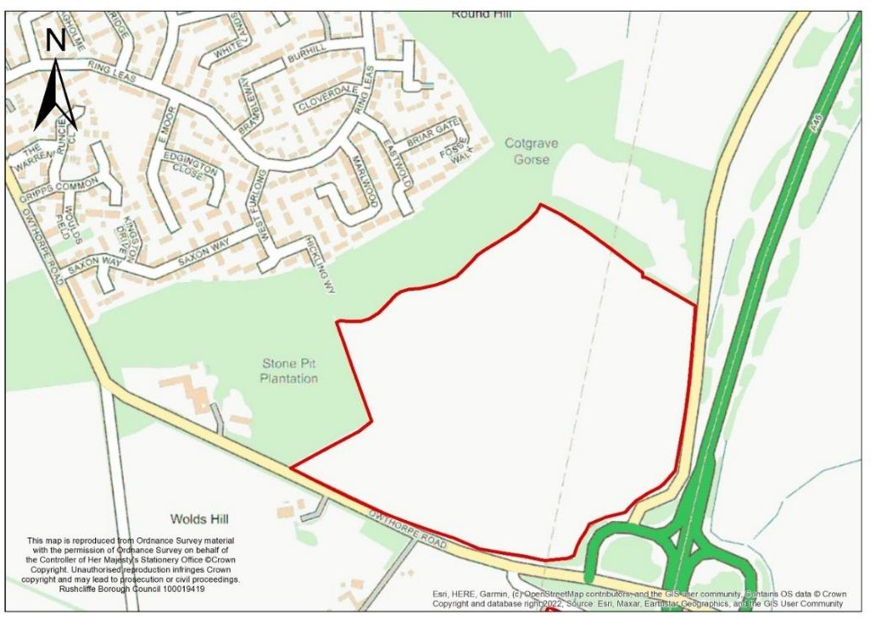

Stage 1 Criteria | Details
Strategic Scale – Is the site greater than 25Ha? | 32.6 ha (23 ha (excluding woodland))  Yes
Strategic Location – Is the site within an Area of Opportunity? | No
Strategic Highway Connections – Does the site have good connections to the highway network close to a junction with the M1 or long distance dual carriageway? | Site is adjacent to A46 and access to this strategic highway may be achieved via the Owthorpe Road Junction, subject to advice from Highways England. At present, the A46 is single carriageway around Newark. Not located close to the M1. Access to the M1 north and the A1 would utilise largely single carriageway routes.
Conclusion – Is the site a reasonable alternative that is carried forward to a Stage 2 Assessment? | Although located adjacent to the A46, the site is beyond the Areas of Opportunity identified in the Nottinghamshire Core & Outer HMA Logistics Study. It is also around 22 miles from the M1 and around 20 miles from the A1.  Therefore, the site is not identified as a reasonable alternative for further consideration.

RBC-L05: Stragglethorpe Junction

Map
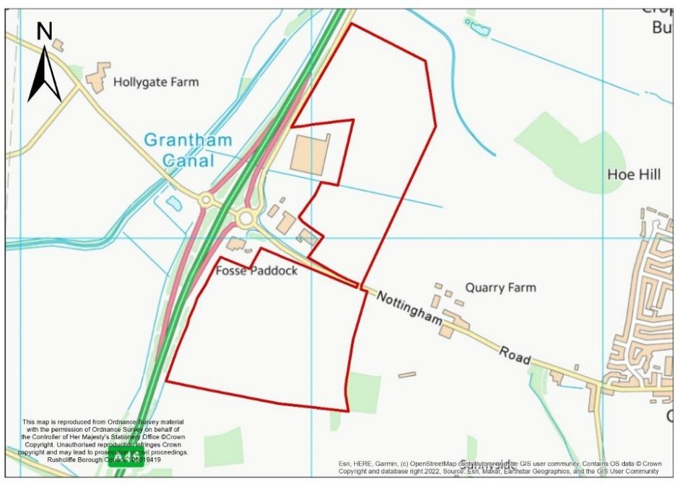

Stage 1 Criteria | Details
Strategic Scale – Is the site greater than 25Ha? | 51 ha  Yes
Strategic Location – Is  the site within an Area of Opportunity? | No – Although on the A46, it is beyond the Area of Opportunity identified along the A46 at Newark.
Strategic Highway Connections – Does the site have good connections to the highway network close to a junction with the M1 or long distance dual carriageway? | Site is adjacent to A46 and access to this strategic highway may be achieved via the Stragglethorpe Junction, subject to advice from Highways England. Not close to the M1. Close to the A46 however the route is not  fully dualled and connections to the M1 northbound and A1 would be via the largely single carriageway A52.
Conclusion – Is the site a reasonable alternative that is carried forward to a Stage 2 Assessment? | Although located adjacent to the A46, the site is beyond the Areas of Opportunity identified in the Nottinghamshire Core & Outer HMA Logistics Study. Therefore, the site is not identified as a reasonable alternative for further consideration.  The site’s location is not considered optimal for strategic distribution. As identified in the Logistics Study access to the M1 and A1 is a priority. However, the M1 is 24 miles south on the A46 at Leicester, less if lorries travel west, using the  A52 and A453 (joining at Kegworth).

RBC-L06: Margidunum

Map
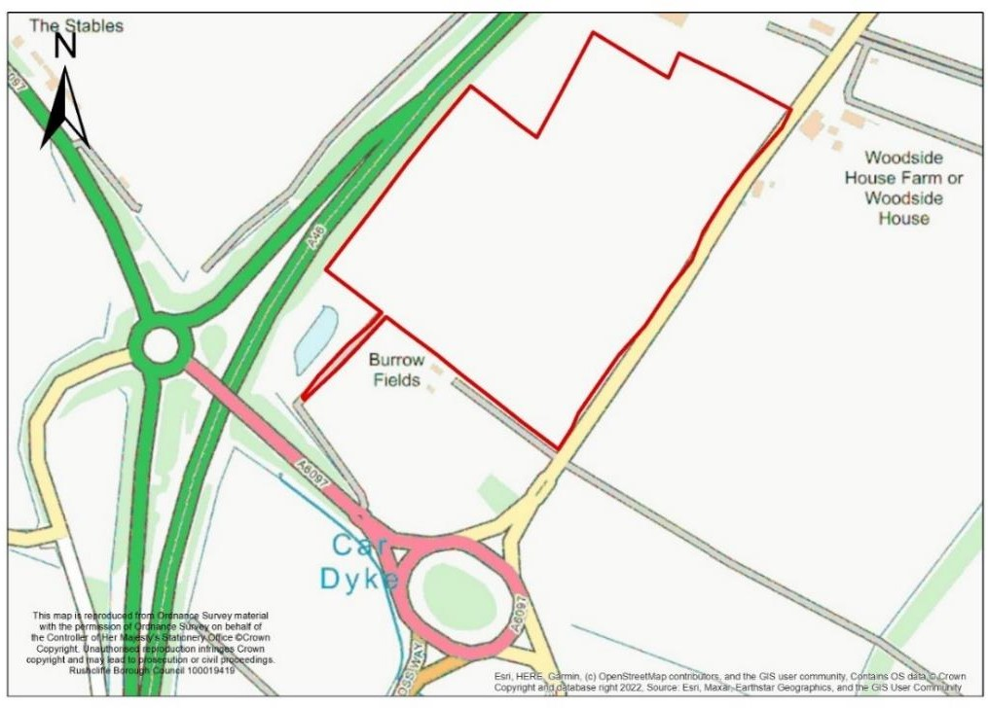

Stage 1 Criteria | Details
Strategic Scale – Is the site greater than 25Ha? | 13.9 ha (taken from site submission)  No
Strategic Location – Is  the site within an Area of Opportunity? | No – Although the site adjacent to the A46, it is beyond the Area of Opportunity identified along the A46 at Newark.
Strategic Highway Connections – Does the site have good connections to the highway network close to a junction with the M1 or long distance dual carriageway? | Site is adjacent to A46 and access to this strategic highway may be achieved via the Foss Way and Bridgford Street Junction, subject to advice from Highways England.  The M1 is 29 miles south on the A46 at Leicester. The A1 is 12 miles north on the A46 at Newark. It is not located close to the M1.
Conclusion – Is the site a reasonable alternative that is carried forward to a Stage 2 Assessment? | The site is not identified as a reasonable alternative for further consideration. It is below 25 ha and not within an Area of Opportunity as identified in the Logistics Study. Although the site is adjacent to A46, the M1 is 29 miles south on the  A46 at Leicester. The A1 is 12 miles north on the A46 at Newark.

RBC-L07: Jerico Farm

Map
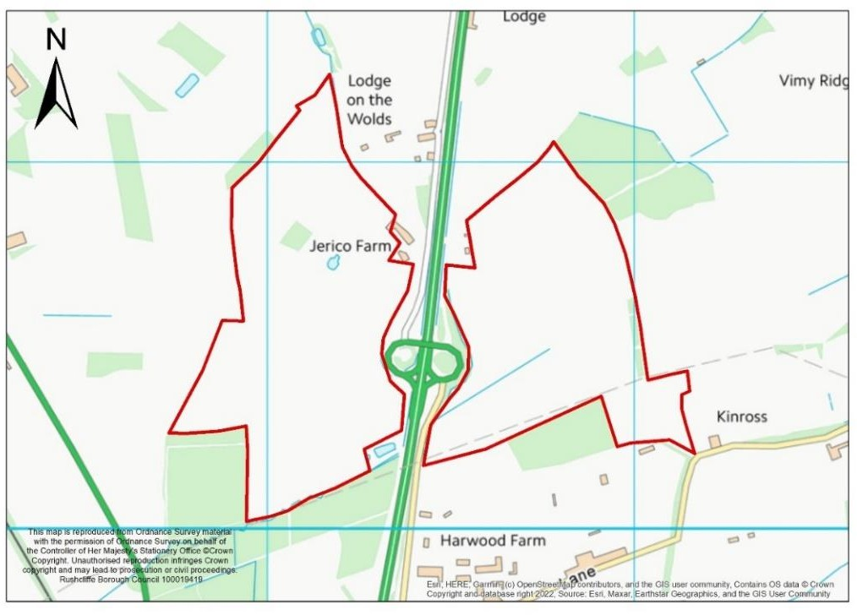

Stage 1 Criteria | Details
Strategic Scale – Is the site greater than 25Ha? | 75 ha  Yes
Strategic Location – Is the site within an Area of Opportunity? | No - Although on the A46, it is beyond the Area of Opportunity identified along the A46 at Newark.
Strategic Highway Connections – Does the site have good connections to the highway network close to a junction with the M1 or long distance dual carriageway? | There is access to the site via the A46 as well as also being located near the A606 (Melton Road). The A606 is a single carriageway, however. The M1 can be accessed south on the A46 (19 miles). The A1 accessed north on the A46 (19 miles). These junctions are a considerable distance. The A46 is currently single carriageway around Newark. To head north on the M1, avoiding this journey south on the A46, requires the use of the A606, A52 and A453 (17 miles). To head south on the A1 requires the use of the A52, a single carriage way (19 miles).
Conclusion – Is the site a reasonable alternative that is carried forward to a Stage 2 Assessment? | The site is not identified as a reasonable alternative for further consideration. It is not within an Area of Opportunity as identified in the Logistics Study. Although the site is adjacent to A46, the M1 is 19 miles south on the A46 at  Leicester. The A1 is 19 miles north on the A46 at Newark.

RBC-L08: Butt Lane (Fosse Way) East Bridgford

Map
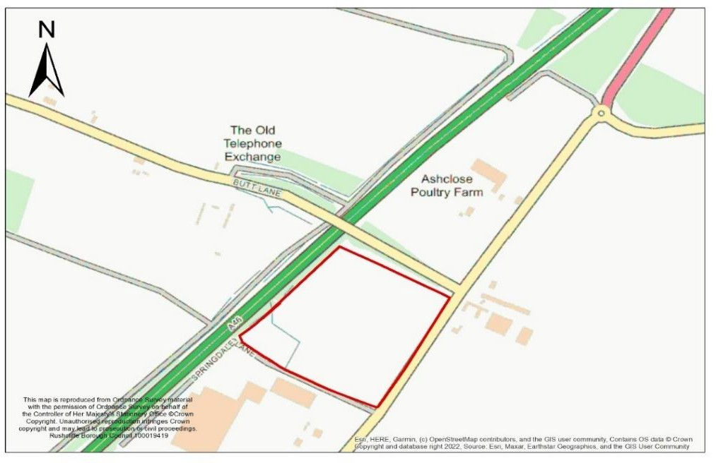

Stage 1 Criteria | Details
Strategic Scale – Is the site greater than 25Ha? | 5.53ha  No
Strategic Location – Is the site within an Area of  Opportunity? | No - Although on the A46, it is beyond the Area of Opportunity identified along the A46 at Newark.
Strategic Highway Connections – Does the site have good connections to the highway network close to a junction with the M1 or long distance dual carriageway? | Site is adjacent to A46 and access to this strategic highway could be achieved via the Foss Way and Bridgford Street Junction, subject to advice from Highways England.  The M1 is 29 miles south on the A46 at Leicester. The A1 is 12 miles north on the A46 at Newark. At present, the A46 is single carriageway around Newark.  Suitable access can be provided from Fosse Way, for both vehicles (including HGVs) and pedestrians.
Conclusion – Is the site a reasonable alternative that is carried forward to a Stage 2 Assessment? | The site is not identified as a reasonable alternative for further consideration. The site is too small to deliver strategic distribution development. Whilst there may be opportunities to deliver a larger allocation if combined with RBC-L1-L06, land between them is in separate ownership and is currently occupied by commercial operations.  The site is not located within an Area of Opportunity within the Logistics Study.

RBC-L09: Land South of A52, Whatton

Map
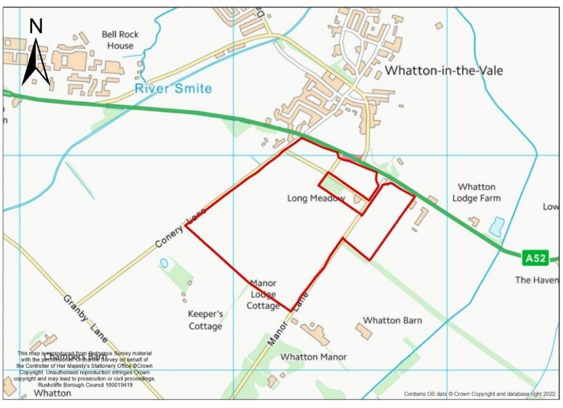

Stage 1 Criteria | Details
Strategic Scale – Is the site greater than 25Ha? | 40 ha  Yes
Strategic Location – Is the site within an Area of Opportunity? | Access to the site from the A52 can be gained from Melton Road (A606). From the junction with the A52, the M1 can be accessed via the A52 and A453. The M1 is 14 miles via this route. The A1 would be accessed via the A52 east and the A46 (21 miles). The route is not dualled between Radcliffe on Trent and the A46.
Strategic Highway Connections – Does the site have good connections to the highway network close to a junction with the M1 or long distance dual carriageway? | The site would be accessed from the A52, which provides access to the M1, A46 and A1. This however is not a dual carriageway and the junctions to the M1 and A1 strategic routes are a considerable distance away.
Conclusion – Is the site a reasonable alternative that is carried forward to a Stage 2 Assessment? | The site is not identified as a reasonable alternative for further consideration. It is not within an Area of Opportunity as identified in the Logistics Study and the A52 is not dualled between the site and the A1, 9 miles to the east. The M1 to the west is a considerable distance via the A52 (also not  dualled until after Radcliffe on Trent) and A453 (22 miles). If heading south, the M1 is 30 miles along the A46.

RBC-L10: Melton Road, Edwalton

Map
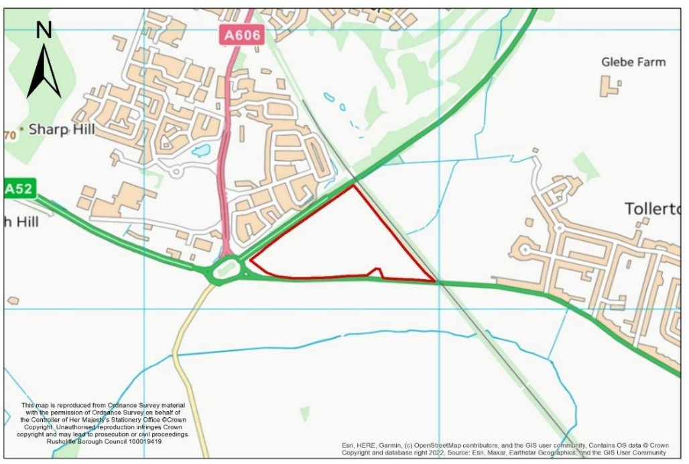

Stage 1 Criteria | Details
Strategic Scale – Is the site greater than 25Ha? | 11 ha.  No
Strategic Location – Is  the site within an Area of Opportunity? | No
Strategic Highway Connections – Does the site have good connections to the highway network close to a junction with the M1 or long distance dual carriageway? | Access to the site from the A52 can be gained from Melton Road (A606). From the junction with the A52, the M1 can be accessed via the A52 and A453. The M1 is 14 miles via this route. The A1 would be accessed via the A52 east and the A46 (21 miles). The route is not dualled between Radcliffe on Trent and the A46.
Conclusion – Is the site a reasonable alternative that is carried forward to a Stage 2 Assessment? | The site is not identified as a reasonable alternative for further consideration. The site is not large enough to deliver strategic scale distribution. Access to the M1 and A1 requires the use of strategic routes which are not dualled and  experiencing significant congestion. Notably the A52.

Appendix 3: Steps 3 – Identification of Suitable and Preferred Sites.
Following the assessments at Stage 1 (see Appendix 2), thirteen sites within Ashfield (3), Broxtowe (7), Erewash (1) and Rushcliffe (2) were carried forward as reasonable alternatives for further assessment of their suitability for strategic distribution and logistics. As reasonable alternatives they have also been assessed within the Sustainability Appraisal. Conclusions determine which sites are potentially suitable and which are preferred.

Ashfield

ADC-L01: Land East of Pinxton Lane, South of A38, Sutton in Ashfield

Map
Aerial Photograph

Map
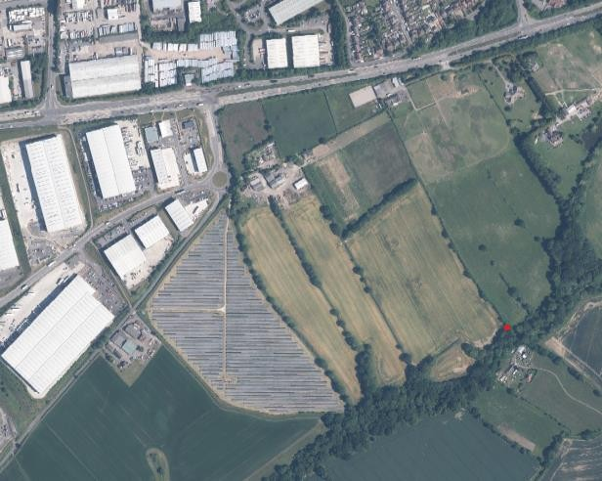

Stage 1 Assessment

Stage 1 Criteria | Details
Strategic Scale – Is the site greater than 25Ha? | 38 ha of which the applicant considers that approximately 25 ha is the net developable area predominantly for Use Classes B2 and B8.  Yes
Strategic Location – Is the site within an Area of Opportunity? | Yes – Area adjacent to M1 Junction 28 and 27 (Sutton in Ashfield, Alfreton, Kirkby in Ashfield and towards Hucknall albeit not all roads dualled notably A611 and A608).  Nottinghamshire Core & Outer HMA Logistics Study Final  Report 2022. Iceni. Paragraph 10.8.
Strategic Highway Connections – Does the site have good connections to the highway network close to a junction with the M1 or long distance dual carriageway? | The site is located off the A38 to the east of Junction 28 of the M1 Motorway. The submission identifies that the site is proposed to be accessed off the roundabout on Pinxton Lane. Significant highway improvements were undertaken as part of the development of Castlewood Business Park. This included the roundabout on Pinxton Lane and substantial junction improvement to the A38 and Pinxton Lane intersection.
Stage 1 Conclusion – Is the site a reasonable alternative that is carried forward to a Stage 2 Assessment? | The site is identified as a reasonable alternative for further consideration. This reflects the site’s size, its location within an area of opportunity as identified in the Logistics Study and its location off the A38 and close to Junction 28 of the M1 Motorway. The site will need to be considered against any  environmental infrastructure and policy constraints within the Stage 2 assessment.
Stage 2 Assessment
General – floorspace, type of site, other assessments and viability

Stage 2 Criteria | Details
Site Size – Is the site 50ha or more? | No  Site is 38 hectares.
Estimated employment floorspace | 80,250 sqm of employment uses in Classes B2 (general industrial) and B8 (storage and distribution) sqm (Outline planning application submitted v/2023/0021).
Existing use | Agricultural use
Extension or new site | New site.
PDL or Greenfield | Greenfield land.
Relevant SHLAA or SELAA conclusion | This site has not been assessed within the SHELAA
Relevant Growth  Options Study Conclusions | The Growth Options Study was not applicable to Ashfield.
Viability and deliverability | Site promoter considers the site is in an attractive location for the logistics market and is economically viable. It would fully fund all necessary infrastructure.

Transport Infrastructure and Accessibility

Transport Infrastructure | Commentary
Strategic highways – Good connection to the highway network close to a junction with the M1 or long distance dual carriageway | The site is located off the A38 close to Junction 28 of the M1 Motorway.  National Highways considers planning applications for new developments under the requirements of the National Planning Policy Framework (NPPF) and Department for Transport Circular 01/2022: The Strategic Road Network and The Delivery of Sustainable Development. As of 12th April 2023 National Highways are requesting a copy of a Transport Assessment for the planning application to consider the implications for the Strategic Road Network. Similarly, Nottinghamshire County Council as the Highway Authority will review the proposed access of the Pinxton Lane/ Farmwell Lane Roundabout and the A38.
Rail network accessibility | The site is not located adjacent to or near existing rail infrastructure.
Accessibility to labour – proximity to centres of population and ability to be served by public  transport and active travel. | Labour market - The site is located on the edge of the Main Urban Area of Sutton in Ashfield and close to the population centres at Kirkby-in-Ashfield, South Normanton and Alfreton.  Bus stops are identified the general area as follows:

Transport Infrastructure | Commentary
- AS0815 Grange Farm (Pinxton Lane) – Bus stop pole and flag, raised boarding kerbs, layby/ enforceable clearway.
- AS0816 Grange Farm (Pinxton Lane) – Custom and practice
- AS0096 Common Road (Alfreton Road) – Bus stop pole and flag, raised boarding kerbs, polycarbonate bus shelter, lay-by/enforceable clearway.
- AS0099 Common Road (Alfreton Road) – Real time pole and flag, raised boarding kerbs, polycarbonate bus shelter (Clear Channel), lay-by/enforceable clearway.

Transport and Travel Services at Nottinghamshire County Council have identified that they would require a bus management plan including details of how bus service would
be enhanced together with contributions towards improvements to bus stops in the area.
Other Critical Infrastructure

Type | Comments
Utilities | Electricity – No abnormal requirements identified by the site promoter.  Gas – No abnormal requirements identified by the site promoter.  Water Supply – No abnormal requirements identified by the site promoter.  Waste Water – No abnormal requirements identified by the site promoter.  IT/ Communications – No abnormal requirements Identified by the site promoter.
Blue and Green Infrastructure | A significant part of the site is designated as local wildlife sites or ancient woodland. The Maghole Brook watercourse  forms the southern boundary of the site. A right of way, Sutton In Ashfield FP56, crosses the northern part of the site.
Other | -

Sustainability Appraisal

Objective | Score | Objective | Score
1. Housing |  | 9. Brownfield Land

Objective | Score | Objective | Score
2. Employment and Jobs |  | 10. Energy and Climate Change
3. Economic Structure and Innovation |  | 11. Pollution and Air Quality
4. Shopping Centres |  | 12. Flooding and Water Quality
5. Health and Well Being |  | 13. Natural Environment, Biodiversity, Blue and Green Infrastructure
6. Community Safety |  | 14. Landscape
7. Social Inclusion |  | 15. Built and Historic Environment
8. Transport |  | 16. Natural Resources and Waste Management
Please note that:
- At the time of drafting this paper, the site had not been appraised in the Local Plan’s SA.
- Ashfield District Council SA has a different objective numbering to the Greater Nottingham SA.
- The SA was undertaken as part of the Draft Local Plan 2021. It does not take into account emerging evidence after the Draft Local Plan when out to consultation, including Heritage Impact Assessment, Habitat Regulations Assessment and Whole Plan Viability.

Constraints and other considerations

Topic | Commentary
Green Belt | The site is not in the Green Belt.
Agricultural Land | There has no specific site assessment of the Agricultural Land Classification. Based on the 1:250 000 Series Agricultural Land Classification the land is broadly identified  as potentially being within Grade 3 and/or Grade 4.
Land Contamination | No contamination identified.
Carbon Neutrality | The development would be subject to full environmental analysis as part of the allocation and planning application  process.
Impact on Air Quality | There are no designated Air Quality Management Areas within Ashfield at this time. However, the A38 near Junction 28 of the M1 Motorway has been identified as an area where there has been a requirement for additional air quality  monitoring in the past.

Topic | Commentary
Flood Risk | The site is located in Flood Zone1. Some areas of surface water flooding are identified on the Flood Map for Planning.
Natural Environment | A significant part of the site to the south east and south is designated as Local Wildlife Sites comprising the Fulwood Grassland II and Fulwood Grassland III. LWS Fulwood Meadows and the Maghole Brook and Ashfield District Dumble are located adjacent to the site. Part of the area is also designed as Ancient Woodland and a significant area of the woodland is subject to a Tree a Preservation Order.  The allocation / development of the site would result in the loss of existing habitats formed by hedgerows and trees would be lost to facilitate the development.  It would need to be demonstrated that the environmental impacts of any development could be mitigated against as it  is anticipating that, if taken forward, there would be a substantial negative impact on the LWSs located on the site.
Historic Environment | There are no identified designated or non-designated heritage assets on the site at this time. However, the proposal is to demolish buildings at Grange Farm and Cuttings Farm. These farms are identified on historic maps and consideration would have to be given to the heritage aspects of these buildings and whether they justify any form  of designation.
Landscape and topography | Under the Ashfield Local Plan Review the site is identified under Policy EV4 as a Mature Landscape Area. That is a local countryside designation, to identify and protect valuable and vulnerable parts of Nottinghamshire’s Landscape which have remained relatively unchanged over time.  The site is identified in the Greater Nottingham Landscape Character Assessment as being located in NC05 Kirkby Coalfield Farmlands/Kirkby Vales. The landscape condition is identified as ‘moderate’, the character strength of this area  is ‘moderate’ and the overall landscape strategy is ‘enhance’.
Regeneration | If taken forward, the site could be anticipated to contribute towards the regional demand for logistics identified in the Nottinghamshire Core & Outer HMA Logistics Study Final Report 2022. The Ashfield Local Plan Review 2002 given a high priority to the development of economic opportunity and regeneration. The NPPF sets out in paragraph 81 that significant weight should be placed on the need to support  economic growth and productivity considering both local business needs and wider opportunities for development.
Compatibility of surrounding uses | The site is located in the countryside adjacent to the Main Urban Area of Sutton in Ashfield formed at this point by the A38. Castlewood Business Park has been developed to the west of the site but there are isolated residential dwellings located close to the eastern boundary of the proposed development site.

Topic | Commentary
Availability | The site was promoted through submission to the Council SHELAA in Autumn 2021, but it was too late to be considered as part of the Draft Local Plan Regulation 18  Consultation.

Conclusions and recommendations

Is the site suitable for strategic? | The site was identified as a reasonable alternative at Step 1. This reflects the site’s size, its location within an area of opportunity as identified in the Logistics Study and its location off the A38 and close to Junction 28 of the M1 Motorway.  The site is subject to a planning application and it has the potential to contribute towards the regional requirement for large logistics units (above 100,000 sq. ft.). However, only one of the units extends above this size on the illustrative scheme. The site is located in close proximity to a number of population centres and a local labour supply with public transport access close to the site.  There are substantial environment issues as there is the potential for a major negative impact on Local Wildlife Sites, with potential the loss of these sites. The proposed site also includes ancient woodland within and adjacent to the site, which would need to be considered as part of any proposed development.  It would also be necessary to establish that there is suitable access to the site from a transport infrastructure aspect both from the Pinxton Lane/ Farmwell Lane Roundabout and A38 Junction as well as the potential impact on the Strategic Highway Network at Junction 28 of the M1 Motorway.  The draft Local Plan has identified proposed allocations at Junction 27 of the M1 Motorway. The site is not a preferred site to take forward to meet the employment land needs identified in the emerging Local Plan.

ADC-L02: Land to the North East of Junction 27 M1 Motorway off A608 Mansfield Road, Annesley

Map – Illustrative Layout
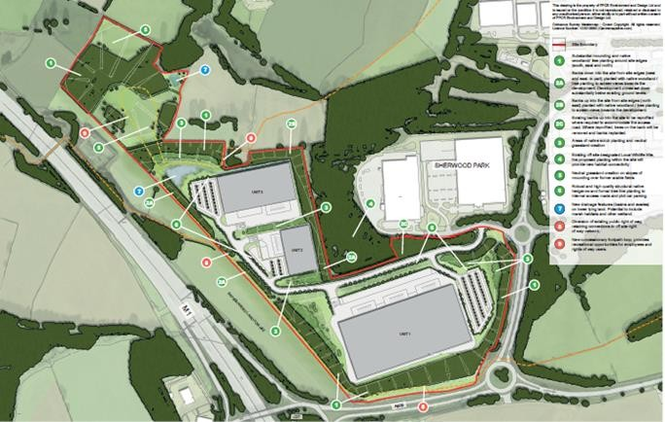
Aerial Image
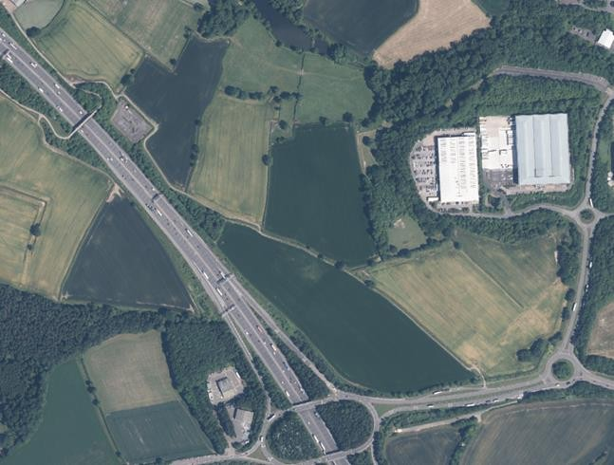

Stage 1 Assessment

Stage 1 Criteria | Details
Strategic Scale – Is the site greater than 25Ha? | The site form part of a proposed employment land allocation in the Draft Local Plan Consultation Oct/Nov 2021. It is also  subject to an outline planning application V/2022/0360 which identifies the site area as 26.32 ha. The application proposes

Stage 1 Criteria | Details
a maximum of 65,000 sq. m the majority of which would be logistics but with some potential element of B2 uses.
Yes
Strategic Location – Is the site within an Area of Opportunity? | Yes – Area adjacent to M1 Junction 28 and 27 (Sutton in Ashfield, Alfreton, Kirkby in Ashfield and towards Hucknall albeit not all roads dualled notably A611 and A608). Nottinghamshire Core & Outer HMA Logistics Study Final  Report 2022. Iceni. Paragraph 10.8.
Strategic Highway Connections – Does the site have good connections to the highway network close to a junction with the M1 or long distance dual  carriageway? | The site is located off the A608 Mansfield Road, Annesley linking into Sherwood Business Park. It has good connections to the M1 Motorway being located to the north east of Junction 27.
Stage 1 Conclusion – Is the site a reasonable alternative that is carried forward to a Stage 2 Assessment? | The site is identified as a reasonable alternative for further consideration. This reflects the site’s size, its location within an area of opportunity as identified in the Logistics Study and its location off the A608 close to Junction 27 of the M1 Motorway. The site will need to be considered against any  environmental, historic, infrastructure and policy constraints within the Stage 2 assessment.
Stage 2 Assessment
General – floorspace, type of site, other assessments and viability

Stage 2 Criteria | Details
Site Size – Is the site 50ha or more? | No  The site is 26 ha.
Estimated employment floorspace | 65,000 sq. m the majority of which would be logistics but with some potential element of B2 uses.
Existing use | Agricultural use
Extension or new site | New site forming an Extension of Sherwood Business Park.
PDL or Greenfield | Greenfield (Located in the Green Belt).
Relevant SHLAA or SHELAA conclusion | Ashfield SHELAA the site is available, potentially suitable, and potentially achievable.
Relevant Growth Options Study Conclusions | The Growth Options Study was not applicable to Ashfield.
Viability and  deliverability | Site promoter considers the site is in an attractive location for the logistics market and is economically viable. It would fully fund all necessary infrastructure.

Transport Infrastructure and Accessibility

Strategic highways – Good connection to the highway network close to a junction with the M1 or long distance dual carriageway | The site is located off the A608 Mansfield Road, Annesley linking into Sherwood Business Park. It has good connections to the M1 Motorway being located to the north east of Junction 27.  As part of the SHELAA the Highway Authority undertook a high level assessment which identified that there are potential access constraints which could be overcome. The response identified that access from A608 was not acceptable and the site must be accessed from existing Sherwood Park road network.  National Highways have identified that mitigation is likely to be required in relation to the Strategic Road Network.  Additional working is being undertaken as part of the planning application through the Transport Assessment to determine the implications for access and Junction 27 of the M1 Motorway.
Rail network  accessibility | The site is not located adjacent to or near existing rail infrastructure.
Accessibility to labour – proximity to centres of population and ability to be served by public transport and active travel. | Labour market - The site is located in close proximity to the population centre at Kirkby-in-Ashfield, and South Normanton and Alfreton.  Nottinghamshire County Council’s Highway Design Guidance (Part 3.1) states that walking distances to bus stops in urban areas, should be located within a maximum of distance of 400metres and desirably no more than 250 metres. The closest existing bus stops are located on Willow Drive approximately 600 metres from the centre of the site.  Bus services that serve Sherwood Park are the Threes 3b, Threes 3C running from Nottingham - Hucknall - Sutton – Mansfield and the Black Cat service running from Derby - Ilkeston - Heanor - Mansfield  Transport and Travel Services at Nottinghamshire County Council have identified the following bus stops which are the nearest to the application site:  - AS0589 Willow Drive – Bus stop pole and flag, raised boarding kerbs, enforceable bus stop clearway.  - AS0590 Willow Drive – Bus stop pole and flag, raised boarding kerbs, enforceable bus stop clearway.  They would require a bus management plan including details of how bus service would be enhanced together with contributions towards improvements to existing and new bus  stops in the area.

Other Critical Infrastructure

Type | Comments
Utilities | Electricity – No abnormal requirements identified by the site promoter.  Gas – No abnormal requirements identified by the site promoter.  Water Supply – No abnormal requirements identified by the site promoter.  Waste Water – No abnormal requirements identified by the site promoter.  IT/ Communications – No abnormal requirements Identified by the site promoter.
Blue and Green Infrastructure | Footpaths Annesley 8 and Annesley 9 cross the site. Footpath Annesley 7 abuts the south eastern boundary.  The right of way which crosses the application site is identified in the Ashfield District Council Green & Blue Infrastructure and Biodiversity Strategy 2022 -2032 as forming part of a key  strategic corridor GI-8: Pinxton to Thieves Wood.
Other | The site is located adjacent to the safeguarded route of HS2.  A high pressure gas pipe is located in close proximity to the site.

Sustainability Appraisal

Objective | Score | Objective | Score
1. Housing | 0 | 10. Water Quality | 0
2. Health | 0 | 11. Waste | 0
3. Historic Environment | - | 12.Climate Change & Flood Risk | -
4. Community Safety | 0 | 13. Climate Change & Energy Efficiency | 0
5. Social Inclusion Deprivation | 0 | 14. Travel & Accessibility | +
6. Biodiversity & Green Infrastructure | - | 15. Employment | +
7. Landscape | - - | 16. Economy | ++
8. Natural Resources | - | 17. Town Centres | 0
9. Air & Noise Pollution | -

Please note that:

- Ashfield District Council SA has a different objective numbering to the Greater Nottingham SA.
- The SA was undertaken as part of the Draft Local Plan 2021. It does not take into account emerging evidence after the Draft Local Plan when out to consultation, including Heritage Impact Assessment, Habitat Regulations Assessment and Whole Plan Viability.
Constraints and other considerations

Topic | Commentary
Green Belt | The site falls within the following areas identified in the Strategic Green Belt Review:  - KA17 / Site 1 – Land south west of Sherwood Business Park.  - KA17 / Site 1 – Land south west of Sherwood Business Park.  - KA17 / Site 1 – Land south west of Sherwood Business Park.
Agricultural Land | There is no specific site assessment of the Agricultural Land Classification. Based on the 1:250 000 Series Agricultural  Land Classification the land is broadly identified as potentially being within Grade 3 and/or Grade 4.
Land Contamination | No contamination identified.
Carbon Neutrality | The development would be subject to full environmental analysis as part of the allocation and planning application  process.
Impact on Air Quality | There are no designated Air Quality Management Areas within Ashfield at this time.
Flood Risk | The site is located in Flood Zone1. Some areas of surface water flooding are identified on the Flood Map for Planning.
Natural Environment | Davis's Bottom Pasture Local Wildlife Site (LWS) is adjacent to the site boundary to the north. Davis's Bottom Grassland LWS is adjacent to eastern site boundary. Natural England’s MAGIC Map identifies the area to north as 'good quality semi- improved grassland' and 'broadleaved deciduous woodland' to  the east and west.
Historic Environment | Scheduled Ancient Monument - Fishponds south of Damstead Farm, is located approximately 140m to the north of the site. The Grade ll* Annesley Hall Registered Park and Gardens is located to the south and south east of the site.  A Heritage Impact Assessment has been commission as part of the emerging Local Plan and will consider the heritage  implication of the site.
Landscape and topography | The application site is not subject to any landscape designation but it should be noted that to the north and east of the proposed site, the area is identified as a mature landscape area in the ALPR, Policy EV4 which is an area which has remained relatively unchanged over time.  The proposed site falls within in the landscaped identified in the Nottinghamshire Landscape Character Assessment 2009

Topic | Commentary
as ML019 Kirkby Quarry, Portland Park and Rise Hill. In summary, it identifies:
- The landscape condition varies from Poor to Moderate within area.
- The strength of landscape character is Poor. Some features are distinctive but these have only a localised effect. Features are typically scattered and inconsistent across the landscape. The pattern of agriculture is in pockets and at the edges of the area and the landscape is influenced by many urbanising features.
There are mature trees and hedgerows through the site and forming the boundary of the site.
Regeneration | If taken forward, the site could be anticipated to contribute towards the regional demand for logistics identified in the Nottinghamshire Core & Outer HMA Logistics Study Final Report 2022. The Ashfield Local Plan Review 2002 given a high priority to the development of economic opportunity and regeneration. The NPPF sets out in paragraph 81 that significant weight should be placed on the need to support  economic growth and productivity considering both local business needs and wider opportunities for development.
Compatibility of surrounding uses | The site is countryside in character but with the Sherwood Business Park to the east, and a transport corridor (M1) and  potentially HS2 to the west.
Availability | The site was promoted through submission to the Council SHELAA it is identified as a proposed allocation in the Draft Local Plan Regulation 18 Consultation and is subject to an  outline planning application v/2022/0360.

Conclusions and recommendations

Is the site suitable for strategic? | The site was identified as a reasonable alternative for further consideration at Step 1. This reflects the site’s size, its location within an area of opportunity as identified in the Logistics Study and its location off the A608 close to Junction 27 of the M1 Motorway.  The site is subject to a planning application and is potentially suitable and could contribute toward logistics provision given its strategic location off the M1. However, consideration would need to be given to a number of aspects:  - It is a greenfield site which is currently used for agricultural purposes.  - It is identified that network improvements may be required in relation to the foul sewerage system.  - The site is located within the Green Belt. Under the National Planning Policy Framework, paragraph 136, it is necessary to demonstrate that there are exceptional

circumstances for the site to be taken out of the Green Belt.
- There are likely to be ground stability issues on site due to the presence of fault lines.
- A Local Wildlife site is adjacent to the north east of the site; Therefore, any potential development will need to take into account the scope to avoid or mitigate the impacts on biodiversity. Mature trees and hedgerows also present on the site. The proposed development would need to achieve biodiversity net gain.
- Potential harm to the significance of Damstead Farm Fishponds (A Scheduled Ancient Monument) and the Register Park and Gardens would need to be assessed.
- Suitable access and mitigation to any potential impact on the Strategic Highway Network at Junction 27 of the M1 would be necessary.

Given the sites proximity to the M1 and Sherwood Park, the site has been taken forward as a proposed allocation in the Local Plan for logistics.

N.B It should be noted that the Nottinghamshire Core & Outer HMA Logistics Study Final Report 2022, Iceni, made an assumption that the site would come forward for logistics in considering the regional demand and supply position for the Nottingham Core and
Nottingham Outer HMA.

ADC-L03: Land to the South East of Junction 27 M1 Motorway off A608 Mansfield Road, Annesley

Map
Aerial Image Map
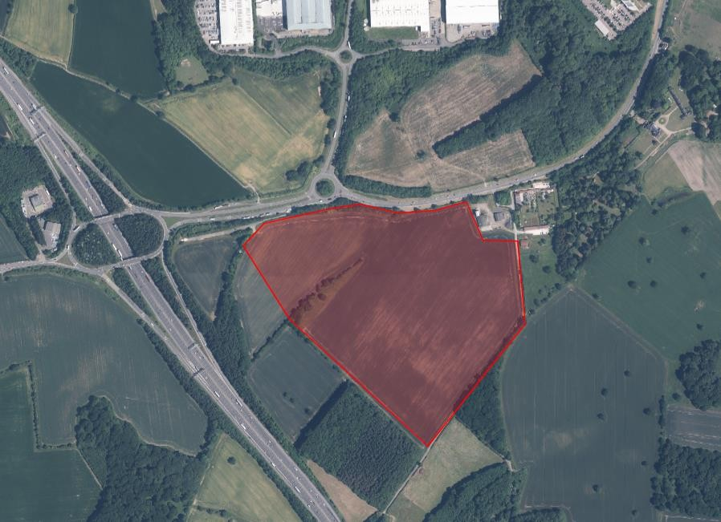

Stage 1 Assessment

Stage 1 Criteria | Details
Strategic Scale – Is the site greater than 25Ha? | The completed Greater Nottingham Councils’ Call for potential Strategic Distribution Sites form identifies the site area as 23.75 ha. This is a smaller site that was submitted to  Ashfield District Council SHELAA in 2019.

Stage 1 Criteria | Details
However, a planning application has been submitted on the site, V/2022/0246, which identifies the site area as 26.75 ha. It proposes development with a gross internal area of up to 91,716 sqm. The use is identified as B2/B8.

Yes
Strategic Location – Is the site within an Area of Opportunity? | Yes – Area adjacent to M1 Junction 28 and 27 (Sutton in Ashfield, Alfreton, Kirkby in Ashfield and towards Hucknall albeit not all roads dualled notably A611 and A608).  Nottinghamshire Core & Outer HMA Logistics Study Final  Report 2022. Iceni. Paragraph 10.8.
Strategic Highway Connections – Does the site have good connections to the highway network close to a junction with the M1 or long distance dual carriageway? | The Highway Authority in response to Ashfield’s SHELAA identified that the site is located off the A608 Mansfield Road, Annesley to the south east of Junction 27 of the M1 Motorway identified that the site has access constraints which could be overcome - accessed off a 4th arm off the existing Sherwood Business Park island on the A608. This will require the existing island being increased substantially in size with appropriate re-alignment of the dual carriageway/ provision of deceleration lanes etc. on the A608.  It is understood that additional work is being undertaken in relation to highways and the potential impact in relation to Junction 27 of the M1 Motorway as part of the current planning application.
Conclusion – Is the site a reasonable alternative that is carried forward to a Stage 2 Assessment? | The site is identified as a reasonable alternative for further consideration. This reflects the site’s size, its location within an area of opportunity as identified in the Logistics Study and its location off the A608 close to Junction 27 of the M1 Motorway. The site will need to be considered against any environmental, historic, infrastructure and policy constraints  within the Stage 2 assessment.

Stage 2 Assessment
General – floorspace, type of site, other assessments and viability

Stage 2 Criteria | Details
Site Size – Is the site 50ha or more? | No
Estimated employment floorspace | The outline planning application V/2022/0360 identifies the site area as 26.32 ha and proposes a maximum of 65,000 sq.  m the majority of which would be logistics but with some potential element of B2 uses.
Existing use | Agricultural use
Extension or new site | New site.
PDL or Greenfield | Greenfield (Located in the Green Belt).
Relevant SHLAA or SHELAA conclusion | Ashfield SHELAA identified the site as available, potentially suitable, and potentially achievable.

Stage 2 Criteria | Details
Relevant Growth Options Study Conclusions | The Growth Options Study was not applicable to Ashfield.
Viability and  deliverability | Site promoter considers the site is in an attractive location for the logistics market and is economically viable. It would fully fund all necessary infrastructure.
Transport Infrastructure and Accessibility

Transport Infrastructure | Commentary
Strategic highways – Good connection to the highway network close to a junction with the M1 or long distance dual carriageway | The site is located off the A608 Mansfield Road, Annesley linking into Sherwood Business Park. It has good connections to the M1 Motorway being located to the north east of Junction 27.  The Highway Authority in response to the SHELAA identified that the site has access constraints which could be overcome  - accessed off a 4th arm off the existing Sherwood Business Park island on the A608. This will require the existing island being increased substantially in size with appropriate re- alignment of the dual carriageway/provision of deceleration lanes etc. on the A608.  National Highways have identified that mitigation is likely to be required in relation to the Strategic Road Network.  Additional working is being undertaken as part of the planning application through the Transport Assessment to determine the implications for access and Junction 27 of the M1  Motorway.
Rail network accessibility | The site is not located adjacent to or near existing rail infrastructure. The East Midlands Gateway Logistics Park (rail freight interchange) is located approximately 20 miles south on the M1. The HS2 Phase 2b route is safeguarded adjacent  to the site.
Accessibility to labour – proximity to centres of population and ability to be served by public transport and active travel. | Labour market – The site is located in close proximity to the population centre at Kirkby-in-Ashfield, and South Normanton and Alfreton.  Nottinghamshire County Council’s Highway Design Guidance (Part 3.1) states that walking distances to bus stops in urban areas, should be located within a maximum of distance of 400metres and desirably no more than 250 metres. The closest existing bus stops are located on Willow Drive and are approximately 700 metres from the centre of the site or 10 minutes walking distance, which includes several highway crossing points.  The current bus services that serve the closest stops are the Threes 3b, Threes 3C running from Nottingham - Hucknall -

Transport Infrastructure | Commentary
Sutton – Mansfield and the Black Cat service running from Derby - Ilkeston - Heanor - Mansfield
As part of the Planning Application consultation responses it has been identified that an indication of the scope of potential public transport improvements are:
- An enhancement of the Trent Barton threes and/or Black Cat to provide additional facilities to meet the employment needs of this site
- Flexible Demand Responsive Service (DRT) for access from areas outside of the bus served areas, including Newstead Rail Station, to coincide with shift start and finish times.
- Integrated, electronic and flexible ticketing with the potential for discounted season tickets paid through payroll deductions.
- Service frequency and timings will be subject to an assessment of shift times and patterns of demand including reference to employee Travel Plan surveys and Travel to Work catchments.
Transport and Travel Services at Nottinghamshire County Council have identified that additional bus stops would be required:
- Phase 1: For the Phase 1 site, the preference is for new bus stop facilities to be provided fronting the site on the A608 Mansfield Road.
- Phase 2: It is unlikely that any of the current bus network would be diverted to serve the site, however, provision should be made for any bespoke/flexible DRT transport to
access and turn within the site, together with suitable waiting, boarding and alighting facilities.
Other Critical Infrastructure

Type | Comments
Utilities | Electricity – No abnormal requirements identified by the site promoter.  Gas – No abnormal requirements identified by the site promoter.  Water Supply – No abnormal requirements identified by the site promoter.  Waste Water – No abnormal requirements identified by the site promoter. However, it is understood that network improvements may be required in relation to the foul sewerage system.  IT/ Communications – No abnormal requirements

Type | Comments
 | Identified by the site promoter.
Blue and Green Infrastructure | Bridleway Annesley 1 runs along Weavers Lane, adjacent to the south eastern site boundary.
Other | A substantial part of the site is subject to a safeguarding direction in relation to HS2 Phase 2b. HS2 draft Environmental Statement identifies the site as a main compound and  temporary material stockpile.
Sustainability Appraisal

Objective | Score | Objective | Score
1. Housing | 0 | 10. Water Quality | 0
2. Health | 0 | 11. Waste | 0
3. Historic Environment | - - | 12.Climate Change & Flood  Risk | -
4. Community Safety | 0 | 13. Climate Change & Energy  Efficiency | 0
5. Social Inclusion  Deprivation | 0 | 14. Travel & Accessibility | +
6. Biodiversity & Green  Infrastructure | - | 15. Employment | +
7. Landscape | - - | 16. Economy | ++
8. Natural Resources | - | 17. Town Centres | 0
9. Air & Noise Pollution | -
Please note that:
- Ashfield District Council SA has a different objective numbering to the Greater Nottingham SA.
- The SA was undertaken as part of the Draft Local Plan 2021. It does not take into account emerging evidence after the Draft Local Plan when out to consultation, including Heritage Impact Assessment, Habitat Regulations Assessment and Whole Plan Viability.
Constraints and other considerations

Topic | Commentary
Green Belt | The site falls within the M01 – Land South East of Junction 27 of M1 which scores 17/20 in the Strategic Green Belt Review.  It scores highly in relation to checking the unrestricted sprawl of settlements, assist in safeguarding the countryside from

Topic | Commentary
 | encroachment and preserve the setting and special character of historic settlements.
Agricultural Land | Based on East Midland Region Agricultural Land Classifications Map (high level mapping; 1:250 000), the site is identified as potentially being grade 3. However, this cannot be determinative of the grade of the land and no site-specific  agricultural classification is available. (ALPR Policy EV9 Agricultural Land was not saved).
Land Contamination | No contamination identified.
Carbon Neutrality | The development would be subject to environmental analysis as part of the planning application process.
Impact on Air Quality | There are no designated Air Quality Management Areas within Ashfield at this time.
Flood Risk | The site is located in Flood Zone 1. Some areas of surface water flooding are identified on the Flood Map for Planning.
Natural Environment | No local designations on site. Two Local Wildlife Sites (Oak Plantation - Annesley & Weavers Lane Grassland) are adjacent to the south eastern boundary (separated by a bridleway/track). Oak Plantation and part of Audrey Wood adjacent to the site are identified under the Natural Environment & Rural Community Act 2006, Section 41 is identified as a Priority Habitat – deciduous woodland, The adjacent Registered Park to the east of the site is identified as  Woodpasture and Parkland (BAP) Priority Habitat.
Historic Environment | The site adjoins Grade II* Annesley Hall Registered Park and Garden. Other heritage assets associated with the Park include:  - Grade II Annesley Hall.  - Grade II Gatehouse Range and Grade II Terrace.  - All Saints Church and Graveyard Scheduled Monument.  - Grade 1 Ruins of Church of All Saints.  - Annesley Motte & Bailey Castle Scheduled Monument.  - Annesley Lodge.  - Whyburn House (Ref 393) is a locally listed heritage asset.  A Heritage Impact Assessment has been commissioned as part of the emerging Local Plan and will consider the heritage implication of the site.  In response to the planning application Historic England have set out a detailed response. They consider that the harm to heritage significance is likely to be substantial, and that the development does not meet the requirements of the National Planning Policy Framework or the Ashfield Local Plan. Historic  England objects to the application on heritage grounds.
Landscape and topography | NC04 Moorgreen Rolling Woodland - The condition of the area is MODERATE. The character of the DPZ is STRONG. The overall landscape strategy is CONSERVE and ENHANCE.  The site comprises arable farmland which slopes down from the A606 Mansfield Road. The site is adjacent to established

Topic | Commentary
 | woodland (Audrey Wood). Other mature trees and hedgerows present on site.
Regeneration | If taken forward, the site is well located to contribute towards the regional demand for logistics identified in the Nottinghamshire Core & Outer HMA Logistics Study Final Report 2022. The Ashfield Local Plan Review 2002 given a high priority to the development of economic opportunity and regeneration. The NPPF sets out in paragraph 81 that significant weight should be placed on the need to support  economic growth and productivity considering both local business needs and wider opportunities for development.
Compatibility of surrounding uses | The site is countryside in character. It is located close to the M1 motorway and the proposed HS2 route. However, the Grade II* Annesley Hall Registered Park & Garden is adjacent to the east of the site and the site is in close proximity to a  number of listed heritage assets.
Availability | The site was promoted through submission to the Council SHELAA it is identified as a proposed allocation in the Draft Local Plan Regulation 18 Consultation and is subject to an  outline planning application v/2022/0360.
Conclusions and recommendations

Is the site suitable for strategic? | The site was identified in Stage 1 as a reasonable alternative for further consideration. This reflects the site’s size, its location within an area of opportunity as identified in the Logistics Study and its location off the A608 close to Junction 27 of the M1 Motorway.  The site is subject to a current planning application. The site is well located to meet a regional demand for logistics along the M1 in Nottinghamshire. However, a number of environmental and heritage issues have been identified in relation to the site including:  - The site is located within the Green Belt. Under the National Planning Policy Framework, paragraph 136, it is necessary to demonstrate that there are exceptional circumstances for the site to be taken out of the Green Belt.  - Substantial heritage concerns have been raised in relation to the site particularly in relation to the Registered Park and Garden and a number of listed heritage assets.  - Suitable access and mitigation to any potential impact on the Strategic Highway Network at Junction 27 of the M1 would be necessary. It is a greenfield site which is currently used for agricultural purposes.  - It is identified that network improvements may be required in relation to the foul sewerage system.

Given the sites proximity to the M1 and Sherwood Park, the site has been taken forward as a proposed allocation in the Local Plan for logistics.
N.B The Nottinghamshire Core & Outer HMA Logistics Study Final Report 2022, Iceni, made an assumption that the site would come forward for logistics in considering the regional demand and supply position for the Nottingham Core and Nottingham Outer HMA.

Broxtowe
BBC-L01: Former Bennerley Coal Disposal Point

Map
Aerial Image
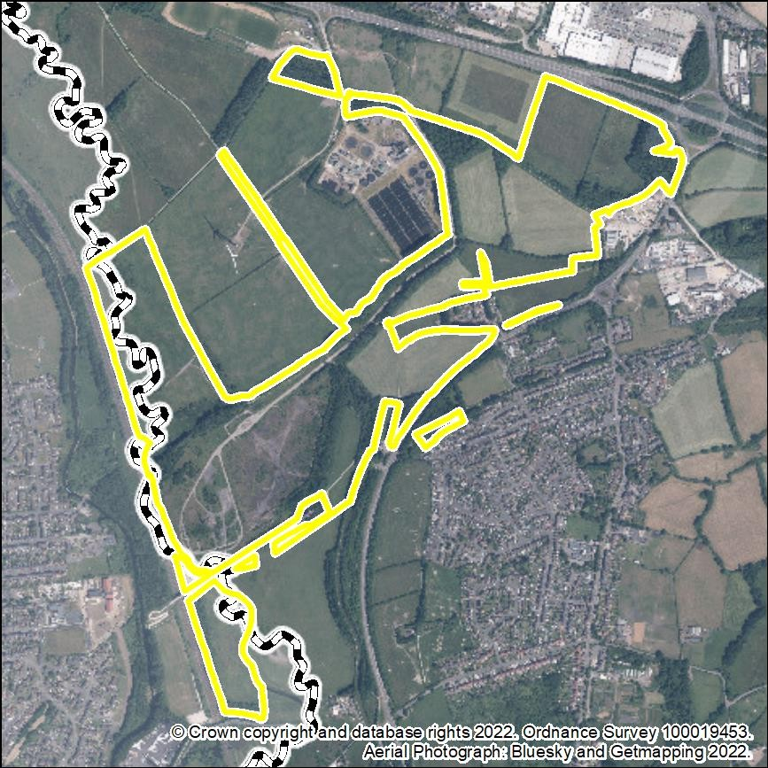

Stage 1 Assessment

Stage 1 Criteria | Details
Strategic Scale – Is the site greater than 25Ha? | Yes.  The site covers 68 ha.
Strategic Location – Is it within an Area of Opportunity | Yes, the site is located within an Area of Opportunity at Junction 26 of the M1.
Strategic Highway Connections – Does the site have good connections to the highway network close to a junction with the M1 or long distance dual carriageway? | The owners/promoters advise:  “Existing access onto the A610, secondary access could also be provided onto an existing junction on the A6096. Directly connected to the rail network. The site is central to the strategic highway network which linking [sic] to Junction 26 of M1 for connections to the south and north, near the A50 to the west and A610 to the east. This would provide suitable road access to the site for HGV’s.”
Stage 1 Conclusion | The site is being identified as a reasonable alternative for further consideration because of its capacity, its proximity to the A610/M1 and the possibility of rail access.

Stage 2 Assessment
General – floorspace, type of site, other assessments and viability

Stage 2 Criteria | Details
Site Size – Is the site 50ha or more? | 68 ha.  The site is over 50 ha in size.
Estimated employment floorspace | Up to approximately 74,000 square metres. (Owners/promoters’ estimate, i.e. “up to 800,000sqft”.)
Existing use | “Lawful use for the reception, storage and dispatch of coal”. (Owners/promoters’ description.)  Part agricultural.
Extension or new site | New site.
PDL or Greenfield | Part greenfield. Remainder is PDL.
Relevant SHLAA or SHELAA conclusion | Not included in the current SHLAA. No S(H)ELAA.

Stage 2 Criteria | Details
Relevant Growth Options Study Conclusions | Not in a ‘Potential Area for Strategic Growth’ (as defined at page 16 of the Study).
Viability and deliverability | The viability of the site would need to be considered through the preparation of a Plan Wide Viability assessment.  Owners/promoters advise that “there are no viability constraints”.

Transport Infrastructure and Accessibility

Transport Infrastructure | Comments
Strategic highways – Good connection to the highway network close to a junction with the M1 or long distance dual carriageway | Close to the A610 and to junction 26 of the M1.  National Highways (NH) (formerly Highways England) advises that the development would be likely to be acceptable, subject to TA and any identified mitigation.  NH also advises that the scale of the development and distance from the SRN suggests the impact of the development on its own may not be significant. However, there is likely to be a cumulative impact when taking into account other developments also impacting on M1 J26  Nottinghamshire County Council (NCC) advises that the preferred access point would be the existing access on the A610 and the roundabout junction on Shilo Way. HGV traffic would be expected to utilise the M1/A610/A6096.  NCC also advises that it would be necessary to ensure that appropriate public transport infrastructure is provided to serve the site with suitable footway connections and crossings where necessary. Cycling infrastructure should be delivered to “LTN 1/20 standard”.  NCC advises that the site is “affected by tram extension”.
Rail network accessibility | Potential for rail network accessibility.
Accessibility to labour – proximity to centres of population and ability to be served by public transport and active travel. | Close to Eastwood, Awsworth and Ilkeston/Cotmanhay, also near to Kimberley/Nuthall and Nottingham.  Limited current public transport accessibility, however there is the potential for this to be improved.  NCC mentions the possibility of a tram extension at some point.

Other Critical Infrastructure

Infrastructure Type | Comments
Utilities | Owners/promoters advise that there are “no known constraints”, regarding all utilities.  No abnormal requirements have been identified by the Council, however further input would be required from consultees.
Blue and Green Infrastructure | On-site provision/enhancement would probably be preferable.  (The site includes parts of several ‘Primary and Secondary Strategic Networks’ and ‘Local/Neighbourhood Networks’, as defined in the ‘Greater Nottingham Blue and Green Infrastructure Strategy January 2022’, and parts of several ‘Primary and Secondary Green Infrastructure Corridors’, as defined in the adopted Broxtowe Part 2 Local Plan.)
Other | 90% of the site is in a Coal Authority 'Development High Risk Area'.
Sustainability Appraisal

Objective | Score | Objective | Score
1. Housing | 0 | 9. Brownfield Land | +
2. Employment and Jobs | ++ | 10. Energy and Climate Change | ?
3. Economic Structure and Innovation | ++ | 11. Pollution and Air Quality | ?
4. Shopping Centres | + | 12. Flooding and Water Quality | -
5. Health and Well Being | + | 13. Natural Environment, Biodiversity, Blue and Green Infrastructure | --
6. Community Safety | ? | 14. Landscape | -
7. Social Inclusion | ++ | 15. Built and Historic Environment | --
8. Transport | ++ | 16. Natural Resources and Waste Management | -

Constraints and other considerations

Topic | Commentary
Green Belt | The site falls within Broad Area 2: West of Awsworth in the ‘Green Belt Review Background Paper December 2022’. Score 15/20. Development would have a major impact on the Green Belt gap between Awsworth/Eastwood and Cotmanhay/Ilkeston.
Agricultural Land | In part.  Agricultural Land Classification Grade 4.
Land Contamination | “The site is not contaminated and has been cleared of all structures since its use as a former coal disposal point.” (Owners/promoters’ description.)  Would need thorough examination before any development.  There is a Historic Landfill Site within 50m of the site and another Historic Landfill Site within 100m of the site.
Carbon Neutrality | The development would be subject to full environmental analysis as part of the allocation and planning application process.
Impact on Air Quality | Not known at this stage.  The site is not part of an Air Quality Management Area.
Flood Risk | River Flooding:  Approximately 29% of the site is in Flood Zone 3. Approximately 39% of the site is in Flood Zone 2.  Surface Water Flooding:  Approximately 13% of the site is at 1 in 30 year risk of surface water flooding.  Owners/promoters consider that flood risk “can be easily addressed through the design process using SUDs”.
Natural Environment | There are 3 Local Wildlife Sites within the site and 1 Local Wildlife Site within 250m of the site.
Historic Environment | There is a Grade II* Listed Building, Bennerley Viaduct, within the site.  The details of any proposed development would not be known until the planning application stage. Development of the site might potentially harm the significance of the listed Bennerley Viaduct and its setting. Development at the site  would be unlikely to enhance or better reveal the significance

Topic | Commentary
 | of any heritage assets. It would be unlikely to promote heritage based tourism or regeneration.
Landscape and topography | The ‘Greater Nottingham Growth Options Study Additional Landscape Assessments’ document (November 2022) includes the following comments:  “Nottinghamshire landscape character policy zone:  NC02 Babbington Rolling Farmlands (moderate condition, strong strength, conserve and enhance landscape strategy) NC01 Erewash River Corridor (moderate condition, strong strength, conserve and enhance landscape strategy)”  “Topography and landuse:  The topography is at its highest in the north of the site towards the A610, this slopes away very gently towards Awsworth. In the south of the site, the topography is very flat which contrasts to the publicly accessible Bennerley Viaduct to the west of Awsworth. The site is a mix of pastoral fields (located to the north) and a brownfield site (located to the south) previously used for mining and an ironworks.”  “Suitability for development in landscape and visual terms: This site has medium potential for strategic growth. It sits between four settlements, with potential for merging should the full site be built out. The north of the site could accommodate development (likely to be employment) linked directly to the A610. However, the south is more sensitive to development due to the presence and setting of the Grade II* listed viaduct and the high recreational value. This area would be better used for more limited development linked to the heritage, building on the existing work around the Bennerley Viaduct.”
Regeneration | Close to Eastwood and to Ilkeston/Cotmanhay, also near to Nottingham, all of which include areas of high deprivation.
Compatibility of surrounding uses | No residential properties in the immediate vicinity.
Availability | Available: promoted through the ‘Call for Sites’.

Conclusions and recommendations

Is the site suitable for strategic? | The site contains significant areas of previously developed land and is considered to be potentially suitable for strategic logistics development.  This is provided that functioning rail freight facilities are incorporated into any development.

Among the sites in Broxtowe, this site is preferred, having regard to its potential for rail access and consequent benefits for carbon reduction, compared against other potentially
suitable sites.

BBC-L02a: Gilt Hill (smaller site)

Map
Aerial Image
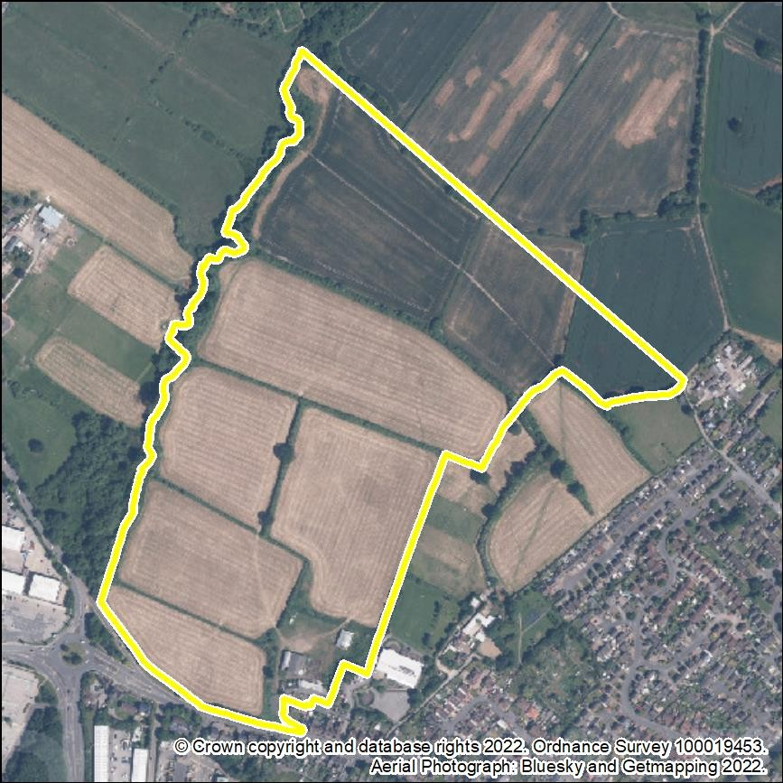
Stage 1 Assessment

Stage 1 Criteria | Details
Strategic Scale – Is the site greater than 25Ha? | Yes.  The site covers 25.17 ha.
Strategic Location – Is it within an Area of Opportunity | Yes, the site is located within an Area of Opportunity at junction 26 of the M1.
Strategic Highway Connections – Does the site have good connections to the highway network close to a junction with the M1 or long distance dual carriageway? | The owners/promoters advise:  “The site has good access to the strategic highway network with access on to the A610 dual carriageway, which is 2 miles to Junction 26 of the M1 Motorway.”
Stage 1 Conclusion | The site is identified as a reasonable alternative for further consideration because of its capacity, location within an Area of Opportunity and its proximity to the A610/M1.

Stage 2 Assessment

General – floorspace, type of site, other assessments and viability

Stage 2 Criteria | Details
Site Size – Is the site 50ha or more? | 25.17 ha.  The site is not over 50 ha in size.
Estimated employment floorspace | Approximately 65,000 – 102,000 square metres, including larger site, BBC-L02b.  (Owners/promoters’ estimate, i.e. “Circa 700,000 to 1,100,000 sq. ft.”)
Existing use | Agricultural.
Extension or new site | New site.
PDL or Greenfield | Greenfield land.
Relevant SHLAA or SHELAA conclusion | Parts of the site are assessed for housing in the current SHLAA as “could be suitable if policy changes”.
Relevant Growth Options Study Conclusions | Not in a ‘Potential Area for Strategic Growth’ (as defined at page 16 of the Study).

Stage 2 Criteria | Details
Viability and deliverability | The viability of the site would need to be considered through the preparation of a Plan Wide Viability assessment.  Owners/promoters advise that “the proposed scheme is deliverable and viable”.

Transport Infrastructure and Accessibility

Transport Infrastructure | Comments
Strategic highways – Good connection to the highway network close to a junction with the M1 or long distance dual carriageway | Adjacent to the A610 and close to junction 26 of the M1.  National Highways (NH) (formerly Highways England) advises that the development would be likely to be acceptable, subject to TA and any identified mitigation.  NH also advises that the scale of the development and distance from the SRN suggests the impact of the development on its own may not be significant. However, there is likely to be a cumulative impact when taking into account other developments also impacting on M1 J26.  Nottinghamshire County Council (NCC) advises that the preferred access point would be Gilt Hill and that the position of the access should avoid conflict with other junctions on the opposite side of the carriageway. Measures may be required to prevent HGVs from routing along the A608.  NCC also advises that it would be necessary to ensure that appropriate public transport infrastructure is provided to serve the site with suitable footway connections and crossings where necessary.  NCC advises that the site is “affected by tram extension”.
Rail network accessibility | No potential for direct rail network accessibility. The site is located approximately 15 miles north of the East Midlands  Gateway Logistics Park of Junction 24 of the M1.
Accessibility to labour – proximity to centres of population and ability to be served by public transport and active travel. | Adjacent to Kimberley/Nuthall, close to Awsworth, Eastwood and Nottingham.  Good ability to be served by public transport and active travel.  NCC mentions the possibility of a tram extension at some point.

Other Critical Infrastructure

Infrastructure Type | Comments
Utilities | Owners/promoters advise that there is “significant spare capacity available in the local network”.  No abnormal requirements have been identified by the Council, however further input would be required from consultees.
Blue and Green Infrastructure | On-site provision/enhancement would probably be preferable.  (The site includes part of a ‘Secondary Strategic Network’, as defined in the ‘Greater Nottingham Blue and Green Infrastructure Strategy January 2022’, and part of a ‘Secondary Green Infrastructure Corridor, as defined in the adopted Broxtowe Part 2 Local Plan.)
Other | 90% of the site is in a Coal Authority 'Development High Risk Area'.

Sustainability Appraisal

Objective | Score | Objective | Score
1. Housing | 0 | 9. Brownfield Land | --
2. Employment and Jobs | + | 10. Energy and Climate Change | ?
3. Economic Structure and Innovation | ++ | 11. Pollution and Air Quality | -
4. Shopping Centres | + | 12. Flooding and Water Quality | -
5. Health and Well Being | + | 13. Natural Environment, Biodiversity, Blue and Green Infrastructure | -
6. Community Safety | ? | 14. Landscape | --
7. Social Inclusion | ++ | 15. Built and Historic Environment | 0
8. Transport | ++ | 16. Natural Resources and Waste Management | -

Constraints and other considerations

Topic | Comments
Green Belt | The site falls within Broad Area 15: North of Gilt Hill in the ‘Green Belt Review Background Paper December 2022’. Score 12/22. Development would have a major impact on the Green Belt gap between Eastwood and Kimberley.
Agricultural Land | Yes.  Agricultural Land Classification Grade 4.
Land Contamination | “Site investigations are ongoing, but from initial assessments there are no known contamination issues that would preclude development.” (Owners/promoters’ description.)
Carbon Neutrality | Any development would be subject to full environmental analysis as part of the allocation and planning application process.
Impact on Air Quality | Not known at this stage.  The site is not part of an Air Quality Management Area.
Flood Risk | River Flooding:  2.7% (0.68ha) of site in Flood Zone 3 3.16% (0.79ha) of site in Flood Zone 2  Surface Water Flooding:  1.97% (0.49ha) of site in 1 in 30 year risk of surface water flooding  5.77% (1.45ha) of site in 1 in 100 year risk of surface water flooding  5.77% (1.45ha) of site in 1 in 1,000 year risk of surface water flooding  Ground Water Flooding:  90.26% (22.72ha) of site in < 25% (Superficial Deposits Flooding)
Natural Environment | Part of a Local Wildlife Site is within the site. There are three Local Wildlife Sites close to the site.
Historic Environment | There are no Listed Buildings or Conservation Areas within or close to the site.
Landscape and topography | The site forms part of the ‘Selston and Eastwood Urban Fringe Farmland’ local landscape character area (moderate condition, moderate strength, ‘enhance’ landscape strategy). It lies on the eastern side of the Gilt Brook valley and development would be prominent in the landscape.
Regeneration | Close to Eastwood and Nottingham, both of which include areas of high deprivation.

Topic | Comments
Compatibility of surrounding uses | Residential properties adjacent.
Availability | Available: promoted through the ‘Call for Sites’.

Conclusions and recommendations

Is the site suitable for strategic? | The site is considered to be potentially suitable for strategic logistics development, however when compared against other sites due to the absence of direct rail access or (very likely) tram access, the land is not a preferred location. The site is located 15 miles from the nearest rail freight interchange at Junction 24 of the M1.  This site (and site BBC-L02b) would however be more preferable than sites BBC-L04, BBC-L06 and BBC-L08 because of lesser anticipated impact on the highways  network.

BBC-L02b: Gilt Hill (larger site)

Map
Aerial Image
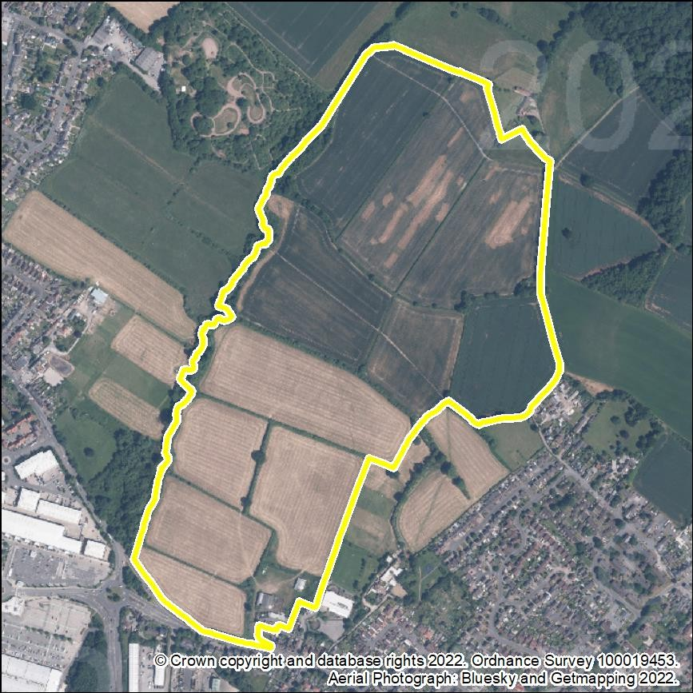

Stage 1 Assessment

Stage 1 Criteria | Details
Strategic Scale – Is the site greater than 25Ha? | Yes.  The site is approximately 50 ha.
Strategic Location – Is it within an Area of Opportunity | Yes, the site is located within an Area of Opportunity at junction 26 of the M1.
Strategic Highway Connections – Does the site have good connections to the highway network close to a junction with the M1 or long distance dual carriageway? | The owners/promoters advise:  “The site has good access to the strategic highway network with access on to the A610 dual carriageway, which is 2 miles to Junction 26 of the M1 Motorway.”
Stage 1 Conclusion | The site is identified as a reasonable alternative for further consideration because of its capacity, its location within an Area of Opportunity and its proximity to the A610/M1.

Stage 2 Assessment
General – floorspace, type of site, other assessments and viability

Stage 2 Criteria | Details
Site Size – Is the site 50ha or more? | Possibly – the figure given by the owners/promoters is 50 ha, Broxtowe’s measurement is 42.02 ha (including the smaller site BBC-L02b).
Estimated employment floorspace | Approximately 65,000 – 102,000 square metres, including smaller site, BBC-L02a.  (Owners/promoters’ estimate, i.e. “Circa 700,000 to 1,100,000 sq. ft.”)
Existing use | Agricultural.
Extension or new site | New site.
PDL or Greenfield | Greenfield land.
Relevant SHLAA or SHELAA conclusion | Parts of the site are assessed for housing in the current SHLAA as “could be suitable if policy changes”.

Stage 2 Criteria | Details
Relevant Growth Options Study Conclusions | Not in a ‘Potential Area for Strategic Growth’ (as defined at page 16 of the Study).
Viability and deliverability | The viability of the site would need to be considered through the preparation of a Plan Wide Viability assessment.  Owners/promoters advise that “the proposed scheme is deliverable and viable”.

Transport Infrastructure and Accessibility

Transport Infrastructure | Comments
Strategic highways – Good connection to the highway network close to a junction with the M1 or long distance dual carriageway | Adjacent to the A610 and close to junction 26 of the M1.  National Highways (NH) (formerly Highways England) advises that the development would be likely to be acceptable, subject to TA and any identified mitigation.  NH also advises that the scale of the development and distance from the SRN suggests the impact of the development on its own may not be significant. However, there is likely to be a cumulative impact when taking into account other developments also impacting on M1 J26.  Nottinghamshire County Council (NCC) advises that the preferred access point would be Gilt Hill and that the position of the access should avoid conflict with other junctions on the opposite side of the carriageway. Measures may be required to prevent HGVs from routing along the A608.  NCC also advises that it would be necessary to ensure that appropriate public transport infrastructure is provided to serve the site with suitable footway connections and crossings where necessary.  NCC advises that part of this site (site BBC-L02a) is “affected by tram extension”.
Rail network accessibility | No potential for rail network accessibility. The site is located  approximately 15 miles north of the East Midlands Gateway Logistics Park of Junction 24 of the M1.
Accessibility to labour – proximity to centres of population and ability to be served by public transport and active travel. | Adjacent to Kimberley/Nuthall, close to Awsworth, Eastwood and Nottingham.  Good ability to be served by public transport and active travel.  NCC mentions the possibility of a tram extension at some point.

Transport Infrastructure | Comments

Other Critical Infrastructure

Type | Comments
Utilities | Owners/promoters advise that there is “significant spare capacity available in the local network”.  No abnormal requirements have been identified by the Council, however further input would be required from consultees.
Blue and Green Infrastructure | On-site provision/enhancement would probably be preferable.  (The site includes part of a ‘Secondary Strategic Network’, as defined in the ‘Greater Nottingham Blue and Green Infrastructure Strategy January 2022’, and part of a ‘Secondary Green Infrastructure Corridor, as defined in the adopted Broxtowe Part 2 Local Plan.)
Other | 89% of the site is in a Coal Authority 'Development High Risk Area'.

Sustainability Appraisal

Objective | Score | Objective | Score
1. Housing | 0 | 9. Brownfield Land | --
2. Employment and Jobs | ++ | 10. Energy and Climate Change | ?
3. Economic Structure and Innovation | ++ | 11. Pollution and Air Quality | -
4. Shopping Centres | + | 12. Flooding and Water Quality | -
5. Health and Well Being | ++ | 13. Natural Environment, Biodiversity, Blue and Green Infrastructure | --
6. Community Safety | ? | 14. Landscape | --

Objective | Score | Objective | Score
7. Social Inclusion | ++ | 15. Built and Historic Environment | 0
8. Transport | ++ | 16. Natural Resources and Waste Management | -

Constraints and other considerations

Topic | Comments
Green Belt | The site falls within Broad Area 15: North of Gilt Hill in the ‘Green Belt Review Background Paper December 2022’. Score 12/22. Development would have a major impact on the Green Belt gap between Eastwood and Kimberley.
Agricultural Land | Yes.  Agricultural Land Classification Grade 4.
Land Contamination | “Site investigations are ongoing, but from initial assessments there are no known contamination issues that would preclude development.” (Owners/promoters’ description.)
Carbon Neutrality | Any development would be subject to full environmental analysis as part of the allocation and planning application process.
Impact on Air Quality | Not known at this stage.  The site is not part of an Air Quality Management Area.
Flood Risk | River Flooding:  2.58% (1.08ha) of site in Flood Zone 3 2.94% (1.23ha) of site in Flood Zone 2  Surface Water Flooding:  2.11% (0.89ha) of site in 1 in 30 year risk of surface water flooding  5.06% (2.13ha) of site in 1 in 100 year risk of surface water flooding  5.06% (2.13ha) of site in 1 in 1,000 year risk of surface water flooding  Ground Water Flooding:  8.26% (3.47ha) of site in < 25% (Clearwater and Superficial Deposits Flooding)
Natural Environment | Part of a Local Wildlife Site is within the site. There is a Local Geological Site and five Local Wildlife Sites close to the site.

Topic | Comments
Historic Environment | There are no Listed Buildings or Conservation Areas within or close to the site.
Landscape and topography | The site forms part of the ‘Selston and Eastwood Urban Fringe Farmland’ local landscape character area (moderate condition, moderate strength, ‘enhance’ landscape strategy). It lies on the eastern side of the Gilt Brook valley and development would be prominent in the landscape.
Regeneration | Close to Eastwood and Nottingham, both of which include areas of high deprivation.
Compatibility of surrounding uses | Residential properties adjacent.
Availability | Available: promoted through the ‘Call for Sites’.

Conclusions and recommendations

Is the site suitable for strategic? | The site is considered to be potentially suitable for strategic logistics development, however when compared against other sites, due to the absence of direct rail access or (very likely) tram access, the land is not a preferred location. The site is located 15 miles from the nearest rail freight interchange at Junction 24 of the M1.  This site (and site BBC-L02a) would however be more preferable than sites BBC-L04, BBC-L06 and BBC-L08 because of lesser anticipated impact on the highways network.

BBC-L04: Land at Kimberley Eastwood Bypass

Map
Aerial Image
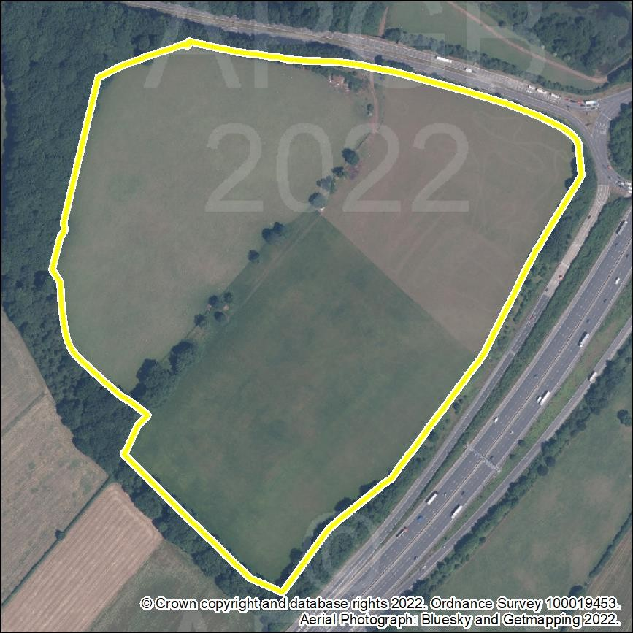

Stage 1 Assessment

Stage 1 Criteria | Details
Strategic Scale – Is the site greater than 25Ha? | No.  The site is 21.64 ha.
Strategic Location – Is it within an Area of Opportunity | Yes, the site is within the Area of Opportunity around junction 26 of the M1.
Strategic Highway Connections – Does the site have good connections to the highway network close to a junction with the M1 or long distance dual carriageway? | The owners/promoters advise that “the site benefits from exceptional connections with the strategic highway network. It sits immediately adjacent to J26 of the  M1 and the A610.”
Stage 1 Conclusion | The site is identified as a reasonable alternative for further consideration because of its size, location within an Area of Opportunity and proximity to the A610 and M1.

Stage 2 Assessment
General – floorspace, type of site, other assessments and viability

Stage 2 Criteria | Details
Site Size – Is the site 50ha or more? | 21.64 ha.  The site is not over 50 ha in size.
Estimated employment floorspace | 77,000 square metres. (Based on an assumption of 3,500 square metres per hectare.)
Existing use | Agricultural.
Extension or new site | New site.
PDL or Greenfield | Greenfield land.
Relevant SHLAA or SHELAA conclusion | Not included in the current SHLAA. No S(H)ELAA completed.
Relevant Growth Options Study  Conclusions | Not in a ‘Potential Area for Strategic Growth’ (as defined at page 16 of the Study).

Stage 2 Criteria | Details
Viability and deliverability | The viability of the site would need to be considered through the preparation of a Plan Wide Viability assessment.  Owners/promoters advise that “there are no constraints that would render the site unviable”.
Transport Infrastructure and Accessibility

Transport Infrastructure | Comments
Strategic highways – Good connection to the highway network close to a junction with the M1 or long distance dual carriageway | Adjacent to the A610 and junction 26 of the M1.  National Highways (NH) (formerly Highways England) advises that mitigation is likely to be required.  NH also advises that the scale of development and distance from M1 J26 suggest that there will be a significant (cumulative) impact and off-site highways mitigation at M1 J26 may be required. National Highways’ preferred approach to highways mitigation is via a Section 278 whereby highways infrastructure improvements are designed, delivered, and funded by the applicant.  Nottinghamshire County Council (NCC) advises that there is a significant level difference between the site and A610 that could make it difficult to form an access. Any new junction is likely to be a left in/left out which will direct traffic towards Giltbrook Interchange which is not ideal. The close proximity of the site access and J26 may increase the likelihood of collisions / compromise performance.  NCC also has concerns regarding the absence of any footway leading directly to the site, and would not encourage cycling along the A610. It is not clear how the development will prioritise the needs of pedestrians/cyclists and is therefore considered by NCC to be contrary to the NPPF.
Rail network accessibility | No potential for rail network accessibility. The site is 13 miles north of the nearest rail freight interchange at the East  Midlands Gateway Logistics Park of junction 24 of the M1.
Accessibility to labour – proximity to centres of population and ability to be served by public transport and active travel. | In close proximity to Nottingham and Nuthall/Kimberley, also close to Eastwood but separated by the M1 to the east and A610 to the north.  Close to good public transport services, however access to them is currently difficult. Opportunities for active travel seem limited.

Other Critical Infrastructure

Type | Comments
Utilities | Owners/promoters advise:  “There are no known utility infrastructure constraints that would preclude delivery of development at this  location. Western Power Distribution (WPD) have confirmed that a 5.5MVA transformer can be  provided.”  No abnormal requirements have been identified by the Council, however further input would be required from consultees.
Blue and Green Infrastructure | On-site provision/enhancement would probably be preferable.  (Elements of the ‘Secondary Strategic Network’, as defined in the ‘Greater Nottingham Blue and Green Infrastructure Strategy January 2022’, adjoin the site, as does a ‘Secondary Green Infrastructure Corridor’, as defined in the adopted Broxtowe Part 2 Local Plan.)
Other | Less than 1% of the site is within a Coal Authority 'Development High Risk Area'.

Sustainability Appraisal

Objective | Score | Objective | Score
1. Housing | 0 | 9. Brownfield Land | --
2. Employment and Jobs | + | 10. Energy and Climate Change | ?
3. Economic Structure and Innovation | + | 11. Pollution and Air Quality | ?
4. Shopping Centres | 0 | 12. Flooding and Water Quality | ++
5. Health and Well Being | 0 | 13. Natural Environment, Biodiversity, Blue and Green Infrastructure | -
6. Community Safety | ? | 14. Landscape | -
7. Social Inclusion | 0 | 15. Built and Historic Environment | ?

Objective | Score | Objective | Score
8. Transport | -- | 16. Natural Resources and Waste Management | --

Constraints and other considerations

Topic | Commentary
Green Belt | The site falls within Broad Area 19: East of Park Avenue / Knowle Lane in the ‘Green Belt Review Background Paper December 2022’. Score 15/20. Development would have a major impact on the Green Belt gap between the main built- up area of Nottingham and the built-up area of Kimberley/Watnall/Nuthall.
Agricultural Land | Yes.  Agricultural Land Classification: 48% Grade 4, 52% Grade 2.
Land Contamination | None known.
Carbon Neutrality | Any development would be subject to full environmental analysis as part of the allocation and planning application process.
Impact on Air Quality | Not known at this stage.  The site is not part of an Air Quality Management Area.
Flood Risk | River flooding: The site is in Flood Zone 1.  Less than 1% of the site is at any identified risk of surface water flooding.
Natural Environment | A small part of a Local Wildlife Site is within the site and three Local Wildlife Sites are within 250m of the site.
Historic Environment | Nuthall Conservation Area is within 50m of the site and a Grade II Listed Building is within 250m of the site.
Landscape and topography | The site forms part of the ‘Nuthall Lowland, Wooded Farmland’ local landscape character area (moderate condition, moderate strength, ‘enhance’ landscape strategy).
Regeneration | Almost adjacent to Nottingham (although difficult to access) and close to Eastwood, both of which include areas of high deprivation.
Compatibility of surrounding uses | No residential properties in the immediate vicinity.

Topic | Commentary
Availability | Available: promoted through the ‘Call for Sites’.

Conclusions and recommendations

Is the site suitable for strategic? | Although located adjacent to Junction 26 of the M1, the site is not potentially suitable, and compared to other sites in the vicinity of this junction, the land is not a preferred location for strategic logistics development. The land is smaller in size (21 ha) and there is an absence of pedestrian or cycling access, and potential rail or tram access. Highways access is more problematic due to the elevation of the site, the limited left turn only junction on the A610 and its proximity to the M1 roundabout. The site is located 13 miles from the nearest rail freight interchange at Junction 24 of the M1.  Among the sites in Broxtowe, this site is the lowest preference, having regard to anticipated issues with  vehicular, pedestrian and cycle access.

BBC-L05: Land at Low Wood Road, Nuthall

Map
Aerial Image
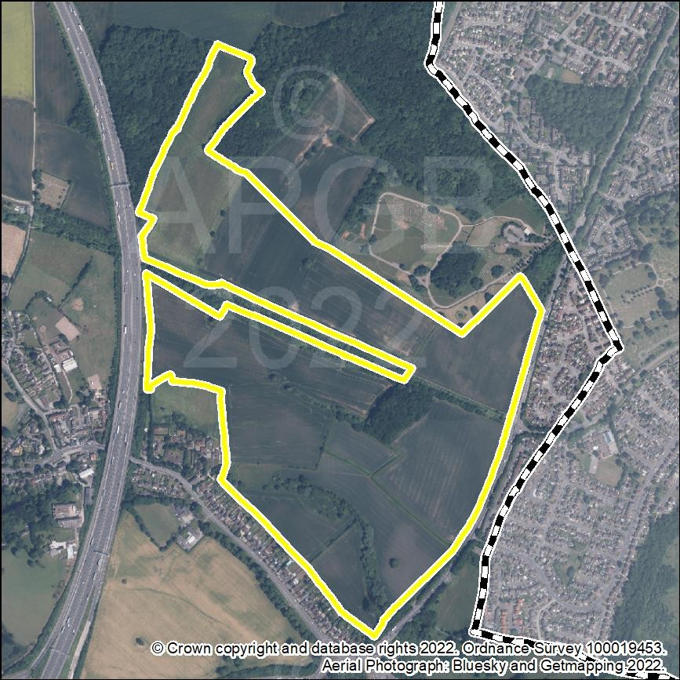

Stage 1 Assessment

Stage 1 Criteria | Details
Strategic Scale – Is the site greater than 25Ha? | Yes.  The site covers 57.22 ha.
Strategic Location – Is it within an Area of Opportunity | Yes, the site is located close to Junction 26 which is an Area of Opportunity.
Strategic Highway Connections – Does the site have good connections to the highway network close to a junction with the M1 or long distance dual carriageway? | The owners/promoters advise:  “The site immediately adjoins the A610 off the two proposed access roads which connects the site to the M1 at Junction  26. Junction modelling undertaken by our Transport Consultant indicates that there is sufficient capacity within the existing junctions within the vicinity of the site.”
Stage 1 Conclusion | The site is identified as a reasonable alternative for further consideration because of its capacity, location within an Area of Opportunity and its connectivity to the  A610 and M1.

Stage 2 Assessment

General – floorspace, type of site, other assessments and viability

Stage 2 Criteria | Details
Site Size – Is the site 50ha or more? | 57.22 ha  The site is over 50 ha in size.  Note: The size of this site has been reduced, by the promoters, since the Stage 1 assessment.
Estimated employment floorspace | Approximately 154,000 square metres. (Owners/promoters estimate, i.e. “1,655,000 sqf”.)
Existing use | Agricultural.
Extension or new site | New site.
PDL or Greenfield | Greenfield.
Relevant SHLAA or SHELAA conclusion | Not included in the current SHLAA. No S(H)ELAA completed.

Stage 2 Criteria | Details
Relevant Growth Options Study Conclusions | Not in a ‘Potential Area for Strategic Growth’ (as defined at page 16 of the Study).
Viability and deliverability | The owners/promoters advise:  “The site is viable to deliver as both a mixed use B8 logistics park with residential to the northern land parcel [now the whole proposed site] or a totally employment / logistics led scheme. The provision of infrastructure such as the Park and Ride and NET extension is viable to deliver as part of the development proposals, subject to a sufficient strategic quantum of development being provided for.”  The viability of the site would need to be considered through the preparation of a Plan Wide Viability assessment.

Transport Infrastructure and Accessibility

Transport Infrastructure | Commentary
Strategic highways – Good connection to the highway network close to a junction with the M1 or long distance dual carriageway | Close to the A610 and to junction 26 of the M1.  National Highways (NH) (formerly Highways England) advises that mitigation is likely to be required.  NH also advises that the scale of development and distance from M1 J26 suggest that there will be a significant (cumulative) impact and off-site highways mitigation at M1 J26 may be required. National Highways’ preferred approach to highways mitigation is via a Section 278 whereby highways infrastructure improvements are designed, delivered, and funded by the applicant.  Nottinghamshire County Council (NCC) advises that the preferred access point is Low Wood Road and that the proposal should seek to minimise the impact of development traffic on the amenity of residents along Nottingham Road.  NCC also advises that it would be necessary to ensure that appropriate public transport infrastructure is provided to serve the site with suitable footway connections and crossings where necessary. Cycling infrastructure should be delivered to “LTN 1/20 standard”.  NCC advises that the site is “affected by tram extension”.
Rail network accessibility | No potential for rail network accessibility. The site is approximately 13 miles north of the East Midlands Gateway  Logistics Park.
Accessibility to labour – proximity to centres of  population and ability to | Adjacent to Nottingham and Nuthall/Kimberley, also close to Eastwood.

Transport Infrastructure | Commentary
be served by public transport and active travel. | Good ability to be served by public transport and active travel.  NCC mentions the possibility of a tram extension at some point.

Other Critical Infrastructure

Type | Commentary
Utilities | The owners/promoters advise:  “There is an existing intermediate pressure gas pipeline that crosses the site. This would either be retained with the required easement or diverted as part of the development proposals.  There is sufficient provision for electricity capacity and high speed broadband in the area.”  No abnormal requirements have been identified by the Council, however further input would be required from consultees.
Blue and Green Infrastructure | On-site provision/enhancement would probably be preferable.  (The site includes parts of ‘Primary and Secondary Strategic Networks’, as defined in the ‘Greater Nottingham Blue and Green Infrastructure Strategy January 2022’, and parts of ‘Primary and Secondary Green Infrastructure Corridors’, as defined in the adopted Broxtowe Part 2 Local Plan.)
Other | Part of the site is 'safeguarded' for HS2.

Sustainability Appraisal

Objective | Score | Objective | Score
1. Housing | 0 | 9. Brownfield Land | --
2. Employment and Jobs | ++ | 10. Energy and Climate Change | ?
3. Economic Structure and Innovation | ++ | 11. Pollution and Air Quality | -

Objective | Score | Objective | Score
4. Shopping Centres | + | 12. Flooding and Water Quality | 0
5. Health and Well Being | + | 13. Natural Environment, Biodiversity, Blue and Green Infrastructure | --
6. Community Safety | ? | 14. Landscape | -
7. Social Inclusion | ++ | 15. Built and Historic Environment | ?
8. Transport | ++ | 16. Natural Resources and Waste Management | --

Constraints and other considerations

Topic | Commentary
Green Belt | The site falls within Broad Area 24: ‘Area between dismantled railway line and Nottingham Road Nuthall’ in the ‘Green Belt Review Background Paper December 2022’.  Score 11/20. Development of parts of the site would have a major impact on the Green Belt gap between the main built- up area of Nottingham and the built-up area of Kimberley/Watnall/Nuthall. Development of any of the site would have a substantial impact on this gap.
Agricultural Land | Predominantly agricultural.  Agricultural Land Classification: 73% Grade 3, 26% Grade 2,  1% ‘urban’.
Land Contamination | None known.
Carbon Neutrality | The development would be subject to full environmental analysis as part of the allocation and planning application process.
Impact on Air Quality | Not known at this stage.  The site is not part of an Air Quality Management Area.
Flood Risk | Approximately 12% of the site is at risk of surface water flooding and less than 1% is at risk of either river or ground water flooding.
Natural Environment | Two Local Wildlife Sites (LWSs) and a small area of ancient woodland are within the site. A Site of Special Scientific

Topic | Commentary
 | Interest is within 50m of the site and six LWSs are within 250m it.
Historic Environment | Nuthall Conservation Area is within 100m of the site and 7 Listed Buildings (Grade II) are within 250m of the site.
Landscape and topography | The site forms part of the ‘Nuthall Lowland, Wooded Farmland’ local landscape character area (moderate condition, moderate strength, ‘enhance’ landscape strategy).
Regeneration | Adjacent to Nottingham and close to Eastwood, both of which include areas of high deprivation.
Compatibility of surrounding uses | Residential properties are adjacent to parts of the site.
Availability | Available: promoted through the ‘Call for Sites’.

Conclusions and recommendations

Is the site suitable for strategic? | The site is considered to be potentially suitable for strategic logistics development.  This is provided that any development incorporates a tram extension that would serve the site and beyond.  Among the sites in Broxtowe, this site is the second preference. It is less preferable than site BBC-L01 because of the absence of potential rail access. It is more preferable than the other options because of the potential for tram access, which, if delivered in the future, would have benefits for carbon reduction and would reduce adverse impacts on the A610 roundabout.

BBC-L06: Land at New Farm, Nuthall

Map
Aerial Image
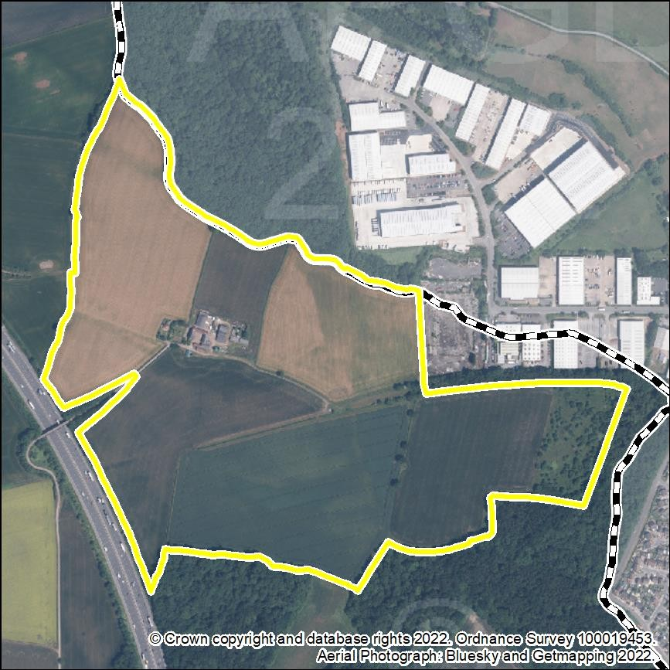

Stage 1 Assessment

Stage 1 Assessment | Details
Strategic Scale – Is the site greater than 25Ha? | Yes.  The site is 40.90 ha.
Strategic Location – Is it within an Area of Opportunity | Yes, the site is located within an Area of Opportunity around Junction 26 of the M1.
Strategic Highway Connections – Does the site have good connections to the highway network close to a junction with the M1 or long distance dual carriageway? | The owners/promoters advise:  “Access to Blenheim Industrial Park, connecting to Low Wood Road (A6002) which connects to the A610 and M1 motorway. Approximately 3.7km (6 minute drive) from the M1 J26 via good quality roads.”
Stage 1 Conclusion | The site is identified as a reasonable alternative for further consideration because of its capacity, its location within an Area of Opportunity, and its proximity to the M1 and A610.

Stage 2 Assessment
General – floorspace, type of site, other assessments and viability

Stage 2 Criteria | Details
Site Size – Is the site 50ha or more? | 40.90 ha.  The site is not over 50 ha in size.
Estimated employment floorspace | Up to approximately 88,000 square metres. (Owners/promoters’ estimate, i.e. “up to 950,000 sqft”.)
Existing use | Agricultural.
Extension or new site | New site for logistics (as an extension to the existing industrial estate).
PDL or Greenfield | Greenfield land.
Relevant SHLAA or SHELAA conclusion | Not included in the current SHLAA. No S(H)ELAA completed.
Relevant Growth  Options Study Conclusions | Not in a ‘Potential Area for Strategic Growth’ (as defined at page 16 of the Study).

Stage 2 Criteria | Details
Viability and deliverability | The owners/promoters advise: “Site considered viable for major industrial and logistics use”.  The viability of the site would need to be considered through the preparation of a Plan Wide Viability assessment.

Transport Infrastructure and Accessibility

Transport Infrastructure | Commentary
Strategic highways – Good connection to the highway network close to a junction with the M1 or long distance dual carriageway | Close to the A610 and to junction 26 of the M1.  National Highways (NH) (formerly Highways England) advises that mitigation is likely to be required.  NH also advises that the scale of development and distance from M1 J26 suggest that there will be a significant (cumulative) impact and off-site highways mitigation at M1 J26 may be required. National Highways’ preferred approach to highways mitigation is via a Section as a location for strategic distribution and 278 whereby highways infrastructure improvements are designed, delivered, and funded by the applicant.  Nottinghamshire County Council (NCC) comments that the City Council will be able to advise on matters such as the preferred access point, routing and sustainable travel.
Rail network accessibility | No potential for rail network accessibility.
Accessibility to labour – proximity to centres of population and ability to be served by public transport and active travel. | Adjacent to Nottingham, also close to Hucknall and Nuthall/Kimberley.  Reasonable ability to be served by public transport and active travel.
Other Critical Infrastructure

Type | Commentary
Utilities | The owners/promoters advise: “Propose to connect to existing utilities – capacities to be reviewed”.  No abnormal requirements have been identified by the Council, however further input would be required from consultees.

Type | Commentary
Blue and Green Infrastructure | On-site provision/enhancement would probably be preferable.  (The site includes parts of ‘Secondary Green Infrastructure Corridors’, as defined in the adopted Broxtowe Part 2 Local Plan.)
Other | Part of the site is 'safeguarded' for HS2.

Sustainability Appraisal

Objective | Score | Objective | Score
1. Housing | 0 | 9. Brownfield Land | --
2. Employment and Jobs | ++ | 10. Energy and Climate Change | ?
3. Economic Structure and Innovation | ++ | 11. Pollution and Air Quality | -
4. Shopping Centres | + | 12. Flooding and Water Quality | ++
5. Health and Well Being | + | 13. Natural Environment, Biodiversity, Blue and Green Infrastructure | --
6. Community Safety | ? | 14. Landscape | -
7. Social Inclusion | ++ | 15. Built and Historic Environment | ?
8. Transport | ++ | 16. Natural Resources and Waste Management | --

Constraints and other considerations

Topic | Commentary
Green Belt | The site falls partly within Broad Area 23: ’Area between Long Lane and dismantled railway line adjacent to Blenheim Industrial Estate’ and partly within Broad Area 24: ‘Area between dismantled railway line and Nottingham Road Nuthall’ in the ‘Green Belt Review Background Paper December 2022’. Scores 12/20 and 11/20 respectively.  Development would have a substantial impact on the Green

Topic | Commentary
 | Belt gap between the main built-up area of Nottingham and the built-up area of Kimberley/Watnall/Nuthall.
Agricultural Land | Yes.  Agricultural Land Classification: 55% Grade 2, 45% Grade 3.
Land Contamination | The owners/promoters advise: “None reported”.  Less than 1% of the site is part of a Historic Landfill Site.
Carbon Neutrality | Any development would be subject to full environmental analysis as part of the allocation and planning application process.
Impact on Air Quality | Not known at this stage.  The site is not part of an Air Quality Management Area.
Flood Risk | Less than 1% of the site is at risk from surface water flooding.  39% of the site is at identified risk of ground water flooding.
Natural Environment | There are two Sites of Special Scientific Interest (Seller’s Wood and Bulwell Wood) adjacent to the site.  There is one Local Wildlife Site within the site and four within 250m of the site.
Historic Environment | There are no Listed Buildings or Conservation Areas within or close to the site.
Landscape and topography | The site forms part of the ‘Nuthall Lowland, Wooded Farmland’ local landscape character area (moderate condition, moderate strength, ‘enhance’ landscape strategy).
Regeneration | Adjacent to Nottingham, which includes areas of high deprivation.
Compatibility of surrounding uses | There are no residential properties directly adjacent to the site.
Availability | Available: promoted through the ‘Call for Sites’.

Conclusions and recommendations

Is the site suitable for strategic? | The site is not considered to be potentially suitable for  strategic logistics development, because of the site’s distance from the strategic road network, cumulative impacts

on the highway network, and absence of potential rail or tram access.
This site (and site BBC-L08) would however be more preferable than site BBC-L04, which is located south west of Junction 26, because of fewer anticipated issues with
vehicular, pedestrian and cycle access.

BBC-L08: Land to south-east of junction 26 of M1, Nuthall

Map
Aerial Image
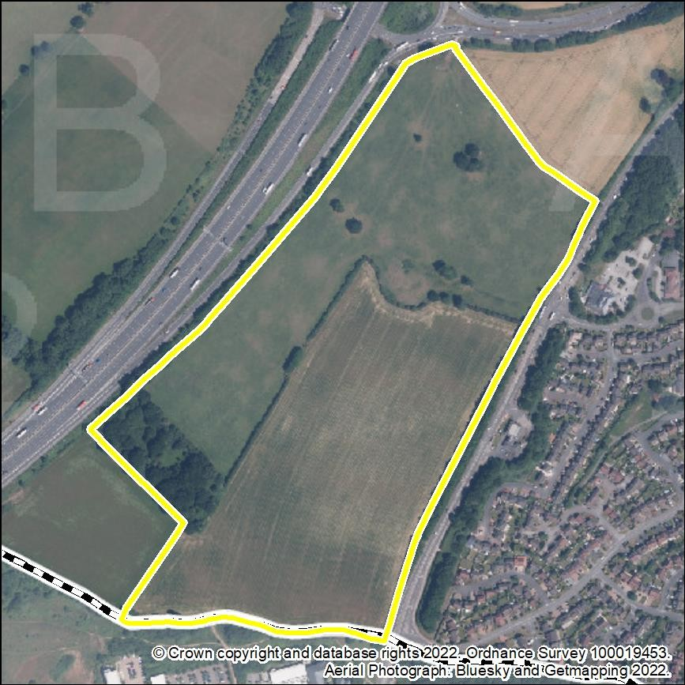

Stage 1 Assessment

Stage 1 Criteria | Details
Strategic Scale – Is the site greater than 25Ha? | Yes.  The site is 25.01 ha.
Strategic Location – Is it within an Area of Opportunity | Yes, the site is within an Area of Opportunity around junction 26 of the M1.
Strategic Highway Connections – Does the site have good connections to the highway network close to a junction with the M1 or  long distance dual carriageway? | The owners/promoters advise that: “Access would be via the A6002, which connects to junction 26 of the M1”.
Stage 1 Conclusion | The site is identified as a reasonable alternative for further consideration because of its capacity, its location within an Area of Opportunity and its proximity to the M1 and A610.

Stage 2 Assessment
General – floorspace, type of site, other assessments and viability

Stage 2 Assessment | Details
Site Size – Is the site 50ha or more? | 25.01 ha.  The site is not over 50 ha in size.
Estimated employment floorspace | Approximately 83,000 square metres. (Owners/promoters’ estimate, i.e. “895,000 square feet”.) (Owners/promoters describe this as being for “industrial / logistics”.)
Existing use | Agricultural.
Extension or new site | New site.
PDL or Greenfield | Greenfield land.
Relevant SHLAA or SHELAA conclusion | The site is assessed for housing in the current SHLAA as “Could be suitable if policy changes”.
Relevant Growth Options Study  Conclusions | Not in a ‘Potential Area for Strategic Growth’ (as defined at page 16 of the Study).

Stage 2 Assessment | Details
Viability and deliverability | The viability of the site would need to be considered through the preparation of a Plan Wide Viability assessment.  The owners/promoters advise that: “The landowners own the freehold of the site and are confident that a viable scheme can be brought forward.”

Transport Infrastructure and Accessibility

Transport Infrastructure | Commentary
Strategic highways – Good connection to the highway network close to a junction with the M1 or long distance dual carriageway | Adjacent to the A610 and to junction 26 of the M1.  National Highways (NH) (formerly Highways England) advises that mitigation is likely to be required.  NH also advises that the scale of development and distance from M1 J26 suggest that there will be a significant (cumulative) impact and off-site highways mitigation at M1 J26 may be required. National Highways’ preferred approach to highways mitigation is via a Section 278 whereby highways infrastructure improvements are designed, delivered, and funded by the applicant.  Nottinghamshire County Council (NCC) advises that the preferred access point would be Mornington Crescent. Traffic would be expected to utilise the M1/A610/A6002.  NCC also advises that it would be necessary to ensure that appropriate public transport infrastructure is provided to serve the site with suitable footway connections and crossings where necessary. Cycling infrastructure should be delivered to “LTN 1/20 standard”.
Rail network accessibility | No potential for rail network accessibility. The site is  approximately 13 miles north, along the M1, of the East Midlands Gateway railway interchange.
Accessibility to labour – proximity to centres of population and ability to be served by public transport and active travel. | Adjacent to Nuthall, very close to Nottingham and Kimberley, also close to Eastwood.  Good ability to be served by public transport and active travel.

Other Critical Infrastructure

Infrastructure Type | Commentary
Utilities | The owners/promoters advise:

Infrastructure Type | Commentary
“A water main is proposed to run along the eastern boundary of the site and can be satisfactorily accommodated into the layout for the redevelopment of the site.”
No abnormal requirements have been identified by the Council, however further input would be required from consultees.
Blue and Green Infrastructure | On-site provision/enhancement would probably be preferable.  (The site includes part of a ‘Secondary Strategic Network’, as defined in the ‘Greater Nottingham Blue and Green Infrastructure Strategy January 2022’, and part of a ‘Secondary Green Infrastructure Corridor’, as defined in the adopted Broxtowe Part 2 Local Plan.)
Other | Part of the site is 'safeguarded' for HS2.  9% of the site is in a Coal Authority 'Development High Risk Area'.

Sustainability Appraisal

Objective | Score | Objective | Score
1. Housing | 0 | 9. Brownfield Land | --
2. Employment and Jobs | ++ | 10. Energy and Climate Change | ?
3. Economic Structure and Innovation | ++ | 11. Pollution and Air Quality | ?
4. Shopping Centres | + | 12. Flooding and Water Quality | ++
5. Health and Well Being | ++ | 13. Natural Environment, Biodiversity, Blue and Green Infrastructure | --
6. Community Safety | ? | 14. Landscape | -
7. Social Inclusion | ++ | 15. Built and Historic Environment | ?
8. Transport | ++ | 16. Natural Resources and Waste Management | --

Constraints and other considerations

Topic | Commentary
Green Belt | The site falls within Broad Area 25: ‘Land between Nottingham Business Park and Nottingham Road Nuthall’ in the ‘Green Belt Review Background Paper December 2022’. Score 11/20. Development would have a major impact on the Green Belt gap between the main built-up area of Nottingham and the built-up area of Kimberley/Watnall/Nuthall.
Agricultural Land | Yes.  Agricultural Land Classification: 71% Grade 2, 29% Grade 4.
Land Contamination | The owners/promoters advise:  “Historic mine shafts are present. An indicative layout for the site has been produced to assess the overall capacity of the site which includes 15 metre stand-offs from each of the mine shafts on site. This will allow remediation / capping.”
Carbon Neutrality | Any development would be subject to full environmental analysis as part of the allocation and planning application process.
Impact on Air Quality | Not known at this stage.  The site is not part of an Air Quality Management Area.
Flood Risk | The site is not at any significant identified risk of any form of flooding.
Natural Environment | There is a Local Wildlife Site within the site and two within 250m of it.
Historic Environment | Nuthall Conservation Area is within 250m of the site.
Landscape and topography | The site forms part of the ‘Nuthall Lowland, Wooded Farmland’ local landscape character area (moderate condition, moderate strength, ‘enhance’ landscape strategy).
Regeneration | Adjacent to Nottingham and close to Eastwood, both of which include areas of high deprivation.
Compatibility of surrounding uses | There are no residential properties directly adjacent to the site, however there are many residential properties on the opposite side of the A6002.
Availability | Available: promoted through the ‘Call for Sites’.

Conclusions and recommendations

Is the site suitable for strategic? | The site is potentially suitable, however because of sites size and the absence of potential rail or tram access it is not a preferred site.  This site (and site BBC-L06 to the north) would however be more preferable than site BBC-L04 (located on the opposite side of the M1) because of fewer anticipated issues with vehicular, pedestrian and cycle access.

Erewash
EBC-L01: Stanton North

Map
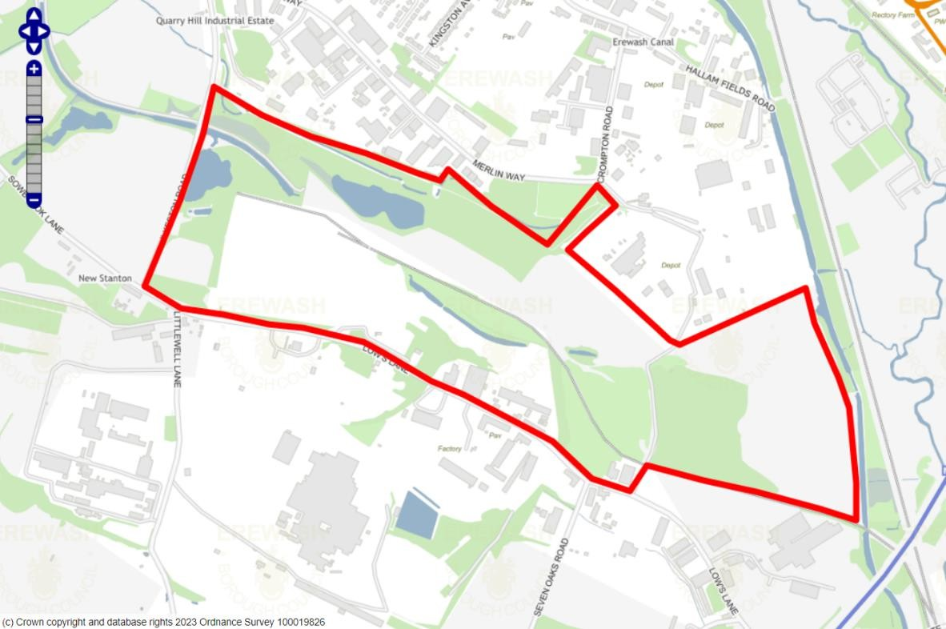
Aerial Image
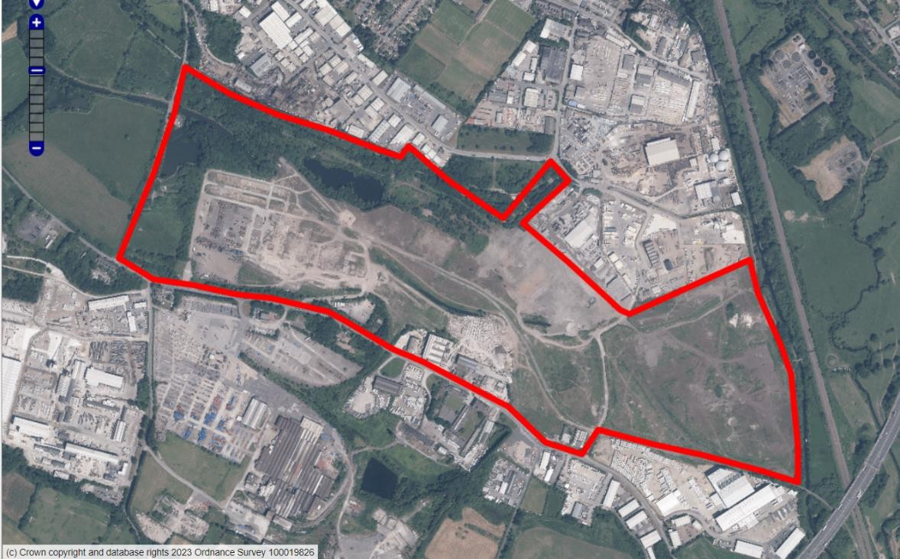

Stage 1 Assessment

Stage 1 Criteria | Details
Strategic Scale – Is the site greater than 25Ha? | Yes, the site is a strategic employment allocation in the draft Erewash Core Strategy Review. It is approximately 80 hectares in size.  An outline planning permission for a maximum of 261,241sqm of mixed employment floorspace was granted in 2022 as part of ERE/1221/0002. The logistics/B8 component will be determined through a reserved matters application.
Strategic Location – Is the site within an Area of Opportunity? | No – the site is located north of Area of Opportunity 3 (Para 10.8 of the Report) identified around J25 of the M1 which also stretches east and west along the A52 corridor.
Strategic Highway Connections – Does the site have good connections to the highway network close to a junction with the M1 or long distance dual carriageway? | Whilst the site is in very close proximity to the M1 motorway, vehicular access is more indirect, with road connections to the strategic highway network needing to be taken through Sandiacre to access J25.
Conclusion – Is the site a reasonable alternative that is carried forward to a Stage 2 Assessment? | The site is identified as a reasonable alternative for further consideration because of its size, its location on the edge of an Area of Opportunity (as identified in the Logistics Study), its location adjacent to the M1 and the planning status of the site now it benefits from an outline consent for mixed employment uses.

Stage 2 Assessment
General – floorspace, type of site, other assessments and viability

Stage 2 Criteria | Details
Site Size – Is the site 50ha or more? | Yes, the site is circa 80 hectares with around 26 hectares net developable area (as confirmed by the outline permission.  The wider site contains areas for landscaping, parking and service areas.
Estimated employment floorspace | 261,241 sqm approved via ERE/1221/0002. Logistics element is unconfirmed, although masterplans show a significant element of floorspace intended for B8 uses.
Existing use | Cleared, vacant former industrial land.
Extension or new site | This has formed part of a long-standing Local Plan allocation spanning several documents, firstly as protected industrial

Stage 2 Criteria | Details
 | land and more recently as part of a wider mixed-use regeneration site. It is classed as a new site for the purposes of this study as it is now a standalone strategic employment allocation with plans to deliver large-scale logistics facilities.
PDL or Greenfield | PDL
Relevant SHLAA or SHELAA conclusion | A portion of the site was assessed in the Nottingham Core and Outer HMAs Employment Land Needs Study with it concluded as being of ‘poor/average’ quality. However, the site was recommended to remain identified for an employment use. The site has not been assessed in a recent SHLAA or a SHELAA.
Relevant Growth Options Study Conclusions | The site formed part of an area assessed within the AECOM Growth Options Study (E07: Stanton Extension) with the conclusion that there was low potential for strategic housing growth. The site sits outside of the five ‘Areas of Opportunity’ identified by the Iceni Logistics Study, although geographically close to the M1, the lack of direct vehicular accessibility has always proven problematic in unlocking the site’s fullest potential.
Viability and deliverability | With an outline planning consent now in place, this confirms the site’s deliverability with site owners committed to developing a range of employment facilities at the site. The investment made in clearing the site of redundant structures reaffirms the site owners’ commitment to providing logistics space at this location.

Transport Infrastructure and Accessibility

Transport Infrastructure | Commentary
Strategic highways – Good connection to the highway network close to a junction with the M1 or long distance dual carriageway | Adjacent to the M1, but without any direct access to the motorway. Nearest route to the strategic road network (SRN) (M1 & A52) is via Sandiacre and totals 2.6 miles in length.  Considered ‘Very poor’ for access to the SRN in the Employment Land Needs Study. With outline consent achieved, highway impacts arising from future development have been considered as acceptable by National Highways.
Rail network accessibility | The site benefits greatly from direct rail connectivity to the Erewash Valley mainline railway running just east of Stanton North. A legacy of the site’s previous industrial operations saw it linked to the mainline through a short section of rail spur. Whilst the spur has been closed in recent decades, development will see it reinstated to enable freight movements into and out of the site.

Transport Infrastructure | Commentary
Accessibility to labour – proximity to centres of population and ability to be served by public transport and active travel. | The site is within the main built-up area of Ilkeston which has a significant pool of potential labour. Whilst connectivity between the site and the residential areas of the town is currently poor, improvements in Green Infrastructure being established through the Stanton North development will provide better access for prospective workers.
Other Critical Infrastructure

Type | Comments
Utilities | Electricity - No abnormal requirements.  Waste Water – Hydraulic modelling required to confirm connection locations.  Water Supply - no abnormal requirements. Gas - no abnormal requirements.  IT - no abnormal requirements
Blue and Green Infrastructure | Site currently private and has no open public access. Some non-statutory wildlife assets across the site. Three local wildlife sites within the site boundaries.  Minimum 10% Biodiversity net gain has been negotiated to be delivered off-site.
Other | New junctions joining to Lows Lane to enable appropriate vehicular access into the site are to be provided through its development.

Sustainability Appraisal

Objective | Score | Objective | Score
1. Housing | +2 | 9. Brownfield Land | +3
2. Employment and Jobs | +3 | 10. Energy and Climate Change | +3
3. Economic Structure and Innovation | +5 | 11. Pollution and Air Quality | -1
4. Shopping Centres | +1 | 12. Flooding and Water Quality | -2
5. Health and Well Being | 0 | 13. Natural Environment, Biodiversity, Blue and Green Infrastructure | +5

Objective | Score | Objective | Score
6. Community Safety | +2 | 14. Landscape | +2
7. Social Inclusion | +2 | 15. Built and Historic Environment | +1
8. Transport | 0 | 16. Natural Resources and Waste Management | -1
Please note that:
- Erewash Borough Council SA has a different scoring methodology to the Greater Nottingham SA.
- The SA was undertaken as part of the Proposed Core Strategy 2022. It does not take into account representations during consultation and evidence concerning Heritage Impact Assessment, Habitat Regulations Assessment and Whole Plan Viability.

Constraints and other considerations

Topic | Commentary
Green Belt | Site is not in the Green Belt.
Agricultural Land | No
Land Contamination | Known land contamination. Contamination due to former use as part of a wider ironworks facility spanning larger area.  Historic uses necessitate remediation works, although a remediation strategy has been approved as part of the site’s outline consent.
Carbon Neutrality | The development has been subject to full environmental analysis as part of the design and planning application process.  Energy use – the site is located with the full range of services and facilities and consequently scope to minimise the need to travel and therefore more potential to reduce energy use and greenhouse gas emissions from more sustainable means of travel.
Impact on Air Quality | The Stanton North site does not form any part of an Air Quality Management Area. Development would not be expected to cause additional harm to the scale where the designation of an AQMA would be necessary. Impacts on air quality have been addressed through the planning application process, with the local planning authority satisfied development would not be detrimental.
Flood Risk | The site is impacted by higher vulnerability areas of flood risk. This is notably along the northern boundary which broadly follows the Nut Brook which is culverted in sections.  Small areas of Flood Zone 3b (functional flood plain), 3a and

Topic | Commentary
 | 2 penetrate into the site – although areas vulnerable to flooding have influenced the proposed site layout and will be incorporated into a sympathetic design.
Natural Environment | Large parts of the site have seen self-seeding shrub and grass coverage emerge as a consequence of its post- industrial status. Two Local Wildlife Sites (ER188 – Ilkeston Road Pond & Nutbrook Canal and ER217 – Stanton Ironworks) are contained entirely within the boundaries of the site. Two further LWSs (ER201 – Quarry Hill Lagoons & ER215 – Erewash Canal) directly adjoins the site on the northern and eastern boundaries.
Historic Environment | Two buildings, one on-site (3 & 4 Low’s Lane) and one immediately adjacent (Saint Gobain Main Offices), are on the Local Buildings of Interest List.  A Heritage Impact Assessment has been undertaken to support the allocation of the site as part of the Core Strategy Review with no adverse impacts being identified by the work.
Landscape and topography | The landscape is characterised as post-industrial/urban with the site comprising vacant and cleared land formerly accommodating parts of the Ironworks facility. General topography is largely even, with some undulations evident along the northern boundary of the site.
Regeneration | The site, whilst located within an SOA which ranks low on the index of highest deprivation, is surrounded by several areas where deprivation is noticeably higher and are categorised within the top 10% and 20% of deprived areas in the country.
Compatibility of surrounding uses | Site is close to the Quarry Hill Industrial Estate, a strategic employment location site, which is located just north of Stanton North. Other, more modern industrial uses of a non- strategic scale are located south and south-west. New logistics uses at the site would complement the diverse employment uses just beyond the boundaries.
Availability | As demonstrated by the application for, and subsequent granting of, outline planning consent, the site is under the control of owners who are committed to developing a strategic-scale employment facility.

Conclusions and recommendations

Is the site suitable for strategic distribution? | This site has been identified as a site which should be considered further by Stage 2, largely as a consequence of its planning status which sees the site benefit from outline  permission for a strategic scale of new employment land and premises. Given the site’s current planning status, there is an

acceptance by the local planning authority of the site’s suitability to deliver an as-yet unspecified scale of B8 logistics floorspace. This has been further strengthened by the site’s inclusion as a strategic employment site in the Erewash Core Strategy Review.
Where constraints have been flagged by the assessment, in most instances these have either been overcome to the satisfaction of the local planning authority through the granting of outline planning permission – or will be addressed in a future reserved matters application.

The site is identified as a preferred location for strategic logistics.

EBC-L02: Land to the Southwest of Junction 25 M1 Motorway & A52 Brian Clough Way, Breaston, Derbyshire.

Map
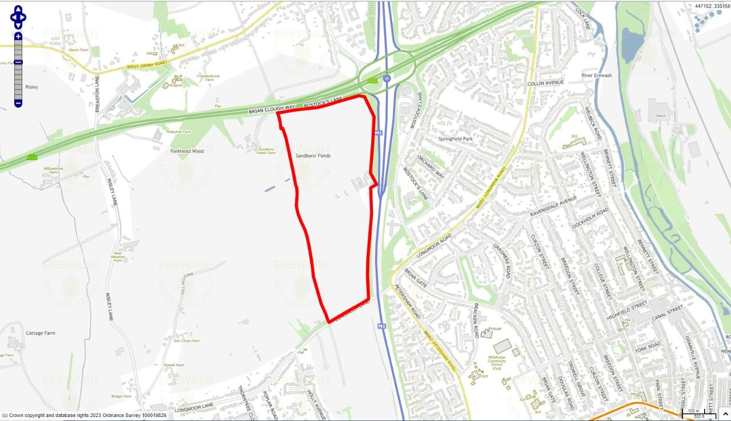
Aerial Image
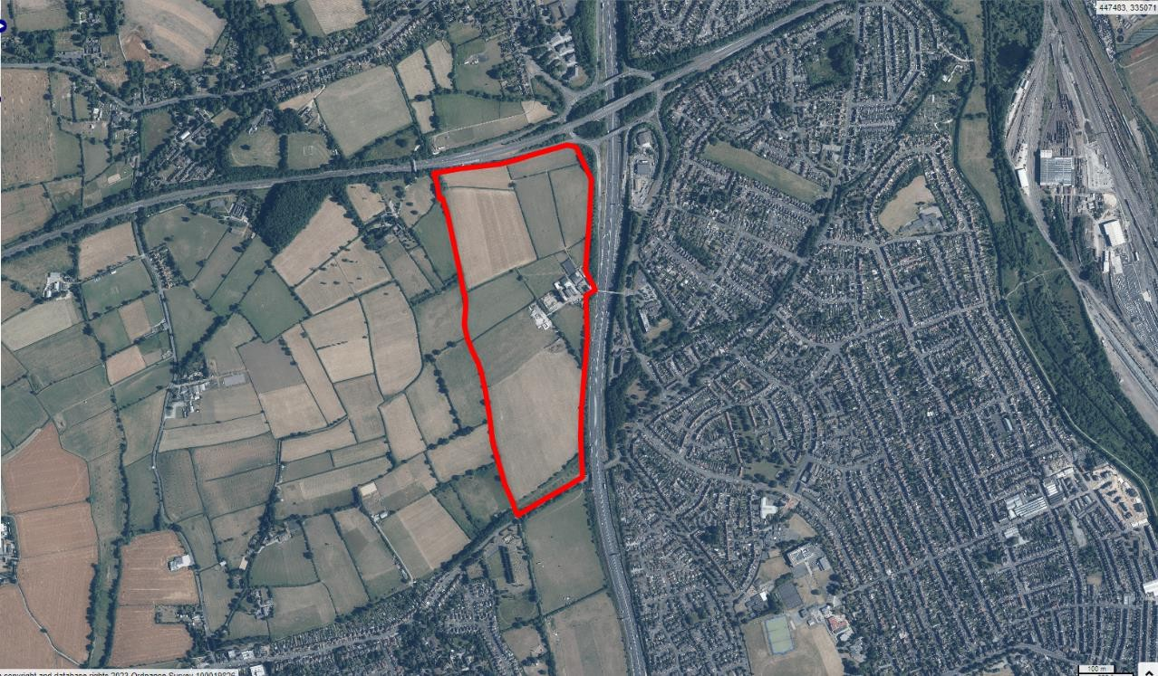

Stage 1 Assessment | Details
Strategic Scale – Is the site greater than 25Ha? | Yes – the site measures 31ha in size and therefore is considered to be strategic. The site was subject of a representation promoting it to the Borough Council as part of the Erewash Core Strategy Review.

Stage 1 Assessment | Details
Strategic Location – Is the site within an Area of Opportunity? | Yes – the site is located within Area of Opportunity 3 (Para 10.8 of the Report) identified around J25 of the M1, an area which also stretches east and west along the A52 corridor.
Strategic Highway Connections – Does the site have good connections to the highway network close to a junction with the M1 or long distance dual carriageway? | The site adjoins the M1/A52 intersection at Junction 25. Roughly half of the site’s boundary is shared with the M1 and the A52, both highways which form part of the strategic road network. Possibility of forming access from the site directly off the raised level intersection, although long-term congestion issues at this junction.
Stage 1 Conclusion – Is the site a reasonable alternative that is carried forward to a Stage 2 Assessment? | The site is identified as a potential reasonable alternative for further consideration. This reflects the site’s size, its location within an area of opportunity as identified in the Iceni Study and its location adjacent to J25 of the M1 Motorway. The site will need to be considered against any environmental, historic, infrastructure and policy constraints within the Stage  2 assessment.

General – floorspace, type of site, other assessments and viability

Stage 2 Assessment | Details
Site Size – Is the site 50ha or more? | No
Estimated employment floorspace | The site submission from promoters advises that the 135,500sq.m (Gross Internal Area) of B8 floorspace could be developed at this location.
Existing use | Agricultural use
Extension or new site | New site
PDL or Greenfield | Greenfield (Located in the Green Belt)
Relevant SHLAA or SHELAA conclusion | Site 365 of the 2022 Erewash SHLAA concludes the site as being Non-Deliverable and Developable for 1,120 dwellings. No SHELAA exists for Erewash. Site promoted for employment use through the Erewash Core Strategy review.
Relevant Growth Options Study  Conclusions | Not applicable as Erewash was not included in the Growth Options Study.
Viability and deliverability | The Council has not produced any viability-based work to assess the deliverability of B8 logistics uses at this location. No specific viability appraisal has accompanied the submission of the site for the logistics call for sites, although the promoter has informed that the landowner has agreed to sell the site for industrial usage and this could see a scheme come forward within a 3-5 year timeframe. Viability of the site for B8 uses would need to be demonstrated by the site  promoter.

Transport Infrastructure and Accessibility

Strategic highways – Good connection to the highway network close to a junction with the M1 or long distance dual carriageway | The site adjoins the strategic road network by bordering both the M1 and A52 roads. It also adjoins Junction 25 of the M1 although early design and access concepts show the primary vehicular access being taken from Longmoor Lane in Breaston which is located to the south of the site. By road, the indicative access point is approx. 0.8 miles from the M1 J25/A52 interchange.
Rail network accessibility | The site is not located adjacent to or near existing rail infrastructure.
Accessibility to labour – proximity to centres of population and ability to be served by public transport and active travel. | Labour market - The site is located in close proximity the main built-up area of Long Eaton on the eastern side of the M1 motorway, with nearby towns of Sandiacre and the villages of Breaston and Risley also close by. Collectively, this sees quite a sizeable working age population is short proximity to the site.  The current bus services that serve the closest stops is the Trent Barton-run ‘Indigo’ service. This route terminates at a stop at Briar Gate around 400m from where the indicative site entrance would be. The Indigo service links Long Eaton town centre to Derby, Beeston and Nottingham City Centre – further enhancing the workforce who might work at facilities on the site.

Other Critical Infrastructure

Type | Comments
Utilities | Electricity – No abnormal requirements identified by the site promoter.  Gas – No abnormal requirements identified by the site promoter.  Water Supply – No abnormal requirements identified by the site promoter.  Wastewater – No abnormal requirements identified by the site promoter.  IT/ Communications – No abnormal requirements Identified by the site promoter.
Blue and Green Infrastructure | Public Right of Way (PROW) 16 runs in a loosely north/south alignment along the western boundary of the identified site. This helps form connections to the villages of Breaston and  Risley. Along the southern boundary of the site is the DCC-

Type | Comments
 | maintained former Derby & Sandiacre Canal which is now an off-road multi-user recreational trail. This connects the Erewash Valley settlements with major urban settlements east and west of the site.
Other | None

Sustainability Appraisal

Objective | Score | Objective | Score
1. Housing | N/A | 10. Energy & Climate Change | N/A
2. Employment & Jobs | N/A | 11. Pollution & Air Quality | N/A
3. Economic Structure &  Innovation | N/A | 12. Flooding & Water Quality | N/A
4. Shopping Centres | N/A | 13. Natural Environment,  Biodiversity & G&BI | N/A
5. Health & Wellbeing | N/A | 14. Landscape & Built  Environment | N/A
6. Community Safety | N/A | 15. Heritage | N/A
7. Social inclusion | N/A | 16. Natural resources & waste  management | N/A
8. Transport | N/A
9. Brownfield land | N/A

Please note:
- The Erewash Core Strategy Review has been developed from a different Sustainability Appraisal to those used to guide the production of the Greater Nottingham Strategic Plan and Ashfield Local Plan. The scoring method used in appraisals also differs.
- The site was not assessed as part of the Borough Council’s Sustainability Appraisal (SA). This means no scores have been attributed to the submitted site in the above table.
Constraints and other considerations

Topic | Commentary
Green Belt | The site sits entirely within the Nottingham-Derby Green Belt. Its development would risk prejudicing two (b & c) of the five  purposes set out at Paragraph 138 of the National Planning

Topic | Commentary
 | Policy Framework. The site, currently undeveloped, contributes to the openness between the settlements of Breaston, Risley and the Long Eaton urban conurbation. Development not only would urbanise land between these settlements and risk their merging (138b), but also encroach out into the open countryside west of the M1 (138c).
Agricultural Land | Site straddles an area of the Agricultural Land Classification (ALC) assessed as Grade 3 (average quality land) with a smaller element classed as ‘urban’. Insufficient details are available to categorise the land into either Grade 3a or 3b.
Land Contamination | No contamination identified, and is unlikely owing to land being greenfield & undeveloped.
Carbon Neutrality | The development would be subject to environmental analysis as part of any future planning application process. No work has been carried out by the Borough Council to understand whether any future development could demonstrate carbon neutrality. Similarly, nothing in the site submission makes reference to this.
Impact on Air Quality | The site sits between the two Air Quality Management Areas (AQMAs) which are located directly west and east of M1 Junction 25. As such, development at the site may impact adversely on identified areas with sub-standard air quality.
Flood Risk | The site is located in Flood Zone 1.
Natural Environment | No local non-statutory, or statutory environmental designations on or immediately off-site.
Historic Environment | A Local List building (non-statutory heritage asset) is located on the eastern boundary of the site at Wilsthorpe Lodge.  Saved Policy EV7 – Buildings of Local Interest establishes the criterion in which development that may impact on Local List assets is acceptable.
Landscape and topography | The site forms part of the Trent Valley Washlands landscape character area, with the landscape type being assessed as forming part of the Lowland Village Farmlands character type. The site is characteristic of the assessed landscape type with its gently rolling, almost flat land that accommodates mixed farming and medium-to-large sized fields. The site’s topography is largely flat with no noticeable undulations.
Regeneration | The area is not within an area of the Borough where major regeneration projects have either occurred or are due to take place. Whilst the Council places importance on boosting  economic development within Erewash, its emerging Core Strategy Review designates the Stanton North site to

Topic | Commentary
 | accommodate a strategic scale of employment uses, including logistics facilities which utilises a rail spur into the brownfield site.
Compatibility of surrounding uses | The site is constrained on its northern and eastern sides by the busy A52 and M1 strategic roads. Agricultural land stretches away to the west, whilst land south of Longmoor Lane accommodates equine uses, with the village of Breaston just beyond. The proposed site vehicular access would see an intensification of traffic along Longmoor Lane which connects to Petersham Road/Longmoor Road, roads which pass through largely residential parts of the Long Eaton urban area.
Availability | The site was promoted both through the Erewash Core Strategy Review and the B8 Logistics Call for Sites consultation exercise.

Conclusions and recommendations

Is the site suitable for strategic distribution? | The site was in Stage 1 as a potential reasonable alternative for further consideration. This reflects the site’s size, its location within an area of opportunity as identified in the Iceni Study and its location in proximity to J25 of the M1 Motorway.  The site has been put forward for consideration by site promoters to the Logistics call for sites and the Erewash Core Strategy Review. The Borough Council have identified several sites within the Green Belt which are necessary to release to help meet short and longer-term housing needs. Insofar as employment needs are concerned, the evidence available to the Council from the Lichfields Employment Land Study (2021) suggests the strategic allocation at Stanton North is more than sufficient to provide for the assessed need for employment uses in Erewash. With this site located within the Green Belt, it is felt to be inappropriate to support further employment uses which are far in excess of what evidence suggests is required in the Borough. Whilst the site would not in itself adjoin inset land, its development would give rise to an urbanisation and loss of openness of land between Long Eaton, Risley and Breaston – also isolating a small band of designated Green Belt south of Longmoor Lane which serves to separate Breaston and Long Eaton.  As such, the Borough Council do not support the delivery of B8 logistics development at this site given that it would be contrary to policies both in the existing and proposed review of the Erewash Core Strategy, as well as performing poorly against the purposes of Green Belt set out by national policy.

Rushcliffe
RBC-L01: Ratcliffe-on-Soar Power Station

Map
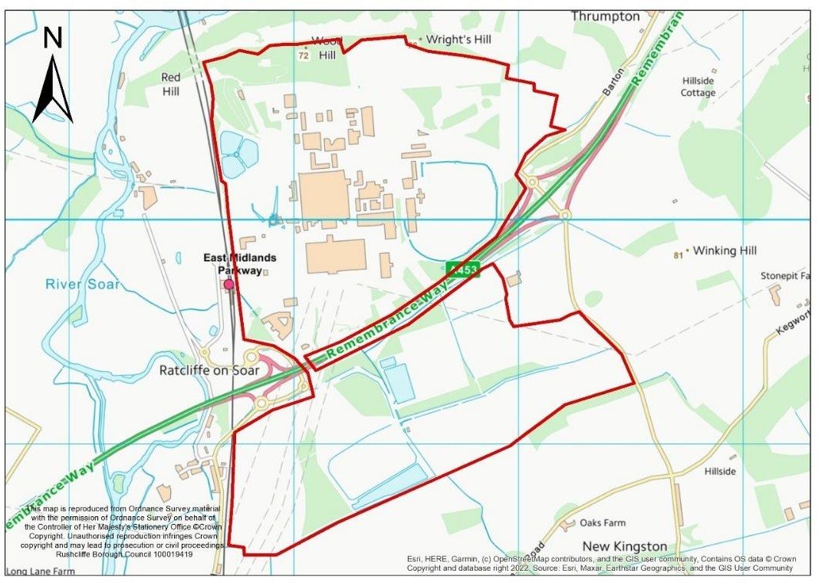
Aerial Image
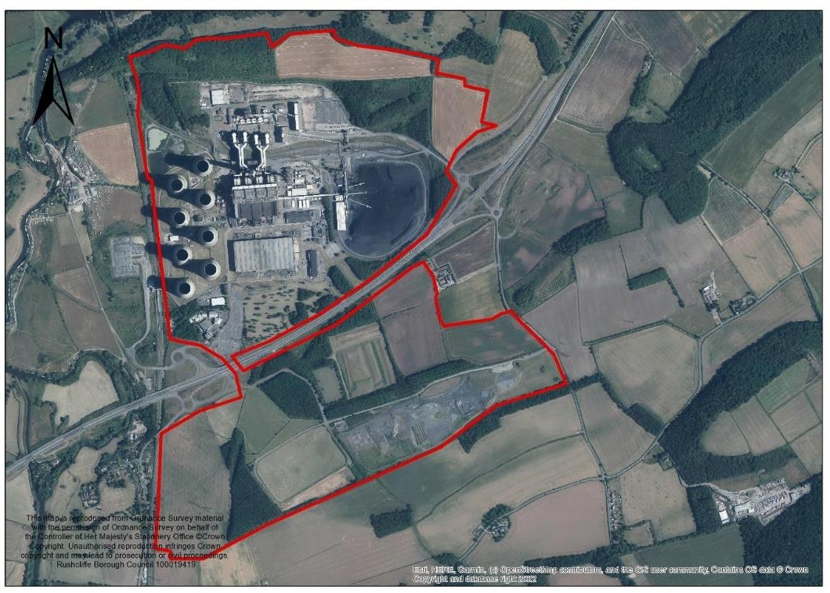

Stage 1 Assessment

Stage 1 Criteria | Details
Strategic Scale – Is the site greater than 25Ha? | 265 ha (gross), of which approximately 36.4 Ha of the site is proposed for logistics  Yes
Strategic Location – Is the site within an Area of Opportunity? | Yes, the site is within an Area of Opportunity adjacent to A453.
Strategic Highway Connections – Does the site have good connections to the highway network close to a junction with the M1 or long distance dual carriageway? | Access can be achieved onto the A453 (and M1) via existing junctions on the A453. Given the scale of employment development Improvements are likely to be required to junctions on the strategic and non-strategic road network.
Conclusion – Is the site a reasonable alternative that is carried forward to a Stage 2 Assessment? | The site is identified as a reasonable alternative for further consideration because of the site’s location adjacent to the strategic network (A453 (M1)) and access to it. The A453 is an Area of Opportunity for strategic distribution. It also has existing utilities infrastructure. Part of the site is promoted by the landowner as a location for strategic distribution and up to 180,000 sqm of logistics development is identified within the draft LDO. Redevelopment offers opportunities  to improve the local environment and wider area.

Stage 2 Assessment
General – floorspace, type of site, other assessments and viability

Stage 2 Criteria | Details
Size – Is the site over 50 hectares | 265 ha (gross), of which approximately 36.4 Ha of the site is proposed for logistics  Yes
Logistics Study – Is it within an Area of Opportunity | Yes (Area adjacent to A453)
Estimated employment floorspace | Up to 180,000 sqm (gross floor space) (as set out within draft Local Development Order)
Existing Use | Coal-fired power station

Stage 2 Criteria | Details
Extension or new site | New site
Known Land Contamination | Site is a coal-fired power generation site. A preliminary Conceptual Site Model has been completed to identify potential contaminant linkages and the associated risks. These will be addressed through a Decommissioning and Remediation Strategy which will outline an appropriate methodology to remediate any identified/confirmed residual  contamination.
PDL or Greenfield | Previously Developed Land
Relevant SHLAA or SELAA conclusion | This site has not been assessed within the SHLAA or SELAA
Relevant Growth Options Study Conclusions | The Growth Options Study concludes that Ratcliffe Power Station has a high potential for strategic growth. It identifies the following constraints within and adjoining the site: a Scheduled Monument (Roman site on Red Hill); Thrumpton Conservation Area; an authorised landfill site; waterbodies; woodland; flood zones and landscape constraints (in the vicinity of Gotham Hill Wood and Kingston on Soar).  However, there are a number of strategic opportunities and locational advantages (East Midlands Parkway, East Midlands Airport, University of Nottingham, access to the A453 and River Trent, previously developed land etc.) that make the site suitable for development pending further  investigations.
Viability and deliverability | Delivery of strategic distribution on this site would be delivered alongside other employment uses (identified in the draft LDO) related to low carbon, renewable and energy storage technologies, research and manufacturing.  Expected some areas available from 2023, while others from closure of power station (end of September 2024). Full site availability after decommissioning and demolition of power  station buildings and structures (2030s)

Transport Infrastructure and Accessibility

Transport Infrastructure | Commentary
Strategic highways – Good connection to the highway network close to a junction with the M1 or long distance dual carriageway | Access can be achieved onto the A453 (and M1) via existing junctions on the A453. Given the scale of employment development Improvements are likely to be required to junctions on the strategic and non-strategic road network.  National Highways advise that the Transport Assessment identified a 'severe' impact on the SRN at several junctions  including M1 J24. Mitigation required at several SRN junctions. Negotiations are currently underway and it has

Transport Infrastructure | Commentary
been agreed that mitigation can be agreed and delivered as the site is redeveloped.
Nottingham County Council highlight the potential for increased traffic on county roads if there is not sufficient capacity on the A453 (the primary route of access), noting that mitigating impacts on Junction 24 will not be delivered
until phase 3.
Rail network accessibility | The site has its own rail freight access to the national network. It is also only 4 miles from the existing rail freight  interchange at the East Midlands Logistics Park.
Accessibility to labour – proximity to centres of population and ability to be served by public transport and active travel. | The site is not located in or adjoining the main built up area but the northern part of the site is adjacent (within 400 metres walking distance) of East Midlands Parkway Railway Station which provides direct rail services to Nottingham, London via Leicester and Sheffield via Derby and Chesterfield. The station also has a bus/coach stop with national and local services. The site is within 30 minutes’ travel time via train to Derby and within 30 minutes’ travel time to Nottingham by bus both cities offer a range of community facilities, schools, retail centres and employment areas.

Infrastructure

Type | Comments
Utilities | Electricity – Power station site is connected directly to the national grid. This infrastructure will stay on site.  Gas – Power station has gas mains supply. No abnormal requirements expected.  Water Supply – Power station is connected to mains water supply. No abnormal requirements expected.  Wastewater – Power station has its own water treatment works. Capacity to accommodate development proposed in LDO will be established prior to redevelopment of the site.  IT/ Communications – Power station site has comprehensive  IT and communications infrastructure. No abnormal requirements expected.
Emergency Services | Consider at more detailed planning application stage.
Blue and Green Infrastructure | LDO includes on-site BGI and off-site 10% BNG.
Other | There is a public right of way that runs through the site to the south of the A453

Sustainability Appraisal

Objective | Score | Objective | Score
1. Housing | 0 | 9. Brownfield Land | +
2. Employment and Jobs | ++ | 10. Energy and Climate Change | ++
3. Economic Structure and Innovation | ++ | 11. Pollution and Air Quality | ?
4. Shopping Centres | + | 12. Flooding and Water Quality | -
5. Health and Well Being | + | 13. Natural Environment, Biodiversity, Blue and Green Infrastructure | -
6. Community Safety | ? | 14. Landscape | ?
7. Social Inclusion | 0 | 15. Built and Historic Environment | -
8. Transport | + | 16. Natural Resources and Waste Management | --

Constraints and other considerations

Topic | Commentary
Green Belt | The Green Belt Review 2022 assessed the Power Station Site, including land south of the A453 which is included in the draft LDO.  The area scored 12 (out of 20). However, inclusion of the land south of the A453 (not proposed here for strategic distribution) increased the site’s performance against Green Belt purposes. Particularly restricting urban sprawl, merging of settlements and safeguarding countryside. Given the extensive development within the Power Station itself, it has  less Green Belt importance.
Agricultural Land | The majority of the site is classified as non-agricultural land,  with two parcels of land being sub-grade 3b and one small parcel on the southern side being sub-grade 3a.
Land Contamination | As an operation power station, areas of the site will be contaminated. The draft LDO is supported by an EIA that confirms there are areas contaminated by harmful material, including hydrocarbons and asbestos. Further risk assessments are required to confirm risks and inform  mitigation.

Topic | Commentary
Carbon Neutrality | The development would be subject to environmental appraisal as part of the allocation and planning application process.  The LDO includes the provision of solar photovoltaic technologies, and the objective is to create a low carbon and  renewable energy technology centre of excellence including research, skills training and manufacturing.
Impact on Air Quality | The site is not within the Nottingham Urban Area agglomeration zone. The site is not within or in proximity to an Air Quality Management Area. It is unknown at this stage whether the allocation / development of the site would create  a new Air Quality Management Area.
Flood Risk | The site is at very low risk of flooding (less than 0.1% each year) from rivers. The power station site also has areas at  low, medium and high risk of surface water flooding.
Natural Environment | The site is adjacent to Thrumpton Park  LWS and part of the southern part of the site adjoins the Kingston on Soar Copse LWS.  The site is of sufficient size that there is potential opportunities to provide new areas of open space and BGI within the site and enhance existing woodland and grassland habitats within the Gotham Hills, West Leake & Bunny Ridge Line Biodiversity Opportunity Area (see  appendix D of the Local Plan Part 2).
Historic Environment | A part of the Roman site scheduled monument at Redhill lies within the site, with the rest of the scheduled monument adjoining the part of the western boundary of the northern area of the site.  Archaeological remains of an Iron Age Settlement at Redhill may extend into the site in the northwest corner,  albeit such remains are likely to have been heavily disturbed by previous development at / operation of the power station.  The Grade II Redhill Railway Tunnel Portals (north and south) are also adjacent to the western boundary of the northern part of site.
Landscape and topography | The site lies within the East Leake Rolling Farmland (DPZ NW02). The overall landscape strategy of the DPZ is to ‘conserve and enhance’. The landscape condition of the DPZ is moderate and the landscape strength is strong.  The existing power station has a significant impact on the local landscape and this could be enhanced by its removal, albeit new employment development would likely have its  own landscape impact.
Compatibility of surrounding uses | The Power Station is located away from residential areas or  other uses that could be adversely affected by strategic distribution on this site.

Topic | Commentary
Availability | The site is being actively promoted for development by the landowner, a significant proportion of the northern part of the site for strategic distribution. Draft LDO is in the planning  process.

Conclusions and recommendations

Is the site suitable for strategic distribution? | The site is identified as a reasonable alternative for further consideration because of the site’s size and location adjacent to the strategic network (A453 (M1)) and access to it.  The stage 2 assessment identifies that, as an operational power station, there are existing utilities infrastructure on site. Part of the site is promoted by the landowner as a location for strategic distribution and up to 180,000 sqm of logistics development is identified within the draft LDO. Its location adjacent to the Midland Mainline railway, the existing rail spur into the site and proximity to the East Midlands Gateway rail freight interchange are significant factors that favour this site as a location for strategic distribution and logistics. This would be delivered alongside other employment uses focused on researching and manufacturing low carbon and renewable energy technologies.  Redevelopment offers opportunities to improve the local environment and wider area.  Whilst the allocation of land south of the A453 is likely to have significant effects on the openness of the Green Belt in this area, redevelopment of the power station offers an opportunity to positively enhance the Green Belt and contribute to Green Belt purposes.  The site is considered potentially suitable for strategic distribution and, given the: brownfield status of site (north of the A453); existing rail access and proximity to the rail freight interchange; the existing power station’s access onto the A453 (two junctions) and proximity to the M1, it is considered a preferred location when compared against other sites.

RBC-L02: Nottingham ‘Gateway’

Map
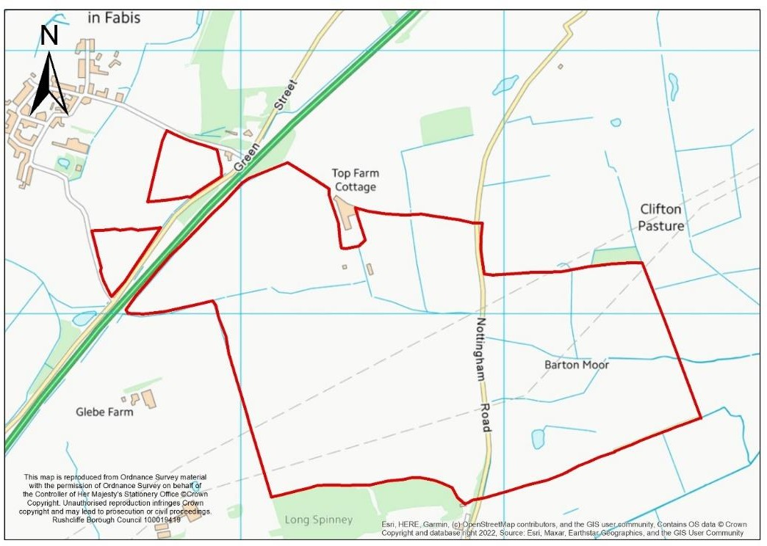
Aerial Image
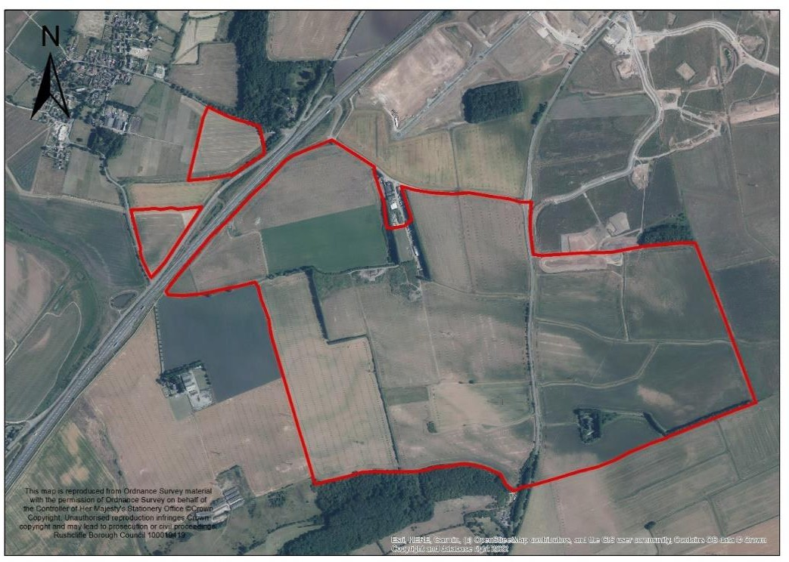

Stage 1 Assessment

Stage 1 Criteria | Details
Strategic Scale – Is the site greater than 25Ha? | 168 ha  Yes

Stage 1 Criteria | Details
Strategic Location – Is  the site within an Area of Opportunity? | Yes – within the A453 Area of Opportunity.
Strategic Highway Connections – Does the site have good connections to the highway network close to a junction with the M1 or long distance dual carriageway? | Adjacent to the A453, however access would require a new junction or access to an existing junction. The landowner has proposed a road bridge over the A453 which connects the site to Green Street from which the A453 can be accessed at the Mill Hill Roundabout. Otherwise access to the strategic road network would be achieved via the South of Clifton Sustainable Urban Extension, which is currently being developed.
Conclusion – Is the site a reasonable alternative that is carried forward to a Stage 2 Assessment? | The site is identified as a reasonable alternative for further consideration because of the site’s size, its location within an area of opportunity (as identified in the Logistics Study) and location adjacent to the A453. Alongside environmental and policy constraints, consideration within the Stage 2 assessment must determine whether access onto the A453  is viable and deliverable.

Stage 1 Criteria | Details
Strategic Scale – Is the site greater than 25Ha? | 168 ha. An alternative smaller area of approximately 115Ha is also being promoted which excludes the land to the east of Nottingham Road in its entirety  Yes
Strategic Location – Is the site within an Area of  Opportunity? | Yes – within the A453 Area of Opportunity.
Strategic Highway Connections – Does the site have good connections to the highway network close to a junction with the M1 or long distance dual carriageway? | Adjacent to the A453 and the northern edge of the site is around 4.5 miles away from Junction 24 of the M1 if direct access could be achieved onto the A453. Access would require a new junction or access to an existing junction. The landowner has proposed a junction arrangement which is considered further in the part 2 assessment, together with National Highways view on whether direct connection to the A453 would be acceptable in principle
Conclusion – Is the site a reasonable alternative that is carried forward to a Stage 2 Assessment? | The site is identified as a reasonable alternative for further consideration because of the site’s size, its location within an area of opportunity (as identified in the Logistics Study) and location adjacent to the A453. Alongside environmental and policy constraints, consideration within the Stage 2 assessment must determine whether access onto the A453  is viable and deliverable.

Stage 2 Assessment

General – floorspace, type of site, other assessments and viability

Stage 2 Criteria | Details
Site Size – Is the site 50ha or more? | Yes the site is 168ha or 115ha
Estimated employment floorspace | 350,000 sqm (according to site submission for the larger area of land). Would be less on smaller site.
Existing use | Agricultural use
Extension or new site | New site (although this site is adjacent to the mixed use  Clifton strategic allocation that includes storage and distribution (adjacent to the A453)).
PDL or Greenfield | Greenfield land.
Relevant SHLAA or SHELAA conclusion | This site has been assessed within the SHLAA for housing but no SELAA carried out to date.
Relevant Growth Options Study Conclusions | The site is within the A453 Potential Area for Strategic Growth. This site is located in Area (B) The SW Nottingham – South of A453. It is a large tract of land and generally free from major constraints except for a Scheduled Monument (Romano-British nucleated enclosed settlement and Roman villa complex at Glebe Farm); Thrumpton Conservation Area; a gas pipeline; woodland bocks; and landscape constraints in the southern portion of the site. Access to the A453 and potential to create links to the tram network and East Midlands Parkway make the site suitable for development  pending further site investigations.
Viability and deliverability | Site promoter considers the site is in an attractive location for the logistics market and is economically viable. It would fully fund all necessary infrastructure.  The viability of the site would be considered through the preparation of the Plan Wide Viability assessment to support the submission of the draft Greater Nottingham  Strategic Plan.

Transport Infrastructure and Accessibility

Transport Infrastructure | Commentary
Strategic highways –  Good connection to the | Adjacent to the A453, however access would require a new junction or access to an existing junction.

Transport Infrastructure | Commentary
highway network close to a junction with the M1 or long distance dual carriageway | New Junction  If a new junction is intended, National Highways consider that this would be unacceptable. This is because of a proposed new access onto the A453 trunk road which is in conflict with DfT Circular 01/22 ‘The Strategic Road Network and the Delivery of Sustainable Development’, Paragraphs 18-19.  Furthermore. They consider that the sole purpose of direct access onto the A453 is as an access point for the site. It does not provide any wider strategic benefits.  Utilising existing junctions  In respect of providing access to an existing junction either at Mill Hill and/or Power Station North, the site promoter has proposed a road bridge over the A453 which connects the site to Green Street from which the A453 can be accessed at the Mill Hill Roundabout. The drawing provided to the Borough Council shows connection to an unmade track south of the A453, to an un-adopted made farm access to the south of the A453 towards the city, and over a new bridge to Green Street. Southbound traffic along Green Street would be via a narrow part of Green Street which would be unsuitable for HGVs, therefore the only route that lorries could take would be via Green Street north for some distance, travelling away from the motorway to Mill Hill junction and then doubling back southbound along the A453. This would add around 6 miles to every lorry trip to and from the site  National Highways have given consideration to this arrangement. It states that the bridge structure would need to be designed according to DMRB and a commuted sum would be payable to National Highways to adopt the bridge structure into its maintenance portfolio. The carriageway would need to be either privately owned or adopted by the local highway authority.
Rail network accessibility | The site is not located adjacent to or near existing rail infrastructure. It is however only 6 miles from the nearest operational rail freight interchange at the East Midlands Logistics Park (further if access to the A453 can only be  achieved via the Mill Hill roundabout)
Accessibility to labour – proximity to centres of population and ability to be served by public transport and active travel. | Whilst the site is not connected to the main built up area of Nottingham by walking and Cycling, the site is within reasonable distance to a major labour pool than other sites promoted for strategic distribution. Notably within Clifton were population densities reach around 6,000 people per km2.  The number 1 bus runs through the eastern part of the site although it does not stop. Journey times to the centre of

Transport Infrastructure | Commentary
Nottingham by bus are estimated to be around 40-45 minutes on average. Nearest bus stop presently is between 400 and 800 metres walking distance from the existing bus stop at the junction of Nottingham Road/Barton Lane that provides a regular service (2-3 times per hour) to Nottingham / Loughborough.

The indicative masterplan proposes a tram extension to the site and a bus / tram stop. Whilst a tram extension is identified through the site, the present terminus is some distance away in Clifton, and there is only a protected route secured through the Strategic Allocation South of Clifton with no proposals or funding secured to extend through the allocation to the northern part of this site submission.

Nottinghamshire County Council (NCC) state that appropriate public transport infrastructure must be provided to serve the site with suitable footway connections and crossings where necessary. Cycling infrastructure to be delivered to LTN 1/20 standard.

They advise that a tram route through the Sustainable Urban Extension should be safeguarded.

If site is accessed from Green Street via Mill Hill roundabout, then the island would need significant alterations.
There would also need to be enhanced segregation between cyclists and HGV's on Green Street.

Other Critical Infrastructure

Type | Comments
Utilities | Electricity – No abnormal requirements identified by the site promoter.  Gas – No abnormal requirements identified by the site promoter.  Water Supply – No abnormal requirements identified by the site promoter.  Waste Water – No abnormal requirements identified by the site promoter.  IT/ Communications – No abnormal requirements Identified by the site promoter.
Blue and Green Infrastructure | Open space – Minimum 10% Biodiversity Net-Gain should be achieved on site.

Type | Comments
The site is in close proximity to the Fairham Brook
biodiversity opportunity area and BGI primary strategic corridor.
Other | Public rights of way run through and adjacent to the western boundary of the site.

Sustainability Appraisal

Objective | Score | Objective | Score
1. Housing | 0 | 9. Brownfield Land | --
2. Employment and Jobs | ++ | 10. Energy and Climate Change | ?
3. Economic Structure and Innovation | ++ | 11. Pollution and Air Quality | ?
4. Shopping Centres | + | 12. Flooding and Water Quality | -
5. Health and Well Being | + | 13. Natural Environment, Biodiversity, Blue and Green Infrastructure | -
6. Community Safety | ? | 14. Landscape | -
7. Social Inclusion | 0 | 15. Built and Historic Environment | -
8. Transport | ++ | 16. Natural Resources and Waste Management | --

Constraints and other considerations

Topic | Commentary
Green Belt | Site is in the Green Belt.  The broad area (FAR/B) scored 15 out of 20 against 4 Green Belt purposes. This indicates the Green Belt performs well against Green Belt purposes, specifically restricting sprawl (4), preventing merging (4),  safeguarding countryside from encroachment (5). Merging is of particular concern both concern both visually and perceptually as once fully developed the gap between the edge of the Green Belt to Gotham would be reduced from 1.2  miles to 0.4 miles from edge of inner boundary of green belt

Topic | Commentary
and the inset at Gotham, with a perception of even less as
the start of the settlement is in advance of the green belt inset.
Agricultural Land | The majority of the site is on very good agricultural land (Grade 2)
Land Contamination | Desktop review does not identify any parts of the site as  contaminated. Assumed agricultural land is free from Contamination.
Carbon Neutrality | The development would be subject to environmental  appraisal as part of the allocation and planning application process.
Impact on Air Quality | Site is not within or near an Air Quality Management Area.
Flood Risk | The site is at very low risk of flooding (less than 0.1%  each year) from rivers but parts of the northern, eastern and western edges of the site that are at low, medium and high risk of surface water flooding.  Unknown at this stage if surface water run-off could be  appropriately managed without increasing flood risk elsewhere.
Natural Environment | The Long Spinney LWS adjoins the southern boundary of the site.  The allocation / development of the site would result in the loss of existing habitats, hedgerows and trees within the site.  The site is of sufficient size that there are potential opportunities to provide new areas of open space and BGI within the site and enhance existing woodland and grassland habitats within the Gotham Hills, West Leake & Bunny Ridge  Line Biodiversity Opportunity Area (see appendix D of the Local Plan Part 2).
Historic Environment | The Scheduled Monument at Glebe Farm is located a short distance to the southwest of the site and is of National importance. The extent of archaeological remains associated to the site could potentially extend into the site. Thrumpton Conservation Area and various listed buildings within that village are located just over 1 km to the west of the site.  Allocation/development of the site could potentially harm the setting and significance of designated heritage assets (in particular unrecorded archaeological features associated to  the nearby Scheduled Monument) however there are potential opportunities for such harms to be mitigated.
Landscape and topography | The site lies within the Clifton Slopes DPZ (SN01). The overall landscape strategy for the DPZ is to ‘enhance’. The landscape condition and strength of the DPZ are both moderate.

Topic | Commentary
As with any development on a greenfield site, there is the potential for it to have some impact on local landscape character that is unlikely to conserve it in its present form,
however, at this stage the severity of any impact cannot be determined.
Regeneration | The site is 2km south of Clifton. This area within Nottingham  City contains areas that are within 10% and 20% of the most deprived areas of the country.
Compatibility of surrounding uses | Site would be located adjacent to residential areas within the South of Clifton Sustainable Urban Extension. Development of the existing strategic allocation has commenced but it will be a number of years to complete. Indicative masterplan provided within the call for sites submission identify  landscape screening and mounds between these areas.
Availability | The site was promoted through the call for strategic distribution sites undertaken during 2022. The site has previously been promoted for mixed use development at previous strategic plan consultation stages and it is  understood that both options are still being promoted.

Conclusions and recommendations

Is the site suitable for strategic distribution? | The site was identified as a reasonable alternative for further consideration within Stage 2 because of the site’s size, location within an Area of Opportunity and proximity of the A453. At 168ha, the site would make a significant contribution to the delivery of strategic distribution and exceeds the minimum preferred site size of 50ha.  There are no significant environmental constraints that would prevent the allocation of this site for strategic logistics development. Adjacent to an existing allocation, currently under construction, it is closely located to centres of population and labour and opportunities to link the site to the tram network.  However, the site cannot access the rail network directly (it is 6 miles from the nearest operating rail freight interchange) and is located within an area of Green Belt that performs well against Green Belt purposes. Exceptional circumstances must be established to allocate this site. In addition, National Highways consider that a direct connection to the A453 would not be supported by them when considered against DfT Circular 1/22. An alternative indicative access arrangement has been provided by the site promoter, although the arrangement does not achieve a satisfactory access arrangement at present because of the reasons outlined in this assessment.

Appendix 4: Existing / potential supply of strategic B8 sites in the Logistics Study Area and preferred sites

 |  | Sq. m | hectares | Notes/source
 | Need
1 | Iceni estimate of need | 1,486,000 | 425 | Iceni Logistics Study
 | Existing supply
2 | Total commitments and “pipeline” supply | 914,641 | 245.94 | Appendix 1 Table C
 | Residual need
3 | Residual need | 571,359 | 163 | Row 1 minus row 2 for floorspace. Land area calculated on  basis of a 35% plot ratio
 | Contributions from redevelopment
4 | Redevelopment potential 10% of remaining need | 57,136 | 16 | 10% of floorspace figure in row 3.  Land area calculated on basis of a 35% plot  ratio.
5 | Redevelopment potential 20% remaining need | 114,272 | 33 | 20% of floorspace in row 3, land area calculated on basis of a 35% plot  ratio.
 | Preferred sites
6 | BBC L01 Bennerley Coal Disposal Point | 74,000 | 68
7 | Stanton North | - | - | Outline planning permission. B8 uses are included  as a commitment.
8 | Ratcliffe on Soar Power Station | - | - | LDO adopted. B8 uses are included  as a commitment
9 | Sub total | 74,000 | 68
10 | Residual need | 383,000 –  440,000 | 63 – 79 ha | Row 3 less assumptions for potential redevelopment (rows 4 and 5),  minus row 9 expressed as a  range (rounded).

