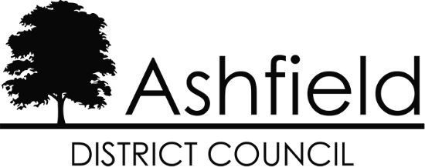

Statement of Common Ground for the Ashfield Local Plan 2023 to 2040 Regulation 19 Pre-Submission Draft
Between Ashfield District Council
and
The Nottingham Outer Housing Market Area Authorities
(Mansfield District Council and Newark & Sherwood District Council)

November 2023

Introduction

  - This Statement of Common Ground (SoCG) has been prepared in relation to the Ashfield Local Plan 2023-2040 Regulation 19 Pre-submission Draft (subsequently referred to as the ‘Local Plan’ throughout the remainder of this statement).

  - The purpose of the SoCG is to inform the inspector of the Ashfield Local Plan and other interested parties about the areas of agreement between Ashfield District Council and Nottingham Outer Housing Market Area Authorities (comprising Mansfield District Council and Newark & Sherwood District Council) with regard to strategic planning matters.

  - The structure of local government varies from area to area - in Nottinghamshire there is a two-tier structure. In broad terms, Nottinghamshire County Council have responsibility for schools, social services, public transport, highways, waste disposal and minerals. Each district/borough council covers a smaller area and provides local services including council housing, planning, recycling and refuse collection and leisure facilities. Nottingham City Council is a unitary authority and is responsible for all local government services within its boundaries.

  - Local planning authorities, county councils and other prescribed bodies are under a duty to cooperate with each other on strategic matters that cross administrative boundaries. (Section 33A of the Planning and Compulsory Purchase Act 2004). Specific Consultees and Duty to Cooperate Bodies are identified in the Town and Country Planning (Local Planning)(England) Regulations 2012, as amended. This approach is also a requirement of the National Planning Policy Framework, 2023 (NPPF) in paragraphs 24 to 27 inclusive. Paragraph 35 of the NPPF seeks to ensure that the Local Plan is ‘Effective’ i.e., deliverable over the plan period, and is based on effective joint working on cross-boundary strategic matters that have been dealt with rather than deferred, as evidenced by the statement of common ground.

  - This statement sets out the confirmed points of agreement between the parties with regard to:

    - Main Urban Area Boundaries
    - Quantity and Location of Housing Development
    - Gypsy, Traveller and Travelling Showpeople provision
    - Provision of Employment Land
    - Infrastructure delivery

Background

  - Ashfield District is located on the western side of Nottinghamshire in the East Midlands Region. The District benefits from a number of high-quality transport links (Plan 1), with the M1 dissecting the District providing communities and businesses with access to the motorway network via Junctions 27 and 28. The A38 provides a major east-west route across the District and the A611 links the District to the City of Nottingham. The National Cycle Route runs through the District. In addition, there are heavy and light rail connections that link Ashfield with the wider area. The Robin Hood Line runs through the District from Worksop to Nottingham with stations at Hucknall, Kirkby-in-Ashfield and Sutton Parkway. The Nottingham Express Transit (NET) runs from Hucknall into Nottingham and other parts of Greater Nottingham including Clifton and Beeston. Within Ashfield, the proposed HS2 route is subject to safeguarding directions to the east of the M1.
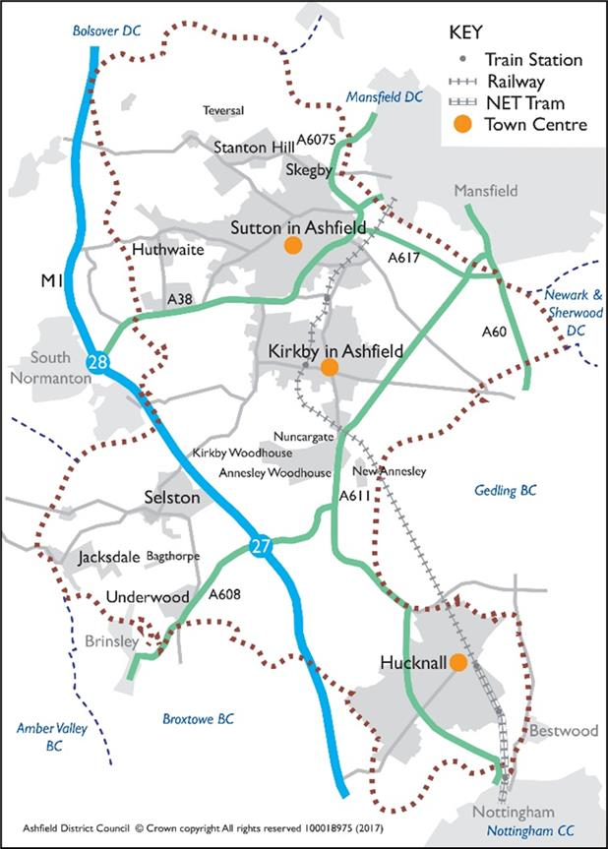

Map 1: The District of Ashfield and Surrounding Area

  - Map 2 shows the extent of the Nottingham and Derby Green Belt within Ashfield. It is largely confined to the south of the District and equates to approximately 41% of Ashfield. This includes land around Hucknall, land to the south and east of Kirkby-in- Ashfield and land surrounding the rural villages of Selston, Jacksdale, Underwood and small parts of Brinsley and Bestwood. The village of Bagthorpe is ‘washed over’ by the Green Belt.

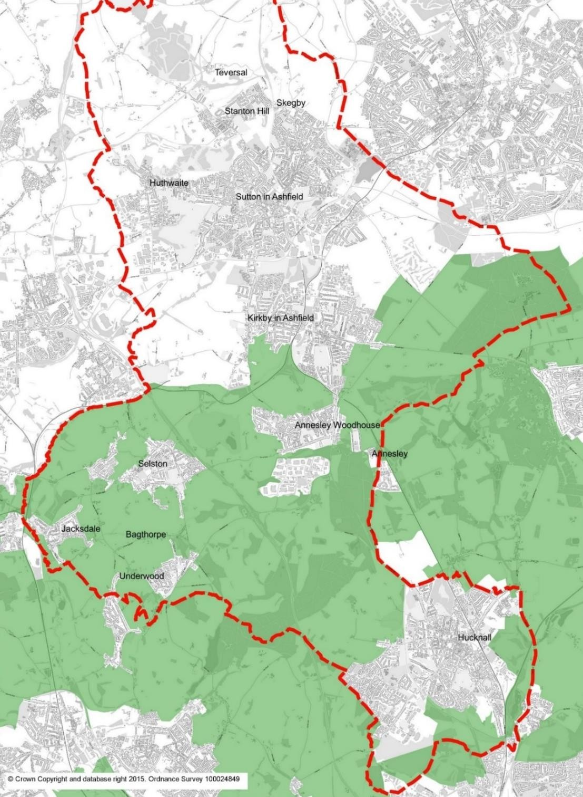

Map 2: Extent of Green Belt in Ashfield District

Housing Market Areas

  - Work undertaken by DTZ Pieda1 initially identified the housing market area for Nottinghamshire. Evidence on the housing market areas is set out in the GL Hearn Nottingham Outer 2015 Strategic Housing Market Assessment2 . It concludes that ‘Ashfield, Mansfield and Newark and Sherwood in view of all the current and historic evidence, as well as the existing ties, comprise a single housing market area.’ However, it is also acknowledged that Hucknall has a strong relationship with the Greater Nottingham Area and the Nottingham Core HA authorities.

Housing Market Area | Districts within Housing Market Area
Nottingham Core | Nottingham, Rushcliffe, Gedling, Erewash, Broxtowe
Nottingham Outer | Ashfield, Mansfield, Newark & Sherwood.

Table 1 - Housing Market Areas
Source: Ashfield District Council
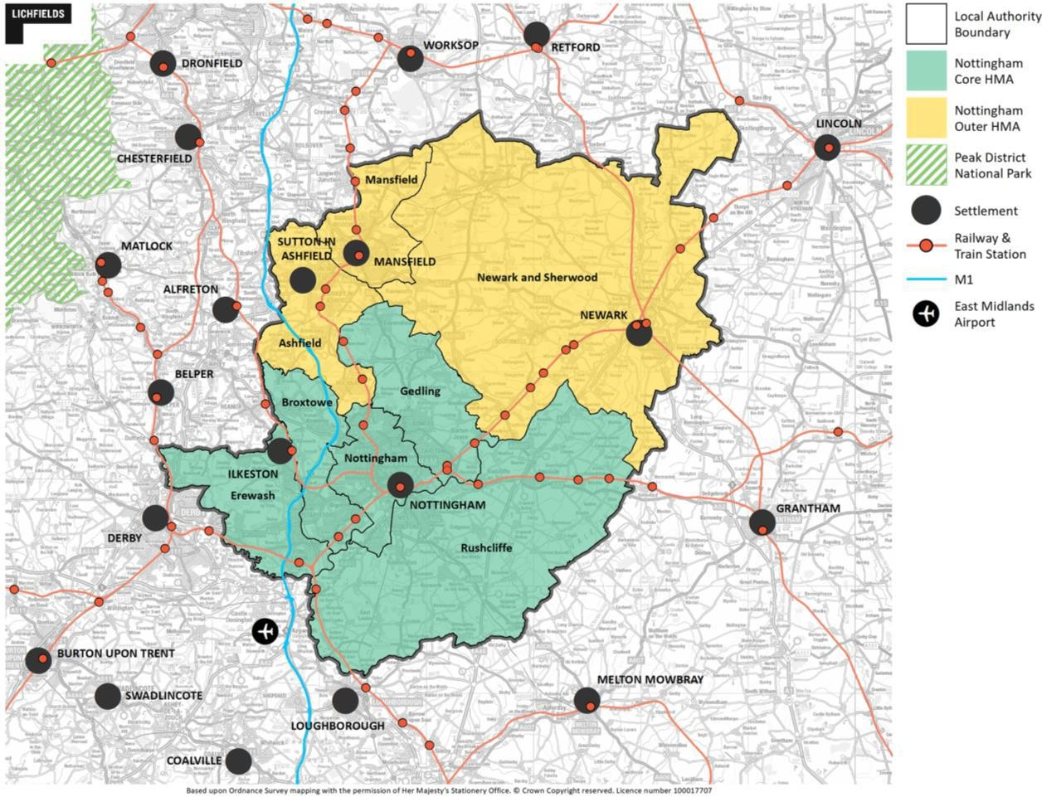

Plan 2: Nottingham Outer and Nottingham Core Housing Market Areas
Source: Nottingham Core HMA and Nottingham Outer HMA Employment Land Needs Study 2021

1 DTZ Pieda (2003) Identifying the Sub-Regional Housing Markets of the East Midlands for East Midlands Regional Assembly.
2 GL Hearn Nottingham Outer 2015 Strategic Housing Market Assessment, Section 2 Reviewing the definition of the housing market area.

Functional Economic Market Area (FEMA)

  - Planning Practice Guidance (PPG) formally identified a FEMA as follows:
‘‘The geography of commercial property markets should be thought of in terms of the requirements of the market in terms of the location of premises, and the spatial factors used in analysing demand and supply – often referred to as the functional economic market area.” (PPG ID:2a-012-20140306).
  - In 2015 the councils comprising the Nottingham Outer Housing Market Area3 and the Nottingham Core Housing Market Area4 commissioned Nathanial Litchfield & Partners to undertake an Employment Land Forecasting Study, (ELF Study) which identified the future quantity of land or floorspace required for economic development uses. The ELF Study identified that:
    - The Nottingham Core HMA is a strong functional economic market area;
    - For the Nottingham Outer HMA this is slightly less clear cut but it can be considered that the Nottingham Outer HMA is self-contained;
    - Hucknall has strong links with the Nottingham Core HMA.
  - The Nottingham Core HMA and Nottingham Outer HMA Employment Land Needs Study 20215 confirms that this remains the case, setting out that Hucknall has a strong relationship with the Nottingham Core HMA, and both Kirkby-in-Ashfield and Sutton in Ashfield link with Mansfield area and the employment areas of Bolsover around Junction 28.

Joint Working

  - Ashfield has a history of joint working with neighbouring authorities and statutory consultees on strategic planning matters. It has a close working relationship with the authorities in both the Nottingham Outer HMA and Nottingham Core HMA.

  - There are a number of established joint working groups in Nottinghamshire of which Ashfield is a member. Those pertinent to the Nottingham Outer HMA authorities are set out in the Table below.

3 Nottingham Outer HMA comprises Ashfield District Council, Mansfield District Council and Newark & Sherwood District Council.
4 Nottingham Core HMA comprises Broxtowe Borough Council, Erewash Borough Council, Gedling Borough Council, Nottingham City Council and Rushcliffe Borough Council.
5 Nottingham Core HMA and Nottingham Outer HMA Employment Land Needs Study 2021, Section 4. Lichfields

D2N2 Local Enterprise Partnership Board | Nottinghamshire local authorities are represented at the D2N2 Partnership Board. Regular meetings between Nottinghamshire Leaders help to ensure that issues relating to D2N2 are discussed as and when necessary.
The City of Nottingham and Nottinghamshire Economic Prosperity Committee | A joint committee of Nottingham City Council, Nottinghamshire County Council and all District Councils in Nottinghamshire. It is a decision-making body on strategic economic development issues. It aims to drive future investment in growth and jobs by prioritising, commissioning and monitoring money available to Nottingham and Nottinghamshire via the D2N2 Local Enterprise Partnership and makes recommendations to D2N2 on its investment priorities. The Committee is made up of one councillor from each local authority.
Nottinghamshire Local Government Leaders Group | A group made up of all the leaders of the County and District Councils in Nottinghamshire.
Nottinghamshire Policy Officers Group meetings | Planning Officers from each Nottinghamshire Council meet on a quarterly basis to discuss and, where necessary, take action on strategic priorities.
Nottinghamshire Development Management Liaison Group Meetings | Development Management officers meet on a regular basis to discuss any issues arising from a development management aspect.
Nottinghamshire Ecological and Geological Data Partnership Meetings | The Nottinghamshire Ecological and Geological Data Partnership consists of officers representing all Nottinghamshire Councils, along with officers from the Nottinghamshire Biological and Geological Records Centre (NGBRC). The group meets twice a year to discuss biodiversity issues, including all local environmental data. The NGBRC, operated by Nottingham City Council on behalf of the Partnership, is Nottinghamshire’s local record centre.
Ashfield Major Projects Group | Considers major planning application in Ashfield. Comprises Ashfield DC, Highways Authority Nottinghamshire County Council representatives, Nottingham and Nottinghamshire Integrated Care Board representative.

Evidence Base
  - Ashfield has worked with neighbouring authorities to produce the evidence base for the Local Plan. Joint studies involving Nottingham Outer HMA authorities are identified in the Table below.

The Nottingham Core HMA and Nottingham Outer HMA Employment Land Needs Study 2021, Lichfields | Nottingham Core HMA & Nottingham Outer HMA authorities.
Employment Land Forecasting Study, Nottingham Core HMA & Nottingham Outer HMA 2015, Nathaniel Litchfield & Partners | Nottingham Core HMA & Nottingham Outer HMA authorities
Nottinghamshire Core & Outer HMA Logistics Study Final Report, Iceni Projects Limited with MDST Transmodal Limited | Nottingham Core HMA, Nottingham Outer HMA authorities, and Nottinghamshire County Council.
Custom and Self Build Register | Nottingham Outer HMA authorities
Maid Marion Rail Extension Economic Impact Analysis 2020, Lichfields | Ashfield DC Mansfield DC
Maid Marion Rail Extension masterplan Report 2021, Ryder | Ashfield DC Mansfield DC

Areas of Common Ground

Main Urban Areas – Cross boundary matter
  - The Ashfield Local Plan Policies Map identifies the Main Urban Areas in relation to strategic Policy S1: Spatial Strategy to Deliver the Vision. These are essentially the towns of Sutton in Ashfield (including Huthwaite, Stanton Hill, and Skegby), Kirkby- in-Ashfield (including Annesley Woodhouse, Kirkby Woodhouse and Nuncargate) and Hucknall. Development has also been proposed adjacent to the urban area of Mansfield which is located in the adjoining authority of Mansfield District Council. As such, it has been agreed that Local Plan Policy S1: Spatial Strategy to Deliver the Vision will identify the following:

Main Urban Areas:
Sutton in Ashfield (Sutton) Kirkby-in-Ashfield (Kirkby) Hucknall
Areas in the District adjacent to the Mansfield Urban Area

  - The parties have agreed that:
The Ashfield Local Plan Policies Map will identify areas allocated for housing
/employment sites and located on the boundary of Ashfield/Mansfield as ‘Main Urban Areas’ in the settlement hierarchy under strategic Policy S1.

The quantity and location of housing development

  - Ashfield Council has applied the Standard Method for determining Local Housing Needs as set out in Planning Policy Guidance to arrive at a requirement of 446 dwelling per annum. The Local Plan identifies a supply of sites under Policy H1: Housing Allocations to contribute towards this requirement. The proposed allocations together with small site supply are estimated to provide for approximately 13 years’ worth of housing supply post adoption (to year 2038/39), and further details will be set out in Background Paper 1: Spatial Strategy and Site Selection.
  - A number of the proposed housing sites are located in the Green Belt and paragraph 141 of the NPPF therefore applies. This paragraph states that before concluding that exceptional circumstances exist to justify changes to Green Belt boundaries, the local planning authority must take into account whether a neighbouring authority could accommodate some of the identified need for development. Mansfield District Council is a geographically small district with a significant amount of recent and planned development. A significant part of Newark

and Sherwood District forms part of the Nottingham-Derby Green Belt. As such, each of the constituent authorities are subject to their own capacity constraints.

  - Ashfield Council approached neighbouring authorities in May 2022 in respect of their capacity to accommodate some of Ashfield’s identified housing need. All authorities responded to advise they were not in a position to meet any of Ashfield’s local housing need at that stage. This position has subsequently been reiterated at officer meetings.

  - The parties have agreed that:

They are all part of the Nottingham Outer Housing Market Area.
All parties seek to meet their own local housing need as informed by the standard methodology. The Ashfield Local Plan proposes to meet the District’s local housing needs to 2038/39 with a review at least every 5 years. It is not proposed that any of this requirement will be met by neighbouring local planning authorities.
Engagement will continue to take place with the Nottingham Outer HMA Authorities.
The parties will continue to share evidence and information to ensure that adequate infrastructure is provided to meet the scale and location of housing need.

Gypsy, Traveller and Travelling Showpeople Provision

  - The requirement for gypsy and traveller accommodation is assessed in the Greater Nottingham and Ashfield District Council Gypsy and Traveller Accommodation Assessment March 2021 (GTAA). The study used 3 different approaches to establishing need as follows:

    - Based on the ethnic identity definition;
    - Based on the needs of families who have not permanently ceased to travel (i.e., based on the PPTS 2015 definition);
    - Based on the ‘travel to work’ interpretation of PPTS 2015.
  - The GTAA study recommended that the local authorities’ Local Plans seek to meet the PPTS need (as required) with ‘ethnic’ need (potential need) covered by a criteria-based policy.

  - Government’s Planning Policy for Traveller Sites (PPTS) requires travellers to demonstrate that they have not ceased to travel in order to be defined as such. However, due to the ambiguity around demonstrating this and various court

challenges to it, the Council have taken the decision to use the higher level of assessed need based on the ‘ethnic definition’, as opposed to the Traveller definition set out in national policy Planning Policy for Traveller Sites. These are as follows:

Ashfield Future Pitch/Plot Requirements 2020 to 2038
Period | Gypsy/Traveller Pitches | Showpeople’s Plots/Yards
2020 to 2025 | 1 | 9
2025 to 2030 | 1 | 2
2030 to 2035 | 1 | 2
2035 to 2038 | 1 | 1
Total 2020 to 2038 | 4 | 14

  - The Local Plan seeks to meet the above needs through land allocations under Policy H2a. It is acknowledged that there is a slight mismatch in the evidence base timeframe, i.e., for the period 2020-2038, rather than 2023-2040. However, since the quantum of assessed need is minimal it is considered appropriate that any additional need will be addressed via the planning application process, using criteria based policy H2 alongside site allocations within Policy H2a.

  - The parties have agreed that:
All parties will each meet the gypsy, traveller and show person accommodation needs within their respective areas.

Employment provision

  - The authorities comprising the Nottingham Core HMA and the Nottingham Outer HMA have worked together on the development of the Employment Land Needs Study 20216 (ELNS). This forms a common evidence base for the future employment land requirements for each authority. The Study included identifying the Functional Economic Market Areas (FEMA) which has informed the employment land requirement for each area.
  - The ELNS highlighted that there were potential issues in relation to a regional demand for logistics which was not reflected in the Study. Nottinghamshire County

6 Nottingham Core HMA and Nottingham Outer HMA Employment Land Needs Study 2021. Lichfields

Council with the support of the Nottingham Core and Nottingham Outer HMA authorities, commissioned a Logistics Study across the housing market areas. The Study findings highlight a substantial demand for logistics along the M1 Motorway in Nottinghamshire. However, this is a complex issue as the M1 is largely located within the Green Belt in Nottinghamshire.

  - Local Plan Policy S8 identifies a demand for approximately 81 hectares of land for employment purposes in Ashfield over the Plan period. The figure in the Policy is based on an adjusted past take up rate scenario and takes account of the demand for space from the logistics sector. This approach will facilitate the priority sectors identified in D2N2’s Strategic Economic Plan which aims to tackle the productivity gap for the D2N2 area to remain a competitive business location and deliver long term prosperity.

  - This demand will be met through:
    - Policy S6 strategic employment allocations (approximately 40.92 hectares) at M1 Junction 27, removing the site out of the Green Belt in order to meet future logistic and distribution needs for the wider sub-region, and
    - Employment land allocations in Policy EM2 primarily to meet Ashfield district requirements.
The combined supply provides in excess of 84 hectares.

  - The allocated strategic sites will make a significant contribution towards the regional logistics requirements along the M1 in Nottinghamshire.

  - The parties have agreed that:

They are all part of the Nottingham Outer Functional Economic Market Area, with all authorities having influences beyond the administrative area.
Nottingham Outer HMA Authorities will meet or exceed employment land requirements within their respective planning authority area and that there are no outstanding unresolved strategic issues relating to employment development.
The proposed employment site allocations under Policies S6 and EM2 are suitable and deliverable and will help to meet identified needs.

Infrastructure delivery

  - Mansfield District Council raised some concern as part of the Regulation 18 consultation over the cumulative impact of Ashfield’s proposed housing sites on Mansfield’s infrastructure. This set out that all infrastructure providers (notably education and highways authority) should be satisfied that any impacts can be

mitigated. The Regulation 19 Local Plan now has a revised spatial strategy which no longer includes proposals for 2 new settlements at Caldwell Road (close to Mansfield’s boundary), and at Whyburn farm near Hucknall. As a result, the cumulative impact of sites in close proximity to Mansfield District have reduced by around 1000 dwellings and consequently the initial concerns are somewhat diminished.

  - Strategic Policy S9: Aligning Growth and Infrastructure sets out the council’s commitment to work with partners, neighbouring councils, infrastructure providers, developers and stakeholders to facilitate the requirements for economic, social and environmental infrastructure to support development. Necessary infrastructure includes (but is not limited to) transport, education, health, green Infrastructure, utilities, waste facilities, wastewater, leisure, cultural and community facilities, and tackling climate change including flooding.

  - The emerging Local Plan is supported by an Infrastructure Delivery Plan (IDP) which addresses the infrastructure requirements based on the level of growth planned. New development will be required to provide or contribute towards the provision of the necessary infrastructure, facilities and services in a timely manner so as to support growth.

  - Development management Policy SD5: Developer Contributions provides the means to offset the impact of a development on infrastructure either by seeking the developer to undertake the necessary work or via a financial contribution that cannot be secured by a planning condition. Part 1c) ix of this policy specifically relates to the provision or enhancement of cross-boundary infrastructure to help deliver and mitigate the effects of development.

  - There have been discussions with infrastructure providers regarding the Local Plan proposals including (but not limited to) the following:

Highways & Transport | - Nottinghamshire County Council – Highway Authority  - National Highways – responsible for M1.  - Network Rail
Utility undertakers | - Severn Trent Water  - National Grid  - British Telecom
Community Infrastructure | - Nottinghamshire County Council – Education, care homes other forms of community infrastructure  - NHS Nottingham and Nottinghamshire Integrated Care Board
Flooding | - Environment Agency  - Nottinghamshire County Council – Lead Local Flood Authority

  - The Council commissioned the Ashfield Strategic Transport Study (2023) to assess the impact of proposals in the Local Plan on the Highway network. This examined impact on key junctions and identified mitigation where possible. The findings have fed into the IDP which supports the Plan. Working with Mansfield District Council and other partners, opportunities are also being considered regarding improving the connectivity of the District with the potential opening of the Maid Marian Line and provision of additional railway stations.

  - The Council has also worked with a number of authorities in relation to the Strategic Housing & Economic Land Availability Assessment (SHELAA) of individual sites, including the Highways Authority, other Nottinghamshire County Council departments and Severn Trent Water. Site assessment has also taken account of Flood Zones identified in the Environment Agency’s Flood Maps for Planning and also considered surface water flooding.

  - The parties have agreed that:

All parties have assessed the transport implications of planned levels of growth within their Local Plans and shared the information with the HMA partners, the Local Highway Authority (Nottinghamshire County Council) and Highways England.
The proposed level of growth has the potential to result in direct and indirect implications for the transport network both within and beyond the administrative boundaries of the HMA partners.
Transport modelling has not identified any insurmountable constraints in Mansfield and Newark & Sherwood district council areas arising from the policies and proposals in the Ashfield Local Plan.
All parties have co-operated with Highways England and Nottinghamshire County Council and no ‘show-stopping’ transport constraints have been identified by these organisations.
The Ashfield Local Plan will seek mitigation measures for required transport improvements to which contributions will be sought from developers. This is included in the Infrastructure Delivery Schedule within the Infrastructure Delivery Plan (IDP).
Any planning obligations sought as part of new development will be directed to infrastructure improvements where mitigation measures have been identified. This includes the provision or enhancement of cross-boundary infrastructure to help deliver and mitigate the effects of development, for instance, educational and health requirements, and tackling climate change including flooding.

Outstanding Areas of Disagreement

4.1 The are no identified areas of disagreement between the Nottingham Outer HMA.

Governance arrangements
  - Ashfield is a member of the Greater Nottingham Planning Policy Officer Group which meets on a regular basis.

  - The Nottingham Outer authorities will continue to meet on a regular basis, to address cross boundary issues, including delivery of development to meet the identified needs.

  - The Nottingham Outer authorities work together under an agreement on the Self- Build and Custom Build Register with Ashfield administering the Register on behalf of the three councils.

  - Along with the other Councils in the Nottingham Outer HMA and Nottingham Core HMA, Ashfield monitors housing and employment land to identify any issues. Should issues arise they are brought up at the Nottinghamshire Planning Policy Officers Group Meeting or at the meeting held between the HMA groups.

  - Ashfield Council will contact/arrange meetings with infrastructure providers as required.

  - Ashfield works with the County Council and other organisations to secure appropriate funding for transport infrastructure projects to unlock new housing and employment development.

  - Ashfield Council has a Major Projects Group which meets on a regular basis to discuss major planning applications and any implications that arise from the emerging Local Plan. Infrastructure providers are invited including representatives of the Highway Authority, the County Council Development Contributions Practitioner (representing education) and representatives of the Integrate Care Board. Typically, the Group meets 3 times a year.

  - Ashfield Council engages and seeks advice from various stakeholders as and when considered appropriate. These include (but are not limited to):
    - The Environment Agency.
    - Lead Local Flood Authority (Nottinghamshire County Council).
    - Severn Trent Water.
    - Natural England.
    - Historic England.
    - Nottinghamshire County Council Heritage Officers.

AGREEMENT

All parties agree that this statement is an accurate representation of matters discussed and issues agreed upon.

Signed on behalf of Ashfield District Council

Name: Christine Sarris
Position: Assistant Director – Planning and Regulatory Services
Dated: 31/01/2024

Signed on behalf of Mansfield District Council

Name: Adam Hill
Position: Chief Executive
Dated: 31 January 2024

Signed on behalf of Newark & Sherwood District Council

Name: Matt Lamb
Position: Director of Planning & Growth Dated: 25/01/2024

