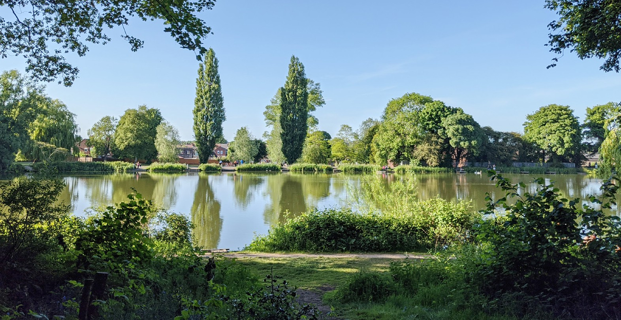
Ashfield
DISTRICT COUNCIL
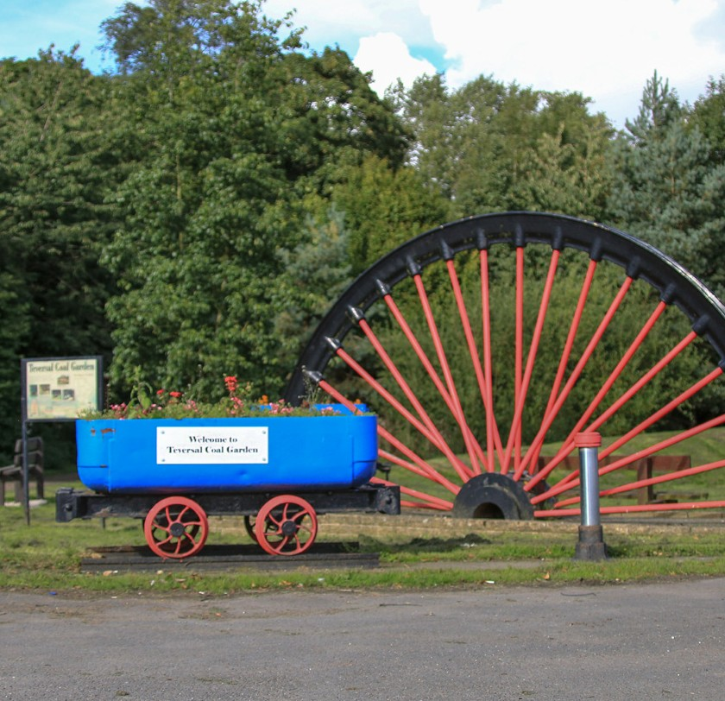
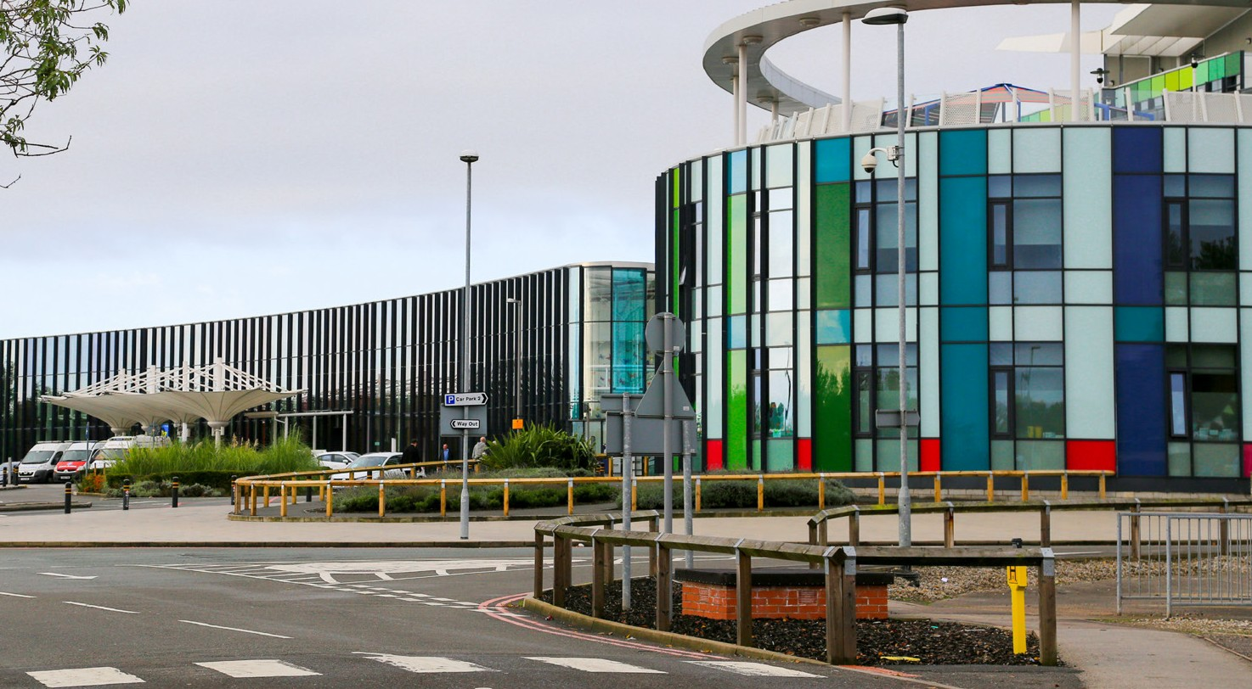
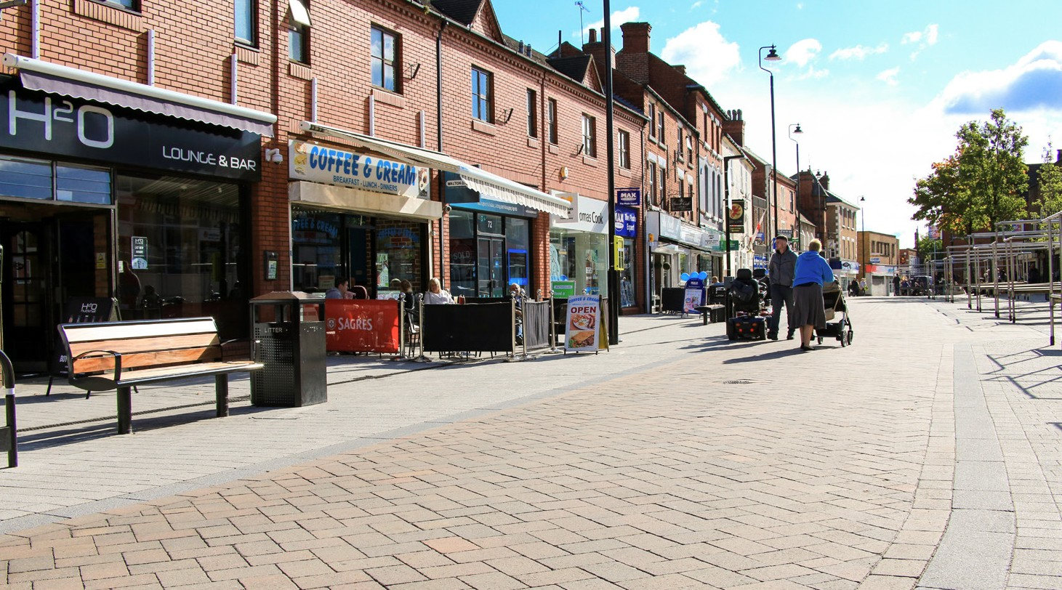
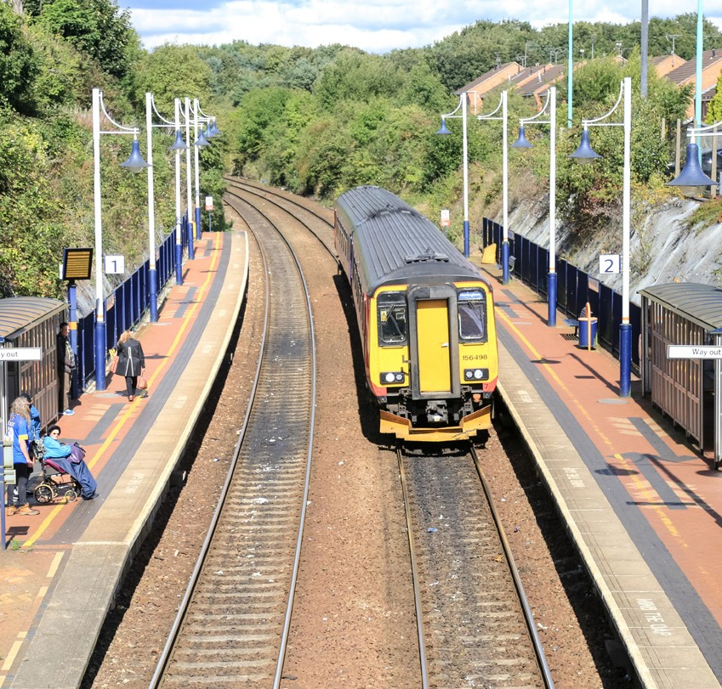

Draft Statement of Accounts
2022/23

CONTENTS
NARRATIVE REPORT 3
THE STATEMENT OF RESPONSIBILITIES FOR THE STATEMENT OF ACCOUNTS 25
AUDIT CERTIFICATE AND OPINION 26
STATEMENT OF ACCOUNTING POLICIES 31

THE CORE FINANCIAL STATEMENTS
COMPREHENSIVE INCOME AND EXPENDITURE STATEMENT 46
MOVEMENT IN RESERVES STATEMENT 48
BALANCE SHEET 51
CASH FLOW STATEMENT 54
NOTES TO THE CORE FINANCIAL STATEMENTS
- ACCOUNTING STANDARDS TO BE ADOPTED 55
- CRITICAL JUDGEMENT IN APPLYING ACCOUNTING POLICIES 55
- ASSUMPTIONS MADE ABOUT FUTURE AND SOURCES OF UNCERTAINT 55
- MATERIAL ITEMS OF INCOME AND EXPENSE 57
- EVENTS AFTER THE BALANCE SHEET DATE 57
- EXPENDITURE AND FUNDING ANALYSIS 58
- EXPENDITURE AND INCOME ANALYSED BY NATURE 64
- ADJUSTMENTS BETWEEN ACCOUNTING BASIS AND FUNDING BASIS UNDER STATUTE 65
- GRANT INCOME 71
- INTEREST PAYABLE AND OTHER CHARGES 73
- TANGIBLE NON-CURRENT ASSETS 74
- HERITAGE ASSETS 77
- TANGIBLE NON-CURRENT ASSETS VALUATIONS 78
- INVESTMENT PROPERTIES 79
- INTANGIBLE NON-CURRENT ASSETS 81

CONTENTS CONTINUED
- GAINS AND LOSSES FROM THE SALE OF ASSETS 81
- FINANCIAL INSTRUMENTS 81
- INVENTORIES 84
- DEBTORS 84
- CASH AND CASH EQUIVALENTS 85
- ASSETS HELD FOR SALE 85
- CREDITORS 86
- PROVISIONS 87
- USABLE RESERVES 89
- UNUSABLE RESERVES 93
- CASH FLOW STATEMENT NOTES 99
- MEMBERS ALLOWANCES 101
- OFFICERS’ REMUNERATION AND EXIT PACKAGES 102
- EXTERNAL AUDIT COSTS 106
- RELATED PARTY TRANSACTIONS 106
- CAPITAL FINANCING REQUIREMENT 108
- ASSETS HELD AS LESSEE 109
- ASSETS HELD AS LESSOR 109
- REVALUATION LOSS 110
- RETIREMENT BENEFITS 110
- CONTINGENT ASSETS AND LIABILITIES 118
- DEFERRED CREDITS 118
- JOINT CREMATORIUM COMMITTEE 119
- NATURE AND EXTENT OF RISKS ARISING FROM FINANCIAL INSTRUMENTS 119
- TRUST FUNDS 123

SUPPLEMENTARY FINANCIAL STATEMENTS
HOUSING REVENUE ACCOUNT 124
COLLECTION FUND 130
ANNUAL GOVERNANCE STATEMENT 136
GLOSSARY OF TERMS AND ABBREVIATIONS 171

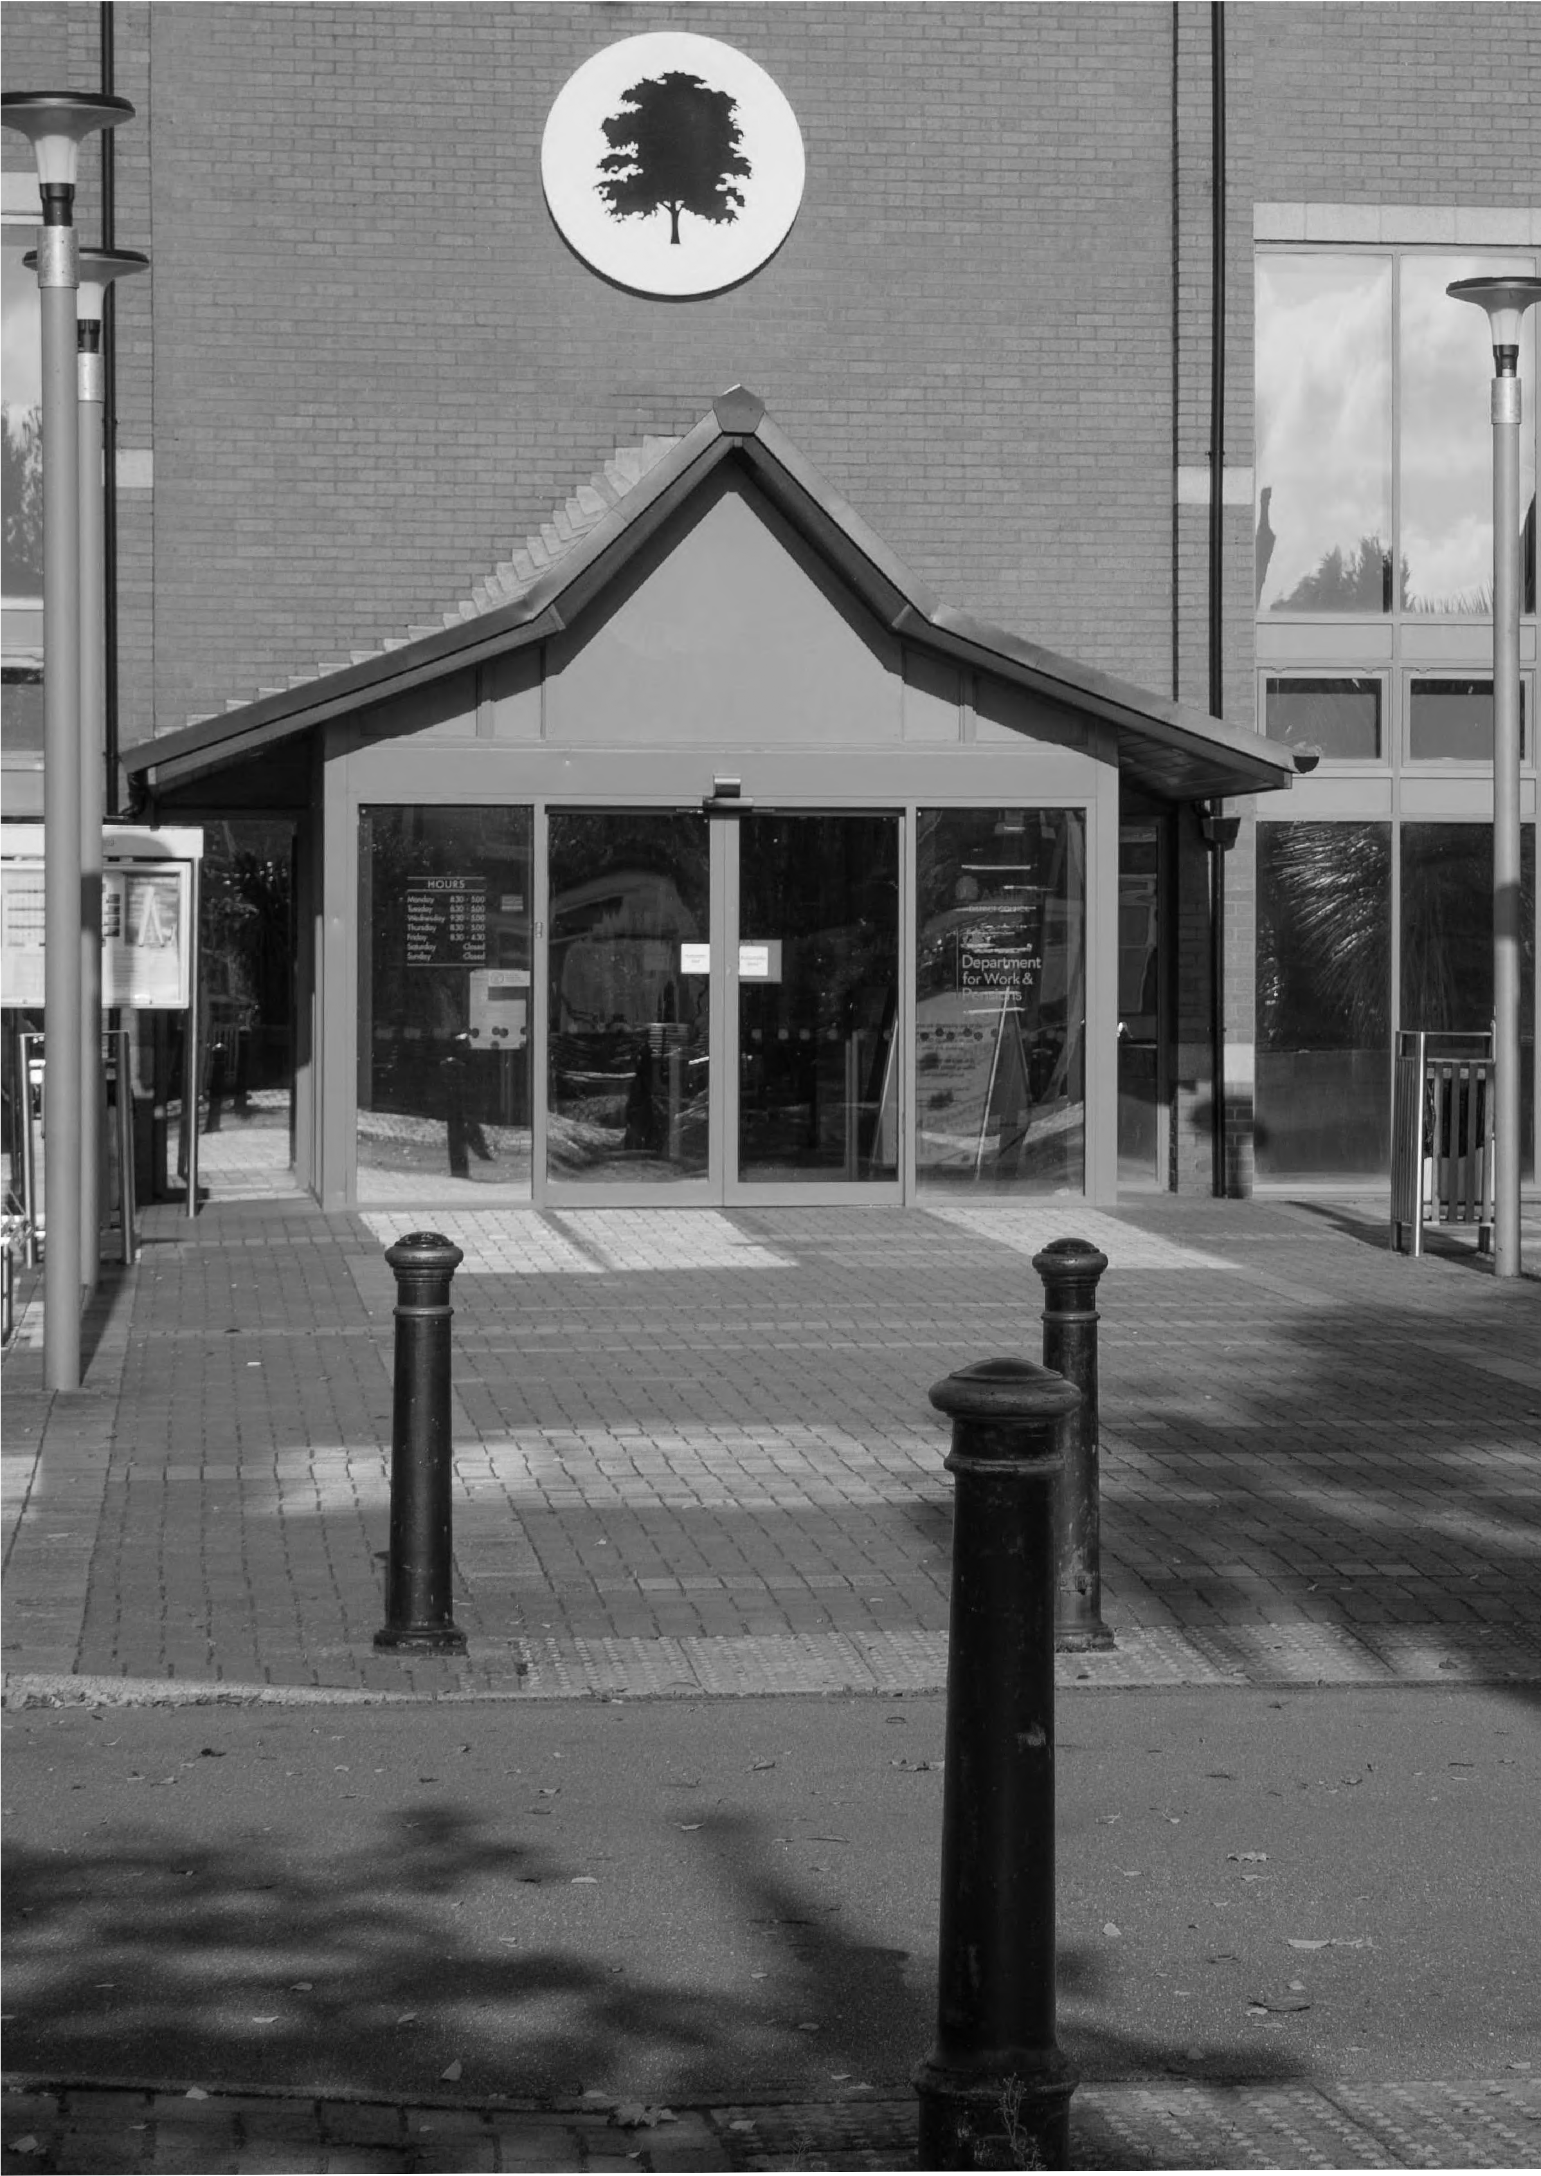

NARRATIVE REPORT

1. BACKGROUND TO
THE NARRATIVE REPORT
The Accounts and Audit (England) Regulations 2015 introduced a requirement for Local Authorities to publish an annual narrative report to accompany its Statement of Accounts. The purpose of the narrative report is to comment on the Council’s financial performance and economy, efficiency and effectiveness in its use of resources over
the financial year. The Narrative Report summarises what Ashfield District Council spent in 2022/23, how it was spent and what has been achieved in line with the Corporate Priorities. It provides a narrative context to the accounts by presenting a clear and simple summary for residents, of Ashfield’s financial position and performance for the year and its prospects for future years.

DRAFT STATEMENT OF ACCOUNTS 2022-2023 3

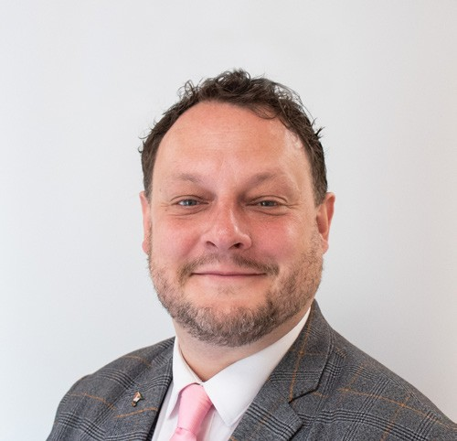2. COUNCIL LEADER’S

PREFACE

2022/23 has been a difficult year for all – our residents, businesses and the Council itself - as a consequence of the unprecedented levels of inflation in the economy which have caused the cost of living crisis. However, despite
this, 2022/23 has still proved to be a very successful year for the Council both in terms of maintaining high quality service delivery
and continued effective financial management, again delivering services within budget.

This year I am particularly delighted with the progression of the projects in our Capital Programme. The completion and opening of our new state-of-the-art Leisure Centre at Kirkby in summer 2022 being the most prominent, as part of our wider Leisure Transformation programme, which has also seen significant enhancements at our Hucknall and Lammas Leisure Centres. The addition of the new swimming pool to Hucknall Leisure Centre is on target for opening to the public this summer.

We continue to make good progress on delivering the Future High Streets and Towns Fund projects. The 14 Low Street Future High Streets funded project completed in March, and we have secured a new tenant for the whole building. The new business ‘Rendezvous’ will
be launched this June bringing a new lease of life to the high street. The Towns Fund project ‘Enterprising Ashfield’ being delivered by our partner, Nottingham Trent University, has also started to deliver key project outputs and outcomes in terms of numbers of learners, business collaborations, and business enterprises supported with grants and non-financial support.
Cllr Jason Zadrozny Leader of Ashfield District Council

Following the success of the Ashfield Independents at the May 2023 District Elections this means that we will see all 21 of these key projects through from inception to full delivery. As these projects come to fruition this investment in our District will offer huge opportunities to our local residents and businesses going forward,
as well as attract further inward investment to the District, all of which will help grow the local economy for the benefit of all.

Following the launch of our Climate Change Strategy (June 2022) the Council has established a Decarbonisation Plan for its non-domestic assets (£5.3m) of which £4m is externally funded. In addition the Council continues to invest in decarbonisation works to its own housing stock and wider social housing having secured £4m
to date. We continue to work collaboratively to influence and assist the wider community to
reduce emissions and to reduce Ashfield’s overall
carbon footprint.
Ashfield is an ambitious and aspirational District
Council, but also one that delivers. We put our residents and businesses at the heart of everything we do and will continue to do so.

We know Ashfield, like all Councils faces future financial challenges but with our passion and desire we are confident that we will continue to invest in our District and through this, deliver increased opportunities and increased chances of an improved quality of life for our residents.
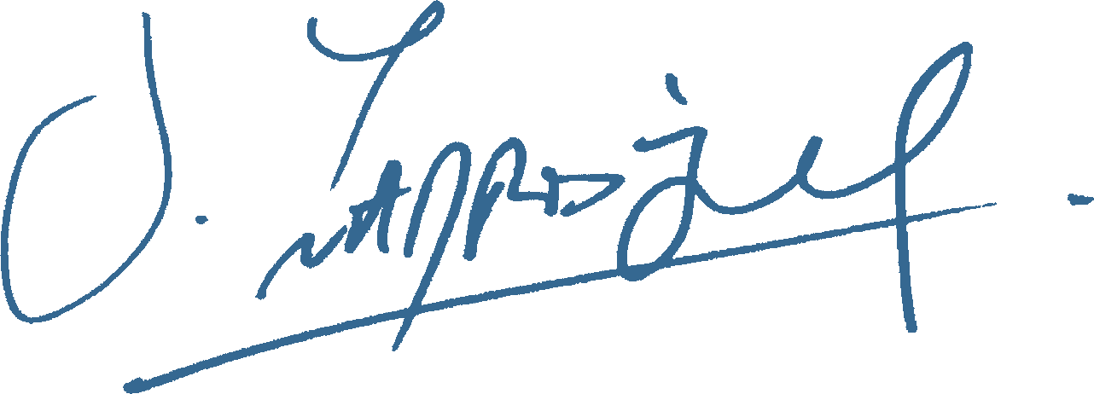
Cllr Jason Zadrozny
- Leader of Ashfield District Council

As the Council’s Chief Finance Officer I am pleased to present Ashfield District Council’s Statement of Accounts for the year ending 31st March 2023. The Statement aims to provide information to all stakeholders (residents, local businesses, Councillors, partners, members of the public) so that they can:
THE NARRATIVE STATEMENT
by the Corporate Resources Director
(Section 151 Officer)
  - Understand the overall financial position of the
Council and the Outturn for 2022/23
  - Have confidence that the Council has used and accounted for public money in an appropriate manner
  - Be assured that the financial position of the
Council is sound and secure

This Statement of Accounts has been prepared and published in accordance with the Code of Practice on Local Authority Accounting 2022/23 issued by the Chartered Institute of Public Finance and Accountancy (CIPFA) and the Accounts and Audit (Amendment) Regulations 2022.

The Statement of Accounts should be read in the context of continuing demand and cost pressures on the services provided by the Council, and
the level of resources available to fund them. This includes the unprecedented level of inflation in the economy which has caused a cost of living crisis, severely impacting both our residents and businesses across the District.

As the Government issued another single year Spending Round for 2023/24 there remains significant uncertainty about the level of future core Government funding. In the 2023/24 Local Government Finance Settlement it was confirmed that Local Government Funding Reform would not be implemented until 2025/26 at the earliest.
This severely hampers effective medium to longer term financial planning. This financial uncertainty is further compounded by the current levels of inflation in the economy.

It is expected that the pressures on Council services will continue to rise and the future financial position of the Council will be dependent on its ability to manage demand, with reducing resources at a time of increasing inflation.

The Council continues to progress implementation of its Digital Services Transformation Strategy, which along with the review of current services and service level provision, and the identification of opportunities for additional income generation, will be critical to the Council’s ongoing financial sustainability. Ashfield is not unique in this regard – all Councils face this future funding uncertainty.

We know that further challenges lie ahead and the Council’s Cabinet working with senior management are actively progressing options to address these challenges.

The 2022/23 accounts demonstrate the Council’s success, despite the ongoing impact of unprecedented inflation, in continuing to deliver high quality services within budget and this will put the Council in a good position in respect of addressing future financial challenges.
Pete Hudson ACMA, CGMA
Corporate Resources Director (S151 Officer)

Ashfield is situated within North Nottinghamshire and serves a population of approximately 128,300 residents (Census 2021) covering an area of 42 square miles across three towns (Kirkby-in-Ashfield, Sutton-in-Ashfield and Hucknall) and a number of rural villages. The area boasts a
THE DISTRICT OF ASHFIELD
Ashley Duffy
mix of beautiful countryside, complemented by award winning urban and country parks. Ashfield is one of seven District Councils in Nottinghamshire.

Ashfield has excellent transport links through the M1 motorway, bus, rail and tram links which makes the area an ideal business location. The District is also within one hour’s drive of East Midlands Airport.

Ashfield has traditionally relied on the manufacturing sector for local employment but recognises the need to move to a more diverse local economy offering ‘high value added’ services as well as manufacturing. In 2022 the unemployment rate (16-64) was 2.7% which
is lower than the East Midlands (3.0%) and Great Britain (3.7%), however, those in employment on average earn less (£564 per week gross, an increase of 5.6% on 2021) than the average weekly pay in Great Britain (£642, an increase of
4.9% since 2021 and the East Midlands (£572, an increase of 5.4% since 2021).

The Council is working with its partners to address the skills gap and promote the area as a place to invest, particularly for Creative, Business, Professional Financial Services, Advanced
Manufacturing and Knowledge Based Industries; and to connect local people to local jobs. The ongoing Towns Fund investment will help realise some of this ambition.

Since October 2016 the Council has managed its own housing stock and remains committed to providing good quality housing and continues to invest in its housing stock. In the last two
financial years the Council has built 24 properties and in partnership with East Midlands Housing has delivered a further 22 new build properties. In the last 5 years the Council has also acquired 63 additional properties to grow its stock and help meet the social housing needs of Ashfield residents. During 2022/23 £6.5m was spent to maintain Council houses to the Decent Homes Standard. This is significantly more than in 2021/22 (£2.0m) largely as a consequence of
the return of availability of materials and shorter lead times to works, post pandemic. As at the 31st March 2023 the Council has 6,623 Council dwellings.

Although the rate of building new homes in the District has declined in the last 3 years, new properties do continue to be built and the
Council Tax base continues to grow. The majority of properties within the District are categorised at the lowest levels for Council Tax billing purposes, Band A to Band C. Band A: 53%, Band B: 20%
and Band C: 16%. Of the £75.754m of Council Tax raised in 2022/23, the Council received £6.656m (8.8%) to help provide residents with the services on which they rely.

GOVERNANCE
& RISK

There have been no significant changes to the potential significant risks included in the Annual Governance Statement from 2021/22; they largely remain the same for 2022/23.
The only change is that the Towns Fund risk has been expanded to capture other external funding
streams (Future High Streets, UK Prosperity Funding and Levelling Up funding).
Details of these potential significant risks and the mitigations in place are set out in the table below:

Corporate  Risk | Risk Mitigation
Future financial sustainability | Robust balanced budget for 2022/23. Ongoing work programme with Cabinet/SLT to identify savings and income generating opportunities to address the estimated funding gap: Digital Services Transformation agenda, service reviews, review of fees and charges, procurement savings, asset rationalisation.  The Council also has robust reserves which will assist in transitioning to revised levels of central government funding whilst at the same time identifying and implementing ‘Options for Change’ to assist with addressing the Council’s future financial challenges.
Failure to adopt a Local Plan | The Council has agreed to progress the Local Plan which will provide for certainty of housing for 10 years. Given the direction of travel by Government in relation to the green belt, and in acknowledgement of local opposition to two new settlements, it has been agreed to progress the Local Plan without the two new settlements originally proposed.  Work has progressed on the evidence base and a meeting held with the Planning Inspectorate.  A new Local Plan Development Scheme will be finalised in June 2023 with the new administration. It is expected that a draft plan will be consulted on in autumn 2023.
Planning Appeals | Following Internal Audit work during the 2021/22 a risk was identified relating to the planning appeal overturn level which was monitored during 2022/23.  Department for Levelling Up, Housing and Communities requirements specify that at 10% a Council’s Planning process may be placed in special measures. A process has been agreed to provide quarterly updates to the Leadership Team when the percentage is over 8%. Officers have regularly reported to the leadership team on the appeals risk during 2022/23.  Member training was provided to all new members in May 2023. The position reported in March 2023 was 8.5%. Monitoring and reporting will continue.

Corporate  Risk | Risk Mitigation
Data Matching and National Fraud Initiative | The Council must continue to develop and embed its corporate approach to anti-fraud (including data matching).  The Anti-Fraud Officer Working Group will continue to deliver the action plan which was developed to  better meet the Government’s functional standard.  Recent realignment of the function to the Corporate Resources Director will enable the Council to create greater operational resilience and improve capacity to identify and deal with suspected fraudulent activity.
External Funding | The Council uses the Local Assurance Framework developed from D2N2’s funding programme.  The flagship project of the Towns Fund programme - the ADMC (Automated Distribution and Manufacturing Centre) is being reviewed by DLUHC (Department for Levelling Up, Communities and Housing) due to its high value (£20m Towns Fund).  Six monthly monitoring returns are submitted to DLUHC for each of the four funds.  The Levelling Up Funds Local Authority Assurance Framework sets out the annual cycle of assurance for grant recipients and the Chief Finance Officer is required to submit an assurance letter annually to confirm that the framework is being adhered to.  Reports are taken to the Discover Ashfield (DA) Board (which acts as the town Deal Board for Towns Fund projects) every six weeks and to the Council’s Strategic Leadership Team and Leadership team, as well as bi-monthly to the internal Regeneration Board. The DA Board also acts as the local partnership group for the UK Shared Prosperity Fund.

- CORPORATE

PLAN

The current Corporate Plan covers the period 2019 to 2023 and was originally approved by Cabinet in September 2019 with a refresh of the Plan being approved by Cabinet in June 2022.
VISION
The purpose of the Council as set out in the current Corporate Plan is to:
- Serve the Communities and
Residents of Ashfield;
- Provide good quality, value
for money services; and
- To act strategically and plan for the future, working with others to bring about sustainable improvements in people’s lives.
PRIORITIES
The Council’s Priorities as set out in the current Corporate Plan are:
- Health & Happiness;
- Homes & Housing;
- Economic Growth & Place;
- Cleaner & Greener;
- Safer & Stronger; and
- Innovate & Improve
Each Directorate has a number of service areas and each has a Service Plan which supports effective delivery of the Corporate Plan priorities.

OVERALL PERFORMANCE
Corporate Plan progress is monitored through both the successful delivery of key projects and initiatives, and performance achieved against the corporate scorecard.
Overall, the corporate scorecard outturn for April 2022
to March 2023 indicates the following:

79%
63%
of measures achieved or exceeded target,
or were within a 10% variance of target.

of measures indicated an improved position compared to the previous year, or were within 5% of previous year’s performance levels.

OPERATIONAL
PERFORMANCE / ACHIEVEMENTS
2022/23

The Council has delivered many significant achievements in 2022/23. Some of the key achievements set out by Corporate Plan Priority are:

HEALTH AND HAPPINESS
  - Events - Ashfield Day was a huge success with around 12,000 people attending across the day. The Food and Drink festival in Hucknall in August was also a great success with approximately 4,000 attendances. There were 1,405 attendances through the Holidays Activities and Food (HAF) during Easter, summer and October school holidays.
  - Health & Wellbeing - Better Care Fund (BCF) expenditure on Disabled Facilities Grants (DFGs) has remained on track throughout the year.
  - The Leisure Transformation Programme 2022/23 saw the completion and formal opening of the new state-of-the-art Kirkby Leisure Centre and further significant investment at Hucknall and Lammas Leisure Centres. The new learner pool being added to Hucknall Leisure Centre will be open, as planned, this summer.
  - Leisure Attendance - From April 2022 to March 2023 there were over 1.3 million attendances at our Leisure Centres (a 25% increase compared with 2021/22) and the highest level of attendances in the last 9 years. We are now able to assess the value of the leisure facilities in meeting social value objectives such as reduced GP visits, hospital admissions, cancer, diabetes, education attainment and crime prevention. Social Value across the sites and active communities programme totalled £4.859m, an increase of
£1.197m since 2021/22.
- Support for Families - The Council continues to facilitate the Coxmoor and Broomhill/Butler’s Hill priority places partnership which now meets every six weeks.
- 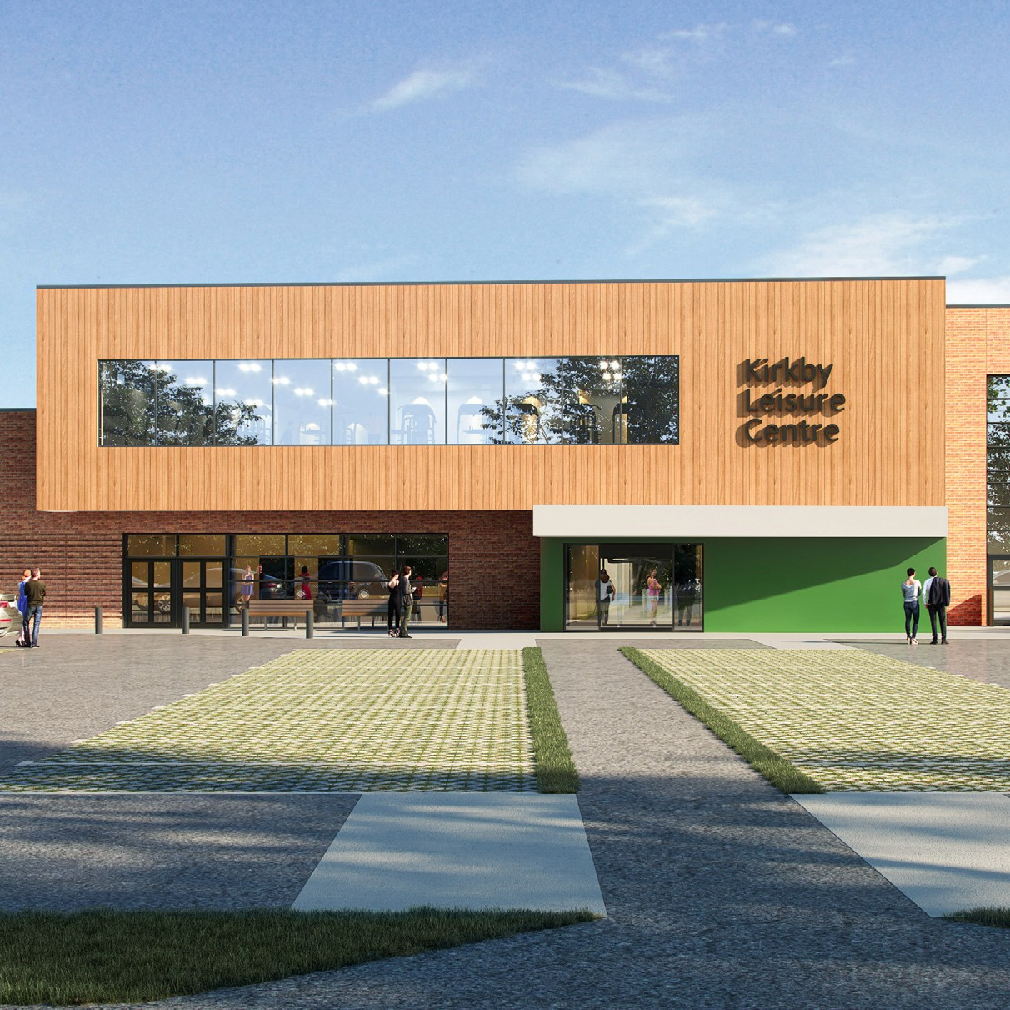The new Health Hub at Kirkby Leisure Centre has received a donation from a local resident enabling the purchase of furnishings for the facility. New sessions including Singing for the Brain, Warm Hub, MSK (Muscular Skeletal),
Escape Pain and Domestic Abuse support have been set up. The Health Hubs at Lammas and Hucknall provide a variety of sessions for people living with Dementia, Parkinson’s and Autism.
- Cost of Living - A 15 point Cost of Living Action Plan was developed with input from Ashfield Voluntary Action and implemented on the Council’s website. Since its launch there have been nearly 13,000 views.

HOMES AND HOUSING
  - Housing - Void re-let times – These have reduced by 20%
from 29.8 days (April 2021 to March 2022) to 23.8 days
(April 2022 to March 2023).
  - Housing Developments - The Affordable Housing Development Programme which the Council has in place in respect of properties to rent with a total of 11 sites delivering over 100 units with more in the pipeline.
  - Homes made available under the Next Steps Accommodation Programme (NSAP) are having a significant positive impact on levels of street homelessness. The Sanctuary Scheme has been reinvigorated preventing homelessness by ensuring survivors of domestic violence can remain safe in their home. The Council has also actively participated in the Homes for Ukraine Scheme and other asylum and resettlement schemes.
  - Social Housing White Paper - following the introduction of the Social Housing White Paper, multiple sections of the Council are working to ensure that the necessary compliance is in place to meet the new standards and regulations coming into force for the Council’s social housing stock. In July 2022 the Council was notified that it had to install carbon monoxide detectors in 6,153
properties. By the end of March 2023 all except 32 had been installed.
  - Welfare & Money Management Advice - 955 tenants have been assisted throughout the year, and all tenancy support cases have been able to successfully remain in their tenancy following targeted support.
  - Tackling disrepair and poor housing - Implementation of a new Selective Licensing Scheme for private rented properties in parts of Sutton and Stanton Hill has taken
place with over 550 license applications received by the end
of March 2023.
  - Suitable Housing - Improvements to the thermal efficiency of older private properties achieved through various ‘Green Homes’ schemes.

ECONOMIC GROWTH AND PLACE
- Levelling Up Bid for the Science Discovery Centre and Planetarium - was successful securing £3.1m match funding.
- The four Future High Street projects - have progressed well with the 14 Low Street project delivered for the end of May 2023 with the other projects well advanced and most will be delivered, as planned, during 2023/24.
- Business Support - quarterly update meetings are held with a range of industry sector stakeholders and partners to discuss delivery of business support and inward investment goals for the District. Our third Business Leaders Networking Event was held in March 2023 showcasing the business benefits of apprenticeships. These events are part of the local UK Shared Prosperity funding supporting local business delivery. Two further events are planned for May and November 2023.
- Business Development - proposals around Junction 27 of the M1 motorway are progressing with discussions with Highways England and Nottinghamshire County Council. Discussions also continue with partners around raising the profile of the potential of reopening the Maid Marian Line.
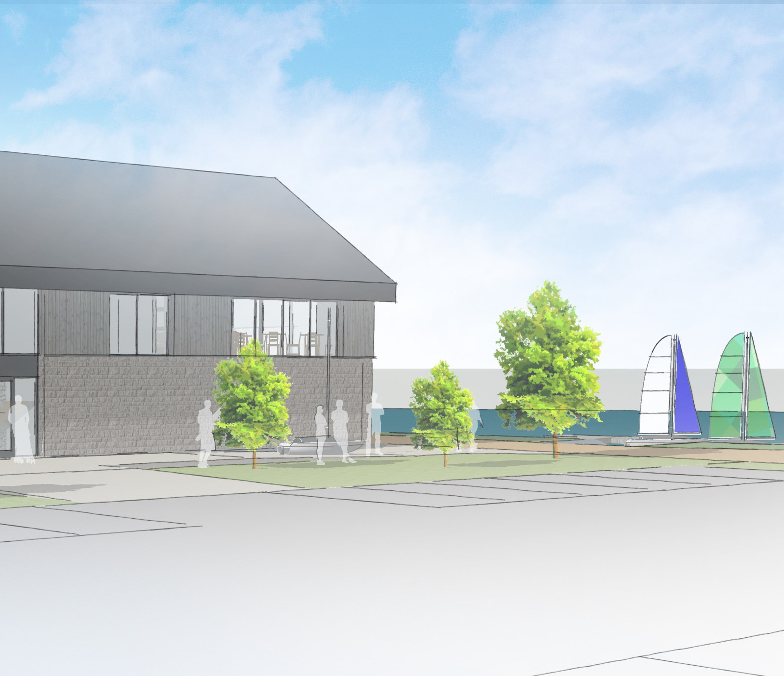
- Town Centres - Idlewells Market is at 91% occupancy with only 3 stalls vacant at the end of March 2023. Town Centre unit vacancy rates are also lower at 9%, 11% and 9% for Hucknall, Kirkby and Sutton respectively.
- Towns Fund Key Projects - Good progress is being made with eight of the seventeen Towns Fund projects now in the delivery phase and
a number of these will be completed during
2023/24.
- Dilapidated Buildings - there have been several successes this year and good progress made dealing with dilapidated buildings.
- UK Shared Prosperity Fund - Work is ongoing to deliver the programme which includes
the tendering of the local business and skills themed projects with other district/borough Councils to achieve greater value for money.
- The Local Plan - work has continued towards the next stage of consultation (Regulation 19) of the emerging Local Plan. Consideration is now being given to new Government guidance around housing numbers flexibility and a revised National Planning Policy Framework. Work has continued on completing the Local Plan evidence base.
- The Skills strategy - the Council’s Education
and Skills Improvement Plan (2022-2031) is being progressed with regular primary/
secondary schools and adult skills partnership meetings. A Careers Fair was held on 4th November 2022 at the new Kirkby Leisure Centre involving key private and public sector partners. The event was a success bringing together over 720 individuals seeking job and training opportunities with 91 partners and businesses.
- Social Value - Excluding the Social Value from our Leisure contacts over £2.2m of social and economic value has now been delivered since measurement via the Social Value Portal commenced.

CLEANER AND GREENER
  - Parks and Open Spaces - The six Green Flag Awards for the main parks were retained this year and an application has been made for a Green Flag Award for the Kings Mill Reservoir site. The outcome will be known later in 2023. Implementation of the Green Spaces Programme has progressed and a review undertaken of the Green Space and Public Realm Investment Plan for the next 5 years. During 2022/23 £100k capital investment has been made into our parks and open spaces.
  - The Big Ashfield Spring Clean - another successful year with free bulky waste collections continuing across the District. The Council also ran ‘flying skips’ over 3 weeks of the Spring Clean Event and collected over 70 tonnes of waste from residents.
  - Green Initiatives - Following on from donating litter pickers during 2022, 16 primary schools received upcycled planters handmade by Council staff using recycled wood and filled with donated compost. The Council continues to have the second highest recycling rate in Nottinghamshire. During 2022/23 the Council planted circa 1,500 trees, significantly greater than its 1,000 annual commitment.

The Council’s Climate Change Strategy and
Carbon Management Plan were approved at Council in the summer 2022. The Council has engaged specialist support to develop a Decarbonisation Plan for its non-domestic assets, looking at identifying measures to significantly reduce its carbon emissions.
This work is nearing completion. The
Council successfully bid for Public Sector Decarbonisation Phase 3 funding for the Urban Road offices and Hucknall Leisure Centre
(total value of works £2m). Other funding bids for Green Homes Grants and Social Housing Decarbonisation have also been successful and are delivering £4m for works to improve the thermal efficiency of private sector and Council homes, and reduce energy demands thereby assisting in reducing the District’s carbon footprint and helping to reduce fuel poverty.
The Council continues to purchase zero carbon electricity certified under the Renewable Energy Guarantee of Origin (REGO). The electricity is generated from wind, solar, hydro, landfill gas and biomass pellets.

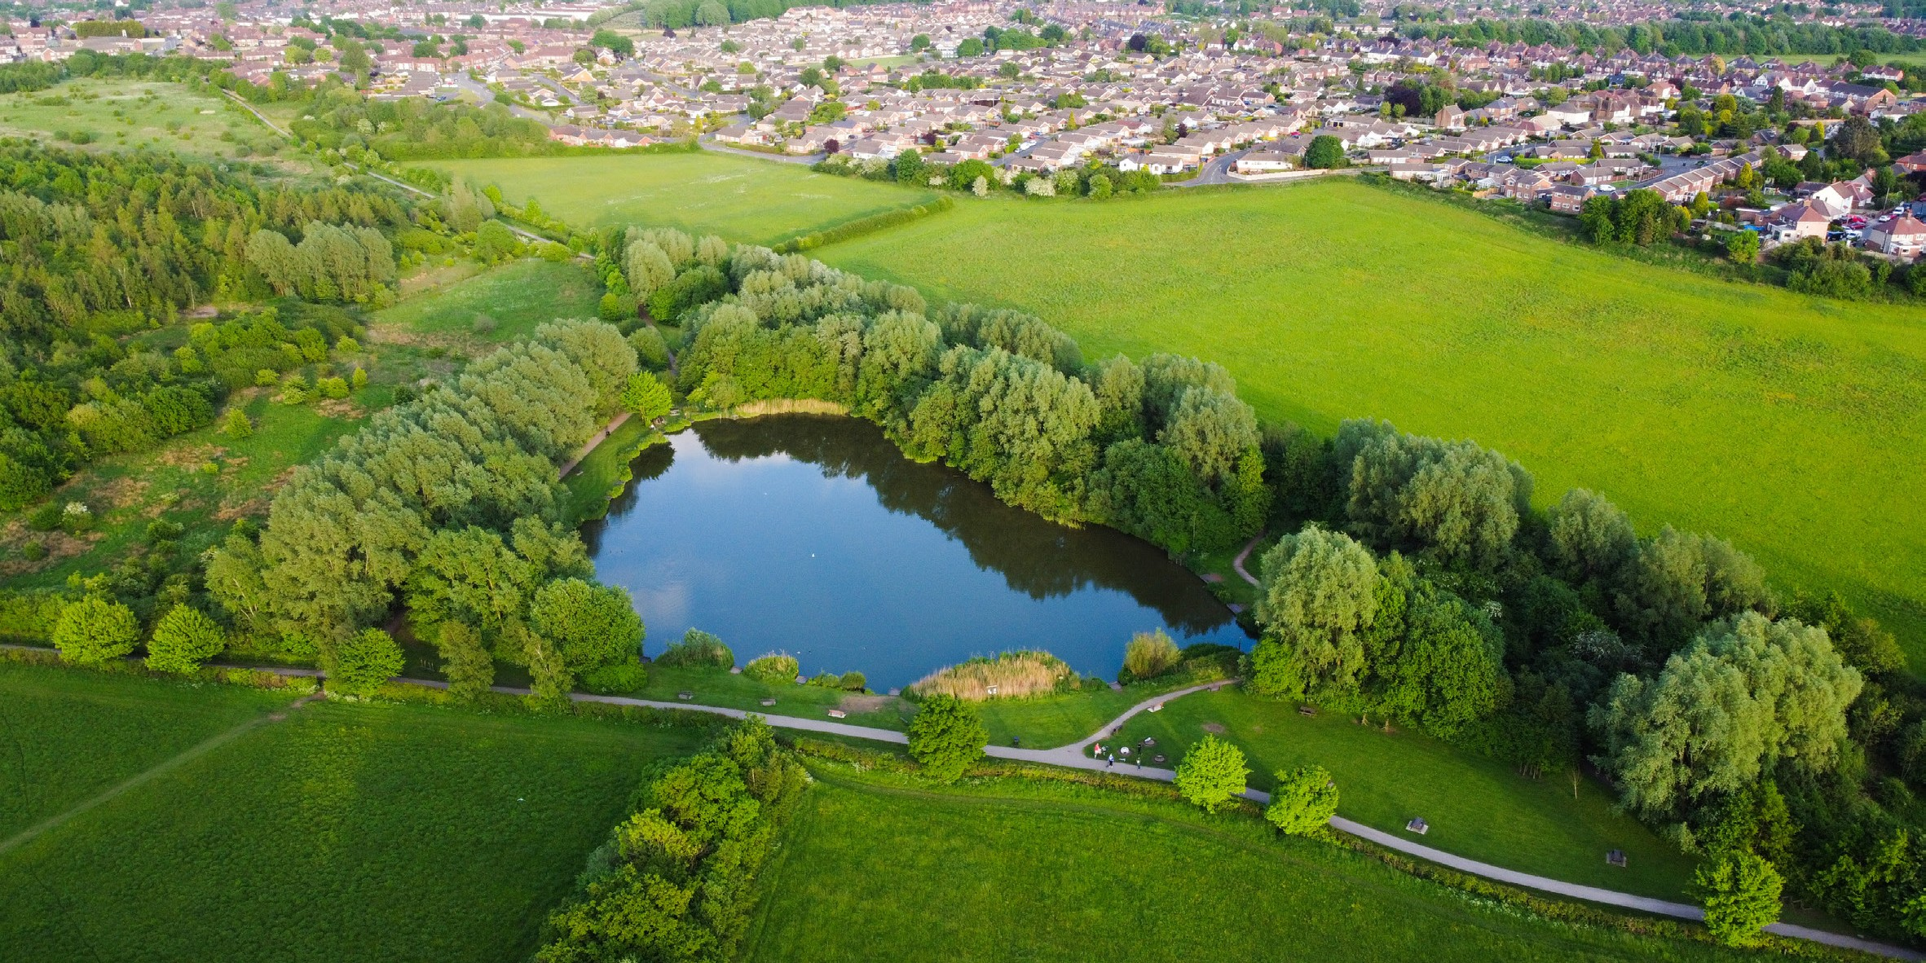
Dylan Elliot

SAFER AND STRONGER
  - Anti-Social Behaviour - The Council responded to 4,807 reports of anti-social behaviour, neighbourhood nuisance and environmental crime reports between 1st April 2022 and 31st March 2023. Based on the
reporting period for the previous year of 5,754 reports, this is a 16% reduction in reported demand over the course of the year.
  - Enviro-crime - A number of action and awareness days have been undertaken to address fly tipping, waste on land, littering and dog fouling across the District. The Council investigated 1,612 cases of environmental crime related reports last year, resulting in educational sessions and 318 notices being issued.
  - Safer Streets - the Council, alongside partners and the Office of Police and Crime Commissioner, was successful in securing
£750,000 for Mansfield and Ashfield as part of the Safer Streets Round 4 Funding programme. The funding is being used to address longstanding community concerns relating to feelings of safety, neighbourhood crimes and the perception of crime and anti-social behaviour
in public places. The Council also received total funding of £169,333 from the Shared Prosperity Fund, Home Office Prevent Fund and Police Crime Commissioner to address community safety issues across the District.
  - Safeguarding Vulnerable People - The Community Safety Team made 115 referrals to the MASH (Multi- Agency Safeguarding Hub) to safeguard vulnerable adults and children and protect them from further harm/abuse. The
Council also chairs and operates the Partnership Complex Case Panel and dedicated Vulnerable Adult Support Scheme to assist those who present vulnerable or with multiple support needs.
- CCTV - The Council has increased its public space CCTV cameras to 51 devices across the District, to help promote feelings of safety, detect and deter crime and anti-social behaviour. The new equipment installed comprises of dedicated safe point cameras in all our town centers which has intruder alert activation and communicates directly with the Police control room. The cameras are monitored from Nottinghamshire Police Headquarters 24 hours, 7 days per week.
- Partnership Working - The Community Safety partnership works together to tackle crime and anti-social behaviour through the facilitation of neighborhood meetings, community action days and joint patrols in neighborhoods, town Centre’s and public spaces across the District. The framework enables the Council to have a co-ordinated approach to tackle trends and emerging issues across Ashfield.
- Domestic Abuse - The Council has been successful in extending its White Ribbon Accreditation until November 2025. The accreditation illustrates the Council’s commitment to ending violence against women and girls. Over £90,000 has been secured to address domestic abuse in 2022/2023, which comprises of £33,761 for domestic abuse statutory duty funding for safe accommodation and £60,000 for support provision for survivors of domestic abuse and
help deliver the Sanctuary and Serenity Scheme to prevent homelessness and provide safe accommodation.

DRAFT STATEMENT OF ACCOUNTS 2022-2023 1 4

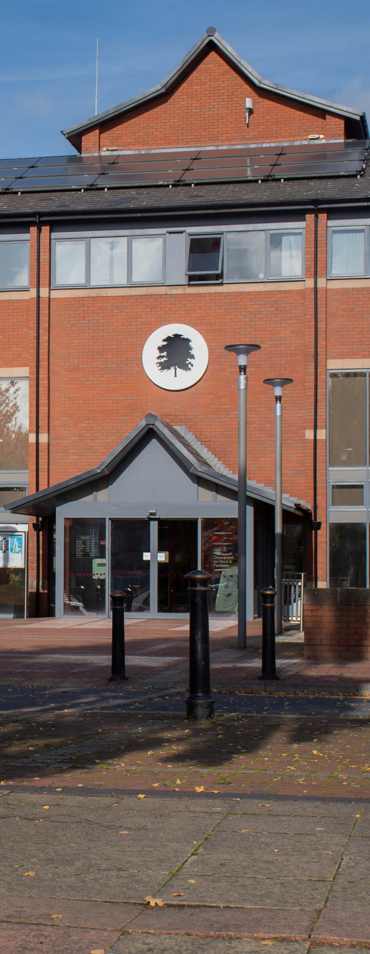

INNOVATE AND IMPROVE
  - Customer Services - the level of take-up for making payments easily, using digital channels, continues to increase with 88% of payments received during 2022/23 being made either
by direct debit, online ‘e-store’, automated telephone or recurring card payments. Paypoint and post office transactions which are more expensive for the customer continue to decrease with a further 13% reduction during 2022/23.
20% of Council Tax payers and 80% of Business Rates payers are now signed up to the Revenues portal. The new Customer Portal, Ashfield 24/7, was launched in February 2022 and now has over 11,000 residents signed up. The Council
Tax Energy Rebate Scheme was successfully administered quickly and at short notice with
£150 payments made from April to November 2022 to 54,753 households (almost £8.2m).
  - Digital transformation - The Digital Transformation Programme has now delivered approaching £3m of financial benefits (cashable and cost avoidance) over the last 5 years. In house digital development is now also leading more modern approaches in community projects, for example, a Safer Streets project has incorporated significantly less costly in house development, digital proof of concept using QR codes on lamp posts so residents can easily report street lighting issues to the County
Council. Significant strides have also been made in the ongoing modernisation of the Council’s solution architecture with a particular focus
on moving business solutions to the ‘cloud’ to improve accessibility, usability and business continuity.
  - Partnering - At the end of March 2023
there was a successful transition to our new Procurement Partner (Nottinghamshire County Council) ensuring continued access to specialist support and minimising anticipated cost increases. In February 2023 the Council started implementation of its new core Finance system ‘One Council’ from Technology One, with implementation expected to be complete by March 2024.

ORGANISATIONAL DELIVERY
POLITICAL STRUCTURE

During 2022/23 the Council consisted of 35 Councillors, controlled by the Ashfield Independents (28) with 3 Conservative, 2 non-aligned and 2 Labour Councillors. In 2022/23 the Council’s Cabinet comprised of ten Councillors:
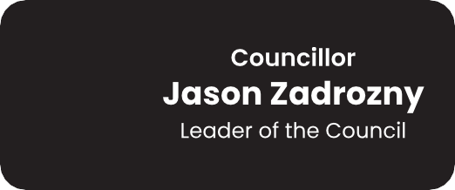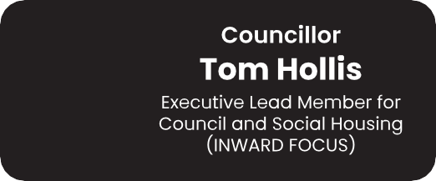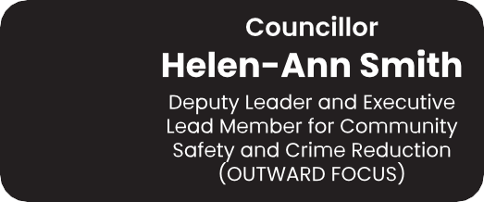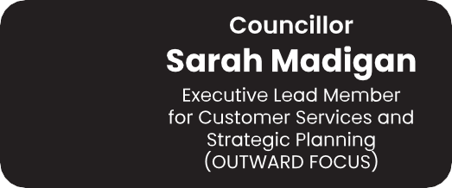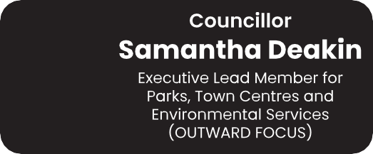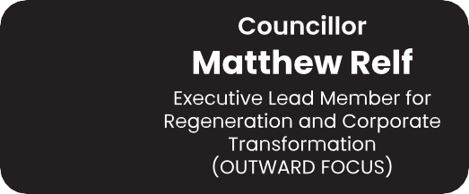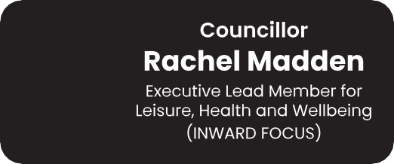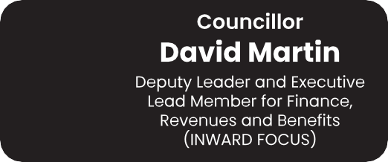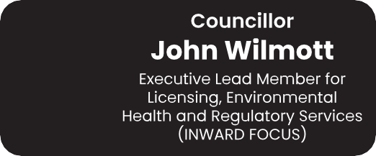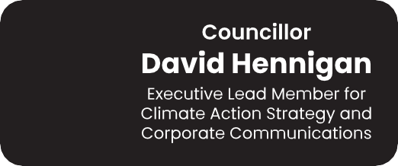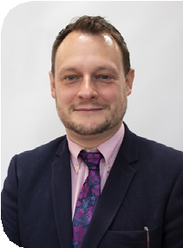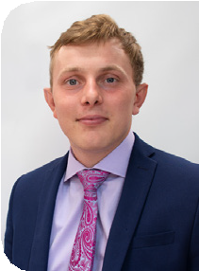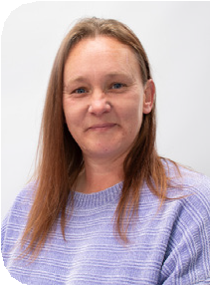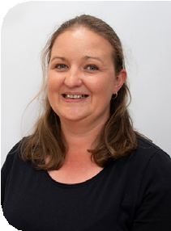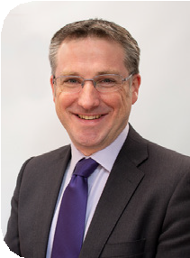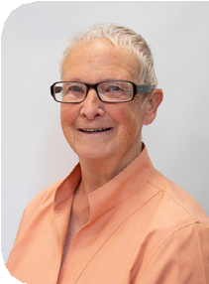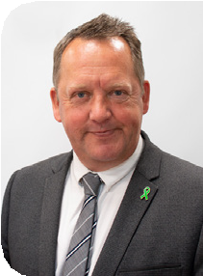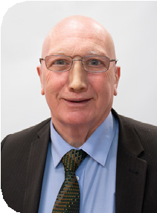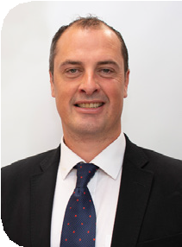

Within Ashfield there are two parishes, Selston Parish Council and Annesley & Felley Parish Council who provide additional services to residents within their respective boundaries.

The JUS-t Neighbourhood Plan was made for a substantial part of the Parish of Selston following a referendum in October 2017. Currently no neighbourhood plan has been adopted by Annesley & Felley Parish Council.

The Teversal, Stanton Hill and Skegby Neighbourhood Forum brought forward a Neighbourhood Plan for Teversal, Stanton Hill and Skegby, which was also made in October 2017. The Forum was re-designated for a further five years following a decision of the Cabinet on 27th January 2020.

MANAGEMENT STRUCTURE
AND WORKFORCE
The Council’s management structure – the Strategic Leadership Team (SLT) is documented in the Council’s Constitution and is comprised of the Chief Executive, four Executive Directors and the Corporate Resources Director (& Section 151 Officer).
SLT is responsible for implementing
the Council’s strategic goals as determined
by elected Members, and for the effective operational delivery and management of Council services.

As at 31st March 2023 the Council’s workforce comprised 589 employees in post (544.11 full time equivalent posts) on the approved staffing establishment.

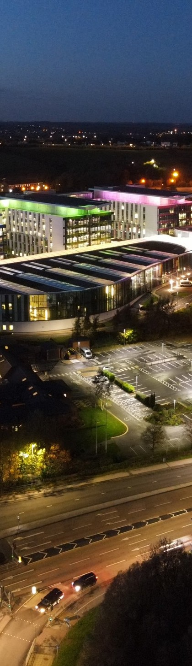
KEY OPERATIONAL PARTNERING ARRANGEMENTS
In 2022/23 Ashfield District Council has key working relationships with the following organisations:
- Discover Ashfield Board – to oversee the development and implementation of Towns Fund and Future High Streets Fund projects.
- Mansfield District Council and Newark & Sherwood District Council for owning and operating the Mansfield Crematorium.
- Mansfield District Council for delivering shared services across both
authorities for Human Resources & Payroll.
- Ashfield District Council is the Lead Partner for the Rough Sleeper Initiative
funding/service.
- Mansfield District Council – Homefinder Lettings Scheme
- Mansfield District Council and Newark & Sherwood District Council – Private
Sector Landlord Forum
- Broxtowe Borough Council - Ashfield provides Business Rates processing support to Broxtowe.
- J. Tomlinson Ltd, our delivery partner for completing capital improvements to
the Council’s housing stock.
- Nottingham City Homes for the Lifeline Service.
- Sport & Leisure Management Ltd for operating the Council’s Leisure Centres.
- Nottingham City Council for provision of Procurement services (This ceased at the end of March 2023, and Nottinghamshire County Council is now the Procurement Service provider.
- Central Midlands Audit Partnership (CMAP) for the provision of our Internal Audit function.
- Erewash Borough Council for the provision of our Building Control function.

FINANCIAL PERFORMANCE
2022/23

GENERAL FUND REVENUE OUTTURN
The General Fund supports the day to day running of the Council’s services, excluding Council Housing provision.

Directorate | Revised Budget £’000 | Outturn  £’000 | Variance  £’000
Chief Executive | 670 | 645 | (25)
Legal & Governance | 1,973 | 2,066 | 93
Resources & Business Transformation | (392) | 291 | 683
Place & Communities | 9,791 | 8,394 | (1,397)
Housing & Assets | 2,426 | 2,226 | (200)
Net Cost of Services | 14,468 | 13,622 | (846)

Key Variance Explanations:
Net staff cost savings (vacancies) | (160)
Net additional service income | (327)
Additional Grant income | (920)
Additional Housing Benefit & Discretionary Housing Payments | 367
Planned use of earmarked reserves | 202
Other items (net) | (8)
 | (846)

GENERAL FUND RESERVES (£M)
20
18.596
14.929
9.003
9.235

15

10

5

0
2021/2022 2022/2023
GENERAL RESERVE
EARMARKED
RESERVES

HOUSING REVENUE ACCOUNT (HRA)
The HRA is a ring-fenced landlord’s account for the management and maintenance of the Council’s housing stock. This account funds both day to day revenue costs as well as funding borrowing costs for capital work to maintain and improve council properties.
Compared to the 2022/23 revised budget the HRA achieved a surplus of £3.051m, these are shown in the Table below:

Key reasons for HRA variances: | £’000
Reduced capital expenditure largely due to the delay on some housing capital schemes and replacement vehicles | (2,641)
Additional rents and charges income and interest and investment income | (1,233)
Utility Price increases | 313
Staffing expenditure - Pay Award less vacancies | 200
Digital Transformation | 192
Housing - Maintenance Repairs and Materials | 140
Other various minor variances (net) | (22)
 | (3,051)

HRA RESERVES (£M)
50
42,969
43,344
821
578

40

30

20

10

0
2021/2022 2022/2023

GENERAL RESERVE
EARMARKED
RESERVES

Further information relating to the Housing Revenue Account can be found
within the Supplementary Financial Statements.

CAPITAL SPENDING 2022/23

Capital monies are spent on building or enhancing the Council’s asset base. There are rules and regulations regarding what can be classed as capital expenditure and this expenditure must be financed separately from the day to day running costs of the Council.
During 2022/23 the Council spent £32.7m on capital works. Key projects were:
Leisure Transformation
Programme
Almost £4.7m was spent on the new Leisure Centre at Kirkby, this includes demolition works to the Festival Hall site and a new car park. Significant transformation works to both Hucknall and Lammas Leisure Centres also cost £3.9m.

Parks and Open Spaces
Over £100k capital funding has been spent on Parks and Open Spaces infrastructure across the whole District during 2022/23.

Disabled Facilities Grants
The Council spent £951k to meet the statutory duty to provide Mandatory Disabled Facilities Grants to qualifying applicants under the Housing Grants Construction and Regeneration Act 1996. These grants provide the funds for adaptations to modify environments to restore or enable independent living, privacy, confidence and dignity for individuals and their families in non-Council dwellings.

Future High Streets and Towns Fund Projects
£3.4m was spent on progressing the above projects. The significant areas of spend
have been the refurbishment and alterations to the vacant units at Low Street, Kings Mill Reservoir development and the Science Discovery Centre and Planetarium.

Housing Projects
£17.3m was spent in 2022/23 on building new and improving existing Council dwellings throughout the District ensuring
that the Decent Homes Standard is maintained. Other projects included the acquisition of houses to add to the Council’s stock to help meet the social housing demands of our residents and undertaking disabled adaptations to Council properties and undertaking ‘Green Homes work’ to make properties more energy efficient.

BALANCE SHEET

Property, Plant & Equipment (PPE)
The value of PPE increased by
£35.877m to £368.746m as at 31st March 2023. This increase is largely due to increases in
revaluations of Council dwellings (£16.9m), new dwellings added to the Council’s stock (£13.3m), revaluation due to expenditure on Council Leisure Centres (£8.6m) and the disposal of Council dwellings (-£2.6m).
Council dwellings are valued utilising the East Midland Council dwellings are valued utilising the East Midland Adjustment Factor, as required by Government.
This Adjustment Factor reduces the value of social housing from the market level to a level
which reflects the Government’s assessment of valuation, taking account of ‘right to buy’ and other factors.

Investment Properties & Assets Held for Sale
The overall value of Investment Properties decreased in year by
£5.222m. This decrease was due to valuation reductions across the portfolio. The Assets Held for Sale value increased by £1.379m in the year; this was largely due to the transfer in of surplus land at Clegg Hill Drive.

Long Term Provisions
The value of Long Term Provisions increased by £201k to £2.840m at the end of March 2023. The main provision within this £2.840m is in respect of Business Rates appeals.

Pension Liability
The Council is a member of the Nottinghamshire County Council Pension Fund. The Pension Liability decreased by £82.957m to £26.811m at 31st March
2023 largely due to changes to the financial and demographic assumptions, in line with economic information as advised by Barnett Waddingham, the Council’s Pensions Actuary, which have reduced the pension liability.

OUTLOOK

BUDGETS AND FUNDING
There is significant uncertainty about the level of funding the Council will receive beyond 2023/24. In the 2023/24 Local Government Finance Settlement it was stated that Local
Government Funding Reform would not now take
place until 2025/26 at the earliest.

This gives significant uncertainty to Council’s in respect of their ability to plan financially for the medium term.

It is anticipated that a key outcome of the above will be a redistribution of resources to address the national social care pressure in both Adults’ and Children’s services and as District Councils do not provide these services, District Councils’ resources are expected to reduce.

Ashfield District Council, like most Councils, receives support from Local Government Futures (LG Futures) and has used their resource forecasting model and the Council’s own forecast expenditure requirements to estimate the anticipated funding gap for the next four financial years. Notwithstanding the uncertainty
brought about by the delay of Local Government Funding Reform, the estimated cumulative funding gap from 2024/25 to 2026/27 as shown in the March 2023 MTFS updated position
was £5.226m with the largest proportion of
this funding gap (£4.151m) expected to be in 2025/26, assuming this is the year in which Local Government Funding Reform is implemented.

As set out in the Council’s 2023/24 Budget Setting Report, robust plans are in place to identify options and implement actions to address the future estimated financial challenge.
This includes a line by line review of all of the Council’s budgets and Medium-Term Financial Strategy (MTFS) assumptions; a review of
fees and charges and income generating opportunities; a review of procurement and contracting arrangements; a review of services and future service delivery options;
consideration of asset rationalisation potential and delivery of financial efficiencies from the investment in technology via the Council’s Digital Transformation Strategy. The Strategic Leadership Team and the Council’s Cabinet meet frequently to progress this work.

The Council has a strong track record of setting a balanced and deliverable budget and this robust approach will continue with the future
development of the MTFS to ensure the Council’s
ongoing financial sustainability.

The Medium-Term Financial Strategy will be updated and presented to Cabinet as part of the annual budget setting process for 2024/25 and will reflect the 2022/23 Outturn, progress on identifying savings to help close the estimated funding gaps for future years and the level of core Central Government funding being made available to support the Council to deliver its services.

CAPITAL INVESTMENT
In 2023/24 the Council will conclude its extensive Leisure Transformation Programme with the opening of the new second swimming pool at Hucknall Leisure Centre this summer.

The Council will continue to implement the remaining 3 (of 4) Future High Streets funded projects and the 17 Government approved Towns Fund projects. It is anticipated that at least 6 of these projects will be fully implemented
in 2023/24 with significant progress made on
implementing the remaining projects.

All of the above significant investment will deliver jobs and further education opportunities, long-term economic and productivity growth, new homes, improved transport infrastructure, reduced carbon and new cultural and visitor facilities to the District.

FUNDING BIDS
In 2022/23 the Council was successful in its bid to the Government’s Levelling Up Fund (Round 2) for the Science Discovery Centre and Planetarium in Sutton in Ashfield. However, its bid for funding for Hucknall was unsuccessful.

It is the intention that the Council will submit a further bid for Hucknall to the Levelling Up Fund (Round 3) during 2023/24.

As new external funding streams are announced in respect of moving to carbon net zero by 2050, the Council will continue to apply for this funding as it has with decarbonisation and Green Homes funding.

Where the Council enters into arrangements for new housing developments it will also submit funding applications to Homes England.

EXPLANATION OF THE
FINANCIAL STATEMENTS

The Statement of Accounts is for the financial year 31st March 2023 and as required by the Code, comprises of Core and Supplementary Statements, together with Disclosure Notes. The style and format of the Accounts complies with the local authority accounting standards.

THE CORE FINANCIAL STATEMENTS

Comprehensive Income and Expenditure Statement (CIES)
This Statement records all of the Council’s income and expenditure for the year. It includes both the amounts spent on local taxpayer services and also local rent payer services. The top half of the statement provides analysis
of spend by Directorate on services that the Council is required to undertake by law (statutory duties such as street cleansing, planning and registration) and discretionary services focussed on local priorities and need. The bottom half of the statement deals with corporate transactions and funding.

Movement in Reserves Statement (MiRS) This statement summarises the movement in year on the Council’s different reserves. These reserves are analysed into ‘useable reserves’ (i.e. those that can be used to fund expenditure or reduce local taxation) and ‘unusable reserves’ which must be set aside for specific purposes (as they relate to gains and losses on statutory adjustment accounts).

Balance Sheet
The Balance Sheet is a ‘snapshot’ of the Council’s financial position at the end of March 2023.
It shows the Council’s assets, liabilities, cash
balances and reserves at 31st March 2023.

Cash Flow Statement
The Cash Flow Statement shows the reasons for changes in the Council’s cash balances during the year, and whether the change is due to operating activities (day to day costs), new investments,
or financing activities (such as repayment of borrowing and other long term liabilities).

THE SUPPLEMENTARY FINANCIAL
STATEMENTS

Housing Revenue Account (HRA)
This Account separately identifies expenditure incurred in the provision, management and maintenance of the Council’s housing stock and demonstrates how this has been funded
from rents, service charges and other income. In accordance with the Local Government and Housing Act 1989 this is maintained as a separate account and must operate with a positive working balance.

The Collection Fund
The Collection Fund details all monies due from Council Tax and Non Domestic Rate payers and redistribution of some of these payments to other organisations on whose behalf the Council collects these taxes including the County Council, Nottinghamshire Police and Crime Commissioner and the Fire & Rescue Authority.

ANNUAL GOVERNANCE STATEMENT (AGS)
This Statement sets out the Council’s governance
structures and its key internal controls.

OTHER KEY SECTIONS IN THE STATEMENT
OF ACCOUNTS

Statement of Responsibilities
This Statement sets out the respective responsibilities of the Council and the Chief Finance Officer.

Accounting Policies
These Policies explain the treatment and basis of the figures in the accounts in accordance with proper accounting practices.

Notes to the Financial Statements
These provide additional information on important points included in the Core Financial Statements.

Expenditure and Funding Analysis (EFA) This Statement shows how annual expenditure is used and funded from Council resources
in comparison with how those resources are consumed or earned by the Council. It also shows how this expenditure is allocated for decision making purposes across the Council’s Directorates.

Glossary of Terms and Abbreviations
Key terms used throughout this Statement of Accounts are more fully explained.
Peter Ludlam

Further Information
If you require further information concerning the Council’s 2022/23 Accounts please contact:
The Corporate Resources Director
Ashfield District Council
Urban Road, Kirkby in Ashfield, Nottinghamshire NG17 8DA
Telephone: 01623 457362
or Email: pete.hudson@ashfield.gov.uk

THE STATEMENT OF RESPONSIBILITIES
FOR THE STATEMENT
OF ACCOUNTS

RESPONSIBILITIES OF THE COUNCIL

The Council is required to:
- Make arrangements for the proper administration of its financial affairs and to ensure that one of its officers has the responsibility for the administration of those affairs. In this Council, that officer is the Corporate Resources Director;
- Manage its affairs to secure economic, efficient and effective use of resources and safeguard its assets;
- Approve the Statement of Accounts.
I confirm that the Financial Statements were approved by the
Audit Committee meeting held on XXth November 2023.
Signed on behalf of Ashfield District Council:

Councillor
Chairman of the Audit Committee

RESPONSIBILITIES OF THE CORPORATE RESOURCES DIRECTOR

The Corporate Resources Director is responsible for the preparation of the Council’s statement of accounts in accordance with proper practices as set out in the CIPFA/LASAAC Code of Practice on Local Authority Accounting in the United Kingdom 2022/23 (“the Code of Practice”).

In preparing this Statement of Accounts, the Corporate Resources Director has:
- Selected suitable accounting policies and then applied them consistently;
- Made judgements and estimates that were reasonable and prudent;
- Complied with the Code of Practice.

The Corporate Resources Director has also
- Kept proper, up to date accounting records;
- Taken reasonable steps for the prevention and detection of fraud and other irregularities.
I confirm that the Statement of Accounts presents a true and fair view of the financial position of the Council at the accounting date and its income and expenditure for the year ended 31st March 2023.

P. Hudson, ACMA, CGMA
Corporate Resources Director & Section 151 Officer XXth November 2023

AUDIT CERTIFICATE
AND OPINION

THESE 5 PAGES ARE
LEFT BLANK FOR
THE INDEPENDENT
AUDITOR’S REPORT.

THESE 5 PAGES ARE
LEFT BLANK FOR
THE INDEPENDENT
AUDITOR’S REPORT.

THESE 5 PAGES ARE
LEFT BLANK FOR
THE INDEPENDENT
AUDITOR’S REPORT.

THESE 5 PAGES ARE
LEFT BLANK FOR
THE INDEPENDENT
AUDITOR’S REPORT.

THESE 5 PAGES ARE
LEFT BLANK FOR
THE INDEPENDENT
AUDITOR’S REPORT.

STATEMENT OF
ACCOUNTING POLICIES

GENERAL PRINCIPLES
The Statement of Accounts summarises the Council’s transactions for the financial year 2022/23 and its position at the year-end 31st March 2023. The Council is required to prepare an annual Statement of Accounts by the Accounts and Audit Regulations 2015. These Regulations require the accounts to be prepared in accordance with proper accounting practices. These practices under Section 21 of the 2003 Act primarily comprise of the Code of Practice on Local Authority Accounting in the United Kingdom 2022/23 and International Financial Reporting Standards (IFRS).

The accounting convention adopted in the Statement of Accounts is principally historical cost, modified by the revaluation of certain categories of non-current assets and financial instruments.

ACCRUALS OF INCOME AND EXPENDITURE
Activity is accounted for in the year that it takes place, not simply when cash payments are made or received. In particular:

  - Revenue from contracts with service recipients, whether for services or the provision of goods, is recognised when (or as) the goods or services are transferred to the service recipient in accordance with the performance obligations in the contract.
  - Supplies are recorded as expenditure when they are consumed; where there is a gap between the date supplies are received and their consumption, they are carried as inventories on the Balance Sheet;
- Expenses in relation to services received (including services provided by employees) are recorded as expenditure when the services are received rather than when payments are made;
- Interest receivable on investments and payable
on borrowings is accounted for respectively as income and expenditure on the basis of the effective interest rate for the relevant financial instrument rather than the cash flows fixed or determined by the contract.
- Where revenue and expenditure have been recognised but cash has not been received or paid, a debtor or creditor for the relevant amount is recorded in the Balance Sheet.
Where debts may not be settled, the balance of debtors is written down and a charge made to revenue for the income that might not be collected.

CASH AND CASH EQUIVALENTS
Cash is represented by cash in hand and deposits with financial institutions repayable without penalty on notice of not more than one working day.

Cash Equivalents are highly liquid investments that mature in 3 months or less from the date of acquisition and that are readily convertible to known amounts of cash with insignificant risk of change in value.

In the cash flow statement, cash and cash equivalents are shown net of any bank overdrafts that are repayable on demand and form an integral part of the Council’s cash management.

EXCEPTIONAL ITEMS
When items of income and expenditure are material, their nature and amount is disclosed separately, either on the face of
the Comprehensive Income and Expenditure Statement or in the notes to the accounts, depending on how significant the items are to an understanding of the Council’s financial performance.

PRIOR PERIOD ADJUSTMENTS, CHANGES IN ACCOUNTING POLICIES AND ESTIMATES AND ERRORS
Prior period adjustments may arise as a result of a change in accounting policies or to correct a material error. Changes in accounting estimates are accounted for prospectively, i.e. in the current and future years affected by the change and do not give rise to a prior period adjustment.
Changes in accounting policies are only
made when required by proper accounting practices or the change provides more reliable or relevant information about the effect of transactions, other events and conditions on the Council’s financial position or financial performance. Where a change is made, it is applied retrospectively (unless stated otherwise) by adjusting opening balances and comparative
amounts for the prior period as if the new policy had always been applied.

Material errors discovered in prior period figures are corrected retrospectively by amending opening balances and comparative amounts for the prior period.

CHARGES TO REVENUE FOR NON- CURRENT ASSETS
Service revenue accounts, support services and trading accounts are charged with the following amounts to record the real cost of holding non- current assets during the year:

  - Depreciation attributable to the assets used by the relevant service.
  - Revaluation and impairment losses on assets used by the service where there are no accumulated gains in the Revaluation Reserves against which the losses can be written off.
  - Amortisation of intangible assets attributable to the service.

The Council is not required to raise Council Tax to cover depreciation, revaluation and impairment losses or amortisations. However, it is required to make an annual provision from revenue to contribute towards the reduction in its overall borrowing requirement equal to an amount calculated on a prudent basis determined by the Council in accordance with statutory guidance.
Depreciation, revaluation, impairment losses and amortisation are therefore replaced by the contribution in the General Fund Balance by way of an adjusting transaction with the
Capital Adjustment Account in the Movement in Reserves Statement for the difference between the two.

EMPLOYEE BENEFITS
- Benefits payable During Employment Short-term employee benefits are those due to be settled within 12 months of the year- end. They include such benefits as wages and salaries, paid annual leave and paid sick leave,
bonuses and accumulated flexi time for current employees and are recognised as an expense for the services in the year in which the employees render service to the Council. An accrual is made for the cost of holiday entitlements etc. earned by employees but not taken before the year- end, which employees can carry forward into the next financial year. The accrual is made at the wage and salary rates applicable the following accounting year, being the period in which
the employee takes the benefit. The accrual is charged to Surplus and Deficit on the Provision of Services, but then reversed out through the Movement in Reserves Statement so that holiday benefits are charged to revenue in the financial year in which the holiday absence occurs.

Termination Benefits
Termination benefits are amounts payable
as a result of a decision by the Council to terminate an officer’s employment before the normal retirement date or an officer’s decision to accept voluntary redundancy in exchange for those benefits. These are charged on an accruals basis to the Non Distributed Costs line in the Comprehensive Income and Expenditure Statement when the Council can no longer
withdraw the offer of those benefits or when the
Council recognises costs for a restructuring.

Where termination benefits involve the enhancement of pensions, statutory provisions require the General Fund Balance to be charged with the amount payable by the Council to the pension fund or pensioner in the year, not the amount calculated according to the relevant accounting standards. In the Movement in Reserves Statement, appropriations are required to and from the Pensions Reserve to remove the notional debits and credits for pension enhancement termination benefits and replace
them with debits for the cash paid to the pension
fund and pensioners and any such amounts payable but unpaid at the year-end.

Post Employment Benefits
Most employees of the Council contribute to the Nottinghamshire Pension Fund, the Local Government Pension Scheme administered by Nottinghamshire County Council. The scheme
provides defined benefits (retirement lump sums and pensions) earned as employees work for the Council.
The Nottinghamshire Pension Fund is accounted
for as a defined benefit scheme:
  - The liabilities of Nottinghamshire Pension Fund attributable to the Council are included in
the Balance Sheet on an actuarial basis using the projected unit method, i.e. an assessment of the future payments that will be made in relation to retirement benefits earned to date by employees, based on assumptions including mortality rates, employee turnover rates and projections of projected earnings for current employees.
  - Liabilities are discounted to their value at current prices using a discount rate based on an appropriate rate of return on high quality corporate bonds.
  - The assets of the Fund attributable to the Council are included in the Balance Sheet at their fair value.

    - Quoted securities – current bid price
    - Unquoted securities – professional estimate
    - Unitised securities – current bid price
    - Property – market value

The change in the net pension liability is analysed
into the following components:
      - Service Cost comprising
        - Current Service Cost - the increase in liabilities as result of years of service earned this year - allocated in the Comprehensive Income and Expenditure Account to the services for which the employees worked
        - Past Service cost - the increase in liabilities as a result of a scheme amendment or curtailment whose effect relates to years
of service earned in earlier years - debited to the Surplus or Deficit on Provision of Services in the Comprehensive Income and Expenditure Account as part of Non-
Distributed Costs
        - Net interest on the net defined liability (asset), i.e. the net interest expense for the Council – the change during the period in the net defined benefit liability (asset) that arises from the passage of time charged to the Financing and Investment Income
and Expenditure line of the Comprehensive Income and Expenditure Statement – this is calculated by applying the discount
rate used to measure the defined benefit obligation at the beginning of the period to the net defined benefit liability (asset) at the beginning of the period – taking into account any changes in the net defined
benefit liability (asset) during the period as a result of contribution and benefit payments

Re-measurement comprising:
          - the return on plan assets – excluding amounts included in net interest on the defined benefit liability (asset) –
charged to the Pensions Reserve as Other Comprehensive Income and Expenditure
          - actuarial gains and losses - changes in the net pension liability that arise
because events have not coincided with assumptions made at the last actuarial valuation or because the actuaries have updated their assumptions – charged to the Pensions Reserve as Other
Comprehensive Income and Expenditure.
    - Contributions paid to Nottinghamshire Pension Fund - Cash paid as employer’s contributions to the pension fund in settlement of liabilities; not accounted for as an expense.

In relation to retirement benefits, statutory provisions require the General Fund Balance to be charged with the amount payable by the Council to the pension fund or directly to
pensioners in the year, not the amount calculated according to the relevant accounting standards.

In the Movement in Reserves Statement this means that there are transfers to and from the Pensions Reserve to remove the notional debits and credits for retirement benefits and replace them with debits for the cash paid to the pension fund and pensioners and any such amounts payable to the fund but unpaid at the year-end.

The negative balance that arises on the Pensions reserve thereby measures the beneficial impact on the General Fund of being required to account for retirement benefits on the basis of cash flows rather than as benefits are earned by employees.

Discretionary Benefits
The Council also has restricted powers to make discretionary awards of retirement benefits in the event of early retirements. Any liabilities estimated to arise as a result of an award to any member of staff are accrued in the year of the decision to make the award and accounted for using the same policies as are applied to the Local Government Pension Scheme.

EVENTS AFTER THE REPORTING PERIOD
Events after the Balance Sheet date are those events, both favourable and unfavourable, that occur between the end of the reporting period and the date when the Statement of Accounts is authorised for issue. Two types of events can be identified;

  - those that provide evidence of conditions that existed at the end of the reporting period – the Statement of Accounts is adjusted to reflect such events,
  - those that are indicative of conditions that arose after the reporting period – the
Statement of Accounts is not adjusted to reflect such events, but where a category of events would have a material effect, disclosure is made in the notes of the nature of the events and their estimated financial effect.

Events taking place after the date of authorisation for issue are not reflected in the Statement of Accounts. For the purposes of consideration, Post Balance Sheet events can occur up to approval of the Statements by the Audit Committee.

FINANCIAL INSTRUMENTS

Financial Liabilities
Financial liabilities are recognised on the Balance Sheet when the Council becomes a party to the contractual provisions of a financial instrument, which are initially measured at fair value, and are carried at their amortised cost. Annual charges to the Financing and Investment Income and Expenditure line in the Comprehensive Income and Expenditure Statement for interest payable are based on the carrying amount of the liability,
multiplied by the effective interest rate of interest for each instrument. The effective interest rate is the rate that exactly discounts estimated future cash payments over the life of the instrument to the amount at which it was originally borrowed.

For most of the borrowings that the Council has, this means that the amount presented in the Balance Sheet is the outstanding principal repayable (plus accrued interest); and interest
charged to the Comprehensive Income and Expenditure Statement is the amount payable for the year according to the loan agreement.

Where premiums and discounts have been charged to the Comprehensive Income and Expenditure Statement, regulations allow the impact on the General Fund Balance to be spread over future years. The Council has a policy of spreading the gain or loss over the term that was remaining on the loan against which the premium was payable or discount receivable when it was repaid. The reconciliation of amounts charged to the Comprehensive Income and Expenditure Statement to the
net charge required against the General Fund Balance is managed by a transfer to or from the Financial Instruments Adjustment Account in the Movement in Reserves Statement.

Financial Assets
Financial assets are classified based on a classification and measurement approach that reflects the business model for holding the financial assets and their cashflow characteristics. There are three main classes of financial assets measured at:
  - amortised cost
  - fair value through profit or loss (FVPL), and
  - fair value through other comprehensive income (FVOCI)

The Council’s business model is to hold investments to collect contractual cash flows. Financial assets are therefore classified at amortised cost.

Financial Assets measured at amortised costs Loans and receivables are recognised on the Balance Sheet when the Council becomes a party to the contractual provisions of a financial instrument and are initially measured at fair value. They are subsequently measured at their amortised cost.

Annual credits to the Financing and Investment Income and Expenditure line in the Comprehensive Income and Expenditure Statement for interest receivable are based on the carrying amount of the asset multiplied by
the effective rate of interest for the instrument. For most of the loans that the Council has made, this means that the amount presented in the Balance Sheet is the outstanding principal receivable (plus accrued interest) and interest credited to the Comprehensive Income and Expenditure Statement is the amount receivable for the year in the loan agreement.

Investments are classed as either long-term assets, if repayable after 12 months or longer, or current assets, if repayable within 12 months. Investments are shown in the Balance Sheet at amortised cost, using the effective interest rate
that applies to the individual loans that comprise
the total borrowing held by the Council.
The amount shown in the Balance Sheet represents the outstanding principal due to be repaid to the Council and the interest that is credited to the Comprehensive Income and
Expenditure Statement is the amount receivable in the year under the loan agreement.

Expected Credit Loss Model
The Council recognises expected credit losses on all of its financial assets held at amortised cost, either on a 12-month or lifetime basis. The expected credit loss model also applies to lease receivables and contract assets. Only lifetime losses are recognised for trade receivables (debtors) held by the Council.

Impairment losses are calculated to reflect the expectation that the future cash flows might not take place because the borrower could default on their obligations. Credit risk plays a crucial part in assessing losses. Where risk has increased significantly since an instrument was initially recognised, losses are assessed on a lifetime basis. Where risk has not increased significantly or remains low, losses are assessed on the basis of 12-month expected losses.

GOVERNMENT GRANTS AND
CONTRIBUTIONS
Whether paid on account, by instalments or in arrears, government grants and third party
contributions and donations are recognised as due to the Council when there is reasonable assurance that:
  - the Council will comply with the conditions
attached to the payments, and
  - the grants or contributions will be received.

Amounts recognised as due to the Council are not credited to the Comprehensive Income and Expenditure Statement until conditions attached to the grant or contribution have been satisfied. Conditions are stipulations that specify that the future economic benefits or service potential embodied in the asset acquired using the grant or contribution are required to be consumed by the recipient as specified, or future economic benefits or service potential must be returned to the transferor.

Monies advanced as grants and contributions for which conditions have not been satisfied are carried in the Balance Sheet as creditors. When
conditions are satisfied, the grant or contribution is credited to the relevant service line (attributable revenue grants and contributions) or Taxation and Non-Specific Grant Income (non- ring-fenced revenue grants and all capital grants) in the Comprehensive Income and Expenditure Statement.

Where capital grants are credited to the Comprehensive Income and Expenditure Statement, they are reversed out of the General Fund Balance in the Movement in Reserves Statement. Where the grant has yet to be used to finance capital expenditure, it is posted to the Capital Grants Unapplied reserve. Where
it has been applied, it is posted to the Capital Adjustment Account. Amounts in the Capital Grants Unapplied Reserve are transferred to the Capital Adjustment Account once they have been applied to fund capital expenditure.

Non-specific Grants
These are general grants allocated by central government directly to local authorities as additional revenue funding. They are non-ring- fenced and are credited to Taxation and Non- Specific Grant Income in the Comprehensive Income and Expenditure Statement. For example, New Homes Bonus funding.

INTANGIBLE ASSETS
Expenditure on assets that do not have a physical substance but are identifiable and controlled by the Council are capitalised when it is expected that future economic benefits or service potential will flow from the intangible asset to the Council.
During 2022/23, no Council assets met the
‘Intangible Assets’ definition.

INTERESTS IN COMPANIES AND OTHER ENTITIES
The Council has no material interests in companies and other entities that have the nature of subsidiaries, associates and jointly controlled entities and require it to prepare Group Accounts.

(a) Joint Crematorium Committee
The Council is a constituent member of a joint crematorium committee with neighbouring authorities of Mansfield and Newark and Sherwood District Councils. Current activities are split between all the councils based on the number of residents of each district area cremated. The balance sheet is apportioned
based on the current year’s cremations from each area. The Council’s share of running costs and income has been included in the Comprehensive Income and Expenditure Statement and the share of assets included within the Balance Sheet using these apportionments. Due to the nature of the relationship of the Council within the committee, Group Accounts are not required for this entity.
Information on the Council’s share of the income and expenditure and associated assets and liabilities is shown in note 38 to the Core Financial Statements.

INVENTORIES AND LONG TERM CONTRACTS
Inventories are included on the balance sheet at the lower of cost and net realisable value. In determining the cost of raw materials, consumables and goods purchased for resale, the weighted average purchase price is used. For work in progress and finished goods, cost is taken as production cost, which includes an
appropriate proportion of attributable overheads.

Long term contracts are accounted for on the basis of charging the Surplus or Deficit on the Provision of Services with the value of works and services received under the contract during the financial year.

INVESTMENT PROPERTIES
The Council does hold properties for investment purposes.

Investment properties are those that are used solely to earn rentals and/or for capital appreciation. The definition is not met if the property is used in any way to facilitate the
delivery of services or production of goods or is held for sale.

Investment properties are measured initially at cost and subsequently at fair value, being the price that would be received to sell such an asset in an orderly transaction between market participants at the measurement date. As a non-financial asset, investment properties are measured at highest and best use. Properties are not depreciated but are revalued annually according to market conditions at the year-
end. Gains and losses on revaluation are posted to the Financing and Investment Income and Expenditure line in the Comprehensive Income and Expenditure Statement. The same treatment is applied to gains and losses on disposal.

Rentals received in relation to investment properties are credited to the Financing and Investment Income line and result in a gain for the General Fund Balance. However, revaluation and disposal gains and losses are not permitted
by statutory arrangements to have an impact on the General Fund Balance. The gains and losses are therefore reversed out of the General Fund Balance in the Movement in Reserves Statement and posted to the Capital Adjustment Account and (for any sale proceeds greater than £10,000) the Capital Receipts Reserve.

LEASES
Leases are classified as finance leases where the terms of the lease transfer substantially all the risks and rewards incidental to ownership of the property, plant and equipment from the lessor to the lessee. All other leases are classified as operating leases.

Where a lease covers both land and buildings, the land and building elements are considered separately for classification.

Arrangements that do not have the legal status of a lease but convey a right to use an asset in return for payment are accounted for under this policy where fulfilment of the arrangement is dependent on the use of specific assets.

Operating Leases The Council as Lessee
Rentals paid under operating leases are charged to the Comprehensive Income and Expenditure Statement as an expense of the services benefitting from the use of the leased property plant or equipment. Charges are made on a straight-line basis over the life of the lease; even if this does not match the pattern of payments, (e.g. there is a rent-free period at the commencement of the lease).

The Council as Lessor
The Council does act in the capacity as lessor for the leases of land and properties it owns. Rents due under operating leases are accounted for on a straight-line basis as they become due. Land and property leased under operating leases are held as non-current assets within the Balance Sheet and valued in accordance with appropriate valuation practices.

Finance Leases
The Council as Lessee
Plant and Equipment held under finance leases are recognised on the Balance Sheet at the lower of the fair value of the asset at the lease inception and the present value of the minimum lease payments. The value of the asset is matched by a liability to pay the finance lessor.

The Council does not have any finance leases where it acts as lessee.

The Council as Lessor
The Council does not have any finance leases where it acts as lessor.

OVERHEADS AND SUPPORT SERVICES
The cost of overheads and support services are charged to service segments in accordance with the Council’s arrangements for accountability and financial performance.

PROPERTY, PLANT AND EQUIPMENT
Assets that have physical substance and are held for use in the provision of services or for
administrative purposes on a continuing basis are classed as Property, Plant and Equipment.

Recognition
Expenditure on the acquisition, creation or enhancement of Property, Plant and Equipment is capitalised on an accruals basis, provided that it is probable that the future economic benefits or service potential associated with the item will flow to the Council and the cost of the item can be measured reliably. Expenditure that maintains but does not extend the previously assessed standard of performance of an asset (e.g. repairs and maintenance) is charged to revenue as it is incurred.

Property, Plant and Equipment may also include assets held under finance leases, which have been capitalised and included in the Balance Sheet at a value reflecting the fair value of the asset.

A de-minimis asset value of £10,000 has been set and expenditure on new assets of less than this amount is charged to the service revenue account as a proxy for depreciation, unless the expenditure forms part of a larger scheme.

Measurement
Assets are initially measured at cost, which comprises all expenditure that is directly attributable to bringing an asset into working condition for its intended use. The Council does not capitalise borrowing costs incurred whilst assets are under construction.
Assets are then carried in the Balance Sheet using
the following measurement bases:

Asset Category | Basis of Valuation
Property, Plant and Equipment | Fair value determined in the existing use of the asset
Dwellings | Fair value in the existing use value for social housing
Investment Properties | Fair value to reflect market conditions at the end  of the reporting period
Infrastructure, community assets and assets under construction | Depreciated historic cost once the asset becomes operational

Where there is no market based evidence of
fair value because of the specialist nature of an asset, depreciated replacement cost is used as an estimate for fair value. Where assets have a short useful life then depreciated historical cost is used as a proxy for fair value.

Assets included in the Balance Sheet at fair value are re-valued where there have been material changes in their value, but as a minimum every 5 years. The Council’s housing stock is re-valued annually by applying an appropriate housing price index to a series of beacon values at the start of the financial year.

Increases in valuations are matched by a credit to the Revaluation Reserve to recognise unrealised gains. Exceptionally, gains might be credited to the Income and Expenditure Statement where they arise from the reversal of an impairment loss previously charged to a service revenue account.

Where decreases in value are identified they are accounted for by a debit to the Revaluation Reserve to the extent that an accumulated gain has been recorded against that asset; where there is no balance or an insufficient balance on the revaluation reserve for that asset the
write down of the asset value is charged against the relevant service within the Comprehensive Income and Expenditure Statement.

The Revaluation Reserve contains revaluation gains recognised since 1st April 2007 only, the date of its formal implementation. Revaluations are recorded by individual asset. Gains arising before that date have been consolidated into the Capital Adjustment Account.

Costs of dismantling assets such as roofs, windows and heating systems in Council Dwellings are included in the costs paid to the main contractor. The main contractor is responsible for the disposal of the dismantled
assets. The dismantled assets have been assessed by the valuer as only having a negligible value.

Impairment
Assets are assessed at each year-end as to whether there is any indication that an asset may be impaired. Where there is an indication that there is a material impairment in the value of an asset when compared to the carrying value an impairment loss is recognised. The impairment loss is written down to the revaluation reserve
to the extent that any balance for that asset is held within the revaluation reserve. Where there is no balance or an insufficient balance then the carrying amount of the asset is written down against the relevant service line
in the Comprehensive Income and Expenditure Statement.

Disposals and Non-Current Assets Held for Sale
When it becomes probable that the carrying amount of an asset will be recovered principally through a sale transaction rather than continued service use then it is reclassified as an Asset Held for Sale. The asset is re-valued immediately
before classification and then carried at the lower of this amount or fair value less costs of disposal. Where there is a subsequent decrease in the valuation determined on classification
to Asset Held for Sale then a loss is posted to the Other Operating Expenditure line in the Comprehensive Income and Expenditure Statement. Gains in the fair value of Assets Held for Sale are only recognised to the extent that they reverse a previous loss recognised within the Comprehensive Income and Expenditure
Statement. Depreciation is not charged on Assets Held for Sale.

When an asset is disposed of or decommissioned, the carrying value of the asset in the Balance Sheet is written off to the Other Operating Expenditure line in the Comprehensive Income and Expenditure Statement as part
of the gain or loss on disposal. Receipts from disposals are credited to the same line in
the Comprehensive Income and Expenditure Statement as part of the gain or loss on disposal (i.e. netted off against the carrying value of the asset at the time of disposal). Any revaluation

gains relating to the asset in the Revaluation Reserve are transferred to the Capital Adjustment Account.

Amounts received in excess of £10,000 are Amounts received in excess of £10,000 are categorised as capital receipts. Prior to 2021/22 a proportion of receipts relating to housing disposals was payable to the Government. This is no longer the case for 2022/23 and 2023/24. These receipts are required to be credited to the Capital Receipts Reserve and can then only be used for new capital investment or set aside to reduce the Council’s underlying need to borrow (the capital financing requirement). Receipts
are appropriated to the Capital Receipt Reserve
within the Movement in Reserves Statement.

The written-off value of disposals is not a charge against Council Tax, as the cost of non-current assets is fully provided for under separate arrangements for capital financing. Amounts are appropriated to the Capital Adjustment Account from the General Fund Balance within the Movement in Reserves Statement.

Depreciation
Depreciation is provided for on all Property, Plant and Equipment over a period of their estimated useful lives; freehold land is determined to have an infinite economic life and is not depreciated, assets under construction are not depreciated until they become operational in providing services. Depreciation is calculated using the straight-line method. Assets are depreciated
over the estimated economic life of the asset, which has been assessed as being the following periods:

Council dwellings 40 years Other HRA assets 10 - 80 years Other Buildings 10 - 80 years Vehicles, plant
and equipment 3 - 10 years
Infrastructure 10 - 40 years Community Assets 20 years
Revaluation gains are also depreciated. The difference between the depreciation on the current value and that, which would have been charged on the historic value, is transferred each year from the Revaluation Reserve to the Capital Adjustment Account.

Componentisation
The Council allocates the costs of an individual asset to its various components to calculate depreciation charges where the value of the asset exceeds £500K and more than one individual component exceeds 20% of the asset value.
The impact on depreciation charges for assets below the threshold is not considered material. The componentisation is based on the following elements of the asset:-
- Boilers, heating and plant systems
- Lifts
- Roofs
- Windows and doors

In terms of Council Dwellings, these assets are collectively valued in excess of £500K. However, when comparing the value of depreciation charged on a component basis compared to the current 40-year life straight-line methodology, the difference is not considered material. Council Dwellings are therefore not currently subject
to componentisation but the policy is to be
reviewed on an annual basis.

HERITAGE ASSETS
The Council’s Heritage Assets held are Historical Monuments, Statues and Artwork. Heritage Assets are recognised and measured (including the treatment of revaluation gains and losses) in accordance with the Council’s accounting policies on property, plant and equipment. However, no depreciation is charged on Heritage Assets as they are deemed to have an indeterminate life and have a high residual value.

Historical Monuments
The Council has seven Cenotaphs that are located at various outside locations throughout the District. These monuments are reported in the Balance Sheet on an average replacement cost basis, which has been agreed following discussions with our internal valuer.

Statues and Artwork Collection
The collection includes Statues, Sculptures and Mosaics situated within the local town and village streets throughout the District. The collection depicts the District’s mining and engineering history to ensure the knowledge, culture and understanding of our heritage is preserved for future generations. An artwork example would
be The Flight of Fancy sculpture that represents the Rolls Royce Flying Bedstead thrust measuring machine that was developed to research the
use of direct lift. These items are reported in the Balance Sheet on an historic cost basis or on
an insurance valuation basis and were mainly
purchased from grant funding.

Non Balance Sheet Items
The Council also holds a collection of items that are not recognised on the Balance Sheet as cost information is not readily available and the Council believes that the benefits of obtaining the valuation for these items would not justify the cost. These items are believed to have

a value of £10k or less. The majority of the collection is street mosaics, murals and sculptures purchased through grant funding or produced
by the public art events. The Council has also received a number of donations including a Knitting machine and a Stocking machine dating back to the 18th and 19th century, both of which are believed to be forerunners to the Spinning Jenny. It is difficult to obtain a valuation on these two items as there is no comparable item that provides a market value. Most assets are located on public streets, in parks or are on display within public Council buildings. A few items are stored securely in the Council’s Offices and not currently available for public viewing.

Heritage Assets – General
Heritage Assets are reviewed by the Council for impairments such as where an item has suffered physical deterioration or breakage. Any impairment is measured and recognised within the Revaluation Reserve. The Council works closely with the Ashfield War Memorial Committee to preserve and maintain the local
historical monuments. All other Heritage Assets
are reviewed and maintained as required. Disposal proceeds are disclosed separately in the notes to the financial statements and accounted for in accordance with statutory accounting requirements relating to capital expenditure and capital receipts.

PROVISIONS, CONTINGENT LIABILITIES
AND CONTINGENT ASSETS

Provisions
Provisions are made where an event has taken place that gives the Council an obligation that probably requires settlement by a transfer of economic benefits, but where the timing of the transfer is uncertain. For instance, the Council may be involved in a court case that could eventually result in the making of a settlement or the payment of compensation.

Provisions are charged to the appropriate service revenue account in the year that the Council becomes aware of the obligation, and are measured at the best estimate at the balance sheet date of the expenditure required to settle the obligation, taking into account relevant risks and uncertainties.

When payments are eventually made, they are charged to the provision set up in the Balance Sheet. Estimated settlements are reviewed
at the end of each financial year; where it becomes more likely than not that a transfer of economic benefits will not be required (or a
lower settlement than anticipated is made), the provision is reversed and credited back to the relevant service revenue account.

Where some or all of the payment required to settle a provision is expected to be met by another party (e.g. from an insurance claim),
this is only recognised as income in the relevant service revenue account if it is virtually certain that reimbursement will be received if the obligation is settled.

Contingent Liabilities
A Contingent Liability arises where an event has taken place that gives the Council a possible obligation whose existence will only be confirmed by the occurrence or otherwise of uncertain future events not wholly within the
control of the Council. Contingent Liabilities also arise in circumstances where a provision would otherwise be made but either it is not probable that an outflow of resources will be required
or the amount of the obligation cannot be measured reliably. Contingent Liabilities are not recognised in the Balance Sheet but disclosed in a note to the accounts.

Contingent Assets
A Contingent Asset arises where an event has taken place that gives the Council a possible asset whose existence will only be confirmed by the occurrence or otherwise of uncertain
future events not wholly within the control of the Council. Contingent Assets are not recognised in the Balance Sheet but disclosed in a note to the accounts where it is probable that there will be an inflow of economic benefits or service potential.

RESERVES
The Council sets aside specific amounts as reserves for future policy purposes, or to cover contingencies. Reserves are created by
appropriating amounts out of the General Fund Balance in the Movement in Reserves. When expenditure to be financed from a reserve
is incurred, it is charged to the appropriate revenue account in that year to score against the Surplus or Deficit on the Provision of Services
in the Comprehensive Income and Expenditure Statement. The reserve is then appropriated back into the General Fund Balance in the Movement in Reserves Statement so that there is no net charge against Council Tax for the expenditure.

The level of reserves and balances is reviewed annually to ensure they are appropriate. The General Fund Balance, Earmarked Reserve and Reserves arising from Capital Receipts together with Capital Grants Unapplied are deemed to be usable reserves in that they may be used to fund future expenditure.

Certain reserves are kept to manage the accounting processes for non-current assets, financial instruments retirement benefits and employee benefits; these are termed unusable reserves and are not available to be used to fund future expenditure.

REVENUE EXPENDITURE FUNDED FROM CAPITAL UNDER STATUTE (REFCUS)
Expenditure incurred during the year that may be capitalised under statutory provisions but that does not result in the creation of non-current assets has been charged as expenditure to the relevant service in the Comprehensive Statement of Income and Expenditure in the year. Where the Council has decided to meet the cost of
this expenditure from existing capital resources
or by borrowing, a transfer in the Movement in Reserves Statement from the General Fund Balance to the Capital Adjustment Account reverses out the amounts so that there is no impact on the level of council tax.

VALUE ADDED TAX
Value Added Tax (VAT) is excluded from all income and expenditure received and paid by the Council except where it is classed as irrecoverable by HM Revenue and Customs.

THE COLLECTION FUND

Council Tax
The Council includes its share of the accrued Council Tax due for the year within its Comprehensive Income and Expenditure Statement. The difference between this sum and the local precept for Council and parish activities is reversed through the General Fund Balance
to ensure only the level of Council Tax required to pay for Council activities is credited to the General Fund in the year. The balance is taken to the Collection Fund Adjustment Account, within the Balance Sheet.

Amounts collected on behalf of the other preceptors of Nottinghamshire County Council, Nottinghamshire Police and Crime Commissioner and Nottinghamshire Fire and Rescue Authority are treated as either debtors or creditors depending upon the respective share of the Collection Fund attributable to these bodies at 31st March.

Business Rates
The Council includes its share of accrued Business Rates due for the year within its Comprehensive Income and Expenditure Statement. The difference between this sum and the forecast amount due to the Council is reversed through the General Fund Balance to ensure only the level of Business Rates required to pay for Council activities is credited to the
General Fund in the year. The balance is taken to the Collection Fund Adjustment Account, within the Balance Sheet.

Amounts collected on behalf of the other partners of the pool (Central Government, Nottinghamshire County Council and Nottinghamshire Fire and Rescue Authority) are treated as either debtors or creditors depending upon the respective share of the Collection Fund attributable to these bodies at 31st March.

FAIR VALUE MEASUREMENT
The Council measures some of its non- financial assets such as investment properties and potentially some of its financial instruments
at fair value at each reporting date. Fair value is the price that would be received to sell an asset or paid to transfer a liability in an orderly transaction between market participants at the
measurement date. The fair value measurement assumes that the transaction to sell the asset or transfer the liability takes place either:
  - in the principal market for the asset or
liability, or
  - in the absence of a principal market, in the most advantageous market for the asset or liability.

The Council measures the fair value of an asset or liability using the assumptions that market participants would use when pricing the asset or liability, assuming that market participants act in their economic best interest.

When measuring the fair value of a non-financial asset, the Council takes into account a market participant’s ability to generate economic benefits by using the asset in its highest and best use or by selling it to another market participant that would use the asset in its highest and best use.

The Council uses valuation techniques that are appropriate in the circumstances and for which sufficient data is available, maximising the use of relevant observable inputs and minimising the use of unobservable inputs.
Inputs to the valuation techniques in respect
of assets and liabilities for which fair value is measured or disclosed in the Council’s financial statements are categorised within the fair value hierarchy, as follows:

- Level 1 – quoted prices (unadjusted) in active markets for identical assets or liabilities that the Council can access at the measurement date
- Level 2 – inputs other than quoted prices included within Level 1 that are observable for the asset or liability, either directly or indirectly
- Level 3 – unobservable inputs for the asset or liability.

