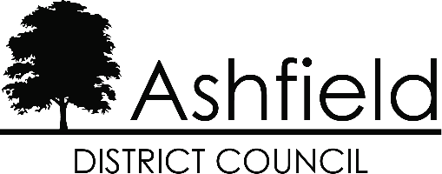

APPLICATION FOR DIRECT PAYMENTS OF LHA TO YOUR LANDLORD
Ashfield District Council has to make all payments of Local Housing Allowance (LHA) directly to you, but we can make payments directly to your landlord where you have difficulty managing your affairs.
The information you provide in this form will help us decide whether it is appropriate to pay LHA directly to your landlord. You may not need to complete all the questions, as some of these may not be relevant to you, but you should try to give as much information and evidence as possible to enable us to make an informed decision.
The Financial Assessment form should only be completed if you would like assistance with money advice issues.

Who should complete this form?
This form should be completed by the tenant, but it can also be completed on behalf of the tenant by:
- Family or friends
- Main carer
- An advice or welfare agency
- The landlord or letting agent
- Another service within the Council
The tenant or their representative must always sign the form, and be fully aware that it may lead to their Local Housing Allowance being paid directly to the landlord.

What should be sent with this form?
Written evidence needs to be provided to support the evidence given in this form. This can be from various sources depending on a person's individual circumstances, for example:
The tenants: -
- Family and/or friends
- Landlord
- General Practitioner (GP)
- Probation Officer
- Social Worker
- Main carer
- Welfare Groups
- Department for Work and Pensions
Please note this list is not exhaustive.

Claim reference
Issue date

Tenant’s Name
Address

Person completing the form if not the tenant
Contact address and telephone number, if the above is not the tenant
Please tell us your relationship to the tenant and the reason for completing the form on their behalf

1 | Tell us about any learning disabilities that may cause you problems in paying your rent

2 | Tell us about any physical disabilities or medical conditions that may cause you problems in paying your rent

3 | Tell us about any mental health problems that may hinder your ability to pay your rent

4 | Are you affected by an addiction?  E.g. alcoholism, substance misuse, gambling

5 | Have you encountered difficulties in managing your affairs because you need assistance with understanding English?

6 | Please tell us about any recent changes that mean you need additional support, or if you anticipate any in the near future?

7a | Do you have rent arrears? | No / Yes  If yes, please tell us.

7b | How much are your rent arrears? | £

7c | The period they cover | From  To

7d | Are they a result of you not paying the difference between your Housing Benefit and your rent liability? | No / Yes  If yes, please tell us.

7e | Has your landlord taken any action to recover the rent? | Please circle any action taken and send us any proof you have:  Court action / Notice of seeking possession / Notice to quit / a letter / a payment plan

7e  Cont. | Other:  Please specify

7e  Cont. | Have you tried to re-negotiate with your landlord about reducing the rent? | Yes / No

8 | Have you had any previous problems in maintaining rent payments and if so please explain why?

9 | Do you have multiple debts and need assistance to resolve them?

10 | Do you currently receive any ongoing support from an agency that can help you organise rent payments?

11 | Can anyone else support you in managing your financial affairs or do you need help with this?

12 | Are you having deductions made from your income to repay debts?

13 | How long might you need payments to be made to the landlord? | 26 weeks |  | 52 weeks

If you require payments to be sent for a longer or shorter period of time, please specify the period and tell us why?

14 | Tenant's Declaration  • The information given is true and correct  • I agree for my LHA to be paid directly to my landlord  • I will contact the Council should I feel I am able to receive my benefit directly  Please sign and date the form below (if you have a partner they should also sign)

You |  | Date
Your partner |  | Date

15 | Person completing the form, if not the tenant  • The information given is true and correct  • I believe it to be in the best interest of the tenant to pay LHA directly to their landlord  I have read and understood the declaration. Please sign and date the form below

Name
Signature
Date

Please use this space for any additional information indicating the question you are referring to.

How we collect and use information
This Authority is under a duty to protect the public funds it administers. We may check information that you provide, or information provided by a third party, with other information we hold to check its accuracy; to prevent or detect crime; and to protect public funds in other ways, as permitted by law.
We may also share this information with other Council departments or bodies administering public funds for these purposes.
We may also use this information to put you in touch with council services that may be able to help you. We will not disclose information about you to anyone, unless the law permits us to.

General Data Protection Regulation 2016 (GDPR) / Data Protection Act 2018 (DPA) - Privacy Notice.
Under the GDPR and DPA, Ashfield District Council, Urban Road, Kirkby in Ashfield, Nottingham. NG17 8DA is a Data Controller for the information it holds about you. The Council will hold all personal data provided by you for your Housing Benefit and Council Tax Reduction application. The lawful basis under which the Council uses personal data for this purpose is Public Task.
The information provided by you includes the following special categories of personal data:
- physical or mental health
Special Category Data is used by the Council on the basis that such use is necessary for reasons of substantial public interest, in this instance Schedule 1, Part 2, 6(1), Statutory etc and government purposes in accordance with the provisions of the Data Protection Act 2018.
Your data will be held for 6 years after the end of your claim for Housing Benefit and Council Tax Reduction. Subject to some legal exceptions, you have the right to request a copy of the personal information the Council holds about you; to have any inaccuracies corrected; to have your personal data erased; to place a restriction on our processing of your data; to object to processing; and to request your data to be ported (data portability). The information provided by you may also be used for other functions carried out by the Council in accordance with GDPR and DPA. For more information about how the Council may use your data and to learn more about your rights please see the Council’s Privacy Statement www.ashfield.gov.uk/privacy
If you have any concerns or questions about how your personal data is processed, please contact the Council’s Data Protection Officer at the above address or by email to dpo@ashfield.gov.uk . If you are dissatisfied with the Council’s response you can complain to the Information Commissioner's Office in writing to: Information Commissioner's Office, Wycliffe House, Water Lane, Wilmslow, Cheshire SK9 5AF or by telephone 0303 123 1113 (local rate) or 01625 545 745.

Please return this form to:
Ashfield District Council, PO Box 5752, Kirkby in Ashfield, Nottingham. NG17 8QW.
Or hand it in at our Customer Service point at Urban Road, Kirkby.

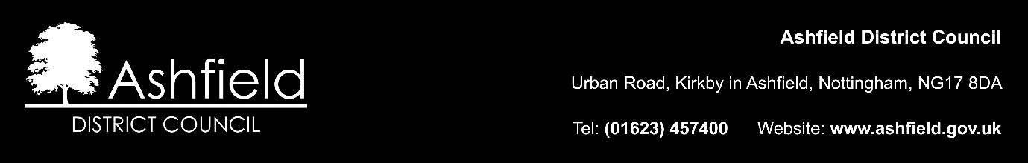

LHA - App for direct payments of LHA to landlord.2019.doc

