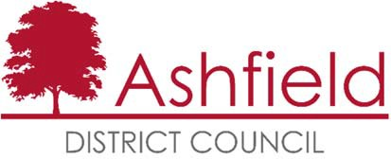

Ashfield Workforce Report 2018



# Table of Contents

**Page**

Executive Summary 2

Actions for 2018 2

Workforce Profile 2018 3

* Ashfield Workforce 3
* Workforce Diversity **5**
* Maternity/Paternity **7**
* Pay **8**
* Training **8**
* Recruitment **8**

Gender Pay Gap 2017 11

The Equality Act 2010 and the Public Sector Equality Duty requires all public authorities to publish equality information on their workforce to demonstrate that they are compliant and transparent in their practices. This report builds on the previous year’s reporting and forms part of the information that we collate, monitor and publish to help us ensure that equality considerations are embedded within our employment policies and practices and they meet our responsibilities under the duty.

### Executive Summary

Ashfield District Council workforce, in common with many Local Authorities has become smaller over the past year, in January 2018 there were 612 employees at the council, in 2017 there were 634.

58.8% of the workforce is male and 41.2% female. Part ime working is predominately female. The gender inbalance in the worforce is due to a larger number of roles more traditionally associsted with men, for example grounds maintenance, waste and trades.

The data shows a minimal gender pay gap and the Council is confident that this does not stem from paying men and women differently for the same or equivalent work.

The majority of the work force, 51.9%, falls within the age range 45 – 59, although, thanks to the appointment of apprentices, the 16 -25 age group has increased from 4.4% to 5.9%. This is a positive movement in line with the councils priorities for 2017 although the impetous needs to be maintained in 2018.

The proportion of the workforce who consider themselves disabled has increased slightly. It is difficult to find a comparable district proportion for comparison but the workforce figure is higher than the proportion of working age claiments of disability benefits in Ashfield.

The working age ethnic profile of Ashfield from the Census 2011 is predominately White British, 97.8% and Christian, 56.1% or no religion, 36.1%. The workforce profile does not, however, adequately represent the BME profile of the district. The Council is aware that the recruitment process should continue to encourage and enable employees from minority ethnic and religious belief groups to join the workforce.

Although not reflected in Census data, there is an increase in Eastern European migrants in parts of the district. This is indicated within the workforce by an increase in the number of White Europeans applying, and accepting, jobs at the council in 2017.

### Actions for 2018

Continue the implementation of our Recruitment & Selection Strategy and our work towards becoming a more attractive employer for young people.

Continue to use on line adverts and jobs boards to advertise vacancies as widely as possible so that they are accessible to all possible candidates and therefore not advertise via routes that could attract traditional genders.

To actively encourage a more diverse workforce within the organisation and ensure BME representation across the hierarchy.

Increase number of appointments of young people. This will be supported by the Apprenticeship Levy.

### Ashfield Workforce

In 2018 there were 612 employees at the council, in 2017 there were 634.

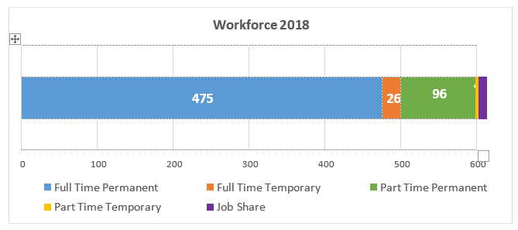

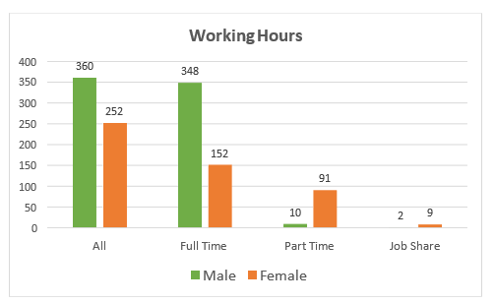

The proportion of Men working for the council has increased to 58.8%, up from 55.2% in 2015. However, a broad categorising by type, for example waste operatives and grounds maintenance classed as ‘environment’ and Community Action Officers and Community Protection Officers as ‘community role’, shows that the council has a greater number of roles traditionally associated as male jobs.

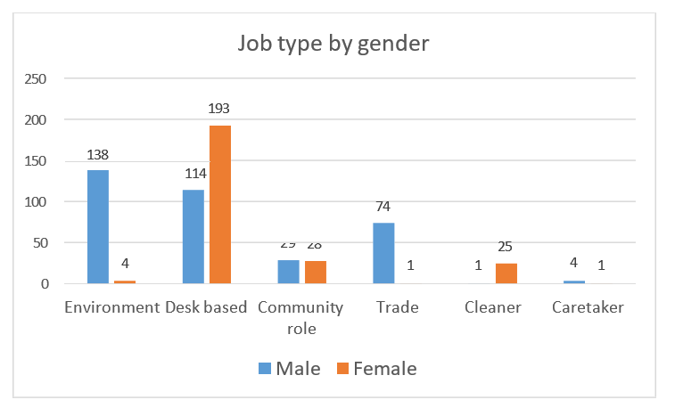

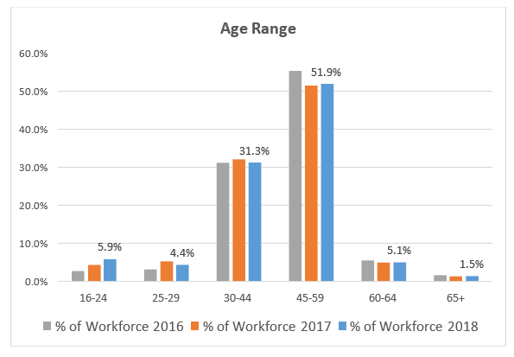

The majority of people working for the council fall within the 45 – 59 age range. The proportion of employees under 24 is increasing, however, amongst those over the age of 60 the proportion is decreasing. From the 2011 Census the proportion of Ashfield’s under 24’s in work in was 13.1%. Over all, there has been a slight increase in the proportion of under 30 year olds working at Ashfield District Council.

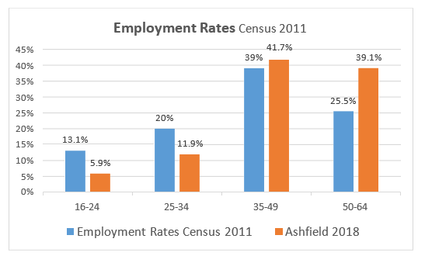

The number of people in each age band resident in Ashfield who were in employment at the time of the census and Ashfield Council 2018 employment figures

### Workforce Diversity

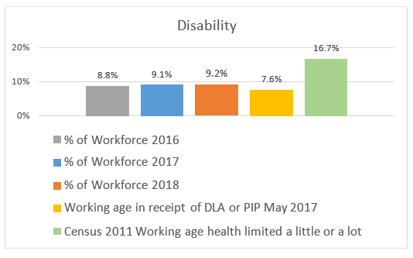

Census data does not directly relate to disability but whether health is limited. The DLA figure refers to Ashfield working age residents in receipt of a Disability Living Allowance or a Personal Independence Payment.

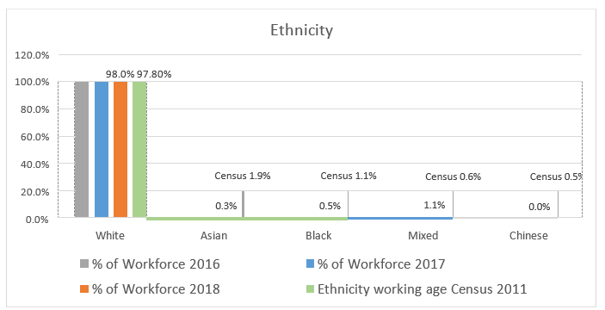

Ashfield’s population is predominately white British. The BME working age population of the district is 4.1%, the BME proportion of the council’s workforce is 1.96%, a very slight increase on the previous year. Clearly the council needs to continue to encourage applications from minority ethnic groups.

Since the 2011 census there has been an increasing number of Eastern European migrants moving into the area, predominantly in Sutton in Ashfield and Hucknall. Between 2012-2017, 2199 international migrants registered for National Insurance in Ashfield. There has been an associated increase of Europeans both applying for, and accepting, jobs at the council.

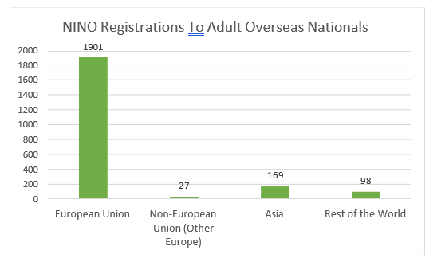

*DWP*

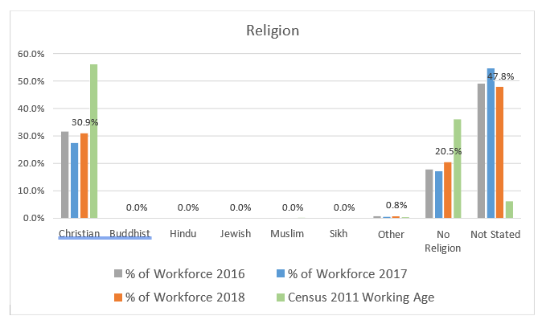

The majority of people working for the council do not state their religion. It is, therefore, difficult to assess how this relates to the general population of the district.

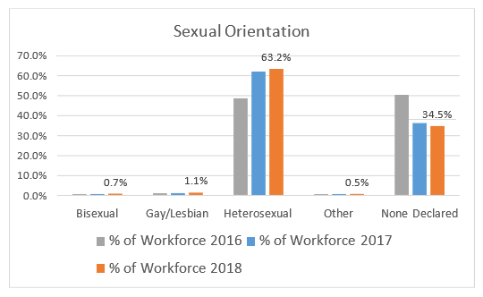

There is no district wide data available for sexual orientation but the proportion of the workforce stating that they are lesbian, gay or bisexual has increased on the previous year.

### Maternity/Paternity

In 2017 10 employees went on maternity leave and 4 had paternity leave.

### Pay

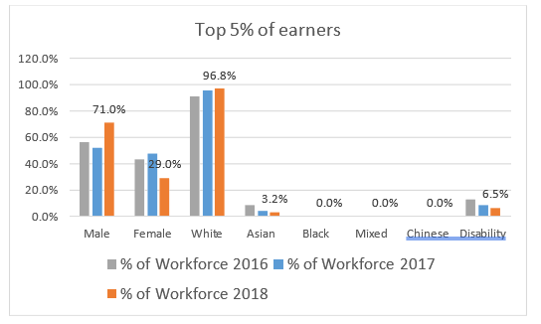

### Training

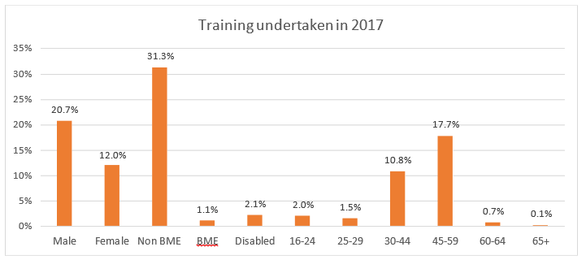

Ashfield recently introduced an online training portal containing a wide variety of training opportunities, this is making access to training more accessible for all employees.

### Recruitment

The Authority is committed to creating a diverse workforce that is fair and free from discrimination. Reasonable adjustments are made to support disabled people throughout the recruitment process and continue into their role if they are successful.

The Authority is accredited to the Disability Confident Scheme and the Mindful Employer Charter.

Turnover of staff across the year was 10.6%

There were no applications from people undergoing, or having completed, gender re-assignment.

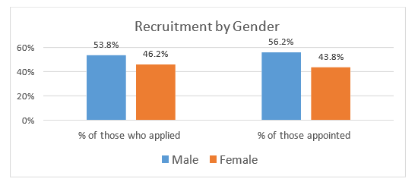

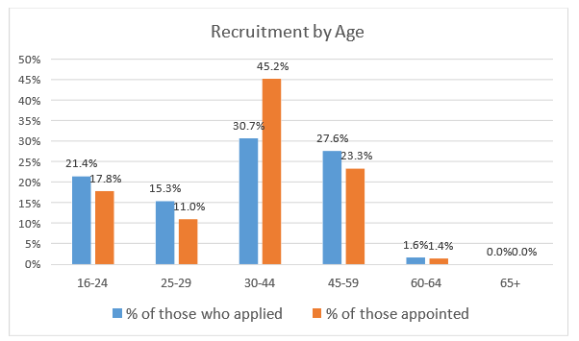

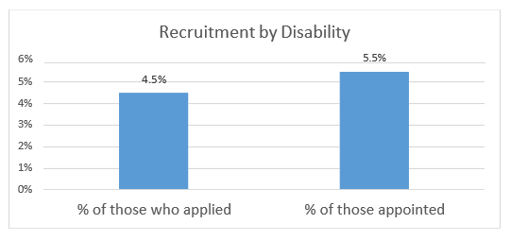

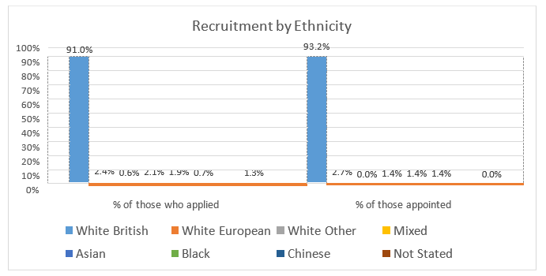

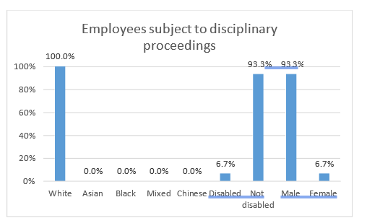

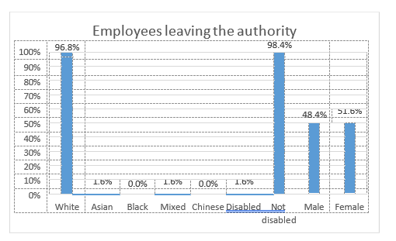

# Ashfield District Council - Gender Pay Gap Information - 2017

Under the Equality Act 2010 (Gender Pay Gap Information) Regulations 2017 The Council is required by law to publish an annual gender pay gap report. The information contained within this report is for the snapshot date of 31 March 2017.

### Summary of data

* The mean gender pay gap is 1.65%
* The median gender pay gap is 0%

|  |  |  |  |
| --- | --- | --- | --- |
| **Quartile** | **Females** | **Males** | **Salary range** |
| Lower | 46% | 54% | £16,302.51 - £18,746 |
| Lower Middle | 39% | 61% | £19,430 - £22,658 |
| Upper Middle | 42% | 58% | £22,658 - £28,485 |
| Upper | 40% | 60% | £28,485 and above |

**Mean** : the average of the figures and is calculated by adding up all the figures and diving by the total number.

**Median** : defined as the salary that lies at the midpoint, there are an equal number above and below.

**Quartile** : number of full pay employees divided by four with an equal number in each quartile to determine salary range. Percentage of male/female employees in each quartile from total relevant employees.

### Analysis of data

The gender pay gaps identified do not appear to be large and are therefore not significantly concerning.

Further analysis of the data outlines that the lower middle quartile contains a high proportion of trades posts such as joiners, painters etc as well as refuse drivers. This would indicate that the disparity is due to employment of men and women in posts that traditionally attract specific genders. The upper quartile also shows a disparity in the number of women in higher paid roles in comparison to men. There are a number of traditionally male professional roles within the quarter (for example, Environmental Health and ICT) which is likely to contribute to the disparity. Currently, within the top three tiers of the organisation, out of the 24 post holders, 46% are male and 54% are female, which demonstrates that women are appointed to the most highly paid posts within the organisation.

The Council is committed to the principle of equal opportunities and equal treatment for all employees and has a clear procedure to ensure employees are paid equally for the same or equivalent work, regardless of their sex or any other protected characteristic. In 2014 the Council implemented job evaluation and undertook a comprehensive review of pay and allowances to address a number of factors which significantly improved the gender pay gap position

In summary, the data shows a minimal gender pay gap and the Council is confident that this does not stem from paying men and women differently for the same or equivalent work. Instead, the small gap outlined is the result of the roles in which men and women work within the organisation and the salaries that these roles attract. Although the gender pay gap outlines a positive position for the Council at the moment, it recognises the need to be mindful going forward and not complacent.

### Action to be undertaken to address the gender pay gap

Although the gender pay gap is not significant enough to be a cause for concern the organisation will continue to implement actions as detailed below to address the disparities.

* Continue to use on line adverts and jobs boards to advertise vacancies as widely as possible so that they are accessible to all possible candidates and therefore not advertise via routes that could attract traditional genders.
* The Council has recently participated in an initiative to promote flexible working, particularly in more senior posts / professional posts, and will continue build on the work of this initiative to ensure that all vacancies are advertised as flexible and encourage applicants to approach managers to discuss flexible working requirements at appointment stage. As part of promotion of flexible working managers will also be undertaking training in 2018 to encourage them to analyse vacancies before appointment to determine if the post could be redesigned more flexibly.
* Implementation of a competency framework which looks at values and behaviours. This is supported by selection exercises in recruitment and combined these aim to reduce any in built bias to recruit people from a specific gender into traditional gender dominated posts.
* Engaging young people early on (for example via apprenticeships) to try and encourage applications from under represented groups in traditional gender dominated posts.