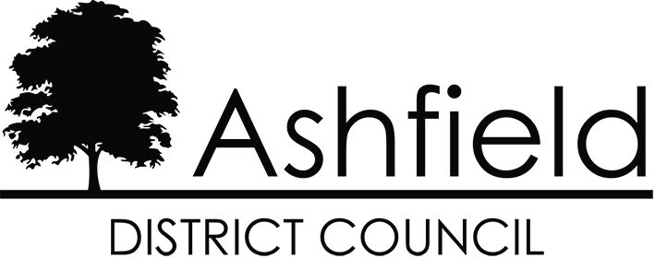

# Ashfield District Local Plan Examination

# Matters, Issues and Questions identified by the Inspectors

# Matter 5:

**Sustainable Development in Ashfield**

**December 2024**

**Ashfield District Council’s response to Inspectors’ Document INS03**

This document is Ashfield District Council’s response to the Matter, Issues and Questions (MIQs) identified for examination by Inspectors Mr. Philip Mileham and Mr Graham Wyatt, of the Planning Inspectorate, as published on the 30th September 2024. This is one of twelve separate papers produced to address the specific matters and issues identified on the front page.

Each response paper includes a number of references to specific evidence which has been relied upon in answering the MIQs. These reference numbers (shown as **[XXXX]**) relate directly to the Examination Library website, where all evidence is published: <https://www.ashfield.gov.uk/local-plan-examination/examination-library/>

The Inspectors’ questions are shown below in ***bold italics***.

The Council’s responses are shown in normal typeface below the Inspector’s questions.

|  |
| --- |
| Proposed Modifications arising from the Inspectors’ MIQs are set out in grey tint boxes. |

## Issue: Whether the Local Plan has been positively prepared and whether it is justified, effective and consistent with national policy in relation to sustainable development in the district.

### Relevant Policies:

**Strategic Policy S12 – Tackling Health Inequalities and Facilitating Healthier Lifestyles**

**Strategic Policy S14 – Conserving and Enhancing Our Historic Environment**

***5.1 Are the requirements of the sustainable development in Ashfield policies S12 – S15 justified by appropriate available evidence, having regard to national guidance, and local context?***

Council’s response

5.1.1 Strategic Policy S12: Tackling Health Inequalities and Facilitating Healthier Lifestyles promotes a range of design and infrastructure considerations to contribute to and improve healthy communities in Ashfield. In addition to promoting a range of development considerations, the policy requires an appropriate quantity and mix of housing to be provided within development schemes, including to meet the needs of older and disabled people, the protection of residential amenity and providing good access to health and social care facilities. The policy provides flexibility and acknowledges that all of these considerations are ‘dependent on the nature of development’.

Paragraph 3.125 of the accompanying text highlights that the Nottinghamshire Health and Wellbeing Strategy and its delivery plans set out actions to tackle priorities in relation to health and wellbeing and that the Local Plan will contribute towards these improvements. Paragraph 002 of Planning Practice Guidance (Reference ID:53-002-20190722 Revision Date 22 07 2019) highlights the importance of key groups in the local health system including Health and Wellbeing Boards. Paragraph 8 b) of the NPPF recognises that the planning system has a social objective:

‘b) **a social objective** – to support strong, vibrant and healthy communities, by ensuring that a sufficient number and range of homes can be provided to meet the needs of present and future generations; and by fostering well-designed, beautiful and safe places, with accessible services and open spaces that reflect current and future needs and support communities’ health, social and cultural well-being’.

5.1.2. Strategic Policy S13: Protecting and Enhancing Our Green Infrastructure and the Natural Environment seeks to protect and enhance green and blue corridors to help preserve the landscape character of the district and it’s biodiversity. Paragraphs 3.130 - 3.131 and 3.133 of the accompanying text highlight the importance of green infrastructure connectivity to the Council. Paragraph 174 of the NPPF sets out a range of ways in which planning policies and decisions should contribute to and enhance the natural and local environment, including recognition of the intrinsic character and beauty of the countryside and minimising impacts on biodiversity.

5.1.3 Strategic Policy S14: Conserving and Enhancing Our Historic Environment seeks to ensure appropriate levels of conservation and enhancement for historic assets. Chapter 16 of the NPPF recognises the importance of conserving and enhancing the historic environment. Paragraph 190 states that ‘Plans should set out a positive strategy for the conservation and enjoyment of the historic environment’.

5.1.4 Strategic Policy S15: Safeguarding Mineral Resources aligns the Local Plan with the Minerals Local Plan in recognising the need to consult with the Minerals Planning Authority regarding proposals for development within the Minerals Consultation Area and the need for development within Mineral Safeguarded Areas to meet the requirements set out in the Minerals Local Plan. Chapter 17 of the NPPF recognises the importance of protecting a supply of minerals. Paragraph 210 states that planning policies should:

‘c) safeguard mineral resources by defining Mineral Safeguarding Areas and Mineral Consultation Areas; and adopt appropriate policies so that known locations of specific minerals resources of local and national importance are not sterilised by non-mineral development where this should be avoided’.

5.1.5 It is considered that the Local Plan is justified in seeking to ensure that development promotes healthy communities, protects and enhances the natural environment and safeguards mineral resources within Mineral Safeguarding Areas as set out in the Mineral Local Plan.

***5.2 Do Policies S12 – S15 provide clear direction as to how a decision maker should react to a development proposal?***

Council’s response

5.2.1 Yes, the policies provide clear direction as set out in NPPF para 16 d) which states that plans should ‘contain policies that are clearly written and unambiguous, so it is evident how a decision maker should react to development proposals’.

5.2.2 The supporting text to these policies provides further detail and refers to the evidence base.

***5.3 Do Policies S12 – S15 serve a clear purpose, avoiding unnecessary duplication of national policy? Is the wording consistent with national policy?***

Council’s response

5.3.1 Yes, the policies serve a clear purpose and avoid unnecessary repetition of national policy, as set out in NPPF para 16 f) which states that plans should ‘serve a clear purpose, avoiding unnecessary duplication of policies that apply to a particular area (including policies in this Framework, where relevant)’.

5.3.2 The supporting text to these policies provides further detail and refers to the evidence base.