**­­**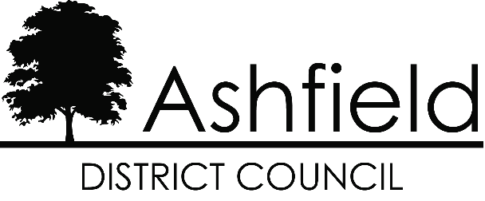

**Ashfield Workforce Report 2025**



# Table of Contents

**Page**

## Executive Summary 1

**Actions for 2024 2**

**Workforce Profile 2024** **3**

* Ashfield Workforce3
* Workforce Diversity 5
* Maternity/Paternity 7
* Pay 8
* Training 8
* Recruitment 9

**Gender Pay Gap 2024 12**

The Equality Act 2010 and the Public Sector Equality Duty requires all public authorities to publish equality information on their workforce to demonstrate that they are compliant and transparent in their practices. This report builds on the previous year’s reporting and forms part of the information that we collate, monitor, and publish to help us ensure that equality considerations are embedded within our employment policies and practices, and they meet our responsibilities under the duty.

## Executive Summary

Ashfield District Council workforce has increased over the past year, in January 2025 there were 619 employees at the council, an increase from 582 in 2024. In January 2023 there were 585.

57.5% of the workforce is male and 42.5% female, a decreased ratio of females to the previous year. There has been a decrease in part time workers from 114 to 98 although part time working remains predominately female.

The proportion of the workforce within the age range 45 – 59 has fallen from 45% to 41.4%, the third year this range has fallen, with those aged 30-44 continuing to increase. There has been a continued increase in the number of over 65’s and a small decrease in those aged 16-24, although the recruitment of this age group increased in 2024.

The proportion of the workforce who consider themselves disabled has decreased significantly over the past year. Disabled employees are now under 1% of the workforce, last year those with a disablity made up nearly 10% of employees.

Those identifying as Christian has fallen for the third year to 37.5%. Religion not stated has fallen, and no religion has increased to 39.6%.

The BME proportion of the council’s workforce is 3.7%, an increase of 1.1% from the previous year. Ashfield workforce is now more representative of the local population which Census 2021 shows as becoming increasingly diverse. The Council is aware that the recruitment process should continue to encourage and enable employees from minority ethnic and religious belief groups to join the workforce.

## Actions for 2025

Following the completion of a comprehensive independent audit and review of the Councils Recruitment and Retention strategy in 2022; implement a revised action plan that seeks to increase applications and appointments across all demographics.

Continue to brand and promote the Council as an attractive employer of choice especially for young people.

Fundamentally review the methodology and approach to recruitment to advertise vacancies as widely as possible so that they are accessible to all possible candidates.

To further strengthen the improvements within 2024 to encourage a more diverse workforce within the organisation and ensure BME representation across all levels of the organisation.

## Ashfield Workforce

In January 2025 there were 619 employees at the council, in 2024 there were 582 employees, an increase of 5.1% from 2020. The full-time permanent workforce has increased from the previous year.

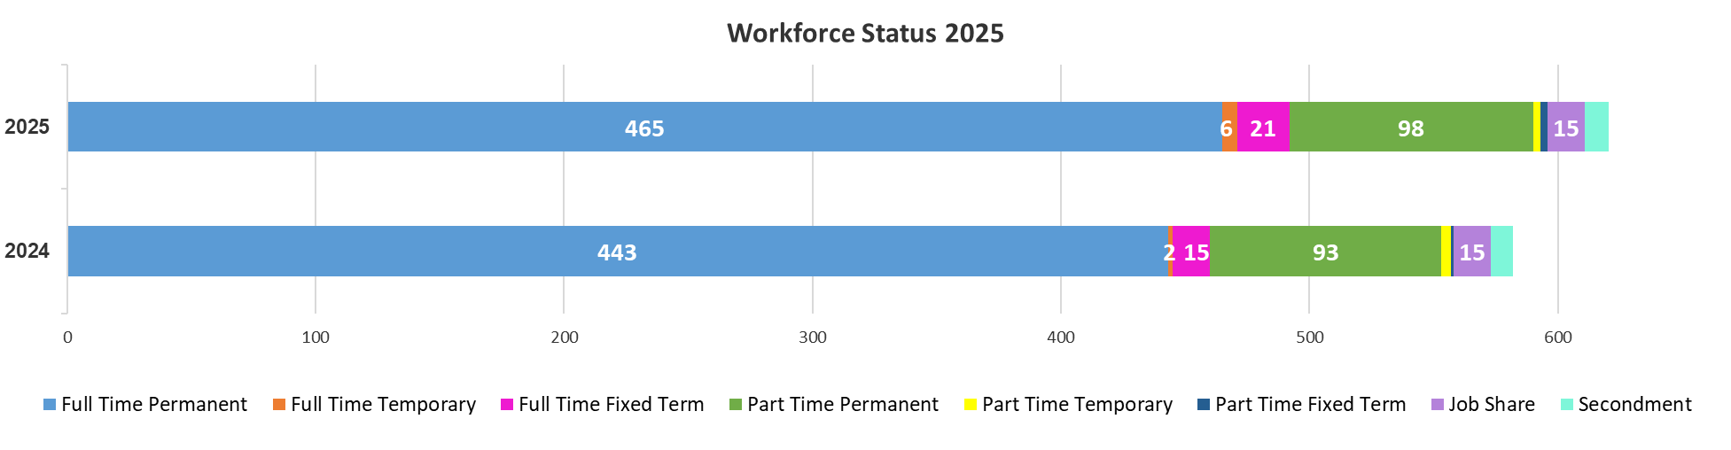

The proportion of males and females working for the council has remained relatively static with males at 57.4%, females 42.6%. The proportion of female   
part-time employees has decreased since 2024 from 16% of the workforce to 15%. Male part-time working has stayed the same.

The proportion of female 
part-time employees has decreased since 2024 from 16% of the workforce to 15%. Male part-time working has stayed the same.


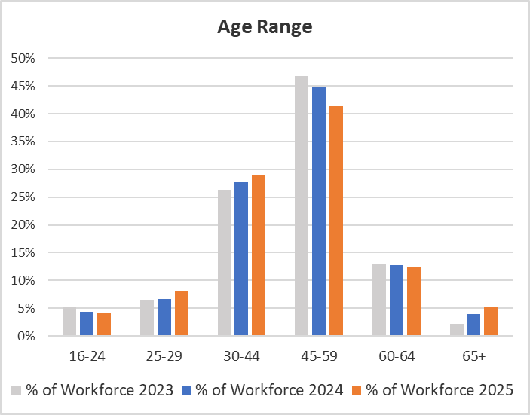

Whilst most people working for the council fall within the 45 – 59 age range there has been a decrease in this age group over the past 3 years and a sustained increase in those aged 25 -44. There has also been an increase in those aged over 65 working for the council.

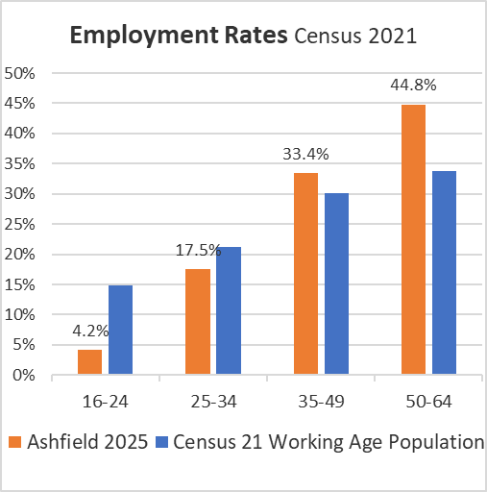

The chart above shows the working age resident population of Ashfield from Census 2021 and Ashfield Council 2025 employment figures.

## Workforce Diversity

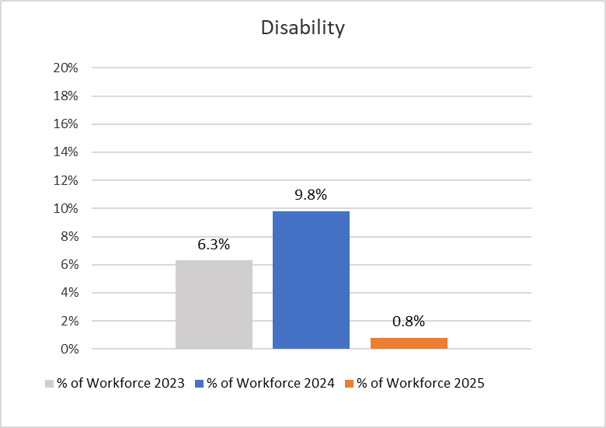

The proportion of the Council workforce with a disability has declined by 9% in 2025

|  |  |  |  |  |
| --- | --- | --- | --- | --- |
| Ethnicity | % of Workforce  2025 | % of Workforce  2024 | % of Workforce  2023 | Ethnicity all ages Census 2021 |
| White | 94.9% | 96.6% | 96.1% | 95.1% |
| Asian | 0.8% | 0.3% | 0.3% | 1.3% |
| Black | 1.1% | 0.9% | 1.2% | 1.2% |
| Mixed | 1.8% | 1.4% | 1.4% | 1.6% |
| Chinese | 0% | 0% | 0.2% | 0.03% |

Ashfield’s population is predominately White British. The BME working age population of the district from the Census 2021 was 4.4%. The BME proportion of the council’s workforce is 3.7%, an increase of 1.1% from the previous year.

This will continue to be a key action; encourage applications from minority ethnic groups.

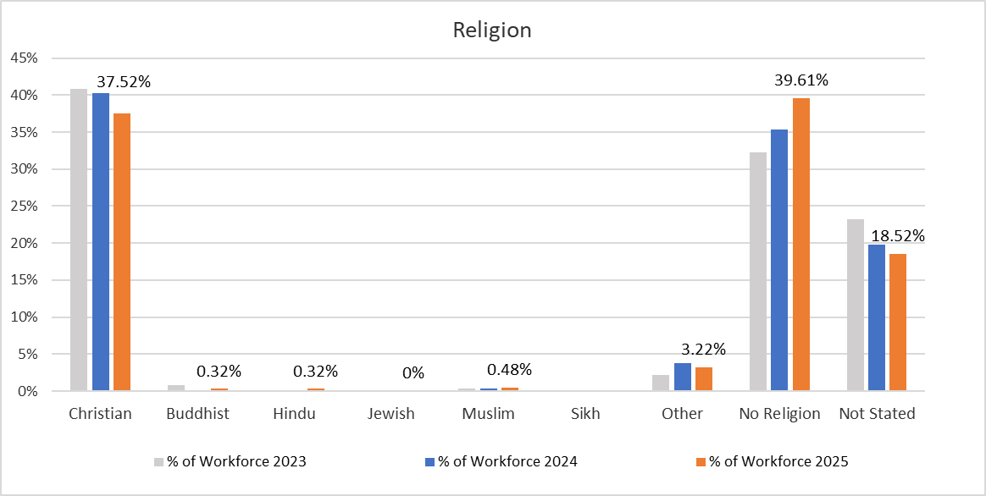

The proportion of employees who do not state their religions has declined slightly in the past years with a continued increase in ‘No Religion’ and decline in ‘Christian’.

The results for all beliefs in the district from the Census 2021 can be seen in the table below.

|  |  |  |  |  |  |  |  |  |
| --- | --- | --- | --- | --- | --- | --- | --- | --- |
| **Religion - Census 2021 - Ashfield District** | | | | | | | | |
| No Religion | Christian | Buddhist | Hindu | Jewish | Muslim | Sikh | Other religion | Not answered |
| 50.3% | 42.0% | 0.2% | 0.3% | 0.0% | 0.6% | 0.2% | 0.5% | 5.8% |

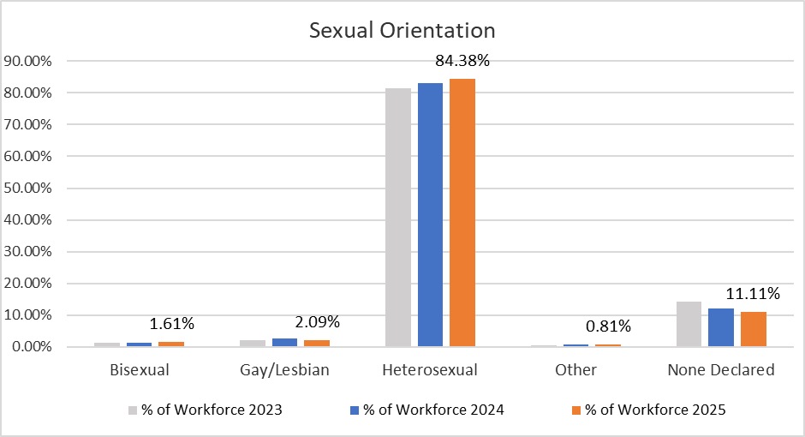

A new question regarding sexual orientation was asked in the Census 2021

|  |  |  |  |  |
| --- | --- | --- | --- | --- |
| **Census 2021 - Sexual Orientation in Ashfield District** | | | | |
| Straight or Heterosexual | Gay or Lesbian | Bisexual | All other sexual orientations | Not answered |
| 90.7% | 1.4% | 1.0% | 0.2% | 6.8% |

## Maternity/Paternity

In 2024 three employees took maternity leave and five employees took paternity leave.

## Pay

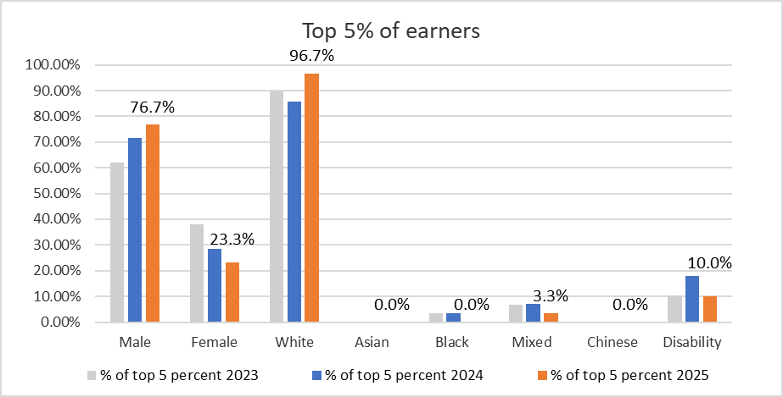

The top 5% of earners at the council have become increasingly white and male over recent years, with women now representing less than a quarter of the total. The proportion of disabled represented in the top 5% has declined.

The above figures of the top 5% of earners excludes CEO, Directors, and Assistant Directors, they are NJC posts only. For JNC posts including CEO, Directors, and Assistant Directors; 34% are female, a decrease from 45% in 2024.

## Training

The council have delivered the following statutory compliance training to employees:-

* Health and Safety
* Fire Safety
* Safeguarding
* Equality, Diversity, and Inclusion
* Cyber Security
* Data Protection
* Vulnerability
* Domestic Abuse
* Climate Change

## Recruitment

The Authority is committed to creating a diverse workforce that is fair and free from discrimination. Reasonable adjustments are made to support disabled people throughout the recruitment process and continue into their role if they are successful. The Authority is accredited to the Disability Confident Scheme, the Mindful Employer Charter, has signed the Armed Forces Covenant and achieved the Employer Recognition Scheme Gold Award.

Turnover of staff across the year was 8.6% a decrease from the 9% from the previous year.

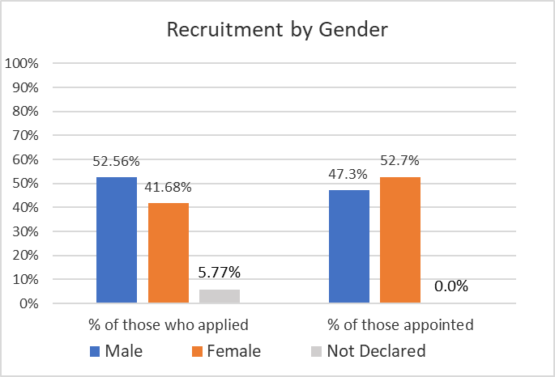

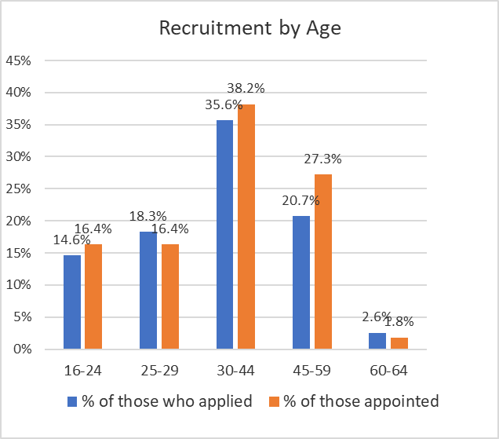

In 2024 Ashfield appointed more female than male applicants than in 2023 although more applicants were male. A higher proportion of younger applicants were appointed, 5.9% in 2023 and 16.4% in 2024 although the dominant age range remains those aged 30-59. No people over the age of 65 were appointed to post and few applied.

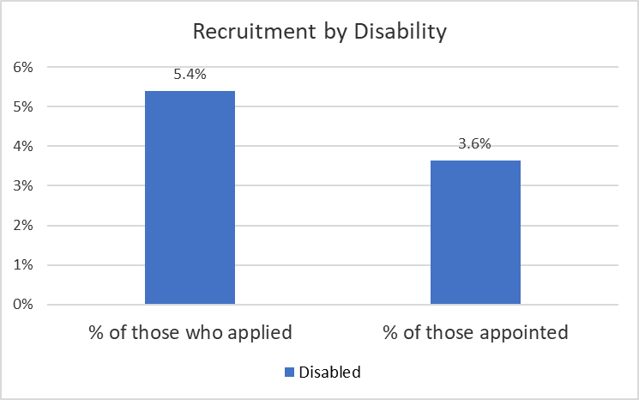

Applications and appointments of people with a disability were lower in 2024, 3.6% of appointees were disabled in 2024, in 2023.

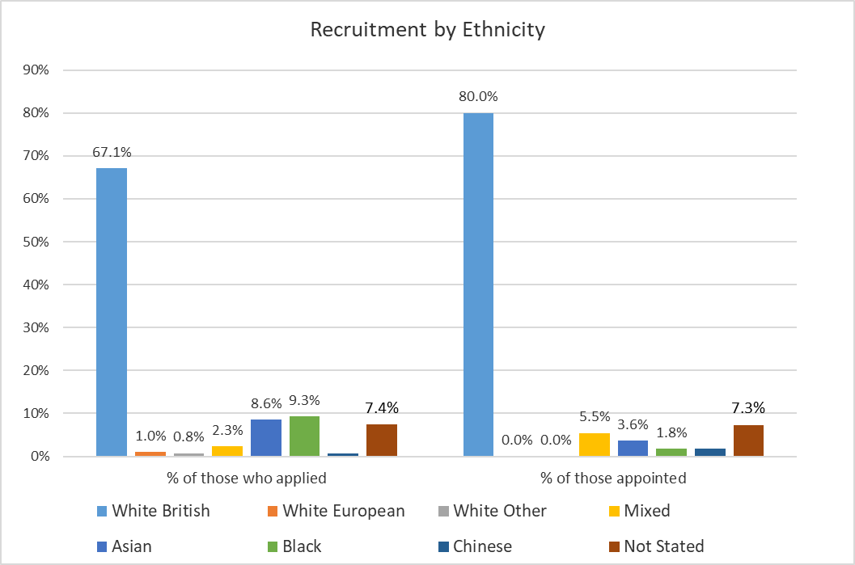

Recruitment has seen a slight increase within the White British cohort applications (65.3% to 67.1%) and percentage of those appointed (68.6% to 80%), the proportion of other ethnicities has risen, with non-white appointments at nearly 13% of compared to 6% last year. The most marked change is with those who did not state their ethnicity, those appointed decreasing from 25.5% to 7.3%.

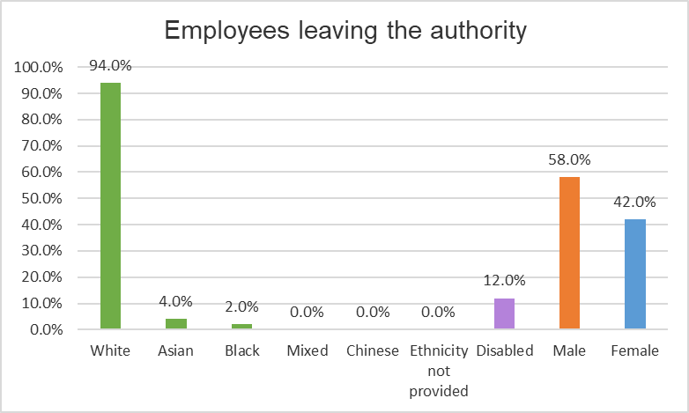

Figures based on permanent staff voluntarily leaving the Authority.

## Disciplinary and Grievance

There were 6 disciplinary actions in 2024, 4 male and 1 female. There were 4 grievances, 2 male and 2 female.

Whilst we would monitor and address any concerns with grievances that were related to the protected characteristics, we will not report on these cases as the small number may identify individual employees and same for disciplinary cases.**Ashfield District Council - Gender Pay Gap Information – 2024**

1. **Introduction**

Under the Equality Act 2010 (Gender Pay Gap Information) Regulations 2017 the Council is required by law to publish an annual gender pay gap report. The information contained within this report is for the snapshot date of 31 March 2024.

**2.0 Summary of data**

* The mean gender pay gap is -1.43%
* The median gender pay gap is -5.30%

Table 1. Comparison to Female and Male in each salary range quartile

|  |  |  |  |
| --- | --- | --- | --- |
| **Quartile** | **Females** | **Males** | **Salary range** |
| **Lower** | 39.33% | 60.67% | £24,404 - £27,269 |
| **Lower Middle** | 39.60% | 60.40% | £27,269 - £30,060 |
| **Upper Middle** | 50.34% | 49.66% | £30,060 - £37,035 |
| **Upper** | 40.94% | 59.06% | £37,035 and above |

Table 2. Breakdown splits of Female to Male across the Authority

|  |  |  |  |
| --- | --- | --- | --- |
| **Quartile** | **Females** | **Males** | **Salary range** |
| **Lower** | 23.23% | 26.53% | £24,404 - £27,269 |
| **Lower Middle** | 23.23 % | 26.24% | £27,269 - £30,060 |
| **Upper Middle** | 29.53% | 21.57% | £30,060 - £37,035 |
| **Upper** | 24.02% | 25.66% | £37,035 and above |
| **Total** | 100% | 100% |  |

The mean is defined as the average of the figures and is calculated by adding up all the figures and diving by the number there are. The median is defined as the salary that lies at the midpoint and is calculated by ordering all salaries from highest to lowest and the median is the central figure. The quartile information is calculated by listing all salaries from highest to lowest and the splitting that information into four equal quarters to determine the percentage of male / female employees in each quartile.

All the figures set out above have been calculated using the standard methodologies used in the Equality Act 2010 (Gender Pay Gap Information) Regulations 2017. Although reporting of the salary ranges for the quartiles is not required, this has been provided for additional information.

1. **Analysis of data**

Although the mean and median pay gaps have increased from the previous year, the mean pay gap still suggests that ranges of pay are spread fairly and equally across the organisation but that the average pat for women is higher. In comparison to last year, this figure has changed from -0.08% to -1.43% suggesting that salaries are fairly equivalent. The mean gender pay gap is likely due to a change in the organisation profile as there has been changes to the female/male split in all quartiles.

Further analysis of the data indicates that the lower quartiles have the higher percentage of males in these roles, one of the key reasons for this is that is contains a high proportion of frontline workers. This would suggest that the disparity is due to posts that traditionally attract specific genders. The Council recognises that although actions are in place to try to address this, it will take time change these historical and social norms.

The quartile data also outlines that there is an increase in the percentage of males in the lower quartile, increasing by 2.05%. Traditionally roles in this quartile attract female applicants due to the flexibility and ability to fit in around caring responsibilities. Widely these responsibilities are generally undertaken by women but there has been a slight increase in males in this quartile.

The Council remains committed to the principle of equal opportunities and equal treatment for all employees and has a clear procedure to ensure employees are paid equally for the same or equivalent work, regardless of their sex or any other protected characteristic. In 2014 the Council implemented job evaluation and undertook a comprehensive review of pay and allowances to address a number of factors which significantly improved the gender pay gap position. As part of that scheme the Council also evaluates job roles as necessary to ensure a fair structure. In 2016 the Council brought the ALMO back into the Council which included the transfer of a large number of craftworkers. The vast majority of employees that have been TUPE transferred are now on ADC terms and conditions however there is a very small number remaining which are not likely to influence any major changes in the gender pay gap.

**4.0 Action to be undertaken to address the gender pay gap**

Although the gender pay gap is not significant enough to be a cause for concern the organisation will continue to implement actions as detailed below to address the disparities.

* Continue to use on line adverts and jobs boards to advertise vacancies as widely as possible so that they are accessible to all possible candidates and therefore not advertise via routes that could attract traditional genders.
* The Council is still involved in initiatives to promote flexible working, including hybrid working in all posts that are viable and continues to build on the work of this initiative to ensure that all vacancies are advertised as flexible and hybrid where possible and encourage applicants to approach managers to discuss flexible working requirements at appointment stage.
* Policies associated with hybrid and flexible working are currently being reviewed to ensure they are fit for purpose
* Review of the level policy has been undertaken to reflect Carers Legislation.
* Officers from the Council attend career fairs to promote all careers within public sector.