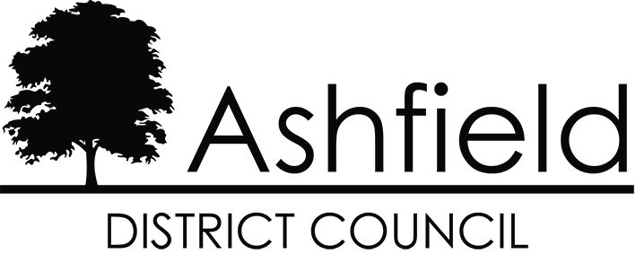

**Ashfield Local Plan 2023-2040**

**Equalities Impact Assessment Position Statement**

**February 2025**



**Disclaimer**

This document or some parts of it may not be accessible when using adaptive technology.

If you require assistance with accessing the content of the document, please contact us and quote the document name and the web page you found it on:

* email: Forward planning – [localplan@ashfield.gov.uk](mailto:localplan@ashfield.gov.uk) .
* telephone: 01623 457381

In response to the Inspector’s letter dated 03 December 2024 (INS.05), the Council has proposed additional housing allocations. The additional proposed housing allocations are all consistent with the spatial strategy which is set out in the Ashfield Local Plan 2023 – 2040: Regulation 19 Pre-Submission Draft.

The question of whether an update of the existing Equalities Impact Assessment May 2023 is needed has been considered in light of the additional proposed housing allocations. As the additional proposed allocations are consistent with the spatial strategy they will not impact on the outcomes of the existing Equality Impact Assessment, which are set out in Appendix 2 of the Assessment and which reflect the spatial strategy. Therefore it is not considered that an update to the existing Equalities Impact Assessment May 2023 is necessary in light of the additional proposed housing allocations.