Ashfield District Council
Infrastructure Funding Statement 2019/20
December 2020

Contents Page no
- Introduction
1.1 About this statement 2
1.2 Key headlines from the statement 4

- Section 106 Contributions
2.1 Section 106 (S106) obligations 4
2.2 Ashfield Local Plan Review 2002 5
2.3 S106 Process for offsite financial contributions 7
2.4 Governance structure for infrastructure delivery 8
2.5 S106 Contributions Received in Previous Years 10
2.6 S106 Agreements signed in 2019/20 11
2.7 S106 Contributions Received in 2019/20 12
2.8 S106 Contributions allocated but not spent in 2019/20 13
2.9 S106 Contributions spent in 2019/20 15
  - Planned expenditure for future years 21

3. Conclusions 26

- Appendices 26 - 32

1: The total amount of money to be provided under any planning obligation which was entered into during 2019/20

2: S106 Contributions received 1st April 2019 – 31st March 2020
3: Information links

1. Introduction

1.1: About this statement
Welcome to Ashfield District Council’s Infrastructure Funding Statement (IFS). This document sets out the 2019/20 (1st April 2019 – 31st March 2020) income and expenditure relating to Section 106 (S106) agreements.
Local authorities, such as Ashfield, are now required to produce an infrastructure funding statement on an annual basis, as a result of recent changes to government legislation¹. This document is the Council’s first infrastructure funding statement.
For the purpose of reporting S106 developer contributions, infrastructure can be defined as the following forms:
BROAD FORMS OF INFRASTRUCTURE
PHYSICAL
Transport | Strategic & local highway networks, bus rail, airports, travel management, cycle and pedestrian facilities, car parking.
Affordable Housing | Houses and flats.
Energy | Gas and electricity generation and distribution, renewable energy projects.
Water | Water supply, water treatment, drainage, flood defences, water quality.
Digital | Including broadband and wireless connections.
Waste | Collection and disposal, recycling.
Minerals | Reserves.
SOCIAL
Education | Primary, secondary, further education, and adult education.
Health | Health centres, GP and dental surgeries, hospitals.
Emergency Services | Police, Fire, Ambulance, community support.
Community Services | Community centres and centres for children, young people, elderly and those with additional needs. Cemeteries, post offices.
Culture and Leisure | Museums, theatres, cinemas, sport centres, swimming pools, libraries, public art and realm, heritage assets.
Community Projects | Including community groups, local community led projects, training and volunteering.
GREEN
Open Space | Parks and country parks, children’s play areas, sport pitches and grounds, allotments.
Forestry | Urban forest, woodland.
Biodiversity | Local wildlife sites, local nature reserves, private nature reserves, Sites of Special Scientific Interest, geological sites.
BLUE
Waterways | Main rivers, small watercourses, canals.
Table 1: Forms of infrastructure
S106 (known as ‘planning obligations’ or ‘developer contributions’) income is used to help fund the provision of supporting infrastructure in association with development and maximise the benefits and opportunities from growth, such as town centre regeneration and affordable homes. This can be onsite, off site or involve financial contributions known as commuted sums, in lieu of provision. Contributions for transport, affordable housing, education, open space, public realm, regeneration and health are most commonly requested for new infrastructure in Ashfield. Further information on this can be found in section 2 below.
Developer contributions are normally a key component of any authority’s approach to developing and delivering an infrastructure strategy for their area. Effective infrastructure planning, prioritisation and governance of spend are critical to supporting the delivery of sustainable development and growth². The Local Plan (Ashfield Local Plan Review 2002), prepared by the Council, is a plan for the future development of the District. The Local Plan (Ashfield Local Plan Review 2002) guides decisions on whether or not planning applications can be granted and details the requirements under which development contributions can be sought. Work is also underway on a replacement plan which, once adopted, will replace the Ashfield Local Plan Review 2002.
This report contains a summary of the financial contributions secured by the Council through S106 agreements from new developments for onsite provision of infrastructure, off-site infrastructure works and affordable housing. This report does not include highway works completed as part of Section 278 agreements (as this is within the remit of Nottinghamshire County Council as the highway authority) or Community Infrastructure Levy (CIL) Tariff payments. The Community Infrastructure Levy (the ‘levy’) is a charge which can be levied by local authorities on new development in their area. Ashfield District Council does not currently operate this charge as part of its development management processes.
Where S106 financial obligations have been secured and received on behalf of Nottinghamshire County Council (NCC) for highways, education or library infrastructure or the NHS Nottingham and Nottinghamshire Clinical Commissioning Group (CCG) for healthcare provision, the obligations will be recorded as spent within this document. NCC or CCG will explain, within their own IFS, details of how the funding has been used.
The information in this report will be published on the Council’s website and updated annually. https://www.ashfield.gov.uk/planning-building-control/planning-applications/section-106/
The information is correct at date of publication. However committed works for future years may be subject to change due to prevailing economic conditions, new legislation and revised corporate priorities.

¹ Community Infrastructure Levy (Amendment) (England) (No. 2) Regulations 2019
² Developer contributions. Start with the spend in mind. PASFebruary2020. https://www.local.gov.uk/pas/delivery/developer-contributions

1.2: Key headlines from the statement
Monetary contributions
Total Money to be provided through planning obligations agreed in 2019/20 | £5,562,163.64
Total Money received through planning obligations ( whenever agreed) in 2019/20 | £4,715,199.78
Total Money received through planning obligations ( whenever agreed) spent in 2019/20 | £5,897,013.89
Total Money received through planning obligations ( whenever agreed) retained at the end of 2019/20 ( excluding “commuted sums” for longer term maintenance) | £4,795,469.99
Total Money received through planning obligations ( whenever agreed) retained at the end of 2019/20 ( excluding “commuted sums” for longer term maintenance) | £51,030.74

Non- Monetary Contributions
Total number of affordable housing units to be provided through planning obligations agreed in 2019/20 | 57
Total number of affordable housing units which were provided through planning obligations ( whenever agreed) in 2019/20 | 0
Total number of school places for pupils to be provided through planning obligations agreed in 2019/20 | 40
Total number of school places for pupils which were provided through planning obligations ( whenever agreed) in 2019/20 | Refer to Nottinghamshire County Council’s Infrastructure Financial Statement

2. S106 Contributions

2.1 Section 106 (S106) obligations
A Local Planning Authority can seek obligations, both physically on-site for a development and contributions for off-site, under Section 106 (S106) of the Town and Country Planning Act 1990. The obligations assist in mitigating the impact of otherwise unacceptable development to make it acceptable in planning terms. Obligations should only be used where it is not possible to address unacceptable impacts through a planning condition. The obligations must be:
- Necessary to make the development acceptable in planning terms;
- Directly related to the development; and
- Fairly and reasonably related in scale and kind to the development.
As part of the planning process, the development of new housing requires the provision of additional social, physical and economic infrastructure to avoid a detrimental effect on the surrounding area and the lives of local residents. Planning obligations assist in mitigating the impact of development which benefits local communities and supports the provision of local infrastructure.³
S106 obligations can include:
- Requirements for parts of a development to be used in certain ways ( “in-kind” contributions), for example for affordable housing;
- Requirements for certain works to be undertaken or for other requirements and /or restrictions on the form of the development, for example requiring the development to be car free;
- Financial contributions to address the impacts of development (“off-site contributions”) – usually limited to those cases where it is not feasible to meet policy requirements on site and / or to mitigate specific development impacts, for example the carbon emissions from development.
However, there are specific circumstances where contributions through planning obligations should not be sought from developers. These are:
Planning obligations for affordable housing should only be sought for residential developments that are major developments…For residential development, major development is identified in the National Planning Policy Framework (2019) as development where 10 or more homes will be provided, or the site has an area of 0.5 hectares or more. For non-residential development, it means additional floor space of 1,000 square metres or more, or a site of 1 hectare or more.
Planning obligations should not be sought from any development consisting only of the construction of a residential annex or an extension to an existing home.
Planning Practice Guidance 2019 Paragraph 023 ‘Planning Obligations ’
https://www.gov.uk/guidance/planning-obligations

Monitoring fees can be secured as part of a S106, but the amount secured must fairly and reasonably relate to the development and must be applied to monitoring costs

2.2 Ashfield Local Plan Review 2002
The previous Ashfield Local Plan was adopted by Ashfield District Council in December 1995 with a plan period to 2001. Following adoption of the Nottinghamshire Structure Plan Review in November 1996, work commenced on the Ashfield Local Plan Review with a plan period to 2011. The Council resolved on 5th September 2002, to formally adopt the Local Plan in its modified form. The Council publicly advertised its decision to adopt the Plan (Ashfield Local Plan Review 2002), on the 22nd November 2002.

3 Guidance Planning Obligations 2019 Paragraph 004 https://www.gov.uk/guidance/planning-obligations
Local Planning Authorities such as Ashfield District Council are required under the Planning and Compulsory Purchase Act 2004 to prepare and maintain an up to date Local Development Scheme which helps project manage the ongoing production of the Local Plan. As part of the production of a new local plan, the Council prepared a revised Local Development Scheme (LDS) adopted 2018
The LDS represents a public statement of the programme for the preparation of the Local Plan, identifying key milestones and preparation arrangements. It also ensures that infrastructure planning forms an integral part of the evidence base for a new local plan.
The Council prepared an Infrastructure Delivery Plan (IDP)as an evidence base document for the Local Plan in 2016 and was submitted for Examination (Feb 2017).The Infrastructure Delivery Plan brings together infrastructure requirements and information relating to the policies and proposals contained in the development plan. In doing so, infrastructure planning may reveal gaps in public funding for infrastructure provision, which will be assisted by developer contributions.
In 2018, the decision was made to withdraw the Local Plan (2016) and start work on a new Local Plan which, at the time of publication of this document is ongoing.
Planning applications must take into account the saved development plan policies of the Ashfield Local Plan Review (2002) until such time as a new plan is adopted. The saved policies, as identified in the table below (Table 2), set out the Council’s priorities on planning obligations in the context of negotiations on planning applications, with the highest priority given to affordable housing and education. Other priorities include public open space and public realm improvements, healthcare provision and transport infrastructure such as cycle lanes / routes, bus service improvements and traffic flow improvements.
Local Plan Policy Reference | Policy Title
HG1 | Housing Land Allocations
HG4 | Affordable Housing
HG6 | Public Open Space in New Residential developments
TR6 | Developer contributions to Transport Improvements
RC3 | Formal Open Space
Table 2: Ashfield Local Plan Review 2002 Policies
The policies are supplemented by a number of adopted strategies such as the Public Open Space Strategy (2016) which considers the open space requirements for Ashfield for the period 2016 – 2026 and the Playing Pitch Strategy (2017) The Playing Pitch Strategy provides an overview of the provision for various sports in Ashfield for the period 2017 – 2020, which set standards and guide requests for developer contributions.
Ashfield District Council continues to work proactively with infrastructure and service providers (Nottinghamshire County Council for Education and Highways, healthcare providers such as NHS Mansfield and Ashfield & Newark & Sherwood Clinical Commissioning Groups, etc.) to determine the needs arising from the anticipated growth of the District, and to coordinate the requirements with other neighbouring authorities. A significant amount of expenditure for the delivery of services, including healthcare, education, police and waste management, is determined on the basis of funding formulae, underpinned by population forecasts.

2.3 S106 process for offsite financial contributions
As part of the planning application process, the Council will hold discussions with the developer to ascertain whether onsite infrastructure and/or affordable housing can be provided. If it is determined that onsite provision is not feasible, then a financial contribution will be negotiated with the developer, in the form of obligations in a S106 agreement. The Assistant Director of Planning and Regulatory Services works with development management case officers, developers and the council’s legal team to instruct S106 agreements for new developments, as required.
The Council will liaise with Nottinghamshire County Council to determine the level of primary and secondary education/ library/ and / or transport infrastructure contribution required to meet the needs (or also in the case of transport, mitigation works to minimise the impact) that would be generated by the development. Similar liaison will also take place with NHS Nottingham and Nottinghamshire Clinical Commissioning Group regarding health care contributions required for additional general practitioner service needs generated by the development. The Council’s internal Place Team will be consulted to determine the level of public open space or public realm contribution required to meet the needs of the new development.
Once all of the contributions have been collated, the requested sums are discussed with the developer and reviewed with regard to the overall viability of the proposed development. The various contributions are set out as time limited or staged payments ( known as triggers) in the S106 agreement and will be due for payment by the developer such as on commencement of the works or at occupation of a specific number of houses.
The financial contribution requirement and planning for education is set by Nottinghamshire County Council. Their “Pupil Place Planning and School Capital Strategy” Nov 2017 can be accessed on the link below.
https://www.nottinghamshire.gov.uk/media/127734/pupil-place-planning-and-new-school-funding-route-policy.pdf
The requirement for affordable housing is set by the Ashfield Local Plan Review 2002, Saved Policy HG4, p.76 of the Local Plan – see link below:
https://www.ashfield.gov.uk/media/8d84ff980f87003/full-document-_text_.pdf
The financial contribution requirement for public open space and public realm is agreed with the developer to be what is proportionate to mitigate the impact of the development on the local area.
The S106 agreement is usually signed by all parties on the same day as the grant of planning permission. It then becomes an obligation which is registered as a land charge which stays with the land, binding future owners until the terms are fulfilled. The agreement will only be realised however if the planning permission is implemented and the trigger points are reached.
Many of the S106 projects will be identified as priorities through the Corporate Plan and the Infrastructure Delivery Plan (IDP). The current IDP is being reviewed and updated as part of the work on the new emerging Local Plan. Developers will be required to contribute to the wider infrastructure, which looks to achieve the planning objective of sustainable development, responding to projected population growth and the need for new homes and jobs.

2.4 Governance structure for infrastructure delivery
Ashfield District Council has a governance and decision making structure to ensure that infrastructure is delivered and the community benefits from S106 funding are realised. The governance arrangements are shown in the table below:
Decision making mechanism | Frequency | Purpose
Cabinet  Chair: Council Leader | As and when required | Under the Ashfield District Council constitution’s scheme of delegation, the Cabinet provides Member oversight for capital spending. The functions reserved to the Cabinet collectively are:  - Proposing the Budget and Policy Framework and Capital Programme to the Council and discharging Executive Functions in accordance with the Budget and Policy Framework agreed by Council.  - Approval to the carry forward of underspends in excess of £15,000.  - In-year budget re-allocations up to £100k (change from £50k).  - Reallocation of capital budgets which do not exceed the overall capital programme.  The Cabinet approves the Capital Programme in February. Updates to project programme can be taken to Cabinet throughout the year. Project performance is reported back to Cabinet.
Council  Chair: Vice Chairman | Monthly | Capital Programme for new financial year approved at full Council, following approval at Cabinet.
Corporate Leadership Team (CLT)  Chair: Chief Executive Officer | Weekly | The Capital Strategy and programme is reviewed in October. Next year’s financial budgets are reviewed in November and the draft budget is approved in December.
Regeneration Board  Chair: Director of Place and Communities | Bi- Monthly | Projects are generated for development in the regeneration pipeline, in line with the corporate plan objectives and departmental service plans. Project business cases are prepared for approval by the Regeneration Board. Project delivery is monitored by the Council’s Performance Team using the Pentana project management system ( quarterly updates) and at the regeneration board meetings
Capital programme review  Extended Leadership Team (ELT) / CLT/ Finance | Monthly | S106 and grant funding project spend are circulated by the Finance team for comment and review.
Table 3: Ashfield District Council governance and decision making structure
The flow chart (Figure 1) below sets out the decision making process:

Corporate Leadership Team.
- October: The Capital Strategy and programme is reviewed.
- December: Next year’s financial budgets are reviewed.
- January: Draft budget is approved in January.

Cabinet
February: Capital Programme considered and recommended for approval by Council for the new financial year, including the allocation of received S106 contributions to specific projects.

Council
February/ March: Capital Programme for new financial year approved at Full Council, following recommendation by Cabinet.

Regeneration Board
Throughout the year: projects are generated for development in the regeneration pipeline, in line with the corporate plan objectives and departmental service plans. Project business cases are prepared for approval by the Regeneration Board. Project delivery is monitored by the Council’s Performance Team using the Pentana project management system (quarterly updates) and at the Regeneration Board meetings

Capital programme review
Throughout the year: S106 and grant funding project spend are circulated by the Finance team for comment and review. Service are required to provide details of forecast S106 and grant funding usage to the end of the financial year.

2.5 S106 Contributions Received in Previous Years
As set out in Section 2.2, Ashfield Local Plan Review 2002, the Council’s IDP sets out the Council’s approach to ensuring the delivery of infrastructure to support anticipated levels of growth. Developer contributions and planning obligations are the main means of delivering local infrastructure.
The table below shows that as at 31st March 2020, a net S106 total of £5,897,013.89 was spent. The bulk of the funding (£5,115,476.85) was transferred to Nottinghamshire County Council to fund a new school and education places in the district. The full detail of the education spend will be reported in Nottinghamshire County Council’s 2019/20 IFS. Public open space, transport and public realm projects in the district made up the balance.
S106 monies | Amount
Total S106 monies received as at 31 March 2019 | £4,715,199.78
Total record of S106 contributions received from 1st April 2019 to 31st March 2020 | £6,028,314.84
Total contributions available | £10,743,514.62
Total Spend of S106 from 1st April 2019 to 31st March 2020 | £5,897,013.89
Total S106 contributions available after 2019/20 spend ( as of 31st March 2020) | £4,846,500.73
Balance held for longer term maintenance obligations ( included in above) | £51,030.74
Table 4: Total S106 monies
The table show that as at 31st March 2020, a net S106 total of £4,846,500.73 was available to fund public open space, education, transport, public realm and affordable housing projects in the district.
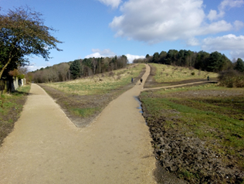
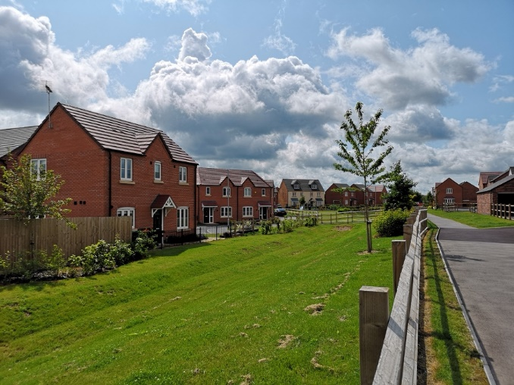
With kind permission of W Westerman Ltd
S106 contributions have been received from the Larwood residential development at Twickenham Road, Kirkby-in-Ashfield and were used to fund a nearby footpath improvement scheme (see above photos), allowing residents to easily access open space.

2.6 S106 Agreements signed in 2019/20
In the period 1st April 2019 to 31st March 2020, Ashfield District Council entered into planning obligations to the sum of £5,562,163.64. Developments with S106 agreements signed in the last financial year (2019/20) are listed below with their planning application reference:
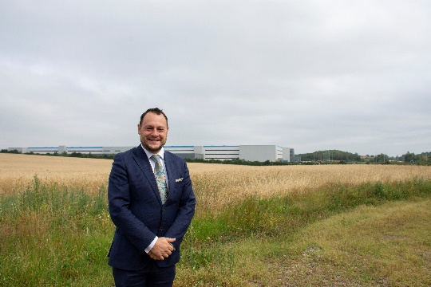
- V/2019/0101. Hamilton Road, Sutton in Ashfield: 162,781m2 Distribution Warehouse (B8) including ancillary B1 business use, creating 1800 new jobs.
The photograph opposite shows the Council Leader in front of the recently constructed distribution warehouse

- V/2016/0569. West of Beck Lane, Skegby, Sutton in Ashfield: Redevelopment of the site to provide up to 332 dwellings, with onsite open space.
- V/2018/0213. The Quarry, rear of 57 Stoneyford Road, Sutton in Ashfield: Redevelopment of the site to provide up to 48 dwellings, with onsite open space.
- V/2018/0393. Land at Annesley Miners Welfare, Derby Road, Annesley Woodhouse: Demolition of existing Miners Welfare premises and redevelopment of the site to provide up to 44 dwellings and 1 flat. Onsite open space and sports pitch to be provided.
- V/2016/0619. Aerial Way and Watnall Road, Hucknall. Demolition of Hucknall Town Football Club and redevelopment to provide a mixed use development of up to 108 dwellings and Business use (B1). A replacement football club is being implemented on Aerial Way.
- V/2019/0433. Land at Watnall Road, Hucknall. Development of an industrial building covering 18,194sq.m comprising B2 (General Industrial), B8 (Storage and distribution) and B1 (Office use). It includes electric car charging points and covered cycle spaces.
- V/2013/0123. Land at Watnall Road, Hucknall. A Deed of Variation to allow transfer of a number of affordable houses on the Rolls Royce housing development
- V/2019/0129. Land off Watnall Road / Daniels Way, Watnall Road, Hucknall. Demolition of existing industrial building and redevelopment of the site to provide up to 50 dwellings.
S106 agreements and other relevant documentation for each of the above planning applications (8 in total) can be viewed online on the Council’s planning portal at:
https://www2.ashfield.gov.uk/cfusion/Planning/plan_findfile.cfm
S106 agreements can also be viewed on line at:
https://www.ashfield.gov.uk/planning-building-control/planning-applications/section-106/view-section-106-agreements
Please see appendix 1 for details of:
- The total amount of money to be provided under any planning obligation which was entered into during 2019/20
- Summary details of any non-monetary contributions to be provided under planning obligations entered into during 2019/20 including details of –
- In relation to affordable housing, the total number of units which will be provided
- In relation to educational facilities, the number of school places for pupils which will be provided and the category of school at which they will be provided.

2.7 S106 Contributions Received in 2019/20
In 2019/20, a total of £6,028,314.84 was received in S106 contributions. The table and bar chart below shows the contributions received by infrastructure type:
Infrastructure Financial Statement:
01 April 2019 to 31 March 2020
Infrastructure type | S106 Contributions received
Public Open Space | £120,380.31
Primary Education | £4,087,275.77
Secondary Education | £882,556.82
Transport | £495,936.12
Public Realm | £37,763.44
Affordable Housing | £399,398.17
Regeneration ( interest) | £444.95
Arts ( interest) | £283.52
S106 monitoring | £1,600.00
TOTAL | £6,028,314.84
Table 5: Total S106 contributions received
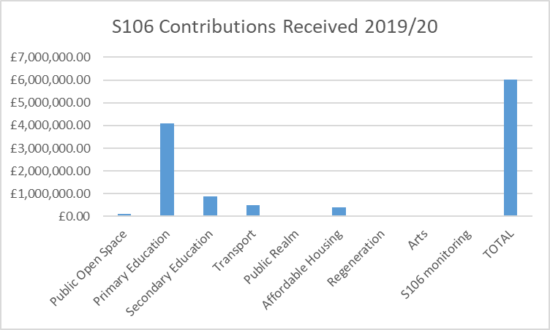
Figure 2: Total S106 contributions received
Total receipts in 2019/20 came from 12 sites, however most of the contributions came from the following sites:
- Rolls Royce, Watnall Road, Hucknall - £4,885,525
- Larwood Park, Kirkby-in-Ashfield - £392,400
- Land Adjacent the Marr, South of Lower Oakham Way, Sutton-in-Ashfield - £200,000
- Papplewick Lane, Hucknall - £300,757
Additional detail for the contributions received is shown in Appendix 2

2.8 S106 Contributions allocated but not spent in 2019/20
Within the reported year, S106 funds received by the Council and allocated to a specific project, but not spent as of 31/03/2020 totals £4,846,500.72. These contributions comprise the following items:
Obligation type | Planning application / Development site location | S106 Funds secured | Project Allocation
Public Open Space | POS
 | Hucknall POS* | £15,948.14 | Hucknall area – Titchfield Park
 | Kirkby POS* | £310,792.95 | Kirkby area – Nuncargate Recreation Ground
 | Sutton POS* | £135,865.14 | Sutton area – Projects in development
 | Rurals POS* | £6,123.46 | Rurals area – Projects in development
 | Total | £456,482.78
Transport | TR6
 | Hucknall TR6* | £80,832.94 | Hucknall area – Projects in development
 | Kirkby TR6* | £138,821.69 | Kirkby area – Projects in development
 | Sutton TR6* | £403,451.45 | Sutton area – Projects in development
 | Rurals TR6* | £10,645.62 | Rurals area – Projects in development
 | Total | £633,751.70
Affordable Housing | AH | £1,279,839.88
Specific Project allocations
 | V/2003/1094 Land at Studfold Lane, Kirkby | £82,574.61 | Kirkby - Regeneration of the town centre
 | V/2005/0886 Annesley Colliery, Kirkby | £275,800.73 | Regeneration of the Woodhouse ward
 | V/2003/1094 Lindleys Lane, Kirkby | £103,572.43 | Sorrel Drive Play area – New play area and play equipment
 | V/2005/0886 Annesley Colliery, Kirkby | £31,094.49 | Art Feature Annesley -bespoke artwork features and street furniture across the Annesley area to link the new estate and site of former colliery with the existing miners’ cottages.
 | V/2013/0493 Washdyke Lane , Hucknall | £13,853.91 | Washdyke Recreation Ground – General landscape improvements.
 | V/2004/0356 Papplewick Lane, Hucknall | £1,010.27 | Commission and install art features within the Papplewick Development
 | V/2019/0005 Royal Foresters, Sutton | £47,032.22 | Improvements to Cowpasture Recreation Ground improvements( £15576.16) and Sutton Town Centre Public Realm (£31152.21)
 | V/2017/0329 Land Adj. The Bluebell, Carsic Lane, Sutton | £8,000 | Improvements at Sutton Lawn
 | Land Adj. The Bluebell, Carsic Lane, Sutton V/2017/0329 | £16,000 | Improvements at Portland Square and or / Low Street or other Public Realm project
 | Rolls Royce V/2013/0123 | £270,000 | To be paid to NCC for bus service contribution
 | Land South of Mansfield Road, Sutton V/2017/0049 | £37,541.01 | Improvements to Low Street or other Public Realm project
Obligations: Open space, Public Realm, Affordable Housing, Transport, Regeneration, Art. | Total | £3,416,156.03
Education | Education  V/2017/0344, V/2013/0123, V/2004/0356, V/2017/0049 | £1,177,310.74 | To be paid to Nottinghamshire County Council for education
Obligations | Education | £1,177,310.74
REVENUE
 | V/2005/0396 Land Off Lindleys Lane, Kirkby | £22,000.40 | Employment Opportunities
 | V/2003/0845 Land off, Prospect Place, Sutton | £5,699.97 | The Old Mill, Silk Street, Sutton – either for improvements to open space around the mill
 | V/2010/0433 Former Annesley Colliery, Hucknall Road,  Annesley | £28,089.41 | Integrated transport initiatives within the district of Ashfield
 | V/2014/0045 The Twitchell,  Sutton | £34,442.70 | Public Realm works in the vicinity of the development
 | Grange Farm, Moor Road,  Papplewick V/2011/0188 | £11,410.16 | Integrated transport initiatives within the district of Ashfield
 | S106 Interest payment* | £113.22 | Kirkby Regeneration
 | Broomhill Farm, Land to West of, Nottingham Road,  Hucknall/2013/0409 | £48,587.03 | Hucknall – Maintenance of Unadopted land
 | Annesley Colliery V/2005/0886 | £40,940.30 | Annesley Regeneration
 | V/2005/0396 Land off Lindleys Lane, Kirkby | £10,720.02 | Revenue contributions for feasibility studies
 | Public Open Space S106 agreements* | £51,030.74 | Maintenance commuted sums district wide
REVENUE | Total | £253,033.95
ALL OBLIGATIONS : S106 BALANCE | Total | £4,846,500.72
Table 6: Contributions allocated but not spent in 2019/20. Monitoring /S106 agreements* = source planning application reference to be added and details added to updated statement in early 2021

2.9 S106 Contributions Spent in 2019/20
In most cases, S106 agreements contain clauses detailing specific criteria as to how and where the contributions must be spent. Occasionally, clauses can be less prescriptive and the associated funding is known as “unrestricted” funds. If there is no pressing need for the area to which the agreement refers, these funds may be held by the Council for a period of up to five years following the grant of planning permission until such time as a suitable need is identified.
Within the reported year, the total amount of S106 funds received by the Council that have been both allocated and spent, or transferred to another party amounts to £5,897,013.89
Of the funded schemes, many of them are at different stages of delivery. The schemes are detailed below under obligation type headings:
- Housing

The Council did not spend any S106 affordable housing contributions during 2019/20. Housing purchases were funded by the use of Right to Buy receipts.

- Education
Ashfield District Council made payments totalling £5,115,476 Education to Nottinghamshire County Council in 2019/20. Of this sum, £4,615,320 came from the Rolls Royce Housing development on Watnall Road in Hucknall (V/2013/0123) and £500,156.85 came from the Papplewick Lane housing development in Hucknall (V/2004/0356).Nottinghamshire County Council will report separately on the spend of this funding as part of their Infrastructure Financial Statement.
- Transportation

Ashfield District Council made payments of £17,400 Transport (TR6) to Nottinghamshire County Council in 2019/20. The funding came from the development on land to the rear of Watnall Road in Hucknall (V/2006/0080). Nottinghamshire County Council will report separately on the spending of this funding as part of their Infrastructure Financial Statement.

The Council delivered the Kirkby footpaths/cycle ways project which comprised works to improve footpaths in the vicinity of Larwood Park housing development. Approximately 1.7km of existing footpath were cleared to the original width and resurfaced, with approximately 600m of new footpath constructed. Six pedestrian access points were improved and made more accessible as part of the works. The funding for the works came from planning application Larwood Park V/2013/0656. A S106 contribution of £6355.82 was spent on the works.

- Business employment and skills

The Retail Improvement Scheme through a variety of grants helped 15 businesses within Ashfield. Funding was available for business start-ups, vacant shops improvements and assistance with business growth. Seventeen indoor and outdoor market traders across the district also claimed funding to help with to develop their businesses. The S106 funding came from V/2010/0433 Former Annesley Colliery

- Job and apprenticeship opportunities
The Careers in Local Government programme funded two graduate placements at Ashfield District Council in 19/20 as follows:
- One placement in the Neighbourhood Services Team (July 2019 - January 2020). The total salary cost was £9,215. The graduate successfully secured a permanent post in the same department following the placement.
- One placement in Marketing and Communications Team (July – Oct 2019). The total salary cost was £3,609. The graduate left the placement early to take up a position elsewhere.
The S106 funding came from V/2010/0433 Former Annesley Colliery
- Parks and open spaces
The following projects as set out in the Table below were delivered across the district as a result of secured S106 monies:
District area | Planning application / Development site | S106 Contribution Spent 2019/20 | Project delivered
Hucknall
 | V/2013/0409 Broomhill Farm, Land to West Nottingham Road, Hucknall | £13,000 | Lime Tree Recreation Ground. Improvement works including new play area, youth equipment and balance trail.
 | Planning application* | £4650.00 | Titchfield Park. The enabling work to relocate the existing play equipment on the park to complement the existing equipment adjacent to the café has been completed.
 | V/2004/0356 Papplewick Lane, Hucknall | £41.67 | Papplewick Green Public Art Work. Completion of art work in the Papplewick housing development.
 | Planning application* | £17,849.85 | Nabbs Lane Play Improvements - completed Feb 2020.Improvement works including the supply and installation of new play and young people’s equipment and associated safety surfacing.
Sutton-in Ashfield | V/2017/0344 Land fronting Unwin Road, Sutton | £11,000.00 | Kings Mill Reservoir management plan: Implementation Works. Works in accordance with the Management plan
 | V/2017/0344 Land fronting Unwin Road, Sutton  V/2017/0329 Land Adj. The Bluebell, Carsic Lane, Sutton in Ashfield | £12,065.56 | Sutton Lawn Play Area. Installation of new play equipment adjacent the park café.
 | Planning application* | £50,000.00 | Roundhills Recreation Ground. Installation of new play equipment.
Kirkby –in-Ashfield | Planning application* | £10,035.50 | Kingsway Park: implementation of management plan. New park entrance and directional signage has been completed
 | Planning application* | £3,329.77 | Portland Park Management Plan: General Improvements. Improvement works including the supply and installation of new entrance, directional and interpretive signage at various locations around the park completed Nov 2019 ( £3329.77)
 | Planning application* | 621.67 | Warwick Close: Glen View Park Scooter Track – contract completed June 2019. Improvement works including the design and build of a small downhill scooter track for younger children.12 month retention fee paid
 | Planning application* | £31,481.00 | Morven Park Play Improvements - completed Aug 2019.  Improvement works including the supply and installation of a new toddler multiple unit, inclusive roundabout, inclusive springie, seesaw and associated safety surfacing, litter bin and the re-configuration of the play trail to suit.
 | V/2013/0656 Larwood Park, Kirkby in Ashfield | £97,633.47 | Kirkby Footpath / Cycleway Improvements - completed Feb 2020  Improvement works including tree felling / thinning / crown raising, the scraping off existing footpaths to their original widths, re-grading to fill ruts, resurfacing paths, installing new accessible chicane entrance restrictions including fence repairs, construction of new footpaths including excavation, sub-base and surface course.
 | V/2010/0433 Former Annesley Colliery | £23,595 | Annesley Art Project - completed Aug 2019  Improvement works including the design, fabrication and installation of bespoke artwork features and street furniture across the Annesley area to link the new estate and site of former colliery with the existing miners’ cottages.
Rurals | Planning application* | £5,000.00 | Friezeland Rec Ground Scooter Park - completed July 2019.Improvement works including the design and build of a new scooter park.
 | Planning application* | £8,828.32 | Jacksdale Bridge Links - completed March 2020  Improvement works including the re-grading of the existing footpath and resurfacing including drainage works together with installing new accessible chicane entrance restrictions including remedial works to the existing vehicle barrier.
Table 7: Contributions spent on Parks and Open Spaces. Planning application* = source planning application reference for S106 agreement to be added and details added to updated statement in early 2021

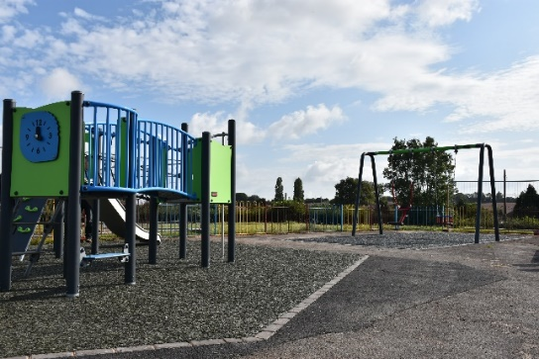

Roundhills Recreation Ground: New play equipment

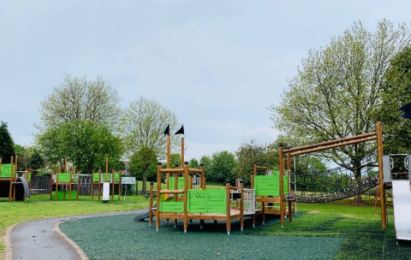
Sutton Lawn Play Area: New Play equipment next to Park café.

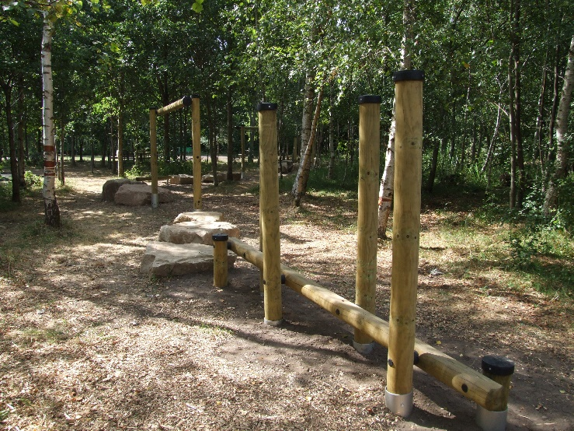
Brierley Forest Park Play Trail: Timber equipment in a woodland setting.

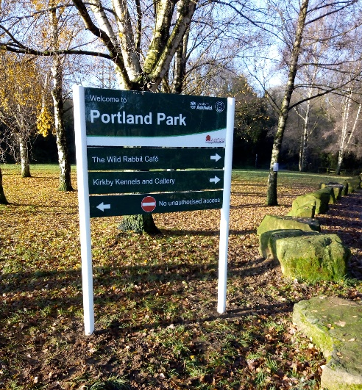
Portland Park: New information signage

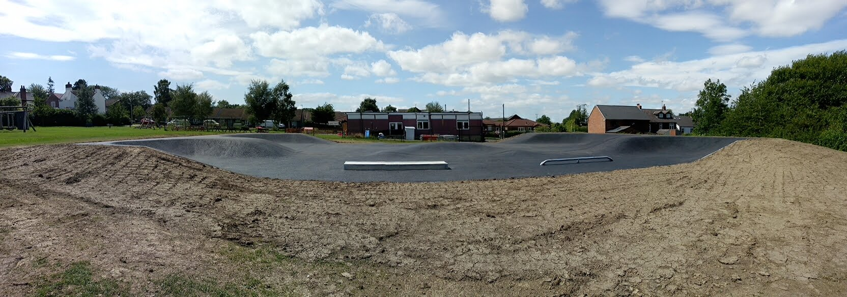
Friezeland Scooter Park

- Regeneration
The Council progressed two regeneration projects during 2019/20. The first project was Ada Lovelace Business Centre Development. The original Kirkby Urban District Council building (located outside the current main Ashfield District Council offices on Urban Road in Kirkby) was refurbished to create 7 units suitable for letting to small businesses (see photos below).

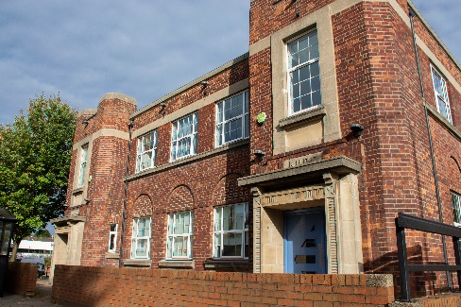
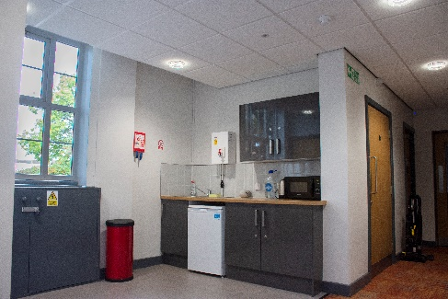

The funding for the works came from planning application Land at Studfold Farm development in Kirkby V/2011/0189. A S106 contribution of £24,530.93 was spent on the works.

The second project is the ongoing Leisure Transformation Programme. The programme reviews the council’s leisure centres in Hucknall, Selston and Edgewood, including the procurement of a new operating contractor for the centres and the development of a new Leisure Centre in Kirkby to replace the Festival Hall facility. Funding for the works came from planning application Land at Studfold Farm development in Kirkby V/2011/0189. A S106 contribution of £12,588.95 was spent on this programme during 2019/20.

- Art
The Council successfully completed the Annesley Art Project in Kirkby - in-Ashfield. An artist was commissioned to work with the local community to delivering artwork in five locations with multiple land owners across Annesley. The installation of artwork was installed to link new residential and established ex-mining communities together and to strengthen pedestrian links to the nearby country park. The funding for the works came from planning application Former Annesley Colliery V/2005/0886. A S106 contribution of £23,595 was spent on the works.
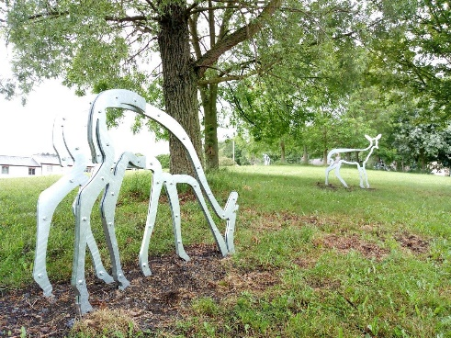
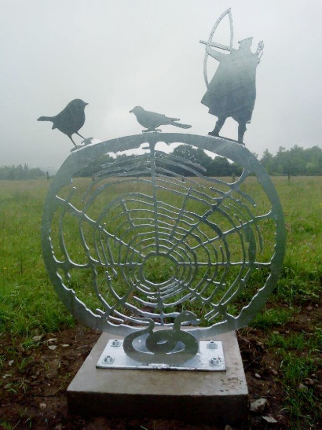
Photos of the art installations located on and around Annesley Cutting / Byron Road, Annesley.

2.10 Planned expenditure for future years
This section sets out how S106 income will be spent in the District of Ashfield. It is difficult to forecast future S106 income and expenditure exactly as contributions are negotiated on a site-by-site basis and depend on a number of considerations such as viability. S106 funding is often closely linked to the phasing of the development as set out in the terms of the legal agreement and can contain clauses relating to the timing (triggers) of the spending. The impact of the current pandemic has had an effect on delivery and the longer term impacts on the construction industry are unclear.
Once complete, the IDP accompanying the Local Plan will also set out the required infrastructure to deliver the identified site allocations. Whilst this will not detail specifically the cost of various infrastructure items, it will provide an overview to developers and the community of the expected contributions.
Planned expenditure for future years sets out how unallocated funds should be spent.
The information below sets out the planned expenditure and funds remaining for the current S106 balance. With regard to the following funds :
- Transport: Spend on projects undertaken by Nottinghamshire County Council will be reported seperately as part of their Infrastructure Financial Statement).
- Affordable Housing: £484,000 Planned expenditure, £ 795,839 remaining to be allocated to specific projects.
- Education: £1,177,310 remaining to be paid to Nottinghamshire County Council on confirmation of suitable projects. Spend will be reported by Nottinghamshire County Council as part of their Infrastructure Financial Statement).

The table below sets out project information in more detail:
Projects
Location | Estimated Cost | S106 / Other public contribution | Required works | Status / funding source
Public Open Space
Hucknall
Titchfield Park and Hucknall Cemetery: implementation of park masterplan | £4000 | £4000 | Actions as identified in the park management plan / Green Flag award requirements | To be implemented
Tichfield Park | £148,000 | £70,000 Capital Receipts | New Play equipment / Youth equipment and associated works | Capital Receipts Funding. Works to be completed by July 2021
Sutton
Ashfield Estate Footpaths | £6,000 | £6,000 S106 | Additional footpath improvements have been identified / possible match funding contribution to NCC highways access improvements | To be implemented 2021 April onwards
Brierley Forest Park Management Plan | £20,000 | £11,000 S106, £9,000 Rural Payments Agency | Actions as identified in the park management plan / Green Flag award requirements | Ongoing implementation of works
Brierley Forest Park Car Park Extension and Entrances | £81,000 | £81,000 S106 | Disabled car park improvements at Skegby Road and main car park extension.Accessibility improvements to the Oval, Stoneyford Road and Brand Lane entrances | To be completed on site by January 2021
Football Changing Rooms | Details to be confirmed | £15,000 | Replacement changing rooms to be provided | S106 funding to potentially be allocated for works at Sutton Lawn
Kingsmill Reservoir footpath links | £1,000 | £1,000 | Footpath improvements are identified in the Heritage Lottery funded works programme | To be allocated to the Kings Mill Reservoir HLF project budget. Completion early 2021
Sutton Lawn Management Plan. | £6,000 | £6,000 | Actions as identified in the park management plan / Green Flag award requirements | To be implemented
Sutton Lawn Play area | £1,000 | £1,000 | To be used for further improvement works | To be implemented 2021
Taylor Crescent Recreation Ground | To be confirmed | £10,000 | Project to be reviewed | No plan to implement project
Kings Mill Reservoir Management Plan | £1,450,000 including costs already incurred | £20,000 S106 +TR6 + capital programme+ HLF bid. | For actions as identifed in the management plan, including footpaths and signage improvements. Heritage Lottery Fund bid to undertake desilting works, ecological and environmental improvements and develop potential for heritage trails with community support. | To be implemented
Healdswood Recreation Ground | £32,500 | All Capital receipts | Equipment replacement and new teenage equipment | Capital receipts and S106 funding. Works to be completed by March 2021.
Riley Recreation Ground | £24,300 | All Capital receipts | Equipment and surfacing replacement | Capital receipts and S106 funding. Works to be completed by March 2021.
Kirkby
Annesley Art Project | £29,000 | £29,000 S106 | Construction of paths across open space | Not on current 2020/21 work programme. Future works
Forest Road Nature Area | £30,000 | £30,000 | General improvements | Not on current 2020/21 work programme. Future works
Glen View/ Warwick Close | 15,000 | £15,000 | Play equipment and safety surfacing | Capital receipts and S106 funding. Works to be completed by March 2021.
Kingsway Park: implementation of management plan | £32,000 | £32,000 | Actions as identified in the park management plan | Ongoing implementation of works
Kirkby footpaths/cycle ways | £31,000 | £31,000 TR6 | Use for possible Phase 2 of path from Rowan Drive to Sutton Middle Lane | To be programmed.
Lindleys Lane – Sorrel Drive Play Area | £178,000 | £103,000 S106  £75,000 Towns Fund | Provision of new play equipment and access paths | S106 and Towns Fund Accelerated Programme. To be completed March 2021
Morven Park / West Park Play Area | £7,000 | £1,000 S106 | Supply and install new toddler and junior swings new topsoil, turf and grass matt safety surfacing | To be completed by March 2021
Nuncargate Recreation Ground | £146,000 | £118,210 S106  £27,790 Capital Receipts | New play equipment, entrance feature,surfacing,footpaths and planting | Capital receipts and S106 funding. Works to be completed by March 2021.
Rowan Drive | £4290 | £8000 | New crushed stone footpath off Rowan Drive | Capital receipts . Works recently completed.
Sports pavilion, Titchfield Park | To be confirmed | £39,000 S106 | Provision of new pavillion | Funding to be transferred to Kingsway Park
Portland Park | To be confirmed | £0 | Actions as identified in the park management plan | Capital receipts to be identified. Works to be completed by March 2021.
West Park | £35,500 | £35,500 S106 | Footpath resurfacing, new equipment and lighting options | Capital receipts and S106 funding. Works to be completed by March 2021.
Rurals
Friezeland Recreation Ground - Scooter Park | £1,228.55  Actual cost | £2,000 S106 | Retention Fee  Underspend could be used for funding shortfall for interpretation at Jacksdale | Works recently completed
Transport
Hucknall Car Park – Titchfield Street | To be confirmed | £93,000 | Provision of new car park, as part of the Inner Relief Road programme of works | Project on hold, land not in ADC ownership
Affordable Housing
Davies Avenue , Sutton in Ashfield | £284,000 | £284,000 | 22 x new affordable bungalows, houses and flats. | To be implemented 2020/21. S106 funding allocation to be agreed
Sutton Infill scheme on Stoney Street, The Poplars and The Beeches in Sutton in Ashfield | £200,000 | £200,000 | 9 houses and bungalows | To be implemented 2020/21. S106 allocation to be agreed
Public Realm
Sutton Town Centre Improvements |  | £70,000 | Fox Street area, Portland Square improvements. | Scheduled for completion in 2021
Art
 | £0 | £0 | Art contributions have not been specifically identified. Contributions may be requested as part of the Towns Fund work development which is currently ongoing. | Scheduled for completion in 2021
Education
 | £1,177,310 | £1,177,310 | For spend by Nottinghamshire County Council. Please see Nottinghamshire County Council Infrastructure Funding Statement 2019/20. | Awaiting confirmation of schemes in accordance with S016 agreements.
Health
 | £0 | £0 | Health contributions have not been specifically identified at this stage. | The Clinical Commisioning Group is currently working on an Estates Strategy.
Libraries
 | £0 | £0 | Please see Nottinghamshire County Council Infrastructure Funding Statement 2019/20.
Maintenance
 | £51,030.74 | £51,030.74 | Maintenance of adopted open spaces | Funded from S106 sites to be adopted by the Council. Figures to be reviewed nearer to dates of adoption
Employment
 | £22,000 | £22,000 | Business support grants | Grant applications being accepted and processed by ADC
Table 8: Planned S106 expenditure 1st April 2020 onwards

3. Conclusions
Ashfield District Council is working to ensure that as part of the planning process, the added value and opportunities that new development can bring such as affordable homes, jobs and environmental improvements are maximised for the wellbeing and benefit of local communities.
If you have any further queries or comments about this statement, please contact the Forward Plans Team via email: localplan@ashfield.gov.uk or phone 01623 457383

4. Appendices
Appendix 1: The total amount of money to be provided under any planning obligation which was entered into during 2019/20
Appendix 2: S106 Contributions received 1st April 2019 – 31st March 2020
Appendix 3: Information links

Appendix 1: The total amount of money to be provided under any planning obligation which was entered into during 2019/20
Application no | Description | Detailed information and funds secured | Total amount of money to be provided under any planning obligation which was entered into during 2019/20 | Summary details of any non-monetary contributions to be provided under planning obligations entered into during 2019/20 including details of –
 |  |  |  | Affordable housing - total number of units which will be provided | Educational facilities - Total number of school places for pupils which will be provided and the category of school at which they will be provided
 |  |  |  |  | Primary | Secondary | Contribution only: spend location
V/2019/0101 | Hamilton Road, Sutton in Ashfield | 162,781m2 Distribution Warehouse (B8) including ancillary B1 business use, creating 1800 new jobs. Transport : £200,000 | £200,000.00
V/2016/0569 | West of Beck Lane, Skegby, Sutton in Ashfield | Redevelopment of the site to provide up to 332 dwellings, with onsite open space. Education:£2,373,973.64 Health: £174,524 Public Realm: £644,000 Transport: £420,206 | £3,609,702.64 | 32 |  |  | Brierley Forest Primary and Nursery School
V/2018/0213 | The Quarry, rear of 57 Stoneyford Road, Sutton in Ashfield | Redevelopment of the site to provide up to 48 dwellings, with onsite open space. Education: £292,240 Health £26,010 Public Realm £96,000 S106 Monitoring £1600 Transport £5000 Public Open Space £48,000 | £468,850.00 | 5 |  |  | Contribution towards the cost of primary education at Leamington Primary School on Clare Road and Secondary education at Quarrydale Academy
V/2018/0393 | Land at Annesley Miners Welfare, Derby Road, Annesley Woodhouse | Demolition of existing Miners Welfare premises and redevelopment of the site to provide up to 44 dwellings and 1 flat. Onsite open space and sports pitch to be provided. Education : £136560 Health : £24493 Public Open Space £88000 Transport £38,500 | £287,553.00 | 4 |  |  | Primary Education Contribution towards Annesley Primary School
V/2016/0619 | Aerial Way and Watnall Road, Hucknall | Demolition of Hucknall Town Football Club and redevelopment to provide a mixed use development of up to 108 dwellings and Business use (B1). A replacement football club is being implemented on Aerial Way. Education: £556,885 Health: £58,247 Public Realm: £50,000 Public Open Space £239,000 Transport £60,000 Libraries £4960 | £969,092 | 11 | 23 | 17 | Secondary - Holgate School. Primary - required as a consequence of the development
V/2019/0433 | Land at Watnall Road, Hucknall | Development of an industrial building covering 18,194sq.m comprising B2 (General Industrial), B8 (Storage and distribution) and B1 (Office use). It includes electric car charging points and covered cycle spaces. | Supplemental deed varies obligations in respect of V/2013/0123 & V/2015/0633
V/2013/0123 | Land at Watnall Road, Hucknall | A Deed of Variation to allow transfer of a number of affordable houses on the Rolls Royce housing development | 0
V/2019/0129 | Land off Watnall Road / Daniels Way, Watnall Road, Hucknall | Demolition of existing industrial building and redevelopment of the site to provide up to 50 dwellings. Health : £2,6966 | £26,966.00 | 5
 |  | TOTAL | £5,562,163.64 | 57 | 23 | 17

Appendix 2: S106 Contributions received 1st April 2019 – 31st March 2020
Ashfield District Council
Infrastructure Financial Statement 01 April 2019 to 31 March 2020 |  |  |  | Contributions received
Payment date | Payment type | Developer | Amount | Application no | Description
20-May-19 | Public Open Space | Woodsett Homes | £15,533.96 | V/2017/0344 | Land Fronting Unwin Road, Sutton -in-Ashfield
20-May-19 | Education | Woodsett Homes | £29,737.18 | V/2017/0344 | Land Fronting Unwin Road, Sutton-in-Ashfield
29-Jul-19 | Public Open Space | Home Life Supported Accommodation Ltd | £8,000.00 | V/2017/0329 | Land Adj. The Bluebell, Carsic Lane, Sutton -in-Ashfield
29-Jul-19 | Regeneration | Home Life Supported Accommodation Ltd | £16,000.00 | V/2017/0329 | Land Adj. The Bluebell, Carsic Lane, Sutton- in-Ashfield
11-Jun-19 | Public Open Space | William May Developments | £4,583.33 | V/2013/0493 | Land at Washdyke Lane, Hucknall
29-Jul-19 | Transport | Muse Developments Limited | £270,000.00 | V/2013/0123 | Rolls Royce, Watnall Road, Hucknall
29-Jul-19 | Education | Muse Developments Limited | £3,731,390.00 | V/2013/0123 | Rolls Royce, Watnall Road, Hucknall
10-Jul-19 | Public Open Space | William May Developments | £4,583.33 | V/2013/0493 | Land at Washdyke Lane, Hucknall
24-Jul-19 | Public Open Space | Johal Property Group Ltd | £16,872.81 | V/2014/0239 | Former Larwood Nursing Home, Main Road, Kirkby
14-Aug-19 | Transport | Gleeson Homes | £20,341.00 | V/2011/0503 | Land Gilcroft/Vere Avenue, Sutton-in-Ashfield
05-Aug-19 | Affordable Housing | Westerman Homes | £392,400.00 | V/2013/0656 | Larwood Park, Kirkby-in-Ashfield
15-Nov-19 | Monitoring S106 | Angela Caulton | £1,600.00 | V/2018/0213 | The Quarry Stoneyford Road, Sutton-in-Ashfield
23-Sep-19 | Public Open Space | William May Developments | £4,583.00 | V/2013/0493 | Land at Washdyke Lane, Hucknall
08-Nov-19 | Education | Muse Developments Limited | £652,745.00 | V/2013/0123 | Rolls Royce, Watnall Road, Hucknall
05-Nov-19 | Transport | Peveril Securities Ltd | £200,000.00 | V/2019/0101 | Land Adj. Marr South of Lower Oakham Way, Sutton-in-Ashfield
09-Jan-20 | Education | Muse Developments Limited | £231,390.00 | V/2013/0123 | Rolls Royce, Watnall Road, Hucknall
17-Jan-19 | Education | Barratt Homes | £300,757.12 | V/20004/0356 | Papplewick Lane, Hucknall
31-Jan-20 | Education | Peveril Securities Ltd | £23,813.00 | V/2017/0049 | Land South of Mansfield Road, Sutton-in-Ashfield
31-Jan-20 | Public Open Space | Peveril Securities Ltd | £9,354.85 | V/2017/0049 | Land South of Mansfield Road, Sutton-in-Ashfield
31-Jan-20 | Public Realm | Peveril Securities Ltd | £37,419.40 | V/2017/0049 | Land South of Mansfield Road, Sutton-in-Ashfield
 |  |  | £57,210.86 |  | Interest on above contributions calculated at year end
 |  | TOTAL RECEIVED | £6,028,314.84

Appendix 3: Information links
Ashfield District Council Corporate Plan 2019 -2023
https://www.ashfield.gov.uk/media/8d84458b550cb95/corporate-plan-2019-2023-final-to-publish.pdf
Ashfield District Council Adopted Local Plan 2002
https://www.ashfield.gov.uk/media/8d84ff980f87003/full-document-_text_.pdf
Infrastructure Delivery Plan
https://www.ashfield.gov.uk/media/8d85025a8aa55c4/infrastructure-delivery-plan.pdf
Playing Pitch Strategy 2017 - (Overview of the provision for various sports in Ashfield for the period 2017 – 2020)
https://www.ashfield.gov.uk/media/8d850ab1f08d9d2/ashfield-playing-pitch-strategy-2017-2020.pdf
Public Open Space Strategy 2016 (Considers the open space requirements for Ashfield for the period 2016 – 2026)
https://www.ashfield.gov.uk/media/8d850ab97b714fe/public-open-space-strategy.pdf

https://www.ashfield.gov.uk/media/8d843791e0527f8/lds-sept-2018.pdf
https://www.ashfield.gov.uk/media/8d85025a8aa55c4/infrastructure-delivery-plan.pdf

