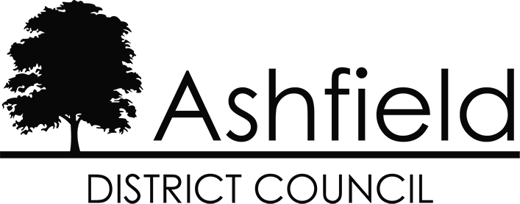

Ashfield District Council Community Trigger Policy

September 2021

# Content:

1. Introduction.
2. What are the criteria to meet a Community Trigger?
3. Who can request a Community Trigger?
4. How can I request a Community Trigger?
5. Information Sharing.
6. What is the case review process?
7. How can a decision about not meeting the threshold for a case? review or the actual outcome of a review be challenged?
8. Assessment and revision of review procedures.
9. Publishing of data.

**Community Trigger**

# Introduction

The Anti-Social Behaviour, Crime and Policing Act 2014 sets out the requirement for relevant bodies to make governance arrangements for the facilitation of case reviews, otherwise known as the ‘Community Trigger’.

Community Triggers enable victims of anti-social behaviour (ASB) and related matters to request a multi-agency review providing the criteria has been satisfied.

The focus is to bring different agencies together to jointly review cases, and by taking a joined-up approach to consider any other actions that could be taken to find a solution for the victim or complainant.

The Community Trigger meetings are impartially undertaken by an independent chair. The review is not intended to act as a complaints procedure that examines how a particular agency or agencies have tackled a problem in the past; but instead, to focus on the existing situation and what more can be done, enabling agencies to re-evaluate their actions quickly and objectively.

# What are the criteria to request a Community Trigger?

In order to request a Community Trigger, a single anti-social behaviour case must have been reported three times or more within six months of the first incident taking place.

The types of incident that can be reported can be any kind of anti-social behaviour including noise nuisance, street drinking or concerns relating to criminality and vulnerability.

Where an agency or agencies receive a complaint (report) they will seek wherever possible to find a satisfactory resolution. Sometimes such a resolution is not easily or quickly achieved, resulting at times in further service requests being made.

The case review process allows a complainant to have their case reviewed, where despite having made at least three separate complaints to one or more relevant bodies, the issue has still not been resolved to their satisfaction.

To meet requirements for the case review procedure complaints will have to meet the following criteria to qualify:

* + they must be made within one month of the behaviour occurring; and
  + a complaint made to several agencies at or around the same time will only count as one, or thought this will be taken into consideration on a case by case basis.

The completion of diary sheets as part of an investigation process will not be considered a qualifying complaint unless this has been formally brought to the services attention as an official report.

# Who can request a Community Trigger?

A Community Trigger can be requested by the victim themselves; this can be an individual, business or community group. A review can also be requested by someone acting on their behalf, such as a family member, carer, MP or councillor.

Any third party requesting a review on the victim’s behalf will need to obtain the victim’s consent in writing to instruct a review of the case and to receive copies of correspondence sent to the victim.

# How can I request a Community Trigger?

In order to use the Community Trigger to request an Anti-Social Behaviour case review an application must be completed and submitted to:

**Community Safety Ashfield District Council Council Offices**

**Urban Road Kirkby in Ashfield Nottingham**

**NG17 8DA**

[Application forms](https://www.ashfield.gov.uk/community-leisure/anti-social-behaviour-community-safety/tackling-anti-social-behaviour/request-a-case-review/) can be found on the Councils website.

If a hard copy of the Community Trigger application form is required or for further assistance contact Ashfield District Council by:

* telephone - **01623 450000**
* email - [**asbduty@ashfield.gov.uk**](mailto:asbduty@ashfield.gov.uk)

# Information sharing.

Information shared between partner agencies during the case review process will be in accordance with existing information sharing agreements and protocols.

# What is the case review process?

The case review process is set out as below:

* + A case review application is received by the local authority specific point of contact (SPOC).
  + The local authority SPOC will within 5 working days acknowledge receipt of the request, contact the SPOC’s of the other relevant bodies to determine whether the application meets the threshold.
  + If the threshold is met, the local authority SPOC will advise the applicant of the details of the case officer their application has been allocated to, on what date, their contact details, and will be advised that contact will be made by that officer within the next 7 working days detailing the next steps.
  + An Anti-Social Behaviour Case Review will take place within 20 working days. This will involve agencies sharing information such as the police, housing, environmental health, social care and health providers, depending on the nature of the case. The Anti-Social Behaviour Case Review will discuss the issues you raise, consider what action has already been taken and consider recommendations for additional action to resolve the problem.
  + We will inform you of the outcome and recommendations of Review within 5 working days following the outcome.
  + If an application does not meet the threshold, the local authority SPOC or nominated case officer will advise the applicant of the position, but also consider what other reasonable steps could be taken to resolve the issue.

# How can a decision about not meeting the threshold for a case review or the actual outcome of a review be challenged?

If you are not satisfied with the outcome of the Community Trigger, you can lodge an appeal with the Office of the Police and Crime Commissioner for Nottinghamshire.

# Assessment and revision of review procedures

The effectiveness of this procedure will be reviewed six months after its commencement and annually thereafter. It will be reviewed jointly by representatives of the relevant bodies across Nottinghamshire. The Police and Crime Commissioner will be consulted during each review.

# Publishing of data

At the end each fiscal year the relevant bodies for each area will publish the following data:

* + the number of applications for case reviews.
  + the number of times it was decided that the threshold for a review was not met.
  + the number of case reviews carried out.
  + the number of case reviews carried out that resulted in recommendations being made.