DISCLAIMER

This document may not be accessible when using adaptive technology.

If you require assistance with accessing the content of the document, please contact:

- online form

- email: dutyplanner@ashfield.gov.uk or planning.admin@ashfield.gov.uk

OCTOBER 2020

Greater Nottingham & Ashfield
ICENI PROJECTS LIMITED ON BEHALF OF THE GREATER NOTTINGHAM PLANNING PARTNERSHIP

Housing Needs Assessment Final Report
Iceni Projects Limited on behalf of the Greater Nottingham Planning Partnership
Greater Nottingham & Ashfield
HOUSING NEEDS ASSESSMNT
FINAL REPORT

October 2020

Iceni Projects
London: Da Vinci House, 44 Saffron Hill, London, EC1N 8FH Glasgow: 177 West George Street, Glasgow, G2 2LB Manchester: 68 Quay Street, Manchester, M3 3EJ Edinburgh: 11 Alva Street, Edinburgh, EH2 4PH

t: 020 3640 8508 | w: iceniprojects.com | e: mail@iceniprojects.com
linkedin: linkedin.com/company/iceni-projects | twitter: @iceniprojects

2

CONTENTS
EXECUTIVE SUMMARY 1
- INTRODUCTION 12
- THE PLANNING POLICY CONTEXT 14
- DEMOGRAPHIC BASELINE AND THE HOUSING MARKET 16
- IDENTIFYING SUBMARKETS 33
- AFFORDABLE HOUSING NEED 57
- OLDER PERSONS HOUSING NEEDS & HOUSING PEOPLE WITH DISABILITIES 99
- STUDENT HOUSING NEEDS 126
- THE APPROPRIATE MIX OF HOUSING 140
- THE PRIVATE RENTED SECTOR AND BUILD TO RENT 166
- CONCLUSIONS 181
- APPENDICES 193
A1. IDENTIFIED SUBMARKETS IN GREATER NOTTINGHAM AND ASHFIELD 194
A2. PROJECTED CHANGES TO OLDER POPULATION WITH A RANGE OF DISABILITIES BY
LPA (POPULATION AGED 65+) 195
A3. PROJECTED CHANGES TO YOUNGER ADULT POPULATION WITH A RANGE OF DISABILITIES BY LPA (POPULATION AGED UNDER 65) 198
A4. PROJECTED CHANGES IN HOUSEHOLD OF HRP BY AGE BY LPA 201

EXECUTIVE SUMMARY

The Greater Nottingham Planning Partnership (“GNPP”) comprising Broxtowe Borough Council, Erewash Borough Council, Gedling Borough Council, Nottingham City Council and Rushcliffe Borough Council; as well as Ashfield District Council, have commissioned Iceni Projects (“Iceni”) to prepare a Housing Needs Assessment.

The Housing Needs Assessment has been prepared for the Greater Nottingham and Ashfield area in order to support the preparation of Local Plans looking ahead to 2037 in Ashfield and to 2038 in all other authority areas; and to provide evidence to support housing market interventions and prospective future funding bids.

Local Housing Need

This report has not created a new or for purpose data set; however, we have drawn on local housing need established by the standard methodology. Projections have been developed to inform the analysis within the report which are linked to the current local housing need figures for each authority area calculated using the standard methodology as set out by Government.

The calculation of the local housing need for each authority in the study area is set out in the Table below. In all cases, the minimum local housing need figure is equal to the need identified under Step2 which takes account of household growth using the 2014-based Household Projections over the period 2020 to 2030 and an affordability adjustment using the 2019 median workplace-based affordability ratio.

Table 1: Calculating Local Housing Need in Greater Nottingham and Ashfield

1: Household Growth | Ashfield | Broxtowe | Gedling | Erewash | Nottingham | Rushcliffe
2014-based Household Growth (p.a.) 2020-2030 | 434 | 314 | 401 | 345 | 1,086 | 451

2: Affordability | Ashfield | Broxtowe | Gedling | Erewash | Nottingham | Rushcliffe
Median Workplace-Based Affordability Ratio, 2019 | 5.74 | 6.77 | 6.25 | 6.19 | 4.93 | 9.45
Adjustment Factor | 11% | 17% | 14% | 14% | 6% | 34%
Minimum LHN | 481 | 368 | 458 | 392 | 1,149 | 604

Identification of Submarkets

Across the study area, the report has recognised that the profile of each local authority and indeed the neighbourhoods within each authority will vary with regards to particular characteristics including demographics, the profile of housing stock and house price dynamics. The identification of submarkets is therefore an important component when analysing affordable housing needs and in advising on the appropriate housing mix.

The assessment has defined submarkets using 2019 ward boundaries with the exception of Cotgrave Village Centre in Rushcliffe which has been built up with LSOAs to reflect the substantial variance in likely development viability. There are potentially further variances at a sub-ward level which this study has sought to address in the supporting text; however, in some instances, this is not possible due to the scale of particular villages which may contrast with the rest of the ward or due to the planned development or regeneration of particular areas which may warrant a separate submarket being established in due course. On this basis, the submarkets in this study should be viewed at a point in time and will invariably be subject to change

The assessment works through a range of analysis with a focus on viability, drilling down at a ward level to review the profile of property transactions and house prices by type of property to identify relationships and substitutability, wherever possible. This analysis has been set alongside other factors such as self-containment and urban morphology when defining submarkets. Drawing the analysis together, Iceni consider that the evidence points to a total of 57 submarkets across the studyarea. A map of the submarkets is set out in Section 4 of this report.

Affordable Housing

This report includes an assessment of affordable housing need which responds to the widened definition of affordable housing set out in the 2019 Framework. This includes households who mightbe able to rent a home in the private sector without financial support but aspire to own a home and require support to do so.

The assessment shows a need for 2,615 rented affordable homes per annum across the study area.A breakdown is provided below by local authority and a further detailed breakdown is provided by submarket in Section 5 of the report.

Table 2: Rented Affordable Housing Net Need by Local Authority, 2020-38

 | Ashfield | Broxtowe | Erewash | Gedling | Nottingham | Rushcliffe
Net Need for Rented Affordable (p.a.) | 237 | 309 | 271 | 392 | 1,112 | 294

The report has also assessed the potential scale of need for affordable home ownership, identifyingthat there is not a particular need for affordable home ownership homes across the study area.

When looking at the need for affordable home ownership products it is clear that there are a number of households likely to be able to afford to rent privately but who cannot afford to buy a suitable home because of the initial outlay/deposit/securing a mortgage. However, there is also a potential supply of homes within the existing stock that can make a contribution to this need, with a reasonable proportion of properties available at lower quartile prices.

It is therefore difficult to robustly identify an overall need for affordable home ownership products. The exception to this is in Rushcliffe where there is a particularly large ‘gap’ between the cost of buying and renting; however, this area does also have a significant need for social/affordable rented housing.

Table 3: Affordable Home Ownership Need/Surplus by Local Authority, 2020-38

 | Ashfield | Broxtowe | Erewash | Gedling | Nottingham | Rushcliffe
Net Need/Surplus for Affordable Home Ownership (p.a.) | -195 | -39 | -123 | -92 | -473 | 96

In bringing together evidence through the new Local Plans, the Councils need to consider the evidence of need, the relative acuteness of the need, issues of residential development viability and other actions which can be taken to support affordable housing delivery.

It is suggested that social rents will be affordable to a greater proportion of households than affordable rents, although some households claiming benefits will be able to access an affordable rent as long as the rent is fully covered by Housing Benefit. As a general rule it is not considered sensible to be charging a rent in excess of Local Housing Allowance (“LHA”) rates, as this would mean many households having to top up their rent from other income sources. The local authoritiescould therefore consider that the affordable level for social rents is equal to the maximum LHA levelfor the relevant area and property size. As a result, low income working households are likely to benefit most from a social rent. However, rents will have to be set in the context of viability.

The data indicates that there are many households across Greater Nottingham and Ashfield who are being excluded from the owner-occupied sector. The analysis would therefore suggest that a key issue in the study area is about access to capital (e.g. for deposits, stamp duty, legal costs) as well as potentially mortgage restrictions (e.g. where employment is temporary) rather than simply the purchase price of mortgage repayments.

If the Councils do seek to provide housing as affordable home ownership (noting that the Framework suggests a 10% figure for sites of 10 or more dwellings), then it is suggested that shared ownershipis the most appropriate option. Shared ownership properties have a clear role to play in the study area with equity starting at 25%; which can provide a valuable first step into home ownership. The analysis in this report does not preclude Councils incorporating a requirement for this form of affordable home ownership into strategies and policies.

Where other forms of affordable home ownership are provided (e.g. Starter Homes or discounted market), it is recommended that the Councils consider setting prices at a level which (in income terms) are equivalent to the midpoint between a lower quartile price and a lower quartile private rent for the respective submarket. This would ensure that some households could potentially afford housing to buy – this might mean greater than 20% discounts from Open Market Value for some types/sizes of homes in some locations.

Overall, the analysis identifies a notable need for affordable housing, and it is clear that provision ofnew affordable housing is an important and pressing issue across Greater Nottingham and Ashfield – particularly for rented products.

Local authorities may seek to prioritise social/affordable rent over affordable home ownership but insome particular submarkets, for example where the market stock has a reasonable portion of former Right to Buy homes, Councils may wish to diversify the market through the provision of new-build affordable home ownership products such as Shared Ownership.

Overall, the analysis identifies a notable need for affordable housing. Further analysis including viability assessments will inform both strategic and local affordable housing targets. The identified need for rented provision in this report provides a starting point for the local authorities in developing an affordable housing target and planning policies is set out for each authority in Table 2 of this Executive Summary and Table 5.13 of the main report.

Older Persons Housing Needs and those with Disabilities

Greater Nottingham and Ashfield is projected to see a notable increase in the older person population, with the total number of people aged 65 and over projected to increase by 37.8% over the 18 years to 2038. This compares with overall population growth of 10.6% and a modest increasein the Under 65 population of 4.8%.

The specific projections linked to the standard method show an expected increase of the older population with dementia by 6,244 and those with mobility problems by 14,134 across the study area. A breakdown is provided below by local authority.

Table 4: Projected Change to Older Population with Disabilities by Local Authority

Council | Disability | 2020 | 2038 | Change | % Change
Ashfield | Dementia | 1,619 | 2,663 | 1,044 | 64.5%
 | Mobility problems | 4,413 | 6,839 | 2,426 | 55.0%
Broxtowe | Dementia | 1,673 | 2,565 | 892 | 53.3%
 | Mobility problems | 4,436 | 6,330 | 1,894 | 42.7%
Erewash | Dementia | 1,710 | 2,716 | 1,006 | 58.8%
 | Mobility problems | 4,473 | 6,698 | 2,225 | 49.7%
Gedling | Dementia | 1,698 | 2,587 | 888 | 52.3%
 | Mobility problems | 4,565 | 6,561 | 1,997 | 43.7%
Nottingham | Dementia | 1,850 | 3,037 | 1,186 | 64.1%
 | Mobility problems | 4,799 | 7,357 | 2,558 | 53.3%
Rushcliffe | Dementia | 2,719 | 3,946 | 1,227 | 45.1%
 | Mobility problems | 7,157 | 10,191 | 3,034 | 42.4%

The analysis also shows that there is a substantial volume of younger adults (aged 65 and under) across the study area with a range of disabilities; with a breakdown shown in the Table below by local authority.

Table 5: Projected Change to Younger Adults with Disabilities by Local Authority

Council | Disability | 2020 | 2038 | Change | % Change
Ashfield | Impaired Mobility | 4,348 | 4,327 | -21 | -0.5%
 | Common Mental Disorder | 14,529 | 15,029 | 500 | 3.4%
 | Autistic Spectrum Disorders | 755 | 779 | 24 | 3.2%
 | Learning Disabilities | 1,972 | 2,056 | 84 | 4.3%
Broxtowe | Impaired Mobility | 3,799 | 3,643 | -156 | -4.1%
 | Common Mental Disorder | 12,839 | 13,122 | 283 | 2.2%
 | Autistic Spectrum Disorders | 684 | 705 | 21 | 3.1%
 | Learning Disabilities | 1,743 | 1,806 | 63 | 3.6%
Erewash | Impaired Mobility | 3,975 | 3,861 | -114 | -2.9%

Erewash | Common Mental Disorder | 13,090 | 13,249 | 159 | 1.2%
 | Autistic Spectrum Disorders | 681 | 687 | 6 | 0.8%
 | Learning Disabilities | 1,774 | 1,811 | 37 | 2.1%
Gelding | Impaired Mobility | 4,073 | 4,091 | 19 | 0.5%
 | Common Mental Disorder | 13,289 | 13,951 | 662 | 5.0%
 | Autistic Spectrum Disorders | 685 | 722 | 36 | 5.3%
 | Learning Disabilities | 1,797 | 1,908 | 111 | 6.2%
Nottingham | Impaired Mobility | 9,205 | 9,340 | 135 | 1.5%
 | Common Mental Disorder | 42,146 | 43,604 | 1,458 | 3.5%
 | Autistic Spectrum Disorders | 2,299 | 2,424 | 125 | 5.4%
 | Learning Disabilities | 5,871 | 6,161 | 290 | 4.9%
Rushcliffe | Impaired Mobility | 4,040 | 4,222 | 182 | 4.5%
 | Common Mental Disorder | 13,048 | 14,420 | 1,373 | 10.5%
 | Autistic Spectrum Disorders | 688 | 758 | 70 | 10.2%
 | Learning Disabilities | 1,779 | 1,980 | 201 | 11.3%

Invariably, there will be a combination of those with disabilities and long-term health problems that continue to live at home with family, those who choose to live independently with the possibility of incorporating adaptations into their homes and those who choose to move into supported housing.

The projected change shown in the number of older persons and younger adults with disabilities provides clear evidence justifying delivering ‘accessible and adaptable’ homes as defined in Part M4(2) of Building Regulations, subject to viability testing and site suitability; and, where possible, ‘fully adapted homes’ as defined in Part M4(3) of the same document.

The PPG for Housing for Older and Disabled People [63-006] refers only to specialist housing for older people; however, clearly local authorities should support specialist housing schemes for younger adults which could come forward across the plan area – particularly those aimed at supporting those with autistic spectrum disorders and learning disabilities given these disabilities are expected to see an increase in all authority areas.

The range of disabilities and client groups under the general banner of ‘younger people with disabilities’ is quite wide and it is clear that there will not be a one-size fits all. The Councils should note the assessment of need in this report and also the range of possible solutions to enable peopleto live as independently as possible. The Councils should also encourage the provision of accommodation where the opportunities arise, as well as keeping information about the options as up to date as possible.

The report does not seek to provide targets for different types of accommodation for younger peoplewith disabilities; however, it is clear that additional housing will be required owing to increasing demand. Local authorities should work together to ensure that there is a reasonable supply of suitable accommodation for a wide range of different client groups by encouraging the developmentof homes which help to meet the growing demand, such as shared living and small group independent living schemes.

In line with the PPG, some older households, particularly those aged over 75, will require specialist housing provision. Across the study area, the analysis in this section points to a need for 8,828 unitsof housing with support to 2038, and 4,608 units of housing with care. A breakdown is set out in theTable below by local authority. In considering extra-care schemes, there is a need to carefully consider the viability and practical feasibility of delivering affordable housing on-site.

Table 6: The Need for Specialist Accommodation for Older People, 2020-38

Council | Accommodation | Rented | Leasehold | Total
Ashfield | Housing with Support | 1,037 | 1,426 | 2,463
 | Housing with Care | 507 | 441 | 948
Broxtowe | Housing with Support | -745 | 1,154 | 1,154
 | Housing with Care | 322 | 420 | 742
Erewash | Housing with Support | -735 | 1,168 | 1,168
 | Housing with Care | 373 | 395 | 768
Gedling | Housing with Support | -444 | 1,253 | 1,253
 | Housing with Care | 316 | 428 | 744
Nottingham | Housing with Support | -1,804 | 1,689 | 1,689
 | Housing with Care | 383 | 388 | 771
Rushcliffe | Housing with Support | -155 | 1,101 | 1,101
 | Housing with Care | 238 | 397 | 635

It should be recognised that although there is a potential surplus of rented housing with support, there may be cases where there are issues with the suitability of stock (i.e. lower demand bedsit sheltered provision vs higher demand modern provision) and therefore appropriate schemes shouldbe supported to meet the needs of the older and disabled population where these align with local strategies.

The analysis also identifies a need for 7,238 care home bedspaces across the study area to 2038. For the avoidance of doubt, these are additional bedspaces. These will fall within a C2 use class. Abreakdown is provided in the Table below for each local authority.

Table 7: The Need for Residential Care Bedspaces, 2020-38

Council | Residential Care Bedspaces
Ashfield | 1,252
Broxtowe | 864
Erewash | 1,167
Gedling | 971
Nottingham | 1,208
Rushcliffe | 1,776

It is important that the councils’ planning policies support the delivery of specialist housing in particular as a notable by-product of doing so will be the release of existing mainstream housing, including family housing, for other groups within the population.

In addition, a need for around 3,203 wheelchair accessible dwellings for wheelchair users across thestudy area has been identified, equivalent to 5% of the total housing need identified through the standard method. Iceni consider that it would be appropriate to seek provision as part of major new- build schemes, subject to support from viability evidence studies and evaluation on a site-by-site basis.

It should be noted that this final report does not include the views of the County Council’s Adult SocialCare Team, although they have been provided with the opportunity to comment.

Student Housing Needs & Concentrations of HMOs in Broxtowe

The study area has two higher education establishments including the University of Nottingham andNottingham Trent University, as well as a number of further education colleges. As of 1st September 2018, the University of Nottingham had 33,545 full and part-time UG and PG students. Nottingham Trent University had 33,255 full and part-time UG and PG students.

Across the study area, the profile of student accommodation varies markedly, which is likely to partly reflect the nature of students living in each of the authority areas and the location of the two universities. Our analysis shows that 31% of students aged 18 and over lived in an all student household in Broxtowe Borough; 44% in Nottingham City and 33% in Rushcliffe which are typically HMO households.

The analysis has also shown that around 90% of students living in this type of accommodation in Broxtowe Borough were concentrated in the Beeston area. The concentration of HMOs in this area is principally driven by strong influences of the University of Nottingham and Nottingham Trent University; and by the fact that this area is located at the western end of the University ofNottingham’s Park Campus.

Our analysis shows that there are clusters of HMOs in certain areas of the Beeston Central ward including along Lower Road and Broadgate, which are all close to University Boulevard and in close proximity to the University of Nottingham. There are also clusters in close proximity to Beeston Railway Station, with a number along Queens Road West (Beeston Central) and Lilac Grove (Beeston Rylands). It is also clear from our analysis that the number of new licensed HMOs has grown year-on-year since 2007 in the Beeston area to reach a total of 142 licensed HMOs as at 2019.

Overall; there are notable clusters and concentrations forming on particular streets; principally on:

- Lower Road, Beeston Central;

- Broadgate, Beeston Central;

- Salisbury Street, Beeston Central;

- Queens Road, Beeston Central; and

- Lilac Grove, Beeston Rylands.

In order to ensure that this area remains mixed but balanced; it is considered that there is sufficientevidence to justify the Council introducing an Article 4 Direction covering these streets. This would mean that planning permission will be required for a change of use from Class C3 (dwelling house) to Class C4 (small house in multiple occupation - HMO).

The Councils should continue to liaise with the Universities as appropriate to ensure that future student growth does not continue to outstrip the supply of purpose-built student accommodation moving forward, which could lead to greater pressure on the availability of family housing. Subject to the future growth of student numbers, purpose-built student accommodation could reverse this trend.

The Need for Different Sizes of Homes

The existing housing mix in all authority areas is important in considering what future mix of housing is appropriate to deliver a mixed and balanced community. This is important at both a strategic and local level.

The analysis in this report shows that looking across the whole study area the analysis shows a smaller dwelling profile in the owner-occupied sector (notably the relatively low number of 4+- bedroom homes). For the social rented and private rented sectors differences are typically smaller although it is notable that study area sees a relatively high proportion of 1-bedroom homes in both of the rented sectors.

At a local authority level, key features of this include high proportions of 3-bedroom market homes inNottingham and Ashfield and a large proportion of 4+-bedroom homes in Rushcliffe.

The social rented sector shows relatively low proportions of 1-bedroom homes in Rushcliffe and Ashfield, the latter having a high proportion of 3-bedroom homes. In the private rented sector, thereare again some variations by area – Nottingham stands out as having a high proportion of both 1- and 4+-bedroom homes in this sector.

The analysis in this report has taken into account how people of different ages occupy homes, market evidence and modelled outputs. The analysis has also factored in the projected growth of family households in order to ensure that prospective development responds to the need for family-sized housing in particular areas; and the assessment has also reviewed recent development trends to better understand particular market strengths and identify any gaps in the market.

The report points to an appropriate housing mix for each local authority shown in the Table below.

Table 8: Recommended Housing Mix by Local Authority

Authority | Housing Type | 1 Bed | 2 Beds | 3 Beds | 4+ Beds
Ashfield | Market | 4% | 27% | 45% | 24%
 | Affordable Home Ownership | 23% | 38% | 24% | 15%
 | Affordable Rented | 35% | 37% | 25% | 3%
Broxtowe | Market | 12% | 31% | 39% | 18%
 | Affordable Home Ownership | 20% | 42% | 32% | 6%
 | Affordable Rented | 21% | 40% | 33% | 6%
Erewash | Market | 7% | 32% | 42% | 19%
 | Affordable Home Ownership | 20% | 37% | 31% | 12%
 | Affordable Rented | 26% | 44% | 26% | 4%
Gedling | Market | 3% | 30% | 48% | 19%
 | Affordable Home Ownership | 20% | 38% | 31% | 11%
 | Affordable Rented | 20% | 49% | 28% | 3%
Nottingham | Market | 11% | 29% | 42% | 18%
 | Affordable Home Ownership | 15% | 46% | 34% | 5%
 | Affordable Rented | 35% | 31% | 32% | 2%
Rushcliffe | Market | 11% | 28% | 40% | 21%
 | Affordable Home Ownership | 19% | 40% | 38% | 3%
 | Affordable Rented | 35% | 34% | 29% | 2%

At a submarket level, it is considered that there should not necessarily be a prescribed mix set out in policy for each submarket within each authority. There are however clearly instances where adjustments should be applied according to the local profile of housing, the character of the local area, the sustainability credentials of the site and the viability of providing a particular mix of housing dependent on submarket characteristics.

The Private Rented Sector

The private rented sector has been the key growth sector in the housing market for the last 15 yearsand now makes up just over 20% of all UK households. Since 2011, the private rented sector has been the second largest housing tenure in England behind owner-occupation, overtaking social housing.

Across the study area, the growth in the private rented sector has been strong over the last three decades in line with the national trend, and now plays an important role in the housing market of allauthorities in the study area.

Over recent years, successive Governments have looked to the private rented sector to play a greater role in providing more new build housing and have sought to encourage “Build to Rent” development.

The profile of those in the private rented sector in the study area is typically focussed on those in their 20’s and 30’s with the largest household group being single households aged under 65 acrossthe board.

There are however significant gaps between private lower quartile rents and Local Housing Allowance rates in all authority areas and for smaller and larger properties, pointing towards serious challenges for those on lower incomes and their ability to access the private rental market.

Given the benefits of Build to Rent development, including longer tenancies and the provision of affordable rented housing, it is considered appropriate that the Councils duly recognise the role of Build to Rent development and develop planning policies which help to support it and provide clarity on how other policies may impact it. Given the nature of the sector, the Councils are advised to alignpolicy requirements to national guidance.

The Councils should develop a policy supporting Build to Rent development which specifies the types of locations considered suitable for such development.

INTRODUCTION

  - The Greater Nottingham Planning Partnership (“GNPP”) comprising Broxtowe Borough Council, Erewash Borough Council, Gedling Borough Council, Nottingham City Council and Rushcliffe Borough Council; as well as Ashfield District Council, have commissioned Iceni Projects (“Iceni”) to prepare a Housing Needs Assessment.

  - The Housing Needs Assessment has been prepared for the Greater Nottingham and Ashfield area in order to support the preparation of Local Plans looking ahead to 2037 in Ashfield and to 2038 in all other authority areas; and to provide evidence to support housing market interventions and prospective future funding bids.

Local Housing Need

  - This report has not created a new or for purpose data set; but has drawn on local housing need established by the standard methodology. Projections have been developed to inform the analysis within the report which are linked to the current local housing need figures for each authority area calculated using the standard methodology as set out by Government. It is important therefore to set out the local housing need figures used upfront.

  - The Planning Practice Guidance (“PPG”) on Housing and Economic Needs Assessments sets out that local housing need should be calculated using the follows three steps:

    - Setting the baseline using the latest national household growth projections to calculate the average annual household growth over a 10-year period
    - Applying an adjustment to take account of affordability using the most recent median workplace-based affordability ratio; and
    - Capping the level of increase at 40% above the higher of the projected household growth over the 10-year period or the average annual housing requirement figure set out in the most recently adopted strategic policies (if a figure exists)

  - The calculation of the local housing need for each authority in the study area is set out in the Table below. In all cases, the minimum local housing need figure is equal to the need identified under Step 2 which takes account of household growth using the 2014-based Household Projections over the period 2020 to 2030 and an affordability adjustment using the 2019 median workplace-based affordability ratio.

Table 1.1 Calculating Local Housing Need in Greater Nottingham and Ashfield

1: Household Growth | Ashfield | Broxtowe | Erewash | Gedling | Nottingham | Rushcliffe
2014-based HouseholdGrowth (p.a.) 2020-2030 | 434 | 314 | 345 | 401 | 1,086 | 451
2: Affordability
Median Workplace-Based Affordability Ratio, 2019 | 5.74 | 6.77 | 6.19 | 6.25 | 4.93 | 9.45
Adjustment Factor | 11% | 17% | 14% | 14% | 6% | 34%
Step Two Housing Need | 481 | 368 | 392 | 458 | 1,149 | 604
3: Applying a Cap
Is the Local Plan over 5Years Old? | Yes | Yes | Yes | Yes | Yes | Yes
Housing Requirement in Local  Plan | n.a. | 362 | 368 | 426 | 1,009 | 774
Cap 40% above Household Growth | 608 | 440 | 483 | 561 | 1,520 | 631
Cap 40% above Local Plan | n.a. | 507 | 515 | 596 | 1,413 | 1,084
Higher Figure | 608 | 507 | 515 | 596 | 1,520 | 1,084
Minimum LHN | 481 | 368 | 392 | 458 | 1,149 | 604

  - For the avoidance of doubt, the analysis undertaken in this report is linked to the local housing need figures set out in Table 1.1 above.

Structure of the Report:

  - This report is structured as follows:

- Section 2: Planning Policy Context

- Section 3: Demographic Baseline and the Housing Market

- Section 4: Identifying Submarkets

- Section 5: Affordable Housing Need

- Section 6: Older Persons Housing Needs and the Needs of those with Disabilities

- Section 7: Student Housing Needs

- Section 8: The Appropriate Mix of Housing

- Section 9: The Private Rented Sector

- Section 10: Recommendations and Conclusions

THE PLANNING POLICY CONTEXT

  - This section sets out an overview of the key national planning policy and guidance underpinning the preparation of this housing market assessment.

National Planning Policy Framework (February 2019)

The latest version of the National Planning Policy Framework (“the Framework”) was published by Government on 19th February 2019. The Framework (paragraph 7) states that the purpose of planning is to contribute to the achievement of sustainable development. It states (paragraph 9) thatplanning policies and decisions should play an active role in guiding development towards sustainable solutions, but in doing so should take local circumstances into account, to reflect the character, needs and opportunities of each area.

  - Accordingly, plans should apply a presumption in favour of sustainable development and for plan- making, this means that plans should positively seek opportunities to meet the development needs of their area, and be sufficiently flexible to adapt to rapid change and strategic policies should, as a minimum, provide for objectively assessed needs for housing and other uses, as well as any needs that cannot be met within neighbouring authorities, where it is sustainable to do so (paragraph 11).

  - The development plan must include strategic policies to address each local planning authority’s priorities for the development and use of land in its area. These policies can be contained in joint or individual local plans.

  - In order to support the Government’s objective of significantly boosting the supply of homes, the Framework (paragraph 59) states it is important that a sufficient amount and variety of land can come forward where it is needed, that the needs of groups with specific housing requirements are addressed and that land with permission is developed without unnecessary delay.

  - The Framework (paragraph 60) sets out that in order to determine the minimum number of homes needed, strategic policies should be informed by a local housing need assessment, conducted using the standard method in national planning guidance – unless exceptional circumstances justify an alternative approach which also reflects current and future demographic trends and market signals.

  - The Framework (paragraph 61) is also clear that within this context, the size, type and tenure of housing needed for different groups in the community should be assessed and reflected in planning policies including, but not limited to, those who require affordable housing, families with children, older people, students, people with disabilities, people who rent their homes and people wishing to commission or build their own homes.

  - This paragraph of the Framework also refers to ‘travellers’, who are part of the overall housing requirement but whose needs should be assessed in accordance with the Planning Policy for Traveller Sites (Framework footnote 25). In view of the particular needs of travellers, a separate Gypsy and Traveller Accommodation Assessment (GTAA) is underway.

  - The Framework’s Glossary (Annex 2) provides an updated definition of affordable housing; as wellas definitions of Build to Rent development, local housing need, older people; and self-build and custom

housebuilding.

Planning Practice Guidance

  - The Planning Practice Guidance on housing needs assessments states1 that authorities will need to consider how the needs of individual groups can be addressed within the overall need established. The need for particular sizes, types and tenures of homes as well as the housing needs of particular groups should be considered separately. There is specific PPG on self-build and custom housebuilding and PPG on Build to Rent which should be taken into account in doing so.

¹ Paragraph: 010 Reference ID: 2a-010-20190220

  - In June 2019, new PPG on housing for older and disabled people was published which provides guidance for authorities preparing policies on housing for this specific group. This PPG provides an overview of the evidence which can be utilised in assessing older persons’ needs; the different types of specialist housing available and the requirements for accessible housing – this should also be taken into account in assessing the needs of specific groups.

DEMOGRAPHIC BASELINE AND THE HOUSING MARKET

  - An important building block for considering what housing is needed in the future is to understand the existing housing offer (by type, tenure and size) and how the mix of properties varies between tenures. Recognising that the majority of the housing stock in 2038 will be that which stands today, we have profiled the current housing offer, housing supply trends, house price and rental statistics and market affordability.

Housing Offer

Tenure Profile

  - At the point of the 2011 Census, Broxtowe, Erewash, Gedling and Rushcliffe had around three quarters of homeowners as a proportion of all households; with Ashfield slightly less at 69% with a greater proportion of social renters. In Nottingham City, the proportion of social renters was notably high at 30% with a larger private rented sector at 23% resulting in a relatively low level of home ownership.

Figure 3.1: Tenure Profile by Households, 2011

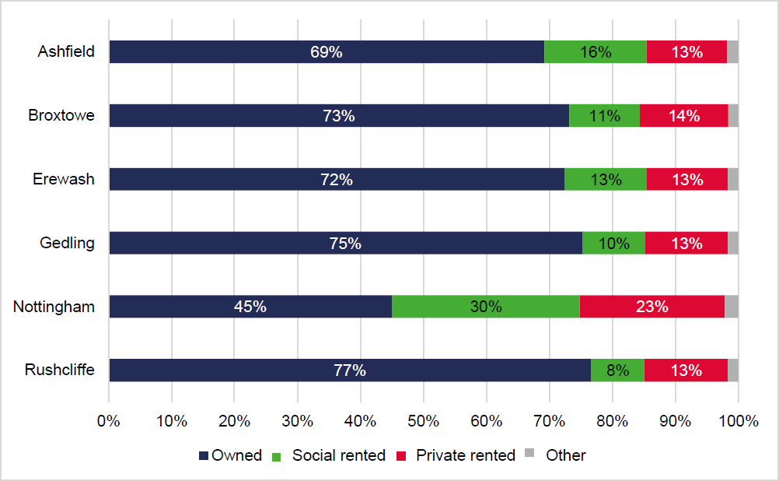

Source: Census 2011

  - Drawing on more recent data from ONS which looks simply at private sector stock againstlocal authority and registered provider stock, the Figure below is clear in showing that Ashfield, Broxtowe and Nottingham all have a relatively high proportion of households in Council- owned stock; accounting for 19% in Nottingham City, 12% in Ashfield and 9% in Broxtowe. Erewash has the highest proportion of households living in housing provided by housing associations at 13%. It should be highlighted that the low levels of Council-owned stock in Gedling and Rushcliffe are due to it having been transferred. Erewash’s housing stock has also been transferred in its entirety and is now operated by East Midlands Housing.

Figure 3.2: Tenure Profile, 2018

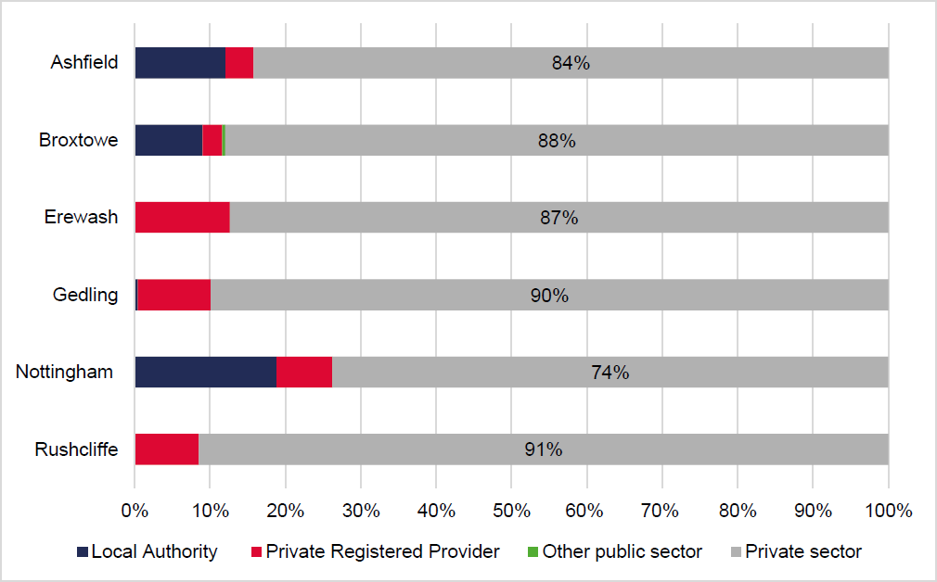

  - The Regulator of Social Housing provides a summary overview of affordable housing owned or part owned by Registered Providers. The Figure below shows that there is a total of 20,684general needs2 homes across the study area with Nottingham City and Erewash representing the authorities with the largest proportions. There is also a large proportion of housing for older people in both of these authorities with lower levels in Broxtowe and Ashfield.

² General needs housing covers the bulk of housing stock for rent. It includes both self-contained units and non-self-contained bedspaces. General needs housing is stock that is not designated for specific client groups or delivered under specific investment programmes.

Table 3.1 The Profile of Existing Affordable Homes in Greater Nottingham andAshfield, 2019

 | Ashfield | Broxtowe | Erewash | Gedling | Nottingham | Rushcliffe | Total
No. of RPs | 24 | 19 | 23 | 25 | 45 | 25 | 161
General Needs, Self-Contained | 1,621 | 1,091 | 4,595 | 3,775 | 6,732 | 2,863 | 20,677
General Needs, Non Self-Contained | 0 | 0 | 0 | 0 | 7 | 0 | 7
General Needs | 1,621 | 1,091 | 4,595 | 3,775 | 6,739 | 2,863 | 20,684
Supported Housing | 179 | 109 | 97 | 191 | 1,241 | 98 | 1,915
Housing for Older People | 291 | 108 | 1,902 | 1,182 | 2,242 | 1,383 | 7,108
Low Cost Home Ownership | 185 | 112 | 173 | 225 | 290 | 375 | 1,360
Source: Regulator of Social Housing, 2019

House Sizes and Types

  - The profile of homes of different sizes across the study area is profiled in the Figure below at 2011. The profile of homes within Rushcliffe was evidently focussed more towards larger properties than elsewhere in the study area, with 4 or more bedroom properties representing 33% of all households. Nottingham City had a higher proportion of smaller properties with 1- and 2-bedroom properties accounting for 44% of all households.

  - Elsewhere, the profile of sizes was relatively consistent with 3-bedroom properties accounting for around a half of all households and smaller 1-bedroom properties around 6 to 7% of all households. There was a higher proportion of larger housing in Gedling and Broxtowe.

Figure 3.3: Households by Size, 2011

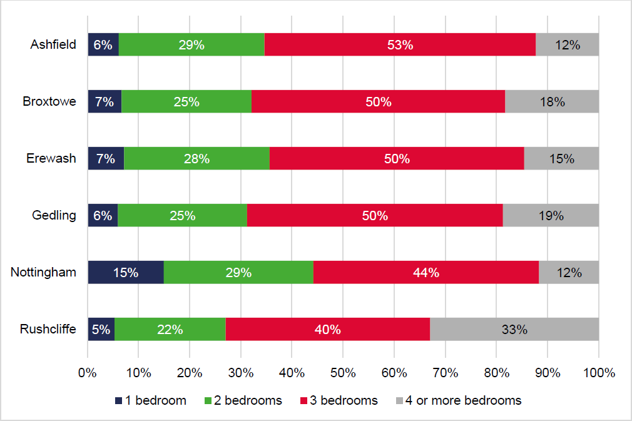

Source: Census 2011

  - The Figure below demonstrates the split of the housing stock across the study area in 2011. The analysis shows that the profile of types in the Greater Nottingham area was relatively balanced across all four types with a relatively high proportion of flats and terraced propertieswith a lower proportion of detached compares with the other authorities.

  - There was a high proportion of semi-detached properties in Ashfield and Erewash at over 40% of households. The proportion of detached properties in Rushcliffe was notably high with this type accounting for almost half of all households, although there was also reasonably high proportions of detached properties in Broxtowe and Gedling.

Figure 3.4: Households by Type, 2011

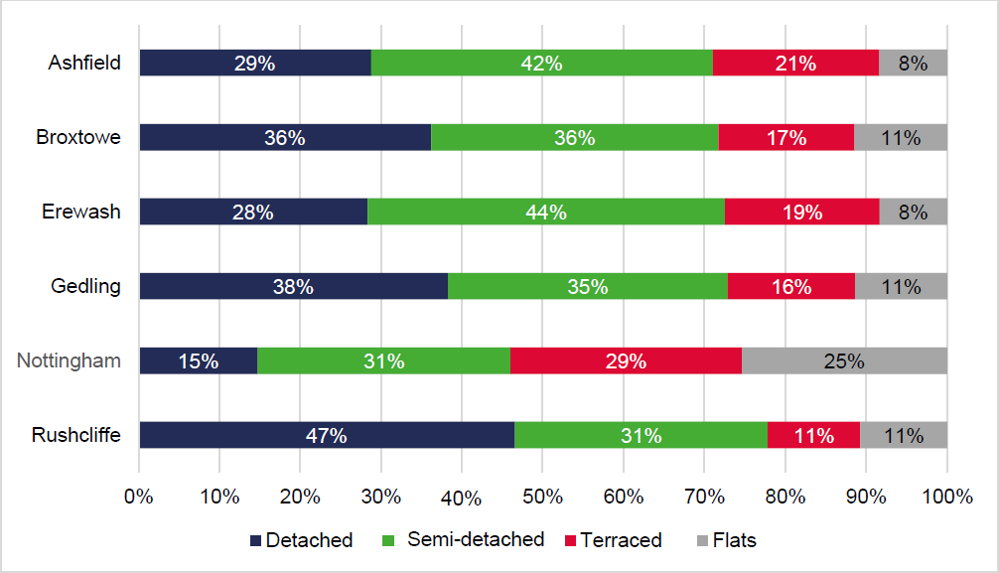

Source: Census 2011

Profile of Households

  - The household composition of households at the point of the 2011 Census is shown in the Tablebelow.

Table 3.2 Household Composition by Area

 | Ashfield | Broxtowe | Erewash | Gedling | Nottingham | Rushcliffe
Single Household: Aged 65 and over | 12% | 13% | 12% | 13% | 11% | 13%
Single Household: Aged under 65 | 16% | 15% | 17% | 17% | 25% | 14%
Couple: Aged 65 and over | 9% | 10% | 9% | 10% | 5% | 10%
Couple: No Children | 20% | 20% | 20% | 19% | 14% | 20%
Couple: Dependent Children | 20% | 20% | 20% | 19% | 15% | 23%
Couple: Non-Dependent Children | 7% | 7% | 7% | 7% | 4% | 6%
Lone Parent: Dependent Children | 8% | 5% | 7% | 7% | 10% | 5%
Lone Parent: Non- Dependent Children | 4% | 3% | 4% | 3% | 4% | 3%
Other: All Full-Time Students | 0% | 1% | 0% | 0% | 4% | 1%
Other: (excl. all full-time students) | 5% | 6% | 4% | 5% | 9% | 5%
Source: Census 2011

  - The analysis shows that there was a relatively low proportion of couples without children living in Nottingham City with this group accounting for only 14% of all households set against around a fifthin all other authorities in the study area. Conversely, there was a higher proportion of single parentswith dependent children in the City.

  - The number of singles aged under 65 in Nottingham City accounted for a quarter of all households which was notably higher than other areas where this group accounted for around 15%. The highestproportion of couples with children was in Rushcliffe (at 23% of all households). Households which comprised full-time students accounted for 4% of households in Nottingham and 1% in Broxtowe andRushcliffe.

Occupation of Households

  - Overcrowding is defined as the number of properties which have fewer rooms than their households require. The requirement is calculated based on the size, age and relationship of household members. Under- occupied properties on the other hand are those with more bedrooms than the household notionally needs. For instance, an under-occupied property can relate to a couple with nochildren living in a two or more-bedroom property.

  - In respect of the room standard, your home is overcrowded by law3 if 2 people of a different sex haveto sleep in the same room and they are aged 10 or over. Therefore, a couple with two boys and a girl all aged under 10 living in a 1 bedroom flat with a living room would not count as overcrowded under the room standard owing to them being under 10 years of age.

³ Sections324-326 of the Housing Act 1985.

  - There has been a notable increase in (a) overcrowded households at a national level (including young people living with their parents for longer in instances where rooms are shared) and (b) Houses in Multiple Occupation (HMOs). This has been a symptom of affordability pressures, restrictions on access to mortgage finance and housing under-supply.

  - The English Housing Survey (2016-2017) states the rate of overcrowding in England for 2016/17 was 3%, with approximately 682,000 households living in overcrowded conditions. Overcrowding was more prevalent in the rented sectors than for owner occupiers. Only 1% of owner occupiers nationally (183,000 households) were overcrowded in 2016-17 compared with 7% of social renters (268,000) and 5% of private renters (231,000).

  - The English Housing Survey indicates that number and proportion of overcrowded households in the owner-occupied sector has remained relatively stable over the last 20 years or so. In the social rented sector, overcrowding peaked at 7% in 2010-11, before dropping to 6% in 2012-13. It remained at 6% until 2014-15 but increased back up to 7% in 2015-16 where it remained in 2016-17.

  - However, the proportion of overcrowded households in the private rented sector increased from 3%in 1995-96 to a peak of 6% in 2011-12, and since then has decreased slightly to 5%. The rapid overall growth in private renters between 1995-96 and 2016-17, affordability pressures and changes to eligibility for Housing Benefit explains the pronounced increase in actual numbers of overcrowded households from 63,000 in 1995- 96 to 231,000 in 2016-17.

  - The number of overcrowded households (based on the room standard4) increased across all authority areas between 2001-11, with the largest increase experienced in Nottingham City at 53% which was well above the national average. Given the criteria for the room standard, it is likely thatthis higher figure is being driven by a higher number of families with two or more children aged 10 and over of the opposite sex sharing a bedroom in the City.

⁴ An occupancy rating of -1 or less means that the household has at least one bedroom too few for the number and composition of people living in the household and is considered overcrowded by the bedroom standard.

  - Elsewhere, Erewash also experienced a relatively high increase at 27% whilst Gedling and Rushcliffe only experienced around a 4% and 5% change respectively. Ashfield saw the number of under- occupied homes increase by a relatively high 11% over the same period.

Table 3.3 Changes in Under and Over Occupied Households – Room Standard

 | Under Occupancy Households |  |  | Over Occupancy Households
 | 2001 | 2011 | % Change | 2001 | 2011 | % Change
Ashfield | 37,620 | 41,611 | 11% | 1,800 | 2,009 | 12%
Broxtowe | 37,417 | 38,410 | 3% | 1,668 | 1,955 | 17%
Erewash | 38,046 | 41,123 | 8% | 1,472 | 1,870 | 27%
Gedling | 39,660 | 39,887 | 1% | 1,722 | 1,794 | 4%
Nottingham | 78,609 | 80,548 | 2% | 10,411 | 15,917 | 53%
Rushcliffe | 37,581 | 39,758 | 6% | 1,342 | 1,405 | 5%
England | 16,254,820 | 17,070,912 | 5% | 1,510,422 | 1,995,860 | 32%
Source: 2001 and 2011 Census

  - The bedroom standard is not a legal definition of overcrowding, but it does provide a more precise assessment of actual levels of overcrowding and under occupancy. Following the bedroom standard, one bedroom should be for either (a) an adult couple, (b) any other adult aged 21 or over, (c) two adolescents of the same sex aged 10 to 20 or (d) two children regardless of sex under the age of 10. Anything above these would be above the minimum threshold of overcrowding.

  - The bedroom standard shows that around 6% of households in Nottingham City in 2011 were overcrowded, which is slightly above the national average. The other authorities in the study area hovered at around 2 to 3%.

  - The proportion of under-occupied homes was notably high in Rushcliffe at 84% in 2011 with Ashfield, Broxtowe, Erewash and Gedling all between 75 to 80% under-occupied.

Table 3.4 Under and Over Occupied Households by Bedroom Standard, 2011

 | Under Occupancy Households | Over Occupancy Households
Ashfield | 75% | 3%
Broxtowe | 77% | 3%
Erewash | 76% | 2%
Gedling | 79% | 2%
Nottingham | 62% | 6%
Rushcliffe | 84% | 2%
England | 69% | 5%
Source: Census 2011

House Prices

  - The median house price in Rushcliffe at June 2019 was £280,000 which was 17% above the nationalaverage and the only authority to sit above the national median at £240,000. The lowest median house price was in Nottingham at £140,000 with relatively higher median house prices in Broxtowe and Erewash at £180,000. Ashfield had the lowest entry-level house (lower quartile) price at slightlyless than £109,000.

Table 3.5 House Price Benchmarks, Year to June 2019

Area | Median | Mean | Lower Quartile
Ashfield | £143,000 | £158,178 | £108,750
Broxtowe | £180,000 | £202,285 | £144,500
Erewash | £180,000 | £183,764 | £125,000
Gedling | £163,000 | £205,236 | £138,500
Nottingham | £140,000 | £167,812 | £110,000
Rushcliffe | £280,000 | £314,005 | £205,000
England | £240,000 | £303,052 | £159,000
Source: ONS, House price statistics for small areas in England and Wales, year ending June 2019

  - The Figure below profiles the house price changes from 1999 to 2019. Notably, house price trends in the authority areas were generally below the regional and national trends with the exception of Rushcliffe which was consistently above. As the Figure demonstrates, median values rose sharply in Rushcliffe over the period 2014- 19 in comparison to other authority areas in the study area.

Figure 3.5: Median House Price Trends, 1999-2019

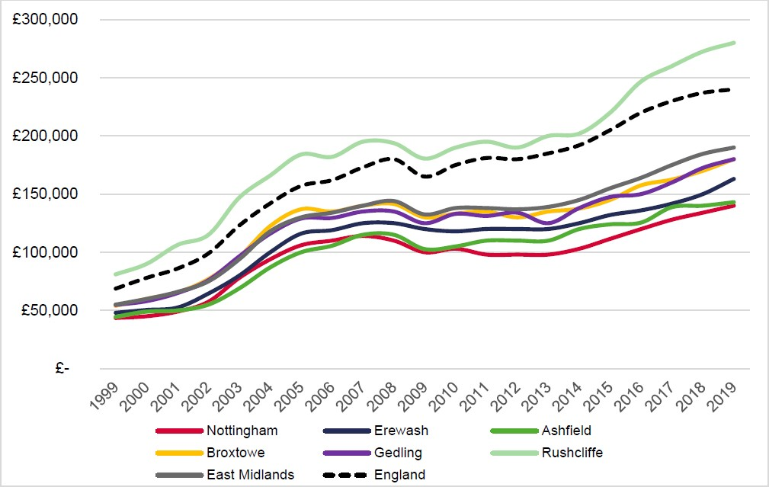

Source: ONS, House Price Statistics for Small Areas in England and Wales, Year Ending June 2019

  - It is clear that all authority areas experienced a fall in median house prices between 2008 and 2009 reflecting the economic downturn. House price growth remained modest between 2010 and 2013, with levels of housing market activity subdued. However, with improving economic performance, increased access to mortgage finance and Government support (such as through the Help-to-Buy scheme) the market began to recover more strongly from 2013 onwards.

  - Since 2013, there has been a steady increase in house prices nationally. Rushcliffe has seen reasonable growth above the national average. Whilst house prices continued to rise between 2015and 2019, this was at a lower rate for the majority of the authorities – particularly for Ashfield – with the exception of Rushcliffe.

  - It needs to be borne in mind however that median house prices are influenced by the mix of properties sold. It is therefore instructive to assess house prices by profile of sales across the authority areas, which is assessed later in this section.

Sales Trends

  - Iceni has benchmarked sales performance against long-term trends to assess the relative demand for market homes for sale. The Figure below benchmarks annual sales over the period 1998-2019 against the pre- recession average5 for all of the authorities and national average. There is a relativesimilarity in trends across areas, reflecting the influence of macro-economic factors.

⁵ The average annual sales over the pre-recession decade (1998-2008)

  - Sales volumes nationally experienced a significant drop between 2008-09 influenced by the credit crunch and subsequent housing market downturn. During 2009-2013 the recovery in sales volumeswas very modest with housing market activity over this period significantly subdued (around 40% below the pre-recession trend). In all authorities with the exception of Nottingham City, sales recovered well between 2010-2014 in comparative terms. Sales in Nottingham City struggled until post-2013.

  - Between 2013 and 2016 there was a gradual recovery in sales volumes influenced by a combination of increasing availability and choice of mortgages together with Government support through the Funding for Lending and Help-to-buy schemes, however since 2016 a decrease in sales can be witnessed apart from in Gedling and Erewash. This is likely to reflect wider macro-economic uncertainty associated with Brexit.

Figure 3.6: Indexed Analysis of Sales Trends, 1998-2019

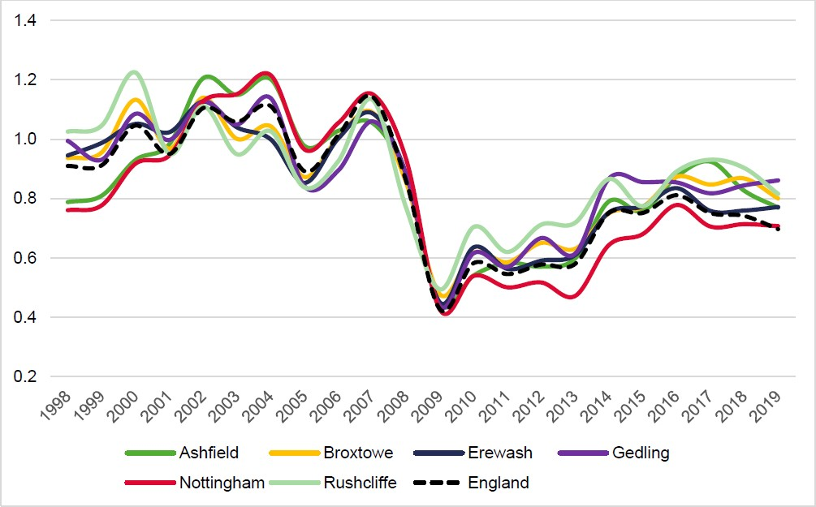

Source: ONS, House price statistics for small areas, 2018

House Price by Type

  - We have examined sales data by type of property for year ending June 2019. The data shows that across all property types except for flats, only median house prices in Rushcliffe exceeded the national average. Median house prices for flats falls notably below the national average across all authorities.

  - With regards to semi-detached and terraced properties, Broxtowe and Rushcliffe experienced the highest sales values with Gedling and Rushcliffe experiencing the highest values for detached properties at £268,750 and £374,750 respectively. It is notable however that median house prices inRushcliffe are notably above all other authority areas.

Figure 3.7: Median House Prices by Type, 2019

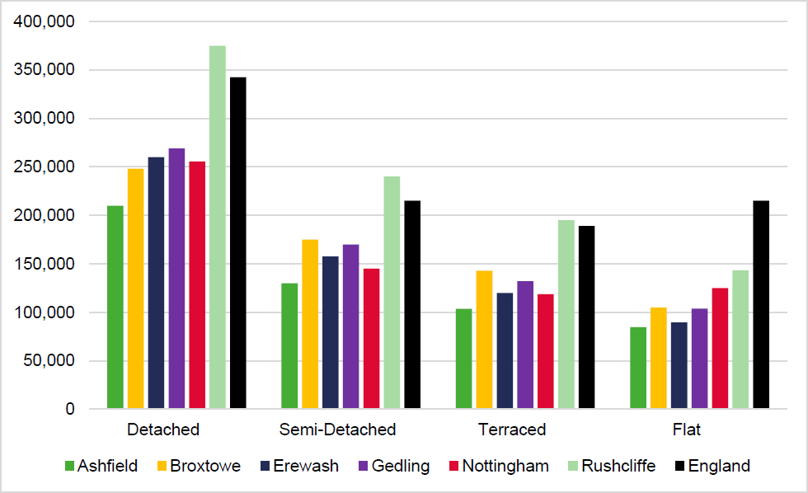

Source: ONS, House price statistics for small areas, Year Ending June 2019

  - Analysing the profile of sales across the study area, the Figure below shows that the proportions of housing types sold in each area varied from the national average. In Nottingham, flats and terracedhousing accounted for half of all sales which was notably higher than the other study area authorities but broadly consistent with the national average.

  - In Rushcliffe, detached housing accounted for 47% of all sales – ultimately reflective of the profile of the dwelling stock – with the proportion of semi-detached sales highest in Erewash at 43%.

Figure 3.8: Sales by Dwelling Type, 2019

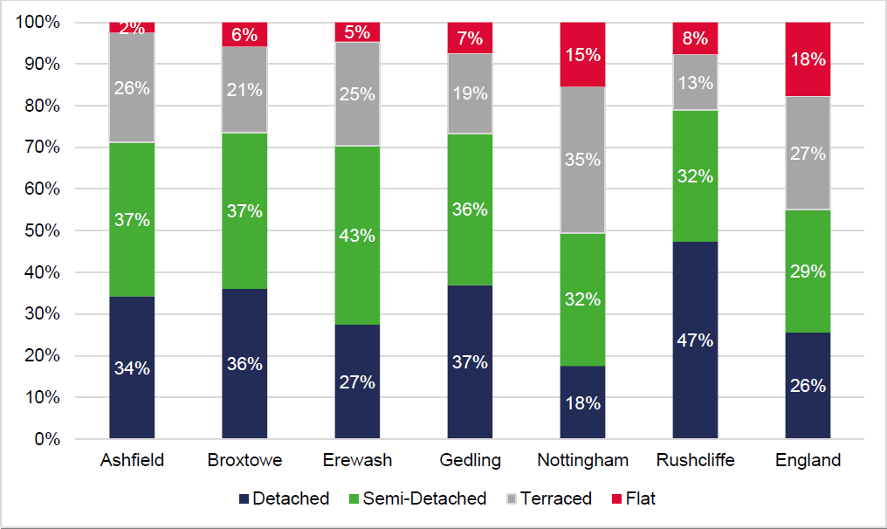

Source: ONS, House Price statistics for small areas, June 2019

Rental Trends

  - The median rental values over the period from October 2018 to September 2019 across the study area were all below the national median of £700 PCM. The highest rents were achieved in Rushcliffe at £665 Per Calendar Month (“PCM”) with the lowest rents achieved in Ashfield at £500 PCM. This is shown in the Table below.

Table 3.6 Median Rents, October 2018 to September 2019

Area | Median Average Rent (PCM)
Ashfield | £500
Broxtowe | £615
Erewash | £550
Gedling | £595
Nottingham | £600
Rushcliffe | £665
England | £700
Source: VOA Private Rental Data Table 2.7

  - An analysis of median rents by number of bedrooms, as set out in the Figure below, shows some variation in prices across each size of property. Rental prices for studio properties were notably high in Nottingham compared to the national median and other authorities. Nottingham and Rushcliffe had higher rents for 1- bedroom properties than other authorities but below the national average; whilst rental values for larger properties were notably higher in Rushcliffe.

Figure 3.9: Median Rental Values by Size, October 2018 to September 2019⁶

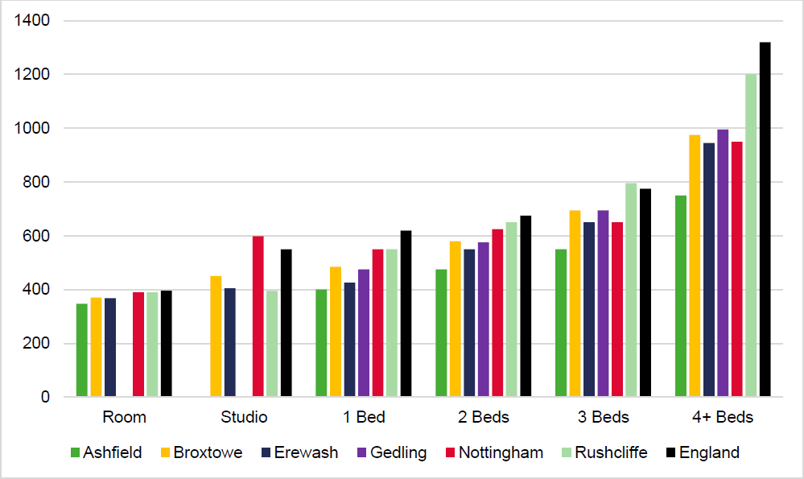
⁶ Missing bars in the graph indicate that no data was available for that property size in the relevant authority area.

Source: VOA Private Rental Data

  - In Nottingham, rents for studios saw the strongest comparative rental growth between 2013/14 and2018/19 at 59% owing to the development of purpose-built student accommodation in the City. Therewas strong growth in Rushcliffe for 1 and 4 bedroom properties whilst rents for 4 bedroom properties in Erewash also experienced strong growth at 36%. The growth in rental values for 3 bedroom properties in all authorities exceeded the national average.

Table 3.7 Rental Increase by Size, 2013/14 and 2018/19

 | Room | Studio | 1 bed | 2 bed | 3 bed | 4 bed
Ashfield | n.a. | n.a. | 14% | 6% | 16% | 11%
Broxtowe | 14% | n.a. | 21% | 10% | 19% | 23%
Erewash | 0% | n.a. | 8% | 16% | 18% | 36%
Gedling | n.a. | n.a. | 12% | 15% | 17% | 17%
Nottingham | 20% | 59% | 22% | 19% | 13% | 19%
Rushcliffe | 20% | n.a. | 29% | 18% | 14% | 26%
England | 10% | 11% | 24% | 8% | 3% | 20%
*this is a % increase between 2016/17 and 2018/19 as there was no data available beyond this dateSource: VOA Private Rental Data

Housing Affordability

  - We have considered evidence relating to the affordability of market housing by looking specifically at the relationship between lower quartile and median house prices and incomes. The Figure belowshows that workplace affordability7 has worsened since 1997 in all authority areas. Overall however, the trend of affordability was below the national trend over this period. The exception to this is Rushcliffe which has seen affordability deteriorate over and above the national picture.

⁷ Workplace affordability is the affordability of house prices set against workplace-based earnings (which refer to the earnings recorded for the area in which the employee works; rather than residence-based earnings which refer to the area in which the employee lives).

  - Over the period since 1997 where median house prices were around 3 times median workplace- based earnings across the majority of the study area, the median affordability ratio has worsened tobetween 5 and 6. However, this is well below the national average of 8. Rushcliffe is higher at around 8.9 which is clearly at an unaffordable level.

Figure 3.10: Workplace-based Median Affordability Ratio, 1997-2018

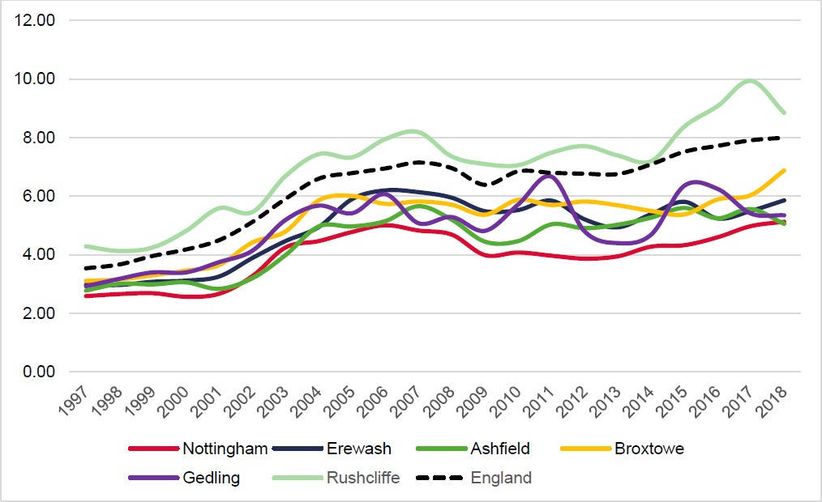

Source: ONS, Ratio of house price to workplace-based earnings (lower quartile and median) 1998-2018

  - The Table below presents the most recent median and lower quartile workplace-based affordability ratios as at the year ending September 2018. At this point, the median house price was a significant 8.85 times median earnings in Rushcliffe; however, elsewhere the affordability ratio was lower at around 5.

  - Lower quartile house prices in Rushcliffe were 9 times lower quartile earnings compared to a ratio of 7.4 in Broxtowe and 5.31 in Nottingham. This points to significant barriers for households in Rushcliffe and younger households in particular, being able to afford to own a home. In other authority areas, affordability is not as significant when set against national figures; however, affordability pressures clearly exist in relative terms with median house prices over five times workplace-based median earnings in all areas.

Table 3.14: Affordability Ratio 2018 - Workplace Based

Area | Lower Quartile Ratio | Median Ratio | Difference
Ashfield | 5.39 | 5.06 | 0.33
Broxtowe | 7.40 | 6.88 | 0.52
Erewash | 6.56 | 5.85 | 0.71
Gedling | 6.11 | 5.35 | 0.76
Nottingham | 5.31 | 5.13 | 0.18
Rushcliffe | 9.0 | 8.85 | 0.15
England | 7.29 | 8.0 | -0.71
Source: ONS, 2019

  - Although workplace-based affordability is recommended in the PPG with regards to calculating localhousing need, we have also given due consideration to resident-based affordability in the Table below. This is to highlight that due to the travel to work area and commuter flows, there is a clear difference in certain areas with regards to affordability. It is clear that on the basis of this data, for those residents in Nottingham City, affordability is more of a challenge – particularly for entry-level housing.

Table 3.15: Affordability Ratio 2018 - Resident Based

Area | Lower Quartile Ratio | Median Ratio | Difference
Ashfield | 5.59 | 5.6 | 0.01
Broxtowe | 6.52 | 5.92 | -0.6
Erewash | 5.84 | 5.58 | -0.26
Gedling | 6.54 | 6.02 | -0.52
Nottingham | 7.62 | 5.80 | -1.82
Rushcliffe | 8.01 | 7.69 | -0.32
England | 7.29 | 8.0 | 0.71
Source: ONS, 2019

Summary: Demographic Baseline and the Housing Market

At the point of the 2011 Census, Broxtowe, Erewash, Gedling and Rushcliffe had around three quarters of homeowners as a proportion of all households; with Ashfield slightly less at 69% with a greater proportion of social renters. In Nottingham City, the proportion of social renters was notablyhigh at 30% with a larger private rented sector at 23% resulting in a relatively low level of home ownership.
The profile of homes within Rushcliffe was evidently focussed more towards larger properties than elsewhere in the study area, with 4 or more bedroom properties representing 33% of all households. Nottingham City had a higher proportion of smaller properties with 1- and 2-bedroom properties accounting for 44% of all households.
Elsewhere, the profile of sizes was relatively consistent with 3-bedroom properties accounting for around a half of all households and smaller 1 bedroom properties around 6 to 7% of all households. There was a higher proportion of larger housing in Gedling and Broxtowe.
The median house price in Rushcliffe at June 2019 was £280,000 which was 17% above the nationalaverage and the only authority to sit above the national median at £240,000. The lowest median house price was in Nottingham at £140,000 with relatively higher median house prices in Broxtowe and Erewash at £180,000.
Ashfield had the lowest entry-level house price at slightly less than

£109,000.

Although house prices have continued to rise across the study area, the evidence suggests that recent market performance has been influenced by wider economic uncertainty, with sales volumeseither falling or slowing since 2015.
Notably, entry-level house prices in Rushcliffe were 9 times lower quartile earnings compared to a ratio of 7.4 in Broxtowe and 5.31 in Nottingham. This points to significant barriers for households in Rushcliffe and younger households in particular, being able to afford to own a home. In other authority areas, affordability is not as significant when set against national figures; albeit affordability pressures exist in relative terms.
The growth in rental values has been strong. In Nottingham, rents for studios saw the strongest comparative rental growth between 2013/14 and 2018/19 at 59%. There was strong growth in Rushcliffe for 1- and 4- bedroom properties whilst rents for 4 bedroom properties in Erewash also experienced strong growth at 36%. Rental growth values for 3-bedroom properties in all authorities exceeded the national average.

IDENTIFYING SUBMARKETS

  - Across the study area, the profile of each local authority and indeed the neighbourhoods within eachauthority will vary with regards to particular characteristics including demographics, the profile of housing stock and house price dynamics. It is recognised that identifying submarkets is therefore animportant component when analysing affordable housing needs and in establishing the appropriate housing mix.

  - This section has drawn on analysis of data on sales transactions by type, house price patterns by type, commuting flows, self-containment and urban form/morphology to identify a number of submarkets across the study area which we have been based on the latest 2019 ward boundaries. These are shown in the Figure below.

Figure 4.1: Study Area 2019 Ward Boundaries

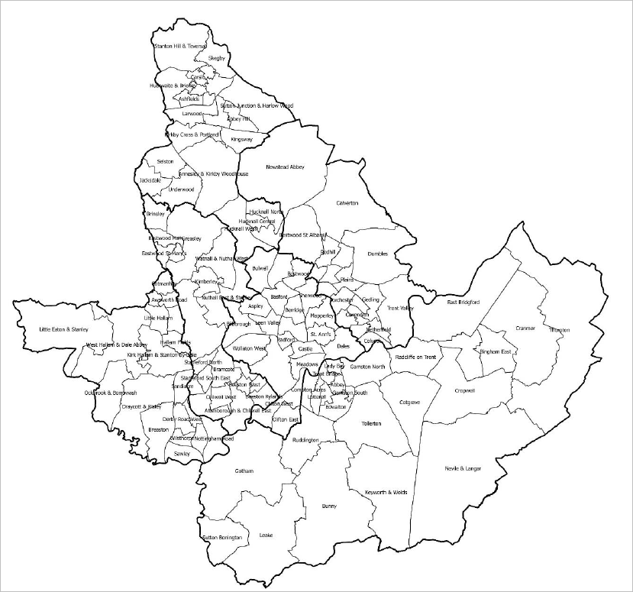

  - It is important to recognise upfront that there are potential variances at a sub-ward level which this study has sought to address in the supporting text; however, in some instances, this is not possibledue to the scale of particular villages which may contrast with the rest of the ward or due to the planned development or regeneration of particular areas which may warrant a separate submarket being established in due course. On this basis, the submarkets in this study should be viewed at a point in time and will invariably be subject to change.

Profile of Housing Transactions

  - The starting point for our analysis has been to identify concentrations of housing transactions by type across the study area at a ward level which will then allow us to focus in on clear relationships between wards with regards to house prices by particular property types. This also allows us to better understand substitutability in housing terms between particular wards across the study area.

  - A concentration has been defined as instances where the proportion of all sales for a particular type of property have exceeded:

    - 40% or above for detached properties

    - 48% or above for semi-detached properties

    - 30% or above for terraced properties

    - 9% or above for flatted properties

  - These percentages represent the upper quartile portion of transactions when compared to other wards across study area. The Figures below depict the analysis of sales by type as at the year ending June 2019, starting with sales of detached properties.

  - As the Figure below demonstrates, there is evidently a higher proportion of detached sales in the rural Newstead Abbey in Gedling to the wards up and around the northern fringe of Ashfield including Sutton Junction & Harlow Wood, Skegby and Stanton Hill & Teversal; as well as in Ashfields and Larwood.

Figure 4.2: Proportion of Detached Sales across the Study Area
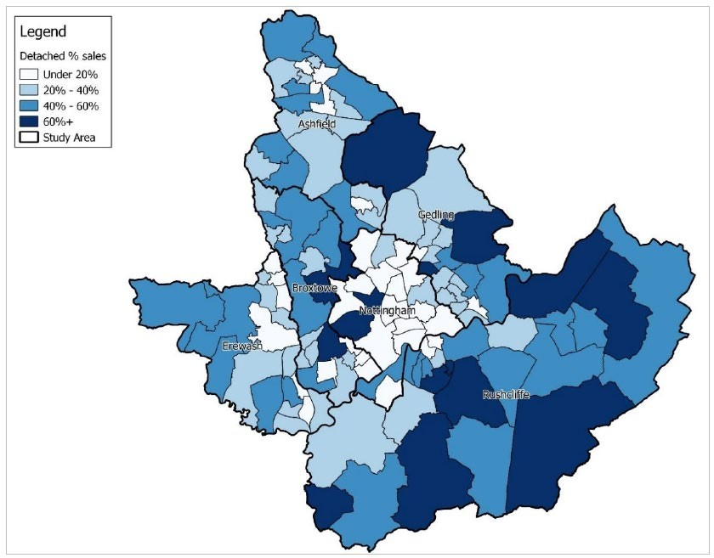

Source: ONS, 2019

  - Focussing in Erewash, Nottingham and Broxtowe, there are relatively high concentrations ofdetached sales to the west of Erewash towards Derby including around the village wards of Little Eaton & Stanley, West Hallam & Dale Abbey and Ockbrook & Borrowash. There is a high concentration of sales towards the north of Broxtowe Borough with a notably high proportion in Nuthall East & Strelley and Bramcote; as well as across the boundary in the Wollaton West and Leen Valley in Nottingham City.

  - There is also a notably high proportion of detached sales across rural Rushcliffe; with a greater proportion of detached sales in the majority of the wards beyond Trent Bridge, Lady Bay, Ruddington, Gotham, Radcliffe on Trent and Abbey.

  - Turning to semi-detached sales, we have focussed in on the main concentrations which are focussed more towards Erewash, Ashfield and Broxtowe with pockets in Gedling and Nottingham City. The Figure below shows a relatively high proportion of semi-detached sales around the southern wards of Erewash and Broxtowe including Sawley, Breaston, Wilsthorpe, Long Eaton, Derby Road West and Nottingham Road in Erewash; and Attenborough & Chilwell East, Chilwell West and Beeston Rylands in Broxtowe.

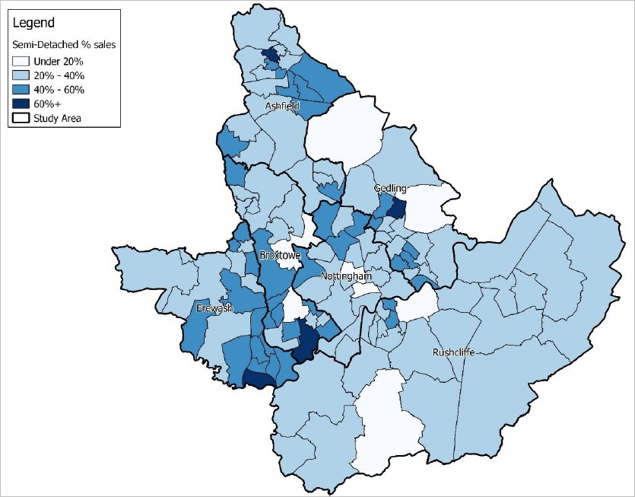

Source ONS, 2019

  - As the Figure above shows, there are also higher proportions towards the north east of the HMA around the Gedling wards of Coppice, Redhill and Daybrook; as well as across the boundary in the Nottingham wards of Bestwood, Basford and Bulwell. There is also a cluster of wards including Phoenix, Cavendish and Carlton Hill in Gedling with a higher proportion of semi-detached sales, and higher levels to the north of Ashfield around the wards of Carsic, Summit and St. Marys.

  - With regards to terraced properties, the Figure below shows that there is a high concentration of sales in the Ashfield wards which surround Kirkby in Ashfield and Sutton in Ashfield, as well as in Annesley. There is also a higher proportion around Hucknall Central and Hucknall North; as well asin Bestwood St. Albans, Gedling.

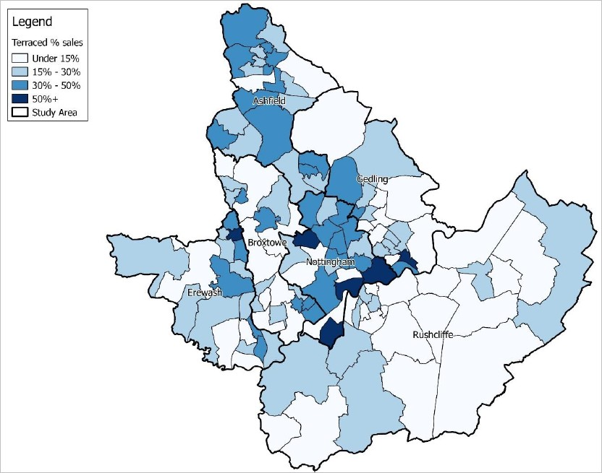

Source ONS, 2019

  - The Figure above shows that there are notably high concentrations of terraced sales down the eastof Ilkeston in the wards of Cotmanhay, Answorth Road and Larklands; as well as Kirk Hallam. Areasin Broxtowe with higher levels of terraced sales include the Beeston wards that relate to higher levels in Lenton, Nottingham City.

  - The Figure is also clear in showing that there also are high levels of terraced sales in Nottingham City in the wards of Basford, Bestwood and Sherwood; as well as to the south of the City in the wardsof Meadows and Dales which relate strongly in sales terms with the Gedling wards of Colwick and Netherfield. In Gedling, terraced sales are also strong around Carlton.

  - Finally, the Figure below depicts the spatial distribution of flatted sales – which are principally in andaround the centre of Nottingham City including the wards of Castle, St. Ann’s, Meadows, Lenton, Mapperley and Sherwood; down into Rushcliffe around West Bridgford across to the Beeston area of Broxtowe and up to Gedling including the wards of Woodthorpe, Porchester, Daybrook and Ernehale.

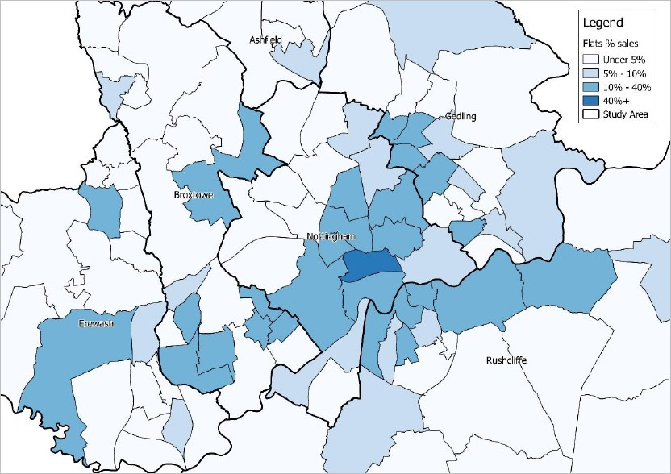

Source ONS, 2019

House Price Dynamics

  - Having worked through the profile of the study area authorities with regards to transactions; we have then analysed median house prices by type at the year ending June 2019, focussing in on particular concentrations whilst looking more broadly at common relationships in house prices by type. In the Figure below, we have mapped median house prices for detached properties; focussing in around Ashfield where there is generally a higher proportion of detached sales.

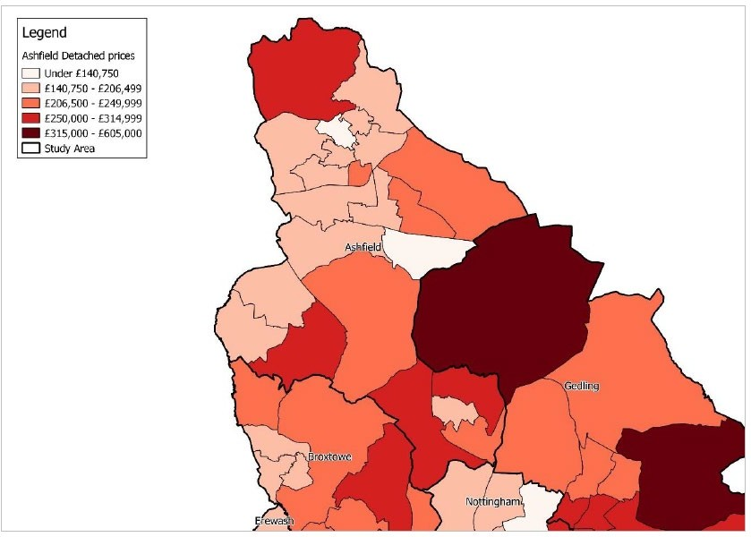

Source: ONS House Price Statistics, 2019

  - As the Figure above shows, there are clear relationships in detached house prices in the wards around Sutton in Ashfield towards the north of Ashfield and in the wards around Kirkby in Ashfield, albeit with higher prices to the far north around Stanton Hill and lower prices in Kingsway. There are however clear geographical relationships in this area with Kingsway ward forming part of the settlement of Kirkby in Ashfield.

  - Towards the west, the wards of Selston and Jacksdale share relatively lower detached house prices in the District which points towards substitutability, particularly compared to the ward of Underwooddespite a similar proportion of detached sales between all three wards, pointing to a separate submarket. House prices for detached properties in the Annesley & Kirkby Woodhouse ward are distinctly different from the surrounding villages, again pointing to a separate submarket.

  - Around Hucknall, there is a clear distinction in detached house prices between Central and South Hucknall and North and West Hucknall with the latter wards seeing notably higher house prices for detached properties.

  - To the north of Gedling, median house prices for detached properties in the ward of Newstead Abbey – which accounted for 70% of all transactions - are within the upper quartile at £315,000 and it therefore defines itself as a separate submarket with substantially higher house prices and a market focussed on larger detached homes. It should however be noted that this area’s detached values are driven by the village of Ravenshead; with the village of Newstead closer to Kirkby in Ashfield representing a lower value market.

  - Turning to detached house prices around Broxtowe, Erewash and Nottingham City, the Figure below shows that detached house prices around the Broxtowe wards of Greasley, Kimberley and Awsworth,Cossall & Trowell sit between £206,500 to £249,999 with a similar profile of detached transactions which would identify with a common submarket. The market around Eastwood including the wards of Eastwood Hall, Eastwood Hilltop and Eastwood St. Mary’s is also reflective of a single submarketwith house prices for detached properties towards the lower end of the market.

Figure 4.7: Detached House Prices around Broxtowe, Erewash and Nottingham City
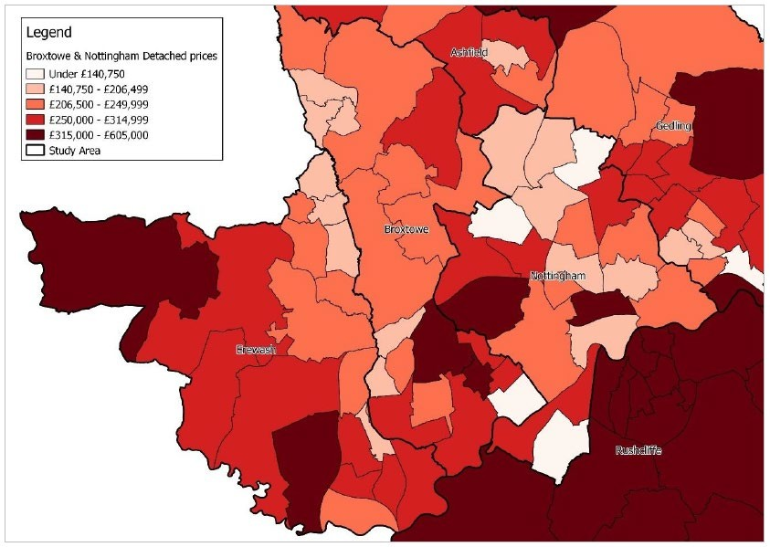

Source: ONS House Price Statistics, 2019
  - In Nottingham, house prices in the wards of Bilborough and Leen Valley sit within the third quartile and there are also strong house price relationships with terraced properties in this area, as considered further in this section. Median house prices for detached properties in Wollaton West arenotably higher than the surrounding wards within the City with this type of housing accounting for 63% of all sales transactions.

  - In Erewash, there is a clear difference in detached house prices moving east to west towards Derby. Focussing in on Ilkeston, there is also a clear difference between the east of Ilkeston (including the wards of Awsworth Road, Cotmanhay and Larklands) where detached house prices are lower and the west of Ilkeston (including the wards of Hallam Fields, Kirk Hallam & Stanton-by-Dale, Little Hallam and Shipley View) which would reflect two clear submarkets.

  - In geographical and values terms, there is then an area encompassing the wards of Breaston, Draycott & Risley, Ockbrook & Borrowash and West Hallam & Dale Abbey which broadly fall within the higher detached house price brackets with a relatively high proportion of detached property transactions which effectively form a mid-Erewash Rural submarket.

  - The ward to the north-west of Erewash – Little Eaton & Stanley – despite a similar proportion of detached sales has achieved a median house price for detached properties of around £375,000, which we consider to be its own submarket.

  - In Gedling, it is clear from the Figure that the wards of Gedling and Plains, as well as the wards of Porchester and Woodthorpe typically see detached house prices towards the upper end of the market with a high proportion of detached transactions, leading to the identification of two additional submarkets.

Figure 4.8: Detached House Prices around Rushcliffe
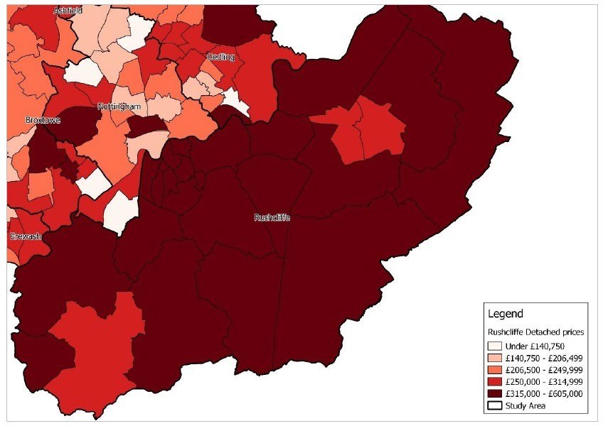

Source: ONS House Price Statistics, 2019

  - Across Rushcliffe, as the Figure above demonstrates, median house prices for detached properties typically sit within the upper quartile; aside from in the wards of Leake, Bingham East and BinghamWest. Recognising the characteristics of Bingham as a market town with distinctively lower detachedhouse prices than the surrounding wards, there is clearly a Bingham submarket in the District.

  - Across the District of Rushcliffe beyond Leake and Bingham, there is little to distinguish between the wards with regards to detached values. However, having regard to the District’s strategic road infrastructure in the A606 and A46, it is logical to draw a division between Rural Rushcliffe East and Rural Rushcliffe West.

  - Moving on with a particular focus on authority areas with a higher proportion of semi-detached sales,the Figure below deals principally with wards in Broxtowe, Erewash and Nottingham. In Broxtowe around the wards of Beeston, where semi-detached and terraced transactions account for the greatest number of sales, there is a clear difference between Beeston West and the eastern wards including Beeston Central, Beeston North and Beeston Rylands.

  - In Erewash, in the southern wards of the Borough/District around Long Eaton, semi-detached housing accounts for over 50% of all housing transactions on average. This includes the wards of Derby Road East, Derby Road West, Long Eaton Central, Nottingham Road, Sawley and Wilsthorpe.

As the Figure shows, median house prices for semi-detached properties around this area are all within the third quartile with the data showing a range of £145,000 to £172,000 across all six wards in the area.

  - In Gedling, there is also a clear relationship between Netherfield and Colwick with semi-detached properties costing £144,000 in Netherfield and £148,000 in Colwick with the same number of semi- detached sales in each ward. Iceni consider these two wards represent a common submarket.

Figure 4.9: Semi-Detached House Prices around Broxtowe, Erewash and Nottingham
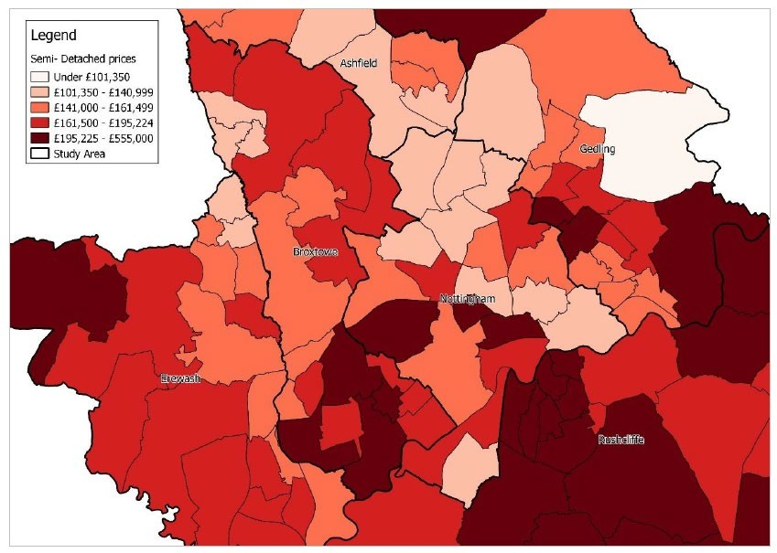

Source: ONS House Price Statistics, 2019

  - In Nottingham, the wards of Bulwell, Basford, Bulwell Forest and Aspley share median house price values for semi-detached properties towards the lower end of the market, pointing to a North Nottingham City submarket. The ward of Lenton & Wollaton East stands alone in the mid-range withsemi-detached values of around £155,000 and there is also a clear distinction with flatted properties, as set out later in this section, pointing to a standalone submarket.

  - Turning to terraced properties around Gedling, the wards of Ernehale, Coppice and Redhill show similar terraced prices towards the upper end of the market between £137,500 and £145,000. Thesewards also have commonality in values across detached and semi-detached properties, pointing to a Redhill and Arnold submarket.

Figure 4.10: Terraced House Prices around Gedling
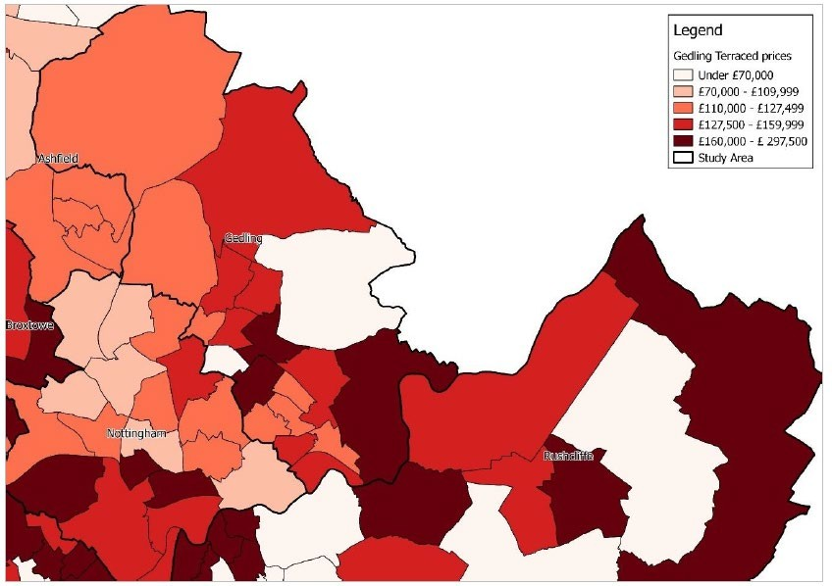

  - The Figure below is clear in showing the substitutability of terraced properties in and around Stapleford in Broxtowe Borough with house prices in the wards of Stapleford South West, StaplefordEast and Stapleford South East sitting around £115,000. A Stapleford submarket has been identified, although it is recognised that Stapleford South East is the more expensive ward of the submarket.

Figure 4.11: Terraced House Prices around Broxtowe, Erewash and Nottingham
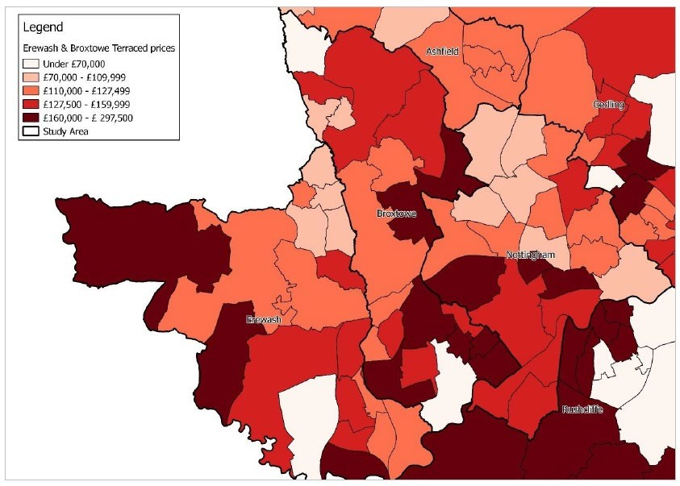

Source: ONS House Price Statistics, 2019

  - Around Nottingham, where the majority of wards have a high proportion of terraced housing transactions, there are notable differences in median house prices for terraced properties. The wards Dales, Hyson Green & Arboretum, Basford, Bulwell, Aspley and Bulwell Forest have lower value terraced properties of less than
£110,000. The latter four wards to the north of Nottingham share a similar profile of housing transactions and sales values overall, again reinforcing a North Nottingham City submarket.

  - Turning to flats, the Figure below provides an overview of the sales values of flatted development as at the year ending June 2019. It is clear that around West Bridgford to the north of Rushcliffe, wherethere is a relatively high proportion of flatted sales, there is also a relationship with regards to pricing with flats typically equal to or greater than the upper quartile (between £125,000 to £255,000).

Figure 4.12: Flatted House Prices

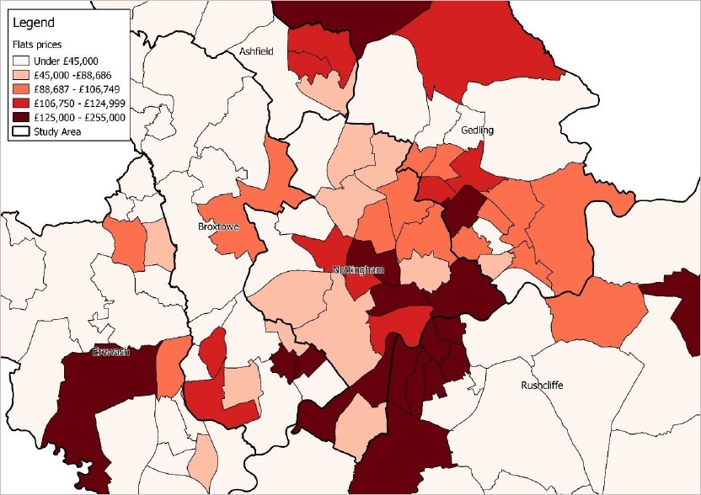

Source: ONS House Price Statistics, 2019

  - In Nottingham, the wards Castle, Lenton and Wollaton East, and St Ann’s are examples ofsubmarkets within the City with a high proportion of flatted sales but with median house prices at opposite ends of the market. In Castle, flats are around £162,500 compared to the wards of Lenton and Wollaton East, and St Ann’s with prices of less than £90,000. There is also a relatively high proportion of flatted sales in Clifton West with prices sitting within the upper quartile.

Summary

  - Bringing the analysis together on house prices, it is clear that there are strong relationships across the study area between particular wards within authority boundaries which point towards a series ofsubmarkets, each with an element of substitutability and commonality on the profile of housing and indeed the strength of the market. Next, we move on to briefly consider commuting patterns and self-containment rates across the study area.

Commuting and Travel to Work

  - The Office for National Statistics (“ONS”) has defined Travel to Work Areas using 2011 Census data.This was published in July 2014. It can be seen that the majority of the study area falls within the Nottingham TTWA. Some parts of Ashfield fall within the Mansfield TTWA and the western areas ofErewash fall within the Derby TTWA.

Figure 4.13: Travel to Work Areas, 2011
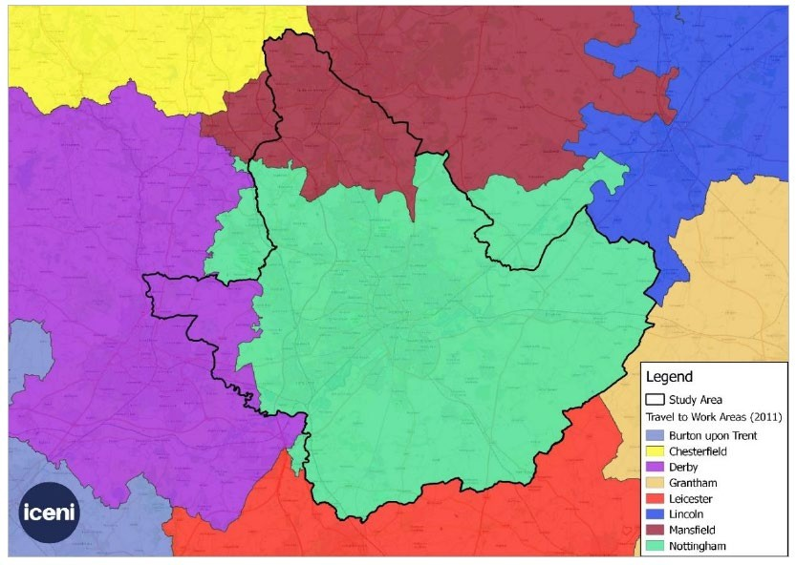

  - Delving further into the detail at a more local level, we have reviewed where people are travelling toand from for employment within the study area at a ward level and is helpful in understanding flows between particular areas within the authority areas. The results of this across the study area are shown in the Figure below.

Figure 4.14: Gross Commuting Flows, 2011

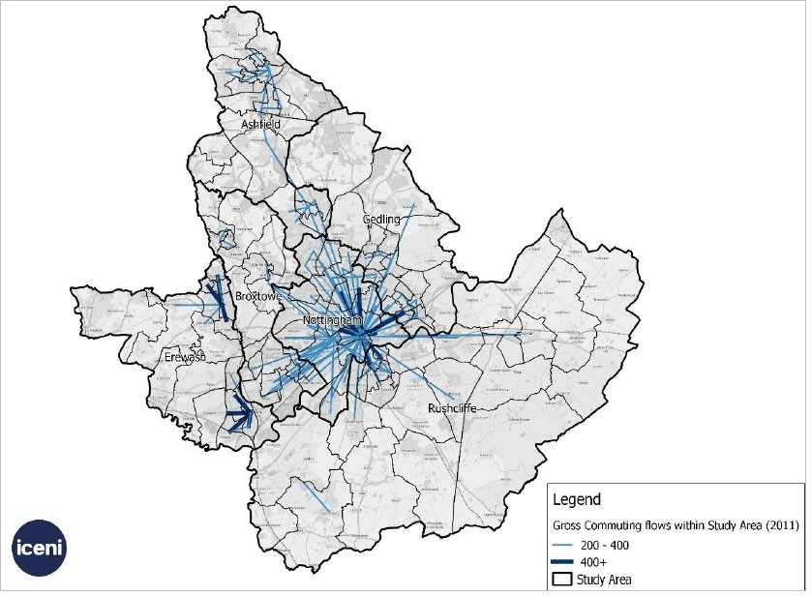

Source: Census 2011

  - The analysis shows a distinctive relationship between particular wards in Nottingham City and some of the southern wards of Broxtowe around Beeston and Toton, Ashfield around Hucknall, Rushcliffearound West Bridgford, Cotgrave and Bingham and Gedling around Calverton. Significant commuting flows are evident along some of the main transport corridors such as the M1 in Erewash and the Nottingham Express Transit service in Ashfield.

  - There are strong local flows in Erewash between Ilkeston and West Hallam (including around the West Hallam Storage Depot) and Kirk Hallam, as well as in Long Eaton around the industrial and commercial estate. Overall, the study area demonstrates high levels of self-containment rates.

  - The highest rates of self-containment can be seen in Nottingham City as well as around Carlton in Gedling, Hucknall in Ashfield, Beeston in Broxtowe and West Bridgford in Rushcliffe. There are alsohigh levels of self- containment in Rushcliffe Borough including the Cotgrave Ward and around Keyworth, due to the British Geological Survey HQ. The self-containment rates in Rushcliffe do identify a general east-west divide with much lower levels to the east.

Figure 4.15: Self-Containment Rates, 2011
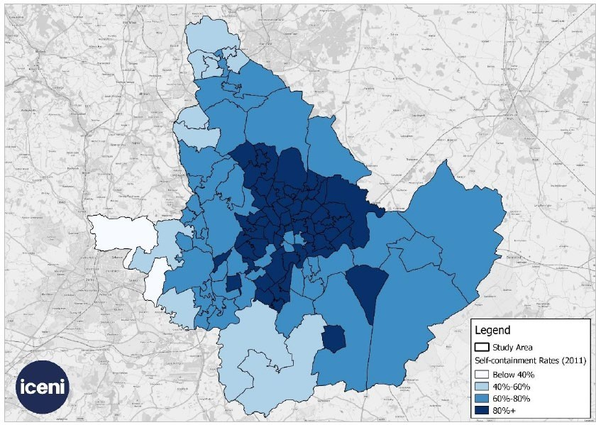

Source: Census 2011

Drawing the Evidence Together

  - Bringing the analysis above together, Iceni consider that the evidence points to a total of 57 submarkets across the study area. These are set out by name and number below alongside the associated wards and Lower Super Output Areas (“LSOAs”) in the Table.

Table 4.1 Identified Submarkets in Greater Nottingham and Ashfield

No | Submarket | Wards | LPA | Best Fit LSOAs
1 | Rural Rushcliffe | Tollerton, Nevile & Langar, | Rushcliffe | E01028412 E01028420
 | West | Cotgrave (excl. CotgraveVillage |  | E01028402 E01028367
 |  | Centre), Radcliffe onTrent, |  | E01028395 E01028394
 |  | Cropwell, Cranmer, Thoroton, |  | E01028393 E01028414
 |  | Gamston South,East Bridgford |  | E01028415 E01028413
 |  |  |  | E01028419 E01028371
 |  |  |  | E01028411 E01028377
 |  |  |  | E01028403
2 | Cotgrave Village | Cotgrave (part) | Rushcliffe | E01028366 E01028368
 | Centre |  |  | E01028369 E01028370
3 | Rural Rushcliffe | Keyworth & Wolds, Bunny, | Rushcliffe | E01028421 E01028383
 | East | Gotham, ,Leake, Sutton, |  | E01028382 E01028381
 |  | Bonington |  | E01028380 E01028379
 |  |  |  | E01028409 E01028410
 |  |  |  | E01028378 E01028389
 |  |  |  | E01028388 E01028390
 |  |  |  | E01028387 E01028408

4 | Ruddington | Ruddington | Rushcliffe | E01028406 | E01028407
 |  |  |  | E01028404 | E01028405
5 | West Bridgford | Compton Acres, Trent bridge, | Rushcliffe | E01028364 | E01028365
 |  | Musters, Lutterell, Lady Bay, |  | E01028363 | E01028398
 |  | Abbey |  | E01028416 | E01028417
 |  |  |  | E01028400 | E01028401
 |  |  |  | E01028392 | E01028391
 |  |  |  | E01028399 | E01028418
 |  |  |  | E01028386 | E01028385
 |  |  |  | E01028384 | E01028356
 |  |  |  | E01028354 | E01028397
 |  |  |  | E01028396 E01028355
6 | Bingham | Bingham East, Bingham West | Rushcliffe | E01028357 | E01028358
 |  |  |  | E01028359 | E01028362
 |  |  |  | E01028360 E01028361
7 | Edwalton | Edwalton | Rushcliffe | E01028374 E01028373 | E01028372
8 | Gamston North | Gamston North | Rushcliffe | E01028376 E01028375
9 | Kimberley & | Kimberley, Greasley, Asworth, | Broxtowe | E01028106 | E01028104
 | Greasley | Cossall & Trowell |  | E01028105 | E01028102
 |  |  |  | E01028103 | E01033412
 |  |  |  | E01033413 E01028118
10 | St. Ann’s | St. Ann’s | Nottingham | E01033399 | E01033411
 |  |  |  | E01013957 | E01013954
 |  |  |  | E01013958 | E01013959
 |  |  |  | E01033405 | E01033401
 |  |  |  | E01033409 | E01013962
 |  |  |  | E01013960 E01013961
11 | Lenton | Lenton & Wollaton East | Nottingham | E01013926 | E01013924
 |  |  |  | E01013928 | E01033410
 |  |  |  | E01013933 | E01013976
 |  |  |  | E01013974 | E01013975
 |  |  |  | E01013973 E01033408
12 | Radford | Radford | Nottingham | E01033395 | E01013953
 |  |  |  | E01033404 | E01013947
 |  |  |  | E01013945 | E01013948
 |  |  |  | E01033396
13 | Castle | Castle | Nottingham | E01033402 | E01033403
 |  |  |  | E01032522 | E01032520
 |  |  |  | E01033406 E01033407
14 | Meadows | Meadows | Nottingham | E01013874 | E01013873
 |  |  |  | E01013870 | E01013871
 |  |  |  | E01033400 E01013872

15 | Berridge | Berridge | Nottingham | E01013840 E01013841 E01013837 E01013838 E01013839 E01013847 E01013844 E01013845 E01013843
16 | North Nottingham City | Bulwell, Bulwell, Forest, Basford, Aspley | Nottingham | E01013885 E01013884 E01013883 E01013882 E01013881 E01013880 E01013876 E01013877 E01013875 E01013878 E01013879 E01013894 E01013893 E01013892 E01013891 E01013890 E01013887 E01013886  E01013889 E01013888
17 | Clifton West | Clifton West | Nottingham | E01013902 E01013901 E01013909 E01013896 E01013895 E01013898 E01013912
18 | Clifton East | Clifton East | Nottingham | E01013906 E01013907 E01013904 E01013905 E01013903 E01013900 E01013908 E01013897 E01013899 E01013910  E01013911
19 | Bestwood | Bestwood | Nottingham | E01033397 E01033398 E01013849 E01013856 E01013854 E01013855 E01013852 E01013853  E01013850 E01013851 E01032621
20 | Daybrook | Daybrook | Gedling | E01028166 E01028167 E01028165 E01028144
21 | Calverton | Calverton | Gedling | E01028153 E01028150 E01028151 E01028154 E01028152
22 | Carlton | Carlton, Cavendish, Carlton Hill, Phoenix | Gedling | E01028156 E01028157 E01028155 E01028158 E01028159 E01028164 E01028162 E01028163 E01028160 E01028161  E01028202 E01028212 E01028210 E01028211
23 | Dales | Dales | Nottingham | E01013920 E01013921 E01013916 E01013917 E01013914 E01013915  E01013913 E01013918 E01013919
24 | Porchester & Woodthorpe | Porchester, Woodthorpe | Gedling | E01028197 E01028196 E01028195 E01028194 E01028193 E01028216 E01028217 E01028215 E01028176 E01028214

25 | Bramcote | Bramcote | Broxtowe | E01028087 E01028089 E01028088 E01028091 E01028090
26 | Gedling | Gedling, Plains | Gedling | E01028168 E01028148 E01028149 E01028179 E01028183 E01028182 E01028180 E01028218
27 | Jacksdale & Selston | Jacksdale & Selston | Ashfield | E01027946 E01027945 E01027962 E01027963
28 | Annesley & Kirkby Woodhouse | Annesley & KirkbyWoodhouse | Ashfield | E01027997 E01027996 E01027995 E01027998
29 | Brinsley | Brinsley | Broxtowe | E01028092 E01028093
30 | Watnall & Nuthall | Nuthall East & Strelley, Watnall & Nuthall West | Broxtowe | E01028119 E01028120 E01028121 E01028124 E01028122 E01028123
31 | Bilborough & Beechdale | Bilborough, Leen Valley | Nottingham | E01013866 E01013867 E01013864 E01013865 E01013860 E01013861 E01013868 E01013858 E01013859 E01013862 E01013863 E01013929  E01013934 E01013932 E01013931
32 | Beeston East | Beeston North, Beeston Central and Beeston Rylands | Broxtowe | E01028074 E01028075 E01028073 E01028083 E01028076 E01028077 E01028078 E01028079 E01028082 E01028081  E01028080
33 | Beeston West | Beeston West | Broxtowe | E01028086 E01028085 E01028084
34 | Stapleford | Stapleford North, Stapleford South East and Stapleford South West | Broxtowe | E01028126 E01028127 E01028125 E01028130 E01028128 E01028129 E01028134 E01028132  E01028133 E01028131
35 | Mid Erewash Rural | Draycott & Risley, Ockbrook & Borrowash, Breaston, West Hallam & Dale Abbey | Erewash | E01019656 E01019654 E01019655 E01019687 E01019686 E01019685 E01019684 E01019683  E01019704 E01019702 E01019703 E01019701

36 | Underwood | Underwood | Ashfield | E01027994 E01027993
37 | Woodborough & Lambley | Dumbles | Gedling | E01028213 E01028178
38 | East Ilkeston | Cotmanhay, Awsworth Road, Larklands | Erewash | E01019664 E01019665 E01019663 E01019661 E01019646 E01019644 E01019645 E01019639 E01019662 E01019660  E01019690 E01019689 E01019688
39 | West Ilkeston | Little Hallam, Hallam Fields, Shipley View, Kirk Hallam & Stanton-by-Dale | Erewash | E01019674 E01019672 E01019673 E01019657 E01019659 E01019658 E01032614 E01019640 E01019638 E01019666  E01019667 E01019668 E01019669
40 | Sandiacre | Sandiacre | Erewash | E01019696 E01019695 E01019693 E01019692 E01019691
41 | Arnold and Redhill | Redhill, Coppice and Ernehale | Gedling | E01028207, E01028205 E01028208, E01028143 E01028206, E01028173 E01028181, E01028209  E01028177, E01028174 E01028175
42 | Ravenshead | Newstead Abbey | Gedling | E01028200, E01028201 E01028199, E01028198 E01028189
43 | Eastwood | Eastwood Hall, Eastwood St Marys and Eastwood Hilltop | Broxtowe | E01028107 E01028114 E01028113 E01028108 E01028109 E01028112 E01028110 E01028111
44 | Toton & Chilwell | Toton & Chilwell Meadows, Attenborough & Chilwell East and Chilwell West | Broxtowe | E01028136 E01028137 E01028135 E01028138 E01028139 E01028069 E01028070 E01028096 E01028095 E01028094 E01028097 E01028099  E01028098 E01028100 E01028101
45 | Long Eaton | Wilsthorpe, Derby Road West, Long Eaton Central, Sawley, Nottingham Road and Derby Road East | Erewash | E01019706 E01019707 E01019705 E01019708 E01019709 E01019647 E01019648 E01019649 E01019694 E01019652 E01019653 E01019650 E01019651 E01019682 E01019676 E01019677  E01019675 E01019678

 |  |  |  | E01019700 E01019697 E01019699 E01019698 E01019681 E01019680 E01019679
46 | Little Eaton & Stanley | Little Eaton & Stanley | Erewash | E01019670 E01019671
47 | Hucknall West & North | Hucknall West & Hucknall North | Ashfield | E01027936 E01027937 E01027934 E01027935 E01027933 E01027931 E01027944 E01027942  E01027940 E01027941 E01027938 E01027939
48 | Hucknall Central & South | Hucknall Central and Hucknall South | Ashfield | E01027943 E01027927 E01027925 E01027928 E01027932 E01027926 E01027929 E01027930
49 | Sutton in Ashfield | Ashfields, Huthwaite & Brierley, Carsic, St. Mary’s, Skegby, The Dales, Central & New Cross, Leamington, Stanton Hill & Teversal, Sutton Junction & Harlow Wood, Kingsway | Ashfield | E01027992 E01027991 E01027990 E01027987 E01027986 E01027988 E01027966 E01027964 E01027965 E01027968 E01027969 E01027989 E01027985 E01027984 E01027982 E01027980 E01027979 E01027971 E01027970 E01027967 E01027977 E01027978 E01027976 E01027974 E01027975 E01027983 E01027981 E01027972  E01027973 E01027949 E01027950
50 | Kirkby in Ashfield | Larwood, Kirkby Cross & Portland, Summit, Abbey Hill | Ashfield | E01027957 E01027959 E01027947 E01027948 E01027956 E01027954 E01027955 E01027952 E01027958 E01027953  E01027951
51 | Colwick & Netherfield | Colwick & Netherfield | Gedling | E01028184 E01028188 E01028171 E01028187 E01028186 E01028185
52 | Burton Joyce & Stoke Bardolph | Trent Valley | Gedling | E01028168 E01028148 E01028149
53 | Hyson Green & Arboretum | Hyson Green &Arboretum | Nottingham | E01013816 E01013814 E01013815 E01013812 E01013813 E01013810 E01013811 E01013930 E01013846 E01013842  E01013944

54 | Bestwood St Albans | Bestwood St Albans | Gedling | E01028146 E01028147 E01028142 E01032622
55 | Mapperley | Mapperley | Nottingham | E01013936 E01013937 E01013935 E01013938 E01013939 E01013942 E01013943 E01013940 E01013941
56 | Sherwood | Sherwood | Nottingham | E01013972 E01013970 E01013971 E01013966 E01013967 E01013964 E01013965 E01013963  E01013968 E01013969
57 | Wollaton West | Wollaton West | Nottingham | E01013985 E01013984 E01013983 E01013982 E01013981 E01013980  E01013977 E01013978 E01013979

  - The Figure below depicts the submarkets with their corresponding reference numbers. An enlargedversion of this Figure can be found at Appendix A1.

Figure 4.16: Identified Submarkets in Greater Nottingham and Ashfield
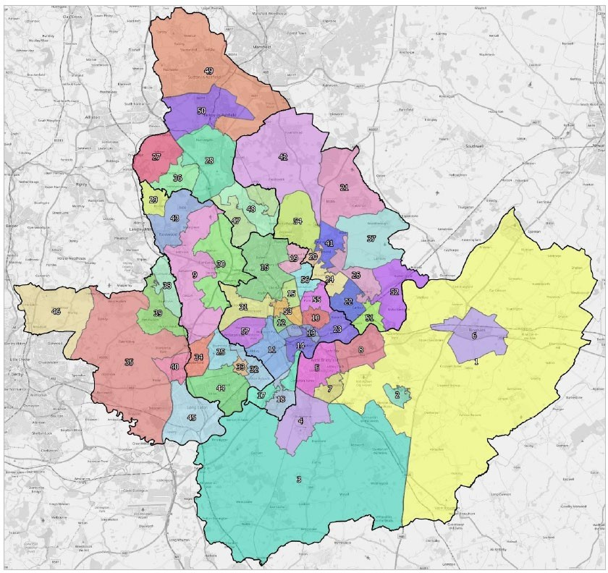

  - The submarkets identified in Table 4.1 and shown in Figure 4.16 are used to inform specific recommendations on affordable housing need and parameters for local housing mix in each of the authority areas. However, as set out upfront, submarkets should not be seen as fixed but need to bemonitored and reviewed as changes occur in the housing market, such as the development of strategic sites.

AFFORDABLE HOUSING NEED

  - This section provides an assessment of the need for affordable housing in the Greater Nottingham and Ashfield study area. The analysis follows the PPG on Housing and Economic Needs Assessments [2a-018 to 2a-024] to provide an assessment of the annual need for affordable housing. The section provides two main outputs, linked to Annex 2 of the NPPF – this is firstly an assessmentof the need for social/affordable rented housing and secondly to consider the need for affordable home ownership products.

Methodology Overview

  - The method for studying the need for affordable housing has been enshrined in Government practice guidance for many years, with an established approach to look at the number of households who areunable to afford market housing (to either rent or buy). The methodology considers the following:

    - Current affordable housing need: an estimate of the number of households who have a need now, at the point of the assessment, based on a range of data modelled from local information – this figure is then annualised so as to meet the current need over a period of time;

    - Projected newly forming households in need: using demographic projections to establish gross household formation, and then applying an affordability test to estimate numbers of such households unable to afford market housing;

    - Existing households falling into need: based on studying past trends in the types of households who have accessed social/affordable rented housing; and

    - Supply of affordable housing: an estimate of the likely number of lettings that will become available from the existing social/affordable housing stock.

  - The first three bullet points above are added together to identify a gross need, from which the supplyof relets of existing properties is subtracted to identify a net annual need for additional affordable housing. For the purposes of this assessment, this analysis is used to identify the overall net need for social/affordable rented housing.

  - This approach has traditionally been used to consider the needs of households who have not been able to afford market housing (either to buy or to rent). As the income necessary to afford to rent homes without financial support is typically lower than that needed to buy, the ability of households to afford private rents has influenced whether or not they are in need of affordable housing.

  - The NPPF and associated guidance has expanded the definition of those in affordable housing need to include households who might be able to rent without financial support but who aspire to own a home, and require support to do so. Such households are now considered to have an affordable housing need. The PPG on Housing and Economic Needs Assessments includes households that “cannot afford their own homes, either to rent, or to own, where that is their aspiration” as having anaffordable housing need.

  - This expanded definition has been introduced by national Government to support increased accessto home ownership, given evidence of declining home ownership and growth in private renting overthe last 10-15 years.

  - Planning Practice Guidance does not however provide specific guidance on how the needs of such households should be assessed. Iceni and Justin Gardner Consulting (“JGC”) have therefore adopted a broadly consistent methodology to that identified in the PPG; and considers a current need; a newly-arising need on an annual basis; existing households falling into need; and an annual estimate of supply.

  - For some of the analysis in this section it has been necessary to draw on other sources of data (applied to local information) to make estimates of the need. The approach is consistent with the PPG on Housing and Economic Needs Assessments [see 2a-020 for example] and includes linkinglocal Census data to national changes (as evidenced in national surveys such as the English Housing Survey).

  - Additionally, information drawn from local surveys previously undertaken by JGC across the countryhave been used to look at potential prevalence rates for some elements of need where comprehensive local data is lacking. This includes considering what proportion of households in theprivate rented sector might have a need due to potential loss of accommodation (e.g., tenancies ending) although again such rates are applied to local information about the size of the sector.

  - This approach is considered to provide a reasonable view about likely local needs and is an approach that has been accepted through a range of Local Plan Examinations over the past five or more years. Our analysis of affordable housing need is therefore structured to consider the need for rented affordable housing, and separately the need for affordable home ownership, which when added together gives the total affordable housing need. The overall need is expressed as an annual figure,which can then be compared with likely future delivery as required by the PPG [2a-024].

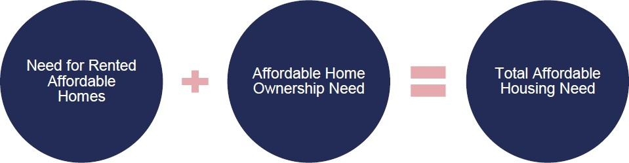

  - Whilst the need for social/affordable rented housing8 and affordable home ownership are analysed separately, there are a number of pieces of information that are common to both assessments. In particular, this includes an understanding of local housing costs, incomes and affordability. The sections below therefore look at these factors.

⁸ Affordable rents are charged at up to 80% of market rents (inclusive of service charges). Social rents are set based on a formula set by Government through the national rent regime.
  - It should however be noted that where a surplus is identified (i.e. a negative figure), this should not be subtracted from the overall need; as affordable rented provision and affordable home ownershiphousing are fundamentally different products.

Local Prices and Rents

  - An important part of the affordable needs model is to establish the entry-level costs of housing to buyand rent. The affordable housing needs assessment compares prices and rents with the incomes ofhouseholds to establish what proportion of households can meet their needs in the market, and whatproportion require support and are thus defined as having an ‘affordable housing need’.

  - For the purposes of establishing affordable housing need, the analysis focuses on overall housing costs (for all dwelling types and sizes), establishing, in numerical terms, the overall need for affordable housing.

  - The analysis below considers the entry-level costs of housing to both buy and rent across the six local authorities. The approach has been to analyse Land Registry and ONS data to establish lower quartile prices and rents. Using a lower quartile figure is consistent with the PPG on Housing and Economic Needs Assessments and reflects the entry-level point into the market recognising that thevery cheapest properties are often of sub-standard quality.

  - Data from the Land Registry for the year to September 2019 shows estimated lower quartile propertyprices by house type. The data shows that entry-level costs to buy are estimated to start from about

£68,000 for a flat in Ashfield and rising to nearly £300,000 for a detached home in Rushcliffe. Thereare some significant variations in house prices by area, with Rushcliffe showing the highest prices for all homes. It should be noted that to some extent the ‘all homes’ figure is influenced by the profileof homes sold in different areas.

Table 5.1 Lower Quartile House Prices by Type, Year to September 2019

 | Ashfield | Broxtowe | Erewash | Gedling | Nottingham | Rushcliffe
Flats | £68,000 | £83,000 | £80,000 | £88,000 | £85,000 | £126,000
Terraced | £75,000 | £114,000 | £93,000 | £110,000 | £95,000 | £158,000
Semi-Detached | £110,000 | £144,000 | £132,000 | £145,000 | £122,000 | £200,000
Detached | £175,000 | £197,000 | £220,000 | £222,000 | £187,000 | £292,000
All Homes | £104,000 | £140,000 | £121,000 | £136,000 | £104,000 | £203,000
Source: Land Registry

  - It is also useful to provide estimates of property prices by the number of bedrooms in a home. Analysis for this draws together Land Registry data with an internet search of prices of homes for sale (using sites such as Rightmove). To some extent the prices should be seen as indicative, in particular the supply of 1-bedroom homes to buy was quite small in some locations.

Table 5.2 Lower Quartile House Prices by Size, Year to September 2019

 | Ashfield | Broxtowe | Erewash | Gedling | Nottingham | Rushcliffe
1-Bedroom | £61,000 | £78,000 | £65,000 | £75,000 | £65,000 | £106,000
2-Bedroom | £86,000 | £110,000 | £107,000 | £103,000 | £107,000 | £138,000
3-Bedroom | £126,000 | £156,000 | £149,000 | £160,000 | £126,000 | £223,000
4-Bedrooms | £216,000 | £244,000 | £233,000 | £243,000 | £177,000 | £320,000
All Homes | £104,000 | £140,000 | £121,000 | £136,000 | £104,000 | £203,000
Source: Land Registry

  - A similar analysis has been carried out for private rents using ONS data for lettings over the 12- month period to September 2019. The analysis shows an average lower quartile cost (across all dwelling sizes) ranging from £435 per month in Ashfield, up to £550 in Rushcliffe.

Table 5.3 Lower Quartile Market Rents, Year to September 2019

 | Ashfield | Broxtowe | Erewash | Gedling | Nottingham | Rushcliffe
Room | £336 | £340 | £325 | - | £359 | £368
Studio | - | £440 | £363 | - | £455 | £325
1-Bedroom | £340 | £425 | £395 | £400 | £490 | £495
2-Bedroom | £425 | £525 | £495 | £525 | £550 | £600
3-Bedroom | £450 | £650 | £575 | £600 | £595 | £695
4-Bedrooms | £650 | £800 | £750 | £825 | £750 | £995
All Homes | £435 | £498 | £480 | £525 | £500 | £550
Source: ONS

Local Incomes

  - The affordability of housing is influenced by housing costs and incomes, which affect households’ ability to afford different housing products. In this section we consider housing affordability, in termsof the ability of a household to afford to buy or rent housing in the market without the need for somesort of subsidy.

  - The data about total household income has been modelled on the basis of a number of different sources of information to provide both an overall average income and the likely distribution of income. The key sources of data include:

    - ONS modelled income estimates (published in April 2018 with a 2015/16 base) – this information is provided for middle layer super output areas (MSOA) and is therefore used to build up to larger areas (e.g. local authorities);

    - English Housing Survey (EHS) – to provide information about the distribution of incomes; and

    - Annual Survey of Hours and Earnings (ASHE) – to assist in looking at how incomes have changed since the ONS base date.

  - Drawing these datasets together, an income distribution for 2019 has been constructed. The figure below shows the income distribution estimated across the whole study area. Overall the mean household income is estimated to be around £40,100, with a median income of £30,200; the lower quartile income of all households is estimated to be £17,500

Figure 5.1: Distribution of Household Income, 2019

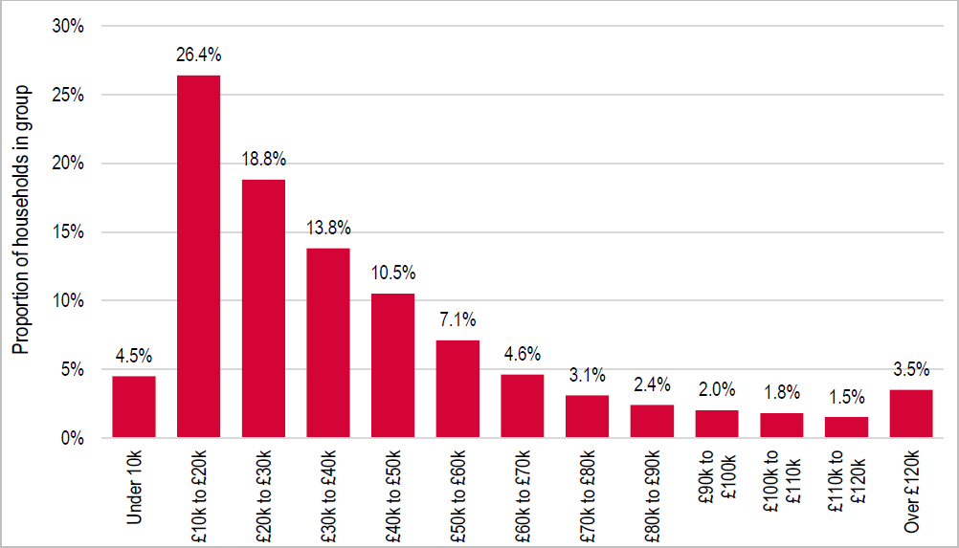

  - The Table below shows how incomes are estimated to vary across the six local authorities. Thisshows the highest incomes in Rushcliffe and notably lower incomes in Nottingham.

Table 5.4 Estimated Household Income by Local Authority, 2019

 | Mean | Median | Lower Quartile
Ashfield | £38,600 | £29,400 | £17,000
Broxtowe | £42,000 | £31,900 | £18,500
Erewash | £40,800 | £31,000 | £18,000
Gedling | £42,400 | £32,200 | £18,600
Nottingham | £35,100 | £26,700 | £15,400
Rushcliffe | £50,300 | £38,200 | £22,100
Study Area | £40,100 | £30,200 | £17,500
Source: ONS Modelled Income Estimates,

Affordability Thresholds

  - To assess affordability two different measures are used; firstly to consider what income levels are likely to be needed to access private rented housing (this establishes those households in need of social/affordable rented housing) and secondly to consider what income level is needed to access owner occupation (this, along with the first test helps to identify households in the ‘gap’ between renting and buying).

  - This analysis therefore brings together the data on household incomes with the estimated incomes required to access private sector housing. Additionally, different affordability tests are applied to different parts of the analysis depending on the group being studied (e.g. recognising that newlyforming households are likely on average to have lower incomes than existing households).

  - A household is considered able to afford market rented housing in cases where the rent payable would constitute no more than a particular percentage of gross income. The choice of an appropriate threshold is an important aspect of the analysis – the PPG on Housing and Economic Needs Assessments does not provide any guidance on this issue. CLG SHMA guidance prepared in 2007 suggested that 25% of income is a reasonable start point, it also noted that a different figure could be used.

  - Analysis of current letting practice suggests that letting agents typically work on a threshold of 40%. Government policy (through Housing Benefit payment thresholds) would also suggest a figure of 40%+ (depending on household characteristics).

  - The threshold of income to be spent on housing should be set by asking the question ‘what level of income is expected to be required for a household to be able to access market housing without the need for a subsidy?’ The choice of an appropriate threshold is therefore judgement based. The keyconsideration to understand here is that local income levels are not setting the threshold but are simply being used to assess how many can or can’t afford market housing. It is important to considerwhat residual income is left, after households have paid for housing.

  - At £435 to £550 per calendar month, lower quartile rent levels in Greater Nottingham and Ashfield are low to average in comparison to those seen nationally. This would suggest that a proportion of income to be spent on housing could be towards the bottom end of the range (the range being from25% to 40%). Across England the lowest lower quartile rents are around £400 per month (areas withrents at or below this level include Hull and Liverpool and there were a total of 20 local authorities with lower quartile rents not exceeding £400 per month).

  - If these areas are considered to be at the bottom end of the range (i.e. 25% of income to be spent on housing) then this would leave a residual income of £1,200 per month. With the same residual income applied to Nottingham (as an example), the gross household income required to afford a £500 PCM lower quartile rent would be £1,700 and so the percentage spent on housing would be 29%.

  - However, it needs to be considered that the cost of living in different areas will vary, and it is likely that areas where rents are higher will also generally have higher living costs. Therefore, a pragmatic approach to determining a reasonable proportion of income has been to take a midpoint between the bottom (25%) and the equivalent residual income figure (29% if looking at Nottingham). In this example a threshold of 27% would therefore be considered as reasonable.

  - There are however differences in housing costs in different parts of the study area and so this analysis has been carried out for all local authorities individually. Below are the affordability thresholds used in analysis for each location:

    - Ashfield – 26%

    - Broxtowe – 27%

    - Erewash – 27%

    - Gedling – 28%

    - Rushcliffe – 28%

    - Nottingham – 27%

  - In reality, many households may well spend a higher proportion of their income on housing and therefore would have less money for other living costs – for the purposes of this assessment these households would essentially be assumed as ideally having some form of subsidised rent so as to ensure a sufficient level of residual income.

  - Generally, the income required to access owner-occupied housing is higher than that required to rentand so the analysis of the need for social/affordable rented housing is based on the ability to afford to access private rented housing. However, local house prices (and affordability) are important when looking at the need for affordable home ownership.

  - For the purposes of this assessment, the income thresholds for owner-occupation assume a household has a 10% deposit and can secure a mortgage for four times their salary. These assumptions are considered to be broadly in line with typical lending practices although it is recognised that there will be differences on a case- by-case basis.

  - The table below shows the estimated incomes required to both buy and rent (privately) in each local authority. This shows a notable ‘gap’ in Rushcliffe and a much narrower spread of incomes required for Nottingham – the figures reflect the varying housing costs in different locations.

Table 5.5 Estimated Household Income Required to Buy & Rent Privately

 | To Buy | To Rent (Privately)
Ashfield | £23,400 | £20,200
Broxtowe | £31,500 | £22,000
Erewash | £27,200 | £21,500
Gedling | £30,600 | £22,700
Nottingham | £23,400 | £22,100
Rushcliffe | £45,700 | £23,400
Source: Based on Housing Market Cost Analysis

Need for Rented Affordable Housing

  - The sections below work through the various stages of analysis to estimate the need for social/affordable housing in each local authority. Final figures are provided as an annual need (including an allowance to deal with current need). As per the PPG on Housing and Economic NeedsAssessments [2a-024], this figure can then be compared with likely delivery of affordable housing.

Current Need

  - In line with PPG on Housing and Economic Needs Assessments [2a-020], the current need for affordable housing has been based on considering the likely number of households with one or morehousing problems. The table below sets out the categories in the PPG and the sources of data being used to establish numbers. The PPG also includes a category where households cannot afford to own despite it being their aspiration – this category is considered separately in this report (under the title of the need for affordable home ownership).

Table 5.6 Main Sources for Assessing the Current Unmet Need for Affordable Housing

 | Source | Notes
Homeless households (and those in temporary accommodation) | MHCLG Live Table 784 | Total where a duty is owed butno accommodation has been secured PLUS the total in  temporary accommodation
Households in overcrowded housing | Census table LC4108EW | Analysis undertaken by tenure and updated by reference to national changes (from the  English Housing Survey (EHS))
Concealed households | Census table LC1110EW | Number of concealed families
Existing affordable housing tenants in need | Modelled data linking to past survey analysis | Excludes overcrowded households – tenure estimates updated by reference to the EHS
Households from other tenures in need | Modelled data linking to past survey analysis
Source: PPG [2a-020]

  - It should be noted that there may be some overlap between categories (such as overcrowding and concealed households, whereby the overcrowding would be remedied if the concealed household moved). The data available does not enable analysis to be undertaken to study the impact of this and so it is possible that the figures presented include a small element of double counting (although this is likely to be small). Additionally, some of the concealed households may be older people who have moved back in with their families and might not be considered as in need.

  - The table below shows the initial estimate of the number of households within the study area with acurrent housing need. These figures are before any ‘affordability test’ has been applied to assess the ability of households to meet their own housing needs; and has been termed ‘the number of households in unsuitable housing’. Overall, the analysis estimates that there are currently some 30,000 households living in unsuitable housing (or without housing).

Table 5.7 Estimated Number of Households Living in Unsuitable Housing

 |  | Homeless/ Concealed Households | Households in Overcrowded Housing | Existing affordable housing tenants in  need | Householdsfrom other tenures in need | Total
Ashfield |  | 475 | 1,497 | 186 | 1,108 | 3,266
Broxtowe |  | 362 | 1,449 | 118 | 1,094 | 3,022
Erewash |  | 347 | 1,249 | 143 | 1,075 | 2,814
Gedling |  | 484 | 1,074 | 111 | 1,115 | 2,785
Nottingham |  | 1,796 | 9,422 | 846 | 3,632 | 15,695
Rushcliffe |  | 342 | 925 | 87 | 1,044 | 2,398
Study | Area | 3,806 | 15,616 | 1,491 | 9,068 | 29,980
Source: MHCLG Live Tables, Census 2011 and Data Modelling

  - In taking this estimate forward, the data modelling next estimates housing unsuitability by tenure. From the overall number in unsuitable housing, households living in affordable housing are excluded (as these households would release a dwelling on moving and so no net need for affordable housingwill arise).

  - The analysis also excludes 90% of owner-occupiers under the assumption (which is supported by analysis of survey data) that the vast majority of existing owner occupiers will be able to afford housing within the private sector without subsidy once savings and equity are taken into account.

  - A final adjustment is to slightly reduce the unsuitability figures in the private rented sector to take account of student-only households – such households could technically be overcrowded/living in unsuitable housing but would be unlikely to be allocated affordable housing (student needs are essentially assumed to be transient). Once these households are removed from the analysis, the remainder are taken forward for affordability testing.

  - The Table below shows it is estimated that were 16,000 households living in unsuitable housing (excluding current social tenants and the majority of owner-occupiers) across the study area.

Table 5.8 Unsuitable Housing by Tenure and No. to Take Forward intoAffordability Modelling, Greater Nottingham and Ashfield

 | In Unsuitable Housing | No. to Take Forward for Affordability Testing
Owner-Occupied | 7,020 | 702
Affordable Housing | 6,367 | 0
Private Rented | 12,786 | 11,532
No Housing (Homeless/Concealed) | 3,806 | 3,806
Total | 29,980 | 16,040
Source: MHCLG Live Tables, Census 2011 and Data Modelling

  - Having established this figure, it needs to be considered that a number of these households might be able to afford market housing without the need for subsidy. To consider this, the income data hasbeen used, with the distribution adjusted to reflect a lower average income amongst households living in unsuitable housing – for the purposes of the modelling an income distribution that reduces the average household income to 88% of the figure for all households has been used to identify theproportion of households whose needs could not be met within the market (for households currentlyliving in housing). A lower figure of 42% has been used to apply an affordability test for the concealed/homeless households who do not currently occupy housing.

  - These two percentage figures have been based on a consideration of typical income levels of households who are in unsuitable housing (based mainly on estimates in the private rented sector) along with typical income levels of households accessing social rented housing (for those without accommodation).

  - The figures have been based on analysis of the English Housing Survey (mainly looking at relative incomes of households in each of the private and social rented sectors) as well as consideration of similar information collected through household surveys across the country by JGC. These modelling assumptions are considered reasonable and have not been challenged through the Local Plan process in other locations (where the same assumptions have been used).

  - Overall, just over half of households with a current need are estimated to be likely to have insufficient income to afford market housing and so the estimate of the total current need is of 8,100 householdsin the study area. The table below also shows how this is estimated to vary by local authority.

Table 5.9 Estimated Current Affordable Housing Need for Social/Affordable Rented

 |  | In unsuitable housing  (taken forward for affordability test) | % Unable to Afford Market Housing (without subsidy) | Revised Gross Need (including Affordability)
Ashfield |  | 1,634 | 48.7% | 796
Broxtowe |  | 1,707 | 46.0% | 785
Erewash |  | 1,465 | 47.1% | 690
Gedling |  | 1,560 | 50.5% | 788
Nottingham |  | 8,232 | 54.4% | 4,475
Rushcliffe |  | 1,443 | 41.5% | 599
Study | Area | 16,040 | 50.7% | 8,132
Source: MHCLG Live Tables, Census 2011 and Data Modelling

  - The estimated figure shown above at 8,132 represents the number of households with a need currently. For the purposes of analysis, it is assumed that the local authorities would seek to meet this need over a period of time.

  - Given that this report typically looks at needs in the 2020-38 period, the need is annualised by dividing by 18 (to give an annual need for 452 dwellings across all local authorities). This does not mean that some households would be expected to wait 18-years for housing as the need is likely tobe dynamic, with households leaving the current need as they are housed but with other households developing a need over time.

Newly Forming Households

  - The number of newly forming households has been estimated through demographic modelling withan affordability test also being applied. This has been undertaken by considering the changes in households in specific 5-year age bands relative to numbers in the age band below, 5 years previously, to provide an estimate of gross household formation.

  - The number of newly-forming households is limited to households forming who are aged under 45 –this is consistent with CLG guidance (from 2007) which notes after age 45 that headship (householdformation) rates ‘plateau’. There may be a small number of household formations beyond age 45 (e.g. due to relationship breakdown) although the number is expected to be fairly small when compared with formation of younger households.

  - The number of newly forming households has been estimated through demographic modelling (linked to 2016-based SNPP and 2014-based SNHP). This is considered to provide the best view about trend-based household formation, but without building in any additional constraints to household formation.

  - In assessing the ability of newly forming households to afford market housing, data has been drawn from previous surveys undertaken nationally by JGC. This establishes that the average income of newly forming households is around 84% of the figure for all households. This figure is remarkably consistent across areas (and is also consistent with analysis of English Housing Survey data at a national level).

  - The analysis has therefore adjusted the overall household income data to reflect the lower averageincome for newly forming households. The adjustments have been made by changing the distributionof income by bands such that average income level is 84% of the all household average. In doing this it is possible to calculate the proportion of households unable to afford market housing. For the purposes of the need for social/affordable rented housing this will relate to households unable to afford to buy OR rent in the market.

  - The assessment suggests that overall around two-fifths of newly forming households will be unableto afford market housing (to rent privately) and this equates a total of 3,227 newly forming households will have a need per annum on average. The table below provides a breakdown by local authority.

Table 5.10 Estimated Need for Social/Affordable Rented Housing fromNewly Forming Households (p.a.)

 | Number of New Households | % Unable to Afford | Annual Newly Forming  Households Unable to Afford to Rent
Ashfield | 983 | 40.5% | 398
Broxtowe | 898 | 40.6% | 364
Erewash | 879 | 40.8% | 358
Gedling | 1,016 | 41.6% | 422
Nottingham | 2,765 | 49.3% | 1,362
Rushcliffe | 916 | 35.3% | 323
Study Area | 7,458 | 43.3% | 3,227
Source: Projection Modelling/Affordability Analysis

Existing Households Falling into Affordable Housing Need

  - The second element of newly arising need is existing households falling into need. To assess this, information about past lettings in social/affordable rented has been used. The assessment looked at households who have been housed in general need housing over the past three years – this group will represent the flow of households onto the Housing Register over this period. From this, newly forming households (e.g. those currently living with family) have been discounted as well as households who have transferred from another social/affordable rented property. An affordability test has also been applied.

  - This method for assessing existing households falling into need is consistent with the 2007 SHMA guide which says on page 46 that ‘Partnerships should estimate the number of existing householdsfalling into need each year by looking at recent trends’. This should include households who have entered the housing register and been housed within the year as well as households housed outsideof the register (such as priority homeless household applicants)’.

  - Following the analysis through suggests a need arising from 929 existing households each year. Thetable below breaks this down by local authority.

Table 5.11 Estimated Need for Social/Affordable Rented Housing from ExistingHouseholds Falling into Need (p.a.)

 | Total Additional Need | % of Total
Ashfield | 192 | 20.7%
Broxtowe | 78 | 8.4%
Erewash | 120 | 13.0%
Gedling | 83 | 8.9%
Nottingham | 384 | 41.4%
Rushcliffe | 71 | 7.7%
Study Area | 929 | 100.0%
Source: Derived from a Range of Sources as set out in the Main Text

Supply of Social/Affordable Rented Housing Through Re-Lets

  - The future supply of affordable housing through relets is the flow of affordable housing arising from the existing stock that is available to meet future need. This focusses on the annual supply of social/affordable rent relets.

  - The PPG on Housing and Economic Needs Assessments suggests that the estimate of likely futurerelets from the social rented stock should be based on past trend data which can be taken as a prediction for the future. Information from CoRe (Continuous Recording) and Local Authority Housing Statistics (LAHS) has been used to establish past patterns of social housing turnover.

  - The figures are for general needs lettings but exclude lettings of new properties and also exclude an estimate of the number of transfers from other social rented homes. These exclusions are made to ensure that the figures presented reflect relets from the existing stock.

  - On the basis of past trend data is has been estimated that 1,993 units of social/affordable rented housing are likely to become available each year moving forward for occupation by newly forming households and existing households falling into need from other tenures.

Table 5.12 Analysis of Past Social/Affordable Rented Housing Supply, 2016/17-2018/19(p.a.)

 | Total Lettings | % as Non- New Build | Lettings in Existing Stock | % Non- Transfers | Lettings to New Tenants
Ashfield | 634 | 92.8% | 588 | 67.4% | 396
Broxtowe | 307 | 94.4% | 290 | 61.3% | 178
Erewash | 428 | 92.0% | 394 | 62.3% | 245
Gedling | 254 | 88.8% | 225 | 69.5% | 156
Nottingham | 1,897 | 85.3% | 1,618 | 54.5% | 883
Rushcliffe | 227 | 81.4% | 184 | 72.7% | 134
Study Area | 3,747 | 88.1% | 3,300 | 60.4% | 1,993
Source: CoRe/LAHS

  - The PPG model also includes the bringing back of vacant homes into use and the pipeline of affordable housing as part of the supply calculation. These have however not been included within the modelling in this report. Firstly, there is no evidence of any substantial stock of vacant homes (over and above a level that might be expected to allow movement in the stock).

  - Secondly, with the pipeline supply, it is not considered appropriate to include this as to net off new housing would be to fail to show the full extent of the need, although in monitoring it will be important to net off these dwellings as they are completed.

Net Need for Social/Affordable Rented Housing

  - The table below shows the overall calculation of affordable housing need for social/affordable rented housing. The analysis shows that there is a need for 2,615 dwellings per annum to be provided with an affordable need being seen in all local authorities within the study area. The net need is calculatedas follows:

Net Need = Current Need (allowance for) + Need from Newly-Forming Households + Existing Households falling into Need – Supply of Affordable Housing (Re-let Supply)

  - The results are shown by local authority in the Table below relating to the 2020 to 2038 period.

Table 5.13 Estimated Need for Social/Affordable Rented Housing by LPA (p.a.)

 | Current Need | Newly Forming Households | Existing Households Falling into  Need | Total Gross Need | Re-let Supply | Net Need
Ashfield | 44 | 398 | 192 | 634 | 396 | 237
Broxtowe | 44 | 364 | 78 | 486 | 178 | 309
Erewash | 38 | 358 | 120 | 517 | 245 | 271
Gedling | 44 | 422 | 83 | 549 | 156 | 392
Nottingham | 249 | 1,362 | 384 | 1,995 | 883 | 1,112
Rushcliffe | 33 | 323 | 71 | 428 | 134 | 294
Study Area | 452 | 3,227 | 929 | 4,607 | 1,993 | 2,615
Source: Census 2011, CoRe, Projection Modelling and Affordability Analysis

Prioritisation of Social or Affordable Rented Housing

  - The analysis above has studied the overall need for social and affordable rented housing with a focus on households who cannot afford to rent in the market. These households will therefore have a needfor some form of rented housing at a cost below typical market rates. Typically, there are two main types of rented affordable accommodation (social and affordable rented) with the analysis below initially considering what form should be prioritised.

  - An analysis has been undertaken to compare the income distribution of households with the cost of different products. For affordable rented housing it has been assumed that this would be available at a cost which is 80% of the established lower quartile costs set out earlier in this section. Any household able to afford a rent between 80% of the market and the full market cost is assumed able to afford an affordable rent, with other households only able to afford a social rent; which would therefore be households paying less than 80% of the lower quartile market rent.

  - The analysis identifies that between 15% and 22% of the group of households unable to afford market housing to rent would fall in the gap between the market and 80% of the market. The Table also shows the rent levels assumed; it is quite possible that (for example) 80% of market rent would be higher than the figures modelled below and if that were the case then a lower proportion of households would be able to afford.

Table 5.14 Estimated Need for Affordable Rented Housing at 80% of Market Rents PCM

 | % of Need for affordable rented | Cost of 1- Bedroom affordable rented | Cost of 2- Bedroom affordable rented | Cost of 3- Bedroom affordable rented | Cost of 4- Bedroom affordable rented
Ashfield | 19% | £272 | £340 | £360 | £520
Broxtowe | 19% | £340 | £420 | £520 | £640
Erewash | 19% | £316 | £396 | £460 | £600
Gedling | 18% | £320 | £420 | £480 | £660
Nottingham | 15% | £392 | £440 | £476 | £600
Rushcliffe | 22% | £396 | £480 | £556 | £796
Source: Affordability Analysis

  - The finding that 15% to 22% of households can afford an affordable rent does not automatically leadto a policy conclusion on the prioritisation between the two forms of affordable rented housing (i.e. between social and affordable rents).

  - For example, many households who will need to access rented accommodation will be benefit dependent and as such could technically afford an affordable rent (as long as the full rent is covered by Housing Benefit) – hence a higher proportion of affordable rented housing might be appropriate.On the flip side, providing more social rents might enable households to return to work more easily,as a lower income would potentially be needed to afford the lower social (rather than affordable) rent.

  - There will be a series of other considerations both at a strategic level and for specific schemes. For example, there may be funding streams that are only available for a particular type of housing, and this may exist independently to any local assessment of need. Additionally, there will be the consideration of the balance between the cost of housing and the amount that can be viably provided, for example, it is likely that affordable rented housing is more viable, and therefore a greater number of units could be provided.

  - For information, the Table below shows average social and affordable rents (taken from CoRe) and compares these with lower quartile and median market rents. This analysis shows that social rentsare in all areas somewhat lower than recent affordable rents; the analysis also shows that affordablerents are generally less than 80% of a median market rent, but a higher proportion if compared withlower quartile figures. In Ashfield, the analysis suggests little difference between affordable rents and lower quartile rents.

Table 5.15 Comparison of Rent Levels for Different Products

 | Social Rent | Affordable Rent (AR) | LQ Market  Rent | Median Market  Rent | AR as % of LQ | AR as % of Median
Ashfield | £307 | £433 | £435 | £500 | 100% | 87%
Broxtowe | £306 | £395 | £498 | £615 | 79% | 64%
Erewash | £381 | £430 | £480 | £550 | 90% | 78%
Gedling | £351 | £467 | £525 | £595 | 89% | 78%
Nottingham | £356 | £403 | £500 | £600 | 81% | 67%
Rushcliffe | £423 | £489 | £550 | £665 | 89% | 74%
Source: CoRe and ONS

  - As a general rule, it is not considered sensible to be charging a rent in excess of Local Housing Allowance rates, as this would mean many households having to top up their rent from other income sources. The local authorities could therefore consider that the affordable level for social rents is equal to the maximum Local Housing Allowance level for the relevant area and property size. As a result, low income working households are likely to benefit most from a social rent. However, rents will have to be set in the content of viability.

Establishing a Need for Affordable Home Ownership

  - The PPG on Housing and Economic Needs Assessments confirms a widening definition of those tobe considered as in affordable need; now including ‘households which can afford to rent in the private rental market, but cannot afford to buy despite a preference for owning their own home’. However, at the time of writing, there is no guidance about how the number of such households should be measured.

  - The methodology used in this report therefore draws on the current methodology, and includes an assessment of current needs, and projected need (newly forming and existing households). The keydifference is that in looking at affordability an estimate of the number of households in the ‘gap’ between buying and renting is used. There is also the issue of establishing an estimate of the supplyof affordable home ownership homes – this is considered separately below.

  - The first part of the analysis seeks to understand what the gap between renting and buying actuallymeans in the study area – in particular establishing the typical incomes that might be required. The information about incomes required to both buy and rent in different locations has already been provided earlier in this section and so the discussion below is a broad example.

  - Using the income distributions developed (as set out earlier in this section) along with data aboutprice and rents, it has been estimated that of all households living in the private rented sector, around 48% already have sufficient income to buy a lower quartile home, with 12% falling in the rent/buy‘gap’.

  - The final 41% are estimated to have an income below which they cannot afford to rent privately (i.e. would need to spend more than the calculated threshold of their income on housing costs) althoughin reality it should be noted that many households will spend a higher proportion of their income on housing. This group is defined as one which therefore “cannot afford to buy or rent” for the purposeof the assessment.

  - These figures have been based on an assumption that incomes in the private rented sector are around 88% of the equivalent figure for all households (a proportion derived from the English Housing Survey) and are used as it is clear that affordable home ownership products are likely to be targeted at households living in or who might be expected to access this sector (e.g. newly forminghouseholds).

  - The Table below shows an estimate of the proportion of households living in the private rented sector who are able to afford different housing products by local authority. This shows a particularly high proportion of households in the rent/buy gap in Rushcliffe, with much lower figures for Nottingham and Ashfield.

Table 5.16 Estimated Proportion of Households living in Private Rented SectorAble to Buy and/or Rent

 | Can Afford to Buy a LQ Home | Can Afford to Rent but Not Buy | Cannot Afford to Buy or Rent
Ashfield | 55% | 7% | 38%
Broxtowe | 44% | 18% | 38%
Erewash | 50% | 11% | 39%
Gedling | 46% | 15% | 39%
Nottingham | 50% | 3% | 47%
Rushcliffe | 35% | 31% | 33%
Study Area | 48% | 12% | 41%
Source: Derived from Housing Market Cost Analysis and Affordability Testing

  - The finding that a significant proportion of households in the private rented sector are likely to have an income that would allow them to buy a home is also noteworthy and suggests that for many households, barriers to accessing owner-occupation are less about income/the cost of housing andmore about other factors (which could for example include the lack of a deposit or difficulties obtaining a mortgage (for example due to a poor credit rating or insecure employment)). However, some households will choose to privately rent, for example as it is a more flexible option that may be more suitable for a particular household’s life stage (e.g. if moving locations with employment).

  - To study current need, an estimate of the number of household living in the private rented sector hasbeen established, with the same (rent/buy gap) affordability test (as described above) then applied.The start point is the number of households living in private rented accommodation; as of the 2011 Census there were some 61,000 households living in the sector across the whole study area. Data from the English Housing Survey (EHS) suggests that since 2011, the number of households in theprivate rented sector has risen by about 22% - if the same proportion is relevant to the study area then the number of households in the sector would now be around 74,500.

  - Additional data from the EHS suggests that 60% of all private rented sector households expect to become an owner at some point (44,700 households if applied to the study area) and of these some25% (11,200 households) would expect this to happen in the next 2 years. The figure of 11,200 is therefore taken as the number of households potentially with a current need for affordable home ownership before any affordability testing.

  - As noted above, on the basis of income it is estimated that around 3%-31% of the private rented sector sit in the gap between renting and buying (depending on location). Applying these proportions to the 11,200 figure would suggest a current need for around 1,100 affordable home ownership units(61 per annum if annualised over an 18-year period). The overall current need is therefore relatively small.

  - In projecting forward, the analysis can consider newly forming households and also the remaining existing households who expect to become owners further into the future. Applying the same affordability test (albeit on a very slightly different income assumption for newly forming households) suggests an annual need from these two groups of around 1,031 dwellings (848 from newly forminghouseholds and 183 from existing households in the private rented sector).

  - Bringing together the above analysis suggests that there is a need for around 1,093 affordable home ownership homes (priced for households able to afford to rent but not buy) per annum. This is beforeany assessment of the potential supply of housing is considered.

Table 5.17 Estimated Gross Need for Affordable Home Ownership by LPA (p.a.)

 | Current Need | Newly Forming Households | Existing Households Falling into  Need | Total Gross Need
Ashfield | 4 | 67 | 13 | 85
Broxtowe | 12 | 157 | 35 | 204
Erewash | 7 | 101 | 21 | 130
Gedling | 10 | 149 | 29 | 188
Nottingham | 9 | 83 | 27 | 118
Rushcliffe | 19 | 290 | 58 | 367
Study Area | 61 | 848 | 183 | 1,093
Source: Range of Sources as Discussed

Potential Supply of Housing to Meet the Affordable Home Ownership Need

  - As with assessing the need for affordable home ownership, it is the case that at present the PPG on Housing and Economic Needs Assessments does not include any suggestions about how the supplyof housing to meet these needs should be calculated. The analysis below therefore provides a general discussion.

  - By definition, a quarter of all homes sold will be priced at or below a lower quartile level. According to the Land Registry, there were a total of 15,183 sales in the last year (year to September 2019) and therefore around 3,800 would be priced below the lower quartile. This is 3,800 homes that would potentially be affordable to the target group for affordable home ownership products and is a potential supply that is well in excess of the level of need calculated.

  - However, it is the case that market housing is not allocated in the same way as social/affordable rented homes (i.e. anyone is able to buy a home as long as they can afford it and it is possible that a number of lower quartile homes would be sold to households able to afford more, or potentially to investment buyers). In the absence of any guidance about how to deal with the supply of affordablehome ownership, a broad further assumption has been used that around half of the lower quartile homes would be available to meet the needs of households with an income in the gap between buying and renting – this amounts to around 1,900 dwellings per annum.

  - In addition, data from CoRe about resales of affordable housing (likely to mainly be sharedownership) shows an average of around 21 resales per annum (based on data for the 2015-18 period) across the study area, with this total comprised of the individual authority figures set out. These properties would also potentially be available for these households and can be included within the potential supply. Therefore, a total supply of 1,919 dwellings per annum is estimated.

  - The table below therefore brings together an estimate of the need for affordable home ownership, across the study area and for the local authorities. This shows no real need for affordable home ownership products per annum across the study area (a net deficit of over 800 units per annum). However, in Rushcliffe the analysis would suggest that there is a notable potential shortfall.

Table 5.18 Estimated Need for Affordable Home Ownership by LPA (p.a.)

 | Total Gross Need | Resale Supply (50% of LQ) | LCHO Supply | Total Supply | Net Need
Ashfield | 85 | 277 | 3 | 280 | -195
Broxtowe | 204 | 240 | 3 | 243 | -39
Erewash | 130 | 252 | 1 | 253 | -123
Gedling | 188 | 276 | 3 | 279 | -92
Nottingham | 118 | 582 | 9 | 591 | -473
Rushcliffe | 368 | 271 | 1 | 272 | 96
Study Area | 1,093 | 1,898 | 21 | 1,919 | -826
Source: Range of Sources as Discussed

Implications of the Analysis

  - Given the analysis above, it would be reasonable to conclude that there is no need to provide housingunder the new definition of ‘affordable home ownership’ – whilst there are clearly some household in the gap between renting and buying, there is also a potential supply of homes within the existing stock that can make a contribution to this need. The exception to this is in Rushcliffe, where a needusing this methodology has been established (albeit a lower need than is shown for social/affordable rented housing).

  - However, it does seem that there are many households in Greater Nottingham and Ashfield who are being excluded from the owner-occupied sector (including in those areas where the cost of housingis lowest). This can be seen by analysis of tenure change, which saw the number of households living in private rented accommodation increasing by 79% from 2001 to 2011 (with the likelihood that there have been further increases since).

  - Over the same period, the number of owners with a mortgage dropped notably (by 9%). That said, some households will choose to privately rent, for example as it is a more flexible option that may bemore suitable for a particular household’s life stage (e.g. if moving locations with employment).

  - On this basis, and as previously noted, it seems likely in Greater Nottingham and Ashfield that accessto owner-occupation is being restricted by access to capital (e.g. for deposits, stamp duty, legal costs)as well as potentially some mortgage restrictions (e.g. where employment is temporary).

  - It should also be noted that the cost of running homes and maintenance costs will be an influencingfactor for some households who choose renting over buying. There is an invariable impact of long- term affordability of purchasing second-hand stock - especially where it is period/Victorian or wherestock is less energy efficient. The BRE Study9 prepared for Nottingham City Council on stock condition in the private rented sector is an example where this issue has been considered. The Councils should look to integrate this approach into the statistical model of needs in the next study.

⁹ BRE Integrated Dwelling Level Housing Stock Modelling and Database for Nottingham City Council, November 2016

  - These issues appear to be having a greater impact on the ability for households to access housing rather than simply being due to the cost of housing to buy. Hence, whilst the NPPF gives a clear direction that 10% of all new housing on larger sites should be for affordable home ownership, it is not clear that this is the best solution in the study area.

  - The NPPF (paragraph 64) does provide some examples of where the 10% might not be required, most notably that the 10% would be expected unless this would ‘significantly prejudice the ability tomeet the identified affordable housing needs of specific groups’. In Greater Nottingham and Ashfield,the clear need for additional rented housing would arguably mean that providing the affordable home ownership would ‘prejudice the ability’ to meet the needs of the ‘specific group’ requiring rented accommodation.

  - The Government’s consultation on Changes to the current planning system however proposes to change national policy such that policy compliant planning applications would be expected to deliver a minimum of 25% affordable housing as First Homes, with the likelihood that the Council would beable to specify the requirement for the remaining affordable housing. This would replace the minimum 10% figure in the NPPF.

  - As noted, given the analysis above, it would be reasonable to conclude on the basis of the evidencethat in general terms there is no substantive need to provide housing under the new definition of ‘affordable home ownership.’ Overall whilst there are clearly some households in the gap between renting and buying, they in many cases will be able to afford homes below lower quartile housing costs.

  - Nevertheless, it is also important to recognise that some households will have insufficient savings to be able to afford to buy a home on the open market (in terms of the ability to afford both a deposit and stamp duty) and low cost home ownership homes - and shared ownership homes in particular -will therefore continue to play a role in supporting some households in this respect.

  - The provision of shared ownership properties with equity starting at 25% can provide a valuable firststep into home ownership. Although there is not a need for affordable home ownership using the methodology in this report, it is important to recognise the importance of shared ownership products. The analysis in this report does not preclude Councils incorporating a requirement for this form of affordable home ownership into strategies and policies.

  - Overall, the evidence points to a clear and acute need for rented affordable housing from lower income households, and it is important that a supply of rented affordable housing is maintained to meet the needs of this group including those to which the authorities have a statutory housing duty.Such housing is notably cheaper than that available in the open market and can be accessed by many more households (some of whom may be supported by benefit payments). Notably, social rents also enable access to employment for lower income families by providing greater flexibility to live closer to a wider range of jobs.

Summary: Local Authority Affordable Housing Need

Analysis has been undertaken to estimate the need for affordable housing in the 2020-38 period. The analysis is split between a need for social/affordable rented accommodation (based on households unable to buy or rent in the market) and affordable home ownership (“AHO”) (which includes housing for those who can afford to rent privately but cannot afford to buy a home).
The analysis has taken account of local housing costs (to both buy and rent) along with estimates of household income. Additionally, when looking at rented needs, consideration is given to estimates of the supply of social/affordable rented housing. For the AHO, consideration is given to the potential supply (from Land Registry data) of cheaper accommodation to buy.
When looking at rented need, the analysis suggests a need for 2,615 affordable homes per annum,with a need shown in all local authority areas. Therefore, the Councils are justified in seeking to secure additional affordable housing. The annual identified need for each is authority for rented accommodation is as follows:
Ashfield: 237 per annum Broxtowe: 309 per annum Erewash: 271 per annum Gedling: 392 per annum Nottingham: 1,112 per annumRushcliffe: 294 per annum
It is also suggested that social rents will be affordable to a greater proportion of households than affordable rents, although some households claiming benefits will be able to access an affordable rent as long as the rent is fully covered by Housing Benefit. Low income working households are likely to benefit most from a social rent.
When looking at the need for affordable home ownership products it is clear that there are a number of households likely to be able to afford to rent privately but who cannot afford to buy a suitable home. However, there is also a potential supply of homes within the existing stock that can make a contribution to this need. It is therefore difficult to robustly identify an overall need for affordable home ownership products. The exception to this is in Rushcliffe where there is a particularly large ‘gap’ between buying and renting – this area does however also have a significant need for social/affordable rented housing.
It does seem that there are many households across Greater Nottingham and Ashfield who are being excluded from the owner-occupied sector. The analysis would therefore suggest that a key issue inthe study area is about access to capital (e.g. for deposits, stamp duty, legal costs) as well as potentially mortgage restrictions (e.g. where employment is temporary) rather than simply the cost of housing to buy.
If the Councils do seek to provide housing as affordable home ownership (noting that the NPPF suggests a 10% figure for sites of 10 or more dwellings), then it is suggested that shared ownershipis the most appropriate option. This is due to the lower deposit requirements and lower overall costs (given that the rent would also be subsidised).

Where other forms of affordable home ownership are provided (e.g. Starter Homes or discounted market), it is recommended that the Councils consider setting prices at a level which (in income terms) are equivalent to the midpoint between a lower quartile price and a lower quartile private rent. This would ensure that some households could potentially afford housing to buy – this might mean greater than 20% discounts from Open Market Value for some types/sizes of homes in some locations.
The evidence does not show any basis to increase the provision of affordable home ownership above the 10% figure currently suggested in the NPPF. Notwithstanding, there is a clear role for shared ownership products in the study area and authorities are fully justified in incorporating this form of affordable housing in their strategy and policies in emerging Local Plans.
Overall, the analysis identifies a notable need for affordable housing. Further analysis including

viability assessments will inform both strategic and local affordable housing targets. The identified need for rented provision in this report provides a starting point for the local authorities in developing an affordable housing target and planning policies which is set out for each authority in Table 5.13.
The evidence does however suggest that affordable housing delivery should be maximised where opportunities arise and the identified need for rented provision in this report provides a starting point for the local authorities in developing planning policies.

Affordable Housing Need by Submarket

  - In addition to providing outputs at the authority area, we have also considered affordable housing needs for the submarkets across the study area. It is recognised that within each authority area, theneed for and type of affordable housing will differ, and this should be reflected in policy making anddecision taking.

  - Following the affordable needs model set out upfront in this section, our starting point is again to establish the entry-level costs of housing to buy and rent. The Table below shows an estimate of the lower quartile purchase price drawn from Land Registry data for the year to September 2019. The data is a published apart from an adjustment to the Meadows submarket in Nottingham where the Land Registry data appeared to be influenced by a large number of sales of student studios in Queens Road.

  - The main rental values are based on the likely variation in private sector rents (taking account of relative prices and the profile of stock). These have then been constrained back to the overall lowerquartile rent shown in the ONS private rental market statistics data. For Rushcliffe and Nottingham in particular, the ONS data contained a number of room-only lets and so a separate estimate of rentshas been provided excluding these properties.

  - It should be noted that the second figure is provided for an indication of the cost of self-contained units, but it is the first (i.e. the lower) figure used in affordability testing – this is to be consistent withthe analysis carried out at a local authority level.

Table 5.19 Estimated LQ Purchase Price and Private Rent by Submarket

Authority | Submarket | LQ Price | LQ Rent | Houses
Ashfield | Annesley & Kirkby Woodhouse | £119,000 | £470 | £500
 | Hucknall Central & South | £115,000 | £460 | £490
 | Hucknall West & North | £116,000 | £460 | £495
 | Jacksdale & Selston | £120,000 | £470 | £500
 | Kirkby in Ashfield | £93,000 | £410 | £440
 | Sutton in Ashfield | £89,000 | £400 | £430
 | Underwood | £129,000 | £490 | £525
Broxtowe | Beeston East | £150,000 | £520 | £585
 | Beeston West | £163,000 | £550 | £610
 | Bramcote | £213,000 | £660 | £735
 | Brinsley | £128,000 | £470 | £525
 | Eastwood | £107,000 | £425 | £475
 | Kimberley & Greasley | £147,000 | £510 | £575
 | Stapleford | £113,000 | £440 | £490
 | Toton & Chilwell | £165,000 | £555 | £620
 | Watnall & Nuthall | £170,000 | £565 | £630
Erewash | East Ilkeston | £83,000 | £395 | £410
 | Little Eaton & Stanley | £198,000 | £650 | £670
 | Long Eaton | £128,000 | £495 | £515

 | Mid Erewash Rural | £152,000 | £550 | £565
 | Sandiacre | £130,000 | £500 | £520
 | West Ilkeston | £122,000 | £485 | £500
Gedling | Bestwood St Albans | £128,000 | £510 | £525
 | Calverton | £137,000 | £530 | £545
 | Carlton | £125,000 | £500 | £520
 | Colwick & Netherfield | £105,000 | £460 | £475
 | Daybrook | £111,000 | £470 | £490
 | Dumbles | £237,000 | £750 | £775
 | Gedling & Plains | £163,000 | £585 | £605
 | Newstead Abbey | £214,000 | £695 | £720
 | Porchester & Woodthorpe | £166,000 | £590 | £610
 | Redhill, Coppice & Ernehale | £143,000 | £540 | £560
 | Trent Valley | £184,000 | £630 | £650
Nottingham | Berridge | £99,000 | £490 | £570
 | Bestwood | £95,000 | £480 | £560
 | Bilborough & Beechdale | £129,000 | £555 | £650
 | Castle | £130,000 | £555 | £650
 | Clifton East | £119,000 | £535 | £625
 | Clifton West | £140,000 | £580 | £675
 | Dales | £97,000 | £485 | £565
 | Hyson Green & Arboretum | £94,000 | £475 | £560
 | Lenton | £125,000 | £545 | £635
 | Mapperley | £105,000 | £505 | £590
 | Meadows | £125,000 | £545 | £635
 | North Nottingham City | £93,000 | £475 | £555
 | Radford | £96,000 | £485 | £565
 | Sherwood | £126,000 | £550 | £640
 | St. Anns | £86,000 | £460 | £535
 | Wollaton West | £199,000 | £710 | £830
Rushcliffe | Bingham | £187,000 | £515 | £580
 | Cotgrave Village | £151,000 | £435 | £490
 | Edwalton | £291,000 | £745 | £840
 | Gamston North | £183,000 | £505 | £570
 | Ruddington | £193,000 | £530 | £595
 | Rural Rushcliffe East | £200,000 | £545 | £615
 | Rural Rushcliffe West | £204,000 | £550 | £620
 | West Bridgford | £226,000 | £600 | £675

Source: Land Registry

  - The affordability of housing is influenced by housing costs and incomes, which affect households’ ability to afford different housing products. The Table below shows an estimate of the median incomeby submarket. To put the data into context, figures have also been provided that show the proportion of this income in relation to both the relevant local authority and the entire study area where the median income is £32,000 per annum.

Table 5.20 Estimated Median Income by Submarket

Authority | Submarket | Median | Income | As % of local authority | As % of study area total
Ashfield | Annesley & Kirkby Woodhouse | £30,000 |  | 102% | 99%
 | Hucknall Central & South | £30,200 |  | 103% | 100%
 | Hucknall West & North | £31,400 |  | 107% | 104%
 | Jacksdale & Selston | £30,800 |  | 105% | 102%
 | Kirkby in Ashfield | £29,100 |  | 99% | 96%
 | Sutton in Ashfield | £28,000 |  | 95% | 93%
 | Underwood | £32,200 |  | 110% | 107%
Broxtowe | Beeston East | £33,800 |  | 106% | 112%
 | Beeston West | £33,300 |  | 104% | 110%
 | Bramcote | £40,600 |  | 127% | 135%
 | Brinsley | £26,900 |  | 84% | 89%
 | Eastwood | £24,800 |  | 78% | 82%
 | Kimberley & Greasley | £31,200 |  | 98% | 103%
 | Stapleford | £28,100 |  | 88% | 93%
 | Toton & Chilwell | £34,700 |  | 109% | 115%
 | Watnall & Nuthall | £32,300 |  | 101% | 107%
Erewash | East Ilkeston | £25,900 |  | 83% | 86%
 | Little Eaton & Stanley | £36,100 |  | 116% | 120%
 | Long Eaton | £31,100 |  | 100% | 103%
 | Mid Erewash Rural | £36,000 |  | 116% | 119%
 | Sandiacre | £32,600 |  | 105% | 108%
 | West Ilkeston | £28,500 |  | 92% | 94%
Gelding | Bestwood St Albans | £33,000 |  | 102% | 109%
 | Calverton | £33,800 |  | 105% | 112%
 | Carlton | £28,400 |  | 88% | 94%
 | Colwick & Netherfield | £29,700 |  | 92% | 98%
 | Daybrook | £27,300 |  | 85% | 90%
 | Dumbles | £35,700 |  | 111% | 118%
 | Gedling & Plains | £33,200 |  | 103% | 110%

 | Newstead Abbey | £39,100 | 121% | 130%
 | Porchester & Woodthorpe | £37,400 | 116% | 124%
 | Redhill, Coppice & Ernehale | £30,500 | 95% | 101%
 | Trent Valley | £35,600 | 111% | 118%
Nottingham | Berridge | £30,700 | 115% | 101%
 | Bestwood | £22,500 | 84% | 74%
 | Bilborough & Beechdale | £22,800 | 85% | 75%
 | Castle | £39,100 | 147% | 129%
 | Clifton East | £22,700 | 85% | 75%
 | Clifton West | £30,500 | 114% | 101%
 | Dales | £26,000 | 98% | 86%
 | Hyson Green & Arboretum | £22,000 | 83% | 73%
 | Lenton | £24,500 | 92% | 81%
 | Mapperley | £32,500 | 122% | 108%
 | Meadows | £28,500 | 107% | 94%
 | North Nottingham City | £23,700 | 89% | 79%
 | Radford | £25,100 | 94% | 83%
 | Sherwood | £34,700 | 130% | 115%
 | St. Anns | £20,300 | 76% | 67%
 | Wollaton West | £41,500 | 156% | 137%
Rushcliffe | Bingham | £35,300 | 92% | 117%
 | Cotgrave Village | £30,500 | 80% | 101%
 | Edwalton | £39,300 | 103% | 130%
 | Gamston North | £43,800 | 114% | 145%
 | Ruddington | £34,400 | 90% | 114%
 | Rural Rushcliffe East | £37,600 | 98% | 125%
 | Rural Rushcliffe West | £37,500 | 98% | 124%
 | West Bridgford | £41,700 | 109% | 138%
Source: Land Registry

  - The Table below shows the estimated income required to buy and rent in each submarket, following the same assumptions as set out for the District/Borough analysis, but adjusted to local data. Thereare a small number of areas where the cost of housing to buy is relatively low and where it is estimated that the income needed to rent in the private sector is actually higher – these are identified with an ‘X’ in the table. For the purposes of the main affordability test applied, the rental income requirement is used in these locations (as it will by definition in the other areas where house prices are higher).

Table 5.21 Estimated Income Needed to Buy or Rent by Submarket

Authority | Submarket | Income to  Buy | Income to  Rent | Rent Income  Higher than to Buy
Ashfield | Annesley & Kirkby Woodhouse | £26,000 | £21,200
 | Hucknall Central & South | £25,900 | £20,900
 | Hucknall West & North | £26,100 | £21,000
 | Jacksdale & Selston | £26,900 | £21,200
 | Kirkby in Ashfield | £21,000 | £19,500
 | Sutton in Ashfield | £20,000 | £19,300
 | Underwood | £29,100 | £21,800
Broxtowe | Beeston East | £33,800 | £22,600
 | Beeston West | £36,600 | £23,300
 | Bramcote | £47,800 | £26,100
 | Brinsley | £28,800 | £21,300
 | Eastwood | £24,100 | £20,000
 | Kimberley & Greasley | £33,000 | £22,400
 | Stapleford | £25,400 | £20,300
 | Toton & Chilwell | £37,200 | £23,500
 | Watnall & Nuthall | £38,300 | £23,800
Erewash | East Ilkeston | £18,600 | £19,100 | X
 | Little Eaton & Stanley | £44,500 | £25,900
 | Long Eaton | £28,800 | £21,900
 | Mid Erewash Rural | £34,200 | £23,400
 | Sandiacre | £29,300 | £22,100
 | West Ilkeston | £27,500 | £21,600
Gedling | Bestwood St Albans | £28,800 | £22,300
 | Calverton | £30,800 | £22,800
 | Carlton | £28,100 | £22,100
 | Colwick & Netherfield | £23,700 | £20,900
 | Daybrook | £25,000 | £21,300
 | Dumbles | £53,300 | £28,300
 | Gedling & Plains | £36,700 | £24,300
 | Newstead Abbey | £48,000 | £27,100
 | Porchester & Woodthorpe | £37,200 | £24,500
 | Redhill, Coppice & Ernehale | £32,100 | £23,200
 | Trent Valley | £41,300 | £25,500
Nottingham | Berridge | £22,400 | £21,800
 | Bestwood | £21,400 | £21,500 | X
 | Bilborough & Beechdale | £29,000 | £23,500
 | Castle | £29,200 | £23,600
 | Clifton East | £26,800 | £23,000
 | Clifton West | £31,500 | £24,200
 | Dales | £21,700 | £21,600

 | Hyson Green & Arboretum | £21,100 | £21,400 | X
 | Lenton | £28,000 | £23,300
 | Mapperley | £23,700 | £22,100
 | Meadows | £28,100 | £23,300
 | North Nottingham City | £21,000 | £21,400 | X
 | Radford | £21,600 | £21,600
 | Sherwood | £28,200 | £23,300
 | St. Anns | £19,300 | £20,900 | X
 | Wollaton West | £44,800 | £27,400
Rushcliffe | Bingham | £42,000 | £22,400
 | Cotgrave Village | £33,900 | £20,200
 | Edwalton | £65,500 | £28,200
 | Gamston North | £41,100 | £22,200
 | Ruddington | £43,400 | £22,800
 | Rural Rushcliffe East | £45,100 | £23,200
 | Rural Rushcliffe West | £45,900 | £23,400
 | West Bridgford | £50,700 | £24,700
Source: ONS Modelled Income Estimates

  - Drawing on the housing costs and estimates of incomes set out, the Table below shows an estimate of the proportion of newly forming households who will not be able to buy or rent a home. This group has been chosen as over time it does not reflect the main group picked up as having an affordable need. The proportion of households able to rent in the private sector and able to buy are set out separately along with a total who can neither buy nor rent at local housing market costs.

Table 5.22 Estimated Proportion of Newly Forming Households Unable to Buy or Rent

Authority | Submarket | Can Afford to Buy but Not Rent | Can Afford to Rent but not Buy | Unable to Buy or Rent
Ashfield | Annesley & Kirkby Woodhouse | 41.6% | 11.7% | 53.3%
 | Hucknall Central & South | 40.8% | 10.4% | 51.2%
 | Hucknall West & North | 39.1% | 10.3% | 49.4%
 | Jacksdale & Selston | 40.4% | 11.6% | 52.0%
 | Kirkby in Ashfield | 39.3% | 3.2% | 42.5%
 | Sutton in Ashfield | 40.5% | 1.7% | 42.2%
 | Underwood | 39.8% | 14.1% | 53.9%
Broxtowe | Beeston East | 39.3% | 19.4% | 58.7%
 | Beeston West | 41.2% | 21.7% | 62.9%
 | Bramcote | 37.5% | 28.8% | 66.3%
 | Brinsley | 46.9% | 14.8% | 61.7%
 | Eastwood | 47.8% | 9.6% | 57.4%
 | Kimberley & Greasley | 42.4% | 18.8% | 61.2%
 | Stapleford | 42.7% | 11.1% | 53.8%

 | Toton & Chilwell | 39.7% | 22.1% | 61.8%
 | Watnall & Nuthall | 43.4% | 23.1% | 66.5%
Erewash | East Ilkeston | 43.7% | 0.0% | 43.7%
 | Little Eaton & Stanley | 42.3% | 26.2% | 68.5%
 | Long Eaton | 41.6% | 13.4% | 55.0%
 | Mid Erewash Rural | 37.9% | 18.4% | 56.3%
 | Sandiacre | 39.8% | 13.8% | 53.6%
 | West Ilkeston | 44.9% | 12.1% | 57.0%
Gedling | Bestwood St Albans | 39.5% | 12.3% | 51.8%
 | Calverton | 39.5% | 14.7% | 54.2%
 | Carlton | 46.2% | 12.0% | 58.2%
 | Colwick & Netherfield | 41.5% | 6.0% | 47.5%
 | Daybrook | 46.2% | 8.4% | 54.6%
 | Dumbles | 47.1% | 30.4% | 77.5%
 | Gedling & Plains | 43.3% | 19.9% | 63.2%
 | Newstead Abbey | 40.7% | 27.6% | 68.3%
 | Porchester & Woodthorpe | 38.2% | 20.2% | 58.4%
 | Redhill, Coppice & Ernehale | 44.9% | 16.1% | 61.0%
 | Trent Valley | 42.1% | 23.3% | 65.4%
Nottingham | Berridge | 41.9% | 1.2% | 43.1%
 | Bestwood | 56.6% | 0.0% | 56.6%
 | Bilborough & Beechdale | 60.2% | 10.0% | 70.2%
 | Castle | 34.7% | 9.5% | 44.2%
 | Clifton East | 59.2% | 7.2% | 66.4%
 | Clifton West | 47.1% | 13.1% | 60.2%
 | Dales | 49.4% | 0.3% | 49.7%
 | Hyson Green & Arboretum | 57.4% | 0.0% | 57.4%
 | Lenton | 56.3% | 8.6% | 64.9%
 | Mapperley | 40.0% | 3.1% | 43.1%
 | Meadows | 48.6% | 9.3% | 57.9%
 | North Nottingham City | 53.7% | 0.0% | 53.7%
 | Radford | 51.2% | 0.1% | 51.3%
 | Sherwood | 39.4% | 9.0% | 48.4%
 | St. Anns | 60.1% | 0.0% | 60.1%
 | Wollaton West | 38.6% | 23.5% | 62.1%
Rushcliffe | Bingham | 36.9% | 29.8% | 66.7%
 | Cotgrave Village | 38.8% | 24.6% | 63.4%
 | Edwalton | 42.3% | 39.2% | 81.5%
 | Gamston North | 26.8% | 28.8% | 55.6%
 | Ruddington | 38.8% | 30.9% | 69.7%
 | Rural Rushcliffe East | 35.7% | 31.4% | 67.1%
 | Rural Rushcliffe West | 36.2% | 31.9% | 68.1%
 | West Bridgford | 33.8% | 34.0% | 67.8%

  - Our analysis in the Table below shows the estimated number of households living in unsuitable housing by the broad categories used in analysis for the District/Borough level. The analysis in this Table is prior to any adjustments being made to take account of households’ current tenure or studenthouseholds.

Table 5.23 Estimated Number of Households Living in Unsuitable Housing

Area | Submarket | Homeless/  Concealed Household | Households in  Overcrowded Housing | Existing Affordable Housing Tenants in  Need | Households from Other Tenures in  Need | Total
Ashfield | Annesley & Kirkby Woodhouse | 28 | 61 | 7 | 62 | 159
 | Hucknall Central & South | 42 | 181 | 22 | 154 | 400
 | Hucknall West & North | 75 | 215 | 25 | 147 | 462
 | Jacksdale & Selston | 41 | 122 | 12 | 81 | 256
 | Kirkby in Ashfield | 71 | 233 | 34 | 147 | 486
 | Sutton In Ashfield | 206 | 650 | 85 | 491 | 1,432
 | Underwood | 11 | 34 | 2 | 26 | 72
Broxtowe | Beeston East | 63 | 440 | 27 | 224 | 754
 | Beeston West | 12 | 127 | 4 | 80 | 223
 | Bramcote | 25 | 44 | 3 | 62 | 134
 | Brinsley | 6 | 23 | 2 | 18 | 49
 | Eastwood | 34 | 160 | 20 | 112 | 327
 | Kimberley & Greasley | 51 | 136 | 12 | 148 | 346
 | Stapleford | 50 | 247 | 22 | 145 | 465
 | Toton & Chilwell | 52 | 193 | 21 | 220 | 486
 | Watnall & Nuthall | 68 | 78 | 7 | 85 | 238
Erewash | East Ilkeston | 64 | 323 | 38 | 208 | 632
 | Little Eaton & Stanley | 9 | 18 | 3 | 29 | 58
 | Long Eaton | 131 | 470 | 48 | 396 | 1,044
 | Mid Erewash Rural | 71 | 111 | 21 | 196 | 398
 | Sandiacre | 23 | 94 | 10 | 76 | 203
 | West Ilkeston | 49 | 234 | 24 | 170 | 478
Gedling | Bestwood St Albans | 34 | 60 | 6 | 51 | 151
 | Calverton | 28 | 59 | 7 | 61 | 156
 | Carlton | 116 | 319 | 31 | 263 | 728
 | Colwick & Netherfield | 34 | 122 | 12 | 121 | 288
 | Daybrook | 22 | 120 | 12 | 79 | 232
 | Dumbles | 18 | 19 | 2 | 46 | 85

 | Gedling & Plains | 43 | 74 | 8 | 113 | 237
 | Newstead Abbey | 44 | 41 | 3 | 64 | 153
 | Porchester & Woodthorpe | 71 | 86 | 5 | 133 | 294
 | Redhill, Coppice & Ernehale | 59 | 157 | 23 | 141 | 379
 | Trent Valley | 15 | 18 | 1 | 44 | 79
Nottingham | Berridge | 118 | 571 | 21 | 250 | 960
 | Bestwood | 82 | 433 | 70 | 137 | 721
 | Bilborough & Beechdale | 201 | 580 | 81 | 172 | 1,033
 | Castle | 12 | 506 | 14 | 274 | 805
 | Clifton East | 104 | 336 | 47 | 124 | 611
 | Clifton West | 41 | 132 | 21 | 84 | 278
 | Dales | 176 | 641 | 43 | 215 | 1,075
 | Hyson Green & Arboretum | 166 | 1,107 | 59 | 315 | 1,647
 | Lenton | 84 | 735 | 41 | 294 | 1,155
 | Mapperley | 64 | 406 | 33 | 258 | 762
 | Meadows | 69 | 470 | 38 | 143 | 719
 | North Nottingham City | 319 | 1,571 | 203 | 553 | 2,646
 | Radford | 60 | 644 | 44 | 230 | 978
 | Sherwood | 82 | 315 | 27 | 197 | 621
 | St. Anns | 91 | 813 | 89 | 261 | 1,255
 | Wollaton West | 128 | 161 | 15 | 125 | 430
Rushcliffe | Bingham | 19 | 83 | 10 | 78 | 190
 | Cotgrave Village | 16 | 56 | 10 | 41 | 123
 | Edwalton | 11 | 28 | 8 | 30 | 78
 | Gamston North | 12 | 22 | 2 | 45 | 82
 | Ruddington | 21 | 36 | 8 | 68 | 134
 | Rural Rushcliffe East | 71 | 160 | 16 | 216 | 462
 | Rural Rushcliffe West | 78 | 159 | 15 | 185 | 438
 | West Bridgford | 112 | 381 | 18 | 381 | 892
Source: Projection Modelling/Affordability Analysis

  - Finally, the Table below shows a summary of an analysis of the overall need for social/affordable rented housing per annum for each submarket. The analysis suggests there is a need for rented provision in all submarkets.

Table 5.24 Estimate Need for Social/Affordable Rented Housing (p.a.) by Submarket

Area | Submarket | Current Need | Newly Forming Households | Existing Households Falling into  Need | Total Gross Need | Re-Let Supply | Net Need
Ashfield | Annesley & Kirkby Woodhouse | 2 | 26 | 8 | 36 | 15 | 20
 | Hucknall Central & South | 5 | 55 | 23 | 83 | 46 | 37
 | Hucknall West & North | 6 | 53 | 25 | 84 | 53 | 31
 | Jacksdale & Selston | 3 | 32 | 12 | 47 | 25 | 22
 | Kirkby in Ashfield | 6 | 56 | 34 | 97 | 72 | 25
 | Sutton in Ashfield | 20 | 167 | 88 | 275 | 181 | 95
 | Underwood | 1 | 9 | 2 | 11 | 4 | 8
Broxtowe | Beeston East | 11 | 49 | 17 | 77 | 40 | 37
 | Beeston West | 4 | 20 | 2 | 26 | 5 | 21
 | Bramcote | 2 | 19 | 2 | 23 | 5 | 18
 | Brinsley | 1 | 8 | 1 | 10 | 2 | 8
 | Eastwood | 5 | 43 | 15 | 62 | 31 | 31
 | Kimberley & Greasley | 5 | 54 | 8 | 66 | 17 | 49
 | Stapleford | 6 | 53 | 15 | 74 | 33 | 40
 | Toton & Chilwell | 6 | 79 | 14 | 99 | 32 | 67
 | Watnall & Nuthall | 5 | 39 | 5 | 49 | 10 | 38
Erewash | East Ilkeston | 8 | 65 | 32 | 106 | 65 | 42
 | Little Eaton & Stanley | 1 | 12 | 2 | 16 | 5 | 11
 | Long Eaton | 15 | 130 | 40 | 185 | 82 | 103
 | Mid Erewash Rural | 5 | 56 | 16 | 77 | 35 | 42
 | Sandiacre | 3 | 25 | 8 | 36 | 18 | 19
 | West Ilkeston | 6 | 69 | 21 | 96 | 41 | 55
Gedling | Bestwood St Albans | 2 | 21 | 4 | 28 | 9 | 19
 | Calverton | 2 | 24 | 5 | 31 | 10 | 21
 | Carlton | 12 | 100 | 24 | 136 | 43 | 92
 | Colwick & Netherfield | 5 | 40 | 9 | 53 | 17 | 36
 | Daybrook | 3 | 30 | 9 | 42 | 17 | 26
 | Dumbles | 2 | 16 | 2 | 19 | 3 | 16
 | Gedling & Plains | 4 | 44 | 6 | 53 | 11 | 42

 | Newstead Abbey | 3 | 25 | 2 | 30 | 5 | 26
 | Porchester & Woodthorpe | 5 | 48 | 3 | 56 | 7 | 49
 | Redhill, Coppice & Ernehale | 5 | 59 | 18 | 82 | 33 | 49
 | Trent Valley | 1 | 16 | 1 | 18 | 2 | 16
Nottingham | Berridge | 17 | 66 | 9 | 92 | 22 | 70
 | Bestwood | 10 | 85 | 32 | 128 | 73 | 55
 | Bilborough & Beechdale | 18 | 110 | 39 | 166 | 85 | 82
 | Castle | 11 | 30 | 5 | 45 | 14 | 31
 | Clifton East | 10 | 67 | 22 | 99 | 49 | 50
 | Clifton West | 4 | 40 | 9 | 53 | 21 | 32
 | Dales | 20 | 81 | 19 | 120 | 45 | 75
 | Hyson Green & Arboretum | 30 | 121 | 28 | 178 | 61 | 117
 | Lenton | 16 | 67 | 19 | 103 | 43 | 60
 | Mapperley | 12 | 64 | 13 | 89 | 35 | 55
 | Meadows | 12 | 43 | 17 | 72 | 39 | 32
 | North Nottingham City | 39 | 303 | 93 | 434 | 212 | 222
 | Radford | 13 | 55 | 20 | 87 | 46 | 41
 | Sherwood | 10 | 56 | 11 | 77 | 28 | 49
 | St. Anns | 21 | 121 | 43 | 184 | 93 | 91
 | Wollaton West | 8 | 52 | 6 | 66 | 16 | 50
Rushcliffe | Bingham | 2 | 34 | 8 | 45 | 15 | 29
 | Cotgrave Village | 2 | 17 | 8 | 27 | 15 | 12
 | Edwalton | 1 | 12 | 7 | 21 | 13 | 8
 | Gamston North | 1 | 9 | 1 | 11 | 3 | 8
 | Ruddington | 2 | 25 | 7 | 34 | 13 | 22
 | Rural Rushcliffe East | 6 | 68 | 13 | 87 | 24 | 63
 | Rural Rushcliffe West | 6 | 52 | 12 | 71 | 23 | 47
 | West Bridgford | 13 | 105 | 14 | 132 | 28 | 104
Source: Census 2011, CoRe, Projection Modelling and Affordability Analysis

  - In order to try to provide an indication of the relative scale of the need, the Table below shows the need in comparison to an estimate of the number of households in each location. Whilst the overall project does not seek to derive projections or estimates for smaller areas, it is the case that by linking to 2016-based projections, an estimate of households in each sub-area was derived.

  - This analysis therefore compares the annual need with the household estimate with the output figure presented on a per 1,000 household basis. The analysis shows some variation between areas with the most acute needs in the Hyson Green & Arboretum area of Nottingham City (12.3 units per 1,000 households). The least acute needs were estimated to be in the Kirkby in Ashfield sub-area (3.4 per 1,000). Despite the variation, it does need to be stressed that a need was identified in all locations

Table 5.25 Standardised Estimate of Annual Need for Social/Affordable RentedHousing (per 1,000 households)

Authority | Submarket | Annual Affordable Need | Estimated Households (2016) | Need per 1,000 Households
Ashfield | Annesley & Kirkby Woodhouse | 20 | 3,365 | 6.08
 | Hucknall Central & South | 37 | 6,881 | 5.35
 | Hucknall West & North | 31 | 7,801 | 3.94
 | Jacksdale & Selston | 22 | 4,228 | 5.24
 | Kirkby in Ashfield | 25 | 7,374 | 3.36
 | Sutton in Ashfield | 95 | 22,648 | 4.18
 | Underwood | 8 | 1,311 | 5.82
Broxtowe | Beeston East | 37 | 7,313 | 5.05
 | Beeston West | 21 | 2,404 | 8.60
 | Bramcote | 18 | 3,114 | 5.82
 | Brinsley | 8 | 1,014 | 7.55
 | Eastwood | 31 | 5,495 | 5.70
 | Kimberley & Greasley | 49 | 7,779 | 6.25
 | Stapleford | 40 | 6,664 | 6.05
 | Toton & Chilwell | 67 | 10,221 | 6.53
 | Watnall & Nuthall | 38 | 4,505 | 8.48
Erewash | East Ilkeston | 42 | 8,664 | 4.80
 | Little Eaton & Stanley | 11 | 1,659 | 6.63
 | Long Eaton | 103 | 17,954 | 5.75
 | Mid Erewash Rural | 42 | 10,420 | 4.04
 | Sandiacre | 19 | 3,384 | 5.58
 | West Ilkeston | 55 | 8,574 | 6.37
Gedling | Bestwood St Albans | 19 | 2,605 | 7.33
 | Calverton | 21 | 3,153 | 6.58
 | Carlton | 92 | 11,622 | 7.92
 | Colwick & Netherfield | 36 | 4,101 | 8.87
 | Daybrook | 26 | 3,004 | 8.50
 | Dumbles | 16 | 2,023 | 7.99
 | Gedling & Plains | 42 | 5,703 | 7.42
 | Newstead Abbey | 26 | 3,620 | 7.05
 | Porchester & Woodthorpe | 49 | 6,287 | 7.79
 | Redhill, Coppice & Ernehale | 49 | 6,951 | 7.07
 | Trent Valley | 16 | 2,195 | 7.37

Nottingham | Berridge | 70 | 6,627 | 10.51
 | Bestwood | 55 | 7,494 | 7.32
 | Bilborough & Beechdale | 82 | 9,936 | 8.24
 | Castle | 31 | 6,405 | 4.83
 | Clifton East | 50 | 7,007 | 7.19
 | Clifton West | 32 | 4,706 | 6.72
 | Dales | 75 | 7,046 | 10.70
 | Hyson Green & Arboretum | 117 | 9,538 | 12.28
 | Lenton | 60 | 7,714 | 7.74
 | Mapperley | 55 | 7,390 | 7.38
 | Meadows | 32 | 4,868 | 6.67
 | North Nottingham City | 222 | 26,625 | 8.35
 | Radford | 41 | 6,177 | 6.62
 | Sherwood | 49 | 6,692 | 7.29
 | St. Anns | 91 | 10,030 | 9.11
 | Wollaton West | 50 | 6,398 | 7.85
Rushcliffe | Bingham | 29 | 4,231 | 6.87
 | Cotgrave Village | 12 | 2,454 | 4.92
 | Edwalton | 8 | 1,846 | 4.34
 | Gamston North | 8 | 1,550 | 5.28
 | Ruddington | 22 | 3,237 | 6.77
 | Rural Rushcliffe East | 63 | 11,448 | 5.49
 | Rural Rushcliffe West | 47 | 9,661 | 4.90
 | West Bridgford | 104 | 13,551 | 7.68

  - The Table below provides a similar analysis to that undertaken for social/affordable rented provision but for affordable home ownership needs. Generally, the submarket patterns follow those for individual Districts/Boroughs, with an apparent surplus of affordable home ownership housing in most parts of areas other than Rushcliffe.

Table 5.26 Estimate Need for Affordable Home Ownership (p.a.) by Submarket

 | Submarket | Current Need | Newly Forming Housholds | Existing Households Falling in  Need | Total Gross Need | Re-Sale Supply | Net Need
Ashfield | Annesley &  Kirkby Woodhouse | 0 | 8 | 1 | 10 | 17 | -7
 | Hucknall Central & South | 1 | 16 | 4 | 21 | 39 | -18
 | Hucknall West & North | 1 | 16 | 3 | 20 | 46 | -27
 | Jacksdale & Selston | 1 | 10 | 2 | 13 | 20 | -7
 | Kirkby in Ashfield | 0 | 5 | 1 | 7 | 42 | -36

 | Sutton in Ashfield | 1 | 8 | 2 | 11 | 110 | -99
 | Underwood | 0 | 3 | 1 | 4 | 6 | -2
Broxtowe | Beeston East | 3 | 23 | 10 | 37 | 32 | 5
 | Beeston West | 1 | 10 | 4 | 15 | 11 | 5
 | Bramcote | 1 | 14 | 2 | 17 | 14 | 3
 | Brinsley | 0 | 2 | 0 | 3 | 4 | -1
 | Eastwood | 1 | 8 | 2 | 11 | 27 | -16
 | Kimberley & Greasley | 1 | 23 | 4 | 28 | 54 | -26
 | Stapleford | 1 | 13 | 3 | 17 | 38 | -21
 | Toton & Chilwell | 3 | 42 | 8 | 53 | 40 | 13
 | Watnall & Nuthall | 1 | 20 | 3 | 24 | 24 | -1
Erewash | East Ilkeston | 0 | 0 | 0 | 0 | 41 | -41
 | Little Eaton & Stanley | 0 | 7 | 1 | 9 | 6 | 3
 | Long Eaton | 3 | 41 | 10 | 54 | 85 | -31
 | Mid Erewash Rural | 2 | 26 | 5 | 33 | 43 | -10
 | Sandiacre | 1 | 9 | 2 | 11 | 20 | -9
 | West Ilkeston | 1 | 18 | 3 | 23 | 58 | -36
Gedling | Bestwood St Albans | 0 | 6 | 1 | 8 | 15 | -7
 | Calverton | 0 | 9 | 1 | 10 | 18 | -7
 | Carlton | 2 | 25 | 6 | 33 | 55 | -22
 | Colwick & Netherfield | 1 | 6 | 2 | 8 | 25 | -18
 | Daybrook | 0 | 5 | 1 | 7 | 16 | -9

 | Dumbles | 1 | 10 | 3 | 13 | 7 | 6
 | Gedling & Plains | 1 | 19 | 3 | 24 | 40 | -16
 | Newstead Abbey | 1 | 16 | 2 | 19 | 25 | -6
 | Porchester & Woodthorpe | 1 | 24 | 4 | 30 | 33 | -2
 | Redhill, Coppice & Ernehale | 1 | 20 | 4 | 25 | 33 | -7
 | Trent Valley | 0 | 8 | 1 | 10 | 13 | -3
Nottingham | Berridge | 0 | 1 | 1 | 2 | 34 | -32
 | Bestwood | 0 | 0 | 0 | 0 | 28 | -28
 | Bilborough & Beechdale | 1 | 13 | 2 | 16 | 52 | -36
 | Castle | 2 | 6 | 6 | 13 | 39 | -25
 | Clifton East | 0 | 6 | 1 | 7 | 33 | -26
 | Clifton West | 0 | 8 | 1 | 10 | 22 | -12
 | Dales | 0 | 0 | 0 | 1 | 35 | -34
 | Hyson Green & Arboretum | 0 | 0 | 0 | 0 | 26 | -26
 | Lenton | 2 | 7 | 5 | 14 | 28 | -13
 | Mapperley | 0 | 4 | 1 | 5 | 43 | -38
 | Meadows | 1 | 6 | 3 | 9 | 40 | -31
 | North Nottingham City | 0 | 0 | 0 | 0 | 112 | -112
 | Radford | 0 | 0 | 0 | 0 | 11 | -11
 | Sherwood | 1 | 9 | 3 | 13 | 35 | -22
 | St. Anns | 0 | 0 | 0 | 0 | 27 | -27
 | Wollaton West | 1 | 23 | 4 | 27 | 26 | 2

Rushcliffe | Bingham | 1 | 27 | 4 | 32 | 25 | 8
 | Cotgrave Village | 0 | 11 | 1 | 13 | 13 | 0
 | Edwalton | 1 | 11 | 2 | 14 | 19 | -5
 | Gamston North | 1 | 9 | 3 | 13 | 7 | 6
 | Ruddington | 1 | 20 | 4 | 25 | 18 | 7
 | Rural Rushcliffe East | 3 | 60 | 9 | 72 | 58 | 14
 | Rural Rushcliffe West | 3 | 46 | 8 | 57 | 57 | -1
Source: Range of Sources as Discussed

  - Outside Rushcliffe, there are a small number of submarkets where a modest need for affordable home ownership housing is likely to exist and these include the Beeston East, Beeston West, Bramcote and Toton & Chilwell areas of Broxtowe, the Little Eaton & Stanley area of Erewash, the Woodborough and Lambley area of Gedling and Wollaton West in Nottingham.

  - Within Rushcliffe, there are two areas where the analysis did not suggest a need for affordable home ownership housing including Edwalton and Rural Rushcliffe West. Particularly in the case of Edwalton, the estimated supply of lower quartile housing looks to have been influenced by a large number of recent new-build properties.

OLDER PERSONS HOUSING NEEDS & HOUSING PEOPLE WITH DISABILITIES
  - This section studies the characteristics and housing needs of the older person population and the population with some form of disability. The two groups are taken together as there is a clear link between age and disability; however, we also provide outputs in this section for younger adults (i.e.those aged under 65) with
long-term health problems and disabilities.

  - This section responds to Planning Practice Guidance on Housing for Older and Disabled People published by Government in June 2019. It includes an assessment of the need for specialist accommodation for older people and the potential requirements for housing to be built to M4(2) andM4(3) housing technical standards (accessibility and wheelchair standards).

  - It should be noted upfront that this final report does not include the views of the County Council’s Adult Social Care Team; however, they have been provided with the opportunity to comment on thereport’s findings.

Understanding the Implications of Demographic Changes

  - The population of older persons is increasing, driven by demographic changes including increasinglife expectancy. This is a key driver of the need for housing which is capable of meeting the needs of older persons.

Current Population of Older People and Younger Adults

  - The tables below provide baseline population data about older persons and younger adults in the study area and compare this with other areas. The population data has been taken from the published 2018 ONS mid-year population estimates (“MYE”).

  - The first Table shows that Greater Nottingham and Ashfield has a relatively young age structure in terms of older people (for the purposes of this report generally considered to be people aged 65 and over), with 17.2% of the population being aged 65 and over in 2018. This compares with 19.3% regionally and 18.2% nationally.

  - However, as seen in the second table, this younger age structure is entirely due to a very low proportion of older people living in Nottingham (11.5% of the population). All other areas have a proportion of the population aged 65 and over that is higher than the national average.

Table 6.1 Older Persons and Younger Adult Population, 2018 – GreaterNottingham and Ashfield

 |  | Greater Nottingham and Ashfield | East Midlands | England
Under 65 |  | 82.8% | 80.7% | 81.8%
65-74 |  | 9.4% | 10.8% | 9.9%
75-84 |  | 5.5% | 6.1% | 5.8%
85+ |  | 2.3% | 2.4% | 2.4%
Total |  | 100.0% | 100.0% | 100.0%
Total | 65+ | 17.2% | 19.3% | 18.2%
Source: ONS 2018 Mid-Year Population Estimates

Table 6.2 Older Persons and Younger Adult Population, 2018 – by LPA

 | Ashfield | Broxtowe | Erewash | Gedling | Nottingham | Rushcliffe
Under 65 | 80.8% | 79.0% | 79.7% | 79.1% | 88.5% | 79.0%
65-74 | 10.8% | 11.6% | 10.9% | 11.5% | 6.3% | 11.3%
75-84 | 6.3% | 6.7% | 6.6% | 6.8% | 3.6% | 6.6%
85+ | 2.1% | 2.7% | 2.8% | 2.5% | 1.6% | 3.0%
Total | 100.0% | 100.0% | 100.0% | 100.0% | 100.0% | 100.0%
Total 65+ | 19.2% | 21.0% | 20.3% | 20.9% | 11.5% | 21.0%
Source: ONS 2018 Mid-Year Population Estimates

Projected Future Change in the Population of Older People and Younger Adults

  - Population projections can next be used to provide an indication of how the numbers of older persons and younger adults might change in the future compared with other areas.

  - Greater Nottingham and Ashfield is projected to see a notable increase in the older personpopulation, with the total number of people aged 65 and over projected to increase by 38% over the18-years to 2038. This compares with overall population growth of 11% and a modest increase in the population aged under 65 of 4.8%.

  - In total population terms, the projections show an increase in the population aged 65 and over of 61,800 people. This is against a backdrop of an overall increase of 98,800 – population growth of people aged 65 and over therefore accounts for 63% of the total projected population change.

Table 6.3 Projected Change in Population of Older Persons and YoungerAdults, 2020 to 2038, Greater Nottingham and Ashfield

 | 2020 | 2038 | Change | % change
Under 65 | 769,548 | 806,500 | 36,952 | 4.8%
65-74 | 87,727 | 108,934 | 21,207 | 24.2%
75-84 | 54,239 | 77,826 | 23,587 | 43.5%
85+ | 21,556 | 38,562 | 17,006 | 78.9%
Total | 933,069 | 1,031,822 | 98,753 | 10.6%
Total 65+ | 163,522 | 225,322 | 61,801 | 37.8%
Total 75+ | 75,795 | 116,388 | 40,594 | 53.6%
Source: Demographic Projections

  - All of the individual local authorities show notable increase in the older person population, with the increase in the population aged 65 and over varying from 30% in Broxtowe, up to 43% in Ashfield. The largest increase in younger adults is expected in Rushcliffe at 10.4% compared with only 1.9%in Erewash.

Table 6.4 Projected Change in Population of Older Persons and YoungerAdults, 2020 to 2038 by LPA

 | Ashfield | Broxtowe | Erewash | Gedling | Nottingham | Rushcliffe
Under 65 | 3.5% | 4.1% | 1.9% | 6.3% | 4.1% | 10.4%
65-74 | 31.0% | 12.1% | 29.2% | 18.1% | 29.0% | 22.5%
75-84 | 43.4% | 34.5% | 39.1% | 40.0% | 53.5% | 45.7%
85+ | 104.5% | 87.6% | 84.6% | 79.5% | 47.9% | 91.6%
Total | 11.3% | 9.5% | 9.8% | 12.0% | 8.2% | 16.8%
Total 65+ | 43.4% | 29.5% | 40.3% | 33.1% | 39.2% | 40.4%
Total 75+ | 58.0% | 49.3% | 52.3% | 50.7% | 51.7% | 59.8%
Source: Demographic Projections

Characteristics of Older Person Households

  - The tenures in which older persons currently live provides a useful indication of the potential tenureprofile of demand for new-build development for this group.

  - The Figure below shows the tenure of older person households. The data has been split between single older person households and those with two or more older people (which will largely be couples).

  - The data shows that the majority of older persons households (74%) are owner occupiers, and indeed 68% are owner occupiers with no mortgage and thus have significant equity which can be put towards the purchase of a new home. Some 20% of older persons households across the studyarea live in the social rented sector. The proportion of older person households living in the private rented sector is relatively low (less than 4%).

  - There are also notable differences for different types of older person households with single older people having a much lower level of owner-occupation than larger older person households – this group also has a much higher proportion living in the social rented sector.

Figure 6.1: Tenure of Older Persons Households in Greater Nottingham andAshfield, 2011

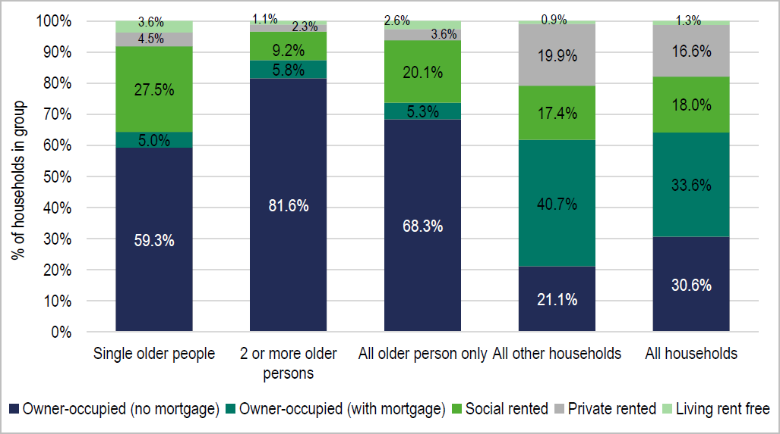

Source: 2011 Census

  - The Figure below shows the same information for local authorities (along with a regional and national comparison) – the data is provided for all older person households. The data shows that the tenure profile of older person households is similar across the study area to that seen regionally and nationally. There are however differences by local authority, the most notable one being the much lower incidence of owner- occupiers in Nottingham.

Figure 6.2: Tenure of Older Persons Households by LPA, 2011

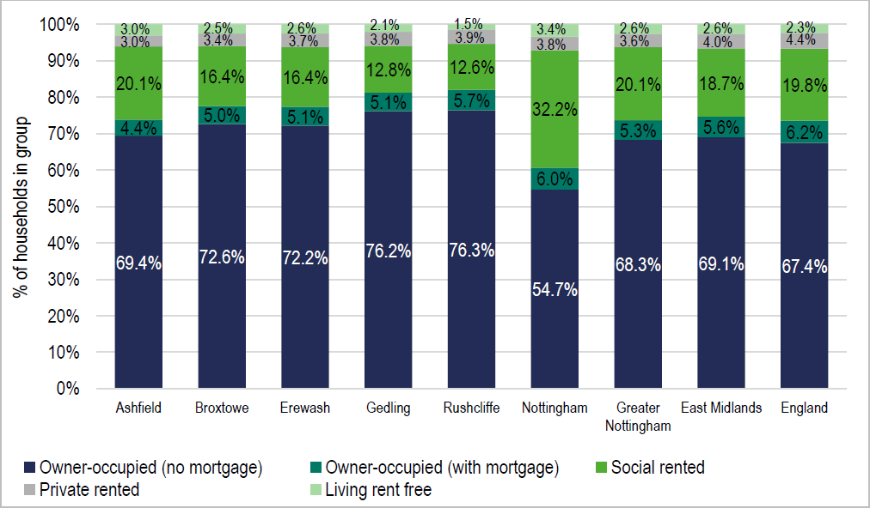

Source: 2011 Census

Prevalence of Disabilities

  - The Table below shows the proportion of people with a long-term health problem or disability (“LTHPD”) drawn from 2011 Census data, and the proportion of households where at least one person has a LTHPD. The data suggests that some 34% of households contain someone with a LTHPD. This Figure is slightly higher than that seen in other areas.

  - The figures for the population with a LTHPD again show a similar pattern in comparison with other areas (an estimated 19% of the population of the study area having a LTHPD). The analysis also shows some differences between different parts of the study area, with Ashfield seeing a notably higher proportion of the population with a LTHPD, and lower figures being seen in Rushcliffe.

Table 6.5 Households and people with a Long-Term Health Problem or Disability, 2011

 | Households containing someone with a health problem |  | Population with a health problem
 | Number | % | Number | %
Ashfield | 20,009 | 39.3% | 26,863 | 22.5%
Broxtowe | 15,919 | 34.0% | 20,591 | 18.8%
Erewash | 16,741 | 34.4% | 21,636 | 19.3%
Gedling | 17,005 | 34.5% | 21,956 | 19.3%
Nottingham | 43,177 | 34.2% | 55,382 | 18.1%
Rushcliffe | 13,363 | 29.2% | 17,479 | 15.7%
Study Area | 126,214 | 34.3% | 163,907 | 18.8%
East Midlands | 644,852 | 34.0% | 844,297 | 18.6%
England | 644,852 | 34.0% | 844,297 | 18.6%
Source: 2011 Census

  - It is likely that the age profile will impact upon the numbers of people with a LTHPD, as older people tend to be more likely to have a LTHPD. The figure below shows the age bands of people with a LTHPD. It is clear from this analysis that those people in the oldest age bands are more likely to have a LTHPD. The analysis also shows higher levels of LTHPD in each age band within Greater Nottingham and Ashfield when compared with both the regional and national position.

Figure 6.3: Population with a Long-Term Health Problem or Disability by Age

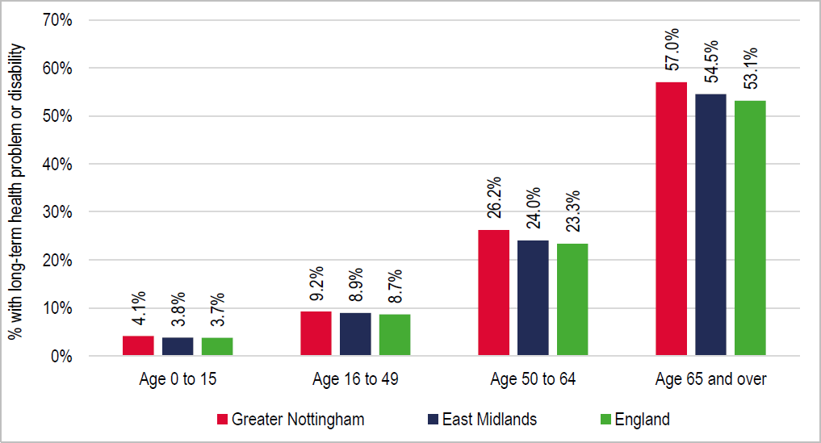

Source: 2011 Census

  - The Figure below shows the same information for each local authority. This shows some considerable variation across areas, with Ashfield and Nottingham having much higher levels of disability and notably lower figures in Rushcliffe.

Figure 6.4: Population with a Long-Term Health Problem or Disability by Age by LPA

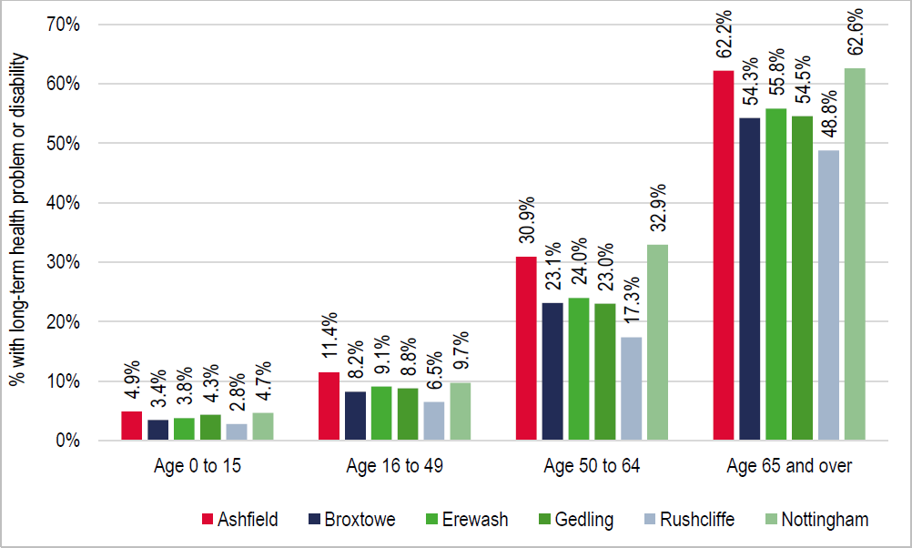

Source: 2011 Census

  - The age specific prevalence rates shown above can be applied to the demographic data to estimatethe likely increase over time of the number of people with a LTHPD. In applying this information to the demographic projections, it is estimated that the number of people with a LTHPD will increase by around 36,400 (20%) between 2020 and 2038. The population increase of people with a LTHPDrepresents 37% of the total increase in the population estimated by the projections set out in Table 6.4 (up to 47% in the case of Ashfield).

Table 6.6 Estimated Change in Population with LTHPD, 2020-38

 | Population with LTHPD |  | Change
 | 2020 | 2038 | Number | %
Ashfield | 31,076 | 37,940 | 6,864 | 22.1%
Broxtowe | 23,063 | 26,796 | 3,733 | 16.2%
Erewash | 24,391 | 29,570 | 5,179 | 21.2%
Gedling | 24,568 | 29,390 | 4,822 | 19.6%
Nottingham | 61,249 | 71,489 | 10,241 | 16.7%
Rushcliffe | 20,346 | 25,903 | 5,556 | 27.3%
Study Area | 184,693 | 221,087 | 36,394 | 19.7%
Source: Derived from Demographic Modelling and 2011 Census

  - The Figure below shows the tenures of people with a LTHPD – it should be noted that the data is for 'population living in households' rather than 'households'. The analysis clearly shows that people with a LTHPD are more likely to live in social rented housing or to be outright owners (this will be linked to the age profile of the population with a disability).

  - Given that typically the lowest incomes are found in the social rented sector, and to a lesser extent for outright owners (many of whom are retired), the analysis would suggest that the population/households with a disability are likely to be relatively disadvantaged when compared to the rest of the population in terms of income levels and therefore the ability to afford goods and services (as well as to access the housing market in many instances).

Figure 6.5: Tenure of People with LTHPD vs those without a LTHPD, 2011 –Greater Nottingham and Ashfield
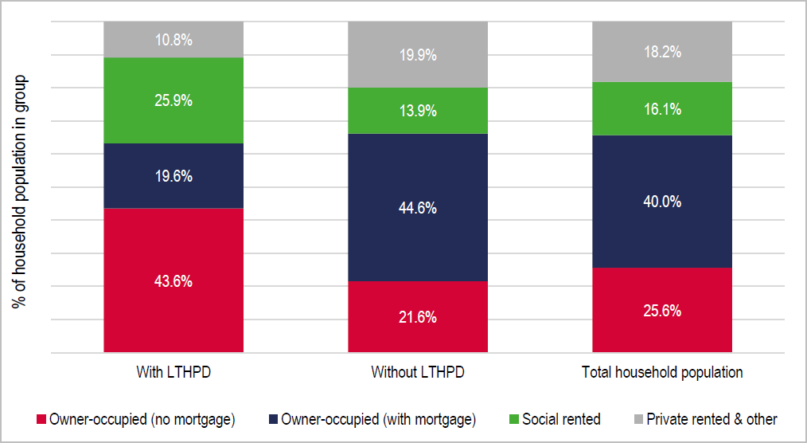

  - The Table below shows further information about the tenure split of the household population with aLTHPD. This shows that people living in the social rented sector are around twice as likely to have a LTHPD than those in other tenures.

Table 6.7 Tenure of People with a LTHPD

 | % of Social Rent with LTHPD | % of other tenures with LTHPD
Ashfield | 32.4% | 19.8%
Broxtowe | 35.3% | 16.5%
Erewash | 32.1% | 16.9%
Gedling | 31.6% | 17.5%
Nottingham | 27.3% | 15.1%
Rushcliffe | 33.5% | 13.6%
Study Area | 29.7% | 16.3%

Health Related Population Projections

  - The incidence of a range of health conditions is an important component in understanding the potential need for care or support for a growing older population as well as younger adults.

  - The analysis undertaken covers a variety of age groups and draws on prevalence rates from the PANSI (Projecting Adult Needs and Service Information) and POPPI (Projecting Older People Population Information) websites. In all cases the analysis links to estimates of population growth based on standard method housing need estimates.

  - Of particular note are the large increases in the number of older people with dementia (increasing by 55% from 2020 to 2038) and mobility problems (47% increase over the same period). Changes for younger age groups are smaller, reflecting the fact that projections are expecting older age groups to see the greatest proportional increases in population. When related back to the total projected change to the population, the increase of 14,100 people with a mobility problem represents 14% of the total projected population growth.

  - It should be noted that there will be an overlap between categories (i.e. some people will have both dementia and mobility problems). Hence the numbers for each of the illnesses/disabilities should notbe added together to arrive at a total.

Table 6.8 Projected Changes to Greater Nottingham and Ashfield OlderPopulation with a Range of Disabilities

Disability | Age Range | 2020 | 2038 | Change | % Change
Dementia | 65+ | 11,270 | 17,514 | 6,244 | 55.4%
Mobility problems | 65+ | 29,843 | 43,976 | 14,134 | 47.4%
Autistic Spectrum Disorders | 65+ | 1,533 | 2,132 | 599 | 39.1%
Learning Disabilities | 65+ | 3,407 | 4,665 | 1,257 | 36.9%
Severe hearing loss | 61+ | 13,711 | 20,461 | 6,750 | 49.2%
Moderate or severe visual impairment | 65+ | 9,764 | 13,549 | 3,786 | 38.8%
Source: POPPI/PANSI and Demographic Projections

Table 6.9 Projected Changes to Greater Nottingham and Ashfield Younger Adult Population with a Range of Disabilities

Disability | Age Range | 2020 | 2038 | Change | % Change
Impaired mobility | 16-64 | 29,440 | 29,484 | 44 | 0.1%
Common mental disorder | 18-64 | 108,939 | 113,375 | 4,435 | 4.1%
Autistic Spectrum Disorders | 18-64 | 5,792 | 6,075 | 283 | 4.9%
Downs Syndrome | 18-64 | 14,936 | 115,723 | 787 | 5.3%
Serious visual impairment | 18-64 | 361 | 376 | 15 | 4.2%
Severe hearing loss | 18-60 | 375 | 391 | 16 | 4.2%
Challenging behaviour | 15-64 | 2,240 | 2,211 | -29 | -1.3%
Source: POPPI/PANSI and Demographic Projections

  - The Table below shows the same information for local authorities (focussing just on dementia and mobility problems in the population aged 65+). This clearly identifies projected increases for these disabilities in all areas across Greater Nottingham and Ashfield for older people. A breakdown is provided for all local authorities and for all disabilities set out for older people at Appendix A2.

Table 6.10 Projected Changes to Greater Nottingham and Ashfield OlderPopulation with a Range of Disabilities by LPA (Population aged 65+)

Area | Disability | 2020 | 2038 | Change | % Change
Ashfield | Dementia | 1,619 | 2,663 | 1,044 | 64.5%
 | Mobility problems | 4,413 | 6,839 | 2,426 | 55.0%
Broxtowe | Dementia | 1,673 | 2,565 | 892 | 53.3%
 | Mobility problems | 4,436 | 6,330 | 1,894 | 42.7%
Erewash | Dementia | 1,710 | 2,716 | 1,006 | 58.8%
 | Mobility problems | 4,473 | 6,698 | 2,225 | 49.7%
Gedling | Dementia | 1,698 | 2,587 | 888 | 52.3%
 | Mobility problems | 4,565 | 6,561 | 1,997 | 43.7%
Nottingham | Dementia | 1,850 | 3,037 | 1,186 | 64.1%
 | Mobility problems | 4,799 | 7,357 | 2,558 | 53.3%
Rushcliffe | Dementia | 2,719 | 3,946 | 1,227 | 45.1%
 | Mobility problems | 7,157 | 10,191 | 3,034 | 42.4%
Study Area | Dementia | 11,270 | 17,514 | 6,244 | 55.4%
 | Mobility problems | 29,843 | 43,976 | 14,134 | 47.4%
Source: POPPI/PANSI and Demographic Projections

  - The growth shown in those with disabilities provides clear evidence justifying delivering ‘accessible and adaptable’ homes as defined in Part M4(2) 10 of Building Regulations and, where possible, ‘fully adapted homes’ as defined in Part M4(3) of the same document. The Councils should ensure that the viability of doing so is also tested as part of drawing together its evidence base.

¹⁰ This requirement is met when a new dwelling provides reasonable provision for most people to access the dwelling and includes features that make it suitable for a range of potential occupants, including older people, individuals with reduced mobility and some wheelchair users.

Requirements for Younger Adults with Disabilities

  - The Table below provides a breakdown of the projected change to each local authority’s adult population range long-term health problems and disabilities with a focus on those with impaired mobility, metal health, autism and learning disabilities. A full breakdown for all long-term health issues and disabilities is attached at Appendix A3.

  - The analysis shows that there is a substantial volume of younger adults (aged 65 and under) acrossthe study area with a range of disabilities. The number of younger adults who are mobility impaired is expected to fall in Ashfield, Broxtowe, Gedling and Erewash; whilst the number is projected to increase by around 150 people in Nottingham and Rushcliffe.

  - The number of younger adults with a common mental disorder is expected to increase in all authorityareas with a particularly high percentage increase in Rushcliffe of 9.8%.

Table 6.11 Projected Changes to Greater Nottingham and Ashfield AdultPopulation with a Range of Disabilities by LPA

Area | Disability | 2020 | 2038 | Change | % Change
Ashfield | Impaired Mobility | 4,348 | 4,327 | -21 | -0.5%
 | Common Disorder Mental | 14,529 | 15,029 | 500 | 3.4%
 | Autistic Spectrum Disorders | 755 | 779 | 24 | 3.2%
 | Learning Disabilities | 1,972 | 2,056 | 84 | 4.3%
Broxtowe | Impaired Mobility | 3,799 | 3,643 | -156 | -4.1%
 | Common Disorder Mental | 12,839 | 13,122 | 283 | 2.2%
 | Autistic Spectrum Disorders | 684 | 705 | 21 | 3.1%
 | Learning Disabilities | 1,743 | 1,806 | 63 | 3.6%
Erewash | Impaired Mobility | 3,975 | 3,861 | -114 | -2.9%
 | Common Disorder Mental | 13,090 | 13,249 | 159 | 1.2%
 | Autistic Spectrum Disorders | 681 | 687 | 6 | 0.8%
 | Learning Disabilities | 1,774 | 1,811 | 37 | 2.1%
Gedling | Impaired Mobility | 4,073 | 4,091 | 19 | 0.5%
 | Common Disorder Mental | 13,289 | 13,951 | 662 | 5.0%
 | Autistic Spectrum Disorders | 685 | 722 | 36 | 5.3%
 | Learning Disabilities | 1,797 | 1,908 | 111 | 6.2%
Nottingham | Impaired Mobility | 9,205 | 9,340 | 135 | 1.5%
 | Common Disorder Mental | 42,146 | 43,604 | 1,458 | 3.5%
 | Autistic Spectrum Disorders | 2,299 | 2,424 | 125 | 5.4%
 | Learning Disabilities | 5,871 | 6,161 | 290 | 4.9%
Rushcliffe | Impaired Mobility | 4,040 | 4,222 | 182 | 4.5%
 | Common Disorder Mental | 13,048 | 14,420 | 1,373 | 10.5%
 | Autistic Spectrum Disorders | 688 | 758 | 70 | 10.2%
 | Learning Disabilities | 1,779 | 1,980 | 201 | 11.3%
Source: POPPI/PANSI and Demographic Projections

  - Invariably, there will be a combination of those with disabilities and long-term health problems that continue to live at home with family, those who chose to live independently with the possibility of incorporating adaptations into their homes and those who choose to move into supported housing.

  - The projected change shown in the number of younger adults with disabilities provides clear evidence justifying delivering ‘accessible and adaptable’ homes as defined in Part M4(2) of BuildingRegulations, subject to viability and site suitability.

  - The PPG for Housing for Older and Disabled People [63-006] refers only to specialist housing for older people; however, clearly local authorities should support specialist housing schemes for younger adults which come forward across the plan area – particularly those aimed at supporting those with autistic spectrum disorders and learning disabilities given these disabilities are expected to see an increase in all authority areas.

  - The analysis suggests that there is likely to be some increase in the number of younger people (generally those aged 16/18 to 64) with a disability across the study area, albeit the increases will be notably lower than projected for the older person population. The analysis has shown a range of disabilities that are likely to require some degree of support, or potentially some form of specialisedhousing solution.

  - This report does not seek to be specific about the exact number of units that need to be provided fordifferent groups, nor where such accommodation should be located; it is the case that some types of specialist accommodation might have a wide catchment, and would be suitable for clients from outside of the study area (it is also possible that some people in the area would be placed in accommodation elsewhere).

  - The brief discussion below therefore broadly considers the range of options that might be relevanton the basis of the data and draws on a number of studies, reports and websites, including:

    - Mencap – Housing for people with a learning disability -
https://www.mencap.org.uk/sites/default/files/2016-08/2012.108-Housing-report_V7.pdf

    - My life my care (information provided to residents of Bournemouth, Christchurch and Poolein Dorset) - https://www.mylifemycare.com/article/6313/Housing-options-for-people-with-a-learning-or-physical-disability

    - Housing Options for Younger Adults with a Disability (NHS website) - https://www.nhs.uk/conditions/social-care-and-support-guide/care-services-equipment-and-care-homes/moving-to-a- new-home-housing-options/

  - The Mencap report notes that he majority of people with a learning disability known to local authorities live in one of three types of accommodation: with family and friends (38%), in a registered care home(22%) or in supported accommodation (16%). The majority of people with a learning disability who live with family and friends want greater independence, with around 70% wanting to change their current housing arrangements to achieve this (89% of parents whose son or daughter lives with them want to see greater independence for them). This clearly identifies for this group that there is a potential need for supported accommodation outside of the family home.

  - The report does however highlight that there are a number of barriers to achieving independent living, including local budgets, a lack of support, problems finding suitable accommodation for people withcomplex or multiple needs as well as a general lack of accommodation.

  - Whilst the Mencap report does not specifically set out the types of accommodation needed it does recommend developing a national strategy for people with learning difficulties and suggests that local authorities should include specific plans for improving the housing situation of people with a learning disability in local housing strategies – the report notes that need from this group of people is expected to increase in the future.

  - Turning to specific types of accommodation for younger people with a disability, we can consider the information provided by the NHS. The NHS website considers a wider range of needs and sets out 5 broad types of housing that might be made available. The following is taken from the NHS website:

“Teenagers and young adults with special needs or disabilities may want – or need – greater independence as they get older. But they're also likely to have care needs that mean they need alternative housing options. Those care needs may be related to, for example, physical or mental health problems, a learning disability, or drug or alcohol misuse. There are a variety of housing options they may want to consider

    - buying or renting an adapted property

    - sheltered housing schemes for younger people

    - supported housing in the community

    - supported living services

    - shared lives schemes”

  - This is a wide range of housing options, and there are likely to be different products within each of these categories. Crucially, it is important for any schemes to encourage and enable people to be as independent as reasonably possible and in addition to accommodation, it is likely that some peoplewill need assistance with ‘life skills’ such as with diet and budgeting as well as tailored care plans insome instances.

  - The range of disabilities and client groups under the general banner of ‘younger people with disabilities’ is quite wide and it is clear that there will not be a one-size fits all. The Councils should note the assessment of need in this report and also the range of possible solutions to enable peopleto live as independently as possible. The Councils should also encourage the provision of accommodation where the opportunities arise, as well as keeping information about the options as up to date as possible.

  - As noted previously, this report does not seek to provide targets for different types of accommodation, although it is clear that additional housing will be required owing to increasing demand. Local authorities should work together to ensure that there is a reasonable supply of suitable accommodation for a wide range of different client groups by encouraging the development of homes which help to meet the growing demand, such as shared living and small group independent living schemes.

Need for Specialist Accommodation for Older Persons

  - Given the ageing population and higher levels of disability and health problems amongst older people, there is likely to be an increased requirement for specialist housing options moving forward. The box below considers different types of older persons housing.

Definitions of Different Types of Older Persons’ Accommodation
Retirement living or sheltered housing (“housing with support”): This usually consists of purpose-built flats or bungalows with limited communal facilities such as a lounge, laundry room and guest room. It does not generally provide care services but provides some support to enableresidents to live independently. This can include 24-hour on-site assistance (alarm) and a warden or house manager.
Extra care housing or housing-with-care (“housing with care”): This usually consists of purpose-built or adapted flats or bungalows with a medium to high level of care available if required, through an onsite care agency registered through the Care Quality Commission (CQC).Residents are able to live independently with 24-hour access to support services and staff, and meals are also available. There are often extensive communal areas, such as space to socialise or a wellbeing centre. In some cases, these developments are known as retirement communitiesor villages - the intention is for residents to benefit from varying levels of care as time progresses.
Residential care homes and nursing homes (“care bedspaces”): These have individual rooms within a residential building and provide a high level of care meeting all activities of daily living. They do not usually include support services for independent living. This type of housingcan also include dementia care homes.
Source: Planning Practice Guidance [63-010] with Iceni Adjustments

  - The need for specialist housing for older persons is typically modelled by applying prevalence ratesto current and projected population changes and considering the level of existing supply. There are a number of ‘models’ for doing this, but they all essentially work in the same way. The model results are however particularly sensitive to the prevalence rates applied, which typically describe the proportion of people aged over 75 who could be expected to live in different forms of specialist housing.

  - Iceni and JGC have drawn on some data from the Housing Learning and Information Network (Housing LIN) Shop@ online toolkit (SHOP@ toolkit). This data is considered alongside demographic projections to provide an indication of the potential level of additional specialist housing that might be required for older people in the future. Through discussions with Housing LIN it is however clear that:

    - Housing LIN consider that the prevalence rates used should be assessed taking account ofan authority’s strategy for delivering specialist housing for older people. The degree for instance which the Council want to require extra care housing as an alternative to residential care provision would influence the relative balance of need

    - The Housing LIN model has been influenced by existing levels of provision and their view on what future level of provision might be reasonable taking account of how the market is developing, funding availability etc. There is a degree to which the model and assumptions within it do not fully capture the growing recent private sector interest and involvement in the sector.

  - What Iceni has therefore done is to consider the Housing LIN methodology first of all, to compare it with other alternative sources; and then to make some judgements on how these might be applied to Greater Nottingham and Ashfield.

  - Housing LIN’s SHOP@ toolkit sets out a series of baseline rates which form a starting point for assessing appropriate prevalence rates to apply. These baseline rates are:

    - Housing with Support (retirement/sheltered housing) – 125 units per 1,000 population aged75 and over;

    - Housing with Care (enhanced sheltered and extra-care housing) – 45 units per 1,000 population aged 75 and over; and

    - Residential care bedspaces (residential and nursing care) – 110 units (bedspaces) per 1,000 population aged 75 and over

  - Following the Housing LIN methodology, an initial adjustment has then been made to these rates toreflect the relative health of the local older person population. This has been based on Census dataabout the proportion of people aged 65 and over who have a long-term health problem or disability compared with the England average.

  - In Greater Nottingham and Ashfield, the data shows slightly worse health in the older person population and so the prevalence rates used have been increased slightly (by an average of around 7%) – this figure is based on comparing the proportion of people aged 65 and over with a LTHPD in Greater Nottingham and Ashfield (57.0%) with the equivalent figure for England (53.1%). Specific adjustments have been made for each local authority.

  - A second local adjustment has been to estimate a tenure split for the housing with support and housing with care categories. This again draws on suggestions in the Shop@ toolkit which suggeststhat less deprived local authorities could expect a higher proportion of their specialist housing to be in the market sector.

  - Using 2015 Index of Multiple Deprivation (IMD) data, the analysis suggests a wide range of levels of deprivation across the study area, with Nottingham being the 10th most deprived local authority in England (out of 326) and Rushcliffe the 318th most deprived. This suggests a higher need for market homes for older people in Rushcliffe and a higher need for affordable housing in Nottingham (other authorities fit somewhere in this range). To be clear this is market housing within the categories described above (e.g., sheltered/retirement and extra-care housing).

  - This analysis suggests a need for 182 units of specialist accommodation per 1,000 population aged 75 and over, and of these 101 (55%) are for market housing. This is before any consideration of the current supply of specialist housing is made. Data about supply draws on a database from the Elderly Accommodation Counsel (EAC).

  - The table below shows estimated needs for different types of housing linked to the standard method projections. The analysis shows a potentially high need for leasehold (i.e. market) accommodation and an apparent current surplus of affordable sheltered housing (although a shortfall in affordable Extra-care dwellings). Overall, the analysis suggests a need for 9,600 additional units by 2038 (equivalent to 530 per annum – or 15% of the need shown by the standard method).

Table 6.12 Specialist Housing Need using SHOP@ Assumptions, 2020-38 – Greater Nottingham and Ashfield

 |  | Housing demand per 1,000, 75+ | Current supply | 2020  demand | Current shortfall | Additional demand to 2038 | Shortfallby 2038
Housing with support | Rented | 57 | 9,468 | 4,318 | -5,150 | 2,305 | -2,846
 | Leasehold | 77 | 1,129 | 5,808 | 4,679 | 3,111 | 7,790
Housing with care | Rented | 24 | 668 | 1,830 | 1,162 | 977 | 2,139
 | Leasehold | 24 | 319 | 1,815 | 1,496 | 973 | 2,469
Total (dwellings) |  | 182 | 11,584 | 13,771 | 2,187 | 7,365 | 9,552
Source: Derived from Demographic Projections and Housing LIN/EAC

  - All areas with the exception of Ashfield show a surplus of rented (affordable) housing with support (e.g. sheltered housing). All areas do however show a shortfall of market housing with support (retirement housing) and also shortfalls of housing with care (e.g. extra-care) in both the leasehold (market) and rented sectors.

  - It should be recognised that although there is a potential surplus of rented housing with support, there may be cases where there are issues with the suitability of stock (i.e. lower demand bedsit sheltered provision vs higher demand modern provision) and therefore appropriate schemes shouldbe supported to meet the needs of the older and disabled population.

  - To provide an indication of the scale of the need shown by the modelling, the figures below show the proportion of the standard method housing need that would be for some form of specialist housing –these figures are heavily influenced by estimates of current supply:

    - Ashfield – 39%

    - Broxtowe – 17%

    - Erewash – 17%

    - Gedling – 19%

    - Rushcliffe – 15%

    - Nottingham – 3%

  - The tables below provide the same information for each local authority.

Table 6.13 Specialist Housing Need using SHOP@ Assumptions, 2020-38 – Ashfield

Ashfield |  | Housing demand per 1,000  75+ | Current supply | 2020  demand | Current shortfall | Additional demand to 2038 | Shortfallby 2038
Housing with support | Rented | 68 | 197 | 781 | 584 | 453 | 1,037
 | Leasehold | 78 | 0 | 903 | 903 | 523 | 1,426
Housing with care | Rented | 28 | 10 | 327 | 317 | 190 | 507
 | Leasehold | 24 | 0 | 279 | 279 | 162 | 441
Total (dwellings) |  | 199 | 207 | 2,290 | 2,083 | 1,328 | 3,410
Source: Derived from Demographic Projections and Housing LIN/EAC

Table 6.14 Specialist Housing Need using SHOP@ Assumptions, 2020-38 – Broxtowe

Broxtowe |  | Housing demand per 1,000  75+ | Current supply | 2020  demand | Current shortfall | Additional demand to 2038 | Shortfallby 2038
Housing with support | Rented | 49 | 1,581 | 560 | -1,021 | 276 | -745
 | Leasehold | 78 | 177 | 891 | 714 | 439 | 1,154
Housing with care | Rented | 21 | 38 | 241 | 203 | 119 | 322
 | Leasehold | 25 | 0 | 281 | 281 | 139 | 420
Total (dwellings) |  | 174 | 1,796 | 1,974 | 178 | 973 | 1,151
Source: Derived from Demographic Projections and Housing LIN/EAC

Table 6.15 Specialist Housing Need using SHOP@ Assumptions, 2020-38 – Erewash

Erewash |  | Housing demandper 1,000, 75+ | Current supply | 2020  demand | Current shortfall | Additional demand to 2038 | Shortfall by 2038
Housing with support | Rented | 55 | 1,709 | 639 | -1,070 | 334 | -735
 | Leasehold | 76 | 163 | 874 | 711 | 457 | 1,168
Housing with care | Rented | 24 | 40 | 271 | 231 | 142 | 373
 | Leasehold | 24 | 21 | 273 | 252 | 143 | 395
Total (dwellings) |  | 179 | 1,933 | 2,058 | 125 | 1,076 | 1,201
Source: Derived from Demographic Projections and Housing LIN/EAC

Table 6.16 Specialist Housing Need using SHOP@ Assumptions, 2020-38 – Gedling

Gedling |  | Housing demand per 1,000,  75+ | Current supply | 2020  demand | Current shortfall | Additional demand to 2038 | Shortfall by 2038
Housing with support | Rented | 51 | 1,330 | 588 | -742 | 298 | -444
 | Leasehold | 78 | 105 | 901 | 796 | 457 | 1,253
Housing with care | Rented | 22 | 64 | 252 | 188 | 128 | 316
 | Leasehold | 24 | 0 | 284 | 284 | 144 | 428
Total (dwellings) |  | 175 | 1,499 | 2,025 | 526 | 1,027 | 1,553
Source: Derived from Demographic Projections and Housing LIN/EAC

Table 6.17 Specialist Housing Need using SHOP@ Assumptions, 2020-38 – Nottingham

Nottingham |  | Housing demand per 1,000,  75+ | Current supply | 2020  demand | Current shortfall | Additional demand to 2038 | Shortfall by 2038
Housing with support | Rented | 73 | 3,746 | 1,280 | -2,466 | 662 | -1,804
 | Leasehold | 74 | 290 | 1,304 | 1,014 | 675 | 1,689
Housing with care | Rented | 30 | 423 | 531 | 108 | 275 | 383
 | Leasehold | 23 | 218 | 399 | 181 | 207 | 388
Total (dwellings) |  | 200 | 4,677 | 3,514 | -1,163 | 1,818 | 655
Source: Derived from Demographic Projections and Housing LIN/EAC

Rushcliffe |  | Housing demand per 1,000  75+ | Current supply | 2020  demand | Current shortfall | Additional demand to 2038 | Shortfallby 2038
Housing with support | Rented | 38 | 905 | 470 | -435 | 281 | -155
 | Leasehold | 76 | 394 | 936 | 542 | 559 | 1,101
Housing with care | Rented | 17 | 93 | 207 | 114 | 124 | 238
 | Leasehold | 24 | 80 | 299 | 219 | 179 | 397
Total (dwellings) |  | 156 | 1,472 | 1,911 | 439 | 1,143 | 1,582
Sources: Derived from Demographic Projections and Housing LIN/EAC

  - The provision of a choice of attractive housing options to older households is a component of achieving good housing mix. The availability of such housing options for the growing older population may enable some older households to downsize from homes which no longer meet their housing needs or are expensive to run. The availability of housing options which are accessible to older people will also provide the opportunity for older households to ‘right size’ which can help improve their quality of life.

  - The tables above should be considered as providing a set of parameters for housing need. The ultimate level of provision the Councils seek to support will be influenced by their broader strategiesfor older persons housing and care, which at the current time are developing.

  - The analysis indicates that the tenure profile of need for housing with support (such as sheltered and retirement housing) is principally for private sector provision. For housing with care (such as extra care schemes), 54% of the need is for leasehold (i.e. private sector) provision. However, there is limited provision of such schemes within the study area.

Residential Care Bedspaces

  - The analysis below provides outputs (drawing on the same sources) for the estimated need for carehome bedspaces. The analysis draws on that above, including making adjustments for the relative health of the population of the local authorities. It should be noted that the rows in tables are for bedspaces and do not have an associated tenure.

  - The table below shows the prevalence rates used and the need associated with these. The analysisshows a current shortfall and notable projected future need. Overall, it is estimated that there is a need for around 7,200 additional care and nursing home bedspaces to 2038.

 | Housing demand per 1,000.  75+ | Current supply | 2020  demand | Current shortfall | Additional demand to 2038 | Shortfallby 2038
Ashfield | 129 | 1,089 | 1,482 | 393 | 859 | 1,252
Broxtowe | 112 | 1,043 | 1,277 | 234 | 630 | 864
Erewash | 116 | 861 | 1,332 | 471 | 696 | 1,167
Gedling | 113 | 1,004 | 1,310 | 306 | 665 | 971
Nottingham | 130 | 768 | 1,237 | 469 | 739 | 1,208
Rushcliffe | 101 | 1,674 | 2,274 | 600 | 1,176 | 1,776
Study Area | 118 | 6,439 | 8,910 | 2,471 | 4,766 | 7,238
Source: Derived from Demographic Projections and Housing LIN/EAC

  - Iceni consider that this figure should be considered as a maximum level, as there is potential for some of this need to be met through provision of extra care housing. This will relate to needs arising for residential rather than nursing care.

Older Persons’ Housing, Planning Use Classes and Affordable Housing Policies

  - The issue of use classes and affordable housing generally arises in respect of extra care/ assisted living development schemes. Page 76 provides a definition of extra care housing or housing with care from the PPG on Housing for Older and Disabled People.

  - There is a degree to which different terms can be used for this type of development inter-changeably,with reference sometimes made to extra care, assisted living, continuing care retirement communities, or retirement villages. Accommodation units typically include sleeping and living accommodation, bathrooms and kitchens; and have their own front door. Properties having their own front doors is not however determinative of use.

  - The distinguishing features of housing with care is the provision of personal care through an agency registered with the Care Quality Commission, and the inclusion of extensive facilities and communalspace within these forms of development, which distinguish them from blocks of retirement flats.

Use Classes

  - Use classes are defined in the Town and Country Planning (Use Classes) Order 1987. Use Class C2: Residential Institutions is defined as “use for the provision of residential accommodation and care to people in need of care (other than a use within class C3 (dwelling houses).” C3 (dwelling houses) are defined as “use as a dwelling house (whether or not as a sole or main residence) a) bya single person or by people living together as a family; or b) by no more than 6 residents living together as a single household (including a household where care is provided for residents).”

  - Care is defined in the Use Classes Order as meaning “personal care for people in need of such care by reason of old age, disablement, past or present dependence on alcohol or drugs or past or present mental disorder, and in class C2 also includes the personal care of children and medical care and treatment.”

  - Personal care has been defined in Regulations as “the provision of personal care for persons who, by reasons of old age, illness or disability are unable to provide it for themselves, and which is provided in a place where those persons are living at the time the care is provided.”

  - Government has released new Planning Practice Guidance of Housing for Older and DisabledPeople in June 2019. In respect of Use Classes, Para 63-014 therein states that:

“It is for a local planning authority to consider into which use class a particular developmentmay fall. When determining whether a development for specialist housing for older people falls within C2 (Residential Institutions) or C3 (Dwelling house) of the Use Classes Order, consideration could, for example, be given to the level of care and scale of communal facilities provided.”

  - The relevant factors identified herein are the level of care which is provided, and the scale of communal facilities. It is notable that no reference is made to whether units of accommodation have separate front doors. Iceni view this as consistent with the Use Classes Order, where it is the ongoing provision of care which is the distinguishing feature within the C2 definition. In a C2 use, the provision of care is an essential and ongoing characteristic of the development and would normally be securedas such through the S106 Agreement.

  - Iceni has reviewed a range of appeal decisions which have addressed issues relating to how to define the use class of a development. These are fact specific, and there is a need to consider the particular nature of the scheme. What arises from this, is that schemes which have been accepted as a C2 use commonly demonstrate the following characteristics:

    - Occupation restricted to people (at least one within a household) in need of personal care, with an obligation for such residents to subscribe to a minimum care package. Whilst there has been debate about the minimum level of care which residents must sign-up to, Iceni’s view is that this should not be determinative given that a) residents’ care needs would typically change over time, and in most cases increase; and b) for those without a care need the relative costs associated with the care package would be off-putting.

    - Provision of access to a range of communal areas and facilities, typically beyond that of simply a communal lounge, with the access to these facilities typically reflected in the servicecharge.

NPPF Policies on Affordable Housing

  - Iceni considers that the Use Class on its own need not be determinative on whether affordable housing provision could be applied. In all cases we are dealing with residential accommodation. Butnor is there a clear policy basis for seeking affordable housing provision or contributions from a C2 use in the absence of a development plan policy which seeks to do so.

  - The 2019 NPPF sets out in Para 34 that Plans should set out the contributions expected from development, including levels of affordable housing. Such policies should not undermine thedeliverability of the Plan. Para 62 states that where a need for affordable housing is identified, planning policies should specify the type of affordable housing required, and expect it to be met on-site unless off-site provision or a financial contribution can be robustly justified; and the agreed approach contributes to the objective of creating mixed and balanced communities.

  - Para 63 states that affordable housing should not be sought from residential developments that arenot major developments. Para 64 sets out that specialist accommodation for a group of people withspecific needs (such as purpose-built accommodation for the elderly or students) is exempt from therequirement for 10% of homes (as part of the affordable housing contribution) to be for affordable home ownership. But neither of these paragraphs set out that certain types of specialist accommodation for older persons are exempt from affordable housing contributions.

  - The implication for the Greater Nottingham and Ashfield authorities is that, in Iceni’s view:

    - The ability to seek affordable housing contributions from a C2 use at the current time is influenced by how its current development plan policies were constructed and evidenced; and

    - If policies in a new development plan are appropriately crafted and supported by the necessary evidence on need and viability, affordable housing contributions could be sought from a C2 use through policies in a new Local Plan.

  - Within forthcoming Local Plans, it would be possible to craft a policy in such a way that affordable housing could be sought on extra care housing from both C2 and C3 use classes. Neither the NPPFnor Use Classes Order appear to preclude this.

  - It is however important to recognise that the viability of extra care housing will differ from general mixed tenure development schemes, and there are practical issues associated with how mixed tenure schemes may operate. The Councils need to consider these in developing a policy.

Viability

  - There are a number of features of a typical extra care housing scheme which can result in substantively different viability characteristics relative to general housing. In particular:

    - Schemes typically include a significant level of communal space and on-site facilities, such that the floorspace of individual units might equate to 65% of the total floorspace, compared to 100% for a scheme of houses and perhaps 85% for typical flatted development. There isa significant proportion of space from which value is not generated through sales;

    - Higher construction and fit out costs as schemes need to achieve higher accessibility requirements and often include lifts, specially adapted bathrooms, treatment rooms etc. In many instances, developers need to employ third party building contractors who are also not able to secure the same economies of scale as the larger volume housebuilders;

    - Sales rates are also typically slower for extra care schemes, not least as older residents are less likely to buy ‘off plan.’ The combination of this and the limited ability to phase flatted schemes to sales rates can result in higher finance costs for a development.

  - There are a number of implications arising from this. Firstly, there is a need for viability evidence to specifically test and consider what level of affordable housing could be applied to different forms of older persons accommodation, potentially making a distinction between general market housing; retirement living/sheltered housing; and extra care/housing with care. It may well be that a differential and lower affordable housing policy is justified for housing with care.

  - Secondly, developers of extra care schemes can struggle to secure land when competing against mainstream housebuilders or strategic land promoters. One way of dealing with this is to allocate sites specifically for specialist older persons housing, and this may be something that the Councils wish to consider through the preparation of new Local Plans. There could be benefits of doing this through achieving relatively high density development of land at accessible locations, and in doing so, releasing larger family housing elsewhere as residents move out.

Practical Issues

  - In considering policies for affordable housing provision on housing with care schemes, there is one further factor which warrants consideration relating to the practicalities of mixed-tenure schemes. The market for extra care development schemes is currently focused particularly towards providers at the affordable and higher ends of the market, with limited providers currently delivering within the‘mid-market.’ At the higher ends of the market, the level of facilities and services/support available can be significant, and the management model is often to recharge this through service charges.

  - Whilst recognising the benefits associated with mixed income/tenure development, in considering whether mixed tenure schemes can work it is important to consider the degree to which service charges will be affordable to those on lower incomes and whether Registered Providers will want orbe able to support access to the range of services/facilities on site. In a range of instances, this hasmeant that authorities have accepted off- site contributions to affordable housing provision.

Wheelchair User Housing

  - Information about the need for housing for wheelchair users is difficult to obtain (particularly at a local level). National data within a research report by Habinteg Housing Association and London South Bank University (Supported by the Homes and Communities Agency) entitled Mind the Step: An estimation of housing need among wheelchair users in England (2010) has therefore been used. This report provides information at a national and regional level although there are some doubts about the validity even of the regional figures; hence the focus herein is on national data.

  - The report identifies that around 84% of homes in England do not allow someone using a wheelchair to get to and through the front door without difficulty and that once inside, it gets even more restrictive. Furthermore, it is estimated, based on English House Condition Survey data, that just 0.5% of homes meet criteria for ‘accessible and adaptable’, while 3.4% are ‘visitable’ by someone with mobility problems (information from the CLG Guide to available disability data (taken from the English Housing Survey) puts the proportion of ‘visitable’ properties at a slightly higher 5.3%).

  - Overall, the report estimates that there is an unmet need for wheelchair user dwellings equivalent to 3.5 per 1,000 households. Moving forward, the report estimates a wheelchair user need from around 3% of households.

  - Applying both of these figures to the demographic projections (as set out in the Table below) suggests a need for around 3,200 wheelchair user homes in Greater Nottingham and Ashfield in the period to 2038. Comparing the need for wheelchair dwellings shown to the local housing need, the need for wheelchair user dwellings equates to about 5% of the total housing need. This would therefore be a suitable policy benchmark for the level of provision required.

Table 6.20 Estimated Need for Wheelchair User Homes, 2020-2038

 | Current Need | Projected Need (2020-38) | Total
Ashfield | 196 | 252 | 448
Broxtowe | 174 | 193 | 367
Erewash | 181 | 206 | 386
Gedling | 184 | 240 | 425
Nottingham | 482 | 602 | 1,085
Rushcliffe | 175 | 317 | 492
Study Area | 1,393 | 1,810 | 3,203
Source: Derived from Demographic Projections and Habinteg Prevalence Rates

  - Information in the CLG Guide to available disability data also provides some historical national dataabout wheelchair users by tenure (data from the 2007/8 English Housing Survey). This showed around 7.1% of social tenants to be wheelchair uses, compared with 2.3% of owner-occupiers (therewas insufficient data for private renting, suggesting that the number is low).

  - This may impact on the proportion of different tenures that should be developed to be for wheelchairusers (although it should be noted that the PPG on Housing and Economic Needs Assessments [56-009] states that ‘Local Plan policies for wheelchair accessible homes should be applied only to thosedwellings where the local authority is responsible for allocating or nominating a person to live in thatdwelling’). For market housing, policy can however require delivery of wheelchair-adaptable dwellings, this being a home that can easily be adapted to meet the needs of a household includingwheelchair users.

Borough & District Summary: Older Person’s Needs & Those with Disabilities

The population of older persons is increasing, driven by demographic changes including increasing life expectancy. This is a key driver of the need for housing which is capable of meeting the needs of older persons.
Greater Nottingham and Ashfield is projected to see a notable increase in the older person population, with the total number of people aged 65 and over projected to increase by 38% over the 18-years to 2038. This compares with overall population growth of 11% and a modest increase in the Under 65 population of 5%.
Linked particularly to a growing older population, it is estimated that the number of people with a LTHPD will increase by around 36,400 (20%) between 2020 and 2038 across the study area. The population increase of people with a LTHPD represents 37% of the total increase in the population estimated by the projections set out in Table 6.4 (up to 47% in the case of Ashfield).
In Ashfield, a need is shown for 2,463 housing with support units, such as sheltered housing or retirement living, over the period to 2038, the majority of which are expected to be leasehold. There is also a need for 948 housing with care units, with a need for both market and affordable provision. Additionally, there is a need for 1,252 care or nursing home bedspaces.
In Broxtowe, a need is shown for 1,154 housing with support units over the period to 2038, all of which are expected to be leasehold. There is also a need for 742 housing with care units, with a need for both market and affordable provision. Additionally, there is a need for 864 care or nursing home bedspaces.
In Erewash, a need is shown for 1,168 housing with support units over the period to 2038, all of which are expected to be leasehold. There is also a need for 769 housing with care units, with a need for both market and affordable provision. Additionally, there is a need for 1,167 care or nursing home bedspaces.
In Gedling, a need is shown for 1,253 housing with support units over the period to 2038, all of which are expected to be leasehold. There is also a need for 744 housing with care units, with a need for both market and affordable provision. Additionally, there is a need for 971 care or nursing home bedspaces.
In Nottingham, a need is shown for 1,689 housing with support units over the period to 2038, all of which are expected to be leasehold. There is also a need for 770 housing with care units, with a need for both market and affordable provision. Additionally, there is a need for 1,776 care or nursing home bedspaces.
In Rushcliffe, a need is shown for 1,101 housing with support units over the period to 2038, all of which are expected to be leasehold. There is also a need for 635 housing with care units, with a need for both market and affordable provision. Additionally, there is a need for 1,208 care or nursing home bedspaces.
There is also a need for wheelchair user housing in all authority areas. Across the study area, the analysis has shown the need for wheelchair user dwellings equates to about 5% of the total housing need of Greater Nottingham and Ashfield. The Councils should include policies to support provision of suitable wheelchair- accessible homes given there is an identified need.

STUDENT HOUSING NEEDS

  - This section considers the needs of students in Broxtowe Borough.

The Existing Profile of Student Housing Need

  - The NPPF is clear that the needs of students (and other groups within the housing market) shouldbe assessed and reflected in planning policies.

  - Across the study area at the point of the 2011 Census, there were around 62,000 full time studentsaged 18 and over with around three quarters of these students living in Nottingham City.

  - The area has two higher education (HE) establishments which are relevant to this assessment - the University of Nottingham and Nottingham Trent University - as well as a number of further education colleges. However, the data allowing us to track trends in student numbers year-on-year for further education establishments is not consistently available. It is HE students which principally impact on the housing market, and therefore the assessment focuses on these.

  - We have access to data allowing us to track trends in student numbers for the University of Nottingham and Nottingham Trent University from the Higher Education Statistics Agency (“HESA”).Drawing on data from the HESA, the Figures below sets out the pattern of growth over the last 10 years from 2008/09 to 2018/19 across the two Universities.

  - As of 1st September 2018, the University of Nottingham had 33,545 full and part-time UG and PG students. Nottingham Trent University had 33,255 full and part-time UG and PG students, which is the highest total number of students at the University in the last decade.

Figure 7.1: Profile of Student Population at University of Nottingham

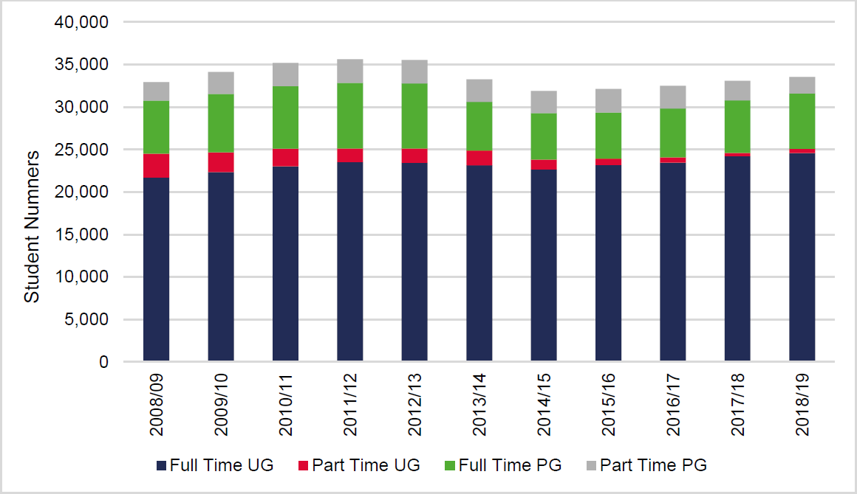

Source: HESA 2019

Figure 7.2: Profile of Student Population at Nottingham Trent University

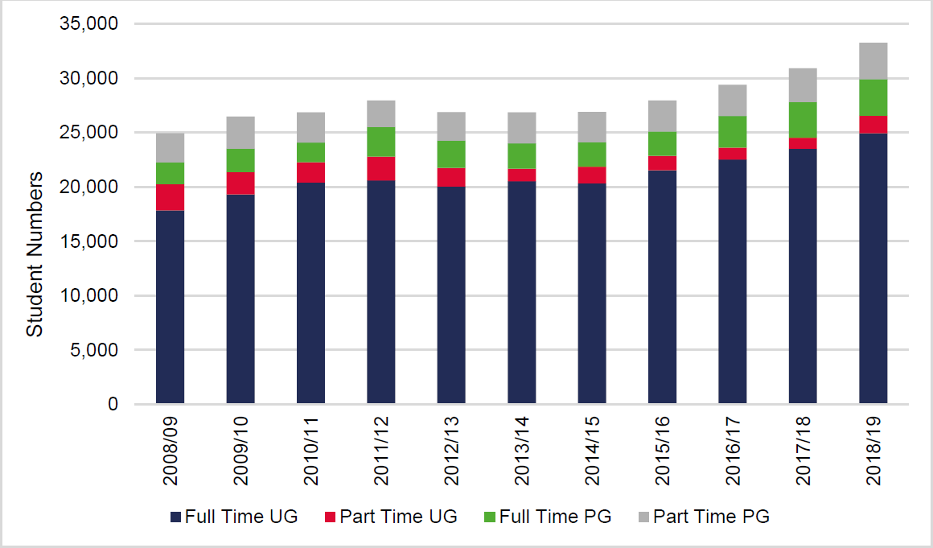

Source: HESA 2019

  - At the University of Nottingham, the number of full time undergraduates grew over the 2008-18 period by 3,250 students whilst the number of part time undergraduates fell by 2,865 students. Across the ten year period, the number of postgraduate students increased modestly by 60 students.

  - At Nottingham Trent University, the number of full time undergraduates increased by a substantial 7,080 students equal to 40% over the ten year period; whilst the number of part-time undergraduatesfell by 800 students. The growing number of full-time students will have had a greater impact on housing across the study area.

  - Housing needs arise principally as a result of full-time students (with those studying part time typically also working relatively locally or living with parents). As of 1st September 2018, there were 31,675 full-time students at the University of Nottingham and 28,620 full-time students at Nottingham TrentUniversity. The trend in the total number of full time students is shown in the Figure below.

Figure 7.3: Trends in Full Time Higher Education Students in Greater Nottinghamand Ashfield

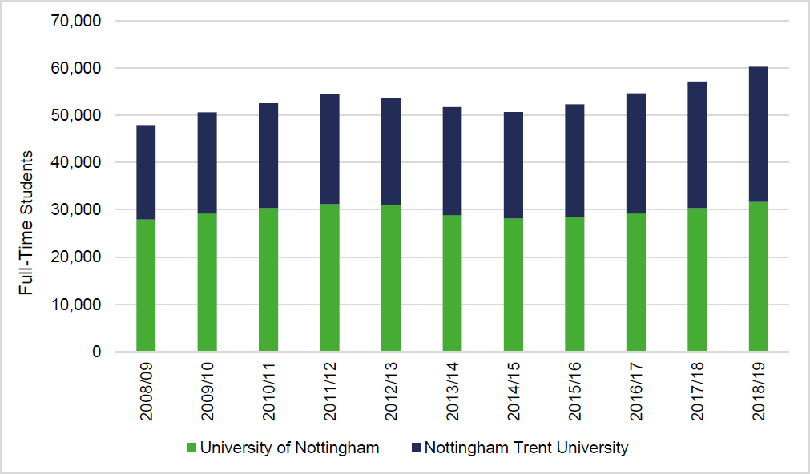

Source: HESA 2019

  - It is notable that both establishments experienced a fall in the number of full time students followingthe introduction of an increase in student fees by the Government in 2011; however, student numbers have increased again in recent years; with full-time student numbers at Nottingham Trent Universitynow at their highest level over the last 10 years.

  - At 1st September 2011, there was a total of 54,515 full-time students at the University of Nottinghamand Nottingham Trent University; suggesting that the two Universities accounted for around 88% ofall full time students aged 18 and over at the point of the 2011 Census. By 2018/19, the number hadrisen by 11% to 60,295 students.

The Profile of Accommodation and Concentrations of Houses in Multiple Occupation

  - At the point of the 2011 Census, there were around 62,000 full time students aged 18 and over across the study area. The Table below sets out a breakdown of this by age and authority area; demonstrating that of the 62,000 students, around 46,000 (74%) were based in Nottingham City. Thesecond largest concentration of students was in Rushcliffe (4,563) followed by Broxtowe (4,412).

Table 7.1 Profile of Full Time Students Aged 18 and Over

Age | Ashfield | Broxtowe | Erewash | Gedling | Nottingham | Rushcliffe
Aged 18-19 | 1,124 | 1,313 | 1,102 | 1,228 | 13,381 | 1,651
Aged 20-24 | 635 | 1,698 | 650 | 790 | 25,597 | 2,216
Aged 25 and Over | 518 | 1,401 | 591 | 603 | 6,943 | 696
Total (No.) | 2,277 | 4,412 | 2,343 | 2,621 | 45,921 | 4,563

  - Across the study area, where students live varies markedly, which is likely to partly reflect the natureof students living in each of the authority areas. For instance, at the point of the 2011 Census, around 70% of the students living in Gedling lived with parents; but only 36% did so in Broxtowe and only 10% did so in Nottingham City. The Table below sets out the profile of full time students and their accommodation across the authority areas at the last census.

Table 7.2 Profile of Full Time Students Aged 18 and Over by Accommodation Type (%)

Accommodation Type | Ashfield | Broxtowe | Erewash | Gedling | Nottingham | Rushcliffe
Living with Parents | 68% | 36% | 66% | 70% | 10% | 36%
University Communal | 4% | 0% | 0% | 0% | 24% | 13%
Other Communal | 0% | 0% | 2% | 0% | 4% | 0%
All Student Household | 4% | 31% | 7% | 7% | 44% | 33%
Living Alone | 3% | 4% | 4% | 4% | 5% | 2%
Other | 21% | 29% | 21% | 20% | 13% | 16%
Total (No.) | 2,277 | 4,412 | 2,343 | 2,621 | 45,921 | 4,563
Source: 2011 Census

  - Beyond those students living at home, as the analysis shows, 31% of students aged 18 and over lived in an all student household in Broxtowe Borough; 44% in Nottingham City and 33% in Rushcliffe. It is notable that students residing in this form of student accommodation typically live in HMOs; and in some instances, the number of HMOs can become concentrated in particular areas.

  - It is particularly notable that around 90% of students living in HMOs in Broxtowe Borough were concentrated in the Beeston area. This area is located at the western end of the University of Nottingham’s Park Campus.

  - Although it is not uncommon for areas with a high population of students to have a number of all student HMOs, it is important that a mix of residential accommodation is maintained within the neighbourhood. In particular:

    - Student populations are transient and thus concentrations of HMOs can create relatively transient communities of people with a high population turnover. This can, in some circumstances, lead to issues of environmental upkeep and fly-tipping.

    - Areas with concentrations of HMOs are those in which there is an above average proportionof properties owned by landlords rather than owner occupiers. This can result in reduced investment in the upkeep of properties, which can lead to a general downward trend in neighbourhood quality.

    - Growth in student HMOs within an area can inhibit the availability and supply of homes for other groups within the population, such as for families.

  - Through discussions with local lettings agents, it is noted that Beeston is known for higher quality compared with areas such as Lenton. Letting agents found that the area continues to maintain a balance of housing with a greater focus towards families, as well as young professionals and students. One letting agent also noted that “there has been a recent [i.e. last 5 years] surge of investment in the Beeston area to upgrade the standard of shared student housing”. Agents also highlighted that a number of local businesses benefit from the number of young professionals and students in the area.

  - Nevertheless, with regards to Beeston, where concentrations of student housing exist, it may be appropriate to consider introducing an Article 4 Direction to remove permitted development rights forthe change of use from a dwelling house (Use Class C3) to an HMO (Use Class C4) in order to ensure a balance of housing is maintained moving forward; and communities remain mixed but balanced.

  - The Figure below shows the spread of HMOs as well as homes subject to a student exemption for Council Tax across Broxtowe Borough. There is a particular concentration shown in the Beeston Central ward; as well as smaller numbers in the Beeston West, Beeston North and Beeston Rylandswards.

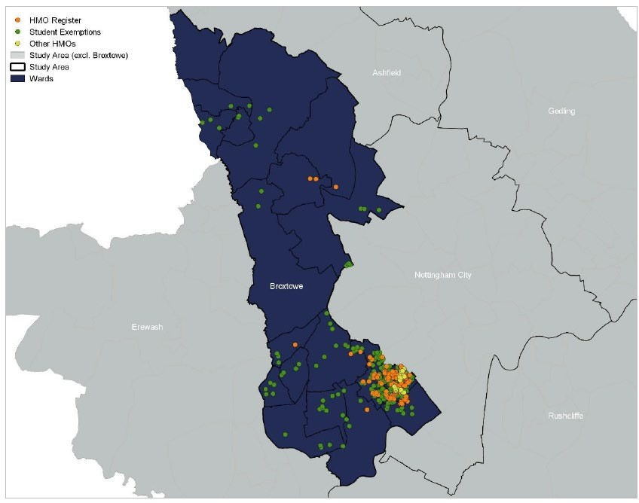

  - Taking the 2011 Census household profile for these four wards as a basis, with a total of 9,347 households at 2011, the number of HMOs at 142 would represent 1.5% of all households if applying the 2018 HMO figures to the Census base. This does not suggest there is a substantial concentration of HMOs at a ward level.

  - The majority of the licensed HMOs are situated in the Beeston Central ward. As at 2018, 69% (equalto 98 HMOs) of Beeston’s HMOs are situated in the Beeston Central ward. However, taking the number of households in Beeston Central at 2,180 at the point of the 2011 Census; we note that this would only represent 4.5% of all households.

  - However, it is important to look at the issue beyond a ward level. The Figure below shows the position at a smaller scale across the Beeston wards with a focus on particular streets. This shows that there are clusters of HMOs in certain areas of the Beeston Central ward including along Lower Road andBroadgate, which are all close to University Boulevard and in close proximity to the University of Nottingham. There are also clusters in close proximity to Beeston Railway Station, with clusters along Queens Road West (Beeston Central) and Lilac Grove (Beeston Rylands).

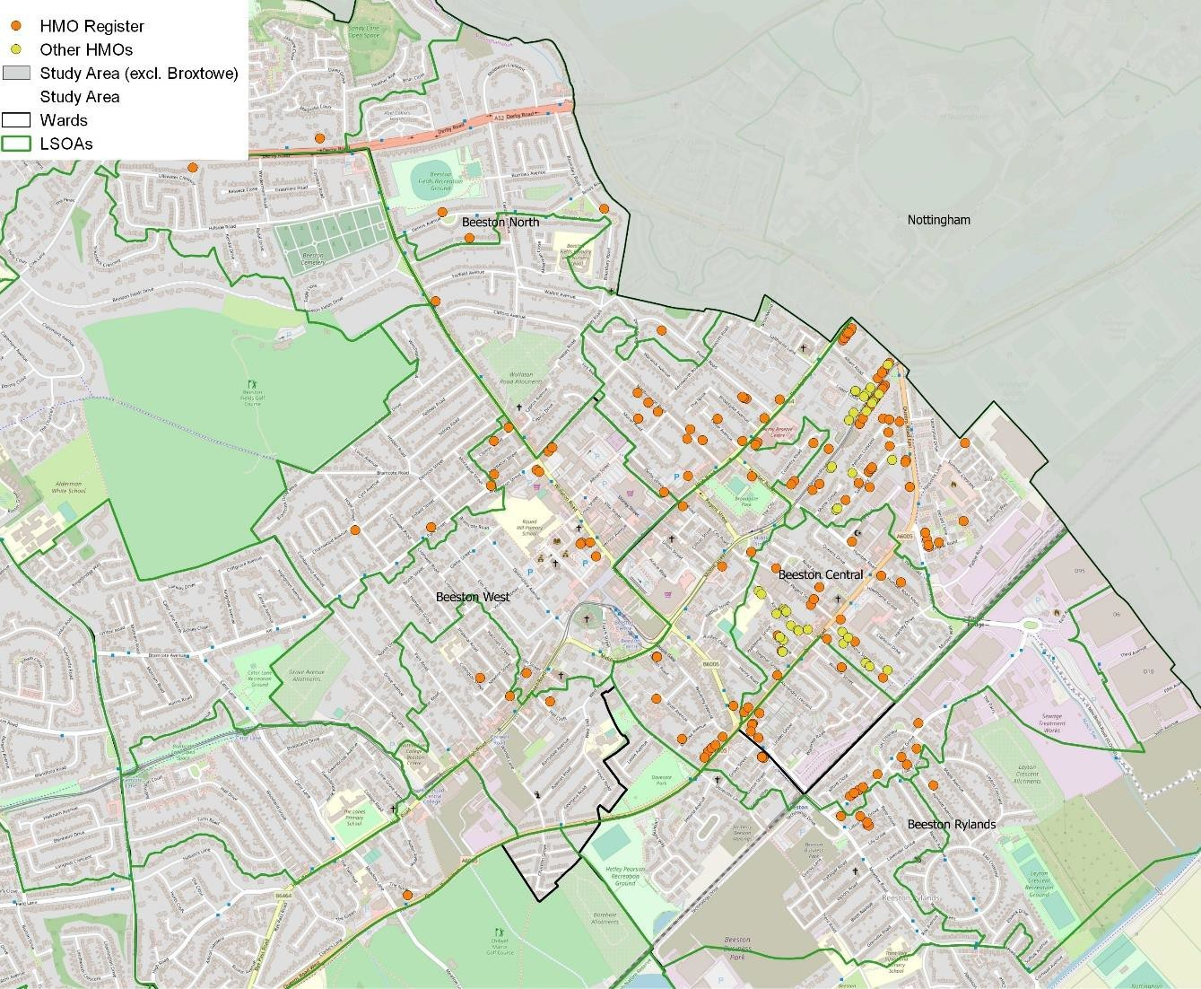

  - In some instances, particularly around areas close to the University of Nottingham’s Park Campus along Broadgate and Lower Road, there are concentrations of 7 to 9 HMOs within a single row or block.

  - The Figure below shows how the number of new licensed HMOs has grown year-on-year since 2007in the Beeston area to reach a total of 142 licensed HMOs as at 2019. The numbers elsewhere in the Borough are modest. This data is drawn from the public register of licensable HMOs, which is maintained by the Council in accordance with Section 232 of the Housing Act. It points to rapid recentgrowth.

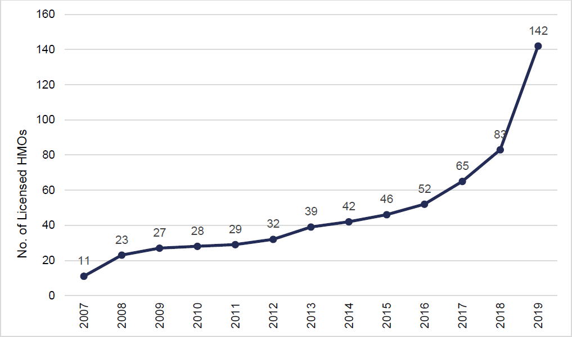

Source: Public Register of Licensable HMOs

  - The number of licensed HMOs in the Beeston area has grown by 238% over the last five years from 42 to 142 HMOs which is clearly substantial growth in percentage terms; with an additional 90 HMOslicensed over the last 3 years. This is clearly significant in relative terms.

  - Looking to Nottingham by way of comparison, the Housing Nottingham Plan (i.e. the City’s Housing Strategy) has placed particular importance on making new student developments sufficiently attractive and affordable for students in all years of study to be persuaded that the purpose-built market is a better option than shared housing in communities.

  - Nottingham City has an estimated 7,261 HMOs which includes licenced, known and suspected. Of the 2,147 HMOs with a mandatory licence and 4,124 HMOs with a non-mandatory licence, 581 (equalto 27%) and 967 (equal to 23%) are located in the Lenton and Wollaton East ward of Nottingham respectively. This ward directly adjoins the Beeston West and Beeston Central wards; and there are particular concentrations on streets around these areas outside of the Broxtowe boundary. Nottingham introduced an Article 4 Direction in March 2011.

  - Although the evidence suggests that as a proportion of all households, the total number of licensedHMOs across the four Beeston wards where HMOs are concentrated is relatively low at a ward level; as is shown in Figure 7.5, there are notable clusters and concentrations forming on particular streets in Broxtowe – principally on:

    - Lower Road, Beeston Central;

    - Broadgate, Beeston Central;

    - Salisbury Street, Beeston Central;

    - Queens Road, Beeston Central; and

    - Lilac Grove, Beeston Rylands.

  - In order to ensure that this area remains mixed but balanced; it is considered that there is sufficient evidence to justify Broxtowe Borough Council introducing an Article 4 Direction covering these streets. This would mean that planning permission will be required for a change of use from Class C3 (dwelling house) to Class C4 (small house in multiple occupation - HMO).

  - However, it is recognised that by defining an Article 4 Direction too narrowly, there is a risk that student concentrations could simply spread to adjoining streets. The Council should take this into account in drawing the boundary to be covered by the Article 4 Direction within the Beeston area.

Purpose-Built Student Accommodation

  - Whether HMO numbers grow over time will be influenced by:

    - Future trends in student numbers at the universities;

    - Delivery of purpose-built student accommodation; and

    - Student decisions regarding the balance between accommodation cost and quality.

  - The number of schemes being built out or coming forward through the planning process for purpose-built accommodation is significant. The Table below sets out schemes approved or pendingconsideration from 1st January 2017 onwards and shows that there are 342 bedspaces currently under construction or subject to determination in Broxtowe.

Table 7.3 Purpose-Built Student Accommodation

Planning Application Address [Ref] | Proposal | Status
1 Queens Road East, Beeston [19/00799/FUL] | Student accommodation building providing 32 bedrooms. | Pending Consideration
Neville Sadler Court, Beeston [18/00607/FUL] | Change of Use of 28 flats to student accommodation (17 cluster flats) and construction of 3 cluster flats (providing 83 bedspaces in total). | Approved and Under Construction
Dagfa House School, Broadgate, Beeston [17/00607/FUL] | Student accommodation, providing 136 bedspaces. | Approved and Under Construction
Dagfa House School, Broadgate, Beeston [17/00608/FUL] | Student accommodation providing 91 bedspaces following demolitionof school buildings. Additional to 17/00607/FUL. | Approved and Under Construction
Total Bedspaces: |  | 342

  - As the number of bedspaces being brought forward in Broxtowe through purpose-built developmentand prospective planning applications would suggest, there is demand outside of traditional shared accommodation and HMOs in favour of purpose-built accommodation.

  - Nottingham City is also seeing substantial growth in the development of purpose-built student accommodation with 6,488 bedspaces in purpose-built dwellings delivered between 1st April 2011 and 31st March 201814. The latest Purpose Built Student Accommodation Vacancy Survey for 2018/19 recorded a vacancy rate of only 0.3% in Nottingham City which has fallen from 1.6% in 2014/15. (14 Nottingham City Council Annual Monitoring Report (March 2019): Appendix 4)

  - Furthermore, Nottingham City Council expects around 5,500 bedspaces to come forward through pipeline development schemes in the coming years (15 Nottingham City Council Annual Monitoring Report (March 2019): Appendix 5)

  - Overall, considering the scale of recent purpose-built provision in Nottingham City coupled with the substantial level of pipeline supply; there is clearly a moving shift away from HMOs to purpose-built accommodation in the City Centre; however, it is important to recognise that provision has not beenkeeping pace with increases in the student population in Nottingham. Nevertheless, moving forward, once coupled with Broxtowe’s supply, Iceni consider that purpose-built provision has the potential tohave a notable impact on the quantum and concentration of HMOs in and around the Beeston area.

  - Through discussions with local letting agents, we also note that one of the main reasons student numbers have increased in Beeston is due to the lack of development in areas such as Lenton andDunkirk – which students have historically preferred; however, further provision of purpose-built accommodation moving forward could help to reverse this trend, such as the North of Jubilee Campus development at Nottingham University which is expected to be available for the September 2021 intake.

Future Student Housing Needs

  - In order to understand how the profile of Beeston and other surrounding areas where students reside are likely to evolve over time, Iceni have engaged directly with the two Universities in Nottingham todiscuss the likely future trends in student numbers and the associated influence of this change on local dynamics and the balance of existing communities.

  - The University of Nottingham has provided us with a breakdown of its recruitment targets over the five-year period to 2024/25; however, it should be noted that these are subject to change and are simply a broad prediction.

  - The results of this are shown in the Table below; indicating that total student numbers enrolling at the University for the first time is expected to grow at an average compound growth rate of 0.7% perannum or around 100 students per annum on average.

Table 7.4 University of Nottingham Recruitment Targets by Level of Study

Level of Study | 2020/21 | 2021/22 | 2022/23 | 2023/24 | 2024/25
Undergraduate Home/EU | 7,048 | 7,159 | 7,200 | 7,208 | 7,216
Undergraduate International | 1,530 | 1,513 | 1,543 | 1,557 | 1,557
Postgraduate Taught Home/EU | 1,640 | 1,703 | 1,754 | 1,758 | 1,768
Postgraduate Taught International | 3,196 | 3,180 | 3,269 | 3,332 | 3,342
Postgraduate Research Home/EU | 613 | 621 | 628 | 629 | 629
Postgraduate Research International | 362 | 362 | 362 | 364 | 364
Total | 14,389 | 14,538 | 14,756 | 14,838 | 14,896
Source: University of Nottingham

  - Nottingham Trent University has been unable to provide us with an indication of its recruitment targets; however, owing to the location of Nottingham Trent University in comparison to the University of Nottingham (situated adjacent to Beeston), growth in student numbers is less likely to have a direct impact on the character of the area and mix of housing which we are specifically considering in this section.

  - Nevertheless, it is possible to review trends in the growth of full-time student numbers over the last five years at the University by way of sensitivity analysis to understand the number of bedspaces which could be required. Drawing on the HESA data set out in Figure 7.2, over the last five years from 2013/14 to 2018/19, full- time student numbers increased by 5,445 which is equal to an averageof 1,089 per annum.

  - Drawing the above together, over the next five years, we could expect an increase of around 5,500 to 6,000 full-time students requiring accommodation within and around Nottingham with the vast majority of this arising from Nottingham Trent University. This is set against pipeline supply of around 5,850 purpose-built student accommodation (“PBSA”) bedspaces which are expected to come forward across Nottingham City and Broxtowe in the coming years.

Table 7.5 Indicative Student Growth vs Pipeline Supply of PBSA Bedspaces

Level of Study | 2020/21 | 2021/22 | 2022/23 | 2023/24 | 2024/25
University of Nottingham | 100 | 100 | 100 | 100 | 100
Nottingham Trent (Trend-Based) | 1,089 | 1,089 | 1,089 | 1,089 | 1,089
Student Growth (2020/21 - 2024/25) | 5,945 Students
Pipeline Supply of PBSA Bedspaces (at 1st April 2019) | 5,850 Bedspaces

Source: University of Nottingham and Iceni Analysis

  - Overall, with particular regard to low levels of planned student growth at the University of Nottingham given the influence of its location in close proximity to Beeston, it does not appear that the recruitment ambitions of the Universities is likely to have a significant impact on the character or mix of housingin Broxtowe over the next five years when set against planned provision of purpose-built student accommodation in Nottingham and Broxtowe.

  - It is important to note however that the assessment of student growth is based on a short-term five-year period, it is indicative and is subject to change. The Council should therefore continue to liaisewith the Universities as appropriate to ensure that student growth does not continue to outstrip the supply of purpose- built student accommodation moving forward, which could lead to greater pressure on the balance of existing communities.

Summary: Student Housing Needs

The NPPF is clear that the needs of students should be assessed and reflected in planning policies. Across the study area at the point of the 2011 Census, there were around 62,000 full time students aged 18 and over with around three quarters of these students living in Nottingham City.
The area has two higher education establishments which are relevant to this assessment including the University of Nottingham and Nottingham Trent University, as well as a number of further education colleges. As of 1st September 2018, the University of Nottingham had 33,545 full and part- time UG and PG students.
Nottingham Trent University had 33,255 full and part-time UG and PG students.

Both establishments experienced a fall in the number of full time students following the introduction of an increase in student fees by the Government in 2011; however, student numbers have increased again in recent years.
Across the study area, the profile of student accommodation varies markedly, which is likely to partly reflect the nature of students living in each of the authority areas. Our analysis shows that 31% of students aged 18 and over lived in an all student household in Broxtowe Borough; 44% in Nottingham City and 33% in Rushcliffe. It is notable that students residing in this form of student accommodation typically live in HMOs; and in some instances, the number of HMOs can become concentrated in particular areas.
In line with this, it is particularly notable that around 90% of students living in this type of accommodation in Broxtowe Borough were concentrated in the Beeston area. The concentration of HMOs in this area is principally driven by strong influences of the University of Nottingham and Nottingham Trent University; and by the fact that this area is located at the western end of the University of Nottingham’s Park Campus.
Our analysis shows that there are clusters of HMOs in certain areas of the Beeston Central ward including along Lower Road and Broadgate, which are all close to University Boulevard and in close proximity to the University of Nottingham. There are also clusters in close proximity to Beeston Railway Station, with a number along Queens Road West (Beeston Central) and Lilac Grove (Beeston Rylands). It is also clear from our analysis that the number of new licensed HMOs has grown year-on-year since 2007 in the Beeston area to reach a total of 142 licensed HMOs as at 2019.
At a ward level, the evidence suggests that as a proportion of all households, the total number of licensed HMOs across the four Beeston wards where HMOs are concentrated – Beeston Central, Beeston West, Beeston Rylands and Beeston North – is relatively low. Taking the number of households in Beeston Central – the ward with the most HMOs in Broxtowe - at 2,180 at the point of the 2011 Census; we note that this would only represent 4.5% of all households.

Although the issue at a Borough or ward level is not particularly significant; as shown in Figure 3.5, there are notable clusters and concentrations forming on particular streets; principally on:

Lower Road, Beeston Central;

Broadgate, Beeston Central;

Salisbury Street, Beeston Central;

Queens Road, Beeston Central; and

Lilac Grove, Beeston Rylands.

In order to ensure that this area remains mixed but balanced; it is considered that there is sufficient evidence to justify the Council introducing an Article 4 Direction covering these streets. This would mean that planning permission will be required for a change of use from Class C3 (dwelling house) to Class C4 (small house in multiple occupation - HMO).
However, it is recognised that by defining an Article 4 Direction too narrowly, there is a risk that student concentrations could simply spread to adjoining streets. The Council should take this into account in drawing the boundary to be covered by the Article 4 Direction within the Beeston area.
Looking at purpose-built student accommodation, the scale of development in Nottingham City has been significant. There is also a substantial level of pipeline supply. Coupled with a notable proportion of supply coming forward in Broxtowe, Iceni consider that this has the potential to have a notable impact on the quantum and concentration of HMOs in and around the Beeston area; and help to ensure that Beeston retains a balanced and mixed community.
It is not considered that the indicative growth in full-time students requiring accommodation from the University of Nottingham and Nottingham Trent University is likely to have a significant impact on the character or mix of housing in Broxtowe over the next five years when set against planned provision of purpose-built student accommodation in Nottingham and Broxtowe, particularly given the majority of student growth is expected from Nottingham Trent University which is situated to the east of Nottingham.
The Council should continue to liaise with the Universities as appropriate to ensure that student growth does not continue to outstrip the supply of purpose-built student accommodation moving forward, which could lead to greater pressure on the availability of family housing. Subject to the future growth of student numbers, purpose- built student accommodation could reverse this trend.

THE APPROPRIATE MIX OF HOUSING

  - This section draws together analysis in the preceding main sections to consider the appropriate mixof housing across the study area having due regard to opportunities for larger and more aspirational housing, family housing and smaller units to diversify the market.

The Mix of Housing

  - A model has been developed that starts with the current profile of housing in terms of size (bedrooms) and tenure. Within the data, information is available about the age of households and the typical sizes of homes they occupy. By using demographic projections linked to the local housing need calculated though the standard method, it is possible to see which age groups are expected to change in number, and by how much.

  - On the assumption that occupancy patterns for each age group (within each tenure) remain the same, it is therefore possible to assess the profile of housing needed is over the assessment periodto 2038.

  - An important starting point is to understand the current balance of housing in the area. The Table below profiles the sizes of homes in different tenure groups. This shows that the profile of housing in the social and private rented sector looks to be fairly balanced in comparison with other areas (i.e. there is no obvious over- or under-supply of particular sizes of homes relative to other locations).

  - In the owner-occupied sector, the analysis does however highlight a relatively high proportion of 3 bedroom homes, and fewer homes with 4+ bedrooms. Observations about the current mix feed intoconclusions about future mix later in this section.

 |  | Greater Nottingham and Ashfield | East Midlands | England
Owner- occupied | 1-bedroom | 2% | 2% | 4%
 | 2-bedrooms | 22% | 22% | 23%
 | 3-bedrooms | 55% | 51% | 48%
 | 4+-bedrooms | 21% | 26% | 25%
 | Total | 100% | 100% | 100%
Social rented | 1-bedroom | 31% | 29% | 31%
 | 2-bedrooms | 32% | 34% | 34%
 | 3-bedrooms | 34% | 34% | 31%
 | 4+-bedrooms | 3% | 3% | 4%
 | Total | 100% | 100% | 100%
Private rented | 1-bedroom | 16% | 15% | 23%
 | 2-bedrooms | 39% | 39% | 39%
 | 3-bedrooms | 33% | 35% | 28%
 | 4+-bedrooms | 12% | 11% | 10%
 | Total | 100% | 100% | 100%
Source: 2011 Census

  - A similar analysis is provided below looking at individual local authorities. Key features of this include high proportions of 3-bedroom market homes in Nottingham and Ashfield and a large proportion of 4+-bedroom homes in Rushcliffe.

  - The social rented sector shows relatively low proportions of 1-bedroom homes in Rushcliffe and Ashfield, the latter having a high proportion of 3-bedroom homes. In the private rented sector, thereare again some variations by area – Nottingham stands out as having a high proportion of both 1- and 4+-bedroom homes in this sector.

 |  | Ashfield | Broxtowe | Erewash | Gedling | Nottingham | Rushcliffe
Owner- Occupied | 1-bedroom | 1% | 1% | 1% | 1% | 3% | 2%
 | 2-bedrooms | 25% | 21% | 25% | 22% | 23% | 17%
 | 3-bedrooms | 58% | 55% | 55% | 54% | 60% | 42%
 | 4+-bedrooms | 16% | 22% | 19% | 23% | 14% | 39%
 | Total | 100% | 100% | 100% | 100% | 100% | 100%
Social Rented | 1-bedroom | 26% | 38% | 34% | 34% | 31% | 23%
 | 2-bedrooms | 33% | 33% | 28% | 26% | 33% | 39%
 | 3-bedrooms | 39% | 27% | 36% | 37% | 33% | 34%
 | 4+-bedrooms | 2% | 2% | 2% | 3% | 4% | 4%
 | Total | 100% | 100% | 100% | 100% | 100% | 100%
Private Rented | 1-bedroom | 10% | 12% | 13% | 13% | 20% | 16%
 | 2-bedrooms | 41% | 39% | 46% | 44% | 36% | 39%
 | 3-bedrooms | 43% | 38% | 35% | 36% | 28% | 30%
 | 4+-bedrooms | 6% | 12% | 6% | 7% | 16% | 16%
 | Total | 100% | 100% | 100% | 100% | 100% | 100%
Source: 2011 Census

Overview of Methodology

  - The method to consider future housing mix looks at the ages of the Household Reference Persons and how these are projected to change over time. The sub-sections to follow describe some of the key analysis.

Understanding How Households Occupy Homes

  - Whilst the demographic projections provide a good indication of how the population and household structure will develop, it is not a simple task to convert the net increase in the number of householdsinto a suggested profile for additional housing to be provided. The main reason for this is that in themarket sector, households are able to buy or rent any size of property (subject to what they can afford) and therefore knowledge of the profile of households in an area does not directly transfer intothe sizes of property to be provided.

  - The size of housing which households occupy relates more to their wealth and age than the numberof people they contain. For example, there is no reason why a single person cannot buy (or chooseto live in) a 4- bedroom home as long as they can afford it, and hence projecting an increase in singleperson households does not automatically translate into a need for smaller units.

  - That said, issues of supply can also impact occupancy patterns, for example it may be that a supplyof additional smaller bungalows (say 2-bedrooms) would encourage older people to downsize but in the absence of such accommodation these households remain living in their larger accommodation.

  - The issue of choice is less relevant in the affordable sector (particularly since the introduction of thesocial sector size criteria) where households are allocated properties which reflect the size of the household, although there will still be some level of under-occupation moving forward with regard toolder person and working households who may be able to under-occupy housing (e.g. those who can afford to pay the ‘bedroom tax’).

  - The approach used is to interrogate information derived in the projections about the number of household reference persons (HRPs) in each age group and apply this to the profile of housing within these groups. The data for this analysis has been formed from a commissioned table by ONS (TableCT0621 which provides relevant data for all local authorities in England and Wales from the 2011 Census).

  - The Figure below shows an estimate of how the average number of bedrooms varies by different ages of HRP and broad tenure group for Greater Nottingham and Ashfield. In the owner-occupied sector the average size of accommodation rises over time to typically reach a peak around the age of 50; a similar pattern (but with smaller dwelling sizes) is seen in both the social and private rentedsector. After peaking, the average dwelling size decreases – as typically some households downsizeas they get older.

Figure 8.1: Average Bedrooms by Age and Tenure in Greater Nottingham andAshfield

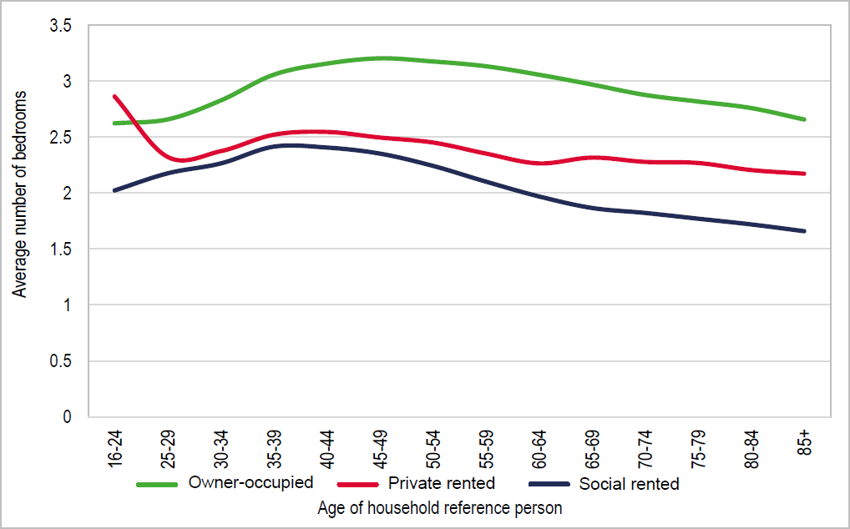

Source: Derived from ONS Commissioned Table CT0621

  - Replicating the existing occupancy patterns at a local level would however result in the conclusionsbeing skewed by the existing housing profile. This is particularly the case in the owner-occupied market sector. On this basis we have also applied regional occupancy assumptions for the East Midlands region. Assumptions are applied to the projected changes in Household Reference Personby age discussed below.

  - The analysis has been used to derive outputs for three broad categories. These are:

    - market housing - which is taken to follow the occupancy profiles in the owner-occupied sector

    - affordable home ownership - which is taken to follow the occupancy profile in the private rented sector (this is seen as reasonable as the Government’s desired growth in home ownership looks to be largely driven by a wish to see households move out of private renting); and

    - affordable rented housing, which is taken to follow the occupancy profile in the social rented sector. The affordable sector in the analysis to follow would include affordable rented housing.

Changes to Household Types

  - The table below presents the projected change in households by age of household reference person, this clearly shows particularly strong growth as being expected in older age groups (and to some extent some younger age groups e.g. 40-49). Households headed by someone aged 50-64 are projected to see a decrease in household numbers.

Table 8.3 Projected Change in Household by Age of HRP in GreaterNottingham and Ashfield

 | 2020 | 2038 | Change in Households | % Change
16-24 | 22,035 | 26,293 | 4,257 | 19.3%
25-29 | 30,505 | 33,532 | 3,027 | 9.9%
30-34 | 32,576 | 36,007 | 3,431 | 10.5%
35-39 | 32,514 | 35,424 | 2,911 | 9.0%
40-44 | 32,175 | 37,973 | 5,797 | 18.0%
45-49 | 33,841 | 38,759 | 4,918 | 14.5%
50-54 | 37,054 | 34,368 | -2,685 | -7.2%
55-59 | 36,402 | 33,820 | -2,582 | -7.1%
60-64 | 30,551 | 30,130 | -421 | -1.4%
65-69 | 27,771 | 35,056 | 7,285 | 26.2%
70-74 | 28,691 | 35,837 | 7,146 | 24.9%
75-79 | 21,458 | 30,491 | 9,033 | 42.1%
80-84 | 16,837 | 23,571 | 6,734 | 40.0%
85 & over | 15,558 | 27,033 | 11,475 | 73.8%
Total | 397,967 | 458,294 | 60,326 | 15.2%
Source: Demographic Projections

  - A breakdown of the projected change in households by age by local authority is attached at Appendix A4.

Modelled Outputs

  - By following the methodology set out above and drawing on the sources shown, a series of outputshave been derived to consider the likely size requirement of housing within each of the three broad tenures at a local authority level. The method includes specific adjustments to take account of the stock profile and the occupancy of the stock at a local level.

  - The analysis for rented affordable housing has also drawn on data from each of the local authority Housing Registers with regards to the profile of need. The data has been taken from the Local Authority Housing Statistics (“LAHS”) and shows a pattern of need which is focussed on 1- and 2- bedroom homes. The data for Broxtowe appears to be an outlier and it should be noted that 44% ofthe Register did not have a bedroom requirement attached.

  - It should also be noted that the higher proportions for 1-bedroom properties in Gedling and Rushcliffe is partly driven by numbers on the register who are seeking sheltered accommodation only. For instance, in Gedling, 275 of the 544 active applications on the register are seeking sheltered only (equal to 51%) which, when removed, would lower the proportion for 1 bedroom to 36%.

  - This difference in approach to the Housing Register has been factored into the recommended mix for Gedling and Rushcliffe in the conclusions of the report at Table 8.12 but is not reflected in the modelled outputs from Table 8.5 to 8.10.

Table 8.4 Size of Social/Affordable Rented Housing – Housing Register Information

 | 1-bedroom | 2-bedrooms | 3-bedrooms | 4+ bedrooms
Ashfield | 58% | 28% | 13% | 1%
Broxtowe | 22% | 36% | 25% | 17%
Erewash | 48% | 31% | 14% | 6%
Gedling | 66% | 24% | 9% | 2%
Nottingham | 60% | 26% | 11% | 4%
Rushcliffe | 82% | 10% | 7% | 1%
Source: Local Authority Housing Statistics, 2019

  - In interpreting the modelled outputs set out in the Tables below, it needs to be noted that to some degree the outputs seek to address the current stock profile. However, it may the case that moving too far away from the current mix could be unrealistic in some areas.

  - This is borne out in the results with the analysis showing a relatively low need for 4 or more-bedroom market homes in Rushcliffe due to the stock currently being quite high; whilst the opposite pattern is shown for Nottingham. However, in reality, it may be that the City is better to continue providing smaller dwellings due to the type of sites and therefore some adjustment should be made to specifictypes and sizes.

  - It is also important therefore to recognise that each of the authority areas play a particular role in the wider study area market which will invariably continue to be the case and ultimately, there are a range of factors which should be taken into account in setting policies for provision. This is particularly the case in the affordable sector where there are typically issues around the demand forand turnover of one-bedroom homes. In most areas, the provision of 2-bedroom housing is highestrecognising that this size provides for flexibility in the stock profile and will enable authorities to meet the needs of those with higher priority (i.e. typically those with dependent children) who will require at least 2 bedrooms.

  - We also need to consider that the stock of four-bedroom affordable housing is very limited in all areas and tends to have a very low turnover. As a result, whilst the number of households coming forward(through the Housing Register) for four or more-bedroom homes is quite small with the exception ofBroxtowe, the ability for these need to be met is even more limited. These factors inform our conclusions on affordable rented provision.

Table 8.5 Modelled Mix of Housing by Size and Tenure in Ashfield

Ashfield | 1-bedroom | 2-bedrooms | 3-bedrooms | 4+ bedrooms
Market | 5% | 26% | 45% | 24%
Affordable home ownership | 23% | 38% | 24% | 15%
Affordable housing (rented) | 35% | 37% | 25% | 3%

Table 8.6 Modelled Mix of Housing by Size and Tenure in Broxtowe

Broxtowe | 1-bedroom | 2-bedrooms | 3-bedrooms | 4+-bedrooms
Market | 4% | 33% | 45% | 18%
Affordable home ownership | 20% | 42% | 32% | 6%
Affordable housing (rented) | 21% | 38% | 37% | 4%

Table 8.7 Modelled Mix of Housing by Size and Tenure in Erewash

Erewash | 1-bedroom | 2-bedrooms | 3-bedrooms | 4+-bedrooms
Market | 3% | 29% | 48% | 20%
Affordable home ownership | 20% | 37% | 32% | 11%
Affordable housing (rented) | 25% | 44% | 27% | 4%

Table 8.8 Modelled Mix of Housing by Size and Tenure in Gedling

Gedling | 1-bedroom | 2-bedrooms | 3-bedrooms | 4+-bedrooms
Market | 3% | 30% | 48% | 19%
Affordable home ownership | 20% | 38% | 31% | 11%
Affordable housing (rented) | 25% | 45% | 27% | 3%

Table 8.9 Modelled Mix of Housing by Size and Tenure in Nottingham

Nottingham | 1-bedroom | 2-bedrooms | 3-bedrooms | 4+-bedrooms
Market | 1% | 29% | 42% | 28%
Affordable home ownership | 15% | 46% | 34% | 5%
Affordable housing (rented) | 25% | 41% | 31% | 3%

Table 8.10 Modelled Mix of Housing by Size and Tenure in Rushcliffe

Rushcliffe | 1-bedroom | 2-bedrooms | 3-bedrooms | 4+-bedrooms
Market | 2% | 33% | 56% | 9%
Affordable home ownership | 19% | 39% | 39% | 3%
Affordable housing (rented) | 40% | 29% | 29% | 2%
Sources: Housing Market Model

Family Households

  - This sub-section considers the need of family households (generally described as households with dependent children) which could be expected to have an impact on the need for larger family housingas part of the overall housing mix.

  - Household projections have been developed, linked to the standard method figures as set out inTable 1.1, to estimate growth in family households over the period to 2038.

Table 8.11 Projected Change in Family Households

Total Households with Dependent Children | 2020 | 2038 | Change in households | % Change
Ashfield | 16,658 | 18,682 | 2,023 | 12.1%
Broxtowe | 14,018 | 16,702 | 2,684 | 19.1%
Erewash | 14,692 | 17,018 | 2,326 | 15.8%
Gedling | 14,645 | 17,032 | 2,387 | 16.3%
Nottingham | 38,553 | 42,655 | 4,102 | 10.6%
Rushcliffe | 14,617 | 17,721 | 3,104 | 21.2%
TOTAL | 113,184 | 129,810 | 16,625 | 14.7%
Source: Demographic Projections

  - The analysis shows that the greatest percentage change in households with dependent children is expected in Rushcliffe equal to 21.2% and a rise of 3,104 households. Nottingham is expected to experience the greatest absolute change at around 4,100 households; however, proportionately this is the lowest level of growth. All authority areas are expected to see strong growth in family households.

  - The level of growth in family households does not automatically translate into an equivalent need for family- sized accommodation, not least as many older households will continue to live in family-sizedproperties that offer space for friends and relatives to come and stay. However, it is clearly a factor to consider in making adjustments to the modelled outputs.

  - The Figure below shows the number of bedrooms for family households at the point of the 2011 Census. The analysis shows the differences between married, cohabiting and lone parent families. Across the study area authorities, the tendency is for family households (irrespective of household composition) to occupy three- bedroom housing with varying degrees of two bedroom and four-bedroom properties depending on the area. There is a notably high proportion of family householdsoccupying four-bedroom housing, particularly in Rushcliffe.

  - The data also, unsurprisingly, highlights the small level of one-bed stock occupied by families acrossthe board. As a result, we could expect continued demand for three-bedroom properties; although, given the affordable housing need profile, a greater balance of homes of medium sized properties should also be factored into the recommendations.

Figure 8.2: Number of Bedrooms by Family Household Type, 2011
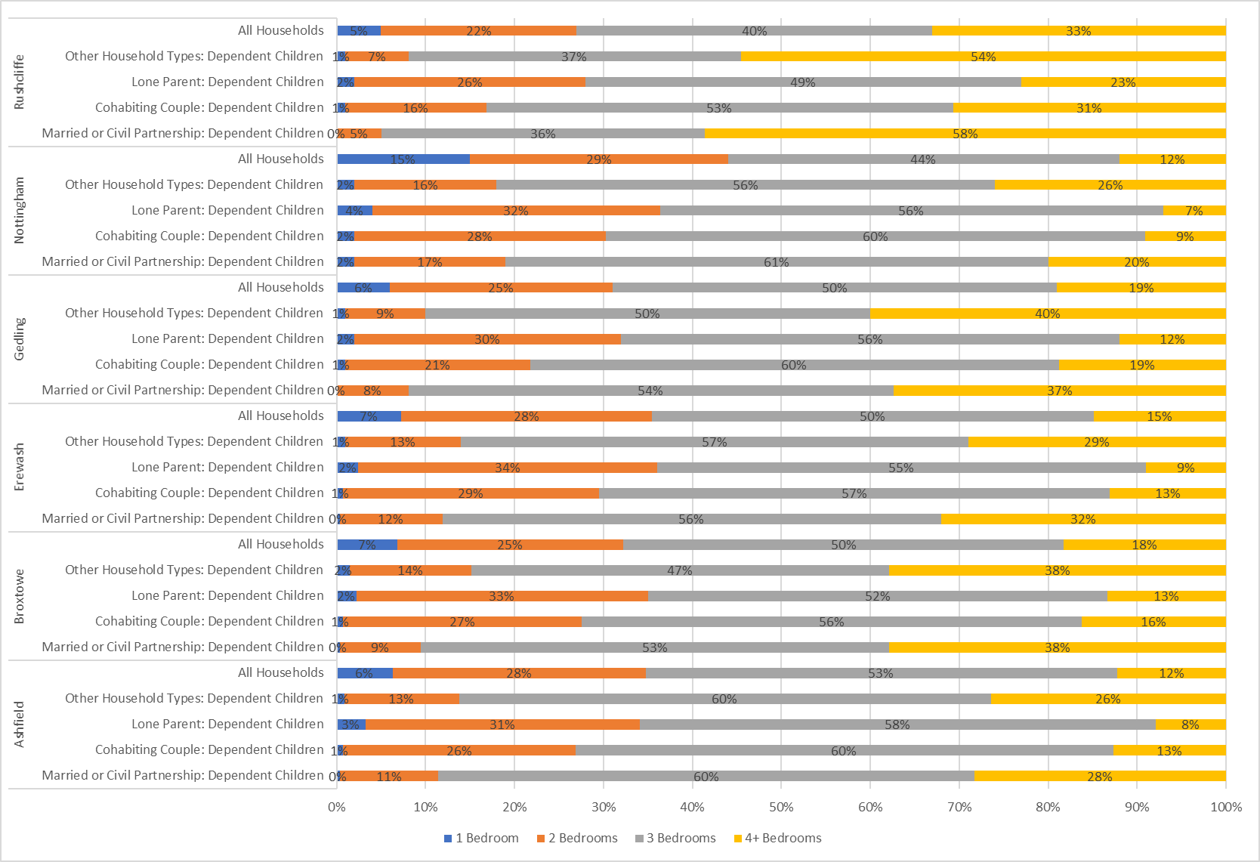

Source: 2011 Census

The Availability and Choice of Family Housing

  - Delivery of family sized housing remains a requirement in both urban and rural locations of the studyarea. This includes providing family housing in the widest possible choice and mix of housing locations including town centres, regeneration areas and through the sustainable expansion of ruraland smaller settlements (particularly helping to support economic and social vitality).

  - It is important to deliver a range of housing sizes and to actively promote this through appropriate planning policies and consideration of the operation of the market. There are however still limitations as to the affordability of larger properties – particularly in Rushcliffe - in the context of continued growth in sales prices and rental values evident across the study area in recent years.

  - In more rural areas, the opportunity to broaden and secure a choice and mix of family sized accommodation alongside smaller accommodation should be explored in order to diversify the market and provide for local housing demand. Whilst in the City, subject to the availability of land (i.e. such as on regeneration development sites such as the Waterside development in Nottingham),the provision of family-sized accommodation should be supported.

  - Iceni have analysed completions data by authority area over the period since the 2011 Census to provide us with an understanding of recent trends in delivery so that we are able to establish whetherthe mix of housing being delivered is meeting the need at a District/Borough-level and whether it is reinforcing the existing mix profile or supporting diversification.

  - The method used to record data on housing completions varies by each authority area and therefore it is not possible to set out a consistent breakdown of completions by size and type; however, whereavailable, the information has been presented in full. The completions data is not gathered by size and tenure.

  - In Ashfield, typically ‘family-sized’ three-bedroom properties have consistently accounted for the largest number of completions since the 2011 Census. This size of property has accounted for 42%of all completions on average and recent delivery has therefore been reinforcing the mix profile in the District. The volume of one- bedroom properties has been increasing as a proportion of all completions, although the absolute figures have remained relatively low.

Figure 8.3: Ashfield Housing Completions by Size, 2011-2019

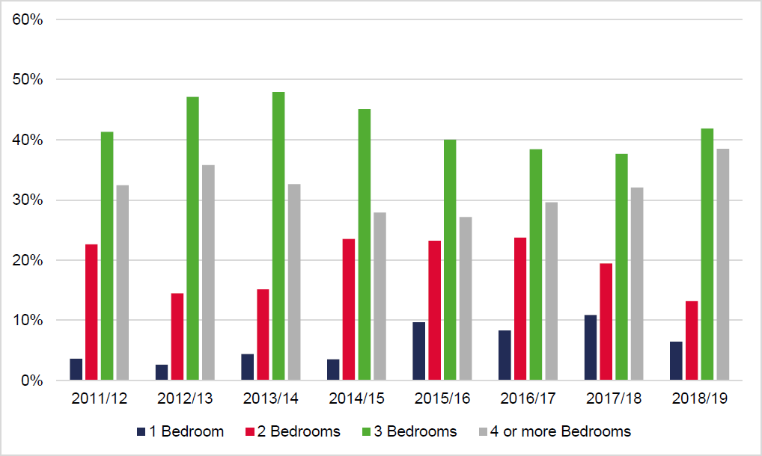

  - In Broxtowe Borough, the balance of houses to flats over the period since 2011 has been around64% to 36% respectively, which varies substantially from the 2011 stock profile, with flats accounting for only 11% of housing stock. Flatted provision has unsurprisingly been focussed on one- and two-bedroom properties. The provision of three-bedroom houses has accounted for an average of around 43% of all housing completions – with the proportion of this size generally rising - with four or more-bedroom houses accounting for around 32% on average of all housing completions.

  - If housing and flatted completions are considered together, overall completions have been broadly balanced between one bedroom (23%), two bedrooms (26%), three bedrooms (30%) and four or more bedrooms (22%) provision – a shift towards a greater proportion of smaller – including greater flatted provision - and larger properties since the 2011 Census, thus supporting diversification of the stock profile.

Figure 8.4: Broxtowe Housing Completions by Size by Type, 2011-2019

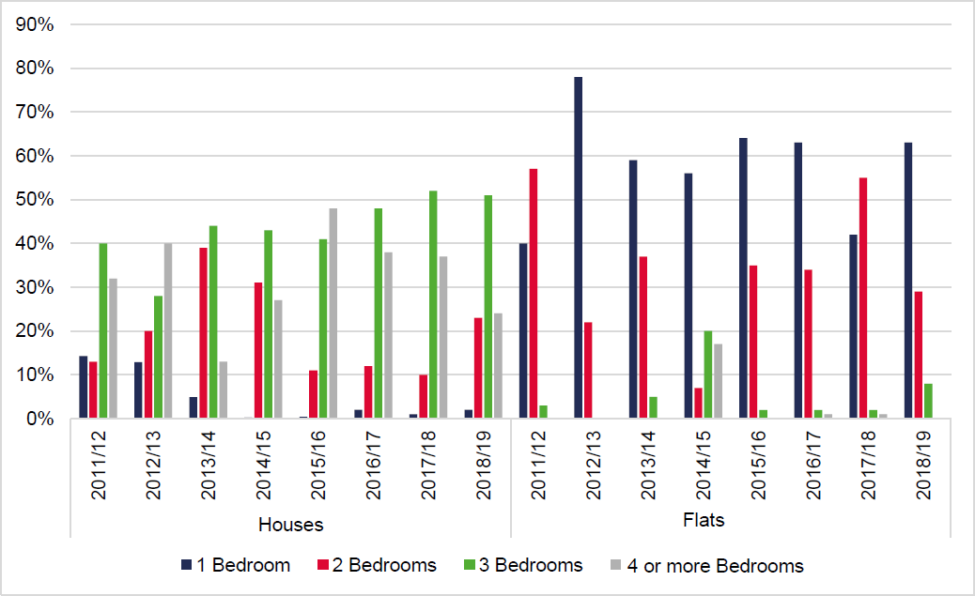

  - In Erewash, the balance of housing and flatted provision since the 2011 Census has been split 70%to 30% in favour of housing. This varies substantially from the 2011 stock profile with flats accounting for only 8% of all households. In respect of flatted completions, the proportion of one bedroom properties has accounted for over half (53%) of all flatted completions on average, rising to around 75% in recent years. There was a small proportion of three-bed flats delivered in 2017/18.

  - There have been very few one-bedroom houses delivered in Erewash, with the largest proportion of housing completions being three bedrooms at 36% on average. Taking housing and flatted completions together, the highest proportion of all completions has been for two-bedroom properties(37%), followed by three bedrooms (26%), four bedrooms (22%) and one bedroom (15%). Recent development has therefore been supporting greater diversification of the market with a greater focuson smaller properties.

Figure 8.5: Erewash Housing Completions by Size by Type, 2011-2018

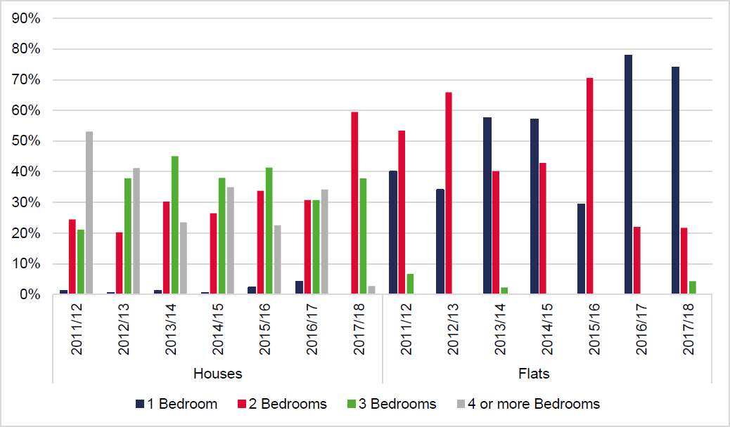

  - In Gedling, the balance of housing and flatted provision since the 2011 Census has been split 78% to 22% in favour of housing. The provision of flats has therefore been above the 2011 stock profile with only 11% of all households being flats.

  - The majority of flatted provision (59%) has been 2-bedroom properties followed by 1 bedroom properties (40%) and a small proportion of 3 bedroom properties. In respect of houses, over half (51%) of completions have been for 4 or more-bedroom properties with almost a third (31%) being 3-bedroom properties.

Figure 8.6: Gedling Housing Completions by Size by Type, 2011-2019

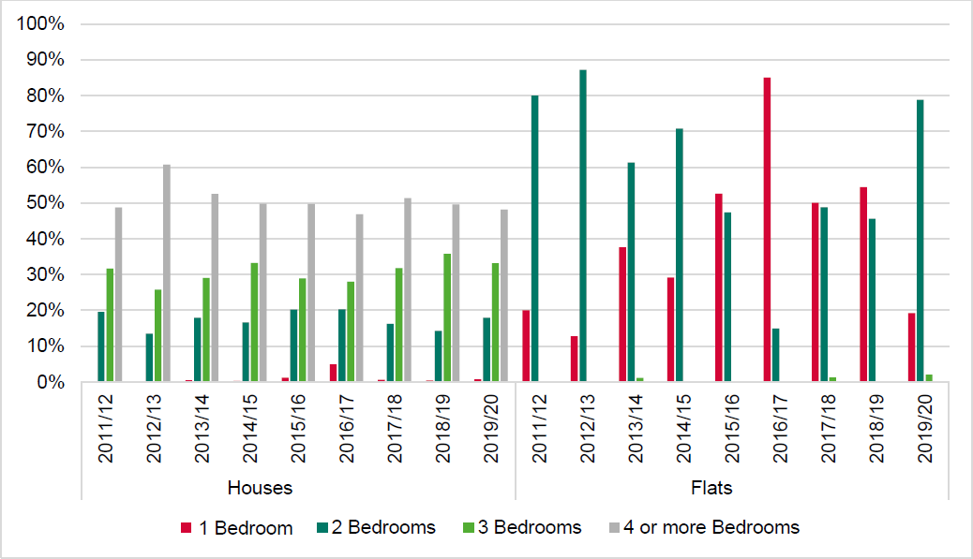

  - In Nottingham, over the period following the 2011 Census, housing completions in the City have been focussed naturally on smaller properties with 2-bedroom properties accounting for 32% of all completions over the 8 year period. Together, 1- and 2-bedroom completions have accounted for 61% of all completions.

  - Development in the City has therefore been focussed more so on delivering smaller properties, whenset against its 2011 Census stock profile.

Figure 8.7: Nottingham Housing Completions by Size, 2011-2019

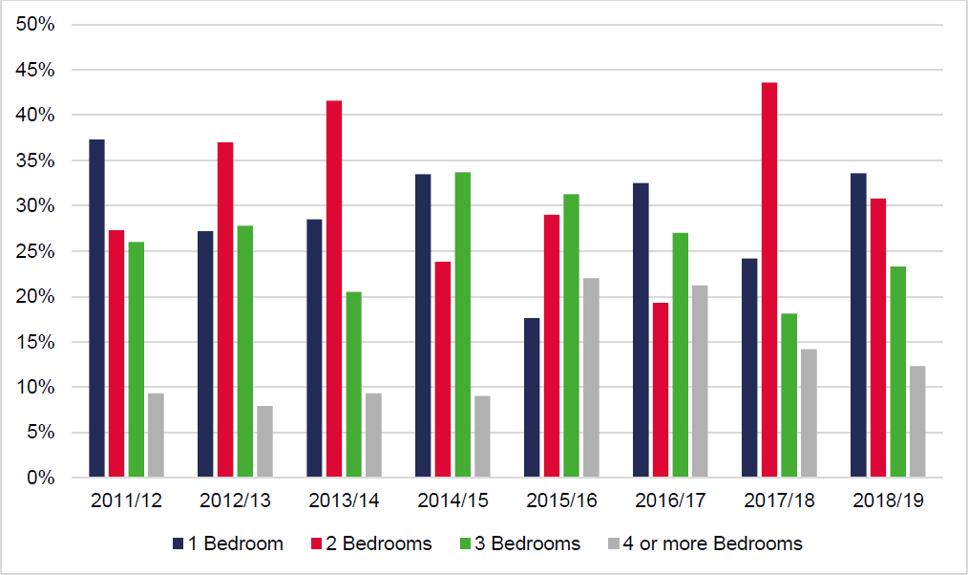

  - In Rushcliffe, the balance of houses to flats since the 2011 Census has been split 85% to 15% in favour of houses, this is broadly in line with the 2011 stock profile where flats accounted for 11% of all households. In respect of flatted provision, two-bedroom properties have accounted for around 60% of all flatted completions. There has also been a relatively high proportion of three- and four-bedroom flatted provision in comparison to other authorities in the study area.

  - Four or more-bedroom homes have accounted for over half (51%) of all housing completions since 2011, followed by three-bedroom houses at 30% of all housing completions. There have been very few one-bedroom homes delivered in the District.

  - Taking housing and flatted completions together, four or more-bedroom provision has accounted for 43% of all completions, followed by three bedrooms (26%), two bedrooms (25%) and one-bedroom properties (7%). Recent development has therefore been driving the mix of housing more towards larger properties, which is already a defining characteristic of the Rushcliffe stock profile; however, it is clear that the mix of housing is becoming unbalanced towards very large properties.

Figure 8.8: Rushcliffe Housing Completions by Size by Type, 2011-2019

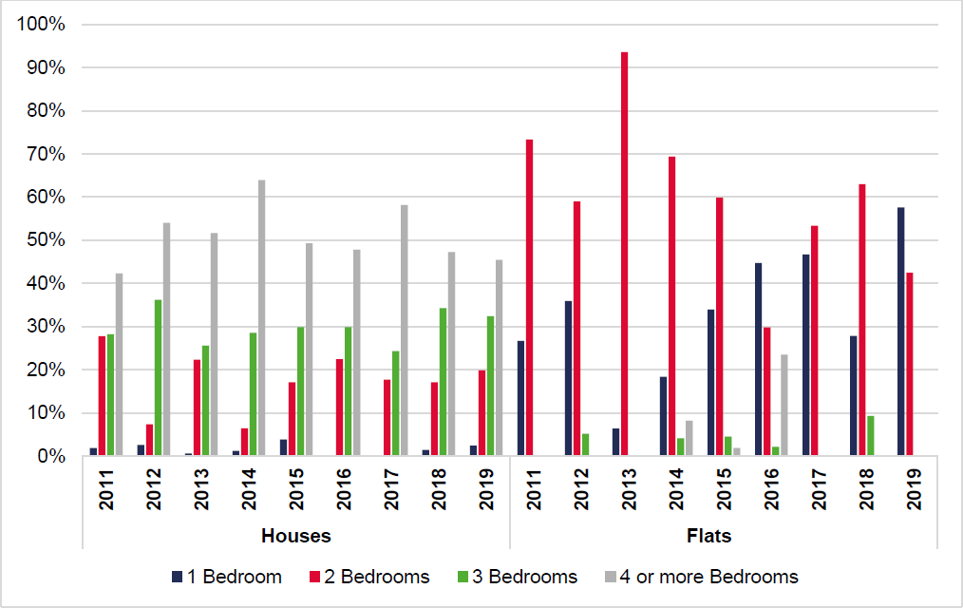

Conclusions on Housing Mix at a District-Level

  - Bringing the above analysis together, having regard to our modelled outputs for housing mix, the expected growth in family households and recent trends in housing delivery, the Table below sets out our recommendation on housing mix in each authority area.

  - The recommendations on market housing mix seeks to respond to the modelled outputs, recent delivery trends and the needs for family households; as well as the role which each area plays in thewider housing market area.

  - In terms of affordable housing provision, consideration is also given to affordability as well as the types of housing which will meet the needs of those of greatest priority and in Nottingham specifically, a waiting list which is overwhelmingly single person dominated. The different approach taken to theregister, as discussed in paragraph 8.22, is also factored in. All of these factors have been broughttogether to arrive at our recommended housing mix by size and type.

Table 8.12 Recommended Housing Mix by Size by Type

Authority | Housing Type | 1 Bed | 2 Beds | 3 Beds | 4+ Beds
Ashfield | Market | 4% | 27% | 45% | 24%
 | Affordable Home Ownership | 23% | 38% | 24% | 15%
 | Affordable Rented | 35% | 37% | 25% | 3%
Broxtowe | Market | 12% | 31% | 39% | 18%
 | Affordable Home Ownership | 20% | 42% | 32% | 6%
 | Affordable Rented | 21% | 40% | 33% | 6%
Erewash | Market | 7% | 32% | 42% | 19%
 | Affordable Home Ownership | 20% | 37% | 31% | 12%
 | Affordable Rented | 26% | 44% | 26% | 4%
Gedling | Market | 3% | 30% | 48% | 19%
 | Affordable Home Ownership | 20% | 38% | 31% | 11%
 | Affordable Rented | 20% | 49% | 28% | 3%
Nottingham | Market | 11% | 29% | 42% | 18%
 | Affordable Home Ownership | 15% | 46% | 34% | 5%
 | Affordable Rented | 35% | 31% | 32% | 2%
Rushcliffe | Market | 11% | 28% | 40% | 21%
 | Affordable Home Ownership | 19% | 40% | 38% | 3%
 | Affordable Rented | 35% | 34% | 29% | 2%

  - It is important to recognise that although the analysis has quantified the housing mix on the basis ofthe market modelling, an understanding of the current housing market and wider analysis, it does not necessarily follow that such prescriptive figures should be included in the plan making process.

  - The demand for different types and sizes of homes can change over time linked to macro-economicfactors and local supply. Whilst this report does not suggest that prescriptive figures necessarily need to be included within the new Local Plans, it is the case that the figures can be used as a monitoring tool to ensure that future delivery is not unbalanced when compared with the likely requirements as driven by demographic change in the area.

  - The recommendations can also be used as a set of guidelines to consider the appropriate mix on larger development sites, and Iceni consider that it would be reasonable to expect justification for a housing mix on such sites which significantly differs from that modelled herein. It is also the case thatsite location and the character of an area are also relevant considerations in determining the appropriate mix housing on individual development sites.

Need/Demand for Bungalows

  - Across the study area, there is an identified need for 425 wheelchair user homes. As a result, it is pertinent to consider the provision of wheelchair accessible homes as part of the overall housing mixincluding the provision of bungalows.

  - The sources used for analysis in this report make it difficult to quantify a need/demand for bungalowsin the study area as Census data (which is used to look at occupancy profiles) does not separately identify this type of accommodation. However, it is typical (where discussions are undertaken with local estate agents) to find that there is a demand for this type of accommodation.

  - Bungalows are often the first choice for older people seeking suitable accommodation in later life and there is generally a high demand for such accommodation when it becomes available. As a newbuild option, it is, however, the case that bungalow accommodation is often not supported by eitherhouse builders or planners (due to potential plot sizes and their generally low densities). There may, however, be instances where bungalows are the most suitable house type for a particular site; for example, to overcome objections about dwellings overlooking existing dwellings or preserving sightlines.

  - There is also the possibility of a wider need/demand for retirement accommodation. Retirement apartments can prove very popular if they are well located in terms of access to facilities and services, and environmentally attractive (e.g. have a good view). However, some potential purchasers may find high service charges unacceptable or unaffordable and new build units may not retain their value on re-sale.

  - Overall, the Councils should consider the potential role of bungalows as part of the future mix of housing. Such housing may be particularly attractive to older owner-occupiers (many of whom are equity-rich) which may assist in encouraging households to downsize. However, the downside to providing bungalows is that they are relatively land intensive for the amount of floorspace created

The Appropriate Mix of Housing by Submarket

  - A recommended mix of housing has been set out for different sizes of homes by differing tenures ata District/Borough level; however, it is recognised that in some instances within each submarket there are spatial differences and therefore a different mix of housing may be more appropriate. A starting point for all local authorities assessing mix at a submarket level should be the existing profileof housing which is set out in the Tables below by tenure.

Table 8.13 Number of Bedrooms by Submarket – Owner-Occupied Housing

 | Submarket | 1-Bed | 2-Beds | 3-Beds | 4+ Beds
Ashfield | Annesley & Kirkby Woodhouse | 1% | 32% | 54% | 13%
 | Hucknall Central & South | 1% | 26% | 58% | 14%
 | Hucknall West & North | 2% | 23% | 58% | 18%
 | Jacksdale & Selston | 1% | 31% | 51% | 17%
 | Kirkby in Ashfield | 1% | 21% | 61% | 18%
 | Sutton in Ashfield | 1% | 24% | 61% | 15%
 | Underwood | 1% | 29% | 50% | 20%
Broxtowe | Beeston East | 2% | 25% | 59% | 14%
 | Beeston West | 2% | 27% | 43% | 28%
 | Bramcote | 1% | 11% | 48% | 40%
 | Brinsley | 0% | 22% | 61% | 17%
 | Eastwood | 1% | 28% | 60% | 11%
 | Kimberley & Greasley | 1% | 26% | 51% | 22%
 | Stapleford | 1% | 23% | 65% | 11%
 | Toton & Chilwell | 1% | 17% | 58% | 24%
 | Watnall & Nuthall | 1% | 16% | 45% | 38%
Erewash | East Ilkeston | 1% | 33% | 56% | 10%
 | Little Eaton & Stanley | 1% | 17% | 48% | 33%
 | Long Eaton | 1% | 26% | 56% | 17%
 | Mid Erewash Rural | 1% | 21% | 52% | 26%
 | Sandiacre | 2% | 24% | 60% | 14%
 | West Ilkeston | 1% | 24% | 56% | 18%
Gedling | Bestwood St Albans | 3% | 26% | 47% | 25%
 | Calverton | 0% | 19% | 58% | 23%
 | Carlton | 1% | 21% | 63% | 14%
 | Colwick & Netherfield | 1% | 36% | 49% | 14%
 | Daybrook | 2% | 30% | 60% | 8%
 | Dumbles | 1% | 20% | 36% | 43%
 | Gedling & Plains | 1% | 16% | 59% | 25%
 | Newstead Abbey | 1% | 15% | 41% | 43%
 | Porchester & Woodthorpe | 2% | 15% | 55% | 27%
 | Redhill, Coppice & Ernehale | 1% | 29% | 52% | 19%
 | Trent Valley | 1% | 20% | 45% | 34%

Nottingham | Berridge | 2% | 25% | 59% | 14%
 | Bestwood | 3% | 14% | 75% | 8%
 | Bilborough & Beechdale | 1% | 15% | 71% | 13%
 | Castle | 12% | 44% | 25% | 19%
 | Clifton East | 4% | 5% | 84% | 7%
 | Clifton West | 3% | 18% | 64% | 15%
 | Dales | 2% | 29% | 58% | 11%
 | Hyson Green & Arboretum | 5% | 37% | 42% | 16%
 | Lenton | 6% | 37% | 39% | 18%
 | Mapperley | 5% | 35% | 34% | 26%
 | Meadows | 7% | 37% | 45% | 11%
 | North Nottingham City | 1% | 26% | 65% | 8%
 | Radford | 8% | 38% | 34% | 20%
 | Sherwood | 3% | 19% | 56% | 22%
 | St. Anns | 5% | 31% | 56% | 8%
 | Wollaton West | 1% | 11% | 56% | 32%
Rushcliffe | Bingham | 1% | 21% | 44% | 34%
 | Cotgrave Village | 1% | 14% | 58% | 26%
 | Edwalton | 0% | 13% | 35% | 52%
 | Gamston North | 4% | 27% | 26% | 43%
 | Ruddington | 2% | 20% | 51% | 28%
 | Rural Rushcliffe East | 2% | 17% | 42% | 39%
 | Rural Rushcliffe West | 1% | 17% | 42% | 40%
 | West Bridgford | 2% | 13% | 41% | 44%
Source: Census 2011

  - The analysis is provided in the Table below for private rented housing.

Table 8.14 Number of Bedrooms by Submarket – Private Rented Housing

 | Submarket | 1-Bed | 2-Beds | 3-Beds | 4+ Beds
Ashfield | Annesley & Kirkby Woodhouse | 3% | 46% | 45% | 6%
 | Hucknall Central & South | 12% | 46% | 33% | 9%
 | Hucknall West & North | 12% | 44% | 39% | 6%
 | Jacksdale & Selston | 5% | 53% | 36% | 6%
 | Kirkby in Ashfield | 11% | 39% | 44% | 6%
 | Sutton in Ashfield | 10% | 37% | 48% | 6%
 | Underwood | 4% | 48% | 44% | 4%
Broxtowe | Beeston East | 14% | 35% | 34% | 18%
 | Beeston West | 16% | 47% | 26% | 11%
 | Bramcote | 11% | 31% | 44% | 14%
 | Brinsley | 4% | 35% | 52% | 10%
 | Eastwood | 12% | 43% | 40% | 4%
 | Kimberley & Greasley | 10% | 43% | 36% | 11%
 | Stapleford | 10% | 41% | 45% | 4%
 | Toton & Chilwell | 9% | 36% | 43% | 12%
 | Watnall & Nuthall | 9% | 41% | 35% | 15%
Erewash | East Ilkeston | 12% | 50% | 35% | 3%
 | Little Eaton & Stanley | 11% | 37% | 42% | 10%
 | Long Eaton | 16% | 45% | 33% | 5%
 | Mid Erewash Rural | 10% | 42% | 38% | 10%
 | Sandiacre | 19% | 45% | 31% | 6%
 | West Ilkeston | 11% | 44% | 40% | 5%
Gedling | Bestwood St Albans | 12% | 34% | 45% | 10%
 | Calverton | 6% | 38% | 48% | 8%
 | Carlton | 13% | 40% | 40% | 7%
 | Colwick & Netherfield | 11% | 54% | 30% | 4%
 | Daybrook | 13% | 49% | 33% | 5%
 | Dumbles | 37% | 43% | 14% | 6%
 | Gedling & Plains | 10% | 40% | 40% | 10%
 | Newstead Abbey | 9% | 35% | 41% | 15%
 | Porchester & Woodthorpe | 15% | 39% | 37% | 9%
 | Redhill, Coppice & Ernehale | 10% | 51% | 33% | 6%
 | Trent Valley | 11% | 44% | 33% | 12%
Nottingham | Berridge | 19% | 41% | 30% | 10%
 | Bestwood | 15% | 30% | 47% | 8%
 | Bilborough & Beechdale | 9% | 31% | 53% | 7%
 | Castle | 39% | 48% | 7% | 6%
 | Clifton East | 12% | 7% | 73% | 9%
 | Clifton West | 9% | 29% | 51% | 12%

 | Dales | 10% | 46% | 35% | 10%
 | Hyson Green & Arboretum | 22% | 38% | 17% | 23%
 | Lenton | 12% | 24% | 20% | 44%
 | Mapperley | 32% | 46% | 15% | 7%
 | Meadows | 21% | 40% | 27% | 12%
 | North Nottingham City | 8% | 40% | 46% | 6%
 | Radford | 17% | 28% | 13% | 41%
 | Sherwood | 24% | 31% | 33% | 12%
 | St. Anns | 32% | 35% | 21% | 11%
 | Wollaton West | 7% | 27% | 51% | 15%
Rushcliffe | Bingham | 12% | 54% | 25% | 8%
 | Cotgrave Village | 8% | 40% | 37% | 16%
 | Edwalton | 2% | 42% | 39% | 17%
 | Gamston North | 13% | 63% | 17% | 7%
 | Ruddington | 11% | 42% | 36% | 11%
 | Rural Rushcliffe East | 8% | 36% | 42% | 14%
 | Rural Rushcliffe West | 6% | 35% | 42% | 17%
 | West Bridgford | 25% | 35% | 21% | 19%
Source: Census 2011

  - The analysis is provided in the Table below for social rented housing

Table 8.15 Number of Bedrooms by Submarket – Social Rented Housing

 | Submarket | 1-Bed | 2-Beds | 3-Beds | 4+ Beds
Ashfield | Annesley & Kirkby Woodhouse | 13% | 37% | 48% | 2%
 | Hucknall Central & South | 32% | 38% | 29% | 2%
 | Hucknall West & North | 33% | 26% | 38% | 3%
 | Jacksdale & Selston | 7% | 37% | 53% | 3%
 | Kirkby in Ashfield | 21% | 32% | 45% | 2%
 | Sutton in Ashfield | 27% | 32% | 38% | 2%
 | Underwood | 40% | 41% | 16% | 3%
Broxtow | Beeston East | 46% | 23% | 27% | 4%
 | Beeston West | 77% | 15% | 6% | 2%
 | Bramcote | 42% | 36% | 21% | 1%
 | Brinsley | 4% | 29% | 67% | 0%
 | Eastwood | 35% | 30% | 31% | 3%
 | Kimberley & Greasley | 34% | 37% | 24% | 4%
 | Stapleford | 29% | 39% | 31% | 1%
 | Toton & Chilwell | 37% | 39% | 23% | 1%
 | Watnall & Nuthall | 37% | 42% | 20% | 1%
Erewash | East Ilkeston | 32% | 29% | 37% | 2%
 | Little Eaton & Stanley | 26% | 32% | 42% | 0%
 | Long Eaton | 40% | 27% | 32% | 2%

 | Mid Erewash Rural | 30% | 30% | 39% | 1%
 | Sandiacre | 27% | 24% | 47% | 2%
 | West Ilkeston | 36% | 28% | 35% | 1%
Gedling | Bestwood St Albans | 38% | 20% | 38% | 4%
 | Calverton | 15% | 39% | 43% | 3%
 | Carlton | 33% | 30% | 33% | 3%
 | Colwick & Netherfield | 30% | 40% | 28% | 2%
 | Daybrook | 40% | 17% | 41% | 2%
 | Dumbles | 27% | 33% | 39% | 1%
 | Gedling & Plains | 33% | 24% | 41% | 2%
 | Newstead Abbey | 11% | 23% | 64% | 2%
 | Porchester & Woodthorpe | 76% | 5% | 17% | 3%
 | Redhill, Coppice & Ernehale | 33% | 20% | 44% | 3%
 | Trent Valley | 50% | 18% | 27% | 5%
Nottingham | Berridge | 29% | 38% | 26% | 7%
 | Bestwood | 40% | 23% | 33% | 3%
 | Bilborough & Beechdale | 26% | 36% | 35% | 3%
 | Castle | 50% | 41% | 6% | 2%
 | Clifton East | 37% | 11% | 50% | 2%
 | Clifton West | 39% | 25% | 33% | 3%
 | Dales | 27% | 43% | 26% | 4%
 | Hyson Green & Arboretum | 39% | 33% | 19% | 9%
 | Lenton | 23% | 50% | 24% | 4%
 | Mapperley | 27% | 30% | 40% | 4%
 | Meadows | 40% | 29% | 27% | 4%
 | North Nottingham City | 21% | 30% | 45% | 4%
 | Radford | 39% | 42% | 11% | 8%
 | Sherwood | 23% | 27% | 44% | 6%
 | St. Anns | 34% | 38% | 25% | 3%
 | Wollaton West | 38% | 38% | 22% | 1%
Rushcliffe | Bingham | 13% | 45% | 41% | 1%
 | Cotgrave Village | 13% | 34% | 40% | 13%
 | Edwalton | 13% | 60% | 25% | 2%
 | Gamston North | 9% | 45% | 44% | 1%
 | Ruddington | 17% | 47% | 34% | 2%
 | Rural Rushcliffe East | 18% | 43% | 37% | 3%
 | Rural Rushcliffe West | 13% | 35% | 49% | 3%
 | West Bridgford | 53% | 27% | 16% | 3%
Source: Census 2011

  - It is not recommended that a prescriptive mix is set out for all submarkets as this is unlikely to be practical for decision-taking. It is however recommended that a flexible approach is taken with policyacknowledging a range of factors to be applied when reviewing housing mix at a submarket level. These factors include:

    - The existing profile of housing in each submarket; however, this should not necessarily be seen as indicating particular surpluses or shortfalls of particular types and sizes of homes asit is important to recognise that each area has a different role to play

    - The profile of recent and pipeline supply within that submarket having due consideration to any gaps in the local offering and potential imbalances arising from recent planning applications

    - The character and appearance of the surrounding area which a planning application relates to and any site-specific constraints

    - The sustainability of sites including proximity to strong public transport connections – particularly towards employment hubs – which would support a greater proportion of smaller homes

    - The need for affordable housing at a submarket level as identified in Section 5 of this report; and

    - The viability of providing a mix of housing which does not necessarily align with what is realistically achievable in that submarket.

  - It is considered that there are clear instances where an alternative mix to the District/Borough recommendation would be appropriate in certain submarkets. As an example, this would include:

    - The Bingham submarket and Gamston North submarket in Rushcliffe are areas where the existing profile of housing is focussed more towards 1 and 2 bedroom properties in comparison to the rest of the Borough. The Bingham area has a railway station which has aservice to Nottingham and it is also well served by a frequent bus service to Nottingham Cityin around 20 minutes. Gamston North has a range of services and facilities and residents can access the centre of Nottingham within 35 minutes on public transport.

    - Set against the Borough mix, which is focussed towards larger properties for market housing, it is considered that there could be opportunities to diversify the Borough profile in these areas by providing a greater proportion of smaller properties. There is also a high need for rented affordable housing in these submarkets, with a need for 6.87 and 6.77 per 1,000 households respectively, which is the second and third highest need in the Borough after the West Bridgford submarket. A mix which would secure a greater level of 1 and 2 bed social/affordable rented provision should therefore be sought.

  - Overall, it is suggested that local authorities should broadly seek the same mix of housing in all locations; however, it is also important to be flexible to a different mix where specific local characteristics suggest an alternative mix would be more appropriate.

THE PRIVATE RENTED SECTOR AND BUILD TO RENT

  - In this section, we undertake analysis of the private rented sector in Greater Nottingham and Ashfield and consider the appropriate policy response to Build to Rent as a product.

The Private Rented Sector

  - The private rented sector has been the key growth sector in the housing market for the last 15 yearsand now makes up just over 20% of all UK households. Since 2011, the private rented sector has been the second largest housing tenure in England behind owner-occupation, overtaking social housing.

  - Across the study area, the growth in the private rented sector has been strong over the last three decades in line with the national trend. The Figure below shows how the private rented sector has grown over the last three Census points.

Figure 9.1: Growth in the Private Rented Sector across the Study Area

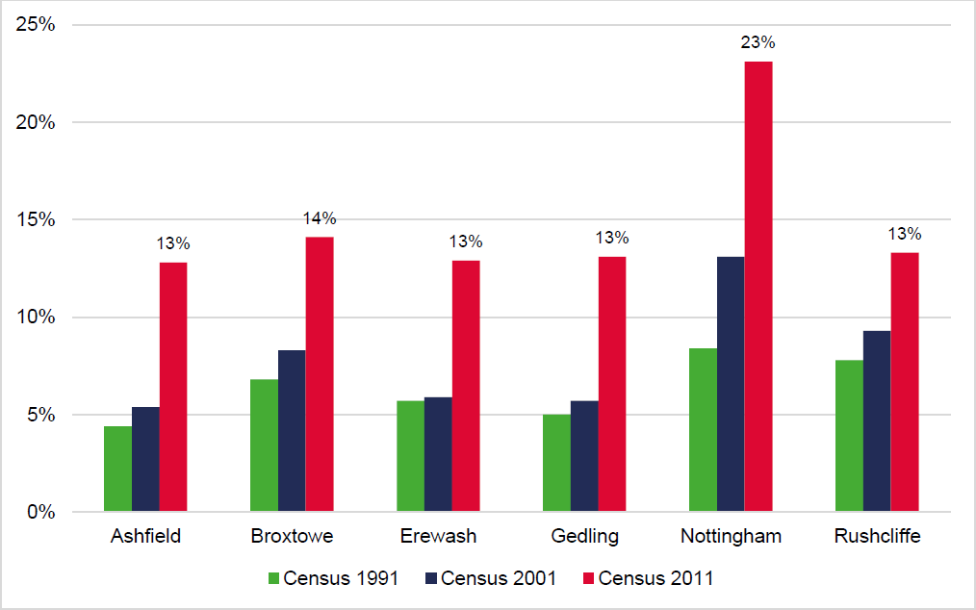

Source: Census

  - The analysis shows that the private renting has grown as a sector in each of the authority areas across the last three census points. As a proportion of all households, the private rented sector wasthe second largest tenure in Broxtowe (14.1%), Gedling (13.1%) and Rushcliffe (13.3%) at the point of the 2011 Census. Nottingham had the highest proportion of private renters at 23.1% of allhouseholds; however, this was still lower than home ownership (45.1%) and social renters (29.7%).

  - Turning to more recent research data published by ONS which looks at dwelling stock by tenure bylocal authority between 2012 and 2017, we have tried to give due consideration to the potential tenure profile across the study area on the basis of this latest research.

  - ONS is clear that the research outputs are not official statistics on dwelling stock by tenure; they are research outputs which provide an estimated breakdown of the number of owner-occupied and privately rented dwellings (and therefore social rented dwellings). However, the data is helpful is understanding how the private rented sector has potentially grown over the period since the last Census in 2011; aligned with the rapid growth of the Build to Rent market. The analysis is set out inthe Figure below.

Figure 9.2: Potential Study Area Tenure Profile in 2017

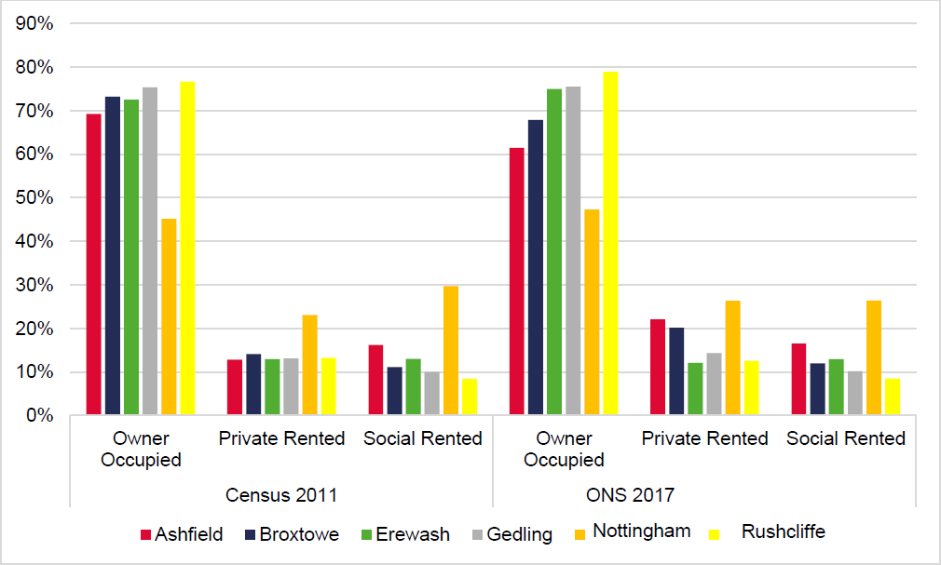

Source: ONS Subnational Estimates of Housing Stock as at 2017

  - Drawing on the Figure above, the ONS research outputs suggest that the private rented sector could have grown further as a proportion of all households since 2011 in all authority areas except for Erewash (-0.8%) and Rushcliffe (-0.7%). In Ashfield, the ONS research outputs would suggest the private rented sector has grown by 9.3% to account for 22.1% of all households with growth of 6% in Broxtowe with over a fifth of households in the private rented sector and 3.2% in Nottingham compared with the 2011 Census. In Gedling, the outputs would suggest marginal growth of 1% in the private rented sector.

Profile of the Private Rented Sector in the Study Area

  - In order to understand the private rented sector across the study area better, we have first sought to consider the demographics of those living in the private rented sector in each authority. In consideringthe age profile of private rented sector residents in each of the authorities; a clear picture can be drawn from the Figures overleaf.

Figure 9.3: Age Profile of Private Rented Sector in Ashfield, Broxtowe and Erewash

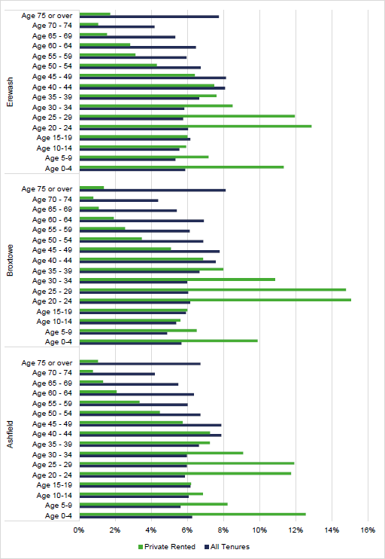

Source: Census 2011

Figure 9.4: Age Profile of Private Rented Sector in Gedling, Nottingham and Rushcliffe

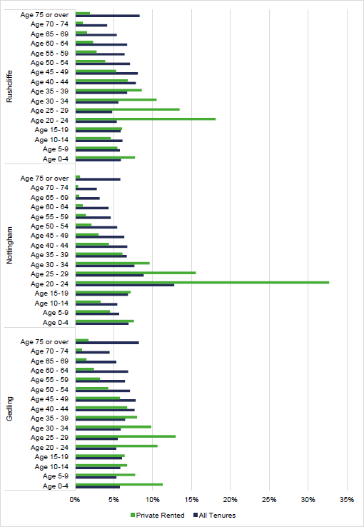

Source: Census 2011

  - The analysis shows that the private rented sector in Greater and Nottingham and Ashfield has a population structure generally focussed on those in their 20s and 30s, although there are notable differences between each authority area.

  - As is shown in Nottingham, almost half (48%) of all residents renting in the private sector are aged between 20-29, with those aged 20-39 accounting for 64% of all residents. Overall, this is somewhatunsurprising in considering that this age range aligns with those who fall under ‘Generation Rent’ but the sector also includes family households and older people.

  - In Ashfield and Gedling, it is notable that children aged under 15 account for over a quarter of all of those living in the private rented sector at 26% and 28% respectively. There is also a large proportion of children in the private rented sector in Broxtowe and Erewash. Coupled with the high proportion of those in their 20’s and 30’s, this would suggest a high proportion of young families.

  - Turning to household composition, the Table below analyses on the basis available data how thoseliving in the private rented sector typically occupy homes.

Table 9.1 Household Composition of Private Renters in Greater Nottingham and Ashfield

Composition | Ashfield | Broxtowe | Erewash | Gedling | Nottingham | Rushcliffe
One Person Aged 65 and over | 4% | 4% | 4% | 5% | 2% | 5%
One Person Aged under 65 | 28% | 23% | 29% | 31% | 28% | 29%
Couple Aged 65 and over | 1% | 1% | 2% | 1% | 1% | 2%
Couple No Children | 15% | 19% | 17% | 16% | 14% | 18%
Couple Dependent Children | 18% | 19% | 17% | 17% | 12% | 16%
Couple Non-Dep. Children | 2% | 2% | 2% | 2% | 1% | 1%
Lone Parent Dep. Children | 20% | 14% | 17% | 17% | 9% | 11%
Lone Parent Non-Dep Children | 3% | 2% | 3% | 3% | 1% | 2%
Full-Time Students | 0% | 4% | 0% | 0% | 15% | 5%
Other Households | 8% | 12% | 8% | 8% | 18% | 11%
Total Households | 6,504 | 6,594 | 6,265 | 6,488 | 29,098 | 6,082
Source: Census 2011

  - The analysis shows that in the private rented sector in every authority, the largest household group is single person households aged under 65; with this group accounting for 31% of all households inGedling down to 23% in Broxtowe. There is also a high proportion of couples and lone parents withchildren in all authorities with the exception of Nottingham which sees a higher proportion of full-timestudents and other households. This aligns with our analysis of the sector’s age structure.

  - Finally, with regards to the mix of stock in the private rented sector, we have considered the profileof household by bedroom size. This analysis is set out in the Table below.

Table 9.2 Bedroom Mix – Private Rented Sector

 | Ashfield | Broxtowe | Erewash | Gedling | Nottingham | Rushcliffe
1 Bedroom | 10% | 12% | 13% | 13% | 20% | 16%
2 Bedrooms | 41% | 39% | 46% | 44% | 36% | 39%
3 Bedrooms | 43% | 38% | 35% | 36% | 28% | 30%
4+ Bedrooms | 6% | 12% | 6% | 7% | 16% | 16%
Total | 100% | 100% | 100% | 100% | 100% | 100%
Source: Census 2011

  - The stock profile is generally focussed on two- and three-bedroom properties in all authority areas with relative variances in Nottingham and Rushcliffe, which both have a higher proportion of 4 or more bedroom properties (equal to 16% of all households). There is also a higher proportion of 1-bedroom properties in Nottingham and Rushcliffe and generally a more balanced profile overall.

The Rental Market

  - Turning to the private rental market, we have sought to analyse current private rents and recentrental trends set against wider comparatives which draws on our baseline analysis upfront in Section 3. The Table below sets out median rents by property size compared with the region and England.

Table 9.3 Median Rents by Property Size, 2019

Local Authority | Room | Studio | 1 Bed | 2 Beds | 3 Beds | 4+ Beds | All
Ashfield | £347 | n.a. | £400 | £475 | £550 | £750 | £500
Broxtowe | £370 | £450 | £485 | £580 | £695 | £975 | £615
Erewash | £368 | £405 | £425 | £550 | £650 | £945 | £550
Gedling | n.a. | n.a. | £475 | £575 | £695 | £995 | £595
Nottingham | £390 | £598 | £550 | £625 | £650 | £950 | £600
Rushcliffe | £390 | £395 | £550 | £650 | £795 | £1,200 | £665
East Midlands | £386 | £425 | £475 | £582 | £675 | £975 | £595
England | £396 | £550 | £620 | £675 | £775 | £1,320 | £950
Source: ONS Private Rental Market Statistics, December 2019

  - Generally, median rents across the study area fall below those achieved at a national level. This is true for all property sizes including Rushcliffe which achieves notably higher rental values than the other study area authorities. However, when median rents are set against the East Midlands, the areas of Broxtowe, Nottingham and Rushcliffe perform relatively well – particularly for smaller sizedproperties. Rushcliffe performs particularly strongly for the larger properties.

  - As set out upfront in this report, there has been rental growth across all sizes in all authority areas where the private rented sector is prominent including in Nottingham, Broxtowe and Rushcliffe. In Nottingham, rents for studios saw the strongest comparative rental growth between 2013/14 and 2018/19 at 59%. There was also strong growth for 1- and 2-bedroom properties in these areas over the five-year period.

Table 9.4 Median Rental Increase by Size, 2013/14 and 2018/19¹⁶

 | Room | Studio | 1 bed | 2 bed | 3 bed | 4 bed | All
Ashfield | n.a. | n.a. | 14% | 6% | 16% | 11% | 11%
Broxtowe | 14% | n.a. | 21% | 10% | 19% | 23% | 17%
Erewash | 0% | n.a. | 8% | 16% | 18% | 36% | 16%
Gedling | n.a. | n.a. | 12% | 15% | 17% | 17% | 10%
Nottingham | 20% | 59% | 22% | 19% | 13% | 19% | 26%
Rushcliffe | 20% | n.a. | 29% | 18% | 14% | 26% | 21%
East Midlands | 19% | 29% | 17% | 16% | 13% | 19% | 15%
England | 10% | 11% | 24% | 8% | 3% | 20% | 18%

¹⁶ “n.a.” means no data was available for this property size. Source: VOA Private Rental Data

  - The Build-to-Rent sector is one which we would describe as relatively ‘embryonic’ outside of London and the major Cities. It has developed to a position where there are now a range of schemes in London and schemes coming forwards in other major Cities and it is only over the last 12 months that completions outside of London have overtaken those within London; with the regions recordinga 51% increase in completions between Q4 2018 and Q4 2019.

  - Although rental values are not high in relative terms when set against wider benchmarks, there hasbeen strong rental growth in areas where private renting plays a greater role in the local housing market including in Broxtowe and Nottingham. Although the private rented sector is not of a significant scale in Rushcliffe, rental growth has been strong – particularly for smaller properties – which is likely to have been driven by the private rental market around West Bridgford in close proximity to Nottingham.

Affordability and Local Housing Allowance

  - Affordable rents as well as securing the initial rental deposit constitute a key barrier to accessing housing for some households, as private rents have grown faster than household incomes and above housing benefit allowances. The relative un-affordability of larger, family sized, homes for rent can often result in distortions and inefficiency in the market limiting the development of larger properties despite evident local needs.

  - The LHA sets the amount of housing benefit or Universal Credit housing element that households in the private rented sector can claim (it is intended to reflect the lowest 30th percentile of local private rents to allow welfare claimants access to the market). These are set out in the Table below for the five BRMAs which cover the study area. The rates for 2-bedroom properties up to 4-bedroom properties are shown, reflecting the typical of profile of family housing in the study area.

Table 9.5 Monthly LHA Rate¹⁷ by Broad Rental Market Area by Size

BRMA | 1 Bedroom | 2 Bedrooms | 3 Bedrooms | 4 Bedrooms
Derby BRMA | £361 | £441 | £502 | £662
North Nottingham BRMA | £310 | £396 | £441 | £620
Nottingham BRMA | £387 | £461 | £528 | £665
Grantham & Newark BRMA | £333 | £422 | £472 | £665
Leicester BRMA | £368 | £466 | £556 | £695

¹⁷ LHA Rate as at February 2020 Source: VOA, 2020

  - Focusing on affordability, it is clear from the analysis that LHA has fallen below market rents acrossthe study area. The Table below shows the difference between the LHA cap (varying depending onthe particular BRMA which each authority falls within) and lower quartile rents.

Table 9.6 Difference between LHA Rate and LQ Rent

Authority Area |  | 1 Bedroom | 2 Bedrooms | 3 Bedrooms | 4 Bedrooms
Ashfield | LQ Rent | £340 | £425 | £450 | £650
 | Derby BRMA | -£89 | £16 | £52 | £12
 | North Nottingham BRMA | -£91 | -£29 | -£9 | -£30
 | Nottingham BRMA | -£46 | £36 | £78 | £15
Broxtowe | LQ Rent | £425 | £525 | £650 | £800
 | Nottingham BRMA | -£131 | -£84 | -£122 | -£135
Erewash | LQ Rent | £395 | £495 | £575 | £750
 | Derby BRMA | -£144 | -£54 | -£73 | -£88
 | Nottingham BRMA | -£111 | -£34 | -£47 | -£85
Gedling | LQ Rent | £400 | £525 | £600 | £825
 | North Nottingham BRMA | -£151 | -£129 | -£159 | -£205
 | Nottingham BRMA | -£106 | -£64 | -£72 | -£160
Nottingham | LQ Rent | £490 | £550 | £595 | £750
 | Nottingham BRMA | -£196 | -£89 | -£67 | -£85
Rushcliffe | LQ Rent | £495 | £600 | £695 | £995
 | Nottingham BRMA | -£201 | -£139 | -£167 | -£330
 | Grantham & Newark BRMA | -£236 | -£178 | -£223 | -£330
 | Leicester BRMA | -£226 | -£134 | -£139 | -£300

Source: VOA and ONS, 2020

  - As the analysis above shows, there are substantial differences between LHA rates and lower quartilerents in some instances depending on which BRMA rate applies. There are particular issues with smaller one-bedroom properties across the study area with LHA rates typically £100 to £200 lower than monthly lower quartile rents which points to particular challenges for those wishing to access the sector on lower incomes.

  - There are particular issues in Broxtowe, where the LHA rate for a one-bedroom property is £131 lower than the lower quartile rent, and a three-bedroom property is £122 below the monthly lower quartile rent. In Gedling, LHA rates for one bedroom and four-bedroom properties are also more than £100 below entry-level rents.

  - In Rushcliffe, monthly lower quartile rents range from £134 up to £330 higher than the LHA rate for particular BRMAs depending on the size of property. Overall, this points to a restricted ability for theprivate rented sector to assist in meeting the needs of family-sized households on lower incomes ineach authority.

  - The changing nature of welfare benefits payments, particularly housing benefits and the introduction and shift to Universal Credit have direct implications for lower earning and economically inactive households.

  - The operation of the welfare benefit cap has been in place now for a number of years, restricting thetotal amount of benefit (including housing benefits) which in turn serves to restrict housing (and locational) choice and opportunity for those family households affected. This has served to form a potential barrier to accessing family-sized housing.

  - The maximum amount of welfare and housing benefit is capped currently at £384.62 per week or
£1,666.67 per month (outside London) for families with children and couples. The benefit cap applies as soon as the household income from benefits would otherwise exceed it.

  - The welfare cap does not apply to housing benefits if sufficient hours are worked to qualify for working tax credit. For a lone parent this is 16 hours worked per week; for families this is 24 hours per week(with one person working at least 16 hours). There are exemptions for those with disabilities or carer attendance responsibilities.

  - In addition to restrictions arising from welfare caps, those households that are Universal Credit claimants are limited (after 6th April 2017) in terms of claiming additional amounts for a third or subsequent child which inevitably restricts larger family household incomes for those claiming Universal Credit.

  - A further difficulty has been widely reported in terms of individuals and family households switchingfrom benefit payments into the Universal Credit system with widely reported delays and significant gaps between the last benefit payment and the first payment by Universal Credit.

  - This has, in some instances been compounded by Universal Credit payments (including money to cover housing costs) being paid directly to the individual/household rather to the local authority or landlord. It is also common in the study area for authorities to use Discretionary Housing Paymentsto bridge the gap between rents and LHA rates. There are also, anecdotally, significant instances where such individuals/households have been unable to budget appropriately leading to a failure topay housing rental charges when they are due.

Build to Rent Development

  - In the context of the sector’s growth over the last 20 years and a national housing shortage, successive Governments have looked to the private rented sector to play a greater role in providingmore new build housing and have sought to encourage “Build to Rent” development.

  - The Housing White Paper (February 2017) was clear in 2017 that the Government wanted to build on earlier initiatives to attract new investment into large-scale scale housing which is purpose-built for market rent
i.e. Build to Rent. At that time, the Government set out that this would drive up overallhousing supply, increase choice and standards for people living in privately rented homes and provide more stable rented accommodation for families – particularly as access to ownership hasbecome more challenging.

  - This was realised through the publication of the revised Framework (February 2019) which recognises the emergence of the strength of the private rented sector. The Framework (paragraph 61) says the size, type and tenure of housing needed for different groups in the community should be assessed and reflected in planning policies including those people who rent their homes (as separate from those in affordable housing need). The Framework’s glossary also introduces a definition for Build to Rent development, thus recognising it as a sector:

“Purpose built housing that is typically 100% rented out. It can form part of a wider multi- tenure development comprising either flats or houses but should be on the same site and/or contiguous with the main development”.

  - Build to Rent schemes will usually offer longer tenancy agreements of three years or more and will typically be professionally managed stock in single ownership or management control. It representsdevelopment which is constructed with the intention that it will be let, rather than sold.

  - In March 2015, the Government published “A Build to Rent Guide for Local Authorities” (Accelerating housing supply and increasing tenant choice in the private rented sector: A Build to Rent Guide for Local Authorities (DCLG, March 2015) ) which recognised the benefits of Build to Rent development based on three key areas including:
    - 1) Supporting the local community – The Government set out that the development of new Build to Rent housing can help local authorities to meet demand for private rented housing whilst increasing tenants choice, as generally speaking tenants only have the option to rent from a small-scale landlord. The Government also noted that successful schemes will retain their tenants for longer and maximise occupancy levels as Build to Rent investment is an income focused business model. In order to achieve this, investors will strive to provide for their tenants, and this is key reason why they want to create sustainable communities.

    - (2) Supporting local growth – the Government set out that Build to Rent development can help increase housing supply, particularly on large, multiple phased sites as it can be built alongside build for sale and affordable housing. The Government also highlighted that Build to Rent has the potential to increase the speed of housing delivery and placemaking as the market absorption rate for private rented sector is higher than build for sale.

    - (3) Financial – the Government set out that some local authorities can become directly involved in provision in some instances, given the potential to generate income or capital receipts. Increasing new housing supply will also generate additional income through the New Homes Bonus and increase the local Council Tax base substantially – providing an additional steady long-term income stream.

  - This Build to Rent Guide provides a helpful overview of the role that Build to Rent is intended to play in the housing market, offering opportunities for those who wish to rent privately (i.e. young professionals) and for those on lower incomes who are unable to afford their own home.

  - Over recent years there has been a rapid growth in the Build to Rent sector backed by domestic and overseas institutional investment. According to the latest research by Savills19, as at Q4 2019, over 40,000 Build to Rent homes have now been completed across the UK. Across the country, the entiresector has grown by 15% since Q4 2018 and in real terms, this amounts to over 20,000 additional Build to Rent homes. There are currently 35,415 units under construction and a further 75,500 in planning.

¹⁹ Savills UK Build to Rent Market Update (2020)

  - In terms of age profile, research by JLL20 focused on Build to Rent case studies identified that the average age of tenants falls within the range from 25 to 35 years old with an average tenant age of 31. Occupiers are above average earners (equal to some 30% above the UK median fullfull-timeary),seeking apartments or flats in urban conurbations, together with ‘satellite’ towns near to or commutable to the centres of employment.

²⁰ JLL Evaluating Build to Rent Performance (2018)

  - The study area authorities currently have no planning policy in place to deal with planning applications which are submitted for Build to Rent development; although this in part reflects the recent emergence of the sector and changes to national planning policies concerning the status and importance of Build to Rent as part of the rental market.

  - However, this has not hindered Build to Rent development coming forward in Nottingham City nor a significant amount of investment and funding being directed towards the sector in Nottingham. Thereare a small number of schemes in the pipeline, including the 117 home Build to Rent development in the Lace Market area of Nottingham, which is to be delivered by Abode and the 300-home development in Arkwright Street in close proximity to Nottingham Railway Station.

  - Cording Real Estate Group, the European real estate investment and asset management firm, areto forward fund the Lace Market Build to Rent development for £17.3m. Construction is expected to commence in 2020 and be completed in around 12 months in 2021; with the Director of ResidentialAcquisitions at Cording stating that the organisation “expect strong demand for the apartments”21 given the demographics and profile of housing stock in Nottingham City. It is also anticipated that the Arkwright Street scheme development will be completed in 2021 to coincide with the opening of thenew HMRC headquarters at Unity Square.

²¹ East Midlands Business Link (2019) “£17.3m secured for Nottingham built-to-rent development”

  - The PPG on Build to Rent recognises that where a need is identified that local planning authorities should include a specific plan policy relating to the promotion and accommodation of Build to Rent. On the basis of our analysis, the private rented sector clearly plays a role in each of the authority areas to varying degrees.

  - However, it is clear that across the board, the private rented sector is growing and there is a particular age profile and household group that it caters for in the study area, which should be recognised by the authorities. On this basis, Iceni consider there is a need and indeed a role for Build to Rent in responding to and supporting those various groups within the sector. A policy should therefore be developed by all authorities in the study area.

  - The PPG on Build to Rent also states that authorities should specify the circumstances and locationswhere Build to Rent schemes would be encouraged. It identifies town centre regeneration areas andparts of large sites as examples. Accordingly, it is our recommendation that schemes should be encouraged within:

    - Nottingham City – principally within the Creative Quarter, Canal Quarter and Royal Quarter,as well as strategic regeneration sites.

    - Broxtowe – principally around Beeston and in close proximity to transport nodes; and

    - Rushcliffe - principally around West Bridgford

    - Gedling – principally around Arnold where there will be regeneration opportunities with the market place

  - There are also clear opportunities for Build to Rent development to come forward around Toton in Broxtowe as a strategic location for growth, which will be one of the best connected places in the UK following the arrival of Phase Two of HS2; alongside opportunities arising through the potential Nottingham Tram expansion. Elsewhere, opportunities should also be encouraged on the main arterial routes into and on the borders of Nottingham City, should funding become available. It should however be noted that the bullet point list set out above it not definitive.

  - In line with national trends, Iceni consider that the sector can be expected to accommodate households typically aged in the 25 to 40 bracket who are unable to afford to buy a home; but may also include some older households looking for flexibility or whose circumstances have changed (e.g. divorcees) in particular areas across the study area.

  - In considering the dwelling mix proposed in relation to a Build-to-Rent scheme; we would expect the focus to be on 1, 2 and some 3-bed properties given the occupancy profile associated with private rented accommodation in the authority areas.

  - The NPPF definition of Build-to-Rent development sets out that schemes will usually offer tenancy agreements of three or more years and will typically be professionally managed stock in single ownership and management control. It would be appropriate for the Councils to adopt a consistent definition, as this is one of the defining characteristics of Build to Rent as a product.

  - The Councils will need to consider affordable housing policies specifically for the Build-to-Rent sector. The viability of Build to Rent development will however differ from that of a typical mixed tenure development: returns from the Build to Rent development are phased over time whereas for a typical mixed tenure scheme, capital receipts are generated as the units are completed. There is potential for a proportion of build-to-rent units to be delivered as ‘affordable private rent’ housing. Planning Practice Guidance (22 ID: 60-002-20180913) states that:

“The National Planning Policy Framework states that affordable housing on build to rent schemes should be provided by default in the form of affordable private rent, a class of affordable housing specifically designed for build to rent. Affordable private rent and privatemarket rent units within a development should be managed collectively by a single build to rent landlord.

20% is generally a suitable benchmark for the level of affordable private rent homes to be provided (and maintained in perpetuity) in any build to rent scheme. If local authorities wishto set a different proportion they should justify this using the evidence emerging from their local housing need assessment, and set the policy out in their local plan. Similarly, the guidance on viability permits developers, in exception, the opportunity to make a case seeking to differ from this benchmark.

National affordable housing policy also requires a minimum rent discount of 20% for affordable private rent homes relative to local market rents. The discount should be calculated when a discounted home is rented out, or when the tenancy is renewed. The rent on the discounted homes should increase on the same basis as rent increases for longer-term (market) tenancies within the development”

  - The Councils should have regard to the specific Planning Practice Guidance on Build-to-Rent development; with the starting point therefore that 20% affordable private rented homes at a discount of 20% to local market rents should be included within a development scheme. This is applicable toall local authorities in the study area.

  - The Councils should test the feasibility of this through viability analysis, but in order to help stimulate the market; Iceni does not consider that a higher proportion of affordable housing or higher discount should necessarily be applied.

Summary: The Private Rented Sector

The private rented sector has been the key growth sector in the housing market for the last 15 years and now makes up just over 20% of all UK households. Since 2011, the private rented sector has been the second largest housing tenure in England behind owner-occupation, overtaking social housing.
Across the study area, the growth in the private rented sector has been strong over the last three decades in line with the national trend, and now plays an important role in the housing market of all authorities in the study area.
Over recent years, successive Governments have looked to the private rented sector to play a greater role in providing more new build housing and have sought to encourage “Build to Rent” development.
The profile of those in the private rented sector in the study area is typically focussed on those in their 20’s and 30’s with the largest household group being single households aged under 65 across the board.
There are however significant gaps between private lower quartile rents and LHA rates in all authority areas and for smaller and larger properties, pointing towards serious challenges for those on lower incomes and their ability access the private rental market.
Given the benefits of Build to Rent development, including longer tenancies and the provision of affordable rented housing, it is considered appropriate that the Councils duly recognise the role of Build to Rent development and craft planning policies which help to support it and provide clarity on how policies will be applied to it. Given the nature of the sector, the Councils are advised to align policy requirements to national guidance.
The Councils should develop a policy supporting Build to Rent development which specifies the types of locations which are considered suitable for such development.

CONCLUSIONS

  - In this section, we bring together a set of conclusions on the various needs sections.

Local Housing Need

  - This report has not created a new or for purpose data set; however, we have drawn on local housingneed established by the standard methodology. Projections have been developed to inform the analysis within the report which are linked to the current local housing need figures for each authority area calculated using the standard methodology as set out by Government.

  - The calculation of the local housing need for each authority in the study area is set out in the Table below. In all cases, the minimum local housing need figure is equal to the need identified under Step 2 which takes account of household growth using the 2014-based Household Projections over the period 2020 to 2030 and an affordability adjustment using the 2019 median workplace-based affordability ratio.

Table 10.1 Calculating Local Housing Need in Greater Nottingham and Ashfield

1: Household Growth | Ashfield | Broxtowe | Gedling | Erewash | Nottingham | Rushcliffe
2014-based Household Growth (p.a.) 2020-2030 | 434 | 314 | 401 | 345 | 1,086 | 451
2: Affordability | Ashfield | Broxtowe | Gedling | Erewash | Nottingham | Rushcliffe
Median Workplace-Based Affordability Ratio, 2019 | 5.74 | 6.77 | 6.25 | 6.19 | 4.93 | 9.45
Adjustment Factor | 11% | 17% | 14% | 14% | 6% | 34%
Minimum LHN | 481 | 368 | 458 | 392 | 1,149 | 604

Identification of Submarkets

  - Across the study area, the report has recognised that the profile of each local authority and indeed the neighbourhoods within each authority will vary with regards to particular characteristics including demographics, the profile of housing stock and house price dynamics. The identification of submarkets is therefore an important component when analysing affordable housing needs and in advising on the appropriate housing mix.

  - The assessment has defined submarkets using 2019 ward boundaries with the exception of Cotgrave Village Centre in Rushcliffe which has been built up with LSOAs to reflect the substantial variance in likely development viability. There are potentially further variances at a sub-ward level which this study has sought to address in the supporting text; however, in some instances, this is not possible due to the scale of particular villages which may contrast with the rest of the ward or due to the planned development or regeneration of particular areas which may warrant a separate submarket being established in due course. On this basis, the submarkets in this study should be viewed at a point in time and will invariably be subject to change

  - The assessment works through a range of analysis with a focus on viability, drilling down at a ward level to review the profile of property transactions and house prices by type of property to identify relationships and substitutability, wherever possible. This analysis has been set alongside other factors such as self-containment and urban morphology when defining submarkets. Drawing the analysis together, Iceni consider that the evidence points to a total of 57 submarkets across the studyarea.

  - The submarkets used to inform a detailed breakdown of affordable housing need and parameters for housing mix are set out Table 4.1 of this report with corresponding best fit LSOA references.

Affordable Housing

  - This report includes an assessment of affordable housing need which responds to the widened definition of affordable housing set out in the 2019 Framework. This includes households who mightbe able to rent a home in the private sector without financial support but aspire to own a home and require support to do so.

  - The assessment shows an annual need for 2,615 rented affordable homes per annum across the study area. A breakdown is provided below by local authority and a further detailed breakdown is provided by submarket in the main body of the report.

Table 10.2 Rented Affordable Housing Net Need by Local Authority

2020-38 | Ashfield | Broxtowe | Erewash | Gedling | Nottingham | Rushcliffe
Net Need for Rented Affordable (p.a.) | 237 | 309 | 271 | 392 | 1,112 | 294

  - The report has also assessed the potential scale of need for affordable home ownership housing, identifying that there is not a particular need for affordable home ownership homes across the study area.

  - When looking at the need for affordable home ownership products it is clear that there are a number of households likely to be able to afford to rent privately but who cannot afford to buy a suitable home. However, there is also a potential supply of homes within the existing stock that can make a contribution to this need.

  - It is therefore difficult to robustly identify an overall need for affordable home ownership products. The exception to this is in Rushcliffe where there is a particularly large ‘gap’ between buying and renting; however, this area does also have a significant need for social/affordable rented housing.

Table 10.3 Affordable Home Ownership Need by Local Authority

2020-38 | Ashfield | Broxtowe | Erewash | Gedling | Nottingham | Rushcliffe
Net Need for Affordable Home Ownership (p.a.) | -195 | -39 | -123 | -92 | -473 | 96

  - In bringing together evidence through the new Local Plans, the Councils need to consider the evidence of need, the relative acuteness of the need, issues of residential development viability andother actions which can be taken to support affordable housing delivery.

  - It is suggested that social rents will be affordable to a greater proportion of households than affordable rents, although some households claiming benefits will be able to access an affordable rent as long as the rent is fully covered by Housing Benefit. Low income working households are likely to benefit most from a social rent. However, this will have to be set in the content of viability.

  - It does seem that there are many households across Greater Nottingham and Ashfield who are being excluded from the owner-occupied sector. The analysis would therefore suggest that a key issue inthe study area is about access to capital (e.g. for deposits, stamp duty, legal costs) as well as potentially mortgage restrictions (e.g. where employment is temporary) rather than simply the cost of housing to buy.

  - Whilst the NPPF gives a clear direction that 10% of all new housing on larger sites should be for affordable home ownership, it is not clear that this is the best solution in the study area. The NPPF(paragraph 64) does provide some examples of where the 10% might not be required, most notablythat the 10% would be expected unless this would ‘significantly prejudice the ability to meet the identified affordable housing needs of specific groups.

  - In Greater Nottingham and Ashfield, the clear need for additional rented housing would arguably mean that providing the affordable home ownership would ‘prejudice the ability’ to meet the needs of the ‘specific group’ requiring rented accommodation.

  - The Government’s consultation on Changes to the current planning system however proposes to change national policy such that policy compliant planning applications would be expected to deliver a minimum of 25% affordable housing as First Homes, with the likelihood that the Council would beable to specify the requirement for the remaining affordable housing. This would replace the minimum 10% figure in the NPPF.

  - However, given the analysis in this report, it would be reasonable to conclude on the basis of the evidence that in general terms there is no substantive need to provide housing under the new definition of ‘affordable home ownership.’ Overall whilst there are clearly some households in the gap between renting and buying, they in many cases will be able to afford homes below lower quartilehousing costs.

  - If the Councils do seek to provide housing as affordable home ownership (noting that the Framework suggests a 10% figure for sites of 10 or more dwellings), then it is suggested that shared ownershipis the most appropriate option. Shared ownership properties have a clear role to play in the study area with equity starting at 25%; which can provide a valuable first step into home ownership. The analysis in this report does not preclude Councils incorporating a requirement for this form of affordable home ownership into strategies and policies.

  - Where other forms of affordable home ownership are provided (e.g. Starter Homes or discounted market), it is recommended that the Councils consider setting prices at a level which (in income terms) are equivalent to the midpoint between a lower quartile price and a lower quartile private rent for each respective submarket. This would ensure that some households could potentially afford housing to buy – this might mean greater than 20% discounts from Open Market Value for some types/sizes of homes in some locations.

  - Overall, the analysis identifies a notable need for affordable housing and it is clear that provision of new affordable housing is an important and pressing issue across Greater Nottingham and Ashfield

– particularly for rented products. Further analysis including viability assessments will inform both strategic and local affordable housing targets. The identified need for rented provision in this report provides a starting point for the local authorities in developing an affordable housing target andplanning policies which is set out for each authority in Table 5.13.

  - Local authorities may seek to prioritise social/affordable rent over affordable home ownership but insome particular submarkets, for example where the market stock has a reasonable portion of former Right to Buy homes, Councils may wish to diversify the market through the provision of new-build affordable home ownership products such as Shared Ownership.

Older Persons Housing Needs and those with Disabilities

  - The analysis in this report has shown a notable growth in the population of older persons aged 65+ across the study area over the period to 2038. Greater Nottingham and Ashfield is projected to seea notable increase in the older person population, with the total number of people aged 65 and overprojected to increase by 37.8% over the 18 years to 2038. This compares with overall population growth of 10.6% and a modest increase in the Under 65 population of 4.8%.

  - The specific projections linked to the standard method show an expected increase of the older population with dementia by 6,244 and those with mobility problems by 14,134 across the study area. A breakdown is provided below by local authority.

Table 10.4 Projected Change to Older Population with Disabilities by Local Authority

Area | Disability | 2020 | 2038 | Change | % Change
Ashfield | Dementia | 1,619 | 2,663 | 1,044 | 64.5%
 | Mobility problems | 4,413 | 6,839 | 2,426 | 55.0%
Broxtowe | Dementia | 1,673 | 2,565 | 892 | 53.3%
 | Mobility problems | 4,436 | 6,330 | 1,894 | 42.7%
Erewash | Dementia | 1,710 | 2,716 | 1,006 | 58.8%
 | Mobility problems | 4,473 | 6,698 | 2,225 | 49.7%
Gedling | Dementia | 1,698 | 2,587 | 888 | 52.3%
 | Mobility problems | 4,565 | 6,561 | 1,997 | 43.7%
Nottingham | Dementia | 1,850 | 3,037 | 1,186 | 64.1%
 | Mobility problems | 4,799 | 7,357 | 2,558 | 53.3%
Rushcliffe | Dementia | 2,719 | 3,946 | 1,227 | 45.1%
 | Mobility problems | 7,157 | 10,191 | 3,034 | 42.4%

  - The analysis also shows that there is a substantial volume of younger adults (aged 65 and under) across the study area with a range of disabilities; with a breakdown shown in the Table below by local authority.

Table 10.5: Projected Change to Younger Adults with Disabilities by Local Authority

Area | Disability | 2020 | 2038 | Change | % Change
Ashfield | Impaired Mobility | 4,348 | 4,327 | -21 | -0.5%
 | Common Mental  Disorder | 14,529 | 15,029 | 500 | 3.4%
 | Autistic Spectrum  Disorders | 755 | 779 | 24 | 3.2%
 | Learning Disabilities | 1,972 | 2,056 | 84 | 4.3%
Broxtowe | Impaired Mobility | 3,799 | 3,643 | -156 | -4.1%
 | Common Mental  Disorder | 12,839 | 13,122 | 283 | 2.2%
 | Autistic Spectrum Disorders | 684 | 705 | 21 | 3.1%
 | Learning Disabilities | 1,743 | 1,806 | 63 | 3.6%
Erewash | Impaired Mobility | 3,975 | 3,861 | -114 | -2.9%
 | Common Mental Disorder | 13,090 | 13,249 | 159 | 1.2%
 | Autistic Spectrum  Disorders | 681 | 687 | 6 | 0.8%
 | Learning Disabilities | 1,774 | 1,811 | 37 | 2.1%
Gedling | Impaired Mobility | 4,073 | 4,091 | 19 | 0.5%
 | Common Mental  Disorder | 13,289 | 13,951 | 662 | 5.0%
 | Autistic Spectrum  Disorders | 685 | 722 | 36 | 5.3%
 | Learning Disabilities | 1,797 | 1,908 | 111 | 6.2%
Nottingham | Impaired Mobility | 9,205 | 9,340 | 135 | 1.5%
 | Common Mental Disorder | 42,146 | 43,604 | 1,458 | 3.5%
 | Autistic Spectrum  Disorders | 2,299 | 2,424 | 125 | 5.4%
 | Learning Disabilities | 5,871 | 6,161 | 290 | 4.9%
Rushcliffe | Impaired Mobility | 4,040 | 4,222 | 182 | 4.5%
 | Common Mental  Disorder | 13,048 | 14,420 | 1,373 | 10.5%
 | Autistic Spectrum Disorders | 688 | 758 | 70 | 10.2%
 | Learning Disabilities | 1,779 | 1,980 | 201 | 11.3%

  - Invariably, there will be a combination of those with disabilities and long-term health problems that continue to live at home with family, those who choose to live independently with the possibility of incorporating adaptations into their homes and those who choose to move into supported housing.

  - The projected change shown in the number of older persons and younger adults with disabilities provides clear evidence justifying delivering ‘accessible and adaptable’ homes as defined in Part M4(2) of Building Regulations, subject to viability testing and site suitability.

  - The PPG for Housing for Older and Disabled People [63-006] refers only to specialist housing for older people; however, clearly local authorities should support specialist housing schemes for younger adults which could come forward across the plan area – particularly those aimed at supporting those with autistic spectrum disorders and learning disabilities given these disabilities are expected to see an increase in all authority areas.

  - The range of disabilities and client groups under the general banner of ‘younger people with disabilities’ is quite wide and it is clear that there will not be a one-size fits all. The Councils should note the assessment of need in this report and also the range of possible solutions to enable peopleto live as independently as possible. The Councils should also encourage the provision of accommodation where the opportunities arise, as well as keeping information about the options as up-to-date as possible.

  - The report does not seek to provide targets for different types of accommodation for younger adultswith disabilities, although it is clear that additional housing will be required owing to increasing demand. Local authorities should work together to ensure that there is a reasonable supply of suitable accommodation for a wide range of different client groups by encouraging the developmentof homes which help to meet the growing demand, such as shared living and small group independent living schemes.

  - In line with the PPG, some older households, particularly those aged over 75, will require specialist housing provision. Across the study area, the analysis in this section points to a need for 8,828 unitsof housing with support to 2038, and 4,608 units of housing with care. A breakdown is set out in theTable below by local authority. In considering extra-care schemes, there is a need to carefully consider the viability and practical feasibility of delivering affordable housing on-site.

Table 10.6 The Need for Specialist Accommodation for Older People

2020-38 | Accommodation | Rented | Leasehold | Total
Ashfield | Housing with Support | 1,037 | 1,426 | 2,463
 | Housing with Care | 507 | 441 | 948
Broxtowe | Housing with Support | -745 | 1,154 | 1,154
 | Housing with Care | 322 | 420 | 742
Erewash | Housing with Support | -735 | 1,168 | 1,168
 | Housing with Care | 373 | 395 | 768
Gedling | Housing with Support | -444 | 1,253 | 1,253
 | Housing with Care | 316 | 428 | 744
Nottingham | Housing with Support | -1,804 | 1,689 | 1,689
 | Housing with Care | 383 | 388 | 771
Rushcliffe | Housing with Support | -155 | 1,101 | 1,101
 | Housing with Care | 238 | 397 | 635

  - It should be recognised that although there is a potential surplus of rented housing with support, there may be cases where there are issues with the suitability of stock (i.e. lower demand bedsit sheltered provision vs higher demand modern provision) and therefore appropriate schemes should be supported to meet the needs of the older and disabled population where these align with local strategies.

  - The analysis also identifies a need for 7,238 care home bedspaces across the study area to 2038. These will fall within a C2 use class. A breakdown is provided in the Table below for each local authority.

Table 10.7 The Need for Residential Care Bedspaces

2020-38 | Residential Care Bedspaces
Ashfield | 1,252
Broxtowe | 864
Erewash | 1,167
Gedling | 971
Nottingham | 1,208
Rushcliffe | 1,776

  - It is important that the councils’ planning polices support the delivery of specialist housing in particular as a notable by-product of doing so will be the release of existing mainstream housing, including family housing, for other groups within the population.

  - In addition, a need for around 3,203 wheelchair user dwellings for wheelchair users across the studyarea has been identified, equivalent to 5% of the total housing need identified through the standard method. Iceni consider that it would be appropriate to seek provision as part of major new-build schemes, subject to support from viability evidence studies and evaluation on a site-by-site basis.

  - It should be noted that this final report does not include the views of the County Council’s Adult SocialCare Team, although they have been provided with the opportunity to comment.

Student Housing Needs & Concentrations of HMOs

  - The study area has two higher education establishments including the University of Nottingham and Nottingham Trent University, as well as a number of further education colleges. As of 1st September2018, the University of Nottingham had 33,545 full and part-time UG and PG students. Nottingham Trent University had 33,255 full and part-time UG and PG students.

  - Across the study area, the profile of student accommodation varies markedly, which is likely to partlyreflect the nature of students living in each of the authority areas. Our analysis shows that 31% of students aged 18 and over lived in an all student household in Broxtowe Borough; 44% in NottinghamCity and 33% in Rushcliffe which are typically HMO households.

  - The analysis has also shown that around 90% of students living in this type of accommodation in Broxtowe Borough were concentrated in the Beeston area. The concentration of HMOs in this area is principally driven by strong influences of the University of Nottingham and Nottingham Trent University; and by the fact that this area is located at the western end of the University ofNottingham’s Park Campus.

  - Our analysis shows that there are clusters of HMOs in certain areas of the Beeston Central ward including along Lower Road and Broadgate, which are all close to University Boulevard and in close proximity to the University of Nottingham. There are also clusters in close proximity to Beeston Railway Station, with a number along Queens Road West (Beeston Central) and Lilac Grove (Beeston Rylands). It is also clear from our analysis that the number of new licensed HMOs has grown year-on-year since 2007 in the Beeston area to reach a total of 142 licensed HMOs as at 2019.

  - Overall; there are notable clusters and concentrations forming on particular streets; principally on:

    - Lower Road, Beeston Central;

    - Broadgate, Beeston Central;

    - Salisbury Street, Beeston Central;

    - Queens Road, Beeston Central; and

    - Lilac Grove, Beeston Rylands.

  - In order to ensure that this area remains mixed but balanced; it is considered that there is sufficient evidence to justify the Council introducing an Article 4 Direction covering these streets. This would mean that planning permission will be required for a change of use from Class C3 (dwelling house) to Class C4 (small house in multiple occupation - HMO).

  - The Councils should continue to liaise with the Universities as appropriate to ensure that future student growth does not continue to outstrip the supply of purpose-built student accommodation moving forward, which could lead to greater pressure on the availability of family housing. Subject tothe future growth of student numbers, purpose-built student accommodation could reverse this trend.

The Need for Different Sizes of Homes

  - The existing housing mix in all authority areas is important in considering what future mix of housing is appropriate to deliver a mixed and balanced community. This is important at both a strategic and local level.

  - The analysis in this report shows that looking across the whole study area the analysis shows a smaller dwelling profile in the owner-occupied sector (notably the relatively low number of 4+- bedroom homes). For the social rented and private rented sectors differences are typically smaller although it is notable that the study area sees a relatively high proportion of 1-bedroom homes in both of the rented sectors.

  - At a local authority level, key features of this include high proportions of 3-bedroom market homes in Nottingham and Ashfield and a large proportion of 4+-bedroom homes in Rushcliffe.

  - The social rented sector shows relatively low proportions of 1-bedroom homes in Rushcliffe and Ashfield, the latter having a high proportion of 3-bedroom homes. In the private rented sector, thereare again some variations by area – Nottingham stands out as having a high proportion of both 1- and 4+-bedroom homes in this sector.

  - The analysis in this report has taken into account how people of different ages occupy homes, market evidence and modelled outputs. The analysis has also factored in the projected growth of family households in order to ensure that prospective development responds to the need for family-sized housing in particular areas; and the assessment has also reviewed recent development trends to better understand particular market strengths and identify any gaps in the market.

  - The report points to an appropriate housing mix for each local authority shown in the Table below.

Table 10.8 Recommended Housing Mix by Local Authority

Authority | Housing Type | 1 Bed | 2 Beds | 3 Beds | 4+ Beds
Ashfield | Market | 4% | 27% | 45% | 24%
 | Affordable Home Ownership | 23% | 38% | 24% | 15%
 | Affordable Rented | 35% | 37% | 25% | 3%
Broxtowe | Market | 12% | 31% | 39% | 18%
 | Affordable Home Ownership | 20% | 42% | 32% | 6%
 | Affordable Rented | 21% | 40% | 33% | 6%
Erewash | Market | 7% | 32% | 42% | 19%
 | Affordable Home Ownership | 20% | 37% | 31% | 12%
 | Affordable Rented | 26% | 44% | 26% | 4%
Gedling | Market | 3% | 30% | 48% | 19%
 | Affordable Home Ownership | 20% | 38% | 31% | 11%
 | Affordable Rented | 20% | 49% | 28% | 3%
Nottingham | Market | 11% | 29% | 42% | 18%
 | Affordable Home Ownership | 15% | 46% | 34% | 5%
 | Affordable Rented | 35% | 31% | 32% | 2%
Rushcliffe | Market | 11% | 28% | 40% | 21%
 | Affordable Home Ownership | 19% | 40% | 38% | 3%
 | Affordable Rented | 35% | 34% | 29% | 2%

  - At a submarket level, it is considered that there should not necessarily be a prescribed mix set out inpolicy for each submarket within each authority. There are however clearly instances where adjustments should be applied according to the local profile of housing, the character and appearance of the local area, the sustainability credentials of the site and the viability of providing aparticular mix of housing dependent on submarket characteristics.

The Private Rented Sector

  - The private rented sector has been the key growth sector in the housing market for the last 15 years and now makes up just over 20% of all UK households. Since 2011, the private rented sector has been the second largest housing tenure in England behind owner-occupation, overtaking social housing.

  - Across the study area, the growth in the private rented sector has been strong over the last three decades in line with the national trend, and now plays an important role in the housing market of allauthorities in the study area.

  - Over recent years, successive Governments have looked to the private rented sector to play a greater role in providing more new build housing and have sought to encourage “Build to Rent” development.

  - The profile of those in the private rented sector in the study area is typically focussed on those in their 20’s and 30’s with the largest household group being single households aged under 65 acrossthe board.

  - There are however significant gaps between private lower quartile rents and LHA rates in all authority areas and for smaller and larger properties, pointing towards serious challenges for those on lower incomes and their ability to access the private rental market.

  - Given the benefits of Build to Rent development, including longer tenancies and the provision of affordable rented housing, it is considered appropriate that the Councils duly recognise the role of Build to Rent development and craft planning policies which help to support it and provide clarity onhow policies will be applied to it. Given the nature of the sector, the Councils are advised to align policy requirements to national guidance.

  - The Councils should develop a policy supporting Build to Rent development which specifies the types of locations which are considered suitable for such development.

APPENDICES

A1. IDENTIFIEDSUBMARKETSINGREATERNOTTINGHAMANDASHFIELD

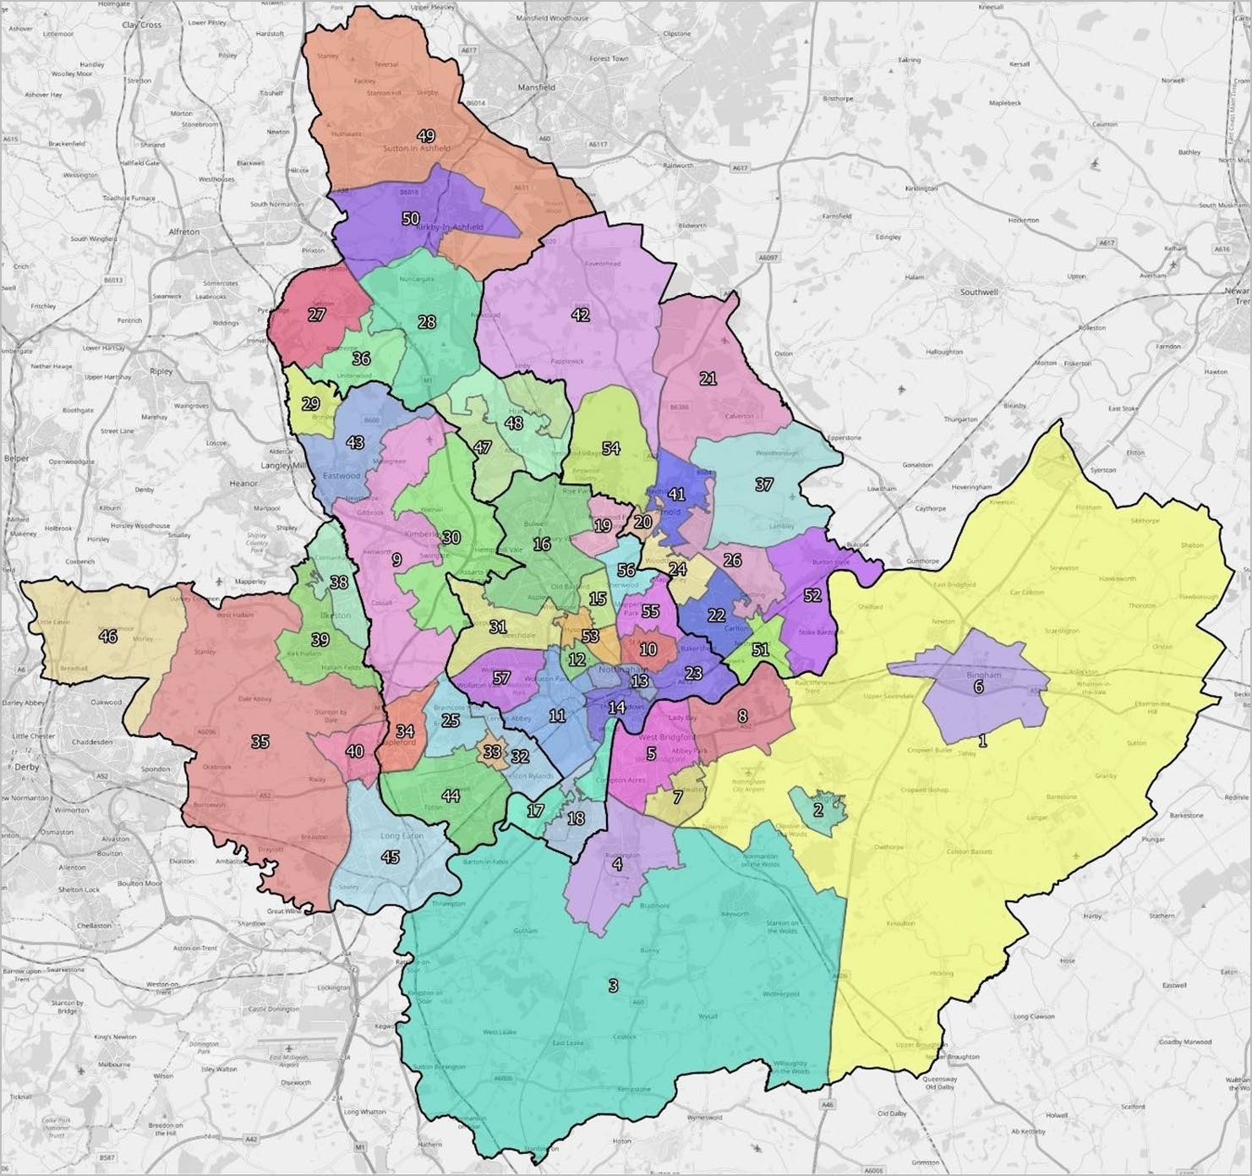

A2. PROJECTED CHANGES TO OLDER POPULATION WITH A RANGE OF DISABILITIES BY LPA (POPULATION AGED 65+)

Table A2.1 Projected Changes to Ashfield Population with a Range of Disabilities(older persons)

Disability | Age Range | 2020 | 2038 | Change | % Change
Dementia | 65+ | 1,619 | 2,663 | 1,044 | 64.5%
Mobility problems | 65+ | 4,413 | 6,839 | 2,426 | 55.0%
Autistic Spectrum Disorders | 65+ | 238 | 344 | 106 | 44.6%
Learning Disabilities | 65+ | 525 | 748 | 223 | 42.4%
Severe hearing loss | 61+ | 1,991 | 3,150 | 1,159 | 58.2%
Moderate or severe visual impairment | 65+ | 1,501 | 2,165 | 664 | 44.3%
Source: POPPI/PANSI and Demographic Projections

Table A2.2 Projected Changes to Broxtowe Population with a Range of Disabilities(older persons)

Disability | Age Range | 2020 | 2038 | Change | % Change
Dementia | 65+ | 1,673 | 2,565 | 892 | 53.3%
Mobility problems | 65+ | 4,436 | 6,330 | 1,894 | 42.7%
Autistic Spectrum Disorders | 65+ | 229 | 301 | 72 | 31.4%
Learning Disabilities | 65+ | 508 | 651 | 143 | 28.1%
Severe hearing loss | 61+ | 2,028 | 2,979 | 951 | 46.9%
Moderate or severe visual impairment | 65+ | 1,454 | 1,900 | 446 | 30.7%
Source: POPPI/PANSI and Demographic Projections

Table A2.3 Projected Changes to Erewash Population with a Range of Disabilities(older persons)

Disability | Age Range | 2020 | 2038 | Change | % Change
Dementia | 65+ | 1,710 | 2,716 | 1,006 | 58.8%
Mobility problems | 65+ | 4,473 | 6,698 | 2,225 | 49.7%
Autistic Spectrum Disorders | 65+ | 224 | 318 | 94 | 42.1%
Learning Disabilities | 65+ | 500 | 698 | 197 | 39.4%
Severe hearing loss | 61+ | 2,053 | 3,124 | 1,071 | 52.2%
Moderate or severe visual impairment | 65+ | 1,438 | 2,028 | 590 | 41.1%
Source: POPPI/PANSI and Demographic Projections

Table A2.4 Projected Changes to Gedling Population with a Range of Disabilities(older persons)

Disability | Age Range | 2020 | 2038 | Change | % Change
Dementia | 65+ | 1,698 | 2,587 | 888 | 52.3%
Mobility problems | 65+ | 4,565 | 6,561 | 1,997 | 43.7%
Autistic Spectrum Disorders | 65+ | 235 | 314 | 79 | 33.6%
Learning Disabilities | 65+ | 526 | 695 | 169 | 32.1%
Severe hearing loss | 61+ | 2,104 | 3,046 | 943 | 44.8%
Moderate or severe visual impairment | 65+ | 1,505 | 2,020 | 515 | 34.2%
Source: POPPI/PANSI and Demographic Projections

Table A2.5 Projected Changes to Nottingham Population with a Range ofDisabilities (older persons)

Disability | Age Range | 2020 | 2038 | Change | % Change
Dementia | 65+ | 2,719 | 3,946 | 1,227 | 45.1%
Mobility problems | 65+ | 7,157 | 10,191 | 3,034 | 42.4%
Autistic Spectrum Disorders | 65+ | 369 | 515 | 147 | 39.8%
Learning Disabilities | 65+ | 816 | 1,134 | 318 | 38.9%
Severe hearing loss | 61+ | 3,332 | 4,687 | 1,355 | 40.7%
Moderate or severe visual impairment | 65+ | 2,339 | 3,273 | 934 | 39.9%
Source: POPPI/PANSI and Demographic Projections

Table A2.6 Projected Changes to Rushcliffe Population with a Range of Disabilities(older persons)

Disability | Age Range | 2020 | 2038 | Change | % Change
Dementia | 65+ | 1,850 | 3,037 | 1,186 | 64.1%
Mobility problems | 65+ | 4,799 | 7,357 | 2,558 | 53.3%
Autistic Spectrum Disorders | 65+ | 239 | 340 | 101 | 42.4%
Learning Disabilities | 65+ | 531 | 739 | 208 | 39.1%
Severe hearing loss | 61+ | 2,203 | 3,475 | 1,272 | 57.8%
Moderate or severe visual impairment | 65+ | 1,527 | 2,163 | 636 | 41.7%
Source: POPPI/PANSI and Demographic Projections

A3. PROJECTED CHANGES TO YOUNGER ADULT POPULATION WITHA RANGE OF DISABILITIES BY LPA (POPULATION AGED UNDER65)

Table A3.1 Projected Changes to Ashfield Population with a Range of Disabilities(adult population)

Disability | Age Range | 2020 | 2038 | Change | % Change
Impaired mobility | 16-64 | 4,348 | 4,327 | -21 | -0.5%
Common Mental Disorder | 18-64 | 14,529 | 15,029 | 500 | 3.4%
Autistic Spectrum Disorders | 18-64 | 755 | 779 | 24 | 3.2%
Learning disabilities | 15-64 | 1,972 | 2,056 | 84 | 4.3%
Down's syndrome | 18-64 | 48 | 49 | 2 | 3.4%
Serious visual impairment | 18-64 | 50 | 51 | 2 | 3.4%
Severe hearing loss | 18-60 | 333 | 324 | -9 | -2.6%
Challenging behaviour | 15-64 | 36 | 38 | 1 | 4.0%
Source: POPPI/PANSI and Demographic Projections

Table A3.2 Projected Changes to Broxtowe Population with a Range of Disabilities(adult population)

Disability | Age Range | 2020 | 2038 | Change | % Change
Impaired mobility | 16-64 | 3,799 | 3,643 | -156 | -4.1%
Common Mental Disorder | 18-64 | 12,839 | 13,122 | 283 | 2.2%
Autistic Spectrum Disorders | 18-64 | 684 | 705 | 21 | 3.1%
Learning disabilities | 15-64 | 1,743 | 1,806 | 63 | 3.6%
Down's syndrome | 18-64 | 43 | 44 | 1 | 2.4%
Serious visual impairment | 18-64 | 44 | 45 | 1 | 2.4%
Severe hearing loss | 18-60 | 288 | 278 | -10 | -3.5%
Challenging behaviour | 15-64 | 32 | 33 | 1 | 3.2%
Source: POPPI/PANSI and Demographic Projections

Table A3.3 Projected Changes to Erewash Population with a Range of Disabilities(adult population)

Disability | Age Range | 2020 | 2038 | Change | % Change
Impaired mobility | 16-64 | 3,975 | 3,861 | -114 | -2.9%
Common Mental Disorder | 18-64 | 13,090 | 13,249 | 159 | 1.2%
Autistic Spectrum Disorders | 18-64 | 681 | 687 | 6 | 0.8%
Learning disabilities | 15-64 | 1,774 | 1,811 | 37 | 2.1%
Down's syndrome | 18-64 | 43 | 44 | 0 | 1.1%
Serious visual impairment | 18-64 | 45 | 45 | 1 | 1.1%
Severe hearing loss | 18-60 | 304 | 287 | -16 | -5.4%
Challenging behaviour | 15-64 | 33 | 33 | 1 | 1.8%
Source: POPPI/PANSI and Demographic Projections

Table A3.4 Projected Changes to Gedling Population with a Range of Disabilities(adult population)

Disability | Age Range | 2020 | 2038 | Change | % Change
Impaired mobility | 16-64 | 4,073 | 4,091 | 19 | 0.5%
Common Mental Disorder | 18-64 | 13,289 | 13,951 | 662 | 5.0%
Autistic Spectrum Disorders | 18-64 | 685 | 722 | 36 | 5.3%
Learning disabilities | 15-64 | 1,797 | 1,908 | 111 | 6.2%
Down's syndrome | 18-64 | 44 | 46 | 2 | 5.0%
Serious visual impairment | 18-64 | 45 | 48 | 2 | 5.0%
Severe hearing loss | 18-60 | 308 | 308 | 0 | 0.1%
Challenging behaviour | 15-64 | 33 | 35 | 2 | 5.9%
Source: POPPI/PANSI and Demographic Projections

Table A3.5 Projected Changes to Nottingham Population with a Range of Disabilities (adult population)

Disability | Age Range | 2020 | 2038 | Change | % Change
Impaired mobility | 16-64 | 9,205 | 9,340 | 135 | 1.5%
Common Mental Disorder | 18-64 | 42,146 | 43,604 | 1,458 | 3.5%
Autistic Spectrum Disorders | 18-64 | 2,299 | 2,424 | 125 | 5.4%
Learning disabilities | 15-64 | 5,871 | 6,161 | 290 | 4.9%
Down's syndrome | 18-64 | 140 | 146 | 5 | 3.9%
Serious visual impairment | 18-64 | 146 | 152 | 6 | 3.9%
Severe hearing loss | 18-60 | 707 | 702 | -5 | -0.8%
Challenging behaviour | 15-64 | 106 | 110 | 5 | 4.7%
Source: POPPI/PANSI and Demographic Projections

Table A3.6 Projected Changes to Rushcliffe Population with a Range of Disabilities(adult population)

Disability | Age Range | 2020 | 2038 | Change | % Change
Impaired mobility | 16-64 | 4,040 | 4,222 | 182 | 4.5%
Common Mental Disorder | 18-64 | 13,048 | 14,420 | 1,373 | 10.5%
Autistic Spectrum Disorders | 18-64 | 688 | 758 | 70 | 10.2%
Learning disabilities | 15-64 | 1,779 | 1,980 | 201 | 11.3%
Down's syndrome | 18-64 | 43 | 48 | 5 | 10.5%
Serious visual impairment | 18-64 | 45 | 50 | 5 | 10.5%
Severe hearing loss | 18-60 | 302 | 313 | 11 | 3.7%
Challenging behaviour | 15-64 | 33 | 36 | 4 | 10.9%
Source: POPPI/PANSI and Demographic Projections

A4. PROJECTED CHANGES IN HOUSEHOLD OF HRP BY AGE BY LPA

Table A4.1 Projected Change in Household by Age of HRP in Ashfield

Age | 2020 | 2038 | Change in Households | % Change
Under 20 | 242 | 332 | 90 | 37.3%
20-24 | 1,641 | 1,921 | 280 | 17.1%
25-29 | 3,478 | 4,001 | 523 | 15.0%
30-34 | 4,617 | 4,498 | -119 | -2.6%
35-39 | 4,445 | 4,615 | 169 | 3.8%
40-44 | 4,221 | 5,115 | 894 | 21.2%
45-49 | 4,674 | 5,204 | 530 | 11.3%
50-54 | 5,497 | 5,051 | -446 | -8.1%
55-59 | 5,587 | 5,036 | -551 | -9.9%
60-64 | 4,640 | 4,498 | -143 | -3.1%
65-69 | 4,270 | 5,602 | 1,332 | 31.2%
70-74 | 4,437 | 5,815 | 1,377 | 31.0%
75-79 | 3,665 | 5,092 | 1,427 | 38.9%
80-84 | 2,584 | 3,679 | 1,096 | 42.4%
85+ | 1,987 | 3,933 | 1,946 | 97.9%
Total | 55,987 | 64,392 | 8,406 | 15.0%
Source: Demographic Projections

Table A4.2 Projected Change in Household by Age of HRP in Broxtowe

Age | 2020 | 2038 | Change in Households | % Change
Under 20 | 112 | 141 | 29 | 25.8%
20-24 | 1,232 | 1,350 | 118 | 9.6%
25-29 | 3,070 | 3,667 | 598 | 19.5%
30-34 | 3,728 | 4,296 | 568 | 15.2%
35-39 | 3,819 | 4,231 | 413 | 10.8%
40-44 | 3,937 | 4,850 | 913 | 23.2%
45-49 | 4,324 | 4,645 | 320 | 7.4%
50-54 | 4,725 | 4,172 | -552 | -11.7%
55-59 | 4,567 | 4,085 | -482 | -10.6%
60-64 | 4,083 | 3,746 | -337 | -8.3%
65-69 | 3,788 | 4,486 | 698 | 18.4%
70-74 | 4,230 | 4,624 | 394 | 9.3%
75-79 | 3,228 | 4,184 | 956 | 29.6%
80-84 | 2,500 | 3,390 | 891 | 35.6%
85+ | 2,309 | 4,214 | 1,906 | 82.5%
Total | 49,649 | 56,081 | 6,431 | 13.0%
Source: Demographic Projections

Table A4.3 Projected Change in Household by Age of HRP in Erewash

Age | 2020 | 2038 | Change in Households | % Change
Under 20 | 130 | 174 | 44 | 33.5%
20-24 | 1,224 | 1,360 | 136 | 11.1%
25-29 | 3,163 | 3,567 | 404 | 12.8%
30-34 | 4,080 | 4,373 | 293 | 7.2%
35-39 | 3,733 | 4,001 | 267 | 7.2%
40-44 | 3,783 | 4,630 | 847 | 22.4%
45-49 | 4,613 | 4,734 | 120 | 2.6%
50-54 | 5,290 | 4,570 | -721 | -13.6%
55-59 | 5,229 | 4,364 | -865 | -16.5%
60-64 | 4,265 | 4,243 | -21 | -0.5%
65-69 | 3,838 | 5,045 | 1,208 | 31.5%
70-74 | 4,131 | 5,331 | 1,200 | 29.1%
75-79 | 3,270 | 4,415 | 1,145 | 35.0%
80-84 | 2,557 | 3,478 | 921 | 36.0%
85+ | 2,403 | 4,275 | 1,872 | 77.9%
Total | 51,709 | 58,559 | 6,850 | 13.2%
Source: Demographic Projections

Table A4.4 Projected Change in Household by Age of HRP in Gedling

Age | 2020 | 2038 | Change in Households | % Change
Under 20 | 117 | 152 | 35 | 30.4%
20-24 | 1,044 | 1,185 | 141 | 13.5%
25-29 | 2,803 | 3,245 | 442 | 15.8%
30-34 | 3,630 | 4,116 | 486 | 13.4%
35-39 | 4,176 | 4,662 | 486 | 11.6%
40-44 | 4,411 | 5,230 | 819 | 18.6%
45-49 | 4,663 | 5,282 | 619 | 13.3%
50-54 | 5,137 | 4,870 | -267 | -5.2%
55-59 | 5,162 | 4,847 | -315 | -6.1%
60-64 | 4,540 | 4,408 | -132 | -2.9%
65-69 | 4,167 | 5,038 | 871 | 20.9%
70-74 | 4,494 | 5,277 | 783 | 17.4%
75-79 | 3,337 | 4,747 | 1,411 | 42.3%
80-84 | 2,674 | 3,578 | 904 | 33.8%
85+ | 2,329 | 4,050 | 1,721 | 73.9%
Total | 52,683 | 60,687 | 8,004 | 15.2%
Source: Demographic Projections

Table A4.5 Projected Change in Household by Age of HRP in Nottingham

Age | 2020 | 2038 | Change in Households | % Change
Under 20 | 1,501 | 2,006 | 505 | 33.7%
20-24 | 13,767 | 16,305 | 2,537 | 18.4%
25-29 | 15,304 | 15,794 | 490 | 3.2%
30-34 | 13,195 | 14,711 | 1,517 | 11.5%
35-39 | 12,519 | 13,301 | 782 | 6.2%
40-44 | 11,684 | 13,228 | 1,545 | 13.2%
45-49 | 11,031 | 13,578 | 2,547 | 23.1%
50-54 | 11,578 | 11,028 | -549 | -4.7%
55-59 | 10,884 | 10,716 | -168 | -1.5%
60-64 | 8,848 | 8,917 | 69 | 0.8%
65-69 | 7,805 | 9,892 | 2,088 | 26.7%
70 74 | 7,092 | 9,561 | 2,469 | 34.8%
75-79 | 4,706 | 7,512 | 2,807 | 59.6%
80-84 | 3,984 | 5,693 | 1,708 | 42.9%
85+ | 3,903 | 5,636 | 1,734 | 44.4%
Total | 137,800 | 157,879 | 20,080 | 14.6%
Source: Demographic Projections

Table A4.6 Projected Change in Household by Age of HRP in Rushcliffe

Age | 2020 | 2038 | Change in Households | % Change
Under 20 | 84 | 100 | 16 | 18.8%
20-24 | 942 | 1,268 | 326 | 34.7%
25-29 | 2,687 | 3,257 | 570 | 21.2%
30-34 | 3,326 | 4,012 | 686 | 20.6%
35-39 | 3,821 | 4,615 | 794 | 20.8%
40-44 | 4,139 | 4,919 | 780 | 18.8%
45-49 | 4,535 | 5,317 | 782 | 17.2%
50-54 | 4,828 | 4,677 | -150 | -3.1%
55-59 | 4,974 | 4,773 | -201 | -4.0%
60-64 | 4,175 | 4,318 | 144 | 3.4%
65-69 | 3,903 | 4,991 | 1,088 | 27.9%
70-74 | 4,307 | 5,230 | 922 | 21.4%
75-79 | 3,253 | 4,540 | 1,288 | 39.6%
80-84 | 2,538 | 3,753 | 1,215 | 47.9%
85+ | 2,628 | 4,925 | 2,297 | 87.4%
Total | 50,140 | 60,695 | 10,556 | 21.1%
Source: Demographic Projections

203

