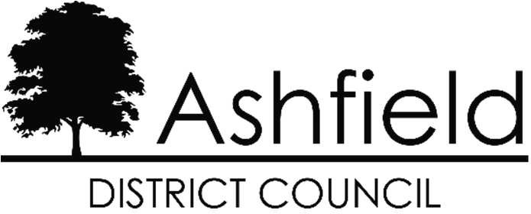

Application for the re-designation of the Teversal, Stanton Hill and Skegby Neighbourhood Forum

Consultation 11 October 2024 to 22 November 2024

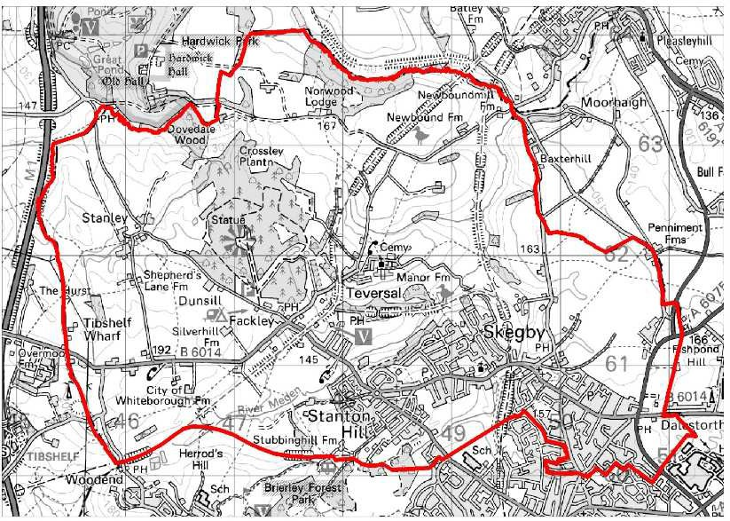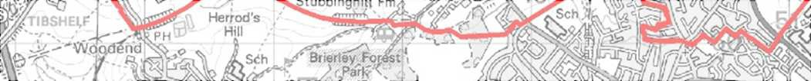

© Crown Copyright and database right 2014. Ordnance Survey

Teversal, Stanton Hill and Skegby Neighbourhood Area

The Council designated the Teversal, Stanton Hill and Skegby Neighbourhood Forum in February 2015. Under legislation, the designation of a neighbourhood forum ceases to have effect at the end of the period of 5 years beginning with the day on which it is made. The Forum was re-designated in 2020.

**Ashfield District Council hereby give notice** that an organisation or body, which is capable of being designated as a neighbourhood forum, the Teversal, Stanton Hill and Skegby Neighbourhood Forum, has applied for the re-designation of the neighbourhood forum. If a designation is made no other organisation or body may be designated for that neighbourhood area until that designation expires or is withdrawn.

The application can be viewed on the District Council’s website under [neighbourhood plans](https://www.ashfield.gov.uk/planning-building-control/neighbourhood-plans/) on the ‘planning & building control’ section

or at the Council’s offices at Urban Road, Kirkby- in-Ashfield during opening hours.

**Representations** - Any representations on the designation of the neighbourhood forum should be made by email to [localplan@ashfield.gov.uk](mailto:localplan@ashfield.gov.uk) or in writing to Ashfield District Council, Urban Road, Kirkby-in-Ashfield, Nottingham, NG17 8DA. **All representations must be received by the Council by 22 November 2024 at 5pm.**

For further information on the application please contact the Forward Planning Team, Ashfield District Council on 01623 457381 or email [localplan@ashfield.gov.uk](mailto:localplan@ashfield.gov.uk)

**Address:** Council Offices, Urban Road, Kirkby in Ashfield, Nottingham, NG17 8DA

**Tel:** 01623 450000 **Fax:** 01623 457006

**Data Protection** - Information on how we process data is set out on the [Council's website](https://www.ashfield.gov.uk/your-council/legal-information-public-data/privacy-notice/).

If reasonable adjustments are needed to fully engage with the Authority - contact **01623 450000**