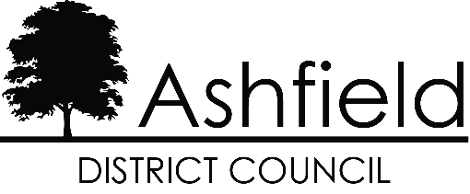**Revenue Services**

Urban Road,

Kirkby-in-Ashfield, Tel: 01623 457200

Nottingham. www.ashfield.gov.uk

NG17 8DA businessrates@ashfield.gov.uk

**APPLICATION BY A REGISTERED CHARITY OR NON-PROFIT MAKING ORGANISATION**

**CLAIMING RELIEF IN RESPECT OF BUSINESS RATES, UNDER SECTION 43, 45 AND 47 OF THE LOCAL GOVERNMENT FINANCE ACT 1988**

|  |  |
| --- | --- |
| Title of the Charity or Organisation |  |
| Address of the property for which the application is made for the relief |  |
| Property description |  |
| Business Rates Account Reference |  |

1. **Particulars of the Charity or Organisation**

|  |  |
| --- | --- |
| a) What are its main objects and purposes? | a) |
| b) Is it registered under the Charities Act 1960? If so please state the Registration No. | b) |
| c) If exempt from registration, state grounds | c) |

1. **Section(s) under which the relief is being claimed**

|  |  |
| --- | --- |
| a) Section 43/45 (Mandatory Relief) | YES/NO If answer is YES please see Note 5(a) to (e) |
| b) Section 47 (Discretionary Relief) | YES/NO If answer is YES please see Note 5(b) to (e) |

1. **Details of hereditament for which relief is claimed**

|  |  |
| --- | --- |
| a) Purpose(s) for which it is used |  |
| b) If used for any purposes other than those of the claimant, please give details |  |

1. **Additional Information (Discretionary Relief Only)**

|  |  |
| --- | --- |
| a) Is membership of your organisation/club open to all sections of the community or are there any restrictions? |  |

|  |  |
| --- | --- |
| b) Do you actively encourage membership from particular groups in the community? If so, which groups? |  |
| c) Are the facilities made available to people other than the members, eg: public sessions, etc? |  |
| d) Do you provide training or education for your members or any specific section of the membership? |  |
| e) Are you affiliated to any local or National Organisations? |  |
| f) Have your facilities been provided by self help or by grant aid? |  |
| g) Are your premises licensed for the sale of alcohol? |  |
| h) Any other information in support of this claim? |  |

1. **IMPORTANT:** The following documents should be forwarded with the application –
2. Copy of the Notice of Registration under the Charities Act 1960
3. Articles of Association / Constitution of the organisation
4. Copies of the audited accounts and balance sheets for the last 2 years.
5. Any leaflets distributed by the charity or organisation.
6. Any written statement you may wish to make in support of your application.
7. **I hereby certify that the particulars given above are correct to the best of my knowledge and belief.**

|  |
| --- |
| Signature |
| Capacity in which signed |
| Date |
| Address |
|  |
| Postcode |
| Telephone: |
| Contact email address: |

1. Please return this form as soon as possible to Business Rates, Revenue Services, Ashfield District Council, Urban Road, Kirkby in Ashfield, Nottingham NG17 8DA

**NOTE: Have you included items required under section 5 above?**