THE LAWN PLEASURE GROUND

MANAGEMENT PLAN

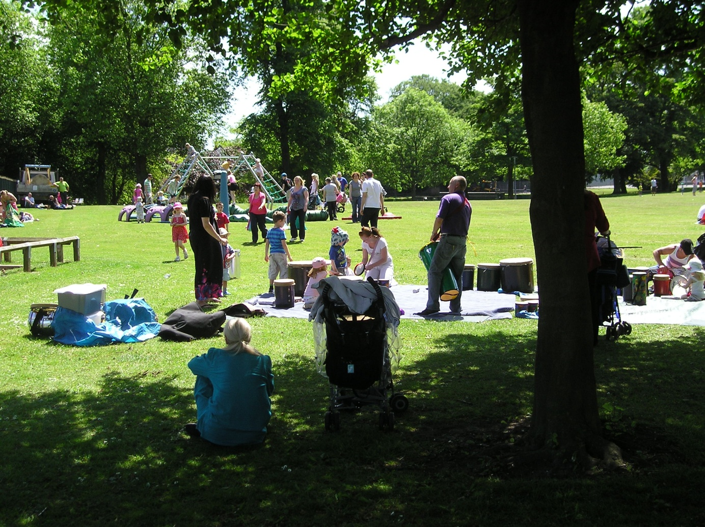

January 2015 - December 2019

(Revised December 2021)

Ashfield District Council
Urban Road, Kirkby-in-Ashfield. Nottinghamshire. NG17 8DA
Tel: 01623 450000 Fax: 01623 457585 Website: www.ashfield-dc.gov.uk

Disclaimer

This document or some parts of it may not be accessible when using adaptive technology.

If you require assistance with accessing the content of the document, please contact:

email: place@ashfield.gov.uk and quote the document name and web page you found it on.

Sutton Lawn Appendix 2

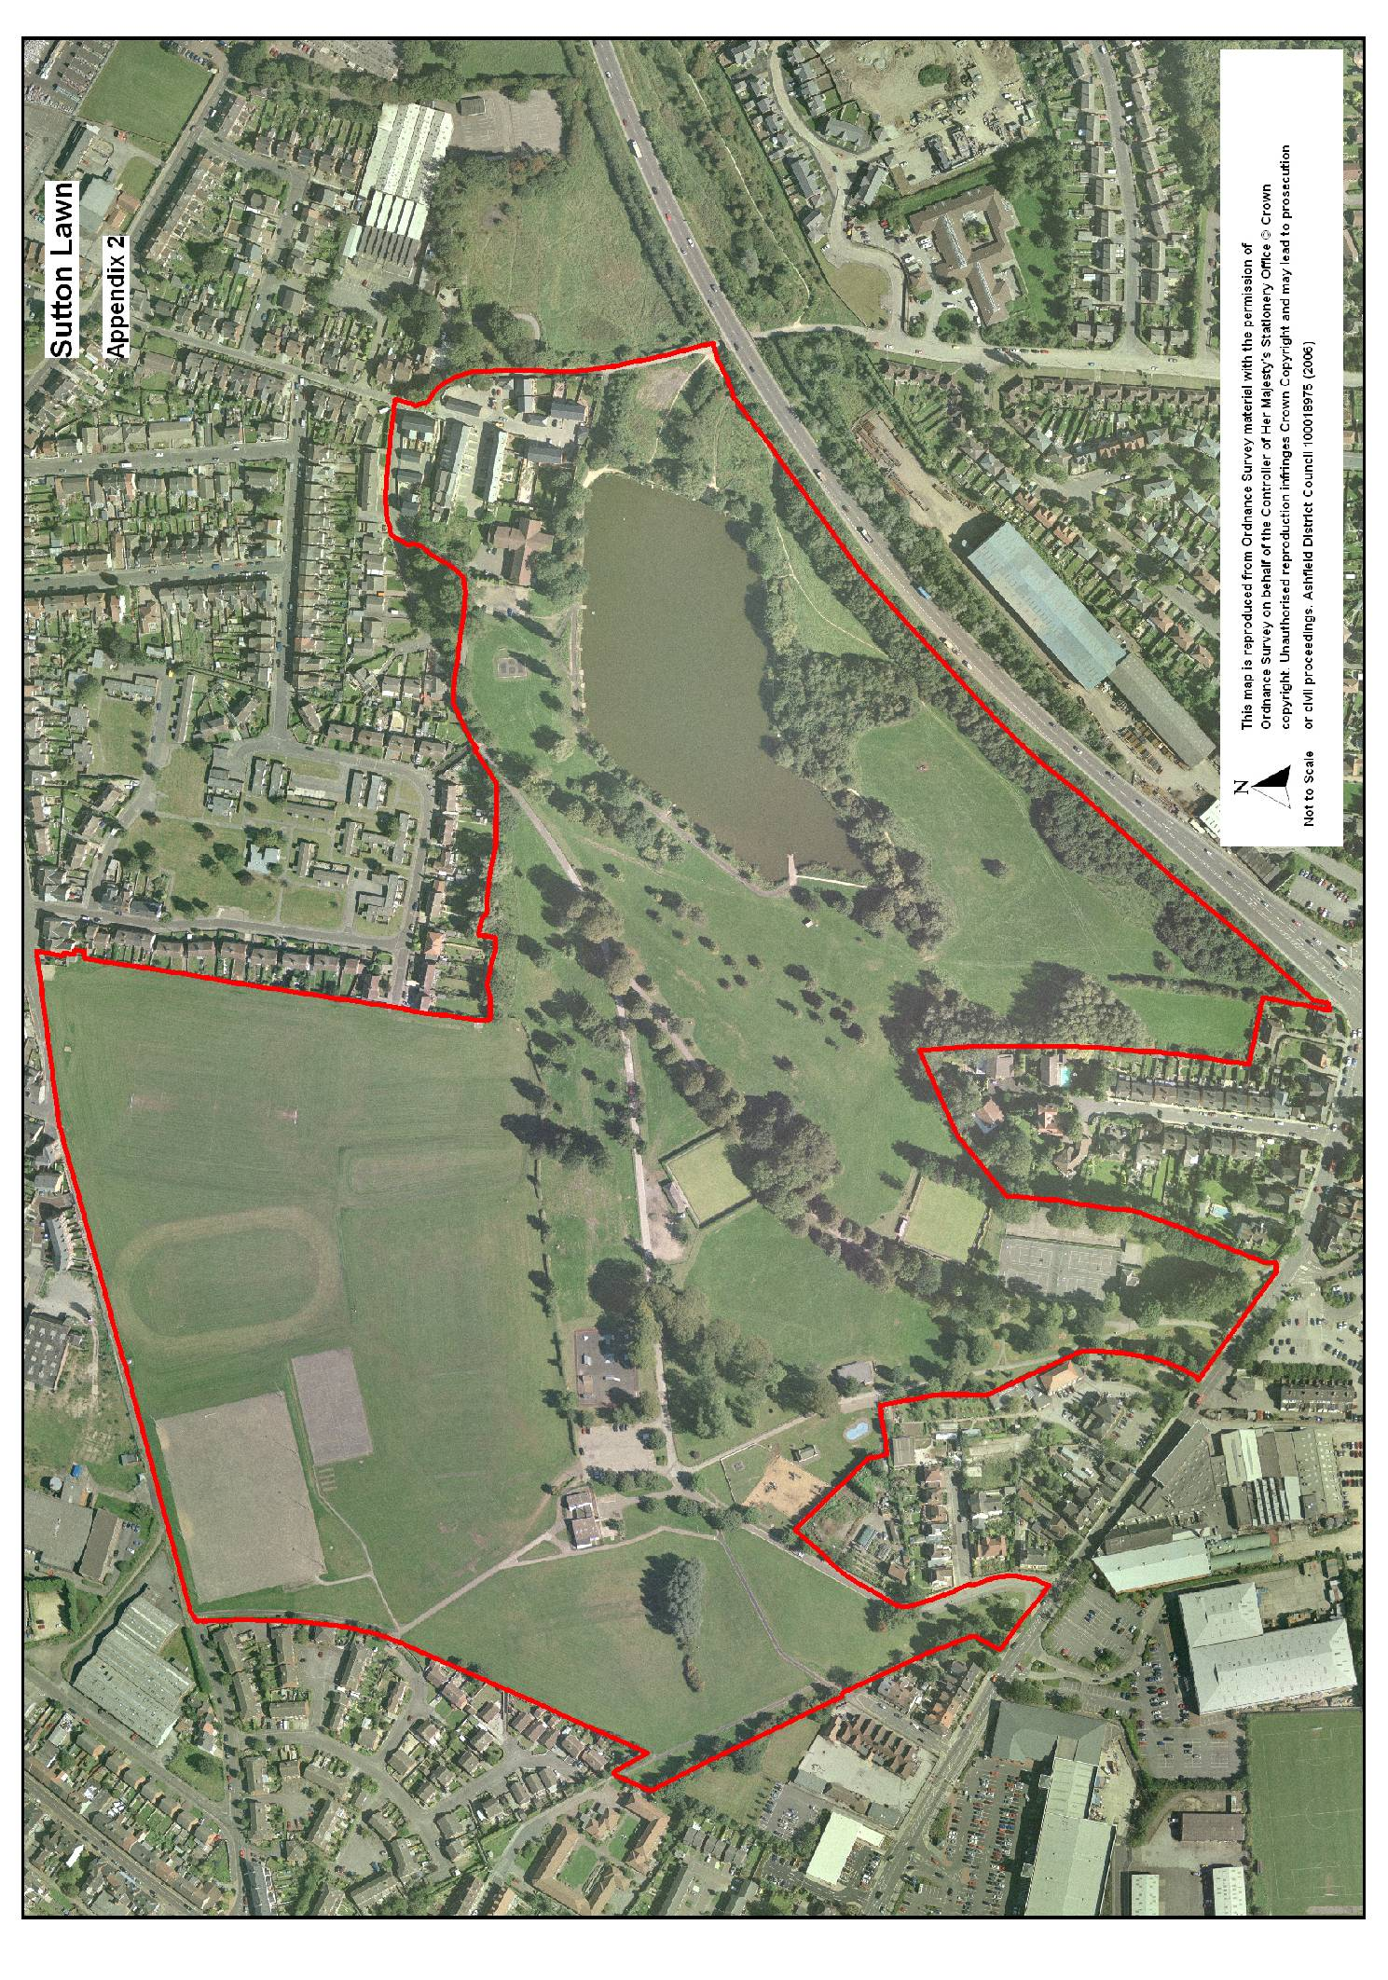

Appendix 1 Sutton Lawn site plan

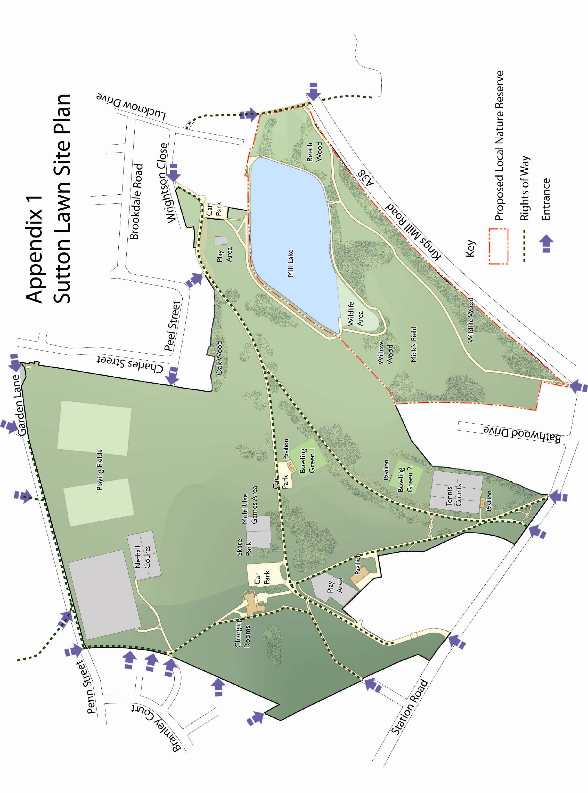

CONTENTS page

- OVERVIEW

1.1 Introduction 5

1.2 Park facilities 5

1.3 Investment 5

1.4 Heritage 6

1.5 Community Involvement 6

1.6 Landscape and Ecology 7

1.7 Green Flag criteria 8

- DELIVERY/ IMPLEMENTATION

2.1 Action Plan 11

3 MONITORING/ REVIEW

3.1 Monitoring and Review 13

3.2 Contacts 13

OVERVIEW

1.1 Introduction

This management plan has been developed by Ashfield District Council in partnership with the Friends of Sutton Lawn and Rumbles Catering Ltd. It is intended that the plan will help to improve general maintenance of the site, plan for the future and as part of this process retain the Green Flag Award, which the park has held since 2005. Details of the Council’s policies and procedures for green space management are contained within the document: ‘Management Plan Overview and Supporting Information.’

The Lawn Pleasure Ground is the original name of the park, although it is also known as The Lawn and Sutton Lawn. The Lawn has a pivotal role in providing facilities for Sutton and is the largest open space in the area, providing a central recreational facility for the community. Many events take place on the park organised by local community groups, Rumbles and the district and county councils which include summer fairs and sporting events.

The park is 7.5 hectares in size and is mainly comprised of grassed areas with woodland, avenues of trees and a lake. The land to the north is owned and managed by Nottinghamshire County Council (NCC) and is principally for sports use for Sutton Community Academy. The remainder of the site is owned by the district council. The management plan refers to land in the ownership of the district council.

1.2 Park facilities Users

Pavilion | Cafe managed by Rumbles Catering Ltd. Toilet facilities managed by the district council
Lake, angler’s hut, fishing platforms x 22 (including 4 disabled pegs) | The 2 hectare lake is classified under the Reservoirs Act due to its size and water capacity. The lake area is managed by Ashfield Anglers
Tennis court x6 and club house | 4 courts and clubhouse leased by Sutton in Ashfield Tennis Club
Bowling green and club house x2 | Facilities used by 3 local clubs
Multi use games area | Open access
Skate/ BMX park | Floodlit facility with open access
adiZone | Open access
Play area x2 | Open access
Car park x3 | Open access
3G (‘Third Generation’) floodlit pitch (NCC land) | The facility is for school use during the day and in the evenings and at weekends is used by community football organisations/ private hire.

1.3 Investment

The site has benefited from over £1.7 million of capital investment since 2002 when a feasibility study was commissioned by the Council and a masterplan developed. The first phase of implementation began in 2003, which included construction of a new pavilion, structural works to the dam wall and lake area, clearance of derelict features, additional seating and litter bins and the installation of railings around the bowling greens. Subsequent works included tree planting, resurfacing of paths and surfacing of desire lines, including a path around the lake, upgrading of the speed inhibitors along Lawn Lane which runs through the park and installation of directional signage.

A woodland planting and interpretation project was completed in 2005 with the planting of over a thousand trees. Over 350 children from local schools and a children’s nursery took part in planting days. Four native woodland areas have been created to complement existing planting and include 22 different species native to the area.

Further works in 2005 included the surfacing of the car park area adjacent to one of the bowling greens and the installation of the Multi Use Games Area and a second phase of footpath works. Several mature trees had to be felled in 2011 due to their condition, replacement planting of lime, beech, ash and wild cherry was carried out in 2012, with the new trees dedicated to the Queen's Diamond Jubilee.

Further works have included installation of an adiZone- a national Olympic legacy project and replacement of the skate/BMX area with a floodlit concrete facility completed in 2014. The main play area was extended and refurbished in 2014.

1.4 Site Heritage/ History
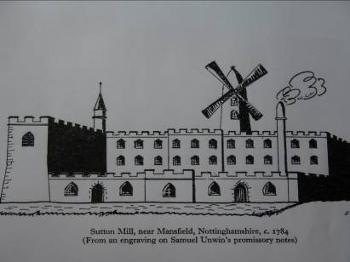
The area has evolved over the past three hundred years, originally shown on maps dating from 1610 as a series of enclosed fields. The park encompasses the grounds of the former Sutton Hall, built as the residence of Samuel Unwin, and the land associated with his nearby Cotton Spinning Mill and Mill Lake. The Mill complex was built around 1770, and the hall and gardens are thought to date from about the same period. The Mill utilised the town's watercourse, locally called the 'River Idle'. Sutton Hall and most of the mill complex no longer exist, but the mill ruins and adjacent lake form a focal feature of the park today.

The former mill site has been developed in to residential properties, which are Grade II listed. Parts of the boundary wall still show the larger structures and the location of the mill.

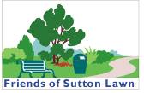
1.5 Community Involvement

Friends of Sutton Lawn

The park is supported by the Friends of Sutton Lawn which works
with the council in the development and management of the park.
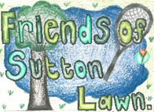
The Friends group was set up in 2000 and meets every two months.
The group works with Rumbles to hold events at the park, including
Halloween and Christmas events.

Rumbles has run the cafe within the pavilion since 2007 and is a Community Interest Company. Rumbles has been operating a catering social enterprise since 1998 and now runs four cafes in Nottinghamshire. The organisation supports disadvantaged local people gain employment and provides the local community with affordable healthy food. Rumbles also organise community events as well as lunch/ tea time clubs and outside catering.

1.6 Landscape and Ecology

Mill Lake is a prominent feature of the Lawn, covering a little more than two hectares. It was created by the construction of Mill Dam at the eastern end and is fed by a culverted stream. The southern tip of the lake is fenced off and forms a small nature reserve where angling is not permitted. Naturally occurring marginal plants include reedmace (Typha latifolia), reed sweet-grass (Glyceria maxima), reed canary-grass (Phalaris arundinacea) and amphibious bistort (Persicaria amphibia). The lake holds fish, and this attracts breeding birds such as great-crested grebe. Other birds include heron, kingfisher, mute swan, moorhen and mallard, while Daubenton's bat has been seen foraging above the water's surface.

Within the marginal strip adjacent to the water, the natural vegetation has been considerably augmented by planting of shrubs and trees, many of which are ornamental or other non-native species. These include dogwood, Indian bean tree, Chinese lantern, grey alder, alder and hornbeam. The lower vegetation in this strip is a mixture of wetland species and others typical of disturbed ground.

Semi-Improved Grassland
Grassland occupies at least 3 hectares of the site with Mick’s Field near the lake the largest area and of most interest ecologically. Sandy soil at the surface supports species such as sheep's sorrel (Rumex acetosella), cat's-ear (Hypochoeris radicata), red fescue (Festuca rubra) and common bent (Agrostis capillaris). The area is managed as a meadow with one cut per year.

Scrub and woodland
Occupying approximately 2 hectares, trees and shrubs occur in three principal areas:
- A long strip adjacent to the A38 boundary- this is the result of relatively recent planting, associated with the construction of the A38 and is planted with native species, but includes hazel (Corylus avellana) and holly (Ilex aquilinum) in a stretch of ancient hedgerow.
- A central wood- this follows most of the southern shore of the lake and includes an old hawthorn hedge (Crataegus monogyna) that extends south almost as far as the planting next to the A38. Various willow species occur close to the lake, including goat willow (Salix caprea), sallow (S. cinerea), osier (S. viminalis), crack willow (S. fragilis) and a large weeping willow.
- At the western end- tall planted poplars (Populus sp.), as well as a small area of naturally-developed diverse vegetation in a damp hollow behind a stone wall.

Non-statutory Designations
The site is within the Southern Magnesian Limestone Natural Area.

Biodiversity
The Local Biodiversity Action Plan for Nottinghamshire (Nottinghamshire Biodiversity Action Group, 1998) lists species and habitats of conservation concern in the county, based on national and local criteria. The habitat action plans which apply to the Lawn are Eutrophic and Mesotrophic Waters and Improved Grassland, the species action plan for Bats also applies.
1.7 Green Flag criteria
The Green Flag Award is the benchmark national standard
for parks and green spaces in the UK. In order to achieve the
award green spaces need to meet eight key criteria. The table
below shows how the park meets the criteria.

1. A welcoming place
Good and safe access | There are 17 formal accesses to the Lawn
Good signage to and in the park/green space | Brown signs at the main entrance off Station Road, entrance signs and directional signage within the park
Equal access for all members of the community | There are a number of level accesses into the park and access around the park is generally good on tarmaced paths, although access down to the lake needs to be improved. The small car park next to the pavilion is specifically for disabled users and staff and disabled bays are provided within all three main car parks. The pavilion is fully accessible with a disabled toilet.

2. Healthy, safe and secure
Equipment and facilities must be safe to use | Comprehensive inspection regime- detailed in the Management Overview
It must be a secure place for all members of the community to use or traverse | Lighting is provided along Lawn Lane and the path from Station Road to the visitor centre which is a well used shortcut through the park. The park has a full time park keeper and is visited by the Council’s Community Protection Officers during the evenings. During the summer, Rumbles is open until 7pm.
Dog fouling must be adequately addressed | Policy information is within the Management Overview
Health and safety policies should be in place, in practice and regularly reviewed | The Council has up to date policies which are regularly reviewed, further information is within the Management Overview
Toilets, drinking water, first aid, public telephones and emergency equipment where relevant (e.g. life belts by water) should be available in or near the park/green space, and be clearly signposted | Toilets are provided within the pavilion, there is a phone for emergency use.

3. Clean and well maintained
Litter and other waste management | Green waste is composted on the site, further policy information is within the Management Plan Overview
The maintenance of grounds, buildings, equipment and other features | Policy information on asset management is provided within the Management Plan Overview
A policy on litter, vandalism and maintenance should be in place, in practice and regularly reviewed | Policy information on asset management is provided within the Management Plan Overview

4. Sustainability
An environmental policy or charter and management strategy in place, which is in practice and regularly reviewed | The Council has a policy in place (within the Management Plan Overview)
Minimise and justify pesticide use | Pesticides are used infrequently
Eliminate horticultural peat use | Horticultural peat is not used on the park
Recycle waste plant material | There is a green waste facility in the works compound within the park
Demonstrate high horticultural and arboricultural standards | The park is maintained to the Council’s standards, details are provided within the Management Plan Overview
Have energy conservation, pollution reduction, waste recycling, and resource conservation measures | The pavilion has a number of energy conservation features, for example use of recycled rainwater system to flush toilets and urinals. Recycled slate tiles made from 80% Welsh slates, no gas fired equipment, aluminium clad timber windows with high insulation value, sheep’s wool insulation in the roof space. Further details are within the Management Plan Overview

5. Conservation and heritage
Particular attention should be paid to the conservation and appropriate management of:  Natural features, wildlife and fauna | Bird boxes have been provided around the park, an area around the lake is fence off as it is a popular breeding area for swans
Landscapes | The main heritage feature of the park in landscape terms are the avenues of trees which line the main paths, these are gradually being restored where possible. Unfortunately no records of the original park planting design have been found
Buildings and structural features | The only historical structural feature within the park itself is the stone boundary wall near Mick’s Field, restoration of this wall is included within the action plan

6. Community involvement
The park/green space management should actively pursue the involvement of members of the community who represent as many park/green space user groups as possible. The following should be demonstrated: | The park has an active Friends group and many local groups use the park. Rumbles supports community use of the site
Knowledge of user community and levels and patterns of use | A user survey is carried out every two years which informs the action plan for the park
Evidence of community involvement in management and/or developments and results achieved | The Friends group and Rumbles are involved in the review of the management plan which takes place every two years
Appropriate levels of provision of recreational facilities for all sectors of the community | There are a wide range of facilities within the park, the pavilion, sports facilities; bowls, skate/ BMX, adiZone, walking routes, angling, tennis, play etc

7. Marketing
A marketing strategy should be in place, which is in practice and regularly reviewed | The Council has a parks and green spaces marketing strategy (Management Plan Overview)
There should be good provision of information to users, e.g. about management strategies, activities, features, ways to get involved | Information is available on the Council’s website
The park/green space should be promoted as a community resource | Information is available on the Council’s website

8. Management
A management plan or strategy should be in place | The management plan is reviewed every two years
The plan must be actively implemented and regularly reviewed | The management plan is reviewed every two years
A financially sound management of the park/green space must also be demonstrated | The park is managed as part of the Council’s green space assets and does not have separate budgets

2.1 Sutton Lawn Action Plan
KEY:
PT: Place Team AI: Assets & Investments S106: Developer Contributions ● To be completed
NE: Neighbourhoods & Environment CS: Community Safety Complete Incomplete/ in progress

VOL: Volunteers TBI To be identified

AIM 1: CREATE A WELCOMING PARK

Objectives | Action | Delivery |  |  |  |  | Resources | Lead
A Welcoming Place |  | 22 | 23 | 24 | 25 | 26
Welcoming | Reduce use of seasonal bedding plants, replace with perennial planting and bulb planting where appropriate | ● | ● | ● | ● | ● | Revenue | NE
 | Re-paint play area railings on a five-year cycle |  |  | ● |  |  | Revenue | NE
 | Paint access gates to car parks on a 5-year cycle |  |  | ● |  |  | Revenue | NE
 | Access road improvements including resurfacing road and improve pedestrian crossing points to reduce conflict between vehicles and pedestrians |  | ● |  |  |  | S106 | PT
Good and safe access – improvements to be made to co-inside with completion of Towns Fund project proposals | Refresh parking bays and cross hatching in car park on a 5-year cycle |  | ● |  |  |  | Revenue | NE
 | Undertake a conditions survey of the footpaths around the park and develop a five-year cycle of repair, maintenance and resurfacing as required |  |  | ● |  |  | S106 / Revenue | PT / NE
Signage | Carry out signage and interpretation audit across the park, undertake necessary improvement works | ● |  |  |  |  | S106 | PT
 | Explore options for installing park notice boards providing a park map and information regarding facilities, events and pitch locations |  | ● |  |  |  | S106 | PT
 | Explore options for installing vehicle speed limit signs along access road |  | ● |  |  |  | Revenue | NE
Equal access for all | Refresh access audit for the park and implement recommendations where appropriate | ● |  |  |  |  | S106 | PT
AIM 2: ENSURE THAT THE PARK HAS GOOD FACILITIES THAT ARE SAFE AND SECURE

Objectives | Action | Delivery |  |  |  |  | Resources | Lead
Healthy, Safe & Secure |  | 22 | 23 | 24 | 25 | 26
Appropriate provision of quality facilities and activities | Fitness Area  Explore options for replacing the Adizone as it is passed economical repair | ● |  |  |  |  | Revenue / S106 | NE / PT
 | (Bottom Play Area)  Remove existing play area and grass over existing area. Develop natural play offer within natural areas of the park | ● | ● |  |  |  | Revenue | NE
 | Sports Pavilion  Replace the existing with a new energy efficient building providing adequately sized and accessible facilities as required by sports teams |  | ● |  |  |  | Towns Funding | PT
 | 3G Pitches  Construct a new full sized 3G synthetic pitch and refurb the existing 3G pitch |  | ● |  |  |  | Towns Funding | PT
 | Pitch Lighting  Upgrade the floodlighting on the existing and new 3G pitch to LED to reduce carbon emissions, running costs and improve the playing experience |  | ● |  |  |  | Towns Funding | PT
 | Old Shale Pitch Area  Remove old all-weather/ shale pitch surface and create area for grass mini pitches |  | ● |  |  |  | Towns Funding | PT
 | Tennis Courts  Resurface 6nr tennis courts to include new court markings, install new fencing and fob activated access gates, upgrade lighting to LED and refurbish the existing tennis pavilion to create a large community room and larger toilets / changing room facilities |  | ● |  |  |  | Towns Funding / LTA Funding (tbc) | PT
Safe equipment and facilities | Sports Pitches  Improve drainage to existing U13/14, 11v11 and 9v9 grass pitches |  | ● |  |  |  | Towns Funding | PT
Personal Security | Continue to liaise with police, community protection officers regarding issues that arise | ● | ● | ● | ● | ● | n/a | NE / CS
 | Continue to improve and maintain sight lines across the park to increase natural surveillance | ● | ● | ● | ● | ● | Revenue | NE
 | Repair and secure boundary fence with A38 | ● |  |  |  |  | Revenue | NE
Control of dogs / dog fouling | Ensure current Public Space Protection Orders are in place and signage displayed | ● | ● | ● | ● | ● | Revenue | NE
 | Continue regular patrols and issue fines to offenders | ● | ● | ● | ● | ● | n/a | CS
 | Continue to monitor dog fouling and continue to top up free dog poo bags on site | ● | ● | ● | ● | ● | Revenue | NE

AIM 3: ENSURE THAT THE PARK IS WELL MAINTAINED AND CLEAN

Objectives | Action | Delivery |  |  |  |  | Resources | Lead
Well Maintained and Clean |  | 22 | 23 | 24 | 25 | 26
Litter and waste management | Review the number and condition of the bins on site |  | ● |  |  |  | n/a | NE
 | Develop and implement a bin replacement strategy for the park |  |  | ● |  |  | Revenue | NE
Horticulture maintenance | Review the condition, quality and age of planting throughout the park | ● |  |  |  |  | n/a | NE
 | Develop and implement a horticulture strategy for the park prioritising key, visual impact areas |  | ● |  |  |  | Revenue | NE
Arboricultural maintenance | Undertake a detailed arboricultural survey of all trees on the park complete with management recommendations for 6mths / 1 yr / 2 yrs paying particular attention to Ash die back | ● |  | ● |  | ● | Revenue | NE
Building and infrastructure maintenance | Continue essential building maintenance whilst detailed plans are developed for new sports pavilion and tennis pavilion refurbishment | ● | ● | ● | ● | ● | Revenue | AI
Equipment maintenance | Continue with annual independent / fortnightly in-house inspections of play and youth facilities | ● | ● | ● | ● | ● | Revenue | NE
 | Inspect, maintain and repair sports equipment such as football goals, tennis nets and sports fencing | ● | ● | ● | ● | ● | Revenue | NE
AIM 4: ENSURE APPROPRIATE MANAGEMENT OF BIODIVERSITY, LANDSCAPE AND HERITAGE FEATURES

Objectives | Action | Delivery |  |  |  |  | Resources | Lead
Biodiversity, Landscape & Heritage |  | 22 | 23 | 24 | 25 | 26
Management of natural features, wild fauna and flora | Lake  Cut and remove areas of woody and other vegetation to ensure that much of the lake margin is maintained in an open and sunny state | ● | ● | ● | ● | ● | Revenue | NE
 | Remove non-native plants around the lake margin | ● | ● | ● | ● | ● | Revenue | NE
 | Nest boxes  Explore options for installing bird / owl / bat boxes around the park; encourage involvement from local schools and community groups | ● |  |  |  | ● | S106 | PT
 | Grassland  Improve the botanical interest of grassland by modifying existing management- identify areas where grass beneath groups of trees can be left unmown - plant bluebells | ● | ● | ● | ● | ● | Revenue | NE
 | Woodland Walk  Continue to develop area as woodland walk - need to make secure dead hedge in front of new timber fence | ● | ● |  |  |  | Revenue | NE
Conservation of buildings & structures | Mick’s Field  Carry out works to restore stone walls | ● |  |  |  |  | Revenue | NE / AI
 | Dam Walls  Remove redundant stone wall in front of bank – requested by inspector to inspect fissures in bank regarding potential flooding issues | ● |  |  |  |  | Revenue | NE / AI

AIM 5: ENCOURAGE AND SUSTAIN COMMUNITY USE AND INVOLVEMENT

Objectives | Action | Delivery |  |  |  |  | Resources | Lead
Community Involvement |  | 22 | 23 | 24 | 25 | 26
Community involvement  in management & development | Volunteers  Attract new volunteers to the park, identify volunteer activities and carry out practical tasks | ● | ● | ● | ● | ● | n/a | PT / NE
Appropriate provision for community | Undertake a user survey before and after the sports hub has been developed to gain valuable insight in community provision and use | ● |  | ● |  |  | n/a | PT

AIM 6: ENSURE THE PARK IS MARKETED AS A DESTINATION SITE

Objectives | Action | Delivery |  |  |  |  | Resources | Lead
Marketing and Communication |  | 22 | 23 | 24 | 25 | 26
Marketing and promotion | Develop a marketing and promotional strategy for the park – to be included in the District wide digital information offer | ● | ● | ● | ● | ● | n/a | PT / NE
Educational and interpretational information | Liaise with café operator regarding displaying historical and interpretational displays within the visitor centre |  |  | ● |  |  | n/a | PT
 | Continue to promote the site for educational use with local schools and community groups | ● | ● | ● | ● | ● | n/a | PT / NE

3 MONITORING/ REVIEW

3.1 Monitoring and Review

The management plan will be reviewed every two years with a review of the action plan carried out annually to monitor progress. This process will be carried out in September to feed into the Council’s business plan cycle. The results of the process will give the opportunity to assess the overall success of the management plan and whether additional funding and resources are required. A site inspection will be carried out during August/ September to check whether any additional works are required, which will then be added to the work programme/ Action plan, as appropriate.

3.2 Contacts

Sutton Lawn
Off Station Road
Sutton in Ashfield
Nottinghamshire
NG17 5FU

Email: environment@ashfield-dc.gov.uk
0800 183 8484 / 01623 457 857

www.ashfield-dc.gov.uk

Café- Rumbles Catering Project Limited
Telephone: 01623 556657 (preferred method of contact is by telephone)
Email: goodfood@rumbles.org.uk
www.rumbles.org.uk/suttonlawn

Friends of Sutton Lawn
For information about the Friends of Sutton Lawn, please contact the
council on 01623 457451.

Clubs

Tennis | Angling
Sutton Lawn Tennis Club  http://suttontennisclub.webs.com | JD Fisheries Management  07515427562  www.jdfisheriesmanagement.co.uk
Bowls
Portland Bowls Club
Tel: 01623 553822

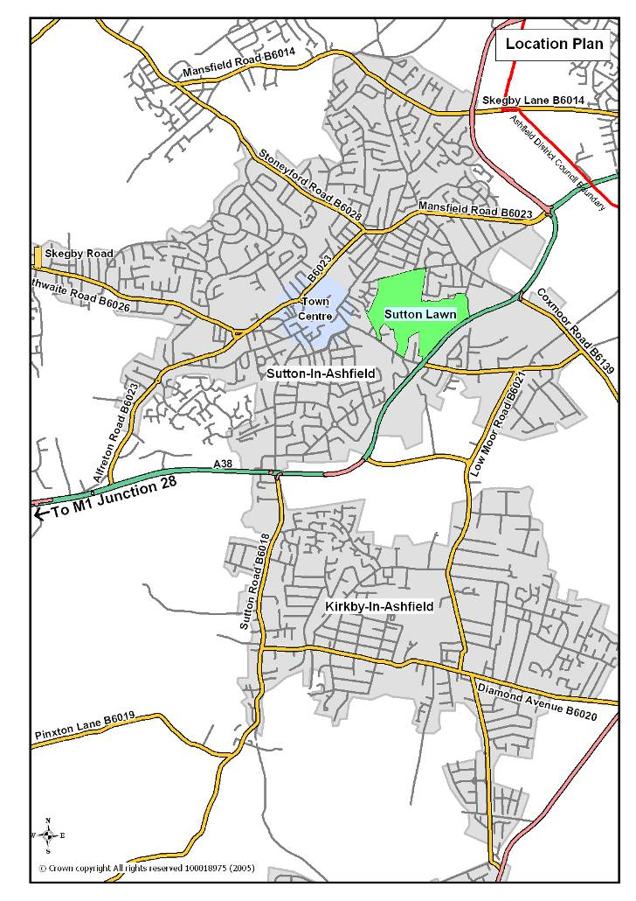

Ashfield District Council
Urban Road, Kirkby-in-Ashfield. Nottinghamshire. NG17 8DA
Tel: 01623 450000 Fax: 01623 457585 Website: www.ashfield-dc.gov.uk

